Life Sciences Datasets Questionnaire: responses – v1.0 (28/02/2015)
  - Integrating ELIXIR reference datasets within the European Grid Infrastructure

Contents
Introduction 2
Response Summary 2
Detailed Survey Responses 3
Section A: Background 3
A1a. Affiliation – Organization Type 3
A1b. Affiliation – Country 3
A1c. Providing answers on behalf 4
Section B: Work with Reference Datasets 5
B1. How often do you use reference dataset for your work? 5
B2. How do you access the reference dataset? 5
B3. Where do you perform your analysis run work with reference datasets? 6
B4. On average, how significant is the data transfer bottleneck in your analysis when you work with reference datasets? 7
B5. On average, how significant in the computational bottleneck in your analysis when you work with reference datasets? 8
Section C: Datasets, Databases, Data Repositories 9
C1. Please list your most frequently used reference datasets (or databases, data repositories that provide such datasets). 9
C2. What is your preferred mode of access for those datasets/databases/repositories? 10
C3. Which is your preferred means of interacting with the reference data: 11
C4: How useful would be the integration of selected Data Repositories within the European Grid Infrastructure? 11
Section D: Comments and Follow-up 13
D1. Other Comments 13
D2. Contact information (confidential) 13

Introduction
This documents provides the details results of the survey regarding the reference datasets in Life Sciences.
The document of the survey can be found here. The URL of the survey is here.
The current version (1.0) of this document was produced with the results retrieved up until (and including) February 28th 2015.

Response Summary

Full responses | 27
Incomplete responses | 37
Total responses | 64

The results listed below are based on the Full Responses (27).

Detailed Survey Responses

Section A: Background

A1a. Affiliation – Organization Type

Answer | Count | Percentage
Research Center | 11 | 40.74%
University | 13 | 48.15%
Foundation | 1 | 3.70%
Government | 1 | 3.70%
Company | 0 | 0.00%
Other | 1 | 3.70%

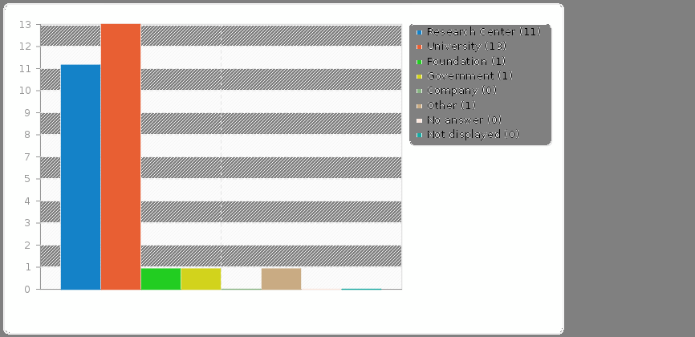
Other
- Non profit organization

A1b. Affiliation – Country

Answer | Count | Percentage
Canada | 1 | 3.70%
Denmark | 1 | 3.70%
Finland | 1 | 3.70%
France | 2 | 7.40%
Greece | 9 | 33.33%
Israel | 1 | 3.70%
MAC | 1 | 3.70%
Netherlands | 5 | 18.51%
Portugal | 1 | 3.70%
Spain | 1 | 3.70%
Switzerland | 2 | 7.40%
UK | 1 | 3.70%
USA | 1 | 3.70%

A1c. Providing answers on behalf

Answer | Count | Percentage
Myself | 20 | 74.07%
Research group | 4 | 14.81%
Project (please name it) | 1 | 3.70%
Community/collaboration/experiment (please name it) | 0 | 0.00%
Other (please name) | 2 | 7.41%

Comments/Other
- CHAIN-REDS
- I try to answer on behalf of the science services of CSC.
- ELIXIR-DK

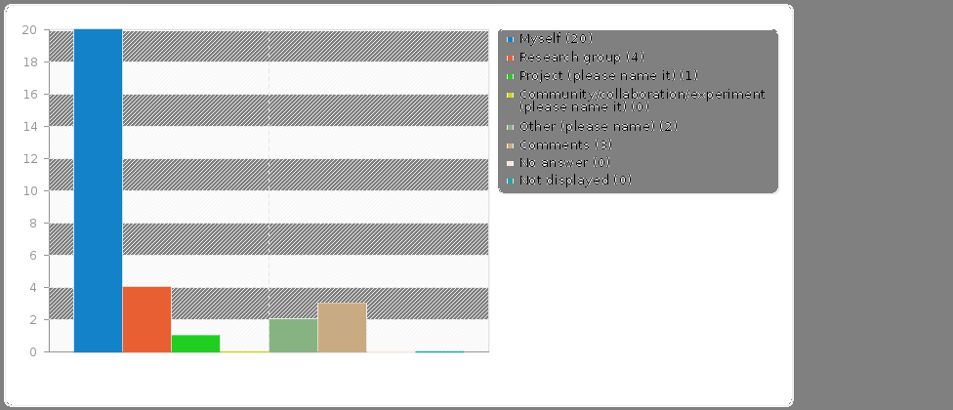

Section B: Work with Reference Datasets

B1. How often do you use reference dataset for your work?

Answer | Count | Percentage
At least a few times a week | 18 | 66.67%
Approximately once a week | 2 | 7.41%
A few times a month | 3 | 11.11%
Less than once a month | 4 | 14.81%
Never | 0 | 0.00%

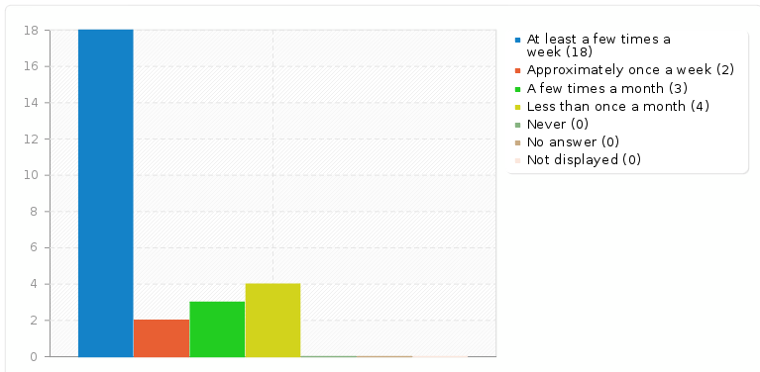

B2. How do you access the reference dataset?

Answer | Count | Percentage
Publicly available | 25 | 92.59%
Access is granted through my team/project/collaboration | 0 | 0.00%
I arranged access directly with data provider | 1 | 3.70%
Other | 1 | 3.70%

Other
- I use the CHAIN-REDS Knowledge Base and Semantic Search Engine

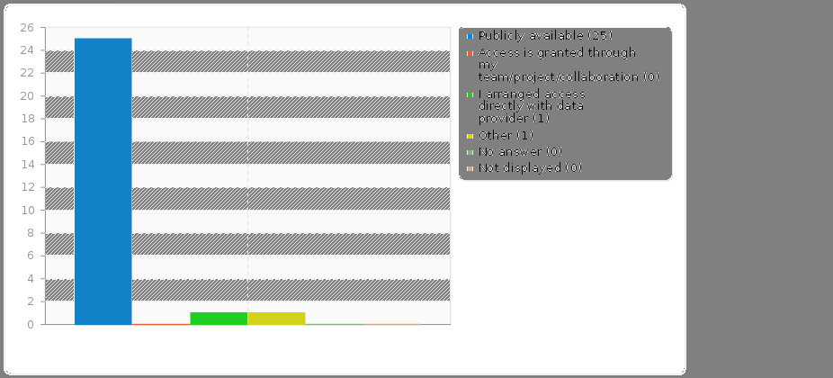

B3. Where do you perform your analysis run work with reference datasets?

Answer | Count | Percentage
On my laptop/desktop | 8 | 29.63%
On a server/mainframe/cluster in my institute | 12 | 44.44%
On a server/mainframe/cluster in a partner institute | 3 | 11.11%
On a commercial infrastructure/cloud (e.g. Amazon, Microsoft Azure) | 0 | 0.00%
On an e-infrastructure (e.g. EGI, PRACE, Embassy Cloud, Nordugrid, etc.) | 2 | 7.41%
Other | 2 | 7.41%

Other
- Laptop/server/EGI
- On a Surfsara cloud

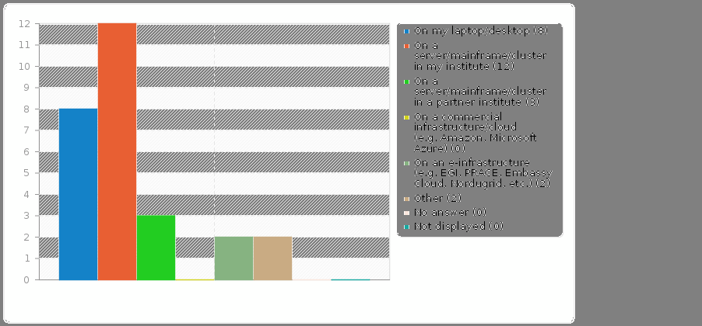

B4. On average, how significant is the data transfer bottleneck in your analysis when you work with reference datasets?

Answer | Count | Percentage
very significant - my analysis is very slow because of slow data download/upload | 3 | 11.11%
significant - my analysis is often impacted by slow data download/upload rate | 13 | 48.15%
insignificant - data transfer rate has little, or no impact at all on my analysis | 11 | 40.74%

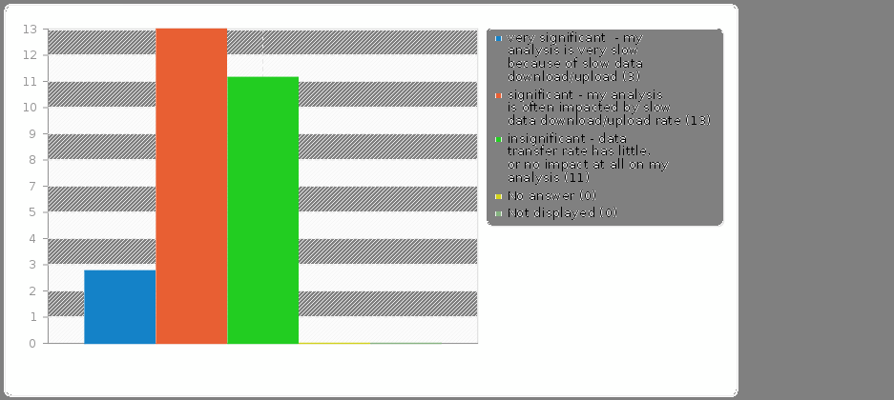

B5. On average, how significant in the computational bottleneck in your analysis when you work with reference datasets?

Answer | Count | Percentage
very significant - my analysis is very slow because of complex computational algorithms | 6 | 22.22%
significant - my analysis is often slow because of complex computational algorithms | 16 | 59.26%
insignificant – my analysis on reference data does not require complex computational algorithms | 5 | 18.52%

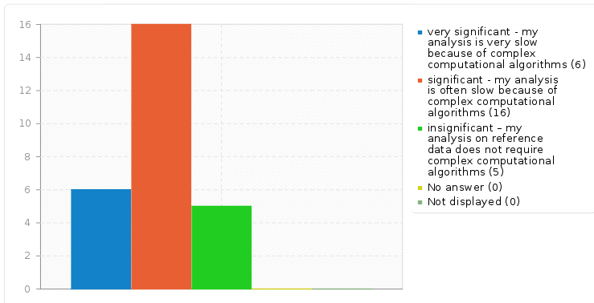

Section C: Datasets, Databases, Data Repositories

C1. Please list your most frequently used reference datasets (or databases, data repositories that provide such datasets).

Examples of such datasets are NR/NT, RefSeq, UniRef100, Ensembl Plants, Plaza, 1000genomes, MouseDB etc.

Answer | Count | Percentage | Notes
RefSeq, RefSeq Bacteria | 8 | 29.62% | Sequence Database
NR/NT | 7 | 25.92% | Sequence Database
Ensembl | 7 | 25.92% | Sequence Database
UniProtKB Reference Proteomes | 6 | 22.22% | Sequence Database
PDB | 4 | 14.81% | Structural Database
UniRef100 | 3 | 11.11% | Sequence Database
SRA | 3 | 11.11% | Sequence Database
1000genomes | 2 | 7.40% | Sequence Database
ucsc genome browser tables, refseq, exons, conservation tracks | 2 | 7.40% | Sequence Database
KEGG | 2 | 7.40% | Metabolic Database
GEO, GEO DATASETS | 2 | 7.40% | Gene Expression Database
OMIM | 2 | 7.40% | Sequence Database
chEMBL | 2 | 7.40% | Reaction Database
GENCODE, ENCODE Mouse and Human | 2 | 7.40% | Sequence Database
JGI Fungi Portal | 1 | 3.70% | Species Database
COSMIC | 1 | 3.70% | Cancer Database
NCBI Pubmed/Pubmed central | 1 | 3.70% | Text Database
MouseDB | 1 | 3.70% | Species Database
HGNC | 1 | 3.70% | Sequence Database
HAMAP | 1 | 3.70% | Sequence Database
PROSITE | 1 | 3.70% | Sequence Database
RegulonDB | 1 | 3.70%
RSAT | 1 | 3.70%
TRANSFAC | 1 | 3.70%
MMDB | 1 | 3.70%
GENbank | 1 | 3.70% | Sequence Database
CHAIN-REDS | 1 | 3.70%
Enclyclopedia of Life (Text content) | 1 | 3.70% | Text Database
Medline abstracts | 1 | 3.70% | Text Database
ENA | 1 | 3.70%
EGA | 1 | 3.70%
GoNL | 1 | 3.70%
RNAseq | 1 | 3.70% | Sequence Database
nextprot | 1 | 3.70%
Drugbank | 1 | 3.70%

The percentage has been calculated based on the number of different responses (i.e. 27), and not with regard to the number of different entries (total 73, multiple entries per response).
Finally, there were more generic responses that are not included in the above tables, such as:
- NCBI (contains many different repositories)
- sequence databases, BLAST databases
- Ontologies (OWL format)
- Bird genomes, various sources
- Plant genomes, various sources

C2. What is your preferred mode of access for those datasets/databases/repositories?

Answer | Count | Percentage
Flat file (FASTA, FASTQ, PDB, etc) | 23 | 85.19%
NoSQL approaches | 0 | 0.00%
Through provided API | 2 | 7.41%
Direct database connection | 2 | 7.41%
Software Platform (e.g. Galaxy) | 0 | 0.00%

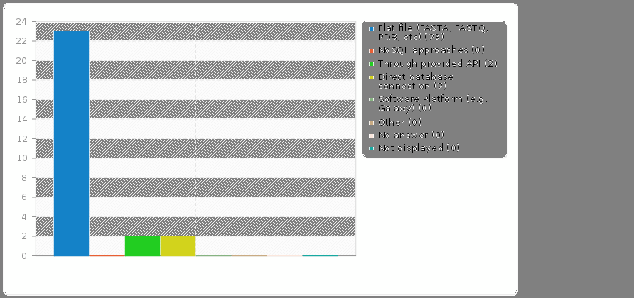

C3. Which is your preferred means of interacting with the reference data:

Answer | Count | Percentage
Custom (in-house) developed tools | 15 | 55.56%
Existing platforms and services (e.g. Galaxy) | 7 | 25.93%
Programming frameworks (e.g. Bioconductor) | 3 | 11.11%
Other | 2 | 7.41%

Other
- Custom + various software
- and Galaxy sometimes

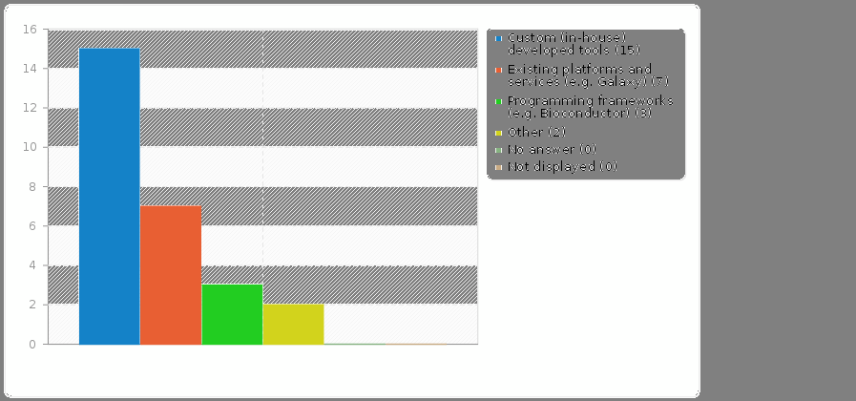

C4: How useful would be the integration of selected Data Repositories within the European Grid Infrastructure?

Answer | Count | Percentage
very useful | 14 | 51.85%
useful | 6 | 22.22%
insignificant | 1 | 3.70%
I don’t know enough about the topic to judge this | 6 | 22.22%

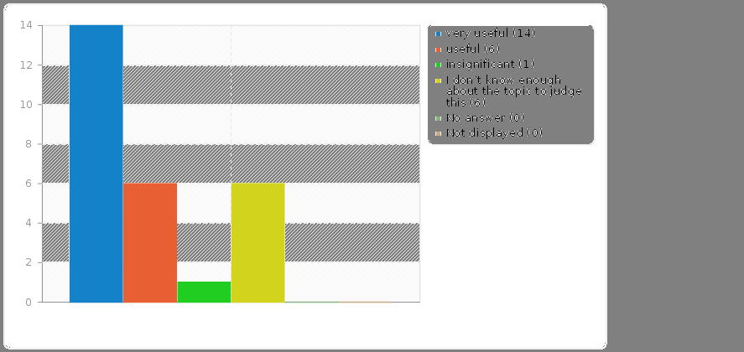

Section D: Comments and Follow-up

D1. Other Comments
e.g. further explanation to some of the answers you provided

 | Other Comments
1 | tools to download specific slices of the database (as tabix for 1000G) are welcome.
2 | We should be able to select more than one answers in a few of your questions.
3 | I was originally a researcher in Europe and recently moved to USA. I still use European tools, mainly through ExPASy. As a mere user, I rely these databases and tools (though my knowledge is very limited in programming and how these work)
4 | The biggest problem in accessing data is the dispersed nature of meta data. For example: bacterial genome assemblies can be obtained from NCBI (although not without scripting efforts), but the corresponding meta data about the bacterial strains is available via the GOLD database. The GOLD database is not accessible via an API or flatfiles so analysis over a large number of genomes is virtually impossible without a lot of hand work.
5 | The datasets need annotating in consistent terms, at least "EDAM format" and possible "EDAM data" for bio datasets.
6 | We use the nt/nr database at the moment via the cloud where we stored the database locally. The ideal situation would be that we could access the database from a shared resource though which we could work on either a cluster/cloud/galaxy because the storage place of the database is one of the biggest limitations

D2. Contact information (confidential)

 | Contact Emails
1 | panagiotis.ioannidis@unige.ch
2 | anastasia.gioti@biology.uoc.gr
3 | katnastou@biol.uoa.gr
4 | lilachfr@gmail.com
5 | cnikolaou@biology.uoc.gr
6 | apolyzos@bioacademy.gr
7 | epk34@drexel.edu
8 | b.b.oudemunnink@amc.uva.nl
9 | v.dejager@nioo.knaw.nl
10 | mntertilis@biol.uoa.gr
11 | mariakamilari@gmail.com
12 | rafael.mayo@ciemat.es
13 | aduarte@itqb.unl.pt
14 | kimmo.mattila@csc.fi
15 | jison@ebi.ac.uk
16 | b.b.oudemunnink@amc.uva.nl

