EGI-InSPIRE

Review of the Website

EU MILESTONE: MS242

Document identifier: | EGI-InSPIRE-MS424-DRAFT.v1
Date: | 02/09/2013
Activity: | NA2.2
Lead Partner: | EGI.eu
Document Status: | DRAFT
Dissemination Level: | PUBLIC
Document Link: | https://documents.egi.eu/document/1904

Abstract
This review aims to report the progress of the EGI main website’s design, structure and content between the 1st August 2012 and the 1st August 2013.

- Copyright notice
Copyright © Members of the EGI-InSPIRE Collaboration, 2011-2014. See www.egi.eu for details of the EGI-InSPIRE project and the collaboration. EGI-InSPIRE (“European Grid Initiative: Integrated Sustainable Pan-European Infrastructure for Researchers in Europe”) is a project co-funded by the European Commission as an Integrated Infrastructure Initiative within the 7th Framework Programme. EGI-InSPIRE began in May 2010 and will run for 4 years. This work is licensed under the Creative Commons Attribution-Noncommercial 3.0 License. To view a copy of this license, visit http://creativecommons.org/licenses/by-nc/3.0/ or send a letter to Creative Commons, 171 Second Street, Suite 300, San Francisco, California, 94105, and USA. The work must be attributed by attaching the following reference to the copied elements: “Copyright © Members of the EGI-InSPIRE Collaboration, 2011-2014. See www.egi.eu for details of the EGI-InSPIRE project and the collaboration”. Using this document in a way and/or for purposes not foreseen in the license, requires the prior written permission of the copyright holders. The information contained in this document represents the views of the copyright holders as of the date such views are published.
- Delivery Slip
 | Name | Partner/Activity | Date
From | Sara Coelho | EGI.eu / NA2.2 | 19/08/2013
Reviewed by | Moderator:  Reviewers: | Catherine Gater  Jan Jona Javorsek | 27 August 2013
Approved by | AMB & PMB |  | 2 Spetember 2013
- Document Log
Issue | Date | Comment | Author/Partner
1 | 19 August 2013 | First version | Sara Coelho
2 | 28 August 2013 | Second version, with comments | Sara Coelho
- Application area
This document is a formal deliverable for the European Commission, applicable to all members of the EGI-InSPIRE project, beneficiaries and Joint Research Unit members, as well as its collaborating projects.
- Document amendment procedure
Amendments, comments and suggestions should be sent to the authors. The procedures documented in the EGI-InSPIRE “Document Management Procedure” will be followed:
https://wiki.egi.eu/wiki/Procedures
- Terminology
A complete project glossary is provided at the following page: http://www.egi.eu/about/glossary/.
PROJECT SUMMARY

To support science and innovation, a lasting operational model for e-Science is needed − both for coordinating the infrastructure and for delivering integrated services that cross national borders.

The EGI-InSPIRE project will support the transition from a project-based system to a sustainable pan-European e-Infrastructure, by supporting ‘grids’ of high-performance computing (HPC) and high-throughput computing (HTC) resources. EGI-InSPIRE will also be ideally placed to integrate new Distributed Computing Infrastructures (DCIs) such as clouds, supercomputing networks and desktop grids, to benefit user communities within the European Research Area.

EGI-InSPIRE will collect user requirements and provide support for the current and potential new user communities, for example within the ESFRI projects. Additional support will also be given to the current heavy users of the infrastructure, such as high energy physics, computational chemistry and life sciences, as they move their critical services and tools from a centralised support model to one driven by their own individual communities.

The objectives of the project are:

- The continued operation and expansion of today’s production infrastructure by transitioning to a governance model and operational infrastructure that can be increasingly sustained outside of specific project funding.
- The continued support of researchers within Europe and their international collaborators that are using the current production infrastructure.
- The support for current heavy users of the infrastructure in earth science, astronomy and astrophysics, fusion, computational chemistry and materials science technology, life sciences and high energy physics as they move to sustainable support models for their own communities.
- Interfaces that expand access to new user communities including new potential heavy users of the infrastructure from the ESFRI projects.
- Mechanisms to integrate existing infrastructure providers in Europe and around the world into the production infrastructure, so as to provide transparent access to all authorised users.
- Establish processes and procedures to allow the integration of new DCI technologies (e.g. clouds, volunteer desktop grids) and heterogeneous resources (e.g. HTC and HPC) into a seamless production infrastructure as they mature and demonstrate value to the EGI community.

The EGI community is a federation of independent national and community resource providers, whose resources support specific research communities and international collaborators both within Europe and worldwide. EGI.eu, coordinator of EGI-InSPIRE, brings together partner institutions established within the community to provide a set of essential human and technical services that enable secure integrated access to distributed resources on behalf of the community.

The production infrastructure supports Virtual Research Communities (VRCs) − structured international user communities − that are grouped into specific research domains. VRCs are formally represented within EGI at both a technical and strategic level.

- EXECUTIVE SUMMARY

This review aims to report the progress of the EGI main website’s design, structure and content between the 1st August 2012 and the 1st August 2013.

The EGI website (www.egi.eu) provides a one-stop-shop for core information about EGI, EGI.eu, EGI-InSPIRE and the other projects that EGI.eu is involved in. The EGI website is designed and structured to appeal to and inform a general audience, with an interest in distributed computing technologies and their applications to collaborative research work. The high-level, general information contained on the website is balanced with more detailed, project specific and user-related information displayed on other websites, such as the EGI wiki. A small number of areas on the main website are frequently updated, such as the press area, news feed, events calendar, metrics and blogs.

The document summarises some of the measures used to drive traffic to the website, including adding links to websites frequented by users, adding case studies across a range of disciplines, publicising the web on printed materials and integrating the website with the EGI blog and social media feeds. Web statistics covering the period 1 July 2012 to 30 June 2013 are presented, covering visits, page views, time spent on the website, visits by country, referring sources and most popular pages. Overall, the website received over 200,000 visits and 99,000 unique visitors, corresponding to about 718,000 page views in the past 12 months.

TABLE OF CONTENTS
1 Introduction 6
2 DESIGN and Structure 7
2.1 Structure 7
2.2 Design 8
3 Content 10
3.1 Community 10
3.2 Infrastructure 11
3.3 Services 12
3.4 Solutions 14
3.5 Case studies 15
3.6 News & Media 15
3.7 About 16
4 Metrics and statistics 17
4.1 Initiatives taken to increase traffic to the website 17
4.2 Overview of web statistics 17
4.3 Visitors 18
4.3.1 Traffic sources 18
4.3.2 Country of origin 20
4.4 Content 21
5 CONclusion 22

Introduction

The EGI website (www.egi.eu) provides a one-stop-shop for core information about EGI, EGI.eu, EGI-InSPIRE and the other projects that EGI.eu is involved in. The EGI website is designed and structured to appeal to and inform a general audience with an interest in distributed computing technologies and their applications to collaborative research work.

The roles and responsibilities of website maintenance (site administrators, web support, content management and administration), the website infrastructure and the list of associate websites (AppDB, document server, the EGI wiki, training services) are detailed in milestone document MS201 EGI website.

This document reports the progress and development of the EGI website’s structure and content from August 2012 to July 2013).

DESIGN and Structure

Structure

The structure of the website has been updated since the publication of the last website report, to improve navigation and usability and to accommodate new areas of content (e.g. Services, Solutions, Federated Cloud) . As of August 2013 the structure of the website can be summarised as (also Fig. 1):

Title of section | Subsections
Homepage | --
Community  [sco] | Virtual organisations [sco], National Grid Initiatives [mov], Projects [mov], Collaborations, Events, EGI Champions [new]
Infrastructure [sco] | Federated Cloud [upg], Operations, Technology, Platform architecture [new]
Services  [sco] | EGI.eu service catalogue, Services for researchers, Services for EGI.eu participants, Services for resource providers [all new]
Solutions  [new] | --
How to | --
Case studies  [sco] | Natural Sciences, Physical Sciences, Medical and Health Sciences, Engineering and Technology, Agricultural Sciences [all new]
News & Media | Newsfeed, Newsletters, Presentations, Publications, Director’s letters, Press, Videos
About | EGI.eu, EGI-InSPIRE, Strategy & Policy, People, EGI in Europe, Glossary, Jobs, FAQs, Contacts, Intranet
sco = a change in scope; upg = the section was moved up from elsewhere; new = new section

The most significant changes are:
- Upgrading the 'Federated Cloud' section, from a subsection under Technology, to give more visibility to the effort of bringing the EGI Federated Cloud into production.
- Moving the 'Projects' and 'NGI' sections from About to Community, to reflect the fact that NGIs and external partners are valued members of the EGI community.
- The reorganisation of the 'Services' section (see chapter 3 for details).

Fig. 1: Sitemap as of August 2013
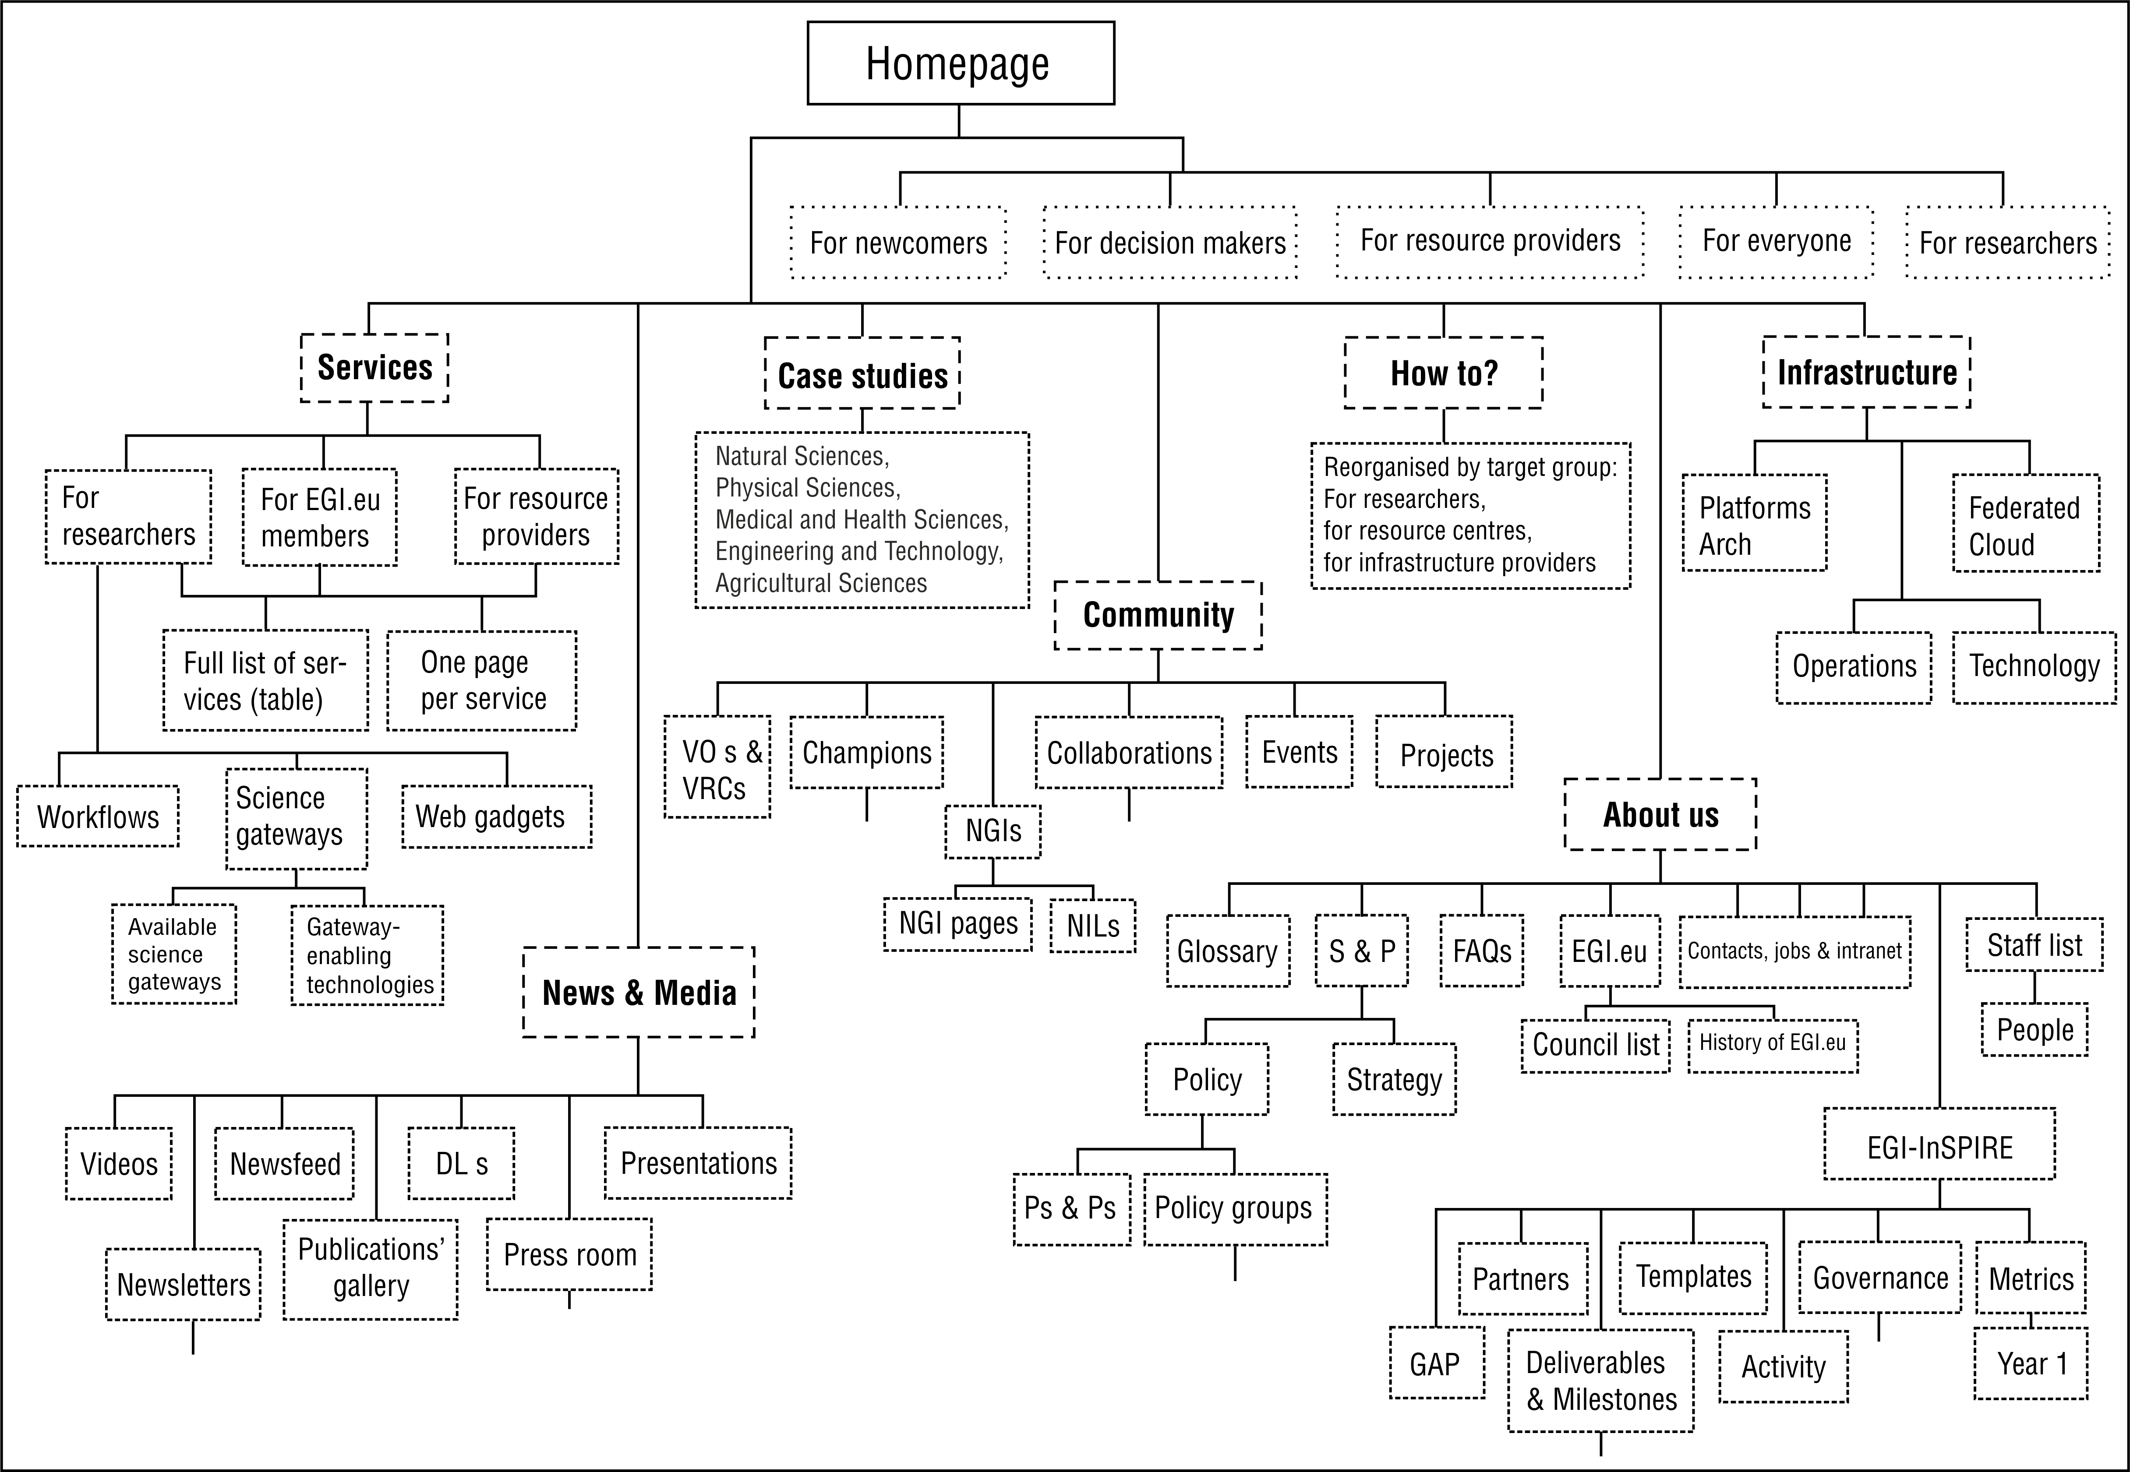

Design

The design of the EGI website has not changed significantly since the new visuals went live on 26 March 2012 and is reported elsewhere.

Between August 2012 and August 2013, some minor updates were implemented:

- New look for the landing pages of the 'Services', 'Community' and 'Case Studies' sections. These pages are now hubs for their respective sections, with further links highlighted by new icons and thumbnails (Fig. 2).

Fig. 2: The 'Community' page highlighting the new look for 'hub' pages with visual thumbnails.
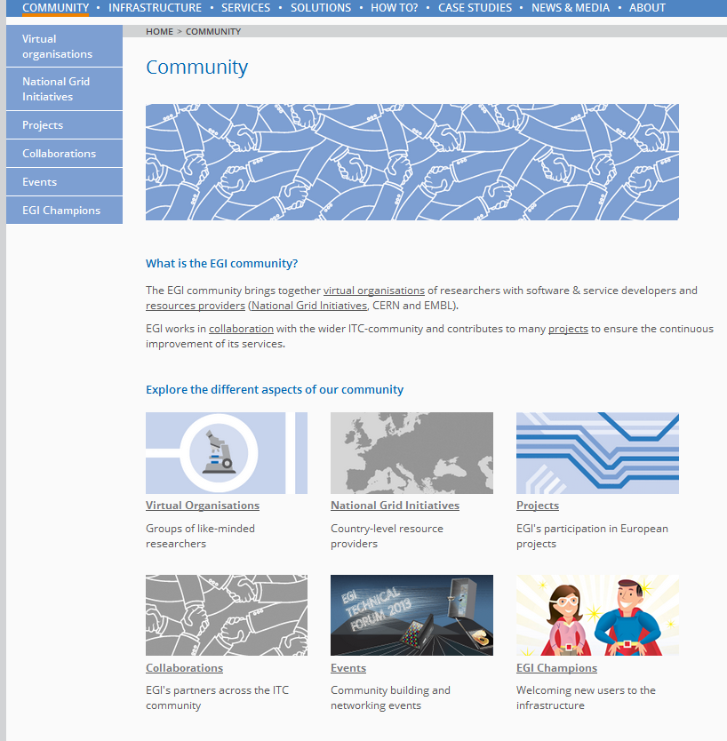

Content

The content of the website has been expanded and updated over the past 12 months. This chapter summarises the recent improvements categorised by section.
The content of the How to section was not significantly changed and the minor updates made in these pages are not reported here.

Community

- The Virtual organisations page was rewritten to reduce word count and simplify information.

- The Projects page (moved from the About section) was expanded with factsheets for every project EGI.eu is counted as a partner. The factsheets (e.g. BioMedBridges) describe the project, its aims and EGI.eu's contribution. Additional information includes: contact points, EU contract number, start & end dates and the project's url.

- The Collaborations page was reorganised by type of collaboration (technology providers, research communities etc.) and an archive was created to store factsheets of completed collaborations.

- The community section was expanded with a new EGI Champions area to highlight one of EGI's flagship outreach schemes. The new section includes:
  - A main page with a high-level introduction to the Champions scheme and brief introductions to the Champions themselves
  - A profile page for each Champion, with short biography, research summary and why grid computing is important to the Champion (e.g. Afonso Duarte, Fig. 3)
  - A page with details about the EGI Champion network.

Fig. 3: An example of the new EGI Champion profile pages.
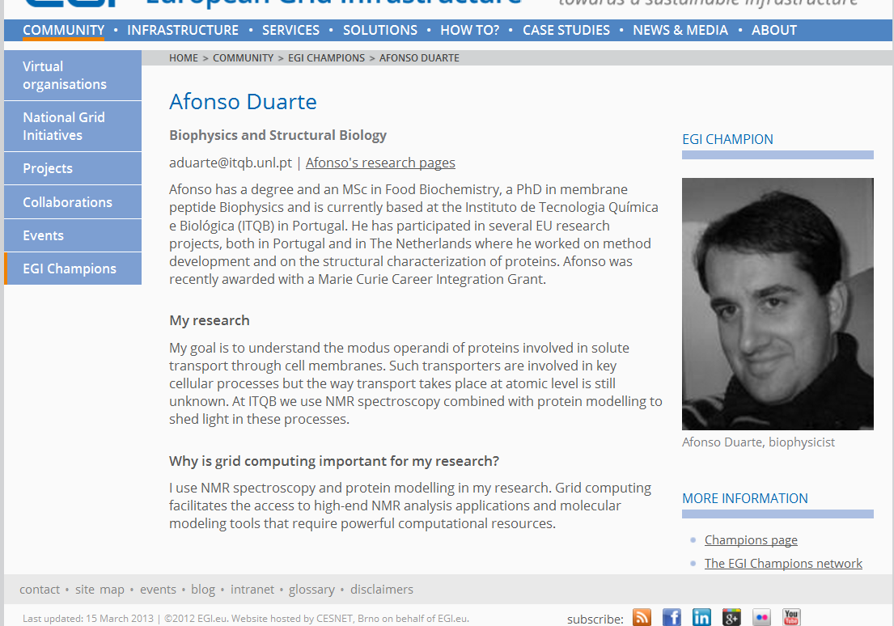

Infrastructure

- The main Infrastructure page was reorganised and simplified, to serve as a hub for the section and to provide a high-level view of the topic.

- The new Federated cloud section (upgraded and expanded from the material previously under technology) was created to raise the profile of the work conducted by the EGI Federated Cloud Task Force over the past 12 months. The main page highlights the main selling points of the EGI Federated Cloud and provides links for further reading: dissemination articles and where to find more information on how to join and how to access.

- The Operations page was reorganised and simplified, to serve as a hub for the section and to provide a high-level view of the topic. The 'Figures and utilisation' page under the Operations umbrella was renamed to EGI in numbers.

- A new Platform architecture page was created to describe the state-of-the-art operational architecture of EGI, reported in the EGI Platform Roadmap.

Services

The Services section has been extensively reorganised and updated with new content, in line with the review of the EGI Service Portfolio reported in the milestone MS123. This task was performed in partnership with the EGI.eu Strategy and Policy team.
The section's restructuring was implemented in a way to present the service offer according to the final consumer, thus improving the site's usability.
As of August 2013, the Services section has the following new subpages and subsections:

- The EGI.eu service catalogue presents a table with an index of the services offered by EGI.eu to EGI.eu participants, resource providers and researchers.
  - Factsheets for each of the services listed on the catalogue. The factsheets (e.g. Specialised consultancy, Fig.4) introduce the added value of the service, the service description, supporting activities, and more information about the service provider and consumer, contact information and service category.

- The Training Marketplace an online database of training materials and events.

- User Support contacts presented in the form of an interactive map.

- Services for researchers aggregates the services from the catalogue that have the research community as a final consumer. The page is also a hub for other services provided by EGI to researchers, but not strictly part of the service catalogue, namely:
  - Science gateways. The content for this page and its daughters was edited for word count.
  - Workflows. The content for this page and its daughters was edited for word count.
    - The EGI workflow applications page was rewritten.
    - The EGI workflow systems page was rewritten
  - Web gadgets. The content for this page and its daughters was edited for word count.

Fig. 4: An example of the new Service factsheet pages.

- Services for EGI.eu participants, aggregates the services provided to the countries represented in the EGI.eu Council.

- Services for resource providers, lists the services provided to the institutions that provide computing services integrated in EGI

Solutions
The new Solutions section introduces the solutions (i.e. a collection of services bundled to answer a specific problem for a specific group) that make up the EGI Solution Portfolio.
The content for this section of the website was developed in partnership with the EGI.eu Strategy and Policy team.
Each solution is presented in its own page (e.g. Federated cloud, Fig.5) with:
- The solution's title;
- A tagline;
- The problem or question the solution is meant to answer;
- The solution's description (EGI offers...);
- The added value (You will get...);
- The list of services used to build the solution.

The EGI Solution Portfolio is a key element in EGI.eu's outreach strategy and to reflect this importance, the homepage slideshow was also updated with two slides featuring the 'Federated cloud' and the 'High-throughput data analysis' solutions.

Fig. 5: An example of the new Solutions factsheet pages.
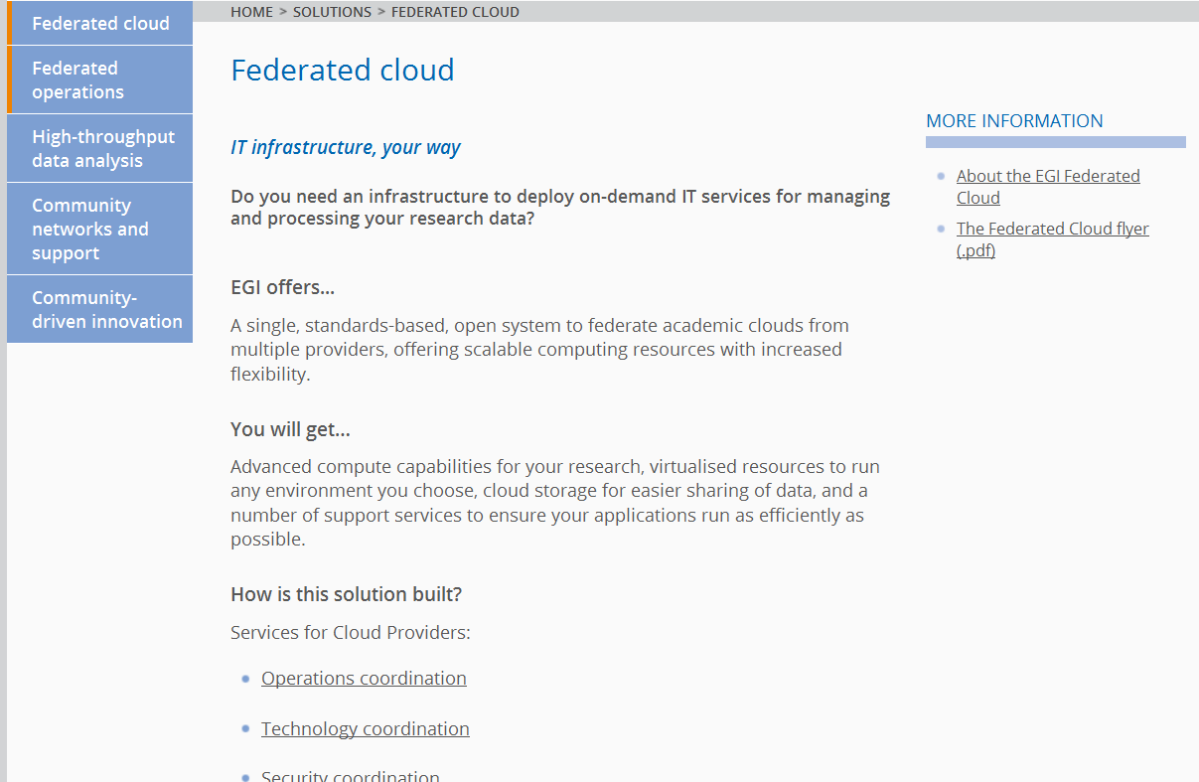

Case studies

- The section has been updated with ten new case studies:
  - Cheaper biodegradable plastics, published 16 August 2012
  - Cracking Goldbach's Conjecture, published 8 October 2012
  - Are comets born in asteroid collisions?, published 17 October 2012
  - Predicting the risk of dam failure, published 5 December 2012
  - Climate change and ozone, published 23 January 2013
  - The mystery of gene regulatory networks, published 22 February 2013
  - How current flows in organic semiconductors, published 14 May 2013
  - Where do African fish parasites come from?, published 7 June 2013
  - New sequencing tests to diagnose hereditary diseases, published 17 July 2013
  - On the double: how high metabolic rates accelerate evolution, published 8 August 2013

As reported in chapter 2, the case study collection was reorganised and each story was assigned to a "Level 1" category as defined by the EGI Scientific Discipline Classification. They are:
- Natural Sciences
- Physical Sciences
- Medical and Health Sciences
- Engineering and Technology
- Agricultural Sciences

News & Media

- The News subsection has been updated with 61 news items about the EGI community. The rate of publication of news items continues to be around 5-6 per month.

- We published four issues of the Newsletter Inspired as PDF and HTML:
  - Summer 2012 (published July 2012)
  - Issue 10 (published January 2013)
  - Issue 11 (published April 2013)
  - Issue 12 (published July 2013)

About

- The About homepage was rewritten to include the mission, vision and core values of the European Grid Infrastructure and defined in EGI's strategy for 2020.

- The Policy section was renamed to Strategy and Policy, and expanded with a new section dedicated to EGI's strategic planning, with a list of key strategic outputs.

Metrics and statistics

Initiatives taken to increase traffic to the website

The EGI website aims to be a hub of reliable and up-to-date information. As part of the ongoing drive to increase the visibility of the website, we have:

- Updated the newsfeed regularly.

- Expanded our collection of case studies. The case studies are republished on the iSGTW website, and on the websites of National Grid Initiatives (e.g. in AEGIS) and local computing centres (e.g. AUTh scientific computing centre).

- The website address is written prominently on all printed brochures, articles and posters to drive traffic to the site. We have produced PDF versions of all printed dissemination materials to make the full range of our publications available to a wider audience. Visitors can read publications onscreen or download a copy to print and read or redistribute.

The website encourages visitors to subscribe to EGI’s social media and feeds (RSS feeds, Facebook, Twitter, LinkedIn, Google+, Flickr and You Tube). The subscribe buttons are embedded in the footer of the website’s templates, making them available on every page of the site. Subscribers (and their followers) are alerted to new content from EGI through their social media accounts, thereby helping to drive further traffic to the EGI website.

Overview of web statistics

The metrics provided in this and the following sections refer to the period between 1 July 2012 and 30 June 2013. When possible, the metrics are compared (in percentage, between straight brackets) to the values reported in the previous website review covering a similar period (1 July 2011-30 June 2012).

- The website received 202,358 visits [+0.4%], with an average of 554 visits per day [+0.4%] and 99,073 unique visitors [+15.9%].
- The website recorded 718,379 pageviews [-9.5%], at an average of 3.6 pages viewed per visit [-9.0%].
- The average time spent on the website was 00:05:22 [-15.3%]

- We confirmed the following trends:
  - Significantly lower number of visitors during weekends;
  - Significantly lower number of visitors during holiday periods (weeks around mid-August and around Christmas/New Year)
  - Significantly higher number of visitors during the Forum’s weeks
- The busiest day of the period was 9 April 2013 (second day of the Community Forum in Manchester) with 1,723 visitors.
- Despite the daily peaks, there is no significant overall trend with the monthly average around 16,862 visits per month [+0.4%].

Fig.6 – Visits and visitors to www.egi.eu
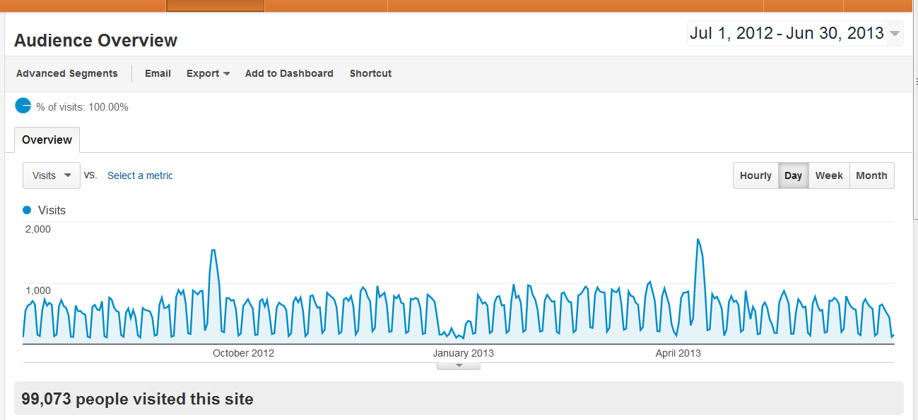

Visitors

Traffic sources

Direct links
Direct links account for 25.2% [-1.9%] of the arrivals at the website. Direct links are typically included in third-party websites and/or publications.
The *egi.eu links most commonly embedded as links elsewhere were:

1 www.egi.eu/index.html 6,518
2 cf2013.egi.eu/index.html 1,125
3 tf2012.egi.eu/index.html 985
4 repository.egi.eu/index.html 883
5 (Indico page for the Technical Forum 2012) 784
6 repository.egi.eu/sw/production/cas/1/current/index.html 720
7 indico.egi.eu/indico/index.html 700
8 www.egi.eu/case-studies/trex.html 652
9 (Indico page for the Community Forum 2013) 629
10 rt.egi.eu/rt/index.html 511

Search engines
46.2% [+12.%] of all visitors arrive at the website via search engines. Google represents about 98% of the total.
The top keywords recorded for the period are:
- egi
- egi technical forum 2012
- egi tf 2012
- egi.eu
- goldbach conjecture
- virtual organization
- virtual organisation
- egi community forum 2013
- egi community forum

Referrals
Referring sites account for 27.7% [-14.2%] of the traffic to our website. The top 10 referrals come from:

# | Referring website | 1 July 2012 –  30 June 2013 | 1 July 2011 –  30 June 2012 | Difference (%)
1 | wiki.egi.eu | 14,521 | 18,358 | -20.9
2 | egi.eu | 3,959 | 5,300 | -25.3
3 | t.co | 1,555 | 1,071 | +45.2
4 | twiki.cern.ch | 1,548 | 1,933 | -19.9
5 | mail.google.com | 1,534 | 2,125 | -27.8
6 | repository.egi.eu | 1,465 | 1,575 | -7.0
7 | ggus.eu | 1,463 | 1,679 | -12.9
8 | facebook.com | 1,458 | 964 | +51.2
9 | indico.egi.eu | 994 | no data
10 | login.cern.ch | 847 | no data

The most significant increase is in the traffic arriving from Facebook (+51.2%).

It is worth mentioning two sites that lay outside the top 10 but are important sources of traffic:
- The English-language wikipedia accounts for 657 visits, up 89% from an equal period last year. Given the popularity of wikipedia as a source of information, the increase is very encouraging.
- International Science Grid This Week (iSGTW), an online weekly magazine focused on e-Science, directed 573 visitors to the EGI website, up 25.1% since the last report.

Country of origin

Visitors to the EGI website come from all over the world, with very few countries registering 0 visits (Fig.7).
The majority of the visits come from Europe and the United States of America, with the United Kingdom, the Netherlands and Italy at the top spots (see table below).
The relative increase of visitors from the United Kingdom and the Czech Republic (+32.0% and +98.6%, respectively) are probably related to the Community Forum 2013 and the Technical Forum 2012 held in Manchester and Prague respectively. This observation mirrors the decrease in visitors from Germany and France, host countries of the previous year's events.

Fig.7 – The EGI world according to Google Analytics
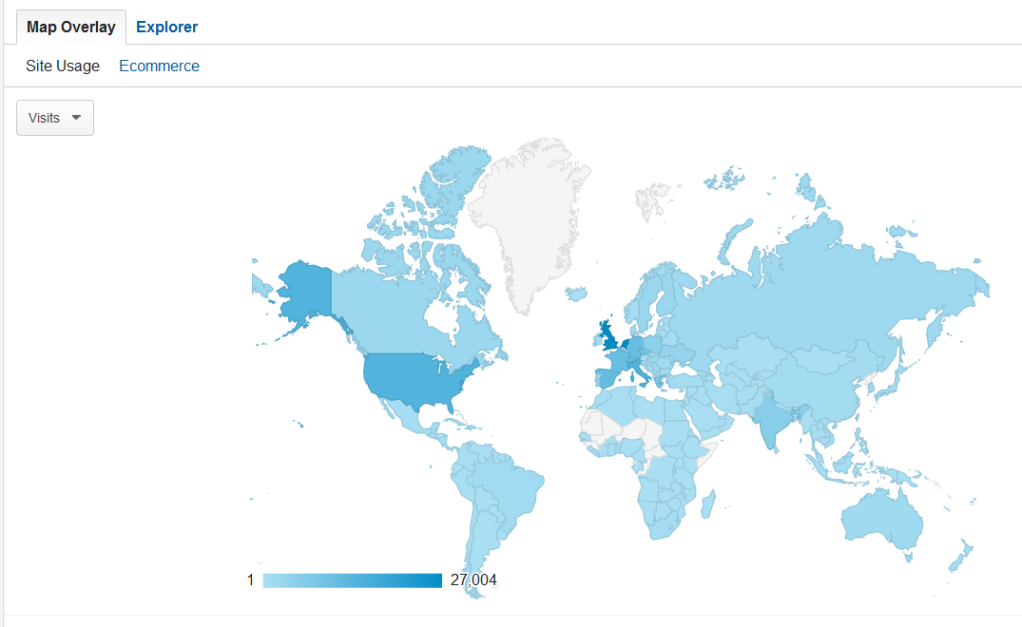

# | Country of origin | 1 July 2012 –  30 June 2013 | 1 July 2011 –  30 June 2012 | Difference (%)
1 | United Kingdom | 25,580 | 19,375 | +32.0
2 | Netherlands | 24,921 | 26,163 | -4.7
3 | Italy | 13,824 | 16,515 | -16.3
4 | United States | 13,587 | 9,985 | +36.1
5 | Spain | 10,534 | 12,503 | -15.7
6 | Germany | 10,223 | 16,435 | -37.8
7 | France | 9,853 | 14,748 | -33.2
8 | Switzerland | 8,200 | 9,148 | -10.4
9 | Czech Republic | 8,142 | 4,099 | +98.6
10 | Greece | 7,561 | 6,180 | +22.3

Content

Excluding the EGI domains in Indico (events website), the forums' websites, the EGI wiki and other areas that share the *.egi.eu domain, the most popular sections of the website (www.egi.eu) were, as a function of ‘page views’:
- About (44,077)
- News and media (23,546)
- Community (16,353)
- Case studies (13,203)
- Infrastructure (10,221)

NOTE: Given that the website was restructured in March 2012 (two thirds along the way of the period considered for the metrics collected in the previous report), it’s difficult to find values to make appropriate comparisons. This is because many pages were moved during the 2012 restructuring and Google Analytics does not take this into account.

CONclusion

The EGI website (www.egi.eu) has been improved during EGI-InSPIRE’s third year and the quality and quantity of the information published in the various new and updated sections has been enhanced. The frequency of updates to news and the dynamic elements of the website has been increased and maintained at the higher-level throughout the review period.

The metrics of the website reveal a steady number of visitors and pageviews. Traffic arriving at the website from social media has increased.

The EGI wiki (https://wiki.egi.eu/wiki/Main_Page) is aimed specifically at the EGI-InSPIRE community and focuses on the practical information required to run the infrastructure.
https://documents.egi.eu/document/126
"Review of the EGI website" (MS231, https://documents.egi.eu/document/1259)
http://www.egi.eu/infrastructure/cloud/
http://www.egi.eu/community/projects/
http://www.egi.eu/community/ngis/
"Review of the EGI website" (MS231, https://documents.egi.eu/document/1259)
http://www.egi.eu/services/
http://www.egi.eu/community/
http://www.egi.eu/case-studies/
http://www.egi.eu/community/vos/
http://www.egi.eu/community/projects/
http://www.egi.eu/community/projects/BioMedBridges.html
http://www.egi.eu/community/collaborations/
http://www.egi.eu/community/egi_champions/
http://www.egi.eu/community/egi_champions/Afonso_Duarte.html
http://www.egi.eu/community/egi_champions/champions_network.html
http://www.egi.eu/infrastructure/
http://www.egi.eu/infrastructure/cloud/
http://www.egi.eu/infrastructure/operations/
http://www.egi.eu/infrastructure/operations/egi_in_numbers/
"EGI Platform Roadmap" (MS514, https://documents.egi.eu/document/1624)
http://www.egi.eu/services/
"EGI Global Task Review" (MS123, https://documents.egi.eu/document/1566)
http://www.egi.eu/services/catalogue/
http://www.egi.eu/services/catalogue/spec-consultancy.html
http://www.egi.eu/services/training_marketplace/index.html
http://www.egi.eu/services/support_contacts/index.html
http://www.egi.eu/services/researchers/index.html
http://www.egi.eu/services/researchers/science-gateways/index.html
http://www.egi.eu/services/researchers/workflows/index.html
http://www.egi.eu/services/gadgets/index.html
http://www.egi.eu/services/egi-eu/index.html
http://www.egi.eu/services/rps/
http://www.egi.eu/solutions/
http://www.egi.eu/solutions/fed-cloud/
http://www.egi.eu/case-studies/eng_tech/PLA.html
http://www.egi.eu/case-studies/natural-sciences/Goldbachs_conjecture.html
http://www.egi.eu/case-studies/physical-sciences/main-belt_comets.html
http://www.egi.eu/case-studies/eng_tech/dam_risk_analysis.html
http://www.egi.eu/case-studies/physical-sciences/ozone.html
http://www.egi.eu/case-studies/medical/grn.html
http://www.egi.eu/case-studies/eng_tech/semiconductor.html
http://www.egi.eu/case-studies/natural-sciences/parasites.html
http://www.egi.eu/case-studies/medical/ngs.html
http://www.egi.eu/case-studies/natural-sciences/evol_metabolism.html
Final report of the VT "Scientific Discipline Classification" (https://documents.egi.eu/document/1514)
http://www.egi.eu/news-and-media/newsfeed/
http://www.egi.eu/news-and-media/newsletters/Inspired_Summer_2012/index.html
http://www.egi.eu/news-and-media/newsletters/Inspired_Issue_10/index.html
http://www.egi.eu/news-and-media/newsletters/Inspired_Issue_11/index.html
http://www.egi.eu/news-and-media/newsletters/Inspired_Issue_12/index.html
http://www.egi.eu/about/
"Seeking new horizons: EGI's role in 2020" (http://go.egi.eu/EGI2020)
http://www.egi.eu/about/policy/
http://www.egi.eu/about/policy/strat-planning.html
http://www.aegis.rs/news/368
http://www.grid.auth.gr/en/posts/2013/01/24/climate-change-and-ozone/
"Review of the EGI website" (MS231, https://documents.egi.eu/document/1259)
The Goldbach Conjecture is a centuries-old mathematical problem featured in an EGI case study published in October 2012 (http://www.egi.eu/case-studies/natural-sciences/Goldbachs_conjecture.html)
http://www.isgtw.org

