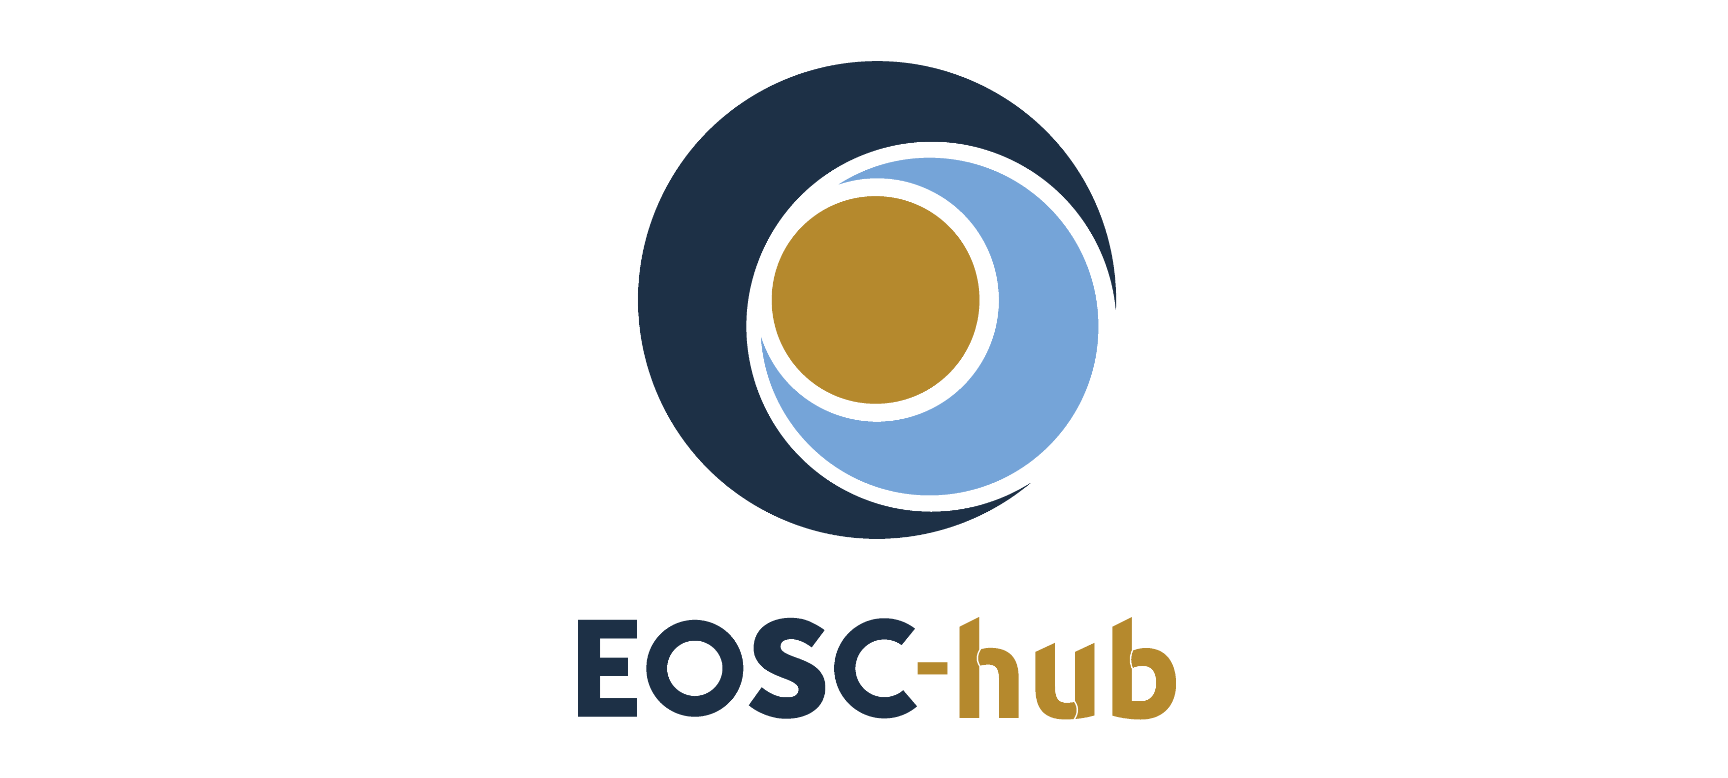

D3.3 Interim report on dissemination and exploitation of project results
Lead Partner: | EGI Foundation
Version: | 1
Status: | Approved by EC
Dissemination Level: | Public
Document Link: | https://documents.egi.eu/document/3496

Deliverable Abstract
This document provides an update to the key exploitable results including aspects such as the definition, value proposition, IP management, exploitation path and dissemination activities and adoption.
The specific focus of this will be on the following areas:
- Introducing additional key exploitable results identified during the first 18 project months and the conceptual framework linking them together
- Introducing the prioritisation framework that is used to focus in-depth analysis of the exploitation paths and actions intended to encourage uptake of the results
- Presenting the evolution of the understanding of the methods to capture and assess value propositions related to individual exploitable results
COPYRIGHT NOTICE
This work by Parties of the EOSC-hub Consortium is licensed under a Creative Commons Attribution 4.0 International License (http://creativecommons.org/licenses/by/4.0/). The EOSC-hub project is co-funded by the European Union Horizon 2020 programme under grant number 777536.
DELIVERY SLIP
 | Name | Partner/Activity | Date
From: | O. Appleton, M. Heikkurinen | EGI Foundation/WP3 | 30/08/2019
Moderated by: | M. Krakowian | EGI Foudation/WP1
Reviewed by | T. Ferrari  P. Oster | EGI Foundation/WP1  CSC/PMB | 23/08/2019
Approved by: | AMB

DOCUMENT LOG
Issue | Date | Comment | Author
V.0.1 | 01/07/2019 | Initial Structure | M. Heikkurinen
V.0.2 | 15/07/2019 | Content outline, feedback from WP leaders and other experts | M. Heikkurinen,  G. La Rocca, G. Sipos, S. Garavelli, O. Appleton,  S. Holsinger, T. Ferrari,  S. Andreozzi
V.0.9 | 14/08/2019 | External review version | M. Heikkurinen,  D. Scardaci, D. Testi, M. van den Sanden, M. Plociennik, T. Kupila-Rantala
V1.0 | 30/08/2019 | Final version | M. Heikkurinen,  O. Appleton, S. Andreozzi, D. Scardaci

TERMINOLOGY
https://wiki.eosc-hub.eu/display/EOSC/EOSC-hub+Glossary
Terminology/Acronym | Definition

Contents
1 Introduction 7
2 Key results and their exploitation 9
2.1 Goals of innovation and exploitation 9
2.2 Key Exploitable Result overview 10
2.3 Exploitation Roles 11
2.4 KERs and role interaction 12
3 Context and general approach 15
3.1 EOSC-hub Innovation Landscape 15
3.2 Planned vs Fortuitous Innovation 17
3.3 Approaches to IPR management 18
3.4 Evolution of Procedures 22
3.5 Dissemination aspects of innovation management 23
4 Stakeholder roles in detail 24
4.1 Enterprise 24
4.2 Researchers and research communities 25
4.3 Service providers 26
4.4 EOSC Hub operators 27
4.5 Other: education and support for eScience activities 27
5 Key Exploitable Results (KERs) in detail 29
5.1 EOSC Marketplace and EOSC-hub contribution to the EOSC Portal 29
5.2 Service Management System 31
5.3 External Services for research in the EOSC Service Portfolio 33
5.4 Internal Services provided in the Hub Portfolio 35
5.5 Digital Innovation Hub: Platform for industrial collaborations with EOSC 36
5.6 Business and sustainability models for services and the Hub 38
5.7 Rules of Participation 40
5.8 Integration and interoperability guidelines 41
5.9 Training courses and material 43
6 Individual project results (PRs) 46
6.1 The mid-project prioritisation approach 46
Examples of the High Priority results 47
6.1.1 Training programme for first project year 47
6.1.2 EOSC Digital Innovation Hub - engagement process 48
6.1.3 Voucher system 48
6.1.4 Marketplace 49
6.1.5 Earth Datacube 50
6.1.6 Data Policy Recommendations 50
6.1.7 AGORA/SPMT 51
6.1.8 PROC07 Allocating financial support for trainers to attend f2f events 52
7 Conclusions and Outlook 53
Annex 1 Catalogue of Project Results 54
High Priority results 54
Requirements and gap analysis 54
Improved portals for EO: Datacube 54
Technical roadmap 55
Common Services - Deployment, maintenance and evolution/enhancement 56
Rules of engagement 57
EOSC-hub strategy plan 58
EOSC-hub Website and Knowledge Hub 58
EOSC-hub Brand 59
HADDOCK 60
Common Service Integration Activities 60
Medium Priority results 61
Bot Mitigation Engine 61
Monitoring and Accounting probes 62
CLARIN Framework 62
Data transfer across EGI, EUDAT and INDIGO 63
Fusion/ITER: Platform data storage and simulation & modelling 63
European Integrated Data Archive framework (EIDA) for seismological data and services 64
ELIXIR dataset distribution service and tools 65
EISCAT_3D incoherent scatter radar framework 65
Low Priority results 66
Technical architecture and standards roadmap 66
Procurement requirement, demand assessment and recommendations 66
Business models for acquiring EOSC services 66
Furniture Enterprise Analytics - DataFurn platform 67
Space Weather Data Services for the future DRACO Observatory 67
Sports Smart Video Analysis 67
CyberHAB (Water body management framework) 67
Ops Support 68
Monitoring 69
EOSC-hub Service Roadmap 69
EOSC-hub Governance and Sustainability Implementation Roadmap 69

Executive summary
As we move into the second period of the project, we review the approach to innovation management and exploitation used by EOSC-Hub. This includes a review of the Key Exploitable results and a new approach to ‘triage’ of the many individual results to focus resources on those that can benefit most from them.
In revisiting the Key Exploitable Results, we also identify a number of roles to consider in exploitation and innovation management, based on which roles would be likely to take up the KERs describes, and benefit from them. These roles differ slightly from those proposed by EOSC-pilot, combining several, and adding one addition role, the EOSC Hub operator. These roles are:
- Researchers and Research Communities
- Service Providers
- EOSC Hub operators
- Enterprise
- Education and support (role)
These then interact with the updated list of KERs, which have been updated to give a better idea of the range of activities which EOSC-hub performs, which will be valuable to other groups, and which are all aimed at supporting the development of a mature EOSC, directly or indirectly. The updated KERs are:
- EOSC Portal and Marketplace
- Service Management System
- External Services in the EOSC Service Portfolio
- Internal Services in the Hub Portfolio
- Digital Innovation Hub: Platform for industrial collaborations with EOSC
- Business and sustainability models for services and the Hub
- Rules of Participation
- Interoperability and Integration guidelines
- Training courses and material
Supporting these outputs, we also consider how they can be protected through IPR management. Here, we deal with a complex topic, as collaborative academic projects can have difficult interactions with normal IPR protection methods. However, as we do not work in a commercial environment, where profit maximisation is the core task, we have other options open to us. Our goal is to ensure that the outputs of EOSC-hub are available to a mature EOSC, rather than to assert ownership to profit from them. Hence, a strategy based on licencing as a ‘shortcut’ for ownership issue, combines with a careful look at where more traditional IPR mechanism can be used, should lead to the desired result.
This document presents a ‘mid project review’ of the situation, based on the many changes experiences since the project was planned (including the addition of the EOSC portal concept, early in the project). A final version at the conclusion of the project will present the final status of the project exploitable results, and how they have been prepared for transfer or use by other groups after the project concludes.

Introduction
The purpose of this deliverable is to provide an overview of the innovation management activities during the first 18 project months. In addition to presenting the Key Exploitable Results (KERs), initially described in the deliverable D3.2, the document provides an overview of how the overall exploitation landscape has evolved during the project’s activities and how project’s innovation management activities can help the project to maximise its impact and contributions to the emerging EOSC ecosystem.
Innovation management is one of the key enabling activities which maximise the impact of the different project activities. It lays the foundations for efficient, coherent and focused dissemination activities. The EOSC-hub DoA defined the goals of the innovation management activity as follows:
“1) rights to access and use of background and side ground are identified; 2) the project results are captured, assessed and protected; 3) appropriate dissemination, exploitation and communication measures are agreed as well as developing interim and final dissemination and exploitation plans.”
These three activity streams provide a solid foundation for the take-up of the project results by the different follow-up activities as well as interested third parties. At the same time, supporting a broader range of exploitation activities requires complementing the above “product-oriented” view of innovation with analysis of the role intangible innovation assets generated by the project. The tangible, IPR-protected assets can also act as proxies that represent the broader set of skills and reputation of the project. This proxy role applies both to the traditional brand-related items (e.g. trademarks), but equally to the documents and software produced by the project.
This view aligns well with the project’s exploitation goal of securing continued EOSC service provision by the follow-up activities. In this context, ensuring reliable and efficient service delivery and making sure that its overall value is understood by the key stakeholders go hand in hand. Innovation management touches on both of these aspects, by ensuring that the IPR-related issues do not cause service disruptions and that the project’s dissemination activities have material that can be used to illustrate value provided by the project to all of its stakeholder groups.
On a more concrete level, this update includes a discussion of the rationale behind the updated Key Exploitable Results, also covering the evolution of the value proposition for the intended target audiences of the KERs. As part of the motive, this deliverable complements the analysis presented in the deliverable D3.2 by analysing the role of innovation management also beyond the formally defined and protected IPR domain. In short, the value provided by a project such as EOSC-hub and its exploitation and sustainability potential are not entirely determined by the project results that can be captured and protected by the formal IPR mechanisms.
Another conceptual level update is the recognition that considering KERs solely as aggregations of individual project results runs a risk of missing some of the value provided by the project. For example, the “Business and Sustainability models” KER could equally well be seen as an individual project result. However, this would run the risk of downplaying the fact that the KER distils the analysis and knowledge from a vast range of project activities. Even when the KER links and collects results from several sources, seeing KERs primarily as an aggregation of project results is problematic. For example, the “Training Courses and Material” KER involves curation of the material and additional quality assurance that requires in-depth knowledge about all the available content.
For the above reasons, the innovation landscape surrounding the analysis of the project results is discussed in some detail. For example, the deliverable includes a relatively in-depth analysis of the overall innovation and exploitation landscape of the project.
The document opens with an introduction to the updated KERs and the roles they interact with in section 2. Section three provides contact and the general approach to exploitation, innovation and IPR management. Sections 4 and 5 then go into detail on the roles and KERs one by one. Section 6 then discusses the individual project results, prioritisation strategy and gives some information on high priority results, before the outlook and conclusions in section 7. Finally, the appendix gives more information on individual results.

Key results and their exploitation

Goals of innovation and exploitation
EOSC-hub is an attempt to create an initial version of the structures imagined for a future mature European Open Science Cloud. As such, the main concern for exploitation is that all outputs of EOSC-hub can flow into EOSC and the other communities which make up the future EOSC-Hub as we move forward, and our entire approach to exploitation, dissemination, IPR and innovation must service this.
This is summarised, in a very broad way in the following diagram, figure 1.
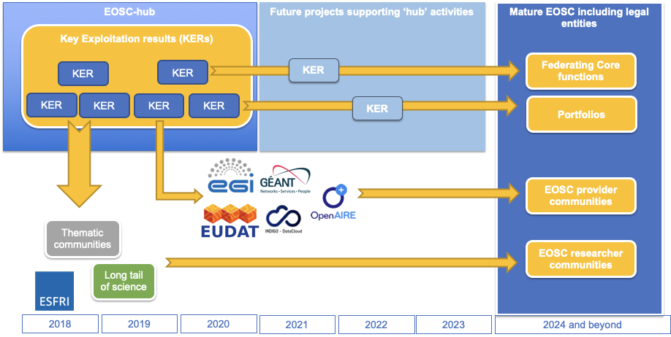
Figure 1. KERs and their exploitation paths
Here we consider just the Key Exploitable Results (KERs) of EOSC-Hub, rather than the much broader and more diverse set of individual projects results. These results contribute to the KERs, but also include much smaller, more specific or specialised outputs that are often relatively independent of the EOSC context. This simplified view only considers some groups and audiences but helps orientate our approach to innovation and exploitation.
As can be seen, the intention is that all KERs feed into a mature EOSC. Some KERs, those related to operating an ‘EOSC Hub’ are intended to be taken up as elements for or input to successor projects to EOSC-hub, and then ultimately folded into the Federating Core of a mature EOSC. Others are to be taken up by provider communities such as EGI, EUDAT and Indigo Datacloud, as well as other major e-Infrastructure provider groups such as GEANT and OpenAIRE among others. These then will become providers in the EOSC ecosystem. A third set would be exploited by research communities including ESFRIs, the long tail of science and thematic communities, who go on to be the researcher communities in a mature EOSC. In this way, whether directly or indirectly, the results of EOSC-hub should be exploited and exploitable by the future and mature EOSC. Other exploitation pathways are desirable and positive, but are secondary to this mail thrust of our work.
This overview also clarifies that it is the KERs which feed into EOSC for which not only must they be well understood, but also disseminated, exploitable, and with IPR risks identified and treated.

Key Exploitable Result overview
The Key Exploitation Results (KERs) are spelled out in much more detail in Section 5, but are summarised here.
Table 1: Summary of the Key Exploitable Results of the project
Key exploitable results | Main or example content
EOSC Portal and Marketplace | Website at www.eosc-portal.eu and catalogues hosted there. Software in repository at https://github.com/cyfronet-fid/marketplace
Service Management System (SMS) | Confidential wiki space at https://wiki.eosc-hub.eu/display/EOSC/EOSC+hub+SMS containing policies, process descriptions, procedures, roles, documents and records related to the SMS
External Services in the EOSC Service Portfolio | Services listed at https://marketplace.eosc-portal.eu/ (pending future migration to single shared catalogue/marketplace under EOSC Enhance project)
Internal Services in the Hub Portfolio | Internal services listed within EOSC-hub service portfolio in Service Management System and at https://www.eosc-hub.eu/support-services
Digital Innovation Hub: Platform for Industrial collaborations with EOSC | Multiple business pilots creating new services. Overview of work at www.eosc-dih.eu.
Business and sustainability models for services and the Hub | Deliverable D12.1 “Procurement requirements and demand assessment”, Briefing Paper - EOSC Federating Core Governance and Sustainability
Rules of Participation | Part of content at https://wiki.eosc-hub.eu/display/EOSC/Service+Provider+Documentation
Interoperability and Integration guidelines | D10.4 EOSC Hub Technical Architecture and standards roadmap
Training courses and material | Material listed on project website at https://www.eosc-hub.eu/training-material
Key Exploitable Results (KERs) represent results that have potential for supporting radical, fundamental innovation and specifically in EOSC-hub that have a major role in the implementation of the European Open Science Cloud. In addition to providing quantitative or incremental benefits, optimal adoption can bring qualitative improvements to the way organisations provide services to their key stakeholders.

Exploitation Roles
The updated KER structure is based on five community roles that are especially relevant for the take-up and exploitation of the identified KERs. These are:
Table 2: Exploitation roles used to assess the value proposition of the KERs
EOSC Exploitation Role | Proposed definition
Researchers and Research Communities | Performing or organising research (scientific or otherwise) in the context of EOSC. Consuming research services and benefiting from research data. Can include academic, public sector, profit and non-profit research.
Service providers | Providing services which support researchers and research communities. Includes IT, Human and other services. Can include academic, public sector, profit and non-profit services.
EOSC Hub Operators | Operating a ‘Hub’ function for some level of EOSC structure, whether it is a central ‘Hub’ (i.e. the Federating Core of EOSC), a regional or thematic Hub. Involves some combination of, listing, exposing, federating or integrating a number of Service providers in support of Researchers and research Communities. Typically acts in support of agendas set by national or European policy makers.
Enterprise | Acting to further their corporate goals, typically growth and maximisation of profit by interacting with EOSC.
Education and support for eScience activities | A cross-cutting role that can be taken by those taking on other roles, when they are providing education and training of members of the border EOSC community in any capacity.

These roles could be seen as a simplification of the model developed by the EOSC-Pilot in the Governance Framework context. For example, when assessing the methods for participation in EOSC governance, the size and level of organisation of a research group are highly important. However, when assessing the value provided by a service accessible through EOSC-hub, it is possible to merge researchers and research communities together. Another simplification is related to strategic decision-makers: engaging with them is critical for the governance and overall sustainability of the whole EOSC. However, they are not stakeholders that would be in a position to adopt a specific project result. On the other hand, the EOSC-Pilot stakeholder model didn’t discuss the role of a hub that would support information exchange, service discovery or delivery monitoring between the different EOSC stakeholders. Based on the EOSC-hub experiences, this is a role that is distinct from a service provider delivering specific, well-defined services through an aggregator or a hub.
For each of these roles, the deliverable generates a characterisation of a typical organisation and the key aspects of the growth and sustainability models. These characterisations support more efficient analysis of the KER value propositions for each of the key stakeholder groups. However, it should be noted that the innovation management model doesn’t assume the mapping presented is exhaustive. There may be organisations that do not fall clearly into any of the above roles that nevertheless find KERs or their components useful and valuable. Similarly, an organisation may play multiple roles at the same time: for example, example a company may provide services against payment (in the Enterprise role) while at the same time providing free, community services as a service provider (e.g. as part of a “freemium” business model). It is also likely that most of the stakeholders that are engaged with EOSC will need to engage in educational and support activities as part of the service provision or research activities.

KERs and role interaction
The KERs identified so far and their key target communities are summarised in the following diagram:
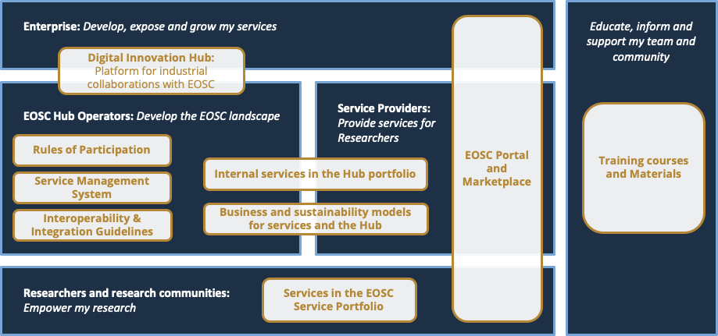
Figure 2. KERs and their key targets
As can be seen in the diagram, there are three KERs that are primarily of interest for building the future EOSC service hub:
- Rules of Participation
- Service Management System
- Interoperability & Integration guidelines
The common aspect of these three is that to fully exploit them, the organisation needs to be engaged in federation of services. However, they naturally provide added value to both users and providers of the services that are accessible through EOSC by ensuring quality of service components and by streamlining the integration of the components.

There are three KERs that contain best practices and tools for linking services to the hub:
- Digital Innovation Hub
- Internal services in the Hub portfolio
- Business and Sustainability models for services and the Hub
The first provides a clear interface for commercial innovation that can be supported by EOSC as part of the broader European Digital Innovation Hub landscape. The Business and Sustainability models are crucial for long-term planning of EOSC and for ensuring the trust of users and user communities on the continued delivery of services. Finally, the Internal Services provide common interfaces to shared tools for basic services such as access control or accounting that need to be aligned in order to provide consistent user experiences.
The three remaining services:
- Services in the EOSC Service Portfolio
- EOSC Portal and Marketplace
- Training courses and Materials
All have the nature of being relatively universal in their potential applications outside the project context. The services in the EOSC Service Portfolio each have their individual application areas and sustainability models. Their integration in the EOSC context can primarily be seen as an additional quality assessment and marketing channel. The training courses and material are similarly applicable on broad range of context that benefits from exposure and quality assessment through EOSC. Finally, the EOSC Portal and Marketplace represents a collection of tools that can be deployed by different communities in addition to EOSC.

In addition to KERs, this deliverable presents a model for tracking and assessing individual project results (prioritisation model). A summary of the project results currently under assessment is presented in Annex 1, preceded by a brief analysis of the lessons learned and approaches to innovation management at the end of the project in Chapter 5.

Context and general approach
The “project results” covered by the innovation management covers – in principle – any output of the project. The results may be tangible or intangible, as presented in the formal definition used by the project:
“Any tangible or intangible output of the project, such as data, knowledge or information, that is generated in the project, whatever its form or nature, whether or not it can be protected, as well as any rights attached to it, including intellectual property rights.”
Naturally, some level of filtering and prioritisation is necessary to keep the number of project results to capture and curate on the manageable level. The previous WP3 deliverables - D3.1 “EOSC-hub Communication & Stakeholder Engagement Plan” and D3.2 “Innovation management plan (PU)” - provided detailed analysis of the project’s target audiences and established the necessary procedures to initiate the innovation management as a concrete activity.
The first 18 project months have identified the following areas of emphasis that further increase the efficiency of the support innovation management can offer to the exploitation activities:
- Grouping and linking innovations based on their target audiences to focus dissemination and exploitation support activities
- Supporting the analysis of potential new markets for the project results and the proximity of the planned and fortuitous innovations to them
- Ensuring that the IPR issues are managed in a consistent manner
While these three goals are quite similar to the list in the DoA, they complement the approach that focuses on the individual - primarily planned - innovation and its path to market presented in the DoA and the deliverable D3.2.

EOSC-hub Innovation Landscape
The innovation activities of the project are grounded on the Vision and Mission statements of the project. The key aspect of both is that the vision is primarily reliant on successful service integration, provision and support, rather than development of new technologies. To successfully mobilise the different service providers to offer their resources through the Hub provided by the project, the project needs to provide an attractive interface that increases the visibility of the services among the target audiences of the service providers.
Paradoxically, the role of robust technological foundations is perhaps even more important in a service-oriented project than in a one that is primarily developing new technologies. In practice, successful operation of the hub requires that the underlying key software-based services are mature (e.g. operate at TRL8- 9). As the user requirements and the services used to meet them evolve, simultaneously meeting the flexibility and stability requirements is a considerable challenge requiring specialised skills and procedural approaches. The individual technical components and the supporting material that can be protected using the formal IPR methods are valuable in themselves, but the scope of the innovation of the project is considerably broader. Figure 3 presents a conceptual model illustrating the relationships and interdependencies of the tangible and intangible innovation assets of the project. It should be noted that practically all the project KERs contain both tangible and intangible aspects of innovation.
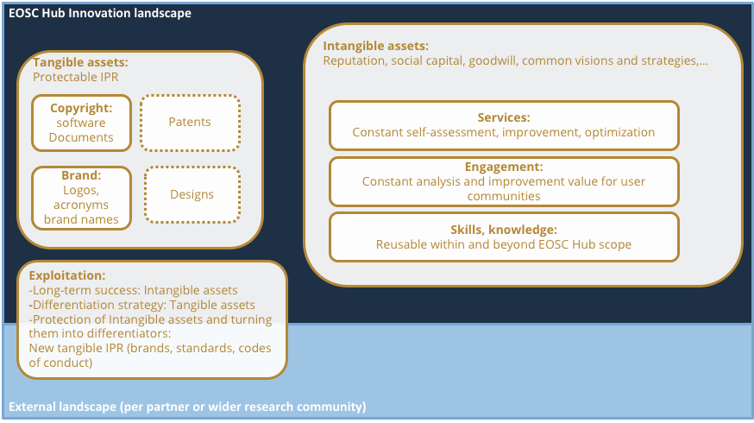
Figure 3. Types of innovation assets considered by the project
The multifaceted nature of innovation has also been taken into account in the categorisation of the project results. The table below presents the initial model used to capture project results and the refined one used in this deliverable:
Table 3: Initial and current project result classification
Initial project result categorisation | Current result categorisation
Software and services: improved components for integrated service hub; | Software
 | Services
Technical specifications for an open ecosystem; | Technical specifications
Policies and procedures for service management, FAIR data management and security; | Policies and procedures
Documents and reports: scientific publications, technical and service roadmaps, training material; | Documents and reports
Business models: new organisational principles to offer services for research sustainably | Business models
Other | Skills
 | Brands
 | Other

The change of terminology in the overlapping categories is a matter of convenience and conciseness. The initial version included material better suited to a help text directly in the name of the category. The semantically important changes are more clear separation of software and services, since the exploitation paths are typically quite different from each other. The preparation of capture of skills and brands as a clearly identifiable project results is result of the analysis presented in the Figure 4. It should be noted that these categories are not mutually exclusive; for example, even if a specific subset of skills becomes a brand and an associated training programme, they cannot fully capture the full set of skills and knowledge (including tacit knowledge) that have acted as their foundations.

Planned vs Fortuitous Innovation
The basic requirement of the innovation management system is the ability to support the exploitation of the project results in their intended application domains. This subset of innovations has certain aspects that help to formalise management processes:
- The innovation management can be tied to the specific stages of the anticipated project deliverables and developers have allocated resources for innovation tasks such as IPR management
- The specification of project deliverables typically already includes a quite extensive analysis of the problem they aim to solve and markets for the solutions
- The dissemination and engagement activities can draw on this background - e.g. it is possible to identify the quantitative improvements that would be most relevant to the target audience.
However, in many cases, the background of innovation success stories differs from the linear model of anticipated results. They may result in applying existing solutions in a novel context or linking the specific innovation with others to form an aggregated result that somehow is more than the sum of its parts. And in many cases, the success is based on the ability to launch a product or service that addresses an unarticulated need of the target audience. For this reason, innovation management should capture a broad range of project results (as discussed above) and keep in mind that project results can have uses that are not anticipated in the design phase and that can serve as sources for complementary sustainability models. In summary, no single pathway or approach to capturing potential innovation is sufficient to cover all cases, and structured mechanisms must be accompanied by opportunistic capture from other means. In practice this means strengthening the links between the service management (especially onboarding processes), user community support and training activities, and use these contacts as “antennas” to capture potential unintended innovations. These approaches are discussed in some more detail in Chapter 7.

Approaches to IPR management
As noted in chapter 3, the main exploitation goal of the project is that the project’s output can contribute to the future mature EOSC. As one of the prerequisites for this goal, the project needs to minimise the IPR-related risks of the EOSC-hub KERs for the future EOSC service provision. Thus, the mission statement of the IPR management could be stated as:
“The primary goal of the IPR management is to minimise the risk of IP-related service disruptions for the EOSC-hub project and future long-term structures under EOSC Governance which would operate a hub.”
Executing this mission is based on reviewing the high-priority project results carefully in terms of obligations arising from the background and foreground IPR. The impact on exploitation potential of different licensing approaches of the results needs to be kept in mind, but the primary concern is ensuring the licenses allow future use in the context defined above. Understanding issues related to ownership of the IP, including keeping track of the contributions made to the project outputs, is important in case the project results would be re-licensed under another license. However, allocating resources to such in-depth scrutiny needs to be carefully considered and justified on case-by-case basis, since the project’s sustainability model is based on service provision instead of anticipated income from licensing fees. This is unlike a more commercial context where maximising future profit would be the goal, here it is maximising easy and efficient operation of the future mature EOSC.
The goal of the brand protection is similar: ensure that EOSC service provision is not disrupted in the future due to challenges related to trademarks. During the first project period, the potential trademark issues were mainly related to EOSC Portal - co-developed and operated in collaboration with the eInfraCentral project. as this should become a permanent entry point to EOSC services. For this reason, an initial trademark-related due diligence check was performed during the first project period, with the initial plans for the registration already in place.
The key approaches to IPR protection and enforcement are presented in Figure 4. It should be noted that the protection is always linked to a legal entity, i.e. the project partner that owns the IPR. Thus, the enforcement steps are - by default - the responsibility of the organisations owning the IPR. The licensing, can be seen as a way to co-opt other parties to support enforcement.. An open-source license makes effectively the whole open-source community a stakeholder with a vested interest in promoting compliance. Thus, while it is unlikely that an individual project partner could credibly initiate formal legal proceedings due to unauthorised use of IPR, the risk of backlash from the broader open source community means that most of the third parties would not intentionally break the licensing conditions. A proprietary license typically brings in a revenue stream that can be used to both finance litigation and to demonstrate the harm of unauthorised use in financial terms. In case the licensee is e.g. a major company, they might also have a vested interest to support litigation.
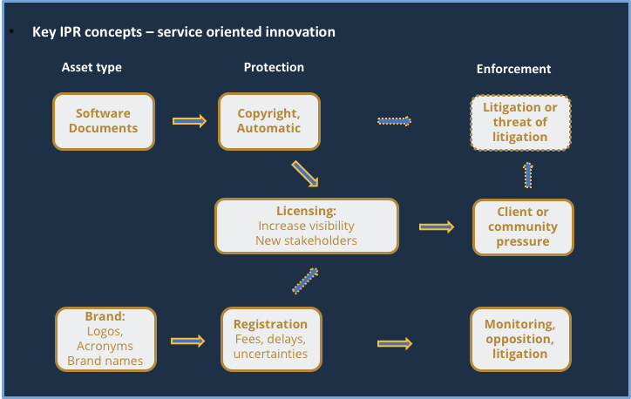
Figure 4. Primary IPR protection and enforcement in the EOSC-hub context
For these reasons, while licensing is technically not an IPR protection mechanism, in practice it serves a similar role. Using an open software repository to publish the open source software developed will also help in establishing a documented timeline of the development and protect against claims of copyright infringements by others.
While from the point of view of view of managing IPR-related risks to service provision any licensing arrangement can be seen as beneficial additional protection, they have different benefits and limitations for the secondary exploitation opportunities. The Table 4 summarises the differences between the strategic options related to some of the common licensing approaches:
Table 4: Summary of some of the common licensing approaches and their implications
Licensing approach | Key obligations for the user | Prerequisites for applying by IPR owners | Key benefits | Limitations
Apache 2.0 | Acknowledge contribution, document changes | Compatibility of the components included (e.g. no GPL, AGPL software) | Simple, low threshold for reuse | In practice no revenue potential from selling licenses
Creative Commons (CC) | Similar to Apache, with different degree of control on derived works (can limit commercial use, derived works,...) | Original work or including only public domain or CC variants that are compatible with the license | Well known, low threshold for reuse | Need to understand the level desired restrictions and their impact
GPL, LGPL | Acknowledge, redistribute derived works under the same license | Need to analyse the IP governance: GPL license can prevent exploitation if parallel licensing is not possible | Can be used to build a strong community or to build the basis for commercial exploitation. | Hard to reconcile community and commercial aspects in the same product; IP governance requires extra effort. Higher threshold for commercial reuse
Affero GPL, Affero LGPL | Provide the source code for any instance running the software (either original or modified), license derived works under the same license | As with GPL | As with GPL and LGPL | As with GPL and LGPL, threshold for commercial reuse possibly even higher
Dual-licensing (commercial or non-commercial) | Contract specific | Compliance with IP governance and constraints of the GA and CA | Revenue, partnership | Time and effort needed may be considerable

From the point of view of securing the future service provision, the key areas to review are:
- Compatibility of the background IP in the components licensed under the Apache license (or similar)
- The feasibility of a re-licensing of components licensed under GPL, LGPL, AGPL and ALGPL (limitations stemming from the background IP, IPR ownership of the contributions through EOSC-hub)
- Dual-licensing: successful cases are exploitation success stories, provided they don’t have unanticipated side-effects for future EOSC use
The situation with Brands differs slightly: first of all, the protection is not automatic, but needs to be applied for. The registration process takes typically some time, at least the duration of the opposition period (3 months from the publication of the trademark applications in the case of EUIPO) when the other trademark holders can oppose registration. The opposition can be e.g. on the grounds that the proposed trademark would cause confusion with an existing one. Once the trademark is granted, the holder of the granted trademark needs to monitor periodically monitor the published trademark applications. Both of these processes involve some costs, although they are still considerably lower than typical litigation costs would be. It is also possible to delegate the rights to oppose new trademarks as part of a licensing arrangement. However, this is less relevant in the case where the follow-up activity of a project will want to continue using the brand.
While the scope of Innovation Management is very wide, IPR management applies to a subset of project results, for which IPR protection can be implemented. This includes:
- Software (applications, middleware) for which licences can be applied
- Products (inventions products) for which patents can be applied for.
- Documents (reports, guidelines, standards) for which copyright can be asserted and licences applied.
- Brands, names and identities, for which a trademark can be applied.
Other, less tangible project results will not incur direct IPR protection but may contribute to activities for which IPR is relevant. For those entities that can be protected, a shared approach to IPR use is needed as outlined in the project’s Consortium Agreement (CA). The review of IPR situation is of specific importance in the final phase of the project where the project results are more mature.
The IPR guidelines can be summarised as:
- As mentioned above, some results will create value which falls outside the formal IPR protection. However, exploitation of the skills and knowledge through training or consulting offerings can benefit from IPR-related strategies (documents with licenses that encourage sharing the project brand, trademarks that can increase the perceived value of service offerings etc.) Even when IPR protection of a result is not clear, project members should consider these elements of them which can be protected.
- Documents created by the project include lists of contributors and are to be licensed with a Creative Commons attribution license.
- Software developed with project funding should ideally be licensed with a permissive (not copyleft) open-source licence to minimise perceived IPR risks for both academic and commercial usage. Dual-licensing of the IPR by the partners is a possible strategy (and one that is anticipated by the Grant and Consortium Agreements), but only when there is a clear need and when contributors are identified and tracked, and that the organisation they work for are empowered to issue new licences if needed. A checklist for dealing with the different licenses in this category will be developed in the second project period. In the case of foreground, the key concern will be tracking contributions to project results in a way that ownership of the IPR can be tracked in detail.
- Brand protection will be considered in the second phase of the project, as a way to ensure handover to a long-term EOSC structure such as a legal entity mandated by EOSC Governance.
Protecting and exploiting the jointly developed IPR is another area the project will investigate during the second project period. While the situation is relatively straightforward in case of project outputs covered by the copyright, other IPR protection mechanisms require registration of the IPR. This registration needs to be done by a single legal entity, thus the joint ownership model needs additional mechanisms to support fair control of the IPR.
The primary IPR protection mechanisms that are relevant to the project are copyright and trademarks. Registration of designs (e.g. elements or layouts of websites and so on) is in principle possible, but unlikely to be relevant in the project context. The software patents are not expected to become an issue during the project lifetime. However, a lightweight due diligence review of the situation will be performed before the end of the project. Finally, the different licensing strategies for software can play a role as de facto enforcement mechanisms for IPR protection. Even a permissive license (such as Apache 2.0) requires including acknowledgement of the project contributions, which - when combined with the code being publicly available - likely increases the perceived risks, for those tempted to breach it, related to copying the code without acknowledging the source. Instead of just risking a conflict with the EOSC-hub consortium, the unauthorised use of IPR would run a risk of censure from the broader open source community. In case, adding such a licence means that (as long as the right to apply the license is not challenged), EOSC will retain the use of the software.

Evolution of Procedures
The main developments in innovation management procedures from the ones described in the earlier deliverables are the following:
- Development of a prioritisation mechanism for the individual project results
- Refinement of the Key Exploitable Results (KERs) and categorising them in a way that supports targeted outreach activities
A large number of project results require prioritisation of the innovation management activities. While exhaustive analysis of the project results is feasible by the end of the project, concrete exploitation successes take time. For this reason, prioritising the project results that are most likely to lead to positive exploitation outcomes already during the project lifetime is crucial. The current prioritisation model is based on a qualitative analysis of two factors:
- Proximity to the intended market
- Ease of uptake
This deliverable outlines the results of the first round of this prioritisation process. Thus, it is likely that the classification and listing of project results will undergo several changes during the rest of the project lifetime. For example, taking the fortuitous innovation opportunities into account may mean that the same technical output (service specification or software component) may need to be listed more than once if it targets more than one market and their expected behaviour is different. Similarly, the ease of uptake will not depend only on the technical maturity of the project outcome: in a new market, the user community may need to adapt their working practices to be able to reap the benefits. This will increase the uptake effort, even though the technical maturity of the solution would be high.
The KERs are discussed in more detail in Chapter 6 of this deliverable.

Dissemination aspects of innovation management
One of the purposes of this deliverable is to report targeted dissemination of the project results. The document provides an interim summary of the exploitable results with sufficient detail to facilitate discussion with the domain experts. The project’s dissemination activities are described in more detail in the periodic report and in the context of the high priority project results that are used as examples in Chapter 6 of this deliverable.
The innovation management during the first project period included also internal dissemination activities to ensure there was sufficient awareness of IPR issues within the project. These have been two project internal workshops focused on innovation management:
- IPR workshop in April 2018, and
- Innovation Management workshop in June 2018.
While these workshops were internal events of the project, they laid the foundations of the necessary aspects of the overall outreach and engagement activities of the project. These face-to-face workshops were followed by several virtual meetings to refine the approaches to innovation management and dissemination.

Stakeholder roles in detail
In order to understand how project results can be exploited, it is useful to group the KERs based on the type of organisational role that would take up each particular KERs.
The categorisation of the organisational roles could be seen as a simplified version of the stakeholder group analysis presented in the deliverable D3.1. Here we focus on the stakeholder types interested in directly exploiting each KER. It allows us to target KERs to those that can benefit them, and also highlights instances where KERs address multiple groups and need to be described differently for each one to stress the specific benefits to them.
Beyond these groups who directly exploit the project KERs and results, the experience and results from EOSC-hub can also be applied to other complex network ecosystems that are moving towards increased digitalisation of the products and services exchanged within the network as well as provided and consumed through interfaces with external stakeholders. These may include Industry 4.0 and emerging prosumer business models.
The following sections illustrate the stakeholder roles intended to take up the project KERs, based on “personas” sketched to present how adopting a KER will be of interest to them.

Enterprise
The Enterprise actors have a very wide range of business models, sizes, constraints, resources. However, in the abstract, we can assume that the commercial entities that would be interested in in-depth collaboration with the project are interested in extending their offerings to new markets in order to grow the size of the overall market size they reach. The research market is not in itself one that would provide “quick wins”, rather it can provide valuable reference projects and contacts with other companies. This means that we can assume that the companies would have the ability to make at least modest investments in ventures that will not produce immediate financial benefits that can be reported in the next quarterly report.
Thus, not all of the commercial entities the project is in contact with are potential early adopters of a broad range of KERs. A provider of standardised IaaS service may only be interested in listing a product offering on the Marketplace, in which case the minimal overhead of the transactions and the size of the market will drive the adoption. However, if this initial, minimal engagement produces positive results, the companies may well be motivated to look into a broader range of project results.
Table 5. Enterprise role characteristics
Goals | Growth of revenue and profits
Challenges | Complex procurement model due to the combination of commercial and publicly funded service providers, variable and non-standardised end-user requirements (scientific software more diverse than business applications), separation of end-user and paying clients, high cost of developing marketing strategies to reach a new customer segment
Potential value of EOSC link (abstract) | For EOSC, expand services offered beyond those that can be provided by noncommercial entities / using public funding. Potentially access low cost generic services based on industrial economies of scale. Increase use and exploitation and hence boost the innovation potential of Europe. Aggregate scale of supply and demand across both commercial and noncommercial sectors.  For Enterprise, access specialist expertise and resources not available outside academia, stay up to date with ‘bleeding edge’ research and services. Have reference projects with noncommercial sector that bring marketing benefits and test services in different environments.
Organisational characteristics | Size: from tens to tens of thousands of employees, typically a single jurisdiction and geographical location.

Researchers and research communities
This user group is very heterogeneous: it represents established research communities that have formalised their collaborations into dedicated organisations (up to and including international organisations), networks of groups crossing organisational boundaries, or individuals performing research activities on their own or through ad hoc collaborations. The organisations involved in these activities can be both public and private, for- or non-profit in nature.
The key common aspect of the members of this group is that the research activities are not directly generating revenue for the users of the services accessed through EOSC-hub. Rather, they are intended to generate new knowledge, either advancing society’s understanding of different phenomena (basic research) or identifying methods to apply knowledge in a new context (applied research) – including optimisation of for-profit activities. The difference between the Enterprise actors developing new solutions discussed in the previous group is that the research activity is typically not as close to the market (TRL 4-8 vs. TRL 1-6). Thus, despite the diversity of this user group, they have a number of common aspects in terms of the sustainability model that allow assessing the relevance of the KERs to this sector as a whole.
Table 6. Common characteristics of the Researcher and research communities’ roles
Goals | - Produce publishable, competitive results faster (before other groups in the same niche), increased research impact factor  - Demonstrate socioeconomic impact (as part of the grant conditions), e.g. through cross-sectoral or -disciplinary collaboration  - Open access to applications, software, data and other scientific outputs
Challenges | - Financial resource availability limited in time and in some cases by national procurement and research funding policies, administrative constraints related to their use,  - Complex user requirements and need of bespoke solutions and expert support,  - Need for open access to scientific outputs (data, software, applications, publications); international dimension of collaborations
Potential value of EOSC link (abstract) | - Minimise resources spent on idle IT resources, “native” support for interdisciplinary research,  - Support to open access, increased discoverability and availability of resources for a faster path towards publication
Organisational characteristics | Size: from few individual researchers (e.g. paper authors) to international organisations with tens of thousands of associated researchers

Service providers
The service providers are interested in the growth of the use of the services in order to demonstrate the positive impact of the services in order to justify continued funding of the services. The key feature of the sustainability/business model is the very indirect links between the actual end users and the revenue of the organisations. The services are typically “free at the point of use”, and the metrics measuring the successfulness of the service provision are complex and can’t typically be compared between different centres.
The increasing scope of EOSC and the growing ambitions in terms of capturing a much broader fraction of the overall volume of research activities in Europe poses certain challenges for the service providers: the increased resource consumption and diversity of use will likely challenge the assumption “free at the point of use” model. Judging whether the activity is research, industrial pilot or pre-commercial can be done efficiently and consistently only through some kind of assessment mechanisms that is shared between resource providers. Similarly, capturing, promoting and categorising success stories and generated value (knowledge, solutions, success stories) greatly benefits from collaboration between service providers.
Table 7. Service provider role characteristics
Goals | Demonstrate the positive impact of the services provided, growth of relevant users
Challenges | - Tracking credit (e.g. there is no formal citation mechanism for computing centres, scientific software just approaching), transaction costs of onboarding new user communities.  - National funding policies restraining the conditions of access to services to specific user groups
Potential value of EOSC link (abstract) | - Neutral collaboration forum that supports the sustainability and growth of the sector as a whole by validating common approaches and increasing the awareness of the value provided by the group.  - Increased discoverability and interoperability of services and in general of resources accessible through the EOSC Portal  - Harmonization of tools and policies for access  - Promotion of adding-value services to new international user groups
Organisational characteristics | Size: from tens to tens of thousands of employees

EOSC Hub operators
The primary member of this group is the emerging EOSC organisational structure (or structures). However, the business model can likely be somewhat similar to other hubs in different platform ecosystems. Thus it is possible that attempts to create Cloud Commodity marketplaces or open digital services hubs might benefit from the lessons learned in the complex environment that EOSC-hub operates in.
Table 8. EOSC-hub operator role characteristics
Goals | Act as a value-added aggregator or agent facilitating the provision of federated IT services
Challenges | - Definition of metrics, sustainable revenue models,  - Enforcement of rules of participation while ensuring low entry barriers  - Provisioning of services in a transparent and robust manner, capturing the value added
Potential value of EOSC link (abstract) | N/A
Organisational characteristics | Size: 10 – 100 employees

Other: education and support for eScience activities
This cross-cutting role of stakeholders is similarly diverse as the research. It is one of the dissemination and exploitation channels of the results emerging from the research activity, but also a “toolbox” that can support educational offerings that are based on knowledge and skills that are not generated on digital infrastructures (e.g. language training).
Thus, this group includes all the EOSC stakeholders when they act in the education/support roles, as well as external actors ranging from individuals offering tutoring services to higher education establishments.
Table 9. Education and support role characteristics
Goals | Education and knowledge transfer in its broadest scope
Challenges | - Mapping the offerings to the market, market creation (generating awareness of available educational services that address unarticulated needs of the stakeholders)  - Pooling expertise across organizations and national borders  - Engagement channels with researchers and other user groups operating at national level, and loosely coupled international user groups
Potential value of EOSC link (abstract) | Visibility, validation of offerings
Organisational characteristics

Key Exploitable Results (KERs) in detail
The following sections summarise the current status of the project Key Exploitable Results. At the end of the project, all of the KERs will be presented on the project’s public website, with links to background material and details to facilitate adoption. It should be noted that in many cases the implementation of a KER in the EOSC-hub context will depend on privileged information (e.g. contractual details with a commercial entity), hence all of the material related to KERs as they are implemented cannot be made public. However, the published material should allow adopting the approaches and tools of the KERs in similar contexts in a relatively straightforward manner.

EOSC Marketplace and EOSC-hub contribution to the EOSC Portal
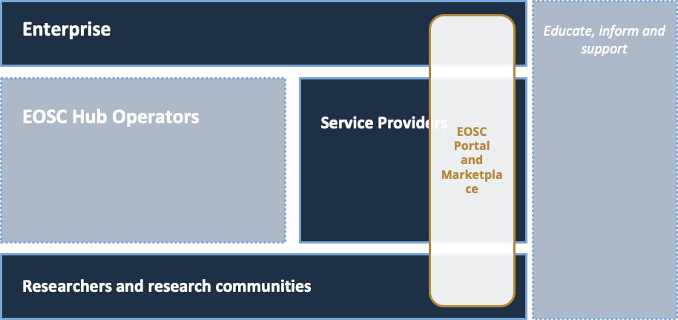
EOSC Portal is a website, created by a collaboration between EOSC-hub, OpenAIRE and partners from the former eInfraCentral project. The EOSC-Portal website holds a list of services onboarded by EOSC-hub and eInfraCentral, which is converging to a single catalogue in late 2019. In the EOSC portal collaboration agreement the portal has been defined as:
“technical components, intangible assets and contractual arrangements that make it possible to provide the service that facilitates the access and use of the EOSC assets. The contractual arrangements include - but are not limited to - the rights to administer the IP addresses and IT infrastructure making accessing the EOSC portal at the URL https://eosc-portal.eu/ possible.”
While the technical implementation of the portal itself may resemble the approaches used on other portal websites and share underlying components with it, the “intangible assets” of the portal make it a crucial component for the whole future EOSC plans. These assets include the awareness of the stakeholders – both of the existence of the portal and the fact that the URL is most likely frequently accessed by the interested parties. Equally importantly, the existing community’s trust in the sustainability and quality service allows it to work as an efficient marketing channel.
Result type | Software, services
URL | https://www.eosc-portal.eu and https://github.com/cyfronet-fid/marketplace
Key innovation | Support for federated service ecosystem: service discovery and access to market
Target audiences | Service Providers, Researchers and Research Communities, Enterprise
Key benefit (for the audiences) | Large, diverse and well-managed marketplace with transparent governance model.  - The service providers will see increased interest in their services with user requirements that better match the specific offering  - Researchers can compare solutions and reuse their credentials and knowledge related to EOSC service access with different providers  - The Enterprise can lower the marketing and transaction costs considerably compared to targeting individual research institutes or researchers.
Key exploitation paths | EOSC through a collaboration agreement with OpenAIRE-Advance and eInfraCentral consortia and EFIS Centre, UoA and JPN
IPR approach | Outlined as part of the collaboration agreement involving the eInfraCentral and OpenAIRE-Advance projects. Brand protection plans are in place, software components licensed under Apache, GPL and LGPL licensed, other components protected by copyright, typically licensed under creative commons. The IPR ownership and licensing strategy will be reviewed periodically as part of the cross-project joint action plan.

Market analysis and exploitation steps
The importance of the EOSC portal as the primary entry point to the EOSC ecosystem is going to grow dramatically as the scope of the EOSC services grow. Thus, the collaboration agreement between the key projects and stakeholders has been established, with a work plan that will build a longer-term sustainability plan for the service.
However, this focused exploitation activity does not preclude the reuse of the portal components by third parties. In fact, the anticipated growth of volume and diversity of use of the components is likely to speed up the maturing process of future versions considerably.
EOSC Portal and EOSC Marketplace dissemination activities
The EOSC Portal was formally launched at an event in Vienna, November 2018. For this launch event, the EOSC-hub project contributed by:
- Developing the concept, the scripts and the implementation of three promotional videos:
  - A generic video about the EOSC Portal;
  - Two videos to support the live demonstration of the EOSC Portal during the launch event (CLARIN and Pufferfish cases);
  - EOSC Portal presentation, Tiziana Ferrari, EOSC Launch Event, Vienna, 23 Nov 2019
- Leading the development of the content of the EOSC Portal entry website (adding case studies, service descriptions, about sections, etc.) - in cooperation with the OpenAIRE-Advance, EOSCpilot and eInfraCentral projects;
- Leading the production of the booklet “EOSC Portal: Accelerating the transition to Open Science and Open Innovation”: concept, structure, commissioning and editing testimonials, final copy-edit, preparation for printing and promotion;
- Editing and promoting the Press Release for the launch event (in cooperation with the OpenAIRE-Advance, EOSCpilot and eInfraCentral projects);
- Creating a Twitter account and YouTube channel for the EOSC Portal and developing the channels in preparation of and during the EOSC Portal Launch.
In addition:
- Sara Garavelli, the leader of WP3, presented the EOSC Portal at the Danish e-Science Forum in June 2019
- EOSC service provider onboarding: Why joining the EOSC portal? (Presentation Apr 2019), EOSC-hub Week 2019
- EOSC support to Earth Observation and EOSC Portal services (Presentation, May 2019), ESA Living Planet Symposium
- EOSC support to scientific computing needs in to Earth Observation with the EGI Federated Cloud (Presentation, May 2019), EODC Forum 2019
- Cloud Computing Needs for Earth Observation Data Analysis: EGI and the European Open Science Cloud Japan Geosciences Union, May 2019, Chiiba, Japan
- Developing the EOSC portal for the benefits of the user communities, Building Open Science in Europe: The road ahead for the EOSC community and the EU Member States, Panel discussion, 20 Jun 2019, Tallinn, Estonia
- (Planned) HORIZON 2020 CONTRIBUTIONS TO BUILDING THE EOSC, Tiziana Ferrari and Per Oster, 9-10 Sep 2019, Euroepan Commission, Brussels
- (Planned) EOSC portal concept 2.0, EOSC-hub Strategy Board, Tiziana Ferrari and Per Oster, 25 Sep 2019, Brussels

Service Management System
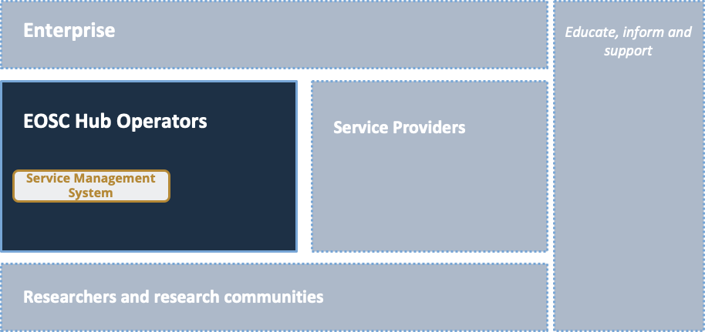
The Service Management System (SMS) comprises the entirety of activities performed by service providers to plan, deliver, operate and control services offered to customers. Service oriented activities are directed by policies, which are structured and organised by processes and procedures. The EOSC Hub facilitates alignment of service management activities of all of the service providers, supporting different options of integration with the centralised services. SMS is a critical component in integrating the services provided by the different providers into the common marketplace and monitoring frameworks in a way that provides value for EOSC.

Result type | Documents and reports, Brands
URL | Confidential wiki space at https://wiki.eosc-hub.eu/display/EOSC/EOSC+hub+SMS containing policies, process descriptions, procedures, roles, documents and records related to the SMS
Key innovation | Comprehensive, coherent and standards-based set of procedures and processes to manage the complete life cycle of services in a complex environment
Target audiences | EOSC Hub operators
Key benefit (for the audiences) | Ensure robust and resilient service delivery in a federated infrastructure with different types of many-to-many relationships between users, providers and customers
Key exploitation paths | EOSC, training events and consultancy
IPR approach | The underlying standard (FitSM) is licenced under Creative Commons. The EOSC-hub specific procedure descriptions (project internal use) are protected by copyright, with a standardised copyright notice mentioning the project and EC grant number.  The contents of the SMS are not public, but are intended to be available to future Hub Operators, so will be packaged as much as possible at the project conclusion for later uptake. This will be largely a set of documents with an appropriate license, as the other elements of the SMS are the intangibles related to individual experience in performing roles. The tangible parts will be documents and templates relating to policies, processes, procedures, role descriptions, reports and records.  Tools supporting the KER (SPMT, also relevant for the portfolio-related KERs) licensed under Gnu Affero license version 3 or later

Market analysis and exploitation steps
As the EOSC grows, the importance of SMS will increase. As the number of users and supported use cases grow, minimising the “surprises” in the service delivery is crucial aspect in building trust of users and user communities in the EOSC ecosystem.
In addition to the continuous validation and improvement of SMS in the day-to-day EOSC hub work, training and consulting based on the FitSM standard provides an important, parallel exploitation and validation path.
Dissemination activities
- Webinar EOSC SMS, Service Portfolios and Federating Core
- FitSM training events co-located with EOSC-hub events
- Part of the EOSC onboarding process as well as engagement with other infrastructures

External Services for research in the EOSC Service Portfolio
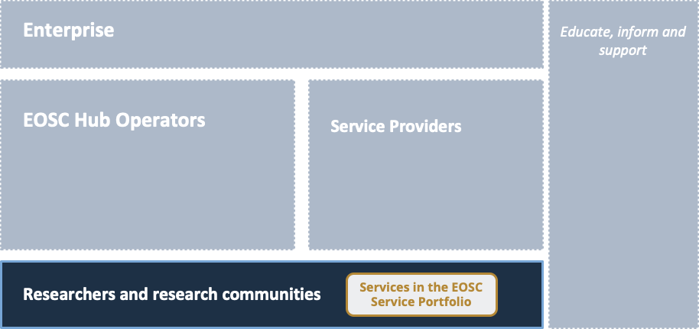
The EOSC Service Portfolio is used to populate the EOSC Portal with services and solutions that are relevant to the different research communities. Thus, the service needs to address a multitude of issues; primarily organisational/procural (describing licensing and acceptable use policies consistently) or data curation related (consistent and accurate metadata for the services), and in some technical details.
In the EOSC context, this KER is closely linked with the EOSC Portal and Service Management System in providing a clear, comparable and valuable set of services to researchers.

Result type | Services
URL | Interface: EOSC Marketplace: https://marketplace.eosc-portal.eu (pending future migration to single shared catalogue/marketplace under EOSC Enhance project)
Key innovation | More and better services for faster and higher quality research results
Target audiences | Researchers and Research Communities
Key benefit (for the audiences) | EOSC provides "one-stop shop" for a range of services and solutions to speed up the research process of the disciplines and enable cross-disciplinary collaboration and reuse of tools and results. It encourages sharing of the research tools and data between different research groups - also across disciplines.
Key exploitation paths | The sustainability of each of the services will ultimately depend on the successful science made using them. The EOSC Service Portfolio will support this goal by making the discovery of the services easier and reducing the effort needed to adopt them.
IPR approach | The marketplace software is published under a GPL 3.0 license. Each of the services accessible through the marketplace has its own IPR approach (ranging from the public domain to proprietary software). The components from the Hub Portfolio (internal services) which are offered for integration by external services in the EOSC Service portfolio integration are offered under a range of open licences. Tool supporting the KER (SPMT, also relevant for the Service management system and the other portfolio-related KER) licensed under Gnu Affero license version 3 or later.

Market analysis and exploitation steps
As the number of research activities and groups supported by EOSC grows, the possibility to easily search, request and re-use research services will become more and more important. Consistent metadata will be crucial for efficient service discovery (either by the researchers themselves or in collaboration with different helpdesk services). Providing an intuitive interface to the service lifecycle information will be of equal importance. The primary exploitation steps will be based on the role of the future EOSC service portfolio.
Dissemination activities to promote the service portfolio
These focus on promoting the service offer to researchers. This is done through:
- Working closely with research communities through the WP3.2 Engagement task, for example through the Early Adopters Programme
- Communications activities to raise awareness:
  - (news item) Services to support FAIR data
  - (news item) Robotbenchmark – cloud-based robot simulations on the EOSC Marketplace
  - (news item) The MIDAS archive – a treasure of data
  - (news item) The symbIoTe service is now available on the EOSC Marketplace
  - (news item) Infrastructure Manager is now available through the EOSC Marketplace
  - (news item) New service on the EOSC Marketplace: 100 Percent IT Trusted Cloud
  - (news item) The EOSC Marketplace has a new service: MetaCentrum Cloud
  - (news item) New services available on the EOSC Marketplace: Galaxy and Figshare
  - (news item) EOSC Marketplace new service: Alien4Cloud
  - (news item) New service published on the EOSC Marketplace: CyVerse UK
  - (magazine article) Oceans observation data is now replicated and stored on a daily basis with B2SAFE
  - (magazine article) EGI Cloud Compute: success stories from the business pilots
  - (magazine article) OPENCoastS and EOSC-hub
  - (magazine article) HADDOCK helps scientists to look at the evolution of brain tumours
  - (magazine article) Secure services for sensitive data in research
  - (magazine article) CLARIN’s Virtual Language Observatory
  - (magazine article) EOSC-hub Service Catalogue
- Presentations and papers aimed at scientific audiences, for example:
  - Synergy of experiment and computation in quantitative systems biology (EMBO workshop
  - OPENCoastS: An Open-Access App for Sharing Coastal Prediction Information for Management and Recreation (International Conference on Computational Science ICCS 2019)
  - West-Life: a virtual research environment for structural biology, Journal of Structural Biology
  - European Open Science Cloud (EOSC): It’s a brave new world - creating and supporting digital Communities, TNC 2019, Tallinn, Estonia
  - EOSC Federating Core Webinar, 06 August 2019
- Training and tutorials targeted at scientists
  - Specifically the materials produced in the context of task T11.5: Domain-specific training to data providers and data scientists

Internal Services provided in the Hub Portfolio
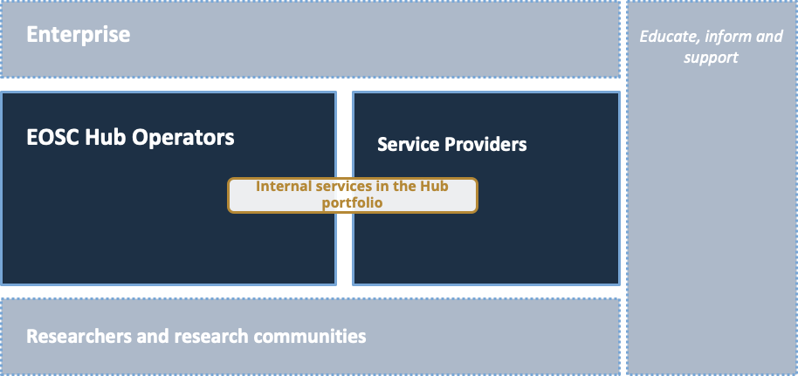
These internal services service two purposes (and so relate to two roles) They enable the operation of the ‘Hub’ and will be a future contribution to the federating core of EOSC. They also offer capabilities which can be used to support or extend external services by offering functions which can be integrated, providing common experience across services and saving effort and avoiding providers have to reinvent the wheel

Result type | Services
URL | https://www.eosc-hub.eu/support-services
Key innovation | Set of service interfaces providing basic enabling services for EOSC access.
Target audiences | EOSC Hub Operators, Service Providers
Key benefit (for the audiences) | This KER provides a common toolset for integrating services to EOSC ecosystem. This is a prerequisite for the function of the hub as a federating core, and a mature implementation of the tools will streamline the processes of the EOSC Hub Operators. For the service providers, the KER provides tools to access several user communities through the hub by integrating their services to a single service API (instead of several community-specific ones)
Key exploitation paths | The common services are targeting adoption by the permanent EOSC services. The reuse of individual components by third parties is encouraged.
IPR approach | Tools supporting the KER are licensed under number of different open source licenses. This ensures that irrespective of ownership. the software is available to EOSC in the future. Some of the services rely on databases that may fall under sui generis database protection.  Due to the nature of this KER, the software implementing the services needs to interface with numerous other software solutions. For this reason, the in-depth analysis of the IPR situation will be of special importance in the context of this KER.

Market analysis and exploitation steps
As with the Services for research in the EOSC Service Portfolio, the growth of number of users and the value delivered through EOSC will increase the importance of the KER. The reuse of the components in the other context is a secondary exploitation path to be encouraged.
Dissemination activities
- SMS and Portfolios webinar
- Promotion to Service Providers during onboarding

Digital Innovation Hub: Platform for industrial collaborations with EOSC
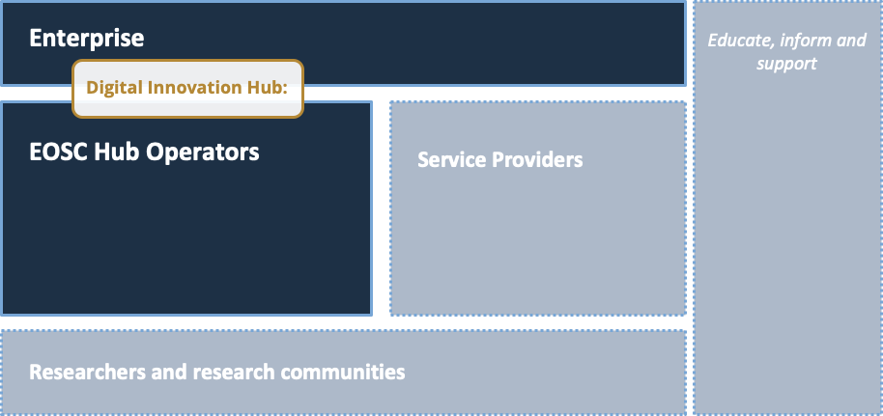
The EOSC Digital Innovation Hub is a multi-dimensional mechanism that allows research e-Infrastructures to support business organisations to stimulate innovation, as well as helping start-ups, SMEs, and other innovative actors to tap into the academic world both in accessing knowledge as well as technical services. The final goal is to create a one-stop shop that brings IT services, research data, and expertise into a single place to support innovation in the industry.
The multifaceted nature of the Enterprise targeted by the project means that the onboarding process needs to support several public-private collaboration models:
- Piloting and co-design of new services (proof-of-concept work, performance testing, etc.)
- Technical access to different “as a Service” resources (HPC/HTC/Cloud computing, storage, data management and higher-level services)
- Training and support (Technical consultancy, service management, commercialisation)
- Visibility: using DIH as a networking tool to expand beyond local markets.
The tacit knowledge that allows choosing the primary approach to take and identify the optimal moments to re-evaluate and fine-tune the approach with the commercial partners forms the core of this Key Exploitable Results (KER). While the approach is yet to be fully formalised as it is only halfway through the project development, the fact that all of the initial six business pilots reached their goals (TRL 7 or 8) as described in the success stories indicates that distilling the lessons learned is likely to provide knowledge that can be successfully applied in other contexts.

Result type | Business models, Policies and procedures, Services
URL | www.eosc-dih.eu
Key innovation | Single contact point with a flexible engagement mechanism supporting all possible collaboration models with industry
Target audiences | Enterprise
Key benefit (for the audiences) | Lowers initial investment (time and effort) for identifying/accessing services and developing/testing new products and services as well as increasing visibility and networking opportunities on a European level.
Key exploitation paths | Continued activity in the context of EOSC and the wider network of digital innovation hubs. In the long-run: formalisation of the knowledge and expertise into procedure descriptions standardised consulting offerings or certification schemes.
IPR approach | Each of the business pilot contacts retain the ownership of their own background IPR and the adaptations made to the proprietary code with the support of DIH. The EOSC-hub services are provided primarily using the standardised interfaces to the EOSC services; thus, DIH doesn’t have an impact on the IPR situation of the EOSC software.

Market analysis and exploitation steps
It is plausible to estimate that, independent of the size, business model or market, European companies are generally aware of the growing Cloud or SaaS/PaaS offerings and see them as having an impact on their operations relatively soon. The ambitious EOSC goals related to private sector R&D involvement are likely to increase the interest in the Digital Innovation Hub networks. However, based on the EOSC-hub experiences, to sustain this interest it is crucial that the approach balances the provision of the technical access to resources with support for more advanced co-design, training and networking.
In the second half of the project, the EOSC DIH will take the following exploitation steps:
- Continue engagement with the companies involved in the initial business pilots for individual exploitation opportunities (i.e. continued support through business agreements; publication of results in the EOSC Marketplace)
- Further developments of the DIH network through participation in wider initiatives such as the EC DIH Working Group and DIHnet CSA project.
- Distil the lessons learned into concrete workflows that capture the key junctions of the onboarding processes
- Concentrate on onboarding new business pilots and promotion of success stories
- Analyse potential sustainability models for expanding the DIH services through a dedicated community platform.
Dissemination activities
Online / Social:
- Dedicated DIH area on the EOSC-hub website
- Dedicated DIH Twitter feed
- Video interviews, for example: https://youtu.be/qCaymgNaOcI
- Profiles for Business Pilots (e.g.: DataFurn)
Articles and news items:
- EOSC magazine, issue 1: Digitizing industry through the European Open Science Cloud
- EOSC magazine, issue 3: Five ways of working with EOSC-hub
- EOSC magazine, issue 4: BBC joining the EOSC Digital Innovation Hub and EGI Cloud Compute: success stories from the business pilots
- EOSC-hub news feed: BBC presented a use case at the EOSC-hub week in Prague
- EOSC-hub news feed: EOSC-DIH is now part of the official EU DIH catalogue
Presence at event, examples:
- Smart City EXPO - Lodz, Poland - June 2019
- HPC for Industry 4.0 - Milan, Italy - May 2019
- Elixir SME Forum - Frankfurt, Germany - October 2018
Publications:
- EOSC Digital Innovation Hub flyer

Business and sustainability models for services and the Hub
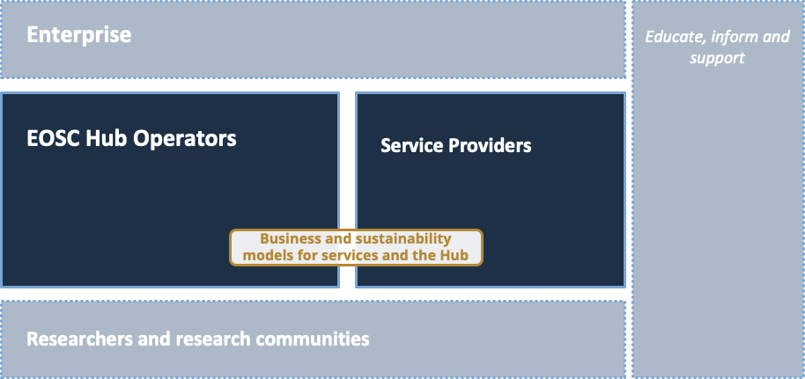
As the scale and complexity of the EOSC ecosystem grow, ensuring the sustainability in a transparent manner becomes more and more important. In the context of the project, there are two main stream of work: 1) structuring the EOSC Federating Core and the related cost and governance model; 2) identifying business models that support the procurement of research-enabling services. In addition to the obvious need for efficient mechanisms to manage expenditures that are considerably larger than before, the growth will have an impact on the public-private partnership aspects of EOSC. Long-term, sustainable EOSC service provision will likely require optimising the use of commercial and academic resources in a seamless manner that doesn’t depend on awareness or explicit optimisation steps of the user communities.
The KER provides solutions in the following areas:
- EOSC Federating Core
  - Structure in terms of capabilities and tiers
  - Cost assessment
- Business models for purchasing of
  - Demand analysis
  - Business models underpinning the procurement of services through demand aggregation and centralised compliance monitoring (economies of scale)
  - Cross-border and -sectoral VAT compliance
- Management of different usage scenarios, ranging from encouraging the “long tail of science” initiatives to join EOSC ecosystem to optimising the resource provision to large, established international research collaborations (such as ESFRI projects)
Result type | Business models
URL | Deliverable D12.1: https://documents.egi.eu/document/3466  Briefing paper: https://documents.egi.eu/document/3479
Key innovation | Achieving compatibility of business and sustainability models of traditional and emerging EOSC stakeholder groups in an intuitive and transparent manner
Target audiences | Service providers, EOSC-Hub operators
Key benefit (for the audiences) | Increased flexibility, lowered barriers of entry and reduced compliance costs in service provision and consumption by the EOSC stakeholders
Key exploitation paths | To be taken up by the EOSC, disseminated to relevant policy bodies (EOSC Executive Board, EOSC Sustainability Working Group)
IPR Approach | Openly available document collection (White Papers and technical documentation). Most of the documents released under the Creative Commons license (Creative Commons Attribution 4.0 International)

Market analysis and exploitation steps
The results of this KER will provide important input to EOSC sustainability planning. Thus, it can be assumed that the development will continue seamlessly at least during the ramp-up phase of the EOSC. During the second project half, EOSC-Hub will ensure that the relevant policy bodies (such as the EOSC Sustainability Working Group and the EOSC Executive Board) are aware of the results and the knowledge available within the EOSC-Hub consortium. The main goals include also supporting the EOSC Working Groups in formulating recommendations on the EOSC implementation.
Dissemination activities
- Deliverable D12.1 “Procurement requirements and demand assessment”
  - Public document, published in June 2019
  - Results presented at the EOSC-hub Week in April 2019 and at the meeting of the heads of IT of the EIROForum
  - Circulated to chairs of the EOSC Sustainability Working Group
- ​Briefing Paper - EOSC Federating Core Governance and Sustainability: This Briefing Paper contains an initial proposal of the EOSC Federating Core, illustrating a possible approach to its composition and relating it to functional and non-functional requirements emerging from EOSC use cases. The Briefing Paper was:
  - Promoted via a webinar and a news item
  - Used as a means to solicit input from the community through a survey.

Rules of Participation
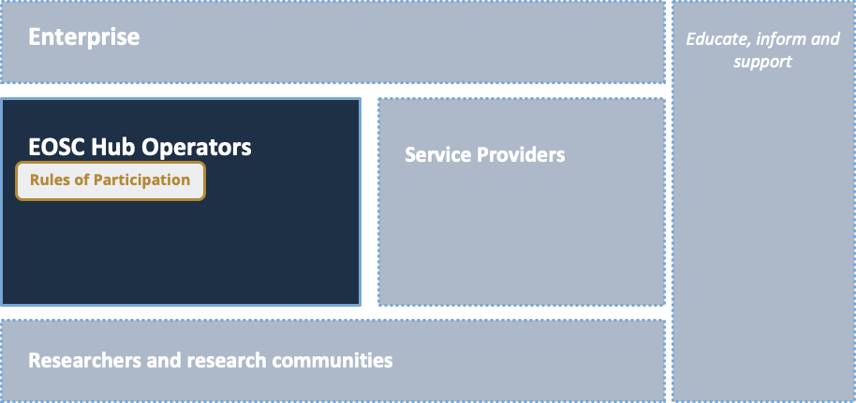
The EOSC-hub Rules of Participation aims to define the conditions for service providers to offer services through the EOSC Service Portfolio. The rules are crucial building block in establishing an EOSC Service Portfolio that is attractive and provides value for both service providers and service users. For this reason the Rules of Participation need to balance two orthogonal goals: they need to be as simple as possible, while at the same time making sure that the providers fulfil certain level of quality that makes it possible to rely on the EOSC-Hub services as an infrastructure.
The current version of the rules of participation covers the following aspects of the quality of the services offered:
- Services must have a minimum maturity of TRL7 or higher.
- Services with a TRL7 are listed only,
- Services at TRL8 and 9 can be ordered via the EOSC Portal.
Result type | Technical specifications, Documents and reports
URL | Part of content at https://wiki.eosc-hub.eu/display/EOSC/Service+Provider+Documentation
Key innovation | Comprehensive and coherent set of rules for the services provides to onboard services into and make them discoverable and accessible through the EOSC Service Catalogue and Marketplace.
Target audiences | EOSC Hub operators (primarily)
Key benefit (for the audiences) | Make it as easy as possible to bring new service providers into the EOSC ecosystem while ensuring the quality and compliance of the overall services and building and maintaining the trust of the users and user communities
Key exploitation paths | Part of the EOSC approach. Input to the EOSC Governance sponsored Working Group on Rules of Participation (WG-RoP)
IPR approach | The documents (such as Service Description Template) describing the onboarding procedure and minimum requirements will be freely available under a creative commons attribution license.

Market analysis and exploitation steps
As a federated digital service ecosystem on the scale of EOSC is still primarily an emerging service delivery model, the primary market and focus of exploitation is based on active participation in the development of the EOSC. However, the project will monitor the digital services landscape for initiatives that could benefit from experiences and know-how generated during the EOSC-hub project. In case such opportunities emerge, the possibilities of developing a standardised training or service offering will be analysed in collaboration with the project’s training activities (WP!1).
The Rules of Participation is presented as input for the Working Group in Rules of Participation.
Dissemination activities
- (Technical paper) EOSC-hub contribution to the EOSC Rules of Participation Consultation
- (Workshop at DI4R 2019) Rules of Participations for EOSC
- Contributions to WG-Rules of Participation (confidential)

Integration and interoperability guidelines
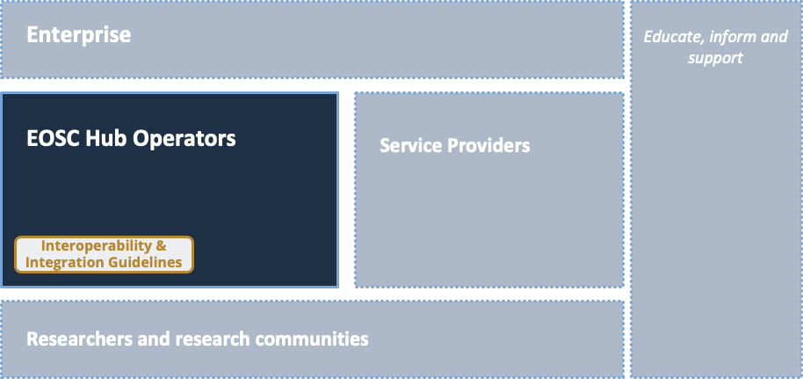
Interoperability and Integration guidelines, defining high-level architecture for basic EOSC technical functions and promoting EOSC standards and APIs, will facilitate access to services, lower barriers to integrate and composes services and promotes the usage of services between adjacent communities. EOSC services ‘compliant’ with these guidelines will offer well-established and documented interfaces for usage and integration, based on well-known standard or APIs, facilitating (1) their exploitation from user communities willing to create new scientific services that could rely on well-established and documented interfaces for the integration (e.g. a community creates a new scientific workflow reusing EOSC federation and common services, like AAI, accounting, etc.) and (2) the combined usage of EOSC services, indeed the adoption of well-known standards and interfaces will very-likely reduce the cost to integrate services (e.g. two accounting infrastructures can be made easily interoperable if they use the same standard usage record format, in such case accounting data extracted from them can be merged and presented in a unique view). As a consequence, less mature or small scientific communities can leverage on EOSC services for a series of IT functions and focus on their scientific work, access to scientific services will be open to new communities thanks to the documented interfaces and new scientific workflows can be created combining existing applications. The guidelines are presented as a set of complementary outputs:
- Formal technical specification
- Interface libraries
- Example software solutions
- Complementary documentation

Result type | Technical specifications, Documents and reports
URL | D10.4 EOSC Hub Technical Architecture and standards roadmap: https://documents.egi.eu/document/3495
Key innovation | A concise and easily adopted set of technical guidelines allowing technical integration of solutions to EOSC system
Target audiences | Service providers, Enterprise
Key benefit (for the audiences) | Minimising the technical design and development effort needed to access to EOSC services market
Key exploitation paths | Part of the EOSC approach, encouraging the development of third-party solutions (interface libraries etc.)
IPR Approach | Openly available standard-like document

Market analysis and exploitation steps
As the EOSC ambition and scope – both in terms of number of users and the applications supported – grows, the importance of and interest in these guidelines will grow dramatically. The primary exploitation path in the short term is through EOSC. However, in the long-term, proactive support of third-party development and investigating the feasibility of forming some kind of public-private structure to maintain the guidelines and the supporting material will be investigated.
Dissemination activities
- How to connect to EOSC?, Social Sciences and Humanities EOSC Cluster Kick-off Meeting (Presentation, Mar 2019)
- Why Open Science is the Future (And how to make it happen), Presentation and contribution to Position Paper, 14 Jun 2019, Brussels
- EGI Cloud Services in a Federated Multi-Supply Environment (Presentation, May 2019), 6th workshop of the Open Research Cloud Alliance, Washington DC, USA
- The Present and Future of Open Science in Europe (Keynote, May 2019)
- Early Adopter Programme, webinar, 29 May 2019
- EOSC-hub technical workshop, in collaboration with OpenAIRE-Advance and GEANT (Presentations and Panels, 25-27 Jun 2019)
- An EOSC-hub proposal for the EOSC Technical Architecture, webinar, 24 July 2019.

Training courses and material
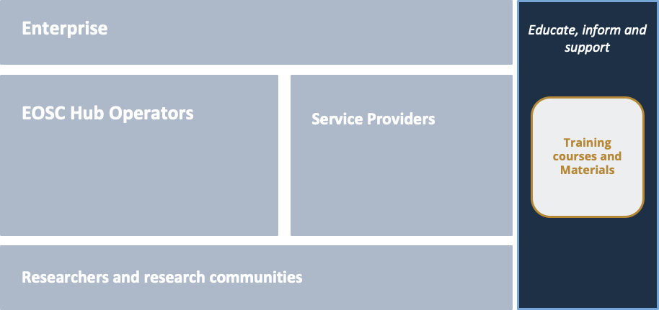
The training courses and material encompass a large variety of project results. They range all the way from technical, downloadable results (e.g. Virtual Appliances, Docker containers and Jupyter notebooks used in training) to consultancy building on training events (such as workshops focused on applying the FitSM standard in the specific circumstances in the client organisations, or helping research communities to develop a sound Data Management Plans) aiming to stimulate the knowledge transfer, foster the use of digital infrastructures and promote the uptake of Open Science paradigm. The sound training programme delivered by the project aimed to stimulate the establishment of a “knowledge network” of expertise and help researchers from different scientific disciplines to better integrate advanced digital services, tools and data to achieve excellence in science, research and innovation.
The target audiences are similarly diverse, ranging from service providers already familiar with the EOSC-Hub to individual researchers possibly encountering the e-Infrastructures for the first time.
In terms of topics, the training courses and material cover all of the other KERs as well as most of the individual project results. Curation of this material by linking the training activity closely with the other developments of the project is this critical part of the project’s outreach activities.

Result type | Documents and reports, services, skills, software
URL | https://eosc-hub.eu/training-material
Key innovation | Rich set of tools, consulting models and material that make it possible to provide training services tailored to optimally fit the needs of the diverse audience EOSC needs to reach.
Target audiences | Users, research communities, EOSC service providers.
Key benefit (for the audience) | Smooth integration into EOSC ecosystem, maximising the benefits.
Key exploitation paths | Through EOSC (part of the sustainability model), freemium approach and consultancy.
IPR approach | Multifaceted – most of the material is openly available, licensing approach differs on a case-by-case basis. The training material can be searched and filtered based on the licensing approach, e.g. to find training material licensed under creative commons, Apache or MIT licenses. The database making searching the training material and displaying it on the website could be protected under the sui generis database rights.

Market analysis and exploitation steps
Training and support activities will play a key role in creating awareness of services and resources, augmenting skills and adapting organisational practices needed as prerequisites of full participation in the EOSC ecosystem. The support and training activities need to be made available to and relevant for the diverse groups of researchers, research groups and organisations in the “Enterprise” role. Initially, the activities need to serve the current users of the European e-Infrastructures and encourage them to consider, test and adapt a considerably broader range of e-Infrastructure services. In the long run, the demand for training and related services will increase dramatically through the extension of the user base beyond this group of early adopters.
To meet this challenge, in a sustainable manner, EOSC-Hub will investigate the following approaches:
- Studying the feasibility of different business models building on openly available training material (paid add-on components, tailored training, consultancy, trainer certification).
- Promoting the FitSM standard as a mature, general purpose IT Service Management approach that is particularly well-suited to the federated ecosystem EOSC represents.
- Offering a technical consultancy to cover the many aspects of the Data Management Plans including, the metadata generation, data preservation and outline how data has to be handled both during the project lifetime, and after the project is finished.
- Developing new approaches to provide training infrastructure services to a broader range of user communities.
- Identify opportunities to capture best practices and tacit knowledge into documents (such as standard operating procedures) that could serve as basis for standardised training offerings that could make reaching larger audiences easier.

Dissemination activities focusing on the training programme as a whole
Excludes dissemination of individual courses, webinars and events
- Upcoming EOSC-hub trainings (News item, June 2019)
- Highlight on EOSC-hub: One year of achievements (Article, EOSC Magazine: issue 3, March 2019)
- How to make your data Open & FAIR (Article, EOSC Magazine: issue 2, October 2018)
- Upcoming EOSC-hub Training Events (News item, July 2018)
- Highlight on the Five Ways to Work with EOSC-hub brochure

Individual project results (PRs)
As noted in Chapter 2, there is implicit filtering based on whether the project result would have broader applicability outside the strict project scope. In addition to these basic selection criteria, during the project lifetime it is important to focus the project’s innovation curation activities to areas that are most likely to provide actionable feedback already during the project’s lifetime. This prioritisation approach differs slightly from assessing the overall impact of the project after the end of the project lifetime, as in that stage one can assume that if there is a clear “business case” for the take-up of the innovation the organisations involved in the exploitation can acquire additional resources or develop an organic sustainability model to take the innovation into broader use. In contrast, the mid-project assessment of innovation activities will usually have to operate with the existing resources due to inherent delays securing additional funding incurs.

The mid-project prioritisation approach
The mid-project prioritisation is based on assessing the project result’s proximity to the market and the ease of uptake based on the following categorisation:
Proximity to Market | Ranking
Market ready – fills an identified need in an obvious manner, e.g. a “Specialist data processing service for geology” | 3
Adaptable through straightforward steps – proven solution that would need addition work to serve a new user groups (e.g. transferring a training program from one target discipline to a related one). | 2
Background/indirect impact – background/fundamental work that needs to be interpreted by the new user community, e.g. a technology roadmap | 1

Ease of uptake | Ranking
Packaged and documented software or standalone service (thematic SaaS, Netflix, generic webmail service) | 3
Medium: beta software, service needing integration work (e.g. new CMS or system like Google analytics). | 2
Hard: proof-of-concept solution, services requiring organisational/governance change or buy-in from multiple parties (e.g. SAP deployment in a supply chain, heavyweight standard deployment/certification) | 1

The answers to these questions will be interpreted based on the score matrix:
Score Matrix | Proximity 1 | Proximity 2 | Proximity 3
Uptake 3 | 4 | 5 | 6
Uptake 2 | 3 | 4 | 5
Uptake 1 | 2 | 3 | 4
Score 5-6 = High Priority, Score 4 = Medium Priority, Score 1-3 = Low priority

The following section will present some of the individual “High Priority” project results as examples of the information collected and curated of these project results. A more complete list of project results in the different categories is included in the Annex 1.

Examples of the High Priority results

Training programme for first project year
Name of the result | Training programme for first project year
Result type | Services
URL | https://eosc-hub.eu/training-material
Key innovation | A broad range of training offerings for the different EOSC-hub stakeholders
Groups the innovation would be beneficial to | All
Key benefit (for the audiences) | Improved efficiency and results of the activities supported by EOSC-hub, improved quality of interaction between actors in the EOSC-hub value network
Sustainability: source of funding or revenue | Part of the overall EOSC sustainability plan
Key dissemination and exploitation paths and plans | Key component in the project’s dissemination topics
IPR situation | Based primarily on freely available material, license details depend on the topic
Estimated launch date for external users | Available
WPs involved | WP11

EOSC Digital Innovation Hub - engagement process
Name of the result | EOSC Digital Innovation Hub - engagement process
Result type | Services, skills
URL | https://www.eosc-hub.eu/digital-innovation-hub
Key innovation | Approaches and knowledge needed to select the initial and follow-up approaches to DIH collaboration
Groups the innovation would be beneficial to | EOSC Hub operators, Enterprise
Key benefit (for the audiences) | Launch initial collaboration rapidly, provide foundations for future engagement
Sustainability: source of funding or revenue | Part of the corresponding KER approach
Key dissemination and exploitation paths and plans | Key part of the overall EOSC Digital Innovation Hub strategy
IPR situation | Largely tacit knowledge; generic approach can be documented and made freely available (e.g. as training material)
Estimated launch date for external users | Available
WPs involved | WP9

Voucher system
Name of the result | Voucher system
Result type | Business model, Service
URL | https://eosc-hub.eu/eosc-dih-free-trial
Key innovation | Provide commercial actors an easy access to the federated EOSC-hub infrastructure
Groups the innovation would be beneficial to | EOSC Hub operators, Enterprise
Key benefit (for the audiences) | One of the concrete collaboration modes used by the DIH (see DIH KER and project result “EOSC Digital Innovation Hub - engagement process”) - typically the first entry point
Sustainability: source of funding or revenue | Part of the DIH KER approach
Key dissemination and exploitation paths and plans | Key part of the overall EOSC Digital Innovation Hub strategy
IPR situation | Service freely available, publishing the source code as an open source solution is being considered (details of the license to be used in the published version are to be determined).
Estimated launch date for external users | Available
WPs involved | WP9

Marketplace
Name of the result | Marketplace
Result type | Software, Services
URL | https://marketplace.eosc-portal.eu and https://github.com/cyfronet-fid/marketplace
Key innovation | EOSC-hub Marketplace (MP) is a user-facing platform where production EOSC-hub services can be promoted, discovered, ordered and accessed.
Groups the innovation would be beneficial to | Researchers and research communities, service providers, EOSC-hub operators
Key benefit (for the audiences) | Single entry point to services that are production ready, documented and provided with defined QoS.
Sustainability: source of funding or revenue | Part of the EOSC Portal sustainability
Key dissemination and exploitation paths and plans | Targeted engagement with service providers and user communities
IPR situation | Software licensed under GPL v3.0
Estimated launch date for external users | Available
WPs involved | WP5

Earth Datacube
Name of the result | Earth Datacube
Result type | Services, software
URL | http://eoschub.rasdaman.com:8080/rasdama n/ows
Key innovation | The datacube service enables flexible spatio-temporal access and analytics on massive multi-dimensional Earth data, such as radar and optical satellite imagery and climate/weather data.
Groups the innovation would be beneficial to | Researchers and research communities
Key benefit (for the audiences) | Users can exploit Petascale datacubes through their well-known tools, in a simple and straightforward way. Hence, no particular IT or EO processing expertise is required, unleashing the potential for a broad spectrum of users within and beyond the EO communities.
Sustainability: source of funding or revenue | Licensing fees
Key dissemination and exploitation paths and plans | LinkedIn, Facebook, Twitter, rasdaman company newsletter, scientific papers
IPR situation | Dual-licensing: GPL/LGPL for community version, proprietary for enterprise version
Estimated launch date for external users | Available
WPs involved | WP7

Data Policy Recommendations
Name of the result | Data Policy Recommendations
Result type | Policies and procedures
URL | https://documents.egi.eu/document/3419
Key innovation | A report covering 22 practical steps which bridge general policy recommendations and future technical implementation of data sharing within the EOSC-hub service ecosystem
Groups the innovation would be beneficial to | EOSC-hub operators
Key benefit (for the audiences) | The report assimilates a number of sources to form a suggested implementation roadmap for data sharing across EOSC
Sustainability: source of funding or revenue | N/A
Key dissemination and exploitation paths and plans | EOSC-Hub General Assembly, Commission
IPR situation | Creative Commons Attribution  4.0 International
Estimated launch date for external users | January 2019
WPs involved | WP2

AGORA/SPMT
Name of the result | AGORA/SPMT
Result type | Software
URL | https://eosc.agora.grnet.gr/ui/ and https://github.com/grnet/agora-sp-admin
Key innovation | The Service Portfolio Management Tool (SPMT/AGORA) provides a full list of services and allows to manage service descriptions according to the service management guidelines of FitSM
Groups the innovation would be beneficial to | EOSC-hub operators
Key benefit (for the audiences) | Makes efficient management of service descriptions possible, to the granularity of service components and allows according to the service management guidelines of FitSM
Sustainability: source of funding or revenue | EOSC
Key dissemination and exploitation paths and plans | EOSC-hub service provision, FitSM trainings
IPR situation | ApacheSoftware License 2.0
Estimated launch date for external users | Available
WPs involved | WP5

PROC07 Allocating financial support for trainers to attend f2f events
Name of the result | PROC07 Allocating financial support for trainers to attend f2f events
Result type | Policies and procedures, skills
URL | https://wiki.eosc-hub.eu/display/EOSC/PROC07+Allocating+financial+support+for+trainers+to+attend+f2f+events
Key innovation | Transparent and fair method for allocating training resources
Groups the innovation would be beneficial to | Researchers and Research Communities
Key benefit (for the audiences) | More experienced trainers available in the events
Sustainability: source of funding or revenue | Part of the overall sustainability of training service
Key dissemination and exploitation paths and plans | Key component in the project’s dissemination topics
IPR situation
Estimated launch date for external users | Available
WPs involved | WP11

Conclusions and Outlook
Here we have presented an update to the KERs, which better shows the breadth of efforts EOSC-hub makes to support EOSC, directly and via other stakeholders. Based on experiences in the first project period, we have developed an innovation management strategy that maximises options for use in EOSC while trying to avoid major IPR pitfalls. The KERs now map to defined exploitation roles, which helps to explain the multifaceted nature of several KERs, meaning different things and offering different value to different people.
Combined with the new approach to categorising the individual project results to allow us to focus effort on those with the highest potential and priority, we are able to better deploy innovation management resources to bring real benefits to the project and the wider community.
Looking forward, the KER structure presented in this document will lay the foundations for the exploitation of the project results towards the end of the project. The KERs and target communities will be further tested and verified as the basic concept for communicating the project results and value provided. The material related to each KER will be presented on the project website consistently, and the IPR situation will be assessed in more detail.
In parallel to this, the process for capturing individual project results will be further developed, with a primary goal of lowering the effort needed to report new results as well as potential secondary uses for the existing solutions in a novel context. The prioritisation of the project results will play a role, as well as building complementary, project-internal channels for reporting innovation-related aspects. In addition to aiming at capturing a more substantial fraction of project outputs, we anticipate that this “innovation management as a service” could also identify some of the fortuitous innovation opportunities discussed in Chapter 3. This process will start with an in-depth analysis of the potential for reuse of data collected by the project in the dissemination, early adopter, digital innovation hub and service management (especially onboarding) processes as input for innovation management purposes.
During the second half of the project, a more in-depth analysis of the potential impact of the IPR issues will be undertaken, covering all of the project results systematically to be published. However, while this will reduce the IPR-related risks in the future, they can’t be entirely eliminated. For example, the compatibility issues between different open-source licences are, from the legal standpoint, largely untested. The IPR management should thus be seen as a continuous risk management function rather than a “one-off” procedural step providing definite, immutable answers. Thus in the groups of project results to be handed over to the future EOSC initiatives, a mature IPR management process is at least as important as the analysis of the individual project results.
Finally, as the initial body of knowledge of innovation potential of the project has been collected (as outlined in this deliverable), methods and approaches to make it a shared tool with the dissemination and exploitation activities of the project will be developed.

Catalogue of Project Results

High Priority results

Requirements and gap analysis
Name of the result | Requirements and gap analysis
Result type | Documents and reports, skills
URL | https://documents.egi.eu/document/3463
Key innovation | Comprehensive GAP analysis
Groups the innovation would be beneficial to | Researcher and research communities, Service providers
Key benefit (for the audiences) | End user that will receive support for implementing in the best way their use cases. Developers of EOSC Services that could learn which features are needed from the end users in their own services.
Sustainability: source of funding or revenue | To be budgeted as an EOSC-hub enabling activity
Key dissemination and exploitation paths and plans | Engagement with the EOSC-hub user and service provider communities
IPR situation | Most likely public documents under creative commons
Estimated launch date for external users | ongoing use
WPs involved | WP10

Improved portals for EO: Datacube
Name of the result | Improved portals for EO: Datacube
Result type | Software
URL | http://eoschub.rasdaman.com:8080/rasdaman/ows
Key innovation | Use any standards-conformant client for accessing and (server-side) processing of massive Earth datacubes
Groups the innovation would be beneficial to | Researchers and Research communities
Key benefit (for the audiences) | Facilitate access to massive earth observation datasets
Sustainability: source of funding or revenue | License fees
Key dissemination and exploitation paths and plans | LinkedIn, Facebook, Twitter, rasdaman company newsletter, scientific papers
IPR situation | Dual-licensing: GPL/LGPL for community version, proprietary for enterprise version
Estimated launch date for external users | Available
WPs involved | WP7 and possibly WP9

Technical roadmap
Name of the result | Technical roadmap
Result type | Documents and reports, skills, Policies and procedures
URL
Key innovation | Output based on the expertise of the Technology Committee members in scouting new or emerging technologies, architectures and services.
Groups the innovation would be beneficial to | All
Key benefit (for the audiences) | Foresight information about opportunities of new technologies
Sustainability: source of funding or revenue
Key dissemination and exploitation paths and plans | Inclusion as a contribution to the RDA roadmap, liaison with standards bodies, EOSCpilot technical activities and additional EC-funded project
IPR situation | Project deliverable
Estimated launch date for external users | Available
WPs involved | WP10

Common Services - Deployment, maintenance and evolution/enhancement
Name of the result | Common Services - Deployment, maintenance and evolution/enhancement
Result type | Services, software
URL | https://documents.egi.eu/document/3414
Key innovation | The project result is a set of common core services which have been deployed and are to be maintained and enhanced throughout the period of the project.  In total 19 common services have been deployed, maintained and enhanced on request. These cover the following core areas; Data Discovery and Access; Federated Compute; Processing and orchestration; Data and Metadata Management.
Groups the innovation would be beneficial to | All EOSC stakeholders
Key benefit (for the audiences) | A single portfolio of common core services, simplifying uptake by communities.  - Services for sensitive data  - Services for long term data preservation/archiving  - Ecosystem of data services designed to meet he FAIR principles  Numerous services have been evolved and enhanced:  - Enhancing services to provide improved data and metadata management functionality  - Ensuring ease of discovery and access for end users  - Enhanced compute solutions to cover a wide range of use-cases  - Cloud, container and high throughput  - Enhanced Orchestration services
Sustainability: source of funding or revenue | Maintenance and future developments as part of the enabling technologies for EOSC
Key dissemination and exploitation paths and plans
IPR situation
Estimated launch date for external users | Available
WPs involved | WP6

Rules of engagement
Name of the result | Rules of engagement (see KER “Rules of Participation”)
Result type | Technical specifications, Documents and reports
URL
Key innovation | Comprehensive and coherent set of rules for the services provides that ensure quality of service and regulatory compliance of the federated EOSC service
Groups the innovation would be beneficial to | EOSC-hub operators, Service provider willing to join the EOSC Ecosystem
Key benefit (for the audiences) | Make it as easy as possible to bring new service providers into the EOSC ecosystem while ensuring the quality and compliance of the overall services and building and maintaining the trust of the users and user communities
Sustainability: source of funding or revenue | See KER
Key dissemination and exploitation paths and plans | See KER
IPR situation | See KER
Estimated launch date for external users | See KER
WPs involved | WP10

EOSC-hub strategy plan
Name of the result | EOSC-hub strategy plan
Result type | Documents and Reports, Policies and procedures
URL | https://documents.egi.eu/document/3354
Key innovation | A high-level description of the strategic direction and ambition of EOSC-hub
Groups the innovation would be beneficial to | EOSC-hub operators
Key benefit (for the audiences) | Strategic guidance for the project as a whole. Additionally, it makes the project’s intentions publicly available in a transparent way.
Sustainability: source of funding or revenue | N/A
Key dissemination and exploitation paths and plans | EOSC-Hub General Assembly, EC
IPR situation | Creative Commons Attribution  4.0 International
Estimated launch date for external users | September 2018
WPs involved | WP2

EOSC-hub Website and Knowledge Hub
Name of the result | EOSC-hub Website and Knowledge Hub
Result type | Services, Brands
URL | https://eosc-hub.eu/
Key innovation | With the establishment of the EOSC-hub website, the project has an online presence
Groups the innovation would be beneficial to | EOSC-hub operators, researchers and research communities
Key benefit (for the audiences) | For EOSC-hub operators’ website serves as a rally point for both those within and outside the project to get immediate, relevant and non-confidential project information. For researchers and research communities, the online presence allows for the hosting and making discoverable important project results such as the Service Catalogue, elements of the Training Programme and more
Sustainability: source of funding or revenue | Relevant parts to be taken up by the future EOSC activities
Key dissemination and exploitation paths and plans | Mentioned in all project communications
IPR situation | Copyright
Estimated launch date for external users | Available
WPs involved | WP3

EOSC-hub Brand
Name of the result | EOSC-hub Brand
Result type | Brands
URL | https://wiki.eosc-hub.eu/display/EOSC/Communications+Toolkit
Key innovation | A unique brand identity for EOSC-hub that will allow dissemination and communication materials, documents, assets, both digital and offline, to be easily identifiable and associated with the project.
Groups the innovation would be beneficial to | Service providers, researchers and research groups
Key benefit (for the audiences) | Identification of the services and users that are part of the EOSC-hub ecosystem
Sustainability: source of funding or revenue | N/A
Key dissemination and exploitation paths and plans | Used in all project communications
IPR situation | Copyright
Estimated launch date for external users | Available
WPs involved | WP3

HADDOCK
Name of the result | HADDOCK
Result type | Services
URL | https://marketplace.eosc-portal.eu/services/haddock
Key innovation | Haddock software provided as a service through EOSC portal
Groups the innovation would be beneficial to | Researchers and research communities
Key benefit (for the audiences) | HADDOCK is a web portal that offers computational tools for structural biologists to model the structure of complexes of proteins and other biomolecules via a user-friendly interface.
Sustainability: source of funding or revenue | Proprietary software
Key dissemination and exploitation paths and plans | EOSC Marketplace (for EOSC market)
IPR situation | Proprietary
Estimated launch date for external users | Available
WPs involved | WP7

Common Service Integration Activities
Name of the result | Common Service Integration Activities
Result type | Services
URL | https://documents.egi.eu/document/3480
Key innovation | The Result is a set of integrated service solutions that build on the common services to provide higher level added value services.
Groups the innovation would be beneficial to | Service providers, EOSC-hub operators
Key benefit (for the audiences) | Common approaches to groups of services
Sustainability: source of funding or revenue | Maintenance and future developments as part of the enabling technologies for EOSC
Key dissemination and exploitation paths and plans
IPR situation
Estimated launch date for external users | Available
WPs involved | WP6

Medium Priority results

Bot Mitigation Engine
Name of the result | Bot Mitigation Engine
Result type | Services
URL | https://www.eosc-hub.eu/digital-industry-hub/guardomic-bot-mitigation-engine
Key innovation | Creation of innovative solution to prevent on-line services from botnets attacks such as: Web Scraping, Online Fraud, Digital Ad Fraud, Web Application Security, Spam.
Groups the innovation would be beneficial to | Enterprise
Key benefit (for the audiences) | Working within EOSC-hub has allowed Koma Nord and Idego to develop and implement Guardomic quicker and more efficiently.
Key dissemination and exploitation paths and plans | DIH network (in addition to corporate marketing channels)
WPs involved | WP9

Monitoring and Accounting probes
Name of the result | Monitoring and Accounting probes
Result type | Software
URL
Key innovation | The produced results are a collection of service specific probes that enable the collection of monitoring and accounting information from distributed services.
Groups the innovation would be beneficial to | All EOSC stakeholders
Key benefit (for the audiences) | These components allow SLAs to be defined and measured.  This improves that stability of the infrastructure and also aids with resources planning and project management.
Key dissemination and exploitation paths and plans
WPs involved | WP6

CLARIN Framework
Name of the result | CLARIN Framework
Result type | Services
URL | Relevant CLARIN components: https://vlo.clarin.eu/ , https://collections.clarin.eu/ and https://switchboard.clarin.eu/
Key innovation | This task proposes the component metadata framework (CMDI) as a way to stimulate the discoverability of data sets, making the citation of these more convenient and to take away the barriers to automated processing of data. The following infrastructure integration activities will be accomplished:  The development of a uniform and robust workflow to (1) gather metadata descriptions from the various scientific communities, (2) convert these files into a suitable CMDI-based equivalent, (3) perform a highly-parallelised indexing of all the resulting metadata files.  Extending the reach of the Language Resource Switchboard to data types outside the scope of the humanities and to use language processing to make the research workflow more efficient
Groups the innovation would be beneficial to | Researchers and Research communities
Key benefit (for the audiences) | The improvements to B2FIND metadata collection have improved discoverability of data sets and the release of these three services has lowered the barrier to automated processing of data.
Key dissemination and exploitation paths and plans | Through CLARIN ERIC and community linked to it
WPs involved | WP7

Data transfer across EGI, EUDAT and INDIGO
Name of the result | Data transfer across EGI, EUDAT and INDIGO
Result type | Services
URL
Key innovation | Demonstration of data transfer scenarios as  - access data collection stored in EGI-datahub using IAM as Identity provider  - access data collection stored in B2SAFE using B2ACCESS as Identity provider
Groups the innovation would be beneficial to | Researchers and research groups, service providers
Key benefit (for the audiences) | Allow linking and using datasets independent of where and how they have been stored
Key dissemination and exploitation paths and plans
WPs involved | WP6

Fusion/ITER: Platform data storage and simulation & modelling
Name of the result | Fusion/ITER: Platform data storage and simulation & modelling
Result type | Services
URL | https://www.eosc-hub.eu/research-communities/fusion-research
Key innovation | Demonstrate the benefits of making open data more readily accessible to members of the fusion community to allow more synergistic research
Groups the innovation would be beneficial to | Researchers and Research Communities
Key benefit (for the audiences) | Federated data storage, Cloud Computing, Federated Authentication and Authorization
Key dissemination and exploitation paths and plans
WPs involved | WP8

European Integrated Data Archive framework (EIDA) for seismological data and services
Name of the result | European Integrated Data Archive framework (EIDA) for seismological data and services
Result type | Services
URL | https://www.eosc-hub.eu/research-communities/epos-orfeus-competence-center
Key innovation | Integrating a broad range of EOSC-hub services to seismology workflows:  - Federated Authentication and Authorization. To develop a production-quality service for federated access leveraging a solution based on eduGAIN and B2ACCESS.  - Data Staging. To enable access to computational and storage resources by minimising data movements.  - Federated data lifecycle. To investigate mechanisms to harmonise data management procedures and share best-practices between data centres.  - User-generated products. To support the generation of data products tailored to users’ requirements.
Groups the innovation would be beneficial to | Researchers and Research Communities
Key benefit (for the audiences) | More efficient data management
Key dissemination and exploitation paths and plans | Through EPOS network
WPs involved | WP8

ELIXIR dataset distribution service and tools
Name of the result | ELIXIR dataset distribution service and tools
Result type | Services
URL | https://www.eosc-hub.eu/research-communities/elixir
Key innovation | The Elixir Competence Centre will demonstrate the analysis of life-science data on EOSC compatible cloud resources by drawing on leading sites of the ELIXIR Platform.
Groups the innovation would be beneficial to | Researchers and Research Communities
Key benefit (for the audiences) | Make the partners' cloud resources compatible with the EOSC framework. Develop a costing model to inform future virtual access models.
Key dissemination and exploitation paths and plans | Through ELIXIR network
WPs involved | WP8

EISCAT_3D incoherent scatter radar framework
Name of the result | EISCAT_3D incoherent scatter radar framework
Result type | Services
URL | https://www.eosc-hub.eu/research-communities/eiscat3d-agile-data
Key innovation | The goal of the EISCAT_3D Agile Data Competence Centre is to develop a unified point of user access to data analysis using distributed e-Infrastructure technology.
Groups the innovation would be beneficial to | Researchers and Research Communities
Key benefit (for the audiences) | This work will build on the existing EISCAT Portal prototype and enrich it with services and capabilities made available through the EOSC-hub project.
Key dissemination and exploitation paths and plans | Through EISCAT_3D network
WPs involved | WP8

Low Priority results

Technical architecture and standards roadmap
Name of the result | Technical architecture and standards roadmap
Result type | Documents and reports
URL | https://documents.egi.eu/document/3495
Key innovation | Reference material for Service/Resource providers and Developers that are willing to implement new Thematic Services / Community Services starting from the Services already available.
WPs involved | WP10

Procurement requirement, demand assessment and recommendations
Name of the result | Procurement requirement, demand assessment and recommendations
Result type | Documents and reports, Policies and procedures, Business models
URL | https://documents.egi.eu/document/3466
Key innovation | Demand-side market research to understand the need for and level of demand of digital services for research. Increased understanding of services needed in the context of the EOSC, how the service provision is organised and funded, what are the barriers and possible opportunities.
WPs involved | WP12

Business models for acquiring EOSC services
Name of the result | Business models for acquiring EOSC services
Result type | Business models
URL | https://documents.egi.eu/document/3466
Key innovation | Definition of business models for acquiring digital services for research in the EOSC covering two main use cases: 1) individual researchers or small research groups in need of limited-scale access to commercial services on an ad hoc basis, 2) services can be ‘called off’ free at the point of use, but where the entity that the user is associated with ‘contracts with’ the service provider directly on a 1-2-1 basis.
WPs involved | WP12

Furniture Enterprise Analytics - DataFurn platform
Name of the result | Furniture Enterprise Analytics - DataFurn platform
Result type | Services
URL | https://eosc-hub.eu/digital-industry-hub/datafurn-furniture-enterprise-analytics
Key innovation | EOSC-hub has provided to DataFurn the necessary infrastructures in order to quickly and efficiently test and deploy its various platform releases.
WPs involved | WP9

Space Weather Data Services for the future DRACO Observatory
Name of the result | Space Weather Data Services for the future DRACO Observatory
Result type | Services
URL | https://www.eosc-hub.eu/digital-industry-hub/space-weather-data-services-future-draco-observatory
Key innovation | Develop a cloud super computational pilot framework for the distribution and commercialisation of data from the future DRACO observatory
WPs involved | WP9

Sports Smart Video Analysis
Name of the result | Sports Smart Video Analysis
Result type | Services
URL | https://eosc-hub.eu/digital-industry-hub/vamos-analysing-sports-performance-through-cloud-hosted-platform
Key innovation | As EOSC-hub business pilot, Moxoff developed VAMOS - Video Analysis for Movement Optimization and Statistical analysis – is a web-application where each authenticated user can analyse and monitor performance of an athletic gesture.
WPs involved | WP9

CyberHAB (Water body management framework)
Name of the result | CyberHAB (Water body management framework)
Result type | Services
URL | https://eosc-hub.eu/digital-industry-hub/cyberhab-using-data-cloud-services-manage-harmful-algae-blooms
Key innovation | As part of their collaboration with EOSC-hub, Ecohydros developed CyberHAB - a platform to process and analyse ecological data related to algal blooms.
WPs involved | WP9

Ops Support
Name of the result | Ops Support
Result type | Services
URL
Key innovation | Advances on the integration and interoperability of the tools supporting the service operations, project request and project management. In particular:  - Data Project Management Tool (DPMT) - a content management system that registers service providers, services, service components, resources and data project requests. The tool is already connected to the SPMT, the SVMON and the CDI accounting repository, and it will be interoperable with the Marketplace, the GOCDB and other tools.  - The Data Management Planning (DMP) - a web-based service that guides users to define a customised data management plan for their research project. The tool is connected to the DPMT already, and it will be integrated with other services. It will incorporate new or modified DMP templates and interface with otherEOSC-hub services.  - The Configuration Management Data Base (GOCDB), a key service of the EGI Federation, will be the Configuration Information Service for the EOSC-hub. The DPMT will feed its configuration information into the GOCDB. The GOCDB will also provide a central information service for third parties. The GOCDB will adopt a new web framework and it will produce a GLUE2 compliant rendering of GOCDB data in JSON and XML format.  - The EGI Operations Portal is an integrated tool to compile information from monitoring, service configuration and user communities. The metric module will be enriched according to the requirements of the e-Infrastructure. The job monitoring and support of service management processes will be improved.  - Interface towards other tools will be extended in order to increase interoperability of all services involved in operations.  - Analytics to generate projection of future needs for storage and computing resources will be integrated.  - The SVMON framework collects information about the installed software versions in the EUDAT CDI and feeds the DPMT that compares the installed software versions with the supported software versions. SVMON will be extended to EGI services to integrate the release and deployment management in both infrastructures.
WPs involved | WP5

Monitoring
Name of the result | Monitoring
Result type | Services, Software
URL | https://argo.egi.eu and https://avail.eudat.eu
Key innovation | ARGO is a monitoring solution adopted by EGI and EUDAT that will be used as a common monitoring service for the EOSC-hub. The monitoring engine will be enhanced to be independent from the underlying infrastructure. In addition, an integrated portal will be made available to monitor the availability and reliability status of the EOSC-hub services. Also Customer Defined Threshold will allow customisation of thresholds for a particular customer/service/use case.
WPs involved | WP5

EOSC-hub Service Roadmap
Name of the result | EOSC-hub Service Roadmap
Result type | Documents and reports, Skills
URL | https://documents.egi.eu/document/3470
Key innovation
WPs involved | WP2

EOSC-hub Governance and Sustainability Implementation Roadmap
Name of the result | EOSC-hub Governance and Sustainability Implementation Roadmap
Result type | Documents and reports, Skills
URL | https://documents.egi.eu/document/3479
Key innovation | This Briefing Paper contains an initial proposal of the EOSC Federating Core, illustrating a possible approach to its composition and relating it to functional and non-functional requirements emerging from EOSC use cases.
WPs involved | WP2

https://documents.egi.eu/document/3466
https://documents.egi.eu/document/3479
https://documents.egi.eu/document/3495
Matthew Dovey; Per Öster; Sergio Andreozzi; Ursula Bassler; Volker Beckmann; Juan Bicarregui; Magchiel Bijsterbosch; Sergi Girona; Anca Hienola; Saara Kontro; Leif Laaksonen; Yannick Legre; Brian Matthews; Jessica Parland-von Essen; Oriol Pineda; Dale Robertson; Stelios Sartzetakis; Matthew Scott; Sanna Sorvari. European Open Science Cloud Governance Framework. (https://europeanopensciencecloud.github.io/Governance/) - see section “Stakeholders and Resources”
Stated in the Description of the Action of the project: Vision: Researchers from all disciplines have easy, integrated and open access to the advanced digital services, scientific instruments, data, knowledge and expertise they need to collaborate to achieve excellence in science, research and innovation. Mission: The EOSC-hub project mobilises providers from the EGI Federation, EUDAT CDI, INDIGO- DataCloud and major research e-infrastructures offering services, software and data for advanced data-driven research and innovation. These resources are offered via the Hub – the integration and management system of the European Open Science Cloud, acting as a single entry point for all stakeholders.
https://eosc-portal.eu/
https://www.einfracentral.eu/
As an example: a centre running software service based on mature software and for a community with well-established collaboration models is likely going to report considerably higher utilisation rate and proportion of successfully completed jobs than a centre developing new platform software for experimental hardware in order to test theories that are evolving rapidly. However, the value of scientific contributions made possibly by the computing services can be equal in both cases.
Do we need to point out that the business case for a centre that is on top-50 in the Top-500 list is very different from a Tier-4 centre serving primarily HEP community
https://github.com/grnet/agora-sp
https://github.com/cyfronet-fid/marketplace
Linked to the page https://eosc-hub.eu/digital-innovation-hub?field_category_value=Success+Cases
https://s3platform.jrc.ec.europa.eu/digital-innovation-hubs and https://dihnet.eu/
https://documents.egi.eu/public/ShowDocument?docid=3466
https://www.eoscsecretariat.eu/working-groups/rules-participation-working-group
https://en.wikipedia.org/wiki/Virtual_appliance

