EGI-InSPIRE

Review of the Website

EU MILESTONE: MS231

Document identifier: | EGI-InSPIRE - MS231-Review-of-the-website-ToC
Date: | 25/07/2012
Activity: | NA2.2
Lead Partner: | EGI.eu
Document Status: | DRAFT
Dissemination Level: | PUBLIC
Document Link: | https://documents.egi.eu/document/

Abstract
This review aims to report the progress of the EGI main website’s design, structure and content since the relaunch of the website in March 2012 (26 March 2012 to 1 August 2012).

- Copyright notice
Copyright © Members of the EGI-InSPIRE Collaboration, 2011-2014. See www.egi.eu for details of the EGI-InSPIRE project and the collaboration. EGI-InSPIRE (“European Grid Initiative: Integrated Sustainable Pan-European Infrastructure for Researchers in Europe”) is a project co-funded by the European Commission as an Integrated Infrastructure Initiative within the 7th Framework Programme. EGI-InSPIRE began in May 2010 and will run for 4 years. This work is licensed under the Creative Commons Attribution-Noncommercial 3.0 License. To view a copy of this license, visit http://creativecommons.org/licenses/by-nc/3.0/ or send a letter to Creative Commons, 171 Second Street, Suite 300, San Francisco, California, 94105, and USA. The work must be attributed by attaching the following reference to the copied elements: “Copyright © Members of the EGI-InSPIRE Collaboration, 2011-2014. See www.egi.eu for details of the EGI-InSPIRE project and the collaboration”. Using this document in a way and/or for purposes not foreseen in the license, requires the prior written permission of the copyright holders. The information contained in this document represents the views of the copyright holders as of the date such views are published.
- Delivery Slip
 | Name | Partner/Activity | Date
From | Sara Coelho | EGI.eu / NA2.2 | 6 July 2012
Reviewed by | Moderator:  Reviewers:
Approved by | AMB & PMB
- Document Log
Issue | Date | Comment | Author/Partner
1 | 6 July 2012 | ToC | C Gater / EGI.eu
2 | 18 July | First draft | S Coelho, V. Li, C Gater / EGI.eu
3 | 20 July | Second draft | V Li
4 | 24 July | Third draft | C Gater
- Application area
This document is a formal deliverable for the European Commission, applicable to all members of the EGI-InSPIRE project, beneficiaries and Joint Research Unit members, as well as its collaborating projects.
- Document amendment procedure
Amendments, comments and suggestions should be sent to the authors. The procedures documented in the EGI-InSPIRE “Document Management Procedure” will be followed:
https://wiki.egi.eu/wiki/Procedures
- Terminology
A complete project glossary is provided at the following page: http://www.egi.eu/about/glossary/.
PROJECT SUMMARY

To support science and innovation, a lasting operational model for e-Science is needed − both for coordinating the infrastructure and for delivering integrated services that cross national borders.

The EGI-InSPIRE project will support the transition from a project-based system to a sustainable pan-European e-Infrastructure, by supporting ‘grids’ of high-performance computing (HPC) and high-throughput computing (HTC) resources. EGI-InSPIRE will also be ideally placed to integrate new Distributed Computing Infrastructures (DCIs) such as clouds, supercomputing networks and desktop grids, to benefit user communities within the European Research Area.

EGI-InSPIRE will collect user requirements and provide support for the current and potential new user communities, for example within the ESFRI projects. Additional support will also be given to the current heavy users of the infrastructure, such as high energy physics, computational chemistry and life sciences, as they move their critical services and tools from a centralised support model to one driven by their own individual communities.

The objectives of the project are:

- The continued operation and expansion of today’s production infrastructure by transitioning to a governance model and operational infrastructure that can be increasingly sustained outside of specific project funding.
- The continued support of researchers within Europe and their international collaborators that are using the current production infrastructure.
- The support for current heavy users of the infrastructure in earth science, astronomy and astrophysics, fusion, computational chemistry and materials science technology, life sciences and high energy physics as they move to sustainable support models for their own communities.
- Interfaces that expand access to new user communities including new potential heavy users of the infrastructure from the ESFRI projects.
- Mechanisms to integrate existing infrastructure providers in Europe and around the world into the production infrastructure, so as to provide transparent access to all authorised users.
- Establish processes and procedures to allow the integration of new DCI technologies (e.g. clouds, volunteer desktop grids) and heterogeneous resources (e.g. HTC and HPC) into a seamless production infrastructure as they mature and demonstrate value to the EGI community.

The EGI community is a federation of independent national and community resource providers, whose resources support specific research communities and international collaborators both within Europe and worldwide. EGI.eu, coordinator of EGI-InSPIRE, brings together partner institutions established within the community to provide a set of essential human and technical services that enable secure integrated access to distributed resources on behalf of the community.

The production infrastructure supports Virtual Research Communities (VRCs) − structured international user communities − that are grouped into specific research domains. VRCs are formally represented within EGI at both a technical and strategic level.

- EXECUTIVE SUMMARY

This review aims to report the progress of the EGI main website’s design, structure and content since the relaunch of the website in March 2012 (26 March 2012 to 1 August 2012).

The EGI website (www.egi.eu) provides a one-stop-shop for core information about EGI, EGI.eu, EGI-InSPIRE and the other projects that EGI.eu is involved in. The EGI website is designed and structured to appeal to and inform a general audience, with an interest in distributed computing technologies and their applications to collaborative research work. The high-level, general information contained on the website is balanced with more detailed, project specific and user-related information displayed on other websites, such as the EGI wiki. A small number of areas on the main website are frequently updated, such as the press area, news feed, events calendar, metrics and blogs.

Following the first year review of the EGI-InSPIRE project, the review panel recommended considerable changes to be made on the website – previously envisioned with the EGI community in mind – to make it more interesting and appealing to a lay audience. The ‘new’ website (described in D2.14 Annual Report on EGI and its External Relations Activity) was launched at the EGI Community Forum 2012 in March 2012.

The overall branding for EGI is under review in PQ9, with much style consolidation and improvement already implemented for the website. These include the use of a defined set of colours and typography (font) to convey a consistent and professional look and feel. The document describes a number of design features introduced across the site, on the home page, in the news section and for case studies, as well as looking ahead to the design work planned for PY3.

The new structure of the site is summarised, including changes to the content in sections such as additional case studies, regular updates to news and events and new sections on federated clouds, science gateways and workflows, as well as the addition of interactive maps. Future plans include expanding the infrastructure section and evaluating the usability and accessibility of the website.

The document summarises some of the measures used to drive traffic to the website, including adding links to websites frequented by users, adding case studies across a range of disciplines, publicising the web on printed materials and integrating the website with the EGI blog and social media feeds. Web statistics covering the period 1 July 2011 to 30 June 2012 are presented, covering visits, page views, time spent on the website, visits by country, referring sources and most popular pages. Overall, the website received over 200,000 visits and 85,000 unique visitors, corresponding to nearly 800,000 page views in the past 12 months.

To further build on the progress already made with the website, we plan to review and improve accessibility to make information available to as wide a range of audiences as possible and carry out evaluation of the website in collaboration with users. A further review of the website will be carried out in PM40 for MS242.

TABLE OF CONTENTS
1 Introduction 6
2 DESIGN and Structure 7
2.1 Design 7
2.2 Further design work 14
2.3 Structure 14
3 Content 16
3.1 Recent content improvements 16
3.2 Future work 16
4 accessibility and W3c standards 18
4.1 Recent improvements 18
4.2 Accessibility assessment result summary 18
4.3 Future work 18
5 Metrics and statistics 20
5.1 Initiatives taken to increase traffic to the website 20
5.2 Overview of web statistics 21
5.3 Visitors 22
5.4 Content 23
6 CONclusion 24
7 References 25
8 Appendix 1: Web accessibility assessment 26

Introduction

The EGI website (www.egi.eu) provides a one-stop-shop for core information about EGI, EGI.eu, EGI-InSPIRE and the other projects that EGI.eu is involved in. The EGI website is designed and structured to appeal to and inform a general audience, with an interest in distributed computing technologies and their applications to collaborative research work.

The high-level, general information contained on the website is balanced with more detailed, project specific and user-related information displayed on other websites, such as the EGI wiki. Due to the availability of detailed information on other sites, the content on the EGI website provides a broad overview and an introduction to these topics in content that remains fairly static. Dynamic information specific to an activity that needs to be updated on a regular basis is added to the wiki site instead. A small number of areas on the main website are frequently updated, such as the press area, news feed, events calendar, metrics and blogs. Using the EGI website as an initial platform, users, the public, press, project members and other stakeholders are able to gain access to the information that they need easily and transparently.

The roles and responsibilities of website maintenance (site administrators, web support, content management and administration), the website infrastructure and the list of associate websites (AppDB, document server, the EGI wiki, training services) are detailed in milestone document MS201 EGI website [R1]. A large number of changes were made to the website in the first six months of the project, which are outlined in MS207 Review of the website [R2]. Between PM4 and PM16, the website was significantly updated in terms of structure and content to streamline the user experience - these changes were reported on the milestone document MS220 Review of the website [R3], which covers the period ending in August 2011.

Following the first year review of the EGI-InSPIRE project, the review panel recommended considerable changes to be made on the website – previously envisioned with the EGI community in mind – to make it more interesting and appealing to a lay audience. The ‘new’ website (described in D2.14 Annual Report on EGI and its External Relations Activity [R4]) was launched at the EGI Community Forum 2012 in March 2012.

This document reports the progress and development of the EGI website’s structure and content since the relaunch (from March 2012 to August 2012). It also includes statistics on the number of visitors and website usage, as well as future work expected.

DESIGN and Structure

Design

The EGI website has been redesigned; the new design was launched on 26 March 2012.

The overall branding for EGI is under review in PQ9, with much style consolidation and improvement already implemented for the website (which will be carried through to the printed materials as well). These include the use of a defined set of colours and typography (font) to convey a consistent and professional look and feel.

New design features throughout the site:
- The new EGI website in effect consists of 3 designs (fig. 1), one for viewing on standard computer monitor screens (‘screen CSS’), one for viewing on mobile and hand-held devices (‘mobile CSS’) and another for reading on paper after printing with a desktop printer (‘print CSS’). The mobile layout is designed with the use of small, touch-screen devices and smaller bandwidth connections in mind. As mobile and smaller devices are gaining in use for web browsing, we must consider those needs to make EGI more accessible to more users under different viewing conditions. The print layout is designed specifically for contents to be read clearly in black and white, presented professionally and printed in an economical way (minimising paper and ink usage wherever possible).
- The new layouts have been designed to better accommodate visual media overall, such as illustrations, photographs and multimedia content (eg. videos). A range of image sizes have been defined in the CSS style sheets, with captions, credit lines and an optional ‘enlarge’ feature to view images better in larger sizes.
- The main navigation menu now consists of two parts:
  - a top horizontal bar (showing the first level of content after the homepage) with a pop down menu (showing the second level content).
  - a left-side contextual menu (showing the second level content) with a right-side pop-out submenu (showing the third level content).
- The navigation menu now incorporates dynamic highlighting to show visitors which section/sub-section part of the site they are in.
- Social media features are integrated into every webpage (in the header and footer) (fig. 2).
- A new ‘summary paragraph’ option for long articles, to allow a reader to grasp the contents of that page without having to read the whole text.
- An optional page pagination menu (to separate a long article into several pages) can be added manually to standard webpages that may otherwise become extremely long. For case study articles, this feature can be generated automatically from Open CMS.
- Use of colour: the main colours of the website are: the EGI blue, orange, and grey. Shades of these colours have been carefully used in the design to direct visitor attention in different ways (eg. hierarchy of information on a page). The EGI blue is the main colour of the website, and it is the standard colour for webpage elements (headings, bullets, etc.) in the generic templates (to convey a more profession/corporate feel). In the templates for contents with an editorial feel (eg. case study, news articles) the blue elements are replaced with the orange colour to give a fresher and more vibrant feel.
- Two table styles have been defined, one for figure/data tabular content, and another for text based content.

Fig. 1: The webpage for Operations, laid out in the 3 designs – the screen CSS (top left), mobile CSS (right) and printed sheet (bottom left)
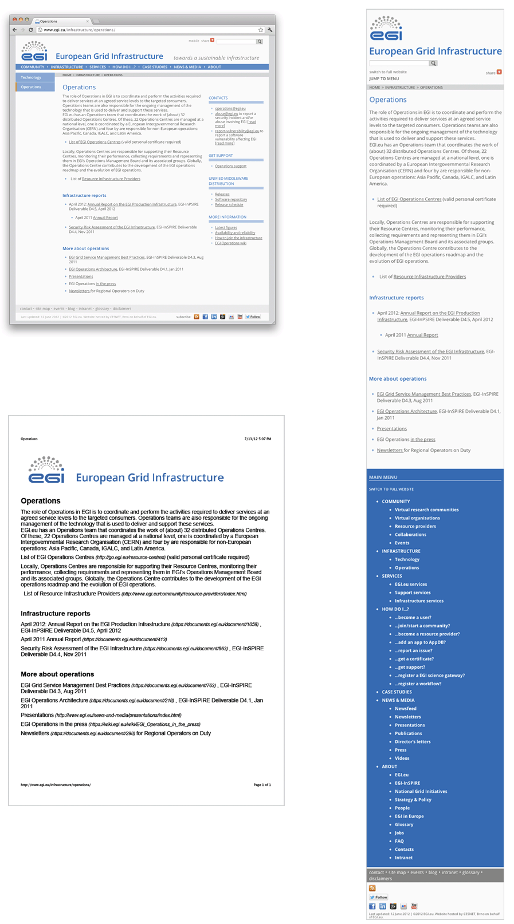
Homepage:

The homepage has been redesigned to make it more attractive and welcoming to visitors, and the contents easier to find and navigate. Useful features from the previous homepage structure have been retained, while new features have been added to improve content visibility and user experience.

Fig. 2 - EGI’s redesigned homepage featuring the new ‘Features’ scrolling gallery, ‘Quick links’ menu targeted at specific audience groups, social media features (top and bottom right corners) and a simplified layout option for mobile devices

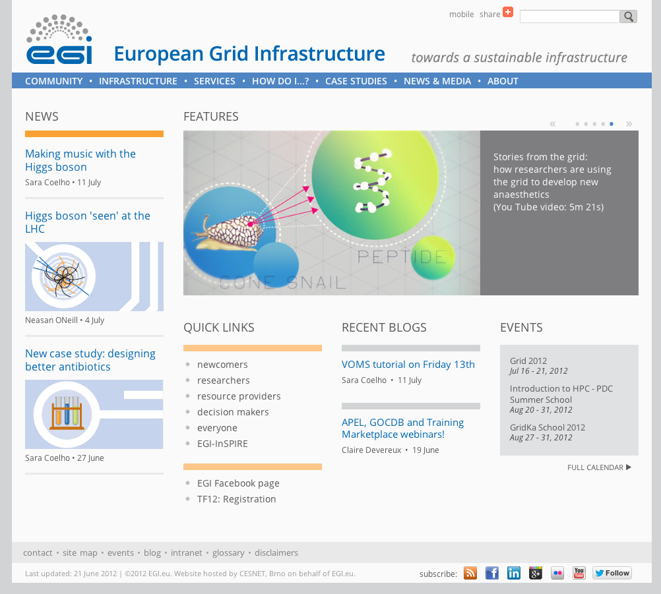

Design features of the new homepage:
- A new ‘Features’ scrolling gallery creates visual impact and highlights current contents of interest. This gallery can accommodate 5 slides, composed of static images (of different file formats: .gif, .jpg, .png) and 1 video embedded directly from EGI’s YouTube channel. Each slide has a teaser headline and links to contents in other parts of the site.
- A ‘Quick Links’ menu with links to landing pages created specifically for different targeted audience groups. (The ‘call for action’ box from the previous website design has been integrated into the lower section this menu.)
- ‘News’ has been brought to the left portion of the website, and highlighted with the brightest orange band, to give this section more prominence.
- The EGI logo and name with tag line, ‘Blogs’, ‘Events’, the search box and the footer menu have been retained and integrated with the new design.

News

New features of the News section:
- In the previous website design, the news landing page consisted of a list of all news articles that have been written since EGI was founded. As the list of News articles grows, they need to be archived to prevent a webpage becoming unusably long. Long webpages overladen with content not only take longer to download, they also make navigation difficult on a small touch screen. In the new design, webpages are archived on separate pages by year (www.egi.eu/news-and-media/newsfeed).
- A larger ‘Add This’ ‘catch-all’ style social media button bar is incorporated into the main content area of every News article (in addition to the smaller standard button embedded in the header) to encourage visitors to share News articles via social media.
- An optional ‘More Information’ section at the bottom of articles can be used for related new articles and links that are not a part of the main article.
- Use of colour to direct user attention. The main news content area has graphic elements in a bright, attention grabbing orange colour (eg. colour of heading and bullet points; see fig. 3) to attract the eye and draw attention to it quickly. The less important ‘More information’ section has grey graphic elements, designed to detract the eye relative to the main article.

Fig. 3 - EGI’s redesigned news article page showing the additional social media button bar (on top of the article date), summary paragraph style (under the heading) and the lower ‘More information’ section for related contents and links.
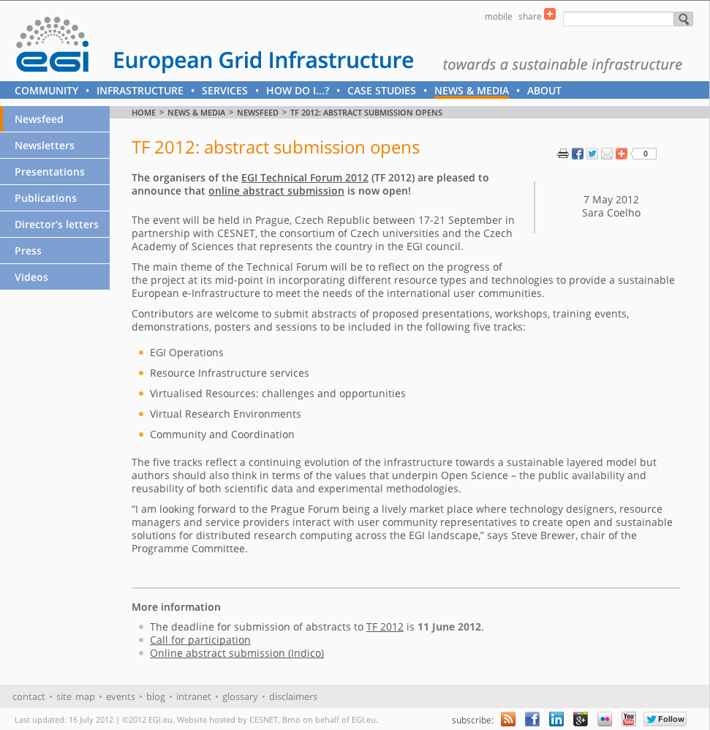

Case Study

The Case Study pages incorporate some design features normally used in magazine articles for an informal editorial look. New features of the Case Study section:
- Pull quote boxes and excerpt boxes with richer images to break up dense blocks of text in the layout.
- The standard-size images (210px), pull quote and excerpt boxes can be used in the right column, or in the main column (positioned to the left or right).
- Pull quotes and excerpt boxes are not displayed in the mobile CSS to save screen display space on small-screen devices.
- A larger ‘Add This’ ‘catch-all’ style social media button bar is incorporated into the top of the right column (in addition to the small standard button embedded in the header) to encourage visitors to share them via social media.
- A PDF download button allows readers to download the entire article to print on a desktop printer and read on paper. This is especially useful where long articles have been separated into more than one page.
- A page pagination menu (to separate a long article into several pages) can be added via the CMS to webpages that may otherwise become extremely long.
Fig. 4 – A case study page showing richer use of text and images; (in the right column) the social media bar, PDF download and excerpt boxes; (at the bottom) a page pagination menu to break up long articles.

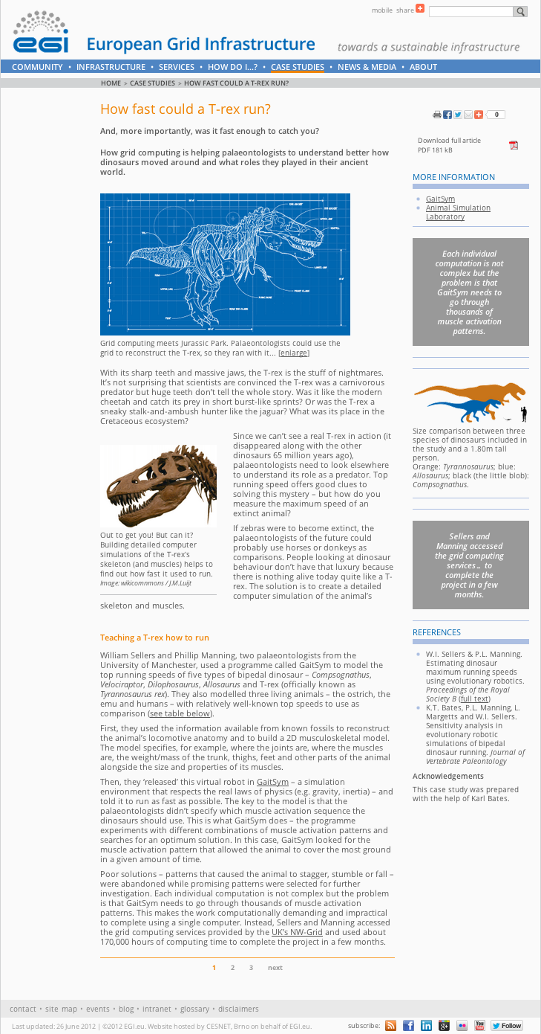

Fig. 5 – A case study page showing the use of pull quote boxes, aligned to the left and right of the main content area
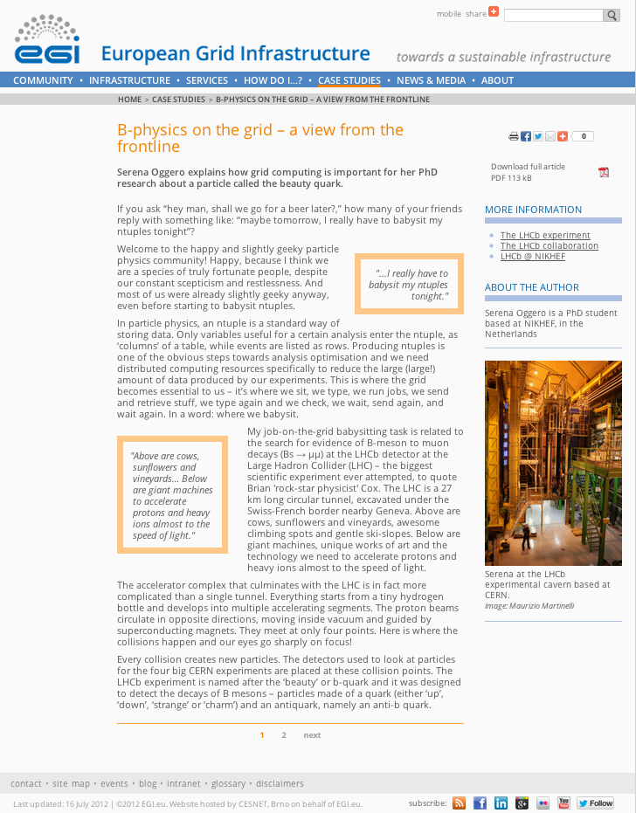

New features for other type of pages:
- gallery of images (for example: www.egi.eu/about/people)
- gallery of thumbnail images (for example: www.egi.eu/news-and-media/publications)
- videos (for example: www.egi.eu/news-and-media/videos)

Further design work

The new design has been completed and little further design work will be necessary, beyond addressing teething problems with the new design that may arise as a result of use, and in response to feedback from users of the website.

A user guide will be created aimed at webpage creators to communicate the design features and how to use them. Snippets of pre-written reusable HTML codes will be incorporated into the CMS for users to add design elements quickly and easily.

A template will be set up to generate PDF files for download for the Cases Study section. The layout will be consistent with the new EGI branding and can be created using open source programmes, without relying on professional design software.

Structure

The website structure has changed considerably since the MS201, MS207 and MS220 reports [R1, R2, R3]. The main sections of the website are:

Title of section | Subsections
Homepage | --
Community  (NEW) | Virtual research communities, Virtual organisations, Resource providers, Collaborations, Events
Infrastructure (rescoped) | Technology, Operations
Services  (NEW) | EGI.eu services, Support services, Infrastructure services
How do I?...  (NEW) | E.g. How do I join/start a community?; How do I add an application to AppDB?; How do I get a certificate?
Case studies  (Upgraded) | Collection of case studies
News & Media  (expanded) | Newsfeed, Newsletters, Presentations, Publications, Director’s letters, Press, Videos
About  (expanded) | EGI.eu, EGI-InSPIRE, National Grid Initiatives, Strategy & Policy, People, EGI in Europe, Glossary, Jobs, FAQs, Contacts, Intranet

Fig. 6: Sitemap as of July 2012

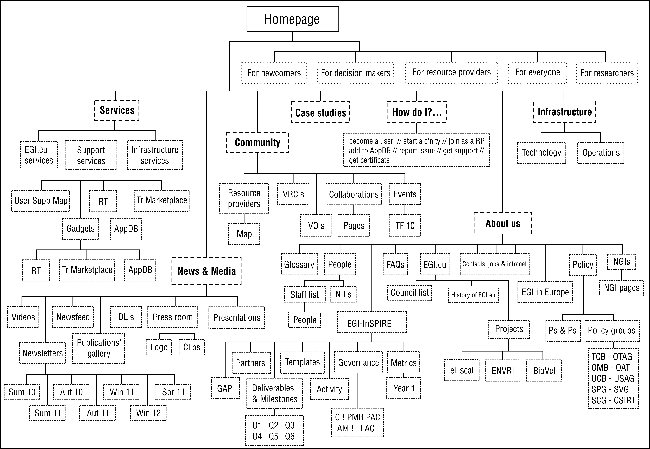

Content

The content of the website has been improved over the past few months, since the relaunch of the website in March 2012.

Recent content improvements

- (Update) We have added three new case studies:
  - Designing better antibiotics (http://go.egi.eu/antib), published 27 June
  - B-physics on the grid – a view from the frontline (http://go.egi.eu/lhcb), published 2 May
  - Modelling earthquakes in Thessaloniki (http://go.egi.eu/thess), published 28 March
All these articles have been republished in iSGTW.

- (Regular Updates) The News subsection has been regularly updated with news items about the EGI community. The rate of publication of news items is now about 5-6 per month.

- (Regular Updates) The Events calendar is now populated with events relevant to the e-Infrastructure community around the world.

- (NEW) Federated clouds page, under Technology in the Infrastructure section

- (NEW) ‘Science gateways’ section, under the Support services section

- (NEW) ‘Workflows’ section, under the Support services section

- (NEW) Interactive map of the worldwide European Grid Infrastructure, highlighting EGI-InSPIRE partners, EGI Council members, peer infrastructures and countries with integrated resource infrastructures (http://www.egi.eu/infrastructure/)

- About section:

- (Updated, rewritten) The ‘EGI in Europe’ has been extensively rewritten to be aligned with the EGI Strategy document that has been published in the meantime
- (NEW) Personal pages for the two new seconded staff members, Jelena Tamuliene and Stephen Burke. The ‘People’ section will be updated within the next few months with pages for permanent or temporary seconded staff.
- (Updated) The ‘Glossary’ pages have been reorganised and updated.

Future work

As of March 2012, the website is fully developed and in line with the EGI strategy for Communications [R5]. Future work will focus on:

- maintain the content of the website, in particular the areas that require frequent updating (e.g.: project metrics, figures and utilisation, milestones and deliverables, newsletter);
- publish news items about the EGI community in the newsfeed;
- develop case studies to populate the ‘Case Study’ section;
- create pages for partner institutions and projects, as EGI.eu enters new collaborations;
- expand the ‘Infrastructure’ section, specifically:
  - add information about the outcomes Federated Clouds taskforce and Virtualised Resources as a service to EGI users
  - reorganise, revise, expand the material within the ‘Operations’ sub-section in consultation with the EGI.eu operations team
- expand the Federated Clouds section of the website as the task force gets underway, and link this to the dedicated social media channels
- carry out evaluation of the website e.g. web survey, observations of usage, focus groups

accessibility and W3c standards

Web accessibility is an evolving subject and a specialist area in itself. However, there are basic standard guidelines that content creators can follow to ensure the site is accessible to a wide range of audiences. An accessibility assessment on the EGI website was carried out on 20 July 2012 based on W3C’s “Checklist of Checkpoints for Web Content Accessibility Guidelines 1.0” (http://www.w3.org/TR/WCAG10/full-checklist.html). Criteria under headings ‘Priority 1 checkpoints’ and ‘Priority 2 checkpoints’ were assessed.

Recent improvements

The redesign had been conducted with W3C good practice in mind, which helps to make the website accessible. An effort was made during this period to correct legacy content with incorrect use of HTML (structurally and/or semantically).

Accessibility assessment result summary

Responses to the W3C checkpoints fall into four categories, defined as follows:
• Yes EGI website is compliant, no action necessary
• Yes, but... EGI website is compliant in certain places, but can be improved
• No EGI website is not complaint with this point
• N/A Not applicable to the EGI website

The table below shows the amount of checkpoints (expressed as %, followed by the quantity in brackets) that fall within each response category. Cells highlighted in blue shows where EGI can make improvements.

Checkpoints | Yes | Yes, but... | No | N/A
Priority 1  (total = 16) | 6% (1) | 25% (4) | 50% (8) | 18% (3)
Priority 2  (total= 30 ) | 23% (7) | 43% (13) | 26 (8) | 6% (2)

This shows that EGI can improve on 75% (25%+50%; 12 out of 16) of the accessibility issues considered most important by W3C; and 69% (43%+26%; 21 out of 30) of the second priority issues. The EGI website is fully complaint with only 8 out of 46 of the accessibility issues assessed.
Refer to the ‘Web accessibility assessment’ document for the full results.

4.3 Future work

To make the EGI website more accessible, training will be explored, so that the whole team is better aware of W3C standards. Training will be arranged for PY3 to allow existing issues to be rectified and to prevent further non-standard HTML being added where it is reasonable and achievable to do so.

Training areas, in order of priority:
- The range of HTML tags available, when to use them and why. How to mark up HTML correctly.
- Accessibility issues
- Usability issues

In this way, legacy and existing contents with accessibility problems should largely be corrected during PY3. The web and communications team will aim to adjust the website meet priority 1 checkpoints initially, followed by priority 2.

Metrics and statistics

Initiatives taken to increase traffic to the website

One of the main goals for running a website is to provide the community with a hub of reliable and up-to-date information. To maximise the impact of this work, it is desirable to increase the traffic and navigation to and within the EGI website. As part of the ongoing drive to increase the visibility of the website, we have:

- Updated the News and Events feed regularly.

- Added a comprehensive list of links to portals, dashboards and other tools used on a day-to-day basis by the Operations teams distributed across the NGIs. The goal is to promote these pages as a directory of useful links to the community.

- Begun a collection of case studies, profiles and engaging stories about the practical uses of e-infrastructures; seven case studies have been completed and many others are (as of July 2012) in several stages of preparation. The case studies are republished on the iSGTW website, where they are often picked by other outlets.

- The website address is written prominently on all printed brochures, articles and posters to drive traffic to the site. We have produced PDF versions of all printed dissemination materials to make the full range of our publications available to a wider audience. Visitors can read publications onscreen or download a copy to print and read or redistribute themselves.

- We have established an EGI blog which gives a dynamic insight ‘behind the scenes of EGI’ and relevant to the community. This is described in more detail in MS217 Dissemination Handbook [R6].

The new website is integrated with social media to help visitors to share content using their preferred channel (from a choice of 323), thereby driving further traffic to the website. An ‘Add This’ ‘catch-all’ type share button is embedded into the header of page templates, making it available on every page of the website.

The new website encourages visitors to subscribe to EGI’s social media and feeds (RSS feeds, Facebook, Twitter, LinkedIn, Google+, Flickr and YouTube). The subscribe buttons are embedded in the footer of the website’s templates, making them available on every page of the site. Subscribers (and their followers) are alerted to new content from EGI through their social media accounts, thereby helping to drive further traffic to the EGI website.

EGI has integrated an automated social media cross-posting process using ‘If This Then That’. When a new News article is published on the website, an excerpt is automatically posted to EGI’s Twitter and Facebook accounts, as well as its RSS feed, with a link back to EGI’s website for the full article or further information.

Overview of web statistics

The metrics provided in this and the following sections refer to the period between 1 July 2011 and 30 June 2012. It is not possible to compare the metrics to the values reported in the previous report. This is due to a reorganisation of the websites within EGI control (which affected the Google Analytics data collection) implemented on 29 January 2010. As such, the previous metrics report accounts for only 5 months, whereas here we give annual metrics. It is however possible to compare rates and as a reference we have included previous values in brackets.

- The website received 201,462 visits, with an average of 552 visits per day [538 visits per day; +2.6%] and 85,494 unique visitors.
- The website recorded 794,061 pageviews, at an average of 3.9 pages viewed per visit [4.5 pages viewed per visit; -13%].
- The average time spent on the website was 00:06:20 [00:07:15; -12.6%]
- We confirmed the following trends:
  - significantly lower number of visitors during weekends;
  - significantly lower number of visitors during holiday periods (weeks around mid-August and around Christmas/New Year)
  - significantly higher number of visitors during the Forum’s weeks
- The busiest day of the period was 20 September 2011 (first day of the Technical Forum in Lyon) with 1,772 visitors.
- Despite the daily peaks, there is no significant overall trend with the monthly average around 16,788 visits per month [16,444 visits per month; ca. +2.1%].

Fig.7 – Visits and visitors to www.egi.eu
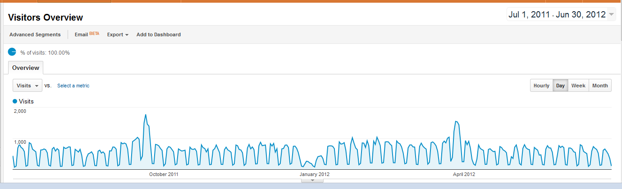

Visitors

- Our visitors come mainly from the Netherlands (26,163 visits), followed by United Kingdom (19,375), and a cluster formed by Italy, Germany, France and Spain (between 12,000-16,000).
- 25.72% of the visitors arrive at the website via direct links, whereas Google accounts for 40.97% of visits (an increase from 34.74% in the last report). Referring sites (top: wiki.egi.eu) are responsible for 32.25% of the traffic (see also Table below).

Fig.8 – Visitors to the www.egi.eu website by country

- The following table lists the top 10 referring sources to the website. Together, they represent 81.2 % of the traffic to the website.

Source/Medium | Visits | % Visits | Variation
google / organic | 82,546 | 41.0% | +5.1%
(direct) / (none) | 51,826 | 25.7% | +16.8%
wiki.egi.eu / referral | 16,259 | 8.1% | -42.1%
egi.eu / referral | 4,904 | 2.4% | +33.3%
mail.google.com / referral | 1,915 | 0.9% | +12.5%
twiki.cern.ch / referral | 1,824 | 0.9% | na
ggus.eu / referral | 1,591 | 0.8% | na
repository.egi.eu / referral | 1,547 | 0.7% | na
eu-egee.org / referral | 1,399 | 0.7% | -65.0%
t.co / referral | 1,064 | 0.5% | na

- Twitter and Facebook appear outside the top 10, with 1,140 and 999 referrals, respectively. Together, visits from Twitter and Facebook resulted in 8,942 pageviews. Overall it’s a small number, but it seems to be an effective way of directing readers to the website with a good potential for growth.
- Top search terms include ‘egi community forum’, egi, ‘egi tf 2011’, ‘egi technical forum’, ‘egi technical forum 2011’, ‘egi.eu’, ‘eudat’

Content

- The most popular sections of the website as a function of ‘page views’ were (see Table 2):
  - Indico (events website) (46.5% [53.0%; -12.3%])
  - About (13.2% [10.6%; +13.2%])
  - SSO (5.3%; [6.0%; -11.7%])

- Given that the website was restructured in March 2012 (two thirds along the way of the period considered for these metrics), it is difficult to create a meaningful list of most popular pages. Some, if not the majority, of the website pages were moved and Google Analytics does not take this into account.

CONclusion

The EGI website (www.egi.eu) has been considerably expanded and upgraded during EGI-InSPIRE’s second year and the quality and quantity of the information published in the various new and updated sections has been enhanced. The frequency of updates to news and the dynamic elements of the website has been increased and maintained at the higher level throughout the review period.

To further build on the progress already made with the website, we plan to review and improve accessibility to make information available to as wide a range of audiences as possible and carry out evaluation of the website in collaboration with users.

A further review of the website will be carried out in PM40 for MS242.

References
R 1 | MS201: EGI website  https://documents.egi.eu/document/126
R 2 | MS207: Review of the website  https://documents.egi.eu/document/179
R 3 | MS220: Review of the Website  https://documents.egi.eu/document/601
R 4 | D2.14 Annual Report on EGI and its External Relations Activity  https://documents.egi.eu/document/1069
R 5 | MS228 Marketing and Communications Handbook  https://documents.egi.eu/document/1160
R 6 | MS217: Dissemination Handbook  https://documents.egi.eu/document/541

Appendix 1: Web accessibility assessment

An accessibility assessment on the WGI website was carried out using W3C’s “Checklist of Checkpoints for Web Content Accessibility Guidelines 1.0” (http://www.w3.org/TR/WCAG10/full-checklist.html). Criteria under headings ‘Priority 1 checkpoints’ and ‘Priority 2 checkpoints’ were assessed. Criteria under ‘Priority 3 checkpoints’ were not assessed.

The term ‘new design’ used in this document refers to the website design launched on 26 March 2012. The assessment was made on webpages that are a part of the new design template only; ie. not the intranet or the EGI blog
(www.egi.eu/blog).

This assessment was intended as an abridged test to identify relatively quickly points that need improvement, rather than a thorough accessibility test. The tools used for assessment were:

Browsers:
- Firefox (version 14.0.1) on Mac (used as the main test browser)
- Chrome (version 20.0.1132.57) on Mac
- Safari (version 5.1.2 (6534.52.7)) on Mac
- Firefox (version 13.0) on Windows PC

Emulators:
- Web Developer 1.1.9 (Firefox add-on): http://addons.mozilla.org/en-US/firefox/addon/web-developer/?src=search
- Fangs Screen Reader Emulator (Firefox add-on): http://addons.mozilla.org/en-us/firefox/addon/fangs-screen-reader-emulator/
- Juicy Studio Accessibility Toolbar 1.7 (Firefox add-on): https://addons.mozilla.org/en-us/firefox/addon/juicy-studio-accessibility-too/
- Lynx Viewer text-based browser test: http://www.yellowpipe.com/yis/tools/lynx/lynx_viewer.php
- Colour analyser: http://gmazzocato.altervista.org/colorwheel/wheel.php

Assessment:
This document’s responses to the checkpoints fall into four categories, defined as follows:
- Yes EGI website is compliant, no action necessary
- Yes, but... EGI website is compliant in certain places, but can be improved
- No EGI website is not complaint with this point
- N/A Not applicable to the EGI website

Weblinks referred to in this document:
Weblinks are provided as references to issues raised, with a description of the problem found. The issues were present at the time of assessment, but web contents change quickly, so may have changed since the assessment was conducted.

Appendix 1:
This section contains links to samples of pages people are likely to visit, and samples of pages containing specific contents. These representative pages were referred to for testing.

SUMMARY OF TEST RESULTS

Checkpoint | Yes | Yes, but... | No | N/A
Priority 1 checkpoints
In General:
1.1 |  | X
2.1 |  |  | X
4.1 |  | X
6.1 |  | X
6.2 |  |  | X
7.1 |  |  |  | X
14.1 | X
Images and image maps:
1.2 |  |  |  | X
9.1 |  |  |  | X
Tables:
5.1 |  | X
5.2 |  |  | X
Frames:
12.1 |  |  | X
Applets and scripts:
6.3 |  |  | X
Multimedia:
1.3 |  |  | X
1.4 |  |  | X
If all else fails:
11.4 |  |  | X
Priority 2 checkpoints
In general:
2.2 |  | X
3.1 |  |  | X
3.2 |  |  | X
3.3 |  | X
3.4 |  | X
3.5 |  | X
3.6 |  | X
3.7 |  | X
6.5 |  |  | X
7.2 |  |  |  | X
7.4 |  |  |  | X
7.5 | X
10.1 |  |  | X
11.1 | X
11.2 |  | X
12.3 |  | X
13.1 |  |  | X
13.2 |  | X
13.3 | X
13.4 | X
Tables:
5.3 |  |  | X
5.4 | X
Frames:
12.2 |  |  | X
Forms:
10.2 |  | X
12.4 |  | X
Applets and scripts:
6.4 |  | X
7.3 |  | X
8.1 |  | X
9.2 |  |  | X
9.3 | X

FULL RESULTS: PRIORITY 1 CHECKPOINTS

In General (Priority 1)

1.1 Provide a text equivalent for every non-text element (e.g., via "alt", "longdesc", or in element content). This includes: images, graphical representations of text (including symbols), image map regions, animations (e.g., animated GIFs), applets and programmatic objects, ascii art, frames, scripts, images used as list bullets, spacers, graphical buttons, sounds (played with or without user interaction), stand-alone audio files, audio tracks of video, and video.

Yes, but we should be doing more.
- Alt tags have been added to most images in the website, but not every image has an alt text.
- Text equivalent elements are missing for interactive elements such as videos and Flash objects. For example:
http://www.egi.eu/news-and-media/videos/
http://www.egi.eu/community/resource-providers/resource_provider_map.html (Flash map)
- Third party plug-in was used, which relied on text embedded in image without alt tag (see example 4a on this page:
http://www.egi.eu/services/support/gadgets/rt/index.html
Screen reader interprets this as:
“Submit requirements to the [Link][Graphic] slash EGI underline logo.png underline one hundred eleven million eight hundred forty-five thousand seven hundred eighty-nine .png [Table] with two columns and eight rows Full Name colon star”

2.1 Ensure that all information conveyed with color is also available without color, for example from context or markup.
No. There has not been an understanding of the need to provide text description for information communicated with colours. Therefore these are missing throughout. For example:
http://www.egi.eu/infrastructure/ (Flash map)
http://www.egi.eu/cms/case-studies/trex.html (image: “Size comparison between three species of dinosaurs...”)

4.1 Clearly identify changes in the natural language of a document's text and any text equivalents (e.g., captions).

Yes, but we should be doing more.
- Captions for tables, where used, have been used within the correct HTML <caption> tags; but all not tables currently have captions. For example, instead of using one caption for each table, one H2 tag has been used for both tables so the structural mark up is incorrect:
http://www.egi.eu/infrastructure/operations/availability_and_reliability
http://www.egi.eu/about/egi-inspire/metrics/
- Language is not currently declared in the <head> of webpages.
- The “lang” attribute has not been used in the contents, but no non-English content was found during this assessment.
- Captions for images are defined in a separate paragraph class <p class="genericcaption">, however, this has no semantic meaning. The <figcaption> semantic HTML tag is intended for this purpose, but it only exists relatively recently in HTML5; the tag is not supported in Internet Explorer earlier than version 8. The current website was not designed in HTML5.

6.1 Organize documents so they may be read without style sheets. For example, when an HTML document is rendered without associated style sheets, it must still be possible to read the document.

Yes, but with one exception from a third party plug-in.
The embedded Google calendar cannot be read easily when styles are disabled:
http://www.egi.eu/community/events/

6.2 Ensure that equivalents for dynamic content are updated when the dynamic content changes.
No. There has not been an understanding of the need to provide text equivalent for dynamic contents, therefore these are missing throughout.

7.1 Until user agents allow users to control flickering, avoid causing the screen to flicker.
N/A (no flickering component present in the website.)

14.1 Use the clearest and simplest language appropriate for a site's content.

Yes

And if you use images and image maps (Priority 1)

1.2 Provide redundant text links for each active region of a server-side image map.
N/A (no image map used)

9.1 Provide client-side image maps instead of server-side image maps except where the regions cannot be defined with an available geometric shape.
N/A (no image map used)

And if you use tables (Priority 1)

5.1 For data tables, identify row and column headers.

Yes, but we have more to do.
There has not been an understanding of how to mark up tables correctly by the whole team. However, since the new design was implemented, some legacy tables have been updated with the correct mark up. For example:
http://www.egi.eu/about/ngis/NILs.html
But not all have been completed. For example:
http://www.egi.eu/community/resource-providers/
In addition, because of this lack of knowledge, tables have been marked up incorrectly to visually format headers in rows and columns, for example, using the <strong> tag:
http://www.egi.eu/infrastructure/operations/figures_and_utilisation/

5.2 For data tables that have two or more logical levels of row or column headers, use markup to associate data cells and header cells.
No. There has not been an understanding of how to mark up tables correctly by the whole team. Data tables with two or more header levels have not been marked up correctly. For example:
http://www.egi.eu/infrastructure/operations/figures_and_utilisation/
http://www.egi.eu/about/egi-inspire/metrics/

And if you use frames (Priority 1)

12.1 Title each frame to facilitate frame identification and navigation.
No. There has not been an understanding of the need to provide ‘name’ and ‘title’ attributes to iframes. Therefore they are missing throughout. For example:
http://www.egi.eu/community/events/ (Google calendar)
http://www.egi.eu/services/support/training_marketplace/index.html
http://www.egi.eu/services/support/applications_database/index.html
http://www.egi.eu/services/support/gadgets/rt/index.html
http://www.egi.eu/community/resource-providers/resource_provider_map.html
http://www.egi.eu/news-and-media/videos/

And if you use applets and scripts (Priority 1)

6.3 Ensure that pages are usable when scripts, applets, or other programmatic objects are turned off or not supported. If this is not possible, provide equivalent information on an alternative accessible page.
No. There has not been an understanding of the need to provide text equivalent content for apps. Therefore they are missing throughout. For example:
- http://www.egi.eu/services/support/applications_database/index.html
- www.egi.eu/services/support/gadgets/rt/index.html
- www.egi.eu/community/resource-providers/resource_provider_map.html
http://www.egi.eu/news-and-media/videos/
- www.egi.eu (the homepage relies on JavaScript to display correctly, because of the slideshow)
- The Google calendar does have HTML equivalent content when JavaScript is disabled.
http://www.egi.eu/community/events/
But the links in the events, link to blank pages; this may be because they are ‘http’ links (?).

And if you use multimedia (Priority 1)

1.3 Until user agents can automatically read aloud the text equivalent of a visual track, provide an auditory description of the important information of the visual track of a multimedia presentation.
No. (because dynamic contents do not have text equivalent at the moment. But they should)

1.4 For any time-based multimedia presentation (e.g., a movie or animation), synchronize equivalent alternatives (e.g., captions or auditory descriptions of the visual track) with the presentation.
No. (because videos do not have text equivalent at the moment. But they should)

And if all else fails (Priority 1)

11.4 If, after best efforts, you cannot create an accessible page, provide a link to an alternative page that uses W3C technologies, is accessible, has equivalent information (or functionality), and is updated as often as the inaccessible (original) page.
No. Effort will be made to make the pages accessible.
FULL RESULTS: PRIORITY 2 CHECKPOINTS

In General (Priority 2)

2.2 Ensure that foreground and background color combinations provide sufficient contrast when viewed by someone having color deficits or when viewed on a black and white screen. [Priority 2 for images, Priority 3 for text].
Yes, but we can improve. (for priority 2; priority 3 criteria are considered for this assessment)
Images are not assessed where they:
- are used as decorative elements
- are photographs
- contain texts but equivalent captions or alt texts have been provided

Some images are missing captions but these should be provided, for example: www.egi.eu/community/events

Where colours have been used to convey information (eg. in maps), the contrast is more difficult to assess because the tests/emulators are assessing texts rather than blocks of colours. In these cases, it is best to provide equivalent content that does not rely on colour perception abilities. for example:
http://www.egi.eu/community/resource-providers/resource_provider_map.html

3.1 When an appropriate markup language exists, use markup rather than images to convey information.
No. (Yes, this applies to the current website, so nothing needs to be addressed on this issue.)

3.2 Create documents that validate to published formal grammars.
No. A sample of the webpages listed for testing, were tested against the W3C validator (http://validator.w3.org). There were a number of errors (from 3 to 7 in one page), mainly extra spaces in the code which were not obvious to see by eye within the header and footer of the template. These errors would be easy to correct.
Note: The website was written in HTML 4, but some structural elements are not HTML4 compliant. For example, the head elements within the main and right content areas of the page. (see the notes in check point 3.5)

3.3 Use style sheets to control layout and presentation.
Yes, but with some exceptions.
The website redesign was carried out with styles controlled by CSS style sheets throughout. However, local styling may still be present in legacy contents in webpages. These should be corrected if and when found. In addition:
- Table had been used for layout in legacy server-side contents generated by the CMS:
https://www.egi.eu/sso/Login.action;jsessionid=A79CC45E4BC9CE0EF7C879C618440B89?to=%2Fsso%2Fuser
- Tables (with further nested tables) have been used in applications made by EGI and third-party:
http://www.egi.eu/services/support/applications_database/index.html
http://www.egi.eu/services/support/gadgets/rt/index.html

3.4 Use relative rather than absolute units in markup language attribute values and style sheet property values.
Yes, but we can improve. (relative units sometimes used, but not always)

3.5 Use header elements to convey document structure and use them according to specification.
Yes, but we can improve. While most pages are correctly marked up in heading structure, this is not the case 100%. For example:
- This page has three H1 level headings and some H2; but there should only be 1 H1 level, with use of H2 and H3 mark-ups for other headings down the page:
http://www.egi.eu/about/jobs/
- “European resource infrastructure providers” has been marked up as an H2 level heading. However, “Other resource providers”, which would be a different category and a separate text to the heading it is under, has been marked up as paragraph text (it should be another H2 heading in this case).
http://www.egi.eu/community/resource-providers

Note: Before the 2012 redesign, the EGI website already consisted of approximately 450 webpages. In a two-column layout, each column in the website was marked up with H1 to H6 heading levels, independent of each other. In other words, you can have an H1 level in the main content area; and another H1 heading in the right side column. This does not conform to HTML 4 best practice, whereby more important information (usually in the main content area) have headings marked up with higher level H tags; and less important information (usually in the right content area) with lower level H tags. To correct this would require manually changing heading tags in the right column to all the affected pages. During the website redesign in 2012, a decision was made not to carry out the labour intensive and time-consuming correction process, because new HTML5 specifications allow this scenario. The current website is still coded in HTML4, because of the relatively new emergence of HTML5 and therefore less browser support for it. While the website remains in HTML4, this mark-up remains incorrect and this is a known error; however, it would aid future transition to HTML5 and save additional labour and time to change heading levels back to match HTML5 specifications (if they were corrected to HTML 4 standard).

3.6 Mark up lists and list items properly.
Yes, but we can improve. Lists (mainly bullet points) are frequently used on the EGI website and occurs on almost every page. Sometimes they are used correctly, however, often they are not necessary or incorrectly used (for visual effect).
- For example, 1 single item does not constitute a list: http://www.egi.eu/infrastructure
http://www.egi.eu/community/vos
http://www.egi.eu/services/egi.eu-services
http://www.egi.eu/about/
- Sometimes they are not used when they can be. For example, the lists in this page can be marked up as ordered lists OL, with indented unordered lists UL nested within. But instead, paragraph tags had been used:
http://www.egi.eu/how-do-I/join_or_start_a_community.html
In this page, point 1 and 2 should be tagged as one ordered list; a nested bullet point is unnecessary:
http://www.egi.eu/how-do-I/add_an_application_to_AppDB.html
- Definition/description lists have been correctly used:
http://www.egi.eu/about/glossary/
http://www.egi.eu/news-and-media/newsfeed/
- It is better to use definition lists than bullet lists in some cases:
http://www.egi.eu/about/egi-inspire/d-and-ms/

3.7 Mark up quotations. Do not use quotation markup for formatting effects such as indentation.
Yes, but we have a lot more to do. There has not been thorough knowledge of the full set of HTML tags, and an understanding of when and why they should be used. Therefore quotation mark ups have not been used where they should. For example, this quote was formatted with ‘<p><em>”’ instead of <q>:
http://www.egi.eu/news-and-media/newsfeed/news_0139_b-physics_on_the_grid.html
However, the new design has been setup to use the q tag where appropriate. For example, template for the pull quote boxes were formatted with <q> tag:
http://www.egi.eu/case-studies/LHCb.html

6.5 Ensure that dynamic content is accessible or provide an alternative presentation or page.
No. (refer to related checkpoints 1.1, 2.1, 6.3, 1.3, 1.4)

7.2 Until user agents allow users to control blinking, avoid causing content to blink (i.e., change presentation at a regular rate, such as turning on and off).
N/A (no blinking content)

7.4 Until user agents provide the ability to stop the refresh, do not create periodically auto-refreshing pages.
N/A (no auto-refresh content)

7.5 Until user agents provide the ability to stop auto-redirect, do not use markup to redirect pages automatically. Instead, configure the server to perform redirects.
Yes. (redirects are carried out by the server)

10.1 Until user agents allow users to turn off spawned windows, do not cause pop-ups or other windows to appear and do not change the current window without informing the user.
No. (at the moment, the website opens a new window for an external link)

11.1 Use W3C technologies when they are available and appropriate for a task and use the latest versions when supported.
Yes. This is true as far as we are aware, excluding certain known issues. For example, heading structure (see note in checkpoint 3.5), the need for the whole team to understand and appreciate the correct usage of HTML tags.
(W3C technologies is understood to mean specifications, guidelines, software, and tools.)

11.2 Avoid deprecated features of W3C technologies.
Yes, but we may have more to do. While effort has been made to correct content with deprecated tags during the course of the new website redesign, there may still be legacy content hidden within the website with deprecated features. These should be corrected if they are found, but it relies on every member of the team knowing which tags are deprecated.

12.3 Divide large blocks of information into more manageable groups where natural and appropriate.
Yes, but we can do more.
This already applies to many parts of the website. However, sometimes a webpage can become very long. Long pages are not so easy to navigate by scrolling on a small screen. Anchor links could have been used to make this easier.

13.1 Clearly identify the target of each link.
No. There has not been an appreciation by the whole team for the need to indicate targets of links before a user clicks on it. While this has been implemented in some places, there are many examples where this has not been the case.
In addition, the use of short links instead of the full URL file path means that a user cannot tell from looking at the status bar of a web browser what type of file or page a link is targeting when the cursor is on top of the link. For example, the short links embedded in the URLs in the right column are directing users to different types of files. But there is no way of knowing (what type of document a link points to (eg. HTML. PDF), whether a link to a page is internal or external, the size of the download, if the link requires the user to log-in an account, etc.) until a user clicks on it and see what happens:
http://www.egi.eu/news-and-media/newsletters/Inspired_Autumn_2011/horizon_2020_what_to_expect.html
http://www.egi.eu/infrastructure/operations/figures_and_utilisation/
('HEP-SPEC 06 definition' link at bottom of the page)

13.2 Provide metadata to add semantic information to pages and sites.
Yes, but we should be doing more.
(1) Metadata:
Meta content currently present (the same on every webpage):
<meta http-equiv="Content-Type" content="text/html; charset=utf-8"/>
<meta name="generator" content="OpenCMS"/>
- These do not give information on the article content of a particular webpage.
- We can improve by adding meta attributes: “keywords”, “lang”, a descriptive “content” text; “dir”.
(2) semantic HTML tags:
- The (mandatory) <title> tag is present.
- Use of tags in the correct context where available, needs to be improved (refer to checkpoints 1.1, 4.1, 5.1, 12.1, 3.5, 3.6, 3.7, 11.2.)
- Form has been laid out using tables, which is unnecessary (should use CSS instead) and semantically incorrect because forms are not tabular content:
http://www.egi.eu/sso/Login.action;jsessionid=A79CC45E4BC9CE0EF7C879C618440B89?to=%2Fsso%2Fuser
http://www.egi.eu/services/support/gadgets/rt/index.html
http://www.egi.eu/services/support/applications_database/index.html

13.3 Provide information about the general layout of a site (e.g., a site map or table of contents).
Yes. (sitemap is used: http://www.egi.eu/about/site-map/)

13.4 Use navigation mechanisms in a consistent manner.
Yes. Navigation menus (top and side navigation menus, breadcrumb, footer) are consistent: look similar on every page; presented in a consistent sequence, page position, terminology and behaviour.

And if you use tables (Priority 2)

5.3 Do not use tables for layout unless the table makes sense when linearized. Otherwise, if the table does not make sense, provide an alternative equivalent (which may be a linearized version).
No.
- Table used for layout in server-side legacy content, where CSS could have been used instead:
http://www.egi.eu/sso/Login.action;jsessionid=A79CC45E4BC9CE0EF7C879C618440B89?to=%2Fsso%2Fuser
- Tables are used for layout in EGI and third-party plug-ins:
http://www.egi.eu/services/support/gadgets/rt/index.html
http://www.egi.eu/services/support/applications_database/index.html

5.4 If a table is used for layout, do not use any structural markup for the purpose of visual formatting.
Yes. (but third party plug-ins embedded in the site have not been assessed)

And if you use frames (Priority 2)

12.2 Describe the purpose of frames and how frames relate to each other if it is not obvious by frame titles alone.
No. Frames (iframes) do not have titles; nor description.

And if you use forms (Priority 2)
10.2 Until user agents support explicit associations between labels and form controls, for all form controls with implicitly associated labels, ensure that the label is properly positioned.
Yes, but we can improve.
- Form labels appear to be sufficient as they are relatively simple:
http://www.egi.eu/404
http://www.egi.eu/sso/email
http://www.egi.eu/sso/Login.action;jsessionid=A79CC45E4BC9CE0EF7C879C618440B89?to=%2Fsso%2Fuser
- However forms in iframe plug-ins are more difficult to assess without access to the original code or a text browser installed on a local machine:
www.egi.eu/services/support/applications_database/index.html
www.egi.eu/services/support/gadgets/rt/index.html

12.4 Associate labels explicitly with their controls.
Yes, but we can do more. While associations between labels and controls are not ambiguous, they are not always explicit. For example:
http://www.egi.eu/sso/email
The code of the form is written as:
<form action="/sso/email" method="post">Please enter you e-mail address: <input name="email" type="text" size="25" />
<input name="mail" value="Submit" type="submit" />
<div style="display: none;"><input type="hidden" name="_sourcePage" value="4j5Wv3ZqtZs5BVYuqycMCG_iCdpqgV1u" /><input type="hidden" name="__fp" value="CxgFymM3Wf4=" /></div>
</form>
“Please enter you e-mail address:” is not in a <label> tag.

And if you use applets and scripts (Priority 2)

6.4 For scripts and applets, ensure that event handlers are input device-independent.
Yes, but we can be doing more. The JQuery slideshow on the home page and embedded app/gadgets (eg. training marketplace, app db) can be navigated using a keyboard or touch screen only:
http://www.egi.eu/services/support/training_marketplace/index.html
http://www.egi.eu/services/support/applications_database/index.html
www.egi.eu/services/support/gadgets/rt/index.html
The embedded Google calendar has very limited navigation using a keyboard:
http://www.egi.eu/community/events/
None of the Flash contents have keyboard access at all; they are also inaccessible to devices without Flash plug-ins (eg. iPhone, iPads). For example:
http://www.egi.eu/community/resource-providers/resource_provider_map.html

Note: In general, it is possible to navigate the website using only the keyboard without a mouse, but not as fluently. Drop-down and pop-out menus currently do not work with keyboard navigation, so secondary and tertiary options are not displayed. Tertiary links are not always obvious without the pop-out menu from the side navigation. Therefore pages below level 3 (not counting the homepage) may be ‘hidden’ from visitors using only a keyboard. (This is also true for visitors using touch screen devices.) Tab ordering can be improved; but how well the tab navigation works appears to differ between browsers and platforms.

7.3 Until user agents allow users to freeze moving content, avoid movement in pages.
Yes, with a few exceptions.
Elements with moving contents, eg. videos, do not autoplay on the website. However, there is rotating text in embedded web gadgets where movement cannot be controlled by a user:
www.egi.eu/services/support/gadgets/rt/index.html

8.1 Make programmatic elements such as scripts and applets directly accessible or compatible with assistive technologies [Priority 1 if functionality is important and not presented elsewhere, otherwise Priority 2.]
Yes, but we can do more and need more in-depth assessment on plug-ins.
This section was checked within the limitation of what technologies we are aware of (screen readers, screen magnifiers (www.webcredible.co.uk/user-friendly-resources/web-accessibility/screen-magnifiers.shtml), keyboard input) and how/what we can assess ourselves, without being users of assistive technologies.
- As mentioned in checkpoint 6.4, embedded elements such as Flash and Google calendar have limited or no accessible capabilities without using a mouse.
- The homepage slide show and image gallery enlarging features (http://www.egi.eu/news-and-media/publications/) that use Javascript/JQuery appear to be accessible using touch screens, keyboards, screen readers and mice (check point 9.3).
- plug-in relies on text created as an image, without supplying alt text (EGI logo embedded in example 4a on this page; also refer to check point1.1): http://www.egi.eu/services/support/gadgets/rt/index.html
- overall, some plug-ins may not be coded correctly for accessibility purposes (eg. refer to check point 10.2), more investigation would be needed to make a full assessment.

9.2 Ensure that any element that has its own interface can be operated in a device-independent manner.
No. (refer to checkpoint 6.4)

9.3 For scripts, specify logical event handlers rather than device-dependent event handlers.
Yes. Forms and scripts appear to be device independent. Form elements; homepage slide show and image gallery enlarging features (http://www.egi.eu/news-and-media/publications/) that use Javascript/JQuery are accessible using touch screens, keyboards, screen readers and mice.

APPPENDIX 1

Samples of pages people are likely to visit, and samples of pages containing specific contents.

A variety of pages people are likely to visit:

- Homepage: www.egi.eu
- Newcomers, researchers: http://www.egi.eu/links-for/researchers/index.html
- Second level pages:
- http://www.egi.eu/services/
- http://www.egi.eu/case-studies/
- Third level pages:
- http://www.egi.eu/news-and-media/newsfeed/news_0142_reviving_sounds_epigonion.html
- http//www.egi.eu/news-and-media/press/

Pages with dynamically generated content:
www.egi.eu
http://www.egi.eu/news-and-media/newsfeed/
http://www.egi.eu/about/glossary/
http://www.egi.eu/about/glossary/glossary_all.html
http://www.egi.eu/about/site-map/

Pages with images:
http://www.egi.eu/news-and-media/publications/
http://www.egi.eu/about/people/
http://www.egi.eu/news-and-media/newsletters/
http://www.egi.eu/cms/case-studies/trex.html
http://www.egi.eu/about/egi-inspire/governance/

Pages with videos:
http://www.egi.eu/news-and-media/videos/

Pages with tables:
http://www.egi.eu/about/ngis/NILs.html
http://www.egi.eu/community/vrcs/
http://www.egi.eu/community/resource-providers/
http://www.egi.eu/infrastructure/operations/figures_and_utilisation/
http://www.egi.eu/infrastructure/operations/availability_and_reliability
http://www.egi.eu/about/egi-inspire/metrics/
http://www.egi.eu/sso/Login.action;jsessionid=A79CC45E4BC9CE0EF7C879C618440B89?to=%2Fsso%2Fuser (Note: incorrect usage of table for layout)

Pages with forms:
http://www.egi.eu/404
http://www.egi.eu/sso/email
http://www.egi.eu/sso/Login.action;jsessionid=A79CC45E4BC9CE0EF7C879C618440B89?to=%2Fsso%2Fuser
http://www.egi.eu/services/support/training_marketplace/index.html
http://www.egi.eu/services/support/gadgets/rt/index.html

Pages with inserted apps:
http://www.egi.eu/community/events/
http://www.egi.eu/services/support/training_marketplace/index.html
http://www.egi.eu/services/support/applications_database/index.html
http://www.egi.eu/services/support/gadgets/rt/index.html
http://www.egi.e

The EGI wiki (https://wiki.egi.eu/wiki/Main_Page) is aimed specifically at the EGI-InSPIRE community and focuses on the practical information required to run the infrastructure.
The EGI wiki (https://wiki.egi.eu/wiki/Main_Page) is aimed specifically at the EGI-InSPIRE community and focuses on the practical information required to run the infrastructure.
For example: Could you outrun a Tyrannosaurus rex? (http://io9.com/5853758/could-you-outrun-a-tyrannosaurus-rex)

