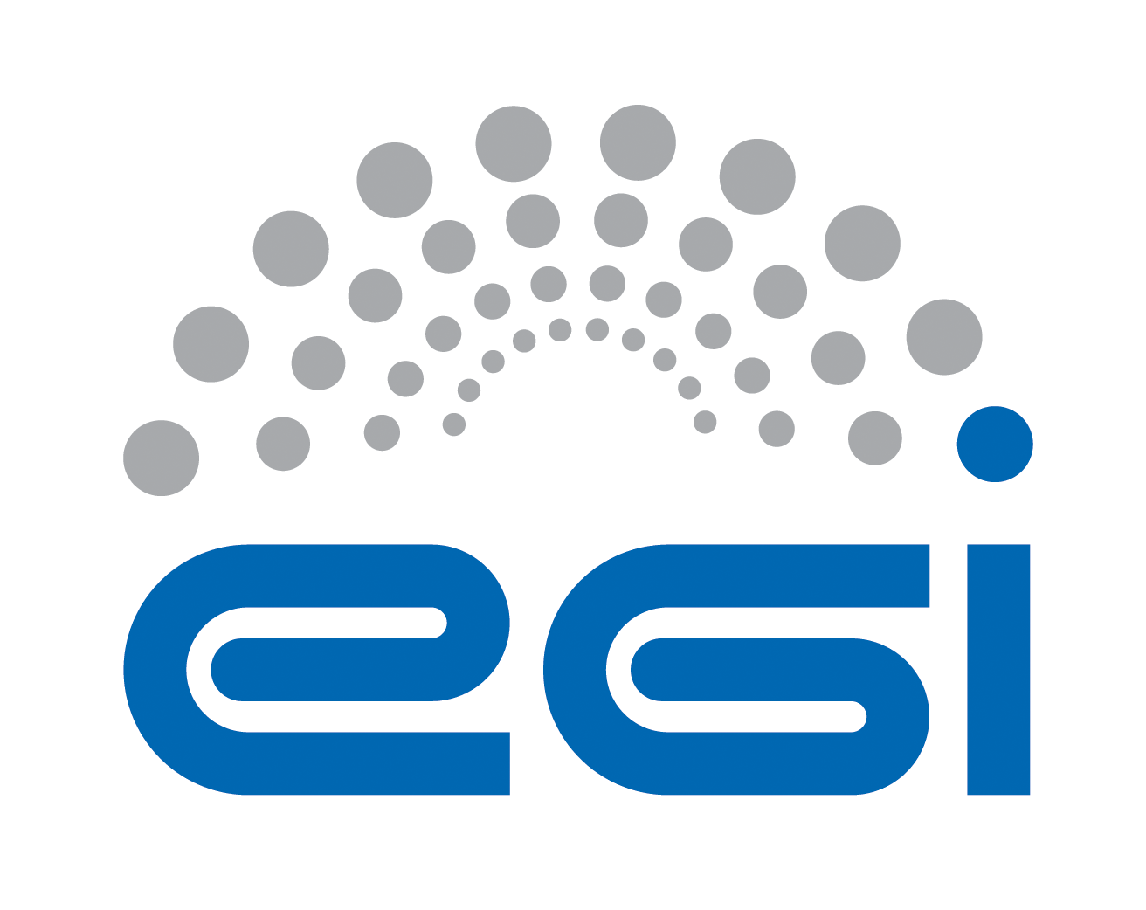
Acceptable Use Policy and conditions of use
of the EGI Platform for sharing and reuse scientific applications

Document identifier | AUP-EGI-Platform-for-sharing-and-reuse-scientific-applications
Document Link | https://documents.egi.eu/document/2635
Last Modified | 30/01/2017
Version | 7
Policy Group Acronym | SPG
Policy Group Name | Security Policy Group
Contact Person | Gergely Sipos / EGI Foundation
Document Type | Security Policy
Document Status | Approved
Approved by | EGI Foundation Executive Board
Approved Date | 10/10/2016

TABLE OF CONTENTS

1 ACCEPTABLE USE POLICY AND CONDITIONS OF USE 4
2 REFERENCES 6

COPYRIGHT NOTICE
This work by EGI Foundation is licensed under a Creative Commons Attribution 4.0 International License (http://creativecommons.org/licenses/by/4.0/).

DELIVERY SLIP
 | Body | Date
Reviewed by | EGI Operation Management Board | 26/05/2016
Reviewed and approved by | EGI Foundation Executive Board | 10/10/2016

DOCUMENT LOG
Issue | Date | Comment | Author/Partner
V1-3 | 01/04/2016 | Internal drafts | Gergely Sipos/EGI Foundation
V4 | 01/05/2016 | Complete version ready for approval (based on input from SPG) | Gergely Sipos/EGI Foundation
 | 10/10/2016 | Approved version (by OMB and EB)
V5 | 20/10/2016 | Updated document metadata | Giuseppe La Rocca/EGI Foundation
V6 | 21/10/2016 | Updated delivery slip, references, metadata | Gergely Sipos /EGI Foundation
V7 | 30/01/2017 | Updated the name of the Platform | Giuseppe La Rocca /EGI Foundation

TERMINOLOGY
A complete project glossary is provided at the following page: https://wiki.egi.eu/wiki/Glossary_V2
APPLICATION AREA
This document is a formal EGI policy or procedure applicable to users of the EGI Platform for sharing and reuse scientific applications that’s accessible at http://access.egi.eu.
POLICY/PROCEDURE AMENDMENT PROCEDURE
Reviews and amendments should be done in accordance with the EGI “Policy Development Process” (https://documents.egi.eu/document/169). Requests for updates should be sent to support@egi.eu.

ACCEPTABLE USE POLICY AND CONDITIONS OF USE
This acceptable Use Policy and Conditions of Use applies to all the users of the ‘EGI Platform for sharing and reuse scientific applications’ [R2], hereafter referred to as the Platform. This policy is one of a set of documents that together define the Security Policy [R3]. The EGI Foundation owns and gives authority to this policy [R4].

The goal of the Platform is to offer user-friendly access to e-infrastructure services for members of the long tail of science, i.e. for individual researchers and small research teams who do not belong to any of the established EGI Virtual Organisation communities [R5].

By registering in the Platform as a user you declare that you have read, understood and will abide by the following conditions of use:

- You can use the services and resources of the Platform only for activities that relate to the work that you described in the form when you applied for access.
- Your registration can be suspended when you exceed the resources that were allocated for you during membership approval, or when your membership expires. (Membership is initially 6 months and can be extended for another 6 months).
- You shall provide appropriate acknowledgement of support for your use of the resources/services provided. The following acknowledgement text can be used for this purpose (e.g. in scientific publications):
This work used the EGI Infrastructure, which is co-funded by the EGI-Engage project (Horizon 2020) under Grant number 654142.
- You shall not use the resources/services of the Platform for any purpose that is unlawful and not (attempt to) breach or circumvent any administrative or security controls.
- You shall respect intellectual property and confidentiality agreements.
- You shall protect your access credentials (for example usernames and passwords).
- You shall keep all your registered information correct and up to date.
- You shall immediately report any known or suspected security breach or misuse of the Platform services/resources or access credentials to abuse@egi.eu and to other relevant credential issuing authorities.
- You use the Platform resources/services at your own risk. There is no guarantee that the resources/services will be available at any time or that their integrity or confidentiality will be preserved or that they will suit any purpose.
- You agree that logged information, including personal data provided by you for registration purposes, may be used for administrative, operational, accounting, monitoring and security purposes. You agree that this logged information may be disclosed to other authorised participants via secured mechanisms, only for the same purposes and only as far as necessary to provide the services.
- You agree that the body or bodies granting you access and resource/service providers are entitled to regulate, suspend or terminate your access without prior notice and without compensation, within their domain of authority, and you shall immediately comply with their instructions.
- You are liable for the consequences of your violation of any of these conditions of use, which may include but are not limited to the reporting of your violation to your home institute and, if the activities are thought to be illegal, to appropriate law enforcement agencies.

REFERENCES
R1 | Long-tail of Science Activity Wiki: https://wiki.egi.eu/wiki/Long-tail_of_science_activity
R2 | EGI Platform for sharing and reuse scientific applications: https://access.egi.eu
R3 | Approved EGI Security Policies: https://wiki.egi.eu/wiki/SPG:Documents
R4 | EGI website: www.egi.eu
R5 | EGI Virtual Organisations: https://operations-portal.egi.eu/vo/search

