User and General EGI Sustainability Workshop
Preparatory Survey for the National Sustainability breakout session

A fully developed EGI ecosystem has many interacting entities. For stability and sustainability these interactions provide value to the different entities. By creating value, we generally mean to realise benefits at an optimal resource cost whilst reducing risks. The EGI ecosystem is sustainable only when it is capable of ensuring its value creation along the chained interactions between different entities.. In order for the EGI ecosystem to be sustainable, all its entities, including NGIs, need to be sustainable.

In this session, we focus on the sustainability of the national parts of the EGI ecosystem. The goal of the session is to gain clarity on:
- How each NGI sees the sustainability of its national entities and how they will evolve as part of the EGI ecosystem?
- What is the NGI’s long-term vision and its relationship to the EGI ecosystem and the overarching E-Research 2020 vision?
- What are the core customer needs that each NGI needs to satisfy?
VISION

E-Research 2020 Vision:
By 2020, the online European Research Area has been established with services designed to meet every phase of the research to innovation life-cycle. Research teams across Europe work together thanks to integrated and federated services that present a seamless environment that is available to the scientist in a University, the researcher in a small enterprise, to the citizen scientist. The data tsunami coming from medical instruments, supercomputers, sensor networks and research infrastructures established from the start of the 21st century and deriving from the digitalisation of research has been harnessed and data analysis can take place anywhere –in our homes, in our work places, co-located with the data to comply with usage restrictions, or anonymously in the vast data and compute centres that will provide the backbone to our European e-Infrastructure.

NGI Vision
What do you see your NGI becoming in 2020? (max 50 words)
e.g.: A national coordinator for a federated national e-Infrastructure seamlessly integrating with other regional e-Infrastructures enabling diverse user communities to deploy on-demand services and manage and preserve their scientific data in a secure, collaborative, fast, stable and way;
e.g.: A centre of competences to provide specialised expertise in consulting user communities to handle their scientific computing needs in in both commercial and publicly-funded e-Infrastructures
EGI Ecosystem by 2020
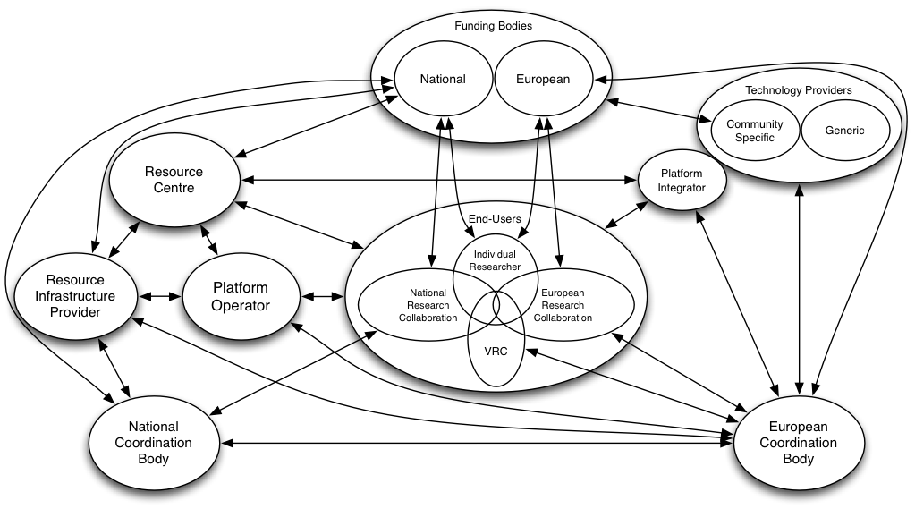
Many entities live in the EGI ecosystem, which engage in interactions that receive inputs from others, converting them into value using internal assets and generate an output. Similar to a natural ecosystem, the EGI ecosystem is complex and continues to evolve. In the above picture we depict an evolution of the EGI ecosystem by 2020. Given this scenario and the description of roles given below, which roles do you foresee your NGI promoting in 2020 and what capacity/capability do you see that needs to be established to achieve this? (say yes or no for each role)

[yes/no] Individual Researcher: a user of e-Science services (supported by e-Infrastructure) in order to run its/her own research analysis. | [yes/no] Resource Centre: Provider of compute, storage and other resources that are exposed through locally deployed services to meet the needs of particular research communities.
[yes/no] Research Collaboration: a group of scientists and researchers from institutes and/or universities working together for a common goal either on a National or European level. | [yes/no] Resource Infrastructure Provider: It manages, on a geographical basis (generally through national borders), the aggregation of the services provided by individual resource centres and manage the operational delivery of the coordination services under their management.
[yes/no] Virtual Research Community: a structured European end-user community such as an EIROForum lab or a European wide research collaboration that has end-users who wish to systematically access distributed resource provided by their own community across Europe. | [yes/no] National Coordination Body: Has a defined governance role within their national borders as being the designated representative for their country’s activities internally and internationally.
[yes/no] Platform Operator: Ensures that the services that make a platform integrated and deployed on behalf of a particular user community are operating effectively on the distributed resources. | [yes/no] Platform Integrator: brings together components from different technology providers to meet the needs of a particular consuming community (e.g. individual researcher, research group, VRC or infrastructure provider).
[yes/no] Technology Provider: an open-source software collaboration or commercial software provider that delivers technology to infrastructure providers or virtual research communities.
Comments (if any):
CUSTOMER NEEDS
The proper identification of the customer needs is of profound importance. Satisfying customer needs is a two-way issue: although the value that your NGI is bringing into the world is above all else designed to satisfy real customer needs, at the same time the satisfaction of those needs in turn creates value for all of the stakeholders involved in creating the product/service. Look at what customers really want from your products/services and what they satisfy deep down.

When exploring the customer needs, consider the two main categories:
- Functional needs
- Emotional needs (e.g., you can consider the top 10: security, attention, sense of autonomy and control, feeling part of a wider community, privacy, sense of status within social groupings, sense of competence and achievement, meaning and purpose)

Explore the possible reasons for those needs (what are they for? what do they satisfy?). Then try to reduce the list to those core unique needs.

NGI Customers’ Needs
What are the core customer needs that your NGI is aiming to satisfy with your products or services? (For each type of customer, identify the top 7 functional needs and top 3 emotional needs listed in order of importance)
E.g.:
For researchers/scientists:
- Functional needs (top 7): 1) Manage, preserve, securely share large-scale scientific data in remote systems; 2) Run large-scale applications on remote systems to analyze/generate data; 3) On-demand deployment of services on OS of their choice in remote systems; 4) Receive specialized consulting on the best way to manage their data remotely and to run their applications; 5) Collaborate with other scientists/researchers; 6) Being timely supported for technical problems;
- Emotional needs (top 3):

For resource centers:
- Functional needs (top 7):
- Emotional needs (top 3):

Name: ___________________________________ NGI _______________________________________

http://www.humangivenscollege.com/hg/needs.html

