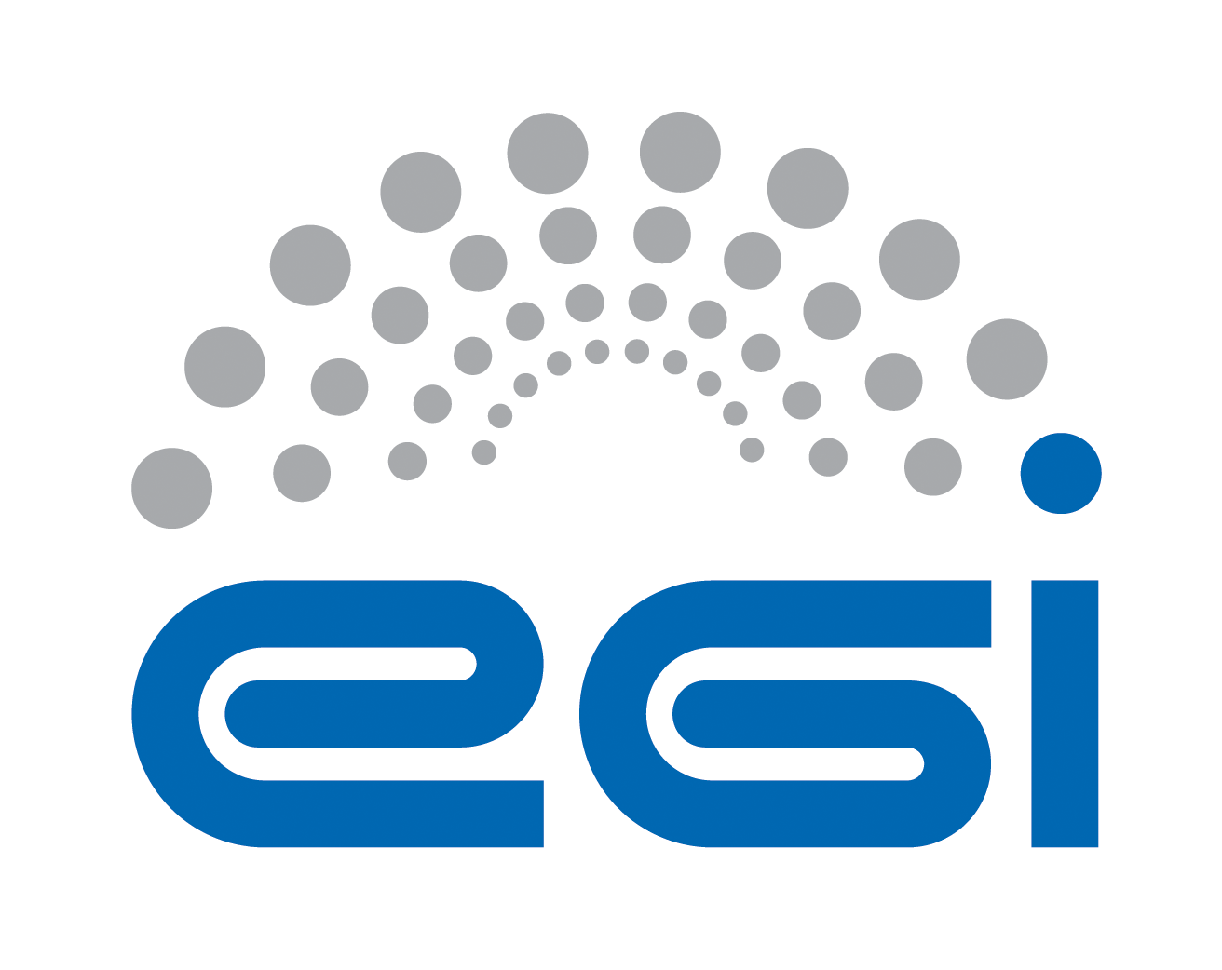
Partner Logo

Memorandum of Understanding between
[EGI.eu|EGI-Engage] and [Partner]

Instructions (to be removed)
This is a modular and unified template to establish an MoU between EGI.eu or EGI-Engage and another partner.
- Define if the MoU should be established with EGI.eu or EGI-Engage
- Define who is the legal partner name and acronym
- Define the type of MoU
  - Infrastructure Provider [MOU:INFRA]
  - Technology Provider [MOU:TP]
  - Virtual Research Community [MOU:VRC]
  - Project [MOU:PRJ]
  - Other (e.g. organisation)
- Add the partner logo in the front page
- Using the function “replace”
  - Replace ‘[EGI.eu|EGI-Engage]’ with the selected partner name
  - Replace ‘[Partner]’ with the partner name
  - Replace ‘[PartnerAcronym]’ with the partner acronym
- Once final, remove yellow
TABLE OF CONTENTS
Background 3
Article 1: PURPOSE 4
Article 2: Definitions 4
Article 3: Joint Work plan 4
Article 4: Communication 5
Article 5: Rights and Responsibilities 6
Article 6: Funding 6
Article 7: Entry into force, duration and termination 7
Article 8: Amendments 7
Article 9: Annexes 7
Article 10: Language 7
Article 11: Governing Law – Dispute resolution 7
Annex 1 – [EGI.eu|EGI-Engage] Description 9
Annex 2 – [Partner] Description 11
Annex 3 – Rights and Responsibilities 12
Annex 4 – Settlement of Disputes 14
Detailed Contact List 15

Background
(If with EGI.eu)
The Stichting European Grid Initiative (hereafter referred to as “EGI.eu”) is a not-for-profit foundation established under Dutch law to coordinate and manage the EGI Infrastructure federation on behalf of its members: National Grid Initiatives (NGIs) and European International Research Organisations (EIROs). EGI.eu offers a variety of services to the wider EGI community such overseeing infrastructure operations, coordinating user community support, working with technology providers, representing EGI in collaborative projects, steering strategy and policy development, organising EGI’s flagship events and publicising the community’s news and achievements. A more detailed description of EGI.eu is attached as Annex 1.
(If with EGI-Engage)
The EGI-Engage project (Engaging the Research Community towards an Open Science Commons) started in March 2015, co-funded by the European Commission for 30 months, as a collaborative effort involving more than 70 institutions in over 30 countries. EGI-Engage aims to accelerate the implementation of the Open Science Commons by expanding the capabilities of a European backbone of federated services for compute, storage, data, communication, knowledge and expertise, complementing community-specific capabilities. A more detailed description of EGI-Engage is attached as Annex 1.

The [Partner] (hereafter referred to as [PartnerAcronym]) aims to (insert a short description about the partner). A summary of [Partner] is attached as Annex 2.

(If with EGI-Engage)
Institutions common to both parties are:…

[MOU:INFRA]
[Partner] received a mandate from <specify> to represent the following Institutions, who wish to participate in the framework of collaboration defined in this document, and delegate it to represent them in EGI.eu policy groups:
- <list of institutions>
Annex 2 contains the list of the participating Resource Centres that the listed Institutions are responsible for.

Article 1: PURPOSE
The purpose of this Memorandum of Understanding (MoU) is to define a framework of collaboration between [EGI.eu|EGI-Engage] and [Partner] (hereafter also referred to as “the Party” or the “Parties”) for delivering the activities outlined within the Joint Work Plan (Article 3). The Parties recognise, by this MoU, the opening of a wider and longer-term cooperation in activities, which will bring visible benefits to everyone involved.

Article 2: Definitions
For the purpose of this MoU, the following definitions are relevant:
- The terms defined in the EGI glossary (http://go.egi.eu/glossary)
- Add definitions relevant for this MoU not present in the EGI Glossary

Article 3: Joint Work plan
The parties contribute to enable the vision of providing European scientists and international collaboration for sustainable distributed computing services to support their work.
In this broad context, the specific goals of the collaborations are to:
(these are just some suggestions for type of content)
Some examples for Technology Providers:
- Provide robust, well-designed, user-centric services to scientific user communities
- Define and monitor SLA for third-level support on incidents and requests
- Accelerate the development of standards within production grid infrastructures
- Disseminate the results of this collaboration within the remit of each project’s dissemination and communication activities such as joint events
- Exchange ideas and collaborate on the definition of sustainability models
- Collaborate in business relationships development
Some examples for Infrastructure Providers:
- Enhance the capacities of both infrastructures
- Provide Local and Global operational services as needed to support the international user community and the EGI operational needs
- Subscribe to a mandatory set of policies, procedures and OLAs
- Comply with the operations interfaces required by the EGI Operations Architecture, which are needed to ensure seamless and interoperable access to resources
- Participate in the Operations Management Board to contribute to the EGI operations agenda
- Participate in the Security Policy Team to contribute to the development of the security policies fabric of the infrastructure
Some examples for Projects and VRCs:
- Dissemination
- Training
- Support Tools and Services
- Sustainability
- Standards and Interoperability
- Integration
- VRC Coordination
The specific activities to be carried out in the framework of the collaboration are:
(you may want to read previously approved MoUs for examples: https://wiki.egi.eu/wiki/Agreements)
WP1 Activity Name
Parties Involved: [EGI.eu|EGI-Engage] Activity (name); Partner (name, organisation)
Description of work:
Expected outcome:
- A1.1 (MM/YYYY) - description (Leader Name Surname)
- A1.2 (MM/YYYY) - description (Leader Name Surname)
- A1.3 (MM/YYYY) - description (Leader Name Surname)
WP2 Activity Name
Parties Involved: [EGI.eu|EGI-Engage] Activity (name); Partner (name, organisation)
Description of work:
Expected outcome:
- A2.1 (MM/YYYY) - description (Leader Name Surname)
- A2.2 (MM/YYYY) - description (Leader Name Surname)

The EGI.eu Strategy and Policy Team (SPT) will coordinate the periodic review of the progress of the activities defined in the table above, follow-up the milestones and distribute reports to both Parties. Special meetings between the points of contact designated under 4 (Communication) shall be held, as often as necessary, to examine the progress in the implementing of this Agreement.

Article 4: Communication
The Parties shall keep each other informed on all their respective activities and on their progress and shall consult regularly on areas offering potential for cooperation.

[MOU:TP]
[Partner] agrees to name a technical representative (with deputy) for the EGI.eu Technical Board (TCB).
[Partner] agrees to name a technical representative (with deputy) for the EGI.eu Security Coordination Group (SCG).
[Partner] agrees to regularly attend the meetings of EGI.eu TCB and SCG as observer.
[Partner] will become a voting member in both groups after signing the SLA.

[MOU:VRC]
[Partner] agrees to name a technical representative (with deputy) for the EGI.eu User Community Board (UCB). Further information about the EGI UCB can be found in the UCB Terms of Reference (https://documents.egi.eu/document/120).
[Partner] may be asked to nominate representatives to serve on other advisory groups as appropriate.
[Partner] will accept and comply with EGI.eu’s policies and procedures that apply to the users of EGI (http://go.egi.eu/policies_and_procedures).

[MOU:INFRA]
[Partner] agrees to name a technical representative (with deputy) for the EGI Operations Management Board (OMB).
[Partner] may be asked to nominate representatives to serve on other policy groups as appropriate.

[MOU:PRJ]
No participation from collaborating EC projects are expected or provided the option of attending EGI Policy Groups. (so just do not include – this is for information purposes only)

Joint working groups may be established to examine in detail proposals in areas assigned to them by the Parties referred to in Article 3 (Joint Work Plan) and to make recommendations to the Parties.

Each Party shall designate a “point of contact” that shall be responsible for monitoring the implementation of this MoU and for taking measures to assist in the further development of cooperative activities. Such points of contact shall be the ordinary channel for the Parties' communication of proposals for cooperation.

The primary point of contact for each Party is:
EGI.eu: <Name> <email>
[Partner]: <Name> <email>

Questions of principle or problems that cannot be solved at primary contact level are escalated to the EGI.eu Director or EGI-Engage Project Director and the Partner Head or Highest Role applicable.

Article 5: Rights and Responsibilities
The procedure is set out in Annex 3.

Article 6: Funding
Each Party shall bear the costs of discharging its respective responsibilities under this MoU, including travel and subsistence of its own personnel and transportation of goods and equipment and associated documentation, unless otherwise agreed in this MoU.

Each Party shall make available free of charge to the other Party any office/meeting space needed for the joint activities.

The Parties' obligations hereunder are subject to their respective funding procedures and the availability of appropriated funds. Should either Party encounter budgetary problems in the course of its respective internal procedures that may affect the activities carried out under this MoU, that Party shall notify and consult with the other Party in a timely manner in order to minimise the negative impact of such problems on the cooperation. The Parties shall jointly look for mutually agreeable solutions.

In order to reduce the impact on travel costs, face-to-face meetings should be co-located with other events where participants are likely to attend. Meeting via teleconferences should be considered when the nature of the discussion does not strictly require a face-to-face presence.

Article 7: Entry into force, duration and termination
This MoU will enter into force when signed by the authorised representatives of the Parties and shall remain in force until completion of the activities identified in Article 3 (Joint Work Plan), or upon termination of the projects in which the Parties participate, or upon three (3) months prior written notice by one Party to the other. In the event of termination, the parties shall endeavour to reach agreement on terms and conditions to minimise negative impacts on the other Party. In the event of the continuation of the present cooperation, the Agreement may be extended and/or amended by mutual agreement in writing.

Article 8: Amendments
The MoU may be amended by written agreement of the Parties. Amendments shall be valid only if signed by the authorised representatives of the Parties.

Article 9: Annexes
Annexes 1, 2, 3, 4 and 5 attached hereto have the same validity as this MoU and together constitute the entire understanding and rights and obligations covering the cooperation accepted by the Parties under this MoU. Annexes may be amended following the provisions of Article 8: Amendments.

Article 10: Language
The language for this MoU, its interpretation and all cooperative activities foreseen for its implementation, is English.

Article 11: Governing Law – Dispute resolution
The terms of this MoU shall be interpreted in accordance with their true meaning and effect independently of national and local law. Provided that if and insofar as this MoU does not stipulate, or any of its terms are ambiguous or unclear reference shall be made to the substantive laws of Belgium. Disputes shall be resolved by amicable settlement or failing which by arbitration in accordance with the procedure set out in Annex 4.

Memorandum of Understanding between [EGI.eu|EGI-Engage] and [Partner]

IN WITNESS WHEREOF, the Parties have caused their duly authorised representatives to sign two originals of this Memorandum of Understanding, in the English language.

The following agree to the terms and conditions of this MoU:

Yannick Legré  EGI.eu Director or EGI-Engage Project Director  Date | <Name>  Partner <equivalent function>  Date

Annex 1 – [EGI.eu|EGI-Engage] Description
(If with EGI.eu)
To support science and innovation, a lasting operational model for e-Infrastructure is needed – both for coordinating the infrastructure and for delivering integrated services that cross national borders. The objective of EGI.eu (a non-for-profit foundation established under Dutch law) is to coordinate and manage the EGI Infrastructure federation on behalf of its members: National Grid Initiatives (NGIs) and European International Research Organisations (EIROs) to help guarantee the long-term availability of a generic e-Infrastructure for all European research communities and their international collaborators.

Services provided by EGI.eu to the wider EGI community:
- Oversee the operations of EGI to guarantee the integration of resources from providers around Europe into a seamless and secure e-Infrastructure.
- Coordinate the support provided to EGI’s user communities.
- Work with technology providers to source high-quality and innovative software solutions to answer users’ requirements.
- Represent the EGI federation in the wider Distributed Computing Infrastructures (DCI) community through coordination and participation in collaborative projects.
- Coordinate the external services provided by partners in the community.
- Steer the evolution of EGI’s policy and strategy development.
- Organise EGI’s flagship events and publicise community’s news and achievements.

The EGI.eu is supporting ‘grids’ of high-performance computing (HPC) and high-throughput computing (HTC) resources. EGI.eu is also ideally placed to integrate new Distributed Computing Infrastructures (DCIs) such as clouds, supercomputing networks and desktop grids, to benefit the user communities within the European Research Area.

EGI collects user requirements and provides support for the current and emerging user communities. Support is also given to the current heavy users of the infrastructure, such as high energy physics, computational chemistry and life sciences, as they move their critical services and tools from a centralised support model to one driven by their own individual communities.

The EGI community is a federation of independent national and community resource providers, whose resources support specific research communities and international collaborators both within Europe and worldwide. EGI.eu, coordinator of EGI, brings together partner institutions established within the community to provide a set of essential human and technical services that enable secure integrated access to distributed resources on behalf of the community.

The production infrastructure supports Virtual Research Communities – structured international user communities – that are grouped into specific research domains. VRCs are formally represented within EGI at both a technical and strategic level.

Further information (e.g. governance; services) can be found at: www.egi.eu/about/EGI.eu

(If with EGI-Engage)
EGI-Engage aims to accelerate the implementation of the Open Science Commons by expanding the capabilities of a European backbone of federated services for compute, storage, data, communication, knowledge and expertise, complementing community-specific capabilities.
Project objectives
- Objective 1: Ensure the continued coordination of the EGI Community in strategy and policy development, engagement, technical user support and operations of the federated infrastructure in Europe and worldwide.
- Objective 2: Evolve the EGI Solutions, related business models and access policies for different target groups aiming at an increased sustainability of these outside of project funding. The solutions will be offered to large and medium size RIs, small research communities, the long-tail of science, education, industry and SMEs.
- Objective 3: Offer and expand an e-Infrastructure Commons solution
- Objective 4: Prototype an open data platform and contribute to the implementation of the European Big Data Value.
- Objective 5: Promote the adoption of the current EGI services and extend them with new capabilities through user co-development

The mission of EGI-Engage is to accelerate the implementation of the Open Science Commons vision, where researchers from all disciplines have easy and open access to the innovative digital services, data, knowledge and expertise they need for their work.

The Open Science Commons is grounded on three pillars:
- the e-Infrastructure Commons, an ecosystem of key services;
- the Open Data Commons, where any researcher can access, use and reuse data;
- and the Knowledge Commons, in which communities have shared ownership of knowledge and participate in the co-development of software and are technically supported to exploit state-of-the-art digital services.

EGI-Engage will expand the capabilities offered to scientists (e.g. improved cloud or data services) and the spectrum of its user base by engaging with large Research Infrastructures (RIs), the long-tail of science and industry/SMEs. The main engagement instrument will be a network of eight Competence Centres, where National Grid Initiatives (NGIs), user communities, technology and service providers will join forces to collect requirements, integrate community-specific applications into state-of-the-art services, foster interoperability across e-Infrastructures, and evolve services through a user-centric development model. The project will also coordinate the NGI efforts to support the long-tail of science by developing ad hoc access policies and by providing services and resources that will lower barriers and learning curves.

Annex 2 – [Partner] Description

Annex 3 – Rights and Responsibilities
- GENERAL
1. [Partner] agrees to adhere to applicable policies and procedures relating to the use of the production infrastructure.
2. A Party which makes material, equipment or components available to the other Party, for the purposes of activities under this MoU shall remain the proprietor of such material, equipment or components.
3. Each Party shall remain fully responsible for its own activities, including the fulfilment of its obligations under any grant agreement with the European Commission or under any consortium agreement related thereto.
- PERSONNEL
1. Each Party shall be solely responsible for any personnel hired to carry out work under this MoU.
2. In case personnel employed by one Party temporarily carries out work under this MoU on the premises of another (hereafter referred to as “secondment”), the following provisions shall apply:
(a) The persons seconded shall be subject to all regulations, including, in particular, safety regulations, applicable on the site of the Party they are seconded to.
(b) The personnel seconded by a Party to another shall remain employees of the Party having seconded them and such Party, as employer, shall bear exclusive responsibility for the payment of salary and for the procurement of adequate social security and insurance, including third party liability insurance and health insurance.
(c) Unless otherwise agreed by the Parties concerned, Intellectual Property Rights generated by personnel seconded by a Party to another shall be owned by the Party having seconded such personnel.
- INTELECTUAL PROPERTY RIGHTS AND LICENSE
1. “Intellectual Property Rights” shall mean all intellectual creations including but not limited to inventions, know-how, layouts, drawings, designs, specifications, computer programs, reports, processes, protocols, calculations and any other matter and protected by intellectual property rights, whether registered or not, including patents, registered designs, copyrights, design rights and all similar proprietary rights and applications for protection thereof.
2. Intellectual property rights generated by a Party under this MoU shall be the property of that Party who shall be free to protect, transfer and use such Intellectual Property Rights as it deems fit.
3. Notwithstanding the foregoing each Party shall grant the other a non-exclusive royalty free, perpetual license to use the Intellectual Property Rights generated by it under this MoU for use within its project or for the exploitation the results thereof. Such license shall include the right to sublicense the entities involved in the project.
- JOINTLY OWNED RESULTS
1. Results that were jointly generated by both Parties will be jointly owned by the Parties, hereinafter referred to as (“Jointly Owned Results”) and each of the Parties shall be free to use these Jointly Owned Results as it sees fit without owing the other Party any compensation or requiring the consent of the other Party. Each Party, therefore, for example and without limitation, has the transferable right to grant non-exclusive, further transferable licenses under such Jointly Owned Results to third parties. Each Party shall be entitled to disclose such Jointly Owned Results without restrictions unless such Jointly Owned Results contain a Joint Invention in which case no disclosure must be made prior to the filing of a priority application.
2. With respect to any joint invention resulting from this MoU (i.e. any invention jointly made by employees of both Parties), the features of which cannot be separately applied for as Intellectual Property Rights and which are eligible for statutory protection requiring an application or registration (herein referred to as “Joint Invention”), the Parties shall agree on which Party will carry out any filling as well as any further details with regard to persecuting and maintaining of relevant patent applications.
- PUBLIC RELATIONS
1. Any publication by a Party resulting from the activities carried out under this MoU shall be subject to prior agreement of the other Party not be unreasonably withheld.
2. The Parties may each release information to the public, provided it is related only to its own part of the activities under this MoU. In cases where the activities of the other Party are concerned prior consultation shall be sought. In all relevant public relations activities, the contribution of each Party related to activities covered by this MoU shall be duly acknowledged.
- CONFIDENTIALITY OF INFORMATION
1. The Parties may disclose to each other information that the disclosing Party deems confidential and which is (i) in writing and marked “confidential”, or (ii) disclosed orally, and identified as confidential when disclosed, and reduced in writing and marked “confidential” within fifteen (15) days of the oral disclosure (hereafter referred to as “Confidential Information”). Confidential Information shall be held in confidence and shall not be disclosed by the receiving Party to any third party without the prior written consent of the disclosing Party.
2. Notwithstanding the foregoing a Party is entitled to disclose Confidential Information which it is required by law to disclose or which, in a lawful manner, it has obtained from a third party without any obligation of confidentiality, or which it has developed independently from any Confidential Information received under this MoU, or which has become public knowledge other than as a result of a breach on its part of these confidentiality provisions.
- LIABILITY
1. Each Party shall use reasonable endeavours to ensure the accuracy of any information or materials it supplies to the other Party and of any other contribution it makes hereunder and promptly to correct any error therein of which it is notified. The supplying Party shall be under no obligation or liability other than as stated above and no warranty or representation of any kind is made, given or to be implied as to the sufficiency, accuracy or fitness for a particular purpose of such information, materials or other contribution or as to the absence of any infringement of any proprietary rights of third parties through the possession or use of such information, materials or other contribution. The recipient Party shall be entirely responsible for its use of such information, materials or other contribution and shall hold the other Party free and harmless and indemnify it for any loss or damage with regard thereto.
2. Except in case of gross negligence or wilful misconduct, neither Party shall be liable for any indirect or consequential damages of the other Party, including loss of profit or interest, under any legal cause whatsoever and on account of whatsoever reason.
- PARTICIPATION IN SIMILAR ACTIVITIES
1. Parties are not prevented by this MoU from participating and activities similar to those described in this document with third parties. There is no obligation to disclose any similar activity to the other party. However, when considered of mutual benefit, both parties are encouraged to involve the other party in similar activities to the goal of disseminating the knowledge about EGI.eu.

Annex 4 – Settlement of Disputes
1. All disputes or differences arising in connection with this MoU which cannot be settled amicably shall be finally settled by arbitration in accordance with the procedure specified below which shall be adapted in the light of the number of Parties involved.
2. Within thirty (30) calendar days of written notification by a Party to the other Party of its intention to resort to arbitration, the first Party shall appoint an arbitrator. The second Party shall appoint an arbitrator within three (3) months of the appointment of the first arbitrator. The two arbitrators shall, by joint agreement and within ninety (90) calendar days of the appointment of the second arbitrator, appoint a third arbitrator, who shall be the Chairman of the Arbitration Committee.
3. If the second Party fails to appoint an arbitrator or the two arbitrators fail to agree on the selection of a third arbitrator, the second or, as the case may be, the third arbitrator, shall be appointed by the President of the Court of Justice of the European Communities.
4. Unless otherwise agreed by the Parties concerned within thirty (30) calendar days of the provision of notice referred to in Article 12 above, the arbitration proceedings shall take place in Brussels and shall be conducted in English. The Parties shall within one month of the appointment of the third arbitrator agree on the terms of reference of the Arbitration Committee, including the procedure to be followed.
5. The Arbitration Committee shall faithfully apply the terms of this MoU. The Arbitration Committee shall set out in the award the detailed grounds for its decision.
6. The award shall be final and binding upon the Parties, who hereby expressly agree to renounce any form of appeal or revision.
7. The costs including all reasonable fees expended by the Parties to any arbitration hereunder shall be apportioned by the Arbitration Committee between these Parties.

Party leading the activity is underlined.

