EGI-Engage

Final Report on Communications,
Dissemination and Engagement
D2.14

Date | 12 September 2017
Activity | NA2
Lead Partner | EGI Foundation
Document Status | FINAL
Document Link | https://documents.egi.eu/document/3036

Abstract
This document presents the final results of the EGI-Engage project regarding communication, dissemination and engagement activities. It describes communication channels and material, analysis of key exploitable project results and their target audience with dissemination and exploitation strategy as well as engagement activities that aim at ensuring growth of EGI.

COPYRIGHT NOTICE
This work by Parties of the EGI-Engage Consortium is licensed under a Creative Commons Attribution 4.0 International License (http://creativecommons.org/licenses/by/4.0/). The EGI-Engage project is co-funded by the European Union Horizon 2020 programme under grant number 654142.
DELIVERY SLIP
 | Name | Partner/Activity | Date
From: | R. Piscitelli, S. Andreozzi, S. Coelho, G. Sipos, S. Holsinger, I. Popescu | EGI.eu | 18.08.2017
Moderated by: | M. Krakowian | EGI.eu/NA1
Reviewed by | J. Marco  I. Collier | LifeWatch  STFC | 14.08.2017
Approved by: | AMB and PMB |  | 12.09.2017

DOCUMENT LOG
Issue | Date | Comment | Author/Partner
v.1 | 28/7/2017 | Initial draft | R. Piscitelli
v.2 | 8/8/2017 | Revision of text, Integrated contributions on communication and engagement | R. Piscitelli, S. Coelho, G. Sipos, S. Andreozzi, S. Holsinger, I. Popescu
v.3 | 9/8/2017 | Integrated engagement information and revised exploitation strategy | G. Sipos, S. Andreozzi
v.4 | 10/8/2017 | Improved document structure | R. Piscitelli, S. Andreozzi
v.5 | 10/8/2017 | Updated document structure | R. Piscitelli, S. Andreozzi, G. Sipos
v.6 | 14/8/2017 | Improved structure, added executive summary and integrated contributions | R. Piscitelli, S. Andreozzi, G. Sipos
v.7 | 18/8/2017 | Improved structure and contributions | S. Holsinger

TERMINOLOGY
A complete project glossary and acronyms are provided at the following pages:
- https://wiki.egi.eu/wiki/Glossary
- https://wiki.egi.eu/wiki/Acronyms

Contents
1 Introduction 8
2 Project results, dissemination and exploitation 10
2.1 Methodology 10
2.1.1 Identification of results 10
2.1.2 Categories of results 10
2.1.3 Characterisation of results 11
2.1.4 Prioritisation of results 12
2.1.5 Commercial exploitation 13
2.2 Key Exploitable Results description and exploitation strategy 13
2.2.1 KERs Table 13
2.2.2 Policy, Processes and Procedures. 15
2.2.2.1 Update of the Strategy, Governance evolution and Procurement 15
2.2.2.2 Policy papers on the EOSC 16
2.2.2.3 Integrated Management System and ISO Certification 18
2.2.2.4 Security Policies 20
2.2.3 Software & services 21
2.2.3.1 Federated Authentication and Authorisation (CheckIn) 21
2.2.3.2 Federated Cloud Computing 22
2.2.3.3 Tools for Federated Service Management 23
2.2.3.4 Thematic Services Integrated 26
2.2.3.5 EGI Applications on Demand service 28
2.2.3.6 EGI Open Data Platform 30
2.2.3.7 EGI Marketplace 31
2.2.3.8 Improved EGI Service Portfolio 32
2.3 Supporting results description and exploitation strategy 34
2.3.1 Technical Specifications 35
2.3.1.1 OCCI Extension 35
2.3.2 Software & services 37
2.3.2.1 E-Infrastructures Integration 37
2.3.2.2 Accelerated Computing 38
2.3.2.3 Pay-for-Use 39
2.3.3 Business models 40
2.3.3.1 Market Studies 40
2.3.3.2 FAO 40
2.3.3.3 Agrifood 44
2.3.3.4 Open for Business programme 44
2.3.4 Know-how 49
2.3.4.1 Training program 49
3 Report on engagement activities 51
3.1 Running and improving the engagement activity 51
3.2 Achievements per target group 52
3.2.1 Research Infrastructures and FET Flagships 53
3.2.1.1 Euro-Argo 53
3.2.1.2 EMSO, EMSODEV 54
3.2.1.3 Euro-Bioimaging 55
3.2.1.4 ENES 55
3.2.1.5 ICOS 56
3.2.1.6 European Research Initiative on chronic lymphocytic leukemia (ERIC CLL) 58
3.2.1.7 European Space Agency (ESA) 58
3.2.2 Research Collaborations or Tool/VRE providers 60
3.2.2.1 OpenDreamKit project 60
3.2.2.2 MultiScaleGenomics project 60
3.2.2.3 BigDataEurope project 61
3.2.2.4 PhenoMeNal project 61
3.2.2.5 Bioexcel project 62
3.2.2.6 ExTRAS project 62
3.2.2.7 BioISI 63
3.2.2.8 D4Science 64
3.2.2.9 Peachnote 64
3.2.2.10 Phobius 65
3.2.2.11 National Bioinformatics Infrastructure Sweden (NBIS) 66
3.2.3 Summary of engagement with research communities 67
3.2.4 European e-Infrastructures 74
3.2.5 Other initiatives 75
3.2.5.1 BDVA 75
3.2.5.2 RDA 76
3.2.5.3 ERF-AISBL 77
3.2.5.4 Knowledge4Innovation 78
3.2.6 SMEs and industry 79
3.2.6.1 Work carried/Summary of Achievements 79
3.2.6.2 Individual Partners 81
3.3 Resource allocation, SLAs and OLAs 90
3.3.1 Summary of achievements and lessons learnt 95
4 Report on EGI Communication Channels 96
4.1 Website 96
4.1.1 Website renovation 96
4.1.1.1 Showcase EGI services and increase service visibility 96
4.1.1.2 Increase the visibility of the EGI Council and resource providers 97
4.1.2 Overview of website statistics 98
4.2 News 98
4.3 Blog 100
4.4 Newsletter 101
4.5 Publications 104
4.6 Social Media 106
4.6.1 Twitter Management accounts: 107
4.6.2 Facebook official account 108
Appendix I. KERs Table 110
Appendix II. Scientific discipline breakdown of engagement cases 118

Executive summary
This document provides a report on the dissemination, communication and engagement activities performed during the EGI-Engage project. As the main goal of these activities is to maximise the impact of the project, the approach is to link them directly to the project results. For this reason, the document presents also a summary of the project results.
Project results
Project results were organised and updated periodically in a catalogue with the relevant information such as ownership, access rights, exploitation and dissemination activities. Project deliverables were also extended with a dedicated section about a plan for dissemination and exploitation of results to ensure regular collection of the information. Among the available results, those with highest relevance for the EGI community (Key Exploitation Results) were analysed and selected. They are summarised by category as follows:
- Policies, processes and procedures: update of the strategy, governance evolution and Procurement, Policy papers on the EOSC, Integrated Management System and Certification, Security policies
- Software and services: a. Federated Authentication and Authorisation (CheckIN), b. Thematic services integrated, c. Improved EGI service Portfolio, d. Tools for federated service management, e. Open Data Platform, f. Improved Federated Cloud Computing, g. Marketplace, h. Applications on Demand
The document also describes other supporting results. In general, for each result of the project, a brief description, the exploitation strategy, the relevant dissemination and engagement activities are outlined.
Engagement activities
During the three years of the project, the consortium engaged with and supported 40 communities in total (including 8 research infrastructures via a competence centre structure). Out of the 40 cases, 25 are active - i.e. either concluded or in technical development. The remaining 15 are early engagement cases, i.e. a joint agreement on required support is still needed.
The project organised two Digital Infrastructures for Research (DI4R) events with European e-Infrastructure initiatives: EUDAT, GÉANT, OpenAIRE, PRACE and RDA Europe. The first DI4R included one session on research engagement, helping the e-Infrastructures exchange experiences from this area, and improving and harmonising support for new communities. The EGI-Engage project organised two “Design Your e-Infrastructure” workshops in 2016, co-located with the EGI Conference and with the first DI4R event. These interactive workshops designed and prepared implementation plans for e-Infrastructures to serve emerging scientific communities. The project engaged with and supported several user communities that wanted to use services from both EGI and EUDAT in an interoperable way: ICOS, EPOS and ENES. A generic use case was defined and implemented for these use cases that was then customised for each community. This generic use case demonstrated basic interoperability between the EGI Federated Cloud and EUDAT data services.
Communication Channels
The website was completely renovated during the period of EGI-Engage, providing a new view of EGI service portfolio divided into two categories: 1) the external catalogue and 2) the internal catalogue. All pages under the services sections all saw a significant increase in traffic (up to 50% increase on single service views and 95% increase on service catalogue). Publications on relevant topics as EGI use cases and the service catalogue were released to provide in depth information and stimulate interest in the added values of EGI services. The newsfeed has been quoted by external sources at least 500 times. The majority of quotes come from websites of partner institutions (e.g. NGIs) and especially associated projects. This fact suggests that EGI is seen as a credible source of information and that the time invested in the newsfeed during the project was well worth it to nurture this effect.
The EGI Blog was frequently updated during EGI-Engage, totalling 50 posts at the time of writing. Social media accounts (Twitter, Facebook, and LinkedIn) have been used as a mean to successfully amplify the other communication channels. From January 2016 to date, we report more than 489 new followers on Twitter, more than 60 new fans on Facebook and more than 1,800 engagement activities (the sum of reactions, comments and shares received on Facebook). 293 people are following the EGI LinkedIn profile page and the EGI LinkedIn Group has 570 members.
Overall the dissemination, communication and engagement activities supported the project in maximising the impact, defining a clear exploitation path and promoting relative communication measures based on the target audience.

Introduction
EGI-Engage aims to accelerate the implementation of the Open Science Commons by expanding the capabilities of a European backbone of federated services for compute, storage, data, communication, knowledge and expertise, complementing community-specific capabilities.
EGI-Engage provides coordination and carries out strategic activities to stimulate the advancement in policy, innovation of technical platforms and user engagement of EGI towards many sectors of the scientific community: researchers within the long-tail of science, domain-specific research communities, research infrastructures within the ESFRI roadmap, as well as the industrial sector and SMEs. The results of EGI-Engage contribute to improve the EGI service offer to new and existing users.
The main engagement instrument within EGI Engage has been a network of eight Competence Centres, where Research Infrastructures joined forces with National Grid Initiatives (NGIs), user communities, technology and service providers to collect requirements, integrate community-specific applications into state-of-the-art services, foster interoperability across e-Infrastructures, and evolve services through a user-centric development model.
The project also coordinated the NGI efforts to support the long tail of science by developing ad hoc access policies and by providing services and resources lowering barriers and learning curves.
EGI-Engage broadened the adoption of a federated identity management, extending accounting to include new services and types of resources, and providing tools for Service Level Agreements (SLA), service discovery and allocation in a federated environment.
The EGI Federated Cloud was extended to provide greater flexibility and elasticity to users, as well as to ensure continuity in the support for Cloud Middleware Frameworks.
During the project1, EGI evolved solutions and their related business models with approaches targeted at each user group for improved sustainability and integration with other infrastructures in Europe and worldwide. In particular, EGI developed a business engagement program to facilitate business relationships with industry and SMEs, and provided an Open Data Platform where general-purpose compute and data services can be offered to develop big data technologies, applications and foster reuse of research data.
This deliverable provides a detailed description of the results of the project and the communication, dissemination and engagement activities. The remaining document is structured in the following sections:
- Section 2 provides an overview of the project achievements grouped by category; key exploitable results are identified and the related dissemination & exploitation strategy is outlined and communication & engagement activities are shown. Supporting results are also described with the relative exploitation strategy.
- Section 3 presents an overview of the engagement activities, achievements and lesson learned.
- Section 4 presents additional information about EGI communication channels, achievements and lessons learned.
- Appendix I shows the findings of the Key Exploitable Results analysis.
- Appendix II provides a breakdown of the scientific community engagement cases that were supported by the project.

Project results, dissemination and exploitation
This section provides an overview of the process followed to identify the Key Exploitable Results of EGI-Engage, which are the results with the highest exploitation opportunity.
More details of the methodology and the commercial exploitation analysis are provided in the sections below.

Methodology
This activity included the identification of all project results based on their relevance for the project, according to their expected impact.
Project results were collected periodically through:
- Periodic reviews of project outcomes with Work-Package leaders
- Plan for Dissemination and Exploitation of results requested in each deliverable of EGI-Engage

Identification of results
This activity included the identification of all project results based on their relevance for the project, according to the expected impacts of EGI-Engage.
Project results were collected periodically through:
- Periodic reviews of project outcomes with Work-Package leaders
- Plan for Dissemination and Exploitation of results requested in each deliverable of EGI-Engage

Categories of results
The project’s results were subdivided into five categories and linked to intended targets as detailed in the following table.
Result category | Definition of outputs | Audiences
Technical specifications | Technical specifications or extensions to standards adopted within the project (e.g. Cloud interface extensions) | Standardisation bodies, industry and SMEs
Policy, processes and procedures | Technical procedures directed at users, service and infrastructure providers (for example to govern access and allocation to resources), policy reports and recommendations, and strategic analysis | Policy makers, researchers, industry/SMEs, service providers, standardisation bodies
Software & services | Software solutions (e.g.: workflows, Virtual Machines, applications), new software services deployed for the direct benefit of researchers (e.g.: web portals, gateways), e-Infrastructure Commons such as accounting, and the Federated Cloud platform and the Open Data platform, demonstrators and prototypes. | Researchers, industry/SMEs, service providers
Business models | Business and sustainability-related outputs (the EGI Service Marketplace concept, the contribution to the Innovation space for the big data value chain, sustainability plans, pay-for-use models) | Researchers, Industry/SMEs, service providers, and policy makers
Know-how | Includes all results from training activities and outputs that can be used for knowledge transfer | Researchers, Industry/SMEs, service providers, and policy makers

Characterisation of results
This process created a table of project results, with information on:
- The result: description of the result, emphasizing the innovation introduced compared to already existing products/services, and the unique selling point (competitive advantages);
- Target audience: who will use the results;
- Intellectual Property Rights status: information to the type of IP protection used;
- Exploitation strategy: exploitation type (developing / creating /marketing products /services /processes, in standardisation activities, in further initiatives), and description of the set of actions to ensure that the results of this project will be integrated by the target groups for the intended use;
- Dissemination strategy: dissemination channels and set of actions that will be put in place to disseminate the output.
The table of project results was periodically reviewed and updated each 3 months.
After the characterisation, project results were aggregated according to their category and the type of contribution to the project goals.
The table of project results was periodically reviewed and updated.
After the initial characterisation, project results were aggregated according to their category and the type of contribution to the project goals.

Prioritisation of results
The aggregated results were prioritised according to the following criteria:
- Analysis of impact area
  - Assessment of relevance to the work programme, looking at how the result satisfies the expected impacts of the project and/or other relevant economic or societal impacts. For each result, relevance to the following impacts was analysed:
    - Impact I1: Increased availability of scientific data for scientific communities independently of them having already embraced or not e-science; this will be measured by cross-border data traffic over the research networks in Europe as a proxy.
    - Impact I2: Better optimisation of the use of IT equipment for research.
    - Impact I3: Avoiding lock-in to particular hardware or software platforms in the development of science.
    - Impact I4: Scientific communities embrace storage and computing infrastructures as state-of-the-art services become available and the learning curve for their use becomes less steep; this will be measured by the storage capacity available for pan-European use as well as by the number of users of EGI and other production e-Infrastructures in this area.
  - Relevance of the results for other policy initiatives as the European Open Science Cloud.
- Classification of impact level based on:
  - Innovation potential, defined as the extent to which the result can bring benefit within three years after the end of the project
  - Innovation capacity, defined as the extent to which the result can generate further innovation outside the project goals or to external parties within the next 3 years
- Classification of exploitability level, defined as the use of results in
  - Developing/creating/marketing product/services/processes
  - Internal use within the EGI federation or commercial
  - Further activities other than project
  - Standardisation
- The final assessment of key results of the project was based on aggregated result relevance, the impact level and their exploitability level.
- The list of Key Exploitable Results was developed during two exploitation strategy working meetings, where the project’s results were individually assessed and prioritised. The EGI team conducted a separate workshop with Spela Stres, an expert to assess the commercially exploitable results.
- The findings of this final assessment are described in Appendix I.
- Section 2.2 provides the Key exploitable results description and the related exploitation strategy. Supporting results are listed and described in Section 2.3.

Commercial exploitation
An exploitation seminar was conducted with one expert in IT solutions, standardisation and commercial exploitation in H2020 projects. The results of this workshop were an exploitation plan covering the following areas:
- Product/ service definition: contains a detailed description of commercially exploitable products and services including the customer and market requirements.
- The market description: i.e. the potential market and the possible share for a given result.
- External factors: legal, normative or ethical requirements (e.g. compliance to standards);
- ‘Go to market’ aspects: cost of implementation (before exploitation), time to market,
- Estimated product/service price, external experts/partners to be involved;
- Exploitation strategy: forms of exploitation (e.g. direct industrial use, patenting, technology transfer, license agreement, publications, standards), sources of financing foreseen after the end of the project (venture capital, loans, other grants, etc.).
- Risk analysis: the risks factors have been analysed according to the level of
importance and probability, resulting in the six categories: partnership, technological, market, IPR, environmental and financial.
An overview of this analysis was provided by Spela Stres from Common Exploitation Booster META Group in the “Final report on EGI-Engage”, which was submitted to the EC in April 2017.

Key Exploitable Results description and exploitation strategy
This section provides a more detailed description of the project results, their exploitation strategy and supporting communication activities.

KERs Table
The table below summarises the key exploitable results of the project.

KER name | Description | Category
Update of the Strategy, Governance evolution and Procurement | Developed the EGI strategy and governance towards the Open Science Commons vision.  Analysis of opportunities and barriers for cross-border procurement of e-Infrastructure services | Policies, Processes and Procedures
Policy papers on the EOSC | Co-authored papers providing a shared vision for the European Open Science Cloud for Research, input on its governance and financial schemes | Policies, Processes and Procedures
Integrated Management System and Certification | Defined a system to plan, implement, monitor and continually improve all business processes under responsibility of EGI Foundation.  Implemented an Integrated Management System + ISO9000/ISO2000 Certification, to enable a service integration and operation layer | Policies, Processes and Procedures
Security policies | Definition/update of a security policy framework to deal with the evolution of the EGI services and also to make them more general and re-usable by other initiatives | Policies, Processes and Procedures
Federated Authentication & Authorization (CheckIn) | Tools for authentication and authorisation (AA) in the EGI ecosystem | Software and services
Thematic services integrated | Integrated scientific applications with EGI’s e-Infrastructure services;  Co-designed and co-developed services for sustainable, structured scientific communities;  Promotion and support of the uptake of new services within scientific communities; | Services and Software
Improved EGI service Portfolio | Improved service definitions, creation of two portfolios and publication of service catalogues.  Brochures and publication of EGI services in the EGI Website | Services and Software
Tools for federated service management | Technological innovation and new services in the area of Service Registry and Marketplace and resource allocation.  Evolved EGI accounting system.  Adapted operations tools to new technologies and to satisfy new requirements from service providers and user communities. | Services and Software
Open Data Platform | A platform designed to make data discoverable and available in an easy way across all EGI federated resources | Services and Software
Improved Federated Cloud Computing | Improved EGI federated Cloud platform with new IaaS capabilities;  Integrated existing commercial and public IaaS Cloud deployments and e-Infrastructures with the current EGI production infrastructures | Services and Software
Marketplace | Establishment of a marketplace where researchers can discover and exchange services relevant to their research, applying the one-stop-shop concept for data and services. | Software and services
Applications on Demand | A service providing researchers dedicated access to computational and storage resources, as well as other facilities needed to run scientific applications. | Software and services

Policy, Processes and Procedures.

Update of the Strategy, Governance evolution and Procurement
This group of results includes the following:
- Analysis of barriers and opportunities for cross-border procurement
  - Report analysing opportunities and barriers for cross-border procurement of e-Infrastructure services, identifying best practices that could enable RIs or large research collaborations to acquire services to support their research agenda collectively.
- Governance Evolution
  - Document assessing the suitability of the EGI governance model in relationship to the evolution of the strategy and the business models.
The document includes the definition of a set of recommendations for supporting the evolution of the governance model.
- Strategy Update
  - Documents assessing the update of the EGI strategy and relative implementation plan. The Strategy documents sets out a concrete plan to help research communities develop and enhance their digital capabilities so that they can exploit today’s advanced IT infrastructures to undertake new and better research.

Exploitation strategy
The results were used to:
- Provide input on the establishment of an EGI marketplace of IT services for science, ideally applying the one-shop-stop concept.
Communication activities
Selected presentations (in events directed at funding agencies and policy makers):
- European Open Science Cloud Summit (June 2017)
- Contribution to panel discussion at EUT0 meeting in Amsterdam (March 2016)
- Contribution to the stakeholders' workshop on "Long term sustainability of Research Infrastructures – Exploring RIs full potential", European Commission, Brussels (November 2016)
- Contribution to panel discussion at EOSC Implementation Summit, Brussels (June 2017)
- "EGI federated e-infrastructure, building block for the Open Science Commons", Cloudscape 2015, Rio de Janeiro
Social Media:
- @moedas opened the #EOSCSummit and wishes to meet again in Autumn with the coalition of the doers and a clear roadmap on the table
- #EOSCSummit #EGI federation defined rules and certifications for providers to join, an experience that can be shared
- @tferrariEGI the #EOSC should include all the elements that are needed to make data exploitable by other researchers #EOSCSummit
- @digitalities delivers the views of Open Science Policy Platform on #EOSC's governance and funding. #EOSCsummit

Policy papers on the EOSC

Position Paper: European Open Science Cloud for Research
EGI, has co-authored a paper with other leading European initiatives EUDAT, LIBER, OpenAIRE and GÉANT, sharing their joint vision for the European Open Science Cloud for Research.
The joint policy publication “European Open Science Cloud for Research” sets out the partners’ strategic vision for the European Open Science Cloud’s organisation, sustainability and governance as a contribution towards the practical realisation of the EC’s vision.
Communication activities
Press release issued with signatories: The European Open Science Cloud for Research (30 Oct 2015), later reprinted at CORDIS.
- 892 + 41 unique page views (old + new website)
- 858 clicks on the dedicated go.egi.eu link
Selected presentations and contributions to panel discussions (in events directed at funding agencies and policy makers):
- e-IRG workshop, Amsterdam (March 2016)
- Demystifying science: Getting science out of the lab and into society, Brussels (June 2016)
- RI sustainability workshop at EC, Brussels (November 2016)
- e-Infrastructure Proposers' day, Amsterdam (January 2017)
- EOSC Implementation Summit, Brussels (June 2017)

Engagement activities
The position paper was successfully used in establishing a consortium for implementing the European Open Science Cloud using funding from the EINFRA12 call of the H2020 programme. EGI – EUDAT - INDIGO-DataCloud published an open call for Research Infrastructures, Research Collaborations, Projects and SMEs to express interest in participating in the implementation. 65 thematic service proposals, 48 Competence Centre proposals and 31 business pilot proposals have been received, out of which 8 thematic services, 8 competence centres and 6 business pilots were selected and will be used to implement the initial version of EOSC between 2018-2020.

OSPP EOSC paper on governance and financial scheme
EGI co-authored the paper "Report on the governance and financial schemes for the European Open Science Cloud" in the context of the OSPP by providing chairing of the sub-group and leadership. The paper provides high-level recommendations for shaping the future EOSC and it was presented at the Competitiveness Council and at the EOSC Summit.
Communication activities

Opinion article in Inspired: Sergio Andreozzi joins the EC’s Open Science Policy Platform (Nov 2016)
- 83 + 51 (unique website views + clicks)

News: New reports on European Open Science Cloud and Open Access Publishing (3 July 2017)
- 111 (unique website views)

Social Media:
- New reports on the European Open Science Cloud and Open Access Publishing are available: https://goo.gl/TBWkRT #EOSC #openscience (9 retweets, 7 likes)

Selected presentations and contributions to panel discussions:
- EOSC Implementation Summit, Brussels (June 2017)
- Draft recommendations on EOSC governance and financial schemes, 3rd Meeting of OSPP (March 2016)
- Governance and financial schemes for the EOSC, e-IRG workshop in Malta (June 2016)

Exploitation strategy
The results have been used to:
- Provide recommendations for the key principles to ensure that the European Open Science Cloud is an open, trusted, service-driven endeavour, inclusive of all stakeholders, which gives researchers from all areas seamless, open access to the advanced digital capabilities, resources and expertise they need to collaborate and to carry out data- and computing-intensive science.
- Advise the Commission on the measures needed to implement the governance and the financial scheme of the European Open Science Cloud.

Integrated Management System and ISO Certification
EGI has defined a system to plan, implement, monitor and continually improve all business processes under the responsibility of EGI Foundation.
This resulted in:
- The implementation of an Integrated Management System (IMS) which integrates all of the distributed organization's systems and processes into one complete framework, enabling an organization to work as a single unit with unified objectives.
- The ISO 9001:2015 and the ISO/IEC 20000-1:2011 certifications for the EGI Foundation.
The certifications show that the EGI management systems put in place to plan, implement, monitor and continually improve all processes regarding the EGI Service Portfolio follow the requirements of the ISO 9001:2015 and ISO/IEC 20000-1:2011 standards. The ISO 9001:2015 certificate covers all business processes including administration and finance, human resources, quality management, risk management, business relationships and continuous improvement.
ISO/IEC 20000-1:2011 certification is a specialization of the previous designed to cover all IT-related services including compute, storage and data as well as internal services enabling Federation. In particular, if in a Federation the certification implies that all members of the Federation are aligned.
- Certification of EGI Foundation staff as Auditor to support the adoption of ISO standards by the service providers.
- Another aspect was to ensure legal compliance with the regulations around the data privacy. The new GDPR regulation adds new requirements that need to be met by May 2018. Therefore, we decided to start the work to ensure compliance with the remaining budget of EGI-Engage by performing an assessment of the needed actions and by defining a roadmap for implementation.

Exploitation strategy
The result has been used to:
- Promote the adoption of good practices in IT Service Management
- Deliver paid training to improve individual expertise of IT Service Managers and Decision Makers in the Federation and User Communities
- Professionally brand the organisation as certified entity, thus emphasising the high quality and reliability of services.
- Offer Audit-as-a-Service (AaaS) and paid consultancies in the future.
Communication activities
Website: call on footer and page.
- 126 unique website views
News: Improving service delivery: EGI is awarded ISO certifications (8 Mar 2017)
- 55 unique website views
Newsletter: The EGI ISO certifications: new and improved service delivery (May 2017)
- 46 + 50 (unique website views + clicks via MailChimp)
Interview in Primeur Magazine with Yannick Legré:
- EGI to finalize service catalogue and ISO certification
Social Media:
- We are thrilled to announce that the EGI Foundation was awarded ISO certifications!https://goo.gl/Eka3MC Congrats to the EGI team!
- The EGI Federation is the only publicly funded e-Infrastructure worldwide to be ISO certified! https://goo.gl/Eka3MC
- Improving service delivery: EGI is awarded ISO certifications:
  - https://www.linkedin.com/pulse/improving-service-delivery-egi-awarded-iso-yannick-legre by @ylegre on @LinkedIn
  - Congratulations to the European Grid Infrastructure @EGI_eInfra who is awarded ISO certifications http://bit.ly/2q8AET9

Security Policies
During the EGI-Engage project, it was necessary to revise the EGI security policies to address issues related to the evolution of EGI services and technology and to mitigate risks identified in recent security risk analyses. The outputs of this work are:
- [NEW] Security Policy for the Endorsement and Operation of Virtual Machine Images, and Policy on the Processing of Personal Data.
- [UPDATED] Acceptable Authentication Assurance.
- [UPDATED] maybe add another example here
- [UPDATED] EGI Security Policy
To summarise, the result includes:
- Evolution of EGI security policies, procedures and best practices to mitigate the security risks arising from new trust models, new technology and new services deployed in EGI.
- IGTF trust developments enabling the EGI AAI platform that allows the integration of service providers with identity federations.
- Definition/update of a security policy framework to deal with the evolution of the EGI services and also to make them more general and reusable by other initiatives.
The full list of currently adopted security policies is always available on the EGI policies and procedures wiki at https://wiki.egi.eu/wiki/Policies_and_Procedures.

Exploitation strategy
The target groups inside the EGI domain will be required to use the new security policies and procedures once formally adopted. The new policies and procedures will be made available to other e-Infrastructures and Research Infrastructures through WISE and via the EGI web site as example of best practice.

Software & services

Federated Authentication and Authorisation (CheckIn)
EGI CheckIn is a complete AAI solution that operates as a central hub to connect federated Identity Providers (IdPs) with EGI service providers. Perun, a tool to manage access to FedCloud resources, was also integrated in this service, in order to support user management, user enrolment and user synchronization from existing VOMSs servers or users' identity management systems.
The EGI CheckIn Service enables research communities to access the EGI services in a user-friendly way, while preserving security and user privacy. Researchers from home organizations that participate in one of the EduGAIN federations are able to access the EGI services using the same credentials they are using at their home organization. Furthermore, the EGI CheckIn Service supports user authentication with social media identities, enabling even those users who do not have a federated account at a home organization (such as many users that belong to the “Long Tail of Science”), to be able to access the EGI services in a seamless way without compromising the security of the EGI platform.
The EGI CheckIn service can connect to existing community based AAIs and it can be offered as "Identity Access Management as a Service" to those communities, which do not have or do not want to operate their own AAIs.

Exploitation strategy
The service was added in the EGI Internal Service Portfolio. The service will be:
- Integrated with the EGI services to enable easy single sign on capabilities for the users
- Interoperable with existing AAI services operated by communities and RI so that their users can access and use EGI services in a uniform and easy way.
- Integrated with external service providers as an “AAI as a service” solution
- Provided to user communities as a full user authentication and authorization solution, including a fully managed group management service, and used with both EGI and non-EGI services

Communication activities
Website: service page
Publications: Brochure aimed at technical teams (in preparation)
Presentations:
- “EGI AAI Demo”, First ASTERICS-OBELICS workshop (December 2016)
- “The EGI CheckIn service”, 10th FIM4R workshop (February 2017)
- "EGI CheckIn", meeting of the EOSCpilot project (July 2017)

Engagement activities
The most significant uptake of the CheckIn service was reached with the ELIXIR Research Infrastructure. In the achieved setup ELIXIR users can interact with EGI services using ELIXIR IDs. The CheckIn service acts as a proxy that connects the ELIXIR Identity Provider to the EGI services that are relevant for the ELIXIR community (Cloud, Configurations database, Applications Database).

Federated Cloud Computing
The EGI Federated Cloud platform has been expanded with new IaaS capabilities, provided by both native APIs (e.g. OpenStack) and standard based interfaces (e.g. OCCI interface). In particular, the following improvements were produced in EGI-Engage:
- User tools to simplify the management of IaaS resources in a distributed infrastructure, providing orchestration and infrastructure as code deployment of resources.
- Simpler and less-invasive components that facilitate new providers joining the federation and allow the creation of custom federations for specific communities.
- The VMOps Dashboard, a GUI for IaaS operations that hides the heterogeneity of the federation and is completely integrated with the AppDB Cloud Marketplace for automatic discovery of the capabilities of each provider.
The evolution of the service increased usability and stability of the cloud resources, making them more suitable to a higher number of communities.
The EGI Federated Cloud, the underlying technology stack and the related operational and security processes enable scientific communities to (1) share resources and applications across institutes and national borders; (2) develop portable, standard-based applications; (3) operate high-quality services for science; and ultimately to (4) establish sustainable e-infrastructures for large-scale, digital science.

Exploitation strategy
The improvements will be used for future commercialisation of the service. The evolution of the developed software components allows them to be used as building blocks of other federations and could be exploited to support the creation of new federations: during 2015 the ELIXIR community – in collaboration with various e-infrastructures and other service providers – initiated the development of the reference architecture for ELIXIR, called the ‘ELIXIR Compute Platform’ (ECP); the concept is very similar to the EGI Federated Cloud, therefore the ELIXIR CC was setup to assess the EGI Federated Cloud, and to deploy the first ECP implementation based on the EGI federated cloud architectural implementation.

Communication activities
Website: Federated Cloud page
Newsletter articles:
- The EGI Federated Cloud architecture (issue 26, February 2017)
- EGI at the OpenStack Summit Barcelona 2016 (issue 25, November 2016)
Selected presentations and contributions to panel discussions:
- Cloudscape 2016, Brussels (March 2016)
- “The EGI Federated Cloud”, ELIXIR All Hands Meeting (March 2017)
- Open Research Cloud Summit, Boston (May 2017)
- Using the EGI Fed-Cloud for Data Analysis, EUDAT summer school (July 2017)

Engagement activities
Setup and continuous improvement and extension of a user handbook about the EGI Federated Cloud technology and infrastructure.
Engaged with, and supported the uptake of EGI Cloud service in 25 communities. Out of these communities (See appendix 1 for the raw data, and Section 3 for descriptive details):
- 9 reached production use
- 2 reached pilot use
- 9 reached prototype demonstrator use
- 5 are still developing applications in the cloud

Tools for Federated Service Management
The tools for Federated Service Management include:
- Enhanced Operations Portal
  - VO management functions and other capabilities, which support the EGI daily operations.
  - VAPOR, a generic tool to assist community managers and support teams in performing their daily activities.
- Updated ARGO release
  - Improved portal design that allows new and easier way to access and visualise data for the final users.
- Updated Messaging service
  - Replaced STOMP interface with an HTTP interface, which makes the implementation of new clients easier and the implementation more robust.
- Extended GOCDB
  - Extension of the write API.
- Enhanced security monitoring
  - Added Secant framework to detect security vulnerabilities in images of virtual machines.
- Updated accounting repository
  - Update to the software that provides the EGI Accounting Repository including a number of small fixes and improvements as well as support for a new cloud accounting usage record schema and storage accounting.
- Improved accounting portal
  - Improved look & feel. New views that allow aggregating data in different ways. Improved support for scientific disciplines.
The results expanded the capabilities of the operations tools to support more new use cases. In particular the accounting will support better cloud usage information, and storage and data usage information.

Exploitation strategy
The produced results have been integrated within the existing EGI production operational services for accounting, which are available for the service providers federated in EGI. The following actions are foreseen for exploitation:
- Operations portal
  - Integrate the VO Administration and operations Portal (VAPOR) into the Operations Portal and enhance the monitor infrastructure resources including the most relevant features currently offered by GSTAT.
- ARGO
  - The new version of the ARGO Monitoring Framework has already been adopted by the production ARGO Monitoring Service. In order to further exploit the results, EGI will promote the service also to research communities and other infrastructures that can benefit of its features.
- Messaging service
  - Promote the service to other research communities and infrastructures that can benefit of its features.
  - Provide the necessary documentation (all, for a publisher, or for a subscriber)
  - Create test accounts per target group to publish messages to topics, or to consume messages as subscribers from a topic.
- GOCDB
  - EGI has integrated the extensions into the production instance of GOCDB, on which much of the target group’s infrastructure relies.
- Security monitoring
  - Secant will be made freely available and its utilization documented.
- Accounting repository
  - Service providers will update client installations. Extra metrics collected in the repository will be presented in the Portal for various uses.
- Accounting portal
  - Published accounting portal in web page.
Communication activities
Accounting Portal
Service page: Accounting Portal (68 unique website views)
Newsletter: The new accounting portal (May 2017)
News item: New EGI Accounting Portal is ready for use (March 2017)
Presentations:
- EGI accounting system, ELIXIR Meeting, for Research Infrastructures (Amsterdam, March 2015
- Delegate of the EGI accounting system, GridPP34 meeting, for the UK WLCG community (London, April 2015)
- Accounting system - presentation, WLCG Workshop, for the WLCG community (Lisbon, February 2017)
Social Media:
- We are happy to announce that the new EGI Accounting Portal is in production and powered by @CESGA_ https://goo.gl/ClSRPC #EGInumbers
- Proud to serve the EGI community through the Accounting Portal: https://www.egi.eu/about/newsletters/the-new-accounting-portal/
GOCDB
Presentation: ELIXIR Meeting, for Research Infrastructures (Amsterdam, March 2015)
ARGO
Presentation: EGI monitoring system, ELIXIR Meeting, for Research Infrastructures (Amsterdam, March 2015)

Engagement activities
Every community and resource provider that EGI engagement with use the federation services directly or indirectly. The most important uptake was within those communities that directly interact with the tools to federate and use their community members’ resources. The following cases were achieved:
- Members of the Disaster Mitigation CC use the tools to operate an Asia-pacific HTC resource pool that underpins the gWRF and iCOMCOT simulation portals.
- Members of the ELIXIR CC use the tools to operate a federated cloud infrastructure out of the cloud resources that ELIXIR partners offer for the community.
- Members of the MoBrain CC use the tools to operate a mixed HTC-cloud-GPGPU resource pool that underpins their structural biology simulation portals.

Thematic Services Integrated
EGI has been partnering with both the public and private sector to develop and/or provide thematic services that support open science research workflows. Thematic services are expected to serve the needs of specific science domains and/or of multidisciplinary research. These services are technically and operationally integrated with generic compute, storage, data management and security, to provide a richer set of digital capabilities to the European and international research collaborations.
The project implemented and/or facilitated the implementation of Thematic services from 11 communities, resulting 33 services in the following disciplines: earth sciences (4), arts and humanities (2), astrophysics (1), biological sciences (7), life sciences (15), diverse (4).
Besides, the project setup the Applications on Demand Service, which alone hosts an additional set of 17 scientific applications, and continued supporting the Virtual Imaging Platform.
These altogether represent 51 applications that benefited from EGI-Engage.

Exploitation strategy
Thematic services are technically and operationally integrated with generic compute, storage, data management and security, to provide a richer set of digital capabilities to the European and international research collaborations. Given their science-domain specific focus, they are primarily promoted towards specific communities and projects that are active in those disciplines. This work is almost entirely performed by the scientific members of the Thematic Service operator groups. EGI’s roles is ensuring a healthy and flourishing Thematic Service ecosystem around the core EGI capabilities, and this is achieved by
- Ensuring that thematic services sit on reliable, high-availability and high-reliability common infrastructure, and benefit from the federated access services that simplify use across countries and institutes;
- Ensuring that existing thematic services can serve as examples for new communities and facilitate the reuse of service development practices (and possibly code) across communities and scientific disciplines.
- Capturing feedback from thematic service developers concerning the baseline EGI service offerings, and using this feedback to drive further the evolution of generic EGI capabilities, ultimately lowing the cost of development and operation for thematic service developers and providers.
The EGI service operation Website (Thematic services section), EGI forums, EGI service management practices (such as SLAs) and Customer Relationship Management practices (such as regular service satisfaction reviews) serve as main elements of the EGI work. As part of the core EGI function these will be continued within the upcoming years, will be further developed through the EOSC-Hub H2020 project, and will be applied to various disciplines in that project as well as other EGI-related initiatives, particularly AGINFRA+ (agricultural sciences), ELITRANS (laser physics), NextGEOSS (earth sciences), AENEAS (astrophysics).
Communication activities
Website: Area dedicated to community-lead scientific applications and tools (thematic services) with individual pages for each service.
- 1,228 unique website views
Additional selected activities per service:

HADDOCK
- News item: Improved HADDOCK web server available online (March 2016)
- Use case: Modelling bacterial iron piracy from plant proteins (reprinted in ScienceNode)
- Publication: Featured in EGI Use Cases

Virtual Imaging Platform (VIP)
- Use case: New biomarkers for multiple sclerosis (reprinted in ScienceNode)
- Publication: Featured in EGI Use Cases
- Newsletter: VIP: medical imaging (April 2015)

Chipster
- News item: New Chipster paper published in EMBnet.journal (February 2017)
- News item: EGI FedCloud: Chipster tutorials now available in YouTube (July 2017)
- News item: NGS Chipster workshop in Thessaloniki (October 2015)
- Use case: New viruses implicated in fatal snake disease (reprinted in ScienceNode)
- Newsletter: Chipster: NGS tools in the FedCloud (April 2015)
- Publication: Featured in EGI Use Cases

Engagement activities
Supported the setup of 33 thematic services, as well as 17 scientific applications within the Applications on Demand Service. These production services and applications came
from 4 Competence Centres:
- MoBrain (8): AMBER, Rosetta, DISVIS, FANTEN, GROMACS, HADDOCK, Powerfit, UNIO
- DARIAH (1): DARIAH Science Gateway
- LifeWatch (7): Collaborative platform for observatories, Modelling Water Masses, GBIF data access biogeographic context, Citizen Science Services, Image Classification Deep Learning Tools, R Services, Digital Knowledge Preservation Framework
- Disaster Mitigation (2): gWRF and iCOMCOT simulation portals
from 7 communities:
- BioISI (4): One from each of the BioISI areas: Biomedicine, Biotechnology & Bioresources, Condensed Matter & Biological Physics and Bioinformatics & Modelling
- D4Science (2): gCube, VREaaS
- ExTRAS (1): ExTRAS web portal
- NBIS (7): Boctopus, Pcons, PconsC3, ProQ3, SHINY, SCAMPI, TOPCONS
- Peachnote (1): Music score sheet search engine
- VIP (1): Virtual Imaging Platform
- Applications on Demand long-tail community (17): Molecular Docking, Workflow and parameter study tool (WS-PGRADE portal). Galaxy, Docker, Octave, Apache Tomcat, GnuPlot, NAMD, Hadoop, Marathon, Chronos, Jupyter Notebook, Cloud orchestrator (in the EC3/IM portal). Chipster, ClustalW2, Semantic Search, the Statistical R for Computing (in the Catania Science Gateway).

EGI Applications on Demand service
The Application on Demand service (AoD) is the EGI’s response to the requirements of researchers, scattered across Europe, without dedicated access to computational and storage resources, as well as other facilities needed to run applications. In a nutshell, the Service offers:
- Applications that are offered "as a service" through online graphical environments.
- Science Gateways and application-hosting frameworks where custom applications can be executed on EGI Cloud Compute and High-Throughput Compute services and offered as scalable, online services to researchers worldwide.
- Cloud and high-throughput compute resources suited for both compute/data intensive applications and for the hosting of scientific services.
- A network of consultants and supporters who can provide guidance on the use of the service.
The AoD operates as an open and extensible ‘hub’ where any provider and e-Infrastructure user support teams can integrate and share applications and compute/data components. The following applications/components are already integrated in the service and are available for users to access:
- Thematic applications for supporting Life Sciences disciplines: Galaxy, ClustalW2, Chipster, NAMD and AutoDock Vina.
- Generic utilities: Docker, Apache Tomcat, Hadoop, Marathon, and Chronos.
- Thematic applications for supporting Engineering disciplines: GnuPlot, Octave, the Statistical R for Computing and Jupyter Notebook.
- Thematic applications for supporting Art and Humanities disciplines: the parallel Semantic Search Engine.

Exploitation Strategy
Since its opening the service it’s intensively promoted to both the NGIs and to long-tail researchers. These represent the main target user groups of the service:
- NGIs can promote and use the service locally to serve the long-tail of science at the national level. They can also enrich the service with locally relevant computational resources, gateways and applications to facilitate reuse across borders.
- Long-tail users can use the applications and gateways that are offered ‘as services’, can integrate custom applications in the service and if they wish can become providers of these high-level application services.
The service is currently offered for free for any long-tail researcher, i.e. to Individual researchers, to small groups and to members of Research Infrastructures/Organisations that have no dedicated service pool in EGI. It’s expected that representatives of ‘long-tail RIs’ will find the service and its concept useful, and will engage with EGI to establish a similar service, but with domain-specific applications for their RI community. Operation and maintenance of the service will continue in the next years. Between 2018-2020 the core elements will be co-funded by the EOSC-Hub project, while we expect to maintain and even increase the unfunded contribution of cloud/HTC resources, gateways and applications from the NGIs.
Replacing some of the service components (User Registration Portal with the EGI Marketplace; AAI system with CheckIn) is also planned in EOSC-Hub, resulting in lower total cost of maintenance and operation.
Communications activities
Website: Applications on Demand service page
News item: Webinar: EGI Applications-On-Demand Service (June 2017)
Webinar: EGI Applications-On-Demand Service (15 participants)
Social Media: Join the webinar tomorrow 13 June to learn about the new EGI Applications On Demand service: https://www.egi.eu/blog/webinar-egi-applications-on-demand-service/ …
Presentations:
EGI Applications on Demand Service (presented at the IWSG 2017) + paper

Engagement activities
The Applications on Demand Service was developed by an open consortium consisting of NGI members who received funding in the EGI-Engage project (CESNET, CNRS, CYFRONET, INFN). During the project, several other providers joint to contribute with expertise, resources, gateways or applications: BIFI, CESGA, INFN-Catania, INFN-Bari, NIKHEF, SZTAKI, ULB-VUB, UPV.
During service roll-out (Jan 2017) the service was opened first to NGI representatives for testing and early assessment. Representatives of the following countries provided feedback: Macedonia, Croatia, Netherlands and Czech Republic. Based on their feedback the service was opened to the public in May 2017. Until the 22nd of August 37 users registered to the service from 17 countries.

EGI Open Data Platform
The EGI Open Data Platform, built on OneData technology, is being developed to provide capabilities to publish, use and reuse openly accessible data (including, but not limited to, scientific data sets released into the public domain, publicly funded research papers and project deliverables, and software artefacts and demonstrators coming out of public research projects). Other functionality to be provided by the EGI Open Data Platform will include: policy-based publication, sharing and linking of open data sets; integration of open data access with community portals; data access across federations and support for data provenance.
The Open Data Platform can be deployed at multiple EGI data centres (or a private computing cloud site), connecting to various storage systems including Lustre, Amazon S3, Ceph, and NFS and other infrastructures.

Exploitation strategy
The EGI Open Data Platform will be used by target communities to manage, process, share and disseminate open data, which are input or output essential to their research activities.
Currently the Open Data Platform is being integrated into the EGI operational services. Once this is complete, selected data centres federated in EGI infrastructure will deploy Onedata and register it with EGI DataHub service to provide a distributed open data environment for researchers.
ICOS, Earth Observation, PanCancer, Molecular Dynamics Simulations, Photon and Neutron communities expressed interest in using the DataHub service.

Communications activities
Webinar: The (43 participants)
Social Media: Towards European Open Science Commons: The EGI Open Data Platform and the EGI DataHub #openscience @ESFRI_eu
Publication: Towards European Open Science Commons: The EGI Open Data Platform and the EGI DataHub
Newsletter: Introducing the EGI DataHub prototype (issue 25, November 2016)

Engagement activities
- As soon as the technical architecture became available, the Open Data platform was included in technical presentations that were given to potential user communities (such as Webinar in May 2016).
- The first demo and tutorial was delivered about the service during the Digital Infrastructures for Research (DI4R) event in Krakow in autumn 2016. Early adopter communities (for example ICOS) provided feedback that helped the developers finalise the release.
- Public release is expected for the end of August, with broadening adoption during the rest of 2017, and between 2018-2020 in the EOSC-hub project.

EGI Marketplace
The Marketplace is a platform where the services offered by EGI providers and partners can be promoted, discovered, shared and accessed. This includes EGI Services as well as discipline- and community-specific tools and services enabled by EGI and/or provided by third parties under defined agreements.
When operational, the Marketplace will become the unique place where a new customer could discover a service (or group of services), get information about it by browsing the service catalogue, and submit an order, specifying quantity, quality and duration. It will expose all the live EGI services, following the same structure of the service catalogue, exposing service options to allow customers to properly define their orders.
The Marketplace implementation is grounded on an initial analysis and development of a legal, policy and business framework for a marketplace capability that would allow the request, provision, accounting, billing of e-Infrastructure services.
Before starting the implementation, the Marketplace technical architecture was defined with a focus on the workflows, the data model and the customisations applied to the adopted technology.
After the initial requirements analysis, EGI started to deploy the Marketplace into production, enhancing the PrestaShop prototype and reaching the beta phase of the service according to EGI Integrated Management System. A mechanism to pre-process and group service orders was integrated in the Marketplace and the first version of the Service Order Management tool was implemented.
The PrestaShop customer dashboard was customised to satisfy EGI needs and the integration of the AoD with the Marketplace is almost complete. Plans to enable the pay-for-use access mode and to integrate the Marketplace with the EGI website were defined.

Exploitation strategy
All the activities to make the Marketplace fully exploitable will be completed by the end of the project.
In particular:
- EGI services will be published on the Marketplace
- A link to the marketplace will be included in the EGI web-site top menu and all the applications described in the EGI web site will be linked to the related entries into the Marketplace

Improved EGI Service Portfolio
The EGI service portfolio has been improved with service definitions, and the creation of two portfolios and publication of service catalogues.
The two portfolios are a direct reflection of what the EGI Foundation offers the participant organisations to enable the Federation itself, and what EGI offers collectively as a federation to the individual researchers and research communities.

Exploitation strategy
The result has been used
- Internally,
  - [Strategy] to analyse service offer
  - [Operations] to apply service oriented managing
- Externally,
  - To market EGI services.
  - To integrate EGI catalogue in broader service offers, as E-EInfraCentral catalogue.
Communications activities
Website:
The external and internal service catalogues now have dedicated areas in the new website, which was restructured in September 2016.
- External catalogue: 9,896 unique website views
- Internal catalogue: 1,087 unique website views
Each catalogue is the homepage for the services' individual pages. These all have two calls for action (activated in March):
- "Request the service": a contact form that is forwarded to the UCST.
  - 26 requests so far
- "Ask a question": a contact form that is forwarded to the UCST
  - 9 requests so far

Publication: The EGI Service catalogue (external catalogue) was published as a brochure in 2016. This brochure was extensively distributed at events and distributed across partners and associated organisations.
Newsletter: EGI Services for Open Science (May 2017)
- 81 + 64 (unique website views + clicks via MailChimp)

News item: EGI computing services catalogue for research and innovation

Selected presentations and contribution to panel discussions:
- “EGI: advanced computing for research” BDVA Summit 2016, meeting for policy makers (Valencia, November 2016)
- “EGI towards the Open Science Cloud” Workshop of DISSCO project, Leiden (May 2017)
- Europe’s future: Open Innovation, Open Science, Open to the World; organised by EC and the RISE high-level group, Brussels (June 2017)
- European Blue Cloud, workshop for the Marine and freshwater biology community (June 2017)
- EGI service presentations at two “Design your e-Infrastructure Workshops”: DI4R, September 2016 (Krakow) and EGI Conference, May 2017 (Catania)

Social Media - Twitter:
- @tferrariEGI highlighting @EGI_eInfra service catalogue at the plenary session of #EGIconf17
- @EGI_eInfra service catalogue goes online! http://go.egi.eu/ServiceCatalogue …
- At the #ICTpropday in Bratislava with the new @EGI_eInfra service catalogue for research
- Are you a scientist & need to use advanced #computing services? Check out what @EGI_eInfra offers http://bit.ly/2kFPE7P #H2020 #eInfra
- Curious about advanced Compute Storage and Data services for research? @eInfraEU @EGI_eInfra Service Catalogue http://go.egi.eu/ServiceCatalogueBrochure …
- @ylegre @EGI_eInfra offering services for #SME and reusing #data capacity to transfer 80 petabytes of data per month #BigData #bdvasummithttps://twitter.com/hashtag/bdvasummit?src=hash
Interview in Primeur Magazine with Yannick Legré:
- EGI to finalize service catalogue and ISO certification

Engagement activities:
The EGI Service Catalogue was used as the core of the engagement with new communities activity as soon as the catalogue was established. 25 communities became user of the Cloud service; 3 of the High Throughput Compute service; 4 of the online storage; 4 of various operational tools incl. AAI services.

Supporting results description and exploitation strategy
Supporting result name | Description | Category
OCCI standard evolution | OGF OCCI 1.2 specification | Technical Specifications
e-Infrastructure Integration | Integration of e-Infrastructures with the EGI infrastructure | Software and Services
Accelerated Computing | Integration of technologies for accelerated computing | Software and Services
Pay for Use | Software enhancement to cover the complete SLA lifecycle-enabling activities for agreed services, capacity reports analysis and billing. | Software and Services
Market Studies | Reports providing investigation on market potential, identification of requirements from SMEs, recommendations for new and enhanced services for (big) and/or open data services targeting the industry and academia. | Business Models
Open for Business programme | Formal structure for engaging with SME including rationale, objectives, channels and onboarding process | Business Models
Training program | Foundational training services and domain specific training events for scientific communities, EGI members and partners | Know-how

Technical Specifications

OCCI Extension
The standardization of resource template replacement with OCCI, originally envisioned as a separate extension to the standard, was achieved by augmenting the existing standard during the preparation of the OCCI 1.2 release. OCCI 1.2 major improvements were:
- A new JSON rendering schema that allows discovery and publishing new information and simplifies the development of clients
- Added support for user-demanded functionality like actions on VMs (resizing, snapshotting) and better handling of VM states
- Improved networking model with support for IP reservations and security groups and implementation for current OpenStack and OpenNebula versions.
OCCI 1.2 solves several usability shortcomings (such as the lack of a JSON rendering) that are present in the OCCI 1.1 implementation.
OCCI and OCCI-based cloud federations would enable application portability across sites and across communities, contributing to lower application development costs, improved sustainability of cloud-based scientific applications and lower cloud operational costs for the long-term.
The EGI-managed Federated Cloud Task Force envisages OCCI as the generic standard to interact with Infrastructure as a Service clouds and manage Virtual Machines and Block storage resources on those. The Task Force improved/extended the standard, and adopted it to the most popular cloud management frameworks used in academia (OpenStack and OpenNebula).

Exploitation strategy
The proposed changes for standardizing the resource templates in existing virtual machine instances were accepted in the public comment phase for the elaboration of the next OCCI 1.2 standard by the OGF.
Exploitation is envisaged through the EGI Federated Cloud and through community-specific cloud installations that are using a similar/same software stack. Promoting OCCI happened during the project, and will happen in the next years through two main channels:
- Research Infrastructure collaborations, especially in those cases when the RI community wants to establish a cloud federation using resources from its partners. (CCs and others)
- International boards, primarily the Open Research Cloud (ORC) collaboration, an international community supporting scientific research computing. The Openness of OCCI standard is very important to avoid proprietary locking and fragmentation, a key concern for the ORC community. EGI will organise the second ORC congress in Amsterdam in September 2017.
The EOSC-Hub H2020 project aims at implementing the European Open Science Cloud. The result will be an integrated catalogue of services, software and data from the EGI Federation, EUDAT CDI, INDIGO-DataCloud and major research e-Infrastructures. Key activities in EOSC-Hub include effort for integrating the thematic services (WP6, WP10), and for the dissemination and promotion of those (WP3).

Communication activities
Papers:
- Lopéz García et al. 2016. ooi: OpenStack OCCI interface. SoftwareX (full text)
- Parak et al. 2016. Evolution of the Open Cloud Computing Interface. CLOSER 2016
- Sustr et al. 2016. Easing Scientific Computing and Federated Management in the Cloud with OCCI. CLOSER 2016
Presentations:
- Special Session on Experiences with OCCI - Closer 2016
- Parak and López García. OCCI 1.2. EGI Conference 2017
News item: New FedCloud paper: OCCI for OpenStack (58 unique website views)

Software & services

E-Infrastructures Integration
EGI expanded its capacity and capabilities by integrating its technical solutions with those offered by other e-Infrastructures. This activity resulted in the following:
- EGI-EUDAT Harmonisation for Virtual Research Environments
  - Harmonisation of the two infrastructures, including technical interoperability, authentication, authorisation and identity management, policy and operations.
  - The ICOS and EPOS use cases have been developed to exploit EGI and EUDAT services for delivering services to their final users.
- Canadian Advanced Network for Astronomical Research integration
  - CANFAR and EGI through INAF, the Italian National Institute for Astrophysics, worked together to integrate both e-Infrastructures towards a seamless and uniform platform for international astronomy research collaboration. Via INAF, community services have been provided on top of the federated cloud of EGI using open source solutions and re-using the CANFAR experience.
- Integration for gCube and the D4Science infrastructure
  - Identification of D4Science specific use cases whose implementation on top of EGI Federated Cloud would maximize the impact on the management and usage of the D4Science infrastructure.

Exploitation strategy
The EGI Federated Cloud will continue to refine its federation model to accommodate the requirements coming from the different use cases and the requirements for providing a technical integration with offered by other e-Infrastructures.
The results of those integrations will be used to provide sustainable computing services to international research collaborations.
Communication activities
News items:
- EGI joins forces with Compute Canada (November 2015)
Presentations and contributions to panel discussions:
- (CANFAR) "EGI technical platforms for advanced computing", ADASS in Trieste (October 2016)
- (CANFAR) Contribution to ASTEROIDS workshop, Rome (December 2016)
- (EUDAT) "Pair data and high-throughput computing resources together", EGU 2016 in Vienna (April 2016)
Demonstrations:
- (CANFAR) Authentication, data access and computing interoperability of IVOA based cloud services integrated in EGI FedCloud, demo at the EGI Conference 2017 (May 2017)

Accelerated Computing
Accelerated computing systems deliver energy efficient and powerful HPC capabilities. Many EGI data centres are providing accelerated computing technologies to enable high performance processing such as GPGPUs or MIC co-processors. The project worked on supporting those capabilities in EGI platforms. In particular:
- Enabling accelerated computing support for cloud systems
  - IISAS-GPUCloud data centre with GPGPU has been established and integrated into EGI Federated Cloud
- Enabling accelerated computing for High-Throughput Compute
  - Developed a solution enabling GPU support in CREAM-C

Exploitation Strategy
EGI is planning to extend its service offer for Cloud Computing and High Throughput Computing with new service options on accelerating computing.
The service will be also offered commercially to industries and SMEs.
Communication activities
Newsletter:
- Accelerated computing in EGI (Issue 22, January 2016)

Pay-for-Use
From a thought experiment in 2013 to production in early 2017, the EGI pay-for-use activities have consistently matured culminating in the first financial transaction facilitated by EGI via collaboration between IBM Research and PSNC. One of the biggest changes was the decision to move from e-GRANT as the pay-for-use interface to the EGI Marketplace, therefore the focus during the last year has been on providing all of the technical and user functionality requirements as well as all business processes. This shift impacted the activities carried out and ultimately delayed any real promotion of the activity until the Marketplace comes online. As an intermediate solution, a dedicated wiki page was created in order to have publicly referenceable information of all providers, services, resource and pricing available.
From a legal and policy perspective, it was important that each provider formally stated its ability and willingness to offer services on a pay-for-use basis given the publicly funded nature in which the EGI Federation operates as well as specifying under which/if any constraint (geographical location, commercial organisations, commercial activity, etc.). This is ensured via signed Letters of Intent by each organisation from an authorised representative. To date, seven such letters have been secured with a few others under internal discussion.
The concept of pay-for-use was originally met with scepticism as the majority of providers were not sure of the feasibility and potential use cases, but over the last few years, many are now seeing the opportunities and are starting to participate more and more over time. This has been demonstrated through different areas such as:
- Funded changes: Funding has shifted from resources to services and many providers are experiencing difficulty in having resources funded through projects and are thus being forced to explore different cost recovery options.
- Tenders: EGI has attempted to submit a number of tenders such as via the European Space Agency, which has stimulated providers to understand costs of the services, even if this has proven difficult to compete with large commercial entities.
- Business Engagement: As EGI’s business engagement activities and overall business model development have taken shape over the last couple years, as use cases are brought in, many are now evaluating the opportunities more on what business options are available after any pilot phase before getting involved. This is coupled with the first point on funding shifts.
One of the most evident examples was the EGI Foundation’s involvement within the NextGEOSS project where EGI was allocated external budget to purchase services from within the EGI Federation during the project to support a number of pilots. This funding model was only available to those providers who were able to provide prices for the services offered and have an ability to invoice for them. This exercise is pushing a number of new providers into the pay-for-use pool and is a potential new model moving forward to ensure that both the EGI providers are reimbursed for the resources and services offered and EGI continues to demonstrate value to its participants.

Exploitation strategy
Commercial exploitation activities include:
- Wide scale promotion through the EGI Marketplace once published
- Offering via EGI’s Business Engagement Programme
- Participation in public tenders (e.g. ESA)
- Additional funding mechanism for EC projects (e.g. NextGEOSS)
Open Actions
- Billing integration with accounting
- Automation of pricing options
Communications activities
Presentation: EGI Conference 2017 (Catania) “Enabling pay-for-use in EGI through a Marketplace”

Business models

Market Studies
This activity consists of two main areas: identification data sharing policies and legal aspects and a market analysis for fishery and marine scientific domains. Those activities provide documents to:
- Investigate market potential, size, structure, stakeholder composition and segmentation, value chains, competing offerings of the agri-food, and/or geospatial data analytics sector.
- Investigate the data analysis sector in Europe and worldwide and identify stakeholders and related interests, value chains and revenue streams, and competing players.
- Explore legal barriers in sharing fishery & marine sciences datasets.
- Deliver a framework of legally relevant instructions to data providers and consumers on how to describe their data, the access to this data, and the lifecycle of data and contents and / or of parts thereof in an infrastructure.
- Advise on how the legal interoperability is best supported through infrastructure security, especially where storage and access arrangements are required.

FAO
The data managed in the fishery and marine sciences sector is growing exponentially in both size and frequency, and it is expected to keep this pace in future years. Technological innovations, such as mobile phones and satellites (to e.g. monitor and detect illegal fishing activities), require big data collection, management and processing, and interoperability across current institutional and infrastructure boundaries. The following sections provide an overview of activities carried out by FAO over the last year that includes a continuation of legal interoperability and data sharing, as well as a first outline of a concrete service delivery model between FAO, D4Science/CNR and EGI.

Legal interoperability and data sharing
In 2016, FAO performed in EGI-Engage a legal interoperability study (D2.6) with the objective to investigate options to establish a legal interoperability framework. As a follow up, FAO incorporated the recommendations from EGI Management, and finalized the market analysis for fishery and marine by describing the data and their legal interoperability for two use cases that span across multiple infrastructures and across fisheries and environmental data:
- A regional Database for Fisheries (RDB)
- A global Record of Stocks and Fisheries (GRSF)
The development of this follow up report, also supported by selected BlueBRIDGE project partners; e.g. Engineering - who was also involved in EGI-Engage, provides the technological scope and business acumen to support legal interoperability in business models, and CNR whose role is in technical development of the test case across the D4Science and EGI infrastructures. The report:
- Describes, if and how, the legal barriers described in D2.6 for sharing fishery & marine sciences datasets can be overcome using business metadata;
- Assists in the delivery of a framework of legally relevant instructions to data providers and consumers to describe their (meta)data, and;
- Validates the above in use cases of a regional fisheries database (RDB – Tuna Atlas and/or WECAFC) and the Global Record of Stocks and Fisheries (GRSF)

Service Delivery Model from data centre to community
The second part of FAO’s continued work over the last year was to document a concrete Service Delivery Model (SDM), bringing together:
- FAO as the end customer with the need for legal interoperability;
- The D4Science infrastructure as a mediator for data services (developed in the BlueBRIDGE H2020 project), and
- EGI as the infrastructure and computational resource provider.
With the legal interoperability objective in mind, FAO reviewed two agreements:
- The SLA between D4Science and the EGI Foundation on e-Infrastructure computing resource provisioning, and
- The MoU between FAO and CNR to enable communities to exploit e-infrastructure services. These agreements in particular were selected due to their legal character. The SDM model provides a template against which these agreements can be assessed to identify gaps in the legal framework.
The aim was to identify potential gaps and to see whether current agreements can be modified or whether completely new agreements are required to fit within the SDM. It is important to note that while organizations like FAO underscribe the need for comprehensive data policies, few have implemented binding and formal policies.
However, an SDM covers more than legal interoperability. It includes the creating, organising, documenting, storing and sharing of data services delivery. An SDM takes into account issues such as data protection and confidentiality, data preservation and curation, and provides a framework that supports researchers and their data throughout the course of their research and beyond. There are various benefits of a complete and applied SDM such as: traceability of data, continuity if project staff leave or new researchers join, avoid unnecessary duplication (e.g. re-collecting or re-working data), maintain underlying publications of data, more collaboration in the research and data sector, easier to cite data for all data users and clarity on legal aspects of data sharing, access and reuse. It is worth mentioning that these benefits might require different types of SDMs.
The figure below presents the SDM with for each step in the ‘value chain’ the minimum required agreement along with a brief description.
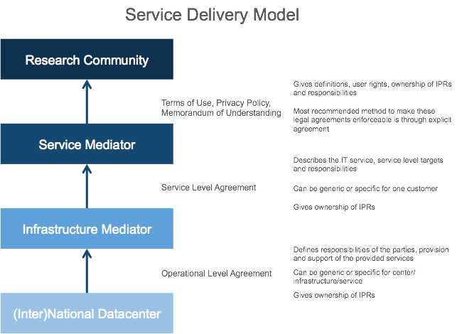

Several gaps were identified such as there are no concrete legal terms on relevant fields such as ownership of IPRs in both the document itself and the reference to EGI’s Policies and Procedures website, these should be secured from back-end to front-end, and there is a lack of concrete consequences when the Provider does not meet the service level targets.
Other recommendations to be included in all agreements within this SDM are:
- Include a fine-grained identity policy within all agreements. Research in the fishery and marine sciences sector is mostly subject to international organizations which can have different statuses with regard to IPRs. For example, the status of FAO in this respect is more extraterritorial than the status of the International Maritime Organization (IMO). Such choices are reflected by policy-decisions of these Organizations;
- Develop and document a standardized process to analyse whether standards for ownership of IPR are included in the metadata;
- The Infrastructure Mediator together with the Service mediator should approach the Research Community to collaborate on user-based management. D4Science is the ideal partner since the decisions with respect to software are being made in this layer.

These current agreements can be modified to develop a complete and concrete SDM. Overall, organizations that wish to exploit cloud-based services, often find it difficult to obtain an overview of the options and opportunities. With a SDM, they can obtain a quick overview of the implications of a specific architecture, but also avoid overlap or even conflicts between different legally relevant documents. A quick scan of an emerging exploitation of EGI resources by a community through an intermediate showed the benefits of the approach.
Further details are provided in a dedicated report at: https://documents.egi.eu/document/2699

Agrifood
A market analysis was conducted (D2.10), which described the potential of the AgTech sector, the actors and value chains, the results of the data requirements analysis and reports on the competing offerings including technical perspectives and specific recommendations for future business development within EGI. Since SME engagement is of high importance for the EGI community, a requirements collection and validation process was provided in order to profile new and enhanced EGI services and propose recommendations for big and/or open data services targeting the industry and academia. This activity also focused on developing personas (descriptions of typical users) and scenarios described in detail, and then these assumptions were validated in a series of interviews with potential users from the AgTech communities.
As a result of this work and involvement within EGI-Engage, the EGI Foundation invited to participate in the AGINFRA+ project to put into practice this initial analysis. EGI will support the uptake of the e-Infrastructures in the agriculture domain and will do that via three use cases: Food security, Agro-climatic and Economic modelling and Food safety risk assessment. A handful of SMEs are involved in the project and discussions are underway with BfR (German Federal Institute for Risk Assessment) to purchase services in support of a project kicking off in 2018. Interestingly, the proposed model is the same as the model developed in support of Marine Fisheries via D4Science.

Open for Business programme
During EGI-Engage, a business engagement programme has been defined, outlining the areas and benefits for collaboration and the required steps to enter business collaborations with EGI. Through the collective efforts of each partner, there are currently ~150 private organisation in a dedicated contact database that range from SMEs (~100) to large enterprises in role such as technology providers, brokers and consumers.
This section provides an overview of the success stories in different domain areas (training, earth observation, fishery and marines, computational fluid dynamic) that resulted out the dissemination activities related to the engagement program.
Communications activities
Website: The Open for Business programme has an area on the EGI website, with calls from the homepage (since September 2016).
- 1,045 unique website views

Publication: We produced a Open for Business brochure This brochure was distributed to partners and at events:
- BDVA Summit, Valencia, November 2017
- EARSC Workshop, Brussels, January 2017
- European Space Strategy Conference, Brussels, January 2017
- DI4R conference, Cracow, September 2016

Webinar (targeted at the EGI Communities): How to engage SMEs for national e-Infrastructures
- 15 attendants from national e-Infrastructures

News item: Webinar: How to engage SMEs for national e-Infrastructures (May 2017)

Numeca
Numeca International, a Belgian SME, in partnership with its Italian distributor, NSI, held a training workshop in the Milan World Join Centre on 24 November 2016 to demonstrate the best techniques and most advanced technologies for Computational Fluid Dynamics (CFD) based on Numeca’s AutoMesh™ grid generation suite that leverages UberCloud containers (an EGI business partner) to offer fast, high fidelity meshes to hundreds of customers.
The EGI cloud providers CESNET (Czech Republic) and FZ Jülich (Germany) provided the underlying compute facilities allowing for the ~10 training participants to have hands-on experience using the software and applications.
This training was considered a first trial for Numeca using the UberCloud containers on EGI’s cloud platform as a basis for a future partnership, which was a direct result from the joint webinar held by EGI and UberCloud on 20 October 2016 “How SMEs Can Use EGI’s Cloud for Computer-Aided Engineering (CAE)“.
Communications activities
Blog post: EGI supports Belgian SME training in Computational Fluid Dynamics (November 2016)
- 97 unique website views
Twitter post: https://twitter.com/syholsinger/status/803945497165725696

IBM Research
The IBM research team in Zurich set up a project to develop a methodology for estimating the performance, power consumption and cost of exascale systems. The project is called Algorithms and Machines (A&M) and is part of DOME, a joint program with the Netherlands Institute for Radio Astronomy (ASTRON).
The main objective of this collaboration is to develop technologies to support the Square Kilometre Array (SKA), the world’s largest radio telescope currently being developed.
The A&M team set out to model an exascale computing system required by the SKA data processing pipeline. This system and the software running on it may allow an early and fast design-space exploration.
To validate the analytical performance estimates, the A&M team required access to systems with different network topologies (e.g., fat-tree and dragonfly). The team contacted EGI for support to obtain service access to such systems. EGI identified the Poznan Supercomputing and Network Center (PSNC) in Poland as a provider to offer such an environment and kicked started the collaboration.
PSNC offered access to Orzel / Eagle, a supercomputer with a performance of 1.4 PFlops computing power and a fat-tree network interconnect fabric. The A&M team then ran MPI applications of different problem sizes and number of MPI processes on the system, using configurations of two and three-level fat-tree topologies. The first validation results for the MPI-simple implementation of Graph 500 (a MPI benchmark for analytics workloads) showed that the analytical methodology can estimate the time performance with an accuracy of 82%, which is a very encouraging result. In the future, more MPI applications will be analysed to validate the A&M methodology.
Communications activities
Newsletter: EGI data centre helps the IBM research lab to model an exascale computing system (February 2017)
- 100 + 56 (unique website views + clicks via MailChimp)
Social Media: EGI data centre helps the IBM research lab to model an exascale computing system: https://goo.gl/jiQwgC & more stories in #EGInewsletter

EO Pilot
EGI has set up collaboration with a group of SMEs (RHEA, SixSq, EOproc) to develop demonstrator for an open integrated platform that delivers a multi-cloud EO data processing service, with the main objective to prevent cloud vendor lock-in situations while addressing end-to- end processing of EO data in multiple clouds environments. The aim is to offer a generic and open service, intended to work with any EO data located anywhere and with any EO processor, that can be rapidly deployed with flexibility, scalability, and at low cost, and which provides services accessed via public and standardised APIs.
The multi-cloud EO data processing platform has been demonstrated with the EGI Federated Cloud, Innovation Platform Testbed (IPT) Poland, and the Amazon Web Services (AWS) cloud. It presents the following capabilities:
- Multi-cloud data discovery: a data discovery service allows discovering and selecting EO scenes relevant to an EO application. It uses a metadata catalogue currently tracking nine satellites including Landsat-8, Sentinel-1 and 2, and currently able to hold up to 10+ millions of scenes.
- Multi-cloud data management and access: a data management service provides a data location API that allows exposing and staging EO data on the cloud infrastructure on which the EO application is deployed and executed. It uses a global high-performance data management system providing access to distributed storage resources.
- Multi-cloud application deployment: an application deployment service allows selecting the cloud infrastructure on which to deploy the EO application, and provides automated deployment, execution and monitoring. It uses a multi-cloud application management service automating the full application management lifecycle, and providing connectors to multiple clouds, public and private, leveraging both open source and proprietary cloud APIs.
Communications activities
Presentations:
- “Multi-Cloud Earth Observation Data Processing with hybrid Clouds” at EARSC Workshop, Brussels, January 2017
- “Multi-Cloud Earth Observation Data Processing with hybrid Clouds” at EGI Conference: Earth Observation Workshop, Catania, May 2017
- “Multi-Cloud Earth Observation Data Processing with hybrid Clouds” at EO Summit, Montreal, June 2017

BlueBRIDGE
BlueBRIDGE’s objective is to support the research communities investigating marine resource overexploitation and ecosystem degradation. BlueBRIDGE is based on the D4Science infrastructure.
BlueBRIDGE brings to EGI the needs and the feedback of the communities they support and a use case of data management in large, distributed communities. From a technical perspective, the EGI-BlueBRIDGE collaboration aims to design, develop, test, validate, and put in operation the technology to link D4Science to the EGI Federated Cloud.
Finally, EGI and BlueBRIDGE defined an SLA between D4Science.org and EGI Foundation for the support of the BlueBRIDGE communities, including but not limited to the iMarine community.
Communications activities
Newsletter: Hybrid data e-Infrastructures: VREs as-a-Service (PDF, page 6)
- 73 reads

UberCloud
EGI established collaboration with UberCloud, based on a shared vision to embrace distributed computing, storage and data related technologies.
The agreement is grounded on a joint commitment to increase IT resources in order to speed up time to market and enable development and innovation of new and more competitive products and services.
UberCloud is the community and online marketplace for engineers and scientists to discover, try and buy computing resources and software on demand, with currently over 3,000 users and partners in 70 countries.
Partnerships with private companies such as UberCloud play a key role in EGI’s strategy to deliver value to its academia and research sector stakeholders.
Activities within the EGI/UberCloud collaboration focus on:
- Establishing an EGI Store with service descriptions in the UberCloud marketplace
- Facilitating interaction with interested European SMEs
- Identifying UberCloud application containers to run on EGI Federated Cloud
- Exchanging experience for outreach/marketing and input to the EGI marketplace and joint promotion
Communications activities
News item EGI-UberCloud Partnership: Bridging Research and Innovation (December 2015)
- 113 + 15 (unique old + new website views)
Blog post: Webinar: EGI Cloud for SMEs in CAE – OpenFOAM demo (October 2016)
- 30 attendees
- 169 reads
Social Media:
- Register now to attend a webinar on “How SMEs can use EGI’s Cloud for computer-aided engineering..:https://www.egi.eu/news/egi-and-ubercloud-webinar-for-smes/… @HPCExperiment
- On YouTube for who couldn't join: #EGISMEWebinar How EU SMEs Can Use @EGI_eInfra Cloud for #CAE #OpenFOAM #UberCloud

Know-how

Training program
The EGI-Engage project provided foundational training services and coordination to training activities across the whole EGI collaboration. The main goal of this activity was to operate a framework that enables members of EGI community as well as external partners to effectively create, deliver, share, reuse and benefit from training services in the context of e-infrastructures and e-science. The ‘SA2.1 Training’ activity of EGI-Engage provided core training services and facilitation of training activities conducted by Competence Centres, NGIs, partner projects and partner infrastructures (including e-infrastructure and Research Infrastructures). Also, this activity provided effort for conducting training on key topics to facilitate uptake of EGI services within scientific communities. The focus was on:
- Federated Cloud Training:
  - Development and delivery of training for researchers and communities interested in using the EGI Federated Cloud or building community-specific cloud federations based on the EGI technology.
  - 14 events were delivered during the project, ranging from 1h webinars to half-day tutorials, and attended by around 400 people in total.
- Design your e-Infrastructure workshop:
  - Interactive workshops where EGI partners up with other e-Infrastructures to help scientific communities to identify suitable generic solutions for addressing community-specific needs.
  - Two workshops were organised, one in 2015, one in 2016, participated by approx. 90 people in total. A similar third workshop was organised with INDIGO-DataCloud in 2017, attended by 20 people.
- Security Training:
  - Development and delivery of trainings about the security operations of an online service centre, and/or EGI site.
  - 8 events were organised during the project, attended by nearly 150 people in total.
- FitSM Training:
  - Development and delivery of trainings on FitSM lightweight service management standard, which was a result of an FP7 project called FedSM (ended Sept 2015).
  - 18 paid courses were held (7 in-house; 11 open registration), with approximately 150 people being certified as a result.

Exploitation strategy
Training strongly relates to the EGI Service Catalogue, and facilitates the uptake of elements from the catalogue by potential user communities. EGI is going to continue with facilitating and delivering training relating to the elements of the catalogue. Moreover, we will start broadening the portfolio with new topics, primarily relating to Data Management and Data Management Planning, through the EOSC-hub initiative from 2018.
Besides continuing with FitSM as a paid course, we are considering starting paid courses also about the security topics, and positioning these to audiences outside the EGI community, working in the domain of operating online services. (e.g. Research Infrastructures)
Communications activities
News items:
- All FitSM Training Levels are now available (April 2017)
Blog:
- Upcoming EGI trainings (April 2017)
- All 4 FitSM Training Levels in November (October 2016)
Website: Dedicated areas added in the renovation of the website (September 2016):
- EGI Training (104 unique website views)
- FitSM training (1,376 unique website views)
Social Media:
- All FitSM Training Levels are now available, organised by @EGI_eInfra: https://goo.gl/pq8XNQ Save your seat! @syholsinger @FitSM_Standard
- The survivors of the 1st #FitSM Expert training by @EGI_eInfra! @FitSM_Standard Congrats!
- All 4 #FitSM training levels available in November (Amsterdam)! Places are limited & filling up fast - Register Now! https://www.egi.eu/services/fitsm-training/calendar/ …
- #FitSM wins best poster at #DI4R2016 - highlights importance of service management for e-infras @FitSM_Standard @syholsinger

Report on engagement activities
Since the project start eight research infrastructure communities are supported with co-design, development, evaluation, dissemination and training support by the Competence Centre tasks of WP6 (task 6.3-6.10). Besides, the project included effort in the task 6.2 to engage with and provide support for additional scientific communities. Within this section, D2.14 reports on the achievements of these additional communities. Despite the primary driver of engagement was WP6, significant support was also received from several other tasks that spread over WP2-5. The engagement work itself (for new communities) included the following activities:
- Reaching out to structured, international scientific communities and projects and discuss e-Infrastructure usage scenarios with them. Target groups included Research Infrastructures and FET initiatives (Future Emerging Technologies), as well as H2020 projects, particularly VRE projects (Virtual Research Environment).
- Support scientific communities in becoming active users of EGI services. The two ‘Design Your e-Infrastructure’ workshops in 2016, as well as regular teleconferences with community representatives were the key instruments in this work.
- Engaging with service providers to integrate their offerings into the EGI catalogue. This work was performed in collaboration with WP2 (task NA2.2 Strategy, Business Development and Exploitation) and WP5 (task SA1.3 Integration, Deployment of Grid and Cloud Platforms).
- Negotiate SLAs and OLAs to secure services and service configurations for communities.
- Promote new EGI services for potential target groups. Promotion of the ‘Applications on Demand’ service and the Open Data Platform were particularly important in this work area.
The next subsections provide details about the work performed. The structure is defined by community who the project engaged with. These were selected by NGI priorities, as well as priorities dictated by the ESFRI roadmap.

Running and improving the engagement activity
The EGI-Engage project inherited the engagement activity from the previous EGI flagship project, EGI-InSPIRE. The process was further improved in EGI-Engage and was formalised within the EGI IT service management system. Most of this formalisation took place within the Customer Relationship Management Process (CRM)). The engagement activity was improved by:
- Organising regular meetings for the NGI International Liaisons, who serve as single point of contact for the outreach, training and engagement within EGI countries.
- Formalising the engagement related procedures within the CRM and other ITSM processes. The most important procedures are:
  - BDS4 Add/update business opportunity
  - BDS5 Prioritise business opportunities
  - CRM2 Customer technical onboarding
  - SLM3 Negotiate, sign, update, resign an VO SLA OLA
  - CRM3 Perform customer satisfaction and service reviews
  - CRM4 Manage service complaints from the customer
  - CRM6 Managing service orders
- Configuring the Confluence system to implement the engagement-related ITSM procedures. Among other items, this included the setup of a Business Opportunity Database (relating to BDS4 and 5 above), a Customer Database (relating to CRM2-3 above), Service satisfaction reviews database (relating to CRM3 above), Complaints database (relating to CRM4 above), and Service orders database (relating to CRM6 above).
- Providing engagement status briefings to the NGI Council, to the Operations Management Board, and to the User Community Board during their regular meetings.
- Organise platform-specific user support meetings for Federated Cloud user support teams. These meetings bring together representatives of those user support teams that operate cloud sites in EGI, and offer consultancy and support for users with these sites.
- Organise weekly meetings for members of the User Community Support Team, who conduct and coordinate engagement related tasks in EGI H2020 projects (Currently: EGI-Engage, AARC and AARC2, Indigo-DataCloud, ENVRIplus, EDISON, HelixNebula-ScienceCloud, AGINFRA+, NextGEOSS, ELItrans, EOSCpilot, AENEAS).

Achievements per target group
Based on the information stored in the Business Opportunity and Customer Databases, the next subsections report about the progress and achievements that were made with engaging with research communities. The report is structured by the main target groups of engagement:
- Research Infrastructures and Future Emerging Technologies (FET) Flagships (section 3.2.1): A growing number of Research Infrastructures (RIs) from the ESFRI roadmap and from national roadmaps reached implementation or operational stage during EGI-Engage, or will reach those stages in the next years. Many of these RIs as well as FET Flagships are already exploring the e-Infrastructure needs of their communities and thus they are key instruments in bringing together a wide diversity of stakeholders to look for solutions to many of the problems science is facing today. Given their large, international nature, awareness of the benefits of e-Infrastructures, and long operational setups measured in decades, these entities represent the primary target for the engagement activities coordinated by EGI Foundation.
- Research Collaborations or Tool/VRE providers (section 3.2.2): Typically, EC-funded projects that bring together researchers and IT experts from a given scientific discipline with the main goal to develop and establish online tools and services (often Virtual Research Environments, VREs) for fragmented research communities. Supporting these initiatives with sustainable services from the NGIs can help reach diverse, fragmented user groups within various disciplines.
- Long tail of science (section 3.2.3): Small research teams and individual researchers who work on their own research agendas are typically unaware of e-Infrastructures and, despite the general benefit e-Infrastructure they could get, they are likely to require only a small subset of the services and functionalities e-Infrastructure on offer for short periods (days or weeks). While several NGIs are working directly with this group of users, there are countries and disciplines where the support is still insufficient. EGI-Engage established the Application on Demand service to equal out the differences and to enable the NGIs provide high-quality, high-level and easy to use services for the long tail.

Research Infrastructures and FET Flagships

Euro-Argo
- Background: Euro-Argo coordinates and strengthens the European contribution to the international Argo programme, a global network of floats deployed in the world oceans to provide data for the quantitative description of the changing state of the upper ocean and the patterns of ocean climate variability from months to decades. One of Euro-Argo’s objectives is to provide quality-controlled data and access to the data sets and data products to the research (climate and oceanography) and operational oceanography (e.g. GMES Marine Core Service) communities.
- Status and achievements: Euro-Argo was among the use cases of the 1st Design your e-Infrastructure workshop in April 2016. The following use case was captured during the event: “Setup an e-Infrastructure based ARGO data subscription service for scientific users. A user can provide data selection criteria, and the system fills matching Argo data into the user’s personal cloud account on a daily basis.” The use case received support from EGI and EUDAT, combining Federated Cloud and B2SAFE services from the two infrastructures. A proof-of-concept setup was achieved in 2017, and was demonstrated at ENVRIplus Week, as well as in a scientific paper.
- Partners involved from EGI: EGI Foundation. In EOSC-Hub the work will be taken over by CINECA, IN2P3-LAL, CSC, MARIS, ULG, IFREMER.
- Next steps: The setup will be extended towards a pilot system by the Marine Competence Centre of the EOSC-Hub project. The pilot will require proper integration of EGI-EUDAT AAI, possible replacement of the filtering Python scripts with Apache Spark (or similar big data system), more robust integration between the various components, negotiating OLAs with cloud and storage capacity providers for the pilot operation.

EMSO, EMSODEV
- Background: The European Multidisciplinary Seafloor and water-column Observatory (EMSO) is a large scale, distributed RI of fixed-point observatories. EMSO consists of ocean observation systems for sustained monitoring of environmental processes and their interactions. The variables address natural hazards, climate change, and marine ecosystems. The EMSODEV project (EMSO implementation and operation: DEVelopment of instrument module) is catalysing the full implementation and operation of the EMSO distributed Research Infrastructure, through the development, testing and deployment of an EMSO Generic Instrument Module. Among the project objectives is “to strengthen the data management and delivery backbone of the EMSO RI by a coordinated approach to data capture, archiving, management, and delivery”.
- Partners involved from EGI: EGI Foundation, RECAS-BARI, NCG-INGRID-PT, INFN-PADOVA, CESGA
- Status and achievements: The EMSO ERIC expressed interest to EGI in setting up a prototype study to evaluate the use of EGI Federated Cloud resources for hosting the EMSO Data Management Platform (DMP) developed by EMSODEV. The DMP will perform processing, publishing and curation of the data ingested by the deep-sea observatories (EGIM) of the EMSO RI. A cloud resource pool with 4 sites from Italy (2), Portugal and Spain was setup and secured with SLA and OLAs. The EMSODEV project members successfully setup the DMP on the RECAS-BARI data centre via the OpenStack tools and EGI certificates (X509 and VOMS). 48 VMs were instantiated that consumed more than 60,000 CPU-hours until July 2017.
- Next steps: Currently the DMP is deployed in one Cloud Provider, RECAS-BARI. In the coming months, a distributed deployment over all the providers offering resources to EMSO will be adopted. This will be needed to guarantee enough resources to manage the increased workflow when new EGIM nodes will be deployed in the EMSO RI.

Communications activities
News item: EGI joins the EMSODEV project in observing climate change effects (January 2017)
- 91 unique website views
Newsletter: EMSODEV pilot running on the EGI Federated Cloud (July 2016)
Social Media: EGI joins the EMSODEV project in observing climate change effects: https://goo.gl/8RfQOc @EMSODEV_2015

Euro-Bioimaging
- Background: EuroBioimaging is a distributed imaging infrastructure for microscopy, molecular and medical imaging. It involves 24 countries and more than 100 institutions participating in the preparatory phase. The research infrastructure focuses on the construction of a network of dedicated, state of the art medical-imaging facilities, together with an innovative overarching e-Science structure for integrated data management and large-scale analysis.
- Status and achievements: The collaboration was envisaged via the Spanish Euro-Bioimaging node, whose representatives (University of Valencia, UPV) are involved in the INDIGO-DataCloud project. Unfortunately, the community use case in INDIGO-DataCloud did not reach the maturity level that would trigger the need for use of cloud services from EGI.
- Partners involved from EGI: UPV
- Next steps: EGI will monitor the use case development in the INDIGO-DataCloud project and will offer cloud services and assistance for the use should the need arise.

ENES
- Background: The European Network for Earth system modelling, ENES, is a research infrastructure that aims to help in the development and evaluation of state-of-the-art climate and Earth system models, facilitate focused model intercomparisons in order to assess and improve these models, encourage exchanges of software and model results, help in the development of high-performance computing facilities dedicated to long high-resolution, multi-model ensemble integrations. ENES counts 47 partners from academic, public and industrial world and, ever since its creation, has been the initiator of many projects and participated in initiatives in the field of European Earth system modelling. This community is strongly involved in the assessments of the Intergovernmental Panel on Climate Change (IPCC) and provides those predictions, on which EU mitigation and adaptation policies are elaborated.
- Status and achievements: EGI is working with two groups from ENES: CMCC who is member of the INDIGO-DataCloud project and is focussed on carbon Earth system modelling, and CERFACS that aims to provide climate projections data to climate change impact to researchers, facilitators, practitioners through easy to access and intuitive interfaces, common data formats and tailored products from data processing workflows:
  - CMCC: The integration was foreseen via the Ophidia big data system, and with co-support by the INDIGO-DataCloud project. Unfortunately, the community did not manage to start the EGI integration part, their effort remained on reaching integration with INDIGO-DataCloud services. (And those services are not integrated with EGI.)
  - CERFACS: CERFACS expressed interest on evaluating EGI and EUDAT services to manage and process large datasets available through the Earth System Grid Federation (ESGF) made of 40 worldwide nodes (18 in Europe coordinated by IS-ENES). For this aim, a prototype for a simplified ENES use case is currently under development where data are staged-in/staged-out in the EGI Federated Cloud from/to EUDAT B2SHARE, B2STAGE and B2SAFE services and processed into a docker container deployed on top of a VM and managed via the EUDAT Generic Execution Framework (GEF). Currently, CERFACS successfully deployed its docker container in the EGI Federated Cloud and is working on setting up the interfaces towards the EUDAT services. 78 VMs were instantiated that consumed almost 40,000 CPU-hours until July 2017.
- Partners involved from EGI: EGI Foundation.
- Next steps:
  - CMCC: EGI will follow up the use case development in the INDIGO-DataCloud project and will offer cloud services and assistance for the future EOSC-hub.
  - The CERFACs use case is still in a testing phase and, then, is supported through the incubator VO, fedcloud.egi.eu. Currently, CERFACS mainly used resources from the IN2P3-IRES cloud provider. In the next months, the main objective for the CERFACS use case will be completing the deployment of the defined use case.

ICOS
- Background: The Integrated Carbon Observation System Research Infrastructure (ICOS) research infrastructure integrates atmosphere, ecosystem and ocean greenhouse gas observations to provide timely and reliable data for research, policy making, and the general public. ICOS RI brings together high-quality European national research communities and measurement stations and, through coordination and support, constitutes a European-wide research infrastructure that serves both scientists and society. ICOS RI consists of a number of researchers and measurement stations, governance bodies and a carbon data portal, collaborating across Europe. ICOS RI has more than 100 measurement stations in twelve European countries. These stations measure greenhouse gas concentrations in the atmosphere and fluxes over the terrestrial and marine ecosystems.
- Status and achievements: This was among the use cases selected for the 1st Design Your e-Infrastructure Workshop in 2016. ICOS has been working closely with the EGI-Engage project within the context of developing the 'Footprint Tool for Atmospheric Stations'. This is a web-based tool designed to help users explore the sensitivity to European emissions at specific ICOS atmospheric sites. This tool uses input from meteorological analysis as well as emissions data to determine the greenhouse gas footprint over time. This is done by making use of the Stochastic Time-Inverted Lagrangian Transport (STILT) model. This use case has been implemented using services from both EGI and EUDAT. Data is stored on EUDAT B2SAFE and users interact with the ICOS Carbon Portal which instantiates a number of VMs in the EGI Federated Cloud to host a number of virtual machines fulfilling different functions. Data are staged-in/staged-out from B2SAFE to the EGI infrastructure via the B2STAGE services. Within the EGI infrastructure, data are saved in a storage linked to the EGI DataHub (based on OneData technology) and accessible by all the ICOS VMs. ICOS deployed in the EGI Federated Cloud: A VM hosting the web interface for requests of model runs and visualization of the results. This VM also runs the controller for load balancing and VM orchestration. The controller distributes the jobs to the required number of VMs and passes input parameters to one or more worker node VMs.
  - VMs hosting the worker node for running the model and sending back-log files. These VMs host the model itself, and due to the parallelisable nature of the workflow, may have multiple instances running concurrently. Software (OneData OneClient) to access the data shared via the EGI DataHub was also deployed in such VMs.
  - A VM hosting the software (OneData OneProvider) to share the data with all the worker nodes.
The use case experienced some delay due to scalability issues with OneData. They decided to slightly change the setup using OneData/EGI DataHub only to manage input files. Output files are shared via NFS. 61 VMs were instantiated that consumed more than 120,000 CPU-hours until July 2017.
- Partners involved from EGI: EGI Foundation. The ICOS use case is still in a testing phase and, then, is supported through the incubator VO, fedcloud.egi.eu. ICOS mainly used resources from the CESNET-MetaCloud cloud provider until now.
- Next steps: ICOS is working to improve its computational pipelines. After that, they will re-try to use OneData also to manage output files since the identified scalability issues were fixed in the latest OneData version.

European Research Initiative on chronic lymphocytic leukemia (ERIC CLL)
- Background: ERIC CLL is a European organization devoted to improving the outcome of patients with chronic lymphocytic leukemia and related diseases. The ERIC CLL has more than 680 members representing more than 46 countries. ERIC members are also active in other European and international scientific societies and consortia, with large lists of members/partners who can be considered potential users.
- Status and achievements: The ERIC CLL was among the selected use cases of the 2nd Design Your e-Infrastructure workshop in 2016, where the following use case was captured: “Currently ERIC involves a loosely joined effort of geographically distributed computational efforts in CLL (services and datasets). A dedicated VRE would be of particular value by providing a persistent sensitive data repository (patient and clinical trial data) as well as computational analysis services around the repository.” Since the workshop ERIC CLL started working on the VRE system, consisting of a CLL Portal, a DB of CLL datasets, analysis applications (ARResT/AssignSubsets, written in Perl, JavaScript and R), and a Galaxy workflow system. EGI Foundation supports the CLL developers in integrating/porting the setup into the EGI Cloud service. Demonstration integration with a limited set of VRE functionalities is already achieved.
- Partners involved from EGI: EGI Foundation, Providers of the fedcloud.egi.eu cloud VO
- Next steps: Expand the capabilities of the EGI-hosted VRE service, then demonstrate the system to the ERIC CLL community to gather feedback and guidance towards a full-fledged VRE service.

European Space Agency (ESA)
- Background: The European Space Agency (ESA) is Europe’s gateway to space. Its mission is to shape the development of Europe’s space capability and ensure that investment in space continues to deliver benefits to the citizens of Europe and the world. ESA is an international organisation with 22 Member States.
- Status and achievements: EGI is collaborating with ESA in different sectors. The most advanced one is those related to the Thematic Exploitation Platforms (TEPs), the ESA’s answer to deal with the unprecedented amount of data that will be delivered by the Sentinel missions, along with the Copernicus Contributing Missions as well as Earth Explorers and other, Third Party missions in the next years. ESA has started in 2014 the EO Exploitation Platforms (EPs) initiative, a set of R&D activities that in the first phase (up to 2017) aims to create an ecosystem of interconnected Thematic Exploitation Platforms (TEPs) on European footing. Furthermore, EGI just started a collaboration with the ESA group working on the Collaborative Ground Segment:
  - TEPs: EGI and ESA worked together to understand how EGI services could facilitate the implementation and deployment of the ESA TEPs. This led to the first concrete activity of integrating two TEPs, Geohazard and Hydrology, within the EGI Federated Cloud in order to guarantee enough computational power for their use cases. Such task was performed in collaboration with Terradue, an SME members of the two consortium appointed by ESA for the design and development of these platforms, and was successfully completed developing an interface between the Terradue Cloud framework and the standard OCCI interface of the EGI Federated Cloud. A cloud resource pool with 7 providers from Italy, UK, Greece, Germany, Poland, Belgium and Spain was setup and secured with SLA and OLAs. 161 VMs were instantiated that consumed almost 220,000 CPU-hours until July 2017.
  - Collaborative Ground Segment: The Collaborative Ground Segment is the layer that manages data coming from the satellites. Its main duty is make them available to third party for exploitation. An exploratory activity started in the last months to analyse possible collaborations with EGI, in particular to understand if resources of the EGI Federated Cloud could be used to process and disseminate EO data.
- Partners involved from EGI: EGI Foundation, 100%IT, HG-09-Okeanos-Cloud, GoeGrid, CESGA, RECAS-BARI, CYFRONET-CLOUD, BEgrid-BELNET.
- Next steps:
- Integration with the Geohazard and Hydrology TEPs will be enhanced providing EO data directly in the EGI infrastructure, via the DataHub service, and reducing the need of executing stage-in and stage-out operations. Other TEPs will be approached to propose similar collaborations.
- Discussion with the ESA team working on the Collaborative Ground Segment will continue to identify possible areas of collaboration.
Communications activities
News: EGI and Terradue: a better cloud service for science (September 2016)
Newsletter: Terradue & EGI: a partnership for Earth Observation (May 2017)
Social Media:
- Terradue & EGI: a partnership for Earth Observation
https://www.egi.eu/about/newsletters/terradue-egi-a-partnership-for-earth-observation/in @EGI_eInfra Newsletter May 2017 @terradue @esa_gep

RI communities that the project established contact with, and exchanged information about collaboration opportunities:
DANUBIUS, Virgo and LIGO, EMPHASIS, KM3Net, EBMRC, SKA (through the AENEAS project), CESSDA ACTRIS, AnaEE, LTER, Earth Observation Data Centre for Water Resources Monitoring (EODC), Agricultural sciences (through the AGINFRA+ project), ‘Blue Cloud’ infrastructure institutes (marine sciences), Human Brain Project (FET initiative), Extreme Light Infrastructure (through the ELITRANS project).

Research Collaborations or Tool/VRE providers
VRE projects were chosen as priority for engagement at the end of PY1 (to respond to the EC reviewers’ suggestion). Such projects develop and operate community or science discipline specific environments and act as ‘business to business’ customers for EGI, i.e. receiving generic e-Infrastructure services from EGI, which they expand into science discipline specific facilities that they offer to scientists.

OpenDreamKit project
- Background: OpenDreamKit is an H2020 project that will deliver flexible VRE toolkit for mathematics supporting collaborative work on software, data, and knowledge. It builds on top of open source projects such as LinBox, MPIR, SageMath, GAP, Pari/GP, LMFDB, Singular, MathHub, and the IPython/Jupyter interactive computing environment. The project runs from 2015 September for 4 years.
- Status and achievements: The project was among the use cases selected for the 2nd Design Your E-Infrastructure workshop in 2016. One of the VRE options of the project is based on tmpnb that creates temporary Jupyter notebooks where users can run and reproduce their research. They are also collaborating with mybinder project, which allows to create new Jupyter kernels from github repositories. OpenDreamKit collaborates with EGI on developing a Jupyter service (SaaS) in the EGI Cloud that would offer users with a permanent notebook environment that can leverage the expertise in OpenDreamKit.
- Partners involved from EGI: EGI Foundation
- Next steps: Setup of a JupyterHub as a EGI service within the Applications On Demand Service in collaboration with OpenDreamKit.

MultiScaleGenomics project
- Background: The MultiScaleGenomics (MuG) VRE project supports the expanding 3D/4D genomics community by developing tools to integrate the navigation in genomics data from sequence to 3D/4D chromatin dynamics data. MuG VRE Compute Platform is a virtualization platform (adapted from TransPLANT European project), that provides access to specific genomic applications and workflows. Applications are run in virtual machines that are instantiated dynamically following the requirements of the analysis workflow. Workflows are defined by the use of COMPSs programming model. The project runs from November 2015 for 3 years.
- Status and achievements: The project was among the use cases selected for the 2nd Design Your e-Infrastructure workshop in 2016. Since the workshop the project matured its computing deployment, and currently using a distributed execution using three cloud deployments (all within the consortium: IRB, BSC and EBI). COMPSs has been successfully used on the EGI FedCloud for other projects in the past. The project is currently solving VM compatibility and contextualization issues with EGI’s help on a mixed OpenNebula and OpenStack infrastructure.
- Partners involved from EGI: EGI Foundation, BSC
- Next steps: Creation of VA in AppDB to be integrated with COMPSs and testing of EGI FedCloud for their use case.

BigDataEurope project
- Background: The Big Data Europe (BDE) project aims at making Big Data simpler, cheaper and more flexible than ever before. BDE offers basic building blocks to get started with common Big Data technologies and make integration with other technologies or applications easy. The project runs from January 2015 for 3 years.
- Status and achievements: The project has defined a platform for the integration of the Big Data building blocks (e.g. Apache Spark, Hadoop HFDS, Apache Flink and others) based on Docker. The deployment requires a working Docker Swarm setup that is enriched with a layer of services, which support the workflows' setup, creation and maintenance. EGI Federated Cloud supports Swarm deployment, and a test Swarm cluster was made available for BDE developers for testing. Documentation on setup was detailed on the EGI wiki so the setup can be reused by other communities.
- Partners involved from EGI: EGI Foundation, BELSpo
- Next steps: Project to complete testing of EGI FedCloud for BDE usage and start SLA negotiation process to establish its own VO.

PhenoMeNal project
- Background: PhenoMeNal (Phenome and Metabolome aNalysis) is an e-Infrastructure project that supports the data processing and analysis pipelines for molecular phenotype data generated by metabolomics applications. It aims to use existing open source community standards to operate and consolidate the e-Infrastructure based on existing resources, including the EGI and the EGI Federated Cloud, and to extend it to world-wide computational infrastructures. The project runs from September 2015 for 3 years.
- Status and achievements: The project was among the use cases selected for the 1st Design Your E-Infrastructure workshop. The PrenoMeNal architecture relies on Kubernetes for creating the platform on top of which user applications run. PhenoMeNal is contributing to the Kubernetes community with KubeNow, a set tool for the deployment of Kubernetes using Terraform and Ansible. The consortium is currently focused on further developing this technology. Terraform plugins for the EGI Cloud have been developed and made available for the project recently. The work and this project are supported as one of the use cases in the ELIXIR Competence Centre (EGI-Engage task 6.3).
- Partners involved from EGI: EGI Foundation, cloud providers of the vo.elixir-europe.org VO (EBI, GRNET, CESNET, IN2P3)
- Next steps: Test KubeNow with Terraform plugins developed by EGI to interact with OpenStack and OCCI providers using EGI credentials.

Bioexcel project
- Background: BioExcel is a Centre of Excellence for provision of support to academic and industrial researchers in the use of high-performance computing (HPC) and high-throughput computing (HTC) in biomolecular research. The project runs from November 2015 for 3 years.
- Status and achievements: tested with AppDB and Embassy cloud, as well as early demo with fedcloud.egi.eu VO
- Next steps: Establish its own VO, or piggyback workload on the ELIXIR VO

ExTRAS project
- Background: The EXTraS project (Exploring the X-ray Transient and variable Sky) is harvesting the hitherto unexplored temporal domain information buried in the serendipitous data collected by the European Photon Imaging Camera (EPIC) instrument on board the ESA XMM-Newton, in 13 years of observations. The main result will be a public catalogue that will become the reference for time domain astrophysics in the soft X-ray band, until a future, dedicated mission is deployed. The project plans to perform part of this analysis by exploiting Cloud resources through a dedicated science gateway. This will allow extending the analysis to recent EPIC data, not included in the public catalogue that will be released at the end of 2016, and will also allow users from the community to analyse their own data using EXTraS pipelines. The project was receiving EC funding between 2014-2017 (3 years).
- Status and achievements: ExTras integrated its web portal, designed following the science gateway paradigm, with the EGI Federated Cloud. This is allowing users from the community to analyse their own data using EXTraS pipelines. The ExTras portal submits jobs that are processed on VMs created on the fly within the EGI Federated Cloud. A cloud resource pool with 3 sites from Italy (2) and Poland was setup and secured with SLA and OLAs. 234 VMs were instantiated that consumed around 16,000 CPU-hours until July 2017.
- Partners involved from EGI: EGI Foundation, RECAS-BARI, CYFRONET-CLOUD, INFN-CATANIA-STACK
- Next steps: EXTras is considering deploying also its application database in the EGI Federated Cloud.
Communications activities
News item: EGI and EXTraS: serving the Astronomy and Astrophysics community (August 2016)
Blog: EXTraS Workshop (June 2016)
Newsletter: Computing & storage resources committed in 2016 (November 2016)
Social Media: @EGI_eInfra and EXTraS: serving the Astronomy and Astrophysics community http://primeurmagazine.com/weekly/AE-PR-10-16-18.htmlhttps://t.co/Ia4hJxZgRJ

BioISI
- Background: The Biosystems and Integrative Sciences Institute (BioISI) is a public research & development (R&D) unit of the Faculty of Sciences of the University of Lisbon (FCUL), under the management responsibility of FFCUL (FCUL Foundation), a nonprofit public organization founded by FCUL. FCUL (b.1911) is one of the leading schools of sciences in Portugal and a main component of the Lisbon University. BioIsI was officially created in January 2015 from the merger of 3 research centres from the areas of Biology, Physics and Computer Science, its main aim is to understand and address biological questions using integrative-systems approaches. BioISI works in four main thematic lines: Biomedicine, Biotechnology & Bioresources, Condensed Matter & Biological Physics and Bioinformatics & Modelling.
- Status and achievements: BioISI is using the EGI Federated Cloud resources to run tools related to the four thematic lines before listed. A cloud resource pool with 2 sites from Spain was setup and secured with SLA and OLAs. Currently they are using only one of these 2 providers, NCG-INGRID-PT, and they are exploiting its resources via the OpenStack dashboard.
- Partners involved from EGI: NCG-INGRID-PT, BIFI.
- Next steps: In the next future, BioISI is interested to also exploit the cloud resources of the second cloud provider, BIFI. They will evaluate the new AppDB VMops dashboard as interface to interact with the BIFI cloud.
Communications activities
News item: EGI data centres support biosystems and integrative sciences (February 2017)
Social Media: EGI data centres support biosystems and integrative sciences: https://www.egi.eu/news/egi-data-centres-support-biosystems-and-integrative-sciences/ … #cloudcompute

D4Science
- Background: D4Science is a hybrid data infrastructure capable of dynamic deployment of Virtual Research Environments (VREs) for user communities. These VREs include user friendly execution environments for applications on distributed e-Infrastructures. It is based on the gCube system developed by CNR and supports several projects and initiatives such as BlueBRIDGE, iMarine, ENVRI+ and AGINFRA+.
- Status and achievements: The D4Science/gCube platform was extended to support the EGI federated Cloud as a platform for the execution of the data miners that provide the bulk of users computations in the VREs. The Virtual Appliances needed to deploy the VMs on the infrastructure are available in AppDB. A SLA was signed with 5 EGI FedCloud resource centres that in total provide 210 virtual CPUs, 584GB of RAM and 12,5TB. After the SLA was established a exhaustive testing was conducted to assure the quality levels required for the operation from D4Science. Currently EGI resources are being actively used for production VREs supported by the platform.
- Partners involved from EGI: CESGA, RECAS-BARI, IISAS-FedCloud, UPV-GRyCAP, GoeGrid
- Next steps: D4Science is expected to grow its usage with several ongoing and upcoming projects. A review of the SLA to expand the number of resources is being discussed.

Peachnote
- Background: Peachnote is a music score search engine and analysis platform. The system is the first of its kind and can be thought as an analogue of Google Books Ngram Viewer and Google Books search for music scores. Peachnote is visited by tens of thousands of users every day from all over the world.
- Status and achievements: Peachnote was one of the first use cases supported by the EGI Federated Cloud. The music score search engine and analysis platform was initially integrated with the EGI Federated Cloud to exploit its Object Storage feature storing the whole database in EGI resources. Later, Peachnote started to use EGI computing resources for a new project, the Music Connection Machine, involving collaborations with researchers working on developments. Recently, they are also running the search engine of the WholoDance project on top of EGI resources. A cloud resource pool with 2 sites from Germany and Czech Republic was setup and secured with SLA and OLAs. 39 VMs were instantiated that consumed around 2,100,000 CPU-hours until July 2017.
- Partners involved from EGI: CESNET-MetaCloud, FZJ.
- Next steps: The usage of Peachnote platform is increasing, the community will need around 50% of more resources allocated in 2018. They are also interested to evaluate the usage of GPGPU resources.
Communications activities
Website page: Peachnote
News item: Peachnote in unison with EGI (November 2016)
Newsletter: Computing & storage resources committed in 2016 (November 2016)
Social Media:
- EGI signs agreement with Peachnote to deliver #cloud resources to the #arts and #music community https://goo.gl/ByWvIQ #cloudcompute #data
- Did you know? The music platform @peachnote can access 108 virtual CPU cores, 162 GB memory and 8TB storage via EGI https://goo.gl/XxeCha

Phobius
- Background: Phobious is a web bioinformatics service that delivers a combined transmembrane topology and signal peptide predictor. It is provided as a web frontend written in perl where users post protein sequences in fasta format and replies with both text and images prediction. This is a long running service that handles ~2000 users a day that needs to be migrated from the current setup to a more long-term stable hosting platform, so EGI was seen as candidate.
- Status and achievements: The community realised that the EGI cloud is not the right platform for their servers, because the virtualisation causes too big performance overhead.
- Partners involved from EGI: BIFI
- Next steps: Phobius community decided not to continue with the setup of a SLA with EGI providers and the project is closed.

National Bioinformatics Infrastructure Sweden (NBIS)
- Background: NBIS is a distributed national bioinformatics infrastructure, supporting life sciences in Sweden. It provides: (1) infrastructure: in the form of services, computational resources, tools and guidelines to the life science community; (2) Support: support service ranging from short consultation, consultancy to long term embedded bioinformaticians; (3) Training: training events in advanced and applied bioinformatics.
- Status and achievements: NBIS integrated with the EGI Federated Cloud several of its bioinformatics tools as web-servers:
  - Pcons.net: a Meta server for 3D proteins structure prediction;
  - PconsC2/PconsC3: A method for accurate contact prediction for all family sizes;
  - SCAMPI: Prediction of membrane protein topology from first principles;
  - BOCTOPUS: Topology prediction of transmembrane beta-barrel proteins;
  - ProQ3: Model Quality Assessment using Rosetta energy; and
  - TOPCONS: Consensus prediction of membrane protein topology and signal peptide.
    - Among those services, TOPCONS has completed more than 4 million queries from 6700 unique users distributed in 73 countries since Feb. 2015. A cloud resource pool with 3 sites from France, Italy and Turkey was setup and secured with SLA and OLAs. 35 VMs were instantiated that consumed almost 200,000 CPU-hours until July 2017.
- Partners involved from EGI: IN2P3-IRES, RECAS-BARI, TR-FC1-ULAKBIM
- Next steps: NBIS is interested to integrate more bioinformatic tools in the EGI Federated Cloud in the coming months. In addition, NBIS is interested to explore new solutions for the data management like the EGI DataHub.
Communications activities
Website page: NBIS toolkit
Newsletter: SLAs: Connecting the BILS research community to national cloud providers (Jan 2016)
Newsletter: Computing & storage resources committed in 2016 (November 2016)

Summary of engagement with research communities
The following tables aim to pull together key information about the use of EGI by various communities:
Table 1: EGI service usage by Competence Centres (Task 6.3-6.10)
Competence Centre | Services used | Level of usage
BBMRI | Cloud Compute | Prototype
ELIXIR | Cloud Compute  Online Storage  Operational tools  Configuration database  CheckIn | Prototype
MoBrain | High-Throughput Compute  Cloud Compute  Online Storage  Accounting | Production
DARIAH | Cloud Compute | Production
LifeWatch | Cloud Compute  Online Storage | Production
EISCAT_3D | High-Throughput Compute  Cloud Compute | Pilot
EPOS | Cloud Compute  AAI (per-user subproxies) | Pilot
Disaster mitigation | High-Throughput Compute  Online Storage  Operational tools | Production

Communications activities for the EGI Competence Centres
Newsletters:
- EISCAT-3D goes for the DIRAC4EGI Service (issue 24, July 2016)
- First updates from the Competence Centres (issue 20, July 2015)
- The MoBrain Competence Centre (issue 19, Aril 2015)
- LifeWatch: a Competence Centre for the environment (issue 19, Aril 2015)
- DARIAH meets EGI (issue 19, Aril 2015)
- The EISCAT_3D Competence Centre (issue 19, Aril 2015)
News items:
- EISCAT_3D gets go ahead for construction (June 2017)
- MoBrain and DRIHM resource agreements renewed (April 2017)
- LifeWatch is appointed European Research Infrastructure Consortium (March 2017)
- EGI and DARIAH: expanding the Arts and Humanities field (September 2016)
- Improved HADDOCK web server available online (March 2016)
- EGI – MoBrain collaboration: an SLA for better research (February 2016)
Blog:
- Bridging science with society: EGI and LifeWatch (July 2016)
Website:
- Page to promote the DARIAH Gateway
- Multiple pages to promote MoBrain portals
Selected presentations:
- "How to innovate Lexicography by means of Research Infrastructures – The European example of DARIAH", presentation at JaDH2015, Kyoto, Japan (September 2015)
- "Bridging science with society: EGI and Lifewatch", presentation at Demystifying Science, European Internet Forum, Political Leadership for Network Society, Brussels, Belgium (June 2016)
- "EISCAT_3D data management and data model", presentation at 43rd Annual European Meeting on Atmospheric Studies by Optical Methods, Winchester, UK (August 2016)
- + 30 lectures about MoBrain's portals and services given by the team in summer schools and workshops for structural biologists

Table 2: EGI Service usage by other communities
Name of community | Type of community | EGI service used | Technologies used in/with EGI cloud | Current level of usage of EGI | Future plans
Euro-Argo | RI | Cloud | Dynamic Real-time Infrastructure Planner (University of Amsterdam system) | Prototype | The setup will be extended towards a pilot system by the Marine Competence Centre of the EOSC-Hub project.
EMSO, EMSODEV | RI | Cloud | Spark | Prototype, 60,000 CPUh used so far. | Scale up cloud use from one site to multiple sites..
EuroBioImaging (Spanish node) | RI | Cloud | Infrastructure Manager (UPV system)) | Development | Monitoring the related developments conducted in the INDIGO-DataCloud project and support the community with cloud resources when the need arise.
ENES (2 use cases: CMCC and CERFACS) | RI | Cloud | Ophidia (CMCC case)  B2Stage, B2Safe and Docker (CERFACS case) | CMCC case: Not yet started  CERFACS case: Prototype, 40,000 CPUh used so far. | CMCC case: Monitoring the related developments conducted in the INDIGO-DataCloud project.  CERFACS case:
ICOS | RI | Cloud | B2Stage and B2Safe | Prototype, 120,000 CPUh used so far. | Use OneData technology for accessing I/O data in the cloud.
European Research Initiative on chronic lymphocytic leukemia | RI | Cloud | Galaxy | Development | Expand the capabilities of the EGI-hosted VRE service, then demonstrate the system to the ERIC CLL community to gather feedback and guidance towards a full-fledged VRE service.
European Space Agency (ESA) (2 use cases: TEPs, Collaborative Ground Segment) | Institute (coordinating RI-like facilities) | Cloud  (DataHub) | TEPs: Terradue Cloud Framework | TEPs: Prototype, 220,000 CPUh used so far | TEPs: Use EGI DataHub for data staging operations.  Ground segment: Identify areas of technical collaboration.
OpenDreamKit | Project | Cloud | Jupyter | Prototype | Promote, maybe operate/maintain the EGI-based Jupyter service
Multi Scale Genomics | Project | Cloud | COMPSs | Development | Solve contextualisation issue on mixed OpenStack-OpenNebula sites; Create and register MuG VA in AppDB.
BigDataEurope | Project | Cloud | Docker Swarm | Development | Complete testing of EGI FedCloud for BDE usage and start SLA negotiation process to establish its own VO.
PhenoMeNal | Project | Cloud | Terraform, Ansible | Development | Test KubeNow with Terraform plugins to interact with OpenStack and OCCI providers using EGI credentials.
BioExcel | Project | Cloud | COMPSs | Prototype | Establish own VO, or piggyback use on ELIXIR VO.
ExTRAS | Project | Cloud |  | Production, 16,000 CPUh used in 2017 | Consider deploying also the project applications database in the EGI cloud.
BioISI | Institute | Cloud |  | Production (no accounting data is available about the cloud site) | Currently only one of the cloud provider in Portugal. Expand the use to multiple providers; Use AppDB dashboard for VM management.
D4Science | Group of projects | Cloud |  | Production, 200,000 CPUh used in 2017 | Expanding cloud use to even more resources (re-discuss SLA). Add community-specific capabilities needed by different projects.
PeachNote | Platform | Cloud |  | Production, 2,100,000 CPUh used until now. | Increase usage in 2018, try to use also GPGPU resources.
National Bioinformatics Infrastructure Sweden (NBIS) | Platform | Cloud |  | Production, 200,000 CPUh used in 2017. | Integrate more Web services with EGI Cloud; Try the DataHub service for I/O staging.

Appendix II provides science discipline classification breakdowns of the Active and the Total (incl. early phase) engagement activities. From the breakdown, the following statistics can be presented:
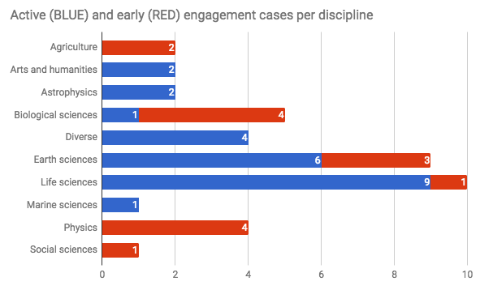During the 3 years of the project the SA2 WP engaged with and supported 40 communities in total (incl. the 8 competence centre communities). Out of the 40 cases 25 are active - i.e. either concluded or in technical development (these are shown as BLUE in the figure). The remaining 15 are early engagement cases, i.e. a joint agreement on required support is still needed.
The scientific classification of these 25 communities can be seen in the next figure below. The chard shows that life sciences and earth sciences dominate the landscape, with 15 communities in total. There are 4 communities working on diverse disciplines (generic also counts here, such as mathematics of OpenDreamKit). There is a rather uniform distribution of the remaining 6 communities among 4 disciplinary areas (Marine, Arts and Humanities, Astrophysics, Biological sciences).
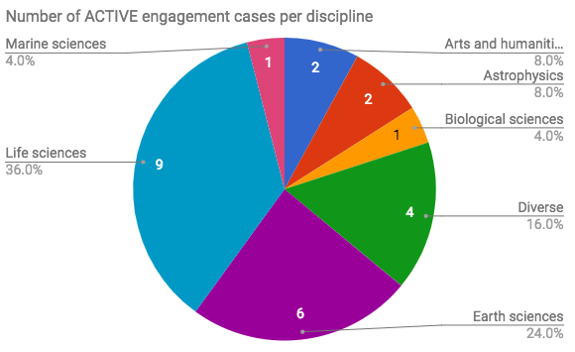
The science discipline coverage is broadened if we include also the early phase engagement cases in the pie chart. (See next Figure below). While life sciences and earth sciences still remain dominant (18 communities in total), biological sciences come up to the third place (5 communities), physics, agriculture and social sciences appear in the portfolio. This shows that the engagement activity is becoming more and more diverse over the years, with RIs and projects requesting e-Infrastructures from a broader set of disciplines.

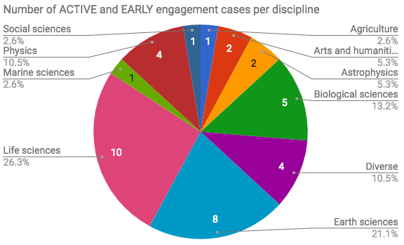

European e-Infrastructures
The project organised two Digital Infrastructures for Research (DI4R) events with European e-Infrastructure initiatives: EUDAT, GÉANT, OpenAIRE, PRACE and RDA Europe. The first DI4R included one session on research engagement, helping the e-Infrastructures exchange experiences from this area, and improving and harmonising support for new communities.
The EGI-Engage project organised two Design Your e-Infrastructure workshops in 2016, co-located with the EGI Conference and with the 1st DI4R event. These interactive workshops designed and prepared implementation plans for e-Infrastructures to serve emerging scientific communities. Each workshop featured 5 user communities that were selected by the organisation board (EGI and EUDAT representatives for the 1st event; EGI, EUDAT, GEANT, OpenAire representatives for the 2nd event). The workshop participants analysed the selected use cases, then - in a collaborative way - designed and defined suitable e-Infrastructure setups and roadmaps to implement the systems. Several engagement cases that were reported in the previous sections started at these workshops. (ICOS, Euro-Argo, OpenDreamKit, Eur. Research I. in CLL, PhenoMeNal project)
The project engaged with and supported several user communities that wanted to use services from both EGI and EUDAT in an interoperable way: ICOS, EPOS and ENES. A generic use case was defined and implemented for these use cases, and then was customised for each community. This generic use case demonstrated basic interoperability between the EGI Federated Cloud and EUDAT data services, and was predicated on the fact that both EGI and EUDAT use the same authentication mechanisms (x509 certificates). In the cases of all user community that Engage worked with, computing services were provided by the EGI Federated Cloud and long-term storage was provided by B2SAFE with data transfer provided by the B2STAGE service. Further details may be found in EGI-Engage D4.6 e-Infrastructures integration report

Other initiatives

BDVA
On March 29 2015, EGI became a member of the Big Data Value Association (BDVA), a public private partnership created to boost the value of European Big Data research.
The BDVA is a non–for-profit organisation with 24 founding members from large and SME industry and research and several universities across Europe.
The association is part of the European Commission’s Digital Agenda plan to generate value (jobs, growth, income) from the research data produced in European facilities. As a full member, EGI is involved in the BDVA’s meetings and working groups.
The Managing Director of the EGI Foundation has recently joined the board of directors of the Big Data Value Association for a two-year mandate.
By being part of the board of directors of BDVA, the EGI Foundation will be able to actively participate in defining the European Strategic Research and Innovation Agenda, but will also strengthen the collaborations between big data initiatives and activities in the EGI community and the European agenda.
Communications activities
Website: Visibility in memberships page (228 unique website views)
Newsletter: EGI becomes a member of the Big Data Value Association (April 2015)
News and blogs:
- EGI joins the Board of Directors of the Big Data Value Association (June 2017, 32 unique website views)
- EGI at the BDVA Summit in Valencia (December 2016, 45 unique website views)
- EGI becomes a member of the Big Data Value Association (April 2015, 27 unique website views)
Social Media:
- EGI joins the Board of Directors of the Big Data Value Association https://goo.gl/NqpDR9 @BDVA_PPP @ylegre #bigdata #eosc #innovation #SME
- Opening of the @BDVA_PPP General Assembly in #Valencia before the #bdvasummit. @EGI_eInfra is a proud full member
- At the first #BDVA summit in Madrid - #EGI is a platinum sponsor of this new venture on #bigdata http://www.bdva.eu/

RDA
The Research Data Alliance (RDA) builds the social and technical bridges that enable open sharing of data. The RDA vision is researchers and innovators openly sharing data across technologies, disciplines, and countries to address the grand challenges of society.
Within RDA, EGI brings experience in generic data fabric services for data management, data transfer and bringing data close to computation for processing, use and re-use. As multidisciplinary e-infrastructure EGI contributes to RDA in various areas:
- Data standards harmonization of existing standards: EGI reports experience on interoperability testing of services of the EGI platforms and those offered by research infrastructures and other data infrastructures such as the community-specific repositories and generic data infrastructures. Adoption of standards is fostered via the porting of community-specific services to standard-based e-Infrastructure services.
- Data sharing, exchange, interoperability, usability and re-usability. The EGI e-Infrastructure Commons provides a federated cloud infrastructure in which open research data and big data can be hosted and made available to experimental applications for processing and reuse. EGI will adopt existing solutions, prototype new ones and share its technical platforms.
- Greater discoverability of research data sets: EGI contributes to the gathering of requirements from users and service providers and to the design and prototyping of a data service registry and marketplace.
- Realization of the data scientist profession. As part of the Open Science Commons, EGI is committed to the realization of the ‘Knowledge Commons’ which represents the community knowledge and understanding needed to conduct e-Science, including the needs for data science. The Knowledge commons concept include the capability to easily share and access knowledge, training facilities, open source software, and other digital assets necessary for Open Science by federating training and education programmes.
Communications activities
Website: Visibility in memberships page (228 unique website views)
News item: Data Management Services In The Cloud

ERF-AISBL
The ERF-AISBL Association has the not-for-profit purpose to promote the cooperation and the projects between European-level research infrastructures which are open, at international level, to external researchers. These infrastructures include national infrastructures as well as European networks and consortia of research infrastructures.
EGI is currently member of the ERF-AISBL Executive Board and the EGI’s director has been appointed as Vice-Chair of ERF-AISBL.
ERF membership comprises ~20 European-level Research Infrastructure facilities or network including EGI and PRACE.
With the latter, we are co-leading a working group on Big Data that aims to collect requirements and best practices in the area of data management planning and data management implementation from the member infrastructures.
The topics of interest of the group will be:
- Data Acquisition: collecting raw data from registered data sources to be made
accessible by the infrastructure.
- Data Curation: storing, managing and ensuring access to all persistent data-sets produced within the infrastructure.
- Data Access: enabling discovery and retrieval of scientific data subject to authorisation.
- Data Processing: providing tools and services for performing a variety of data processing tasks.
The outputs of the Group will be:
- Common requirements for data management planning and implementation across ERF AISBL member infrastructures.
- Best practice recommendations for preparing and implementing data management plans by ERF AISBL research infrastructures.
- Position papers to be endorsed by the ERF General Assembly before public release.
As part of EGI’s contribution to the Executive Board, we are also representing the ERF association in the ERA stakeholder platform.
Communications activities
Website: Visibility in memberships page (228 unique website views)

Knowledge4Innovation
Knowledge4Innovation is an open, independent, non-profit platform with a wide variety of stakeholders including trade organisations and think tanks, universities, research organisations, as well as technology platforms, small and large companies.
Knowledge4Innovation is advocating for favourable framework conditions promoting innovation activities in Europe. The K4I Association has 35 members and is supported by a political forum of around 40 Members of the European Parliament. Since 2009, K4I has organised more than 200 debates most of which during its annual flagship event, the "European Innovation Summit".
EGI is part of the K4I Management Board, which consists of representatives of a set of member organisations and is responsible for the administration and management of the association. It manages the current affairs of the Association and represents it in all legal and extra-legal sectors.
This allows EGI to have high-level strategic communication and advocacy about the innovation undertaken by the federation.
Within K4I, we have direct access to the EU parliament, taking this opportunity to strengthen the links with members of the EU parliament, the Commissioners and high-level members of the EU Commission.
Communications activities
Website: Visibility in memberships page (228 unique website views)
News: The EGI Foundation signed the Pact for Innovation (May 2016)
Participation to the event: “Europe’s future: Open Innovation, Open Science, Open to the World” (June 2017)
Social Media:
- The EGI Foundation signed the Pact for Innovation to support the future of #openscience in Europe http://goo.gl/6Ik8PS @k4innovation
- Welcome speech by Lambert van Nistelrooij at @k4innovation #opentotneworld - innovation post 2020 is made of #competition & #solidarity
- We are at Europe's future: #openinnovation #openscience #opentotheworld event organised by @k4innovation
- Don't miss https://goo.gl/ALaamm organised by @k4innovation, @EUScienceInnov & RISE HLG. #OpenInnovation, #OpenScience, #Open2World #EOSC
- Making innovation possible & creating knowledge should be a top priority in the next years- says Roland Strauss, Co-founder of @k4innovation
- We may need 2 shift from funding 2 investment with clear impact factors says K. Vandenberghe, Director DG R&I @EUinnovation @k4innovation
- I second @HennaVirkkunen statement: "when investing in innovation we should also invest in basic & fundamental research" @k4innovation
- MEP Ivana Maletic urges all European actors to work together to define guidelines to evolve the #OpenInnovation framework. @k4innovation

SMEs and industry

Work carried/Summary of Achievements
The first year of EGI-Engage focused on defining the overall business engagement programme. This initially started within a deliverable (D2.2) to describe purpose and scope, objectives, areas of collaboration, benefits, and approval processes, which was used as a basis for developing a dedicated webpage and promotional material. The second year concentrated on outreach, relationship building and outboarding. This happened at both the European and the national level (further details provided in the following sections).
Activities also addressed key recommendations from the first EC review to reduce scope and target a specific sector to develop concrete use cases while providing suggestions for increasing success and shaping the future Work Program or Framework Program to better support in working with SMEs.
Main achievements:
- Business engagement model/framework that is able to be reused by NGIs (NA2.2 objective)
  - Webinar held “How to engage SMEs for national e-Infrastructures” (May 2017)
  - Based on involvement within EGI-Engage, NGIs specifying local business engagement programmes with national funding and overall better understanding of how to engage SMEs/Industry
- 150+ business related contacts (100+ SMEs)
- 7 concrete use cases with ~20 actively ongoing
  - Webinar held in partnership with UberCloud targeted the manufacturing sector resulting in the NUMECA use case (EC recommendation)
- Initial questionnaire for private organisations in order to structurally analyse opportunities (12 companies reached out via the questionnaire)
- Dissemination material: web pages, brochure
- 30 pilot submissions to EOSC-hub open call for business pilots through Joint Digital Innovation Hub
  - Though not directly funded by EGI-Engage, it demonstrates the outreach and interest from the commercial sector to engage with EGI and its providers and an evolution of the activity
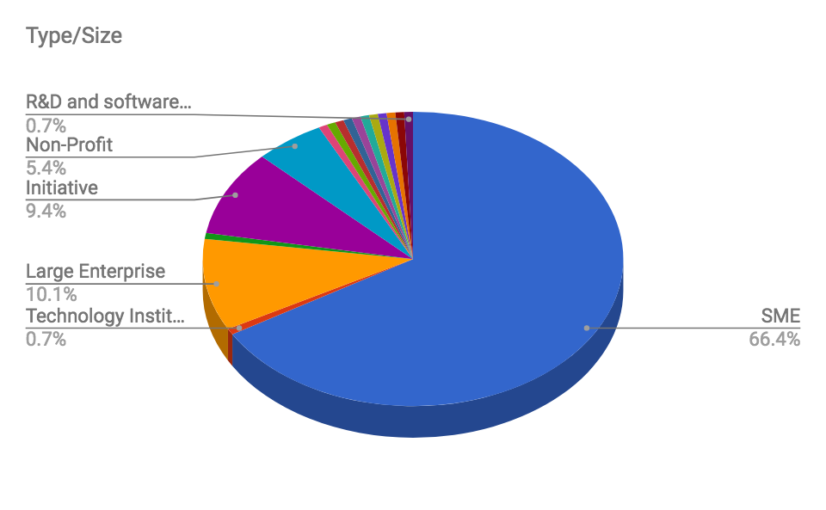
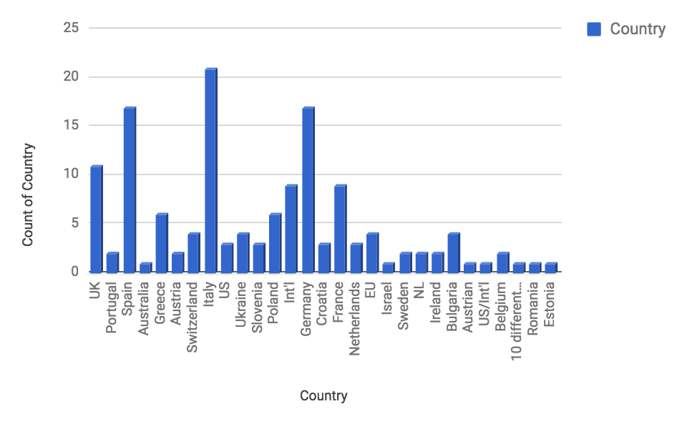

Individual Partners

EGI Foundation
Summary of work carried out
As activity leader, EGI Foundation organised regular phone meetings, chaired discussions, tracked actions, steered the direction of activities and ensured overall reporting. In addition, the main achievements can be summarised as:
- Main author of D2.2 – Master Model for SME Engagement
- Reviewed and coordinated follow-up plans based on recommendations provided in both Market Analysis reports (Marine Fisheries - D2.6); AgriFood - D2.10)
  - Developed the business model between the user communities, D4Science and EGI
- Organized and delivered two (2) webinars
  - “EGI Cloud for SMEs in CAE – OpenFOAM demo” (Oct 2016)
  - “How to engage SMEs for national e-Infrastructures” (May 2017)
- Developed the questionnaire for businesses interested in working with EGI/NGIs
- Gave several presentations and chaired sessions at conferences covering SME engagement such as DI4R, EGI Conferences (2015, 2016, 2017), amongst others previously reported.
- Responsible for 50+ commercial contacts
  - Directly responsible for several use cases and pilots (previously described in Section 2.4.4) and MoUs with UberCloud and CloudSME
- Formally connected the business engagement activity into the EGI Integrated Management System (IMS) through the Business Development and Stakeholder (BDS) process for tracking and managing business opportunities along with a defined interface to the Customer Relationship Management process (CRM)
Work beyond life of project
Since the EGI Foundation was established, SMEs/Industry have been part of its strategic target groups and will remain so well into the future. Business agreements (e.g. MoU, NDA) will continue to be sought as opportunities arise where mutual benefit is identified. The addition of the pay-for-use capability is also starting to support business model development thus increasing willingness to offer support.
The EGI Foundation will coordinate a dedicated work package within the EOSC-hub project set to kick-off in 2018 that will create of a Joint Digital Innovation Hub (DIH), which is an ecosystem that consists of SMEs, large industries, startups, researchers, accelerators, and the e-Infrastructures. The aim is to continue to work closely with the private sector to foster the use of digital infrastructures services and promote the values of open science. The EOSC-hub DIH will initially run 6 pilots with SMEs to kick-start business opportunities and will serve as a dynamic evolution of what EGI-Engage initiated.
Lessons learnt
- Top 5 reported value in using/collaborating with EGI (in order):
  - Access infrastructure and platforms with dedicated support
  - Increase visibility (marketing) on a national/European scale
  - Influence future services for business opportunities
  - Connect to a highly specialised community of experts to develop new products and services
  - Access key information on relevant public policies
- SMEs, and start-ups in particular, are in desperate need of access to funding with the limited availability of venture capital. Many find it difficult to navigate the public funding space.
- Time between initial contact, technical requirement understanding, provision and analysis to actual onboarding is lengthy and laborious, but is not an issue with the services themselves or the processes in place, but is actually seen to be common between the majority companies as they simply need consultancy and support, which is why commercial offerings on the market are not meeting their needs.

Recommendations
- Many European SME/industry initiatives across Europe, however many seem to be fragmented; need to bring this network closer together.
- More incentives for providers to make the physical resources available (e.g. piloting), which can be a catalyst for longer-term business relationships.
- Continue with programmes that target SME involvement, European exposure is a great importance to smaller companies looking to grow.

IICT-BAS
Summary of work carried out
IICT-BAS pursued a strategy of engagement with small and medium enterprises in order to increase the impact and achieve sustainability of our e-Infrastructure activities. We presented the EGI-Engage project and our involvement in it in some events that were either organized by us or we gave a presentation.
- 11th Annual Meeting of the Bulgarian Section of SIAM (Society for Industrial and Applied Mathematics), December 20 – 22, 2016, Sofia, Bulgaria
- WEBIT Festival EUROPE, 25-26 April 2017, Sofia Tech Park, Sofia, Bulgaria
- Ninth Conference of the Euro-American Consortium for Promoting the Application of Mathematics in Technical and Natural Sciences, Albena, Bulgaria, June 21-26, 2017
- Open Workshop "Mathematical Modeling and Advanced Computing for Industry and Society", Sofia, May 12 2016
- 120th European Study Group with Industry, July 25, 2016 - July 29, 2016
We also participated in meetings where we discussed possibilities for collaboration and established contacts with:
- “Startups in the financial industry (fintech)” – during CEE FinTech Sofia Meetup January 12 2017.
- “Companies in the automotive and electronics sector” – meeting between academia and representatives of these industries (clusters) – May 2017.
Statistics of contacts made
Initial contacts were established with many companies (40-50) during these events, however, those with which more concrete ideas for collaboration with EGI were discussed have been entered in the contact database. The sectors are mainly IT and electronics, as well as real estate. All of them are possible users of FedCloud services. One was interested in GPU computing resources.
Main achievements
With one of the companies the work has progressed to a stage where we knew sufficiently the requirements and submitted a joint proposal for the future EOSC hub. Another project involving IoT and mobile data processing was proposed for one of the Horizon 2020 calls and although it was not funded the consortium includes several European SMEs, academia and well-known IT company and new opportunities will be sought to advance its goals.
Work with SMEs and technology transfer forms part of a proposed Centre of Excellence in IT to be funded from structural funds. The integration of the national infrastructure through EGI is an important part of the proposal and our understanding of the needs of SMEs was instrumental in planning for the sustainability of the substantial infrastructure that is to be acquired.
Work beyond life of project
We expect in the next few months a national call for innovative projects that involve both SMEs and academic institutions and we intend to participate jointly with one or more of the companies that are in the EGI contact database, with good chances of success.
Lessons learnt
- One important observation is that it is very difficult to engage SMEs to a point where they would fill-in any kind of questionnaire.
- SMEs are interested in obtaining tangible economic benefit in the short to medium term. It seems that our current frameworks for collaboration are sufficiently flexible and the difficulty is more in achieving sufficient engagement.

Recommendations
As SMEs assess conservatively the possible benefits of collaboration it is highly desirable to have some kind of seed funding or seed resources available.

SwiNG
Summary of work carried out
SwiNG was engaged in the activities related to the EGI Marketplace, and in that context focused on solutions to enable the sharing and management of scientific resources (e.g. equipment, services, compute, storage). At the beginning of the marketplace evaluation Open IRIS (a resource sharing platform developed by the NGI in Switzerland) had the strongest match with the requirements for the EGI Marketplace as demonstrated in D3.2 “Design of the EGI Service Registry and Marketplace”. Originally, Open IRIS was primarily used in Switzerland, however, through the evaluation of Open IRIS in the EGI project its use was extended to several other countries.
Statistics of contacts made
In the course of discussions with multiple organizations, several of them have adopted Open IRIS or have entered into a pilot to evaluate the system as a solution to manage resources within their organizations or share resources across organizations. The list below is of organizations that are in an active pilot, using the system in production, or are having become a partner of the project during the EGI project.
Organization | Status | Pilot
BioImaging Center in Bordeaux | pilot | France
Centre d'Immunologie de Marseille-Luminy | production | France
College de France | production | France
École Normale Supérieure | production | France
ETH Zurich | partner | Switzerland
Harvard | production | United States
Institut Curie | partner | France
Institute of Photonic Sciences | pilot | Spain
Institut du Cerveau et de la Moelle Epinière | pilot | France
Leibniz Institute on Aging | pilot | Germany
Max Delbrück Center for Molecular Medicine | production | Germany
Paul Scherrer Institute | partner | Switzerland
Sainsbury Wellcome Centre | pilot | England
Thermo Fisher Scientific | partner | Germany
University of Basel | partner | Switzerland
University of Goettingen | pilot | Germany
University of Helsinki | pilot | Finland
University of Los Andes | Pilot | Columbia
University Pierre and Marie Curie | pilot | France

The above list is only a partial list of organizations that are evaluating or using Open IRIS as there are organizations evaluating or using the system that have not been in direct contact as it is fully self-service and free to use, some of these organizations are from Brazil, Singapore, and Qatar.
Main achievements
As different organizations have adopted Open IRIS, the usage of the system has grown dramatically during the EGI project. In each of the last two years, the users and resource requests of the system have doubled. In the table below is displayed the current statistics of the system.
Metric | Status
Users registered | 4708
Organizations represented by users | 196
Countries of organizations | 48
Logins per day | 300
Resource providers registered | 248
Resources registered | 1717
Resource requests per month | 10000

The usage of the system has grown substantially, going from around 1000 resource requests per month to over 10,000 resource requests per month as shown the graph below.
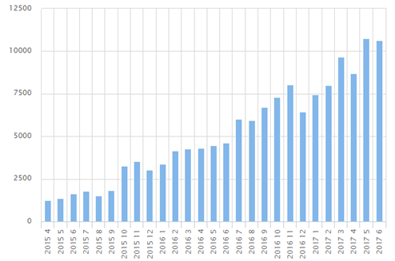
Open IRIS has facilitated resource management and discovery within organizations, however, it has also enabled the sharing of resources and collaborations between academic and commercial entities. Currently there are over 20 commercial organizations registered in Open IRIS that are using the system to share commercial resources to academic organizations, or for commercial organizations to use resources from academic organizations. In particular, there has been the establishment of resource sharing clusters based on Open IRIS in Paris and in Basel, and there is currently one being established in Berlin. There have also been discussions to establish French and Austrian wide solutions for sharing of microscopy resources across countries based on Open IRIS. In May 2017 Open IRIS also received an award for innovation in “Laboratory Effectiveness” by S-Lab and the UK Science Park Association, demonstrating it’s applicability to sharing resources between academic and commercial organizations. It is hoped that this strength can be leveraged with the EGI Marketplace to integrate e-Infrastructure resources with instrument resources and scientific services.
Work beyond life of project
In the course of the EGI-Engage project the Open IRIS platform has transitioned into a consortium based approach where organizations join as partners to the platform and contribute financially. This has led to the platform becoming self-sustaining, while at the same time remaining free to those that would just like to use the platform as is. It is expected that the growth trend of the platform will continue as there are several organizations planning for rollouts this year of the platform, which could add several thousand more users to the platform.
Lessons learnt
It can be seen by the success of Open IRIS that organizations are interested in a platform for resource management and resource sharing. It can also be seen that these organizations then used the platform to share or use resources from commercial organizations. Open IRIS has then been able to optimize resource usage within these organizations and to share resources between organizations. In allowing the sharing of resources between organizations then new opportunities arise to engage with SMEs. Some examples are Institut du Cerveau et de la Moelle Epinière use of the platform for helping local startups, Paul Scherrer Institute plans to use it to share resources with a nearby science park, Institut Curie uses it in a collaboration with Nikon, Thermo Fisher Scientific is using it to open available lab resources to academic organizations, and many other resource providers in the system engage SMEs through the platform.
Recommendations
The approach taken here is not an obvious one in that the goal was to improve resource across organizations, but the initial focus was to make the tools useful to share and manage resources within an organization. As tools to share resources within an organization is in high demand this lead to adoption of the tools by many organizations, then when this tool was adopted by the organization it then enables them to also share resources with other organizations. All of this was done with strong engagement of the end users of the platform, where features were added at their request to meet their particular need, but it was also architected in a manner to facilitate sharing of resources across organizations.

CSIC (BIFI)
Summary of work carried out
In the context of HPC summit (Barcelona, May 2017) BIFI had the opportunity to talk with Stephan Requena from SIMSEO, a French initiative to promote the use of computational simulations in industry. We discussed about how the group was created, what type of companies they involve, the type of activities that they carry out to promote the use of computing infrastructure by the Industry, etc.
BIFI is part of a national group created by the National Supercomputing Network called RESxPYME to promote the use of HPC in Industry.
Thanks to several promotional activities of Industry 4.0 in the region of Aragón, we had a meeting with TEFIPRO, Gotor Communicaciones, AITIIIP, ELT, Inycom, VEA global where we promoted the use of cloud infrastructures by SMEs. Also, we had meetings with Biocurve, Nabladot, Telnet, Podoactiva, Schnell Software and ITAINNOVA.
Statistics of contacts made
A total of 12 contacts from different sectors, mainly industry but also IT companies, consultancy agencies and a Technological centre. In general, they are small and medium, only Telnet and Inycom are mid-caps. We offer our cloud infrastructure as an experimental environment for SMEs and their main interest was focused use of cloud for simulations, and storage.
Main achievements
Some of them are very interested in the use of cloud services, our experience up to now is that they just want to collaborate under a funding programme that will support their experience using the infrastructure.
BIFI participated in the creation of the Digital Innovation HUB of Aragon in collaboration with ITAINNOVA. We will have the support of the Regional Government to get closer to Industry also thanks to ITAINNOVA sales force.
Work beyond life of project
We will keep on working in the promotion of the use of cloud infrastructure in the working groups where BIFI is participating: RESxPYME group at national level, As part of the advisory board of I4MS and in the Digital Innovation HUB of Aragon, with ITAINNOVA
Lessons learnt
Some of the companies contacted were interested in the use of cloud services, but our experience up to now is that they just want to collaborate under funding programs that will support their experience using the infrastructure.
Alliances with other entities (Regional governments, funding programs) are absolutely essential to engage SMEs in the use of cloud infrastructure.
One of the main difficulties is related with the lack of sales force and the "marketing style" of scientific groups and academia. Sometimes a consultancy service is needed as some companies don't know how to start, or what they can do to improve their business.
- Visiting companies, face to face meetings, and participation in funding calls, are some of the activities that really works.
Recommendations
In general we recommend Face to face meeting with companies. Work closer with them. And of course, funding programs to support experiments.
EGI could work closer to other initiatives at European level (PRACE, etp4hpc, I4MS, BDVA). Too many initiatives are created.
Regarding the NGIs, we consider that regional and national government support is the key to engage companies.
Finally, considering funding programs, we recommend the Factories of the Future where the funded projects launch open calls to support new experiments. These calls are more focused in several types of technologies, problems, sectors and SMEs don't feel so lost in the mess of H2020,

CNRS
CNRS attended the meetings and conferences organised by EGI.
CNRS contacted SMEs during the first year of the project. Number of them was systematically contacted in the exhibition part of a main event organised for the IT teams in Research and higher education in France (JRES: www.jres.org). This exhibition gathers SMEs and industry used to work with academic entities. But despite this fact a few contacts were interested and none positive at the end.
The main achievement is a better knowledge of the SMEs and the industry sector.
The work beyond the project will depend on the type of structure that will be decided for the NGI in a few months.
SMEs in France are not well aware of EGI, H2020 and its vocabulary, the NGIs, the international research communities...The context is very rich and it was not easy for them to understand well. It should be useful to improve the dissemination in these domains.

GRNET
GRNET attended the meetings and conferences organised by EGI. GRNET used this task to investigate possibilities and to define internal procedures on how to sell its services to SMEs. The main achievement is that we defined internal procedures on how to issue an invoice, to define a cost model and how to monitor SLAs. GRNET used a request from the SWISS NGI to issue eScience Certificates for them as an opportunity to define the aforementioned procedures and is since 2015 issuing certificates for the Swiss NGI.
The work beyond the project will depend on the opportunities that may arise especially in the area of Satellite data and the bids that are issued by ESA.

INFN
INFN attended the meetings and conferences organised by EGI, contributing to the organization of one of them (EGI Community Forum 2015, Bari, Italy).
INFN contacted SMEs and enterprises and started collaborations, providing them with cloud computing resources and forming research and development partnerships, profiting of this interaction to explore and define the needs of the private sector in order to better plan a commercial engagement. The most required features concerned security, Service Level Agreement, and certificated resources, with guaranteed low downtime.
A number of local, national and international SMEs and enterprises are currently using resources available within the ReCaS-Bari IaaS cloud infrastructure, owned by INFN and University of Bari, with research/project partnerships and agreements. This usage is in a testing phase that, if successful, could lead to a more deep and formal collaboration, following the pay-per-use model.
The ReCaS-Bari data center, as a public/non-profit organization, has defined a pricing plan for IaaS resources, has obtained authorization to provide services on a pay-per-use basis, and has initiated the procedure to obtain certifications. This process will continue after the end of the project, until a wide share of INFN computing resources could be provided to the private sector on a pay-per-use basis.

LIP
LIP participated in the meetings and activities related to the SME topic and also in the EGI conferences and workshops. LIP investigated the possibility and procedures to provide services to SMEs within the scope of the Portuguese National Distributed Computing Infrastructure - INCD. INCD is the Portuguese national infrastructure that bridges with EGI. As a result, a class of users for SMEs has been added to the set of users that can be supported by this initiative and SME support has been specifically incorporated in the national project that will support the INCD infrastructure from mid2017 onwards. An identification of costs and price also took place. Contacts have been established with private companies in areas such as brain encephalography, civil engineering, and earth observation. Fostered by these activities a service for coastal simulations with high potential for future commercialization has been submitted and approved within the EOSC-hub project aiming at providing simulations on demand to public and private entities. LIP aims to continue pursuing the SME activities within the context of INCD and its national and international participation in EOSC and other initiatives thanks to its involvement in this dedicated EGI-Engage activity.

Resource allocation, SLAs and OLAs
To facilitate the allocation of resources to fulfil the needs of a specific group of researchers and allow them to better plan a research programme, EGI has established the framework depicted in the following figure:

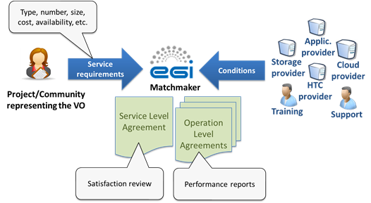
The process starts with collection of technical requirements expressed in terms of number of CPU cores, disk space, software packages, etc., needed by the Customer to support a specific research activity. EGI uses Customer’s requirements to collect offers from the different providers of the federation that can fit-on-purpose. The process allows need for one-to-one interaction between the Customer and the provider of the federation. EGI acts as matchmaker establishing several Operational Level Agreements (OLAs) with the interested providers and single Service Level Agreement (SLA) with the Customer.
Thanks to this framework, EGI acts as central point of contact between the Customer and the providers of the federation who have expressed the interest to collaborate.
The OLAs/SLA agreements proposed by EGI are not legal contracts, but an agreement on intentions to collaborate and support the Customer’s research activity. This agreement states the type of service offered by the providers (e.g. Cloud Compute, Cloud Container Compute, Online Storage, etc.), the conditions under which this service is offered along with the service targets.
To guarantee high quality of service(s) offered to the Customer, EGI coordinates and monitors the service delivery in order to measure the fulfilment of the agreed service level targets and manages the Customer complaints and disputes. From a technical perspective, this is done by monitoring the monthly service performance and checking whether the service targets are met. The performance report, describing how the service is delivered, is sent to the Customer every 6 months. In case of any violations, EGI will contact the provider to understand the problem and identify mitigation plans. In case of repeatedly violations of the service target for 3 consecutive months, the whole agreement with the provider will be reviewed. Every three, six months EGI runs Customer Satisfaction Review process to review the whole agreement and identify possible improvements for the agreement and services. For what concern the Customer’s responsibility, he/she has to acknowledge EGI and the providers in the scientific publications benefiting from the service offered.
The values propositions of this framework are manifold:
- For research communities (the Customer):
  - Better communication and clarity on expectations;
  - Increased confidence that services will be delivered;
  - Easier future planning of research activities.
- For resource providers:
  - Direct communication with user communities and clarity on expectations;
  - Clear responsibilities and rules/policies concerning usage of the resources;
  - Recognition and greater visibility to role of the provider by requiring an explicit acknowledgment.
- For EGI Foundation:
  - Promoting the EGI service value with funding agencies and policy makers at national and European level;
  - Being seen as mature partner;
  - Ensuring a foundation of a control process to what is being delivered in the EGI Federation.
If no dedicated SLA agreements are in place, Corporate Level Service Level Agreement is valid for all services provided to support business processes according to the current valid EGI service catalogue.
Currently the process is run manually and there is a plan to simplify the process with automatization being proposed in EGI Marketplace.
As a result of resource allocation process, 37 providers from 15 countries have allocated: 152M computing hours for HTC, 169 TB of storage, 4.9 TB of RAM and 1410 vCPU cores. The access to these resources is granted with an opportunistic access.
The exploitation and the usage of the EGI resources for supporting research activities is reflected by the accounting records published in the EGI Accounting Portal. Even if not all the Customers have the same level of maturity, and have different workflows to be executed, the trend of resources used is increasing. In the last few months, 6 agreements out of 11 have been reviewed. During the Customer satisfaction review process, these agreements, which state the type of service(s) delivered, have been reviewed and potential suggestions for improvements have been identified, planned, implemented and monitored.
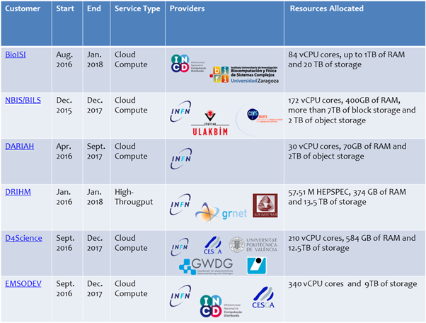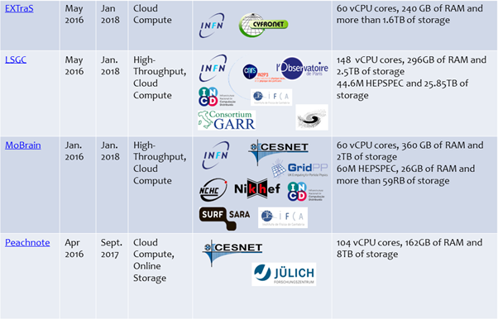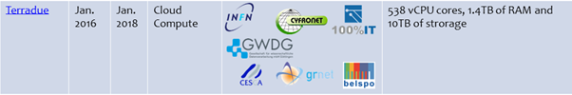

Communications activities
Website:
We have a page to promote the resources committed through the SLA framework: Committed Resources (391 unique website views)
News:
MoBrain and DRIHM resource agreements renewed (April 2017)
EGI data centres support biosystems and integrative sciences (February 2017)
EGI joins the EMSODEV project in observing climate change effects (January 2017)
Peachnote in unison with EGI (November 2016)
EGI and LSGC join forces to support life sciences (October 2016)
EGI and Terradue: a better cloud service for science (September 2016)
EGI and DARIAH: expanding the Arts and Humanities field (September 2016)
EGI and EXTraS: serving the Astronomy and Astrophysics community (August 2016)
EGI – MoBrain collaboration: an SLA for better research (February 2016)
New collaboration: EGI – the DRIHM project (May 2015)

Newsletter:
Terradue & EGI: a partnership for Earth Observation (May 2017)
Computing & storage resources committed in 2016 (November 2016)
SLAs: Connecting the BILS research community to national cloud providers (Jan 2016)

Social Media:
- Terradue & EGI: a partnership for Earth Observation
- https://www.egi.eu/about/newsletters/terradue-egi-a-partnership-for-earth-observation/in @EGI_eInfra Newsletter May 2017 @terradue @esa_gep
- MoBrain and DRIHM resource agreements renewed
- https://www.egi.eu/news/mobrain-and-drihm-resource-agreements-renewed/ …
- New Agreement: DARIAH is granted access to @EGI_eInfra cloud-computing services. Learn more in a short interview: http://bit.ly/2doV8FC
- .@EGI_eInfra and EXTraS: serving the Astronomy and Astrophysics community http://primeurmagazine.com/weekly/AE-PR-10-16-18.ht

Summary of achievements and lessons learnt
- OLA negotiation takes long and does not always conclude with success:
  - We learnt that EGI can confidentially arrange resources if those are …, and in other cases we should not enter into negotiation but rather pass the opportunity to partner e-Infrastructures: PRACE or the PRACE HPC Centre of Excellence projects in case massively parallel applications need more than 128 cores with MPI.
  - We propose the NGI council the setup of a resource pool that can be used as a start-up allocation for new communities, with a lightweight negotiation and approval process. A similar proposal was rejected by the council in the past; we should now reopen this discussion.

Report on EGI Communication Channels

Website
What for: Main communication channel to and from the EGI Community; shop window to the EGI services; give visibility to EGI's resource providers and users

Website renovation
The website was completely renovated during the period of EGI-Engage, according to the plan outlined in milestone M2.3. In a nutshell, the old website (structured around a project model, lacking direction and focus, poor navigation and too much superfluous content) was substituted in September 2016 by a new Wordpress installation in line with the Communications Objectives of the EGI Foundation:
- Showcase EGI services and increase service visibility
- Increase the visibility of the EGI Council and resource providers
Now that it's almost a year since the transition was completed, it is time to assess how the new website is contributing to these objectives.

Showcase EGI services and increase service visibility
The old website targeted the services & (what we then called solutions) at the audiences they were intended to. There was considerable effort to organise the service offer by target audience (e.g. council members, resource providers, researchers).
The new website abandoned this strategy and opted to divide the service portfolio into two simple categories:
- Services that can be requested via the click of a button (the external catalogue)
- Services that cannot be request via the click of a button (the internal catalogue)
This approach removed assumptions of what we think consumers want and stopped the proliferation of ever more specific categories in an effort to cover all possible types and sub-types of audiences. The approach also increases inclusiveness by eliminating unnecessary labels, leaving to the consumers the task of deciding for themselves if they want the service (instead of having to spend time trying to figure out which consumer type they fit in).
The viewership figures presented in the following table strongly suggest that the new structure is on the right track. All pages under the services sections all saw a significant increase in traffic.

Website area |  | Online | Unique website views (per day) | Diff.
Service pages  (graph below) | OLD (all pages under the services and solutions sections) | Apr15 – Sep16 | 13,378 (24.1) | + 49.0%
 | NEW (all pages under the internal and external services sections) | Oct16 – Jul17 | 11,010 (36.0)
Service catalogue | OLD (Table of content page) | Apr15 – Sep16 | 5,592 (10.2) | + 95.5%
 | NEW (Table of content pages; int and ext) | Oct16 – Jul17 | 6,081 (19.2)
Cloud service | OLD (FedCloud solution page) | Apr15 – Sep16 | 990 (1.8) | + 192.3%
 | NEW (FedCloud service page) | Oct16 – Jul17 | 1,610 (5.26)
HTC service | OLD (HTC solution page) | Apr15 – Sep16 | 583 (1.1) | + 70.2%
 | NEW (HTC service page) | Oct16 – Jul17 | 552 (1.8)

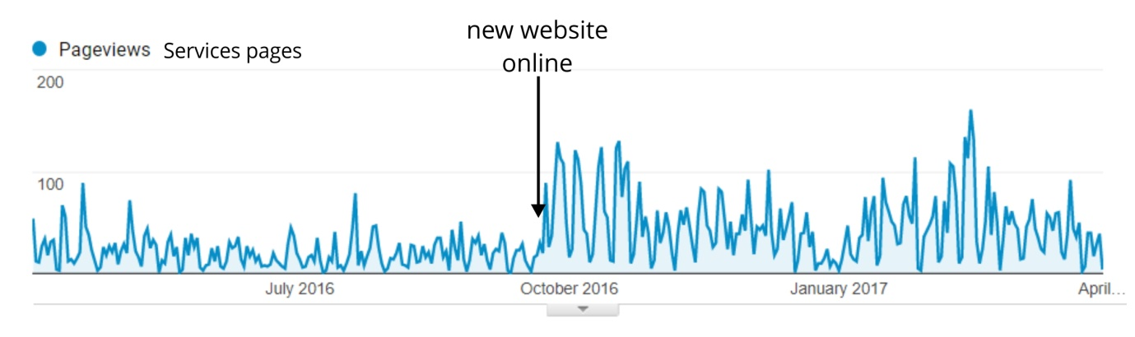

Increase the visibility of the EGI Council and resource providers
The old website was lacking a dedicated page for the EGI Council and did not list the organisations represented in it. The website had a section about the national e-Infrastructure providers (the NGIs), including factsheets on some, but it did not credit their contribution as providers in service pages, or in use cases.
The new website has a slider caroussel on the frontpage, listing the organisations that are represented in the EGI Council. The caroussel links to EGI Council page, where the council participants are clearly indicated and links are provided to their webpages. There are no factsheets on individual participants. In addition, the new website has an area dedicated to the providers of the EGI Federation, listing all EGI federated data centres and the EGI Federated Cloud.
Council participants, federated data centres and federated cloud providers are now wherever applicable listed by name in:
- all service pages (under the section Service provided by:)
- all use cases and research stories (side column)
- every news item related to the usage of resources or services (e.g. articles about SLAs)

Overview of website statistics
This section focusses on viewership statistics of the new website (October 2016 – present).
Unique website views per top menu section and their dependents:
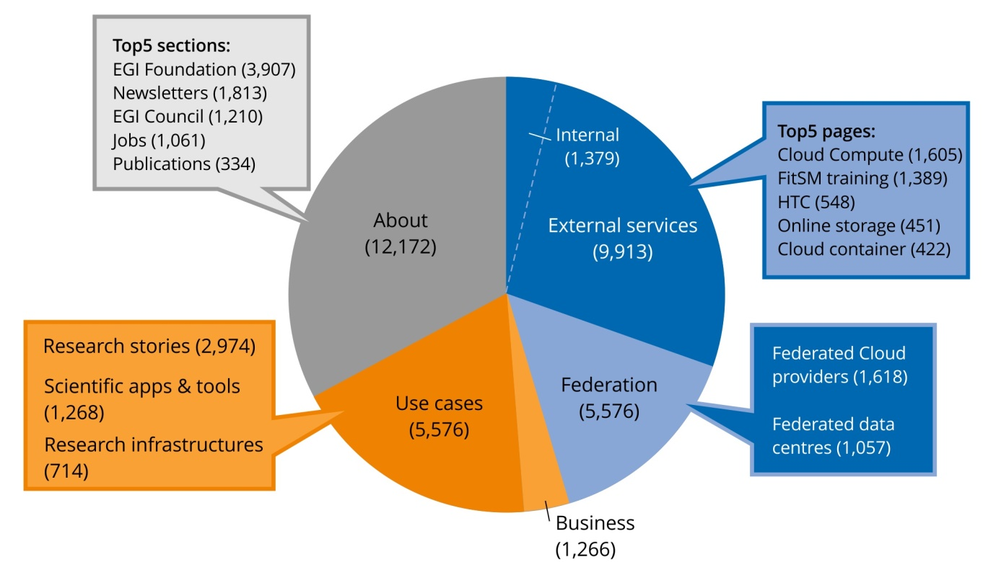
Details about the newsfeed, blog and other communication channels are presented below.

News
What for: Factual reporting, EGI+NGI announcements
During the period of EGI-Engage we posted 103 news items, which can be subdivided into three broad categories:
Articles  Stories about developments, outputs, results (including stories with a focus on communities)  Announcements  About EGI or NGI events (conferences, webinars, training)  Publications  Announcements about EGI publications | 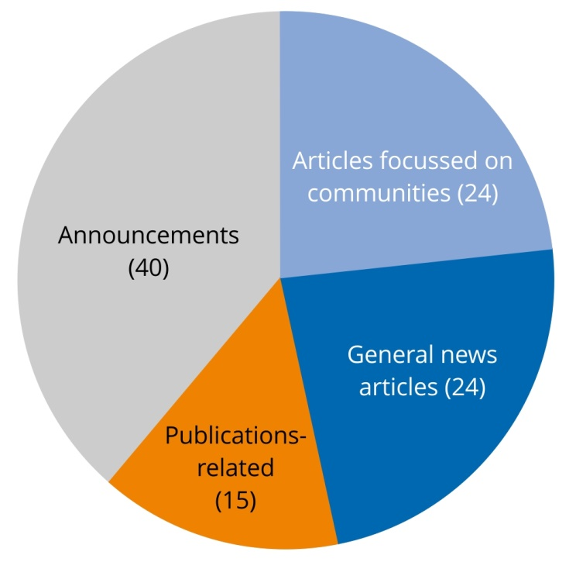
Viewership statistics (as of July 2017)
 | Unique  page views | Average time /page | Top stories [unique views]
Old website | 12,026 | 01:58 | > The European Open Science Cloud for Research [892]  > INDIGO-DataCloud project approved [854]  > EGI-Engage favourably evaluated [570]
New website | 3,742 | 02:45 | > EGI Conference 2017 Catania, 9-12 May [812]  > Call for Competence Centres and Business Pilots [406]  > Open call for thematic services to support open research [357]

The EGI newsfeed is syndicated by the following websites:
- France Grilles: http://www.france-grilles.fr/category/egi-en/
- Hellasgrid: http://www.hellasgrid.gr/
- Ukrainian National Grid: http://infrastructure.kiev.ua/en/news/
What have we learned?
Since we started writing frequent news articles at the beginning of the EGI-InSPIRE project (the predecessor of EGI-Engage), the newsfeed has been quoted by external sources at least 500 times. The majority of quotes come from websites of partner institutions (e.g. NGIs) and especially associated projects. This suggests that EGI is seen as a credible source of information and that the time investment in the newsfeed during the project was well worth it to nurture this effect.

Blog
What for: Event reports, announcements by other people, opinion
The EGI Blog was frequently updated during EGI-Engage, totalling 50 posts at the time of wrighting. The posts can be subdivided in:
External announcements  e.g. events, calls, posted on behalf of partner projects / organisations  EGI events & event reports  e.g. training, webinars, reminders  External news  posted on behalf of partner projects / organisations  Opinion  posted by EGI staff about a topic of their interest  User communities and NGIs  e.g. competence centres, NGIs, use cases | 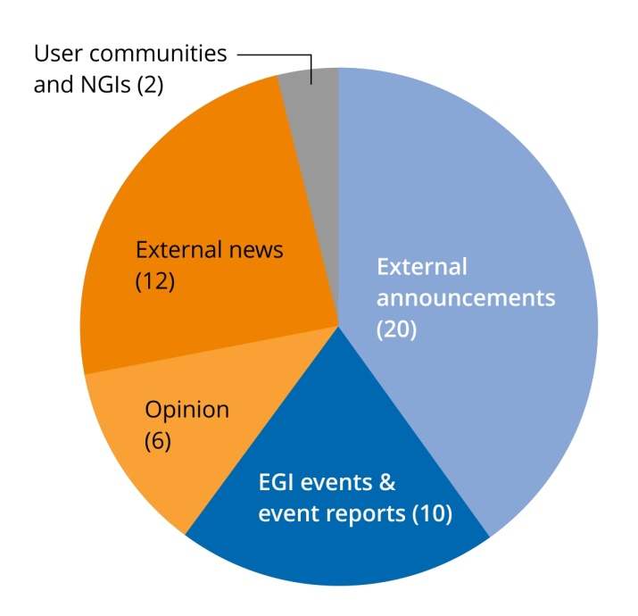
The blog underrepresents EGI-focused topics on purpose. EGI news and announcements are already covered in the EGI newsfeed and newsletter and we chose to use this channel as a way to broadcast of the successes and announcements of our partners.

Top blog posts (as of July 2017)
Title | Unique views
Shaping the Open Science Cloud of the future | 270
Business track summary: outcomes and next steps  (EGI Conference 2015) | 254
Call for papers: workshop on Big Data Analytics 2016 | 243
Summer reflections on the Open Science Cloud | 224
Join the EGI Foundation strategy and policy team | 162
EGI and UberCloud webinar for SMEs CAE OpenFoam | 159
Big Data Analytics Workshop | 158
The Open Science Commons are adopted by the European Council | 151
Registration open for the second workshop on the European Open Science Cloud | 150

What have we learned?
The increasing amount of 'volunteered' stories (the Communications Team seldom has to put effort into looking for external posts) suggests that our partners and related organisations appreciate the value of using the EGI Blog as a way to amplify their messages. The blog has been quoted at least 220 times by external parties since its inception in 2011, which reinforces the idea above.

Newsletter
What for: Community-related in depth stories, opinion, future trends, reflections
The EGI newsletter Inspired had eight issues published during EGI-Engage. In total we published 103 articles that fall into eight categories:
Technical  e.g. portals, pilots, architecture, AAI  Projects with EGI participation  e.g. INDIGO-DataCloud, AARC  User communities and NGIs  e.g. competence centres, NGIs, use cases  EGI-focussed, including lead projects  e.g. EGI Foundation, EGI-Engage  Events  e.g. announcements, reports  Policy-related  e.g. funding programmes, EGI strategy | 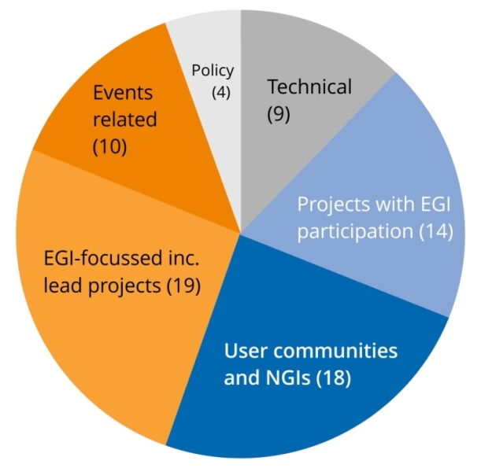

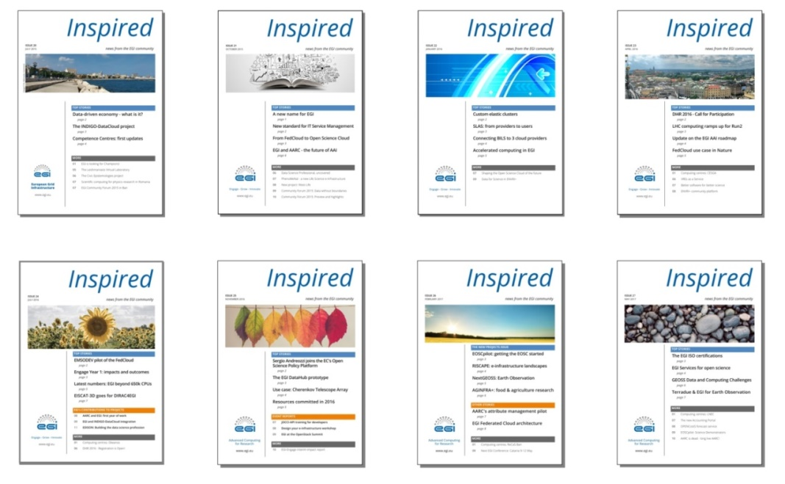
The newsletter is issued every quarter using the MailChimp email tool. Readers can click in the links sent by email to read the articles published in the EGI website. They can also read the newsletter in PDF format. The email is sent to three mailing lists:
- all-SSO: includes all accounts registered in the EGI Single Sign On database. Users join SSO to access EGI web-based tools (for example the event manager Indico). Contains about 3100 emails
- news: includes addresses collected over the years during events, for example. It is used to send EGI-related press releases and outreach information. Contains about 1600 emails
- newsletter: started in early 2017, this mailing list includes the email of people who specifically requested to receive the EGI newsletter. Contains about 20 addresses. (Because of its low total, this list will be ignored in this reporting.)

Readership statistics collected via MailChimp (as of July 2017)
Opens: Total on the left-hand side and subdivided by mailing list on the right-hand-side: all-SSO (top) and news (bottom). In brackets: percentage of the addresses in the mailing lists that open the newsletter email.
 | Opens * |  | Clicks * | C/O ratio | Most popular story
issue 19 | 2212  (47.1) | 1022 | 291 | 0.13 | The EGI-Engage project
Apr '15 |  | 1190
issue 20 | 2150  (45.7) | 926 | 380 | 0.18 | INDIGO-DataCloud project
Jul '15 |  | 1224
issue 21 | 2305  (49.0) | 978 | 554 | 0.24 | A new name for EGI
Oct '15 |  | 1327
issue 22 | 2316  (49.3) | 949 | 295 | 0.13 | Custom elastic clusters
Jan '16 |  | 1367
issue 23 | 2312  (49.2) | 1022 | 418 | 0.18 | EGI AAI roadmap
Apr '16 |  | 1290
issue 24 | 2250  (47.9) | 1026 | 328 | 0.15 | Latest numbers: EGI beyond 650k CPUs
Jul '16 |  | 1224
issue 25 | 2179  (46.4) | 908 | 309 | 0.14 | Introducing the EGI DataHub prototype
Nov '16 |  | 1271
issue 26  Feb '17 | 1888  (40.2) | 806 | 273 | 0.14 | EOSCpilot: getting the EOSC started
 |  | 1074
issue 27  May '17 | 2000  (42.6) | 883 | 280 | 0.14 | EGI: Services for open science
 |  | 1104
* Not including activity in systems protected by tracking blockers

Readership statistics collected in the EGI website (as of July 2017)
 | Unique  page views | Average time  on page | Top stories [unique views]
Old website | 8,676 | 01:47 | > The INDIGO-DataCloud project [316]  > From FedCloud to Open Science Cloud [236]  > Sustainability - next steps [235]*
New website | 1,781 | 02:25 | > Getting the EOSC off the ground [243]  > Introducing the EGI DataHub prototype [179]  > IBM model exascale computing system [100]
* This article was originally published in the Winter 2012 edition (i.e. it was already 3 years old by the time EGI-Engage started)
What have we learned?
The newsletter is a very powerful communication channel: it manages to attract the attention of almost half of the audience on a regular basis.
Readers seem to like stories about big milestones (start of flagship projects) and technical developments.
Readers are not keen on stories about incremental project contributions, or event reports. It is tempting to pursue this route, but we should really put effort on more ambitious types of stories.

Publications
What for: In depth information to convey the added values of EGI services, or information in a nutshell to stimulate interest
During EGI-Engage, we worked on the following publications:

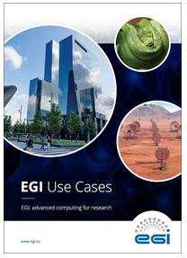 | EGI Use Cases  A collection of the best research use cases published in the EGI website.  July 2017 | PDF: http://go.egi.eu/SCpdf
Keeping EGI secure
EGI CSIRT: Prevention – Response – Training
A short report about the inner workings of the EGI security team.
July 2017 | PDF: http://go.egi.eu/csirt
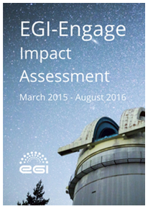 | EGI-Engage Impact Assessment  EGI-Engage’s contribution to the evaluation questionnaire presented by DG-CNECT in September 2016.  September 2016 | PDF: http://go.egi.eu/iir
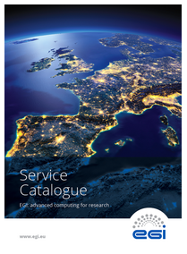 | EGI Service Catalogue  An overview of EGI’s services and examples of how researchers are using them in their daily work.  Distributed at conferences and meetings with partners.  September 2016 | PDF: http://go.egi.eu/SCpdf
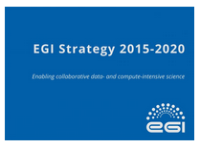 | EGI Strategy 2015-2020  The EGI Strategy 2015-2020 explores what EGI has to offer, its vision, mission and strategic goals, and defines EGI’s value proposition in terms of target groups, service offering and strategic partnership.  July 2015 | http://go.egi.eu/strategy2020
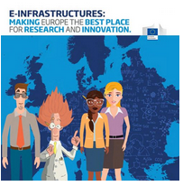 | e-Infrastructures: Making Europe the best place for research and innovation  This booklet, published by the European Commission’s e-Infrastructures Unit, describes how e-Infrastructures contribute to innovation and research.

Social Media
What for: As a mean to amplify the other communication channels.
EGI’s social media channels are: Twitter, Facebook, LinkedIn
Current EGI accounts:
Twitter: @EGI_eInfra, 2157 followers.
Facebook: http://www.facebook.com/EuropeanGrid, 452 followers.
LinkedIn profile page: http://www.linkedin.com/company/stichting-European-grid-initiative
LinkedIn group: European Grid Infrastructure, 570 members.
The EGI social media channels are employed to:
- Showcase EGI’s services within our community
- Foster a good relationship with our stakeholders and users and give them visibility
- Strengthen the image of EGI within our community
- Support the other communication channels
- Build social media influencers: Tiziana Ferrari, EGI Foundation Technical Director, and Yannick Legré, EGI Foundation Managing Director.
The EGI communications team uses the main social media networks – LinkedIn, Facebook, Twitter – to post each time there is something interesting to showcase at EGI: announcements, events, news from the EGI community, reposts from partner-projects or external sources. The frequency of posts varies depending on the news and activities that are worth sharing.

Official EGI Twitter account:
Twitter is the main social channel and it is being used for promoting all EGI’s activities, helping the EGI management become social media influencers and reinforcing the image of EGI as a lead e-Infrastructure for research.
Over the last 2 years, EGI has improved its Twitter presence exponentially, with a reach of 2157 followers today and a significant growth in social engagement.

Available statistics (from Hootsuite analytics tool):
January 2016 - July 2017:
+ 489 followers (number of people who started to follow EGI Twitter)
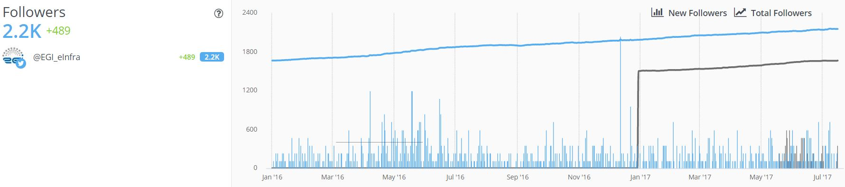
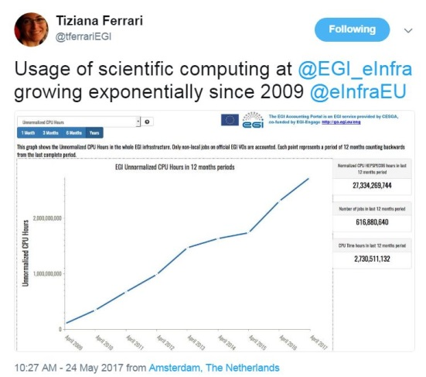
+ 1,300 engagement activities (the sum of interactions received for the EGI tweets: retweets, replies, quotes and likes)
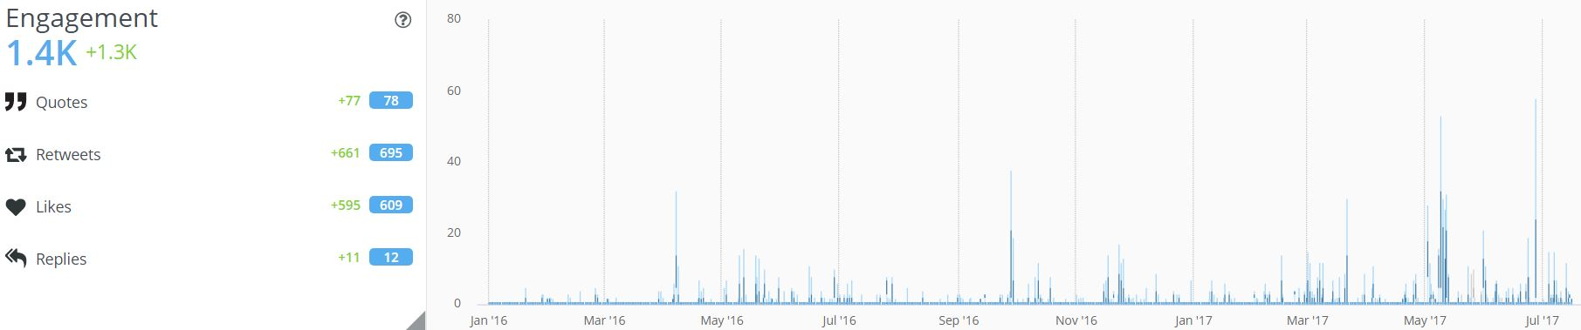

Twitter Management accounts:
Tiziana Ferrari, Technical Director of the EGI Foundation
Twitter account: 202 followers
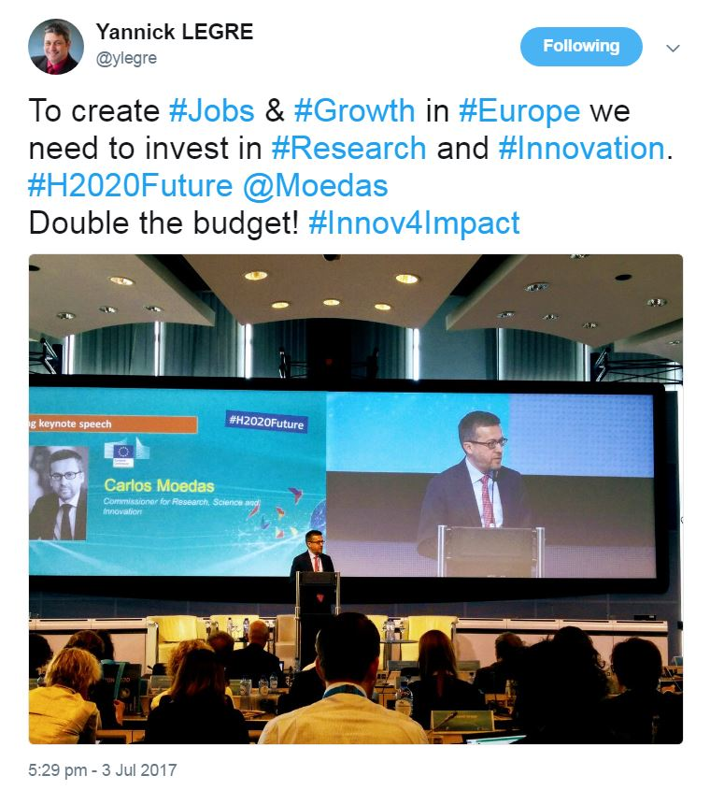
Tweet topics: EGI technical developments, EGI usage reports and figures, news from the EGI community, live tweets from events, scientific computing news and the European agenda for research and innovation.
Examples:
https://twitter.com/tferrariEGI/status/884409739718819840
https://twitter.com/tferrariEGI/status/883246589422292992
https://twitter.com/tferrariEGI/status/874204875516768256
https://twitter.com/tferrariEGI/status/867295957540622338

Yannick Legré, Managing Director of the EGI Foundation
Twitter account: 175 followers
Tweet topics: EGI news, the European Open Science Cloud, live tweets from events, open science and innovative computing developments, news from EGI stakeholders.
Examples:
https://twitter.com/ylegre/status/883227794205028354
https://twitter.com/ylegre/status/881897582427070464
https://twitter.com/ylegre/status/881892745090039808
https://twitter.com/ylegre/status/879638077857288193

Facebook official account
The Facebook account supports the Twitter accounts in endorsing news and developments for the EGI community and our stakeholders. The EGI Facebook page currently amounts 452 likes.
Available statistics (from Hootsuite analytics tool):
January 2016 - July 2017:
+ 60 fans
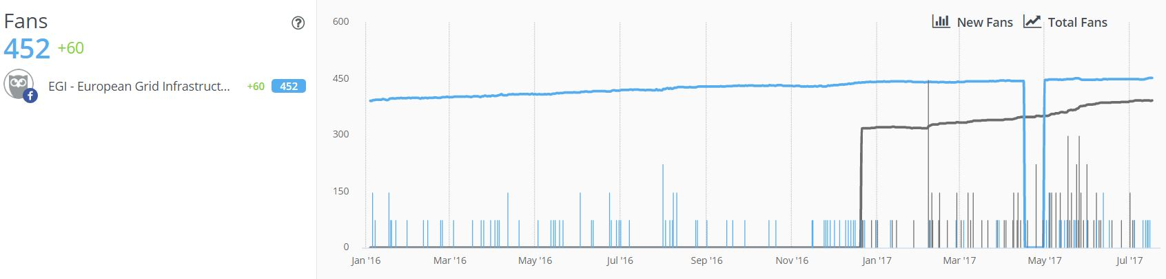

+ 1,800 engagement activities (the sum of reactions, comments and shares received on Facebook)
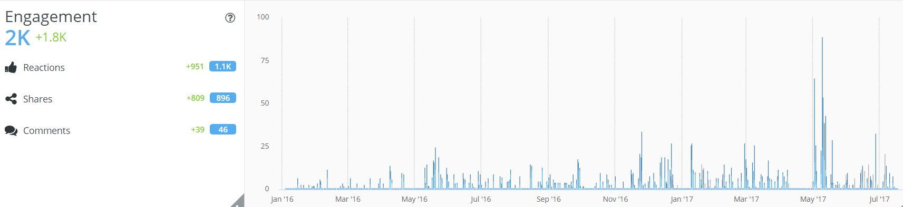
LinkedIn accounts
The EGI LinkedIn profile page is being followed by 293 people and the EGI LinkedIn Group has 570 members. Both channels support EGI news and discussions around scientific computing topics.

- KERs Table
The table below summarises the key exploitable results of the project, and the motivations for the final selection:

KER name | Category | KER criteria
 |  | Impact level for the Project |  |  |  |  |  | Exploitability level
 |  | Innovation level & Motivation | Innovation Capacity & Motivation |  | Relevance to Work Programme and Societal Challenges & Motivation | Relevance of Result for Policy Domain of EOSC
Update of the Strategy, Governance evolution and Procurement | Policies, Processes and Procedures | Very High  Implement the Open Science Commons vision and provide input on the establishment of an EGI marketplace of IT services for science, ideally applying the one-shop-stop concept. | Average  The EC and other stakeholders involved in the development of federated environments and the EOSC can build upon EGI strategy for Open Science and its governance model  Procurement -> Very High |  | High  I2 | Very High |  | Very High
Policy papers on the EOSC | Policies, Processes and Procedures | Very High  Advancement in the thinking to shape the future EOSC. Positioning EGI as trusted player to develop the EOSC. | Very High  The EC and other stakeholders involved in developing the EOSC can build upon the recommendations |  | High  I2 | Very High |  | High
Integrated Management System and Certification | Policies, Processes and Procedures | Very High  Put in place standard processes, procedures and agreements for managing the infrastructure efficiently and effectively. Decision-making has a clearer flow between organizations and individual teams. |  | High  Promote EGI as trusted partner  Processes can be used by other e-infrastructures. | High  I2 |  | Average |  | High
Security policies | Policies, Processes and Procedures | High  Policies increase the security of the infrastructure. They can be used to demonstrate compliance with regulations and standard. |  | High  EGI Security policies are already used by other activities external from EGI (ELIXIR, PRACE, for example). This demonstrate that the work done by EGI in defining a policy framework for the operations is mature and ahead of what is done by other players in the e-Infrastructure ecosystem who can benefit from the existing work made available by EGI and Engage. | High  I2 |  | High |  | Average
Federated Authentication & Authorization (CheckIn) | Software and services | Very High  Only one account needed to sign in for multiple heterogeneous service providers |  | Very High  Enables federated access to services  Enables multiple federated authentication sources using different technologies  Direct integration with the communities AAI services  User registration portal to allow accounts-linking  Provisioning to SPs of an EGI User UID  Enables the creation of other federated clouds re-using the same software stack | Very High  I4 |  | Very High |  | Very High
Thematic services integrated | Services and Software | Very High  Increase Federation service offer with specialized services which support the specific needs of scientific communities |  | High  Creation of thematic Data Competence Centers, providing integration of data analysis and visualization services, and real-time data services | Very High  I1 |  | Very High |  | Very High
Improved EGI service Portfolio | Services and Software | Very High  Increased clarity on EGI service offer. Services are better described making the value of EGI and what it delivers much clearer.  Service oriented managing and promotion of EGI services |  | High  Integration of the catalogue in broader service offers, as E-InfraCentral catalogue and EOSC | Very High  I1 |  | Very High |  | High
Tools for federated service management | Services and Software | High  Operational tools solve common problems with federated operations. Every distributed infrastructure can benefit from some or all the tools operated by EGI. Accounting/Monitoring can be sold as a service or used as an added value to market the EGI federation to new members |  | HIgh  The tools can support the creation of new service federations, or the extension of the existing ones. | Very high  I2 |  | Very high |  | Very high
Open Data Platform | Services and Software | High  Offer scalable data access and compute capabilities around scientific datasets for scientific groups at the large scale. |  | High  It will enable data processing in hybrid environments like public and private clouds | Very high  I1 I4 |  | Very High |  | Very High
Improved Federated Cloud Computing | Services and Software | High  The federated cloud computing enables high demanding use cases to be deployed on distributed computing centers. Increases availability and reduces vendor lock-in risks. The evolution of the service developed during the project increased usability and stability of the cloud resources, making them more suitable to an higher number of communities |  | Average  Only a subset of the federation layer is likely to be usable in other smaller infrastructure, given that it has been designed to enable a very diverse and distributed cloud federation. | Very high  I1 I4 |  | High |  | High
Marketplace | Software and services | Very High  Easily discover expertise that can be tapped into based on usage of resources available  Increase competitiveness by providing a low cost of entry to expensive technologies for small academic institutions and businesses  Facilitate inter-disciplinary research by providing access to technologies typically considered outside of a particular field  Collaborative improvement of services and resources.  Allow researchers and institutions to focus on value creation as opposed to maintaining redundant resources. |  | High  Other third-party services can be easily integrated in the Marketplace with the advantage of expanding the customer base of the services themselves | High  I1 I2 I4 |  | Very High |  | Very High
Applications on Demand | Software and services | Very High  This result is the EGI’s response to the requirements of researchers, scattered across Europe, without dedicated access to computational and storage resources, as well as other facilities needed to run scientific applications. |  | Very High  Other applications and services can be easily integrated with custom applications and offer them as a service that can scale up to support large number resource providers, technology providers, use cases and users. | Very High  I1 I4 |  | High |  | Very High

- Scientific discipline breakdown of engagement cases
This Appendix provides a breakdown of the scientific community engagement cases that were supported by the project, and which are described in Section 3.
NAME OF THE COMMUNITY | SCIENCE DISCIPLINE | STATUS | TYPE OF COMMUNITY
Euro-Argo | Earth sciences | active | RI
EMSO, EMSODEV | Marine sciences | active | RI
EuroBioImaging | Life sciences | active | RI
ENES | Earth sciences | active | RI
ICOS | Earth sciences | active | RI
European Research Initiative on chronic lymphocytic leukemia | Life sciences | active | RI
European Space Agency | Earth sciences | active | RI
OpenDreamKit | Diverse | active | project/platform
Multi Scale Genomics | Life sciences | active | project/platform
BigDataEurope | Diverse | active | project/platform
PhenoMeNal | Life sciences | active | project/platform
BioExcel | Life sciences | active | project/platform
ExTRAS | Astrophysics | active | project/platform
BioISI | Diverse | active | project/platform
D4Science | Diverse | active | project/platform
PeachNote | Arts and humanities | active | project/platform
National Bioinformatics Infrastructure Sweden | Life sciences | active | project/platform
ELIXIR | Life sciences | active | CC
BBMRI | Life sciences | active | CC
MoBrain | Life sciences | active | CC
DARIAH | Arts and humanities | active | CC
LifeWatch | Biological sciences | active | CC
EISCAT_3D | Astrophysics | active | CC
EPOS | Earth sciences | active | CC
Disaster Mitigation | Earth sciences | active | CC
DANUBIUS | Earth sciences | early | RI
Virgo and LIGO | Physics | early | RI
EMPHASIS | Agriculture | early | RI
KM3Net | Physics | early | RI
EBMRC | Biological sciences | early | RI
SKA (AENEAS) | Physics | early | RI
CESSDA | Social sciences | early | RI
ACTRIS | Earth sciences | early | RI
AnaEE | Biological sciences | early | RI
LTER | Biological sciences | early | RI
EODC | Earth sciences | early | RI
Agricultural sciences (AGINFRA+) | Agriculture | early | project/platform
Blue Cloud institutes | Biological sciences | early | project/platform
Human Brain Project | Life sciences | early | project/platform

https://documents.egi.eu/document/3013
https://documents.egi.eu/document/2655
http://go.egi.eu/strategy2020
https://www.eudat.eu/node/924/pdf
https://ec.europa.eu/research/openscience/index.cfm?pg=open-science-policy-platform
https://confluence.egi.eu/spaces/viewspace.action?key=IMS (access restricted)
https://wiki.egi.eu/wiki/Policies_and_Procedures
https://www.egi.eu/internal-services/checkin/
https://www.geant.org/Services/Trust_identity_and_security/eduGAIN
https://www.egi.eu/internal-services/checkin/
https://www.egi.eu/federation/egi-federated-cloud/
https://documents.egi.eu/document/3037
Biomedicine, Biotechnology & Bioresources, Condensed Matter & Biological Physics and Bioinformatics & Modelling
http://go.egi.eu/eosc-hub
www.plus.aginfra.eu/
https://eli-trans.eu/
http://nextgeoss.eu/
www.aeneas-project.eu/
https://www.egi.eu/services/applications-on-demand/
By ‘long-tail RIs’ we mean research infrastructure communities where data and applications are produced and maintained in a fully distributed fashion with no/minimal coordination. Members of such RIs work as loosely coupled groups, and would benefit from an application on demand ‘hub’ to pull together and share the application services with each other.
http://go.egi.eu/eosc-hub
https://indico.egi.eu/indico/event/2969/
http://go.egi.eu/eosc-hub
https://documents.egi.eu/document/3030
https://confluence.egi.eu/display/IMS (access restricted)
http://einfracentral.eu/
https://documents.egi.eu/document/2644
http://www.openresearchcloud.org/
https://indico.egi.eu/indico/event/3414/
http://go.egi.eu/eosc-hub
https://documents.egi.eu/document/2672
https://documents.egi.eu/document/3038
https://documents.egi.eu/document/2672
https://wiki.egi.eu/wiki/GPGPU-FedCloud
https://wiki.egi.eu/wiki/GPGPU-CREAM
https://www.egi.eu/about/newsletters/egi-data-centre-helps-the-ibm-research-lab-to-model-an-exascale-computing-system/
https://wiki.egi.eu/wiki/Pay-for-use
https://documents.egi.eu/document/2700
https://documents.egi.eu/document/2699
https://documents.egi.eu/document/2843
https://www.egi.eu/business/
http://www.numeca.be/en/training/workshops/mesh-it-workshop-cfd-grid-generation-milan-italy
https://www.egi.eu/egi-trainings/
https://www.egi.eu/services/
This database is implemented in RT, which is a ticketing system where the service requests coming in from users through the EGI Website are automatically registered.
http://www.esfri.eu/roadmap-2016
https://indico.egi.eu/indico/event/2895/
Demonstration video: https://indico.egi.eu/indico/event/3249/session/42/contribution/158
Spiros Koulouzis et al: Dynamic Optimization for Time-critical Data Services: A Case Study in Euro-Argo Research Infrastructure, submitted to IEEE eScience Conference 2017.
https://documents.egi.eu/document/2888
Data from http://accounting.egi.eu
https://portal.enes.org/community/about-enes/members-2
https://esgf.llnl.gov/
https://is.enes.org/
Data from http://accounting.egi.eu
http://go.egi.eu/eosc-hub
Data from http://accounting.egi.eu
https://sentinels.copernicus.eu/
https://copernicusdata.esa.int/
https://earth.esa.int/web/guest/missions/esa-operational-eo-missions
https://earth.esa.int/web/guest/missions/3rd-party-missions/overview
https://documents.egi.eu/document/2763
Data from http://accounting.egi.eu
http://opendreamkit.org/
https://github.com/jupyter/tmpnb
http://mybinder.org/
https://www.multiscalegenomics.eu/MuGVRE/
https://www.bsc.es/research-and-development/software-and-apps/software-list/comp-superscalar/
https://www.big-data-europe.eu/
http://phenomenal-h2020.eu/home/
https://github.com/kubenow/KubeNow
http://bioexcel.eu/
http://www.extras-fp7.eu
http://portal.extras-fp7.eu/cms/home
https://documents.egi.eu/document/2869
Data from http://accounting.egi.eu
http://bioisi.campus.ciencias.ulisboa.pt/
https://documents.egi.eu/document/2876
https://documents.egi.eu/public/ShowDocument?docid=2875
http://www.peachnote.com
http://musicconnectionmachine.org
http://www.wholodance.eu/
https://documents.egi.eu/document/2886
Data from http://accounting.egi.eu
https://documents.egi.eu/document/2701
Data from http://accounting.egi.eu
Precisely ‘per-user subproxies’ is not a service, but a component that was developed by the project for the Applications On Demand service.
A prototype setup is available and it was/will be demonstrated to the members of the community to decide on next steps.
Technology was deployed for the community by EGI.eu UCST, we are waiting for the community to test the setup using the instructions that was sent to them.
https://indico.egi.eu/indico/event/2895/
https://indico.egi.eu/indico/event/3025/
https://documents.egi.eu/public/ShowDocument?docid=2672
https://documents.egi.eu/document/2548
https://www.egi.eu/business/
https://www.egi.eu/wp-content/uploads/2016/08/EGI_open_for_business-1.pdf
https://www.egi.eu/news/egi-webinar-how-to-engage-smes-for-national-e-Infrastructure-providers/
https://www.egi.eu/news/egi-webinar-how-to-engage-smes-for-national-e-infrastrcture-providers/
https://documents.egi.eu/public/RetrieveFile?docid=2733
https://www.egi.eu/about/egi-council/
https://www.egi.eu/federation/data-centres/
https://www.egi.eu/federation/egi-federated-cloud/
Conservative estimate: number of results of the Google search ["egi.eu/news" AND NOT site:egi.eu ]. Excludes all sites that do not publish 'naked' links, i.e. that embed links in text.
Conservative estimate: number of results of the Google search [ "egi.eu/blog" AND NOT site:egi.eu ]. Excludes all sites that do not publish 'naked' links, i.e. that embed links in text.
https://twitter.com/EGI_eInfra?lang=en
http://www.linkedin.com/groups/European-Grid-Infrastructure-3344148
https://hootsuite.com/
https://twitter.com/tferrariEGI?lang=en
https://twitter.com/ylegre?lang=en

