EGI-Engage

Final report on EGI Service Registry and Marketplace
D3.16

Date | 11 August 2017
Activity | WP3
Lead Partner | SWING
Document Status | FINAL
Document Link | https://documents.egi.eu/document/3030

Abstract
The EGI Marketplace has the ambition of becoming the platform where an ecosystem of EGI-related services, delivered by EGI providers and partners, can be promoted, discovered, shared, ordered and accessed, including EGI offered services as well as discipline and community-specific tools and services enabled by EGI and/or provided by third parties under defined agreements.
This document details the work done by the EGI Service Registry and Marketplace activity during the whole project lifetime. It summarises past achievements and describes recent analysis and developments on automatic service order management, Applications on Demand service integration, enabling of the pay-for-use mode, and publishing of thematic services.
Furthermore, activities to deploy the Marketplace into production, going one-step further than was originally planned, are reported. The PrestaShop prototype is being enhanced and will reach the beta phase, according to the EGI Integrated Management System (IMS), by the end of the project.

COPYRIGHT NOTICE
This work by Parties of the EGI-Engage Consortium is licensed under a Creative Commons Attribution 4.0 International License (http://creativecommons.org/licenses/by/4.0/). The EGI-Engage project is co-funded by the European Union Horizon 2020 programme under grant number 654142.
DELIVERY SLIP
 | Name | Partner/Activity | Date
From: | Diego Scardaci | EGI F.-INFN/JRA1 | 14 July 2017
Moderated by: | Malgorzata Krakowian | EGI Foundation
Reviewed by | Yannick Legre  Małgorzata Krakowian  Jan Bot | EGI Foundation  EGI Foundation  SURFSara
Approved by: | AMB and PMB

DOCUMENT LOG
Issue | Date | Comment | Author/Partner
v.1 | 14 July 2017 | Full draft ready for internal review | Diego Scardaci/EGI F.-INFN
v.2 | 17 July 2017 | Added section on Open IRIS, review and editing | Dean Flanders / SWING
v. 3 | 25 July 2017 | Document updated according to the reviewers’ comments | Diego Scardaci/EGI F.-INFN
FINAL | 9 August 2017 | Final version

TERMINOLOGY
A complete project glossary and acronyms are provided at the following pages:
- https://wiki.egi.eu/wiki/Glossary
- https://wiki.egi.eu/wiki/Acronyms

Contents
1 Introduction 7
2 Summary of activities 8
2.1 Concept of EGI Marketplace 8
2.2 Technology assessment 10
2.3 Development of the Marketplace prototypes 11
3 Service architecture 14
3.1 High-Level Service architecture 14
3.1.1 Data Model 14
3.1.2 Workflows 17
3.1.3 Technology customisation 22
3.2 Integration and dependencies 23
4 The EGI Marketplace prototype 24
4.1 Discover services and submit orders through the EGI Marketplace 24
5 Marketplace as tool to automate EGI IMS processes 30
5.1 Relationship between the EGI Service Catalogue and the Marketplace 30
5.1.1 Relationship and impact on the EGI tools 30
5.2 Service order management through the Marketplace 31
5.2.1 Service order pre-processing 31
5.2.2 Service order management tool 32
5.2.3 Serving AoDs orders 37
5.2.4 Tools to manage service orders 40
6 Enabling pay-for-use through the Marketplace 42
7 Moving to production 43
7.1 Integration with the Application on Demand service 44
7.2 Customer dashboard 48
7.3 Integration with the EGI web-site 48
8 Publishing of thematic community services 52
8.1 Requirements to expose services in the marketplace 52
9 Open IRIS as instrument marketplace 55
9.1 Evaluation 55
9.2 Metrics 56
9.3 General Usage 57
9.4 Conclusions 57
10 Future plans 58
11 Plan for Exploitation and Dissemination 59
Appendix I. EGI Marketplace data model 62

Executive summary
The EGI Service Registry and Marketplace (in short Marketplace) has the ambition of becoming the platform where an ecosystem of EGI-related services, delivered by EGI providers and partners, can be promoted, discovered, shared, ordered and accessed, including EGI offered services as well as discipline and community-specific tools and services enabled by EGI and/or provided by third parties under defined agreements.
This document details the work done by the EGI Service Registry and Marketplace activity during the whole project lifetime (March 2015 – August 2017).
Initially, the work started with the definition of the concept of the EGI Marketplace. After that, the activity focused on the assessment of technologies to implement the EGI Marketplace. This evaluation was completed with the development of the two prototypes based on Open IRIS and PrestaShop frameworks. The two Marketplace demonstrators have implemented the required specifications and adequately covered the requirements. Therefore, other factors were considered to choose the technology such as its long-term sustainability, availability of expertise, ready-to-use features that could be helpful in the future. As a final decision, PrestaShop was selected
Before starting the implementation, the Marketplace technical architecture was defined with a focus on the workflows, the data model and the customisations applied to the adopted technology. The workflows describe the main actions a customer can perform in the EGI Marketplace, log in, discover services, select service options and related attributes, and submit orders.
During this activity, the role of the Marketplace as tool to automate service order management and its relationship with EGI Integrated Management System (IMS) processes and other tools was also studied. The workflow to manage service order through the Marketplace was deeply analysed including correlations and impact on the other EGI tools. As result, interactions between EGI tools in the service order management workflow were identified and clear duties were assigned to each tool. In addition, features missing at that time were discovered and plans to provide them defined, as for example the need of an SLA/OLA management tool that will be implemented as a plugin of the Operations Portal. A complete semi-automatic workflow to create orders for the Applications on Demand service (AoDs) was designed and implemented. The AoDs is the EGI’s response to the requirements of researchers, scattered across Europe, without dedicated access to computational and storage resources, as well as other facilities needed to run scientific applications.
Activities to deploy the Marketplace into production, enhancing the PrestaShop prototype and reaching the beta phase according to EGI IMS, are progressing. A mechanism to pre-process and group service orders, according to the IMS process that should take care of them, was integrated in the Marketplace and the first version of the Service Order Management tool was implemented. The PrestaShop customer dashboard was customised to satisfy EGI needs and the integration of the AoDs with the Marketplace is almost complete. Plans to enable the pay-for-use access mode and to integrate the Marketplace with the EGI website were defined. All the activities needed to deploy the Marketplace into production will be completed by the end of the project.
Analysis on publishing thematic community services in the Marketplace progressed and the data model was consequently extended. AoDs can be seen as the first thematic service published by the Marketplace. Indeed, integration of other thematic services will be based on the data model extension defined for AoDs. Work was also done for the definition of the criteria and policy to publish such services in the Marketplace. When the Marketplace will become operational, after a first testing phase where only EGI services will be published, it will be opened to the whole EGI collaboration and partners.
Finally, Open IRIS, although it was not selected for the EGI Marketplace, has demonstrated itself to be a good tool for instrument and resource management. Originally, Open IRIS was primarily used in Switzerland, however, through its evaluation in EGI-Engage, its use was extended to several other countries.
The EGI Marketplace will become a key component of the future European Open Science Cloud (EOSC) facilitating the discovery, the order and the access of a large set of services provided by several stakeholders. To reach this aim, several activities are already planned in the future in four main areas:
- Technical enhancements on the Marketplace: development of interfaces to retrieve and publish service data to/from other tools (e.g. a Service Portfolio Management tool and the eInfraCentral service registry);
- Publishing of thematic community services: a campaign to on-board services will start after the Marketplace will be deployed into production;
- Service order management automation: enhancements on the designed model and related developments;
- Pay-for-use: launch of first commercial offers.

Introduction
This deliverable describes the main achievements of the Service Registry and Marketplace activity during the entire project lifetime.
The document is structured as follows:
- Section 2: Contains a summary of past activities already reported in other deliverables. It is focused on a short description of the concept of the EGI Marketplace, the assessment of the technologies that was carried out before starting the implementation of the prototypes, and the assessment of the two prototypes based on Open IRIS and PrestaShop technologies.
- Section 3: Describes the technical architecture of the service.
- Section 4: Depicts, with illustrative screenshots, how a customer can access the EGI Marketplace, login, discover services, select service options and related attributes, and submit orders.
- Section 5: Describes the role of the Marketplace as a tool to automate service order management and its relationship with EGI IMS processes and other tools.
- Section 6: Details the work done to enable the “pay-for-use” mode via the Marketplace.
- Section 7: Gives information on the recent developments to move the Marketplace into production.
- Section 8: Contains the analysis and envisaged strategies to publish thematic services in the Marketplace.
- Section 9: Presents recent activities on Open IRIS, as tool for instrument and resource management.
The document concludes with the dissemination and exploitation plan, and future plans. The Marketplace data model is described in Appendix I.

Summary of activities
This section summarises the main achievements of the Marketplace activity that were already reported in previous deliverables. In particular, it is focused on a short description of the concept of the EGI Marketplace, the assessment of the technologies that were carried out before starting the implementation of the prototypes, and the assessment of the two prototypes based on Open IRIS and PrestaShop technologies.

Concept of EGI Marketplace
In the European Research Area, the emergence of various research infrastructures that will need access to communication, computing, and data infrastructures to perform collaborative compute- and data intensive science are evident. Such research infrastructures would benefit from a shared e-infrastructure that offers the generic capabilities communities need to build their own research platforms. Important elements of this ideal shared e-infrastructure are already present, but further work needs to be done both at the technical level (for greater integration) and at the organisational/governance level (for shared governance, harmonised access policies, and suitable business models that ensure long-term availability).
Even though services are available, it may be difficult for researchers to discover and access them. The European Research Area lacks a single service portfolio and the current offer is fragmented with different policies of access and different channel of engagement with the user communities. EGI attempts to address this issue by developing a marketplace as a service concept to deliver research resources. Electronic markets can play a central role on facilitating the exchange of research knowledge, ICT resources, services, as well as payment options alongside the traditional free at point of delivery model. This means creating a platform where the availability of services can be advertised together with the related access policies and service levels and a customer can easily order and access them.
In addition, the Marketplace can enhance visibility for resource and service providers, raising awareness of what they can provide as well as helping to promote cross-disciplinary research.
In particular, the following potential benefits can be expected from developing a digital marketplace. They are classified according to the beneficiary stakeholders.
Benefits | End-users (scientists, researchers, etc.) | Resource providers | Service providers
Ensure efficient resource usage at the institutional, national, and international level. |  | Yes
Allow cost sharing with accounting, billing, and enabling of fair usage of resources. | Yes | Yes | Yes
Facilitate resource discovery at the institutional and inter-institutional level. | Yes
Facilitate service order and access. | Yes
Allow researchers and institutions to focus on value creation as opposed to maintaining redundant resources. |  |  | Yes
Researchers can discover expertise that can be tapped into based on usage of resources registered. | Yes
Remove administrative burdens from technology platforms allowing them to focus on technology delivery. |  |  | Yes
Increase competitiveness by providing a low cost of entry to expensive technologies for small academic institutions and businesses. | Yes
Facilitate inter-disciplinary research by providing access to technologies typically considered outside of a particular field. | Yes
Avoid re-developing the same solution (tool duplication). |  |  | Yes
Provide opportunities for collaborative improvements of services and resources. |  | Yes | Yes
Possible reduce costs by facilitating complex application implementation and integration (e.g. issuing of persistent identifiers, providing links between resources and services). |  |  | Yes

The methodology that we adopted to define the concept of the EGI Marketplace included the following activities:
- A survey and several interviews were conducted to get the requirements from researchers and research resource providers.
- In addition, service scenarios for resource usage and resource providers were defined.
- Other related research marketplaces were examined to understand how this activity compares to those.
- A Business Model to describe and classify an EGI marketplace and in an “open science commons” space was defined.
As outcome, detailed requirements and a set of recommendations were defined for both business and technical perspectives. It was also agreed to keep the main stakeholders engaged during the different phase of the activity.
For more details, please, refer to the D2.3 “Concept of EGI Marketplace”.

Technology assessment
Before starting the development of the Marketplace prototypes, we analysed existing solutions, open-source tools and extensions to facilitate their implementation. This analysis was based on the previously defined concept of the EGI Marketplace and to the related collected requirements.
Various solutions were considered to identify the most promising to satisfy our needs: AppDB, GOCDB, FIWARE Marketplace Generic Enabler, Open IRIS, PrestaShop and WooCommerce. The list of evaluated technologies included:
- EGI tools that could be extended to become a marketplace (namely, GOCDB and AppDB)
- Technologies supported by other initiatives (Open IRIS and FIWARE)
- Generic web tools with features suitable to the implementation of marketplaces (WooCommerce, WordPress, PrestaShop).
Experts in development, design and operations of user-facing tools and/or a marketplace from various academic organizations, were appointed. The following metrics were taken into consideration by the evaluators:
- Adequacy of the solution in terms of requirements.
- Possible costs in terms of licenses and support.
- Expertise available within the EGI collaboration.
Another important factor that was identified to assess the sustainability and costs in terms of licenses and support is the size of the user base of each tool. Tools with extensive list of user groups and broad adoption across different sectors have larger chances of receiving community support compared to specific technologies adopted by few communities. On the other hand, in these cases integrating ad-hoc features and maintaining them over time may be expensive if these capabilities are not adopted for upstream release and software is not open source.
As a result of this consultation and analysis, Open IRIS, with its increasing user base and the Swiss Federation support, and PrestaShop, a free, open source e-commerce solution largely adopted in the commercial world with a wide community behind it were identified as the most promising solution to fully fulfil the Marketplace requirements.
Details of this analysis are available in D3.2 “Design of the EGI Service Registry and Marketplace”.

Development of the Marketplace prototypes
As follow-up of the analysis of existing solutions, the assessment of technologies to implement the EGI Marketplace was further refined taking into account the originally defined criteria in D3.2 as well as the requirements generated by the definition of the EGI service catalogue, which is one of the outcomes of the EGI Integrated Management System framework.
As outcome of this activity, we set-up two distinct marketplace prototypes aiming at comparing the features of the two selected solutions, one based on PrestaShop and the second on Open IRIS.
A preliminary task for the development of the prototypes was the definition of the data model for the Marketplace. It reflects the EGI service catalogue structure and is made of a three-level hierarchy where the first level contains the EGI service areas (the Marketplace service categories) and the second level maps to the EGI services (the Marketplace sub-categories). Furthermore, there is an additional level that defines the EGI service options (the Marketplace products). The service options represent the products that the end user can discover, request and access via the Marketplace.
The deployment of the two EGI marketplace demonstrators required a prior analysis of the relationship between the Marketplace and the EGI service catalogue with its Integrated Management System (IMS) process and procedures. In the context of this, a first study of the Marketplace interfaces was conducted. These interfaces concern other EGI tools that are relevant to complement the Marketplace with additional business logic related to the maintenance of service information, and the management of service access including the management of user registration and authorization when required. This analysis was further enhanced in the last months and related results are described later in this document.
The development of the Marketplace prototypes was completed in two phases with the release of two versions. First version of the prototypes were created using built-in features of Open IRIS and PrestaShop and only a sub-set of the Marketplace data model was implemented. After this phase, it was clear that both technologies needed customisations to answer to EGI needs. Such customisations were implemented before releasing the second version of the prototypes that fully implemented the Marketplace data model and the Marketplace workflows, which were defined in the meantime.
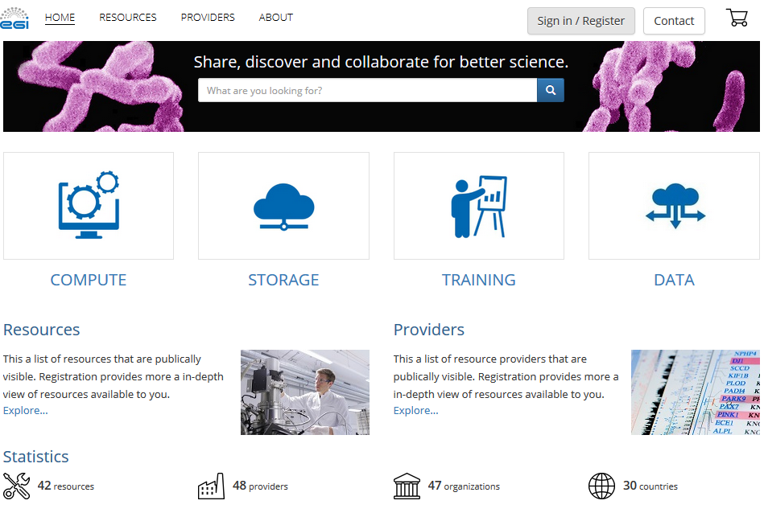
Figure 1. Second release of the EGI Marketplace based on Open IRIS technology.
The two Marketplace demonstrators implemented the required specifications. After their assessment, it was recognised that both systems adequately covered the current workflows as well as supported the data model, reaching the Alpha service phase according to the EGI Integrated Management System (IMS). Then, both could be adopted to implement the EGI Marketplace.
Therefore, other factors were considered to choose the technology such as its long-term sustainability, availability of expertise, ready-to-use features that could be helpful in the future. As final decision, PrestaShop was selected since it was considered simpler to maintain, thanks to the wide community of developers and the availability of expertise within the EGI collaboration, more attractive for the commercial world and with many ready-to-use features to extend the Marketplace features (e.g. to implement the pay-for-use support). A plan was defined to enhance the PrestaShop based prototype and making it operational, reaching the Beta service phase by the end of the project.
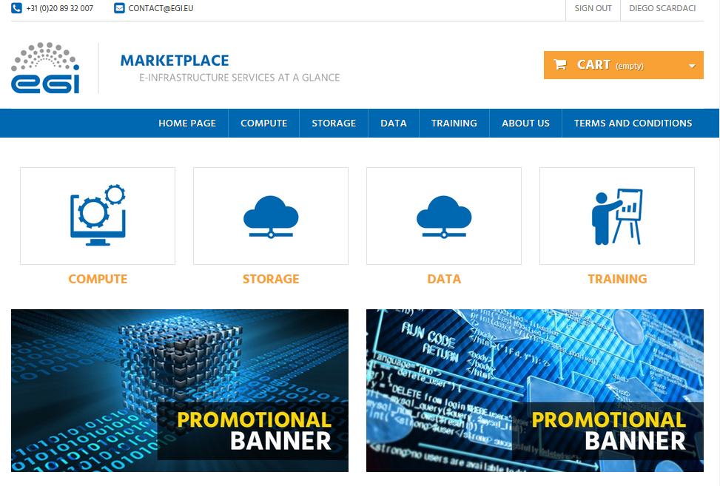
Figure 2. Second release of the EGI Marketplace based on PrestaShop technology.
Details on the two releases of the EGI Marketplace prototypes are available in D3.7 “First release of the EGI Service Registry and Marketplace prototype” and D3.13 “Second release of the EGI Service Registry and Marketplace prototype”.

Service architecture
The EGI Marketplace prototypes were implemented adopting and customising technologies developed by third parties. The two demonstrators were established leveraging their existing architecture, one based on PrestaShop and the other based on Open IRIS.

High-Level Service architecture
The high-level service architecture of the two demonstrators is based on the underlying technologies, PrestaShop and Open IRIS. Refer to the PrestaShop and Open IRIS documentation for more details.
A SaaS instance for both technologies were deployed and customised according to the EGI requirements.
This section focuses on the description of the data model and workflows that have been implemented into the two prototypes.
Finally, PrestaShop and Open IRIS customisations needed to fully implement the required specifications described.

Data Model
The data model of the Marketplace reflects the EGI service catalogue structure. It is made of a three-level hierarchy where the first level contains the EGI service areas (categories in the Marketplace) and the second level maps to the EGI services (sub-categories in the Marketplace). Furthermore, an additional level defines the EGI service options (products in the Marketplace). The service options represent the products that the end user could access or purchase in the Marketplace.
The Marketplace data model was already detailed in the D3.7 “First release of the EGI Service Registry and Marketplace” prototype and D3.13 “Second release of the EGI Service Registry and Marketplace prototype”. It was further extended recently, introducing a new service category to host thematic services. As first example, service options for the Applications on Demand service (AoDs) were defined.
In the following, the data associated with a customer (customer/user profile) and to a service order (service order profile) are described. The complete data model is described in Appendix I.

Customer/User profile
Authentication in the EGI Marketplace is managed through the EGI CheckIn service, the AAI tool, based on federated authentication mechanisms, that enables customers to access the EGI services in a user-friendly way, using the same credentials they are using at their home organization.
Each customer/user of the EGI Marketplace needs to be registered to submit service orders. Customers are required to register during their first login into the Marketplace, the registration allows the Marketplace to gather enough information to create and store a customer profile in its internal database. Part of the data is retrieved by the EGI CheckIn service, during the authentication, and additional data is gathered from the same customers completing a form.
The following table shows the attributes that comprises the customer profile, specifying the source of the information (CheckIn or the Marketplace) and if an attribute is mandatory or optional.
Attributes | From | Mandatory/Optional
Name | CheckIn service | Mandatory
Surname | CheckIn service | Mandatory
e-mail | CheckIn service | Mandatory
Display name | CheckIn service | Mandatory
EGI unique identifier | CheckIn service | Mandatory
Country | Marketplace | Mandatory
Institution | Marketplace | Mandatory
Department | Marketplace | Mandatory
Departmental web page | Marketplace | Optional
Linkedin profile | Marketplace | Optional
ResearchGate profile | Marketplace | Optional
Supervisor name | Marketplace | Optional
Supervisor profile | Marketplace | Optional

Service order profiling
The EGI Marketplace associates to each service order a set of customer information, which is gathered during the Check-Out phase. Such information, complemented with the customer profile and the order details (the service options), enables the Marketplace to implement a service order profile, which allows for appropriate service order management, accordingly to the EGI Integrated Management System (IMS) processes and procedures.
The table below shows the customer information that is linked to a service order. Such information can be extended in the future according to emerging needs.
Attributes | Note
Customer type  (single user, research group/community/project/private company) | Customer classification enabling an appropriate service order management. Different procedures will be executed according to the customer type.
Reason to request access to the EGI services | Information gathered to identify the customer needs and adopt the better support strategy.
Research group/project/ community or company name  (only if the customer represents a research group/ community/project or a private company) | Allow to identify if the request is related to an existing or new project.  It maps to the VO name.
Additional Information on the project  (only if the customer represents a research group/ community/project or a private company) | Additional information on the project that will be used as input for the technical support and resource allocation activities.  If the project already uses the EGI infrastructure, information can be automatically retrieved from the operations portal.

Workflows
This section describes the procedures or workflows implemented in the two marketplace prototypes. For each procedure, the following information is provided:
- Overview: short description of the workflow
- Trigger: events that start a workflow
- Involved entities: all the entities that play a role in the workflow
- Input: input data
- Output: output data
- Steps: step-by-step description of the workflow
- Integration with other EGI tools: list of the EGI tools involved in the workflow and description of their interfaces with the Marketplace
The following workflows are currently implemented:
- Authentication: The login procedure including the user registration during the first access.
- Discover and order services: Finding and ordering services within the Marketplace.
- Check-Out: Submitting a service order together with a set of information to profile it.

Authentication and user enrolment
Overview:
The customer logs into the EGI Marketplace through the CheckIn service.
Trigger:
- The customer can decide to log in while they are visiting the Marketplace.
- The customer starts the checkout process.
Involved entities
- Customer
- Marketplace
- CheckIn service
Input
- User credentials (federated or social login)
Output
- Personal customer information including the unique EGI identifier
- Customer’s VO membership list
Steps
Step | Conditions | Tool | Action
1 | N/A | Marketplace | Redirect the customers to the CheckIn service. Only required to complete the order process.
2 | N/A | CheckIn service | Authenticate the customers and provide the Marketplace with personal customer information (including the unique EGI identifier) and VO membership list.
3 | After successful authentication and during first login | Marketplace | Complements the personal customer information already provided by the CheckIn service. The Marketplace asks the customer to complete a form with the missing attributes (see section 3.1.1.1).  Additional attributes are stored in the Marketplace and the customer will not be required again to provide them.  Customers can update their profile at any time.
4 | Successful authentication | Marketplace | After the customer has successfully logged in, the Marketplace shows their name on its web interface.

Integration with other EGI tools
Tool | Integration
CheckIn service | Perform the customer authentication on behalf of the Marketplace and provide it with customer information (including the unique EGI identifier) and VO membership list.

Discover and order services
Overview:
The customer navigates via the service catalogue exposed in the EGI Marketplace and selects one or more services. This can be done before or after authentication. The Marketplace exposes services according to the service catalogue structure:
- First level: service categories
- Second level: services
- Third level: service options
Trigger:
- The customer accesses directly the Marketplace or through the EGI web site.
Involved entities
- Customer
- Marketplace
Input
- No input
Output
- List of services including service options.
Steps
Step | Conditions | Tool | Action
1 | N/A | Marketplace | The customer navigates through the service catalogue published in the Marketplace.
2 | N/A | Marketplace | The customer selects one or more services specifying a set of service options.

Integration with other EGI tools
There are no dependencies from the EGI tools.

Check-Out
Overview:
Define or update the customer profile, and gather information on the user or research community/project/private company willing to exploit the EGI services and common options for the selected services. Forward all the information to a backend system that will take care of managing the service order.
Trigger:
- Customer starts the Check-Out process after he has selected one or more services.
Involved entities
- Customer
- Marketplace
- CheckIn service
- Operations Portal
Input
- Personal customer information including the unique EGI identifier.
- Customer’s VO membership list.
- Service list including options selected by the customers.
Output
- Personal customer information including the unique EGI identifier
- Customer type: single user or representing a research group/community/project/private company
- Reason to request access to the EGI services
- Only for customers representing a community:
  - Information on the project
  - VO information
    - New or existing
    - VO name
Steps
Step | Condition | Tool | Action
1 | Only if the customer is not authenticated. | Marketplace  CheckIn | Automatically starts the authentication process redirecting the customers to the CheckIn service.
2 | Successful authentication. | Marketplace | Presents to the customers the selected service options and their profile, as gathered during the authentication process, and requests them to fill in a form with the following fields:  - Customer:  - single user  - representing a research group/community/project  - representing a private company  - Reason to request access to the EGI services
3 v1 | Only if the customer represents a research community/project or a private company | Marketplace  Ops Portal | Request to the customer to fill in an additional form with the following fields:  - User group name: It maps to the VO name. In the case the customers is already using the EGI infrastructure (VO list not empty), the VO name could be chosen from a drop down menu listing all the customer VOs (retrieved during the authentication) plus the option to specify a new VO.  - Information on the project will be automatically filled in by querying the operations portal if the customer select an existing VO in the User group name field.
3 v2 | Only if the customer is a single user | Marketplace | Check if the amount of resources requested by the customer is less than the threshold defined to access the applications on demand platform:  - If yes, mark the customer as user eligible for the applications on demand platform.  - If no, mark the customer as a normal user.
4 | Completion of step 3 (v1 or v2) | Marketplace | Submit/record the service order and the customer profile to a backend system
5 | Completion of step 3 (v1 or v2) | Marketplace | Send a confirmation e-mail to the customers: “your order is being processed…”

Integration with other EGI tools
Tool | Integration
CheckIn | Authenticate the customer when needed.
Operations Portal | Provide the Marketplace with information related to already existing projects (VOs).
Marketplace backend | Receive the service request and the customer profile from the Marketplace backend.

Technology customisation
In order to satisfy the requirements and the specifications above described, both PrestaShop and Open IRIS technologies needed customisations. This section summarises the changes applied.

PrestaShop
The basic PrestaShop tool was enriched with the following plugins to extend its functionalities:
- Additional Product Attributes/Custom Product Fields Module: It allowed to add new fields on the product pages. It was essential to implement all the service options as specified in the data model.
- Custom Checkout and Customer and Address Fields manager Module: It allowed to easily add new fields on checkout pages and collect more data about the customers with extra fields on the registration form and customer account area. It was needed to implement both the customer and service order profiles.
- Dynamic Product Price Module: It allowed to define dynamic prices based on the values that customers defined for the service options. It was needed in order to implement the experimental pay-for-use support.
- Google Accounts login-in module for PrestaShop: It was needed in order to extend the login functionality of PrestaShop.
In addition, ad-hoc customisations were needed to implement the authentication and user enrolment, and the Check-Out workflows. In particular, to retrieve customer information from the CheckIn service, to prevent the service order submission before the customer profile is completed and to profile the service orders. The PrestaShop customer dashboard was customised to better fit EGI needs. Minor changes were also done to adjust the service options, the service list in the cart and the e-mail templates. All the changes were applied to both the PrestaShop basic code and the extra modules listed above.

Open IRIS
The main changes on Open IRIS were related to:
- Integration of the Open IRIS authentication mechanism with the EGI CheckIn service;
- Development of the user enrolment procedure according to the specifications;
- Development of a cart allowing the submission of multiple service orders:
- Implementation of the service hierarchy as described in the specification.
In particular, last point was particularly complex to achieve considering that Open IRIS were designed to show services in a flat mode and categorise them via keywords. The concept of a service hierarchy did not exist in Open IRIS and its introduction requested relevant changes.

Integration and dependencies
Both prototypes were integrated with the EGI CheckIn service and have a dependency on it for the user authentication.

The EGI Marketplace prototype
This section depicts how a customer can access the EGI Marketplace, login, discover services, select service options and related attributes, and submit orders with illustrative screenshots.
The content is based on the PrestaShop prototype, as PrestaShop is the chosen technology to create a production instance of the Marketplace.
A similar content for the Open IRIS prototype is available in the D3.13 “Second release of the EGI Service Registry and Marketplace prototype”.

Discover services and submit orders through the EGI Marketplace
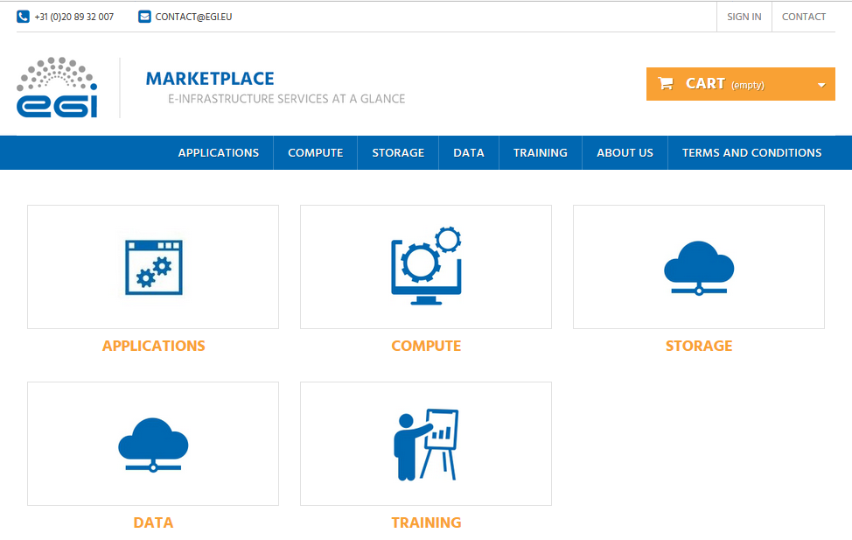
Figure 3. Home page of the EGI Marketplace prototype based on PrestaShop technology.
- After the customer lands on the EGI Marketplace, he/she can easily discovers services navigating on the service tree from the homepage.
- The customer can log in from each page of the Marketplace. During the first login, he/she is requested to register. Part of the customer information is collected by the CheckIn service, see grey fields in Figure 4, the other attributes are manually provided by the same customer through the following form.
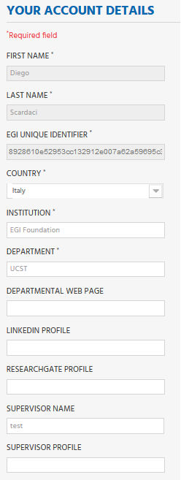
Figure 4. Form to gather the user profile. Fields in grey are filled in with values retrieved by the EGI CheckIn service and cannot be modified.
- When the customer selects a service category, a new view showing all the services under the category is shown. Figure 5 shows the view for the Compute service category.
Now, the customer can then select the service he/she wants to order.
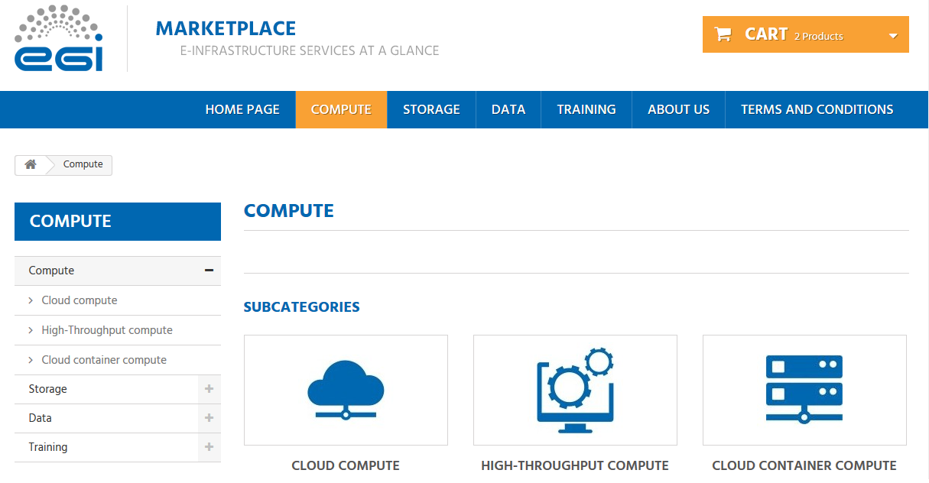
Figure 5. Service category view - Compute
- After the selection of a service, the customer is redirected to the service page that provides:
  - A short description of the service.
  - Links to the terms of use, the default SLA and to a more detailed description.
  - All the available service options.
Figure 6 and Figure 7 show relevant parts of the Cloud Compute service page. As an example, two options for the Cloud Compute service, Compute-intensive instance and High-memory instance, are shown.
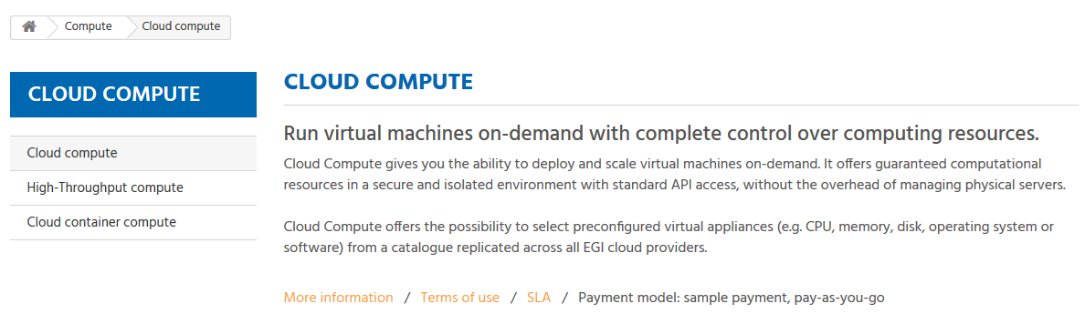
Figure 6. Service view - Cloud Compute
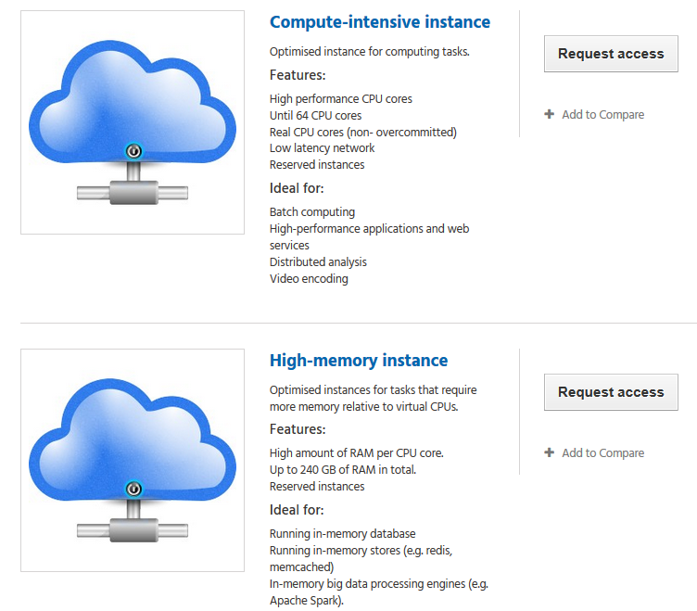
Figure 7. Example of service options - Cloud Compute
- Selecting a service option forwards the customer to a view that allows the customisation of the service option according to his/her requirements via the definition of additional attributes (see the data model in Appendix I). In addition, the customer can decide to add the option to the Cart to submit an order later. As example, see Figure 8 that shows the page for the Compute-Intensive Instance option of the Cloud Compute service.
- The customer can repeat this operation for all the services he/she wants to order.
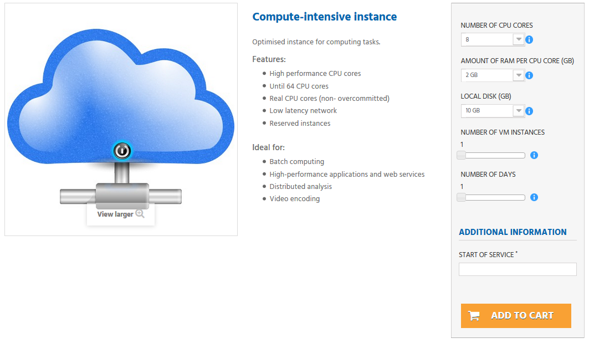
Figure 8. View to order a service. Compute-Intensive Instance in Cloud Compute service
- After the customer has added to the cart all the services he/she wants to order, the Check-Out process can be started by going to the cart. The cart lists all the services and the related options selected, see Figure 9.
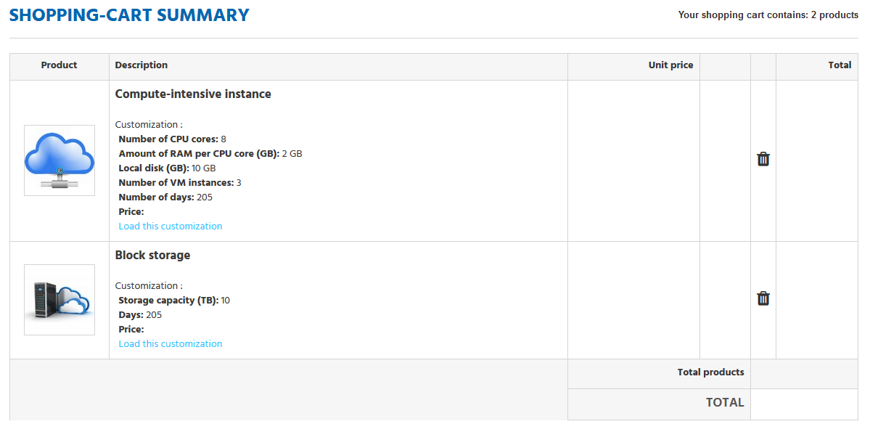
Figure 9. List of selected service options in the Cart
In the cart, the customer is asked to provide some additional information that allows the profiling of the service order, see Figure 10.
The order can only be submitted after the acceptance of the terms of service.
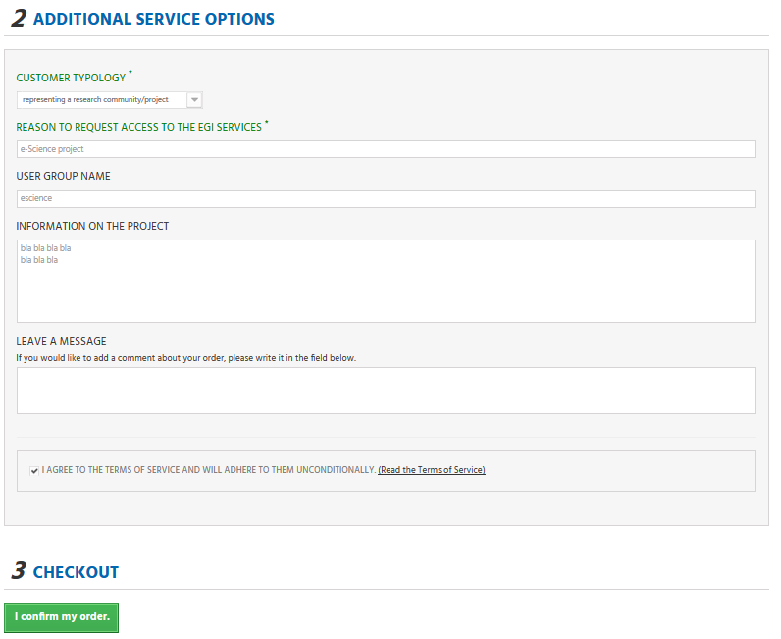
Figure 10. Service order profiling in the cart
After the service order is submitted, the customer will be notified by e-mail and could check the status of his/her order through the customer dashboard.

Marketplace as tool to automate EGI IMS processes

The EGI Integrated Management System has been put in place to plan, implement, monitor and continually improve all processes regarding the EGI Service Catalogue, following the requirements of the ISO 9001:2015 and ISO/IEC 20000-1:2011 standards. It is made of several processes and procedures that need to be thoroughly and systematically executed to guarantee the quality and the reliability of the EGI service delivery.
The whole set of processes and procedures introduce a certain level of complexity that needs to be supported with automated tools. As first step of this effort, we decided to implement automatic workflows to manage service orders via the EGI Marketplace. This section describes the outcome of this activity.

Relationship between the EGI Service Catalogue and the Marketplace
When operational, the EGI Marketplace will become the unique place where a new customer could discover a service (or group of services), get information about it by browsing the service catalogue, and submit an order, specifying quantity, quality and duration. It will expose all the live EGI services, following the same structure of the service catalogue, detailing service options to allow customers to properly define their orders.
Furthermore, the Marketplace will partially automate the service order procedures to handle the customers’ request and trigger related IMS processes. It will act as an orchestrator of the several EGI tools involved in processes exploiting the customer and service order profile information collected through its workflows.

Relationship and impact on the EGI tools
The introduction of the Marketplace on the EGI tool ecosystem implies changes on other tools to remove redundancies and implement new workflows. This is particularly relevant for tools that already offer features related to the service order management, such as e-Grant and the Applications on Demand service (AoDs). E-Grant had been implemented before the service catalogue was defined and since then has been providing a mechanism to support on-demand access to a subset of the services of the catalogue (Compute and Storage), while the AoDs partially implements a service discovery and a user profiling features to identify small research groups (the so-called Long Tail of Science).
Now that the Marketplace has been introduced, such features available in e-Grant and AoDS have become redundant. For this reason, we plan to convert e-Grant to a backend service for SLA/OLA management that will be integrated as plugin into the Operations Portal. In this way, it could benefit of already available interfaces towards other EGI tools (e.g. the monitoring system). In addition, e-Grant logic will be extended to cover the whole service catalogue. Also, the AoDs will need significant changes, it will entirely rely on the Marketplace for the user profiling and for exposing its service options (the applications) to the customers. Details about the integration of the AoDs with the Marketplace are provided later in the document (see section 5.2.3).
The Marketplace was already integrated with the EGI AAI CheckIn service delegating to it the process to register, authenticate, authorise and profile the customers. Customers’ information retrieved by CheckIn is be integrated by the Marketplace as needed during the registration process.
The service registry, GOCDB, could be used by the Marketplace to automatically retrieve information about service instances and service providers to facilitate the data provisioning.
An analysis is still ongoing to define the interface between the Marketplace and the AppDB, in particular, to understand how to expose the AppDB VMops dashboard to the EGI customers via the Marketplace. As first step, access to the Vmops dashboard will be granted to AoDS users requesting Cloud Compute or Cloud Container Compute services. This will happen when the integration of the Vmops dashboard with the AoDs is completed.

Service order management through the Marketplace
Once a customer submits an order via the Marketplace, it will be pre-processed by the Marketplace and stored in the Service Order Management tool, a system that keeps trace and enables the management of the service orders through manual and automatic actions.

Service order pre-processing
The pre-processing is based on an analysis of the ordered services. A customer could request services of different nature, in terms of both service type (e.g. Cloud Compute and a FitSM training) and amount of resources (few resources or a large set of resources), which needs to be managed in different ways according to the EGI IMS. The Marketplace creates a service order for each sub-set of requested services that could be managed homogeneously (with the same IMS processes and procedures). For example, if a customer orders some Cloud Compute and Online Storage resources and a FitSM training, the Marketplace will create two service orders, one for the Cloud Compute and Online Storage services, the other for the FitSM training. In such way, the Service Order Management tool could trigger the right IMS procedure to deal with the specific customer’s request.
Service orders are grouped as follows:
- Cloud Compute, HTC Compute, Cloud Container Compute, Online Storage, Archive Storage
- Data Transfer
- Training Infrastructure
- FitSM
- Applications on Demand service: this group includes both AoDs options and any combination of the service in the first group under the condition that the amount of requested resources is lower than predefined thresholds.
This grouping will be updated as new services are exposed via the Marketplace.

Service order management tool
The Service Order Management tool keeps trace and enables the management of the service orders through manual and automatic actions.
Currently, it is implemented via a dedicated “service order” queue in the EGI ticketing system, based on RT technology, enriched with a ticket management module that monitors the queue and performs automatic actions when a change is detected (new order/ticket, ticket status updated, etc.). It was decided to adopt this technology since it already provides many of the needed features and could be easily extended. Details on the service order-queue are available in the following section.
The Marketplace stores the following information in the Service Order Management tool:
- Customer profile: information allowing to identify the customer;
- Service order profile: information allowing to identify the service order typology (e.g. from a single user, a large community, a private company, a new or existing customer, etc.);
- Service order: list of services ordered by the customer.
After a service order is recorded, it will be managed according to the EGI IMS processes with a series of manual and automatic actions. The following picture shows the interactions that happen during the management of a service order between the Marketplace, the Service Order management and the SLA/OLA management tools with the EGI IMS processes and databases.
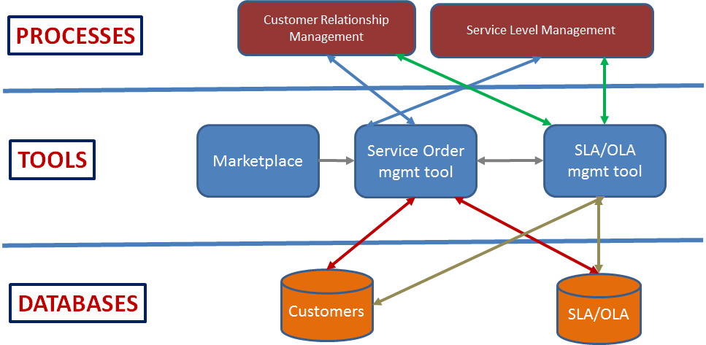

Figure 11. Interactions that happen during the management of a service order between the Marketplace, the Service Order management and the SLA/OLA management tools with the EGI IMS processes and databases.
The Customer Relationship Management (CRM) and the Service Level Management (SLM) are the two processes of the EGI IMS involved in service order management. They are shortly described below:
- Customer Relationship Management (CRM): The goals of this process are to:
  - Turn prospective customers into active users of EGI services by configuring/integrating/developing relevant components and new services (accessing services though a VO SLA).
  - Direct users to ready use services and configurations to satisfy service orders (accessing services through Corporate SLA).
  - Support the customers in reaching long-term operational setups at EGI Service Providers (securing resources through SLA-OLAs using the SLM process).
  - Maintain a good relationship with active customers (regular satisfaction and service reviews; handling complaints).
- Service Level Management (SLM): The primary purpose of this process is to maintain a service catalogue, and to define, agree and monitor service levels with customers by establishing meaningful service level agreements (SLAs), supportive operation level agreements (OLAs) and underpinning agreements (UA).
The complexity of all the processes and steps to manage a service order according to the EGI IMS requires the creation of as much automation as possible to make the customer support effective. A workflow, which with minimal human intervention allows processing of orders for AoDs was already defined and implemented. It is described later in this section.
Automations that serve other order typologies will be defined and implemented gradually. EGI tools will be enriched with new features as needed. For example, it is already planned to integrate e-Grant as backend system for SLA/OLA management into the Operations Portal, which then provides the remaining building block to fully implement the service order management workflow.

Service order queue specification and tickets
After the user submits a service order through the marketplace, the Service Order Management tool will create one or more tickets, representing service orders, in the service order queue of the EGI RT ticketing system.
This section describes the structure of such tickets.
- Ticket subject: it is a string with the following format:
“Service order, [Customer Name] [Customer Surname], [Service 1], [Service 2], … , [Service N]”
For example:
“Service order, Diego Scardaci, CloudCompute, OnlineStorage”
- Generic information: this section contains generic information about service orders, such as an order reference number, request status, etc. The following table lists and describes all the attributes in the generic information.
Attributes | Mandatory/  Optional | Note
Order reference number | Mandatory | Same value of the Marketplace order reference
Order status | Mandatory | Possible values:  - New  - Approved  - Rejected  - Suspended  Default value: “New”.
AoDs | Mandatory | Yes/NO. Flag to identify orders that have to be served by the AoDs platform.
SLA | Optional | The Marketplace leaves this attribute empty. It will contain a link to the SLA document (manually provided by an operator) when available.  This attribute is mandatory for “Approved” orders.

- Customer/User profile: Information retrieved by the EGI CheckIn service is integrated with additional information gathered by the Marketplace during the registration process. The following table lists and describes all the attributes of this section.
Attributes | Mandatory/  Optional | Note
Name | Mandatory | Text
Surname | Mandatory | Text
email | Mandatory | email format validated
Display name | Mandatory | Human readable username
EGI unique identifier | Mandatory | Unique identifier assigned to the customer by CheckIn
Country | Mandatory | Selected from pre-defined list
Institution | Mandatory | Text
Department | Mandatory | Text
Departmental web page | Optional | URL
Linkedin profile | Optional | URL
ResearchGate profile | Optional | URL
Supervisor name | Optional | Text
Supervisor profile | Optional | URL

- Service order profile: Customer information associated to each service order gathered during the Check-Out phase in the Marketplace. Such information enables an appropriate service order management, accordingly to the EGI Integrated Management System (IMS) processes and procedures. The following table lists and describes all the attributes of this section.
Attributes | Mandatory/  Optional | Note
Customer typology | Mandatory |  | - single user  - representing a research community/project  - representing a private company
Reason to request access to the EGI services | Mandatory |  | Free text
User group name | Optional  (Only if the customer represents a research community/project or a private company, leave empty in the other case) |  | It is a text that maps to the VO name. In the case the customers is already using the EGI infrastructure (VO list not empty), the VO name could be chosen from a drop down menu listing all the customer VOs (retrieved during the authentication) plus the option to specify a new VO.
Information on the project | Optional  (Only if the customer represents a research community/project or a private company, leave empty in the other case) |  | Project name: text  Project web site: URL  To be expanded in the feature. It could be automatically filled in querying the Operations Portal (if the project is already using the EGI infrastructure).

- Service orders: List of strings that contain the service options for each ordered service.
Service orders are represented in the ticket with the following syntax:
[Service Area]/[Service]/[ServiceOption]?[Attribute1=XX]&[Attribute2=YY]&..&[AttributeN=ZZ]
For example:
Compute/CloudCompute/GeneralPurposeInstance?NumberOfCPUCores=2&AmountOfRAMPerCPUCore=2&LocalDisk=10&NumberofVMInstances=5&NumberOfDays=200&StartOfService=20170501&AccessType=Opportunistic
Standard formats could be adopted in the future (e.g. JSON, XML) to facilitate the automatic processing of the data.

Serving AoDs orders
A semi-automated workflow to manage AoDS orders has already been defined and is described in this section.
The Marketplace must initially identify the users eligible for the AoDS. This is done during the service-order pre-processing phase.
A customer that submits a service order through the Marketplace will be identified as an eligible user for the AoDs if he/she is a single user and one of the following conditions will be respected:
- If he/she directly requests access to one or more applications hosted in the AoDs (service options of the Applications on Demand service);
- If he/she orders one or more of the following services Cloud Compute, HTC Compute, Cloud Container Compute, Online Storage, Archive Storage with an amount of requested resources lower than predefined thresholds and with “Opportunistic” access mode;
In such case, the Marketplace marks the service order as an order for the AoDs and stores this information in the Service Order Management tool (it sets the AoDS flag to “yes” in the ticket related to the service order).
Details on the formula to identify users eligible for AoDs are provided in the next section.
The Service Order Management tool notifies AoDs administrators that will review the request and decide to approve or reject it updating the “Order status” attribute. This is the only manual step of the process.
A change on the “Order status” attribute triggers the Service Order Management tool that checks the new value and performs an action accordingly. If the user’s request has been rejected, an e-mail with an explanation is sent to the user. Otherwise, if the order is approved, the tool contacts the CheckIn service to enable the user as an AoDs user. From a technical point of view, this means that the user will be registered as member of the AoDs VO, vo.access.egi.eu, in CheckIn.
After that, the user is enabled to access the AoDs and will be notified about the outcome. The Service Order Management tool will also provide the user with the information on how to access the requested AoDs applications. Direct links to access such applications are also available in the Marketplace AoDs section that will act as the front-end platform of the service.
The following picture describes the workflow to serve AoDs orders in a graphical format.
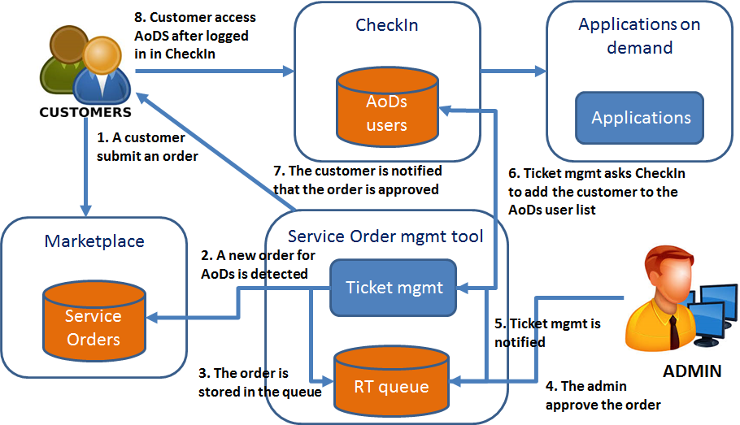
Figure 12. Semi-automatic workflow to manage a service order eligible for the Applications on Demand service.

Identify orders eligible for the AoDs
This section describes the formula that has been defined to identify orders eligible for the AoDs.
As described above, services ordered by a customer are grouped during the pre-processing performed by the Marketplace. Only two service group types can be accessed through the AoDs:
- Groups that include one or more of the following services: Cloud Compute, HTC Compute, Cloud Container Compute, Online Storage, Archive Storage.
- Groups that include only Applications on Demand service and related options (the applications).
While the second group type (Applications on Demand service and related options) is always eligible for the AoDs, the first one can be served via the AoDs only under certain conditions:
- All the resources have been requested with “opportunistic” access mode (not “reserved”);
- The amount of requested resources should be lower than some predefined thresholds.
Currently, we have defined the thresholds described in the two following tables:
Thresholds | Max value | Involved Services | Description
Total number of CPU cores | 20 cores | Cloud Compute and Cloud Container Compute | Include all the ordered cores for the General Purpose Instance options of Cloud Compute and Cloud Container Compute services.
Total amount of RAM | 40 GB | Cloud Compute and Cloud Container Compute | Consider the total amount of memory ordered for the General Purpose Instance options of Cloud Compute and Cloud Container Compute services.
Total block storage capacity | 100 GB | Online Storage | Consider the total amount of ordered block storage.
Total object storage capacity | 100 GB | Online Storage | Consider the total amount of ordered object storage.
Figure 13. Cloud - Thresholds per AoDs.

Thresholds | Max value | Involved Services | Description
Total number of CPU hours | 1000 CPU.hour | HTC Compute | Total amount of CPU/hours ordered for Base HTC.
Amount of RAM per CPU core | 4 GB/core | HTC Compute | All the orders related to HTC compute must require not more than 4 GB per CPU core.
Total file storage capacity | 100 GB | Online Storage | Consider the total amount GB per of ordered file storage
Figure 14. HTC -Thresholds per AoDs.
These thresholds will be validated and fine-tuned in the next months in collaboration with resource providers. Changes could be applied to both the “max values” and the threshold set if needed.
If a customer orders services belonging to the two service types eligible per AoDS (e.g. Cloud Compute with opportunistic access type and satisfying the thresholds and an applications of the AoDs), the request will be considered as a single order and only one ticket will be created in the service order queue. Otherwise, the orders will be split as specified in section 0.

Tools to manage service orders
This section shortly describes the main role of each EGI tool in the service order management workflow when it will be fully implemented in the future.
- CheckIn: manages customer authentication and authorisation. When a customer is authorised to access a Service, CheckIn will take care to retrieve such information (e.g. VO membership) and provide the service provider with it. Customers authenticated with CheckIn in the Marketplace could access services through the same Marketplace interface without the need to re-do the authentication process.
- GOCDB: it will be used to associated service providers to the services published in the Marketplace.
- Marketplace: exposes the EGI services to the customers, which could submit orders, and acts as a Frontend (direct access to a service from the Marketplace. e.g. the AoDs case).
- Service Order Management tool: takes care of a customer order for its lifetime, triggering other tools when needed.
- Operations Portal: it will create VOs on demand according to the requests coming from the Service Order Management tool.
- SLA/OLA management tool: plugin of the Operations Portal that will take care of the SLA/OLA management (creation, renewal, registry, report generations).
- ARGO (monitoring) and Accounting system : provides the SLA/OLA management tool with the information to create the SLA/OLA reports.
Figure 15 shows the interactions between EGI tools in the service order management workflow.
This is a preliminary work that will be further extended in the next future.
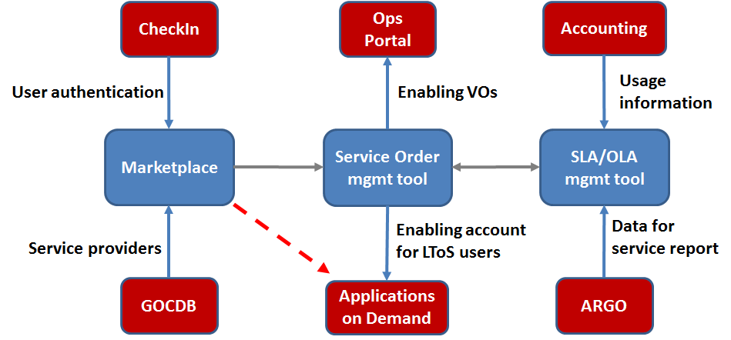
Figure 15. Interactions between EGI tools in the service order management workflow

Enabling pay-for-use through the Marketplace
An analysis on how to implement the pay-for-use support in the Marketplace was performed in the last months. As result, three different options were defined.
- EGI acts as a broker / or individual provider offers listed separate, but aggregated on the service level: under service level, differentiate each option according to the access mode, for free or for pay. Then, e.g., for Cloud Compute service, the Marketplace will expose the options “General purpose instance” and “General purpose instance for pay”, etc.
- EGI acts as a broker: add the pay-for-use attributes directly in the service options (product in the Marketplace). A flag “for pay” will be added as extra attribute. If this option is selected the access policies will change accordingly.
- Direct contracts between customers and providers: an additional category, related to the pay-for-use providers, will be added in the first level of the data model hierarchy (service categories). Under this category, all the providers will be listed. Under each provider, all its products will be listed.
These options were discussed within the Pay-for-Use working group that decided to adopt the second solution in which is foreseen the role of EGI as a broker.
To implement this option, a flag “for pay” will be included as extra attribute in the Marketplace forms to order service options that could be accessed in pay-for-use mode. A clear explanation of the different access policies (“for free” and “for pay”) will be included in the service option descriptions highlighting the different level of services offered according to the chosen policies.
Furthermore, it will be clarified that access to a large resource set “for free” requires agreements with the NGIs correlated with the national research infrastructure roadmap of each country.
The role of EGI as broker will be to facilitate the process between the demand and the offer. EGI’s expertise allows it to analyse a customers’ requirements, provide them with advices and technical support and identify the best providers to satisfy their needs.
The Pay-for-Use mode will be enabled into the Marketplace in the coming months and will be tested in the context of the NextGEOSS project where EGI is a member with exactly these duties, supporting project use cases and identifying the Cloud providers of the EGI Federation that satisfy their needs in the best possible way.

Moving to production
After the objective to design and the develop a prototype of a Service Registry and a Marketplace for the EGI infrastructure was fully achieved with the release of two demonstrators, one based on Prestashop and the other based on Open IRIS, a plan was defined to enhance the PrestaShop based prototype and making it operational, reaching the Beta service phase by the end of the project.
As main activities, this plan included:
- The implementation of the service order pre-processing described in section 5.2.1.
- The implementation of the first version of the Service Order Management tool with the recording of the service orders and the related profiling information in the EGI RT system, see section 5.2.2 for details.
- The integration of the Marketplace with the Applications on Demand service.
- The implementation of the semi-automatic workflows to serve orders for AoDs described in section 5.2.3.
- The customisation of the PrestaShop customer dashboard to view/manage orders according to the needs of EGI.
- The integration of the Marketplace with the EGI web site.
All these activities were already completed or planned to be completed by the end of the project. Only the integration of the Marketplace with the EGI web site could be slightly postponed since it was considered more convenient collecting some feedback from our customers before deploying it into production.
Furthermore, a Service Design and Transition Package (SDTP) for the Marketplace was created in order to ensure proper evaluation, define the necessary pieces of information regarding the service design, delivery and transition planning. The SDTP is an instrument that supports a service provider when it is planning to extend its service portfolio and to implement a new service. It can be used to both propose and evaluate services, as well as to plan the design, development and deployment of services that the provider has decided to create. It also lists all the requirements the service has to satisfy in order to change phase, as moving from Alpha into Beta (e.g. perform the service risks assessment, activate the support through EGI helpdesk, agree OLA/UA with the involved providers, etc.).
Many of the items covered by the plan have already been described in Section 5 “Marketplace as tool to automate EGI IMS processes”. In this section, details will be provided for the other points:
- The integration of the Marketplace with the Applications on Demand service.
- The customisation of the PrestaShop customer dashboard to view/manage orders according to the needs of EGI.
- The integration of the Marketplace with the EGI web site.

Integration with the Application on Demand service
The Application on Demand service (AoDs) is the EGI’s response to the requirements of researchers, scattered across Europe, without dedicated access to computational and storage resources, as well as other facilities needed to run scientific applications.
Briefly, the service provides access to:
- Applications that are offered "as a service" through online graphical environments.
- Portals, science gateways and Virtual Research Environments that offer integrated development environments to port custom applications with High-throughput computing and cloud resources.
- Cloud and High-throughput compute resources suited for both compute/data intensive applications and for the hosting of scientific services.
- Online Storage resources for storing scientific data that serve as input and output for computational jobs.
- A network of Consultants and supporters who can provide guidance on the use of the service.
The AoDs operates as an open environment where any provider can integrate and share applications and compute/data components. The following applications/components are already integrated in the service and are available for users to access:
- Thematic applications for supporting Life Sciences disciplines: Galaxy, ClustalW2, Chipster, NAMD and AutoDock Vina;
- Generic utilities: Docker, Apache Tomcat, Hadoop, Marathon, and Chronos;
- Thematic applications for supporting Engineering disciplines: GnuPlot, Octave and the Statistical R for Computing and Jupyter Notebook;
- Thematic applications for supporting Art and Humanities disciplines: the parallel Semantic Search Engine.
Initially, the AoDs was designed including a Frontend, the User Registration Portal, which partially implemented a service discovery and a user profiling features to identify small research groups (the so-called Long Tail of Science). Now that the Marketplace is available, these features have become redundant. The Marketplace already profiles the customers and, in addition, gathers information on service orders allowing the identification of AoDs users. Furthermore, it has been considered more convenient offering to potential customers a single point of access (frontend) to all the EGI services (the Marketplace).
For these reasons, we decided to integrate the AoDs with the Marketplace for both exploiting its profiling features and exposing its service options (the applications) to the customers. The Marketplace also lists the links to access the applications and, then, can be used as a full frontend for the AoDs.
For this aim, a new service category was introduced in the Marketplace data model, “APPLICATIONS”, and the AoDs was included in this category.
The new main page of the Marketplace is shown in the following image.
Figure 16. Marketplace homepage with the new "APPLICATIONS" service category.
AoDS service options, included in the third level of the Marketplace data model hierarchy, are the same applications offered by the AoDs.
Customers can order such applications together with other EGI services following the usual Marketplace workflows.

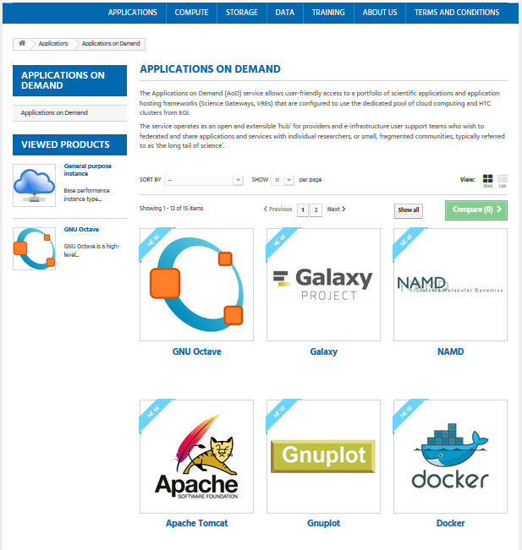
Figure 17. Applications on Demand service page in the Marketplace. Customers can order one or more applications together to other EGI services.
When the customer selects one application, he/she is redirected to a page, see Figure 18 and Figure 19, where the following elements are available:
- A form to submit the order allowing only to choose the time period to access the application. All the other attributes are not changeable since AoDs offers to each user a grant, providing a pre-defined quota of resources, for running the applications.
- Description of the application.
- Direct link to access the application after the user is authorised.
- List of service providers supporting the application.
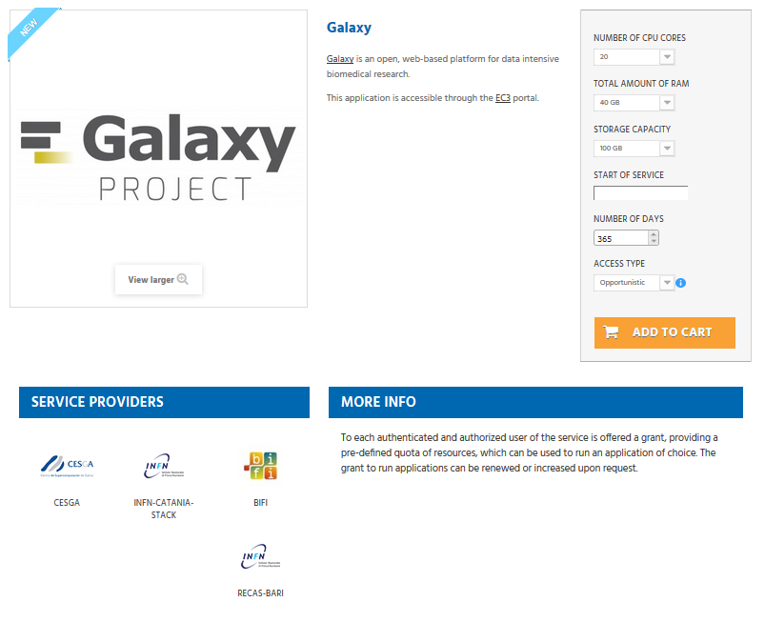
Figure 18. Example of a page allowing to request access to the Galaxy application.
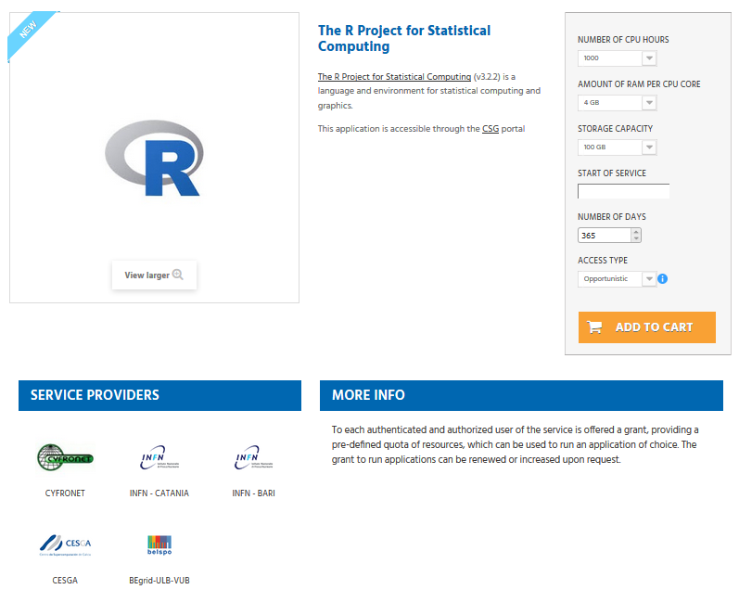
Figure 19. Example of a page allowing to request access to the R application.
Furthermore, since both the Marketplace and AoDs adopted CheckIn for authentication and authorisation, a user authenticated in the Marketplace and already authorised to access the AoDs could access transparently, without re-doing the authentication via CheckIn, to the AoDs applications from the Marketplace following links included in the application descriptions.

Customer dashboard
After a service order is submitted, a customer needs to be kept informed about its status. For this aim, we have decided to customise the built-in PrestaShop customer dashboard.
In particular, the following changes were implemented:
- The Status column shows information about the service order status as reported in the related RT ticket. If several tickets have been created for one order in Prestashop, status of each request is reported in the “Details” section.
- A new column, SLA, was added. This column report the URL to retrieve the SLA document when an order is approved.
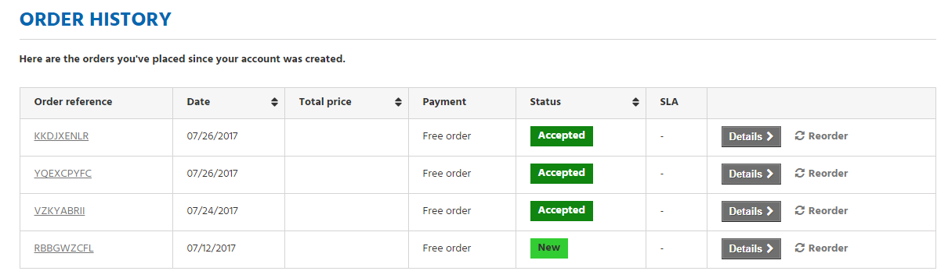
Figure 20. Customised PrestaShop customer dashboard.

Integration with the EGI web-site
The EGI web site shows the EGI external service catalogue at https://www.egi.eu/services/, as shown in the following image.
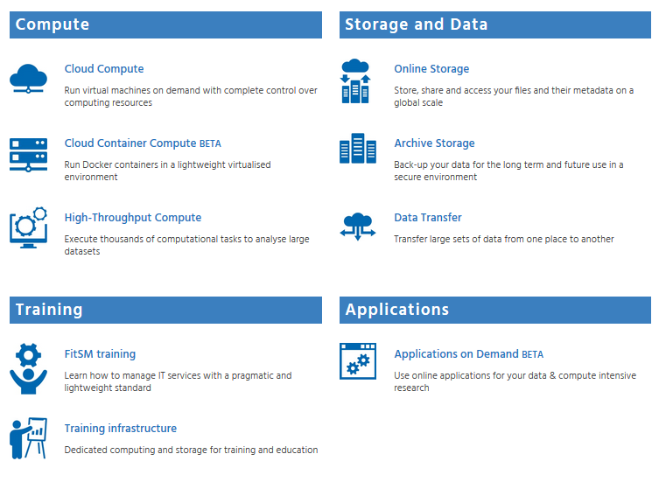
Figure 21. EGI Service Catalogue in the corporate web site.
Customers can retrieve more information about each specific service by visiting the dedicated web page, see the below image showing the Cloud Compute page as example:
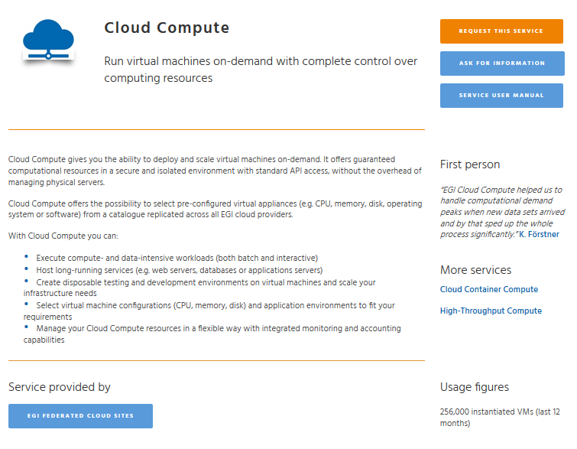
Figure 22. Page in the EGI web-site describing the Cloud Compute service.
Furthermore, customers can request more information about one or more services by clicking on the “ASK FOR INFORMATION” button and filling in a generic form. The form is the same for all the services and customers need to specify which services they are interested to use.
Integration between the EGI web site and the Marketplace will be done by linking the “REQUEST THIS SERVICE” button to the Marketplace page describing the service the customer is interested. On this page, in addition to the service presentation, lists also all the service options available for the given service, which facilitates the customer to better specify his/her requirements, and on the other side, EGI as service provider, collecting better structured information in an order. This is the base for fully implementing the service order automation in the future.
See below, as example, the Marketplace page of the Cloud Compute service.
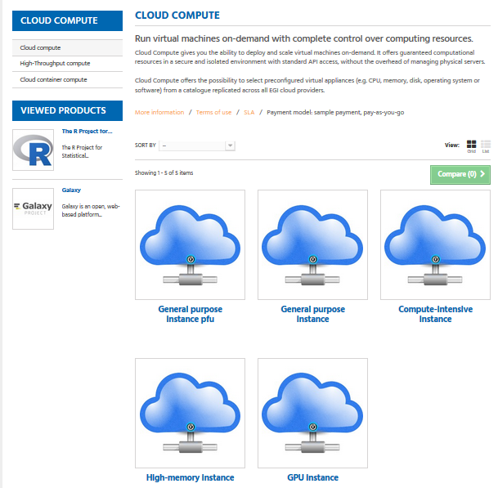
Figure 23. Cloud Compute service in the EGI Marketplace.
In the future, a tighter integration between the web site and the Marketplace could be implemented. The Marketplace could be included in the web-site top menu and all the applications described in the web site could be linked to the related entries into the Marketplace with the final aim to facilitate and promote the access to all the services offered by the EGI community.

Publishing of thematic community services
Now that the Marketplace is going to become operational, after a first phase where only EGI services will be published, this new tool will be opened to the whole EGI collaboration and partners.
The Marketplace has the potential to become an important instrument to better promote and provide visibility to the thematic community services that are fundamental enablers of research and mediators of access to the EGI services. As a thematic community service, it is intend to be used for all services and platforms that make use in some form of the EGI services.
The service design activity performed in the last months to integrate the Application on Demand service with the Marketplace can be also considered as a driver for the integration of other platforms in the coming months. Indeed, the new “APPLICATIONS” service category was thought as a container for all the thematic platforms that will be exposed through the Marketplace in the future.
When a thematic platform is published into the Marketplace, a new entry for such service will be created under the “APPLICATIONS” category and the related service options will be defined and exposed to the customers. We will also explore the possibility to split such categories into sub-categories taking into account the different scientific disciplines served by the EGI infrastructure to facilitate service discovery.
When possible, as already done for the AoDs, the Marketplace AAI based on the CheckIn service will be made interoperable with the thematic platform AAI allowing a transparent access to the applications from the Marketplace for authorised customers. In this way, the Marketplace will act as a sort of single Frontend for accessing the applications and tools available in the EGI infrastructure greatly decreasing the barriers to discover and access them.

Requirements to expose services in the marketplace
The services that will be published in the Marketplace should satisfy criteria such as guaranteeing a certain level of quality of the service, being compliant to generic security policies and EC regulations like GDPR, etc.
The preliminary work for the definition of such requirements was already completed and the results are described in this section. The requirement list will be fine-tuned and updated according to the feedback collected and the experience gained during the first phase of service boarding.
Services were classified in two categories:
- Services in the EGI catalogue: community platforms, in the form of scientific applications/VREs, that will be introduced in the EGI service catalogue. EGI financially supports the operations of the service. If the supplier is also a technology provider, the supplier retains IPs of the software produced. EGI and the supplier agree on how to maintain and further develop the service (new features).
- External services: leaving the ownership and funding of the service to the organization developing and operating it, but promoting the service in the EGI service marketplace as an "EGI powered" community service, operated by a partner, in the context of a partnership agreement.
For each of this category requirements were defined. They are described in the following table.
Requirements | Services in the EGI Catalogue | External services (from external partner’s catalogues)
Belongs to EGI catalogue | - Yes (EGI is the provider) | - No (partner is the provider)
Published in EGI marketplace | - Yes | - Yes, if requirements in this table are met and if the partner agrees
Agreement type | - OLA or UA (underpinning agreement) established | Contract between the EGI Foundation and the Service Provider including:  - Motivation of the collaboration  - Acceptance of the requirement list  - If the service uses EGI services: SLA between the service provider and EGI.
Readiness | - TRL 8 or higher | - TRL 8 or higher
Service targets | - Min Availability/Reliability (thresholds defined by EGI)  - Min Incident and Service Request Response time (thresholds defined by EGI). | - Min Availability/Reliability (thresholds defined by service provider)  - Min Incident and Service Request Response time (thresholds defined by service provider)
Monitoring | - Service is monitored and registered in GOCDB | - Minimal monitoring in place by EGI (where possible) to ensure online services are up and running
Support | - Mandatory via the EGI support system (GGUS) | - Mandatory (support channel defined by provider)
Acknowledgement policy | - EGI acknowledgement mandatory | - EGI acknowledgement mandatory if service relies on components provided by EGI
Annual report on scientific publications and users | - Mandatory for services where it is applicable | - Mandatory if service relies on components provided by EGI
Service Performance Report | - Mandatory (requires report from supplier) | - No
Interoperation levels:  - Level 1: AAI  - Level 2: AAI, accounting, monitoring, service registration | - Level 2 (mandatory) | - Level 1 (mandatory where applicable)
Compliance to EGI policies | - Mandatory | - Compliant to generic security policies and EC regulations
Terms of use | - Service: Acceptable Use Policy and Conditions of Use  - Content (where applicable): <depends on the service>  - Software (where applicable): The service code software is licensed under <depends on the service> and is available upon request. | - Defined by provider

Open IRIS as instrument marketplace
Although Open IRIS was not selected for the EGI Marketplace, it has demonstrated itself to be a good tool for instrument and resource management with the goal of enabling marketplaces for scientific services and instrumentation. Originally, Open IRIS was primarily used in Switzerland, however, through the evaluation of Open IRIS in the EGI-Engage project, its use was extended to several other countries.

Evaluation
In the course of discussions with multiple organizations, several of them have adopted Open IRIS as a solution to manage resources within their organizations or have entered into a pilot to evaluate the system. The list below is of organizations that are in an active pilot, using the system in production, or are have become a partner of the project during EGI-Engage.
Organization | Status | Pilot
BioImaging Center in Bordeaux | pilot | France
Centre d'Immunologie de Marseille-Luminy | production | France
Colledge de France | production | France
École Normale Supérieure | production | France
ETH Zurich | partner | Switzerland
Harvard | production | United States
Institut Curie | partner | France
Institute of Photonic Sciences | pilot | Spain
Institut du Cerveau et de la Moelle Epinière | pilot | France
Leibniz Institute on Aging | pilot | Germany
Max Delbrück Center for Molecular Medicine | production | Germany
Paul Scherer Institute | partner | Switzerland
Sainsbury Wellcome Centre | pilot | England
Thermo Fisher Scientific | partner | Germany
University of Basel | partner | Switzerland
University of Goettingen | pilot | Germany
University of Helsinki | pilot | Finland
University of Los Andes | Pilot | Columbia
University Pierre and Marie Curie | pilot | France

The above list is only a partial list of organizations that are evaluating or using Open IRIS as there are organizations evaluating or using the system that have not been in direct contact as it is fully self-service and free to use, some of the these organizations are from Brazil, Singapore, and Qatar.

Metrics
As different organizations have adopted Open IRIS, the usage of the system has grown dramatically during the project lifetime. In each of the last two years, the users and resource requests of the system have doubled. In the table below is displayed the current statistics of the system.
Metric | Status
Users registered | 4708
Organizations represented by users | 196
Countries of organizations | 48
Logins per day | 300
Resource providers registered | 248
Resources registered | 1717
Resource requests per month | 10000

The usage of the system has grown substantially, going from around 1000 resource requests per month to over 10,000 resource requests per month as shown the graph below.
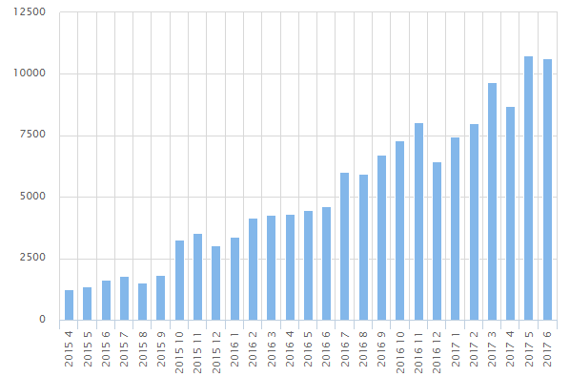

General Usage
Open IRIS has facilitated resource management and discovery within organizations, however, it has enabled the sharing of resources between academic organizations and collaborations with commercial entities. Currently there are over 20 commercial organizations registered in Open IRIS that are using the system to share commercial resources to academic organizations, or for commercial organizations to use resources from academic organizations. In particular, there has been the establishment of resource sharing clusters in Paris and in Basel, and there is currently one being established in Berlin. There have also been discussions to establish French and Austrian wide solutions for sharing of microscopy resources across countries.

Conclusions
Though Open IRIS was not selected as the solution for the EGI Marketplace it can be seen through its metrics that it is a good solution for sharing of scientific resources within and across organizations. In addition, it can be seen that via EGI-Engage the adoption and usage of Open IRIS has grown substantially. In May 2017, Open IRIS also received an award for innovation in “Laboratory Effectiveness” by S-Lab and the UK Science Park Association. A possible integration of Open IRIS into the EGI Marketplace to manage instrument resources will be considered in the future.

Future plans
In a close future, initiatives and services from several stakeholders will be published in the EGI Marketplace. It will act as a facilitator for discovering, ordering and accessing these services becoming a key component of the future European Open Science Cloud (EOSC).
To reach this aim, the Marketplace activity will continue with tasks in four main areas:
- Technical enhancements on the Marketplace
- Publishing of thematic services
- Service order management automation
- Pay-for-use
In the first area, work will be done to create interfaces towards external tools. EGI is planning to adopt a Service Portfolio Management tool to manage in a more structured way its Service Portfolio, this tool should feed the Marketplace with information on the EGI live services. Then, service information exposed in the Marketplace should be automatically retrieved with an interface. In addition, EGI will ensure its service catalogues are also compliant with the service registry requirements currently under development within the eInfraCentral project. The Marketplace will publish EGI service information in a standard format to enable its publication in the EOSC registry.
In regards to the publishing of thematic community services, the current prototype solution based on the integration with AoDs will be evaluated and fine-tuned. After that, selected thematic service providers will be invited to join the Marketplace. When enough experience is gained, a structured procedure to involve other providers will be defined. Procedures to delegate the registration and the management of service entries to their providers will be implemented and the criteria to publish services in the Marketplace will be fine-tuned. Furthermore, the possibility to create “satellite” Marketplace per NGI or provider linked to EGI central instance will be explored.
The work on the service order management automation will continue both in terms of design and implementation with the final aim to automate as much as possible the management of all the order types. The RT queue will be extended with information to allow the IMS processes to take care of an order in each phase. The SLA/OLA management tool will be implemented enabling the automatic generation of SLA/OLA and related reports.
Finally, pay-for-use entry will be included in the Marketplace as defined in this document and the implementation will be tested with the launch of the first commercial offers.

Plan for Exploitation and Dissemination

Name of the result | EGI Marketplace
DEFINITION
Category of result | Software & service innovation
Description of the result | The EGI Marketplace is a platform to advertise the EGI services, manage the customer service requests and facilitate access to services as much as possible.
EXPLOITATION
Target group(s) | RIs, international research collaborations, single users, industry/SMEs, service providers, funding agencies and decision/policy makers.
Needs | There is an increasingly high demand for e-Infrastructure services for researchers. The EGI Marketplace platform provides a portal where researchers can easily discover and gain access to those resources.
How the target groups will use the result? | Resource providers within the EGI federation who are interested in providing services to internal and external resources can now expose them via the EGI Marketplace. In addition, researchers and innovators now have a common location to discover services and resources that they may require for their. The EGI Marketplace can then provide a framework for which e-Infrastructure services are provided to users internal and external to the EGI collaboration with different access modes (“for free” or “for pay”).  The PrestaShop model offers a full service model, where the EGI Federation provides the services to add services into the store on the behalf of service providers. The goal is for that to transition to a self-service model.
Benefits | The primary benefits are efficient sharing of resources and provision or e-Infrastructure services to researchers. Easy discoverability and access to the services.
How will you protect the results? | The EGI Marketplace prototype is available to others to use freely. An open-source license (Apache 2.0) will protect the customisations applied to the underlying technologies.
Actions for exploitation | - The prototype is developed with a SaaS delivery model.  - EGI service will be published on the Marketplace  - A link to the marketplace will be included in the EGI web-site top menu and all the applications described in the EGI web site will be linked to the related entries into the Marketplace
URL to project result | - PrestaShop prototype: http://marketplace.egi.eu/
Success criteria | Effectiveness of the Marketplace will be monitored by counting the number of accesses and the service requests performed through it. The latter value will be compared with the number of service requests managed through other traditional channels.
DISSEMINATION
Key messages | Discover and access EGI services with a few clicks.
Channels | EGI web site, EGI newsletter, participation in conferences
Actions for dissemination | - Participation to conferences: DI4R 2016 (Krakow), EGI Conference 2017 (Catania). It is planned to present the work at DI4R 2017 (Brussels).  - Article in the newsletter  - Promotion in the EGI web site  - Marketplace link added to the EGI dissemination material (e.g. leaflet)
Cost | N.A.
Evaluation | Number of accesses and the service requests performed through the Marketplace.

Name of the result | Open IRIS
DEFINITION
Category of result | Software & service innovation
Description of the result | Platform to advertise the EGI services, manage the customer service requests and facilitate access to services as much as possible.
EXPLOITATION
Target group(s) | RIs, international research collaborations, single users, industry/SMEs, service providers, funding agencies and decision/policy makers.
Needs | There is an increasingly high demand for e-Infrastructure services for researchers. The EGI Marketplace platform provides a portal where researchers can easily discover and gain access to those resources.
How the target groups will use the result? | Open IRIS already offers a full self-service model where resource providers can login and register a resource provider and offer services via the platform. The creation of satellite marketplaces for service providers is already planned.
Benefits | The primary benefits are efficient sharing of resources and provision or e-Infrastructure services to researchers. Easy discoverability and access to the services.
How will you protect the results? | The Open IRIS prototype is available to others to use freely. An open-source license (Apache 2.0) will protect the customisations applied to the underlying technologies.
Actions for exploitation | The prototypes is developed with a SaaS delivery model.  A possible integration of Open IRIS into the EGI Marketplace to manage instrument resources
URL to project result | - Open IRIS prototype: http://egi.science-it.ch
Success criteria
DISSEMINATION
Key messages | Discover and access EGI services with a few clicks.
Channels | EGI web site, EGI newsletter, participation in conferences
Actions for dissemination | - Participation to conferences: DI4R 2016 (Krakow), EGI Conference 2017 (Catania). It is planned to present the work at DI4R 2017 (Brussels).  - Article in the newsletter  - Promotion in the EGI web site  - Marketplace link added to the EGI dissemination material (e.g. leaflet)
Cost | N.A.
Evaluation

- EGI Marketplace data model
The data model of the Marketplace reflects the EGI service catalogue structure (https://www.egi.eu/services & https://www.egi.eu/internal-services). It is made of a three-level hierarchy where the first level contains the EGI service areas (categories in the Marketplace) and the second level maps to the EGI services (sub-categories in the Marketplace). Furthermore, an additional level defines the EGI service options (products in the Marketplace). The service options represent the products that the end user could access or purchase in the Marketplace.
The first two levels of the hierarchy are described in the table below.
Table 1. EGI Service Catalogue - first and second levels
Service area | Services
Compute | Cloud Compute, Cloud Container Compute and High-Throughput Compute
Storage | Online Storage, Archive Storage
Data | Data transfer, Content Distribution
Operations | Configuration Database, Service Monitoring
Security | Check-in, Attribute Management
Training | Training Infrastructure, FitSM
Applications | Applications on Demand

For all the services in the external catalogue, service options have been also defined. They are described in this appendix.
The following subsections describe the attributes that will be shown in the Marketplace for each level of the hierarchy:
- Service areas (category in the Marketplace)
- Services (sub-category in the Marketplace)
- Service options (what the customers can order in the Marketplace)
Finally, data to describe service providers in the Marketplace are also defined. Each service in the Marketplace will be linked to one or more providers.
Service areas (category in the marketplace):
Each category in the Marketplace demonstrators is described with the attributes shown in the table below.
Table 2. Service areas
Attribute | Definition | Notes
Name | Name of the category | The first level category maps to the EGI service area:  - Compute  - Storage  - Data  - Operations  - Security  - Training  - Applications
Description | Description of the category | Inspired by the description of the EGI service areas in the service catalogue: short, punchy and expressing the value

Service areas in the EGI Marketplace demonstrators:
The following table lists the four categories that were included in the EGI Marketplace demonstrators with the related description.
Table 3. Service areas in the EGI Marketplace demonstrators.
Service Area | Description
Compute | Services for processing data supporting different computing models
Storage | Services for storing/retrieving files
Data | Services for moving or distributing data
Training | Services for skills development
Applications | Applications for researchers and innovators

Services (sub-categories in the Marketplace):
The EGI Marketplace demonstrators present services to the end-users with a set of attributes described in the table below. These attributes are inherited and sometime specialised by the service options.
Table 4. Services (sub-categories in the Marketplace).
Attribute | Definition | Notes
Name | Name of a specific service as assigned by the service provider | Format: Free text  Example: Cloud Compute
Unique ID | Global unique and persistent identifier of a specific service  Note: this allows to map a service to a specific organization/e-Infrastructure | Format: DOI or any other relevant standard; it should contain information about the identifier type and value.  Additional info:  A PID can be used ideally resolvable to a landing page or a machine readable data typed metadata page. It should be assigned by the CoS owner.
Short description | High-level description of what the service does in terms of functionalities it provides and the resources it enables access to. It may include the value (benefit) to a customer and their users delivered by a service | Format: Free text  Additional info:  It may provide also information related to the offered capacity, number of installations, underlying data that is offered.  Benefits are usually related to alleviating pains (e.g., eliminate undesirable outcomes, obstacles or risks) or producing gains (e.g. increased performance, social gains, positive emotions or cost saving).
Description | Longer description of what the service does in terms of functionalities it provides and the resources it enables access to the service | Format: Free text
Web page | URL to a webpage providing more information about the service | Format: URL  Additional info:  This webpage is usually hosted and maintained by the service provider. It contains current and additional information, such as what APIs are supported or links to the documentation.
Service phase | Phase of the service design selected among:  beta: service being developed while available for testing publicly  production: service available in the live environment meeting security/performance requirements | Source: UK Government Service Design Manual  Format: Closed enumeration
Category | Link to categories this service belongs to | Format: Closed enumeration
Service condition | Restrictions that apply to this service | Format: List of sentences, each of them defining a condition
Payment Model | Supported payment models and restrictions that apply to each of them | Format: List of sentences, each of them stating the type of payment model and the restriction that applies to it.  Additional info:  Example of types of payment models are: free, pay-as-you-go, subscription, membership  Variable pricing for corporate customers, higher education, etc.
Term of use | URL to a document containing the rules which one must agree to abide by in order to use the service | Format: URL
SLA | URL to a document containing information about the levels of performance that a service provider is expected to achieve (service level agreement) | Format: List of URLs

Services included in the Marketplace:
Services that were included in the current release of the Marketplace classified for service areas.
Table 5. Services in the second release of the Marketplace.
Service area | Services
Compute | Cloud Compute, Cloud Container Compute and High-Throughput Compute
Storage | Online Storage, Archive Storage
Data | Data transfer
Training | Training Infrastructure, FitSM
Applications | Applications on Demand

Service options:
The service options include some common options described in the table below.
Table 6. Common service options.
Common service options | Description | Notes
Description of the research activity | Information on the research activity that needs to access the EGI services. In particular, relevant when access for free is requested. | This attribute has to be requested to the customer in the Cart and not in the service option form.
Access type | Reserved or opportunistic (does not apply to the training and to some Cloud Computing options). | When applicable, this attribute has to be requested in the service option form.
Start and end dates | Specify the period in which users will access the services. The period can also be undefined.

- Compute/Cloud Compute
Service description: Cloud Compute gives you the ability to deploy and scale virtual machines on-demand. It offers guaranteed computational resources in a secure and isolated environment with standard API access, without the overhead of managing physical servers.
Cloud Compute offers the possibility to select preconfigured virtual appliances (e.g. CPU, memory, disk, operating system or software) from a catalogue replicated across all EGI cloud providers.
Table 7. Cloud Compute service options.
Service option (Instance types) | Description | Attributes
General purpose instance | Base performance instance type.  Features:  - Accessible in opportunistic or reserved ways  - CPU cores could be overcommitted  Ideals for:  - Web services  - Micro-services  - Development environments  - Building server  - Small database  - Test environments | Number of CPU cores: [1,2,4,8]  Amount of RAM per CPU core (GB): [1,2,4]  Local disk (GB): [10,20,40]
Compute-intensive instance | Optimised instance for computing tasks.  Features:  - High performance CPU cores  - Until 64 CPU cores  - Real CPU cores (non- overcommitted)  - Low latency network  - Reserved instances  Ideals for:  - Batch computing  - High-performance applications and web services  - Distributed analysis  - Video encoding | Number of CPU cores: [8,12,16,20,24,28,32,64]  Amount of RAM per CPU core (GB): [2,4,8]  Local disk (GB): [10,20,40]  Note 1: Some CPU cores/RAM per core combinations are not permitted. Maximum total RAM available for 1 instance is 240 GB.  Note 2: Only reserved instances admissible.
High-memory instance | Optimised instances for tasks that require more memory relative to virtual CPUs.  Features:  - High amount of RAM per CPU core.  - Up to 240 GB of RAM in total.  - Reserved instances  Ideal for:  - Running in-memory database  - Running in-memory stores (e.g. redis, memcached)  - In-memory big data processing engines (e.g. Apache Spark). | Number of CPU Cores: [2,4,8,12,16]  Amount of RAM per CPU core (GB): [16,32,48,64,80,96,112,120]  Local disk (GB): [10,20,40]  Note 1: Some CPU Cores/RAM per core combinations are not permitted. Maximum total RAM available for 1 instance is 240 GB.  Note 2: Only reserved instances admissible.
GPU instance | GPU-enabled instances.  Features:  - 1 or 2 GPU cores  - 8 CPU cores for each GPU core  - Large memory  Ideals for:  - graphics and general purpose GPU compute applications | Number of GPU cores: [1,2]  Number of CPU cores per GPU core: [8]  Amount of RAM (GB): [24,50]  Local disk (GB): [280]  Note 1: The amount of RAM will be 24GB with 1 GPU core or 50GB with 2 GPU cores.  Note 2: Only reserved instances admissible.

- Compute/Cloud Container Compute
Service description: Cloud Container Compute (in Beta phase) gives you the ability to deploy and scale Docker containers on-demand. It offers guaranteed computational resources in a secure and isolated environment with standard API access, without the overhead of managing the operating system. The result is improved performance, ideal for development work.
Same options as the Cloud Compute service.
- Compute/High-throughput Compute
Service description: High-throughput Compute allows you to run computational jobs at scale on the EGI infrastructure. It allows you to analyse large datasets and execute thousands of parallel computing tasks.
High-throughput Compute is provided by a distributed network of computing centres, accessible via a standard interface and membership of a virtual organisation. EGI offers more than 650,000 cores of installed capacity, supporting about 1.6 million computing jobs per day.
This service supports research and innovation at all scales: from individuals to large collaborations.
Table 8. High-throughput Compute service options.
Service option | Description | Attributes
Base | It allows the execution of large numbers of independent or loosely coupled computing tasks. Limited parallel and multi-thread computing can be supported as well. | Number of CPU cores: [1-32]  Amount of RAM per CPU core (GB): [4-8]  Other technical requirements: [text]
MPI | It allows parallel computing, with support of MPI protocol and libraries. | Number of CPU cores: [1-256]  Amount of RAM per CPU core (GB): [4-8]  Parallelism (Threads): [8-24]  Other technical requirements: [text]

- Storage/Online Storage
Service description: Online Storage allows you to store data in a reliable and high-quality environment and share it across distributed teams. Your data can be accessed through different standard protocols and can be replicated across different providers to increase fault-tolerance.
Online Storage gives you complete control over the data you share and with whom.

Table 9. Online Storage service options.
Service option | Description | Attributes
Block storage | Block Storage is a block-level storage solution that allows you to expand the storage capacity of your instances in the EGI Federated Cloud. This means you can increase your storage without increasing the size or capacity of your instance or by provisioning new ones. Once you mount and format your drive, you can use it just like a regular hard drive attached to your server. You can also detach your block storage volume from one server and attach it to another or you can delete your server, keeping your data intact and ready for the next time you need it. | Storage capacity [TB]: [1, 5, 10, other]  Special requirements (e.g. performance, close to the computational resources, etc.): [text]
Object storage | Object storage manages data as objects. Each object includes the data itself, a variable amount of metadata, and a globally unique identifier. Cloud object storage allows relatively inexpensive, scalable and self-healing retention of massive amounts of unstructured data. | Storage capacity [TB]: [1, 5, 10, other]  Interfaces: [CDMI, POSIX, SWIFT, to be specified by the users]  Special requirements (e.g. performance, close to the computational resources, etc.): [text]
File storage | Highly scalable storage system accessible from anywhere allowing to easily share data through different standard interfaces. It assigns global identifiers to files and allows to organise your data using a flexible hierarchical structure. | Storage capacity [TB]: [1, 5, 10, other]  Technology: [DPM, DCache, STORM, …, any]  Special requirements (e.g. performance, close to a specific site, etc.): [text]

- Storage/Archive Storage
Service description: Archive Storage allows you to store large amounts of data in a secure environment freeing up your usual online storage resources.
The data on the Archive Storage can be replicated across several storage sites, thanks to the adoption of interoperable open standards. The service is optimised for infrequent access, which allows it to be delivered at a lower cost.
Table 10. Archive Storage service options.
Service option | Description | Attributes
Archive Storage | Archive Storage allows you to store large amounts of data in a secure environment freeing up your usual online storage resources.  The data on the Archive Storage can be replicated across several storage sites, thanks to the adoption of interoperable open standards. The service is optimised for infrequent access.  Main characteristics:  - Store data for long-term retention  - Store large amount of data  - Free up your online storage | Amount of data (TB): [number]

- Data/Data Transfer
Service description: Data Transfer allows you to move any type of data files asynchronously from one place to another. The service includes dedicated interfaces to display statistics of on-going transfers and manage network resources.
Data Transfer is ideal to move large amounts of files or very large files. The Data Transfer service has mechanisms to ensure automatic retry in case of failure.
Table 11. Data Transfer service options.
Service option | Description | Attributes
Data Transfer | Data Transfer allows you to move any type of data files asynchronously from one place to another. The service includes dedicated interfaces to display statistics of on-going transfers and manage network resources.  Data Transfer is ideal to move large amounts of files or very large files. The Data Transfer service has mechanisms to ensure automatic retry in case of failure.  Main characteristics:  - Ideal for very large files  - Able to handle large amounts of files  - Transfer process with automatic retry | Tool: [FTS3, Globus Online]

- Training/Training Infrastructure
Service description: Training Infrastructure offers cloud compute and online storage for training activities. It is useful to organise onsite tutorials or workshops and online training courses or as a platform for self-paced learning.
For example, with the Training Infrastructure trainers can create and deploy any custom virtual machine images for the students. A library of existing virtual machines images is offered so that tutors can customise and use these according to their specific needs. This allows easy deployment, sharing and reuse of course materials.
The Training Infrastructure uses the same high-quality computing and storage environment that EGI provides to researchers.
Table 12. Training Infrastructure service options.
Service option | Description | Attributes
Cloud Training Infrastructure | The Training Infrastructure offers cloud compute and online storage for training activities. It is useful to organise onsite tutorials or workshops and online training courses or as a platform for self-paced learning.  For example, with the Training Infrastructure trainers can create and deploy any custom virtual machine images for the students. A library of existing virtual machines images is offered so that tutors can customise and use these according to their specific needs. This allows easy deployment, sharing and reuse of course materials.  The Training Infrastructure uses the same high quality computing and storage environment that EGI provides to researchers. | Location: [text]  Aim of the training event: [text]  Number of concurrent trainees: [number]  Number of CPU cores (total): [number]  Amount of RAM (total) (GB): [number]  Online storage size (total) (GB): [number]  Special requirements (e.g. VM images/apps available in the training infra, big instances, etc.): [text]

- Training/FitSM
Service description: FitSM is a lightweight standards family aimed at facilitating service management in IT service provision, including federated scenarios. FitSM training aims at providing those involved in operating federated infrastructures with the professional skills they need in order to effectively manage their services.
FitSM professional training is certified by TÜV SÜD, a global leader in standardisation and certification. The qualification programme offers three training levels: Foundation, Advanced and Expert.
Table 13. FitSM service options.
Service option | Description | Attributes
Foundation level | Target audience:  - All individuals involved in the provisioning of (federated) IT services  - Candidates who wish to progress to advanced level of the qualification and certification scheme  Contents:  - Basic IT service management concepts and terms (based on FitSM-0)  - Purpose and structure of FitSM standards and their relationship to other standards  - Process framework underlying FitSM  - Requirements defined in FitSM-1 | Number of students: [number]  Location: [text]
Advanced Level in Service Planning and Delivery | Target audience:  - Individuals aiming to fulfil a coordinating role in the ITSM processes related to the planning and delivery of IT services  - Candidates who wish to progress to expert level of the qualification and certification scheme  Contents:  - Repeat the most important foundation knowledge on (lightweight) ITSM  - Become familiar with the general aspects of implementing ITSM, the processes required to plan and deliver services effectively (according to the FitSM-1 standard), and important interfaces in a service management system  - ITSM processes in focus of this training: Service portfolio management, service level management, service reporting management, service availability and continuity management, capacity management, information security management, customer relationship management, supplier relationship management  Entry requirements:  - Must hold FitSM Foundation Certificate | Number of students: [number]  Location: [text]
Advanced Level in Service Operation and Control | Target audience:  - Individuals aiming to fulfil a coordinating role in the ITSM processes related to the operation and control of IT services  - Candidates who wish to progress to expert level of the qualification and certification scheme  Contents:  - Repeat the most important foundation knowledge on (lightweight) ITSM  - Become familiar with the general aspects of implementing ITSM, the processes required to operate and control services effectively (according to the FitSM-1 standard), and important interfaces in a service management system.  - ITSM processes in focus of this training: Incident and service request management, problem management, configuration management, change management, release and deployment management, continual service improvement management  Entry requirements:  - Must hold FitSM Foundation Certificate | Number of students: [number]  Location: [text]
Expert level | Target audience:  - Individuals aiming to fulfil the role of internal or external consultant or auditor in the topic area of IT service management (ITSM).  Contents:  - Repeat the most important advanced level knowledge on (lightweight) ITSM  - ITSM-related frameworks and standards  - Understanding the organisational context of implementing ITSM (including federation structures and scope setting)  - Leadership and governance (including top management responsibilities, governance practices, effective communication and organisational change management)  - Planning and implementing ITSM (including service management planning, service design and transition and effective documentation)  - Monitoring, reviewing and improving ITSM (including capability & maturity assessment, key performance indicators, managing an audit program and conducting audits)  Entry requirements:  - Must hold both FitSM Advanced Certificates in Service Planning and Delivery (SPD) and Service Operations and Control (SOC) | Number of students: [number]  Location: [text]
Consultancy | Advise on how to manage IT services with a pragmatic and lightweight standard. | Description of the consultancy: [text]

- Applications/Applications on demand
Service description: The Applications on Demand (AoD) service allows user-friendly access to a portfolio of scientific applications and application hosting frameworks (Science Gateways, VREs) that are configured to use the dedicated pool of cloud computing and HTC clusters from EGI.
The service operates as an open and extensible ‘hub’ for providers and e-infrastructure user support teams who wish to federated and share applications and services with individual researchers, or small, fragmented communities, typically referred to as ‘the long tail of science’.
Service option | Description | Attributes
Cloud Compute based applications | GNU Octave, Galaxy, NAMD, Apache Tomcat, Gnuplot, Docker, Hadoop, Marathon, Chronos, Jupyter, AutoDock Vina.  Details of each application are available at http://marketplace.egi.eu/42-applications-on-demand | Number of CPU cores (20 cores as fixed default value)  Total amount of RAM (40 GB as fixed default value)  Storage capacity (100 GB as fixed default value)
HCT Compute based applications | The R Project for Statistical Computing, The Semantic Search Engine (SSE), Chipster, ClustalW2.  Details of each application are available at http://marketplace.egi.eu/42-applications-on-demand | Number of CPU hours (1000 CPU/hour as fixed default value)  Amount of RAM per CPU core (4 GB as fixed default value)  Storage capacity (100 GB as fixed default value)

Service Providers:
The following table defines the attributes that identify the service providers within the EGI Marketplace demonstrators.
Table 14. Service providers.
Attribute | Definition | Notes
Name | Organisation or federation or part of an organisation or federation that manages and delivers a service or services to customers | Format: Free text  Additional info:  The entity with whom the customer signs the SLA; this entity will be able to give information about other contributors to the service
Description | Short description of the organisation or federation or part of an organisation or federation | Format: Free text
Contacts | Delegate of the organisation | Format: Name and e-mail
Logo | Organisation logo | Format: Image
Webpage | URL to the provider website | Format: URL

http://marketplace.egi.eu/
As thematic community service, we intend all the services and platforms that make use in some form of the EGI services and are discipline or community specific by offering computing pipelines, research data and analytics tools. The thematic community services are fundamental enablers of research and mediators of access to the EGI services.
http://einfracentral.eu/
https://documents.egi.eu/document/2535
http://egi.science-it.ch
https://www.prestashop.com/en/
https://documents.egi.eu/document/2658
http://go.egi.eu/ServiceCatalogue
https://documents.egi.eu/document/2914
https://documents.egi.eu/document/3028
https://www.prestashop.com/en/documentation
http://iris.science-it.ch
https://www.egi.eu/services
https://wiki.egi.eu/wiki/AAI
http://addons.prestashop.com/en/20201-additional-product-attributes-custom-product-fields.html
http://addons.prestashop.com/en/19736-custom-checkout-and-customer-and-address-fields-manager.html
http://addons.prestashop.com/en/19389-dynamic-product-price.html
Other options of the Cloud Compute and Cloud Container Compute services admit only reserved instances then an order including such options cannot be eligible for the AoDs.
Other options of the Cloud Compute and Cloud Container Compute services admit only reserved instances then an order including such options cannot be eligible for the AoDs.
MPI HTC service option is not eligible per the AoDs.
https://wiki.egi.eu/wiki/AAI
https://wiki.egi.eu/wiki/GOCDB
https://wiki.egi.eu/wiki/Operations_Portal
https://wiki.egi.eu/wiki/ARGO
https://wiki.egi.eu/wiki/Accounting
https://wiki.egi.eu/wiki/Accounting_Portal
http://nextgeoss.eu/
EGI-Engage D3.13 Second release of the EGI Service Registry and Marketplace prototype: https://documents.egi.eu/document/3028
https://rt.egi.eu/rt/index.html
for some examples see https://www.egi.eu/use-cases/scientific-applications-tools/),
https://documents.egi.eu/document/2623
http://einfracentral.eu/

