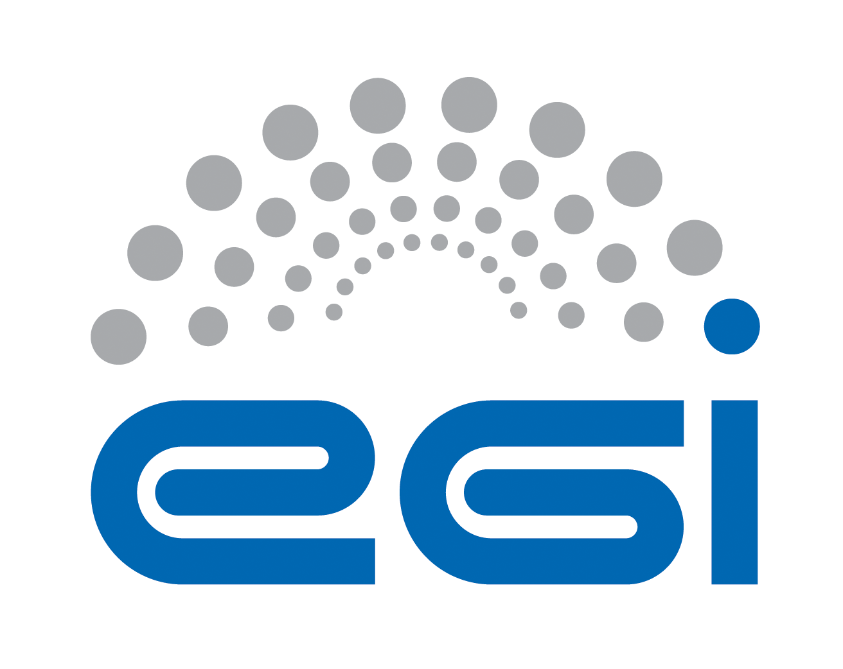

<add partner’s logo>

Memorandum of Understanding

between

EGI Foundation

and

[partner]

This Memorandum of Understanding (“MoU”) is made between:

EGI Foundation, a not-for-profit foundation established under the Dutch law to coordinate the EGI federation (abbreviated as “EGI”)

and

[partner].

EGI and [partner] shall hereinafter be referred to individually as a “Party” and collectively as the “Parties.”

This MoU is composed of the following Articles and Annexes.
Annexes have the same validity as this MoU and together constitute the entire understanding and rights and obligations covering the cooperation accepted by the Parties under this MoU. Annexes may be amended following the provisions of Article 7. Amendments

Article 1. Parties 4
1.1 EGI Foundation 4
1.2 [Partner] 5
Article 2. Purpose and Scope 6
Article 3. Communications and Contact Information 6
EGI Foundation contact 6
[Partner contact] 7
Article 4. Rights and Responsibilities 7
4.1 General 7
4.2 Personnel 7
4.3 Intellectual property rights and licence PROPERTY RIGHTS AND LICENCE 8
4.4 Ownership of results 8
4.5 Public relations 8
4.6 Confidentiality of information 8
4.7 Liability 9
4.8 Participation in similar activities 9
Article 5. Funding 9
Article 6. Entry into Force, Duration and Termination 10
Article 7. Amendments 10
Article 8. Miscellanea 10
Article 9. Language 10
Article 14. Governing Law and Dispute Resolution 10
EGI Foundation 12
[Partner] 12
Annex 1. Joint Work plan 13
Joint Activity 1. [Title] 13
Joint Activity 2. [Title] 13
Joint Activity 3. [Title] 13

Article 1. Parties

1.1 EGI Foundation
EGI the scientific computing infrastructure that delivers open solutions for advanced computing and data analytics in research and innovation to support all researchers to have seamless access to services, resources and expertise to collaborate and conduct world-class research and innovation.
The EGI Federation is an international infrastructure that provides advanced computing and data analytics services for research and innovation. The federation is composed of providers from national/community initiatives forming one of the largest distributed computing infrastructures for researchers. EGI delivers technical and support services at European and global scale including high-throughput and cloud computing, storage and data management, analytics, consultancy and support, training and co-development.
The EGI Foundation is a not-for-profit foundation established under the Dutch law to coordinate the EGI federation (abbreviated as “EGI”), an international collaboration that federates the digital capabilities, resources and expertise of national and international research communities in Europe and worldwide. The main goal is to empower researchers from all disciplines to collaborate and to carry out data- and compute-intensive science and innovation.
The EGI Foundation has participants and associated participants drawn from representatives of national e-infrastructure consortiums (NGIs), EIROs, ERICs, and other legal entities. These entities provide the physical resources, shared services and innovative technical solutions that enable the EGI Federation to deliver, improve and innovate services for communities. The EGI Foundation coordinates areas such as overseeing infrastructure operations, user community support, contact with technology providers, strategy and policy development, flagship events and dissemination of news and achievements.
Further information can be found at: www.egi.eu/about/

1.2 [Partner]
[description]

Article 2. Purpose and Scope
The purpose of this Memorandum of Understanding (MoU) is to [define overall purpose].
Specific objectives include:
- [Objective 1]
- [Objective 2]
- [Objective 3]
- …

A detailed collaboration plan (the “Joint Work Plan”) is defined in Annex 1. Joint Work plan.

Article 3. Communications and Contact Information
The Parties shall keep each other informed on all their respective activities and on their progress and shall consult regularly on areas offering potential cooperation. Joint working groups may be established to examine in detail proposals in areas assigned to them by the Parties referred to in the joint Work Plan, and to make recommendations to the Parties.
The Parties acknowledge their obligations taken by this MoU and by the Joint Activity Plan to disseminate their results, and the task to support and promote the coherent and coordinated dissemination of information on activities such as joint events and workshops.
The Parties shall support efforts by providing relevant inputs and ensuring attendance at events as required by the Joint Activity Plan.
No Party is allowed to publish or allow the publishing of the other Party’s results unless the owner Party agrees to the publication.
Each Party shall designate a “point of contact” that shall be responsible for monitoring the implementation of this MoU and for taking measures to assist in the further development of cooperative activities. Such points of contact shall be the ordinary channel for the Parties' communication of proposals for cooperation.
Any approvals, notices, and other communications between the Parties under this MoU shall be sent to the applicable Party as follows

EGI Foundation contact
Name and family name:
Role:
Address: | Science Park 140
 | ZIP Code: | 46023 | City: | Amsterdam
 | Country: | The Netherlands
E-mail
Tel:

[Partner contact]
Name and family name:
Role:
Address:
 | ZIP Code: |  | City:
 | Country:
E-mail
Tel:

Questions of principles or problems that cannot be solved at primary contact level are escalated to the director of two parties or the highest role applicable.

Article 4. Rights and Responsibilities

4.1 General
Each Party agrees to adhere to applicable policies and procedures relating to the use of the production infrastructure.
A Party which makes material, equipment or components available to the other Party, for the purposes of activities under this MoU, shall remain the proprietor of such material, equipment or components.
Each Party shall remain fully responsible for its own activities, including the fulfilment of its obligations.

4.2 Personnel
Each Party shall be solely responsible for any personnel hired to carry out work under this MoU.
In case personnel employed by one Party temporarily carry out work under this MoU on the premises of another (hereafter referred to as “secondment”), the following provisions shall apply:
The personnel seconded shall be subject to all regulations, including, in particular, safety regulations, applicable on the site of the Party they are seconded to.
The personnel seconded by a Party to another shall remain employees of the Party having seconded them and such Party, as employer, shall bear exclusive responsibility for the payment of salary and for the procurement of adequate social security and insurance, including third-party liability insurance and health insurance.
Unless otherwise agreed by the Parties concerned, Intellectual Property Rights generated by personnel seconded by a Party to another shall be owned by the Party having seconded such personnel.

4.3 Intellectual property rights and licence PROPERTY RIGHTS AND LICENCE
“Intellectual Property Rights” shall mean all intellectual creations including but not limited to inventions, know-how, layouts, drawings, designs, specifications, computer programs, reports, processes, protocols, calculations and any other matter and protected by intellectual property rights, whether registered or not, including patents, registered designs, copyrights, design rights and all similar proprietary rights and applications for protection thereof.
Intellectual property rights generated by a Party under this MoU shall be the property of that Party who shall be free to protect, transfer and use such Intellectual Property Rights as it deems fit.
Notwithstanding the foregoing, each Party shall grant the other a non-exclusive royalty-free licence to use the Intellectual Property Rights generated by the Party under this MoU for the implementation of the Joint Work Plan. Such licence shall include the right to sublicense the entities involved in the Joint Activity Plan.

4.4 Ownership of results
Results are owned by the Party that generates them.
The Parties give each other – under fair and reasonable conditions – access to results of this MoU needed for exploiting their own results.
Results that were jointly generated by both Parties will be jointly owned by the Parties, hereinafter referred to as (“Jointly Owned Results”) and each of the Parties shall be free to use these Jointly Owned Results for non-commercial research activities on a royalty-free basis, and without requiring the prior consent of the other joint owner(s).
Each of the joint owners shall be entitled to otherwise commercially exploit the Jointly Owned Results and to grant non-exclusive licences to third parties (without any right to sub-license), if the other joint owners are given: (a) at least 45 calendar days advance notice; and (b) Fair and Reasonable compensation. Each Party shall be entitled to disclose such Jointly Owned Results without restrictions unless such Jointly Owned Results are confidential information or contain a Joint Invention in which case no disclosure must be made prior to the filing of a priority application.
With respect to any Joint Invention resulting from this MoU (i.e. any invention jointly made by employees of both Parties), the features of which cannot be separately applied for as Intellectual Property Rights and which are eligible for statutory protection requiring an application or registration (herein referred to as “Joint Invention”), the Parties shall agree on which Party will carry out any filing as well as any further details with regard to persecuting and maintaining relevant patent applications.

4.5 Public relations
Any publication by a Party resulting from the activities carried out under this MoU shall be subject to prior agreement of the other Party which should not be unreasonably withheld.
The Parties may each release information to the public, provided it is not confidential and related only to its own part of the activities under this MoU. In cases where the activities of the other Party are concerned, prior consultation shall be sought. In all relevant public relations activities, the contribution of each Party related to activities covered by this MoU shall be duly acknowledged.

4.6 Confidentiality of information
The Parties may disclose to each other information that the disclosing Party deems confidential, and which is:
- in writing and marked “confidential”, or
- disclosed orally, and identified as confidential when disclosed, and reduced in writing and marked “confidential” within fifteen (15) days of the oral disclosure (hereafter referred to as “Confidential Information”). Confidential Information shall be held in confidence and shall not be disclosed by the receiving Party to any third party without the prior written consent of the disclosing Party.
Notwithstanding the foregoing, a Party is entitled to disclose Confidential Information which it is required by law to disclose or which, in a lawful manner, it has obtained from a third party without any obligation of confidentiality, or which it has developed independently from any Confidential Information received under this MoU, or which has become public knowledge other than as a result of a breach on its part of these confidentiality provisions.

4.7 Liability
Each Party shall use reasonable endeavours to ensure the accuracy of any information or materials it supplies to the other Party and of any other contribution it makes hereunder and promptly to correct any error therein of which it is notified. The supplying Party shall be under no obligation or liability other than as stated above and no warranty or representation of any kind is made, given or to be implied as to the sufficiency, accuracy or fitness for a particular purpose of such information, materials or other contribution or as to the absence of any infringement of any proprietary rights of third parties through the possession or use of such information, materials or other contribution. The recipient Party shall be entirely responsible for its use of such information, materials or other contribution and shall hold the other Party free and harmless and indemnify it for any loss or damage with regard thereto.
Except in case of gross negligence or wilful misconduct, neither Party shall be liable for any indirect or consequential damages of the other Party, including loss of profit or interest, under any legal cause whatsoever and on account of whatsoever reason.

4.8 Participation in similar activities
Parties are not prevented by this MoU from participating in activities similar to those described in this document with third parties. There is no obligation to disclose any similar activity to the other Party. However, when considered of mutual benefit, both Parties are encouraged to involve the other Party in similar activities to the goal of disseminating the knowledge about both Parties.

Article 5. Funding
Each Party shall bear the costs of discharging its respective responsibilities under this MoU, including travel and subsistence of its own personnel and transportation of goods and equipment and associated documentation, unless otherwise agreed in this MoU or by the parties on a case-by-case basis.
Each Party shall make available free of charge to the other Party any office space or meeting facility needed for the joint activities.
The Parties’ obligations hereunder are subject to their respective funding procedures and the availability of appropriate funds. Should either Party encounter budgetary problems in the course of its respective internal procedures that may affect the activities carried out under this MoU, the Party shall notify and consult with the other Party in a timely manner in order to minimise the negative impact of such problems on the cooperation. The Parties shall jointly look for mutually agreeable solutions.
In order to reduce the impact on travel costs, face-to-face meetings should be co-located with other events that participants are likely to attend. Meeting via teleconferences should be considered when the nature of the discussion does not strictly require a face-to-face presence.

Article 6. Entry into Force, Duration and Termination
This MoU will enter into force when signed by the authorised representatives of the Parties.
Either Party may terminate this MoU for any reason upon 30 days written notice to the other Party.
In the event of termination, the Parties shall endeavour to reach agreement on terms and conditions to minimise negative impacts on the other Party. In the event of the continuation of the present cooperation, the MoU may be extended and/or amended by mutual agreement in writing.

Article 7. Amendments
The MoU may be amended only by written agreement of the Parties. Amendments shall be valid only if signed by the authorised representatives of the Parties.

Article 8. Miscellanea
Notwithstanding anything in this MoU to the contrary, neither Party shall have any legally binding obligation to the other Party as a result of the execution of this MoU, or otherwise relating to this MoU or the subject matter hereof. Although the Parties will try to reach one or more future agreements as to the matters described herein, this MoU shall not require the Parties to reach any future agreement, and, notwithstanding anything in this MoU to the contrary, neither Party shall have any liability to the other Party as a result of the Parties’ failure to reach one or more future agreements.
Neither Party shall reassign this MoU or any of its responsibilities without the other Party’s prior written consent.
The failure of either Party to enforce any term hereof shall not be deemed a waiver of any rights contained herein.
If any provision of this MoU is determined to be invalid or unenforceable under any controlling law, the invalidity or unenforceability of that provision shall not affect the validity or enforceability of the remaining provisions of this MoU.

Article 9. Language
The language for this MoU, its interpretation and all cooperative activities foreseen for its implementation, is English.

Article 14. Governing Law and Dispute Resolution
The terms of this MoU shall be interpreted in accordance with their true meaning and effect independently of national and local law. Provided that if and insofar as this MoU does not stipulate, or any of its terms are ambiguous or unclear reference shall be made to the substantive laws of Belgium. Disputes shall be resolved by amicable settlement or failing which by arbitration in accordance with the procedure described in this article.
1. All disputes or differences arising in connection with this MoU which cannot be settled amicably shall be finally settled by arbitration in accordance with the procedure specified below which shall be adapted in the light of the number of Parties involved.
2. Within thirty (30) calendar days of written notification by a Party to the other Party of its intention to resort to arbitration, the first Party shall appoint an arbitrator. The second Party shall appoint an arbitrator within three (3) months of the appointment of the first arbitrator. The two arbitrators shall, by joint agreement and within ninety (90) calendar days of the appointment of the second arbitrator, appoint a third arbitrator, who shall be the Chairman of the Arbitration Committee.
3. If the second Party fails to appoint an arbitrator or the two arbitrators fail to agree on the selection of a third arbitrator, the second or, as the case may be, the third arbitrator, shall be appointed by the President of the Court of Justice of the European Communities.
4. Unless otherwise agreed by the Parties concerned within thirty (30) calendar days of the provision of notice referred to in Article 12 above, the arbitration proceedings shall take place in Brussels and shall be conducted in English. The Parties shall within one month of the appointment of the third arbitrator agree on the terms of reference of the Arbitration Committee, including the procedure to be followed.
5. The Arbitration Committee shall faithfully apply the terms of this MoU. The Arbitration Committee shall set out in the award the detailed grounds for its decision.
6. The award shall be final and binding upon the Parties, who hereby expressly agree to renounce any form of appeal or revision.
7. The costs including all reasonable fees expended by the Parties to any arbitration hereunder shall be apportioned by the Arbitration Committee between these Parties.

IN WITNESS WHEREOF, the Parties have caused their duly authorised representatives to sign two originals of this Memorandum of Understanding.

The following agree to the terms and conditions of this MoU:

EGI Foundation
Tiziana Ferrari
Director
Science Park 140
1098 XG Amsterdam
The Netherlands

Date: Signature:

[Partner]
[Name and family name]
[Role]
[Address]

Date: Signature:

Annex 1. Joint Work plan
To support the collaboration objectives defined in Article 2. Purpose and Scope, a joint work plan is defined and will be regularly reviewed and updated at least annually.
The cooperation is focused, but not limited to the following areas:
- [Area 1]
- [Area 2]
- [Area 3]
- …
In this broad context, the specific goals of the collaborations are as follows.

Joint Activity 1. [Title]
[description]
Expected Results:
Task duration: [specify]

Joint Activity 2. [Title]
[description]
Expected Results:

Task duration: [specify]

Joint Activity 3. [Title]
[description]
Expected Results:
Task duration: [specify]

[Add additional activities as necessary]

