EGI-Engage

gWRF Web Portal User's Guide

Date | 14 April 2016
Activity | WP6
Lead Partner | Academia Sinica
Document Status | DRAFT
Document Link | https://documents.egi.eu/document/2784

Abstract
This user guide describes the user interfaces of gWRF Web Portal. The web portal of gWRF (grid-based WRF), developed by Academia Sinica Grid Computing Centre (ASGC), utilizes the global grid computing resources for the weather simulation by the Weather Research and Forecasting (WRF) model. The gWRF web portal supports high performance simulation and significantly reduces the barrier of numeric weather analysis.

COPYRIGHT NOTICE
This work by Parties of the EGI-Engage Consortium is licensed under a Creative Commons Attribution 4.0 International License (http://creativecommons.org/licenses/by/4.0/). The EGI-Engage project is co-funded by the European Union Horizon 2020 programme under grant number 654142.
DOCUMENT LOG
Issue | Date | Comment | Author/Partner
v.1 | 14/04/16 | Document creation | E. Yen/ AS

TERMINOLOGY
A complete project glossary is provided at the following page: http://www.egi.eu/about/glossary/

Contents
1 Introduction 4
2 Main Page 5
3 Simulation Workflow 6
4 Result Visualization 10

Introduction
Weather Research and Forecasting (WRF) model is a state-of-the-art regional modeling tool developed at the National Center of Atmospheric Research (NCAR) of US. It is designed to serve both operational forecasting and atmospheric research needs and it has a rapidly growing community of users all around the world.
The gWRF web portal supports high performance simulation and significantly reduces the barrier of numeric weather analysis. The web portal of gWRF (grid-based WRF) utilizes the global grid computing resources for the weather simulation by the Weather Research and Forecasting (WRF) model. To improve the WRF overall efficiency, gWRF allows the most computing intensive WRF model to run on the Grids whereas users handle WPS and post-processing which do not require intensive CPU resources on a shared front-end or on their local machines. DMCC designed a package of scripts and made WRF MPI version running on EGI-based Grid infrastructure.

User only needs the web browser to access to the gWRF web portal services. The following browsers are supported:
- Chrome 3+
- Firefox 3.5+
- Opera 12+
- Safari 4+
- Internet Explorer 8+

Main Page
From the main page, user could login to the gWRF services with his/her personal certificate with EUAsia VO membership. Background and contact information of gWRF web portal services could be also found at the gWRF web homepage in Figure 1.
Figure 1 gWRF Web Portal Homepage

Simulation Workflow
Running WRF simulation involves execution of several pre-processing steps for the input data, initial conditions and boundary conditions at first. The second step is running the WRF core which is computing intensive to generate simulation results of every certain number of time steps and output several result files. The last step is to hide the complexity of both Grid and WRF, gWRF provides the Web Portal Services to integrate numerical weather pre-diction tools and the e-Infrastructure. The general workflow running WRF is shown in Figure 2.
Figure 2Workflow of running WRF

For the pre-processing, user could run DomainWizard at his/her own computer or using the DMCC front-end server with the terrestrial data and Gridded data as Figure 3. WRF Prepro-cessing System (WPS) is used to define simulation domain area and nests, produce static fields such as terrain, land use, soil type on the simulation domain, and interpolate meteoro-logical data (such as wind speed, pressure, temperature, etc.) to WRF model grid.

Figure 3WRF Preprocessing System by DomainWizard
Then, running core WRF processes involves two steps. First steps are to create initial condition and boundary condition files according to model levels defined. The second step is to integrate models. In gWRF web portal, user could choose Simulation from the Menu bar to create a new simulation job as Figure 4.

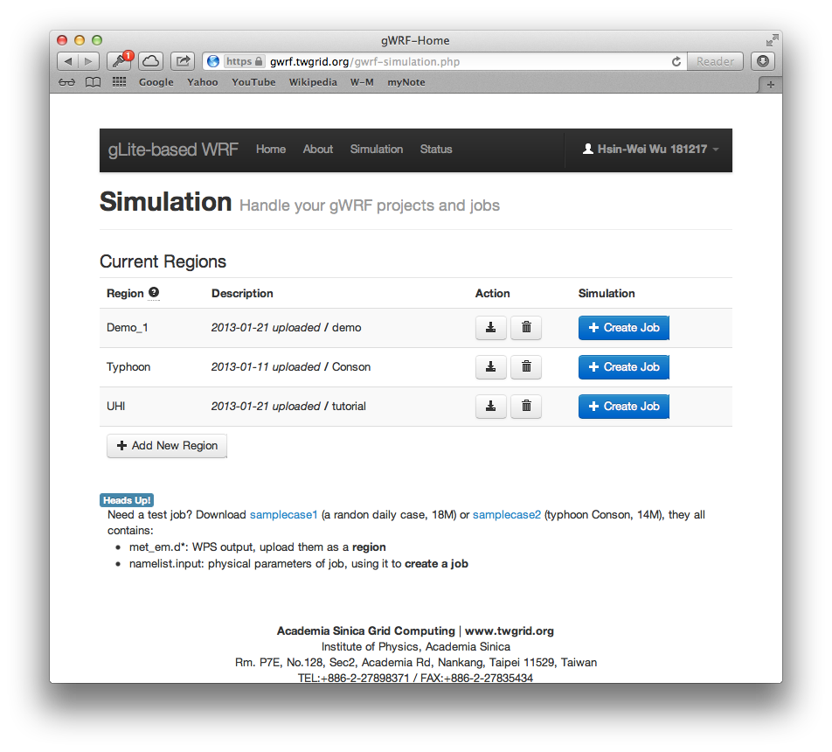
Figure 4 Running WRF simulation by gWRF
gWRF provides two samples for user’s reference in job submission. One is random selection of daily data; the other one is the typhoon Conson which hit Taiwan in 2010. Results from the preprocessing stage should be uploaded as a region. Once all required data are ready, user could create a job to submit it to the Grid/Cloud. From gWRF web portal, when choose ‘Status’ from the top menu, user could check his job status and get output as Figure 5.

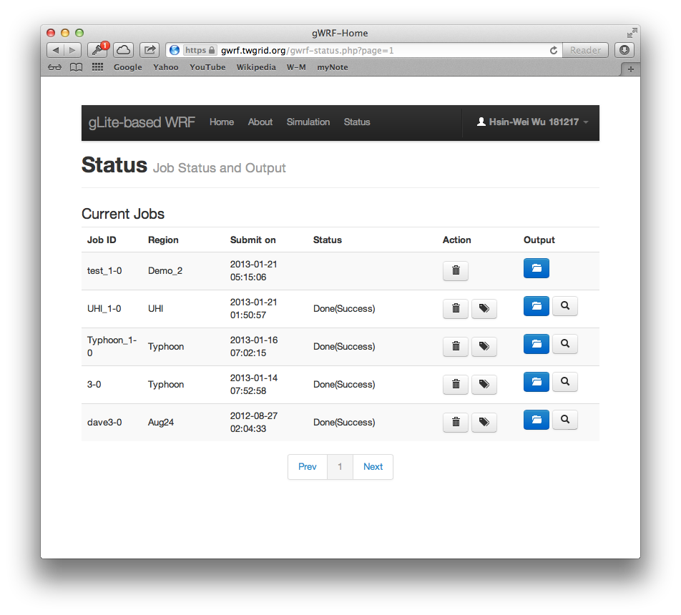
Figure 5Job status and output checking

Result Visualization
Simulation results include the pressure and precipitation (Figure 6), temperature and wind map (Figure 7), could be accessed from the Status page once the job is done. WRF output data files are generally in NetCDF format. To visualise the final output, usually the output data will be converted into GrADS format by ARWpost and then visualize by GrADS.
Figure 6 Result Visualization of Pressure and Precipitation by GrADS on a specific time slice of series results

Figure 7 Result Visualization of Temperature and Wind Map by GrADS on a specific time slice of series results

