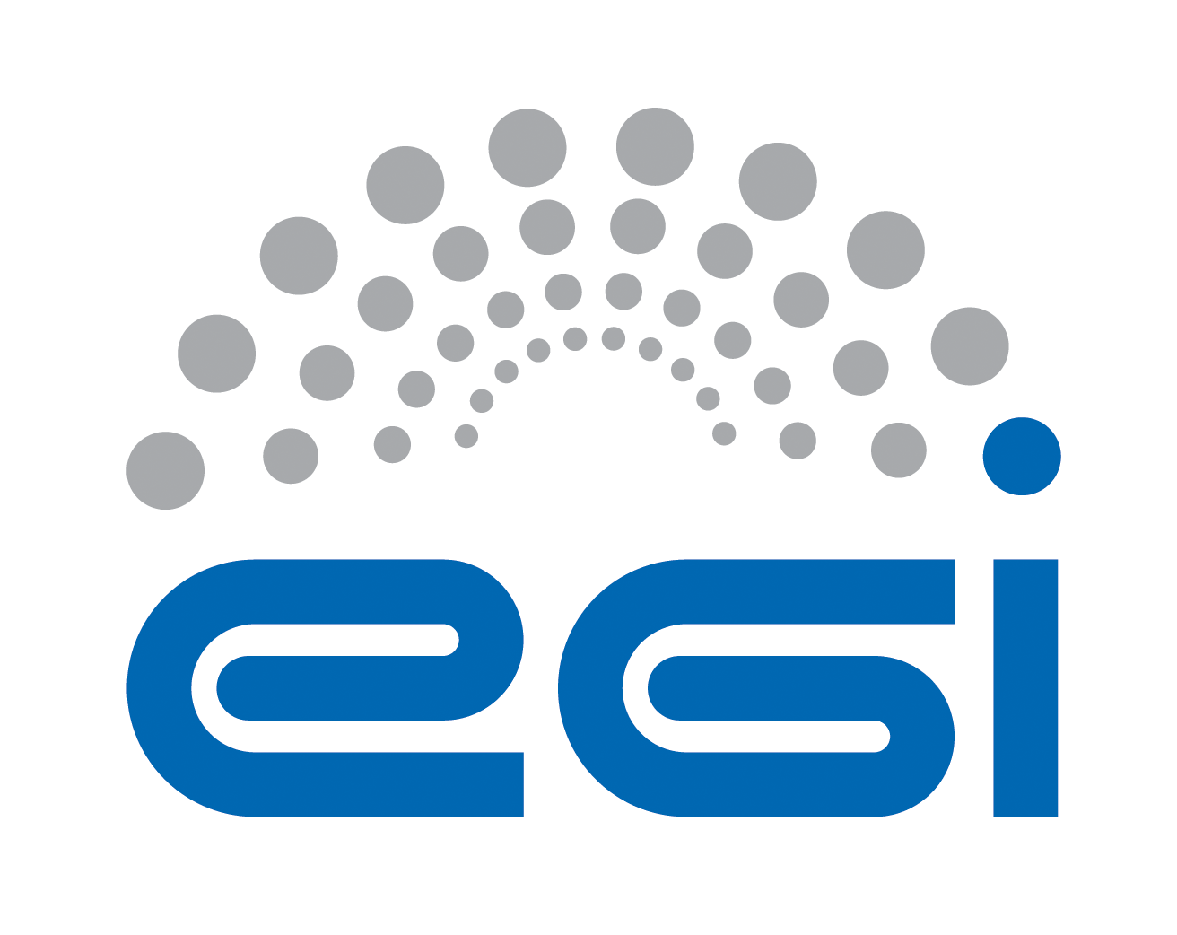
Partner Logo

Memorandum of Understanding between
[EGI Foundation|EGI Project Name] and [Partner|Project Name]

Instructions (to be removed)
This is a modular and unified template to establish an MoU between EGI Foundation and another organisation or between two projects.
- Define if the MoU should be established with the EGI Foundation or with a project led by the EGI Foundation
- Define who is the legal partner name and acronym
- Define the type of MoU
  - Infrastructure Provider [MOU:INFRA]
  - Technology Provider [MOU:TP]
  - Virtual Research Community [MOU:VRC]
  - Project [MOU:PRJ]
  - Other (e.g. organisation)
- Add the partner logo in the front page
- Using the function “replace”
  - Replace ‘[EGI Foundation|EGI Project Name] ’ with the selected partner name
  - Replace ‘[Partner|Project Name]’ with the partner name
  - Replace ‘[PartnerAcronym]’ with the partner acronym
- Once final, remove yellow
TABLE OF CONTENTS
Background 3
Article 1: PURPOSE 4
Article 2: Definitions 4
Article 3: Joint Work plan 4
Article 4: Communication 5
ARTICLE 5: RIGHTS AND RESPONSIBILITIES 6
Article 6: Funding 6
Article 7: Entry into Force, Duration and Termination 7
Article 8: Amendments 7
Article 9: Annexes 7
Article 10: Language 7
Article 11: Governing Law – Dispute resolution 7
Annex 1 – [EGI Foundation|EGI Project Name] Description 9
Annex 2 – [Partner|Project Name] Description 11

Background
(If with EGI Foundation)
The Stichting EGI (known as the EGI Foundation and abbreviated here as “EGI.eu”) is a not-for-profit foundation established under the Dutch law to coordinate the EGI federation (abbreviated as “EGI”), an international collaboration that federates the digital capabilities, resources and expertise of national and international research communities in Europe and worldwide. The main goal is to empower researchers from all disciplines to collaborate and to carry out data- and compute-intensive science and innovation. The EGI Foundation has participants and associated participants drawn from representatives of national e-infrastructure consortiums (NGIs), EIROs, ERICs, and other legal entities. These entities provide the physical resources and shared services that enable EGI to deliver, improve and innovate services for communities. A more detailed description of EGI.eu is attached as Annex 1.

(If with EGI-Engage)
The EGI-Engage project (Engaging the Research Community towards an Open Science Commons) started in March 2015, co-funded by the European Commission for 30 months, as a collaborative effort involving more than 70 institutions in over 30 countries. EGI-Engage aims to accelerate the implementation of the Open Science Commons by expanding the capabilities of a European backbone of federated services for compute, storage, data, communication, knowledge and expertise, complementing community-specific capabilities. A more detailed description of EGI-Engage is attached as Annex 1.

The [Partner|Project Name] (hereafter referred to as [PartnerAcronym]) aims to (insert a short description about the partner). A summary of [Partner|Project Name] is attached as Annex 2.

(If with EGI-Engage)
Institutions common to both parties are:…

[MOU:INFRA]
[Partner|Project Name] received a mandate from <specify> to represent the following Institutions, who wish to participate in the framework of collaboration defined in this document, and delegate it to represent them in EGI.eu policy groups:
- <list of institutions>
Annex 2 contains the list of the participating Resource Centres that the listed Institutions are responsible for.

Article 1: PURPOSE
The purpose of this Memorandum of Understanding (MoU) is to define a framework of collaboration between [EGI Foundation|EGI Project Name] and [Partner|Project Name] (hereafter also referred to as “the Party” or the “Parties”) for delivering the activities outlined within the Joint Work Plan (Article 3). The Parties recognise, by this MoU, the opening of a wider and longer-term cooperation in activities, which will bring visible benefits to everyone involved.

Article 2: Definitions
For the purpose of this MoU, the following definitions are relevant:
- The terms defined in the EGI glossary (http://go.egi.eu/glossary)
- Add definitions relevant for this MoU not present in the EGI Glossary

Article 3: Joint Work plan
The parties contribute to enable the vision of providing European scientists and international collaboration for sustainable distributed computing services to support their work. In this broad context, the specific goals of the collaborations are to:
(these are just some suggestions for type of content)
Some examples for Technology Providers:
- Provide robust, well-designed, user-centric services to scientific user communities
- Define and monitor SLA for third-level support on incidents and requests
- Accelerate the development of standards within production grid infrastructures
- Disseminate the results of this collaboration within the remit of each project’s dissemination and communication activities such as joint events
- Exchange ideas and collaborate on the definition of sustainability models
- Collaborate in business relationships development
Some examples for Infrastructure Providers:
- Enhance the capacities of both infrastructures
- Provide Local and Global operational services as needed to support the international user community and the EGI operational needs
- Subscribe to a mandatory set of policies, procedures and OLAs
- Comply with the operations interfaces required by the EGI Operations Architecture, which are needed to ensure seamless and interoperable access to resources
- Participate in the Operations Management Board to contribute to the EGI operations agenda
- Participate in the Security Policy Team to contribute to the development of the security policies fabric of the infrastructure
Some examples for Projects and VRCs:
- Dissemination
- Training
- Support Tools and Services
- Sustainability
- Standards and Interoperability
- Integration
- VRC Coordination
The specific activities to be carried out in the framework of the collaboration are:

WP1 Activity Name
Parties Involved: [EGI Foundation|EGI Project Name] Activity (name); Partner (name, organisation)
Description of work:
Expected outcome:
- A1.1 (MM/YYYY) - description (Leader Name Surname)
- A1.2 (MM/YYYY) - description (Leader Name Surname)
- A1.3 (MM/YYYY) - description (Leader Name Surname)
WP2 Activity Name
Parties Involved: [EGI Foundation|EGI Project Name] Activity (name); Partner (name, organisation)
Description of work:
Expected outcome:
- A2.1 (MM/YYYY) - description (Leader Name Surname)
- A2.2 (MM/YYYY) - description (Leader Name Surname)

Article 4: Communication
The Parties shall keep each other informed on all their respective activities and on their progress and shall consult regularly on areas offering potential for cooperation.

[MOU:TP]
[Partner|Project Name] agrees to name a technical representative (with deputy) for the EGI.eu Technical Board (TCB).
[Partner|Project Name] agrees to name a technical representative (with deputy) for the EGI.eu Security Coordination Group (SCG).
[Partner|Project Name] agrees to regularly attend the meetings of EGI.eu TCB and SCG as observer.
[Partner|Project Name] will become a voting member in both groups after signing the SLA.

[MOU:VRC]
[Partner|Project Name] agrees to name a technical representative (with deputy) for the EGI.eu User Community Board (UCB). Further information about the EGI UCB can be found in the UCB Terms of Reference (https://documents.egi.eu/document/120).
[Partner|Project Name] may be asked to nominate representatives to serve on other advisory groups as appropriate.
[Partner|Project Name] will accept and comply with EGI.eu’s policies and procedures that apply to the users of EGI (http://go.egi.eu/policies_and_procedures).

[MOU:INFRA]
[Partner|Project Name] agrees to name a technical representative (with deputy) for the EGI Operations Management Board (OMB).
[Partner|Project Name] may be asked to nominate representatives to serve on other policy groups as appropriate.

[MOU:PRJ]
No participation from collaborating EC projects are expected or provided the option of attending EGI Policy Groups. (so just do not include – this is for information purposes only)

Joint working groups may be established to examine in detail proposals in areas assigned to them by the Parties referred to in Article 3 (Joint Work Plan) and to make recommendations to the Parties.

Each Party shall designate a “point of contact” that shall be responsible for monitoring the implementation of this MoU and for taking measures to assist in the further development of cooperative activities. Such points of contact shall be the ordinary channel for the Parties' communication of proposals for cooperation.

The primary point of contact for each Party is:
EGI.eu: <Name> <email>
[Partner|Project Name]: <Name> <email>

Questions of principle or problems that cannot be solved at primary contact level are escalated to the EGI Foundation Director or EGI Project Director and the Partner Head or Highest Role applicable.

ARTICLE 5: RIGHTS AND RESPONSIBILITIES
The procedure is set out in Annex 3.

Article 6: Funding
Each Party shall bear the costs of discharging its respective responsibilities under this MoU, including travel and subsistence of its own personnel and transportation of goods and equipment and associated documentation, unless otherwise agreed in this MoU.
Each Party shall make available free of charge to the other Party any office/meeting space needed for the joint activities.
The Parties’ obligations hereunder are subject to their respective funding procedures and the availability of appropriate funds. Should either Party encounter budgetary problems in the course of its respective internal procedures that may affect the activities carried out under this MoU, the Party shall notify and consult with the other Party in a timely manner in order to minimise the negative impact of such problems on the cooperation. The Parties shall jointly look for mutually agreeable solutions.
In order to reduce the impact on travel costs, face-to-face meetings should be co-located with other events that participants are likely to attend. Meeting via teleconferences should be considered when the nature of the discussion does not strictly require a face-to-face presence.

Article 7: Entry into Force, Duration and Termination
This MoU will enter into force when signed by the authorised representatives of the Parties and shall remain in force until completion of the activities identified in Article 2: Joint Work Plan, or upon termination of the projects in which the Parties participate, or upon three (3) months’ prior written notice by one Party to the other. In the event of termination, the Parties shall endeavour to reach agreement on terms and conditions to minimise negative impacts on the other Party. In the event of the continuation of the present cooperation, the Agreement may be extended and/or amended by mutual agreement in writing.

Article 8: Amendments
The MoU may be amended by written agreement of the Parties. Amendments shall be valid only if signed by the authorised representatives of the Parties.

Article 9: Annexes
Annexes 1, 2, 3, 4 attached hereto, have the same validity as this MoU and together constitute the entire understanding and rights and obligations covering the cooperation accepted by the Parties under this MoU. Annexes may be amended following the provisions of Article 8: Amendments.

Article 10: Language
The language for this MoU, its interpretation and all cooperative activities foreseen for its implementation, is English.

Article 11: Governing Law – Dispute resolution
The terms of this MoU shall be interpreted in accordance with their true meaning and effect independently of national and local law. Provided that if and insofar as this MoU does not stipulate, or any of its terms are ambiguous or unclear, reference shall be made to the substantive laws of Belgium. Disputes shall be resolved by amicable settlement or failing which by mediation in accordance with the procedure set out in Annex 4.

Memorandum of Understanding between [EGI Foundation|EGI Project Name] and [Partner|Project Name]

IN WITNESS WHEREOF, the Parties have caused their duly authorised representatives to sign two originals of this Memorandum of Understanding, in the English language.

The following agree to the terms and conditions of this MoU:

Yannick Legré  EGI Foundation Director  or EGI Project Director  Date | <Name>  Partner <equivalent function>  Date

Annex 1 – [EGI Foundation|EGI Project Name] Description
(If with EGI.eu)
The Stichting EGI (aka the EGI Foundation and abbreviated as EGI.eu) is a not-for-profit foundation established under the Dutch law to coordinate the EGI federation (abbreviated as EGI), an international collaboration that federates the digital capabilities, resources and expertise of national and international research communities in Europe and worldwide. The main goal is to empower researchers from all disciplines to collaborate and to carry out data- and compute-intensive science and innovation.
The EGI Foundation has participants and associated participants drawn from representatives of national e-infrastructure consortiums (NGIs), EIROs, ERICs, and other legal entities. These entities provide the physical resources and shared services that enable EGI to deliver, improve and innovate services for communities. The EGI Foundation coordinates areas such as overseeing infrastructure operations, user community support, contact with technology providers, strategy and policy development, flagship events and dissemination of news and achievements.
EGI brings together hundreds of data centres worldwide and also includes the largest community cloud federation in Europe with tens of cloud providers across several European countries offering IaaS cloud and storage services. EGI offering includes a federated IaaS cloud to run compute- or data-intensive tasks and host online services in virtual machines or docker containers on IT resources accessible via a uniform interface; high-throughput data analysis to run compute-intensive tasks for producing and analysing large datasets and store/retrieve research data efficiently across multiple service providers; federated operations to manage service access and operations from heterogeneous distributed infrastructures and integrate resources from multiple independent providers with technologies, processes and expertise offered by EGI; consultancy for user-driven innovation to assess research computing needs and provide tailored solutions for advanced computing.
Over the last decade, EGI has built a federation of long-term distributed compute and storage infrastructures that has delivered unprecedented data analysis capabilities to tens of thousands of researchers from many disciplines (e.g., Medical and Health Sciences, Natural Sciences, Engineering and Technology, Agricultural Sciences, and Art and Humanities). Examples of the supported research include the search for the Higgs boson at the Large Hadron Collider particle accelerator at CERN; finding new tools to diagnose and monitor diseases such as Alzheimer’s, or the development of complex simulations to model climate change.
Further information (e.g. governance; services) can be found at: www.egi.eu/about/

(If with EGI-Engage)
EGI-Engage aims to accelerate the implementation of the Open Science Commons by expanding the capabilities of a European backbone of federated services for compute, storage, data, communication, knowledge and expertise, complementing community-specific capabilities.
Project objectives
- Objective 1: Ensure the continued coordination of the EGI Community in strategy and policy development, engagement, technical user support and operations of the federated infrastructure in Europe and worldwide.
- Objective 2: Evolve the EGI Solutions, related business models and access policies for different target groups aiming at an increased sustainability of these outside of project funding. The solutions will be offered to large and medium size RIs, small research communities, the long-tail of science, education, industry and SMEs.
- Objective 3: Offer and expand an e-Infrastructure Commons solution
- Objective 4: Prototype an open data platform and contribute to the implementation of the European Big Data Value.
- Objective 5: Promote the adoption of the current EGI services and extend them with new capabilities through user co-development

The mission of EGI-Engage is to accelerate the implementation of the Open Science Commons vision, where researchers from all disciplines have easy and open access to the innovative digital services, data, knowledge and expertise they need for their work.

The Open Science Commons is grounded on three pillars:
- the e-Infrastructure Commons, an ecosystem of key services;
- the Open Data Commons, where any researcher can access, use and reuse data;
- and the Knowledge Commons, in which communities have shared ownership of knowledge and participate in the co-development of software and are technically supported to exploit state-of-the-art digital services.

EGI-Engage will expand the capabilities offered to scientists (e.g. improved cloud or data services) and the spectrum of its user base by engaging with large Research Infrastructures (RIs), the long-tail of science and industry/SMEs. The main engagement instrument will be a network of eight Competence Centres, where National Grid Initiatives (NGIs), user communities, technology and service providers will join forces to collect requirements, integrate community-specific applications into state-of-the-art services, foster interoperability across e-Infrastructures, and evolve services through a user-centric development model. The project will also coordinate the NGI efforts to support the long-tail of science by developing ad hoc access policies and by providing services and resources that will lower barriers and learning curves.

Annex 2 – [Partner|Project Name] Description

Annex 3 – Rights and Responsibilities
- GENERAL
1. Each party agrees to adhere to applicable policies and procedures relating to the use of the production infrastructure.
2. A Party which makes material, equipment or components available to the other Party, for the purposes of activities under this MoU, shall remain the proprietor of such material, equipment or components.
3. Each Party shall remain fully responsible for its own activities, including the fulfilment of its obligations under any grant agreement with the European Commission or under any consortium agreement related thereto.
- PERSONNEL
1. Each Party shall be solely responsible for any personnel hired to carry out work under this MoU.
2. In case personnel employed by one Party temporarily carry out work under this MoU on the premises of another (hereafter referred to as “secondment”), the following provisions shall apply:
(a) The personnel seconded shall be subject to all regulations, including, in particular, safety regulations, applicable on the site of the Party they are seconded to.
(b) The personnel seconded by a Party to another shall remain employees of the Party having seconded them and such Party, as employer, shall bear exclusive responsibility for the payment of salary and for the procurement of adequate social security and insurance, including third-party liability insurance and health insurance.
(c) Unless otherwise agreed by the Parties concerned, Intellectual Property Rights generated by personnel seconded by a Party to another shall be owned by the Party having seconded such personnel.
- INTELLECTUAL PROPERTY RIGHTS AND LICENCE
1. “Intellectual Property Rights” shall mean all intellectual creations including but not limited to inventions, know-how, layouts, drawings, designs, specifications, computer programs, reports, processes, protocols, calculations and any other matter and protected by intellectual property rights, whether registered or not, including patents, registered designs, copyrights, design rights and all similar proprietary rights and applications for protection thereof.
2. Intellectual property rights generated by a Party under this MoU shall be the property of that Party who shall be free to protect, transfer and use such Intellectual Property Rights as it deems fit.
3. Notwithstanding the foregoing, each Party shall grant the other a non-exclusive royalty-free, perpetual licence to use the Intellectual Property Rights generated by it under this MoU for use within its project or for the exploitation of the results thereof. Such licence shall include the right to sublicense the entities involved in the project.
- JOINTLY OWNED RESULTS
1. Results that were jointly generated by both Parties will be jointly owned by the Parties, hereinafter referred to as (“Jointly Owned Results”) and each of the Parties shall be free to use these Jointly Owned Results as it sees fit without owing the other Party any compensation or requiring the consent of the other Party. Each Party, therefore, for example and without limitation, has the transferable right to grant non-exclusive, further transferable licences under such Jointly Owned Results to third parties. Each Party shall be entitled to disclose such Jointly Owned Results without restrictions unless such Jointly Owned Results contain a Joint Invention in which case no disclosure must be made prior to the filing of a priority application.
2. With respect to any Joint Invention resulting from this MoU (i.e. any invention jointly made by employees of both Parties), the features of which cannot be separately applied for as Intellectual Property Rights and which are eligible for statutory protection requiring an application or registration (herein referred to as “Joint Invention”), the Parties shall agree on which Party will carry out any filling as well as any further details with regard to persecuting and maintaining relevant patent applications.
- PUBLIC RELATIONS
1. Any publication by a Party resulting from the activities carried out under this MoU shall be subject to prior agreement of the other Party which should not be unreasonably withheld.
2. The Parties may each release information to the public, provided it is related only to its own part of the activities under this MoU. In cases where the activities of the other Party are concerned, prior consultation shall be sought. In all relevant public relations activities, the contribution of each Party related to activities covered by this MoU shall be duly acknowledged.
- CONFIDENTIALITY OF INFORMATION
1. The Parties may disclose to each other information that the disclosing Party deems confidential and which is (i) in writing and marked “confidential”, or (ii) disclosed orally, and identified as confidential when disclosed, and reduced in writing and marked “confidential” within fifteen (15) days of the oral disclosure (hereafter referred to as “Confidential Information”). Confidential Information shall be held in confidence and shall not be disclosed by the receiving Party to any third party without the prior written consent of the disclosing Party.
2. Notwithstanding the foregoing, a Party is entitled to disclose Confidential Information which it is required by law to disclose or which, in a lawful manner, it has obtained from a third party without any obligation of confidentiality, or which it has developed independently from any Confidential Information received under this MoU, or which has become public knowledge other than as a result of a breach on its part of these confidentiality provisions.
- LIABILITY
1. Each Party shall use reasonable endeavours to ensure the accuracy of any information or materials it supplies to the other Party and of any other contribution it makes hereunder and promptly to correct any error therein of which it is notified. The supplying Party shall be under no obligation or liability other than as stated above and no warranty or representation of any kind is made, given or to be implied as to the sufficiency, accuracy or fitness for a particular purpose of such information, materials or other contribution or as to the absence of any infringement of any proprietary rights of third parties through the possession or use of such information, materials or other contribution. The recipient Party shall be entirely responsible for its use of such information, materials or other contribution and shall hold the other Party free and harmless and indemnify it for any loss or damage with regard thereto.
2. Except in case of gross negligence or wilful misconduct, neither Party shall be liable for any indirect or consequential damages of the other Party, including loss of profit or interest, under any legal cause whatsoever and on account of whatsoever reason.
- PARTICIPATION IN SIMILAR ACTIVITIES
1. Parties are not prevented by this MoU from participating in activities similar to those described in this document with third parties. There is no obligation to disclose any similar activity to the other Party. However, when considered of mutual benefit, both Parties are encouraged to involve the other Party in similar activities to the goal of disseminating the knowledge about both Parties.

Annex 4 – Settlement of Disputes
1. Any dispute, controversy or claim arising under, out of or relating to this MoU and any subsequent amendments of this MoU, including, without limitation, its formation, validity, binding effect, interpretation, performance, breach or termination, as well as non-contractual claims, will try to be solved through mediation in English language, according to bMediation (Brussels).
2. The Parties undertake not to put an end to the mediation before the introductory statement made by each Party in joint session.
3. Should the mediation fail to bring about a full agreement between the Parties putting an end to the dispute, sole competent courts will be the courts of Brussels.
4. The costs including all reasonable fees expended by the Parties to any mediation hereunder shall be shared equally between the Parties.

http://www.bmediation.eu/

