EGI-InSPIRE

Annual Report on the status of Software Provisioning activity and the work of DMSU

EU DELIVERABLE: D5.6

Document identifier: | EGI-D5.6-v5.docx
Date: | 25/04/2012
Activity: | SA2
Lead Partner: | EGI.eu
Document Status: | DRAFT
Dissemination Level: | PUBLIC
Document Link: | https://documents.egi.eu/document/1015

Abstract
This document is the annual report of the Software Provisioning activity in EGI-InSPIRE. It provides a record of progress of all activity related to Software Provisioning, the Distributed Middleware Support Unit, and the general EGI.eu IT services providing the general IT infrastructure for EGI.eu and EGI-InSPIRE.

- Copyright notice
Copyright © Members of the EGI-InSPIRE Collaboration, 2010. See www.egi.eu for details of the EGI-InSPIRE project and the collaboration. EGI-InSPIRE (“European Grid Initiative: Integrated Sustainable Pan-European Infrastructure for Researchers in Europe”) is a project co-funded by the European Commission as an Integrated Infrastructure Initiative within the 7th Framework Programme. EGI-InSPIRE began in May 2010 and will run for 4 years. This work is licensed under the Creative Commons Attribution-Noncommercial 3.0 License. To view a copy of this license, visit http://creativecommons.org/licenses/by-nc/3.0/ or send a letter to Creative Commons, 171 Second Street, Suite 300, San Francisco, California, 94105, and USA. The work must be attributed by attaching the following reference to the copied elements: “Copyright © Members of the EGI-InSPIRE Collaboration, 2010. See www.egi.eu for details of the EGI-InSPIRE project and the collaboration”. Using this document in a way and/or for purposes not foreseen in the license, requires the prior written permission of the copyright holders. The information contained in this document represents the views of the copyright holders as of the date such views are published.
- Delivery Slip
 | Name | Partner/Activity | Date
From | Michel Drescher | EGI.eu
Reviewed by | Moderator:  Reviewers:  <<To be completed by project office on submission to AMB/PMB>>
Approved by | AMB & PMB  <<To be completed by project office on submission to EC>>
- Document Log
Issue | Date | Comment | Author/Partner
1 | 17-03-2012 | First draft | Michel Drescher/EGI.eu
2 | 26-03-2012 | Second draft for external review | Michel Drescher/EGI.eu
4 | 18-04-2012 | Fourth draft incorporating review comments | Michel Drescher/EGI.eu
5 | 25-04-2012 | Fifth draft including minor comments | Michel Drescher/EGI.eu
- Application area
This document is a formal deliverable for the European Commission, applicable to all members of the EGI-InSPIRE project, beneficiaries and Joint Research Unit members, as well as its collaborating projects.
- Document amendment procedure
Amendments, comments and suggestions should be sent to the authors. The procedures documented in the EGI-InSPIRE “Document Management Procedure” will be followed:
https://wiki.egi.eu/wiki/Procedures
- Terminology
A complete project glossary is provided at the following page: http://www.egi.eu/about/glossary/.
- PROJECT SUMMARY
To support science and innovation, a lasting operational model for e-Science is needed − both for coordinating the infrastructure and for delivering integrated services that cross national borders.
The EGI-InSPIRE project will support the transition from a project-based system to a sustainable pan-European e-Infrastructure, by supporting ‘grids’ of high-performance computing (HPC) and high-throughput computing (HTC) resources. EGI-InSPIRE will also be ideally placed to integrate new Distributed Computing Infrastructures (DCIs) such as clouds, supercomputing networks and desktop grids, to benefit user communities within the European Research Area.
EGI-InSPIRE will collect user requirements and provide support for the current and potential new user communities, for example within the ESFRI projects. Additional support will also be given to the current heavy users of the infrastructure, such as high energy physics, computational chemistry and life sciences, as they move their critical services and tools from a centralised support model to one driven by their own individual communities.
The objectives of the project are:

- The continued operation and expansion of today’s production infrastructure by transitioning to a governance model and operational infrastructure that can be increasingly sustained outside of specific project funding.
- The continued support of researchers within Europe and their international collaborators that are using the current production infrastructure.
- The support for current heavy users of the infrastructure in earth science, astronomy and astrophysics, fusion, computational chemistry and materials science technology, life sciences and high energy physics as they move to sustainable support models for their own communities.
- Interfaces that expand access to new user communities including new potential heavy users of the infrastructure from the ESFRI projects.
- Mechanisms to integrate existing infrastructure providers in Europe and around the world into the production infrastructure, so as to provide transparent access to all authorised users.
- Establish processes and procedures to allow the integration of new DCI technologies (e.g. clouds, volunteer desktop grids) and heterogeneous resources (e.g. HTC and HPC) into a seamless production infrastructure as they mature and demonstrate value to the EGI community.

The EGI community is a federation of independent national and community resource providers, whose resources support specific research communities and international collaborators both within Europe and worldwide. EGI.eu, coordinator of EGI-InSPIRE, brings together partner institutions established within the community to provide a set of essential human and technical services that enable secure integrated access to distributed resources on behalf of the community.

The production infrastructure supports Virtual Research Communities (VRCs) − structured international user communities − that are grouped into specific research domains. VRCs are formally represented within EGI at both a technical and strategic level.

- EXECUTIVE SUMMARY
The Annual Report on the status of the Software Provisioning activity and the work of the DMSU (this document) summarises activities in the second year of the EGI-InSPIRE project in WP5/SA2 “Provisioning the Software Infrastructure”. It covers general EGI.eu (and EGI-InSPIRE) IT support; activities that have taken place to implement, and to enact the Software Provisioning activity; providing and populating a central EGI software repository; and second level support for EGI users, provided by the DMSU. This document also includes a summary of the activities that have taken place in the EGI Federated Clouds Task Force.

During the second year of the project, SA2 mostly consolidated and improved the processes that were designed and implemented in the first project year. Timing of software releases coming from the Technology Providers didn’t allow ramping up the activity. Tested only using small-scale project-internal software releases (SAM and CA trust anchor updates), the Software Provisioning infrastructure underwent a very high load “test” with the release of EMI-1 in early May 2011. As such, the SA2 activity performed rather well, integrating its activities with TSA1.3 (Staged Rollout). The fundamental design and implementation of the Software Provisioning process has proven to scale well with only individual adjustments necessary to further increase performance and communication. Most of the performance improvements came from participants getting “trained on the job” using the provided software provisioning infrastructure.

2nd level support continued to operate as designed from the beginning. However, due to its pivotal role and oversight on software-related incidents, the scope of the DMSU was slightly widened to provide authoritative documentation on core software services operated by SA1, and to steer the workload and focus of 3rd level support units (operated by the Technology Providers) by setting ticket priority and follow-up.

Following a couple of virtualisation-related workshops, EGI has set up the Federated Clouds Task Force to explore the technical challenges on how to set up a federation of institutional Cloud deployments, and how to integrate these into the management infrastructure set up and operated by SA1. Starting its activities in September 2011, this Task Force settled to organise its workload around the identified core capabilities that such a federated Clouds infrastructure should provide. The first results will be demonstrated at the EGI Community Forum 2012 in Munich. The initial 6 month effort was mostly voluntary, and governed as a TCB mandated Task Force. Support for this activity has grown since its beginning, so that this activity is now examined how it might be integrated into the EGI-InSPIRE project structure as a regular task.

In retrospection, the second Project Year was a success for SA2 with very satisfactory results.. Although a couple of adjustments were necessary, these are considered as part of continuous service improvement. With the two major Technology Provider project ending in Spring 2013, SA2 is already anticipating the potential impact by weighing the available options.

TABLE OF CONTENTS
1 Introduction 6
2 Software Provisioning and Midleware Support 7
2.1 Quality Assurance: Definition of the UMD Quality Criteria 7
2.2 Quality Control: Verification of Conformance Criteria 8
2.3 Provision of a software repository and support tools 8
2.3.1 Request Tracker (RT) 9
2.3.2 Repository frontend 9
2.3.3 Repository backend 9
2.3.4 IT Support 11
2.4 Deployed Middleware Support Unit 11
3 Processed Software releases 14
3.1 Unified Middleware Distribution (UMD) 16
3.1.1 UMD 1.0.0 16
3.1.2 UMD 1.1.0 16
3.1.3 UMD 1.2.0 17
3.1.4 UMD 1.3.0 17
3.1.5 UMD 1.4.0 18
3.1.6 UMD 1.5.0 18
3.1.7 UMD 1.6.0 18
3.2 EGI Trust Anchors 18
3.3 System Availability Monitor (SAM) 18
4 Technology Provider performance 20
4.1 Software quality 20
4.2 3rd level support 21
5 Plans for the next year 24
5.1 Quality Assurance: Definition of the UMD Quality Criteria 24
5.2 Quality Control: Verification of Conformance Criteria 24
5.3 Provision of a software repository and support tools 24
5.4 Distributed Middleware Support Unit 25
6 Federated CLouds Task Force 26
7 Conclusions 27
8 References 28

Introduction
This document is the second Annual report of the Software Provisioning activity and the work of the DMSU. It covers the activities that took place in the time from (and including) May 2011 up to mid-March 2012.
The existing objectives of this activity have not changed, and therefore this document serves as an update to D5.3, the first annual report on the activities of this work package [R 17].
Starting with the EGI User Virtualisation Workshop held in Amsterdam in May 2011 [R 18] EGI began investigating how to integrate Cloud computing into its service portfolio. This has led to the formation of a “Federated Clouds Task Force”, mandated by the EGI Technology Coordination Board. This new activity is managed and partly carried out under the auspices of SA2.

Section 2 provides a summary on the activities that have taken place in SA2 regarding its existing duties and tasks.
Section 3 provides individual summaries of all UMD releases that were published during this project year, and aggregated overviews on the provisioning of CA Trust Anchor releases, and SAM updates.
Section 4 provides an overview of the performance of EGI’s Technology Providers over the last year with respect to the quality of the software delivered to EGI, and the management of software problems reported through GGUS.
Section 5 describes the plans of SA2 tasks for the next year (except the Federated Clouds Task Force).
Section 6 provides an overview of the activities of the Federated Clouds Task Force.
Finally, conclusions are drawn from the information provided in previous chapters.

Software Provisioning and Midleware Support

Quality Assurance: Definition of the UMD Quality Criteria
The Quality Assurance team has continued with the release cycle of Quality Criteria Documents as planned during the initial stages of the task. These documents are produced in a 6-month release cycle with public drafts every 2 months that are peer reviewed by the Quality Assurance teams of Technology Providers. During this year, releases 2 and 3 of the documents were produced. Both collections of documents are available in the EGI Document DB [R 1, R 2].
Detailed change logs and release notes for each Quality Criteria revision are publically available [R 3]. Each change in the documents is tracked with the source of the change and the criteria it affects. In turn, the affected criteria include in their description also a revision log. As described in [R 20], changes to individual Quality Criteria are triggered by feedback given through the Software Provisioning process reports produced for each Product (e.g. see Verification report for L&B at [R 19]), and by monitoring the Software Vulnerability mailing list.
Each complete Quality Criteria revision is produced through continuous updates to individual quality criteria, and approximately bi-monthly peer-reviews of published drafts that specifically involve Technology Providers (see Table 1). This peer-review process serves two main purposes: It ensures that Quality Criteria are feasible, testable, and accurate, thus facilitating continuous service improvement of the Quality Criteria Verification task (TSA2.3). The second main purpose is to establish and ensure a proactive communication channel with EGI’s Technology Providers. By peer-reviewing the Quality Criteria, Technology Providers will learn well ahead in time exactly which quality criteria will apply to which of their products delivered for deployment into EGI’s production infrastructure.

Revision | Publication Date | Number of Criteria | Reference
v2 draft 1 | 14. 04. 2011 | 190 | https://documents.egi.eu/secure/ShowDocument?docid=364&version=2
v2 draft 2 | 30. 06. 2011 | 199 | https://documents.egi.eu/secure/ShowDocument?docid=364&version=3
v2 FINAL | 04. 08. 2011 | 180 | http://go.egi.eu/qualitycriteria-2
v3 draft 1 | 21. 10. 2011 | 194 | https://documents.egi.eu/public/ShowDocument?docid=718&version=1
v3 draft 2 | 26. 01. 2012 | 200 | https://documents.egi.eu/public/ShowDocument?docid=718&version=2
v3 FINAL | 10. 04. 2012 | 204 | http://go.egi.eu/qualitycriteria-3
Table 1: Quality Criteria reviews and revisions
During the second year of EGI-InSPIRE, the focus was put on two main objectives. The first objective was to achieve complete coverage of all UMD Capabilities defined in [R 21]. This goal was achieved with the publication of Revision 3 of the EGI Quality Criteria. The second objective was to improve the presentation and usability of the Quality Criteria, based on the main feedback received (see [R 22], [R 23]) through formal revision and actual usage of Quality Criteria by TSA2.3. In order to plan and organise the verification effort for a planned UMD release, the verifiers had to browse through all Quality Criteria documents and identify all applicable criteria. Peer-reviewers of the criteria observed the same issue as a general feedback to the Quality Criteria process (e.g. comments on verification report for EMI VOMS 2.0 [R 24]). Therefore, Quality Criteria are still maintained in separate per-Capability documents, but peer reviewers and Quality Criteria verifiers (i.e. members of TSA2.3) are using per-Product documents [R 4] that list all applicable quality criteria for that specific document. A publically available mapping table documents which Quality Criterion is maintained in which base document, and to which product it applies during review and verification.

Quality Control: Verification of Conformance Criteria
Several changes were introduced to the Verification process during the past year, as described in the following paragraphs.
The complete verification process was documented to help new verifiers to quickly get familiar with the verification infrastructure [R 5]. The new wiki describes step by step all the actions that a verifier must carry out to verify a Product, and how to use the RT ticketing system to coordinate with the UMD repository.
To further reduce the verification effort, and the preparation time until verification can begin, TSA2.3 produced a Verification engineer matrix [R 6], a cheat sheet, following the DMSU’s suit [R 25] and good results. This matrix shows the number of sites involved in the verification process and which middleware expert will verify which product provided by Technology Providers.
Verifiers are now keeping records of the verification effort for each product version undergoing the Software Provisioning process in the respective RT tickets. In the second project year, the RT system was augmented to daily update an Excel sheet with a number of technical metrics to improve the oversight on the Verification activities, and the Software Provisioning process in general. This Excel workbook is available at [R 7], and is also used to provide executive summaries to the TCB (e.g. [R 8]). Additionally, Verification-related project metrics for SA2 metrics are collected monthly and are available at [R 9].
CESGA provides the Verification test-bed [R 10] based on an IaaS private Cloud, using OpenNebula 3.2. The test-bed is now fully integrated into the Software Provisioning process, sustaining more than 20 Virtual Machines covering all services and products provided in the UMD Repository.
To aid both new and existing Verifiers in their daily work, a new set of Quality Criteria Verification templates were developed, and used presently in the process [R 11]. These new templates are automatically generated based on the current UMD products service mapping [R 12] using a python script to generate an Excel workbook containing all Quality Criteria that apply to the respective product. The Verifiers now use this template according to the updated Software Verification process description.
Section 3 provides more detail on the verified Products and UMD releases.

Provision of a software repository and support tools
During PY2 SA2.4 finalised the development of the 2nd iteration of the EGI Software Provisioning Workflow, which is now running in production mode since July 2011. The system has proven itself by supporting 6 UMD Releases, 6 CA trust anchor updates and 11 SAM Updates as described in section 3. Anticipating future developments in EGI and specifically in SA2, independent dedicated instances of the StratusLab marketplace and the StratusLab Appliance repository were deployed and made available for SA2 and the Federated Clouds Task Force to test the acceptance and uptake in the EGI community, before committing significant resources for its maintenance.
The following subsections provide more details on the various teams of TSA2.4.

Request Tracker (RT)
Regarding RT the task implemented during PY2 are the following:
- Implementation of notifications in the RT during different RolloutProgress stages.
- Fork off the stage rollout phase from the software release workflow into the staged-rollout queue, this includes passing all necessary information, parent-child ticket relationships and ticket status updates from the software release workflow to the staged-rollout queue, and back.
- Implementation of Early Adopters groups and notifications for them within the staged-rollout queue.
- Implementation of the Bouncer, a new module that is capable of parsing a technology provided release xml file and create individual PPA (Product per Platform and Architecture) releases to be passed through the software release workflow.
- Implementation of the interface between RT and GGUS to provide the Technology Providers an entry point to the software release workflow and related part of the workflow in the Software provisioning queue.
- Implemented the digests to provide the managers of Technology Providers an overview of how are their products passing through the software release workflow.
- Implementation of similar digests for the Software Provisioning administrators.
- Various changes to the automation of the software release provisioning workflow in the RT e.g., automated resolving of tickets when they reach certain status.
- Implementation of automated collection of verification [R 7] and other SA2 metrics [R 9] from the software release workflow.

Repository frontend
During the second year of the EGI project a great effort was put in improving the mechanism that allows for automated publication of internal products releases into the repository.egi.eu portal. In addition, this mechanism was extended to include UMD Candidate Releases and UMD Releases, e.g. http://repository.egi.eu/2011/10/31/release-umd-1-3-0/.
Another priority was offering general support for the repository.egi.eu Wordpress site including administration tasks such as software upgrades, support for the site's replication mechanism and so on.

Repository backend
The repository backend is the subsystem of the EGI software repository that handles the business layer of the New Software Release workflow. It is responsible for sanitising the input coming from RT, for storing new software releases in its data store so that it can be passed through the workflow according to instructions given by the RT and finally for constructing the UMD releases based on the products submitted by the technology providers.
During PY2 the work was focused on the following supporting tasks and/or developments, regarding the repository backend:
- Bug fixes, continuous improvements on the setup, checks and possible corrective actions prior and after each UMD release deployment.
- A new module has been developed, named ‘UMD Composer’ (see Figure 1 and Figure 2), capable of composing/constructing a major, minor or revision update of the Unified Middleware Distribution (UMD), based on the versioned product releases residing in the UMDStore area and being submitted by the Technology Providers. The said versioned product releases are of a specific platform and architecture pair and for reference to them the acronym PPAs is used. Through the component’s user interface, three key functionalities are available to a group of authorized members of the SA2 activity:
  - initiate a UMD major or minor/revision update,
  - work with active UMD releases (not deployed in production yet) and
  - view archived UMD releases (already in production).
- The Repository Backend subsystem was extended in order to provide support for Debian-based software.
- The RESTful API has been further developed and extended for better integration with the other components, mainly with the EGI Repository Front-end.
- A mirroring facility module has been developed, as an autonomous sub-system, independent from the EGI Software provision workflow and aims to provide mirroring capabilities to a group of authorized members of the SA2 activity.

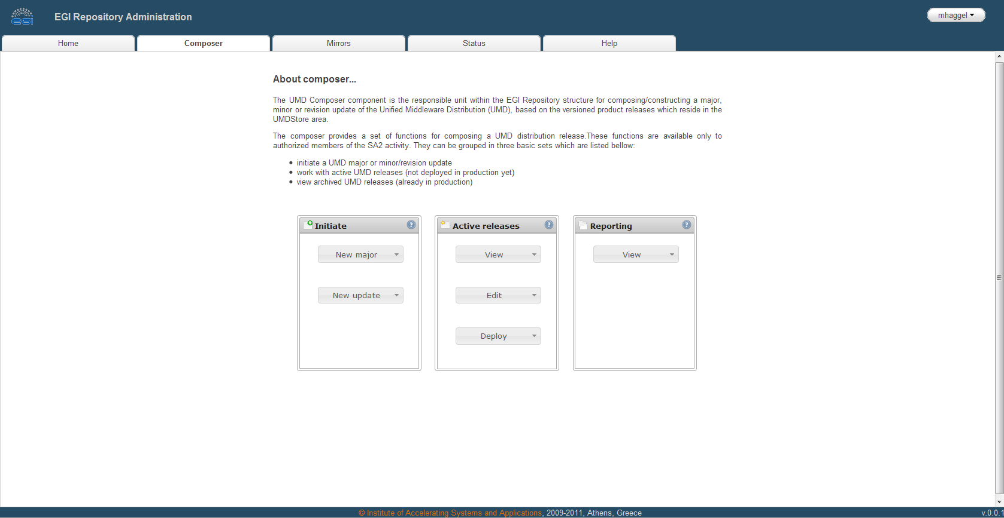
Figure 1: The UMD Composer welcome screen
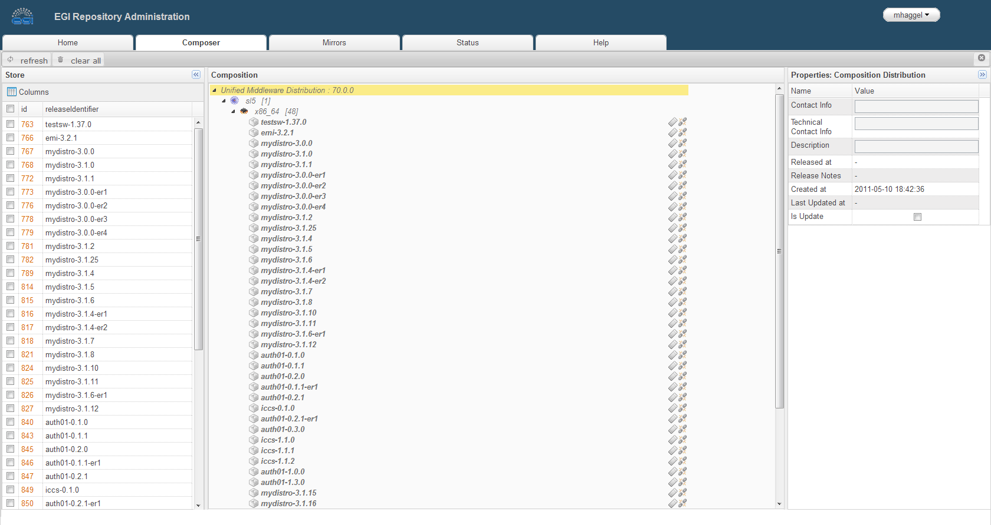
Figure 2: Composing a UMD release in the UMD Composer

IT Support
IT support faced mainly routine user support, e.g. setting up email lists and groups, changing configuration of the various systems (MediaWiki, DocDB, OpenCMS) to support new features, updating inspire-members from an Excel file send by e-mail, deleting or merging SSO accounts, creating new web sites for the Technology Forums, Community Forums etc.
The following list provides an overview of the most important tasks carried out in the second project year:
- Support X509 certificates authentication in Mailman and Wiki.
- Mirror the EGI wiki to ASGC in Taiwan.
- Create the "Early adopters" web application to manage the groups of TSA1.3 Early Adopters. The groups are then used in the Staged Rollout phase of the software release workflow for some automation. The application is available at https://www.egi.eu/earlyAdopters/
- Implement a news section in the EGI web site.
- Major change in the setting of Google Analytics to better track web visitors of all EGI web sites.
- Added links to EGI blog items on the EGI main web page.
- Provided CSS with printing layout for the EGI web pages.

Deployed Middleware Support Unit
The DMSU work was well established in project year 1, and it followed its patterns with gradual development only, without any abrupt changes. At the beginning of PY2 the leadership of the task was formally taken over by CESNET.
Updated processes of DMSU work were described in MS507 [R 26]. The changes address the most serious issue, the low ratio of tickets solved in DMSU (see below).
Further updates on DMSU work are related to the follow-up of tickets that were handed over to the 3rd line middleware support (the Technology Providers). The discussion and an initial proposal were presented at the 7th TCB meeting, followed by a convergence on an agreed process on how the DMSU will direct and manage the workload of all Technology Provider 3rd level support units, currently described at [R 13]. This process splits the management of GGUS tickets into two categories. Important tickets (with GGUS priority “top priority” and “very urgent”) are closely monitored, and Technology Providers are required to provide an “Estimated Time of Arrival” (ETA) at which the corrected software product will be made available to EGI. All Technology Providers will be monitored against this Key Performance Indicator. GGUS tickets of lesser priority (of GGUS priority “urgent” and “less urgent”) will be handled differently, as described in [R 13]. The upcoming MS511 will formally document the state of that process, which will be maintained in the EGI wiki on a daily basis.
The number of tickets in the table below reflects the daily work of DMSU:
Metric | PQ5 | PQ6 | PQ7 | Feb-Mar 2012
Assigned to DMSU | 218 | 183 | 173 | 156
Solved by DMSU | 37 | 27 | 53 | 39
Reassigned to TPM | 20 | 18 | 23 | 15
Assigned to 3rd level support | 175 | 137 | 118 | 99
Mean (median) time to solve in days | 24 (4.2) | 17(11) | 21.4(5.1) | 11(1.9)
Table 2: DMSU GGUS ticket statistics in PY2.

The numbers provided in Table 2 show that the incoming traffic reached a more or less sustained level. Figure 3 shows the monthly distribution of tickets assigned to the DMSU. The apparent peak in June is related to the pre-release testing of UMD 1.0.0, which was routed through DMSU as well, the peek in February 2012 corresponds to adding WMS, a large complex piece of software coming in major upgrade compared to previous distributions, into UMD. On the other hand, there is a quiet time at the end of year.

Figure 3: Monthly breakdown of tickets assigned to the DMSU.
The ratio of tickets solved by DMSU improved steadily, and the adopted processes (as documented in MS507 and at [R 13]) make sure that the remaining tickets, which are reassigned to the 3rd line support, are real defects requiring the Technology Provider taking action to provide a fix.
The tickets that are assigned back to TPM are, in more than 50% fraction, related to batch system support units. This software is supported internally in EGI, therefore the tickets must be routed through TPM instead of assigning to the 3rd line support units directly. The remaining issues assigned to TPM (less than 5% of all DMSU traffic) are operational problems wrongly considered to be middleware defects. This is an acceptable error rate at TPM.
The relatively high average time to solve is caused by a few outlier tickets, being kept on hold until another problem is fixed. Therefore the median time is more representative.
DMSU regularly interacts with EGI Operations. The most common communication channel is GGUS, where issues get reported, specific issues are discussed through email or occasional phone calls between the DMSU leader and SA1 management. Vice versa, DMSU started to maintain the wiki page [R 14], where issues, which potentially affect wider user community or more sites, are thoroughly documented. In addition, the gathered DMSU expertise was leveraged in producing requested “best practices” manuals on BDII, WMS, and VOMS services available at [R 15].
Besides the work visible through GGUS tickets DMSU members also handle middleware issues coming through traditional local support channel for the non-gLite middleware components. DMSU also collaborates with the Technology Providers on final pre-release tests, helping to proactively discover and to fix problems that would have otherwise a serious impact on the production infrastructure.
More precise specification of which tickets in what state are eligible to be assigned to 3rd line support was discussed and agreed (as documented in the DMSU wiki pages [R 13]). In general, only analysed tickets indicating a defect in software, documentation etc. released by Technology Providers should be assigned to the 3rd line support. Similarly, the conditions under which 3rd line support assigns a ticket back to DMSU were specified.
Some of the incoming tickets (though very few) are feature requests rather than defect reports. A vast majority of those are minor functionality requests that are assessed by DMSU not requiring much effort, and they are assigned to the 3rd line support as low-priority tickets. Major functionality requests are routed through the standard EGI requirement gathering procedure. On the other hand, requirements coming through other channels are sometimes submitted as DMSU tickets by EGI staff, requesting DMSU assessment only. Such tickets are closed in GGUS after the required information was provided.

Processed Software releases
SA2, in collaboration with TSA1.3 (Staged Rollout) has provisioned more than 140 Product releases and versions, as described in the following sub-sections. The main goal of the implemented Software Provisioning infrastructure and process is to provide a Grid middleware repository (the Unified Middleware Distribution) that serves as a single source of software updates to the Resource Centres that, in turn, provide operational support to the EGI user communities through deploying and operating Grid Middleware. This section serves as a retrospective reference to key performance metrics of the Software Provisioning unit
Anticipating the summaries given below, the changes applied to the Software Provisioning process, and specifically to the tools and processes of the Verification step, led to an overall decrease in the effort spent on the Quality Criteria Verification (see Figure 4).
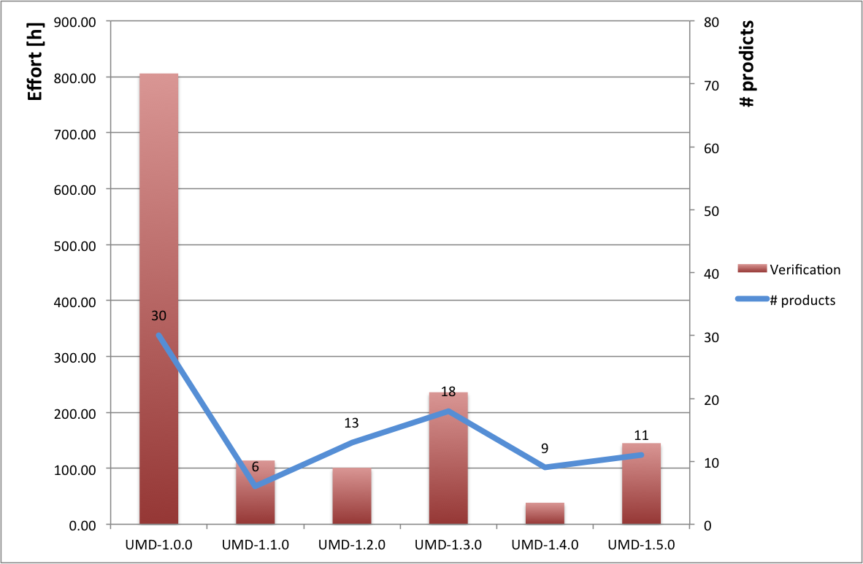
Figure 4: Total verification effort and total number of products per UMD release in PY2

 |  | Products |  |  | Verification |  |  | trend deviation |  | Median [h]
UMD Version |  | # | incr. % |  | effort [h] | incr. %
UMD-1.0.0 |  | 30 | -- |  | 806.00 | -- |  |  |  | 23.7
UMD-1.1.0 |  | 6 | -80% |  | 114.00 | -86% |  | -6% |  | 16.0
UMD-1.2.0 |  | 13 | 117% |  | 102.00 | -11% |  | -127% |  | 7.0
UMD-1.3.0 |  | 18 | 38% |  | 236.00 | 134% |  | 95% |  | 8.0
UMD-1.4.0 |  | 9 | -50% |  | 38.5 | -84% |  | -34% |  | 4.0
UMD-1.5.0 |  | 11 | 22% |  | 145 | 277% |  | 254% |  | 7.0
Table 3: UMD release capacities, verification times and trend deviations for all published UMD releases
Figure 4 and Table 3 show a downward trend in the number of included products per UMD release. This trend is logical; for the first UMD release it was necessary to include a number of critical products needed by the EGI communities (30 new products were included for UMD1.0.0). After the first release the number of new products provided by the TPs was decreasing progressively. At this moment the number of updates provided in each UMD does not vary significantly.
However, there is a significant increase in verification effort to be noticed comparing UMD 1.4.0 to UMD 1.5.0. Although there are only 2 more products contained in UMD 1.5.0, the verification effort did not rise correspondingly (see Table 3, last two rows), but by 277%. Analysing the actual verification effort for UMD 1.5.0 (see Figure 5 for details) it becomes clear very quickly, that two products, namely L&B and WMS are held accountable for more than 50% of all verification efforts. Both WMS and L&B are complex services that require much more verification effort as full services when compared to internal components, such as GE Utils or BLAH.

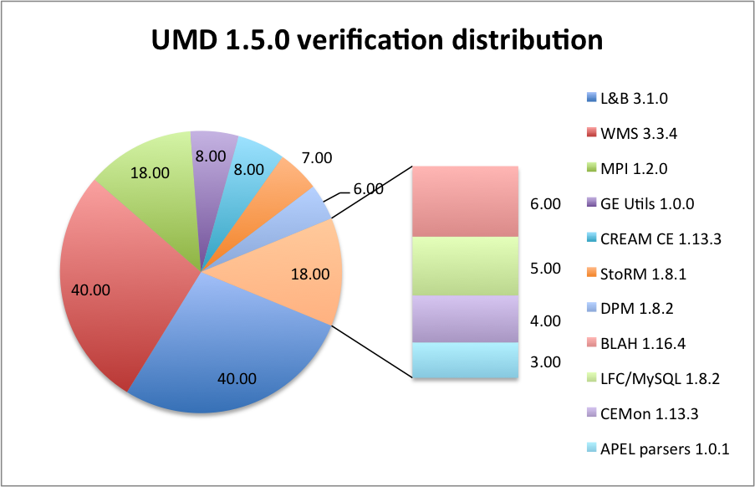
Figure 5: Verification effort distribution for UMD 1.5.0

Another important point is the time effort spent during the verification process to include a new product into UMD repository. In this case this effort has decreased since the first update; this behaviour is due to three main reasons:
- Verifiers have gained more experience after each release. The verification workflow is a complex process; the documentation and guidelines were improved to simplify the verifier’s work. At same time verifiers have more experience after the first releases.
- Complex products require more time since they often integrate many different components, and interface with many others.
- Technology Provider software quality: Software quality has increased since the first release (see section 4.1). This software enhancement has led shorten verification processes, The new middleware tends to include less software defects, and the waiting time for responses and Technology Provider feedback has been removed in some cases.

Unified Middleware Distribution (UMD)

UMD 1.0.0
Release Date: 11/07/11
Announcement: http://repository.egi.eu/2011/07/11/release-umd-1-0-0/
Included Products: 30
Rejected/not published products: 10
30 products were verified and accepted in the first UMD release. In this process it were included the high priority services requested by OMB (Client tools, storage services and Compute nodes). In this first release the time worked metric (in hours) was not included by the verifiers, it’s an estimated value. It was generated automatically based on RT ticket age.
The following EMI products were verified, but not included in UMD 1.0.0 for reasons summarised below. More details can be found in the respective reports for Verification and Staged Rollout.
- Cream 1.13.0 (RT #2206): Not published after SR, a new cream version 1.13.1 was released by EMI during Stage Rollout process and the older version was set as deprecated. The new version was accepted and included in UMD 1.0.0.
- MPI 1.0.0 (# 2215): This product was rejected during verification phase due to its YAIM plugin using wrong paths.
- LFC_Oracle for 1.8.1 (# 2218): This product was rejected during the verification process because LFC_Oracle had a package dependency with a specific Oracle version, only provided and used by CERN.
- WMS 3.3.0 (# 2221): Rejected during verification process due to issues with new VOMS proxies from EMI VOMS.
- UNICORE Registry 6.4.0 (# 2229): This product was rejected during the verification process due to a repository misconfiguration. The dependencies file provided by the TP had errors and it was impossible to install it by the verifier.
- ARC CE 1.0.0 (# 2232): Set as not published during SR process. This version was overridden by a newer version in Staged Rollout.
- ARC GridFTP 1.0.0 (# 2235): Set as not published during Staged Rollout. This version was overridden by a newer version later on.
- ARC Core 1.0.0 (# 2236): Set as not published during Staged Rollout. This version was overridden by a newer version later on.
- dCache 1.9.12 (# 2238): This version was not included in UMD1.0.0 to wait for some bug fixes from EMI. dCache was finally released in UMD1.2.0.

UMD 1.1.0
Release Date: 1 August 2011
Announcement: http://repository.egi.eu/2011/08/01/release-umd-1-1-0/
Included Products: 6
Rejected/not published products: 6
This release included 3 new products: StoRM as storage capability and ARC-infosys/BDII core as information capabilities. It also included 3 updates (Logging and Bookkeeping, Unicore UVOS and Proxy renewal) to fix different bugs.
The following EMI products were verified, but not included in UMD 1.0.0 for reasons summarised below. More details can be found in the respective reports for Verification and Staged Rollout.
- All IGE-1 products (# 2436, 2451, 2456, 2459): IGE retracted the submission of its first release to EGI due to issues found in its core multi-threading system.
- MPI 1.0.1 (# 2532): This version was rejected after Staged Rollout as it was superseded by a newer version.
- WMS 3.3.1 (# 2534): Not published after Staged Rollout since it failed mandatory Nagios monitoring tests. This issue was detected after Staged Rollout already had accepted this version.

UMD 1.2.0
Release Date: 12 September 2011
Announcement: http://repository.egi.eu/2011/09/12/release-umd-1-2-0/
Included Products: 13
Rejected/not published products: 8
This release included 5 new products into UMD: dCache, Globus GridFTP as storage capabilities, ARC-CE as compute capability, Globus RLS as metadata catalogue capability and Globys MyProxy as credential management capability. For this release, the verifiers for the first time tracked their actual verification effort in the respective RT ticket. That way time effort values are more accurate and realistic.
Some EMI products were rejected or ignored during UMD1.2.0 software provisioning process:
- Gridsite 1.7.15 (# 2632): This product was rejected due to an authorization problem with EMI WMS.
- WMS 3.3.2 (# 2634): It was rejected after Verification and SR due to authorization errors. This issue is related with Gridsite 1.7.15 (# 2632) and glite-wms-ice-extras (# 2650).
- AMGA 2.1.2 (# 2709): Amga was rejected because it was discovered and show stopper issue. Amga installation fails and it was impossible to configure this service during verification process.
- FTS 2.2.6 (# 2824): This product was ignored because it requires an Oracle backend. UMD releases will not contain Oracle based products until appropriate
expertise and EA sites are available for provisioning.
- StoRM 1.7.1 (# 2825): This StoRM version was rejected in Staged Rollout. It was rejected because the new update overwrites StoRM configuration with wrong values.
- WMS 3.3.3 (# 2826): Rejected in Stage Rollout. Under certain circumstances WMS crashed when more than 31999 subdirectories were created.

UMD 1.3.0
Release Date: 31 October 2011
Announcement: http://repository.egi.eu/2011/10/31/release-umd-1-3-0/
Included Products: 18
Rejected/not published products: 0
Three IGE products were included in this UMD release: Globus Default Security, Globus GridFTP and Globus RLS. No major issues were found during provisioning of UMD 1.3.0, and consequently no products were rejected.

UMD 1.4.0
Release Date: 19 December 2011
Announcement: http://repository.egi.eu/2011/12/19/release-umd-1-4-0/
Included Products: 9
Rejected/not published products: 2
The fourth UMD release included 9 products, of which 6 were updates of previously released packages and 3 were not released before in UMD (MPI, Globus MyProxy and Globus GSISSH).
The following EMI products were verified, but not included in UMD 1.0.0 for reasons summarised below. More details can be found in the respective reports for Verification and Staged Rollout.
- Gridway 5.8.1 (# 3092): It was not published after Stage Rollout due to some issues. This version is not ready to be used with EMI UI installations. An existing workaround is too complex to include it into UMD release notes. The new Gridway version will include these new fixes and features.
- BLAH 1.16.3 (# 3182): It was rejected due to a memory leak issue.

UMD 1.5.0
Release Date: 31 January 2012
Announcement: http://repository.egi.eu/2012/01/30/release-umd-1-5-0/
Included Products: 9
Rejected/not published products: 0
UMD 1.5.0 contained 9 verified products by the SA2.3 team. This release included EMI WMS in the UMD for the first time, after being verified and rejected several times before due to several reasons (see above). No blocking issues were found during verification, and consequently no products were rejected or not included in this update.

UMD 1.6.0
At the time of writing, UMD 1.6.0 is planned to be published by 2 of April 2012. Therefore this release is not included in this annual report.

EGI Trust Anchors
Total number of updates: 6
Accepted updates: 5
Rejected updates: 1
Only one CA update was rejected during software provisioning process (1.39-1). After SR, an issue was detected for a specific CA (Uni Andes CA) and the new update was finally removed. The average time to verify CA updates is decreasing since the first release; this pattern reflects the new experience acquired by the verification team.

System Availability Monitor (SAM)
Total number of updates: 12
Accepted updates: 8
Rejected updates: 4
Note: Two releases do not have an assigned worked time (Update 11.2 and 11.3). These SAM updates were emergency releases to solve several issues detected in production.
SAM was rejected 4 times due to different causes:
- Update 10: It was rejected in Stage Rollout due to problems discovered by the Early Adopter.
- Update 11: The Technology Provider requested to reject this update
- Update 11.2: This update was not released due to a problem during RT.
- Update 13: Probes for monitoring UNICORE services were not included in this update. The update was rejected during verification waiting for a new release 13.1

Technology Provider performance

Software quality
As discussed in the previous section, the software quality has increased in the latest UMD releases. This trend has been achieved in part thanks to Verification and Stage Rollout processes. For the first releases a great number of new GGUS tickets were opened to solve unknown or new middleware bugs (detected during Verification or Staged Rollout by Early Adopter sites). The Technology Providers and EGI Software Provisioning teams have increased their interaction (through mailing list and GGUS ticketing system) and these changes have led to improved middleware.
Documentation is also important in this process and deserves a special section. Documentation has its own Quality Criteria. If the new middleware fails documentation quality criteria (due to the new documentation is missing or incomplete), the product is not rejected but it’s registered as a new metric. The new metric was not included for the first releases; only after PQ6 it was included in the software provisioning process. When a verified product version fails against a mandatory documentation quality criterion the verifier opens a GGUS ticket for the respective Technology Provider to improve or include the new documentation in the next release, and registers the failure in the respective RT ticket.
The following four tables and figures illustrate the progression of the quality of the software delivered by EMI (Table 4 & Figure 6), and IGE (Table 5 & Figure 7). Figures are not provided for SAGA as there was no software delivered by SAGA at the time of writing.

EMI software quality
 | finished | passed | passed | failed |  | success |  | doc. QC
 | # | QC | SR | doc. QC |  | QC | SR | failure %
PQ 5 | 30 | 27 | 27 | 0 |  | 90% | 90% | 0%
PQ 6 | 30 | 28 | 26 | 2 |  | 93% | 87% | 7%
PQ 7 | 27 | 26 | 24 | 2 |  | 96% | 89% | 7%
PQ 8 | 7 | 7 | 7 | 0 |  | 100% | 100% | 0%
Table 4: Quality of software delivered by EMI

Figure 6: EMI software quality has improved over PY2.

IGE software quality
 | finished | passed | passed | failed |  | success |  | doc. QC
 | # | QC | SR | doc. QC |  | QC | SR | failure %
PQ 5 | 0 | 0 | 0 | 0 |  | 0% | 0% | 0%
PQ 6 | 4 | 4 | 4 | 2 |  | 100% | 100% | 50%
PQ 7 | 8 | 8 | 8 | 3 |  | 100% | 100% | 38%
PQ 8 | 0 | 0 | 0 | 0 |  | 0% | 0% | 0%
Table 5: Quality of software delivered by IGE

Figure 7: When delivered for provisioning, IGE software quality was consistently very good.

3rd level support
The following charts show numbers and median time to solve tickets with EMI and IGE.

Figure 8: Consistent low figures for top priority and very urgent tickets demonstrate satisfactory EMI ticket management.

The ratios between ticket priorities (see Figure 8) witness that the process of assessing the ticket priority is well defined, being realistic while still pointing out the really important issues. The problem of increasing backlog of unsolved tickets of lower priorities is apparent too. The drop in January corresponds to code freeze of EMI-2 releases, and it witnesses the validity of the assumption of a pre-release bug-fixing campaigns.

Figure 9: EMI continuously improved the median solution time for tickets, irrespective of its priority

The peak of solution time in July (see Figure 9) is caused by the UMD 1.0.0 release; the tickets had cumulated long time before, and they were all closed at once when the release was available. However, the number of those tickets is approximately 20, therefore probably an outlier rather statistically significant. The same holds even more for the high priorities, e.g. the peak in September seems to be caused by a single ticket. Moreover, this particular ticket distorts the statistics even more, its priority was raised due to finding a related issue on the fly (afterwards it was solved in approx. 3 weeks).
Due to very low number of tickets for IGE software raised in the GGUS system (see Table 6) the presented numbers are illustrative only, the statistical significance is very poor. The number of tickets shows the same trend – increase of the backlog, which drops with the release of IGE-2 at the end of January 2012.
IGE - open tickets by priority
Month | top priority | very urgent | urgent | less urgent
Apr '11
May '11 |  |  |  | 1
Jun '11
Jul '11 |  |  | 1 | 2
Aug '11 |  |  | 2 | 4
Sept '11 |  |  | 2 | 4
Oct '11 |  |  | 1 | 4
Nov '11 |  |  | 1 | 7
Dec '11
Jan '12 |  |  | 2 | 1
Feb '12 | 1 |  | 1 | 2
Mar '12 | 2 |  | 2 | 1

IGE - mean time to solve by priority [d]
Month | top priority | very urgent | urgent | less urgent
Apr '11 |  |  |  | 17.8
May '11 |  |  |  | 10.7
Jun '11 | 0.1 |  |  | 22
Jul '11
Aug '11
Sept '11
Oct '11 |  |  | 90.9 | 68.8
Nov '11
Dec '11
Jan '12
Feb '12 | 0.1 |  | 15.2 | 16.8
Mar '12 |  |  |  | 4.7
Table 6: Only very few GGUS tickets were raised against IGE software in PY2

Plans for the next year

Quality Assurance: Definition of the UMD Quality Criteria
The Quality Criteria Definition team will continue with the established process for creating the next releases of the Quality Criteria Documents. During the next year, releases 4 and 5 will be produced. Any changes and sources of those changes will be tracked in the Quality Assurance section of the EGI.eu wiki.
As with the last release of the documents, per product documents will be also produced along with the documents classified by groups of capabilities. These documents ease the verification tasks and the review of the external Technology Providers by narrowing the scope of the documents and removing any non-applicable criteria.
Since all the currently defined UMD capabilities are now covered by the documents, the effort for the next year will be focused on the definition of criteria due to issues found in the production infrastructure and new requirements originating from the EGI ecosystem. The SA2.2 team will perform a regular tracking of GGUS tickets and the requirements collection process of EGI-InSPIRE. The relevant tickets and requirements will be analysed by the team and those relevant for the quality of the software will be added to the quality criteria, taking into account that the verification process must not be overloaded.
The collaboration within the task force on Software Quality Assurance will continue in order to retrieve feedback from the Technology Providers and to keep up with the Quality Controls enforced in the software developed by those providers.

Quality Control: Verification of Conformance Criteria
The Verification task is similar to ITIL continual service improvement process, some changes were included in the last year but more changes are needed to integrate the incoming software into UMD. One of these processes is the Quality Criteria evaluation. Each six months a new Quality Criteria is released by SA2.2; a new release will be provided soon and it will include significant changes. SA2.2 and SA2.3 members are collaborating to provide the new set of templates to improve and simplify the current verification process, based on platforms instead of services, Verification and Staged Rollout then can easier prioritise which product update released by a Technology Provider should be taken through the provisioning process by detgermining which platform will be affected by this update. The number of templates will be decreased and also the possibility of error by the SA2.3 members.
Another important improvement to implement the next months is the integration of the current SA2 test-bed based on OpenNebula and the Virtual Machines provisioning. CESGA is collaborating in both tasks to provide virtual machines verified and tested in SA2.3 to be made available in the EGI Marketplace. The new images will be ready to start any grid service after passing the software provisioning process. If this new service will be useful to production sites or not is currently under discussion by SA1 members.
Recently SA1.3 members have released a new UMD provisioning proposal [R 16]. This proposal includes strong changes that affect the current software provisioning process; most of them are related to providing Staged Rollout with a set of public permanent repositories (though volatile in contents). The Quality Criteria Verification process is not directly affected by these changes but its impact should be discussed, and how it can change the current verification workflow.

Provision of a software repository and support tools
During PY3, SA2.4 plans to focus its efforts in the following areas.
Beginning with the release of EMI-2, EMI will expand its support of OS platforms from Scientific Linus 5 to Scientific Linux 5, Scientific Linux 6 and Debian 6. No change to the Software Provisioning tool-chain is necessary to support Scientific Linux 6, but in order to support Debian 6, the repository management backend needs to be changed. Dry-run tests have been conducted using IGE’s Debian repository with promising results. This activity is expected to conclude in May 2012 with the first UMD release that will provide Grid Middleware provisioned for Debian 6.
Assessing TSA1.3’s proposal for changes to the Software Provisioning process, TSA2.4 is looking into how the transient repositories for Verification and Staged Rollout can be amended to provide stable repository configurations independent to the current set of products being provisioned.
Preliminary download statistics for the UMD repository are available. These will have to be further expanded to monthly statistics and geographical spread. We also expect some smaller iterations on the algorithm, based on wider circulation of these figures.
TSA2.4 has deployed test instances of the StratusLab Marketplace and Appliance Repository (see section 2.3). These will be further evaluated how they can be used for provisioning existing Grid Middleware for production use, particularly with the interactions of TSA2.3 (Quality Criteria Verification) and TSA1.3 (Staged Rollout). These services are maintained at a very low level to determine their popularity and acceptance in the EGI ecosystem, before committing any significant amount of effort for further support and expansion in the future.
Download statistics for the appliance repository will be provided based on the experiences made with the UMD repository, and published once the appliance repository is used and numbers are sufficient to report.
Finally, with the approaching end of the IGE and EMI projects, we are looking into further amending the existing solution to generate release.xml artefacts for existing Technology Providers, to support any type and number of Technology Provider.

Distributed Middleware Support Unit
DMSU will follow the stabilized procedures on ticket handling. The figures reported in 2.4 show clearly that both acceptable ratio of tickets solved, as well as solution time were reached. In addition, the work will be extended by the follow-up of high-priority tickets as soon as the details on the process are agreed. Operational "best practices" manuals and the "Middleware issues and
solutions" pages will be regularly updated according to the emerging needs.

Federated CLouds Task Force
In May 2011, EGI held a User Virtualisation Workshop in Amsterdam as a follow up to initial talks that took place at ISGC 2011 at Academia Sinica in Taipei, Taiwan. In preparation to this workshop an initial Cloud Profile document [R 27] was compiled against which various EGI User Communities validated their own Cloud and Virtualisation use cases during that workshop.
Following this, the TCB appointed several representatives of EGI to develop a mandate to form a Task Force exploring how a federated Cloud Infrastructure might be set up in support to the User Community use cases and scenarios distilled into the Cloud Profile document (see above). Eventually, the Mandate was developed and documented [R 28]; the TCB approved the Mandate in September 2011 and appointed Matteo Turili, STFC, and Michel Drescher, EGI.eu, as the chairs of the Task Force.
As per the Mandate, the Task Force began to recruit members through out the EGI community, and set up its infrastructure using EGI’s Indico for meeting management, HiDef Conferencing for conference calls (later replaced by WebEx), EGI wiki for live documentation of the work groups, the Blueprint and the testbed documentation, EGI’s SSO and Mailman mailing list to manage the Task Force membership, and last but not least OerC’s Basecamp instance to manage and follow-up on actions assigned to members of the Task Force. The Task Force’s central point of communication and documentation is the Task Force Wiki.
The Task Force progresses through its workload having weekly conference calls and assigning actions to members. In general, the workload is divided following the scenarios documented in the initial EGI Cloud profile document. In December 2011, however, the Task Force decided to add two more scenarios/Capabilities to its portfolio, a total of eight Capabilities:
- VM Management
- Storage/Data management
- Information Discovery
- Accounting
- Monitoring
- Notification
- Federated AAI
- VM Image sharing
The Task Force is developing a Blueprint as a living Wiki document (as part of the Task Force’s main Wiki space – see above) describing the available software, standardised interfaces, and gaps where desired features were not available. The main input to the Blueprint next to investigative search and liaisons is the test-bed maintained by a subset of participating Resource Providers, where available software is practically tested and deployed. Where necessary, small-scale integration effort ensures that selected components work together sufficiently, though not in production quality.
The current state of art of the Federated Clouds infrastructure will be demonstrated at the EGI Community Forum 2012 in Munich.

Conclusions
The second project year saw a couple of significant changes in the work of the SA2 activity, the most obvious being the delivery of in total 7 UMD updates (the last update, UMD 1.6.0 currently in progress at the time of writing).
While the first project year mostly saw the design of the Software Provisioning process, including the first application to the EGI Trust Anchor, and SAM components, the second project year revealed how well this process was designed, and where changes were necessary to address issues that appeared only after executing the process at scale.
The necessary changes affected all SA2 tasks: The management and maintenance of Quality Criteria had to be changed to be more of a service to the main users, the verification engineers. The organisation of the verification test bed, how verification reports are written and stored, and how we monitor the spent verification effort needed to be adjusted to improve efficiency of the verification sub-process.
Likewise, the provisioning infrastructure was extended to automatically collect metrics of verification effort in its various aspects, i.e. how well the software quality of delivered middleware components was when verified against Quality Criteria and deployed during Staged Rollout. Technology Providers receive a daily digest on the progress of delivered software through the Provisioning process, as well as a publically available dashboard for an overview including search functionality in RT, as well as an overview of all products that are currently planned to be included in a specific UMD release.
Last but not least, the DMSU is starting to take on responsibility to direct the workload of associated Technology Providers by determining the priority of GGUS tickets that are assigned to the 3rd level support units managed and operated by EMI, IGE and SAGA. Technology Providers have agreed on different GGUS ticket handling procedures based on the ticket’s priority, and generally adhere well to these procedures (see section 4.2)

The second year has seen many changes applied to the overall Software Provisioning workflow, simply as a result of carrying it out against real software delivered at a real provisioning scale. The total amount of changes applied to the software provisioning workflow is a mix of changes mitigating problems that could have been implemented before (e.g. automated verification effort reporting) and changes due to additional requirements for the provisioning workflow (e.g. Technology Providers ceasing to deliver formal software update descriptions in a “release.xml” artefact). This is considered a healthy state of continuous service improvement – a commonplace in commercial software and service development. The lesson learned from this second project year has to be that the value in developing new services and functionalities must be in the agility of the employed process leaving room for changes and adjustment early in the process as opposed to costly changes late in the process, simply because a dynamic environment such as EGI in its current state will always cause constant flux in the requirements for any given software and service it will employ.

References
R 1 | EGI Quality Criteria, Revision 2, http://go.egi.eu/qualitycriteria-2
R 2 | EGI Quality Criteria, Revision 3, http://go.egi.eu/qualitycriteria-3
R 3 | EGI Quality Criteria overview, https://wiki.egi.eu/wiki/EGI_Quality_Criteria_Dissemination
R 4 | Quality Criteria grouped per product they apply to, https://documents.egi.eu/document/945
R 5 | Verifier Guideline: https://wiki.egi.eu/wiki/EGI_Verifier_Guideline
R 6 | Verification engineer skill matrix: https://wiki.egi.eu/wiki/EGI_Quality_Criteria_Verification - Verification_engineer_skill_matrix
R 7 | Software Provisioning metrics reports,  https://rt.egi.eu/rt/SA2/sa2-sw-rel-verification-metrics.xls
R 8 | Report on Software Provisioning and Technology Provider performance, TCB-9,  http://go.egi.eu/TCB-9
R 9 | EGI-InSPIRE SA2 Software Provisioning metrics, https://rt.egi.eu/rt/SA2/SLA/index.html
R 10 | The EGI Verification test bed, https://wiki.egi.eu/wiki/EGI_Verification_Testbed
R 11 | QC Verification templates: https://documents.egi.eu/document/417
R 12 | Quality Criteria to Product mapping, https://documents.egi.eu/document/418
R 13 | http://wiki.egi.eu/wiki/EGI_DMSU
R 14 | https://wiki.egi.eu/wiki/Middleware_issues_and_solutions
R 15 | EGI Operations Manuals, https://wiki.egi.eu/wiki/Operations_Manuals
R 16 | SA1.3 UMD provisioning proposal: https://wiki.egi.eu/wiki/UMD:Provisioning:Proposal_SR
R 17 | First Annual Report on the status of the Software Provisioning activity and the work of the DMSU, https://documents.egi.eu/document/375
R 18 | EGI User Virtualisation Workshop, https://www.egi.eu/indico/conferenceDisplay.py?confId=415
R 19 | Verification Report for EMI L&B, https://documents.egi.eu/document/968
R 20 | EGI Quality Criteria definition, https://wiki.egi.eu/wiki/EGI_Quality_Criteria_Definition
R 21 | UMD Capabilities, https://wiki.egi.eu/wiki/EGI_Roadmap_and_Technology
R 22 | Feedback from EMI on Quality Criteria v1, https://twiki.cern.ch/twiki/bin/view/EMI/EmiEgiQcReviewPerProductV3
R 23 | Feedback from EMI on Quality Criteria v2, https://twiki.cern.ch/twiki/bin/view/EMI/EmiEgiQcReviewV2
R 24 | Verification Report for EMI VOMS 2.0, https://documents.egi.eu/document/452
R 25 | DMSU cheat sheet, https://wiki.egi.eu/wiki/DMSU_People_Institutes
R 26 | MS507 – Deployed Middleware Support Unit Operations Procedures, https://documents.egi.eu/document/504
R 27 | EGI Cloud Architecture, https://documents.egi.eu/document/435
R 28 | EGI Federated Clouds Task Force mandate, https://documents.egi.eu/document/720
R 29
R 30
R 31

http://cf2012.egi.eu
This source of information is not publically available; this is by design so that vulnerabilities can be discussed freely between appointed members while reducing the risk to trigger zero-day exploits.
http://marketplace.egi.eu and http://appliance-repo.egi.eu, respectively
For technical details of the bouncer see section 3.3.1 in MS506 (https://documents.egi.eu/document/503).
http://go.egi.eu/TCB-7
https://ggus.eu/tech/ticket_show.php?ticket=71437
http://www.ige-project.eu/news-events/news/igev20released
https://www.egi.eu/indico/conferenceDisplay.py?confId=415
http://event.twgrid.org/isgc2011/index.html
http://go.egi.eu/TCB-7
https://wiki.egi.eu/wiki/Fedcloud-tf
http://cf2012.egi.eu

