EGI-Engage

Technical Forum 2016 is organised
M2.5

Date | 20 February 2017
Activity | WP2
Lead Partner | EGI Foundation
Document Status | FINAL
Document Link | https://documents.egi.eu/document/2673

Abstract
This milestone aims to provide a factual description of the EGI flagship events organised in 2016. The report includes the results of surveys and other information. The first event was the EGI Conference 2016, hosted by the EGI Foundation and held at the foundation’s headquarters in Amsterdam, Netherlands, between 6-8 April 2016. The Digital Infrastructures for Research 2016 was co-organised by EGI, EUDAT, GÉANT, OpenAIRE and RDA Europe, and hosted by AGH Cyfronet (28-30 September 2016).

COPYRIGHT NOTICE
This work by Parties of the EGI-Engage Consortium is licensed under a Creative Commons Attribution 4.0 International License (http://creativecommons.org/licenses/by/4.0/). The EGI-Engage project is co-funded by the European Union Horizon 2020 programme under grant number 654142.
DELIVERY SLIP
 | Name | Partner/Activity | Date
From: | Sara Coelho | EGI Foundation/WP2 | 27/03/2017
Moderated by: | Małgorzata Krakowian | EGI Foundation/WP1

DOCUMENT LOG
Issue | Date | Comment | Author/Partner
FINAL | 27/03/2017 | Final version | Sara Coelho

TERMINOLOGY
A complete project glossary is provided at the following page: http://www.egi.eu/about/glossary/

EGI Conference 2016
The EGI Conference 2016 took place in Amsterdam, Netherlands, 5-8 April 2016. The event was hosted by the EGI Foundation. The goal of the conference was to put research communities, NGIs and EIROs and collaborating e-Infrastructures in the spotlight as key players for the delivery of digital services for borderless science.
The event was attended by 188 participants. The follow-up survey was filled by 40 attendants.
Programme: https://indico.egi.eu/indico/event/2875/

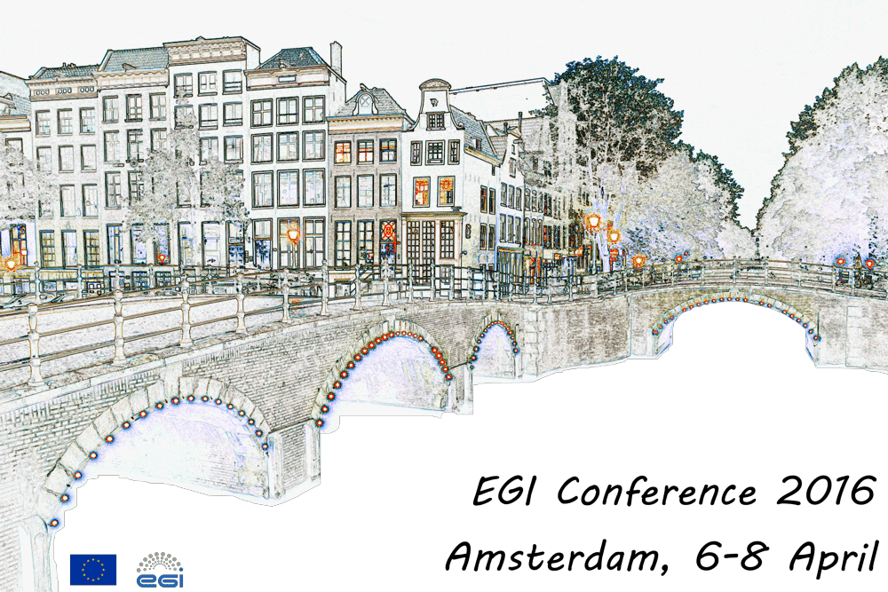

Digital Infrastructures for Research 2016
The Digital Infrastructures for Research 2016 was co-organised by EGI, EUDAT, GÉANT, OpenAIRE and RDA Europe, and hosted by AGH Cyfronet (28-30 September 2016). Designed with research communities in mind, the DI4R 2016 event aimed to foster broader adoption of digital infrastructure services and promote user-driven innovation.
The event was attended by 407 participants, of which 89 filled the feedback questionnaire.
Programme: https://www.digitalinfrastructures.eu/programme

