EGI Governance

1 Introduction 2
2 Governance Structure 3
2.1 EGI.eu Statutes and Governance Bodies 4
2.1.1 Council 4
2.1.2 Executive Board 4
2.1.3 EGI.eu Participants 4
2.2 Other relevant EGI Groups 8
2.2.1 Strategy and Innovation Board (SIB) 8
2.2.2 User and Community Board (UCB) 8
2.2.3 Operations Management Board (OMB) 9
2.2.4 Technology Coordination Board (TCB) 9
2.2.5 Services and Solutions Board (SSB) 9
2.2.6 Security Policy Group (SPG) 9
2.3 Funding Model 9
2.3.1 Participant Fees 10
2.3.2 European projects 10
2.3.3 Other funding streams 10
2.4 Relationship to the EGI-Engage governance 11
Appendix I. Structure of governance bodies 13

Introduction
Over the last decade, EGI has built a federation of long-term distributed compute and storage infrastructures that support research and innovation. This international e-Infrastructure has delivered unprecedented data analysis capabilities to more than 46,000 researchers from many disciplines. The federation brings together more than 350 data and compute centres worldwide. EGI is coordinated by a not-for-profit foundation, EGI.eu, and funded through a combination of participant fees, national and EC funding.
EGI in Numbers*
EGI: 32 countries + CERN + EMBL
EGI Federation: 51 countries + CERN + EMBL
Virtual Organisations: 290
Users: ~46,000
Resource centres: 335
Federated CPU cores: 650,000+
Federated storage (disk): ~310PB
Computational Jobs: ~ 1,6M/day
Virtual Machines: ~ 1,3K/day
*(Feb 2016)

CompJobs/

Today, EGI provides both technical and human services, from integrated and secure distributed high-throughput and cloud computing, storage and data resources to consultancy, support and co-development. The benefits of EGI are:
- Ensuring uniform and reliable availability of resources to researchers on a local, national and European scale
- Enabling faster production of scientific results through collaboration across organisational and national boundaries
- Promoting open and collaborative science and ensuring open access to shared resources and expertise
- Allowing researchers to focus on their research rather than managing their e-Infrastructure needs
- Providing effective utilisation of resources in different administrative domains to ensure the most effective return on infrastructure investments
- Facilitating the innovation and sharing of solutions by building a thriving ecosystem through community events and collaborative services.
This document presents an overview of the EGI Governance and its recent update towards a more flexible model following this structure: Section 2 starts off describing EGI and its governance structure and how the different boards interact with the governance of the EGI-Engage project; Section 3 describes how the Governance system has been modified over the last year and the motivations that support the new statutes; Section 4 focuses on the analysis of the ERIC framework, first outlining how the new statutes are compliant with this model and what is still missing; Section 5 concludes the document by summarising key points and outlining future work.

Governance Structure
The organisational and governance structure of EGI builds on EGI.eu, a not-for-profit foundation established under Dutch law in the Netherlands. The Foundation has participants and associated participants drawn from NGIs, EIROs, ERICs, and other such legal entities. These entities participate in the foundation independantly or as the representative of a national e-Infrastrcuture consortium. EGI.eu participants form the governing body (EGI Council). Participants and associated participants also provide the physical resources and shared services that enable EGI to deliver, improve and innovate services for research communities. EGI.eu coordinates areas such as overseeing infrastructure operations, user community support, contact with technology providers, strategy and policy development, flagship events and dissemination of news and achievements. Figure 1 clarifies the relationship between EGI.eu, EGI, the EGI Federation and the EGI Community.

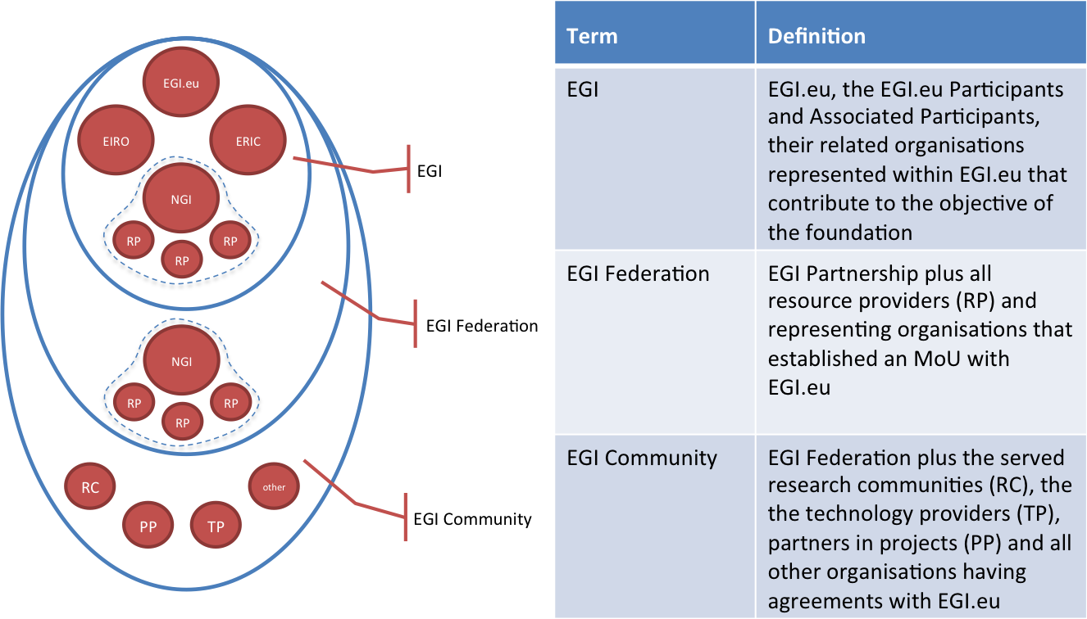
Figure 1: Defining EGI, EGI Federation and EGI Community

EGI.eu Statutes and Governance Bodies
EGI.eu has adopted the legal form of a ‘Foundation’ under the Dutch law. Its statutes was recently updated during 2015 and defines the objectives of the foundation, the composition in terms of participants and associated participants, the organisation and tasks of the Council and Executive Board (EB), the role of the Director.

Council
The Council is the supervisory authority and monitors the general course of affairs in the Foundation. It consists of participants and associated participants of the foundation. Only participants have voting rights proportional to the paid fee, while associated participants cannot vote. The Council is also responsible for appointing the chairperson and the members of the Executive Board. The Terms of Reference (ToR) for the Council is defined by the EGI.eu Statutes and by a dedicated ToR.

Executive Board
The Executive Board is charged with the management of the foundation, for which it is accountable to the Council. It is composed from minimally five and maximally nine members appointed for a maximum period of two years. A number of resolutions of the Executive Board are subject to the approval of the Council (e.g. adoption of the budget, employment conditions of the personnel employed by the foundation). The Executive Board devolves financial and organisational responsibility to the EGI.eu Director, who is supported by a staff of ~20 people based at the EGI.eu headquarters in Amsterdam with some limited remote working staff. The Terms of Reference for the EB is defined by the EGI.eu Statutes and by a dedicated ToR.

EGI.eu Participants
Participants and Associated Participants can be NGIs, EIROs, ERICs and such other legal entities, in their own capacity or as representative of a consortium, that contribute to the objective of the foundation. In case of consortium representatives, membership is subject to there being a letter of support from the appropriate relevant authority indicating how the identified organisation represents the National e-Infrastructure strategy. Representation within the EGI Council would be determined by the lead member within the organisation or as defined in its statutes or within a Memorandum of Understanding (MoU) for membership with EGI. By being an EGI.eu participant, an organisation benefits from a set of activities that are delivered by EGI.eu in collaboration with a sub-set of participants listed in Table 1 and can obtain the values identified in Table 2. A comparison of Full versus Associate Membership is outlined in Table 3.

Core activities | Additional activities
Federated operations and tools supporting High Throughput, Cloud and Data services | Business engagement
Security/technical/operations/community coordination | Software portals
Communications and promotion | Training and capacity development
Project management and planning | Marketplace and service brokering
Strategy and policy development
Table 1 Activities for EGI.eu participants

Area | Value | Description
Strategy & Policy | Influence European-level policy on e-Infrastructure | Improve your access to policy makers, ensure your issues are considered, e.g. to H2020 work programmes, with the support of EGI.eu. Increase your policy impact as part of a pan-European collaboration. Ensure your efforts are aligned with other countries, simplify international collaboration and support transnational access
 | Improve your transfer of innovation to the private sector | Simplify your engagement with the private sector to achieve impact for your research and demonstrate resulting innovations. Be seen as more commercially relevant by funding bodies
 | Influence EGI strategy to better support your international users | Influence the evolving joint European service portfolio; check that it matches the needs of your local/national research groups
Funding | Improve access to H2020 funding | Take a leading role in H2020 calls, benefit from the shared reputation of the EGI community, get invited to proposals directly or as a third party due to your EGI participation
 | Explore innovative revenue generation models | Benefit from new revenue generating activities, such as acting as an EGI subcontractor or participating in the ‘pay for use’ programme to receive money in return for resource access
Skills Development | Improve the skills of your personnel through accessing community knowledge, expertise and training | Share knowledge with other EGI participants and increase your community skill levels through working with European experts in many areas, e.g. service management and data science
Technical | Access common tools, services and processes to operate a federated infrastructure | Benefit from a suite of technical tools, internal services and management processes that support federated operations. Avoid building your own alternatives and facilitate cooperation
 | Promote your services in a shared marketplace | Get access to a common marketplace supporting a wide range of commodity services, also supporting independent use by smaller communities and the long tail
Community Building | Improve your access to requirements from ESFRIs and emerging user communities | Use strong connections of EGI to user communities and ESFRIs to better understand needs and serve their users
 | Connect your local users with international collaborations | Help your local research communities grow to a European or global scale. Help them finding collaborators and highlight their successes
Table 2 Values for EGI.eu participant

 | Full Participants | Associate Participants
Advertised on EGI website, according to type of membership | √ | √
Attend Council meetings | √ | √*
Vote on any decision submitted to the council | √
Participate to working groups** | √ | √
Be elected as chair of the Council or as EB member | √
Access the member benefits (see Error! Reference source not found.) | √ | √
Be part of the “linked third party” mechanism to join proposals (e.g., projects in H2020) | √
Benefit from the new EC regulation about public procurement | √
Access Strategy and Policy Decision Support briefing and document reports | √
Compensate Infrastructure Fees with in-kind contribution** | √
* Only upon express invitation and as observer only
** In the form and conditions defined by the council and supervised by the in-kind committee
Table 3 Comparing EGI.eu participants
Participants pay a fee based on a six-level scheme defined in Table 4. Participants connected to a country pay according to the GDP of their country of origin. For International Research Infrastructures (e.g. EIROs and ESFRIs), the fee is calculated according to the size of the International consortium. For other organisations such as industries and SMEs, fees need to be defined. Full participants have a number of votes related to the paid fee, while associated participants pay 50% of the fee indicated by the corresponding fee level, but do not have voting rights.
Category (1) | Full Participant |  | Associate Participant Fee (€)
 | Fee (€) | Votes
> 2,000,000 | € 90,000.00 | 90 | € 45,000.00
750,000 < x ≤ 2,000,000 | € 75,000.00 | 75 | € 37,500.00
300,000 < x ≤ 750,000 | € 55,000.00 | 55 | € 27,500.00
100,000 < x ≤ 300,000 | € 40,000.00 | 40 | € 20,000.00
30,000 < x ≤ 100,000 | € 25,000.00 | 25 | € 12,500.00
0 < x ≤ 30,000 | € 10,000.00 | 10 | € 5,000.00
Table 4 Participant fees levels

Affiliation partners program
During 2015, the EGI Council approved an affiliation partners program that aims to give a temporary role derived from the Associate Participant status to candidate organisations. Eligible organisations and/or NGIs can apply for a period of 12 months renewable once. It can be exceptionally extended for a third year upon approval of the Council after a proposal from the Executive Board. The Executive Board shall decide on each membership request temporarily. Decisions of the EB have to be confirmed by the subsequent Council meeting. Affiliated partners will pay a membership fee as decided by the EB and approved by the Council. Typical Affiliated partners can include organisations and/or NGIs who either:
- Want to have a first contact with the infrastructure;
- Are in a country where there is no national strategy;
- Does not have a proper e-Infrastructure in place;
- Want to assess the interest of such e-Infrastructures for their scientific communities.
They can be either from non-European or associated country or European or associated country with a GDP of up to US$100,000 million. The fee is set up at 1,500 euros/year regardless the type or size of the organisation.

Other relevant EGI Groups
Other EGI groups and boards have been created to define policies and procedures within a specific functional area. Each group has well-defined responsibilities, composition and operational procedures via Terms of Reference. The main relationships are depicted in Figure 2.
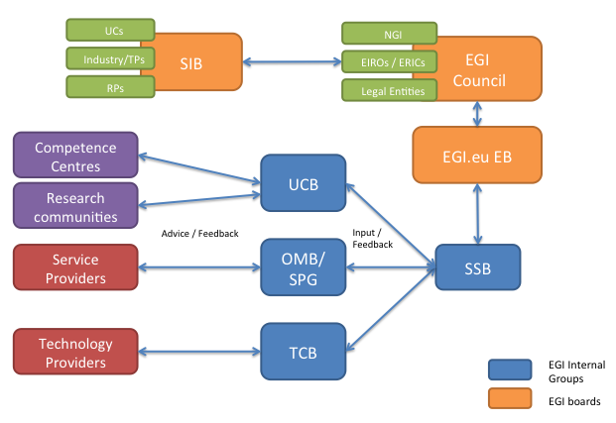
Figure 2: Main relationships among EGI governance bodies

Strategy and Innovation Board (SIB)
The Strategy and Innovation Board (SIB) is an external advisory body that provides advice and guidance to the EGI council and to EGI.eu leadership about the strategy in the area of: relationship and service provision to user communities, relationship to other e-Infrastructures, relationship to industry, technology and innovation; e-Infrastructure organisation and management. The SIB will have ownership of strategy and innovation recommendations, which are intended to be formalised within a living document that will be maintained and updated through regular meetings. Members of the SIB will be appointed during 2016 through an open call mechanism managed by the EB.

User and Community Board (UCB)
The User Community Board (UCB) gathers feedback from the user community relating to the quality of the production infrastructure and prioritises issues requiring management attention for resolution through the OMB. It also defines and prioritises requirements relating to new functionality in the production infrastructure or the user facing operational tools. The UCB includes representatives from the research communities and projects served by EGI.

Operations Management Board (OMB)
The Operations Management Board (OMB) is an advisory body, which develops strategy and technical priorities concerning the deployment and operation of the production infrastructure, oversees the status and progress of the global EGI operational services and of the NGI operational services. Responsibilities of the OMB include the development of policies and procedures that require formal consensus from the NGI operations managers and their respective resource providers, the collection of requirements from the EGI resource providers, the definition of work plans the long-term development of the EGI operations.

Technology Coordination Board (TCB)
The Technology Coordination Board (TCB) provides the focus for the technologies that will be used within the EGI production infrastructure to deliver distributed computing services for the research communities. The TCB carries out strategic activities, such as coordinating the technology evolution and insertion across platforms deployed in the EGI production infrastructure, act as a liaison hub to connect with Research Infrastructure technology coordinators, source components in UMD through bi-lateral relationships with technology providers in the community. The TCB is under reorganisation and new terms of reference will be proposed during 2016.

Services and Solutions Board (SSB)
The Services and Solutions Board (SSB) is responsible for managing the portfolio of services and solutions regarding EGI.eu and the EGI federated services. This includes all services and solutions that are planned, active or to be retired. The SSB also conducts regularly scheduled management reviews of both services and solutions portfolios and related ITSM processes. It also collects inputs from the UCB concerning the services and solutions for the research communities, from the TCB concerning the evolution of technology and how this can affect services and solutions; from the OMB concerning the services and solutions for resource providers.

Security Policy Group (SPG)
The Security Policy Group (SPG) is responsible for developing the policy needed to provide a secure, trustworthy distributed computing infrastructure. The SPG output defines the behaviour expected from NGIs, Sites, Users and other participants to maintain a beneficial and effective working environment. The SPG also seeks to prepare and maintain simple and general policies which are not only applicable to EGI, but that also to other distributed computing infrastructures.

Funding Model
EGI.eu and NGIs are bodies created to provide coordination and to manage the infrastructure. Whereas EGI.eu would fill the European position, NGIs would be in the National part of the transnational-axis. The budget/monetary perspective is given by the presence of the funding bodies, which again can be either European, national or local. This network could be expanded with commercial parties, which could fill a wide number of roles such as for example e-Infrastructure providing commercial resources, developers, or even users of some of the services. This section provides a brief overview on the EGI.eu funding model.

Participant Fees
The participant fees aim at giving EGI.eu the financial capacity to ensure all of the shared services necessary to coordinate the provision of the e-Infrastructure through its resource providers and make it available to the different scientific communities; coordinate a common voice to national and international policy; ensure communication, outreach and community engagement.

European projects
Participation in European projects is not only aimed to increase opportunities for socio-economic impact or to ensure the future sustainability of EGI as collaboration, but also is meant to align with the main objectives of the European Commission, made explicit in the definition of the H2020 strategy. In particular, it allows to accelerate the implementation of the Open Science Commons vision, where researchers from all disciplines have easy and open access to the innovative digital services, data, knowledge and expertise they need for their work; facilitate the deployment and promotion of a pan-European identity federation; deploy new service models and user tools to tackle the challenges of the Big Data era.

Other funding streams

“Pay for use” business model
Until now, EGI has operated within a publicly funded research and academic environment providing services free at point of delivery with resources bought from grants dedicated to certain groups or disciplines either by direct allocation or by peer review. With the advent of cloud computing, business models and user expectations are shifting towards on-demand and pay-for-use service provision with increasing flexibility and agility.
This new paradigm provided motivation for EGI to explore new service definitions by enabling the possibility to provide ICT services that can be paid for the use, along with the more traditional procurement of resources to be managed and offered for free to the owners.
EGI.eu is leading the activity of exploring the pay-for-use business model in collaboration with key resource providers. This additional business model will be rolled out in production during 2016 (more information can be found in D2.9 “EGI Sustainability and Business Development Plan”).

Training and consultancy
Over the last years, EGI.eu has contributed to the definition and adoption of a standard for lightweight service management in federated infrastructures (FitSM). This standard envisions also a training and certification program. Given the need to stimulate the adoption and improvements of skills and practices across all resource providers’ part of EGI, EGI.eu has defined a new training service with a paid business model.

Relationship to the EGI-Engage governance
EGI-Engage is the flagship project supporting the coordination and evolution of EGI. It is important that its governance is well aligned with the EGI governance so to ensure and efficient delivery of the expected outcomes. The main governance bodies are:
- Collaboration Board (CB): It includes one representative per partner and is chaired by one of the members (rotating chair); it is the ultimate decision-making body of the consortium and is responsible for all decisions having a direct legal and financial impact on consortium members; all partners are entitled to send one voting representative to the CB;
- Project Management Board (PMB): it acts as the executive and supervisory body of the project, reporting and accountable to the CB; it is composed of one member representing the Coordinator, 6 members from EGI Participants and 5 members from Competence Centres; it is responsible for coordinating the project and implementing the decisions of the CB.
- Activity Management Board (AMB): it is responsible for monitoring the progress of the project and the day-to-day management of the individual activities within the; it has representation from all the work packages and Quality manager.
- Administrative and Finance Coordinator (AFC): responsible for administrative and financial coordination within and across work packages, serving as the official contact point for the European Commission and ensuring that the project is carried out efficiently and in accordance with the contractual obligation; the AFC is the EGI.eu Director;
- Technical Coordinator (TC): leads the execution of the project and ensures the technical integration of the work delivered by each WP; the TC is the EGI.eu Technical Director.
The coordination of the EGI Community (as shown in the Figure below) is achieved by interacting with the EGI policy boards active in the various domains: technology, operations, user community and policy: WP2 strategic activities will support the EGI.eu Executive Board, the EGI Council; innovation management will involve the Strategy and Innovation Board; the WP2 leader is the EGI.eu Strategy and Policy Manager; WP3 and WP4 will liaise with the external Technology Providers via the Technology Coordination Board (TCB). The TC will lead the TCB; the EGI.eu Senior Operations Manager chairing the Operations Management Board will lead WP5; the EGI.eu Technical Outreach Manager will lead the User Community Board and WP6.
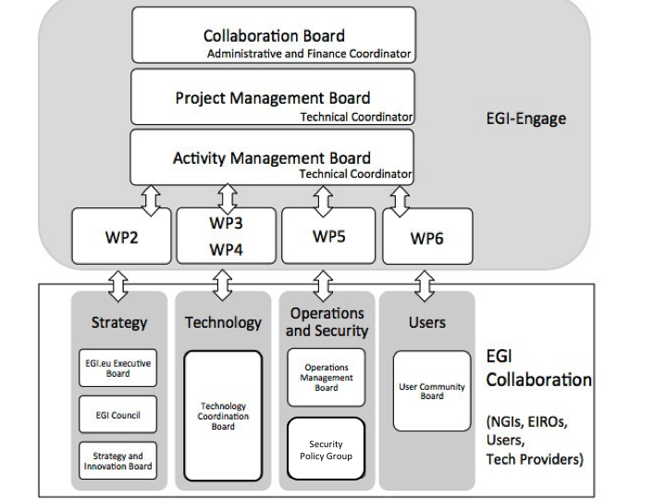
Figure 3: Relationship between the EGI-Engage management structure and the EGI Boards

- Structure of governance bodies
Body | Composition | Meeting | Decision making and voting | Minutes
Council | The core participants of the Council consist of national based e-Infrastructure federations called NGIs.  Countries (be they EU member states, associate countries or third countries – as recognised by the European Commission) may become members of the Council represented by the lead or other appropriate organisation within a given NGI.  International Research Infrastructures (e.g. EIROs, ESFRIs) may also become members of the Council where there is a legally recognised Intergovernmental Organisation such as an ERIC or an EIRO. | The Council meets at least twice a year, face-to-face: first within six months after the expiry of any financial year in order to adopt the annual account of the past year and then in the second six month period in order to approve the budget for the following calendar year.  The Council will furthermore meet whenever deemed necessary by the chairperson, or by two representatives of Participants or a member of the Executive Board.  Virtual meetings are not possible, only face-to-face meetings are envisioned. | Generally by consensus with a required quorum in some cases.  1 vote submission per representative (number of votes counted per submission differ by participation level). | In writing, to be signed by one appointed note-taker and approved by all partners.
Executive Board | The Council will appoint, suspend and dismiss the members of the Executive Board.  The Executive Board shall consist of minimally five (5) and maximally nine (9) members, currently comprised of 7 members. The members of the Executive Board are natural persons within EGI.eu. The Council determines the number of members of the Executive Board. | Regular virtual meetings (via telephone and web conferencing) will take place. These meetings will take place monthly.  The Group deliberations happen by face-to-face meetings, phone/video conferences or via the Group mailing list. | Generally by consensus  1 vote per representative | In writing, to be signed by one appointed note-taker and approved by all partners
Strategy and Innovation Board (SIB) | The Group is composed by 9 members. Membership should involve high-level representatives of the following sectors:  - Public research: 3 members  - Computing/Data: 2 members  - Big industry: 1 member  - SMEs: 1 member  - Policy makers/advisors: 2 members | Regular virtual meetings (via telephone and web conferencing) will take place. These meetings will take place monthly, however virtual meetings may be less frequent after the initial version.  It is also foreseen that there will be a face-to-face meeting at least annually (for example collocated with the EGI Conference/Forum).  The Group deliberations happen by face-to-face meetings, phone/video conferences or via the Group mailing list. | Generally by consensus  1 vote per representative | In writing, to be signed by one appointed note-taker and approved by all partners
User and Community Board (UCB) | The UCB is formed by:  - VRC representatives (via MoU)  - Large research communities representatives  - Competence Centre representatives  - Champions representatives | Regular virtual meetings (via telephone and web conferencing) will take place. These meetings will take place every 3 months. | Generally by consensus  1 vote per representative | In writing, to be signed by one appointed note-taker and approved by all partners
Operations Management Board (OMB) | The OMB is formed by:  - Operations Manager for each NGI and integrated/peer infrastructure  - Virtual Research Communities (VRC) representatives | Regular virtual meetings (via telephone and web conferencing) will take place. These meetings will take place once a month.  The Group deliberations happen by face-to-face meetings, phone/video conferences or via the Group mailing list. | Generally by consensus  1 vote per representative | In writing, to be signed by one appointed note-taker and approved by all partners
Technical Coordination Board (TCB) | The Technical Coordination Board has the scope of:  - Manage a forum of technology providers - sharing information on development plans, interest groups  - Discuss interoperability issues | Regular virtual meetings (via telephone and web conferencing) will take place. These meetings will take place once every 3 months.  The Group deliberations happen by face-to-face meetings, phone/video conferences or via the Group mailing list. | Generally by consensus  1 vote per representative | In writing, to be signed by one appointed note-taker and approved by all partners
Services and Solutions Board (SSB) | The SSB is formed by:  - Service Owners  - EGI ITSM Process Owners, mainly SPM, SLM, CRM and SUPPM  Appointed representative from the UCB, TCB and OMB (one per board) | Regular virtual meetings (via telephone and web conferencing) will take place. These meetings will take place once a month.  The Group deliberations happen by face-to-face meetings, phone/video conferences or via the Group mailing list. | Generally by consensus  1 vote per representative | In writing, to be signed by one appointed note-taker and approved by all partners
Security Policy Group (SPG) | The SPG is formed by:  - Participants and Associate Participants of EGI.eu | The Group will meet as often as the work requires but this will be at least twice per year, at least one of which will be face to face (ideally during the annual EGI technical forum)  The Group deliberations happen by face-to-face meetings, phone/video conferences or via the Group mailing list. | Generally by consensus  1 vote per representative | In writing, to be signed by one appointed note-taker and approved by all partners

NGI: Organisation representing a national e-Infrastructure which provides long-term distributed compute and storage resources for research and innovation
EIRO: European Intergovernmental Research Organisation
ERIC: European Research Infrastructure Consortium
https://documents.egi.eu/document/18
https://www.egi.eu/about/EGI.eu/council_members.html
https://www.egi.eu/about/EGI.eu/
https://documents.egi.eu/document/2669
http://www.egi.eu/services/catalogue/fitsm/index.html

