D2.6 First Service roadmap, service portfolio and service catalogue
Lead Partner: | EGI Foundation
Version: | 1
Status: | Approved by EC
Dissemination Level: | PUBLIC
Document Link: | https://documents.egi.eu/document/3470

Deliverable Abstract
This report presents the first version of the EOSC-Hub service roadmap, the service portfolio and the service catalogue. The document also describes the service portfolio management process established within the project.

COPYRIGHT NOTICE
This work by Parties of the EOSC-hub Consortium is licensed under a Creative Commons Attribution 4.0 International License (http://creativecommons.org/licenses/by/4.0/). The EOSC-hub project is co-funded by the European Union Horizon 2020 programme under grant number 777536.
DELIVERY SLIP
Date | Name | Partner/Activity | Date
From: | Owen Appleton  Hilary Goodson  Luciano Gaido  Nicholas Cazenave  Anne Whiting  Mark Van de Sanden  Bjorn Backeberg  Gergely Sipos  Sergio Andreozzi  Malgorzata Krakowian  Matthew Viljoen | EGI.eu/WP2  EGI.eu/WP2  INFN/WP2  CINES/WP2  EPCC/WP2  SURFsara/WP2  EGI.eu/WP4  EGI.eu/WP3 WP8  EGI.eu/WP2  EGI.eu/WP1  EGI.eu/WP4 | 24/07/2019
Moderated by: | Małgorzata Krakowian | EGI.eu/WP1
Reviewed by: | Damien Lecarpentier  Diego Scardaci  Michelle WIlliams | CSC  EGI.eu  GEANT | 20/06/2019  02/07/2019  21/6/2019
Approved by: | AMB |  | 24/07/2019

DOCUMENT LOG
Issue | Date | Comment | Author
v0.1 | 19/10/2018 | Set up the document structure | Sergio Andreozzi
v0.11 | 04/12/2019 | Draft of introduction, executive summary, and plotting of sections | Hilary Goodson
v0.12 | 25/2/2019 | Inclusion of EOSC service portfolio services and external engagement | Bjorn Backeberg/Gergely Sipos
v0.2 | 15/4/2019 | Refinement of document structure | Małgorzata Krakowian
v0.21 | 22/5/2019 | Terminology, description of onboarding workflow, the Hub service portfolio contents added | Mark Van de Sanden, Hilary Goodson, Luciano Gaido
v0.22 | 19/05/2019 | Description of Portfolio contents, EOSC-hub Services Landscape, EOSC-hub Service and Portfolio management added, Portfolio roadmap | Luciano Gaido, Davide Salomni, Nicholas Cazenave, Anne Whiting, Hilary Goodson
v0.23 | 7/6/2019 | Portfolio roadmap provided | Mark Van de Sanden
v0.3 | 11/6/2019 | Re-structure of portfolios and terminology, edits of chapters 3, 4, 6, and introduction, and executive summary | Owen Appleton
v0.31 | 17/6/2016 | Portfolio roadmap agreed on | Mark Van de Sanden, Owen Appleton, Hilary Goodson
v0.32 | 18/06/2019 | Edits to chapters 4, 5 | Matthew Viljoen
v0.33 | 18/06/2019 | Finalization of all sections | Owen Appleton, Hilary Goodson
v0.34 | 19/06/2019 | Sent for external review | Hilary Goodson
v0.4 | 05/07/2019 | Implementation of corrections from external review | Owen Appleton, Hilary Goodson, Sergio Andreozzi
v.0.5 | 15/7/2019 | Implementation of further clarifications | Owen Appleton
v0.6 | 17/7/2019 | Clarifications on service portfolios | Owen Appleton
v0.7 | 18/7/2019 | Further clarifications on service portfolio concepts. | Owen Appleton, Damien Lecarpentier
v1.0 | 24/7/2019 | Final acceptance of changes, move to word | Owen Appleton

TERMINOLOGY
Please note, this terminology was originally based on https://wiki.eosc-hub.eu/display/EOSC/EOSC-hub+Glossary , but has been updated here in anticipation of later updates to the shared Glossary.

Terminology/Acronym | Definition
AAI | Authentication and authorisation infrastructure
EC | European Commission
EDI | European Data Infrastructure
EGI | Federated e-Infrastructure to provide advanced computing services for research and innovation
eInfraCentral | European E-Infrastructure Services Gateway, Horizon2020 project contributing to EOSC
EOSC-Hub | A project bringing together a range of service providers to create a ‘hub’ for EOSC and contribute to the Federating Core.
EOSC Portal Marketplace | A Marketplace of services at https://marketplace.eosc-portal.eu/ , contributed to EOSC-Portal by EOSC-Hub
EOSC Portal Catalogue. | A Catalogue of services at https://catalogue.eosc-portal.eu contributed to EOSC from the former eInfraCentral project.
EOSC-Pillar | EOSC-Pillar project, Horizon2020 project contributing to EOSC
EOSC Portal | (in short, “the Portal”): A web portal provided through a collaboration of EOSC-Hub, OpenAire and partners of the former eInfraCentral project to expose EOSC Services. Includes the EOSC Portal Marketplace and EOSC Portal Catalogue and other information,
EOSC Portal Operator | An organisation responsible for supplying one or more components of the EOSC Portal
EOSC Portal User | (in short, “the User”): Individual that primarily benefits from and uses the Portal.
EOSC Service Portfolio | Portfolio of customer and researcher facing services managed by EOSC-hub but including services from a wide variety of providers.
The Hub Portfolio | Portfolio of internal or provider-facing services offered by EOSC-hub. Used to empower and operate the Hub and offered to providers such that they can be integrated as components to add value to researcher facing services.
EOSC Service Provider | A specialization of an EOSC Resource Provider
EOSC Service Management System | Entirety of interconnected policies, processes, procedures, roles, agreements, plans, related Resources and other elements needed and used by a Service Provider to effectively manage the delivery of services to EOSC Customers
ERIC | European Research Infrastructure Consortium
ESFRI | European Strategy Forum on Research Infrastructures
EUDAT CDI | EUDAT Collaborative Data Infrastructure
FAIR | Guiding principles to make data Findable, Accessible, Interoperable, and Reusable
FitSM | A family of standards for lightweight IT service management
SPMT | a specialist web tool designed to allow for better management of the EOSC Service Portfolio
Thematic services | Scientific services (incl. data) that provide discipline-specific capabilities for researchers. (e.g. browsing and download data and apps, workflow development, execution, online analytics, result visualisation, sharing of result data, publications, applications)
Common Services | Generally technical and human services which are of use to support a wide range of research disciplines. Can support or be integrated in multiple thematic groups and services.
WP | Work Package

Contents
1 Introduction 8
2 Context, Scope and Ambition 10
2.1 Defining Services, Portfolios and Catalogues 10
2.2 Contributing to the development of EOSC 10
2.3 Transit to a mature EOSC 12
3 EOSC-hub Services Landscape and evolution 14
4 EOSC hub Service and Portfolio Management 18
4.1 The EOSC hub Service Management System 18
4.2 EOSC hub Process model 18
4.3 Scope of Portfolio management 19
4.4 Portfolios, Catalogues and Listings 20
4.5 Tools 21
4.6 Methodology and Governance 21
4.7 Maturity of services within the EOSC Service Portfolio 23
5 Portfolio contents 24
5.1 The Hub service portfolio 24
5.2 EOSC service portfolio 30
6 Service roadmap 37
6.1 Experience in comparison to the EOSCpilot Portfolio Roadmap 37
6.2 EOSC-hub Service Roadmap 41
7 Planned actions to improve Service Portfolio Management 43
7.1 Immediate steps 43
7.2 Short term goals 44
7.3 Medium-term plans 45
Appendix I. Service Maturity Categorisation and TRL levels 47
Appendix II. Initial description of Hub Portfolio services, descriptions and components 49
Appendix III. Initial contents of the EOSC Service Portfolio 51

Executive summary
EOSC-hub is a key project in the formation of the EOSC landscape, and a first large scale attempt to collect, list, federate, manage and deliver EOSC-level resources from a wide range of providers and sources. It acts as a ‘beta’ version of the long terms’ structures imagined for EOSC, and hence while its outputs are not the final EOSC structures, it is expected that they will be adopted as or provide a major input to these long-term structures. Hence the project must simultaneously consider the project lifespan and its need to deliver short- and medium-term successes but also build for larger, long-term benefits and models.
To support this, EOSC-hub deploys an effective Service Management System based on the FitSM standard for IT Service Management, which includes Service Portfolio Management as a key and highly strategic process. It collects internal and external processes into the Hub Portfolio, which is a proposed contribution to the Federating Core. The Federating Core is complemented by the EOSC Service Portfolio which provides additional added-value services (common and thematic) which exploit the Federating Core and are discoverable, selected, customised and instantiated through the EOSC Portal, to address the needs of specific user communities. The external services are then exposed to customers and users through various catalogues, notably the EOSC Portal Marketplace, which is part of the collaborative EOSC Portal, developed and operated by EOSC-hub along with other cooperating projects and stakeholders.
Both portfolios are governed and managed with appropriate project structures, which fulfil their immediate purposes but must also be designed to transit to and integrate with long-term EOSC structures at a later date. They are supported by effective tools and are moving toward greater automation which will improve customer and providers experiences.
An initial service roadmap envisages increasing maturing of the portfolios, improved management structures and increasing integration of external services with internal service components to offer greater value to providers and a Minimum Viable Ecosystem for researchers, where there are real benefits to using services via EOSC rather than directly. Ultimately EOSC-hub targets a moderate average level of integration of internal and external services through a ‘service package’ paradigm, where additional requirements and rules are imposed on providers based on which internal services they wish to integrate with. This ultimately supports a multi-speed; hybrid model where different services integrate to different levels depending on their maturity and particular characteristics creating the basis to develop an EOSC tiered partnership schema. Finally, this vision is advanced by a set of short- and medium-term actions within the EOSC-hub lifetime which support it.

Introduction
The European Open Science Cloud (EOSC), as described in the EC Communication on the European Cloud Initiative, aims to ensure that European scientists can tap into the full potential of data-driven science. It is a process that brings scientific users, research funders and implementers together to form a digital environment where researchers can find and access well-managed research data, employ advanced analytical software, and learn about the best data-driven science practices globally and across research disciplines. The vision to achieve EOSC is ambitious in respect of paradigm shift, but also in terms of its timescale. EOSC aims to change the way we do science by advancing the adoption of FAIR-principles, i.e. making research data findable, accessible, interoperable and re-usable. The timeline for this change was set in the European Commission’s April 2016 Communication on the European Cloud Initiative, as a part of the Digital Single Market Strategy. In his speech “Open science: share and succeed” in Amsterdam, in 4 April 2016, Commissioner Carlos Moedas formulated the vision for EOSC as follows: “By 2020, we want all European researchers to be able to deposit, access and analyse European scientific data through a European Open Science Cloud."
The EOSC-hub project supports the implementation of EOSC by contributing to the action lines defined in the Commission Staff Working Document on the Implementation Roadmap of the European Open Science Cloud, released in March 2018. The project is a key instrument to achieve advances in action lines of (a) architecture, (b) data, (c) services, (d) access and interfaces, and (e) Rules of Participation. EOSC-hub is intended to federate existing and future data infrastructures and services, to develop “glue” services that further interoperability, to advance good data stewardship, and to steer all these efforts toward the needs of researchers. In order to complete this, EOSC-hub builds upon the achievements of the preceding EOSC pilot project and capitalises on mature processes, policies and tools from the European federated e-Infrastructures, such as the EGI Federation, EUDAT CDI, and INDIGO-DataCloud.
EOSC-hub will enable different kinds of Users, with different skills and interests, to discover, access, use and reuse of a broad spectrum of EOSC Resources (services, datasets, software, support, training, consultancy, etc.) for advanced data-driven research through the provisioning of access to integrated and composable products and services from the EOSC Catalogue. Ultimately it will facilitate the composition of services and products to support multi-disciplinary science for example with high-level generic or community-specific interfaces for running workflows involving EOSC services.
This document is concerned with how the services EOSC-hub supports are identified, described, listed, managed and exposed to customers, both internal and external. This includes the generation of new internal services and on-boarding of external ones.
EOSC-hub collects both internal and external services into portfolios, both of which began from the initially envisaged services in the EOSC-hub proposal. These in turn came from the project partners, either from the major communities in the EGI Federation, EUDAT CDI, INDIGO-DataCloud communities, or the thematic communities represented in the EOSC-hub thematic services and competence centres.
After the introduction, the document begins with an overview of the context scope and ambition of the EOSC-hub Service Portfolio management. We then introduce the Service Landscape of EOSC Hub, before moving into Service Management, and how Service Portfolio management sits within it. The following section looks at the content of the portfolios, before we present an initial Serviced Portfolio Roadmap, and some planned actions to move forward.

Context, Scope and Ambition
"This deliverable aims to improve the organisation of ideas and concepts that are already available and used in a non-consistent way in the context of EOSC. In this work, it considers the output of the EOSCpilot project (The EOSC Glossary), and knowledge that the context is evolving, therefore improvements are needed alongside with the work on the implementation of the EOSC. Therefore, we must try and set out for this document what we mean in various cases, especially since we deal with external groups with their own terminology.

Defining Services, Portfolios and Catalogues
For the purposes of this document, we will adopt the definitions for these key terms from the FitSM standard, which were also used as a source for the EOSC Glossary.
Service: A way to provide value to a user / customer through bringing about results that they want to achieve
Service Portfolio: Internal list that details all the services offered by the service provider (those in preparation, live and discontinued.
Service Catalogue: User/customer facing list of all live services offered along with relevant information about these services
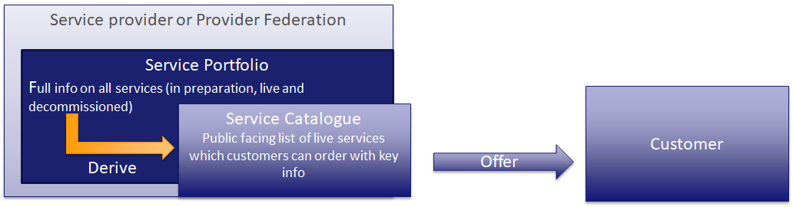
Figure 1 Service portfolios and Catalogues
For the purposes of this deliverable, we see a Marketplace as containing a Service Catalogue and other enriching features.
EOSC-hub intends to create, together with others, a Service Portfolio, derived public facing Service Catalogue and Marketplace through which the Catalogue is exposed, which offer a range of services, at a range of degrees of integration.

Contributing to the development of EOSC
EOSC-hub is the largest implementation effort among a raft of projects which have been co-funded by the EC to contribute to and help build EOSC from an idea to a functioning part of the European research landscape. While we play an important role and generate real-world experience, we are not the only project or point of view involved. Here we capture some of the closely related projects in the area.
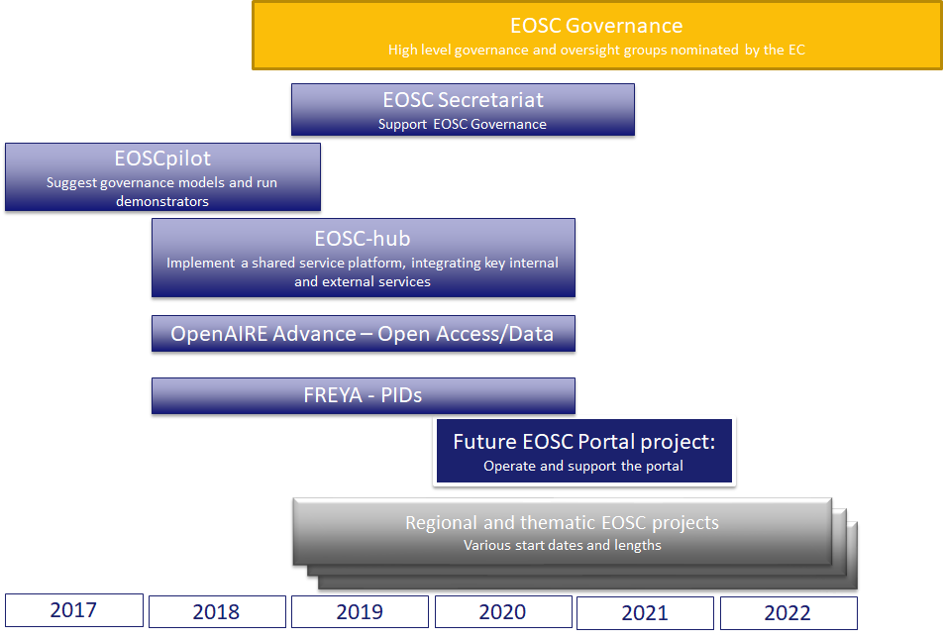
Figure 2 Selected projects and entities in the EOSC development process

EOSCpilot began this work with a set of landscape analyses and roadmaps on various topics, as well as demonstrators to show the viability of the EOSC concept in practice. EOSC Secretariat provides support and assistance to the EOSC Governance, which is defined by the European Commission, and includes the EOSC Executive Board and the Working Groups under it.
A future project to consolidate and scale-up the EOSC Portal and its underlying service platform as well as other EOSC-supporting activities under INFRAEOSC-06 is proposed to take on this shared platform (initially shaped, developed and operated by EOSC-hub in collaboration with eInfraCentral, OpenAIRE and EOSCpilot) to provide an increasing portfolio of high quality standard compliant and interoperable services, reinforce the role of the marketplace as the access channel to integrated, composable and reliable services, attract more users and ensure its long-term sustainability, while a raft of new projects on regional or thematic EOSC initiatives are in preparation or recently begun.
Within this, EOSC-hub provides the practical deployment and transition of the existing services from several core providers (the EGI Federation, EUDAT CDI and Indigo DataCloud, as directly involved in the project, but also other relevant e-infrastructures in Europe like GEANT and OpenAIRE through the related collaboration agreements) as well as a huge range of community services to a working initial structure for an EOSC shared service landscape, including a Service Portfolio and public facing Service Catalogue. It supports multiple levels of integration to support different provider and usage patterns, foster service integration and composability, and is the first practical attempt at a ‘hub’ for EOSC with true operational services.

Transit to a mature EOSC
In the current landscape, EOSC-hub is the largest implementation platform for delivering EOSC services to the European research community. It brings together three sizable service communities, many research infrastructures and provides both internal services to empower the federated provider community and the external services which offer value to research communities. It aims to pave the way for the development and growth of the other EOSC service delivery projects, including regional and thematic efforts, currently launching.
EOSC-hub models its internal components after the entities needed to form the mature, sustainable EOSC, such that there is a direct mapping between them.
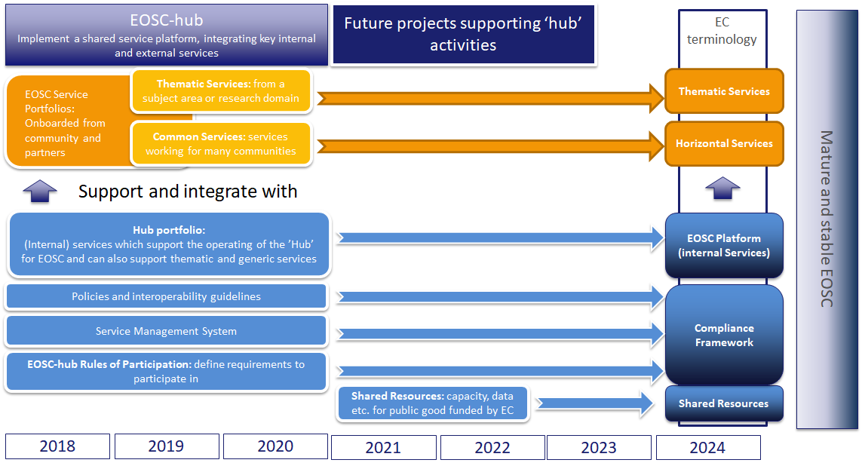
Figure 3 Mapping project outputs to elements of the future EOSC
The logic of EOSC-hub is that its outputs should be immediately useful to and adoptable by the longer terms EOSC structures, hence we do not design elements just for the project lifetime. We expect, under the guidance of EOSC Governance, that the major EOSC-hub outputs will be adopted by EOSC or will provide a significant input to the matching EOSC elements as source material, recommendations, initial population of portfolios and practical experience. While there will clearly be other inputs, in this way we are the ‘beta’ version of an operational EOSC that delivers services in a planned, manageable and researcher-focussed manner. EOSC Governance can then oversee the expansion of EOSC, building on these ‘hub’ elements through the projects, initiatives and new entities which follow. This is captured in the figure above.
As an example of this transition, the EOSC-hub Service Management System is an IT Service Management structure used to manage the internal services (called the Hub portfolio) and to support various levels of integration of the external services (called the EOSC Service Portfolio).
A Service Management System (SMS) is typically a long term, internal structure for a service provider or provider federation, to support effective management and delivery of their services. Normally, it would not make sense to deploy an SMS for a project but here the intention is that the SMS is adopted or absorbed by the longer term EOSC efforts, such that they can be professionally delivered. Adding an SMS later is typically very difficult with a high failure rate, so deploying it from the start of the EOSC service delivery phase makes sense. The EOSC-hub SMS can therefore be seen as the candidate or initial EOSC SMS, with approval for this and other transitions being handled through the next phase of projects, and under the oversight of EOSC Governance.
The same applies to the other elements shown in the figure above. For the Compliance Framework, we see the work of the EOSC-hub Rules of Participation activity as an input to the Working Group on Rules of Participation being organised by the EOSC Executive Board, and have provided initial input to the WG RoP based on our experience trying to define Rules of Participation within EOSC-Hub. Equally the policies and technical interoperability guidelines would support long term onboarding of services to a shared portfolio and derived catalogue.
Similarly, the internal services in the Hub Portfolio are intended to provide long term internal structure and function to the EOSC federated landscape and enable the ‘Hub’ functions foreseen. The onboarded Thematic and Common (generic or horizontal) services are on boarded not just to EOSC-hub, but to the EOSC Service Portfolio which we expect to persist far beyond the project lifetime, but which can be taken on by successor projects or by new EOSC structures.
In this way, while we cannot guarantee that all EOSC-hub elements are simply the permanent solution for EOSC, we must proceed on the basis that they form at least a significant input for such permanent elements.

EOSC-hub Services Landscape and evolution
This section seeks to explain the current way services are described and understood, and how this situation arose, based on initial project plans and subsequent practical experience and community developments.
The EOSC-hub project mobilises providers from the EGI Federation, EUDAT CDI, INDIGO-DataCloud and major research e-infrastructures offering services, software and data for advanced data-driven research and innovation. EOSC-hub provides an initial integration and management platform for these early EOSC-supporting groups and a basis for later expansion to other providers and customers.
EOSC-hub tries not only to bring together the many service providers and federators in its consortium, but also to introduce an increased professionalism in how services are described, managed, integrated and delivered. This is achieved through instituting industry-standard best practices and management approaches from IT Service Management.
The initial model for EOSC hub described the various service types available using a Service Integration and Management (SIAM) model. Following the first IT Service Management Audit of the project, and considering the material coming from the commission services, there was a change to how these elements were communicated and grouped. The SIAM model and later mapping can be seen in the following diagram.
This led to the clarification and reorganisation of the services supported by EOSC-Hub into two groups, the Hub Portfolio and EOSC Service Portfolio.
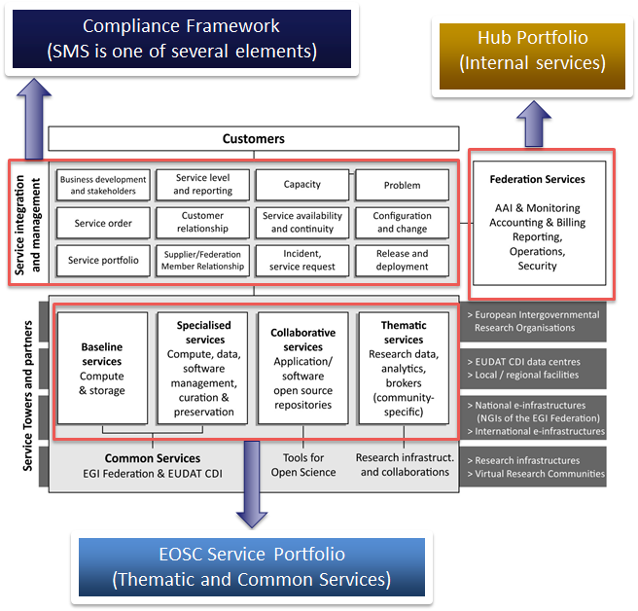
Figure 4 SIAM based description of EOSC-Hub services and elements from initial project plans.
The Hub Portfolio comprises the internal services which empower the core, provide a ‘minimum viable product’ for a federated service landscape for EOSC, and offer functionality to be integrated into or to support the services in the other catalogue. It maps to a component of the foreseen EOSC Federating Core mentioned by the EC. These are directly governed by EOSC-Hub, though the components that make them up are provided by project partners to the Hub.
The EOSC Service Portfolio contains services addressing EOSC customers; both single researchers and research communities. These currently include what EOSC-hub foresaw as thematic services from single communities and common services which can support many if not all research communities (these map the thematic and common services in the Federating Core).
An initial set of services for this portfolio came from the EOSC-hub proposal and EOSC-hub partners, as well as demonstrators from the EOSCpilot project. Further services have been onboarded from the wider community, and these are then exposed in the EOSC-hub Service Portfolio and through the EOSC portal Marketplace. After the end of the eInfraCentral project (June 2019), requests will still be managed in a collaborative manner as described in the EOSC Portal Collaboration Agreement with the idea of convergence to a single shared portfolio and list of services on the portal.
EOSC-hub exposes to the EOSC Service Portfolio a current list of orderable and potentially integrated services, but it does not own or govern these services, only currently governing the rules that allow for their inclusion in the portfolio. These rules are currently formed by the project in an open and permissive manner but will be adjusted to reflect the recommendations of the Working Group on Rules of Participation as these become available. This governance will later be shared with other EOSC Portal partners, and ultimately transferred to a long-term structure to be defined by EOSC Governance.
Following the Implementation Roadmap for the European Open Science Cloud, we mapped our components to the model these documents provide, including Thematic Services, Common services, and the Federating Core. EOSC-hub intendeds to contribute to all of these, with the EOSC-service portfolio including the thematic and common services, and the Hub portfolio being an element of the Federating Core. This is seen in the diagram below.
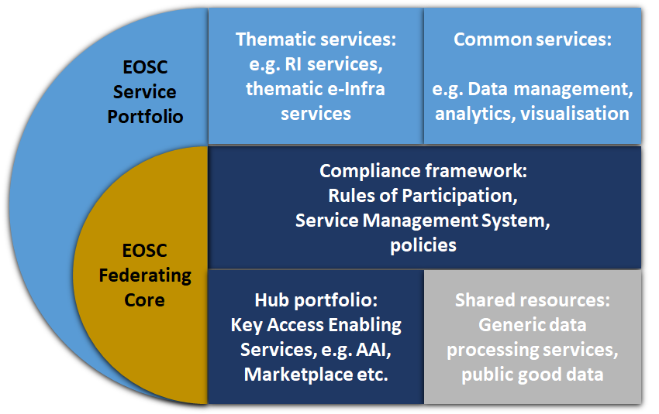
Figure 5 Mapping of EOSC-hub portfolios and elements to the EOSC model and EOSC Federating Core, from EOSC-Hub Strategy Deliverable D2.1.
Alongside the Hub Portfolio in the Federating Core there are two components foreseen, the Shared Resources and the Compliance Framework.
The ‘Shared Resources’ would comprise access to central research enabling services such as data sets of broad interest, centralised repositories, data processing facilities or other key resources of the Federating Core. At present this is an identified component but not yet an operational component, as denoted with the shading in the Diagram above. We expect these resources to be clearer based on the future decisions of the EC and of the approved projects in future calls.
The ‘Compliance Framework’ represents the policies, processes and Rules of Participation that define the scope of the EOSC potential interest to all customers. As in previous sections, we map outputs of the EOSC-hub project to this crucial element.

EOSC hub Service and Portfolio Management

The EOSC hub Service Management System
EOSC-hub seeks to ensure that not only are the services within the EOSC landscape valuable to research, but that they are also provided and managed in a professional, predictable and measured way. This entails a logical network of policies, processes and procedures that interact to generate managed services. The EOSC Hub Service Management System (SMS) is organised according to the FitSM standard for IT Service Management. FitSM was developed through an EC-funded project, specifically to accommodate the sorts of situation EOSC seeks to create. It remains compatible with commercial and traditional IT Service Management approaches such as ITIL and international standards like ISO-IEC 20000, but is better suited to the research sector.
The approach taken here is consistent with that recommended by the EOSCpilot project, we preceded EOSC-hub which recommended adoption of FitSM and a way of approaching management of services in EOSC.

EOSC hub Process model
The EOSChub SMS defines 14 processes needed to deliver managed services, adapted from the FitSM Process Model to fit EOSC-hub needs.
IT Service Management Process | Typical activities
Service Portfolio Management | Consider future services (to be under the control of EOSC-hub, in the Federating Core), plan and implement these services, given the strategic position of EOSC-hub. Manage the onboarding of thematic and common services to the EOSC Service Portfolio. Maintain Service Catalogues.
Service Level Management | Define, agree and monitor Service Level Agreements and their fulfilment for EOSC Platform services in the federating core. Assist EOSC Service Portfolio providers in defining their own SLAs
Service Reporting Management | Define, agree and produce service reports for customers and other groups, reporting on the degree of fulfilment of SLAs.
Service Order and Customer Relationship Management | Handle customer orders and manage relationships with customers, monitoring satisfaction, ensuring clear communication and that we are responsive to customer needs.
Supplier and Federation Member Relationship Management | Identifies suppliers and federation members and ensures that there is a designated contact responsible for managing the relationship and communication with each supplier and federation member. Monitors the performance of suppliers and federation members.
Service Availability and Continuity Management | Monitor and manage the availability of services in the Federating Core EOSC Platform. Ensure suitable continuity plans are in place to deal with serious service failures.
Capacity management | Ensure sufficient capacity is available (human and technical) to meet agreed service levels (from SLAs) for the EOSC Platform services.
Configuration Management | Manage collection and storage of information about all the assets (configuration items), technical and otherwise, that must be controlled in order to manage services effectively. Populate and manage the CMDB
Incident and Service Request Management | Respond to incidents where agreed service levels are not met, to restore agreed services, largely through a helpdesk support function.
Problem Management | Investigate incidents to understand underlying sources of service failure and degradation, maintain listing of temporary workarounds, while also seeking to remedy the underlying problems.
Information Security Management | Manage information security through setting Information Security policies, managing security risks and implementing security controls, whether they are technical or organisational.
Change Management | Manage changes to all configuration items needed to deliver agreed EOSC Platform services are appropriate service levels.
Release and Deployment management | Bundles agreed changes into releases, which can be tested together before deployment into production environments
Continual Service Improvement | Collect, prioritise, agree and plan improvements to services and the service management system.

These processes are supported by training, clearly assigned responsibility and the tools from the EOSC-hub Collaboration Software service within the Hub Portfolio.

Scope of Portfolio management
As mentioned in previous sections, the intention is that the SMS developed by the project be transitioned to the longer term EOSC structures. In any case, a Service Management System will be required to support the sort of federated operation and onboarding envisaged for EOSC. Without it, the challenge of coordinating such a wide range of entities and providing some measure of quality will not be easily possible.

The EOSC hub SMS aims ultimately to manage both Portfolios, though in different ways, as will be explained in later sections. For the Hub Portfolio, it is under the direct control of the SMS, as it is provided by members of EOSC-hub, or suppliers to EOSC-hub. The Hub Portfolio services must be tightly controlled, as they both support the operation of the Hub and of the federated service landscape, and also they are (to varying extents) integrated with the onboarded services which rely on them, so we must be able to tightly maintain their quality and control their operation.
For the EOSC Service Portfolio, the integration with the SMS should be lighter, but still important. All services should fall (to some extent) under the Service Portfolio Management process of the SMS, as they wish to be in the portfolio and derived catalogue. This implies some level of control and management of them, though it is by no means absolute. Beyond this, as onboarded services make use of increasing numbers of Hub Portfolio services to integrate with, they will touch on more SMS Processes and must comply to more policies and procedures. This is discussed in a later section and is overseen by the EOSC-hub Rules of Participation task force.
As a large number of services have already been onboarded, the scope of the SMS has already spread beyond the project, and is (in the spirit of EOSC-hub) operating as a working ‘beta’ version for a longer term EOSC SMS, depending on how the landscape develops and the decisions of EOSC Governance.

Portfolios, Catalogues and Listings
The Service Portfolio Management situation of EOSC-hub is a complex one, due to the multiple portfolios and actors. It is especially complex to describe how these portfolios are exposed to potential customers. We try to capture these in the figure below.
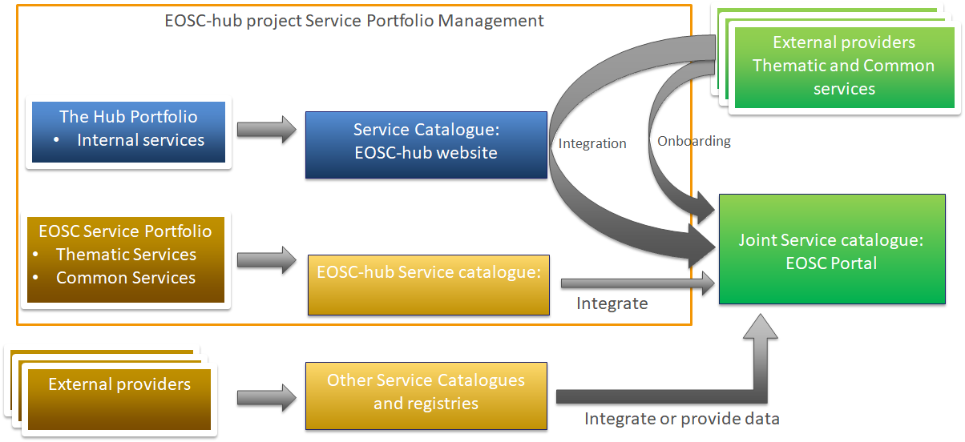
Figure 6 Catalogues derived from EOSC-hub portfolios
The Hub Portfolio is exposed as a Service Catalogue on the EOSC-hub website, showing the internal services provided, which may also be of interest to other service providers who wish to integrate with them.

The EOSC Service Portfolio services are exposed in a current catalogue on the EOSC-hub website, but it is then exposed as a marketplace on the EOSC Portal. Other groups also contribute to the EOSC Portal Marketplace, including OpenAIRE and eInfraCentral.
Finally, external providers who onboard to the EOSC Portal Marketplace (which is managed according to EOSC-hub Service Portfolio Management) include their services into the EOSC Portal Marketplace either by ‘onboarding’ which includes providing data, meeting minimal requirements and having their service validated, or may opt to integrate more fully with EOSC-hub components from the Hub Portfolio.
In line with the intention to converge on a single location for access to services through EOSC, and based on the collaboration agreements around EOC Portal, while EOSC-Hub will publish services on its own website, we see the EOSC Portal and the Marketplace which EOSC-Hub contributes to it as the main Service Catalogue and access point for the external services we support.

Tools
To manage both portfolios EOSC-hub is using currently EGI Confluence and Jira platforms. The project is planning to move the EOSC Service Portfolio to a Service portfolio management tool for service description together with EGI Confluence for supporting documentation e.g. procedures. The Service Portfolio Management Tool (SPMT) will ideally simplify interaction with providers, gathering and validation of information, and then simplify transfer to the EOSC Marketplace on the EOSC Portal.
In 2020, EOSC-hub will work to establish a collaboration with the project that will be funded under the INFRAEOSC-06 call to select, share and operate a common set of tools for the service portfolio management as a unique point of access to EOSC for service providers and service management according to the EOSC hub SPM process.

Methodology and Governance
The two initially scoped and current portfolios are subject to the same high-level service management system described above. However, the two components of the EOSC service portfolio The Hub service portfolio and the EOSC service portfolio have distinct management process and are implemented with different set of procedures and activities and managed under different governance structures.
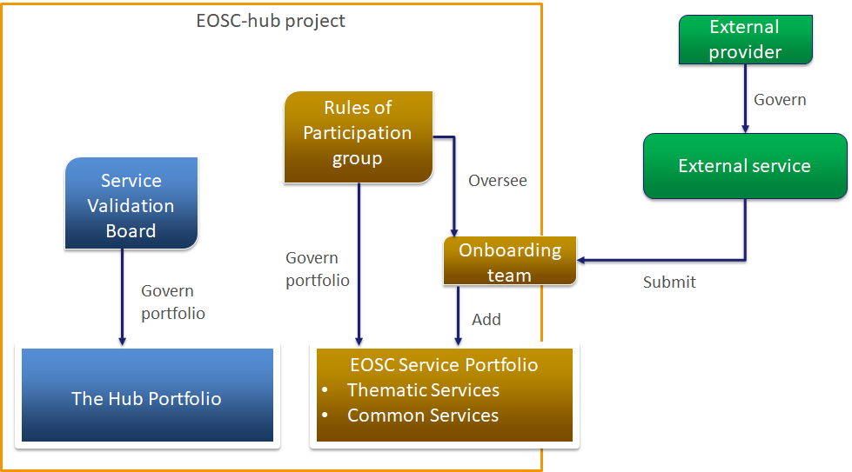
Figure 7 Governance of EOSC-hub portfolios
The EOSC-hub project is designed to provide technical elements for the EOSC, in particular the EOSC Federating Core. This is governed by the Service Validation Board (SVB), which considers additions, removals or changes to the Hub portfolio (and perhaps in future to Shared Resources as they develop). Governance is based on the needs of the EOSC community, the capabilities and capacity within EOSC-hub, and a strategic view on what services and components are needed for baseline operation of an integrated EOSC. The SVB is described in more detail in a later section.
The EOSC Service Portfolio, on the other hand, is governed by the Rules of Participation (RoP) group. This cross-work package group considers the basic requirement which must be placed on what services can be onboarded to maximise the availability and promotion of new services, but maintain coherent description of them, maintain and promote service quality.
The RoP then oversees the Onboarding team, which received requests to onboard external services from their providers, and then adds them to the EOSC Service Portfolio. However, the governance of these services remains the responsibility of the external service provider.
The RoP group also mirrors the structure and approach of the WG-RoP formed by the EOSC Executive board, which considers similar topics. EOSC-Hub will take input on rules from WG-RoP as they become available and is providing initial experiences from onboarding in EOSC-Hub to WG-RoP. Within EOSC-hub, the RoP group considers various kinds of rules:
- Technical rules: Requiring service providers to meet certain functional and operational capabilities.
- Managerial rules: Requiring service providers to exert certain levels of control or implement some basic level of Service Management
- Legal rules: Requiring the providers to meet compliance requirements (e.g. GDPR)
- Sustainability rules: Requiring some form of sustainability/continuity guarantees from the provider
The shaping of these rules requires inputs from other areas of EOSC-hub to ensure the strategy can be executed successfully. These areas include:
- WP1: Service Management system
- WP2: T2.2 Service roadmap, service portfolio and service catalogue and T2.1 Strategic direction
- WP4: Operations Coordination
- WP5: EOSC Marketplace and portal development
- WP10: Technical coordination
- WP13: Virtual Access
All services will be described in the service portfolio following an agreed template that is currently being defined and is moving towards convergence with other efforts like eInfraCentral to support joint work in the context of the proposed EOSC-enhance project.

Maturity of services within the EOSC Service Portfolio
In addition to levels of integration, onboarded services are provided at various levels of maturity. For EOSC-hub, we use the Technology Readiness Level system, as recommended by the EC, as one useful measure of maturity. These are detailed in Annex 1.
During the preparation stages of the EOSC-hub project, services initially considered for inclusion in the project were built on technologies deemed to be of TRL 8 or higher and addressing interoperability needs by promoting the adoption of open standards and protocols, as confirmed within Objective 3 of the Grant Agreement (No. 777536, EOSC-hub).
Services at TRL 8 are considered within EOSC-hub to be at a Production level, where it is made clear to users which functionalities are present and which are not, and users’ reasonable expectations of stability are met. Such services will have passed through the previous development states of proof-of-concept, pilot and pre-production, and will have successfully proven to users that the services are mature and fit-for-purpose for their target communities.
Since the launch of the EOSC Marketplace (and its later integration into EOSC Portal as the EOSC Portal Marketplace), there have been several services which have approached to join EOSC-hub at a TRL of 7. There has since been a re-evaluation of the original position, and services of this TRL are now accepted, but such services are listed only, in comparison to TRL 8 and 9 services, which are integrated and can be ordered directly through the EOSC Marketplace and EOSC Portal where appropriate. TRLs of services are also shows to research customers and users via the portal. We are considering requiring a clearly defined or time-bound plan for such services to advance to TRL8 to remain in the portfolios (and resulting Marketplaces). It may also be necessary to spell out on a more operational level what we expect at different TRLs. For instance, for a lower TRL an email-based helpdesk, maybe even an individual in some cases, may be acceptable. However, at a higher level, we would expect to see a ticket-based helpdesk that would allow tracking and analysis of incidents and service requests.

Portfolio contents
This section gives more details of the contents and governance of the two portfolios.

The Hub service portfolio
The ‘Hub portfolio’ contains services that are crucial technical elements of the Federating Core which must be sustained. We see it as a likely element of the e EOSC Platform mentioned in some EC documents, along with other crucial elements like the GEANT network )The Hub Portfolio contains the services which enable the federation, access, ordering, delivery, reporting and management of the researcher facing services and the shared resources. In addition, services in the EOSC Service Portfolio may choose to integrate with some of the Hub Portfolio services (e.g. make use of EOSC AAI rather than their own). The Hub Portfolio also includes the key access enabling services needed to operate EOSC. Such services are, for example, authentication and authorisation infrastructure, accounting, the EOSC hub Marketplace (also part of the EOSC Portal Marketplace), and other elements which enable the federation, access, ordering, delivery, reporting and management of research facing services and the shared resources.
Many of the services in the Hub portfolio originate from the technical components inherited from the EGI and EUDAT e-Infrastructures and the INDIGO-DataCloud project. However, they have been combined and enhanced to support federated operation of European-scale federated services, and to support professional management of these services. Therefore, they can support professional delivery of the federated service built on top of them.
These exist primarily to empower and operate the federated EOSC, but also offer integration opportunities for services from the EOSC Service Portfolio.

The Hub Portfolio contents
Services in this portfolio are essential for the existence of the Federating Core of EOSC, and try to present a minimal set of internal, enabling functions to allow for an integrated and value generating EOSC landscape.
An initial list of Hub Portfolios services, as envisioned in the EOSC-hub Description of Work is provided below, full details are available in Annex 2.
- EOSC hub AAI
- EOSC hub accounting
- EOSC hub CMDB
- EOSC hub collaboration software
- EOSC hub helpdesk
- EOSC hub monitoring
- EOSC hub operations portal
- EOSC hub service portfolio management tool
- EOSC hub Marketplace
- EOSC Portal (closely related to Marketplace, shared responsibility with other organisations)

Other services may be added the Hub Portfolio though the EOSC-hub Service Portfolio Management Process and via the Service Validation Board. These should be crucial components of the technical platform that enables EOSC-hub and the emerging EOSC Federating Core. More optional technical services would enter the project portfolios as Common Services (for instance, alternate AAI system for specific situations, file transfer systems for scientific data or other common research IT services) in the EOSC Service Portfolio.

Integration with the Hub Portfolio Services and EOSC Service Packages
The Hub Portfolio (as an expected part of the federating core) consists of services which are centrally offered to the benefits of the European stakeholders They serve two purposes, to empower the Federating Core or Hub of EOSC as a Minimum Viable Ecosystem (beyond a very basic list of services), and to offer integration opportunities for external providers. For the latter, this does not automatically mean that it is mandatory for Service Providers to make use of these potentially integratable services. The only minimum requirement for service providers to be part of the EOSC, as described in the introduction section, is to register the services in and comply to the basic Rules of Participation (RoP) of the EOSC Portal Marketplace, which are intended to be lightweight and achievable but support some level of shared quality, metrics collection and management of services.
EOSCPilot made suggestions on integration in their recommended EOSC Federated Service Management Framework. They lay out three models for integration: Service Promotion, Semi-integrated Service Management and Fully Integrated Service Management.
 | Service Promotion | Semi-Integrated Service Management | Fully Integrated Service Management
PR1 Service Portfolio Management | Individual service provider responsibility | Defined process for how proposed integrated services and/or service components are evaluated / managed | Single service portfolio  New or major changes are evaluated and managed
Figure 8 Excerpt of EOSCpilot mapping of SMS processes to federation models and scenarios
From the starting point of EOSC-hub, some of the partners and services being integrated were already working at the Semi-Integrated Service Management level, such as the EGI Federation services and EUDAT CDI services. Both groups already have shared processes in areas like configuration and incident management. A Service Promotion model would mean a lessening of value for these services and their customers, so at least Semi-Integrated Service Management needed to be supported, but equally could not be required for all providers. Equally, while Service Promotion was the lowest common denominator, it does not represent great value for Europe in an EOSC, as it would operate really as a listing with few opportunities to build and compose services, workflows and research structures on top of it. On the other hand, Fully Integrated Service Management cannot be a fixed goal, as it implies that EOSC fully manages all services even in the Early Implementation phase, and it seems unlikely that this will be true for all services.
At present EOSC-hub supports both Service Promotion and Semi-Integrated Service Management, with a general push to move those Service Promotion level upwards to higher integration where appropriate and useful. Fully Integrated Service Management is not yet in place or offered but may occur at some point for a subset of services, especially those owned and governed directly by EOSC, such as the foreseen Shared Resources.
From this starting point, based on experience, a tier-based scheme was developed as part of the EOSC Portal concept paper.
 | Entry | Standard | High
EOSC Provider benefits | > EOSC plays the role of demand aggregator  > EOSC is a platform to advertise Resources to a wide range of European-level target groups.  > The EOSC Resource delivery channel is directly managed by the Provider | > EOSC plays the role of demand and offer aggregator  > EOSC brings Customers and Providers together through a coordinated delivery channel | > EOSC plays the role of demand and offer aggregator, and of integrator  > Providers offload service integration and access management overhead to EOSC for one or more target groups
EOSC User benefits | > Discover from many Providers. They receive the service directly from the Provider.  > EOSC does not guarantee the actual service performance delivered, however service level targets are described in an SLA | Get support in obtaining the Resources they need from trusted Providers  > Quality of the received service varies within a certain range depending on the Provider of choice | > One entry point for placing their demands  > High level of trust  > Turn-key solutions and expert advice
Figure 9 EOSC benefits scheme in a tiered partnership scenario from the EOSC Portal Concept Paper.
Moving further forward, feedback suggested that this system might still be too rigid and might require providers to meet rules or integrate with services not of interest to them as they were in a tier with other things they did want to benefit from. This led to considering package-based integration.
The elements of the Hub Portfolio will be offered as service packages through the EOSC Portal and EOSC Portal Marketplace from which stakeholders can choose in line with their own objectives and roadmap. The other services packages are optional, therefore complying to the RoP of the optional service packages is also optional. Fig. 9 shows a simplified view of the EOSC Service Packages concept with an overview of the EOSC Service Packages available and under discussion. In general, the more services taken, the higher the degree and sophistication of integration and the greater requirements on the provider. For instance, in the figure below, while listing is the EOSC Portal Marketplace basic step for a service, this doesn't mean it must be orderable through it. To be orderable, additional information must be provided, to allow the customer to understand the order process, and the ordering must be connected to the backend of the Marketplace. This might involve, for instance, wither opting to use EOSC-hub AAI to authenticate customers and users with (for instance) the Check-In service, or alternatively to integrate a provider’s existing AAI with EOSC-hub AAI.
These options can be logically ‘packaged’ or ‘bundled’ based on experience and use cases. We foresee a common package to adopt would be the EOSC Helpdesk, which within it could mean either adopting an instance of the xGUS helpdesk EOSC-hub uses, which would integrate out of the box with the wider services, or again to integrate an existing helpdesk with xGUS, in either case imposing some set of requirements and Rules of Participation. As another example, if a provider wishes to use EOSC hub Accounting, to keep track of usage, it is required that they also adopt the EOSC-hub CMDB, which underlies the Accounting, to allow the accounting systems to access and understand usage data. The Accounting ‘bundle’ then imposes the requirements and Rules of Participation related to both EOSC hub Accounting and EOSC hub CMDB.
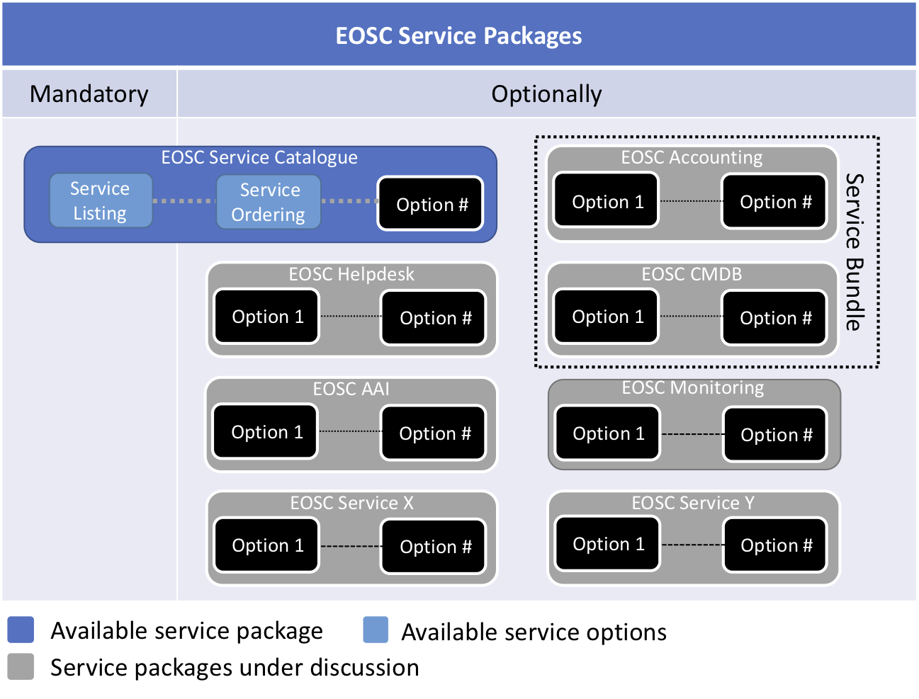
Figure 10 A simplified view of the overview of the EOSC hub Service Packages concept
In this way integration with Hub Portfolios services operates at two levels, by ‘service package’ (adoption or not of a service and accompanying rules) and by tier of integration’ (extent and manner of the integration). The intention is to offer providers as much value as possible through different degrees of integration, while not imposing rules on them unless it is needed in that particular situation.
Considering these different approaches, based on experience the most likely outcome, is a multi-speed EOSC, which supports different degrees of integration, with the hope that in order to support a Minimum Viable Ecosystem which still generates noticeable value, a moderate degree of integration is targeted where possible, with more and less integration possible depending on maturity, situation and other factors.

Governance and management of the Hub Portfolio
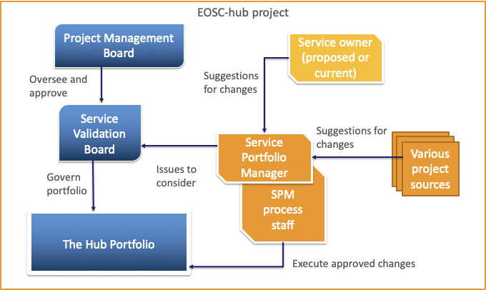
Figure 11 Roles and responsibilities in managing the Hub Portfolio
The Hub portfolio is under the responsibility of the Service Portfolio Management process within the EOSC hub SMS and is the operational responsibility of the Service Portfolio Manager. They receive requests or suggestions for alterations (adding services, changing existing services, removing services) from a variety of courses, including current or proposed Service Owners. They then channel these requests to the Service Validation Board
The Service Validation Board is intended to be a compact entity, as while it has a strong influence on changes to the portfolio, it does not have full responsibility to decide on changes. As, within the structure of EOSC-hub, major changes to the Hub portfolio are inevitably political and must relate to larger scale changes within EOSC, these major changes must be escalated to the EOSC-hub Project Management Board (PMB).
When a change is suggested or requested, the SVB will assess it, and decide if it is a minor change (which the SVB can approve or reject itself) or a major change (significant change to an existing service, addition or removal of a service). For these major changes instead the SVB will format a recommendation or a small number of options to be presented to the PMB. In either case, approved changes are then executed by SPM staff.
Practically, changes are documented through a Service Design and Transition Package (SDTP) which details potential new services (including a business case, technical factors, resource needs, roles and responsibilities, timelines and risks). SDTPs are also used to document changes to services or closing of services.
In the current structure the SVB operates at a project level, but in the longer term, beyond EOSC-hub, governance will have to operate at a higher level. This could involve either expanding the SVB to cover multiple groups agreeing a shared larger Hub Portfolio, or transfer of responsibility to new higher-level governance structures related to EOSC-Governance.

Procedures
Managing the Hub Service Portfolio includes two major procedures:
- SPM3 Add or Retire a service in the Hub Service Portfolio
- SPM4 Modify a service in the Hub Service Portfolio
The two procedures follow a similar pattern, someone proposes a change to the Service Portfolio Manager, who raises this in the Service Validation Board. Minor changes are decided here while major changes, including adding or removing services are escalated to the Project Management Board together with a recommendation or a small number of options for it to consider.
Changes are captured in new or adjusted Service Design and Transition Packages.

EOSC service portfolio
As noted above, the EOSC Service Portfolio includes the common and thematic and researcher facing services either provided by EOSC-hub partners, or on-boarded from the community. While partners may be involved, these services are not under EOSC-hub governance, and their level of integration with the Hub Portfolio (as part of the Federating Core) varies widely based on which service package and level of integration is selected.
These services are exposed in EOSC Portal Marketplace, see https://marketplace.eosc-portal.eu/ At present it comprises 71 services from 55 providers in 32 countries, with new services being progressively onboarded all the time, at around 1-2 per week.
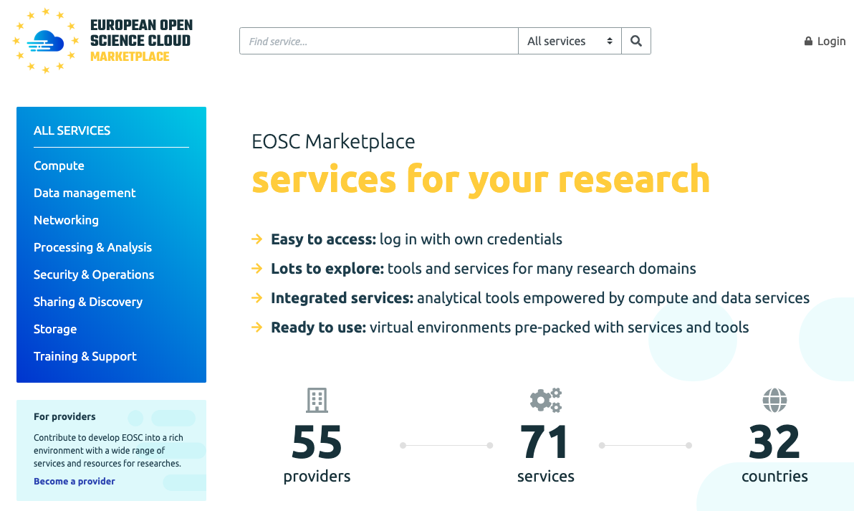
Figure 12 Screenshot of the front page of the EOSC Portal Marketplace (main Service Catalogue for EOSC Service Portfolios services)

Thematic and Common services
Within this portfolio, there are two broad categories of service, as well as various other categorisations by technology or field.
Thematic Services are those coming from a specific scientific or research domain, that provide value to researchers in that area. These are not expected to be under the management or responsibility of EOSC-hub. Rather, EOSC (and EOSC-hub in particular) improve access to them and support their composition with other thematic or horizontal services in order to build innovative analysis pipelines and structures.
These include research data, advanced data brokering and analysis capabilities for specific research communities and multidisciplinary research. An initial set of services serving Humanities, Physical Sciences, Earth Sciences, Biological Sciences, Medical and Health Sciences was included during the proposal preparation. This set is continuously extended with new services onboarded through the EOSC Portal.
Common services (also noted as Horizontal or Generic Services in some EC documents) are more technological than the thematic services and address focussed technical needs that are common to multiple research areas. Examples are visualisation platforms, reusable AAI components, data management platforms and other cross cutting services. Like the thematic services, they are not managed by EOSC-hub, but are accessible through EOSC-hub.

As previously discussed, both can offer various levels of connection to Hub Portfolio and offer some level of integration in how they are displayed, described, ordered and accessed with other EOSC services.
The initial services for the EOSC Service Portfolio are listed in Annex 3.

Current EOSC Service Portfolio entries
The EOSC Service Portfolio represents the aggregation of services that are provided to the research and scientific community in Europe and beyond. The portfolio will manage the information gathering and validation to properly describe those services in EOSC Portal Marketplace and other catalogues.
The content provided by EOSC-hub to the EOSC Service Portfolio is currently stored as a list of items in the Jira system. Jira forms part of the EOSC hub Collaboration Tools and empowers the EOSC hub Service Management System.
This list is made up of the initial services from the EOSC-hub plans and the many services onboarded through the project lifetime from external groups. As this list is dynamic, replicating it here is off limited value, hence the best way to view the current live services is the catalogue derived from this portfolio visible on the EOSC Portal Marketplace at https://marketplace.eosc-portal.eu/.
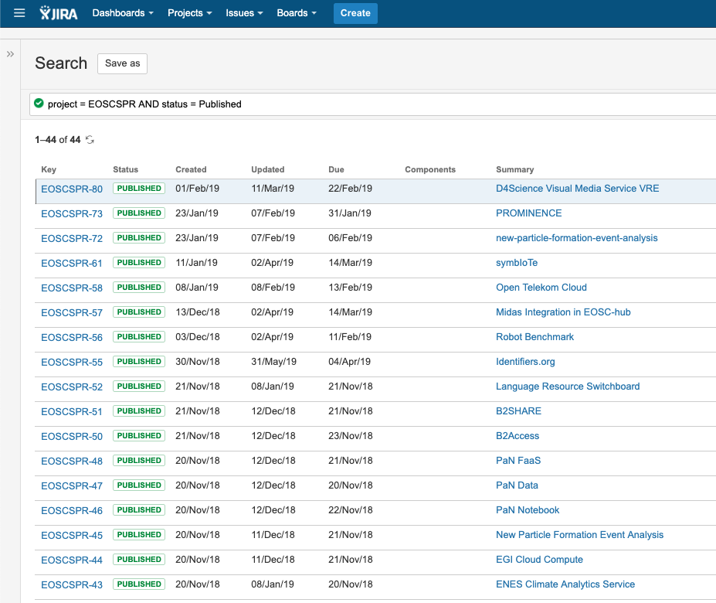
Figure 13 Screenshot of the EOSC Service Portfolio (internal) as held within the EOSC-hub Jira system
Being listed in the EOSC Portal Marketplace requires a Technology Readiness Level (TRL) of 7. In order to access order management and integration benefits, a service will need to be at a minimum TRL of 8. The benefit for TRL7 services is limited, but we have an expectation that EOSC-hub will push and support such services to increase their maturity level and be able to benefit from more of the value EOSC-hub generates.
Services are listed in the following categories:
Sharing & Discovery | Services to search and discover data, publications, tools and other resources useful for your research
Processing & Analysis | Software, platforms, tools, analytics and end-user applications offered-as-a-service or deployed-on-demand also specialised by discipline or research domain
Compute | Services to access virtual machines, containers and job processing to support your general computing needs
Storage | Service for storing your data
Data Management | Service to manage your data
Networking | Ultra-fast connectivity and ubiquitous access to eInfrastructures' resources and services you need
Training & Support | Grow your research knowledge and skills with specialised training or seek dedicated professional support for a wide range of scientific disciplines and research activities
Security and Operations | Services to integrate identity management, authorisation and other security services to comply with policies and regulations or access services to support the operations of your infrastructures and services
Figure 14 Categories in the EOSC Service Portfolio

Governance and Management
At a high level, governance and management of the EOSC Service Portfolio is a strategic process which EOSC-hub has initiated, but which is converging with collaborators through EOSC Portal (notably convergence of onboarding with eInfraCentral partners into a shared process). This process will eventually be transferred by EOSC-hub and collaborators to a location to be designated by EOSC Governance, potentially a legal entity supporting EOSC. Such transfer will be managed according to the IPR guidelines of EOC-hub and its consortium and grant agreements.
Practically, current governance and management of the EOSC Service Portfolio differs from that of the Hub Portfolio, as rather than strategically considering whether a service should be included, the default position is that services should be included if they meet minimum requirements.
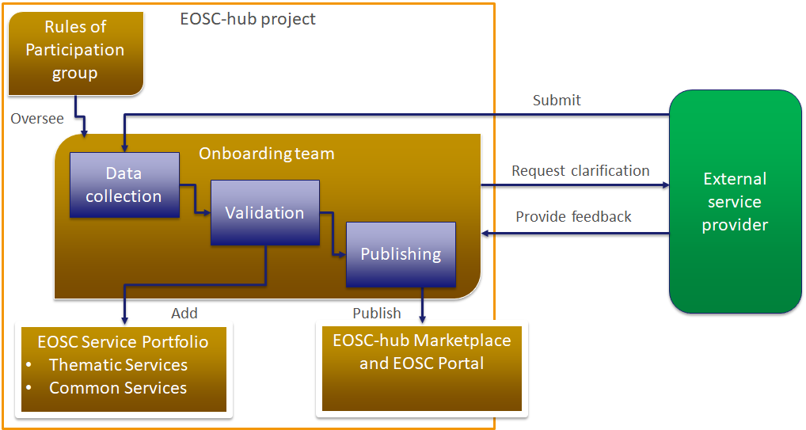
Figure 15 Current roles and responsibilities in managing the EOSC Service Portfolio
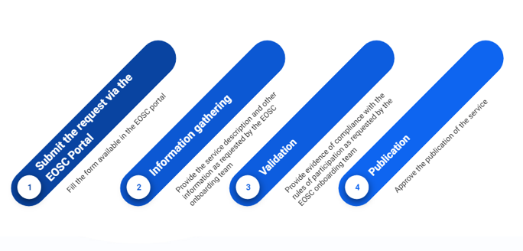
For the EOSC service portfolio, most tasks are handled by the onboarding team, which included members of WP2, WP4 and WP5, coordinated by the Service Portfolio Manager. New services submit a request and basic info to EOSC-hub, where it is directed to the onboarding team. Within the onboarding team there are three subtasks with different teams. Data collection is carried out by ‘Shifters’ who help populate the data in a service description template and seek feedback from providers. Validators then check the data for consistency and matching to EOSC-hub and later EOSC wide policies and requirements. It is then added to the internal portfolio and also moved to a publishing team who perform additional steps to publish the service on the EOSC Portal Marketplace, and other catalogues.
Figure 16 The current onboarding process at a high-level, as it is presented to potential service providers
The main governance step for the EOSC Service Portfolio is then setting the minimum requirements for inclusion. For the current situation, these were proposed within the Service Portfolio Management Process but are managed by the Rules of Participation Group within EOSC-hub. This group is made up from members of many parts of EOSC-hub and considers what requirements and limitations on providers are reasonable, realistic and contribute to a long-term high-quality portfolio of services. They also make decisions on exceptional cases and new questions arising from the onboarding process.
The Rules of Participation group shares a name (and broad goals) with the new Working Group on Rules of Participation set up within EOSC Governance by the EOSC Executive Board. In the medium to long term, the EOSC-hub Rules of Participation group will need to be transitioned to a more stable structure that can be expanded to cover the multi-project collaboration around EOSC Portal, operate after the project concludes or fed into the WG RoP. Already, the EOSC-hub RoP group has provided input to WG-RoP and awaits its initial recommendations.

Procedures
Managing the EOSC Service Portfolio includes two main procedures:
- SPM1 Add a service in the EOSC Service Portfolio
- SPM2 Change/retire a service in the EOSC Service Portfolio

These procedures are different to those for the Hub Portfolio as they also involve outside groups. In addition, in a typical SPM scenario, decisions on additions to a portfolio are made based on customer needs, organisational strategies, available capacity and competencies. Here, however, the default answer is to accept a new service, as it is not for EOSC-hub to determine if it is needed by a certain community. Instead EOSC-hub simply tries to ensure services meet minimum TRL and quality of service requirements and are adequately and consistently explained so that users can understand and benefit from them. Checking quality and service descriptions better enables services to be integrated with the EOSC federating core and the services in the Hub Portfolio.
SPM1 operates via a ticket-based system utilising JIRA, which is being used as an initial workflow tool that is intended to migrate to SPMT, a specialised tool for managing service portfolio entries in the EOSC Service Portfolio, SPMT. It is currently being tested and will be deployed later in the year.
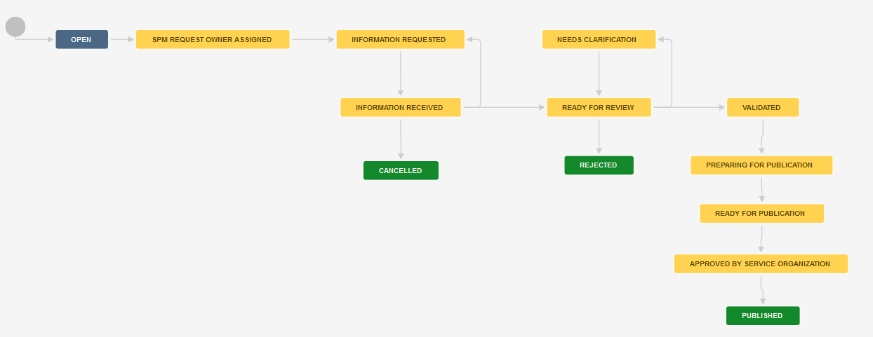
Figure 17 Workflow associated with SPM1 for on-boarding external services

Tools
The onboarding procedures have been set up with an initial set of tools to support the gathering of information, its validation and publishing. This currently includes properly coordinated information gathering and validation. The following tools are being used:
- The EOSC portal, including a request form to initiate onboarding
- A Service Description template used to gather information from the service provider, currently a word processing document, soon to be a spreadsheet.
- EGI JIRA, a task management system used to coordinate the work of the team responsible for information gathering and validation
- EOSC Portal Marketplace, a user-facing platform where services can be promoted, discovered, ordered and accessed. Other catalogues exist, as discussed in earlier sections, but this is considered the main catalogue at this stage.

Service roadmap

Experience in comparison to the EOSCpilot Portfolio Roadmap
The prior EOSCpilot project delivered an EOSC Service Portfolio Roadmap which makes a number of observations and recommendations. We take these as useful inputs to our approach and adapt them based on experience in implementing Service Portfolio Management in the EOSC-hub project.

The EOSC Pilot Portfolio Roadmap phase model
The figure below shows the EOSCpilot Service Portfolio Roadmap, from EOSCpilot D5.5.
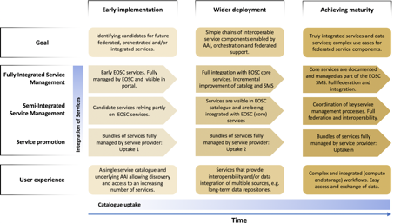
Figure 18 EOSCpilot Service Portfolio Roadmap
This defines three phases, which map to foreseen levels of integration. Service Promotion maps to Early Implementation, Semi-Integrated Service Management to Wider deployment, and Fully Integrated Service Management to Achieving maturity.
The model is an interesting one, and through EOSC-hub, demands for all three phases and levels have been seen. The main difference from the EOSC-hub experience, as previously stated, is that while the EOSCpilot roadmap implies a general desire and move of all services to the highest level of maturity and integration, we see a desire for a multi-speed EOSC landscape. We believe that services will and should be available through EOSC that vary in their management and governance, from those simply listed in the Service Promotion model, to those owned, managed and governed by EOSC (these may include the Shared Resources in the EOSC Implementation Roadmap Staff Working Document). The general outcome of discussions within EOSC-hub seems to be to accept Service promotion, to encourage migration to Semi-Integrated Service Management and to support Fully Integrated Service Management for selected providers and services. This multi-speed or hybrid model recognises the great diversity of services, experiences, maturities and goals of different countries, regions, research domains and technology groups. For instance, the High Energy Physics community which acted as a key early customer for European eInfrastructure has highly mature international relationships, and due to reliance on a small number of facilities like the Large Hadron Collider at CERN, an ability and drive to agree on shared technology and approaches. In comparison, the digital humanities sector, which joined the eInfrastructure landscape later, shows more fragmentation and will likely not be able to jump to higher levels of integration as quickly.
Overall, one underlying implication of the EOSCpilot Roadmap does stand out as very much valid, that greater levels of integration lead to greater value-add by EOSC over and above the constituent services within the EOSC ecosystem. However, the cost of the integration means that we will always have to balance this cost with the benefits it brings. A general policy of an ‘ever closer Union’, as underlies the European Union, will be balanced by the differences between provider and stakeholders as much as it is balanced by the differences between European states. Diversity of providers and customers moderated by easy and free flowing connection between them will empower a truly valuable EOSC.
Based on experience, the level model here evolved into the tier-based model discussed earlier, which is then further evolved into the package-based model of integration described in this document.

Addressing the EOSCpilot Service Portfolio Roadmap Recommendations
In this section we examine the High-level Recommendations of the EOSCpilot Roadmap versus our experience in EOSC-hub.
Recommendation 1 states that “Service Portfolio Management is an ITSM strategic process with high impact for all EOSC stakeholders. This process ensures that EOSC is able to cope with the demands and requirements from the customers. As such we recommend that EOSC Governance body takes close control/ownership of this process to ensure current and future business plans succeed. Strong service portfolio management and governance would assist the achievement of the European Open Science Cloud vision, especially in the context of bringing together the various thematic service catalogues of the multiple European implementation projects, with the potential to create a coherent and recognisable ‘catalogue of catalogues’, additional to the portfolio of services offering value across all disciplines.”
Service management has a governance and oversight function, but it seems likely that the operational part of Service Management and Service Portfolio Management must stay close to the operational level of service integration and delivery. Hence, the way to address this recommendation depends on the structure foreseen for EOSC and EOSC Governance. At present, it would seem prudent and effective for EOSC Governance to take on a governance and oversight role, perhaps effected through the new Working Groups, rather than a hands-on role in Portfolio Management. In future, if EOSC emerges as a more coherent and integrated structure, then moving Portfolio Management to it might well make sense, but at this stage it would likely be something like EOSC Operations as an entity linked to EOSC Governance. For this, the approaches seen in COBIT might be useful as a way to separate IT Governance from IT Service Management. However, the importance of Service Portfolio Management is not understated. It might be of interest to EOSC Governance to consider a Working Group on Service Portfolio Management or Service Management in general, either connected to or overlapping with WG Rules of Participation.
Recommendation 2 states that “A set of desired capabilities and associated services was identified from the EOSCpilot Science Demonstrators (as described herein). These should be addressed by the EOSC service roadmap to ensure the needs of representative communities are met, with particular emphasis on feasibility and design of automated orchestration between services (across infrastructural and geographic boundaries), which is where the real added value of EOSC is likely to lie.”
The initial setup of EOSC-hub included a number of key thematic services which, while not identical to the EOSCpilot science demonstrators, do also ensure that a wide range of points of view and services are supported. As in EOSCpilot, we see integration of these pilot provider groups to show the value add for integration and the resulting facilitation of automated orchestration or building of scientific workflows over these services. As stated above, this is then complemented by support for lower levels of integration.
Recommendation 3 states that “An agile EOSC Service Portfolio Management, much like agile project management, values that customers and service providers work more closely. It will ensure that EOSC offer provides the expected added value in this European competitive Digital Market. Furthermore, the final report and recommendations of the Commission 2nd High-Level Expert Group on the EOSC – ‘Prompting an EOSC in practice’, provides “considerations and pointers for the timely implementation of the EOSC, based around the concept of a ‘Minimal Viable Product’”, where a service (a product) should aim to have “just enough features to satisfy early customers, and to provide feedback for future product development.” Thus, we recommend that EOSC services (and notably all core/enabling services) should be managed following agile best practice methodologies, such as the core value concepts highlighted by the Agile Manifesto.”
Here experience from EOSC-hub has some relation to the recommendation, but also diverges from it. The four basic principles from the Agile Manifesto are:
- Individuals and interactions over processes and tools
- Working software over comprehensive documentation
- Customer collaboration over contract negotiation
- Responding to change over following a plan
FitSM (recommended by EOSCpilot and adopted by EOSC-hub), like all IT Service Management frameworks and standards, stresses a process-oriented approach, where processes are crucial to delivering a set of managed services. It is true that tools can be overemphasized in some models but FitSM already stresses that alongside processes, the other key element in ITSM implementation is assigning responsibility and roles. Individuals are highly important, in that roles are assigned to them, which they must perform, and their resistance to ITSM can make implementation extremely difficult, but individuals are not more important than processes in this regard.
Working services are more important than comprehensive documentation in a FitSM-based approach, but in as much as the services and processes working is the first priority, documentation must still occur to move beyond a fairly basic level of maturity. FitSM and Agile agree on the need of sufficient rather than excessive documentation, but it is important in both approaches to avoid this as a license not to document services.
Customer collaboration and contract negotiation should, ideally go hand in hand, but the point is perhaps related to the difference between delivering a software product and a service. Good Customer Relationship Management is required for ITSM and is a critical success factor for an effective SMS. Ideally, agreements with customers represent a way to understand their concerns and needs, which then allow for good collaboration with them, which then is reflected in updated agreements.
Finally, responding to change over following a plan presents risks in the context of an SMS. Within FitSM, and other ITSM approaches, plans are rarely fixed things, but rather are living documents which represent the current best understanding of the content they contain. ITSM is underpinned by a commitment to continual improvement and the PDCA cycle, which allows for a fusion of planning and responsiveness to change. They are not incommensurable approaches in this regard.
Agile represents a valuable and transformative approach in software development, and the new thinking behind it is certainly of value, but its applicability to ITSM and the SMS is evolving. It can be argued that FitSM is ‘Agile-like’ to a considerable extent, and already embodies the lighter weight, more iterative, flexible approach to managing services. Recommending direct appropriation and implementation for Agile for EOSC, however, may not be the optimal path. However, the concept of a Minimum VIable Product or Ecosystem is of interest. Here, we consider that some level of integration above “Service Promotion” is necessary to provide enough value to justify the costs of EOSC, and this is hence the general target for many if not most onboarded services.
Recommendation 4 states that “A resilient set of non-user facing services, i.e. internal EOSC services, must be federated and or well- integrated, before offering them to the community at large via the EOSC Service Registry. The development of services, by researches and service integrators, aiming to integrate service components by EOSC, need to rely and trust on mature EOSC services. Service providers can continue publishing existing services while waiting for a mature internal EOSC services set.”
This recognises the difference between the EOSC Service Portfolio and Hub Portfolio mentioned many times through this document. However, it suggests the Hub Portfolio services must achieve maturity before they are offered for integration. In some cases, these services, while new, are already mature as they are based on highly mature components from the groups that came together to form the EOSC-hub consortium. It is certainly correct that the Hub Portfolio services should be reliable before we ask providers to rely on them by integrating them, but equally we require the assistance of these providers in testing integration with Hub Portfolio services to make sure they reach this level of maturity. In addition, these services are typically needed for some internal operations of the Federating Core, as well as for integration with providers. In either case, their maturity and reliability are high priority for EOSC-hub.
Recommendation 5 states that we must “Recognise that the pace of service development will not align across all service providers. Reaching maturity and full integration with EOSC services, will happen at different speeds, and is dependent on multiple processes not controlled by EOSC nor its service management system. Researchers prefer reliability over interoperability and must be made aware of service deployment interdependencies.”
Here experiences closely match that of EOSC-hub, except that while the recommendation implies that all services may reach full integration, EOSC-hub experience suggests this might not be the case. A multi-speed hybrid approach seems highly appropriate, with Semi-Integrated Service Management being a goal for all onboarded services, and Fully Integrated Service Management a suggested and supported but not required next step.

EOSC-hub Service Roadmap
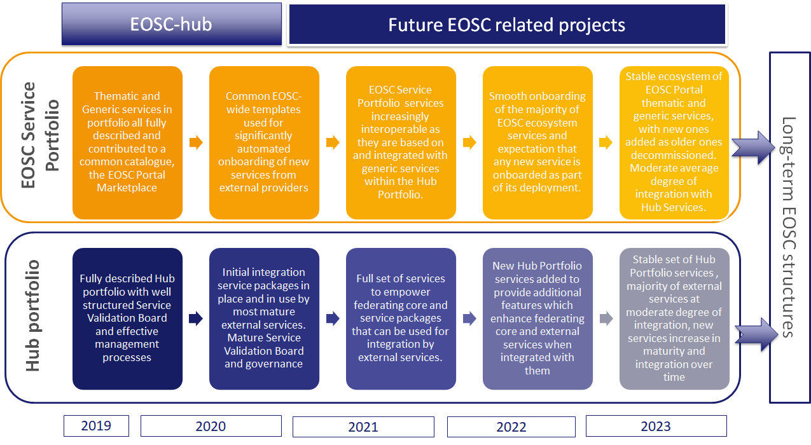
Figure 19 EOSC-hub Service Roadmap
The above figure represents a likely roadmap for EOSC-hub managed services in the two portfolios the project supports.

EOSC Service Portfolio
In the immediate term, the EOSC Service Portfolio captures all services in a consistent manner and converges into a common catalogue, through the EOSC Portal Marketplace. From this, by the end of EOSC-hub, a common format for describing EOSC Portal services is available and in use across multiple projects and groups. This allows for onboarding which is significantly automated and supports a base level of integration and service ordering for the services that wish to benefit from it. This means that following EOSC-hub, in the next raft of projects and initiatives which take on its work, services can begin to be effectively composed by customers, and EOSC begins to offer real added value beyond access to services. This shifts over time to a situation where services are onboarded rapidly by a wide range of groups, and onboarding is a normal event for new services arriving from projects across the EOSC landscape, including national services and those supported by a wide range of European Commission funded projects in many topic areas and DGs. Finally, by the end of the next phase of projects, there is a stable ecosystem with constant input of new services and natural attrition of those retiring as they no longer meet needs. Even at this stage, a range of degrees of integration (whether expressed as packages or levels) with Hub Portfolio services is seen, but the average level is a moderate degree of integration, with almost all services reaching this extent over time, and a significant number moving on to a tighter integration.

The Hub Portfolio
In the immediate term, the Hub Portfolio should be fully documented and detailed, and the Service Validation Board structured with clear Terms of Reference, supported by effective management processes. By the end of EOSC-hub, a range of Service Packages for Hub Portfolios services should be available and in use. In particular, the initial services in the EOSC-hub proposal should be making use of them. The definition of the Service Packages will facilitate the creation of a tiered partner schema. As the next phase of projects launch, there should be a full set of services which both are part of the Federating Core and are offered in packages to the external services in the EOSC Service Portfolio. These should support service and workflow composition by external services. Following this the Hub Portfolio should start to grow as new services are added that empower or facilitate new shared functionality in external services and new functions in the Federating Core. This should eventually lead to a fairly stable set of Hub Portfolios services which support a moderate level of integration and can be handed on to a long term EOSC structure.

Planned actions to improve Service Portfolio Management
Considering the roadmap and longer-term goals, the following sections set out actions EOSC-hub hopes to undertake during the project lifetime.

Immediate steps
In preparing this document, we identified some immediate needs for reflection or development, which must be addressed. Due to the delay of this document, we have a Milestone, M2.3 Service portfolio and service catalogue update, due almost immediately after this deliverable. We will use this Milestone as an opportunity to address these issues, which require wider consultation. These are briefly introduced below.

Review of terminology
The terminology used around service portfolio management is complex, as it attempts to bring together ideas from various projects, national initiatives and commission documents, created at different times. Prior attempts such as the Glossary produced by EOSCpilot were very useful but need to be updated as living documents. Many of the issues faced in creating a service portfolio roadmap relate to finding agreed common terms for entities in the landscape and agreed meanings for them.
We have engaged with former members of (the now concluded) EOSCpilot project to discuss their glossary, and we will discuss with other groups such as EOSCSecretariat how it can be maintained moving forward. In the immediate term, WP2 will make plans to do a first update of terms to reflect current thinking and new developments, with a view to agreeing a longer-term plan for maintaining the Glossary, perhaps connected to the future work on EOSC-Portal. This first update will be connected to M2.3, mentioned above, and will consider the use of terms such as ‘EOSC Service Portfolio’ and ‘Hub Portfolio’, as well as the definitions for Thematic and Common services.

Review and feedback on service portfolio roadmap and evolution
Because the EOSC-hub project works in a larger environment, involves stakeholders well outside the project consortium (e.g. providers of onboarded services) and also seeks to leave entities which are taken up after the project concludes to support a mature and effective EOSC, we must seek a greater level of review and feedback. In light of the issues raised in this document, we will seek feedback and input from wider and external communities on the ideas presented here as part of M2.3 and use this to guide future work including the planned update to this deliverable next year. Topics will include the terminology mentioned above, but also topics such as criteria for validating maturity, how internal services for integration are packaged and the onboarding process. This will occur in parallel to the related the convergence into EOSC Portal mentioned several times in this document.

Short term goals
These short-term goals for the EOSC-hub portfolios are focussed on improving and optimizing processes to make them more effective for providers and more efficient for EOSC-hub.

Onboarding workflow and materials
While the onboarding process is operational, there is considerable room for improvement in it at several levels. The current workflow is in the process of being tuned, with clearer responsibilities between the team's contributing to it and more descriptive names for some steps.
In parallel, there is a need to improve documentation for the onboarding process for all stakeholders: providers, shifters, validators and publishers. Current knowledge is held by the individuals doing the tasks and communicated verbally to new team members, but for effective processes and procedures, documentation is needed. It will also help to prepare and orient providers onboarding their services.

Service description alignment with eInfraCentral templates
Following a recent review of the EOSC-hub templates, a review of the new eInfracentral templates by EOSC-hub staff and a comparison of the two, EOSC-hub will soon release updated and improved service description templates. These aim to be more accessible to providers, easier to process for on-boarding staff and easier to publish in the EOSC Marketplace. The templates will also be adjusted to better serve as a specification for the move to a specialist stool for portfolio entries foreseen in the medium term.

EOSC Portal Collaboration agreement with eInfraCentral and OpenAIRE
In collaboration with eInfraCentral, EOSC-hub has been co-developing the EOSC Portal and Service Catalogue. The first version of the EOSC Portal and Service Catalogue has been launched during the EOSC Launch Event, held on the 28th of November 2018 in Vienna.
To sustain and plan the future development of the EOSC Portal and included Marketplace, the INFRAEOSC-06-2019-2020 call was published by the EC. To sustain the EOSC Portal and Marketplace and progress on the Portal development in the time between the EOSC Portal launch and the new project starts, EOSC-hub with key technical partners of eInfraCentral and OpenAIRE partners a collaboration agreement has been shaped. In the short term, EOSC-hub is currently finalising the collaboration agreement which covers a number of topics related to convergence into EOSC, including those relating to service portfolios. Details of the collaboration agreement are described in the medium-term plans.

Explaining partnership and integration levels
One challenge for EOSC-hub is how to promote (but not require) integration with Hub Portfolio tools by external providers in the EOSC Service Portfolio. We are currently defining the package-based approach, but this must be fleshed out and offered to providers in a simple way, which stresses the benefits and value of different packages. The goal is that external providers can easily see the different ways they can profit from Hub Portfolio benefits, but also understand the related rules they must then comply to. For this aim, we plan to define a tiered partner schema built on top of the packages model as described in the EOSC Portal concept paper.

Clarification of Hub Portfolio governance through the Service Validation Board (SVB)
As the project began with the Hub Portfolio prepopulated with components and services from the projects which preceded it, the control of the Hub Portfolio was a less tightly controlled task at first, as additions and removals were not immediately foreseen and did not occur, though some changes were managed. Now that we must clarify how we manage this portfolio, refine the procedures used and must build for the future and a lively EOSC landscape where new technologies will bring new Hub Portfolio services and components, we must define the terms of reference for the SVB so it can be a more sustainable entity.

Medium-term plans
Medium-term plans for the EOSC-hub portfolios concentrate on moving to more effective technical platforms, increasing automation and efficiency and moving forward with harmonisation with other efforts.

Migration to Service Portfolio Management Tool
The Service Portfolio Management Tool is a specialist web tool designed to allow for better management of the EOSC Service Portfolio for EOSC-hub and others. The intention is that it offers a platform where providers and members of the Federating Core and EOSC-hub can submit, review, improve, change and publish Service Portfolio entries. This then allows for automation in how the material is published on the EOSC-Portal and EOSC Marketplace. SPMT is under active development and testing and should be available in late 2019.

Convergence to a single shared ESOC Portal catalogue in support of a future EOSC Portal support project
A future project, due to start in 2020, will take over responsibility for the EOSC Portal, though it will still rely on elements of EOSC-hub for operation. In advance of this, greater harmonisation with the other parties contributing to the EOSC Portal must be achieved. This will be supported by signing the collaboration agreement mentioned in the short-term plans, but this must be followed by more practical actions.

The EOSC Portal collaboration agreement (covering July to December 2019) between EOSC-hub, key eInfraCentral technical partners and OpenAIRE focuses on:
- Operating the EOSC Portal and Marketplace services and providing first line and expert support for users and service providers
- Running and optimising the onboarding process to onboard services from service providers into the EOSC Service Portfolio through a shared onboarding process, developing documentation describing the onboard process, requirements, responsibilities and validation criteria for service providers and gathering usage metrics of the EOSC Portal and Marketplace
- Further develop and optimize the EOSC Portal and Marketplace, agree a single shared EOSC Service Description Template, define and develop a single-entry point for a Service Provider to register services and update the EOSC Service Portfolio API to register services in the Marketplace and other related catalogues
- Define and develop a single portal and entry point for the discovery of scientific products across different disciplines and research infrastructures (EOSC scientific product catalogues framework)
- Operate an editorial team for the content provisioning of the EOSC Portal and run a communication campaign to attract new service providers and to promote services and resources made available through the EOSC Portal.
A clear priority within this collaboration is to come to a shared template for the collecting of service description information between the different projects (EOSC Marketplace and EOSC Catalogue).

Appendix Service Maturity Categorisation and TRL levels
- Service Maturity Categorisation and TRL levels
The following is based on the Service Maturity Classification at
https://wiki.eosc-hub.eu/display/EOSC/Service+Maturity+Classification
This schema provides typical characteristics to help assess the service maturity of a service via the operational definition of the Technology Readiness Level (TRL) indicators: TRL, 7, 8 and 9. This is an attempt to create reasonably objective criteria that can be used in validating the maturity of services, given that the TRL is currently the measure used to determine whether a service is sufficiently mature to onboard. This is a current approach for a workflow which is still a work in progress, and further consultation will be undertaken through the Rules of Participation group on what criteria are used to determine maturity, and what other elements are required of providers, also in light of WG-RoP recommendations.
 | TRL 7 | TRL 8 | TRL 9
EC definition | System prototype demonstration in operational environment | System complete and qualified | Actual system proven in operational environment
Operational environment | Service has passed through development and is an advanced stage of pre-production: the software is stable, reliable and has been deployed in an operational environment
Documented | Functionality as required by the target users is documented, understood, validated with target sample users and accepted by them. Internal documentation exists regarding preliminary validation tests. | Service documentation for end-users exists and is made available
Service delivered | An assessment has been made of the required load of the system once the transition into production is complete and a plan has been made to service this load. This assessment has been documented. | Evidence that the service is being delivered in a way consistent with user expectations
Policy/SLA | An SLA is optional. | An acceptable use policy/terms of use/SLA is in place
Real users |  | There are users who are making real use of the service and rely on it for their work
Support |  | Provision is made for user support, with response to incident and problem management
Feedback from users |  |  | Customer feedback is gathered and documented. The service has been in a production state and relied upon by users for at least 1 year and evidence is provided to show this.  There are quantitative outputs as a direct result of the service usage

- Initial description of Hub Portfolio services, descriptions and components
The following table lists the services of the Hub Portfolio proposed by EOSC-Hub i.e. the services which constitute the federating core of the EOSC. This list is being reviewed to align with the needs of EOSC central activities and with the needs of EOSC Service Portfolio providers.
Service | Description | Service component
EOSC hub AAI | An AAI platform for federated authentication to services. Needed to access Federating Core elements but also can be offered to EOSC Portfolio service owners to mediate access to their services if they do not have their own AAI options. | - EGI Check-in  - B2ACCESS  - RC AUTH  - INDIGO IAM
EOSC hub accounting | The service stores and reports on accounting records from the services. | - Accounting portal  - Messaging brokers network  - Accounting repository
EOSC hub CMDB | Service for tracking the configuration items (assets) needed to operate the Federating Core and support the EOSC Service Portfolio. Provide sufficient configuration information for federated change management and service operation. | - GOCDB  - DPMT
EOSC hub collaboration software | The set of integrated internal collaboration software platforms, such as wikis, task tracking, meeting management and other tools needed to coordinate a geographically distributed and organisationally federated service landscape. | - EGI Jira  - EGI Confluence
EOSC hub helpdesk | A central point for Incident Management and issue tracking for Federating Core components. Can integrate support functions for EOSC Portfolios services if needed and agreed. | - xGUS (federated helpdesk)  - TTS  - GGUS
EOSC hub monitoring | Monitoring infrastructure to track services status and the deployed service versions. | - SVMON  - ARGO
EOSC hub operations portal | A portal supporting Service level management and Service reporting management. | - EGI operations portal
EOSC hub service portfolio management tool | A tool which facilitates the management of service definitions during the full lifecycle. | - Service portfolio management tool (SPMT)
EOSC hub Marketplace | A user-facing platform where EOSC services can be promoted, discovered, ordered and accessed. | - EOSC Marketplace for providers  - EOSC Marketplace for researchers
EOSC Portal | A portal with information about EOSC Services and a catalogue of available services. The catalogue is an integration of the EOSC-hub Marketplace. This service is the shared responsibility of EOSC-hub and OpenAIRE+, together with some members of the eInfraCentral project. | - EOSC hub marketplace

- Initial contents of the EOSC Service Portfolio
This initial list was provided as part of the Description of Work, and includes components and services which were later moved to the Hub Portfolio or are internal components of other services; it also includes the relevant enabling services and components for the technical Infrastructures brought into EOSC-hub by its partners, such as BDII, STORM, CREAM-CE, VOMS and ARGUS.
Service Name | Service Description
Common services: High-throughput computing, cloud compute, storage, data management and other specialised services from local, regional and national digital infrastructures in Europe
EGI High-Throughput Compute | High throughput computing service
EGI Cloud Compute | Infrastructure as a service cloud computing
EGI Cloud  Container Compute | Docker containers for cloud computing
EGI Checkin | EGI AAI service
EGI Workload Manager | Workload management service to distribute and centrally manage thousands of computational tasks on both cloud and HTC resources
EGI Online storage | Store data in a reliable and high-quality environment and share it across distributed teams.
EGI Data Hub | Access selected public datasets and efficiently consume them from EGI compute services
B2HANDLE | Persistent Identifiers management service
B2FIND | Metadata-based data discovery service
B2DROP | Secure and trusted data exchange service for researchers
B2SAFE | Distribute and store large volumes of data based on data policies
B2STAGE | Data transfer service between data resources and external computational facilities
B2SHARE | Service to store and publish research data
B2NOTE | Data annotation service
B2ACCESS | EUDAT AAI service
Onedata | INDIGO global data management system
ETDR | European certified Trusted Digital Repository
Sensitive  Data Service | European certified Trusted Digital Repository
Advanced IaaS | A set of common solutions ranging from Docker support for OpenStack and OpenNebula and on HPC clusters.
TOSCA for Heat | Support for TOSCA templates in the OpenStack heat component
OPIE | Open source implementation of preemptible instances extensions for OpenStack
BDII | Information system that collects information about distributed available resources in the HTC infrastructure
VOMS | Virtual Organizations Membership Service
ARGUS | Resources access policies service
SToRM | Interface to access distributed storage based on the OGF standard SRM
CREAM-CE | General interface to computing resources
IM | Infrastructure Manager is able to implement complex TOSCA Templates over heterogeneous cloud infrastructure
PaaS Orchestrator | TOSCA-based deployment orchestration on multiple IaaS
INDIGO Future Gateway | Generic web frontend to distributed computing resources such as grid, cloud and HPC.
uDocker | A basic user tool to execute simple docker containers in batch or interactive systems without root privileges
CVMFS | Application software distribution service
IAM | INDIGO-DataCloud AAI enabling service
WaTTS | Token translation service
TSD, ePouta | Service platforms for sensitive data
Thematic services: research data, advanced data brokering and analysis capabilities for specific research communities and multidisciplinary research. An initial set of services serving Humanities, Physical Sciences, Earth Sciences, Biological Sciences, Medical and Health Sciences is included.
ECAS | Climate Analytics Service (ECAS), provided by ENES
DARIAH SG | DARIAH science gateway tailored for the digital arts and humanities communities
OPENCoastS | OpenCoastS: On-demand Operational Coastal Circulation Forecast Service
GEOSS | GEO DAB (Discovery and Access Broker), GEOSS portal  Driven by the same KPIs of the EO Pillar services
EO Pillar | Earth observation services coordinated by ESA. The tools are: MEA, EPOSAR, Sentinel playground, Datacube analytic service, Geohazards exploitation platform, OSS-X Sentinel service
WeNMR | Structural biology services: DISVIS, POWERFIT, HADDOCK, GROMACS, AMPS-NMR, CS-ROSETTA, UNIO, FANTEN
DODAS | Dynamic On Demand Analysis Service
LifeWatch | PAIRQURS, Citizen science services, GBIF, Digital Knowledge preservation framework, remote monitoring and smart sensing.
CMI | The Component MetaData Infrastructure, including the Virtual Language Observatory and the Virtual Collection Registry, provided by CLARIN
Collaborative services: Open science platforms for sharing of research digital objects like scientific applications, pipelines and virtual appliances
AppDB | Virtual appliances and application software repository and management

COM(2016)178 final https://eur-lex.europa.eu/legal-content/en/TXT/?uri=CELEX%3A52016DC0178
Available: https://www.force11.org/group/fairgroup/fairprinciples
Definitions taken from FitSM-0: Overview and Vocabulary - http://fitsm.itemo.org/wp-content/uploads/sites/3/2018/05/FitSM-0_Overview_and_vocabulary.pdf
Involving EOSC-hub, OpenAIRE-Advance and key technical partners of eInfraCentral.
Implementation Roadmap for the European Open Science Cloud, Commission Staff Working Document, 14 March 2018, https://ec.europa.eu/research/openscience/pdf/swd_2018_83_f1_staff_working_paper_en.pdf
See https://eoscpilot.eu/sites/default/files/eoscpilot-d5.3.pdf
https://ec.europa.eu/info/funding-tenders/opportunities/portal/screen/opportunities/topic-details/infraeosc-06-2019-2020
See https://eoscpilot.eu/sites/default/files/eoscpilot-d5.3.pdf
See https://eoscpilot.eu/sites/default/files/eoscpilot-d5.5-v1.1.pdf pp25
Refer to Annex 1 of this document
See https://eoscpilot.eu/sites/default/files/eoscpilot-d5.5-v1.1.pdf PP 27
See https://agilemanifesto.org/
https://eosc-launch.eu/home/
https://ec.europa.eu/info/funding-tenders/opportunities/portal/screen/opportunities/topic-details/infraeosc-06-2019-2020
https://wiki.eosc-hub.eu/download/attachments/34637786/EOSC%20Portal%20Concept%202.0-pdf.pdf?version=1&modificationDate=1554371068919&api=v2

