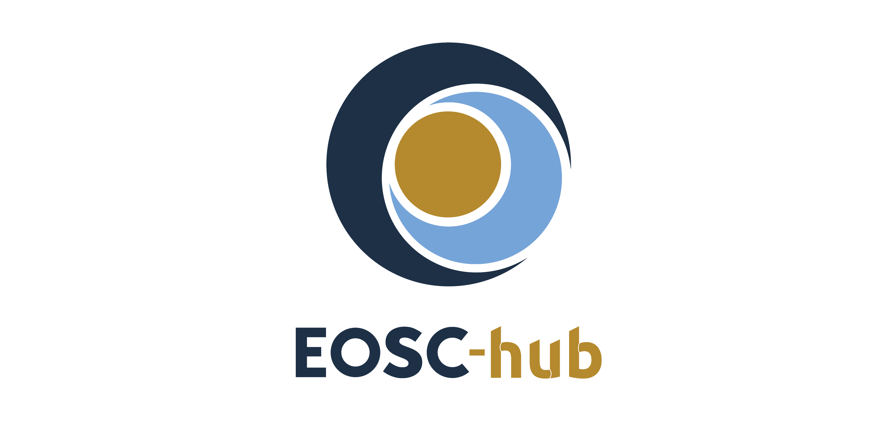

D2.2 Final EOSC-hub Strategy plan
Lead Partner: | CSC
Version: | 1
Status: | Approved by EC
Dissemination Level: | Public
Document Link: | https://documents.egi.eu/document/3469

Deliverable Abstract
This document constitutes the Final EOSC-hub strategy plan valid until the end of 2020. It explores the expectations of various stakeholders for EOSC and the assets that the EOSC-hub project can lend to EOSC in order to respond to these expectations. The document also discusses contributions of the EOSC-hub to the EOSC Governance Working Groups and recommends 15 strategic actions by which the EOSC-hub can facilitate the generation of a sustainable EOSC beyond 2020.

COPYRIGHT NOTICE
This work by Parties of the EOSC-hub Consortium is licensed under a Creative Commons Attribution 4.0 International License (http://creativecommons.org/licenses/by/4.0/). The EOSC-hub project is co-funded by the European Union Horizon 2020 programme under grant number 777536.
DELIVERY SLIP
Date | Name | Partner/Activity | Date
From: | Tiina Kupila-Rantala  Owen Appleton  Tiziana Ferrari  Hilary Goodson  Damien Lecarpentier  Dale Robertson | CSC / WP2  EGI.eu / WP2  EGI.eu /WP1  EGI.eu / WP2  CSC / WP2  JISC / WP2 | 26/06/2019
Moderated by: | Małgorzata Krakowian | EGI.eu/WP1
Reviewed by: | Anabela Oliveira  Steven Newhouse  Alex Vermeulen  EOSC-hub PMB Members:  Alexandre Bonvin  Franciska de Jong  Shaun de Witt  Daniel Mallmann  Marcin Plociennik  Arjen van Rijn  Per Öster | LNEC  EBI  ICOS-RI  WeNMR  CLARIN  UKAEA  Forschungs-  zentrum Jülich  PSNC  NOW  CSC | 23/06/2019
Approved by: | AMB |  | 28/06/2019

DOCUMENT LOG
Issue | Date | Comment | Author
0.1 | 17/02/2019 | Set up the document structure | Tiina Kupila-Rantala
 | 13/03/2019 | Preparation of the Interview guideline (Appendix III) | Damien Lecarpentier
 | 18/03/2019 | Appendices I, II and III inserted | Tiina Kupila-Rantala
 | 26/03/2019 | Comments of the EOSC-hub WP leaders’ strategy task force to the document structure adopted. Comments of Sergio Andreozzi to the Interview guideline adopted. | Tiina Kupila-Rantala
0.2 | 02/05/2019 | Draft of Chapter 2 | Tiina Kupila-Rantala
 | 07/05/2019 | Draft of Chapter 1 | Tiina Kupila-Rantala
 | 13/05/2019 | Edits to Chapters 1 and 2 | Dale Robertson
0.3 | 15/05/2019 | Draft of Section 3.1 | Tiina Kupila-Rantala
 | 20/05/2019 | Draft of Section 3.2 | Tiina Kupila-Rantala
 | 22/05/2019 | Section 3.2.4 inserted | Damien Lecarpentier
 | 22/05/2019 | Draft of Section 3.3 | Tiina Kupila-Rantala
 | 23/05/2019 | Edits to Chapter 3 | Damien Lecarpentier and Dale Robertson
0.4 | 23/05/2019 | Draft of Section 4.1 | Damien Lecarpentier
 | 24/05/2019 | Edits to Sections 3.1 and 4.1 | Tiina Kupila-Rantala
 | 27/05/2019 | Draft of Sections 4.3, 4.4 and 4.5 | Tiina Kupila-Rantala
 | 29/05/2019 | Description of the EOSC Federated Core provided, Section 4.2 inserted and Section 1.2 modified accordingly | Owen Appleton and Hilary Goodson, edits Tiina Kupila-Rantala
 | 29/05/2019 | Edits to Chapter 3 | Dale Robertson
0.5 | 30/05/2019 | Draft of Chapter 5 | Tiina Kupila-Rantala
0.6 | 01/06/2019 | Draft of Chapters 6 and 7, and edits to Chapter 5 | Tiina Kupila-Rantala
 | 02/06/2019 | Abstract and Executive Summary added | Tiina Kupila-Rantala
0.9 | 26/06/2019 | Edits to Chapters 1, 3, 4, 5, and 6 | Tiziana Ferrari
1.0 | 26/06/2019 | Comments of the reviewers and the PMB members adopted and the document finalised | Tiina Kupila-Rantala

TERMINOLOGY
https://wiki.eosc-hub.eu/display/EOSC/EOSC-hub+Glossary
“Glossary 1.0” denotes terms delivered from EOSCpilot Glossary v.1.0.
“FitSM” denotes terms derived from the FitSM standard.
Terminology/Acronym | Definition
AAI | Authentication and authorisation infrastructure
Archiver PCP | Archiving and Preservation for Research Environments, Horizon2020 project contributing to EOSC
ASTERICS | Astronomy ESFRI & Research Infrastructure Cluster
BBMRI | Biobanking and BioMolecular resources Research and Infrastructure – European Research Infrastructure Consortium
CERN | The European Organization for Nuclear Research
CESAER | A non-profit association of leading universities of science and technology in Europe
CESSDA | Consortium of European Social Science Data Archives
CLARIN | European research infrastructure for language resources and technology
CMS | The Compact Muon Solenoid, a general-purpose detector at the Large Hadron Collider
CORBEL | Coordinated Research Infrastructures Building Enduring LIfe-science Services
DARIAH | Digital Research Infrastructure for the Arts and Humanities
DEEP-HybridDataCloud | Designing and Enabling E-infrastructures for intensive Processing in a Hybrid DataCloud project, Horizon2020 project contributing to EOSC
DESY | The Deutsches Elektronen-Synchrotron (In English, German Electron Synchrotron)
DSM | Directive on Copyright in the Digital Single Market, also known as ‘DSM directive’
EaP | The Eastern Partnership, a regional and multilateral initiative between the EU and six partner countries in its immediate Eastern neighbourhood: Armenia, Azerbaijan, Belarus, Georgia, the Republic of Moldova and Ukraine.
EC | European Commission
ECRIN | European Clinical Research Infrastructure Network
EDI | European Data Infrastructure
EGI | Federated e-Infrastructure to provide advanced computing services for research and innovation
EIF | European Interoperability Framework
eInfraCentral | European E-Infrastructure Services Gateway, Horizon2020 project contributing to EOSC
e-IRG | The e-Infrastructure Reflection Group, a strategic body to facilitate integration of European e-Infrastructures and connected services
EISCAT | European Incoherent Scatter Scientific Association
ELIXIR | Intergovernmental organisation that brings together life science resources from across Europe
eLTER | European Long-Term Ecosystem Research infrastructures
EMBL | European Molecular Biology Laboratory
ENES | European Network for Earth System
ENPA | The European Network of Postdoctoral Associations
ENVRI | Community of the environmental research infrastructures, projects and networks
EO | Earth observation pillar of Horizon 2020
EOSC-Life | Project that implements the Life Science part of the European Open Science Cloud under coordination of ELIXIR, European infrastructure for Life Science Information
EOSC Nordic | EOSC Nordic project, Horizon2020 INFRAEOSC-5b project advancing the take-up of the EOSC at the Nordic level. The consortium members are research infrastructures and service providers Finland, Sweden, Norway, Denmark, Iceland, Estonia, Latvia, Lithuania, Netherlands and Germany.
EOSC-Pillar | EOSC-Pillar project, Horizon2020 INFRAEOSC-5b project coordinating and harmonising national and thematic initiatives to support EOSC in Austria, Belgium, France, Germany and Italy.
EOSC Portal | (In short, “the Portal”): The EOSC Service providing online access to and use of the EOSC Resources. [Glossary 1.0]
EOSC Portal User | (In short, “the User”): Individual that primarily benefits from and uses the Portal. [FitSM]
EOSC Resource | (In short, “the Resource”): Any asset made available (by means of the EOSC system and according to the EOSC Rules of Participation) to EOSC System Users to perform a process useful to deliver value in the context of the EOSC. EOSC Resources include assets like services, datasets, software, support, training, and consultancy. [Glossary 1.0]
EOSC Service | An EOSC Resource providing ready-to-use capabilities. EOSC Services are supplied by an EOSC Service Provider in accordance with the EOSC Rules of Participation for EOSC Service Providers. [Glossary 1.0]
EOSC Service Management System | (In short, “SMS”): Entirety of interconnected policies, processes, procedures, roles, agreements, plans, related Resources and other elements needed and used by a Service Provider to effectively manage the delivery of services to EOSC Customers.
EOSC-synergy | EOSC-synergy project, Horizon2020 INFRAEOSC-5b project expanding the capabilities and building the capabilities of EOSC. The consortium members are research infrastructures and service providers from Spain, Portugal, Germany, Poland, Czech Republic, Slovakia, the Netherlands and the UK. The project will also act as a bridge of EOSC towards South America.
EPOS | European Plate Observing System
ERAC | European Research Area Committee
ERIC | European Research Infrastructure Consortium
ESFRI | European Strategy Forum on Research Infrastructures
ESRF | The European Synchrotron Radiation Facility
EUA | The European University Association
EUDAT CDI | EUDAT Collaborative Data Infrastructure
EuroHPC JU | Joint collaboration between European countries and the European Union about developing and supporting exascale supercomputing
ExPaNDS | European Open Science Cloud Photon and Neutron Data Services, Horizon2020 project contributing to EOSC
eXtreme-DataCloud | eXtreme DataCloud – XDC project, Horizon2020 project contributing to EOSC
FAIR | Guiding principles to make data Findable, Accessible, Interoperable, and Reusable
FAIRsFAIR | Fostering Fair Data Practices in Europe project, Horizon2020 project contributing to EOSC
FREYA | Connected Open Identifiers for Discovery, Access and Use of Research Resources project, Horizon2020 project contributing to EOSC
GÉANT | Pan-European data network for the research and education community
GDPR | General Data Protection Regulation
GEOSS | Global Earth Observation System of Systems
Horizon 2020 | The EU Framework for Research and Innovation
HybridDataCloud | HybridDataCloud project
HPC | High-performance computing
ICOS | Integrated Carbon Observation System
IFAE | The Institute for High Energy Physics of Barcelona, Spain
INAF | Research institution in astronomy and space sciences, Italy
INDIGO-DataCloud | INtegrating Distributed data Infrastructures for Global ExplOitation
INFN | National Institute for Nuclear Physics, Italy
ITER | International Thermonuclear Experimental Reactor
LifeWatch | e-Infrastructure for Biodiversity and Ecosystem Research
LOFAR | Low-Frequency Array, a large radio telescope network
LNEC | National Laboratory for Civil Engineering, Portugal
NIS | Directive on security of network and information systems, also known as ‘NIS directive’
NI4OS-Europe | National Initiatives for Open Science in Europe project, Horizon2020 project contributing to EOSC
OCRE | Open Clouds for Research Environments, Horizon2020 project contributing to EOSC
OpenAIRE | Initiative to support the implementation of Open Access in Europe
OpenAIRE-Advance | OpenAIRE Advancing Open Scholarship, Horizon2020 project contributing to EOSC
PESTLE | Business analysis tool for assessing political, economic, social, technological, legal, environmental aspects
PRACE | Partnership for Advanced Computing in Europe
PSI | Directive on the re-use of public sector information, also known as the ‘PSI Directive’
RDA Europe 4.0 | The European plug-in to the global Research Data Alliance project
SMEs | Small and medium-sized enterprises
WeNMR | Worldwide e-Infrastructure for NMR spectroscopy and Structural biology
WP | Work Package

Contents
1 Introduction 9
1.1 Context 9
1.2 Scope and objective 10
1.3 Structure of the document 11
2 Methodology 12
3 External analysis: Factors influencing the construction of EOSC 14
3.1 A brief review on broad factors 14
3.2 Stakeholders’ expectations and interests 17
3.3 Summary of findings 25
4 Internal analysis: EOSC-hub assets for EOSC 28
4.1 Expertise 29
4.2 EOSC Federating Core 30
4.3 Capability to contribute to the design of a sustainable EOSC 34
4.4 Capability to contribute to the adoption of FAIR principles 36
4.5 Key exploitable results 37
5 EOSC-hub contribution to the EOSC Working Groups 39
5.1 Architecture 40
5.2 Rules of Participation 41
5.3 FAIR 42
5.4 Landscape 42
5.5 Sustainability 43
6 Recommended strategic action plan 45
7 Conclusions 48
References 49
Appendix I. The EOSC-hub Strategy Board and the ESFRI cluster projects 50
Appendix II. Interviews of EOSC implementation projects 51
Appendix III. The interview guideline 53
Appendix IV. Example of the use of EOSC Resources 56

Executive summary
This deliverable is part of the Strategy and Business Development Work Package (WP2) of the EOSC-hub project. It presents the final strategy plan for EOSC-hub covering the remaining project lifetime until the end of 2020. Since producing the First EOSC-hub Strategy Plan in 2018, several factors driving change have emerged that affect the EOSC-hub project and the European research arena in general. They include major reforms of legislation, such as the General Data Protection Regulation (GDPR) and a recent update of the public sector information (PSI) directive, but also significant developments in the second pillar activities of the European Cloud Initiative, namely the EuroHPC Joint Undertaking that is a parallel and complementing initiative to the EOSC.
Additionally, the stakeholder landscape of EOSC and EOSC-hub, in particular, has become richer and more diversified since 2018. Several new projects that share the interest of EOSC-hub to build a sustainable and strong EOSC have started or are about to be kicked-off. In order to outline a solid strategy plan for EOSC-hub, the approaches of these peer initiatives need to be understood and the complementarity with them ensured.
Further and before anything, EOSC-hub needs to be constantly attuned to the expectations of the EOSC service providers, funders, and most importantly end-users, in order to make the right strategic choices. Therefore, the authors of this deliverable examined in this plan the views and opinions of research communities, Research Infrastructures, and EOSC implementation projects about the EOSC developments so far and their anticipations for the future EOSC, by conducting interviews and applying a comprehensive desk based research exercise.
Apart from the viewpoints and expectations of these stakeholders, the recently established EOSC Executive Board Working Groups form another important point of reference for the EOSC-hub strategic plan. Several activities of these Working Groups call for input from EOSC-hub but also have an impact on EOSC-hub. Taking into account all these circumstances, the capabilities of EOSC-hub to respond to the needs of all stakeholders were scrutinised and ten key exploitable results that the project can offer at the disposal of EOSC were identified. Building upon them, the authors suggest 15 strategic actions for EOSC-hub to adopt in order to support the generation of a sustainable EOSC in a propitious way. Finally, the proposed actions are ordered in a timeline and assigned to the respective Work Packages of EOSC-hub to form a practical implementation plan of this strategy.

Introduction

Context
The European Open Science Cloud (EOSC), as described in the EC Communication on the European Cloud Initiative, aims to ensure that all European scientists can tap into the full potential of data-driven science across all disciplines. It is a process that brings scientific users, research funders and infrastructure developers together to form a digital environment where researchers can find and access well-managed research data, employ advanced services, and learn about the best data-driven science practices, globally and across research disciplines. The vision to achieve EOSC is ambitious in respect of paradigm shift, but also in terms of its timescale. EOSC also aims to change the way science is conducted by advancing the adoption of FAIR-principles, i.e. making research data findable, accessible, interoperable and re-usable. The timeline for this change was set in the European Commission’s April 2016 Communication on the European Cloud Initiative, as a part of the Digital Single Market Strategy. In his speech “Open science: share and succeed” in Amsterdam, in 4 April 2016, Commissioner Carlos Moedas formulated the vision for EOSC as follows: “By 2020, we want all European researchers to be able to deposit, access and analyse European scientific data through a European Open Science Cloud."
The EOSC-hub project supports the implementation of EOSC by contributing to the action lines defined in the Commission Staff Working Document on the Implementation Roadmap of the European Open Science Cloud, released in March 2018. The project is a key instrument to achieve advances in action lines of (a) architecture, (b) data, (c) services, (d) access and interfaces, and (e) Rules of Participation. EOSC-hub is expected to federate existing and future data infrastructures and services, to develop “glue” services that promote interoperability, to advance good data stewardship, and to steer all these efforts toward the needs of researchers. For completing this, EOSC-hub builds upon the achievements of the EOSCpilot project and capitalises on mature processes, policies and tools from the European federated e-Infrastructures, such as the EGI Federation, EUDAT CDI and INDIGO-DataCloud. The project also liaises with other EOSC implementation projects and partakes in joint activities with them to advance the EOSC vision. A list of currently active and some soon-to-begin peer projects are given in Appendix II.
Work Package 2 (WP2) of the EOSC-hub project is concerned with strategy and business planning. The overall strategy is formulated by Task 2.1 in collaboration with the EOSC-hub Project Management Board and other relevant boards, in particular the EOSC-hub Strategy Board. WP2 also ensures ongoing liaison with other strategic initiatives (such as OpenAIRE-Advance, e-InfraCentral, ESFRI Funder Forum) in view of aligning strategic activities and exploiting synergies. The main output of Task 2.1 is a Strategy plan that serves as a strategic guidance for the project as a whole, for other outputs of WP2, especially the Service roadmap and the Governance and Sustainability Implementation roadmap, for the Technical roadmap (WP10) and for the Stakeholder engagement plan (WP3). While communicating the project’s intentions publicly, the Strategy plan also helps the EOSC-hub consortium to engage with research communities, funders and other EOSC implementation projects.
The present deliverable 2.2 constitutes the Final EOSC-hub Strategy Plan. It follows up on the work captured in the document D2.1 The First EOSC-hub Strategy Plan, which outlined the positioning of EOSC-hub within EOSC and suggested roles and actions the project, should take to advance the action lines of the EOSC Implementation Roadmap (SWD/2018/83). Since the production of the First EOSC-hub Strategy Plan, the landscape of EOSC-related initiatives and governance activities has become richer and more diversified, thus encouraging the EOSC-hub project to revisit its strategic directions and positioning.

Scope and objective
Deliverable 2.2 broadens and deepens the perspectives taken in D2.1. This is necessary for two reasons: First, the EOSC Implementation Roadmap (SWD/2018/83) was complemented by the insights delivered in the Final report and recommendations of the Commission 2nd High Level Expert Group on the European Open Science Cloud (EOSC) in November 2018 (EOSC 2nd HLEG). The latter presents practical implementation recommendations for the EOSC, building on the SWD and giving greater depth to the governance structure, rules of participation and business model options than the SWD. The influence of these aspects on the EOSC-hub project needs to be evaluated to provide practical, actionable steps that support the establishment of the EOSC.
Secondly, in addition to EOSC-hub, various Horizon 2020 projects, organised per ESFRI cluster or per geographical or thematic context, are currently funded to harmonise and consolidate services, software and data to meet FAIR principles. Together they will help EOSC to grow into an open ecosystem for the scientific community, providing user-friendly and collaborative functions for finding, sharing and re-using data. The expanded spectrum of EOSC implementation projects challenges EOSC-hub to reconsider its role and how it positions itself vis-à-vis other initiatives.
The objective of this deliverable is therefore to lay out a well-reasoned and serviceable strategy plan for the EOSC-hub. It aims to respond to the changed circumstances, be applicable until the end of the project timeline in 2020 and, as far as possible, pave the way beyond 2020. For preparing such a strategy plan, the scope of EOSC-hub needs to be clearly identified. Following the EOSC Implementation Roadmap (SWD/2018/83), EOSC-hub is suggested to be responsible for the Federating Core which the EC Staff Working Document defines as “constituted by EOSC shared resources and by a compliance framework including notably the Rules of Participation”. It is an entity that underpins the Thematic Services and Common Services of the EOSC Resource Portfolio and represents the minimal set of services and policies in order to allow the function, integration and use of federated artefacts (see Figure 1).
The EOSC Federating Core is and a primary contribution of EOSC-hub to EOSC. Hence, the scope of this deliverable covers the EOSC Federating Core services, as well as the project’s input to the building of a sustainable EOSC and support to the FAIR principles. The definitions of the Federating Core, Thematic Services and Common Services will be expanded and discussed in detail in section 4.2.
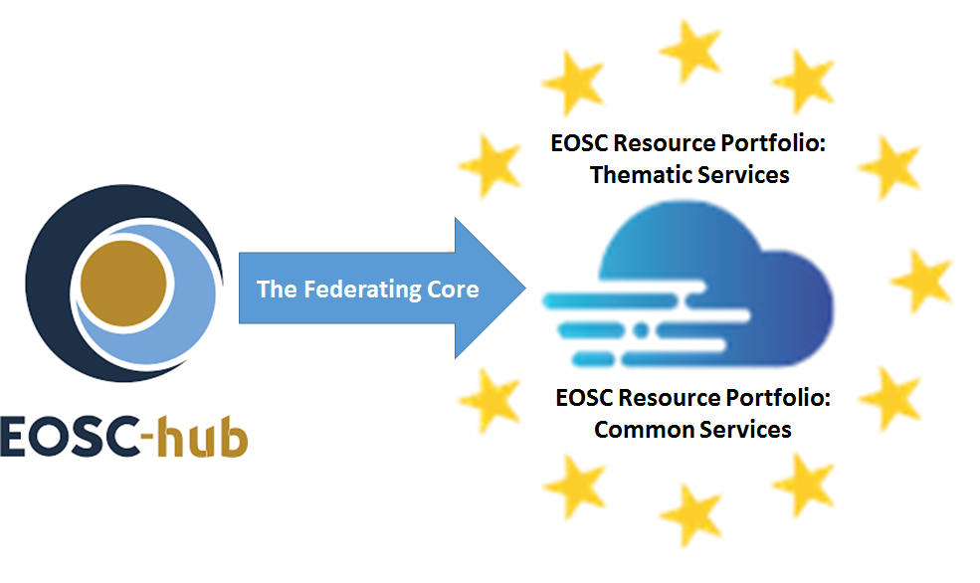
Fig. 1 – The contribution of the EOSC-hub project to the EOSC Resource Portfolio.

Structure of the document
The subsequent parts of this document are structured as follows: Chapter 2 provides an overview of the working and information gathering methods used. Chapter 3 discusses first some macro-environmental factors that are of relevance to the EOSC developments. It then analyses the opinions towards EOSC of two central stakeholder groups that have multiple roles in regard to EOSC, namely research communities and EOSC implementation projects. Additionally, this chapter discusses briefly the Member States’ viewpoints. Chapter 3 closes by summarising the key findings related to the external analysis. Chapter 4 takes an opposite view and discusses which capabilities and assets the EOSC-hub project can offer to EOSC. The internal analysis covers themes like the EOSC Federating Core and the Rules of Participation in EOSC. Chapters 5 and 6 build upon the previous chapters when analysing the EOSC-hub contribution for the EOSC Working Groups and when recommending the consequent directions to the EOSC-hub project. Finally, Chapter 7 concludes with key messages.

Methodology
The discussion and recommendations of this deliverable rest upon an evidence base elicited by applying various methodological approaches. They include meetings with senior experts about strategy, consultative semi-structured interviews, and desk research to identify and analyse relevant sources of information and to stay informed about recent developments in other parallel efforts. This work was guided by the EOSC-hub Strategy Board which consists of six members who represent e-Infrastructures and Research Infrastructures and thematic service providers contributing to the EOSC-hub project (see Appendix I for details). In the course of the preparation of Deliverable 2.2, the Strategy Board assembled twice to discuss the focal themes to be highlighted in this deliverable, with meetings at the second EOSC Stakeholders Forum in Vienna on 23 November 2018 and at EOSC-hub Week in Prague on 11 April 2019. The Strategy Board also gave advice in the form of written recommendations on the strategy plan and its implementation.
Two independent workshops were also arranged to gather input for the Deliverable 2.2. The first one was an all hands workshop in Amsterdam, 15-16 November 2018, bringing together the four strategy-related tasks of EOSC-hub WP2 and enabling the preliminary discussions of the content of Deliverable 2.2. The second workshop between the EOSC-hub and OpenAIRE-Advance representatives, held in Helsinki, 21-22 February 2019, assisted the production of the EOSC-hub and OpenAIRE-Advance White Paper “Common Vision, Service Provision, and Role in the EOSC Governance” (Joint Activity Milestone 3.3) that supports Deliverable 2.2. Liaison with other WPs of the EOSC-hub project was organised by establishing a strategy task force that embraced all WP leaders and helped validating the form, analyses and recommendations of this deliverable.
A major source of information for this document were consultative interviews, conducted during March and April 2019, with key representatives of 14 horizontal implementation projects that contribute to the construction of EOSC. The interviews highlighted mainly the service providers’ viewpoints with emphasis on either technical, political, regional or research community-specific issues. The interviews explored how the current EOSC implementation projects see their own role in the EOSC landscape, where they stand on the developments so far – especially with regard to the EOSC Portal, Service Catalogue and Marketplace – and what their views are on the upcoming EOSC legal and organisational framework. This consultation work provided the authors of Deliverable 2.2 with an adequate account of how the current status of EOSC and its future potential role are perceived among various contributors. It also threw light on their expectations and concerns related to the future development and sustainability of EOSC. The list of projects and their respective spokespersons is presented in Appendix II. The full interview guideline is presented in Appendix III.
Another significant source of information was the insights presented in two events in spring 2019: The ESFRI Workshop on RIs and EOSC in London in 30 January 2019,, and the EOSC-hub Week in Prague, 10-12 April 2019. The presentations and discussions in both events provided a representative cross-section of expectations of research communities, especially ESFRI RIs, as well as how the horizontal EOSC implementation projects aim to respond to these needs. This material was post-analysed similarly to the aforementioned interview material.
Further, a desk-based research activity was carried out in order to analyse related external factors, to supplement the understanding of end-user needs, and to keep up-to-date with concurrent achievements. Finally, several deliverables of the EOSCpilot project were studied as they provide a fertile ground to build upon [R7-R11].
While the guidance of the EOSC-hub Strategy Board extends to all aspects of this document, the other information gathering methods primarily served the need to form a good understanding of the external factors affecting EOSC, and in particular, EOSC-hub. These factors are discussed in Chapter 3.

External analysis: Factors influencing the construction of EOSC
This chapter discusses drivers of change that affect the EOSC and the EOSC-hub project but are beyond their control. Key findings of these factors are summarised in section 3.3.

A brief review on broad factors
A broad factors analysis, usually referred to as PESTLE analysis, assesses prevailing and foreseeable political, economic, social, technological, legal and environmental changes and helps arriving at an understanding of their net impact. Speaking of EOSC, several factors overlap with the political dimension as EOSC represents one of the three pillars that drive the policy actions of the European Cloud Initiative, the other two pillars being the European Data Infrastructure (EDI) and Widening access and building trust. The outer sphere of Figure 2 encapsulates some relevant external developments that coexist in the construction phase of EOSC. In this connection, they are discussed from the point of view of the EOSC-hub project, albeit they are recognized to have wider implications to the European research communities and society in general.

Since the European Commission presented the vision for EOSC in April 2016, the second pillar activities of the European Cloud Initiative have taken major steps in respect of the development and deployment of large-scale European HPC, data and network infrastructure. By the end of 2020, which is also the ending time of the current EOSC-hub project, the EuroHPC Joint Undertaking (JU) will deliver three pan-European pre-exascale supercomputers and another five petascale machines that will support data-intensive applications and the analysis of vast amounts of data produced in various domains. The EuroHPC JU is one of the main components of the European Data Infrastructure (EDI) together with GÉANT that is the other main component of the EDI, and it will complement the EOSC catalogue of services. From the EOSC-hub point of view, an important notion is that the EC aspires to federate European supercomputing resources that link up with EOSC. In his speech “EuroHPC – the EU strategy in HPC”, given in Poznan, Poland on 14 May 2019, Director Thomas Skordas from the DG Connect referred to this linkage with EuroHPC and stated: “We have a big consortium with the name of EOSC-hub and in some stage, it’s absolutely fundamental to make the connection between the two.”.

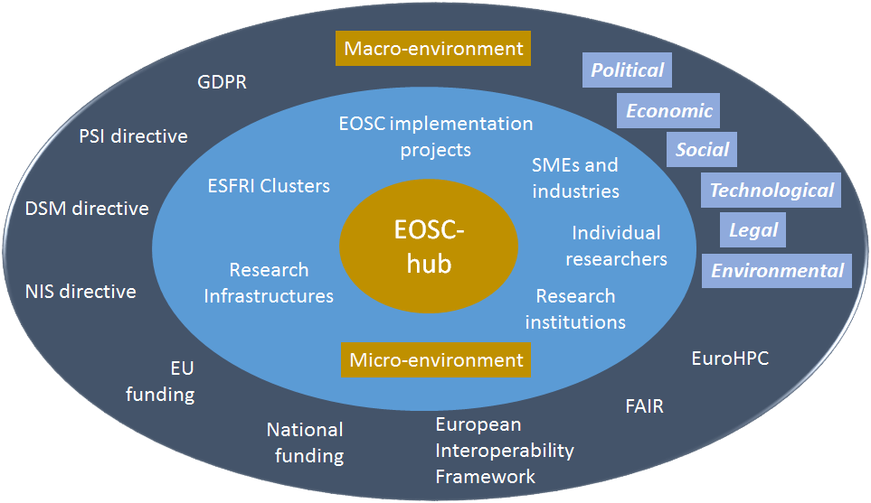

Fig. 2 – Developments and actors co-existing with and influencing EOSC-hub.

Another significant driver of change is the FAIR data movement that shapes the research process and associates with political, legal and social factors. FAIR data has been in the core of EOSC from the very beginning and the EOSC Implementation Roadmap (SWD/2018/83) highlights this in the action line (b) that discusses data. Accordingly, the deliverable D2.1 The First EOSC-hub Strategy Plan of WP2 suggested that EOSC-hub should take a central role as a “facilitator of FAIR data discovery”. Many outputs of EOSC-hub and other EOSC implementation projects, such as FAIRsFAIR, RDA and OpenAIRE, are anticipated to represent the EU contribution to a global field of open and FAIR research data.

At the same time, the FAIR principles are being progressively extended to other digital objects produced by researchers, including algorithms, models, and workflows. This sets new requirements for the conventional practices and data stewardship skills of researchers, and is calling for implementation efforts, meaning that the obstacles may also lie in processes and competences as well as in platforms and services. A recent cost-benefit analysis, prepared by PwC for the DG RTD of the European Commission, shows that investing in the adoption of FAIR principles unquestionably pays back. As a side effect, it also supports dematerialization, for example, by reducing the costs of storage and needs of research duplication.

When it comes to interoperability, the European Interoperability Framework (EIF) should provide a common core of interoperability elements to European national interoperability frameworks and domain-specific interoperability frameworks. According to the EIF, interoperability of public services covers the concepts of openness of data, software and specifications. Also the Governance structure designed for the EOSC and presented in Deliverable 2.6 of the EOSCpilot project is derived from the European Interoperability Framework with some minor re-interpretation of the four layers of the framework.

As regards research data, it must be taken into consideration that existing legal interoperability barriers are identified, whether there are sectoral or geographical reasons that restrict the use or storage of data, vague data license models, over-restrictive obligation to use certain technologies or similar hurdles. The legal interoperability should be assessed before adoption of new measures, as well as evaluating their performance after coming into force. Legal interoperability is essential for the reuse of open data to reach its full potential.

The European Union has laid the legal groundwork for EOSC with the General Data Protection Regulation (GDPR) and other legislation, such as the network and information security (NIS) directive and the public sector information (PSI) directive. A recent update of the PSI directive on 4 April, 2019 expands the scope of the directive to also cover publicly funded research data. Its Article 10 obliges the Member States to “support the availability of research data by adopting national policies and relevant actions aiming at making publicly funded research data openly available (‘open access policies’) following the principle of open by default and compatible with FAIR principles.” The recast PSI directive thus supports EOSC-hub and other EOSC implementation projects in advancing the re-use of research data. On the other hand, data mobility still faces some legislative barriers that need to be tackled. For example, the final compromise of the Directive on Copyright in the Digital Single Market (DSM), made on 26 March 2019, relies on voluntary licensing by copyright-holders and doesn’t enable automated text and data mining for research purposes. From the point of view of the EOSC-hub strategy, it’s necessary to understand the enabling and restricting implications of the legal scene and to adjust the EOSC-hub services to create value for the research communities in the given conditions.

To conclude the brief overview of the broad factors, we observe that the funding bodies both at national and EU level play a crucial role in the development of a sustainable EOSC. EOSC-hub, as a key provider of the “glue” services for EOSC, needs to be underpinned with a funding framework that provides adequate support for long-term planning and service provision. The sustainability and governance roadmaps for EOSC-hub will be discussed in more detail in deliverables D2.3, D2.4 and D2.5 to be produced by Task 2.3 of WP2.

Stakeholders’ expectations and interests
The key players of the micro-environment of EOSC-hub are displayed in the inner circle of Figure 2. They are beyond the control of the project, like the macro-environmental phenomena, but they still influence the strategic choices to be made in the project. Roughly speaking, these players can be categorised into three main stakeholder groups, namely consumers, service providers and funders of the EOSC ecosystem (see Figure 3). The context is not that simple, however. Research communities or individual researchers, as consumers of EOSC, not only use data and services available in the EOSC ecosystem, but they also supply EOSC with original research data or ex-post research results which EOSC enables by FAIR services. Thus, they act as service providers, operating either at national or international level. Also the relationship of Research Infrastructures and ESFRI Clusters with e-Infrastructures that underpin EOSC-hub and the other EOSC implementation projects is more intricate than a mere customer / provider relationship. All of them serve a particular community of users and can therefore be characterised as service providers. These service providers share the interest in expanding the opportunities of science. Apart from their specific objectives, that may not be fully aligned with those of the others, they work as collaborators to bring value to their consumers, e.g., research communities, and in particular, European researchers. The EC and national governments, while funding organisations and projects contributing to EOSC, expect that the expansion of the opportunities accelerate scientific discovery, and thus, will in general benefit society.
The subsequent sections of this section discuss expectations and approaches of these different stakeholders. They also study how the developments provided so far by the EOSC-hub project satisfy the expectations, and for what kind of common challenges EOSC-hub is expected to take a leading role.

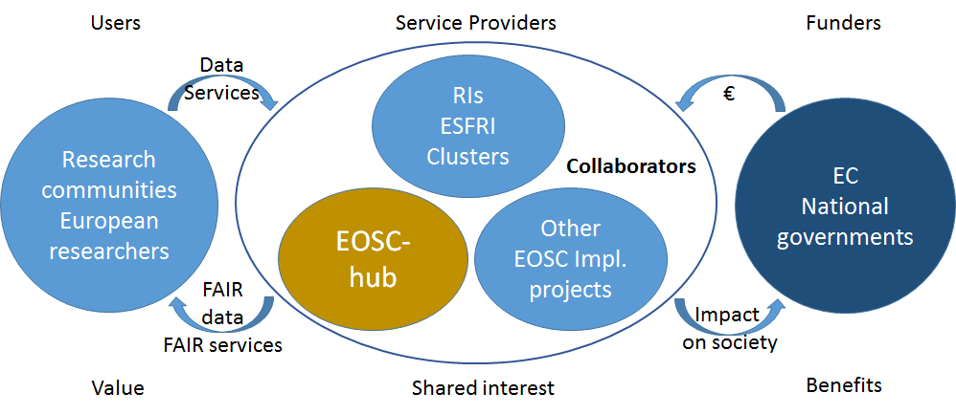
Fig. 3 - Relationship of EOSC users, service providers and funders.

Expectations of research communities for EOSC
Research communities, represented by universities, research institutions, intergovernmental research organisations, research laboratories, libraries and associations formed by them, gave an endorsement to the EOSC Declaration in November 2018. They have also taken an active role in contributing to EOSC both via governance structures and by partaking in the concrete implementation work. For example, the EOSC Executive Board, nominated in November 2018, is chaired by Prof. Karel Luyben from the European Association of Universities of Technology (CESAER). Also several organisations of the research communities are working towards EOSC by participating in various EOSC implementation projects, such as OpenAIRE-Advance and FAIRsFAIR.
Because they are placing their insight and expertise at the disposal of EOSC, the research communities justifiably expect that their role is not simplified to mere users and they wish to be recognised as active partners. They encourage EOSC to maintain a close dialogue with “the different scientific communities in order to identify their needs and ensure the adequate provision of e-infrastructure and e-services to them”. This anticipation was also echoed in the presentations and discussions of the Second EOSCpilot Stakeholder meeting in Vienna in November 2018. Both the panel discussion on Governance on 21st November and the discussion in the session called “Users meet service providers” on 22nd November highlighted that the research communities’ contributions are of prime importance in all phases of the EOSC implementation. The researchers have an essential role in setting the scene by articulating their needs, but their role is equally, if not even more important over the course of the implementation phase. A regular dialogue with the communities helps with validating the implemented solutions along the way and modifying them more cost-effectively than if the users’ suggestions and needs were received only after the full delivery.
The achievements of the EOSC-hub project are of primary interest to the research communities as they provide a door to the EOSC services and resources. The developments published so far are the EOSC Portal, the marketplace and the service catalogue, created together with the eInfraCentral, EOSCpilot and OpenAIRE-Advance projects, and launched in November 2018. The statistics of the Portal and marketplace usage show a moderate but steady growth since January 2019 after the initial burst of interest at the end of 2018. However, as these products are still in the introduction phase of their lifecycle, it is more important to pay attention to how they are received in regard to the user experience, as this forecasts their future trend of usage. No systematic and all-embracing survey has been carried out yet to measure the user experience, but some preliminary feedback is already available, for example, via the EOSC-hub Strategy Board members from their communities (see Appendix I).
The input gathered by the EOSC-hub Strategy Board members from their research communities (see Appendix I for details) and communicated to the EOSC-hub project both in written form and in two Strategy Board meetings (in Vienna, 23 November 2018 and in Prague, 11 April 2019), reinforces the perception that the user engagement to the planning and implementation-time validation is crucial for the successful adoption of the EOSC services. The research communities seem to find the EOSC Portal a collection of disparate services where it is not clear what is behind each category. As such, the Portal is considered difficult to approach – its goal should be more pragmatic and user oriented. The communities suggest discussing the structure of the EOSC Portal with those Research Infrastructures which have a good understanding of the domain-specific workflows. This could happen, for example, via the EOSC Stakeholders Forum and in cooperation with the EOSC Executive Board and EOSC Secretariat. They also suggest that there should be several layers in the Portal, with decreasing abstraction. The categories could be, for example, 1) Overview of Research Infrastructures 2) Services per Research Infrastructure and 3) Special communities.
The feedback received from the interviews of the EOSC implementation projects with a close connection to research communities revealed similar concerns, but also the issue of security was raised. EOSC-hub was expected to ensure a secure environment where privacy and data protection are guaranteed and users can be confident that they won’t face data security, privacy and liability risks. Users expect a robust authentication system, which, at its best, combines a single sign-on process and results in a federated identity and credentials. On the other hand, while a single solution for AAI would enable interoperability, it would also need an absolute trust in the safety of this solution as a single point of failure that might compromise all services. This would support keeping vital parts of the system under local control of the Research Infrastructures.

Viewpoints of Research Infrastructures
Research Infrastructures such as the ones on the ESFRI roadmap 2018 and others, have strong links with research communities and projects. They manage significant data volumes and enhance effective research data exploitation by developing data analytics tools and processes. They are also expected to federate part of their infrastructures and resources to EOSC. The European Commission has supported this connection by gathering ESFRI projects and landmarks to form thematic clusters in the fields of Biomedical Science, Environment and Earth Sciences, Physics and Analytical Facilities, Social Science and Humanities, Astronomy, and Energy. Through the INFRAEOSC-04-2018 Connecting ESFRI infrastructures through Cluster projects topic, the Commission pursues the consolidation of the ESFRI clusters as EOSC thematic platforms, thus giving a major impetus to the design and implementation of converging strategies.
Already the ESFRI roadmap, published in August 2018, acknowledged the potential of the ESFRI / EOSC collaboration to bring about a high level of interdisciplinarity. Consequently, the roadmap sets several expectations towards EOSC, namely that “EOSC should adopt a subsidiarity and participatory principle” and take advantage of practices developed by ESFRI RIs as much as feasible. Also “EOSC should fill the gaps of unstructured areas” meaning that those domains (the long tail of science) that don’t have strong RIs to support them should be taken under the wings of EOSC. Furthermore, the ESFRI roadmap recommends that “EOSC should enable high level of interdisciplinarity” and “make high level of interoperability possible and workable”. These two recommendations suggest that improving cross-domain interoperability is expected to be the goal of EOSC.
The recommendations of the ESFRI roadmap signpost some directions to the EOSC-hub projects. The first two recommendations quoted above guideline the development of the EOSC Portal and service catalogue while also highlighting the need of the constant discourse between all collaborating service providers (see Figure 3). The latter two recommendations that were quoted from the ESFRI roadmap address the federation of services and the architecture considerations that are essential contributions of EOSC-hub to the EOSC ecosystem. In these two recommendations, the ESFRI RIs ask EOSC-hub to help expanding the opportunities of science by bridging data and other resources, but without hampering the established domain-specific workflows by unnecessary deep integration.
Recent discussions in the EOSC thematic sessions in the EOSC-hub week in Prague, on 10 April 2019, and in a specific ESFRI workshop on RIs and EOSC in London, on 30 January 2019 demonstrate how the ESFRI Clusters and EOSC endeavour to build a common future and align related activities. The discussions in these events have made it clear that EOSC should be seen as an ecosystem and there may be multiple entry points providing different views, namely thematic, European, national or regional. Regarding EOSC-hub, this immediately implies a few practical aims. For example, the need for a common generic authentication and authorisation infrastructure model for all communities becomes more evident. Also the possibility to implement a common API that is searchable across domains and sites should be investigated to overcome the challenges of several non-interoperable service catalogues. Finally, the need for coordinated user support, training and outreach activities are foreseen.

Viewpoints of other EOSC implementation projects
Since the launch of the EOSC-hub project in January 2018, several other projects have been started or committed to contribute to the implementation of EOSC. The projects reflect various aspects of EOSC and they mean to complement each other’s work. A list of such projects that are currently ongoing or soon to be started is presented in Appendix II. The representatives of these projects were interviewed for this deliverable during March and April 2019 by using the interview guideline presented in Appendix III. The goals of the interviews were to learn about 1) how the EOSC implementation projects see their own role and the role of EOSC-hub in the EOSC ecosystem, 2) how they assess the existing elements of EOSC (c.f. EOSC Portal, market place and service catalogue, and 3) how they assess the future legal and organisational framework for EOSC. The received information helps with reviewing the position of EOSC-hub in the EOSC ecosystem and planning of coherent strategic actions that not only benefit the EOSC-hub project but support the whole EOSC ecosystem.

Being in charge of providing horizontal “glue” services to the EOSC ecosystem, EOSC-hub collaborates at some level with all other implementation projects. However, the project has formed deeper relationships with eInfraCentral and OpenAIRE-Advance and confirmed these with formal collaboration agreements. These three projects, together with the already-ended EOSCpilot project, are behind the EOSC Portal. In March 2019, the collaboration with OpenAIRE-Advance also resulted in a joint White Paper “Common Vision, Service Provision, and Role in the EOSC Governance” (Joint Activity Milestone 3.3) which supports Deliverable 2.2. Because of this intensive common effort, OpenAIRE-Advance was not interviewed as the other projects were, but the essence of the common discussions was captured into the White Paper. The EOSC-hub and OpenAIRE-Advance projects identified four areas of common interest, which they will pursue together. They are 1) the serviceability of the EOSC offering for individual researchers, 2) the relations between local, national and international infrastructures, 3) the need for novel business models, and 4) the need to form a strategic point of contact for comprehensive discussion within and beyond the projects. The White Paper presented a preliminary action plan to address these challenges, but a more elaborate follow-up paper with a more detailed work plan is under construction while writing Deliverable 2.2. It is expected to be finalised by the end of June 2019.
The 14 interviews with the other EOSC implementation projects revealed that the EOSC implementation projects share similar thinking patterns in many topics, but there are also dichotomies and hesitancy about which directions the EOSC and the supporting projects should take. The ensuing analysis of the interview input is organised corresponding to the previously mentioned interview goals.

Expected role of EOSC-hub

The characterisation of EOSC-hub by its peer EOSC implementation projects can be summarised in three qualities, namely technical, networking and policy making. The most evident and frequently used description highlighted the technical nature of the project. Some interviewees considered EOSC-hub as a mere operational-level project that creates a skeleton for EOSC and provides procedures for the basic operational layer, including e.g., authentication and authorisation infrastructure, service monitoring tools and security procedures. According to this approach, the primary role of EOSC-hub within the EOSC ecosystem was suggested to be a provider of a service management system that consists of tools, and related processes, procedures and policies for managing services within a distributed environment. In this role, EOSC-hub was also expected to deliver coordinated technical support to user communities.

Another perception of EOSC-hub, shared by a few interviewees, described the project as a builder of an interoperability layer for various data sources and services from basic infrastructures. In this role, EOSC-hub was expected to provide technical components and related processes, procedures and policies that help the adoption of FAIR principles into the normal research workflows. To this end, EOSC-hub was suggested to prepare an interoperable infrastructure where the soft elements, namely policies and guidelines, can be rooted.

Apart from a technical label, another characterisation given to the EOSC-hub was that of a network. The project was acknowledged for having been successful in bringing several infrastructures together. However, EOSC-hub was challenged to create a sense of community around the whole EOSC ecosystem, which would imply researchers, resource providers, software developers and policy makers. The human networking capacity of EOSC-hub was identified as an asset that the other EOSC implementation projects would like to exploit, for example in training and outreach contexts. Having a lot of contacts and providing feasible structures, such as competence centres, EOSC-hub was encouraged to closely engage with user communities to form a good understanding of how they see the EOSC fitting to their needs. Likewise, EOSC-hub was prompted to engage with service providers and to create a more consolidated way to engage and involve the private sector in the EOSC. These activities were considered to help the whole EOSC ecosystem to create strategies on how to respond to the end-user needs and how to effectively liaise with service providers of all kinds.

The fourth quality that was sought by many interviewees, but not very well perceived, was the policy aspects of the EOSC-hub project. EOSC-hub was not regarded to have produced yet that much of interest to policies and other soft elements, albeit some of the interviewees did recognise the project’s work in formulating the Rules of Participation. While many interviewees were of the opinion that the focus of EOSC-hub is on architectural challenges and service provision related issues, they also reminded that the EOSC strives for a cultural change. The change needs to be well supported by technical elements and infrastructures, and this can be achieved only by working in good alignment with policies.

Expectations for the EOSC Portal, marketplace and service catalogue

At the time of the interviews in March and April 2019, the EOSC Portal had been publicly available for about four to five months and some of the interviewees had not yet gained much experience with it. Also the standpoints of the interviewees varied, some of them taking the user’s perspective while others reviewed the situation from the service provider’s point of view. Regardless of standpoint, the current deployment of the EOSC Portal, marketplace and service catalogue seemed to raise more questions than answers. Also the suggestions for the future development partly converged and partly diverged.

A broad consensus prevailed among the interviewees about the need to better identify the target audiences and to clarify the value proposition of the Portal, marketplace and service catalogue to these audiences. There seemed to be a lot of confusion about the roles and relationships of the EOSC portal, marketplace and service catalogue and for whom they are intended. Improvement of the user experience, whether it concerned end-users or service providers, was much called for. The lack of navigation assistance and brokering services was highlighted, and the Portal was regarded as a collection of links, mixing services of general interest with others that are more domain-related. The necessity of using the right language (from the point of view of researchers) was emphasised. Here, the approaches of the European Network of Postdoctoral Associations (ENPA), as well as EUA and CESAER could serve as examples.

The proposals for solving the issue varied. Should EOSC-hub aim to provide yellow pages of online repositories, or a central marketplace, or both? Some interviewees advocated that the Portal should include rich features for tailoring, thus enabling different views for different audiences. Even several portals for different audiences were speculated. Others were of the opposite opinion by stating that less is more. They suggested that there shouldn’t be too many parallel services that serve the same purpose. Instead, the Portal could offer services that are generated through several service catalogues and resources.

From the point of view of service providers, the discussion of the value proposition was entwined with the aspect of visibility and an opportunity to attract different or new users. However, the procedures for entering the marketplace, including private sector and companies, were queried: If you want to put your service in the catalogue, what to do? Some interviewees also felt that the current procedures for getting services into the marketplace and into the service catalogue are challenging. It was broadly felt that there should be a common process for technical validation and that the certification processes should be as automated as possible. Some interviewees also raised the point that the service providers need to get funds to sustain and develop their services. This opens the discussion about the EOSC business model, which the interviewees found as yet unknown and not within their remit to define.

Considerations on EOSC legal and organisational framework

The EOSC Declaration, launched in Brussels in 26 November 2017, aims firmly at a sustainable and long-term EOSC. This aim is supported by the EOSC Governance 2019-2020, and in particular, by the Sustainability Working Group set up by the EOSC Executive Board in spring 2019 along with four other Working Groups. The EOSC-hub project also plays a role in planning and implementing a sustainable EOSC, especially through the WP2 and WP12 contributions and the work done for the Rules of Participation. In the context of WP2, EOSC-hub is preparing a roadmap for governing and sustaining the provision of EOSC-hub services to European researchers, while WP12 addresses business models and supporting procurement and purchasing frameworks.

The questions concerning a legal framework and a workable business model for the EOSC divided the opinions of the interviewees in many ways. First, the timeliness and topicality of the discussion about these subjects were argued to be urgent, on the one hand, and untimely, on the other hand. Several interviewees stressed that the EOSC legal entity needs to be in place in 2020 to sustain EOSC, meaning that the schedule of negotiations is very tight. However, other interviewees considered that it is premature to think about creating a legal entity when there seem to be no conclusive ideas about how it will be funded. The supporters of this view called for a serious review of the EOSC implementation project results before creating such structures.

Another topic of debate was the funding model. The contribution of the EC was widely seen as necessary and EC funding was expected to sustain the primary components of the EOSC, meaning the federating core. The national contributions sparked off lively discussions. Some of the interviewees suggested that the national funding agencies should co-fund the primary components of the EOSC alongside the EC, while the others were sceptical about the Member States’ willingness to contribute. Also the question of charging for services was raised and some interviewees speculated on an idea that the EOSC services would be free for individual researchers but not for the institutions. Finally, some of the interviewees also commented on the challenges from the service providers’ perspective. For example, a situation where the national service providers would get income through the EOSC while simultaneously taxpayers’ money would be used for supporting EOSC was found paradoxical. The same dilemma would emerge if the national service providers were competing against commercial services while being supported by taxpayers’ money at the same time. This may trigger issues with the competition law.

On the subject of an organisational framework, the interviewees assumed overall that a legal entity will be created. Given that, the majority of the interviewees supported a lightweight framework that should not be too prescriptive to avoid ambiguity. It should also be inclusive of national initiatives and all domains. The need for pragmatism was pointed out by many – the purpose of the legal entity needs to be clearly defined and it should then build on the experience of existing structures. As one solution it was suggested that the current EOSC governance model with the EOSC Secretariat supporting would be transformed so that they could continue without being legally a part of the EC. Another suggestion highlighted the need to study the ERIC model.

Viewpoints from the Member States
Taking into account the viewpoints from the national governments is critical for planning the contribution of EOSC-hub. In 2018, the ERAC standing working group on open science and innovation released the results of a survey conducted among European national governments which stressed that “in order for the European Open Science Cloud to be feasible, the project has to be designed as a true partnership, based on trust, synergies and dialogue among the European Commission, national (and regional) governments and stakeholders”. The report outlines some critical aspects to be tackled such as governance, long-term sustainability, business model and rules of engagement, services and accompanying activities relevant to monitor research impact, and research accountability, and concludes that EOSC should primarily build on existing regional and national infrastructures and be driven by users’ needs.
The issue of EOSC funding is one that seems of primary importance for the national governments the authors have had the opportunity to speak to. The current market for scientific data infrastructures is typically characterised by two tiers of supply-side provision through budgets from national funding agencies (one “base” tier) and grants from the European Union (a higher “federating” tier). The European Commission has allocated €260 million from the Work Programme 2018-2020 of Horizon 2020 for the federation of the existing scientific data infrastructures, but it is not yet clear how much money will need to come from national budgets to contribute to EOSC. National governments seem to be reluctant to divert existing funding to EOSC in the absence of a clearer definition as to what EOSC is and the services that need to be supported, and how much would it cost. For now, many national governments emphasise the importance of organising infrastructures at regional and local level (including the adoption of open science and FAIR principles) and build a soft interoperability layer which would allow to connect national assets together.
The recently released e-IRG report on National Nodes reports on aspects of national coordination and funding of horizontal e-infrastructures, and their relation to vertical discipline specific infrastructures. One of the recommendations for Member States and Associated Countries is to explore, pilot and install funding schemes, which give the incentive to both research communities and provisioning organisations to collectively optimise e-Infrastructure service development and provisioning and which enable easy cross border research collaboration.

Summary of findings
Table 1 collects the key findings from Sections 3.1 and 3.2 and closes the analysis of the external factors affecting the EOSC-hub project. The findings are categorised into four focus areas that emerged from the desk research and were highlighted in the interviews and other discussions. The next chapter turns the focus to the internal analysis of the project’s assets. Table 1, together with the outcome of the internal analysis, will form the basis for the discussion, presented in Chapter 5, about the contribution of EOSC-hub to the future EOSC.

Focus area | Findings
Services | - EOSC-hub is expected to provide the EOSC ecosystem core services and technical specifications related to service management and APIs.  - EOSC-hub should contribute to building an interoperability layer that will allow connecting services and data coming from the various infrastructures pertaining to EOSC.  - EOSC-hub is recommended to engage with the EuroHPC initiative to define a common technical architecture and service interoperability framework providing access to HPC capacity to EOSC users.  - The value proposition of the EOSC Portal, marketplace and the service catalogue to different audiences should be clarified. Multiple entry point and tailoring options providing different views (thematic, European, national) are called for.  - EOSC-hub is expected to advance the adoption of FAIR principles into the normal research workflows by providing assisting technical components, such as metadata tools, and related processes, procedures and policies.
Rules of Participation | - Rules of Participation to EOSC-hub and service onboarding processes should be progressively evolved with operational experience and input from the providers. Current procedures to get services into the marketplace and to the service catalogue are considered challenging.  - A common process for technical validation and as automated certification process as possible are expected.
Business model | - EOSC-hub is recommended to further articulate the EOSC Portal business proposition for users and EOSC resource providers.  - The EC is expected to sustain the primary components of EOSC. The criteria for the national contribution may not be simple to define. A clearer definition of what EOSC is and what needs to be supported is needed to stimulate the buy-in from funders.  - Transactions to nationally funded service providers may trigger issues with competition law if they compete against commercial services while supported by taxpayers’ money.  - The purpose of the legal entity needs to be defined prior to starting to model it. A lightweight framework elicited by studying workable existing structures gets support.
Engagement | - Engagement of researcher communities (universities, research institutions, libraries, etc.) to the planning and validation of the EOSC is emphasised and seen as critical for the successful adoption of the EOSC.  - National governments emphasise the importance of organising infrastructures at regional and local level (including the adoption of open science and FAIR principles) and build a soft interoperability layer which would allow to connect national assets together.

Table 1 – Summary of findings stemmed from the analysis of external factors.

Internal analysis: EOSC-hub assets for EOSC
Recognising the project’s assets well is a prerequisite for a proper prioritisation and a path to success. While examining the assets, EOSC-hub should not be considered a self-contained entity but a part of an ecosystem as discussed in section 3.2 and displayed in Figure 3. Also the success of the project should be evaluated relative to this ecosystem. Acknowledging this, we review the assets of EOSC-hub in the light of the feedback received from the stakeholders, as they represent the EOSC ecosystem.
By and large, the assets of EOSC-hub for EOSC might be thought to fall into three baskets that can be titled as the EOSC Federating Core, capability to contribute to the design of a sustainable EOSC, and capability to contribute to the adoption of FAIR principles (see Figure 4). The Federating Core is suggested to include the technical components which enable the federation, access, ordering and delivery of services as well as the management and reporting of services. It also contains policies and processes that underpin and empower the EOSC Portal, marketplace and service catalogue and support the thematic and common services displayed on these fora. The capability to contribute to the design of sustainable EOSC refers to the input that EOSC-hub can give to the discussion about the EOSC business model and governance model, but also some softer elements of sustainability are subsumed, for example, how EOSC-hub can consolidate the stakeholder engagement. By capability to contribute to the adoption of FAIR principles, we mean the project’s involvement into discussion on data policies.
The subsequent sections 4.2-4.4 discuss these asset baskets one by one. Prior to going deeper into them, the key asset of EOSC-hub is reviewed: the vast amount of intellectual capital attributed to the project by the EOSC-hub partner organisations.
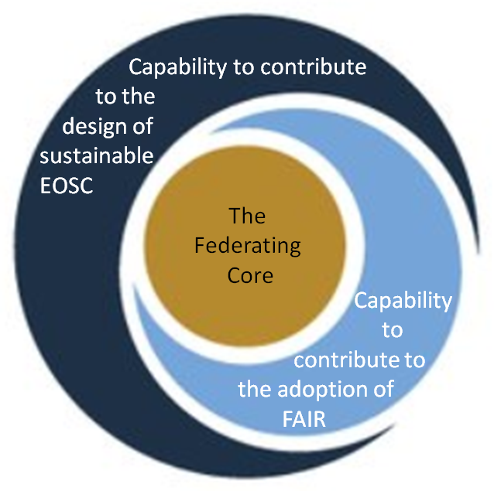
Fig. 4 - Assets of EOSC-hub for EOSC.

Expertise
The EOSC-hub consortium builds on the expertise of the EGI and EUDAT e-Infrastructures and the INDIGO-DataCloud project. As a whole, it counts 100 members with 76 beneficiaries from 53 countries and includes three international research organisations, 12 Research Infrastructures of which two are ERIC Research Infrastructures, universities and academic institutions, and eighteen SMEs. This consortium was brought together based on the research and operational excellence, commercial involvement and, most importantly, the complementarity of each partner.
The partners involved in the service provision have a long-standing tradition in designing, deploying and operating services to support diverse research communities. They can be grouped in four categories, namely Service providers and national e-Infrastructure representatives, Technology providers, User communities and Research Infrastructures, and SMEs and industries. The expertise they lend to the EOSC-hub project is described in Table 2.

Partner category | Expertise
Service providers and national e-Infrastructure representatives | Service providers and national e-Infrastructure representatives bring expertise to manage the federated e-Infrastructures and to operate and provide access to the resources and services for the benefit of consumers. The depth and breadth of coverage allows EOSC-hub to work with data centres throughout Europe that support multiple user groups. Several of these infrastructure providers operate ‘end-to-end’ across the networking, grid, HPC and data management layers of the e-infrastructures.
Technology providers | Technology providers bring expertise that foster the integration of services into the EOSC-hub service catalogue and contribute to its evolution.
User communities and Research Infrastructures | User communities and Research Infrastructures bring expertise on data, processes and tools adopted in various fields of science. Many Research Infrastructures are also very experienced in providing cloud services to researchers.  Overall, the EOSC-hub consortium involves 12 Research Infrastructures, namely BBMRI, CLARIN, CMS, DARIAH, ECRIN, EISCAT, ELIXIR, EPOS, ICOS, eLTER, LifeWatch, and LOFAR, and 9 research collaborations, namely disaster mitigation, ENES, EO pillar, GEOSS, ITER, OPENCoastS, Marine, WeNMR, and the Fusion Research Community.
SMEs and industries | SMEs and industries bring expertise on how to stimulate innovation and knowledge transfer between e-Infrastructures and the private sector. They are involved mainly in the context of the EOSC Digital Innovation Hub that is designed for this purpose. Experts in business development are also involved to support successful market take-up and commercial boost strategy.

Table 2 - Expertise that different partner categories bring to EOSC-hub.

As regard to the expectations of the EOSC-hub stakeholders, summarized in Table 1, the EOSC-hub project possesses ample expertise to design and develop together with other EOSC ecosystem parties the required services and processes to generate the EOSC. The operational EOSC Portal, though it is yet to be further developed and improved, can be regarded as an evidence of this. However, expertise, albeit imperative, is not enough. Only true engagement and creation of a genuine feeling of ownership among all four categories of partners can release the full potential of expertise and the capability of the project to implement and deliver. Therefore, the project’s investments in Competence Centres, knowledge management and training activities, as well as in forming a Digital Innovation Hub that helps engaging researchers, SMEs, large industries, startups, accelerators, and investors alongside public e-Infrastructures, are major contributions.

EOSC Federating Core
As briefly discussed in section 1.2 and as illustrated in Figure 5, the overall EOSC Resource Portfolio includes two broad categories of resources: The EOSC Federating Core and the EOSC Service Portfolio.

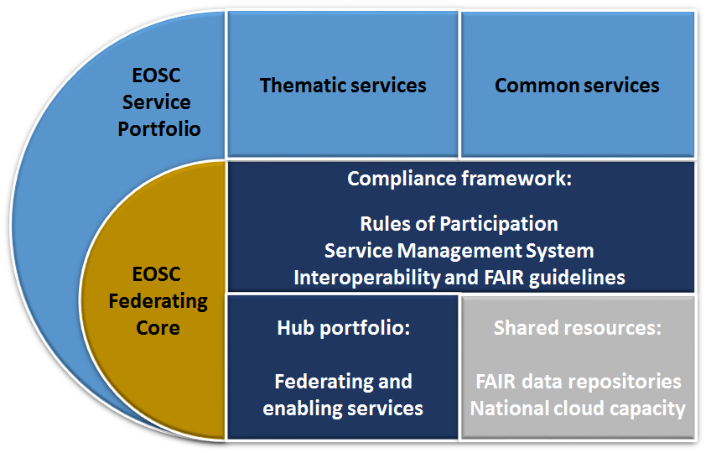
Fig. 5 - The EOSC Resources, organized into two portfolios: the EOSC Federating Core (yellow) and the EOSC Service Portfolio (light blue). The EOSC Federating Core provides three capabilities: services that implement the federating tier (Hub portfolio), the tentative resource tier (Shared resources) and the EOSC regulatory framework (the Compliance framework, including the Rules of Participation, the Service Management System and related policies). The EOSC Service Portfolio provides additional adding-value services (common and thematic) that exploit the Federating Core and are discoverable through the EOSC Portal.

The first element, the EOSC Federating Core, is a fundamental asset that EOSC-hub provides to EOSC. It includes a number of parts which were already described in the EOSC Implementation Roadmap (SWD/2018/83), and have been expanded and instantiated by EOSC-hub, resulting in a more complete picture of the elements that are needed to allow the research targeted services to operate. These elements are technical, human, policy and resource related by nature and they must be maintained over the long term. The Federating Core comprises the resources entrusted to EOSC, namely: 1) The Hub portfolio contributing the EOSC federating tier, 2) Compliance framework providing the EOSC regulatory framework, and tentatively, 3) Shared resources contributing to the EOSC resource tier. These three elements are discussed in more detailed in subsections 4.2.1-4.2.3.
The second element, the EOSC Service Portfolio, provides added-value resources (both thematic and common) making use of the EOSC Federating Core, and providing complementary capabilities to the EOSC users. The Thematic services of the EOSC Service Portfolio are community-specific capabilities including research core data, data products, scientific software, and pipelines. They are provided by science centres, Research Infrastructures and other sources, supported by national or international infrastructures. The Common services (sometimes referred to as a “horizontal” catalogue) provide generic capabilities that support the entire research data lifecycle from creation to processing, analysis, preservation, access and reuse. The services of EOSC Service Portfolio are not under the management or responsibility of EOSC-hub, but they would be discoverable through the EOSC Portal, which provides a service marketplace through which the services may be ordered. The policies and processes contained in the Compliance framework of EOSC are recommended to equally apply to both portfolios.

The Hub portfolio
The Hub portfolio (also noted as EOSC Platform in some EC documents) includes the portfolio of key access enabling services needed to operate EOSC. Such services are, for example, authentication and authorisation infrastructure, accounting, the marketplace, and other elements which enable the federation, access, ordering, delivery, reporting and management of research facing services and the shared resources. A full list of these services is given in D2.6 First Service roadmap, service portfolio and service catalogue, to be published in autumn 2019.
Many of the service in the Hub portfolio originate from the technical components inherited from the EGI and EUDAT e-Infrastructures and the INDIGO-DataCloud project. However, they have been combined and enhanced to support federated operation of European-scale federated services, and to support professional management of these services. Therefore, they can support professional delivery of a federated service built on top of them.
Apart from operating the Hub portfolio services as part of the Federating Core, they can also be offered to EOSC Service Portfolio providers who do not already have these components, or do not wish to operate them themselves. For instance, the helpdesk can be provided to them as a component to integrate into their service.

Compliance framework
Another element of the Federating Core is the Compliance framework that represents the policies and processes required to operate the Federating Core. The main vehicles are the Rules of Participation, the EOSC-hub Service Management System, and the Interoperability Guidelines for thematic and common services, but other policies may be included on a case-by-case basis, in particular when they concern collaboration with other EOSC implementation projects. Beyond this, EOSC-hub is trying to develop shared policies and protocols for programmatic exchange of information with other EOSC stakeholders, on topics such as ordering, reporting and accounting. Allowing a flow of information between stakeholders supports interoperability and a better user experience.
The Rules of Participation is a key element of the Compliance framework. It sets out the policies to be adhered to in order to provide thematic or common services through the EOSC Service Portfolio. The intention is not to limit access to services to the research market, but rather to ensure that the services provided can be understood, ordered, assessed and reported on in a coherent way. The Rules of Participation set out and oversee the on-boarding process for thematic and common services, and manage exceptions or new developments that require changes to policies and procedures.
The other main element, the EOSC-hub Service Management System helps ensuring that the services in the EOSC Service Portfolio and in the Federating Core are managed in a professional, predictable, measured and optimized way. The Service Management System is organised according to the FitSM standard that is compatible with, but more lightweight than the traditional ITIL framework and ISO/IEC 20000 standard. The EOSC-hub Service Management System comprises 14 processes. They are described in more detail in D2.6 First Service roadmap, service portfolio and service catalogue, to be published in autumn 2019.
Finally, several Interoperability Guidelines are under development and will assist smooth service on-boarding and management. They include, for example, technical guidelines for common and thematic services, federated service management guidelines, and service description metadata, the latter being part of a joint effort with eInfraCentral an OpenAIRE-Advance projects.

Shared resources
The third element suggested to be incorporated into the Federating Core portfolio is the Shared resources. While the Hub portfolio enables access to services and supports the federation, and the EOSC Service Portfolio onboard thematic and common services, the Shared resources would provide data management and processing services for EOSC exploitation, hosted by generic storage and computing resource tier. The precise makeup of the Shared resources is still under discussion, but EOSC-hub sees them as fitting into several broad categories. For example, access to large scale infrastructures for storage or processing of data could support a wide variety of communities, including the long tail of science, community of practice, and short-term research collaborations who typically have no easy access to internally managed infrastructures. This is complementary to the common services of the EOSC Service Portfolio, which are typically still more focused on a specific capability in the data lifecycle management process, rather than being the full general purpose infrastructures imagined here.
Shared resources can potentially include access to datasets and other scientific products (e.g. software, applications and pipelines) otherwise not easily accessible in a sustainable coordinated manner through existing research infrastructures. Examples of such datasets include the Copernicus long term archive, Earth Observation data and genomic data archives, which cannot be accessed and processed in a scalable way at the researcher’s in-house facilities. The Federating Core should provide access to such open science resources through the same portals and systems used to access other services. However, the datasets themselves may be mirrored, stored and managed in collaboration with the respective data providers, and could provide mechanisms of ingestion back to EOSC to allow users to share tools, software and data that are the output of their research. The added value for researchers here would be that they are exposed to such public good, open science datasets and can integrate them into their research more easily.
Finally, EOSC-hub sees that the Shared resources could include repositories for storage and processing of Digital Research Objects in support of open science. Due to the digitisation of science, it is now possible to collect together the full ‘source’ material for a piece of research: the source data, analysis pipelines, result data and scientific publication derived from it. These can be collected and stored together in a way that would support the traceability and reproducibility of science, as well as opening up new opportunities for promoting and supporting new research avenues. Infrastructures storing, managing and processing such objects could bring considerable benefits to the European Research Area.

Capability to contribute to the design of a sustainable EOSC
All observations of the stakeholders surrounding the challenges of creating a sustainable EOSC (see Table 1) are such that they can be tackled only by an overarching collaboration of EOSC stakeholders. The definitions of the EOSC funding model, organisational model and other governance-related topics need to be widely discussed and solved at the level of Member States and the EC. The EOSC Governance Board will have an advisory and implementing role concerning the setting up of a business model for the EOSC. The following sections discuss some assets that EOSC-hub can place at the disposal of the decision makers.

Business model
Broadly speaking, the formation of the EOSC business model doesn’t differ from that of any new business in development – it intertwines closely with funding schemes, on the one hand, and with a value proposition, on the other hand. EOSC-hub approaches the question from the latter point of view. In WP12, the project aims to develop prototype procurement and purchasing framework that would lower the barriers, risks and administrative cost to purchase digital services for research from either publicly-funded infrastructures or commercial providers. Thus, the activities of WP12 will enrich the project’s understanding on processes to create value cost-effectively from the ecosystem of providers for the EOSC users.

WP12 will produce four deliverables on this topic. The first of them, to be published in summer 2019, will analyse the demand-side market, as well as business models suitable for the selected scenarios. The next two deliverables will specify in more detail the procurement and purchasing framework for the selected business model(s) and provide supporting definition of processes, templates and guidance, as well as the validation via early adopters. The final evaluation of the business models and recommended procurement and purchasing framework with a respective roadmap of activities beyond the project time span will be produced by December 2020.

Another way for EOSC-hub to partake in the design of EOSC value proposition, and consequently a solid business model, is to work together with other EOSC implementation projects that are specialized in procurement activities, such as OCRE and ARCHIVER (PCP). Also an earlier work in the context of the Helix Nebula Science Cloud lays the foundations for this activity. OCRE aims to accelerate cloud adoption in the European research community, by providing access to commercial IaaS, SaaS and PaaS cloud services and Earth Observation (EO) services through ready-to-use service agreements. ARCHIVER will use a Pre-Commercial Procurement (PCP) instrument to competitively procure R&D services from firms for archiving and preservation needs of research infrastructures, based on requirements from four procurer organisations (CERN, EMBL-EBI, DESY and IFAE). The difference between the two projects is that OCRE is buying services that exist (e.g., community adopting things that are already available), whereas ARCHIVER is working with the private sector to develop new services. The WP12 of EOSC-hub collaborates with both projects. For example, it provides input for tenders that OCRE will issue. Similarly, WP12 works towards that the services that ARCHIVER procures can become part of the service catalogue of the EOSC, and thus, strengthen the EOSC value proposition.

Following the recommendations of the High Level Expert group report it is advisable that different partnership levels and related business models can be chosen by EOSC resource providers. The level of support received from EOSC by Thematic and Common services will consequently vary depending on the partnership level of choice of the provider, from Entry, Standard to High.

Governance model
While a business model should ensure financial sustainability, by appropriate funding sources and demand increasing value proposition, a governance model takes up with the legal aspects of sustainability. The possible organisational and governance framework for the EOSC beyond 2020 is currently a subject of hot debate, as observed from the interview outcome in Chapter 3, and it requires all-round, critically analysed input for coming to a satisfying conclusion. EOSC-hub studies these issues in the context of WP2. It takes a standpoint of translating viable funding and business models identified by WP12, into formal governance requirements, and also investigate related legal constraints and opportunities. As a result, it will produce three consecutive deliverables analysing and suggesting a roadmap for organising, governing and sustaining the provision of EOSC services to the European researchers. The first governance and sustainability implementation roadmap will be produced by the end of September 2019.
At the same time, EOSC-hub also collaborates with OpenAIRE-Advance to produce a proposal on aligned roadmaps for service positioning and sustainability within EOSC (Joint Activity Milestone 3.4 in the EOSC-hub / OpenAIRE-Advance Collaboration Agreement, Annex 1). Leveraging from the work of EOSCpilot and the preceding work in Joint Activity Milestone 3.3, the two projects seek to develop different scenarios and models for service provisioning in EOSC focusing, in particular, on the Federating Core. More specifically, they will describe what the Federating Core should look like in order to avoid to be considered too expensive by the Member States, how the Federating Core would relate to the EOSC architecture, and how the Federating Core would impact the funding and governance of EOSC. The common proposal of EOSC-hub and OpenAIRE-Advance is due to be released in September 2019.

Community and ecosystem building
The third perspective is how a sustainable EOSC relates to the building of the EOSC community and ecosystem. By community, we mean the collaboration of people in distinction to ecosystem that refers to the projects and organisations that are implementing the EOSC.
EOSC-hub brings together a unique consortium of e-infrastructure providers, Research Infrastructure operators, specialist application/solution providers and researchers from a wide range of scientific disciplines under several of the main ESFRI themes. They also have a diverse network of relationships and influence from partners representing research disciplines across all major fields of science. Along with expertise, the capability of creating collaborative partnerships and forming wide-ranging networks is an important intangible asset that EOSC-hub can lend to the EOSC. This is becoming increasingly important when the EOSC ecosystem continues to expand by new implementation projects, such as the INFRAEOSC-5b projects to be started in the second half of 2019, or by new service provides, for example SMEs and other commercial partners.
EOSC-hub has several activities that enhance the consolidation of the community and partnership network. Especially, the activities related to stakeholder engagement, communication and events in WP3, and the activities responding to various needs of training in WP11 are targeted to reinforce the participation of individuals. They are important vehicles for creating affinity and building a community. The willingness of the community to endorse the EOSC is a critical success factor for a sustainable EOSC.
Nurturing the engagement of the partners within the EOSC ecosystem is equally important, as was emphasized in many interviews referred to in Chapter 3. EOSC-hub fulfills this involvement primarily through three work packages, namely WP7, WP8 and WP9, which deal with thematic services, competence centres, and the Digital Innovation Hub, respectively. These WPs act as promoters of EOSC in the research community and their capacity to bring in new services to the service catalogue. Further, WP1, with the support of contributors from other WPs, bridges EOSC-hub with other projects and initiatives by establishing formal collaboration agreements including joint activities. Such agreements concluded so far with OpenAIRE-Advance, eInfraCentral and GÉANT, and under preparation with OCRE, FREYA and EaP, pave way for aligned strategies and amplify the capabilities of EOSC-hub to respond to the needs of the stakeholders. The feeling of engagement is a result of how the project encounters its stakeholders and how it manages relationships with them. These encounters and the quality of the relationship management affect the cohesion of the ecosystem which again is a measure for the level of sustainability of the EOSC.

Capability to contribute to the adoption of FAIR principles
The majority of the expertise of the EOSC-hub project is harnessed to provide technical elements for the EOSC, in particular the EOSC Federating Core, and outputs, like the Rules of Participation, that support the compliance and compatibility assessment of the services suggested to be part of the EOSC. While the project is primarily associated with tasks of more technical nature, it is also expected to contribute to some policy-related aspects of EOSC. This is often done in collaboration with other EOSC implementation projects that have the advancement of data policies and FAIR principles on their agenda. One manifestation of such collaboration is a series of three workshops organised by OpenAIRE, RDA Europe, FAIRsFAIR and EOSC-hub in the period from April to September 2019 under the headline of “Services to Support FAIR Data”. The workshops explore how existing infrastructures can work together to deliver services that support the creation of FAIR research outputs.
EOSC-hub has also dedicated a small amount of work and expertise in formulating policies to facilitate the sharing and safe processing of both open and “restricted” data and to promote existing models of good practice on the management of such data from around the EOSC-hub consortium. This work, performed in WP2 of EOSC-hub, liaise with emerging codes of conduct associated with the introduction of the GDPR, and aim to define policy recommendations for the safe sharing and processing of research data across European e-Infrastructures. As the first output, WP2 delivered in January 2019 the EOSC-hub Deliverable 2.8 which gives 22 practical recommendations bridging general policy recommendations (such as the EOSCpilot policy recommendations and the EC Expert Group report on FAIR data) and the technical implementation of data sharing within the EOSC-hub service ecosystem. Broadly speaking, these recommendations land into the following categories: Implementation of FAIR principles, Building of technical expertise in ‘safe data’ and ‘safe settings’, and Supporting of the wider development of ethical and information governance frameworks.
While the ESFRI cluster projects and the FAIRsFAIR project, launched in 2019, take a large role in developing FAIR practices and promoting their adoption, also EOSC-hub is prepared to continue to contribute from its standpoint. For example, the FAIRsFAIR and EOSC-hub projects have a common target to suggest FAIR-aligned Rules of Participation for the EOSC. These rules will be designed to establish FAIR compliance of components and practices.

Key exploitable results
To conclude the discussion, Table 3 presents a summary of the EOSC-hub assets. Since it will be practical to separate the Rules of Participation from the Federating Core in the discussion of the next Chapters, the two elements are also presented separately in Table 3. These assets lay the foundation for ten key exploitable results that EOSC-hub can offer to EOSC.

EOSC-hub asset for EOSC | Key exploitable result
EOSC Federating Core | - EOSC Portal website, marketplace and service provider onboarding  - The Hub portfolio  - The Hub Service Management System  - Rules of Participation for users, for providers and for operators  - Technical Interoperability Guidelines
Capability to contribute to the design of sustainable EOSC | - Business plans and roadmaps on service sustainability  - Procurement framework
Community and ecosystem building  Capability to contribute to the adoption of FAIR principles | - Digital Innovation Hub  - Competence Centers  - Knowledge management and training

Table 3 - The EOSC-hub key exploitable results, relying on the project’s assets.

EOSC-hub contribution to the EOSC Working Groups
The First EOSC-hub Strategy Plan (D2.1) took the EOSC Implementation Roadmap (SWD/2018/83), released in March 2018, as its starting point and identified five roles for EOSC-hub to form a basis for its strategic actions. All of these roles highlighted the technical aspects of the project, which was also needed at that time, because the fundamental elements of the EOSC Federating Core were still heavily under development. The left hand side of Figure 6 portrays the structure of the First EOSC-hub Strategy Plan and how it was meant to guide the development of the EOSC Federating Core services and the work towards the Rules of Participation.
Since 2018, the discussion of what the EOSC actually is has received new nuances which also have expanded the focus. This is evidenced by the EOSC Working Groups, set up in spring 2019 and to be operational until the end of 2020, to support the EOSC Executive Board. As a consequence of this development, also in EOSC-hub other aspects than the technical ones are gaining more ground, albeit the project’s key outputs are still more of technical nature.
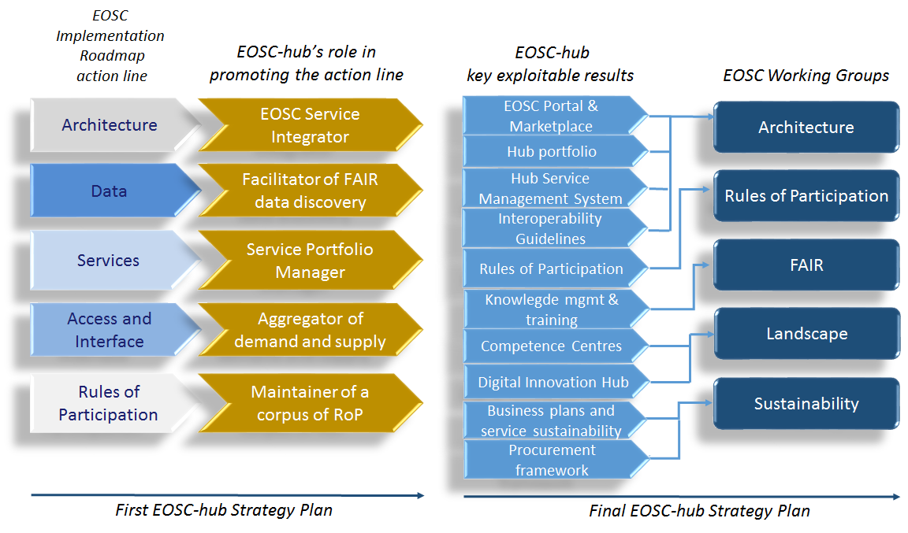
Fig. 6 - Point of reference for the Final EOSC-hub strategy plan.

This Chapter takes a viewpoint of the EOSC Working Groups and discusses how the EOSC-hub assets and key exploitable results, identified in Chapter 4, can contribute to their efforts. The Working Groups will be the vehicles to formulate the EOSC beyond 2020 for the EOSC Governance bodies to decide. Thus, we align the contributions of the EOSC-hub project accordingly to assist this process. The discussion is structured under the themes of Architecture, Rules of Participation, FAIR, Landscape and Sustainability, correspondingly to the five EOSC Working Groups. The right hand side of Figure 6 displays how the key exploitable results of EOSC-hub liaise with each area of the Working Groups.

Architecture
The EOSC Architecture Working Group will propose the technical framework required to enable and sustain an evolving EOSC federation of systems. The Working Group is commissioned to define the EOSC architecture, essentially comprising of “a federating core and a variety of federated research data infrastructures committed to providing services as part of the EOSC”. The assignment further explains that “the EOSC federating core is understood to be constituted by EOSC shared resources and by a compliance framework including notably the Rules of Participation.” The EOSC-hub project is foreseen as one of the key instruments in giving input to the EOSC architecture and its implementation.
The initial specification of the EOSC Federating Core, shortly outlined in Section 4.2 and more completely explained in the EOSC-hub deliverable D2.6 First Service roadmap, service portfolio and service catalogue, provides a basis for an exchange of views over the EOSC architecture elements. The scope of EOSC-hub in this discussion is above all in particularising the Federating Core. This work contains two aspects: First, we need to be clear about the elements belonging to the Federated Core and how we call them. Secondly, we need to define the relations between these elements and their interlinkages with other EOSC architecture elements, namely thematic and common services of the EOSC Service Portfolio.
As in any architecture work, it is important to pay special attention to the definition of elements and the vocabulary when speaking about them. What do we actually mean when talking, for example, about “shared resources”? Are the epithets “common”, “generic” and “horizontal” synonyms or not when we describe certain types of services? The EOSC-hub project currently suggests the definitions and terminology used in Section 4.2 and in deliverable D2.6, but they are still to be validated by the EOSC ecosystem partners. The vocabulary needs to be commonly agreed and rigorously applied to avoid unnecessary confusion. Further, it needs to contribute towards a consistent and more intuitive vocabulary at the outreach level.
Another contribution from EOSC-hub for the EOSC Architecture Working Group can be a conceptual model of the Federating Core which describes the relations and information carrying processes between the defined elements. This also includes open source APIs for reuse by thematic services. Apart from relations within the Federating Core, it is necessary to describe the relations and interfaces to the EOSC Service Portfolio elements. As with vocabulary, the mere definition of the conceptual model is not enough, but it needs to be submitted to a broad validation process that can include small pilots in addition to consultation.
A practical architecture of the Federating Core, taking into account the user requirements and adaptable to changing circumstances, will also be a key prerequisite for preparing to further developments of the EOSC Portal marketplace and website. In the EOSC Portal Collaboration Agreement between EOSC-hub, OpenAIRE-Advance and eInfraCentral, it has been agreed that the EOSC Portal will be operated following the EOSC Service Management System being developed by EOSC-hub.. To support this development and to support the work of the Architecture Working Group, EOSC-hub should prepare a set of Interoperability Guidelines for the EOSC Portal.
Appendix IV presents an example how EOSC Resources, namely the Federating Core services and various EOSC Service Portfolio elements might support different phases of the research cycle.

Rules of Participation
The EOSC Rules of Participation Working Group “will focus on recommending a minimal set of clear Rules of Participation that shall define the rights, obligations and accountability governing all EOSC transactions by the various EOSC users, providers and operators.” The task description of the Working Group states that it will build upon the work reported in the EOSCpilot deliverable D2.5. The aim is to release an initial set of Rules of Participation by the end of 2019, and a revised proposal of them in the end 2020, after gathering feedback from stakeholders and adopting the suggested improvements.
Being an essential part of the Compliance framework of the EOSC Federating Core (see Figure 5 in Section 4.2), the Rules of Participation have been on the agenda of EOSC-hub from the very beginning of the project. The work is connected to the activities of WP10 (Technical Coordination) and especially, to Task 10.2 (Service catalogue technical evolution) that was commissioned to define the EOSC-hub “Rules of Engagement”. In addition, the project runs a special task force on these topics related to the Rules of Participation, engaging several other pertinent work packages. In this work, EOSC-hub has also studied related contributions from other initiatives, especially from the EOSCpilot, OpenAIRE, RDA, and eInfraCentral projects. As in the architecture work, it is important to validate the Rules of Participation by engaging Research Infrastructures, SMEs and other stakeholders.
While the actual definition of the EOSC Rules of Participation will happen in the respective Working Group, EOSC-hub sees that it has a role in giving input, based on its previous work and based on its experience of the onboarding process, on how to make sure that the Rules of Participation and related guidelines and processes are practical and understandable for all three target audiences, namely users, operators and service providers. At the same time, EOSC-hub has also gathered experience about how to ensure that the service providers meet the required level of quality and guarantee a service interoperability in order to provide added value for end-users. Hence, EOSC-hub foresees that it can validate that the initial set of the Rules of Participation, to be published in the end of 2019, is applicable to the uptake of various types of services into the EOSC Portal marketplace and service catalogue. Guidelines for publishing services at the Technology Readiness Level 8 and 9 (TRL 8, TRL 9) in the EOSC Service Portfolio are produced.

FAIR
The EOSC FAIR Working Group “will provide recommendations on the implementation of Open and FAIR practices within the EOSC”. It goes into the matters of semantic interoperability, certification and community data standards, thus enhancing the cultural change in how we do science. The FAIR Working Group aims to define and implement a FAIR work plan, based on the Action Plan proposed by the EC High Level Expert Group on “Turning FAIR into reality”, as well as ongoing work of projects like FAIRsFAIR, RDA and FREYA. The work plan will eventually constitute an operational framework for FAIR research data. The FAIR Working Group will operate in close alignment with the Architecture Working Group which has the related technical specifications on its agenda.
As discussed in Section 4.4, EOSC-hub takes a stand on the open and FAIR data topics through the work of WP2 Task 2.4. The root cause for stepping into this non-technical area is that the project seeks to bridge the policy recommendations and the future technical implementation of data sharing within the EOSC ecosystem. Through the work of WP2 Task 2.4 EOSC-hub gains understand about what kind of implications the open and FAIR data recommendations might have on the Hub portfolio, in particular. This helps the project to support both FAIR Working Group and Architecture Working Group by providing coherent and easy-to-use Hub portfolio services that assist the adoption of FAIR principles. Such services include the access and federation services in general, but also the procedures and services of onboarding and handling sensitive datasets.
Advancing the adoption of open science and FAIR data principles requires systematic and persistent collaboration between all EOSC implementation projects. From the point of view of the mandate of EOSC-hub, a frequent dialogue is foreseen as a necessity, especially with eInfraCentral, OpenAIRE-Advance, FAIRsFAIR, RDA, and FREYA, for ensuring our best support for the efforts of the FAIR Working Group. The already intensive collaboration with eInfraCentral and OpenAIRE-Advance addresses the development of the EOSC Portal and related service requirements for FAIR implementation. As regards FAIRsFAIR, RDA, and FREYA, EOSC-hub seeks to liaise with them more closely in order to be able to contribute promptly to the Federating Core related requirements that derive from the FAIR Working Group for the EOSC Interoperability Framework and a Persistent Identifier (PID) policy for the EOSC.

Landscape
The EOSC Landscape Analysis Working Group will map the existing Research Infrastructures and e-Infrastructures, national open science initiatives, ESFRI RIs and cluster projects, as well as thematic initiatives and clouds which all are candidates to be part of the EOSC federation. The Working Group will also assess constraints and opportunities arising from national and regional contexts which may affect the level of federation. Further, the Landscape Analysis Working Group will propose mechanisms for “convergence and alignment between European, national and regional structures and initiatives”, and finally, it will “conduct an analysis of the Member State’s level of preparedness to provide financial resources and support for political stability and infrastructural planning to EOSC”, thus also approaching the question of sustainability.
The EOSC-hub project, being very well networked with various EOSC stakeholders as discovered in the interview analysis in Chapter 3, has a lot of formal, but also tacit information to offer for the Landscape Analysis Working Group. Due to the size and diversity of the consortium, described in Section 4.1, EOSC-hub has far-reaching connections to the national and regional structures, through which it is possible to form a comprehensive situational analysis. EOSC-hub has also shown steady readiness to establish relationships with all parties within the EOSC ecosystem, including the ESFRI clusters, peer EOSC implementation projects, and the new INFRAEOSC-5b projects to be kicked-off in September 2019 and representing the national and regional perspectives. Evidence of this are the various events and workshops that EOSC-hub has arranged to consolidate these relationships and to provide opportunities to partners to learn from each other, as explained in Chapter 3.
As practical contributions assisting both the Landscape Analysis Working Group and the project itself, EOSC-hub can prepare an engagement plan for ESFRI Clusters and other EOSC implementation projects. It would help rationalising the networking activities by investigating the approaches and motives of different projects involved in the EOSC ecosystem, and hence, setting right-sized, properly focused and timely engagement measures that serve the common interests. EOSC-hub can also lend expertise for the Working Group task that aims to “take stock of federation constraints and opportunities at the various architectural levels”. EOSC-hub could validate these constraints and opportunities with selected candidates from national and regional contexts, and at the same time, get valuable input for developing the Federating Core services.

Sustainability
The EOSC Sustainability Working Group will “provide a set of recommendations concerning the implementation of an operational, scalable and sustainable EOSC federation after 2020”, by examining suitable business models and their implications in the choices of finance strategies and organisational settings for the EOSC beyond 2020. The Working group will conduct in-depth analyses of these topics and also “examine the impact of each legal and financial option to different stakeholders at national and European level”. This should lead to both an effective governance and identification of solid “income streams as well as opportunities for consolidation and economies of scale”.
As discussed in Section 4.3, a major part of the EOSC-hub contributions that touch on the efforts of the Sustainability Working Group comes from WP12 (Business models and procurement) and WP2 Task 2.3 (Governance and sustainability). The first output of WP12, deliverable D12.1 Procurement requirements and demand assessment, to be published in summer 2019, explores the demand-side market and bases its findings on a market-research of a sample of 65 representatives. On the other hand, D12.1 also studies different approaches to form an EOSC value chain and what kind of implications they would have on business models in the EOSC context. While D12.1 already feeds preliminary insights at the disposal of the Sustainability Working Group, also the upcoming activities of WP12 should aim to be well-aligned with the needs of the Sustainability Working Group.
Regarding the discussion of an EOSC business model, EOSC-hub can support the Sustainability Working Group in two ways: 1) By enhancing the generation of a strong value proposition that lays ground for the business model, and 2) by suggesting a procurement and purchasing framework supporting the selected business model, including the provision of the required definitions of processes, templates and guidelines. For the first task, EOSC-hub needs to pay attention to a good user experience in the side of both end-user and service provider. All services and resources offered in the Federating Core need to be understandable and easy to approach and use. For achieving the best result in the latter task, EOSC-hub is currently establishing close relations with other EOSC implementation projects that are specialized in procurement activities, in particular with OCRE and ARCHIVER (PCP). For example, collaboration with OCRE will give deeper insight into the usage vouchers in transactions with end-users and platform operators. Finally, EOSC-hub can validate the emerging framework and tools via its early adoption programme.
As regards the aspects of organisational settings and governance structures, the contribution of EOSC-hub to the work of the Sustainability Working Group is lesser, as the project is primarily of a technical nature. The WP2 Task 2.3 will address the topic in its forthcoming three deliverables which should, similarly to the WP12 deliverables, be oriented to support the goals and needs of the Sustainability Working Group.
Further, EOSC-hub recognizes its responsibility in developing and maintaining a participatory and inclusive EOSC ecosystem and community. Even if not mentioned in the agenda of the Sustainability Working Group, the feeling of belonging and the aspiration for a common future are fundamental building blocks for a sustainable EOSC. EOSC-hub contributes to this in many levels, but especially through the work of Thematic Services (WP7), Competence Centres (WP8), and EOSC Digital Innovation Hub (WP9).

To conclude Chapter 5, it is necessary to call attention to adaptability. While fulfilling the project goals, EOSC-hub should be agile to adapt to the outputs from the EOSC Working Groups where they differ from existing practices within the project.

Recommended strategic action plan
This chapter determines how EOSC-hub is recommended to move forward in response to its external environment, should address the needs defined by the EOSC Working Groups, and how it should capitalise on its assets and maximize their impact by working in collaboration with other implementation projects. In addition to what is written about the project tasks in Annex 1 (A) of the EOSC-hub Grant Agreement (2017, Grant no. 777536, 2018-2020), we recommend that EOSC-hub takes the following strategic actions on its agenda to make sure that its contributions support the overall construction of EOSC in the best possible way.
The recommended strategy plan is summarised in Table 4. It presents the recommended actions, emerging from the previous analyses and discussions, and addresses them to the responsible WPs with an expected timeline. The Table also indicates the promoter(s) of each action to help the assignees to put the actions into an appropriate context. Stakeholder expectations with the focus area put in brackets refer to the findings presented in Table 1.
Strategic action | Responsible EOSC-hub WPs | Timeline | Promoters
Engage with EOSC Governance and provide input to the EOSC Working Groups. [High] | WP2, WP3, WP4, WP10, WP12 | Q2-Q3/2019 | EC
Based on user consultation define the elements and underlying components of the EOSC Federating Core. Prepare a vocabulary for them and validate the definition by submitting it to a large consultation. [High] | WP2, WP4, WP5, WP10 | Q3/2019 - Q4/2019 | Architecture WG, Stakeholder expectation  (Services, Business model)
Prepare a conceptual model for the elements in the Federating Core including interfaces to thematic and common services of the EOSC Service Portfolio, and validate the model by piloting and by submitting it to a large consultation. [Medium] | WP2, WP4, WP5, WP10 | Q3/2019 | Architecture WG,  Stakeholder expectation (Services, Business model)
Clarify the value proposition of the EOSC-hub Federating Core services (especially EOSC Portal, marketplace and service catalogue) to different audiences. Investigate the tailoring possibilities for providing different views (thematic, European, national) to these audiences. [High] | WP2, WP5 | Q3/2019 - Q4/2019 | Stakeholder expectation (Services)
Provide technical architecture and interoperability guideline recommendations as input to the Architecture Working Group. [High] | WP5, WP6, WP10 | Q3/2019 - Q1/2020 | Architecture WG,  Rules of Participa-  tion WG, Stakehol-  der expectation (Services)
Define what will be included in the suggested Shared resources and validate the proposition with stakeholders. [High] | WP2, WP5 | Q3/2019 – Q1/2020 | Architecture WG
Contribute to the validation of the Initial EOSC Rules of Participation and provide extensively feedback from the onboarding processes to support the preparation of the Final EOSC Rules of Participation. [High] | WP7, WP9, WP10 | Q3/2019 - Q3/2020 | Rules of Participation WG,  Stakeholder expectation (Rules of Participation)
Provide a common process for technical validation and as automated certification process as possible for the services to be onboarded to EOSC. [High] | WP5, WP10 | Q3/2019 - Q1/2020 | Stakeholder expectation (Rules of Participation)
Engage with the EuroHPC Joint Undertaking to discuss collaboration, architecture and integrated service provisioning needs and opportunities. [High] | WP2, WP3, WP10 | Q4/2019-  Q3/2020 | EC
Prepare an engagement plan for ESFRI Clusters and EOSC implementation projects for being able to set right-sized, properly focused and timely engagement measures that serve the common interests. [Medium] | WP3 | 03/2019 - Q4/2019 | Landscape WG,  Sustainability WG,  Stakeholder expectation (Engagement)
Validate the constraints and opportunities arising from national and regional contexts with selected candidates to be part of the EOSC federation. Engage with national projects. [Medium] | WP7, WP8, WP9 | Q3/2019 - Q3/2020 | Landscape WG, Stakeholder expectation (Business model and Engagement)
Provide coherent and easy-to-use Hub portfolio services that assist the adoption of FAIR principles. Such services include the access and federation services in general, but also the procedures and services of onboarding and handling sensitive datasets. [High] | WP5, WP6 | Q3/2019 - Q4/2020 | FAIR WG,  Architecture WG,  Stakeholder expectation (Services)
Establish practical liaisons with FAIRsFAIR, RDA, and FREYA for being able to contribute promptly to the Federating Core related requirements that derive from the recommendations concerning the EOSC Interoperability Framework and a Persistent Identifier (PID) policy for the EOSC. [Medium] | WP1, WP5, WP6, WP10 | Q3/2019 - Q4/2019 | FAIR WG,  Architecture WG
Enhance the strong value proposition of EOSC by strengthening activities to support the demand side, and ensuring that all services and resources offered in the EOSC Federating Core provide a good user experience, i.e., are understandable and easy to approach and use. [High] | WP4, WP5, WP6, WP10, WP13 | Q3/2019 - Q3/2020 | Sustainability WG,  Architecture WG
Prepare procurement and purchasing framework (including the respective definitions of processes, templates and guidelines) that supports the recommended business model by the EOSC Sustainability Working Group. Validate the framework and tools via the EOSC-hub early adoption programme. [High] | WP12 | Q3/2019 - 03/2020 | Sustainability WG
Establish a close collaboration with OCRE that are specialized in procurement activities in order to ensure good realisation of the procurement and purchasing framework. [High] | WP1, WP12 | Q3/2019 - Q4/2019 | Sustainability WG

Table 4. Recommended strategic actions and their assignee, expected timeline and promoter(s).

Conclusions
In this deliverable, we presented the Final EOSC-hub strategy plan that is designed to set priorities and provide steering for the EOSC-hub project until the end of 2020. We examined some central macro-environmental phenomena and factors influencing EOSC-hub in order to understand its contextual constraints and opportunities. We then investigated the micro-environment of the project by interviewing selected stakeholders and by using desk research for analysing comprehensively related material available both in written and video format. The results of this process revealed that the major expectations of stakeholders from EOSC-hub were to clarify the EOSC Service Portfolio and Federated Core services and related processes, to contribute to the definition of the EOSC business model, and to make sure that all stakeholders can participate timely in the development of EOSC.
The analysis of internal capabilities of EOSC-hub exposed six asset areas that the project can lend to the use of EOSC. They were studied against the needs of expertise of the five recently set EOSC Governance Working Groups. By means of this analysis and the findings from the stakeholder consultation, we deduced 13 strategic actions that we recommend for EOSC-hub to take into its agenda. These actions were set on a timeline and assigned to the respective Work Packages of EOSC-hub to form a strategy plan until December 2020.
The EOSC-hub strategy plan presented in this deliverable will help EOSC-hub to organise effectively its resources to achieve its goals in a good alignment with the other EOSC implementation projects that share the same interest to have a sustainable EOSC. It will also help EOSC-hub to prepare for the period of post 2020 and link the current project with the suggested next phase.

References

No | Description/Link
R1 | Communication from the Commission to the European Parliament, the Council, the European Economic and Social Committee and the Committee of the Regions, European Cloud Initiative - Building a competitive data and knowledge economy in Europe, COM/2016/0178 final. Available: https://eur-lex.europa.eu/legal-content/en/TXT/?uri=CELEX%3A52016DC0178
R2 | European Commission, Commission Staff Working Document: Implementation Roadmap for the European Open Science Cloud, SWD/2018/83 final. Available: https://ec.europa.eu/research/openscience/pdf/swd_2018_83_f1_staff_working_paper_en.pdf
R3 | Final report and recommendations of the Commission 2nd High Level Expert Group on the European Open Science Cloud (EOSC) (EOSC 2nd HLEG). Available: https://publications.europa.eu/en/web/eu-law-and-publications/publication-detail/-/publication/5253a1af-ee10-11e8-b690-01aa75ed71a1
R4 | Cost of not having FAIR research data, Study of PwC EU Services. Available: https://publications.europa.eu/en/publication-detail/-/publication/d375368c-1a0a-11e9-8d04-01aa75ed71a1
R5 | The European Open Science Cloud: Who pays for what? A report of Science/Business networks Coud consultation group, February 201. Available: https://sciencebusiness.net/system/files/reports/Who-pays-what-European-Open-Science-Cloud-.pdf
R6 | Turning FAIR into reality, Final report and action plan from the European Commission expert group on FAIR data, November 2018. Available: https://publications.europa.eu/en/publication-detail/-/publication/7769a148-f1f6-11e8-9982-01aa75ed71a1/language-en/format-PDF/source-80611283
R7 | EOSCpilot deliverable D2.6: Governance Framework for the European Open Science Cloud.  Available: https://eoscpilot.eu/sites/default/files/eoscpilot-d2.6-v2.12.pdf
R8 | EOSCpilot deliverable D3.1: Policy Landscape Review. Available: https://eoscpilot.eu/sites/default/files/eoscpilot-d3.1.pdf
R9 | EOSCpilot deliverable D3.3: Draft Policy Recommendations. Available: https://eoscpilot.eu/sites/default/files/eoscpilot_d3.3_final-withannexes-forweb.pdf
R10 | EOSCpilot deliverable D3.6: Final Policy Recommendations. Available: https://eoscpilot.eu/sites/default/files/eoscpilot-d3.6-v2.7_0.pdf
R11 | EOSCpilot deliverable D5.2: EOSC Service Portfolio. Available: https://eoscpilot.eu/sites/default/files/eoscpilot-d5.2.pdf

The EOSC-hub Strategy Board and the ESFRI cluster projects
The EOSC-hub Strategy Board advises the EOSC-hub Project Management Board by providing written recommendations on the strategy plan and its implementation. The Strategy Board consists of the following members and they represent the following research domains and ESFRI cluster projects:
Name | Affiliation
Niklas Blomberg | ELIXIR and Life Sciences, RIs participating in CORBEL and EOSC-Life
Serge Bogaert | PRACE e-Infrastructure
Ron Dekker  (Chair of the Board) | CESSDA and RIs participating in the Social Sciences and Humanities Open Cloud (SSHOC)
Andrew Gotz | ESRF and Neutron and Photon Research Infrastructures and RIs participating in PaNOSC
Giovanni Lamanna | CTA and Astronomy, Astrophysics and Astro-particle Physics RIs participating in ASTERICS and ESCAPE
Andreas Petzold | Environments Research Infrastructures, ENVRI community and ENVRI-FAIR project consortium
Description of the ESFRI cluster projects
ENVRI-FAIR for environmental research
ENVRI-FAIR will implement the ENVRI-hub - a virtual, federated machine-to-machine interface to access environmental data and services provided by the contributing RIs. The complete set of thematic data services and tools will be incorporated into the EOSC service catalogue, through the EOSC-hub Marketplace.
PaNOSC for multidisciplinary scientific analysis
PaNOSC will help the Photon and Neutron ESFRIs to adopt and implement data management, simulation and analysis services, and to make their open data available to the EOSC. It will work closely with EOSC-hub partners to integrate general-purpose distributed computing and data management solutions and promote its products through the EOSC Portal.
ESCAPE for astronomy and particle physics
ESCAPE brings together ESFRI facilities of astronomy, astroparticle & particle physics into a single EU collaborative cluster. Plus, it will create a cross-border & multi-disciplinary environment that will benefit EOSC thanks to the management of extremely large data volumes at the multi-exabyte level. It will also support “scientific software” as a major component of RI data to be preserved and exposed in EOSC through dedicated catalogues.
SSHOC for social sciences and humanities
SSHOC aims to provide an open cloud for social sciences and humanities where data, tools, and training are available and accessible for users. This open cloud aims to be a part of the EOSC. The consortium covers the whole data cycle, from data creation and curation, to optimal data reuse, and can address training and advocacy to increase actual reuse of data.
EOSC-Life for life sciences
EOSC-Life brings together biological and medical RIs to create an open collaborative space for digital biology. It aims to publish FAIR life science data resources for cloud use creating an ecosystem of innovative tools in EOSC and enabling groundbreaking data-driven research in Europe by connecting life scientists to EOSC.

Interviews of EOSC implementation projects
The following Horizon 2020 projects contributing to EOSC along the EOSC-hub project were interviewed. The interviews were conducted with the following representatives of the projects on the dates recorded.
Project | Grant Agreement ID | Period | Volume | Interviewee | Date of interview
Archiver PCP | 824516 | 2019-2022 | 4,9 M€ | João Fernandes | 10.4.2019
DEEP-  HybridDataCloud | 777435 | 2017-2020 | 3 M€ | Álvaro Lopez | 30.4.2019
eInfraCentral | 731049 | 2017-2019 | 1,5 M€ | Jelena Angelis | 1.4.2019
EOSC Nordic | INFRAEOSC-05-2018-2019 | 2019-2022 | 6 M€ | Gudmund Høst | 11.4.2019
eXtreme-DataCloud | 777367 | 2017-2020 | 3,4 M€ | Daniele Cesini | 17.4.2019
EOSC-Pillar | INFRAEOSC-05-2018-2019 | 2019-2022 | 6,9 M€ | Fulvio Galeazzi | 10.4.2019
EOSC-synergy | INFRAEOSC-05-2018-2019 |  |  | Isabel Campos | 9.4.2019
ExPaNDS | INFRAEOSC-05-2018-2019 |  |  | Knut Sander | 25.4.2019
NI4OS-Europe | INFRAEOSC-05-2018-2019 |  |  | Ognjen Prnjat | 9.4.2019
FAIRsFAIR | 831558 | 2019-2022 | 10 M€ | Ingrid Dillo | 22.3.2019
FREYA | 777523 | 2017-2020 | 5,3 M€ | Simon Lambert | 11.4.2019
GÉANT |  |  |  | Matthew Scott | 5.4.2019
OpenAIRE-Advance | 777541 | 2018-2021 | 10 M€ | Natalia Manola, Wolfram Horstmann | Several discussion in 01-03/2019
OCRE | 824079 | 2019-2021 | 14,4 M€ | Andres Steijaert | 1.4.2019
RDA Europe 4.0 | 777388 | 2018-2020 | 3,5 M€ | Hilary Hanahoe | 18.4.2019

The interview guideline
Invitation Letter
Dear Interviewee,
This stakeholder consultation approaches European Union Horizon 2020 programme projects that are contributing to the European Open Science Cloud (EOSC). One of these projects is EOSC-Hub (Grant Agreement N. 777536) that contributes to the EOSC implementation by enabling seamless and open access to a system of research data and services provided across nations and multiple disciplines.
The EOSC-Hub WP2 Task 2.1 (Strategic Direction) is preparing a Strategy Plan for the EOSC-hub project for the timeframe of 2019-2020 and beyond. With this interview, the Task 2.1 team gathers understanding on how different contributors to EOSC see their positioning and role within EOSC and their input in the construction of the EOSC ecosystem. Your insights and reflections on these topics will help us in formulating the Final EOSC-Hub Strategy Plan (Deliverable 2.2) due in 30 June 2019. At the same time, the newly started EOSC Secretariat has similar needs in forming an overview of the EU initiatives developing the EOSC ecosystem. While the principal and formal utilizer of the interview input is the EOSC-Hub WP2 Task 2.1, the interviews are conducted together with EOSC Secretariat.
The dissemination level of the Final EOSC-Hub Strategy Plan will be public. Information received in interviews will be used anonymously for identifying affinities, dichotomies and trends for the basis of analysis. Direct quotes may be used, but without referring to interviewees by name.
With highly appreciating your collaboration,
The EOSC-Hub WP2 Task 2.1

Questions
Part I: Me, myself & EOSC
The goal of this chapter is to understand the role played by the specific stakeholder, (or the role it would like to play) in EOSC; gather information on the overall opinion & expectations of the stakeholder about EOSC and its latest developments.
Q1. EOSC has developed significantly over the last few months with the launch of an EOSC portal, the emergence of a governance structure, and several implementation projects involving e-Infrastructures and research infrastructures. Can you tell us how you see the role of (your project/initiative) in this new landscape?
Q1a What are (will be) the key contributions of (your project/initiative) to EOSC?
Q1b How do you engage with EOSC, concretely? What are the activities you are involved in? With which EOSC components / stakeholders are you engaging?
Q2. Have you been engaging with the EOSC-hub project?
Q2a Would you say you have a clear idea of what EOSC-hub is? And if so can you describe it?
Q2b What role do you see for the EOSC-hub project in EOSC? What would you say its key contribution will/should be?
Q2c How would you best benefit from EOSC-hub? What kind of interaction should take place with your project / initiative, and what could / should EOSC-hub do to support your objectives?
Part II : EOSC as a portal & service catalogue
The goal of this chapter is to collect some specific feedback on the latest developments with regard to the EOSC portal, service catalogue and marketplace, and to understand how the stakeholder expects EOSC-hub to play a role in delivering / contributing to the delivery of these components.
Q3 We have seen lately the development of an EOSC portal, a service catalogue and a marketplace. How important do you think these three components are for the realization of EOSC?
Q3a-c questions only address prospective service providers / users
Q3a Have you looked at the Portal? What do you think about the Portal?
Q3b Do you think you can make use of the services available?
Q3c Do you plan to publish your services / data in the Portal?
Q3d Would you consider using the marketplace to avail your services, or acquire some? If so, what do you expect from this marketplace? If not, please explain why.
Q4 Could you try to describe an ideal workflow for a service provider or an end users which would involve your project/infrastructure and EOSC?
Part III: EOSC legal & organizational framework
The goal of this chapter is to collect views & input on EOSC future legal & organizational framework.
Q5. There are currently discussions about establishing an EOSC legal entity in 2020 to sustain EOSC. In your view, what should this entity look like? Which role & missions should it have?
Q6. In your view, how would you expect the interaction between your initiative /infrastructure and this EOSC legal entity to take place? How could this legal entity be useful for you?
Thank you for your insights and time!

Appendix IV. Example of the use of EOSC Resources

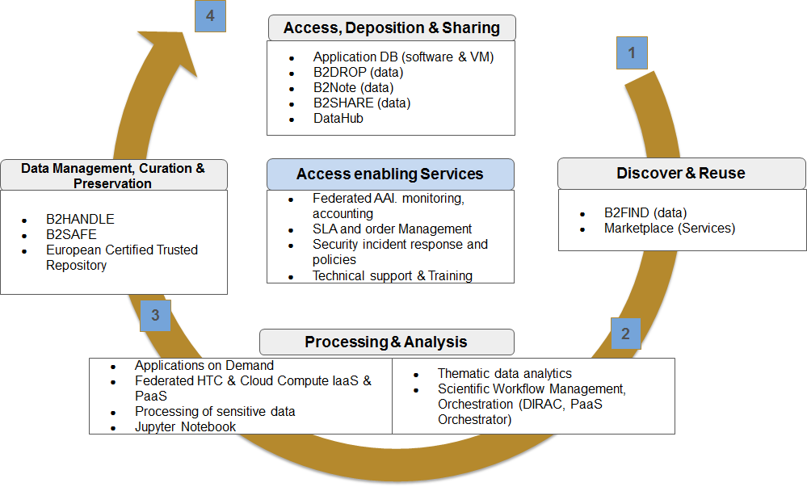

The role of the EOSC Federating Core services (in the middle) and various common and thematics services of the customer-facing EOSC Service Portfolio in different phases of the research cycle. The B2-services refer to the common services provided by the EUDAT CDI.

Available: https://eoscpilot.eu/eosc-glossary#overlay-context=eosc-glossary
Available: https://fitsm.itemo.org/wp-content/uploads/sites/3/2018/05/FitSM-0_Overview_and_vocabulary.pdf
COM(2016)178 final https://eur-lex.europa.eu/legal-content/en/TXT/?uri=CELEX%3A52016DC0178
Available: https://www.force11.org/group/fairgroup/fairprinciples
Available: http://europa.eu/rapid/press-release_SPEECH-16-1225_en.htm
SWD(2018)83 final https://ec.europa.eu/research/openscience/pdf/swd_2018_83_f1_staff_working_paper_en.pdf
Available: https://publications.europa.eu/en/web/eu-law-and-publications/publication-detail/-/publication/5253a1af-ee10-11e8-b690-01aa75ed71a1
SWD(2018)83 final https://ec.europa.eu/research/openscience/pdf/swd_2018_83_f1_staff_working_paper_en.pdf
Available: https://eosc-hub.eu/sites/default/files/Common%20Vision%2C%20Service%20Placement%20and%20Role%20in%20EOSC%20Governance%20June2019.pdf
Available: https://www.esfri.eu/esfri-events/esfri-ris-eosc-liaison-workshop?qt-event=1#qt-event
F. Karayannis, Summary notes of ESFRI Workshop on RIs and EOSC, 30 January 2019, London. Available: https://www.esfri.eu/sites/default/files/ESFRI-EOSC_Workshop_30Jan2019_summary-note_5.pdf
Available: https://www.eosc-hub.eu/events/eosc-hub-week-2019/programme
For more information: https://www.researchgate.net/publication/257303449_PEST_analysis
COM(2016)178 final https://eur-lex.europa.eu/legal-content/en/TXT/?uri=CELEX%3A52016DC0178
EuroHPC Work Plan 2019: https://eurohpc-ju.europa.eu/documents/EuroHPC-Work-Plan-2019.pdf
SWD(2018)83 final https://ec.europa.eu/research/openscience/pdf/swd_2018_83_f1_staff_working_paper_en.pdf
EuroHPC Summit Week 2019 live stream on 14 May 2019: https://events.prace-ri.eu/event/850/overview
PwC study on the cost of not having FAIR research data https://publications.europa.eu/en/publication-detail/-/publication/d375368c-1a0a-11e9-8d04-01aa75ed71a1
Available: https://ec.europa.eu/isa2/eif_en
Available: https://eoscpilot.eu/sites/default/files/eoscpilot-d2.6-v2.12.pdf
Available: https://ec.europa.eu/digital-single-market/en/network-and-information-security-nis-directive
Available: http://www.europarl.europa.eu/doceo/document/TA-8-2019-0352_EN.pdf
Available: https://ec.europa.eu/digital-single-market/en/modernisation-eu-copyright-rules
List of institutions endorsing the EOSC Declaration. Available: https://ec.europa.eu/research/openscience/pdf/list_of_institutions_endorsing_the_eosc_declaration.pdf
CESAER White paper 2019. Available: https://www.cesaer.org/content/statements-and-publications/2019/20190313-white-paper-rii.pdf
Second EOSCpilot Stakeholders Forum, Vienna, 21-22 Nov 2018, https://eoscpilot.eu/stakeholders-forum/2018-edition/second-eoscpilot-stakeholders-forum-agenda
Available: http://roadmap2018.esfri.eu/
Available: https://cordis.europa.eu/programme/rcn/703194/en
Available: https://www.eosc-hub.eu/events/eosc-hub-week-2019/programme
Available: https://www.esfri.eu/esfri-events/esfri-ris-eosc-liaison-workshop?qt-event=1#qt-event
Available: https://eosc-hub.eu/sites/default/files/Common%20Vision%2C%20Service%20Placement%20and%20Role%20in%20EOSC%20Governance%20June2019.pdf
Available: https://ec.europa.eu/research/openscience/pdf/eosc_declaration.pdf
See, e.g.: https://www.eosc-hub.eu/sites/default/files/3_EOSCsecretariat.eu%20EOSC%20HUB_Prague_final_Agis.pdf
For more information, see: https://www.eoscsecretariat.eu/eosc-working-groups
Available: http://data.consilium.europa.eu/doc/document/ST-1202-2018-INIT/en/pdf
Available: https://sciencebusiness.net/system/files/reports/Who-pays-what-European-Open-Science-Cloud-.pdf
Available: http://e-irg.eu/catalogue/eirg-1006
For full EOSC-hub consortium, see: https://www.eosc-hub.eu/partners
Available: https://marketplace.eosc-portal.eu/
For further information, see https://www.hnscicloud.eu/
Available: https://ec.europa.eu/info/publications/180131-sustainable-finance-report_en
Available: https://wiki.eosc-hub.eu/display/EOSC/EOSC+Portal
Available: https://eoscpilot.eu/sites/default/files/eoscpilot-d2.6-v2.12.pdf
See: https://ec.europa.eu/info/funding-tenders/opportunities/portal/screen/opportunities/topic-details/infraeosc-05-2018-2019
Available: https://www.eosc-hub.eu/news/services-support-fair-data
Available: https://www.eoscpilot.eu/content/d36-final-policy-recommendations
Available: https://publications.europa.eu/en/publication-detail/-/publication/7769a148-f1f6-11e8-9982-01aa75ed71a1/language-en/format-PDF/source-80611283
Available: https://ec.europa.eu/research/openscience/pdf/swd_2018_83_f1_staff_working_paper_en.pdf
Available: https://www.eoscsecretariat.eu/eosc-working-groups
Available: https://www.eoscsecretariat.eu/working-groups/architecture-working-group
Available: https://www.eoscsecretariat.eu/working-groups/rules-participation-working-group
Available: https://eoscpilot.eu/sites/default/files/eoscpilot-d2.5.pdf
Available: https://www.eoscsecretariat.eu/working-groups/fair-working-group
Available: https://publications.europa.eu/en/publication-detail/-/publication/7769a148-f1f6-11e8-9982-01aa75ed71a1/language-en/format-PDF/source-80611283
Available: https://www.eoscsecretariat.eu/working-groups/landscape-working-group
Available: https://www.eoscsecretariat.eu/working-groups/sustainability-working-group

