EGI-Engage

Risk analysis and risk response for Period 1
D1.2

Date | 02 November 2015
Activity | NA1
Lead Partner | EGI.eu
Document Status | FINAL
Document Link | https://documents.egi.eu/document/2595

Abstract
This document provides guidelines on how risk management (identification, analysis, response and control) will be conducted in EGI-Engage project. It also provides the results of the first re-assessment of the probability and impact of risks identified during the project proposal phase and the proposed response, as well as the result of new risk identification activities.

COPYRIGHT NOTICE
This work by Parties of the EGI-Engage Consortium is licensed under a Creative Commons Attribution 4.0 International License (http://creativecommons.org/licenses/by/4.0/). The EGI-Engage project is co-funded by the European Union Horizon 2020 programme under grant number 654142.
DELIVERY SLIP
 | Name | Partner/Activity | Date
From: | Małgorzata Krakowian | EGI.eu | 8.10.2015
Moderated by: | Roberta Piscitelli | EGI.eu | 21.10.2015
Reviewed by | Luciano Gaido  Jacco Konijn | INFN/PMB  UvA | 21.10.2015
Approved by: | Approved by AMB and PMB |  | 4.11.2015

DOCUMENT LOG
Issue | Date | Comment | Author/Partner
v.1 | 1.10.2015 | First draft | Małgorzata Krakowian/EGI.eu
v.2 | 8.10.2015 | Version after internal review | Małgorzata Krakowian/EGI.eu
v.3 | 28.10.2015 | Version after external review | Małgorzata Krakowian/EGI.eu
FINAL | 4.11.2015 | Final version for approval | Małgorzata Krakowian/EGI.eu

TERMINOLOGY
A complete project glossary is provided at the following page: http://www.egi.eu/about/glossary/

The following definitions are used in the EGI-Engage Risk management process:
Risk: a risk is defined as an uncertain event or condition that if it occurs, has a negative (threads) or positive (opportunities) effect on a Project's Objectives. (Source: PMBOK) In EGI-Engage the risk management process has been limited to threads.
Risk Registry: a database of identified risks with the associated analysis and response planning as well the estimation of risk occurrence and the history of their treatment.

Contents
1. Introduction 4
2. Risk management process 5
2.1 Risk identification 6
2.2 Risk analysis 7
2.2.1 Risk likelihood descriptors 7
2.2.2 Risk impact descriptors 8
2.2.3 Risk likelihood and impact matrix (risk level) 8
2.3 Risk response 8
2.4 Risk control 10
3. Timing 11
4. Actors involved 12
5. First results of the risk analysis activity 12
6. Conclusions 15

Introduction
Project Risk management process includes conducting risk management planning, identification, analysis, response planning and control. The objective is to detect threads and decrease their likelihood and impact by proper treatment as well as to collect lessons learned from risks occurrence to facilitate continuous learning of project management team.
Benefits of a risk management include:
- Increase focus and attention on risks
- Proactive approach for preventing risks from becoming issues
- Provide a consistent approach for analyzing, prioritizing, communicating and managing risks
- Provide an approach to efficiently and effectively mitigate risks
- Save cost and time by identifying, prioritizing, and managing risks
- Increase the impact and success of the project
In section 2 each of the sub-processes is described with a clear definition of its inputs, outputs and actions performed, as well as the related supporting materials.
Section 3 describes when and how often the risk management processes will be performed during the project life cycle.
Actors involved in the process are defined in Section 4 with clear description of responsibilities.
Section 5 provides the results of the first re-assessment of the probability and impact of risks identified during the project proposal phase and proposed response, as well as the results of new risk identification performed within the Work Packages.
The Risk registry has been reviewed by the Work Package leaders and the Project Management Board. It is kept confidential, with access restriction to PMB and AMB members only, it is an excel table attached to the deliverable (appendix A).

Risk management process

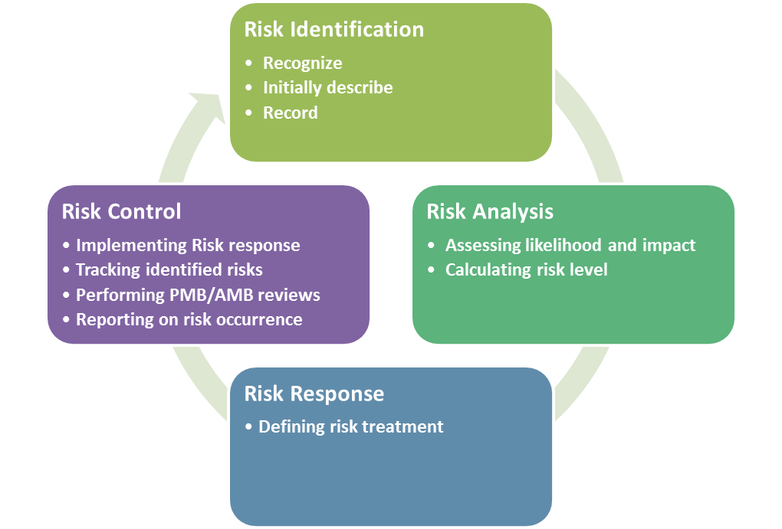
Risk management process contains four sub processes:
Risk identification
- goal: determining which risks can affect the project and documenting it in the Risk registry
- description: a process that is used to find, recognize, and describe the risks that could affect (prevent or undermine) the achievements of objectives.
Risk analysis
- goal: assessing likelihood and impact , evaluate the risk level
- description: a process that is used to understand the nature, sources, and causes of the risks that have been identified and to estimate their level. It will also study impact and consequences and examine the controls (an activity that prevents or detects issues to mitigate risks) that currently exist.
Risk response
- goal: defining the actions to be taken in order to avoid the risks or to minimize their impact (risk response plan) for each risk
- description: a process of developing options and actions to reduce threats to project objectives
Risk control
- goal: improve success of risk management activities through continuously monitoring and adjustment
- description: a process for implementing the risk response plan, tracking identified risks, performing risk status review

In the following sections each of the sub processes is described with a clear definition of the inputs, outputs and actions performed.

Risk identification
Input: Expertise of actors involved
Output: Initial entry in risk registry
Risk identification is a process that involves finding, recognizing, and describing the risks that could affect the achievement of the project objectives. It is used to identify possible sources of risks in addition to the events and circumstances that could affect the achievement of objectives. It also includes the identification of potential consequences.
Risks are identified:
- Periodically:
  - During Risk registry review through interviews and brainstorming conducted by Quality and Risk manager with Work Package leaders
- Continuously (whenever necessary):
  - Work Package leaders are expected to inform the Quality and Risk manager in case of identification of new risks or occurrence of a risk.

Each risk is supposed to be described in following way:
- Risk number – (mandatory) unique risk identifier assigned by Quality and Risk Manager
- Risk description - (mandatory) short description of the risk
- Likelihood - (mandatory) Likelihood (probability) is the chance that something is going to happen
  - Options: Unlikely, Possible, Likely, Almost Certain
- Impact - (mandatory) A consequence (impact) is the outcome of an event and has an effect on objectives
  - Options: Minor/Moderate/Major/Catastrophic
- Risk level - (mandatory) The level of risk is its magnitude. It is estimated by considering and combining impact and likelihood. Likelihood is the chance that something might happen.
  - Options: Low/Medium/High/Extreme (automatically calculated based on Risk likelihood and impact matrix)
- Consequences – (mandatory) description of the consequences the risk will have in case of occurrence
- Deliverables – Deliverables which might be impacted in case of occurrence
- KPIs – Impacted KPIs
- WP1-WP6 – (mandatory) Impacted WPs
- Treatment – (mandatory) description of possible actions to avoid or mitigate the risk
- Owner – (mandatory) A risk owner is the WP leader that has been given the authority to manage a particular risk and is accountable for doing so.
- Trend – (mandatory) Indication of risk trend comparing to the previous assessed risk status
  - Options: Stable, Improving, Degrading, New, Deprecated
- Comment for PMB - additional comments for PMB after Work Package leaders periodic rick review (every 3 months)

Risk analysis
Input: entry in the Risk Registry
Output: Prioritized list of risks (list of risks that pose the greatest threats), risk trends
During the analysis the risk level is evaluated by means of interviews to the Work Package leaders and other relevant actors performed by the Quality and Risk manager.
Risk rating (level) is calculated according to likelihood and impact matrix, reported in section 2.2.3.

Risk likelihood descriptors
The following table contains the risk likelihood descriptors:
Rating | Description | Likelihood of occurrence
1 | Unlikely | - Not expected, but there's a slight possibility it may occur at some time.
2 | Possible | - The event may occur at some time.
3 | Likely | - There is a strong possibility the event will occur
4 | Almost Certain | - Very likely. The event is expected to occur in most circumstances

Risk impact descriptors
Rating | Description | Project Objectives impact
1 | Minor | - Any risks which will have just a light impact on the project, still these must be addressed in time.  - Degradation of deliverable quality barely noticeable.
2 | Moderate | - Risks which will cause some problems, but nothing too significant. Reduction of deliverable quality requires approval.
3 | Major | - Risks which can significantly jeopardize some aspects of the project, but which will not compromise the success of the whole project.  - Reduction of deliverable quality unacceptable.
4 | Catastrophic | - A risk that can be detrimental for the whole project.

Risk likelihood and impact matrix (risk level)
The risk likelihood and impact matrix is a grid for mapping likelihood of each risk occurrence and its impact to the project objectives in case the risk occurs. Risks are prioritized according to their potential consequences on the project objectives.

Likelihood | Impact
 | Minor | Moderate | Major | Catastrophic
Unlikely | Low | Low | Medium | Medium
Possible | Low | Medium | High | High
Likely | Medium | High | High | Extreme
Almost Certain | Medium | High | Extreme | Extreme

Risk response
Input: Risk registry
Output: Risk response plan for each risk
Within this process the risk owner, who is responsible for given risk and its risk response, must be identified by Quality and Risk manager and Technical Coordinator. Risk response should be appropriate for the significance of the risk (risk level), cost-effective, realistic and agreed by impacted Work Packages leaders, Technical Coordinator and for high and extrema level risks also by PMB during periodic rick registry review (every 3 months).
For each risk impact level the following table presents a suggested response, to be properly defined:
Risk Impact level | Response
Minor | - Accept  - Define recovery activities  - Monitor and review
Moderate | - Avoid or Mitigate  - Define and implement mitigation activities  - Managed by monitoring or response procedures
Major | - Avoid or Mitigate  - Define and implement  - controls  - mitigation activities  - recovery activities  - requires Project Management Board attention and definition of management responsibility
Catastrophic | - Avoid or mitigate  - Define and implement  - controls  - contingency plan  - recovery activities  - mitigation activities  - Must be managed by Project Management Board with a detailed treatment plan.

For each risk level the following table presents a suggested involvement of the actors:
Risk level | Involvement
 | Technical Coordinator | Work Package leader | Project Management Board
Low | Informed | Active engagement | Informed
Medium | Consulted | Active engagement | Informed
High | Active engagement | Active engagement | Consulted
Extreme | Active engagement | Active engagement | Active engagement

Risk control
Input: Risk registry
Output: Improved success of risk approach
Risk control is a process to improve efficiency of the risk management through continuously monitoring and adjustment. It implements risk response plan, tracking identified risks, performing risk reviews.
The main activities planned as part of risk control are:
- Continuously (whenever necessary)
  - Work Package Leaders are
    - applying risks response
    - reporting on risk occurrence
    - reporting on new risks identified
- On a monthly basis
  - Quality and Risk Manager is
    - reporting to PMB risk occurrences and newly identified risks which require PMB attention.
- Every 3 months
  - Quality and Risk Manager is conducting the risk registry review with Work Package leaders, including:
    - identification of deprecated risks
    - reassessment of impact and probability of existing risks
    - review of risk response
    - identification of new risks
  - Quality and Risk Manager is reporting to PMB the results of the review.

Timing and reporting
This section describes when and how often the Risk Management Process will be performed during the project life cycle.
The Risk Management Process timing is as follow:
- Continuously (whenever necessary)
  - Work Package Leaders are
    - applying risks response measures
    - reporting by email on risk occurrence to the Quality and Risk Manager
    - reporting by email on new risks identified to the Quality and Risk Manager
- On a monthly basis (whenever necessary)
  - Quality and Risk Manager is
    - reporting by email to PMB about risks occurrence and newly identified risks which require PMB attention.
- Every 3 months
  - Quality and Risk Manager is conducting risk registry review with Work Package leaders (through Activity Management Board), including:
    - identifying deprecated risks
    - reassessment of impact and probability of existing risks
    - reviewing of risk response
    - identification of new risks
  - Quality and Risk Manager is reporting during PMB meeting about the results of the review.

Actors involved
Involved actors are project team members who take part in risk management process. All actors have clearly assigned roles and responsibilities, which are defined as follow:
Quality and Risk Manager
Responsible for:
- coordinating project risk management activity
- defining and keeping up to date risk management plan
- helping Work Package leaders in risk analysis and response
- performing risk registry reviews
- reporting to Project Management Board risk management status
Technical Coordinator
Responsible for:
- coordinating with Work Package leaders implementation of risk response plan
- performing risk analysis and coordinating contingency planning tasks within the project
Work Package leaders
Responsible for:
- identifying and defining new risks
- reviewing the status of identified risks during risk registry review
- implementing an appropriate risk response plan within their WP
- reporting on risk status and its occurrence to Quality and Risk Manager
Project Management Board
Responsible for:
- approving risk response for risks level high and extreme
- supporting Technical Coordinator in performing risk analysis

First results of the risk analysis activity
Risk analysis has been performed by Work Package leaders with the support of the Quality and Risk Manager in September 2015.
All 20 risks identified during the project proposal phase (foreseen) have been reviewed according to the following questions:
- Are the risks still relevant to the project?
- Have the risk levels changed?
- Are the proposed countermeasures still valid and being applied?
- Are the consequences of the risk occurrence still valid?
In addition for each risk an owner has been assigned, the Work Package leader responsible for coordinating the treatment application, as well as the trend in comparison to the risk level defined during the project proposal phase.
Each Work package leader has also been responsible, based on a 6 month period experience, to identify new risks (unforeseen) and report on risks materialized (occurrence of events related to the risks) during the period.
As a result of the review:
- From 20 (foreseen) risks 11 have been identified as deprecated, not applicable to the project any more
  - 4 – Risks duplicated by other risks
  - 4 – Risks not valid any more
  - 3 – Risks not related to the project but to the EGI Infrastructure
- 9 (foreseen) risks have been identified as still relevant
  - Risk level
    - 2 – high
    - 2 – medium
    - 5 – low
  - Risk trend
    - 3 – stable – risk level has not change
    - 6 – improving – risk level has been decreased
- 31 (unforeseen) new risks have been identified
  - Risk level
    - 15 – high
    - 10 – medium
    - 6 – low
- 5 events occurred, related to 3 risks
  - Risk event occurrences’ status
    - 3 – improving
    - 2 – stable
- No risks have been identified as requiring a contingency plan.

Conclusions
Risk management process is part of Activity Management Board and Project Management Board activities. Quality and Risk Manager is in charge of coordinating and controlling the process.
Any issues related to the process will be reported to Work Package 1 leader.
The risk management process assessment and revision will be part of deliverable D1.4 Risk analysis and risk response for Period 2 delivered in project month 20.

