EGI-Engage

EPOS EGI pilot integrating computational resources and services
D6.19

Date | 15 February 2017
Activity | [provide]
Lead Partner | [provide]
Document Status | DRAFT
Document Link | https://documents.egi.eu/document/XXX

Abstract

COPYRIGHT NOTICE
This work by Parties of the EGI-Engage Consortium is licensed under a Creative Commons Attribution 4.0 International License (http://creativecommons.org/licenses/by/4.0/). The EGI-Engage project is co-funded by the European Union Horizon 2020 programme under grant number 654142.
DELIVERY SLIP
 | Name | Partner/Activity | Date
From:
Moderated by:
Reviewed by
Approved by:

DOCUMENT LOG
Issue | Date | Comment | Author/Partner
v.1
...
...
v.n

TERMINOLOGY
A complete project glossary and acronyms are provided at the following pages:
- https://wiki.egi.eu/wiki/Glossary
- https://wiki.egi.eu/wiki/Acronyms

Contents
1 AAI use case 6
1.1 Introduction 6
1.1.1 Scientific use case description 7
1.1.2 E-infrastructure requirements 8
1.2 Service architecture 8
1.2.1 High-Level Service architecture 9
1.3 Release notes 10
1.3.1 Requirements covered in the release 10
1.4 Feedback on satisfaction 10
1.5 Plan for Exploitation and Dissemination 10
1.6 Future plans 10
2 Earthquake simulation use case (misfit) 12
2.1 Introduction 12
2.1.1 Scientific use case description 13
2.1.2 E-infrastructure requirements 13
2.2 Service architecture 14
2.2.1 High-Level Service architecture 15
2.2.2 Integration and dependencies 15
2.3 Release notes 17
2.3.1 Requirements covered in the release 17
2.4 Feedback on satisfaction 17
2.5 Plan for Exploitation and Dissemination 17
2.6 Future plans 19
3 Satellite Data use case 20
3.1 Introduction 20
3.1.1 Scientific use case description 21
3.1.2 E-infrastructure requirements 21
3.2 Service architecture 22
3.2.1 High-Level Service architecture 22
3.3 Release notes 23
3.3.1 Requirements covered in the release 23
3.4 Feedback on satisfaction 23
3.5 Plan for Exploitation and Dissemination 23
3.6 Future plans 24

Executive summary

AAI use case

Introduction
EPOS main aim is to coordinate, collect, archive high quality Earth Science data across Europe. By a definition EPOS is a distributed Research Infrastructure where Data, Data Products, Software and Services (DDSS) are provided by different communities in the domain of the solid Earth sciences. In this framework, EPOS envisage the construction of a central hub called “Integrated Core Services” (ICS) which aggregates all DDSS from the various disciplines. From the technical viewpoint, DDSS are provided by a distributed network of endpoints (Thematic Core Services, TCSs) which use heterogeneous authorization mechanisms. Users access to the ICS querying for some data/dataproducts/software/service, and ICS are delegated to fetch the resources on behalf of the user. The purpose of this use case is to provide a framework, to be used in the ICS hub, which enable any user to access to the ICS with one type of authorization mechanism (e.g. OAuth, eduGAIN, X509 certificates etc.) and delegate ICS to fetch resources at the various endpoints which may implement heterogeneous authorization mechanisms.
The prototype mimics the functionality a user will utilise on a target ICS-C/D platform. After evaluation of different existing solutions to define the EPOS AAAI infrastructure the prototype has been chosen to be based on solution implemented by the EGI Long Tail of Science platform (LToS). Thus, we base the prototype on Unity IDM and target ICS-C platform will utilise special proxies generated by robot certificate (Per-User Sub-Proxies) for heavy job execution.

Tool name | Prototype of the EPOS Authorisation Authentication Infrastructure (AAI)
Tool url | https://epos-aai.cyfronet.pl/home/home
Tool wiki page | Not applicable
Description | The service aims to provide of the Authentication and Authorisation Infrastructure service prototype for EPOS. For this purpose, the AAI backbone of the EGI LToS have been applied and, the AAI prototype is thus based on Unity technology. For the sake of simplicity, the EGI AAI is used as Identity provider for EPOS AAI prototype
Value proposition | EPOS infrastructure is currently under heavy development. The knowledge transfer from EGI to EPOS concerning AAI is meant to speed up development of the AAI service(s) and thus ease the integration between Integrated Core Services and Thematic Core services and underlying national research infrastructures.
Customer of the tool | Whole EPOS community, since Integrated Core Services, through Thematic Core services up to national (Earth science) research infrastructures.
User of the service | Large scientific community
User Documentation | Not applicable
Technical Documentation | http://www.unity-idm.eu/, see also https://wiki.egi.eu/wiki/LToS
Product team | ACC Cyfronet AGH, l'Istituto Nazionale di Geofisica e Vulcanologia
License | Open Source, TBD
Source code | http://www.unity-idm.eu/

Scientific use case description
User Story | - The user access to ICS-C portal for the first time, therefore s/he registers to EPOS ICS-C user database.  - The user logs in with his/her credentials (different technologies IdP enabled, for instance X509 certificates, OpenIdConnect, eduGAIN).  - Currently TCS AH and EGI LToS are supported  - User does some simple but multidisciplinary data discovery (i.e. accessing to at least two types of data from different domain and TCSs, say seismological waveforms from seismology TCS and events from AH TCS)  - S/he gets the complete list of results (e.g. data-objects, files in this case) and selects some of them to be downloaded  - S/he obtains the data (e.g. download as zipped/tar format or simply in the native file format).
(Potential) User base | The potential user base is composed by all users interested in the solid earth sciences, and in particular by: a) Data and service providers, b) Scientific user community, c) Governments, d) Private sector, and e) Society.  Each of those stakeholder categories can interact with the system in a different way and therefore be identified as:  - Active users, those actively using the system. The majority of these users will be registered. We estimate this category to be the 20% of the total engaged.  - Occasional users, those occasionally using the system in a “lightweight” mode. We estimate this category to be the 40% of the total engaged users in each year.  - Sporadic users, those rarely using the system and for no specific purpose (e.g. they are simply curious, etc.). We estimate this category to be the 40% of the total engaged users in each year.  As for the number of users for each stakeholder category, a systematic study is being carried on, considering that: a) EPOS is a system under development and the ACTIVE user base will be increasing in time and b) the potential number of users can be enormous if we consider as “interested stakeholders” the total number of participants to huge geological meetings as EGU (12.500 registered users) or AGU (20.860 registered users).

E-infrastructure requirements
HW Resources | This use case does not require any specific HW resources for processing. The amount of resources to host the AAI services will provided by ICS-C resources. It is required however, high availability of the EGI CheckIn service, on which large number of EPOS users will rely.
SW Resources | The use case does not have particular SW requirement from EPOS. The SW requirements depend on the exact solution to be used and offered from EGI.
Cost of delivery | The service will be provided by EPOS ICS-C. Thus, the cost will be associated with the EPOS AAAI services solely. However, due to dependence of the EGI CheckIn we expect some extra costs for covering it.
Operational aspect | The use case is foreseen as proof of concept only. Once integrated within EPOS infrastructure will be operated by EPOS ERIC ICS-C. NGI interested will involve all countries supporting EPOS Infrastructure.

Service architecture
General Considerations:
- Taking in to account dispersed character of the EPOS infrastructure, including scientific data sets, high level services, computing facilities, etc. users should be provided with AAAI system capable to interact with all the EPOS resources,
- Several TCSs, RIs, etc., have already developed some AAAI solutions. These will have to be connected to the general EPOS AAAI in order to avoid break-up of already existing services.
- To connect existing AAAI approaches in EPOS into one ecosystem AAAI hub is needed which will assure interoperability between existing technologies. Hub technologies passing logins, passwords, etc. have to be abandoned by principle. Instead modern, attribute based, solution is advised. Once user is authenticated within the infrastructure all the authorisation should be done by attributes only. Set of the EPOS specific attributes should be defined on the hub.
- Curent IdPs EPOS is aware of include: EduGAIN, LDAP, OpenID, x509 certificates.
The proposed AAAI scheme including all the above-mentioned requirements is sketched on Figure 1.
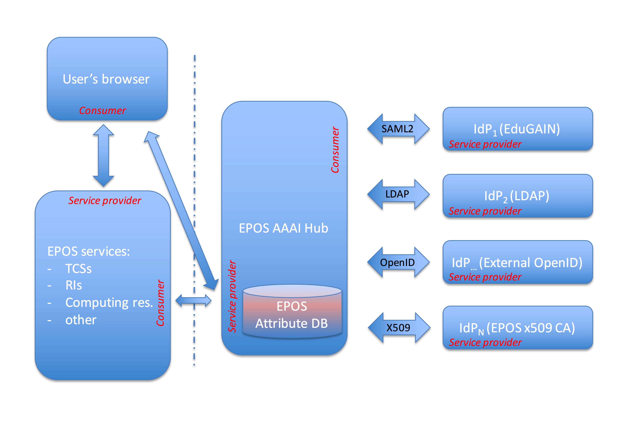
Figure 1. The proposed AAAI scheme for EPOS

High-Level Service architecture
The prototype has been built according to the scheme sketched on Picture 2. In the current implementation two IdPs have been integrated as a proof of concept including EGI CheckIn and TCS AH. Additional IdPs will be integrated within the EPOS ICS-C after initial integration with the ICS-C science gateway. The thick arrows on the scheme represent any further communication (between TCSs, ICS-C and EGI CheckIn) after the authorisation has been completed. I.e. this includes job submission with data analysis, processing, advanced visualisations, etc.
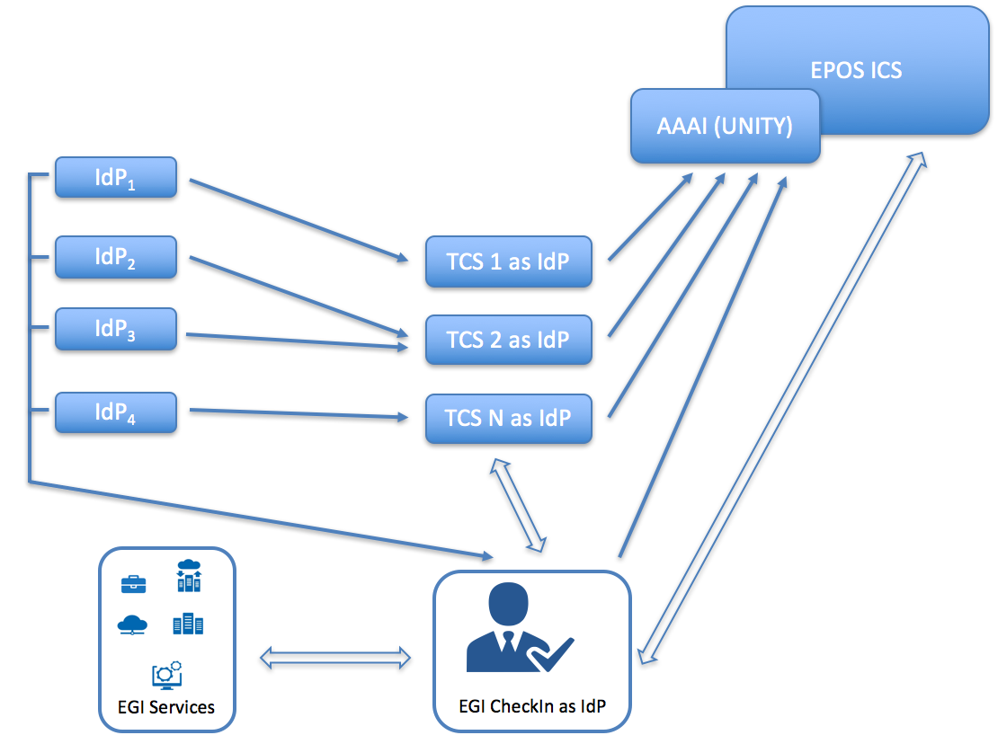
Figure 2. EPOS AAI prototype scheme

Release notes

Requirements covered in the release
List requirements that have been implemented in the release

Feedback on satisfaction
The prototype has been presented for the EPOS IT teams (EPOS IP project WP6 and WP7 packages). Access to the prototype is open for anyone with valid EGI or TCS AH credentials. After the presentation at the TCS-ICS meeting in Prague the prototype has been accepted by EPOS WP6 and WP7 teams as a general solution of EPOS AAAI. The first version, integrated with the EPOS ICS-C portal, is expected in a fall 2017, together with a second version of the ICS-C science gateway.

Plan for Exploitation and Dissemination
The AAI prototype will become an internal part of the ICS-C science gateway and for most of the time will work invisible for the EPOS user. Therefore, there is no need for special plan for its exploitation and dissemination. The two took place however, during several technical meetings with the EPOS WP6 & WP7.

Future plans
The major step is to integrate the prototype with the EPOS ICS-C science gateway. As mentioned, according to EPOS IT teams plans, this step shall be done by fall of 2017. Second stage will include integration of the remaining Thematic Core Services with the ICS-C platform. Final step will bind the computing resources provided by EGI with ICS-C and TCSs via ICS-D services.

Earthquake simulation use case (misfit)

Introduction
The use case enables the processing and the comparison of data resulting from the simulation of seismic wave propagation following a real earthquake and real measurements recorded by seismographs. While the simulation data is produced directly by the users and stored in a Data Management System, the observations need to be pre-staged from institutional data-services, which are provided by the international seismic-data archives of the FDSN consortium. Users can interactively select the data of interest, compose and execute processing pipelines and conduct eventually the MISFIT analysis between the synthetics and the observed-data streams. The final scope of the systems is to support the researchers with the study and the improvement of regional and global Earth Models. The target system is a comprehensive computational platform developed in the context of the EC funded project VERCE. It provides a science gateway and technological stack that is currently endorsed and supported by the EPOS-IP initiative.
The activities of the Competence Center aim at extending the computational capabilities of the platform with EGI FedCloud resources and the required management middleware.

Tool name | EPOS Computational Earth Science – Siesmology - VERCE Portal
Tool url | http://portal.verce.eu
Tool wiki page | http://www.verce.eu
Description | Virtual Earthquake and seismology Research Community e-science environment in Europe
Value proposition | The platform generally aims at facilitating the integration of computational resources to be exploited by seismological applications, adopting standard interfaces towards cloud and HPC. Integrating FedCloud would extend the possibilities of procurement, accounting and sustainability of the service.
Customer of the tool | Universities, International Research Centers and Earthquakes Monitoring Centers.
User of the service | The main users of the platform are researchers in computational seismology, teachers in Geodynamic, students and analysts. The latter, together with decision-makers benefit from the execution of rapid simulations and analysis, for the refined evaluation of seismic scenarios.
User Documentation | http://www.verce.eu/Training/UseVERCE.php
Technical Documentation | http://www.verce-project.eu (requires authentication)
Product team | Fraunhofer SCAI, INGV, Uliv, KNMI, CNRS
License | OpenSource
Source code | https://github.com/KNMI/VERCE

Scientific use case description
User Story | - Through the VERCE Science Gateway, user selects for which simulation results he/she would like to download also the observed row data.  - User triggers the execution of a download workflow that will pre-stage the observed data in a dedicated storage space.  - User combines observed data and simulation results and configure a processing pipeline.  - User triggers the execution of the pipeline workflow which will ingest and process the observed and synthetic data  - User selects the pre-processing results and specifies the parameters for the misfit analysis  - User triggers the execution of the misfit processing workflow  - Progress of the computations can be always monitored and the results and the associated metadata visualised at runtime or offline
(Potential) User base | The current deployment of the platform counts ca. 110 users.  Users mostly belong to the seismological community and are typically students, academics and researchers. We recognize that a certain number are also IT experts who are interested in the platform’s generics.  Potential user base can be reached by training sessions that combine scientific lectures with the acquisition of technical skills aiming at clear research targets.

E-infrastructure requirements
HW Resources | Apart from the existing infrastructure (Gateway, Middleware backend services, VOMS server, iRODS infrastructure) the use-case only requires additional Cloud VMs for carrying out the processing tasks. Of course the requirements for the processing will depend on the amount of jobs and data volume to be processed. We foresee that a low number of VMs (1-10) will be suitable for evaluation purposes.
SW Resources | SW Product: ObsPy  Technology Provider: The ObsPy Development Team (devs@obspy.org)  License: GNU Lesser General Public License, Version 3  SW Product: Dispel4Py  Technology Provider: The Dispel4Py Development Team (rosa.filgueira@ed.ac.uk)  License: Apache License, Version 2.0  SW Product: gUSE (grid and cloud user support environment)  Technology Provider: LPDS Sztaki (portalsupport@lpds.sztaki.hu)  License: Apache License, Version 2.0  SW Product: Globus Toolkit  Technology Provider: The Globus Alliance  License: Various
Cost of delivery | Extension of the current VO with FedCloud attributes. Enablement of cloud-friendly submission from WS-PGRADE workflow towards these cloud resources. Contextualisation of generic VMs suitable for the tasks or delivery of full-fledged dedicated VMs. Instances can be used by single users or in pools.  The envisaged cost of delivery is estimated in about 20 person-months.
Operational aspect | The existing services (Gateway, Middleware backend services, VOMS server, iRODS infrastructure) are operated by SCAI which is member of NGI-DE.  The EGI FedCloud resources to be used are operated by CNRS IPHC whose participation is supported by the French NGI.  Until now there have been no further negotiations with NGIs about additional support.

Service architecture
The VERCE virtual research environment (VRE) requires communities driving the research, collections of relevant data, application software tuned and maintained to meet the latest research requirements and to exploit hardware advances, and teams of ICT experts maintaining the VRE’s advanced capabilities. Its usability and sustainability is key to attracting these researchers, enabling their collaboration, creating effective interplay between ICT experts and domain-focused researchers, gaining access to the resources required and amortising costs over sufficiently broad communities. The design of the VERCE platform embraces this diversity.

High-Level Service architecture
The platform offers a number of application specific services to perform operations such as simulation, raw-data pre-staging from FDSN archives, pre-processing and misfit. These high level services are organised into independent workspaces, which operate through the interaction with the platform’s webservices and workflows. The infrastructure serve these interfaces with computational and data resources. We provide below a high-level overview of the architecture including user interaction and data-flows.
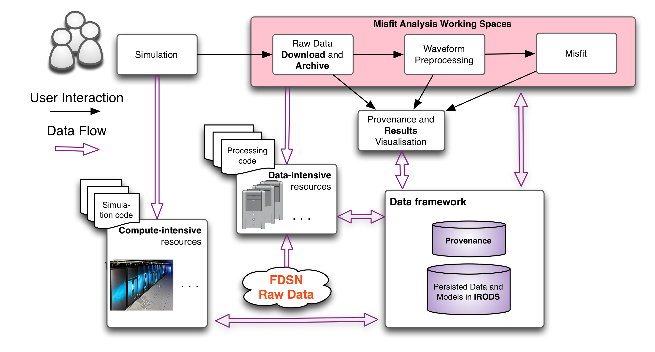
The efforts of the team are focusing on extending the Data-Intensive component shown by the illustration with FedCloud capabilities.

Integration and dependencies
This section provides a System-centric overview of the VERCE integrated software and dependencies.
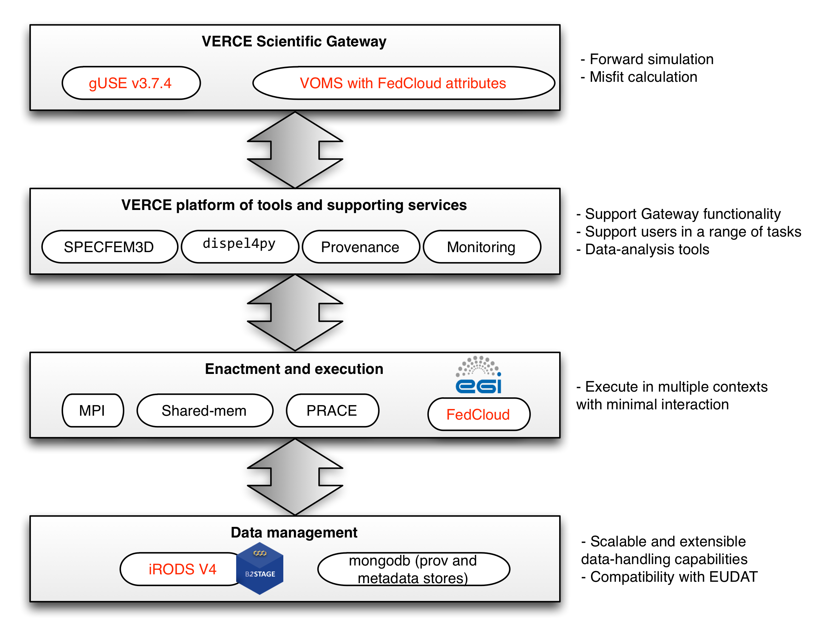
Figure 3. VERCE integration and dependencies: In red the updated components
VERCE Science Gateway
gUSE is a Liferay-powered science-gateway framework. The support of VOMS and x.509 certificates is a clear security requirement, which has been met both through gateway/portal technologies.
Platform tools and supporting services
- SPECFEM3D is a widely used tool for simulating seismic wave propagation (http://geodynamics.org/cig/software/specfem3d). Its support for SPECFEM3D was requested by the seismology research community.
- dispel4py: A Python framework for describing abstract data-intensive workflows. It is used for all the data processing tasks in shared-memory as well as MPI-powered clusters.
- The VERCE Provenance service: It is used on the gateway and it interacts with a number of architectural components, such as the corresponding data management elements shown under “Data Management”. It follows the W3C-PROV standard (http://www.w3.org/TR/prov-overview).
- Monitoring of execution is a service offered on the gate- way, interacting with the provenance solution.

Enactment and Execution
These are architectures and computational services that the VERCE solution is able to make use of, thus adding to sustainability and standardisation. We extended this portfolio with the possibility of integrating resources provided by the EGI FedCloud
Data Management
iRODS is a rule-based data-management system order to address requirements to do with storage and access at scale, with configurable access policies. We have updated the current setup to the iRODS v4. This brought improvements also to the GridFTP support for data-staging operations to and from iRODS, thanks to the integration of the EUDAT B2-STAGE technology. MongoDB is a distributed and scalable document database used by the provenance and monitoring subsystems.

Release notes

Requirements covered in the release
- Setup the IPHC (@IN2P3/CNRS) cloud site to allow verce.eu VO members usage of its resources
- Setup the IPHC network to allow relevant traffic to pass (http/https/GUSE)
- Install GUSE images from EGI application database
- Add the IRES-IN2P3 (IPHC) cloud resource site to the Verce development portal
- Upgrade the GUSE/WSPGRADE portal at SCAI to version 3.7.4, supporting the OCCI interface and, more generally, VMs with no automatically assigned floating IP addresses

Feedback on satisfaction
Who was involved in testing and what the outcome of the review was

Plan for Exploitation and Dissemination
As already mentioned, the Computational use case in the EPOS Competence Center builds upon results of previous work and aims at enhancing and providing computational resources to the VERCE platform, whose goal is facilitating the integration of computational resources to be exploited by seismological applications.
In such a framework, the exploitation and dissemination activities take advantages of already existing plans and user base, that need to be expanded.
The aim of the dissemination strategy is to maximize the exposure, impact and usage of the VERCE platform and of all the connected resources representing an extremely valuable tool for seismological and in general geophysical analyses. The key objectives of the strategy are:
- Increase the visibility of the use case and the platform by advertising them at national and international meetings, educational schools and public events;
- Regularly distribute and share updates about the platform;
- Transfer knowledge through training materials and dedicated events, educational resources and the organisation of workshops;
- Support the development of a strategy for the exploitation of the key outcomes of VERCE both for an increasing number of seismological applications and also for other geophysical fields that will benefit from the VERCE accomplishments.
In order to achieve these goals, the existing material (summarized at the end of the paragraph) is a useful starting point. In particular, the VERCE website provides a complete and detailed view of all the platform functionalities, resources and services and can be used to advertise its possible applications and also its important societal implications. Moreover, the website has a dedicated section to access training presentations and videos that we distributed during the webinars and the face-to-face training events of the VERCE project and that explain step-by-step (with included demos) how to use the platform and its services and how to access and exploit the produced output. The user guide of the portal and the VERCE legacy video are also available for a thorough overview. Finally, there is a section of the VERCE website that links to all the project-specific publications and to other related papers.
Based on this material, our exploitation and dissemination plan is organised as follows:
- Review the already available material in order to update it to the latest release of the portal and to its new functionalities (e.g., misfit calculation, simulation at global scale, …);
- Disseminate and advertise this training material trough all the available channels (e.g., mailing lists of interested users, newsletters, project website, etc.) in order to attract the attention of domain specific scientific communities and of more general geophysical users;
- Organise new interactive webinars addressed to a broader audience thanks to the framework of EPOS-EGI-EUDAT projects;
- Advertise the use case and the portal at forthcoming conferences and meetings;
- Advertise the use of the platform for solving scientific issues as the analysis of seismic waves generated by the ongoing 2016 Central Italy seismic sequence;
- Support and enhance scientific publications on national and international journals and magazines to highlight the impact and potentialities of the VERCE tool;
- Organise a large face-to-face training event open to a broad public with theoretical presentations, demos and interactive sessions.
The structure and contents of our dissemination plan will be addressed in order to reach different categories of audience often interconnected with each other:
- Domain scientists as well as members of the broader earth sciences community;
- Industry actors in the earth sciences, and in computing and information technologies;
- National public services, policy makers and governments.

Summary of the dissemination material already available:
- VERCE website http://www.verce.eu
- VERCE portal user guide http://www.verce.eu/Training/UseVERCE/VERCEPortal-UserGuide-vers1.1.pdf
- Trainings’ presentations and videos http://www.verce.eu/Training/UseVERCE.php
- Comprehensive legacy video of the VERCE project
- https://www.youtube.com/watch?v=t9Adh1042-M&feature=youtu.be
- VERCE-specific and correlated publications:
http://www.verce.eu/PublicDissemination/Publications.php

Future plans
More communities within EPOS, are looking with interest at the capabilities of the platform and at the outcome of the EGI use case. Currently a plan is developing to include Vulcanological research applications in the same VERCE framework, with the scope of scaling all the generic components to a larger user-base. Towards the characterisation of the EPOS Computational Earth-Science strategy.

Satellite Data use case

Introduction
This use case is related to the services that will be offered by the EPOS satellite data TCS to the wide range of EPOS users: a) Data and service providers, b) Scientific user community, c) Governments, d) Private sector, and e) Society.
The satellite data TCS services deal with the processing of the Earth Observation datasets collected by various satellites, including the Sentinels of the Copernicus programme to address several societal challenges related to climate, natural hazards and risk assessment and, efficient usage of resources.
Satellites are very extensive and complex sources of information and their exploitation requires advanced knowledge on Earth Observation systems.IT platforms can make access to satellite data possible for a broader research community, and therefore the EPOS satellite data TCS decided to host services on top of some ESA Thematic Exploitation platforms (e.g. Geohazard TEP).
In the context of this use case, a pilot EPOS service will be deployed on top of the Geohazard TEP that is now interconnected to the EGI FedCloud to exploit its computing and storage resources. The work to integrate the Geohazard TEP with the EGI FedCloud has been done under the EGI-Engage task SA1.3.
The selected demonstrator is P-SBAS InSAR Sentinel-1 TOPS developed by CNR-IREA. P-SBAS stands for Parallel Small BAseline Subset and it is a DInSAR processing chain for the generation of Earth deformation time series and mean velocity maps, which uses as Input SLC (Level-1) Sentinel-1 data. Such processing chain generates as output in csv format: Line Of Sight (LOS) Displacement time series, Mean LOS Velocity, Temporal Coherence, Average scatterer elevation (Topography). The service can also generate wrapped and unwrapped interferograms that are delivered in geoTiff format. This pilot is planned to run in the EGI FedCloud from February/March 2017 to February 2018.

Tool name | P-SBAS InSAR Sentinel-1 TOPS
Tool url | N.A.
Tool wiki page | N.A.
Description | P-SBAS stands for Parallel Small BAseline Subset and it is a DInSAR processing chain for the generation of Earth deformation time series and mean velocity maps, which uses as Input SLC (Level-1) Sentinel-1 data.
Value proposition | Describe how the new or changed service alleviates specific user pains and/or supports its intended customer(s) to exploit new opportunities
Customer of the tool | Scientific community representatives, Governments, and Industries.
User of the service | Large research groups, individual researcher, Government agency employers, Industry employers.
User Documentation | Please provide url
Technical Documentation | Please provide url
Product team | CNR-IREA
License | Please provide license
Source code | Please provide url

Scientific use case description
User Story | - A user accesses the Geohazard TEP to exploit one of the services hosted by the platform.  - The user requires some data via the selected services.  - The user’s request trigger a computation.  - The Geohazard TEP create a certain number of VMs into the EGI FedCloud to perform the computation  - The Geohazard TEP will copy the input data needed for the computation into the EGI FedCloud storage  - The Geohazard TEP retrieve the output data from the EGI FedCloud  - The Geohazard TEP provides the requested data to the user.
(Potential) User base | The potential user base is composed by all users interested in the solid earth sciences, and in particular by: a) Data and service providers, b) Scientific user community, c) Governments, d) Private sector, and e) Society.  See the AAI use case for more details.

E-infrastructure requirements
HW Resources | The amount of needed HW resources requested by this pilot are the following:  - n. 10-12 virtual machines with 2-4 CPUs, 32 GB RAM, 100 GB of local disk.  Such resources will be provided by the EGI BEgrid-BELNET resource provider in the context of the SLA agreed between EGI and Terradue.
SW Resources | The SW resources needed are the P-SBAS InSAR processing chain, the ESA TEPs and related packages setup on top of them.
Cost of delivery | Integration of the ESA Geohazard TEP into the EGI FedCloud could be done at different level.  The one implemented in the EGI-Engage task SA1.3 is the “On-Demand” model: TEPs are deployed and operated by external organisation and use the EGI FedCloud to perform computations on demand:  - create VMs when a new computation should be performed  - transfer input data to the EGI FedCloud  - retrieve the output data  - free all the resources allocated after the output data have been downloaded.  Different types of integration would be examined and assessed in the next future. For example, we will investigate how to create clone or big cache of the Satellite Data in the EGI infrastructure accessible by all the FedCloud sites to reduce the transfer time.
Operational aspect | The ESA Geohazard TEP is currently in a pre-operation phase and is managed and operated by Terradue.

Service architecture

High-Level Service architecture
The P-SBAS InSAR Sentinel-1 TOPS demonstrator will run on top of the Geohazard TEP that has been developed outside this project. The Geohazard TEP implements the ESA Thematic Exploitation Platform architecture, see the figure below.
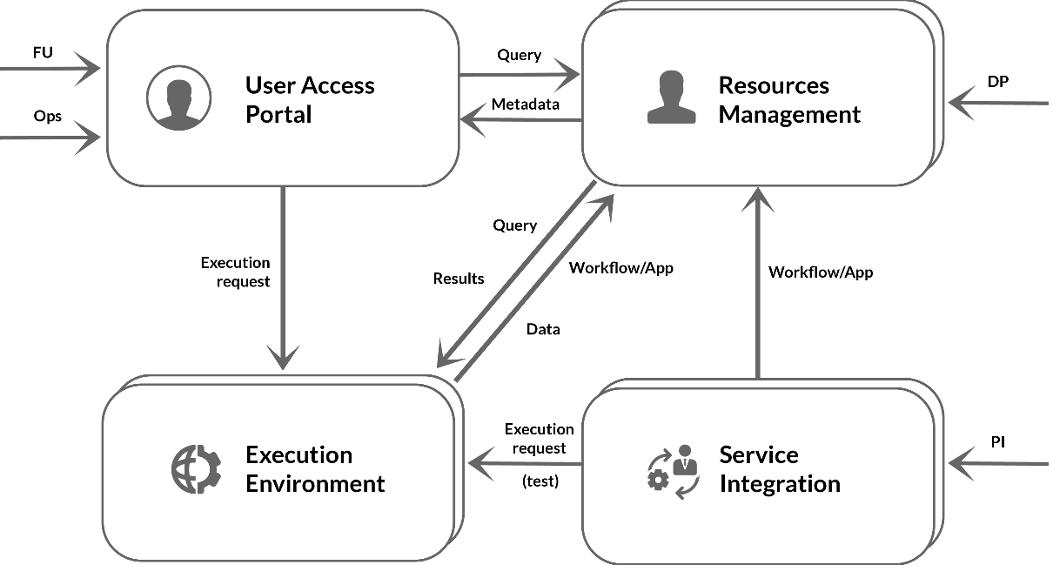
Figure 4. ESA Thematic Exploitation Platform architecture

Release notes

Requirements covered in the release
- Generation of Earth deformation time series and mean velocity maps from SLC (Level-1) Sentinel-1 data. The output will be in csv format and contain the following measurements: Line Of Sight (LOS) Displacement time series, Mean LOS Velocity, Temporal Coherence, Average scatterer elevation (Topography).
- Generation of wrapped and unwrapped interferograms delivered in geoTiff format.

Feedback on satisfaction
The demonstrator will run later this year for the EPOS community. A feedback on satisfaction will be requested to the users that will try the service.

Plan for Exploitation and Dissemination
The deployment of the P-SBAS InSAR Sentinel-1 TOPS demonstrator within the Geohazard exploitation platform is an activity that has been performed outside the EGI-Engage project. The integration of the Geohazard exploitation platform, instead, has been done in the context of the task SA1.3.
Aim of this use case is demonstrating how EGI, through its Cloud Compute service, could offer the provisioning of cloud compute and storage resources to the EPOS community serving as ICS-D for many EPOS TCS and the EPOS ICS.
Such result will be advertised to the EPOS community with the aim of creating a long term collaboration between EGI and the future EPOS ERIC.

Future plans
The P-SBAS InSAR Sentinel-1 TOPS demonstrator will run during the remaining months of the EGI-Engage project and after. In this period, we will invite people of the EPOS community to test and validate the service.
In addition, the integration of the Geohazard Exploitation Platform with the FedCloud will be further exploited scheduling and running new Satellite Data pilots according to the needs of the EPOS community.

EPOS-IP WP6 &WP7 teams. (2015). ICS-TCS Integration Guidelines - Handbook for TCS integration: Level-2. Zenodo. 10.5281/zenodo.34666
http://www.gnu.org/copyleft/lesser.html
http://www.apache.org/licenses/
http://toolkit.globus.org/toolkit/docs/5.2/5.2.3/licenses/
http://irods.org
http://www.mongodb.org
The e-Collaboration for Earth Observation (e-CEO) platform: https://wiki.egi.eu/wiki/EGI-Engage:WP5#TASK_SA1.3_Integration.2C_Deployment_of_Grid_and_Cloud_Platforms
http://www.irea.cnr.it/en/
http://go.egi.eu/EP-OpenArchitecture

