EGI-Engage

Second release of the EGI Service Registry and Marketplace prototype
D3.13

Date | 27 April 2017
Activity | WP3
Lead Partner | SWING
Document Status | DRAFT
Document Link | https://documents.egi.eu/document/3028

Abstract

COPYRIGHT NOTICE
This work by Parties of the EGI-Engage Consortium is licensed under a Creative Commons Attribution 4.0 International License (http://creativecommons.org/licenses/by/4.0/). The EGI-Engage project is co-funded by the European Union Horizon 2020 programme under grant number 654142.
DELIVERY SLIP
 | Name | Partner/Activity | Date
From:
Moderated by:
Reviewed by
Approved by:

DOCUMENT LOG
Issue | Date | Comment | Author/Partner
v.1
...
...
v.n

TERMINOLOGY
A complete project glossary and acronyms are provided at the following pages:
- https://wiki.egi.eu/wiki/Glossary
- https://wiki.egi.eu/wiki/Acronyms

Contents
1 Introduction 5
2 Service architecture 6
2.1 High-Level Service architecture 7
2.1.1 Data Model 7
2.1.2 Workflows 9
2.1.3 Pay-for-Use support 15
2.1.4 Technology customisation 15
2.2 Integration and dependencies 16
3 Release notes 16
3.1 Requirements covered in the release 16
4 Prototypes evaluation 18
4.1 PrestaShop prototype 18
4.2 Open IRIS prototype 23
4.3 Outcome of the assessment 24
5 Feedback on satisfaction 25
6 Plan for Exploitation and Dissemination 26
7 Future plans 27
Appendix I. EGI Marketplace data model 28

Executive summary
This document details the work done to release the second release of the EGI Service Registry and Marketplace prototype. . It describes the work done on two distinct marketplace prototypes, one based on PrestaShop and the second on Open IRIS. This is based on the subsequent work done on the first demonstrator of the EGI Service Registry and Marketplace. The EGI marketplace has the ambition of becoming the platform where an ecosystem of EGI-related services, delivered by EGI providers and partners, can be promoted, discovered, shared and accessed, including EGI offered services as well as discipline and community-specific tools and services enabled by EGI and/or provided by third parties under defined agreements.

Introduction
This deliverable describes the work done to implement the second release of two marketplace demonstrators based on PrestaShop and Open IRIS platforms. EGI-Engage funding supported the deployment of these tools, their customization to meet a number of requirements and provides effort for the integration of the selected platform with the EGI tool ecosystem; in both cases software development is conducted externally.
PrestaShop is a free, open source e-commerce solution. The software is published under the Open Software License (OSL). It is written in the PHP programming language with support for MySQL database. PrestaShop is currently used by 250,000 shops worldwide and is available in 60 different languages. PrestaShop has its strength in being like a traditional online store that most people are already familiar with. It gives an attractive and simple to use interface, as well as a set of functionality that is immediately useful, like the support of commercial transactions when building products and services. The adoption of PrestaShop offers a large community of existing users that EGI may be able to leverage and could help in designing a marketplace ready to attract commercial actors, such as SMEs.
Open IRIS (Integrated Resource and Information System) is a platform that was originally developed as a Swiss wide project to facilitate sharing of research resources of many different types within Switzerland. In the course of evaluating the requirements for the EGI marketplace the opportunity was taken to work with a variety of organizations outside of Switzerland to validate the different marketplace concepts as well as drive the direction of the development of the system to broaden its features and to increase adoption. This has resulted in Open IRIS now being used in several other countries by hundreds of researchers daily with currently over 4000 registered users as well as several institutional partners. Historically Open IRIS has been focused on instrumentation and lab services, but the objective is to be a single point where researchers can find and use all forms of resources needed to conduct their research. This includes resources within their organization, including those of the researchers, as well as resources from other organizations or commercial providers. Open IRIS is tailored for the research world, so it looked promising to be easily adapted to the EGI world.
The selected service registry and marketplace will be paramount in order to make EGI services more easily discoverable and accessible.
The document is structured as follows:
- Section 2: Describes the high-level service architecture defining the workflows and the data model implemented in the two demonstrators. Customisations applied to the underlying technologies are explained, as well as the integration with other EGI tool.
- Section 3: Lists the requirements satisfied in this release.
- Section 4: Gives details on the two prototypes, describes the evaluation procedure and the motivation for the choice of the PrestaShop technology.
The document concludes with the feedback on satisfaction, a draft dissemination and exploitation plan, and future plans.

Tool name | EGI Marketplace
Tool url | PrestaShop based demonstrator: http://marketplace.egi.eu/  Open IRIS based demonstrator: http://egi.science-it.ch
Tool wiki page | PrestaShop: N.A.  Open IRIS: https://wiki.systemsx.ch/display/openiris/Open+IRIS
Description | The EGI Marketplace demonstrators show and promote EGI services. End users can discover the services and request access to them by specifying a set of options.
Value proposition | The EGI Marketplace will facilitate the discovery and the access to the EGI services.
Customer of the tool | EGI Foundation, NGIs, RIs, service providers, academic organizations.
User of the service | Prospective EGI users: research groups, individual researcher, site admins, academic organizations, SMEs, etc.
User Documentation | PrestaShop: https://www.prestashop.com/en/documentation  Open IRIS: https://wiki.systemsx.ch/display/openiris/Open+IRIS
Technical Documentation | N.A.
Product team | PrestaShop: CYFRONENT  Open IRIS: SWING
License | N.A.
Source code | N.A.

Service architecture
The EGI marketplace prototype has been implemented adopting and customising technologies developed by third parties. In particular, two demonstrators have been set up, one based on PrestaShop and the other based on Open IRIS.

High-Level Service architecture
The high-level service architecture of the two demonstrators is based on the underlying technologies of PrestaShop and Open IRIS, please refer to the PrestaShop and Open IRIS documentation for more details.
This section focuses on the description of the data model and workflows that have been implemented into the two prototypes. In addition, different alternatives for the pay-for-use support in the marketplace are depicted.
Finally, PrestaShop and Open IRIS customisations needed to be customized to fully implement the specifications are described.

Data Model
The data model of the marketplace reflects the EGI service catalogue structure (https://www.egi.eu/services & https://www.egi.eu/internal-services). It is made of a three-level hierarchy where the first level contains the EGI service areas (categories in the marketplace) and the second level maps to the EGI services (sub-categories in the marketplace). Furthermore, an additional level defines the EGI service options (products in the marketplace). The service options represents the products that the end user could access or purchase in the marketplace.
The marketplace data model has been already detailed in the D3.7 First release of the EGI Service Registry and Marketplace prototype. It has been updated and extended in this second release, defining service options for all the services in the EGI service catalogue.
In the following, the data associated with a customer (customer/user profile) and to a service order are described. The complete data model is described in Appendix I.

Customer/User profile
Each customer/user of the EGI marketplace needs to be registered to submit service orders. Customers are required to register during their first login into the marketplace, the registration allows the marketplace to gather enough information to create and store a customer profile in its internal database. Part of the data is retrieved by the EGI CheckIn service, which provides user authentication, and additional data is gathered from the same customers completing a form.
The following table shows the attributes that comprises the customer profile, specifying the source of the information (CheckIn or the Marketplace) and if an attribute is mandatory or optional.

Attributes | From | Mandatory/Optional
Name | CheckIn service | Mandatory
Surname | CheckIn service | Mandatory
e-mail | CheckIn service | Mandatory
Display name | CheckIn service | Mandatory
EGI unique identifier | CheckIn service | Mandatory
Country | Marketplace | Mandatory
Institution | Marketplace | Mandatory
Department | Marketplace | Mandatory
Departmental web page | Marketplace | Optional
Linkedin profile | Marketplace | Optional
ResearchGate profile | Marketplace | Optional
Supervisor name | Marketplace | Optional
Supervisor profile | Marketplace | Optional

Service order profiling
The EGI marketplace associates to each service order a set of customer information, which is gathered during the Check-Out. Such information, complemented with the customer profile and the order details (the service options), enables the marketplace to implement a service order profile, which allows for appropriate service order management, accordingly to the EGI Integrated Management System (IMS) processes and procedures.
The table below shows the customer information that is linked to a service order. Such information can be extended in the future according to emerging needs.

Attributes | Value | Note
Customer type | Dropdown: single user, research group/community/project, private company | The typical model will be to work within the context of a community/project or a private company. However, the single user case is also supported.
Reason to request access to the EGI services | free text
Research group/project/ community or company name (only if the customer represents a research group/ community/project or a private company) | only in cases when not a “single user” | It maps to the VO name. In the case the customers is already using the EGI infrastructure (VO list not empty), the VO name could be chosen from a drop down menu listing all the customer VOs (retrieved during the authentication) plus the option to specify a new VO.
Additional Information on the project  (only if the customer represents a research group/ community/project or a private company) | Project name: text  Project web site: URL | To be expanded in the future. It could be automatically filled in querying the operations portal if the project is already using the EGI infrastructure

Workflows
This section describes the procedures or workflows implemented in the two marketplace prototypes. For each procedure, the following information is provided:
- Overview: short description of the workflow.
- Trigger: events that start a workflow.
- Involved entities: all the entities that play a role in the workflow.
- Input: input data.
- Output: output data.
- Steps: step-by-step description of the workflow.
- Integration with other EGI tools: list of the EGI tools involved in the workflow and description of their interfaces with the marketplace.
The following workflows are currently implemented:
- Authentication: the login procedure including the user registration during the first access.
- Discover and order services: finding and ordering services within the marketplace.
- Check-Out: submitting a service order together with a set of information to profile it.

Authentication and user enrolment
Overview:
The customer logs into the EGI marketplace through the CheckIn service.
Trigger:
- The customer can decide to log in while he/she is visiting the marketplace.
- The customer starts the checkout process
Involved entities
- Customer
- Marketplace
- CheckIn service
Input
- User credentials (federated or social login)
Output
- Personal customer information including the unique EGI identifier.
- Customer’s VO membership list.
Steps
Step | Conditions | Tool | Action
1 | N/A | Marketplace | Redirect the customers to the CheckIn service. Only required to complete the order process.
2 | N/A | CheckIn service | Authenticate the customers and provide the Marketplace with personal customer information (including the unique EGI identifier) and VO membership list.
3 | After successful authentication and during first login | Marketplace | Complements the personal customer information already provided by the CheckIn service. The Marketplace asks the customer to complete a form with the following attributes:  - Country (mandatory)  - Institution (mandatory)  - Department (mandatory)  - Departmental web page (optional)  - Linkedin profile (optional)  - ResearchGate profile (optional)  - Supervisor name (optional)  - Supervisor mail (optional)  These additional attributes are stored in the Marketplace and the customer will not be required again to provide them.  Customers can update their profile at any time.
4 | Successful authentication | Marketplace | After the customer has successfully logged in, the Marketplace shows his/her name on its web interface.

Integration with other EGI tools
Tool | Integration
CheckIn service | Perform the customer authentication on behalf of the marketplace and provide it with customer information (including the unique EGI identifier) and VO membership list.

Discover and order services
Overview:
The customer navigates via the service catalogue exposed in the EGI Marketplace and selects one or more services. This can be done before or after authentication. The Marketplace exposes services according to the service catalogue structure:
- First level: service categories
- Second level: services
- Third level: service options
Trigger:
- The customer accesses directly the marketplace or through the EGI web site.
Involved entities
- Customer
- Marketplace
Input
- No input
Output
- List of services including service options.
Steps
Step | Conditions | Tool | Action
1 | N/A | Marketplace | The customer navigates through the service catalogue published in the marketplace
2 | N/A | Marketplace | The customer selects one or more services specifying a set of service options

Integration with other EGI tools
There are no dependencies from the EGI tools.

Check-Out
Overview:
Define or update the customer profile, and gather information on the user or research community/project/private company willing to exploit the EGI services and common options for the selected services. Forward all the information to a backed system that will take care of managing the service order.
Trigger:
- Customer starts the Check-Out process after he has selected one or more services.
Involved entities
- Customer
- Marketplace
- Check-In service
- Operations Portal
Input
- Personal customer information including the unique EGI identifier.
- Customer’s VO membership list.
- Service list including options selected by the customers
Output
- Personal customer information including the unique EGI identifier.
- Customer type: single user or representing a research group/community/project/private company.
- Reason to request access to the EGI services.
- Only for customers representing a community:
  - Information on the project
  - VO information
    - New or existing
    - VO name
Steps
Step | Condition | Tool | Action
1 | Only if the customer is not authenticated. | Marketplace  CheckIn | Automatically starts the authentication process redirecting the customers to the CheckIn service.
2 | Successful authentication. | Marketplace | Presents to the customers the selected service options and their profile, as gathered during the authentication process, and requests them to fill in a form with the following fields:  - Customer typology:  - single user  - representing a research group/community/project  - representing a private company  - Reason to request access to the EGI services
3 v1 | Only if the customer represents a research community/project or a private company | Marketplace  Ops Portal | Request to the customer to fill in an additional form with the following fields:  - User group name: it maps to the VO name. In the case the customers is already using the EGI infrastructure (VO list not empty), the VO name could be chosen from a drop down menu listing all the customer VOs (retrieved during the authentication) plus the option to specify a new VO.  - Information on the project will be automatically filled in by querying the operations portal if the customer select an existing VO in the User group name field.
3 v2 | Only if the customer is a single user | Marketplace | Check if the amount of resources requested by the customer is less than the threshold defined to access the applications on demand platform:  - If yes, mark the customer as user eligible for the applications on demand platform.  - If no, mark the customer as a normal user.
4 |  | Marketplace | Submit/record the service order and the customer profile to a backend system
5 |  | Marketplace | Send a confirmation e-mail to the customers: “your order is being processed…”

Integration with other EGI tools
Tool | Integration
CheckIn | Authenticate the customer when needed.
Operations Portal | Provide the marketplace with information related to already existing projects (VOs).
Marketplace backend | Receive the service request and the customer profile from the marketplace backend.

Pay-for-Use support
An analysis on how to implement the pay-for-use support in the Marketplace has also been done. As result, three different options have been defined.
- EGI acts as a broker / or individual provider offers listed separate, but aggregated on the service level: Under service level, differentiate each option according to the access mode, for free or for pay. Then, e.g., for Cloud Compute service, the Marketplace will expose the options “General purpose instance” and “General purpose instance for pay”, etc.
- EGI acts as a broker: Add the pay-for-use attributes directly in the service options (product in the marketplace). A flag “for pay” will be added as extra service option. If this option is selected the access policies will change accordingly.
- Direct contracts between customers and providers: An additional category, related to the pay-for-use providers, will be added in the first level of the data model hierarchy (service categories). Under this category, all the providers will be listed. Under each provider, all its products will be listed.
These three different options are currently in discussion within the Pay-for-Use working group. The Marketplace prototypes implemented the first one for demonstration purposes. Thhis will be updated accordingly to the decision of the Pay-for-Use working group.

Technology customisation
In order to satisfy the requirements and the specifications above described, both PrestaShop and Open IRIS technologies needed customisations.
This section summarises the changes applied.

PrestaShop
The basic PrestaShop tool was enriched with the following plugins to extend its functionalities:
- Additional Product Attributes/Custom Product Fields Module. It allowed to add new fields on the product pages. It was essential to implement all the service options as specified in the data model.
- Custom Checkout and Customer and Address Fields manager Module. It allowed to easily add new fields on checkout pages and collect more data about the customers with extra fields on the registration form and customer account area. It was needed to implement both the customer and service order profiles.
- Dynamic Product Price Module. It allowed to define dynamic prices based on the values that customers defined for the service options. It was needed to implement the experimental pay-for-use support.
- Google Accounts login-in module for PrestaShop.
In addition, ad-hoc customisations were needed to implement the authentication and user enrolment, and the check-out workflows. In particular, to retrieve customer information from the CheckIn service, to prevent the service order submission before the customer profile is completed and to profile the service orders. Minor changes were also requested to adjust the service options, the service list in the cart and the e-mail templates. All the changes were applied to both the PrestaShop basic code and the extra modules listed above.

Open IRIS
The main changes on Open IRIS were related to:
- Integration of the Open IRIS authentication mechanism with the EGI CheckIn service;
- Development of the user enrolment procedure according to the specifications;
- Development of a Cart allowing the submission of multiple service orders:
- Implementation of the service hierarchy as described in the specification.
In particular, last point was particularly complex to achieve considering that Open IRIS were designed to show services in a flat mode and categorise them via keywords. The concept of a service hierarchy did not exist in Open IRIS and its introduction requested relevant changes.

Integration and dependencies
Both prototypes have been integrated with the EGI CheckIn service and depends on it for the user authentication.

Release notes

Requirements covered in the release
- Authentication and user enrolment workflow.
  - Integration with the EGI CheckIn services to manage the user authentication.
  - Gathering of customer data from the CheckIn service.
  - Form to gather additional customer data during the registration.
- Discover and order services workflow.
  - Implementation of the three level hierarchy of the EGI service catalogue as specified in D3.7. See Appendix I for a full specification of the data model.
  - Implementation of a custom form for each service option.
  - Registration of the service providers in the system. Each provider is linked to a set of services and visible in the service pages.
- Check-Out workflow.
  - Customised cart allowing to gather additional information to profile the service orders.
- Basic pay-for-use support.
  - Implement the first option for experimental aims: Under service level, each option is differentiated according to the access mode (for free or for pay).

Prototypes evaluation
After the completion of the developments, the two prototypes were assessed to decide which technology to adopting for the EGI marketplace.
Both prototypes sufficiently implemented the specifications demonstrating that both technologies are suitable, although customisations were needed. The unique lacking features are the retrieval of the customer’s VO membership list from the CheckIn, since it not supported yet, and the interface with the Operations Portal to automatically retrieve project information, which directly depends from the customer’s VO membership list.
The following two sections shortly describe the two prototypes. Then, the outcome of the assessment is reported.

PrestaShop prototype
Customer can easily navigate on the service tree from the marketplace homepage.
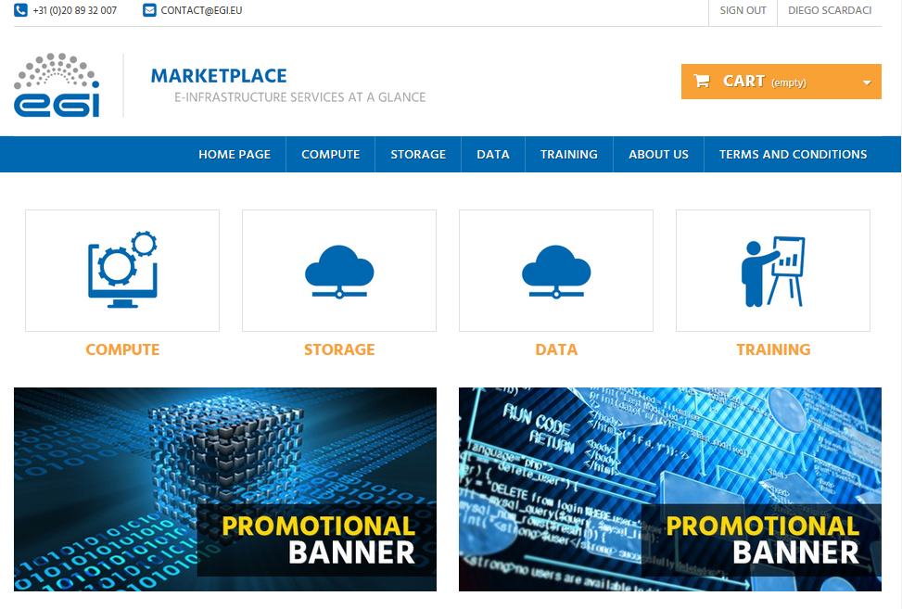
Figure 1. EGI Marketplace based on PrestaShop technology.
Login can be started on each page of the marketplace. During the first login, customers are requested to register. Part of the customer information is collected from the CheckIn service, see grey fields in Figure 2, the other attributes are manually provided by the customer through the following form.
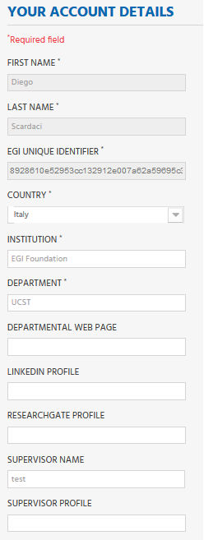
Figure 2. Form to gather the user profile. Fields in grey are filled in with values retrieved by the EGI CheckIn service and cannot be modified.
When a service category is selected, a new view showing all the services under the category is shown. Figure 3 shows the service view for the Cloud Compute service.
Customer can select the service they want to order.
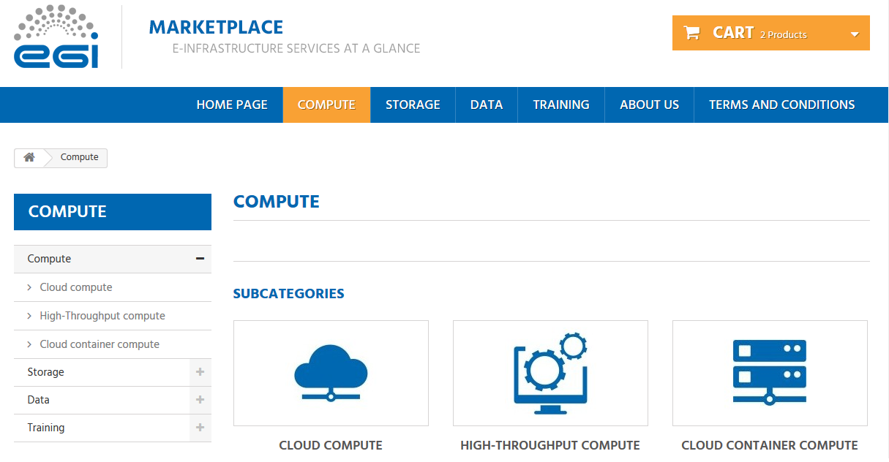
Figure 3. Service category view - Compute
Each service page shows a short description of the service and provide links to the terms of use, the default SLA and to a more detailed description. Figure 4 shows the Cloud Compute service page.
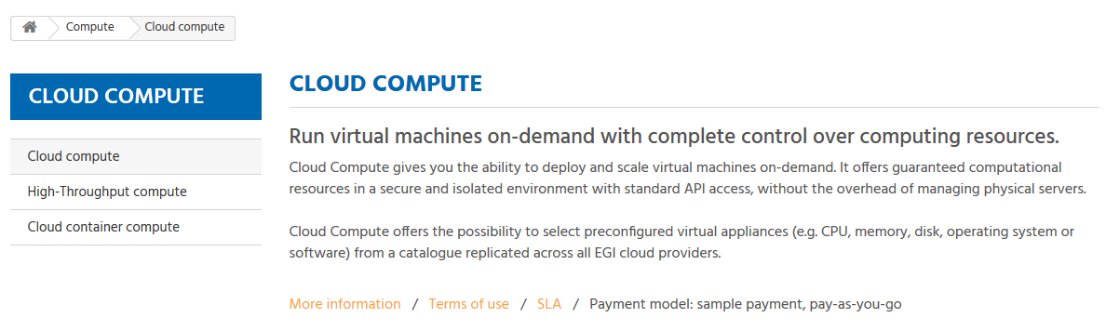
Figure 4. Service view - Cloud Compute
After a customer selects a service, a view listing all the options for such specific service is shown. As example, Figure 5 shows two options for the Cloud Compute service: Compute-intensive instance and High-memory instance.
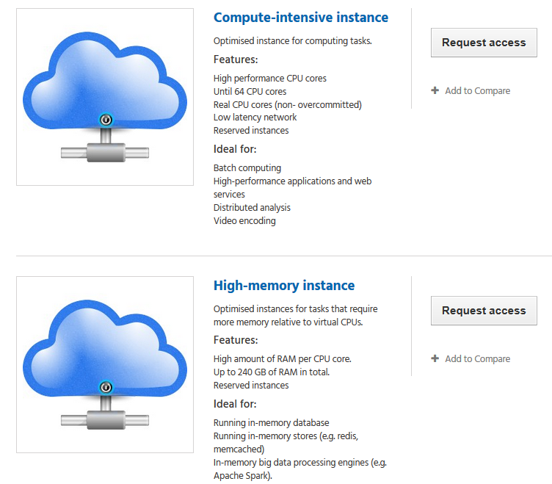
Figure 5. Example of service options - Cloud Compute
Selecting one service option, the customer are forwarded to a view that allows them to add a service to the cart. They have to specify the additional attributes requested for the specific service option (see the data model in Appendix I).
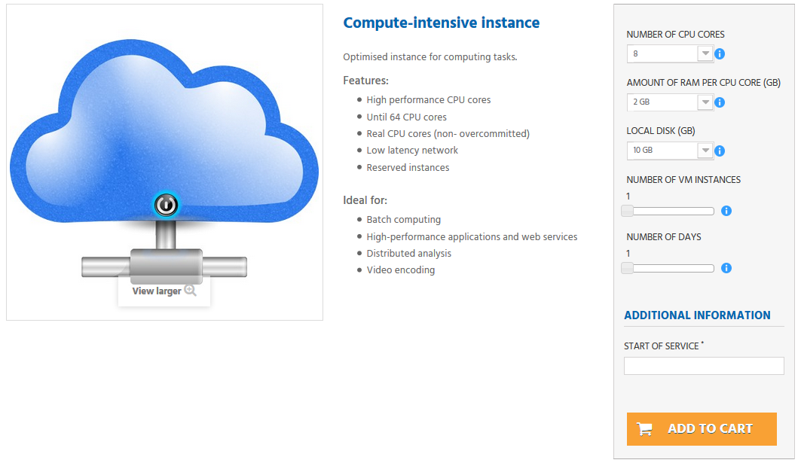
Figure 6. View to order a service. Compute-Intensive Instance in Cloud Compute service
After the customers add to the cart all the services they want to order, they can start the check-out by going to the cart. The cart lists all the services and the related options selected, see Figure 7.
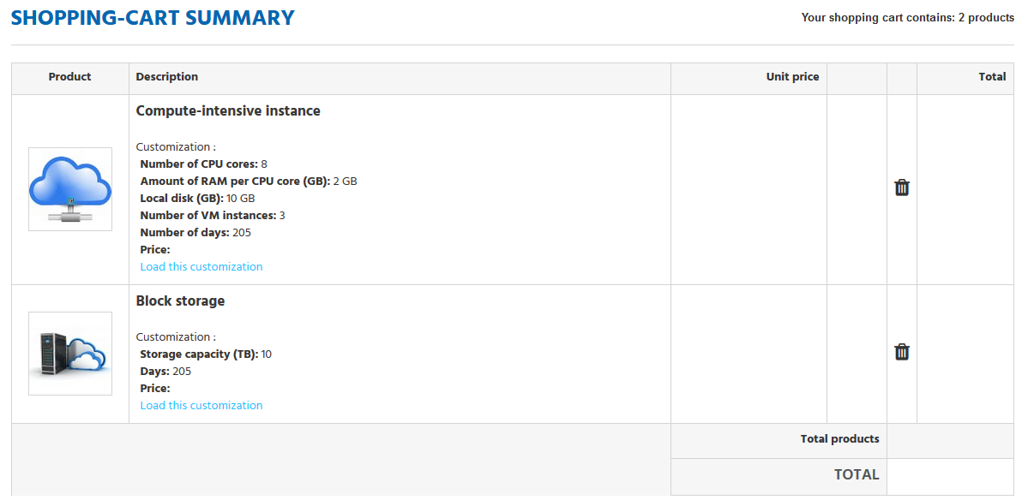
Figure 7. List of selected service options in the Cart
In the cart, the customer is asked to provide some additional information that allows the profiling of the service order, see Figure 8.
The order can only be submitted after the acceptance of the terms of service.
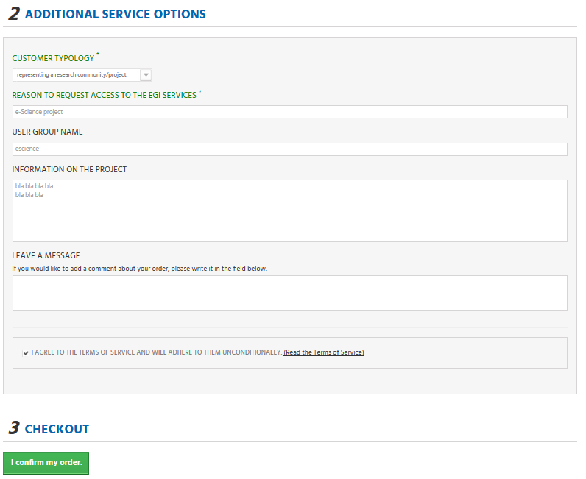
Figure 8. Service order profiling in the cart

Open IRIS prototype
Customer can easily navigates on the service tree from the marketplace homepage.
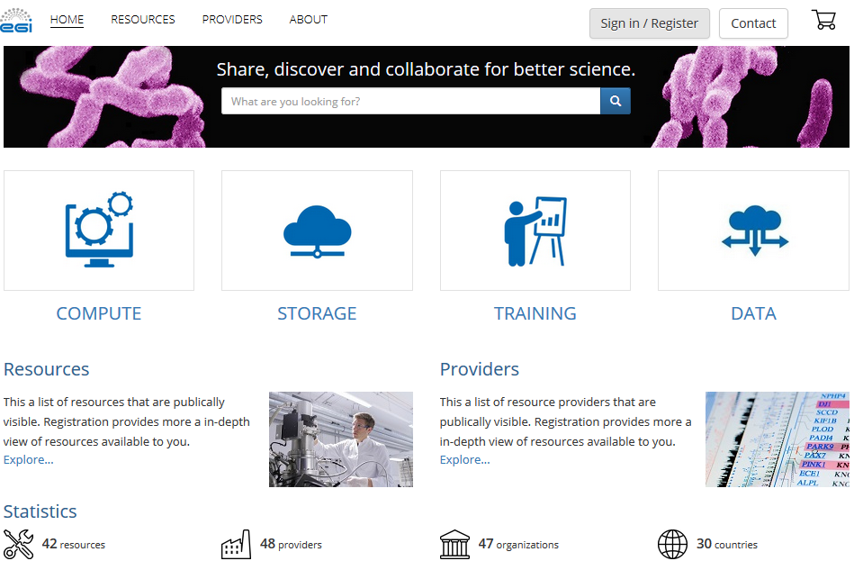
Figure 9. The EGI Marketplace based on Open IRIS technology.
Login can be started on each page of the marketplace. During the first login the customers are requested to register. Part of the customer information is collected from the CheckIn service, see read only fields in figure 10, the other attributes are manually provided by the customer through the form fields.
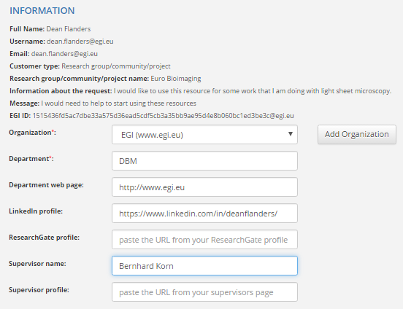
Figure 10. Form to gather the user profile. Fields in grey are filled in with values retrieved by the EGI CheckIn service and cannot be modified.
When a service category is selected, a new view showing all the services under such category is shown. Figure 11 shows the service view for the Cloud Compute service. The customer can then select the service they would like to order.
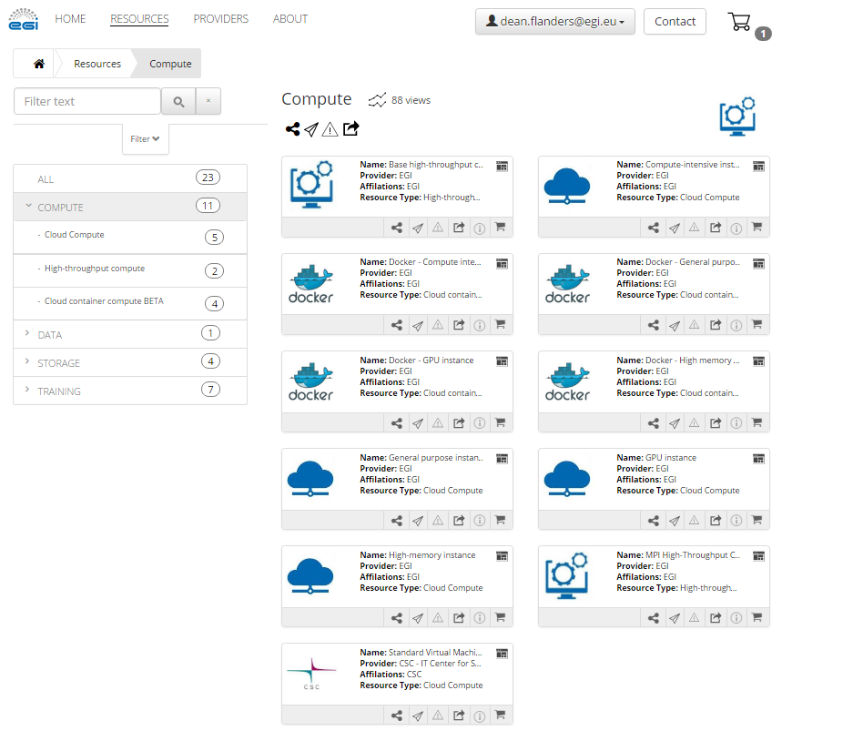
Figure 11. Service category view - Compute
Each service page shows a short description of the service and an overview of the items available. Figure 12 shows the Cloud Compute service page.
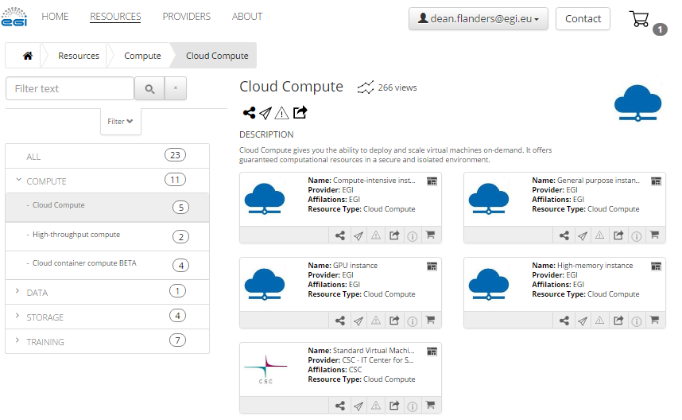
Figure 12. Service view - Cloud Compute
After a customer selects a service, a view listing all the options for such specific service is shown. As example, Figure 12 shows five options for the Cloud Compute service: Compute-intensive instance, High-memory instance, General purpose instance, GPU instance, Standard virtual machine.
When selecting one service option, the customer is then forwarded to a view that allows them to add a service to the cart. They have to specify the additional attributes requested for the specific service option as shown in Figure 13 (see the data model in Appendix I).
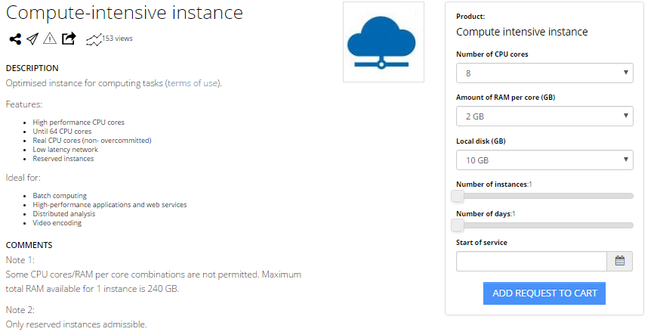
Figure 13. View to order a service. Compute-Intensive Instance in Cloud Compute service
After the customer adds to their cart all the services they want to order, they can start the check-out by clicking on the shopping cart icon. The cart lists all the services and the related options selected, see Figure 14.
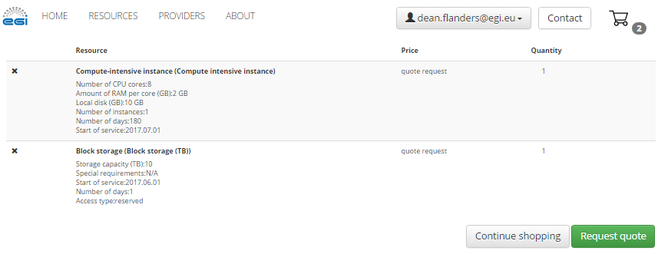
Figure 14. List of selected service options in the Cart
In the cart, the customer is asked to provide some additional information that allows the profiling of the service order, see Figure 15. The order can only be submitted after the acceptance of the terms of service.
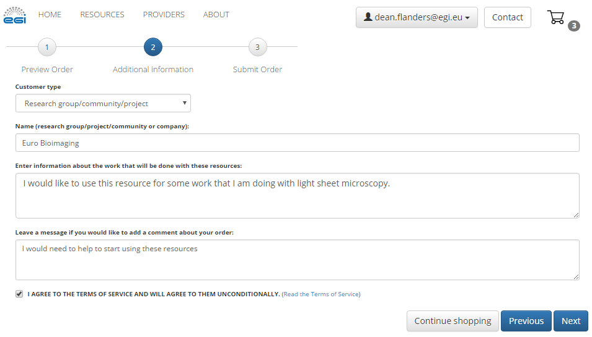
Figure 15. Service order profiling in the cart

Outcome of the assessment
The above mentioned workflows were evaluated in both systems. It was found that both systems adequately covered the current workflows as well as supported the data model demonstrating that both could be adopted to implement the EGI Marketplace.
Then, other factors were considered to choose the technology such as its long-term sustainability, availability of expertise, ready-to-use features that could be helpful in the future. As final decision, PrestaShop were selected for the following reasons:
- Widely used by other Internet web stores
- Easy to maintain as it has a wide community of developers
- Expertise within the EGI collaboration
- Ready-to-use feature to implement the pay-for-use support.

Feedback on satisfaction
The two demonstrators have been reviewed by the persons directly involved in the task JRA1.2 and personnel from the EGI Foundation.
The involved parties agreed that both the assessed solutions reached a good level of quality. Minor bugs were identified.
The reviewers identified two critical features that need to be implemented before moving the service into production:
- a customer dashboard, where the customer can manage his/her service orders
- recording of the service orders in another EGI tool (e.g. an RT queue) where it could be further managed according to the EGI IMS processes and procedures.

Plan for Exploitation and Dissemination

Name of the result | EGI Marketplace
DEFINITION
Category of result | Software & service innovation
Description of the result | The EGI Marketplace will become the main instrument to advertise the EGI services, manage the customer service requests and facilitate access to services as much as possible.
EXPLOITATION
Target group(s) | RIs, international research collaborations, single users, industry/SMEs, service providers, funding agencies and decision/policy makers.
Needs | There is an increasingly high demand for e-Infrastructure services for researchers. The EGI Marketplace platform provides a portal where researchers can easily discover and gain access to those resources.
How the target groups will use the result? | Resource providers within the EGI federation who are interested in providing services to internal and external resources can now expose them via the EGI Marketplace. In addition, researchers now have a common location to discover services and resources that they may require for their. The EGI Marketplace can then provide a framework for which e-Infrastructure services are provided to users internal and external to the EGI collaboration.
Benefits | The primary benefits are efficient sharing of resources and provision or e-Infrastructure services to researchers. Easy discoverability and access to the services.
How will you protect the results? | The EGI Marketplace prototypes are available to others to use freely. An open-source license (to be defined) will protect the customisations applied to the underlying technologies.
Actions for exploitation | Both prototypes are developed with a SaaS delivery model. The PrestaShop model offers a full service model, where the EGI Federation provides the services to add services into the store on the behalf of service providers. The goal is for that to transition to a self-service model. Open IRIS already offers a full self-service model where resource providers can login and register a resource provider and offer services via the platform. The creation of satellite marketplaces for service providers is already planned.
URL to project result | - PrestaShop prototype: http://marketplace.egi.eu/  - Open IRIS prototype: http://egi.science-it.ch
Success criteria | Effectiveness of the marketplace will be monitored by counting the number of accesses and the service requests performed through it. The latter value will be compared with the number of service requests managed through other traditional channels.
DISSEMINATION
Key messages | Discover and access EGI services with few clicks.
Channels | EGI web site, EGI newsletter, participation in conferences
Actions for dissemination | - Participation to conferences  - Article in the newsletter  - Promotion in the EGI web site  - Marketplace link added to the EGI dissemination material (e.g. leaflet)
Cost | N.A.
Evaluation | Number of accesses and the service requests performed through the Marketplace.

Future plans
The EGI Marketplace project was fortunate enough to produce two valid prototypes. Though PrestaShop was selected for the main EGI Marketplace, Open IRIS is already gaining adoption in usage by research labs and core facilities to manage their resources (currently over 4000 users registered on the platform and a partnership with ThermoFisher Scientific).
Several activities related to the EGI marketplace are planned for the next months. The EGI IMS will now be integrated into the use of the tool. Steps will be taken to define how to integrate the other EGI tools involved in the access request management. In addition, the steps to integrate user-facing tools, such as e-Grant and the Long Tail of Science platform will now be taken. The outcome of this is that the EGI Marketplace will expose EGI services to a broader set of users and communities, and offer a simplified way to gain access to these services.
- EGI Marketplace data model
The data model of the marketplace reflects the EGI service catalogue structure (https://www.egi.eu/services & https://www.egi.eu/internal-services). It is made of a three-level hierarchy where the first level contains the EGI service areas (categories in the marketplace) and the second level maps to the EGI services (sub-categories in the marketplace). Furthermore, an additional level defines the EGI service options (products in the marketplace). The service options represents the products that the end user could access or purchase in the marketplace.
The first two levels of the hierarchy are described in the table below.
Table 1. EGI Service Catalogue - first and second levels
Service area | Services
Compute | Cloud Compute, Cloud Container Compute and High-Throughput Compute
Storage | Online Storage, Archive Storage
Data | Data transfer, Content Distribution
Operations | Configuration Database, Service Monitoring
Security | Check-in, Attribute Management
Training | Training Infrastructure, FitSM

For five of the services, Cloud Compute, High-Throughput Compute, Online Storage, Training Infrastructure and FitSM, have been also defined the service options that are described in the following.
The following subsections describe the attributes that will be showed in the marketplace for each level of the hierarchy:
- Service areas (category in the marketplace)
- Services (sub-category in the marketplace)
- Service options (products in the marketplace)

Finally, data to describe service providers in the marketplace are also defined. Each service in the marketplace will be linked to one or more providers.
- Service areas (category in the marketplace)
Each category in the marketplace will be described with the attributes shown in the table below.
Table 6 - Service areas
Attribute | Definition | Notes
Name | Name of the category | The first level category maps to the EGI service area:  - Compute  - Storage  - Data  - Operations  - Security  - Training
Description | Description of the category | Inspired by the description of the EGI service areas in the service catalogue: short, punchy and expressing the value

- Service areas in the first release of the EGI Marketplace
The following table lists the 4 categories that will be included in the first release of the EGI marketplace with the related description.

Service Area | Description
Compute | Services for processing data supporting different computing models
Storage | Services for storing/retrieving files
Data | Services for moving or distributing data
Training | Services for skills development

- Services (sub-categories in the marketplace)
The EGI marketplace will present services to the end-users with a set of attributes described in the table below. These attributes are inherited and sometime specialised by the service options.
Attribute | Definition | Notes
Name | Name of a specific service as assigned by the service provider | Format: Free text  Example: Cloud Compute
Unique ID | Global unique and persistent identifier of a specific service  Note: this allows to map a service to a specific organization/e-Infrastructure | Format: DOI or any other relevant standard; it should contain information about the identifier type and value.  Additional info:  A PID can be used ideally resolvable to a landing page or a machine readable data typed metadata page. It should be assigned by the CoS owner.
Short description | High-level description of what the service does in terms of functionalities it provides and the resources it enables access to. It may include the value ( benefit) to a customer and their users delivered by a service | Format: Free text  Additional info:  It may provide also information related to the offered capacity, number of installations, underlying data that is offered  Benefits are usually related to alleviating pains (e.g., eliminate undesirable outcomes, obstacles or risks) or producing gains (e.g. increased performance, social gains, positive emotions or cost saving).
Description | Longer description of what the service does in terms of functionalities it provides and the resources it enables access to the service | Format: Free text
Web page | URL to a webpage providing more information about the service | Format: URL  Additional info:  This webpage is usually hosted and maintained by the service provider. It contains current and additional information, such as what APIs are supported or links to the documentation.
Service phase | Phase of the service design selected among:  beta: service being developed while available for testing publicly  production: service available in the live environment meeting security/performance requirements | Source: UK Government Service Design Manual  Format: Closed enumeration
Category | Link to categories this service belongs to | Format: Closed enumeration
Service condition | Restrictions that apply to this service | Format: List of sentences, each of them defining a condition
Payment Model | Supported payment models and restrictions that apply to each of them | Format: List of sentences, each of them stating the type of payment model and the restriction that applies to it  Additional info:  Example of types of payment models are: free, pay-as-you-go, subscription, membership  Variable pricing for corporate customers, higher education, etc.
Term of use | URL to a document containing the rules which one must agree to abide by in order to use the service | Format: URL
SLA | URL to a document containing information about the levels of performance that a service provider is expected to achieve (service level agreement) | Format: List of URLs

- Services in the first release of the marketplace

Services to be included in the first release of the marketplace classified for service areas.

Service area | Services
Compute | Cloud Compute, Cloud Container Compute and High-Throughput Compute
Storage | Online Storage, Archive Storage
Data | Data transfer
Training | Training Infrastructure, FitSM

The following table shows how to represent the different service attributes in the first release of the EGI marketplace.

Attribute | Notes
Name | As described in the above table
Unique ID | Not available, skip it.
Short description | Copy text from https://www.egi.eu/services/
Description | Text specified below in the service option paragraphs
Web page | https://www.egi.eu/services/
Service phase | Productions for all service except Cloud Container Compute and Data Transfer (both in Beta)
Category | TBD
Service condition | TBD
Payment Model | TBD
Term of use | TBD
SLA | TBD

- Service options (products in the marketplace)
The service options includes some common options described in the table below.
Common service options | Description | Notes
Description of the research activity | Information on the research activity that needs to access the EGI services. In particular, relevant when access for free is requested. | This attribute has to be requested to the customer in the Cart and not in the service option form.
Access type | Reserved or opportunistic (does not apply to the training and to some Cloud Computing options). | When applicable, this attribute has to be requested in the service option form.
Start and end dates | Specify the period in which users will access the services. The period can also be undefined.

- Compute/Cloud Compute
Service description: Cloud Compute gives you the ability to deploy and scale virtual machines on-demand. It offers guaranteed computational resources in a secure and isolated environment with standard API access, without the overhead of managing physical servers.
Cloud Compute offers the possibility to select preconfigured virtual appliances (e.g. CPU, memory, disk, operating system or software) from a catalogue replicated across all EGI cloud providers.
Service option (Instance types) | Description | Attributes
General purpose instance | Base performance instance type.  Features:  - Accessible in opportunistic or reserved ways  - CPU cores could be overcommitted  Ideals for:  - Web services  - Micro-services  - Development environments  - Building server  - Small database  - Test environments | Number of CPU cores: [1,2,4,8]  Amount of RAM per CPU core (GB): [1,2,4]  Local disk (GB): [10,20,40]
Compute-intensive instance | Optimised instance for computing tasks.  Features:  - High performance CPU cores  - Until 64 CPU cores  - Real CPU cores (non- overcommitted)  - Low latency network  - Reserved instances  Ideals for:  - Batch computing  - High-performance applications and web services  - Distributed analysis  - Video encoding | Number of CPU cores: [8,12,16,20,24,28,32,64]  Amount of RAM per CPU core (GB): [2,4,8]  Local disk (GB): [10,20,40]  Note 1: Some CPU cores/RAM per core combinations are not permitted. Maximum total RAM available for 1 instance is 240 GB.  Note 2: Only reserved instances admissible.
High-memory instance | Optimised instances for tasks that require more memory relative to virtual CPUs.  Features:  - High amount of RAM per CPU core.  - Up to 240 GB of RAM in total.  - Reserved instances  Ideal for:  - Running in-memory database  - Running in-memory stores (e.g. redis, memcached)  - In-memory big data processing engines (e.g. Apache Spark). | Number of CPU Cores: [2,4,8,12,16]  Amount of RAM per CPU core (GB): [16,32,48,64,80,96,112,120]  Local disk (GB): [10,20,40]  Note 1: Some CPU Cores/RAM per core combinations are not permitted. Maximum total RAM available for 1 instance is 240 GB.  Note 2: Only reserved instances admissible.
GPU instance | GPU-enabled instances.  Features:  - 1 or 2 GPU cores  - 8 CPU cores for each GPU core  - Large memory  Ideals for:  - Graphics and general purpose GPU compute applications | Number of GPU cores: [1,2]  Number of CPU cores per GPU core: [8]  Amount of RAM (GB): [24,50]  Local disk (GB): [280]  Note 1: The amount of RAM will be 24GB with 1 GPU core or 50GB with 2 GPU cores.  Note 2: Only reserved instances admissible.

- Compute/Cloud Container Compute
Service description: Cloud Container Compute (in Beta phase) gives you the ability to deploy and scale Docker containers on-demand. It offers guaranteed computational resources in a secure and isolated environment with standard API access, without the overhead of managing the operating system. The result is improved performance, ideal for development work.

Same options of the Cloud Compute service.
- Compute/High-throughput Compute
Service description: with HighThroughput Compute you can run computational jobs at scale on the EGI infrastructure. It allows you to analyse large datasets and execute thousands of parallel computing tasks.
HighThroughput Compute is provided by a distributed network of computing centres, accessible via a standard interface and membership of a virtual organisation. EGI offers more than 650,000 cores of installed capacity, supporting about 1.6 million computing jobs per day.
This service supports research and innovation at all scales: from individuals to large collaborations.
Service option | Description | Attributes
Base | It allows the execution of large numbers of independent or loosely coupled computing tasks. Limited parallel and multi-thread computing can be supported as well. | Number of CPU cores: [1-32]  Amount of RAM per CPU core (GB): [4-8]  Other technical requirements: [text]
MPI | It allows parallel computing, with support of MPI protocol and libraries. | Number of CPU cores: [1-256]  Amount of RAM per CPU core (GB): [4-8]  Parallelism (Threads): [8-24]  Other technical requirements: [text]

- Storage/Online Storage
Service description: Online Storage allows you to store data in a reliable and high-quality environment and share it across distributed teams. Your data can be accessed through different standard protocols and can be replicated across different providers to increase fault-tolerance.
Online Storage gives you complete control over the data you share and with whom.

Service option | Description | Attributes
Block storage | Block Storage is a block-level storage solution that allows you to expand the storage capacity of your instances in the EGI Federated Cloud. This means you can increase your storage without increasing the size or capacity of your instance or by provisioning new ones. Once you mount and format your drive, you can use it just like a regular hard drive attached to your server. Or you can detach your block storage volume from one server and attach it to another. Or you can delete your server, keeping your data intact and ready for the next time you need it. | Storage capacity [TB]: [1, 5, 10, other]  Special requirements (e.g. performance, close to the computational resources, etc.): [text]
Object storage | Object storage manages data as objects. Each object includes the data itself, a variable amount of metadata, and a globally unique identifier. Cloud object storage allows relatively inexpensive, scalable and self-healing retention of massive amounts of unstructured data. | Storage capacity [TB]: [1, 5, 10, other]  Interfaces: [CDMI, POSIX, SWIFT, to be specified by the users]  Special requirements (e.g. performance, close to the computational resources, etc.): [text]
File storage | Highly scalable storage system accessible from anywhere allowing to easily share data through different standard interfaces. It assigns global identifiers to files and allows to organise your data using a flexible hierarchical structure. | Technology: [DPM, DCache, STORM, …, any]  Special requirements (e.g. performance, close to a specific site, etc.): [text]

- Storage/Archive Storage
Service description: Archive Storage allows you to store large amounts of data in a secure environment freeing up your usual online storage resources.
The data on the Archive Storage can be replicated across several storage sites, thanks to the adoption of interoperable open standards. The service is optimised for infrequent access.

Service option | Description | Attributes
Archive Storage | Archive Storage allows you to store large amounts of data in a secure environment freeing up your usual online storage resources.  The data on the Archive Storage can be replicated across several storage sites, thanks to the adoption of interoperable open standards. The service is optimised for infrequent access.  Main characteristics:  - Store data for long-term retention  - Store large amount of data  - Free up your online storage | Amount of data (TB): [number]

- Data/Data Transfer
Service description: Data Transfer allows you to move any type of data files asynchronously from one place to another. The service includes dedicated interfaces to display statistics of on-going transfers and manage network resources.
Data Transfer is ideal to move large amounts of files or very large files. The Data Transfer service has mechanisms to ensure automatic retry in case of failure.

Service option | Description | Attributes
Data Transfer | Data Transfer allows you to move any type of data files asynchronously from one place to another. The service includes dedicated interfaces to display statistics of on-going transfers and manage network resources.  Data Transfer is ideal to move large amounts of files or very large files. The Data Transfer service has mechanisms to ensure automatic retry in case of failure.  Main characteristics:  - Ideal for very large files  - Able to handle large amounts of files  - Transfer process with automatic retry | Tool: [FTS3, Globus Online]

- Training/Training Infrastructure
Service description: The Training Infrastructure offers cloud compute and online storage for training activities. It is useful to organise onsite tutorials or workshops and online training courses or as a platform for self-paced learning.
For example, with the Training Infrastructure trainers can create and deploy any custom virtual machine images for the students. A library of existing virtual machines images is offered so that tutors can customise and use these according to their specific needs. This allows easy deployment, sharing and reuse of course materials.
The Training Infrastructure uses the same high-quality computing and storage environment that EGI provides to researchers.

Service option | Description | Attributes
Cloud Training Infrastructure | The Training Infrastructure offers cloud compute and online storage for training activities. It is useful to organise onsite tutorials or workshops and online training courses or as a platform for self-paced learning.  For example, with the Training Infrastructure trainers can create and deploy any custom virtual machine images for the students. A library of existing virtual machines images is offered so that tutors can customise and use these according to their specific needs. This allows easy deployment, sharing and reuse of course materials.  The Training Infrastructure uses the same high quality computing and storage environment that EGI provides to researchers. | Location: [text]  Aim of the training event: [text]  Number of concurrent trainees: [number]  Number of CPU cores (total): [number]  Amount of RAM (total) (GB): [number]  Online storage size (total) (GB): [number]  Special requirements (e.g. VM images/apps available in the training infra, big instances, etc.): [text]

- Training/FitSM
Service description: FitSM is a lightweight standards family aimed at facilitating service management in IT service provision, including federated scenarios. FitSM training aims at providing those involved in operating federated infrastructures with the professional skills they need in order to effectively manage their services.
FitSM professional training is certified by TÜV SÜD, a global leader in standardisation and certification. The qualification programme offers three training levels: Foundation, Advanced and Expert.

Service option | Description | Attributes
Foundation level | Target audience:  - All individuals involved in the provisioning of (federated) IT services  - Candidates who wish to progress to advanced level of the qualification and certification scheme  Contents:  - Basic IT service management concepts and terms (based on FitSM-0)  - Purpose and structure of FitSM standards and their relationship to other standards  - Process framework underlying FitSM  - Requirements defined in FitSM-1 | Number of students: [number]  Location: [text]
Advanced Level in Service Planning and Delivery | Target audience:  - Individuals aiming to fulfil a coordinating role in the ITSM processes related to the planning and delivery of IT services  - Candidates who wish to progress to expert level of the qualification and certification scheme  Contents:  - Repeat the most important foundation knowledge on (lightweight) ITSM  - Become familiar with the general aspects of implementing ITSM, the processes required to plan and deliver services effectively (according to the FitSM-1 standard), and important interfaces in a service management system  - ITSM processes in focus of this training: Service portfolio management, service level management, service reporting management, service availability and continuity management, capacity management, information security management, customer relationship management, supplier relationship management  Entry requirements:  - Must hold FitSM Foundation Certificate | Number of students: [number]  Location: [text]
Advanced Level in Service Operation and Control | Target audience:  - · Individuals aiming to fulfil a coordinating role in the ITSM processes related to the operation and control of IT services  - · Candidates who wish to progress to expert level of the qualification and certification scheme  - Contents:  - · Repeat the most important foundation knowledge on (lightweight) ITSM  - · Become familiar with the general aspects of implementing ITSM, the processes required to operate and control services effectively (according to the FitSM-1 standard), and important interfaces in a service management system.  - · ITSM processes in focus of this training: Incident and service request management, problem management, configuration management, change management, release and deployment management, continual service improvement management  Entry requirements:  - · Must hold FitSM Foundation Certificate | Number of students: [number]  Location: [text]
Expert level | Target audience:  - · Individuals aiming to fulfil the role of internal or external consultant or auditor in the topic area of IT service management (ITSM).  Contents:  - · Repeat the most important advanced level knowledge on (lightweight) ITSM  - · ITSM-related frameworks and standards  - · Understanding the organisational context of implementing ITSM (including federation structures and scope setting)  - · Leadership and governance (including top management responsibilities, governance practices, effective communication and organisational change management)  - · Planning and implementing ITSM (including service management planning, service design and transition and effective documentation)  - · Monitoring, reviewing and improving ITSM (including capability & maturity assessment, key performance indicators, managing an audit program and conducting audits)  Entry requirements:  - · Must hold both FitSM Advanced Certificates in Service Planning and Delivery (SPD) and Service Operations and Control (SOC) | Number of students: [number]  Location: [text]
Consultancy | Advise on how to manage IT services with a pragmatic and lightweight standard. | Description of the consultancy: [text]

- Service Providers
The following table defines the attributes that will identify the service providers within the EGI marketplace.

Attribute | Definition | Notes
Name | Organisation or federation or part of an organisation or federation that manages and delivers a service or services to customers | Format: Free text  Additional info:  The entity with whom the customer signs the SLA; this entity will be able to give information about other contributors to the service
Description | Short description of the organisation or federation or part of an organisation or federation | Format: Free text
Contacts | Delegate of the organisation | Format: Name and e-mail
Logo | Organisation logo | Format: Image
Webpage | URL to the provider website | Format: URL

Production instance at Institut Curie, http://iris.curie.fr.
https://www.prestashop.com/en/documentation
http://iris.science-it.ch
http://addons.prestashop.com/en/20201-additional-product-attributes-custom-product-fields.html
http://addons.prestashop.com/en/19736-custom-checkout-and-customer-and-address-fields-manager.html
http://addons.prestashop.com/en/19389-dynamic-product-price.html
The customer’s VO membership list cannot be retrieved from the CheckIn service yet.
The Check-Out workflow was entirely implemented except for the interface with the Operations Portal since the customer’s VO membership list cannot be retrieved from the CheckIn service yet.

