EGI-Engage

EGI Accounting Portal User's Guide

Date | 08 March 2016
Activity | WP3
Lead Partner | CSIC
Document Status | DRAFT
Document Link | https://documents.egi.eu/document/2789

Abstract
This user guide describes the main interface and user interaction of the EGI Accounting Portal. The EGI Accounting Repository receives data from APEL and ultimately from sites participating in the EGI and WLCG infrastructures as well as from sites belonging to other Grid organisations that are collaborating with EGI. This is crossed with metadata from other sources to offer a integrated view of accounting data on the EGI Infrastructure.

COPYRIGHT NOTICE
This work by Parties of the EGI-Engage Consortium is licensed under a Creative Commons Attribution 4.0 International License (http://creativecommons.org/licenses/by/4.0/). The EGI-Engage project is co-funded by the European Union Horizon 2020 programme under grant number 654142.
DELIVERY SLIP
 | Name | Partner/Activity | Date
From: | Iván Díaz Álvarez | CESGA/JRA1 | 08/03/16
Moderated by:
Reviewed by
Approved by:

DOCUMENT LOG
Issue | Date | Comment | Author/Partner
v0.1 | 08/03/16 | Document creation | I. Díaz/ CESGA
...
...
v.n

TERMINOLOGY
A complete project glossary is provided at the following page: http://www.egi.eu/about/glossary/

Contents
Introduction 4
Main Page 5
Standard Views 6
Restricted UserDN view 8

Introduction
The EGI Accounting Portal receives data from APEL and ultimately from sites participating in the EGI and WLCG infrastructures as well as from sites belonging to other Grid organisations that are collaborating with EGI. This is crossed with metadata from other sources to offer a integrated view of accounting data on the EGI Infrastructure.
The interface shown to final users is a Web site. To use it you will need at least a web browser. The following browsers are supported:
- Chrome 3+
- Firefox 3.5+
- Opera 12+
- Safari 4+
- Internet Explorer 8+
If you need to get data from the Restricted view you will need:
- An user certificate installed in your browser. This is a file that identifies you securely. This certificate must be current (they usually are valid only for a year) and signed by a trusted organization, a CA or certificate authority.
- To be able to see restricted site information, being registered as a Site Operations Manager in the GOCDB web (https://goc.egi.eu/). Note that being a Site Administrator is not enough. The UserDN in the certificate and GOCDB database must match.
- To be able to see restricted VO information, being registered as a VO manager in the EGI Operations Portal (https://operations-portal.egi.eu/). Note that being a Site Administrator is not enough. The UserDN in the certificate and GOCDB database must match.
- To have the EGI trusted CAs file installed on your machine.

Main Page
The main page is the first view shown when accessing the portal. It shows a rolling graph of the accounting in the last weeks/months/years and the numbers for the last period.
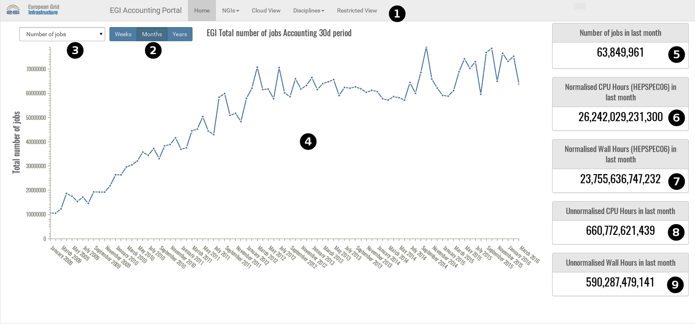
- Pull-down menu that allows access to the rest of the views and is accessible elsewhere in the Portal.
- This lets the user choose between Weeks/Months/Years for the period shown.
- This lets the user choose the metric shown between number of jobs, CPU Time, Wall Time or normalised CPU or Wall time.
- The graph showing the metric for the last periods from the current date.
- Number of jobs in the last period.
- Normalised HEPSPEC06 CPU hours in the last period.
- Normalised HEPSPEC06 Wall hours in the last period.
- Unnormalised CPU hours in the last period.
- Unnormalised Wall hours in the last period.

Standard Views
This covers the VO Discipline, NGI, Country and Cloud View for the moment. We will see the top and bottom half of the page separately.
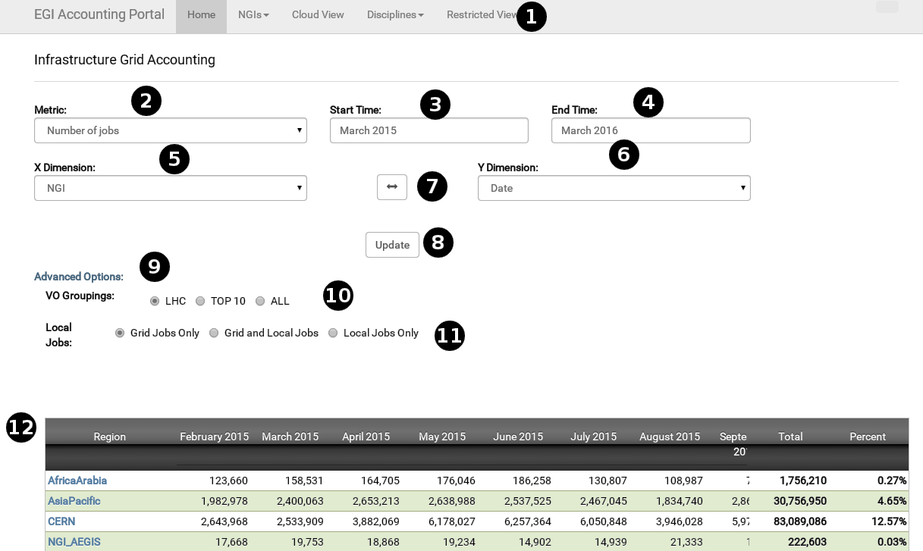
- Pull-down menu that allows access to the rest of the views.
- Metric shown, it varies depending if a grid/cloud view is selected.
- Start Date for the period shown.
- End Date for the period shown.
- Variable for which the data is tabulated on rows, it can be NGI, Country, Date, Site, VO, VMId (for Cloud), Discipline, etc..
- Like 5, but for columns.
- Clicking this button will interchange 5 and 6.
- Clicking this will update the page after a change in the form.
- Exposes advanced VO related options, N/A on cloud.
- VOs shown, ranging from LHC only, TOP10 with most CPU use or ALL Vos.
- This toggles wether locally accounted VOs are shown. These VOs have the “local-” prefix and are not published by most sites.
- A table showing the data, it can be scrolled horizontally and sorted by any column. Blue column headers are contextual links to another Portal page, or an AppDB page in case of AppDB format VMIDs.

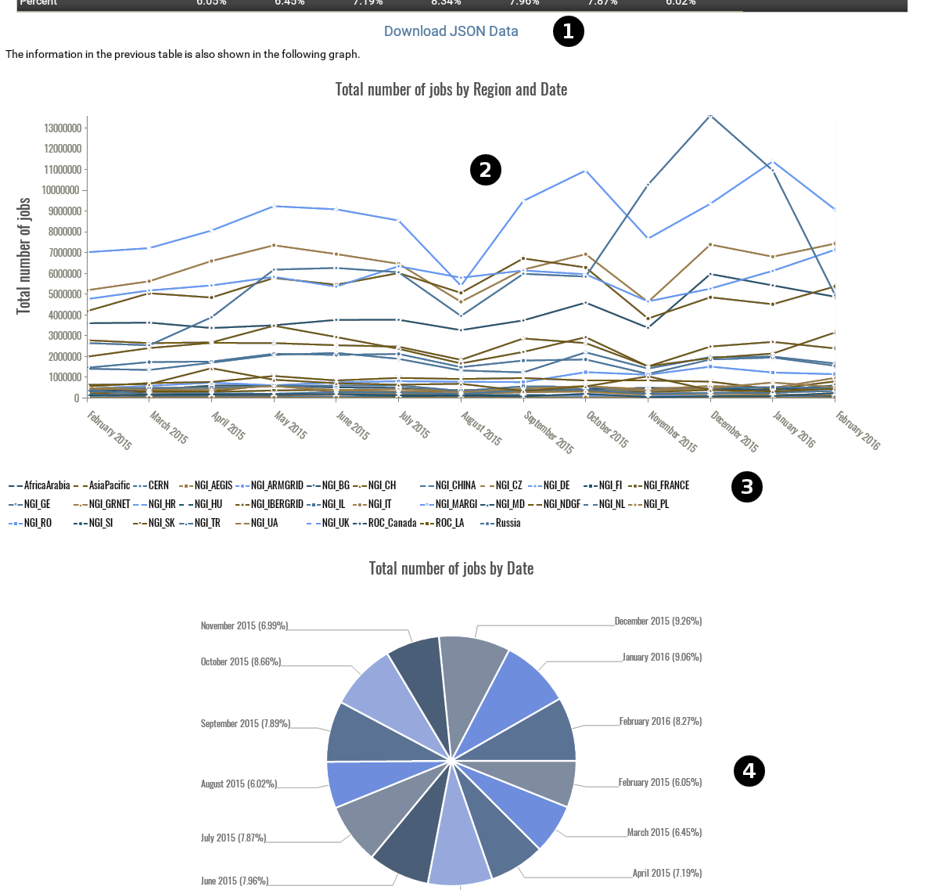
- This link points to a downloadable JSON dump of the page data.
- An interactive graph based on the table, hovering over any point shows all the data associated to it. It can also be zoomed and scrolled with the mouse.
- A legend showing which line pattern is used for each row.
- Two pie graphs are shown, one for the row totals and another one for the column totals. Hovering above any portion will show the data associated to it.

Restricted UserDN view
To access this view you will need a user certificate and permissions either in GOCDB or the Operations Portal as detailed in the introduction. Once this is done, a page like in the last section will be shown. Here we will cover the differences.
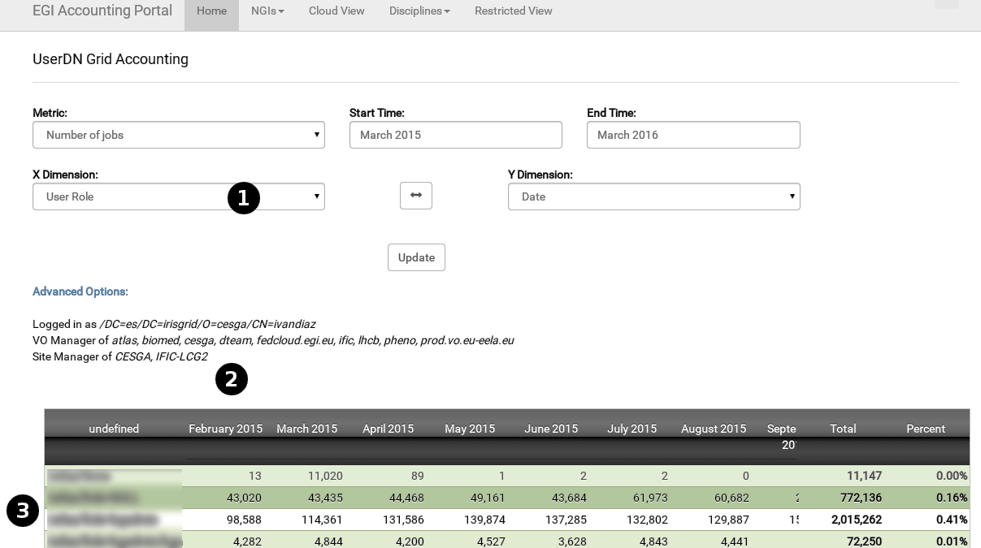
- In the dimensions (both X and Y), you will have the option to select User DNs and User VO Roles. This information is sensitive so it is not accessible on other views.
- Here your UserDN and privileges are shown, first those as VO Manager and Site Manager. If you have privileges on several VOs or Sites at the same time, all the information you have access to will be shown at the same time.
- This table is the same as the one in the standard view, except for the fact you can see UserDNs and Roles.

