EGI / NGI Sustainability and Business Models – Survey Analysis
EGI Technical Forum – 20 Sept 2011 – Lyon, France
Over the last decade, e-Infrastructures have proven to be a strategic resource for the European Research Area as they enable researchers to push the boundaries of science. However, e-Infrastructures are expensive to build, coordinate and maintain. In a period where all investments are under intense scrutiny, the need for exploring sustainability strategies with a more radical view, from both the technical, organisational and financial perspectives has come to the forefront of the e-Infrastructure agenda.
It is essential for us to consistently evaluate the current activities throughout the EGI ecosystem in terms of the components and functions, as well as the revenues they generate and the expense they incur. Together, a long-term strategy needs to be developed and refined to derive plans that will solve both the current and future sustainability issues facing e-Infrastructures.
In this context, the EGI.eu Policy Development Team (PDT) recently conducted a survey with the National Grid Initiatives (NGIs) and European Intergovernmental Research Organisations (EIROs) participating in EGI in order to start to analyse the current status regarding sustainability on a national level and maturity of business models around providing grid services.
15 NGIs and EIROs responded to the survey, which has led to an analysis of the current state of play presented in this short report. Overall, the survey and ensuing analysis compliments the ongoing work around sustainability and business models offering an opportunity for EGI.eu to understand key information from an NGI/EIRO perspective as well as essential feedback for shaping the discussion of the dedicated session on the topic at the Technical Forum in Lyon [R1].
EGI Sustainability Efforts
Early this year, the EGI-InSPIRE project produced an initial EGI Sustainability Plan [R2] providing a comprehensive list of the wide range of services that EGI provides and outlined a taxonomy of potential pricing models and revenue streams in order to sustain these services for future discussion and exploration.
Roughly 80% of the responding NGIs have either read or reviewed the document with mostly positive feedback stating it as a good start but with more work to be done. For many, the report was descriptive in nature and covered the majority of business scenarios using a structured approach to the identification of possible business models, and mapping to existing actions and services, but lacked a future strategic ‘plan’.

Due to the interdependencies within the EGI ecosystem, the future of EGI relies heavily on the sustainability of the NGIs. In addition, the availability of technology that is able to meet these needs from diverse sources, either from the mainstream open-source community, the open-source development community within EGI or commercial providers, is vital for the long-term sustainability of EGI.
Business Models
A business model is defined as the rationale of how an organisation creates, delivers, and captures value sustainably. A business model for EGI and its ecosystem is not about turning ‘profit’, but simply the application of a methodology for covering the costs of coordinating, building and maintaining the components within the ecosystem.
With this clear mission in mind, EGI.eu needs to work together with its resource providers, technology providers and user communities to ensure that we formulate an integrated understanding as to what the value proposition around particular services is and how to best demonstrate it to current or potential users and/or investors.
Survey Results
One issue is that only two responding NGIs have a defined business model for providing grid services with neither having produced a document outlining the business model. In addition, neither was produced following a structured modelling tool such as the business model canvas [R3].
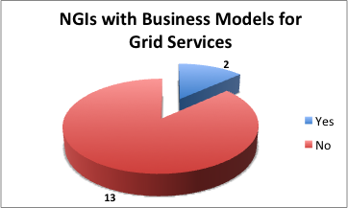
In order to stimulate better engagement and provide a common ground for discussion, we have organised a two-session Sustainability and Business Models workshop part of the EGI Technical Forum 2011 covering sustainability plans and issues from the EGI community; and an overview of business models and the context within EGI.
Benefits / Value Proposition
Identifying a ‘value proposition’ is a key part of a business strategy, which clearly and succinctly outlines a set of unique features or benefits for why a consumer should buy a product, use a service or invest.
The EGI community needs clarity as to what exactly is the value proposition that we offer from the different parts of the ecosystem. E-Infrastructures are complex systems, but should not be so complex to explain what are the benefits.
Defining our value proposition will empower anyone with the right tools to lobby their national funding agency or attract any potential new user community.
Therefore, a set of questions was posed to review the NGIs/EIROs viewpoint on: NGI benefits to its members; EGI.eu benefits to NGIs/EIROs; and EGI benefits for the European Research Area (ERA).
The top 5 values of an NGI for its members:
- Provides a unique interface at the national level for users to access the available distributed computing capabilities.
- Improves collaboration among researchers from different disciplines at the national level.
- Ability to operate a secure, integrated production grid infrastructure that seamlessly federates resources from providers on a national level.
- Increases visibility at the governmental level by providing a single, stronger voice to represent the collective needs for research e-Infrastructures.
- Cost reduction for services, which benefit from being run centrally.
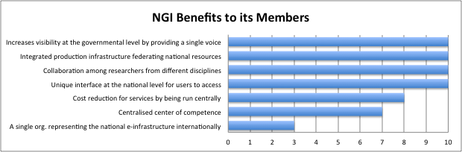
The top 5 values of EGI.eu for the NGIs/EIROs:
- Provides central coordination that binds a potentially fragmented landscape of national or domain specific infrastructure providers into a European wide infrastructure and increases its visibility on an international scale.
- Organises workshops and forums for community engagement and knowledge exchange.
- Increases visibility at the EC level by providing a single, stronger voice to represent the collective needs for e-Infrastructures for research in Europe.
- Guides how the infrastructure and its participants should operate.
- Negotiates and interfaces with technology and resource providers on behalf of the community.
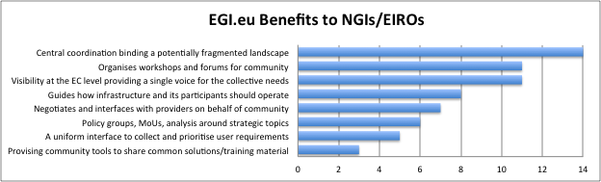
Finally, the top 5 values of EGI for ERA:
- Optimises IT infrastructure utilisation for both responsiveness to dynamic workloads and economy of scale.
- Shares the cost of expensive resources while obtaining more compute power.
- Improves collaboration with other researchers by sharing applications, best practices, training material, etc.
- Researchers conduct their analysis and run computations in new and more effective ways enabling new computer paradigms that speeds up achievement of new scientific results and papers.
- Reduces costs as a result of improved efficiency and smarter capacity planning.
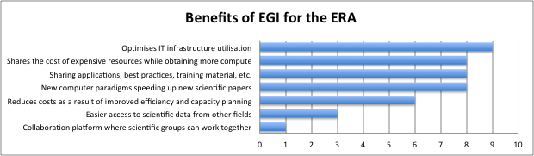
Revenue Streams
The first iteration of the EGI Sustainability Plan considered various cost models such as fixed fee-based and usage-based models, free to use models, in-kind efforts and public funding options.
With EC funding expecting to decrease for maintenance and operations, it is crucial to evaluate how revenue streams for grid services could be restructured, e.g. evaluating the option of resource centres to apply usage-based pricing, thus raising the issue of the need to identify who could be billed.
Though usage-based pricing may be appropriate for user communities that do not contribute computing resources to EGI, it may not be appropriate for the existing heavy user communities that are contributing computing resources to EGI.
This would put more emphasis on the collaborative aspects of grids and in kind contribution (users owning and/or directly controlling resources). Governmental subsidy for research infrastructures through research project or programme may perhaps be the best solution.
However, the ‘charging’ for services or direct usage-based pricing could diminish the collaborative grid spirit and reduce it to just another computer centre provision model. Even if accounting and billing mechanisms were put in place, the legal implications around charging for services vary within each country, which would also need to be individually analysed.
The central issue remains; what happens if the current funding channels decrease? How can we still guarantee the availability of the infrastructure? The most common responses have proposed to explore structural funds for the NGIs, in-kind payments within the EGI community, paying subscription fees to EGI.eu to broker services within the EGI community and then directly charge the users employing institution for resources or services consumed.
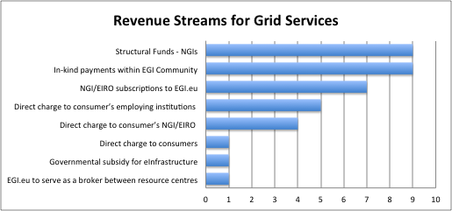
Following this trend, only a quarter of the responding NGIs charge for grid services. How each NGI is charging varies slightly and all are in early stages of development. One NGI has the mechanisms in place to charge for access to CPU and data storage, but with no uptake of paid services to date. Others have started with simply defining a policy to pay the EGI.eu membership fee and only one NGI directly charges national research projects for HPC resources that are dedicated to researchers working within them.
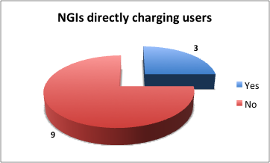
A usage-based model depends on assigning a price to the use of a resource or service made available by the infrastructure for particular groups. Integration of a billing function onto the accounting repository would enable different resource usage to be accounted for and a bill generated – analogous to a phone bill containing text, voice and voicemail charges. Any accounting system must provide functionality such that an NGI can charge a consumer's employing institution if needed. What remains to be seen is if charging the employing institution becomes too bureaucratic. If so, an individual end-user could then be charged who might have a grant that could be used. In the end, charging the NGI/EIRO related to the end-user’s employing institution may be the most viable option to explore in greater depth.
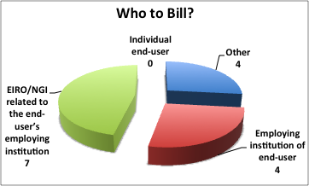
Funding
The EC has invested heavily in e-Infrastructures over the past decade. In fact, e-Infrastructures have been solely dependent on public funding sources. It is clear that public funding of all activities is coming under increased scrutiny in the current economic climate and dependency for maintenance and general operations is expected to decrease with each passing year.
Many public funding bodies are seeing e-Infrastructures as way to drive innovation and economic growth nationally and across Europe, and do so in a way that is sustainable for the long-term.
So where does EGI-InSPIRE fit within the criticality of NGI existence? Most of the NGIs only partially depend on EGI-InSPIRE funding to support activities, with one NGI having a critical dependency and two being independently sustainable.
This potentially shows that European funding can focus on its Digital Agenda for 2020 (smart growth and innovation), while allowing for incremental implementation of new business models and increased support through national funding mechanisms.
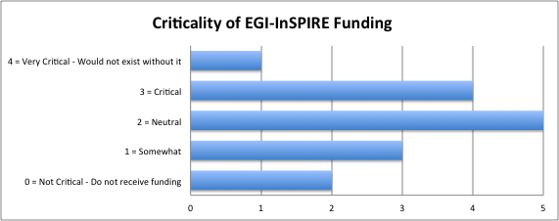
Questions to be addressed
The responding NGIs/EIROs have also suggested the following items for discussion:
- The EGI Business Model is ultimately dependent on strategy. What is the best way to determine this strategy?
- Sustainability of EGI depends critically on sustainability of NGIs and EGI.eu. What are the most significant issues that need to be tackled?
- What can we learn from actual experiences of other e-Infrastructure providers?
- How are the needed services of the infrastructure going to continue and be structured? What process should be followed to evolve the EGI service portfolio?
- Which NGIs would be willing to continue to contribute financially and provide services to EGI if they received no EC funding?
- In addressing usage fees, and assuming the community agrees on its implementation, who would pay and how could they be billed?
- What are the benefits and drawbacks of centralised payment of grid services compared to direct payment from users, who are also paid through research money coming ultimately from the same source?
Summary and Next Steps
This report has presented the status of the NGIs regarding business models and main issues for future sustainability. The survey respondents have expressed their view regarding the value proposition of the NGIs to their members, EGI.eu to NGIs/EIROs, and EGI as a whole. A variety of revenue streams were also discussed as well as potential billing mechanisms in terms of whom to bill and how.

Overall, defining a business model is a strategic but complex process considering the invested interests of a wide range of stakeholders. Many NGIs are only at the beginning of planning a long-term strategy beyond the life of EGI-InSPIRE. In fact, only two of the respondents have defined a business model for grid services.
However, even though the survey represents a fraction of the total landscape, stronger collaboration between the NGIs and EGI.eu can speed up the process of generating business models by sharing knowledge and best practices across the community.
The EGI/NGI Business Model and Sustainability Workshop is another step forward in exploring our business strategy and pave a road forward.
Possible follow up could be through the establishment of a task force in order to have regular activity among the NGI representatives to explore and define business models for the sustainability of NGIs and EGI.eu and to link the overall EGI long-term strategy.

References
- EGI TF Sustainability and Business Model Session http://go.egi.eu/qrcbp
- EGI Sustainability Plan https://documents.egi.eu/document/313
- Business Model Canvas http://en.wikipedia.org/wiki/Business_Model_Canvas

