EGI-InSPIRE

Review of the Website

EU MILESTONE: MS220

Document identifier: | EGI-InSPIRE - MS220-Review of the website - v3
Date: | 01/08/2011
Activity: | NA2.2
Lead Partner: | EGI.eu
Document Status: | FINAL
Dissemination Level: | PUBLIC
Document Link: | https://documents.egi.eu/document/601

Abstract
This review aims to report the progress of the EGI main website’s design, structure and content during EGI-InSPIRE’s first 15 months (1 May 2010 to 1 August 2011).

- Copyright notice
Copyright © Members of the EGI-InSPIRE Collaboration, 2011-2014. See www.egi.eu for details of the EGI-InSPIRE project and the collaboration. EGI-InSPIRE (“European Grid Initiative: Integrated Sustainable Pan-European Infrastructure for Researchers in Europe”) is a project co-funded by the European Commission as an Integrated Infrastructure Initiative within the 7th Framework Programme. EGI-InSPIRE began in May 2010 and will run for 4 years. This work is licensed under the Creative Commons Attribution-Noncommercial 3.0 License. To view a copy of this license, visit http://creativecommons.org/licenses/by-nc/3.0/ or send a letter to Creative Commons, 171 Second Street, Suite 300, San Francisco, California, 94105, and USA. The work must be attributed by attaching the following reference to the copied elements: “Copyright © Members of the EGI-InSPIRE Collaboration, 2011-2014. See www.egi.eu for details of the EGI-InSPIRE project and the collaboration”. Using this document in a way and/or for purposes not foreseen in the license, requires the prior written permission of the copyright holders. The information contained in this document represents the views of the copyright holders as of the date such views are published.
- Delivery Slip
 | Name | Partner/Activity | Date
From | Sara Coelho | EGI.eu / NA2.2 | 1 July 2011
Reviewed by | Moderator: Helen Cordier  Reviewers: Mariusz Sterzel | CNRS/SA1  CYFRONET/NA2.2 | 25 July 2011
Approved by | AMB & PMB |  | 30 July 2011
- Document Log
Issue | Date | Comment | Author/Partner
1 | 21 June | ToC | C Gater / EGI.eu
2 | 5 July | First draft | S Coehlo, V. Li, C Gater / EGI.eu
3 | 7 July | Second draft | C Gater / EGI.eu
4 | 28 July | Third draft | C Gater / EGI.eu
- Application area
This document is a formal deliverable for the European Commission, applicable to all members of the EGI-InSPIRE project, beneficiaries and Joint Research Unit members, as well as its collaborating projects.
- Document amendment procedure
Amendments, comments and suggestions should be sent to the authors. The procedures documented in the EGI-InSPIRE “Document Management Procedure” will be followed:
https://wiki.egi.eu/wiki/Procedures
- Terminology
A complete project glossary is provided at the following page: http://www.egi.eu/about/glossary/.
PROJECT SUMMARY

To support science and innovation, a lasting operational model for e-Science is needed − both for coordinating the infrastructure and for delivering integrated services that cross national borders.

The EGI-InSPIRE project will support the transition from a project-based system to a sustainable pan-European e-Infrastructure, by supporting ‘grids’ of high-performance computing (HPC) and high-throughput computing (HTC) resources. EGI-InSPIRE will also be ideally placed to integrate new Distributed Computing Infrastructures (DCIs) such as clouds, supercomputing networks and desktop grids, to benefit user communities within the European Research Area.

EGI-InSPIRE will collect user requirements and provide support for the current and potential new user communities, for example within the ESFRI projects. Additional support will also be given to the current heavy users of the infrastructure, such as high energy physics, computational chemistry and life sciences, as they move their critical services and tools from a centralised support model to one driven by their own individual communities.

The objectives of the project are:

- The continued operation and expansion of today’s production infrastructure by transitioning to a governance model and operational infrastructure that can be increasingly sustained outside of specific project funding.
- The continued support of researchers within Europe and their international collaborators that are using the current production infrastructure.
- The support for current heavy users of the infrastructure in earth science, astronomy and astrophysics, fusion, computational chemistry and materials science technology, life sciences and high energy physics as they move to sustainable support models for their own communities.
- Interfaces that expand access to new user communities including new potential heavy users of the infrastructure from the ESFRI projects.
- Mechanisms to integrate existing infrastructure providers in Europe and around the world into the production infrastructure, so as to provide transparent access to all authorised users.
- Establish processes and procedures to allow the integration of new DCI technologies (e.g. clouds, volunteer desktop grids) and heterogeneous resources (e.g. HTC and HPC) into a seamless production infrastructure as they mature and demonstrate value to the EGI community.

The EGI community is a federation of independent national and community resource providers, whose resources support specific research communities and international collaborators both within Europe and worldwide. EGI.eu, coordinator of EGI-InSPIRE, brings together partner institutions established within the community to provide a set of essential human and technical services that enable secure integrated access to distributed resources on behalf of the community.

The production infrastructure supports Virtual Research Communities (VRCs) − structured international user communities − that are grouped into specific research domains. VRCs are formally represented within EGI at both a technical and strategic level.

- EXECUTIVE SUMMARY

This review documents the progress and development of www.egi.eu - the EGI website’s design, structure and content during the past year, since the publication of milestone MS207, which covers the May-August 2010 period.

The overall layout of the website has remained essentially the same, and the features are described in detail in milestone MS207. Following implementation of the current design in September 2010, a number of adjustments have been made to the homepage, including enhancing the Latest News and Events sections, adding a ‘call for action’ box featuring events and links, and adding quick links to key pages.

The root structure has been upgraded and new content sections added. The website’s content has been enhanced to broaden and expand information in areas including the history of EGI, governance, FAQs, the training marketplace, interactive maps with lists of the User Support and operations contacts, services, availability and reliability figures, success stories, gender action and collaborations.

Future work will be concentrated on maintaining the frequently updated sections of the website e.g.: project metrics, figures and utilisation, milestones and deliverables, newsletters, news items; as well as developing case studies; creating pages for partner institutions and projects; adding the blog post feed to the home page; adding personal profile pages; and adding a photo and image gallery for download by the media, project partners and collaborating projects. In addition, the EGI website will be reviewed for its accessibility and improvements will be made to adhere to W3C accessibility standards where possible and feasible.

The overall branding for EGI.eu will be reviewed and developed further to accommodate the future development of the organisation. In project year two, the design of the website will be refreshed to reflect this development and maintain a cohesive image for the organisation. In particular, the website layout will be reconsidered to better accommodate visual media.

A number of measures have been implemented during the last 12 months to drive traffic to the EGI website. This has included frequent updates of the News and Events feed, adding a comprehensive list of links to portals, dashboards and other tools used on a day-to-day basis by the operations teams, adding a collection of success stories, including two interactive maps, adding the website address prominently on all printed materials and establishing an EGI blog.

The Google Analytics metrics for the period 29 January 2011 to 30 June 2011 show that the website received 82,392 visits, with an average of 538 visits per day and 32,980 unique visitors. A number of other web statistics for the time spent on the site, the origin of visitors, referring sites and search terms are also presented. A further review of the website will be carried out in PM28 for MS238.

TABLE OF CONTENTS
1 Introduction 6
2 DESIGN and Structure 7
2.1 Design 7
2.2 Upcoming design changes 8
2.3 Structure 8
3 Content 10
3.1 Recent content improvements 10
3.2 Future work 14
4 accessibility and W3c standards 16
4.1 Recent improvements 16
4.2 Future work 16
5 Metrics 17
5.1 Initiatives taken to increase traffic to the website 17
5.2 Overview 17
5.3 Visitors 18
5.4 Content 19
6 CONclusion 21
7 References 22

Introduction

The EGI website (www.egi.eu) provides a one stop shop for core information about EGI, EGI.eu, EGI-InSPIRE and the other projects that EGI.eu is involved in. This information has to be balanced against the detailed, project specific and user related information contained on other websites. In general, the content on the EGI website provides a broad overview and an introduction to these topics in content that remains fairly static. Dynamic information specific to an activity that needs to be updated on a regular basis is often added to the wiki site instead. A small number of areas on the main website are frequently updated, such as the press area, news feed, events calendar, documents, metrics and blogs. Using the EGI website as a jumping off point, users, the public, press, project members and other stake holders are able to gain access to the information that they need easily and transparently.

The roles and responsibilities of website maintenance (site administrators, web support, content management and administration), the website infrastructure and the list of associate websites (AppDB, document server, the EGI wiki, training services) are detailed in milestone document MS201 EGI website [R1]. A large number of changes were made to the website in the first 6 months of the project, which are outlined in MS207 Review of the website [R2]. These included updating the design of the website with a new skin to match the colours and style of the new EGI logo. The root menu was shifted from its original position under the banner to the left hand side of the screen. The width of the body text was reduced to improve readability and an editable column was introduced to the right-hand side. Between PM4 and PM16, the root structure of the website was significantly updated to streamline user experience of the website and included the creation of additional root menu sections (such as press, publications or policy). The website’s content has also been substantially improved as detailed in the following sections.

This document reports the progress and development of the EGI website’s structure and content during EGI-InSPIRE’s first 15 months (1 May 2010 to 1 August 2011). It also includes statistics on the number of visitors and website usage, as well as future work expected.

DESIGN and Structure

Design

The design of the website has remained the same, with the features described in detail in milestone MS207 [R2]. Following implementation of the current design in September 2010, and since publication of MS207, we have made a number of adjustments reported below (Fig.1):

- We have reduced the area of the homepage dedicated to the placeholder map and pulled the Latest News and the Events columns upwards. This small change was implemented to increase the area of the News and Events visible to the reader before a ‘scroll down’ and maximise the impact of these sections.

- We have added a ‘call for action’ box on the left-hand side, below the main menu. This box features links to current events, the EGI blog or other areas of the website that we want to encourage the website visitor to interact with.

- Quick links to Contact us, Sitemap and Intranet have been added to the top right of the banner and the disclaimer section in the footer has been populated with content.

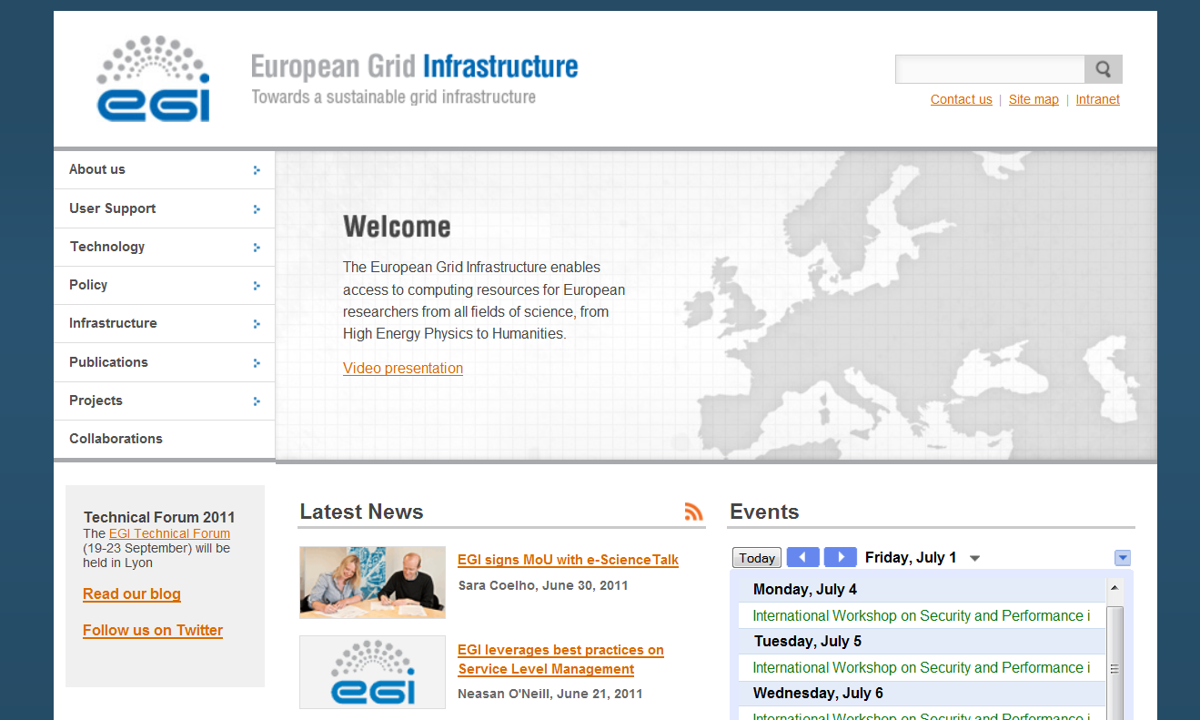

Fig. 1 - EGI’s current homepage featuring the new ‘call for action box’ (bottom left) and the smaller placeholder map

Upcoming design changes

The overall branding for EGI.eu will be reviewed and developed further to accommodate the future development of the organisation. The design of the website will be refreshed in PY2 to reflect this development and maintain a cohesive image for the organisation.

The website layout will be reconsidered to better accommodate visual media, such as photographs and multimedia content (eg. videos). We will add a scrolling gallery to the homepage, and a picture gallery function to the website, to allow images to be downloaded for use by press and partner organisations.

We will add a CSS (Cascading Style Sheet) for a print layout to the website. This will allow the contents of the website to be printed easily using a desktop printer. A layout will be designed specifically for this purpose so that contents can be read clearly and printed in the most economical way (minimising paper and ink usage).

Structure

The EGI.eu website structure is currently composed of the following root sections (see Fig.1):

Title of section | Subsections
Homepage | --
About us | News; Events; Governance; Glossary; Staff; Jobs; Press; FAQ; History of EGI (new); Contact; Intranet
User Support (updated) | VRC gateways; NGI support teams; Applications database; Services and tools; Training marketplace; Help and feature request
Technology (renamed) | Technology providers; Assessment; Technology roadmap
Policy | Policy groups
Infrastructure (expanded and updated, renamed) | Figures and utilisation; Resource providers; Services; Join the infrastructure
Publications (renamed) | Newsletters; Presentations; Director’s Letters; Success stories (new)
Projects | EGI-InSPIRE; e-ScienceTalk
Collaborations | --

The basic structure of the website remains the same as reported in the MS201 and MS207 milestones [R1, R2], although some subsections were expanded and/or relocated. As outlined in MS207 Review of the website, the following changes have been implemented:

- The homepage has been redesigned to accommodate new elements, alongside the current ones. The new homepage now includes:
- Left-hand side menu, listing the root sections of the website.
- Welcome box, with link to EGI’s video presentation, in a prominent location in the homepage together with a clear, concise mission statement.
- News box, with an RSS feed of the latest articles published on our website. Each item includes linked title, thumbnail and subtitle.
- Events box, with the embedded events calendar, driven by Google.
- “Call for action” box, with links corresponding to the main needs of visitors to the site, such answering the visitor’s questions. Examples may include:
  - Get started > Link to starting guide
  - Get help > Link to user support
  - Register for an event > Link to the event
- Placeholder for images and videos.

- The creation of an independent Policy section, hosting the material listed previously under Collaborations.

- Upgraded the Press subsection to the main menu. The Press Room is meant to be the first port of call for journalists, reporters and freelancers and, as such, should be as visible as possible.

- Renaming three of the sections:
- Deployed Technology > Technology
- Production Infrastructure > Infrastructure
- Results > Publications

- Addition of a Gender Action subsection to the EGI-InSPIRE area of the website.

Content

The content of the website has been improved over the past few months, since publication of MS207.

Recent content improvements

- (Update) We have rewritten the welcome message displayed in the homepage to describe succinctly the mission of EGI in a 30-second elevator pitch style (Fig.1).

- (Regular Updates) The News subsection has been regularly updated with news items about the EGI community. The rate of publication of news items is now about 5-6 per month.

- (Regular Updates) The Events calendar is now populated with events relevant to the e-Infrastructure community around the world.

- About section:
- (Updated) We have revised the ‘FAQ’ section to provide answers about the organisation, governance, grid computing for a lay audience and how to use the infrastructure (Fig.2).
- (NEW) We have added a ‘History of EGI’ page to provide an overview of the historical context for the organisation and acknowledge the pioneering projects that contributed to its development.
- (Updated) The governance page was rewritten for clarity.

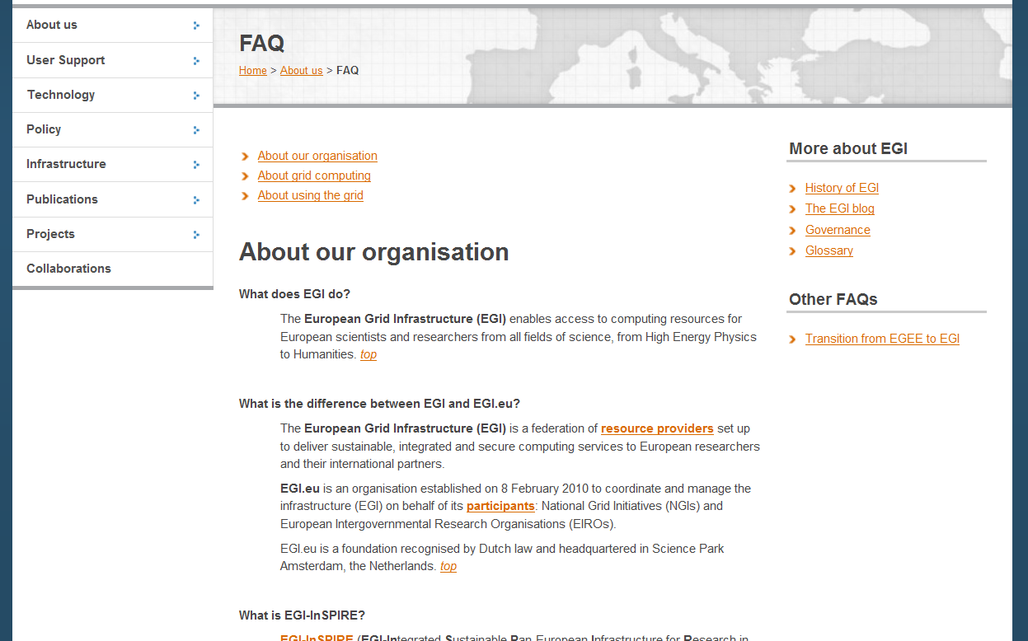

Fig. 2 – The new FAQ section

- (Updated) The ‘User support section’ was rewritten and restructured after consultation with the EGI.eu User Community Support Team and their external partners. The most important changes include:
  - The contacts for the NGI support teams can now be found in an interactive map of the world (Fig.3).
  - The training marketplace was redeveloped as an interactive tool to advertise training events across communities, projects and national teams. The new Training Marketplace enables trainers to advertise events and resources, and users to locate, comment on and suggest training material and events that meet their needs.

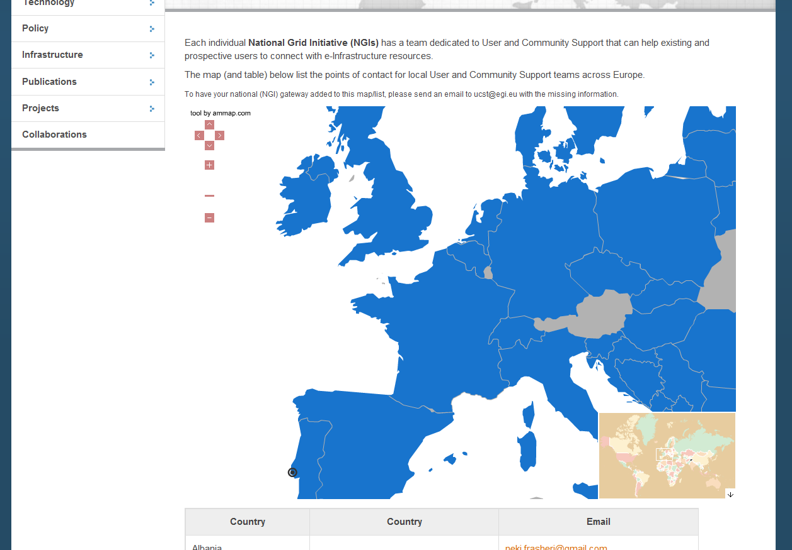

Fig. 3 – Interactive map of the world with a list of the User Support contacts in each participating National Grid Initiative. A similar map is also used to show the operations contacts in each Resource Infrastructure Provider (within the Infrastructure section)

- (Updated) The ‘Infrastructure’ section was rewritten and restructured with the support of the EGI.eu Operations team. It now features the following subsections:
  - (NEW) A summary of the EGI Operations Architecture (section homepage)
  - (NEW) A ‘Figures and utilisation’ page to list the latest operational metrics and a page with regularly updated information on availability and reliability.
  - An interactive map of Resource providers to complement the previous table (Fig.3).
  - (NEW) The Services page describes the four types of services provided by the Operations community. The technical and infrastructure services are detailed in individual pages (Fig.4).
  - (NEW) The ‘Join the infrastructure’ page describes the possible routes to integration of a resource centre in the EGI infrastructure

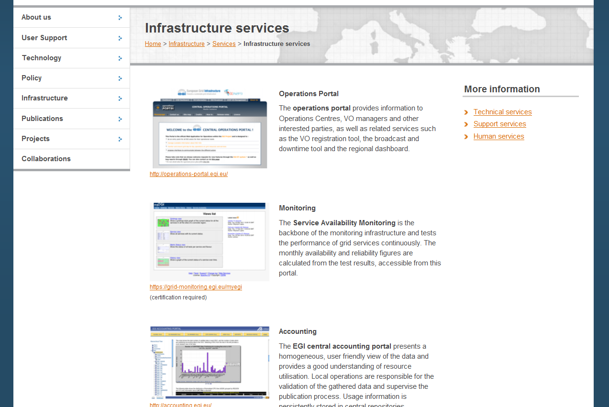

Fig. 4 – Detail of the ‘Infrastructure services’ page and the different tools available for use of the operations community

- Publications section:
  - (NEW) We have added a subsection on Success stories, which is intended to become a library of featured case studies showing how grid computing is helping scientists and researchers. The first two full case studies are already online with short summaries of further case studies (Fig.5).
  - The main section page now includes a visual directory of the EGI publications (including the User Forum Book of Abstracts, EGI Annual Report 2010-2011, and brochures) with all documents available as downloadable PDFs.

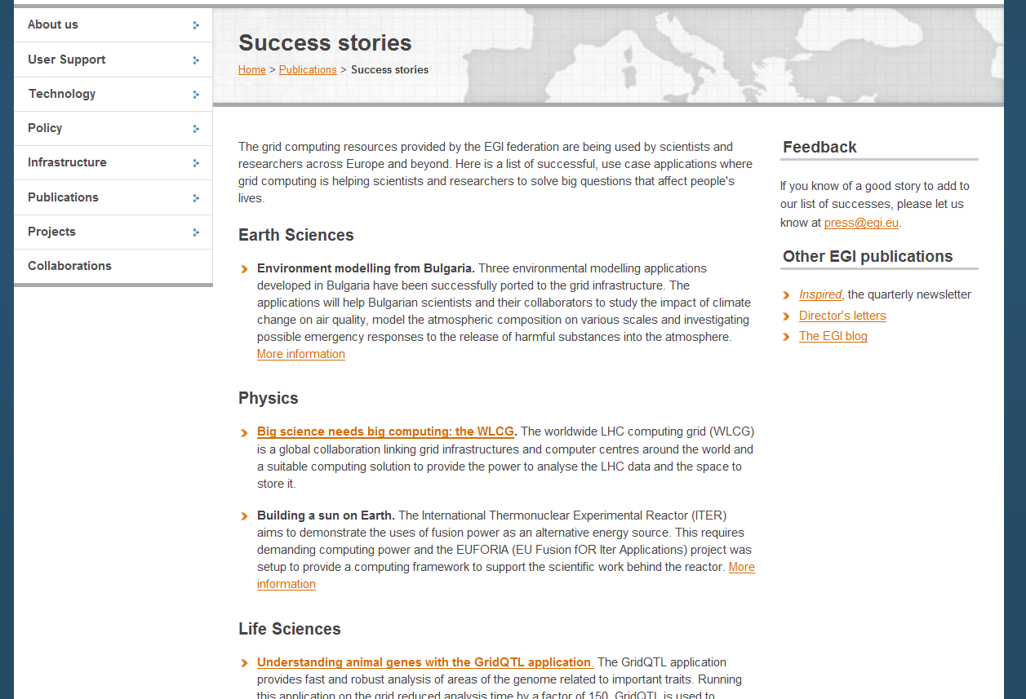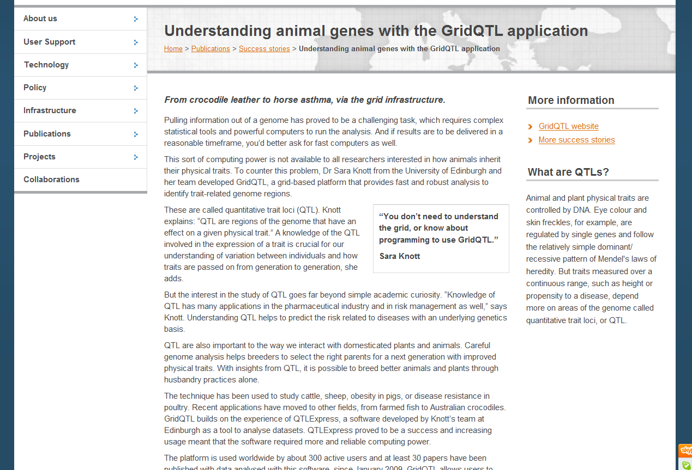
Fig. 5 – ‘Success stories’ homepage (left) and example of a case study (right)

- (Updated) The Collaborations section was re-launched with material that was previously under the Policy section. The improved content of this section reflects the recent achievements of the EGI.eu Policy team, in particular the signing of Memoranda of Understanding and Service Level Agreements with several partners and institutions across the Distributed Computing community. As part of these agreements, we have created a page for each of EGI.eu’s partners. As of 1 July 2011, the website includes pages (Fig.6) for:

- Technology Providers
  - (NEW) EMI
  - (NEW) IGE
  - (NEW) SAGA
  - (NEW) StratusLab
- Resource Infrastructure Providers
  - (NEW) UFRJ (Latin America)
- Virtual Research Communities
  - (NEW) LSGC
  - (NEW) WeNMR
- Policy and standards bodies
  - (NEW) e-IRG
  - (NEW) EUGridPMA
  - (NEW) Open Grid Forum
- Other projects
  - (NEW) e-ScienceTalk
  - (NEW) GISELA
  - (NEW) gSLM
  - (NEW) SIENA

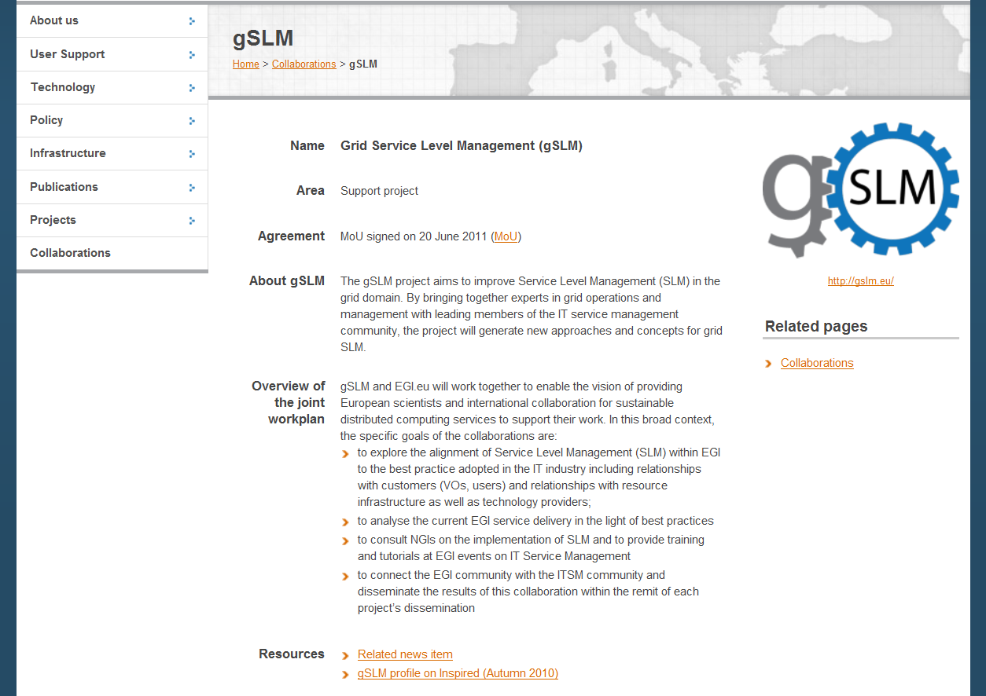

Fig. 6 – Example of one of the new partner pages in the Collaborations section

- (NEW) According to the plan outlined in the last report, we have created a subsection dedicated to the Gender Action Plan in the EGI-InSPIRE section to feature the gender equality strategies of EGI.eu and its project partners, as well as statistics, links and policy documents.

Future work

As of 1 July 2011, the first phase of the website structure is fully developed and no longer ‘in construction’. Future work will focus on:

- maintaining the content of the website, in particular the areas that require frequent updating (e.g.: project metrics, figures and utilisation, milestones and deliverables, newsletter);
- publishing news items about the EGI community in the newsfeed;
- developing case studies to populate the ‘Success story’ section;
- creating pages for partner institutions and projects, as EGI.eu enters new collaborations;
- adding the blog post feed to the home page so that the most recent blog posts are available;
- adding personal profile pages drawn from the public data in the SSO database;
- adding a photo and image gallery for download by the media, project partners and collaborating projects.
- gathering feedback and requirements from users of the website eg carry out a survey at each of the bi-annual user events, do some ‘over the shoulder’ evaluation of how people use the site with visitors to EGI booths, and liaise with the UCST team on any requests emerging from their requirements gathering tools.

accessibility and W3c standards

Web accessibility is an evolving subject and a specialist area in itself. However, there are basic standard guidelines that content creators can follow to ensure the site is accessible to a wide range of audiences. The EGI website will be reviewed for its accessibility and improvements will be made to adhere to W3C accessibility standards where possible.

Recent improvements

All the ‘ALT’ tags for images on the website (up to 1 June 2011) have been reviewed. Any images that did not have this tag (and where there should be ALT tags present), or where the tags were not meaningful, have been corrected. This will improve the readability of the site by visually impaired users, for example when using screen reading software.

Future work

During PY2, 2e will review the accessibility of the website using steps outlined by W3C (http://www.w3.org/WAI/eval/preliminary.html). Any issues that fail these recommendations will be addressed and corrected to meet the accessibility standards where possible. A checklist will be drawn up and made available to all content creators of the website, so that any future pages created will meet the standards also.

Metrics

Initiatives taken to increase traffic to the website

One of the main goals for running a website is to provide the community with a hub of reliable and up-to-date information. To maximise the impact of this work, it is desirable to increase the traffic and navigation to and within the EGI website. Since the publication of the previous website review (MS207 in July 2010), we have taken a number of initiatives to stimulate navigation.

- We have updated the News and Events feed regularly.

- We have added a comprehensive list of links to portals, dashboards and other tools used on a day-to-day basis by the Operations teams distributed across the NGIs. The goal is to promote these pages as a directory of useful links to the community.

- We have begun a collection of success stories, profiles and engaging stories about the practical uses of e-infrastructures; two case studies have been completed and many others are (as of 1 July 2011) in several stages of preparation. The ‘success story’ section provides content to readers unfamiliar with the grid infrastructure and mostly interested in its applications.

- We have included two interactive maps (in the User Support and Infrastructure section) of partners’ contacts and URLs to their respective homepages. The idea is to develop a network of mutual links with associate and partner websites to maximise traffic through referring links.

- The website address is written prominently on all printed brochures, articles and posters to drive traffic to the site. We have produced PDF versions of all printed dissemination materials (User Forum 2011 Book of Abstracts, Annual Report, brochures) to make the full range of our publications available to a wider audience. Visitors can read publications onscreen or download a copy to print and read or redistribute themselves.

- We have established an EGI blog which gives a dynamic insight ‘behind the scenes of EGI’ and relevant to the community. This is described in more detail in MS217 Dissemination Handbook.

Overview

The metrics provided in this and the following sections refer to the period between 29 January 2011 and 30 June 2011. It is not possible to extend the analysis prior to 29 January 2011, due to a reorganisation of the websites within EGI control (which affected the Google Analytics data collection) implemented on 29 January 2010. As such, it is not possible to compare absolute numbers directly with what was previously reported in MS207. It is however possible to compare rates and as a reference we have included previous values in brackets.

- The website received 82,392 visits, with an average of 538 visits per day [196 visits per day; +174%] and 32,980 unique visitors.
- The website recorded 369,915 pageviews, at an average of 4.5 pages viewed per visit [5.2 pages viewed per visit; -13%].
- The average time spent on the website was 00:07:15 [00:04:40; +55%]
- We confirmed the trend for a significantly lower number of visitors during weekends.
- The busiest day of the period was 11 April 2011 (first day of the User Forum in Vilnius) with 1,605 visitors.
- Despite the daily peaks, there is no significant overall trend with the monthly average around 16,444 visits per month [2,300 visits per month; ca. +600%].

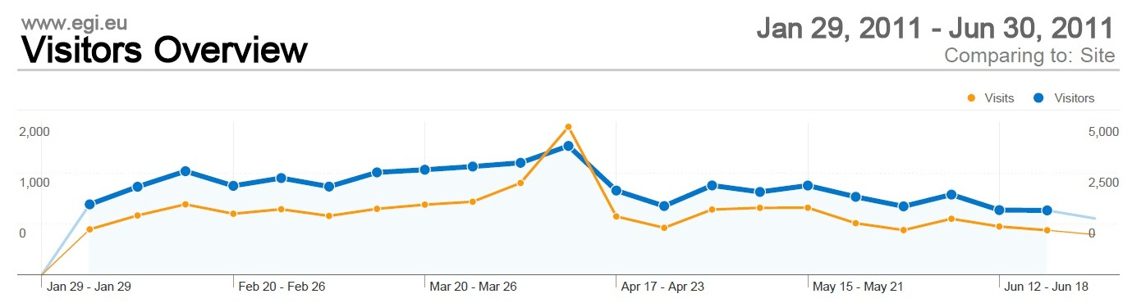

Fig.7 – Visits and visitors to www.egi.eu

Visitors

- Our visitors come mainly from the Netherlands (12,622 visits), followed by Italy (6,535), and a cluster formed by the United Kingdom, Germany and Spain (all with an average of around 5,500). Lithuania also features prominently with 4,905 visits, possibly due to the User Forum held in Vilnius during the analysed period (Fig.8).
- 22.62% of the visitors arrive at the website via direct links, whereas Google accounts for 34.74% of visits (an increase from 24% in the last report). Referring sites (top: wiki.egi.eu) are responsible for 19.87% of the traffic (see Table 1).
- Top search terms include egi user forum, egi, egi.eu, egi inspire, egi grid and egi technical forum.

Fig.8 – Visitors to the www.egi.eu website by country

Source/Medium | Visits | % Visits
google / organic | 17793 | 39%
(direct) / (none) | 9971 | 22%
wiki.egi.eu / referral | 6526 | 14%
eu-egee.org / referral | 924 | 2.0%
egi.eu / referral | 838 | 1.8%
web.eu-egi.eu / referral | 487 | 1.1%
eu-emi.eu / referral | 415 | 0.9%
mail.google.com / referral | 388 | 0.8%
twitterfeed / twitter | 337 | 0.7%
appdb.egi.eu / referral | 298 | 0.6%

Table 1: Referring sources to www.egi.eu

Content

- The most popular sections of the website were (see Table 2):
  - Indico (events website) (53% [47.0%; +13%])
  - About (10.6% [14.9%; -28.9%])
  - SSO (6.0%; [14.5%; -58.9%])

Page | Pageviews | % Pageviews | Unique Pageviews | Avg. Time on Page (s)
/index.html | 16824 | 9.86 | 12904 | 93
/indico/conferenceTimeTable.py?confId=207 | 11756 | 6.89 | 6351 | 123
/about/intranet/index.html | 2745 | 1.61 | 2138 | 172
/sso/index.html | 2012 | 1.18 | 1503 | 30
/projects/egi-inspire/index.html | 1934 | 1.13 | 1517 | 85
/indico/index.html | 1860 | 1.09 | 1309 | 24
/blog/index.html | 1811 | 1.06 | 966 | 97
/indico/conferenceDisplay.py?confId=415 | 1543 | 0.90 | 1269 | 85
/about/staff/index.html | 1496 | 0.87 | 1174 | 79

Table 2: Most popular pages under *egi.eu

CONclusion

The EGI website (www.egi.eu) has been considerably expanded and upgraded during EGI-InSPIRE’s first year and the quality and quantity of the information published in the various new and updated sections has been enhanced. The frequency of updates to news and the dynamic elements of the website has been increased and maintained at the higher level throughout the review period.

To further build on the progress already made with the website, we plan to review and improve accessibility to make information available to as wide a range of audiences as possible and carry out evaluation of the website in collaboration with users

A further review of the website will be carried out in PM28 for MS238.

References
R 1 | MS201: EGI website  https://documents.egi.eu/document/126
R 2 | MS207: Review of the website  https://documents.egi.eu/document/179
R 3 | MS203: Dissemination Handbook  https://documents.egi.eu/document/145
R 4 | MS205: Establishing the policy area of the website  https://documents.egi.eu/document/93
R 5 | MS217: Dissemination Handbook  https://documents.egi.eu/document/541

EGI User Forum 2011 website
EGI User Virtualisation Workshop website

