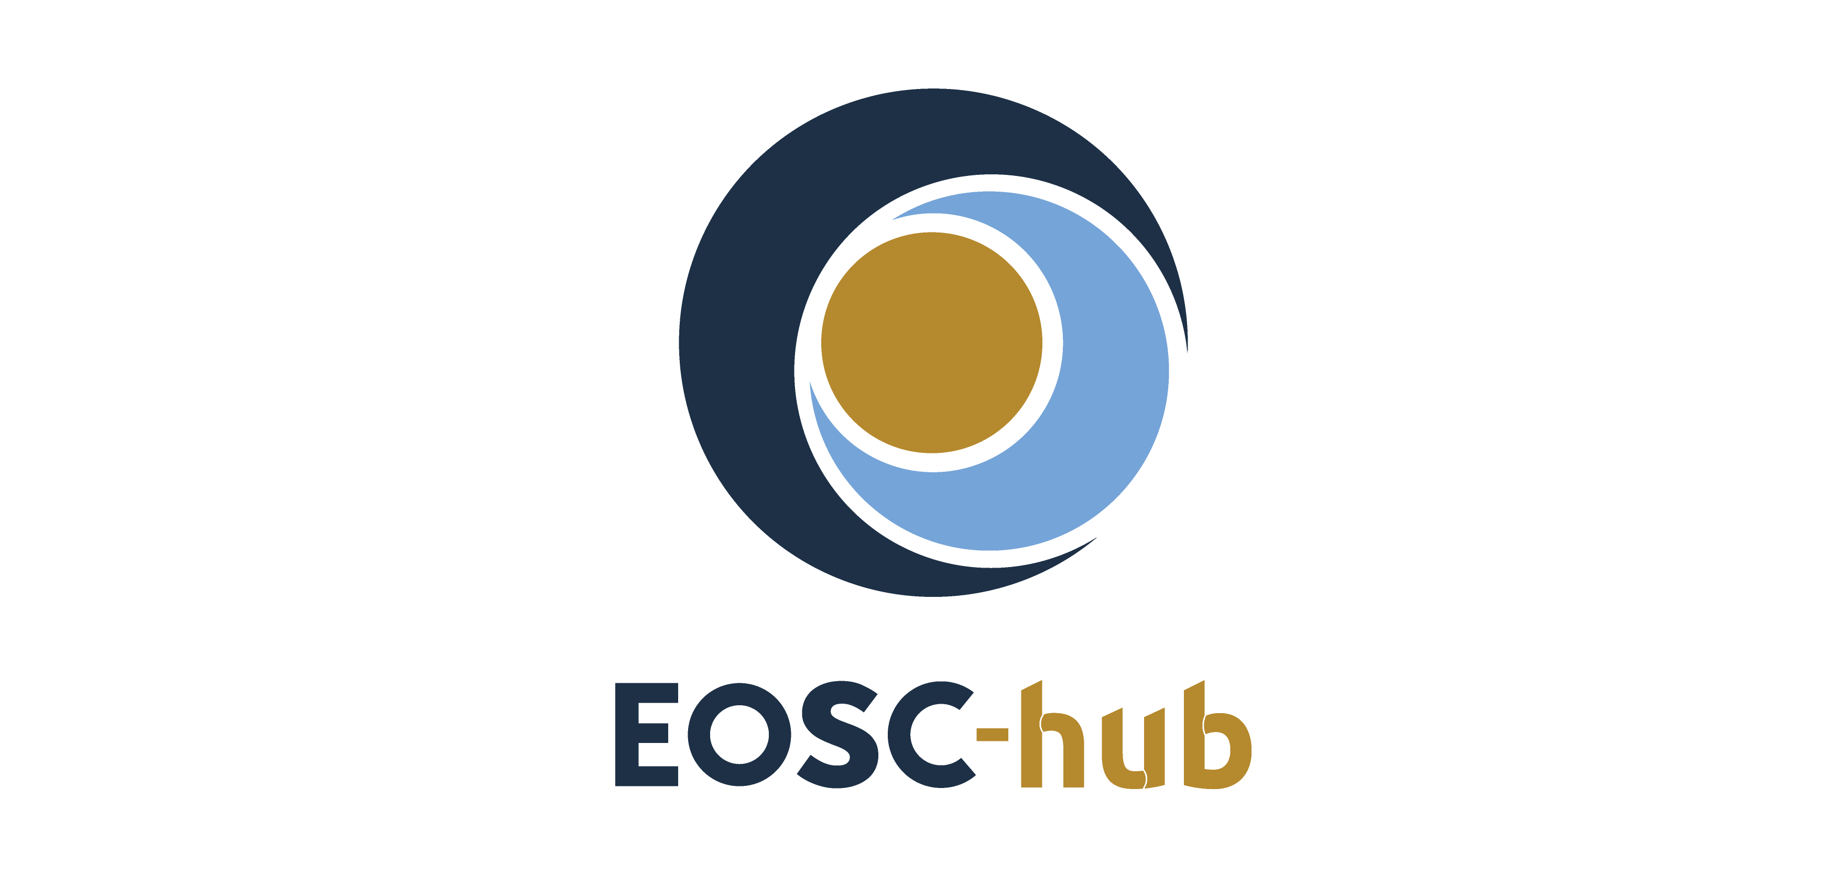

D9.4 Joint Digital Innovation Hub Final Results and Sustainability Plan
Lead Partner: | EGI Foundation
Version: | 1
Status: | FINAL
Dissemination Level: | Public
Document Link: | https://documents.egi.eu/document/3630

Deliverable Abstract
This document provides a detailed report of the EOSC Digital Innovation Hub (EOSC DIH) supported by EOSC-hub WP9, including all activities carried out in the different tasks, the main results achieved during the project period as well as the sustainability plan for the future.

COPYRIGHT NOTICE
This work by Parties of the EOSC-hub Consortium is licensed under a Creative Commons Attribution 4.0 International License (http://creativecommons.org/licenses/by/4.0/). The EOSC-hub project is co-funded by the European Union Horizon 2020 programme under grant number 777536. In case of PSNC the scientific work is co-financed from financial resources for science in the years 2018-2020 granted for the realization of the international project co-finances by Polish Ministry of Science and Higher Education no 4093/H2020/2018/2.
DELIVERY SLIP
Date | Name | Partner/Activity | Date
From: | Sy Holsinger | EGI Foundation/WP9 | 31/03/2021
Moderated by: | Malgorzata Krakowian | EGI Foundation/WP1
Reviewed by: | Simon Farr  Nikos Vogiatzis | JISC/External  JNP/External | 24/03/2021
Approved by: | AMB

DOCUMENT LOG
Issue | Date | Comment | Author
v.0.1 | 02/09/2020 | Table of Contents | Elisa Cauhe,  Sy Holsinger
v.0.2 | 10/02/2020 | Input from T9.3 | Samuel Almeida
v.0.3 | 18/11/2020 | Input business pilots | Agnieszka Rabenda Tomczak,  Marcin Plociennik,
v.0.4 | 16/12/2020 | EOSC DIH community workshops. Community creation. | Elisa Cauhe
v.0.5 | 20/01/2021 | EOSC DIH community workshops and creation of the building community and value chain, diagrams; Branding material, partnerships, and events; Draft of SWOT analysis and Business Model Canvas and stakeholder analysis | Samuel Almeida, Marcin Plociennik, Nick Laver,  Sy Holsinger,  Elisa Cauhe
v.0.6 | 19/02/2021 | Input business pilots from the open call for Annexes; Description of the Open call procedure; Draft of the PEST analysis | Agnieszka Rabenda Tomczak,  Marcin Plociennik
v.0.7 | 03/03/2021 | Executive summary and conclusions drafted and full doc review with additional content | Sy Holsinger
v.0.8 | 15/03/2021 | Final version for external review | Sy Holsinger
v.0.9 | 24/03/2021 | External review provided | Simon Farr,  Nikos Vogiatzis
v.1 | 31/03/2021 | Final | Sy Holsinger,  Elisa Cauhe,  Samuel Almeida, Marcin Plociennik
- |  | Contributors:  Konrad Leszczyński, Agustín Monteoliva Herreras, Matteo Longoni, Antonella Mauri, Ilaria Speranza, Gilberto Pastorella, Frank Braunschweig, Rodrigo Fernandes, Adam Majewski, Radosław Januszewski, Krzysztof Gibas, Maciej Hłasko, Jose Collazo, Manuel Valladares, Andrés Gomez, Carlos Fernández, Ruben Diez-Lazaro, Fenareti Lampathaki, Alberto Criado, Fernando Aguilar, María José Núñez, Javier Martín Anós, Rafa Porcar, Vicente Sales, Cristina Revert,, Catherine O’Donoghue, Hugo Cantão, Nick Laver, Nuno Varandas. David Iñiguez, Alejandro Rivero, Daniel Martinez Cucalon, Marcin Mazurek, Dorota Kot, Krzysztof Mierzejewski, Grzegorz Niemiec, Jara Pascual, Christian Schultz, Alexey Kulik, Alex Shkor, Smith Donkor, Manuel Herrero, David Casanova Ronco, Maria Mateo Iborra, Jean Baptiste, Antonio F. Skarmeta Gómez, Aurora Gonzalez, Fabio Franzoso, Pablo Martinez Ruiz del Arbol, Eric Pascolo, Laura Cappelli, Szymon Mueller, Michał Urbaniak, Rafał Chrupała, Sebastian Mamczak, Piotr Piórkowski, Ana Belén Gonzalez, Andreas Ocklenburg, Andrea Hanninger, Isabel Campos, Carlos Díez González, Pablo Gómez García, Aitor Orio Alonso, Paweł Berus, Gerard Frankowski, Marcin Materna, Jan Maciołka

TERMINOLOGY
https://wiki.eosc-hub.eu/display/EOSC/EOSC-hub+Glossary
Terminology/Acronym | Definition
AI | Artificial Intelligence
BDVA | Big Data Value Association
DI4R | Digital Infrastructures for Research
DIH | Digital Innovation Hub
EC | European Commission
EOSC | European Open Science Cloud
EU | European Union
HPC | High Performance Computing
IPR | Intellectual Property Rights
i-Space | BDVA Innovation spaces
ML | Machine Learning
MIDIH | Manufacturing Industry Digital Innovation Hubs
NREN | National Research and Education Network
RTO | Research and Technology Organisation
SAE | Smart Anything Everywhere
SHAPE | PRACE SME HPC Adoption Programme in Europe
SME | Small and medium-sized enterprises
TRL | Technology Readiness Level

Contents
1 Introduction and scope 8
2 The EOSC DIH report 9
2.1 Activities 2018-2020 9
2.2 Key results and Impact assessment 51
3 Shaping the EOSC DIH future: The Sustainability Plan 53
3.1 Mission, Vision and value proposition 53
3.2 The services 53
3.3 The EOSC DIH ecosystem 54
3.4 The SWOT and PEST analysis 58
3.5 Business Model Canvas 60
3.6 Financial sustainability 61
3.7 Organization and legal sustainability 62
4 Lessons learnt and recommendations for other DIHs 63
5 Conclusions 66
ANNEX I. Onboarding new pilot procedure 67
ANNEX II. Business Pilot Detailed Descriptions 69
ANNEX III. Survey 92
ANNEX IV. Industrial Events and dissemination activities 97
Annex V. Memorandum of Understanding and Terms of Reference 109

Executive summary
The EOSC Digital Innovation Hub (EOSC DIH) was set up and is being marketed as the mechanism for business organisations (e.g., start-ups, SMEs, large enterprises) to directly engage the European Open Science Cloud (EOSC). EOSC-hub WP9 defined specific service offers to facilitate establishing business partnerships and business pilots to increase exploitation potential of commercially viable research data and other existing e-Infrastructure services while providing both human and technical services to commercial organisations to increase digitization capabilities and move new products or services into the market.
WP9, via the creation, operation, and evolution of the DIH, directly contributed to project objective 4 “Widen the access to services to all user groups including researchers, high-education, business organizations and expanded the user base.” In addition, the EOSC DIH was recognized as a project key exploitable result as well as in the EC DIH catalogue.
The long-term strategy of the DIH is to live beyond the life of the project and to be the single, future mechanism for industry to engage with the EOSC. Therefore, the DIH has been branded as the EOSC DIH with all online and promotional material reflecting this: dedicated service offers; package of EOSC DIH logos; own URL (eosc-dih.eu) and social media accounts (Twitter; LinkedIn); brochures; posters; reusable slide decks; video; entry to the EC DIH Catalogue, etc.
Partners were active in both event organisation and participation as well as running dedicated webinars on community gathered topics of interest, totalling around 30 events. This included sessions within EOSC flagship events, where business pilots were also present having won best demos and posters.
Regarding the business pilots, the EOSC DIH initially ran 6 pilots with SMEs to kick-start business opportunities and has onboarded an additional 12, for a total of 18 during the life of the project. 5 of these were obtained via an open call held in the spring of 2020. New business pilots started to take advantage of a wider set of EOSC services beyond infrastructure-as-a-service and into requiring technological expertise, co-designing services using EOSC-hub services, and support and co-development with other projects.
In order to showcase these business pilots in addition to presence at events, WP9 partners prepared 2 success story publications and transitioned technical meetings within pilots into community wide meetings, further coalescing the community. Sharing of other funding opportunities was expressed by the community as an area of interest, therefore a dedicated section was added to the EOSC DIH website as other open calls and funding opportunities became available.
Partnerships with other initiatives, projects and regional DIHs were also sought as an additional means of both dissemination and achieving a multiplier effect, such as the flagship DIH coordination project DIHnet, Deep-Hybrid-DataCloud for augmenting the EOSC DIH service offering with artificial intelligence and machine learning services, OpenAIRE for data services, EOSC-Synergy for regional connections, amongst others.
Several lessons learned and recommendations have been identified for both the future of the EOSC DIH as well as for the wider ecosystem. This includes the challenge of identifying and involving the wider services and expertise from EOSC members not formally part of the DIH for ensuring support to pilots, and the human resource requirements needed to support diverse SMEs. EOSC governance bodies have a broad range of topics that must be considered to ensure inclusion, with recognition in high-level strategic documents proving to be more difficult than expected.
Sustainability measures have always been a consideration during the project lifetime, ensuring that what was created by the project partners would continue into the future. In addition to the branding and dedicated online presence, a formal Terms of Reference was drafted outlining how the DIH could continue to operate outside of any single project as a number of initiatives will continue in the short-to-medium term (i.e. EOSC Future, EUHubs4Data, EGI-ACE). As the DIH matures into the future with initial support from both projects and organisation in-kind contributions, further monetary business models will be explored.

EOSC-hub Key Exploitable Results
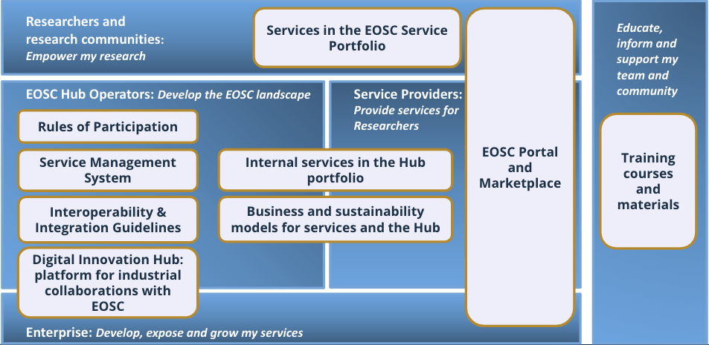
Specifically related to the EOSC DIH, the following key results can be considered:
- 18 business pilots. A wide and diverse list of business pilots and success stories from different sectors (environment, manufacturing, software simulation, blockchain, AI, logistics, housing…).
- Specific website and branding. The rebranding and independent website was the first step for sustainability after the EOSC hub project. A new image according to the EOSC portal style and more content on the website to start growing as a community.
- A platform for community interaction. A forum and several communication mechanisms allowed the EOSC DIH to create and develop its community getting a space for interacting with the companies and partnerships.
- Memorandum of Understanding including a Terms of Reference for operating the DIH post-project. The EOSC DIH agreed to create an MoU and Terms of Reference to set up the basis of collaboration between the partners.
- Processes and Procedures. Design and implementation of processes and procedures to manage the onboarding of new DIH partners, community members, pilots, or partnerships. The experience of the Open call is also considered a learning mechanism allowing to define future Open call procedures.
- The funding matchmaking: Information about funding opportunities were shared with the EOSC DIH community, previously matched to the activities and interests of the pilots. Multiple funding opportunities from ICT-51, EUhubs4data, REACH Incubator SMART4ALL and the NGI, such as DAPSI, ESSIF LAB, POINTER, and TRUST, were explored by the companies of the EOSC DIH community. In the words of the pilots, it was “extremely interesting the number of funding opportunities announced within the EOSC DIH” and "many of them were interesting".

EOSC DIH In Numbers
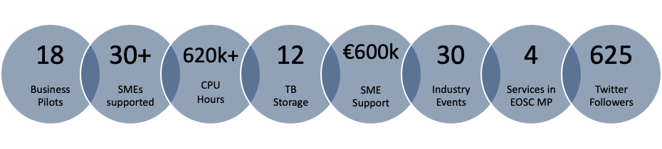

Recommendations for EOSC
- Better definition and UX of EOSC offerings to be linked to the EOSC DIH offering.
- Realistic SLA to not mismatch pilots’ expectations
- EOSC DIH to be considered as main interface between EOSC and Industry
- Procedure definition for a faster onboarding of services labelled EOSC DIH
- More support on the DIH dissemination from the EOSC
- Easier access to data for pilots

Recommendations for DIHs
- Reuse community building tools
- Keep small and focused with clear internal organization
- Open calls are useful instruments for the community but require many efforts
- Definition of initial metrics and KPIs to assess the real impact

Introduction and scope
The scope of this document. This report focuses on describing the EOSC DIH activities during the whole project period including a business pilots overview and sets the basis for the future of the DIH in the sustainability plan. The document summarizes the initial setup phase when the EOSC DIH was created and its evolution, encompasses the description of the new pilots (the initial 6 pilots were covered in D9.3) and includes the main outcomes, the description of the support offered, and the valuable feedback that will be used in further developments of the DIH.
Related tasks. This report is the last output of WP9 as a whole, therefore related to all tasks within it: Task 9.1 Joint DIH Ecosystem (led by EGI.eu), Task 9.2 Business Pilots (led by PSNC) and Task 9.3 Commercialisation Support (led by F6S).
General timeline. The first timeline of business pilots started in the first month of the project (January 2018) and finished in Project Month 18. The Open call for new pilots was launched in April 2020 (Project month 28) and closed 1 month later and the selected projects started in July 2020 (Project Month 31), finishing in February 2021 (Project Month 38). The business support (starting in Project Month 6 through T9.3) focused its main efforts once the pilots were running the experiments and periods when the market analysis and commercialization support were more needed, while the T9.1 effort have covered the general management of the DIH during the full project.
Organization of this document
Section 1: Introduces the document and its structure.
Section 2: Describes the work done in WP9 during the whole project split by Task, including an overview of the 18 business pilots supported by the EOSC DIH and a wide description of the last 12 pilots, 5 of these selected from the open call.
Section 3.1-3.5: Shapes the future of the EOSC DIH presenting the strategic analysis, including the mission, vision, and value proposition of the DIH, a stakeholder analysis and community ecosystem, a SWOT and PEST analysis, and finally a Business Model Canvas.
Section 3.6-3.7: Provides the sustainability plan based on three main pillars: community building, economical sustainability, and organization and legal sustainability collected as a Terms of Reference.
Section 4: Explains the lessons learnt and suggest recommendations
Section 5: Concludes the document.
Annex I-V: Improves readability of the overall document, while providing further reference details comprising the description of the onboarding process; full description of the business pilots; list of events, and dissemination as well as the draft Memorandum of Understanding (MoU) including a Terms of Reference (ToR) for operating the EOSC DIH post-project.

The EOSC DIH report
This section summarizes the work carried out in WP9 during the full project lifetime. WP9 was dedicated to building and expanding an ecosystem of SMEs, large industries, start-ups, researchers, accelerators, and investors alongside public e-Infrastructures in the form of a Joint Digital Innovation Hub (DIH). The goal of this WP was to foster the creation of partnerships that stimulate innovation between e-Infrastructures and the private sector. This was carried out through the achievement of the following objectives:
- Create partnerships with SMEs/industry, innovation clusters, accelerators and investors that stimulate innovation (new products, services).
- Facilitate access to e-Infrastructure resources to support prototyping, scaling-up, design, performance verification, testing, demonstration, development of pilot lines, validation for market replication, including bringing innovation to investment readiness and maturity for market take-up.
- Connect with regional and pan-European networks of Digital Innovation Hubs.
- Share best practices and competencies for knowledge transfer between the public and private sector.
- Develop long-term business relationships outside of/beyond the project.
- Provide feedback from the SMEs, industries on provided services and infrastructure (also through pilot activities).
- Offer business-oriented coaching with the mission to accelerate market uptake and results in exploitation of the both the pilots and Competence Centres.

Activities 2018-2020

Task 9.1: Joint EOSC DIH
Task 9.1 served to create, manage, and expand the overall DIH ecosystem. It defined and coordinated the overall strategic direction of the various activities within the work package, while ensuring liaison with other project work packages.
This task contributed to the Digitising Europe policy and other European policy initiatives, such as the High-Level Expert Group on the EOSC, providing the means to foster the transition from science to innovation and enabling networking and collaboration of e-infrastructures and private actors.

Building the EOSC DIH
Definition of services
The catalogue of EOSC-hub services and infrastructure available for industry was defined in the EOSC-hub Marketplace which was considered the initial building blocks for the EOSC DIH offerings. The catalogue can be broken into five services categories: technical, thematic, collaborative, federation and human. This catalogue was extended during the EOSC-hub project including new data and thematic services.
However, not all the services provided in the EOSC-hub Marketplace fulfil the needs of private sector companies. The initial requirements identified as part of the analysis of the first 6 business pilots allowed to identify the key resources and services that would be considered the main 4 pillars of the EOSC DIH:
Piloting and co-design | Technical access
- Pilots/proofs of concepts  - Service / Product design  - PaaS/SaaS Integration  - Performance verification  - Testing | - Compute (HTC, HPC, Cloud)  - Storage (Online/Archive)  - Data management  - Research data  - Tools & application
Training & Support | Visibility
- Technical consultancy  - Service management  - Commercialization and business coaching  - Brokerage to funding and opportunities | - Media Exposure  - Participation to events  - Promotional print material  - Inclusion in the Marketplace  - Networking
Providers
The EOSC DIH initially ran 6 pilots with SMEs to kick-start activities, which were selected via an open call during the project preparation phase. Each pilot was matched with a project service provider to ensure an initial service offering composed by CINECA, PSNC, and the EGI Federated Cloud. In order to guarantee the matchmaking and the accounting of the services, an internal spreadsheet file was created to store the pilot requirements and the services offerings, and the final use of technical and human resources involved in the experiment.
Setting up communication and tools
- Working space. The main working space was created according to the rest of the EOSC-hub project, based on the Confluence tool. A mailing list was also created as well as a parallel Skype group, later Slack group for everyday faster communications.
- Task management tools. Trello panels were created to follow the Collaborations and the Pilot status.
- Regular meetings tools. The meetings schedule followed a bi-weekly video conference call with GoToMeeting as a tool for communication and Indico to host the agenda, relevant links/materials, and minutes of each meeting.

The EOSC DIH in the S3platform
The S3 Platform assists EU countries and regions to develop, implement and review their Research and Innovation Strategies for Smart Specialisation (RIS3). The EOSC DIH was included in the DIH map of the S3Platform in 2018.

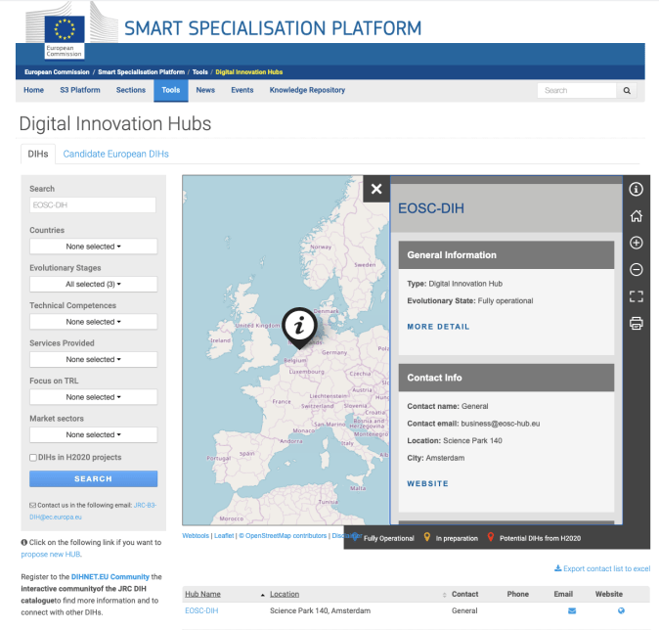
Fig. 1: Image of the EOSC DIH in the S3platform map of Digital Innovation Hubs in Europe
The EOSC DIH is described as fully operational with the following main technological competences:
- Artificial Intelligence and cognitive systems
- Data mining, big data, database management
- Simulation and modelling
- Software as a service and service architectures
- Cloud computing
- ICT management, logistics and business system

Onboarding new pilots’ procedure
New pilots or business contacts are onboarded and managed via dedicated processes that follow the lightweight service management standard, FitSM. For example, service levels with business pilots are ensured and monitored by establishing meaningful service level agreements (SLAs) and where necessary, supportive operational level agreements (OLAs).
A full description of the onboarding process for new pilots is described in Annex II.

Promoting the EOSC DIH
Logo and Branding
With the launch of the EOSC-hub project the branding for the whole project was designed including the logo for the EOSC DIH. This design was well-aligned with the EOSC-hub image by using the same colour scheme and brand mark.

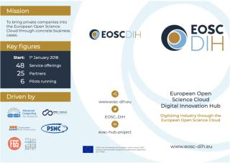 | 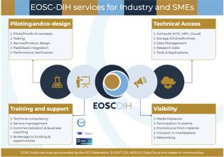
Fig.2: The initial EOSC DIH logo with some branding material.
In 2020, the EOSC DIH logo was redesigned to be more aligned with the EOSC portal style. The new logo is represented by a graphical image which reflects the innovation concept through a bulb aligned with a colour scheme that reflects well the European-wide approach. The text lets the reader easily recognise the context and the meaning of the DIH. Various formats of the logo have been created where needed for being used in different contexts (web, media, printed material).
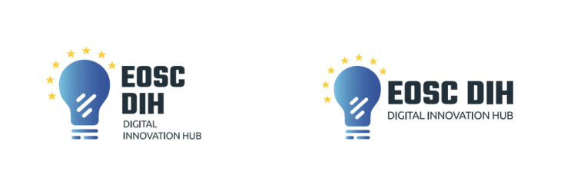
Fig.3: The new EOSC DIH logo with some representations and different applications
A PowerPoint template as well as document and poster templates, brochures and leaflets were updated following the new logo design and shared with the partners and community members to be used in their dissemination activities.
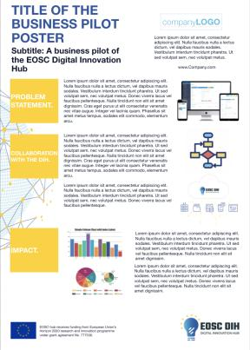 | 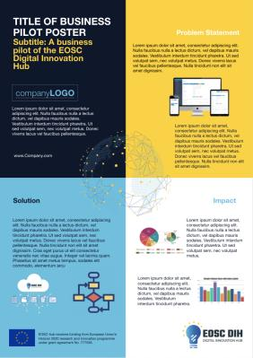
Fig.4: Poster templates with the new logo
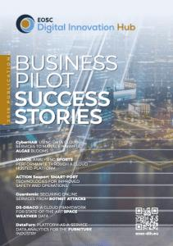 | 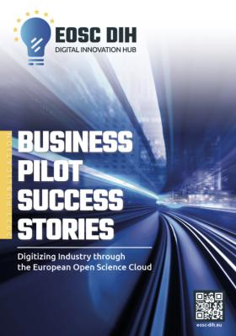
Fig.5: Business Pilot Success Stories Publication, 2019 and 2021 edition.
EOSC DIH Website
The EOSC DIH page was initially integrated in the EOSC-hub project website, launched by month 1 and included the main activities related to WP9. During the last year of the project, an independent website was specifically created for the EOSC DIH and launched integrating the new visual identity. Currently, the EOSC DIH website (www.eosc-dih.eu) is the main channel for dissemination activities and news with the community and the centre point to share the services that the EOSC DIH offers, while the Pilots section provides a description of the experiments running in the DIH.
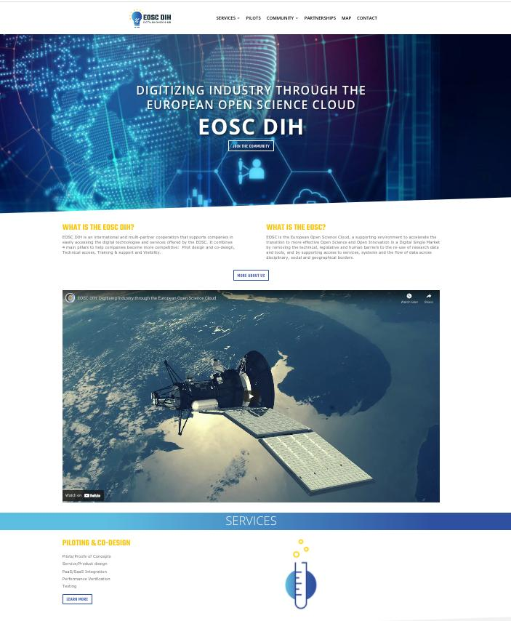
Fig.6: EOSC DIH new website
The homepage includes the promotional video of the EOSC DIH with the declarations of Sy Holsinger, Coordinator of the EOSC DIH.
With the aim of building a strong identity, a set of branding-based graphics were designed to visually display the key services of the EOSC DIH on the website. The website has been designed to emphasize technical services and the community interaction.
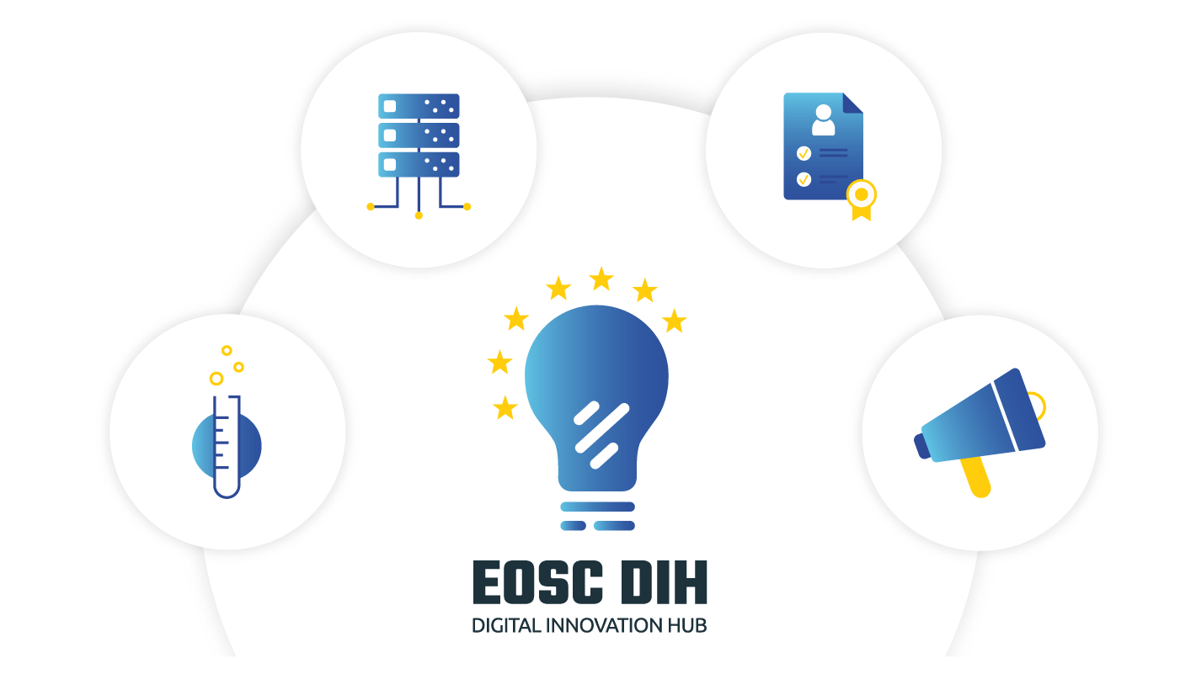 | 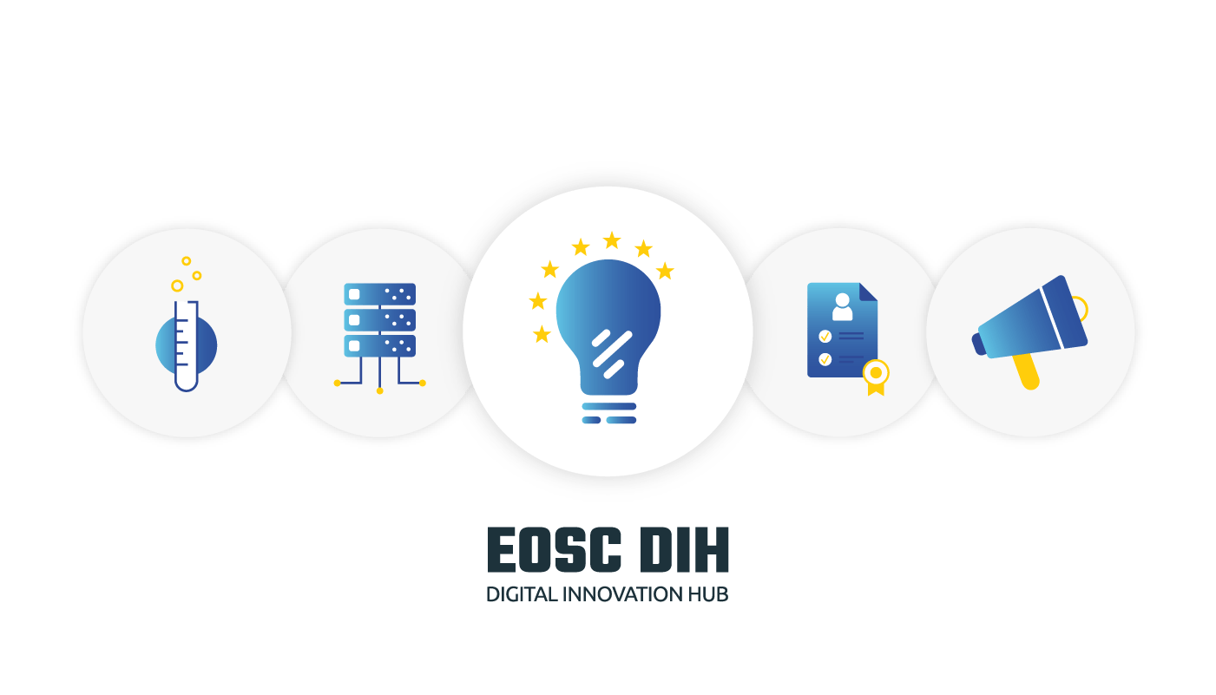
 | 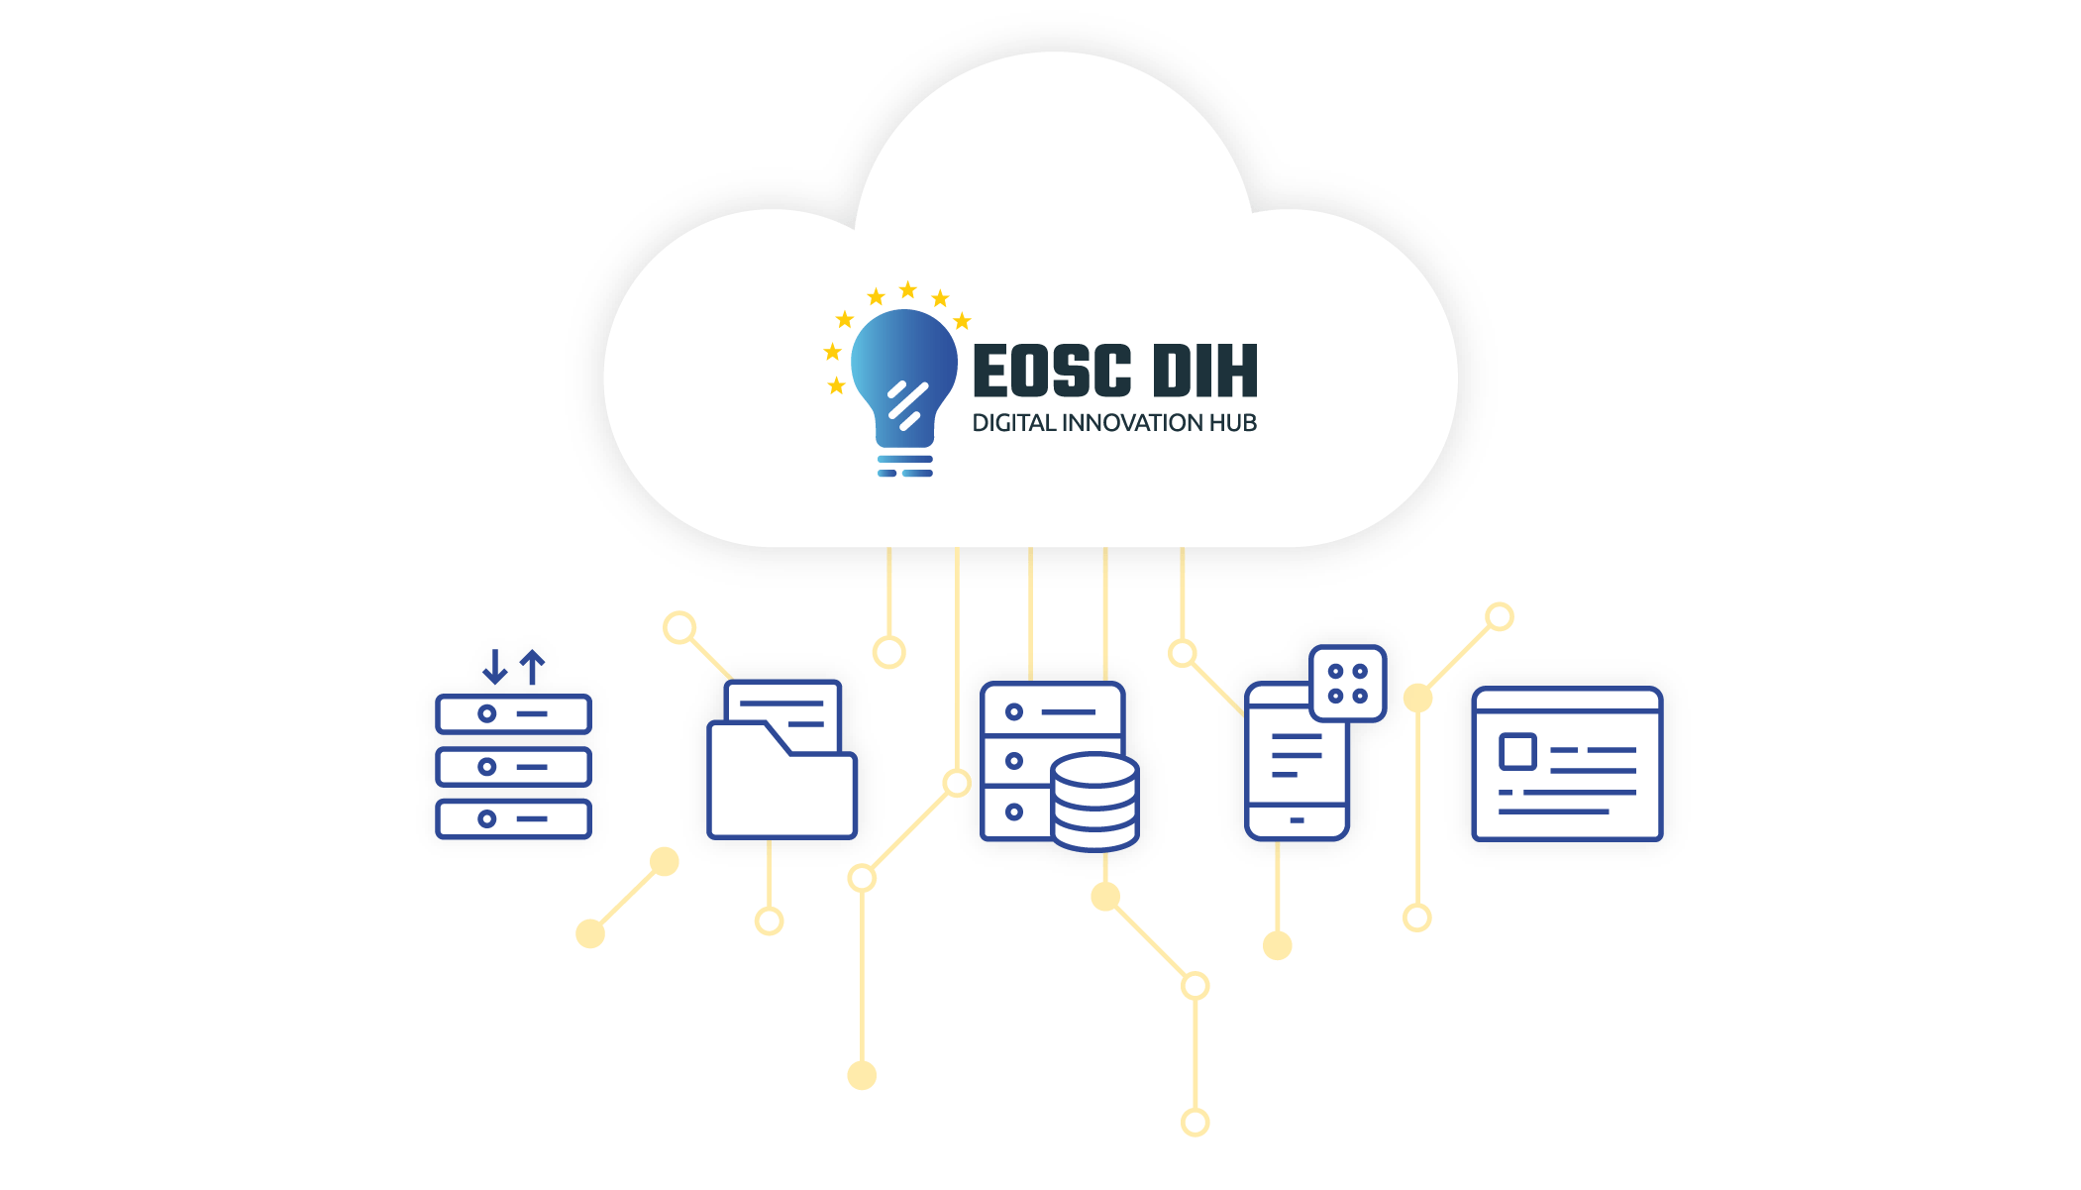
Fig.7: Representation of the EOSC DIH with the main 4 services.
The content of the website follows the following structure:
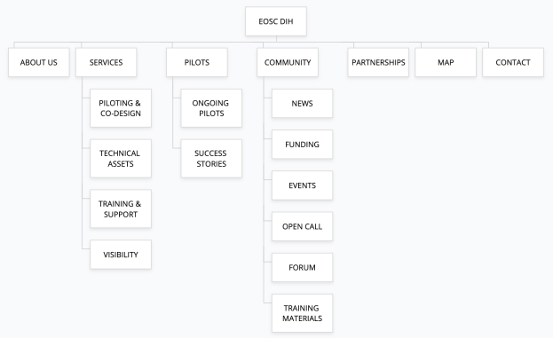
Fig.8: Representation of the EOSC DIH with the main 4 services.
Social media
The EOSC DIH social media strategy initially focused on Twitter to test traction, with LinkedIn added during the second half of the project. The Twitter account @EOSC_DIH currently has more than 600 followers and the LinkedIn profile almost 100 followers, both mainly used to establish engagement with the community and regularly connect with stakeholders and relevant accounts in the context of EOSC and DIHs as well as to communicate the main outcomes and news of the EOSC DIH.
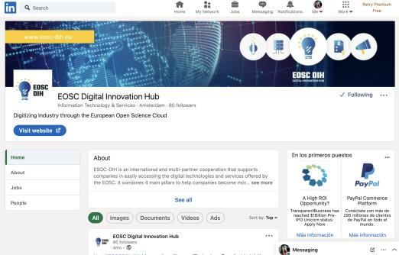

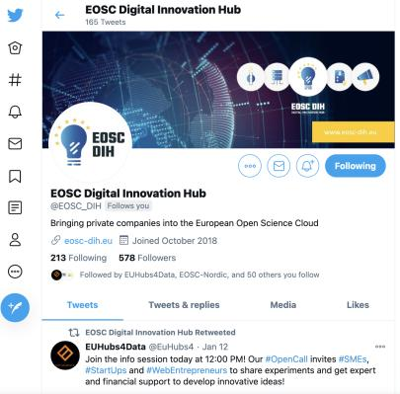
Fig.9: EOSC DIH LinkedIn and Twitter profile

Tweets about the meetings, news related to pilots, participation in conferences and the launch of the open call are some examples of the dissemination done within these channels using relevant hashtags and topics such as #EOSC #webinars #opencall #innovation #SMEs #data #compute #cloud #hpc.
In addition to the interaction with the consortium partners and related projects, the EOSC DIH is also active interacting with key stakeholders, mainly EU and DIH related accounts such as @DihnetE @FutureTechEU, @EUScienceInnov, @EU_Growth, @STFC_B2B, @EuHubs4, @DigIndEU, @OpenAIRE_eu, @RDA_Europe, @eInfraEU.

Facilitating collaboration with regional and European DIHs
As part of the EOSC DIH strategy, contacts have been established with regional and European DIHs, namely:
Collaboration with Regional DIHs
HPC4Poland
- Scope: National
- Country: Poland
- Sector: HPC/ HPCC
- Web: http://www.hpc4poland.pl/en/
- Description: The main objective of HPC4Poland is to create and provide advanced high performance computing tools, addressing the real-life demand of Polish manufacturing companies. HPC4Poland as regional DIH is interested in collaborating with the EOSC DIH in order to provide wider offers of the opportunities to local SME's.
AgriSmartHUB
- Scope: European
- Country: North East Europe
- Sector: Agriculture
- Web: https://www.smartagrihubs.eu/regional-cluster/north-east-europe
- Description: This Regional Cluster (RC) acts as a first contact point and link between farmers and technology providers in the North East Europe region. Its goal is to bridge the gap between the needs, challenges, interests, and expectations of actors in the agri-food sector. To achieve this the RC promotes a multi-actor approach, exploiting complementary competencies and interactive innovation models to connect science with practice as well as public with private. The collaboration aims to exchange experiences, develop cross-border cooperation in common fields of interest in regard to digital services related to Agriculture 4.0 as well as explore possible synergies and search opportunities for joint development of services as it is covered under a Letter of Interest signed in February 2021.
DIHAragon
- Scope: Regional (Aragon)
- Country: Spain
- Sector: HPC, logistics, cognitive systems
- Web: https://www.aragondih.com/
- Description: DIH Aragón is the Aragonese initiative that makes tangible, under a European cooperation framework, the Economic and Industrial Promotion strategy, and the smart regional strategy (RIS3) of Aragon, shaping the technological and innovative action of the Aragonese Innovation System towards the digitization of the Industry. ESOC DIH and DIH Aragon are interested in complementing their service offering. Some of Aragon DIH members participate in DIH and cloud related projects where some of the EOSC DIH partners also participate, such as EUHubs4Data or PolicyCLOUD.
CINECA
- Scope: National
- Country: Italy
- Sector: HPC and cloud computing
- Web: http://www.cineca.it
- Description: CINECA is a non-profit Consortium, made up of 67 Universities, 9 Research Institutions and the Italian Ministry for University and Research. The HPC department of CINECA (SCAI) is the largest computing centre in Italy. CINECA offers industries a state-of-the-art HPC-cloud environment, specialized training, access to competences from the excellences constituting the Consortium, and support to access funding for R&D activities. CINECA and EOSC DIH agreed to cooperate and complement each other in the technical offering.
Collaboration with European DIHs
The DIHnet project (Next Generation European DIH Network) is the network of engaging hubs, competence centres, national and international programmes, and infrastructures to ensure the coordination of these initiatives across Europe. The project aims to guarantee the best possible support to SMEs and midcaps by increasing collaboration between stakeholders from the EU DIH community. The EOSC DIH has actively collaborated with the DIHNET network by participating in several of its activities and conferences, with a special highlight for the Champions Challenge, a prize for those mature DIHs that can inspire and guide other DIHs in their developments. Although the EOSC DIH applied for the challenge, the score was not enough to be awarded, but was a useful internal self-assessment process.
In addition, in recent years, the European Commission (EC) has been working on the definition of the European Digital Innovation Hubs (EDIHs) for the Digital Europe Programme. EDIHs are specific labels provided by the EC to regional DIHs that would benefit from European funding to implement their development at regional level and create the Network of European Digital Innovation Hubs to cooperate with other DIHs in Europe. The call for EDIHs will be open in the second quarter of 2021. The pre-selection of DIHs done by member states has taken place in the last months by the national governments and the preliminary list of candidates are already listed in the S3platform .
As the EOSC DIH is a pan-European DIH, and the EDIH framework focusing mainly on regional/nationally selected DIHs, the EOSC DIH will take a two-pronged strategy by first targeting EOSC related industrial activities using the DIH as a concept to formalize pilots and partnerships; and build a network to provide support to other EDIHs. Partners will continue to monitor the EDIH framework for identifying opportunities.
Participation in events
Part of the community engagement relies on the participation of scientific and industry related events where the EOSC DIH finds opportunities to showcase the services and the use cases or success stories. There are several types of events, that can be split into 4 main categories:
- EOSC related events: Events organised by the EOSC communities, with a research focus and involving the main partners and research groups participating in diverse EOSC related projects. The objective when participating in these events is to share the DIH as the main mechanism for innovation, offering EOSC services to industry and to influence EOSC policy makers to support the EOSC DIH. One of the business pilots, namely Sports Smart Video Analysis (shown in Fig. 10) won the prize for the best demo during this conference out of 12 other contesters.
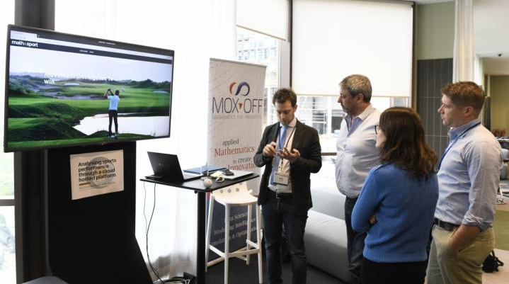
Fig.10: Pilot demo during the EOSC-hub week, April 2019, Prague (Czech Republic)
- DIH related events: Events organised by the main DIH actors and projects, with the main opportunity of giving visibility to the EOSC DIH at a European level, establishing new links with other DIHs and learning about the latest DIH related news, funding opportunities and joint activities.
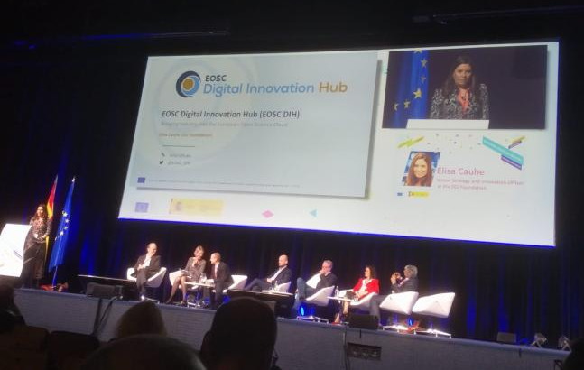
Fig.11: Digitising European Industry Stakeholder Forum, Nov 2019 Madrid (Spain)
- General EC related events: The EC organises regular ICT events where there is specific space and time slots for DIHs. The objectives for participating in these events are to give visibility of the EOSC DIH by sharing the services and the use cases to attract new companies, to establish new networking links or partnerships with other DIHs or projects related, and to learn about the EC strategy about the DIH.
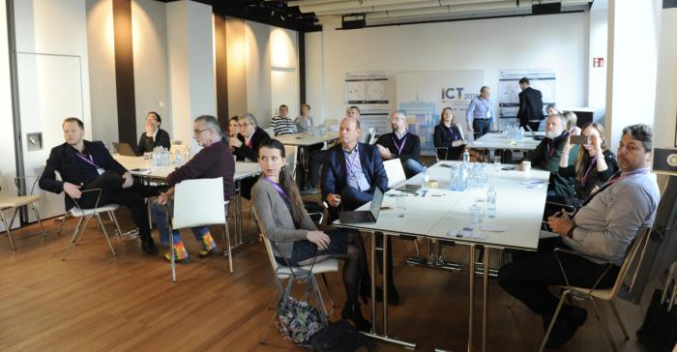
Fig.12: "Matchmaking Industry with the European Open Science Cloud EOSC" session during the ICT 2018, December 2018, Vienna (Austria)
- Industry related events and fairs: Events typically attended at a national level. They offer the opportunity to get in touch with several local companies, SMEs, start-ups and to uptake new business opportunities. Another goal when attending these events is to obtain visibility at national or local level, and to engage with the national policy makers.
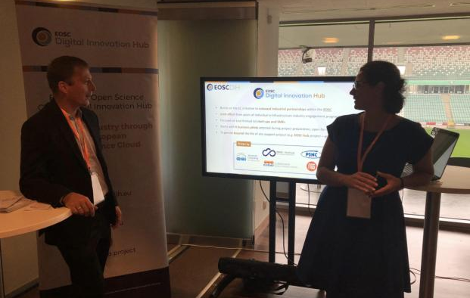
Fig.13: 7th IT Future Expo in September 2019, Warsaw (Poland)
The impact of the COVID outbreak during March 2020 had a relevant impact on the activities done in the second half of the project with only a few selected events attended in a virtual way, mainly those closely related to the EOSC. With this unprecedented situation, organisers of events were required to adapt to the situation and the use of new videoconference tools helped to simulate a real networking scenario with booths and poster sessions, that the EOSC DIH used in the final EOSC-hub event and was awarded with the first runner up - best booth.

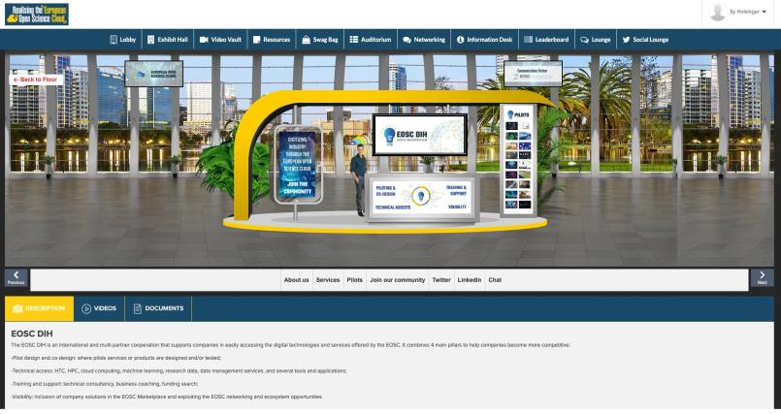
Fig.14: EOSC DIH Virtual booth during the event Realising the European Open Science Cloud, November 2020.

A final virtual event was organised by the EOSC DIH on March 2021 with the participation of 9 pilots showing demos to a wide audience of more than 50 participants and with the participation of a member of the European Innovation Council and invited speakers from EOSC and DIH related projects (EUH4D, DIH4CPS, ENRIITC, DICE, C-scale, Reliance, OpenAIRE Nexus and EGI-ACE).

Fig 15: EOSC DIH final event with pilot demonstration
A total of 30 events were attended during the project period. The full list of events attended by the EOSC DIH partners is available in the Annex III.

Contacts with companies
As a result of the multiple industrial events attended, with the networking activities carried out within the partners contacts and with the dissemination for the Open Call, more than 50 companies had direct interactions with the DIH, in addition to the 25 directly involved in the 18 business pilots. Most of these companies showed their interest in the EOSC DIH services, in possible collaboration paths and some others in applying for the Open call.
Although some of these interactions did not end in a specific collaboration or direct participation in the DIH, a total of 7 pilots from the 18 total business pilots supported in the EOSC DIH were the result of these direct interactions. Considering that a long period of the project has been affected by the COVID situation with no participation in industrial fairs or business conferences the overall result of the interactions with companies has been successful and will be closely monitored in the future activities under the EOSC Future project, amongst others.

Partnerships with other DIH initiatives and related projects
In the context of the DIH in Europe, the collaboration between projects, entities and initiatives is crucial to offer a complementary offer and help each other in the innovation process. The partnerships or collaboration agreements that the EOSC DIH has established had the main interest on the exploration of joint innovative activities, sharing knowledge and capacities and the search of use cases or business pilots to implement them.
- DIHNET. The EC flagship project for organising and facilitating the collaboration between DIHs in Europe and ultimately to support the creation of a sustainable pan-European network of networks. DIHnet is a strategic initiative for the EOSC DIH, and the joint collaboration activities comprise:
  - Serving as a member within 2 DIHnet Working Groups: Funding & Finance; Collaboration
  - Participating and presenting in the DIH Annual Events, supported workshops and webinars
  - Engaging via the DIHnet online community forum
  - Dissemination of DIH activities and EOSC DIH results
- Deep Hybrid Data Cloud. Project that supports intensive computing techniques (ML/DL) that require access to specialized HPC hardware, like GPUs or low-latency interconnects, to explore very large datasets. EOSC DIH and DEEP-Hybrid-DataCloud (DEEP) have entered into a collaboration agreement aiming to foster their adoption by SMEs, undertake dissemination of new offerings, and collaborate on business pilots. Specifically, the collaboration agreement focused on:
  - Disseminating DEEP-Hybrid Data Cloud services through their inclusion into the EOSC DIH offering, fostering their adoption by SMEs:
    - ML application porting to EOSC technological infrastructure
    - ML implementation best practices
    - AI-enabled services prototyping in EOSC landscape
  - Identifying SMEs interested in such an offer and set up a business pilot
  - Disseminating the new offer through EOSC DIH channels
  - Redirecting existing and future SME collaborations through the EOSC DIH channel
  - Finding providers willing to support the business pilot and DEEP services through the EOSH DIH.
- CloudSME. CloudSME was created to provide vendor independent cloud technology to support sustainable growth and digitalization within Europe as well as to increase its competitiveness in the worldwide economy. EOSC DIH and CloudSME started a collaboration to support each other in undertaking dissemination of their business opportunities and uptaking new business pilots.
  - Introducing the MiCADO tool as a framework that supports automated scalability of a large variety of applications in the EOSC Marketplace.
  - EOSC DIH supporting CloudSME in the visibility from an operational point of view (not technical support/integration)
  - CloudSME providing information about the DIH services to research collaborators, Cloudifacturing and COLA projects and their stakeholders.
  - Exploring possible collaborations between the parties to promote the visibility of them in both research and commercial markets and to participate in H2020 proposals.
  - Supporting uptake of business relevant relations.
- OpenAIRE. A network of Open Access repositories, archives and journals that support Open Access policies. It goes beyond the traditional publications aggregator by interconnecting entities related to scholarly communication (publications, research data, funding, people, organizations, data sources) allowing users to navigate alongside a rich information space graph and provides a wide range of services, from deposition to statistics. EOSC DIH and OpenAIRE started a collaboration aiming to include OpenAIRE services in the EOSC DIH offerings fostering their joint adoption by SMEs.
  - Identifying SMEs interested in a combined offer and setup business pilot
  - Including the following OpenAIRE services into the EOSC DIH offering, fostering their adoption by SMEs:
    - OpenAIRE Research Graph: for access to the whole graph collection - 110M publications, 10M datasets, 180K software, 7.5M other products, interlinked between them and with research projects from 28 funders.
    - OpenAIRE Scholexplorer: for efficient access to resolution of article-dataset links.
  - Promoting partnership and new offers
  - Redirecting existing and future SME collaborations through the EOSC DIH channel.
- SoBigData. The European Research Infrastructure for Big Data and Social Mining. From data to knowledge, investigating stories ethically, paying attention to citizens' privacy. Through the SoBigData++ support project, and within a dedicated activity on Accelerating Innovation, the partnership with the EOSC DIH served by:
  - Expanding the SoBigData industrial and institutional network
  - Investigating joint business pilots
  - Exchanging speaking engagements to industrial events organized
  - Offering opportunities through SoBigData ‘Challenge Us’ Programme for exploitation of competences and skills
  - Exchanging knowledge to and from the SoBigData Industrial Board
  - Reciprocating dissemination and promotional activities and results
- EOSC-Synergy. A European project coordinated by CSIC (Spain) in the IBERGRID framework that contributes to the European Open Science Cloud landscape by expanding the capabilities and adoption of EOSC services at the National level in the countries participating in the consortium: Portugal, Spain, UK, Netherlands, Poland, Germany, Slovakia, and Check Republic. Thematic services and training initiatives deployed in EOSC Synergy are susceptible to be integrated as innovation activities through the experiments or pilots developed in the EOSC DIH. The objective of this partnership was to:
  - Explore the exploitation of research data and services with a clear industrial exploitation path, from the EOSC Synergy thematic services, considering different business models to be applied.
  - Analyse the adoption and integration of EOSC Synergy training tools, specifically the Hackathon as a Service (HaaS), under the Training and support service of the EOSC DIH. This would increase the skill development service provided by the EOSC DIH while maximizing the visibility of the Key Exploitable Results of the EOSC Synergy in a commercial environment.
  - Reciprocate dissemination and promotional activities and results.
- EU-ToxRisk. An Integrated European ‘Flagship’ Programme Driving Mechanism-based Toxicity Testing and Risk Assessment for the 21st century. The vision of EU-ToxRisk is to drive the required paradigm shift in toxicological testing away from ‘black box’ animal testing towards a toxicological assessment based on human cell responses and a comprehensive mechanistic understanding of cause-consequence relationships of chemical adverse effects. Edelweiss Connect (EwC, previously known as Douglas Connect and renamed from February 2019) is a Swiss SME located in Basel, specialised in developing and implementing integrated scientific and technology solutions for industrial use and regulatory acceptance in areas of significant societal and market impact. EwC has extensive experience in scientific research and innovation integrating data, in silico and in vitro methods and related infrastructure into solutions, and has been involved in organising scientific, technical and knowledge management solution development projects since 2008 Edelweiss Connect provides the expertise and experience to initiate, coordinate and manage large collaborative research projects, with partners from industry, government and academia. Its goal is to incubate high impact products, services, and start-up companies at the forefront of innovation, with sustainability and responsibility.
  - Facilitating the inclusion of EU-ToxRisk services in the EOSC Marketplace.
  - Exploring a potential pilot through the EOSC DIH.
  - Identifying the EU-ToxRisk services that could extend the EOSC DIH portfolio to further improve their exploitation capabilities, while also enriching EOSC DIH offers.
  - Conducting joint promotion of the partnership through existing dissemination channels, offer opportunities to participate in key events, as well as publish results in print/online material and potentially in the EOSC Portal. They will also investigate further collaboration ideas and common possible initiatives and projects.
- BigDataStack. An R&D project in the Big Data domain under the umbrella of the BDVA PPP. BigDataStack aims at providing a complete infrastructure management system, which will base the management and deployment decisions on data from current and past application and infrastructure deployments. This complete infrastructure management system is delivered as a full “stack” that facilitates the needs of operation data and application. BigDataStack project started in 2018 and the project consortium is composed of 10 industrial partners and 4 Academia and research partners. EOSC-DIH and BigDataStack have started a collaboration aiming to explore the joint collaboration in the execution of pilots with SMEs.
  - Understanding the offerings of the BigDataStack project
  - Investigating possibilities of extending EOSC DIH offers with the BigDataStack offerings in a partnership
  - Investigating the possibilities of defining common pilots
  - Looking for potential SMEs interested in the collaboration

Task 9.2: Business Pilots

Overview
The initial demonstrators of the EOSC DIH were the 6 business pilots selected via an open call during the project preparation phase. The pilots represented different domains and had different technical requirements, while introducing added value services and clear exploitation and long-term business plans. Activities comprised:
- Enabling access to e-Infrastructure services by maximising the use of provided resources
- Providing first level support and monitoring progress
- Defining pre-commercial agreements and IPR
- Assessing and validating results
After these 6 initial pilots, an additional 12 business pilots ran experiments in the DIH, 5 of them selected from the Open Call that was launched in Spring 2020. As the project did not have cascade funding available, selected pilots got a voucher for services to support their pilots.
With a total of 18 pilots, the EOSC DIH has provided companies with a technical environment to experiment with advanced computing, data services, the EOSC Marketplace to offer some of the services to the research community and direct consultancy and support. A wide range of expertise was requested in addition to infrastructure such as Machine Learning, Big Data, AAI, Security, AAI and some sector specific (Earth Observation, Agriculture).
In terms of the support models, we can differentiate them depending on the requirements and characteristic of the pilots:
- Resources needs: Computing/storage support
  - Example: DataFurn, Muon, BBC R&D: Video coding and compression
- Providing technological expertise
  - Example: Knowco4EOSC, IBISA, Erasmus Play
- Co-design using EOSC-hub services
  - Example: Cyberhab, DCP
- Support and co-development with other projects
  - Example: BI Insight, BIGcoldTRUCK, DEIPDASFD

Success stories at a glance
The six business pilots that ran during the first period of the project were:
Business Pilot 1:
CyberHAB
Using data cloud services to manage harmful algae blooms.
(Water body management sector)
Description:
Pilot in the field of administrations involved in the management of water bodies: water quality and ecological state, water supply companies and blue economy: seafood producers and management agencies. The main objective of the pilot is to demonstrate the technical and economic advantages of applying the CIS (Cyber Infrastructures) concept to the early warning and integral management of Harmful Algae Blooms in different pilot cases, exploiting Data Cloud Services (DCS) to support the key processes required (data processing, modelling, integration of images).
Output:
Demonstration of the advantages of a CIS for HAB detection and improved management of this kind of high economic impact events and have launched its commercialization.
Services:  EGI Cloud Compute, PaaS Orchestrator, Jupyter Notebooks | EOSC providers:

Business Pilot 2:
VAMOS
Analysing sports performance through a cloud hosted platform.
(Sport sector)
Description:
The pilot project targets the sport sector. The objective of the pilot is to develop a mobile-friendly cloud platform, to be configured as a SaaS, for data-driven video analyses and automatic processing of videos of athletes training sessions. The web-based, cloud-hosted software platform will provide coaches, athletes and, in general, sport professionals with a user-friendly and reliable tool to analyse and improve the athletic gesture performance through objective, customised and fully automated video analysis.
Output:
Reduce the training session video processing time, and to build and expand the SaaS user base, even in different industrial sectors, e.g. biomedicine.
Services:  Cloud Compute | EOSC providers:

Business Pilot 3:
Guardomic
Bot Mitigation Engine
(Business sector)
Description:
Pilot that targets online service providers in the business sector (e.g. finance institutions, governments institutions). The major objective is to create a solution to prevent on-line services from botnet attacks such as web scraping, online fraud, digital ad fraud and spam. It will be offered as a SaaS and will behave as a filter between global networks and a client’s on-line services independent to where they are running (on premises or in the cloud).
Output:
The key objective was to create “Bot Mitigation Engine” software including (backend API, log processing engine, frontend web interface and all relevant software and server configurations). The solution prepared within the pilot was at the stage of MVP (Minimum Viable Product), which means ready-to-use core features and valuable feedback from early adopters about expected functionalities in the commercial product. The goal was to acquire clients interested in using Bot Mitigation Engine solution, who decided to test it and, in the future, commercially use the product. (KPI: number of clients who register to Bot Mitigation Engine-SaaS service portal for testing purposes).
Services:  Cloud Compute with IaaS resources | EOSC providers:

Business Pilot 4:
ACTION Seaport
Smart-port technologies for improved safety and operations.
(Local Coastal authorities)
Description:
ACTION Seaport is to be an advanced mobile-friendly platform aiming to be accurate, computationally efficient, scalable, and reliable, capable of serving simultaneously multiple Port Authorities - as well as coastguards and other maritime authorities – worldwide in decision support to improve safety, environmental and operational performance.
Output:
Cloud-based decision support system using big data fusion (high resolution metocean models, on-demand drift forecasts, vessel AIS data, webcams, satellite images, weather stations or buoys) and distributing information in mobile-friendly maps, charts, tailor-made SMS/email alerts, reports, and web services (WMS + REST API).
Services:  Cloud Compute | EOSC providers:

Business Pilot 5:
DS-DRACO
A cloud framework for state-of-the-art Space Weather data.
(Climate sector)
Description:

The main objective was to develop an appropriate cloud super computational pilot framework for the future commercialisation of the DRACO data. The outcome was the framework for the analysis, storage and distribution for the state-of-the-art Space Weather data generated first by the existing TRL6 next-gen cosmic ray prototypes and then by the future DRACO observatory.
Output:
Framework for the development and distribution of high-resolution Cosmic Ray data products and services.
Services:  Cloud Compute | EOSC providers:

Business Pilot 6:
DataFurn
Furniture Enterprise Analytic
(Furniture Industry sector)
Description:
The DataFurn pilot aimed at designing and deploying a furniture analytics PaaS that collects, analyses, and visualises online content (from social media and blogs to online portals), detects useful product-related content, extracts relevant furniture product-service topics/features, monitors brand influence and customer interactions and early predicts furniture trends for the upcoming seasons (e.g. regarding colours or textiles)
Output:
A data analytics platform-as-a-service (DataFurn) with business value-added services. A prescriptive analytics framework based on experimentation with different machine learning algorithms. A DataFurn platform instantiation, calibrated and validated for the furniture industry in 2 languages (English and Spanish).
Services:  Cloud Compute | EOSC providers:

A full description of the 6 initial pilots was covered in the D9.3.
The following 12 pilots that were supported in the EOSC DIH are summarised as follows:
Business Pilot 7:
BBC
Video coding and compression
(Media sector)
Description:
The video coding team within BBC R&D focuses on multiple aspects of video technology, with the general goal of supporting the delivery of high-quality content to all BBC audiences. In addition to performing core fundamental research on video compression standards, the video coding team is researching new, advanced ways of performing compression based on machine learning, artificial intelligence, and content analytics, while also applying our findings to enable new content experiences.
Output:
Activities were still ongoing by project end due to delays resulting from the pandemic and the change of internal priorities by BBC R&D. Though the tasks had not yet been completed, project members gained experience in formalizing agreements with large enterprise and were able to provision the initial infrastructure based on technical requirements analysis and support.
Services:  Cloud Compute | EOSC providers:

Business Pilot 8:
NetService
Blockchain for Universities certificates
(Public Admin sector)
Description:
The aim of the pilot was to address the possibility for public institutions to issue valid official documents in a digital form, on the blockchain. The proposed architecture was based on a permissioned blockchain (Ethereum Proof of Authority, or similar). This blockchain can be obtained, at project level and possibly within a commercial version of the product, via an authentication service from a Certification Authority of the EUTSL list, or the AAI service provided by EOSC-hub project such as Check-In or B2Access. The pilot looked to demonstrate that the solution can be deployed on a federated infrastructure such as the EOSC along with cloud service support.
Output:
Activities were still ongoing by project end due to delays resulting from the pandemic and the change of internal priorities. To date, 2 of the 4 planned phases were carried out in terms of investigating the EOSC-hub AAI integration with blockchain and accessing a cloud environment via multiple providers to evaluate federated capabilities.
Services:  AAI, Cloud Compute and Storage | EOSC providers:

Business Pilot 9:
DCP  Dynamic resource allocation and accounting in a digital marketplace  (Academia sector) | 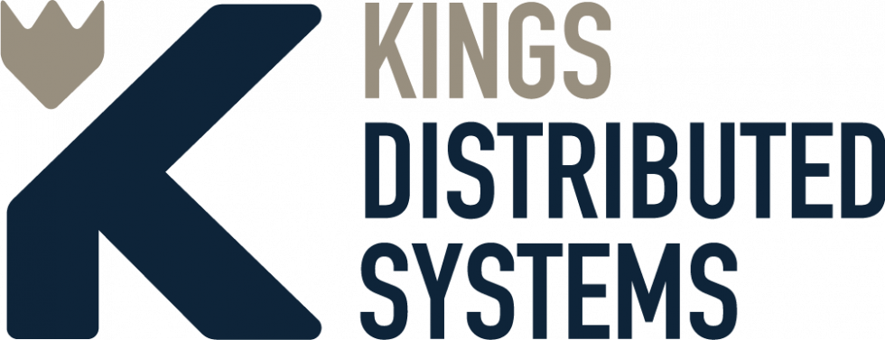
Description:
Kings Distributed Systems is a Canadian company deploying the Distributed Compute Protocol (DCP), a web platform that aggregates excess computing power from underutilized devices and digital infrastructure and makes it available to researchers and innovators. Their Compute API allows users to trivially express parallel workloads, e.g. Advanced Research Computing, AI/ML, blockchain, mathematical finance. The Protocol automatically distributes those workloads for computation.
Output:
Dynamic computing resource allocation and credit-based accounting in a digital marketplace.
Services:  Cloud Compute | EOSC providers:  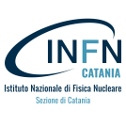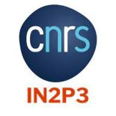

Business Pilot 10:
KAMPAL
Artificial Intelligence for rare disease diagnosis
(Health sector)
Description:
The Spanish Foundation for the Study and Treatment of Gaucher Disease and other Lysosomal Diseases (FEETEG) promotes the scientific research of Gaucher disease and its treatment methods. The Foundation was interested in predicting the probability of development of diseases such as neoplasms or Parkinson’s disease in patients of Gaucher disease (correlations between diseases). For this purpose, Kampal Data Solutions was contacted by FEETEG to develop an advanced analytical model based on Artificial Intelligence with the information available in the Gaucher Spanish Disease Registry. Kampal developed a machine learning model able to cope with big data samples by using the cloud infrastructure provided by EOSC DIH.
Output:
A validated Machine Learning model for the Gaucher diagnosis.
Services:  Cloud Compute | EOSC providers:

Business Pilot 11:
BI Insight
Business Intelligence, Artificial Intelligence and Big Data technologies
(Health sector)
Description:
BI Insight S.A. is a Polish company operating in the market since 2006. It specializes in solutions combining Business Intelligence, Artificial Intelligence and Big Data technologies as well as best practices in data management. BI Insight has many years of experience in natural language processing (NLP), closely cooperates in the field with leading academic centres and industry experts and is one of the leaders of this type of solution on the Polish market.
BI Insight has created a system enabling users to access the knowledge contained in artifacts: presentations, text documents, sheets and others. The system utilizes Natural Language Processing and Machine Learning algorithms in creating recommendations, document classification, information retrieval (both from text and images embedded in documents), as well as building intelligent summaries.
Output:
A cloud-deployed DoRIS system enabling testing by interested users or companies.
Services:  Cloud Compute, Storage | EOSC providers:

Business Pilot 12:
KNOWCO4EOSC
(R&D sector)
Description:
Knowco Collabwith is the digitalization of collaborative relationships between academia and businesses to valorise knowledge gained and created by universities and start-ups in a modern way. It is a matchmaking platform for innovation, which provides global access to a database of professors from universities and start-ups and also enables users to make requests to collaborate with each other, all while ensuring protection by following a smart legal framework. Knowco Collabwith platform is based on providing a database of registered academics, start-ups and businesses across Europe and opportunities marketplace for those who are seeking new knowledge and new technology to generate new innovations through collaborations and bring them to the market.
The aim of this pilot was to connect communities and automatically match needs and challenges with knowledge and technology in the Knowco Collabwith platform and beyond current innovation ecosystems in Europe.
Output:
Single Sign On to Collabwith Platform and integration of EOSC Marketplace.
Services:  EGI Check-in, EOSC Marketplace | EOSC providers:

Business Pilot 13:
DEIPDASFD
Decentralized Assessment of FAIR datasets
(R&D sector)
Description:
Citizen Science has incredible potential. It might bring millions of new talents all over the world to work on the toughest and the most exciting challenges of humanity. However, it is still not widely popular and lacks quality of projects. We have identified the core problem and found an ultimate solution to it. Imagine how many new discoveries we can get in all possible disciplines and domains if we increase the quality of Citizen Science projects by 10X… Sounds impossible, right? But not anymore – with the Decentralized Assessment System built by DEIP Collective Intelligence Protocol, we can not only achieve a higher level of quality, but also make it scalable. This pilot project aimed to showcase how DAS can tackle this problem and unlock full potential of Citizen Science.
Output:
An online platform for the assessment of the outputs of the citizen science projects.
Services:  Cloud Compute, Data Storage | EOSC providers:

Business Pilot 14:
ErasmusPlay
Accommodation search engine
(Housing sector)
Description:
Erasmus Play is an aggregation platform (meta-search) for international student accommodation, which brings together all the market’s offerings into a single platform, allowing students to search, compare and book accommodation with the main platforms that provide this service.
There are regional and local platforms for booking student accommodation online and Erasmus Play aims to bring into one site all accommodation available in all Europe. On one side, these online platforms are not very known to international students, and on the other hand, students have a hard time searching and comparing through the internet and all platforms out there. Over 800.000 people participate in the Erasmus+ programme and over 50% of them have serious difficulties in finding and booking their new homes.
Erasmusplay.com aimed to make their search and booking easier, faster, and safer by aggregating into its meta-searcher all available online accommodations on local trustworthy platforms. Through Erasmus Play, users can search and compare accommodations and when they are ready to book, they will be directed to the correspondent platform.
Output:
Student accommodation metasearch engine across Europe.
Services:  Consultancy on Security and Geospatial Data | EOSC providers:

Business Pilot 15:
IBISA
Crop loss assessment stress test
(Agriculture sector)
Description:
BISA’s mission is to enable agriculture insurance for agricultural entrepreneurs. We leverage technology and data to build and manage efficient, scalable, and transparent parametric insurance products worldwide and in an easy manner.
One of our key values is the innovative solution for loss assessment. For loss assessment IBISA combines the use of EO products with a “crow-watching” platform. The theory behind is that errors in individual assessment caused by partial information or bias tend to be cancelled.
The objective of this pilot project was to back test this solution to validate it faster and widely and identify points of improvement.
Output:
Satellite-based remote loss assessment for crops validation.
Services:  Consultancy on agriculture data analytics | EOSC providers:

Business Pilot 16:
BigColdTrucks
Big data analytics for cold chain logistics optimization in refrigerated trucks.
(Cold chain sector)
Description:
Data analysis to predict the demand of goods, optimise the routes in real-time and provide visualizations and descriptions.
Odin Solutions (OdinS) is a SME founded in August 2014 and accredited as an innovative ICT company (EIBT) by MINECO and ANCES. OdinS has a strong background in the R&D fields of Internet of Things, Security and Data Analytic. The pilot contributed to the development of the supply chain 4.0, specifically the cold chain, and it is aligned with the interest of OdinS to contribute to the emergence of smart environments.
Output:
A working prototype of BIGcoldTRUCKS dashboard
Services: | EOSC providers:

Business Pilot 17:
ESAX
Enhancing the Scalability of the Axyon platform
(Fintech sector)
Description:
Axyon AI is an Italian fintech start-up whose current applications are mainly focused on financial time series analysis with Machine Learning algorithms. More specifically, Axyon AI partners with financial institutions (asset managers, hedge funds, trading desks) to improve the performance and risk profiles of investment strategies.
The main objective of the pilot was to work with EOSC DIH as a proof of concept of using the EOSC infrastructure and competences to enhance the TRL of the company services.
Output:
A scalable multi-GPU multi-node machine learning platform for time series data.
Services:  High Performance Computing | EOSC providers:

Business Pilot 18:
MUON
Enhancing the Scalability of the Axyon platform
(Engineering sector)
Description:
Muon Systems is a small enterprise founded in 2015. The company develops all necessary hardware and software tools for the application of muon tomography or muography in different sectors like heavy industry, borders security or mining and civil engineering. This technique uses muons, a natural radiation generated at the atmosphere and reaching the earth surface. By studying the interaction of muons with matter, it is possible to reconstruct an image like X-ray radiography.
The objective of this pilot project was to validate by simulation the use of muography to reconstruct the complex inner structure of large industrial equipment.
Output:
A fully-functional muography simulation of a blast furnace.
Services:  High Performance Computing, Storage | EOSC providers:

A full description of the 12 ongoing pilots is covered in Annex II.

Feedback from the pilots
Once the pilots finish their experiments, the EOSC DIH invites them to complete a survey to collect the feedback on the use of the services and assess the experience working with the EOSC DIH. The majority of the 18 pilots completed the survey.
A total of 25 questions were shared via Google Forms with the main objective to understand the companies' satisfaction at technical level, business level and training level, also asking about the impact of working with the DIH on the company and the knowledge acquired in this period.
Most of the questions were yes/no format and assessment questions from 1 (Very bad) to 5 (Excellent) while some others were free text to collect their opinion about strengths and weaknesses or the recommendations.
The content of the survey is collected in the Annex III.
Insights from the surveys
“The project is much more than the use of infrastructure, it is really opening a network and connecting with relevant groups and opportunities across Europe.”
“Good communication initiatives and appreciated community”
“Well managed and structured. Work oriented”
These are some of the pilot declarations collected by the survey that show a common satisfaction in the use of the EOSC DIH services.
- EOSC-hub is perceived as a huge project, and some pilots recommended a better alignment between the EOSC DIH and the project, and to understand the service offer, benefits, and the integration of the pilot members in the overall project.
- For the second wave of the pilots, some of them considered that 6-8 months was too short of a period for running a pilot.
- The delivered infrastructure met the expectations of more than 90% respondents. The most demanded technical service was cloud computing and storage. When asking about the main strengths of the EOSC DIH, the access to infrastructure, the support and training are considered as the main strengths.
- Almost half of the answers considered that no services were necessarily missing in the DIH, while some desired a bit more automatic orchestration of resources and back up, and an integrated system to build containers.
- The communication with the supervisor was perceived as Excellent for almost 70% while the communication with the service provider was perceived as Excellent for more than 45% and 30% considered it good.
- The satisfaction with the solution provided for the experiment was 50% good and excellent while more than 40% found it acceptable. None of them were unsatisfied with the experiment.
- More than 70% considered that the training and knowledge acquired was good or excellent and only 15% respondents were not fully satisfied, while almost 60% considered that the business support received was good or very good with only 15% respondents not satisfied.
- After running the pilots, the assessment of the maturity level for cloud computing was good or excellent for more than 85% of the respondents while 70% was good or excellent for the assessment of the digital maturity level on data analytics. In the case of Artificial Intelligence, the assessment was more than 50% for good or very good while 15% respondents were not fully satisfied.
- Almost 60% of the respondents were able to reduce costs and optimize processes working with the EOSC DIH.
- Less than 30% of the respondents were able to obtain new customers this year, a situation that is understandable considering the impact of the COVID and the short period for running the pilot.
- More than 40% of the respondents fulfilled their expectations on testing new technologies and almost 70% fulfilled their expectations on opening new business opportunities.
- More than 25% of the respondents were able to learn new technologies.
- In the short time, none of the pilots were able to raise investment thanks to the EOSC DIH although at least 4 pilots have applied for external open calls suggested by EOSC DIH open calls (not all results are known, at least one was successful).
- Unfortunately, none of the pilots have significantly increased their commercial agreements. However, some of them already increased the number of positions in the company while working with the EOSC DIH. After finishing the pilot, 3 of the companies will be able to commercialize their products or services.
- More than 75% of the respondents will participate again in an initiative such as the EOSC DIH mainly because of the help to innovate in solutions, for accessing computing infrastructure for the first time and learning from the experience, for the benefits of collaborating with the EOSC community, for business development opportunities and facilitating the European level visibility, because the access to funding opportunities.
- The DIH should include digital marketing solutions and tools oriented to support fully internet-based business.

Task 9.3: Commercialization support
This task aimed to support the DIH pilots as well as Thematic Services (TS) and Competence Centres (CCs) to build successful market take-up and commercialisation boost strategies. This was to be made through tailor-made coaching, market insights and networking with investors/corporate.
The primary goals of the joint activities were to:
- Identify market/business opportunities, and create, test and implement business models
- Define exploitation plans (strategy and commercial strategy and plans)
- Analyse/evaluate IPR in collaboration and support definition of pre-commercial agreements
- Design a communication plan to exploit Pilots/CCs achievements
Based on specific identified needs, the team delivered workshops/webinars about specific topics (e.g. technology transfer, marketing and communication, business internationalisation, pitching, funding opportunities), which are also supported by WP3.

Training activities
Within the framework of the commercialisation support activities of the EOSC DIH, an assessment of interests was carried out with the competence centres, thematic services, and pilots of the EOSC-hub.
A first assessment was carried out in January 2019, resulting in 14 responses from the aforementioned partners: six replies from EOSC DIH pilots and eight replies from thematic services representatives. Despite interest from these partners, effective participation in the planned commercialisation support activities was lower than anticipated. It is considered that this is in part due to the fact that in January 2019 the pilots and thematic services were still in early stages of their activities and therefore, commercialisation support was not yet relevant.
As part of this first assessment, three webinars were organised (described below):
- Marketing and Communication (May 2019)
- Business Internationalisation (June 2019)
- Intellectual Property Rights (October 2019)
A second assessment was carried out in April 2020, resulting in 34 responses, including representatives from nine thematic services, six competence centres and eight EOSC DIH pilots (Fig.16). Following this second assessment, there was a greater participation in the commercialisation support activities, which included three webinars (described below):
- Technology Transfer Models (September 2020)
- Growth Marketing and Communication (October 2020)
- Funding for Innovation: programmes and opportunities (November 2020)
The six webinars were organised and hosted by F6S, involving external speakers with relevant experience on the topics in several of the webinars. Follow up surveys were only considered for the second round of webinars.
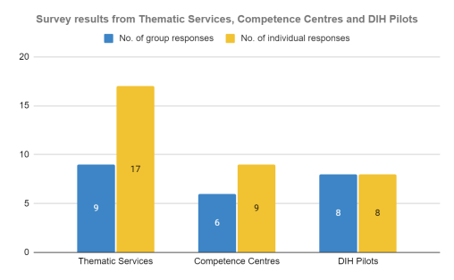
Fig.16: Survey results from the Technology Transfer Models and Funding for Innovation webinars

Webinar | Marketing and Communication (May 2019)
A webinar on Marketing and Communication was conducted on 30 May 2019. The objective of the webinar was to provide an overview of the marketing and communication landscape, building a campaign for an event or other project initiative, and provide participants with relevant resources and materials. The webinar was delivered by Maja Zikic (Communication manager and business developer at F6S).
A link to the webinar recording can be found here.
Webinar | Business Internationalisation (June 2019)
The webinar on Business Internationalisation was conducted on 18 June 2019. The objective of the webinar was to provide participants with best practices, and what to look out for when internationalising their projects. The webinar covered reasons for moving into international markets; and decisions on the how, when, and where; challenges for internationalisation; and useful tools. The webinar was delivered by Tim Brown (Head of EU projects at FastTrack VC) and was participated by two individuals.
A link to the webinar recording can be found here.
Webinar | Intellectual Property Rights (October 2019)
The webinar on Intellectual Property Rights (IPR) was conducted on 30 October 2019. The objective of the webinar was to provide participants with an overview of the fundamentals of intellectual property, the IPR roadmap, examples of IP protection, commercial exploitation for technologies, among others. The webinar was delivered by José Ricardo Aguilar (Legal Advisor at IPN) and was participated by five individuals
A link to the webinar recording can be found here.
Webinar | Technology Transfer Models (September 2020)
The webinar on technology Transfer Models (IPR) was conducted on 24 September 2020. The objective of the webinar was to provide participants with an overview and the setup of technology transfer offices, and the roles, methodologies and tools for technology transfer and innovation management. It also addressed good practices and options for exploitation and licensing. Lastly, it addressed IPR as part of a business strategy. The webinar was delivered by Jorge Pimenta (Project Manager at IPN).
This webinar was participated by 11 individuals, three from the EOSC DIH partners, seven from EOSC DIH pilots; two from the EOSC-hub thematic services; one from EOSC-hub competence centres; and one external to the project. The participants represented different industries (e.g. education, technology, software development) and roles (e.g. CEO, CIO, project managers, business development). The initial number of registrations was 15 (73% turn-up).
A follow-up survey was sent to participants, which resulted in five answers collected. The following results can be highlighted:
- Four respondents were from EOSC DIH pilots; one from a thematic service of the EOSC-hub.
- Three respondents come from SMEs; one from industry and another from academia/ universities/research centres.
- Regarding respondents’ level of experience on the topic of technology transfer models, the average score was 3.2, considering a 5-point Likert scale (1 - No experience at all; 5 - Highly experienced).
- Regarding respondents’ feedback on the relevance of the webinar contents, the average score was 4, considering a 5-point Likert scale (1 - Not at all relevant; Very relevant).
- Regarding respondents’ feedback on the relevance of the webinar contents for their ongoing/upcoming activities, the average score was 3.2, considering a 5-point Likert scale (1 - Not at all relevant; Very relevant).
- Regarding respondents’ overall satisfaction with the webinar organisation/ implementation, the average score was 4, considering a 5-point Likert scale (1 - Not at all satisfied; Very satisfied).
A link to the webinar recording can be found here.
Webinar | Growth Marketing and Communication (October 2020)
The webinar on Growth Marketing and Communication was conducted on 07 October 2020. The objective of the webinar was to help participants understand the mindset of experimentation, explore the processes of an experiment and data-driven organisation, and discover the tools that will help create a consumer-centric journey for their organisation. The webinar was delivered by Hasan Tahir (International Growth Trainer & Coach at the Growth Tribe).
This webinar was participated by seven individuals, six directly involved in the EOSC DIH, and the other a representative from one of the EOSC DIH pilots. Due to lack of external participation, no follow-up survey was sent. The initial number of registrations was 24 (29% turn up). Partners that registered and did not participate were contacted to understand the reason for not participating, but no answers were received.
Webinar | Funding for Innovation: programmes and opportunities (November 2020)
The webinar on Funding for Innovation: programmes and opportunities was held on 11 November 2020. The objective of the webinar was to provide participants with an overview of the main European instruments that support research and innovation activities. Particularly, the webinar addressed the upcoming Horizon Europe research and innovation programme, explored other European funding mechanisms, and presented some of the ongoing and upcoming open calls that fund highly innovative start-ups, SMEs, and other entities. The webinar was delivered by EOSC hub partner F6S.
This webinar was participated by 15 individuals, six from the EOSC DIH partners, four from EOSC DIH pilots, one from an EOSC-hub competence centre, and four externals to the project. These participants represent different industries/ sectors (e.g. government, technology, financial services, education). The initial number of registrations was 22 (68% turn-up).
A follow-up survey was sent to participants, which resulted in six answers collected. The following results can be highlighted:
- One respondent was from the EOSC DIH partners; one respondent from a EOSC DIH pilot; four from outside of the project.
- Four respondents come from start-ups/scale-ups; one from non-for-profit organisations; and one from an SME.
- Regarding respondents’ level of experience on the topic of funding for innovation (funding programmes/ instruments), the average score was 4, considering a 5-point Likert scale (1 - No experience at all; 5 - Highly experienced).
- Regarding respondents’ feedback on the relevance of the webinar contents, the average score was 4.7, considering a 5-point Likert scale (1 - Not at all relevant; Very relevant).
- Regarding respondents’ feedback on the relevance of the webinar contents for their ongoing/upcoming activities, the average score was 4.5, considering a 5-point Likert scale (1 - Not at all relevant; Very relevant).
- Regarding respondents’ overall satisfaction with the webinar organisation/ implementation, the average score was 4.5, considering a 5-point Likert scale (1 - Not at all satisfied; Very satisfied).
A link to the webinar recording can be found here.
Fig.17 represents a summary of the survey results collected from the Technology Transfer Models and Funding for Innovation webinars, presented individually in the previous descriptions. The numbers presented are average values for each question, based on the number of replies to each survey (five and six answers, respectively). Overall, it is considered that while the majority of respondents felt that the contents in both webinars were relevant, they are not necessarily relevant for any ongoing or upcoming activities. Furthermore, the respondents’ overall satisfaction was similar for both webinars. Note that this analysis excludes the Growth Marketing and Communication webinar due to the lack of participation.
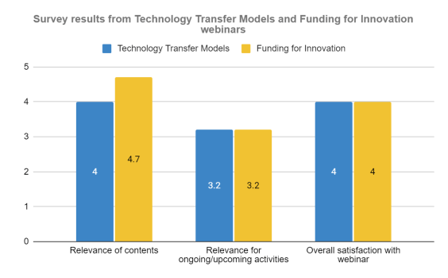
Fig.17: Survey results from Technology Transfer models and Funding for Innovation webinars
In addition to the aforementioned webinars, a one 1-to-1 meeting was requested and held with a representative of the CyberHAB pilot. The meeting focused on funding opportunities aligned with the objectives and framework of the pilot. Specifically, the meeting included a briefing of the pilot and its objectives, value proposition and target. This was followed by a discussion of different possible customers and distribution channels. The discussion then shifted towards funding, with an overview of key H2020 topics and opportunities of interest.
Overall assessment of the training activities
Despite a varying level of attendance to the webinars, it is felt that overall, these were successful and well received by those that attended (considering the results from the follow-up survey, presented above). The webinars were an important opportunity to convey relevant information and knowledge on key commercialisation topics (technology transfer, growth marketing, funding) to the EOSC DIH’s business pilots and the project’s Competence Centres (CC) and Thematic Services (TS).
In fact, there was a significant interest from the EOSC DIH in extending the webinars to representatives of the CC and TS - reason for which a second survey was carried out across the pilots, CCs, and TS - but the level of participation was not significant. Nonetheless, the webinars and presentations have been made available for consultation by the project partners and external stakeholders via the EOSC DIH website.

Pre-commercial agreements
This task was also responsible for managing the development of Pre-commercial Agreements, which outlined a Service Level Agreements (SLA) for continued support beyond the original pilot objective. These agreements between the EOSC DIH and representatives of selected pilots provide a framework for collaboration. Each PCA/SLA is structured into several articles and outlines, among others, the defined work plan, activities, communications, rights and responsibilities, and funding, among others. By the end of M39, the EOSC DIH had signed an PCA/SLA with three pilots, which also met a WP KPI:
- DataFurn (represented by Suite5 and AIDIMME)
- Guardomic (represented by KomaNord and Idego)
- ACTION Seaport (represented by Bentley)

Open call for new business pilots
An open call for new business pilots was launched in April 2020. The open call invited start-ups, SMEs, large enterprises, Digital Innovation Hubs, Competence Centres, Innovations, or small consortia (of up to 3 partners) to submit a proposal for a pilot and to receive a voucher for up to €10,000 in services (not direct funds). The awarded applicants would be required to run their pilots from 3-6 months, making use of selected services provided by the EOSC DIH.
The open call resulted in a total of 16 applications submitted: 11 from start-ups/spin-offs and five from SMEs. Applications originated from 11 different EU / associated countries.
Below is presented a description of the process that was implemented for the EOSC DIH open call for new business pilots, as illustrated in Fig.18.
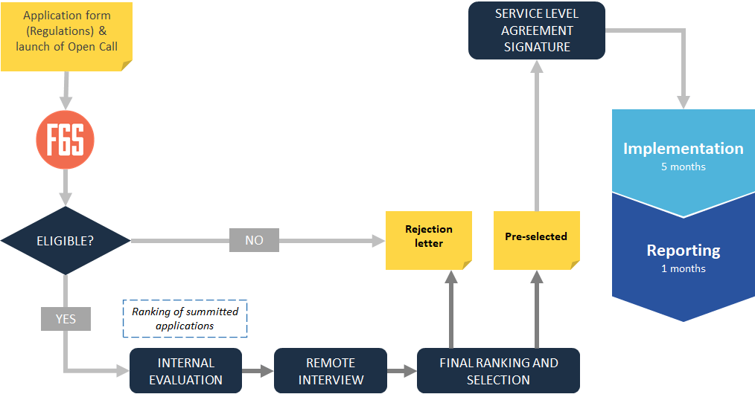
Fig.18: The EOSC DIH Open Call process
Preparation and launch
The EOSC DIH Open Call for business pilots opened on 2 April 2020 and ran until 3 May 2020 (17:00 CET). The preparation of the open call began with the definition of the scope of the open call and development of the respective documentation kit.
It was defined that the scope of the open call would be to stimulate innovation activities within private companies and to take advantage of different services offered by the DIH and public sector. To achieve this, applicants would have to submit proposals describing pilots with a duration of 3-6 months and identifying what services they would require. The documentation kit consisted of: (1) Open Call Guide for Applications, (2) Service Level Agreement template, and (3) Frequently Asked Questions (FAQ) document.
- Open Call Guide for Applicants. This document provided detailed information on the scope of the open call as well as the requirements and procedures. The document detailed what applicants would receive from the open call (i.e. voucher of up to €10.000 to be used in services), the submission and selection process, the implementation process, and other general information.
With regard to the submission procedure, all proposals had to be submitted via F6S on the EOSC DIH profile. Among other items, proposals were required to provide:
  - Pilot acronym and abstract.
  - Description of the pilot concept, objectives and novelty.
  - Description of the requested services and how they would be used in the framework of the pilot.
  - Description of the expected impact (socio-economic, market potential) and dissemination and exploitation activities.
  - Description of the consortium partners carrying out the activities.
- SLA template. The SLA template constituted the formal document to be signed between the pilot and the EOSC DIH, detailing the services to be provided by the DIH and respective rights and responsibilities between the parties.
- Frequently Asked Questions (FAQ). A FAQ document was prepared with a list of the most relevant questions that applicants could have in regard to their participation in the open call.
An open call information webinar was organised on 23 April 2020. The objective of the webinar was to provide interested participants with an overview of the EOSC DIH and respective services; information about the open call, including scope, eligibility, and requirements; an overview of some of the ongoing EOSC DIH pilots; and a Q&A session.
Evaluation and selection
The evaluation of the 16 applications began with an eligibility check, namely, to assess if the applicants were one of the eligible entity types, if the proposal was written in English, and if proposal eligibility criteria was met. As all applications were eligible, these moved on to the internal evaluation process.
The internal evaluation was managed by 10 representatives (evaluators) of the five EOSC DIH partners. Each evaluator was assigned 4 or 5 applications, ensuring that each of the 16 applications was reviewed by three evaluators. Each evaluator was given access to the applications they were responsible for, as well as an Individual Evaluation Report (IER) template they were requested to fill out for each application.
For each application, evaluators were required to score the proposal against four criteria: (1) Concept of the pilot; (2) Services and support; (3) Impact; and (4) Consortium. Bonus points were also awarded if the application met selected items. For each of these criteria, a score between 0-10 was given, and a written evaluation was provided. The final result of each criteria and overall score was the average scores received from the three evaluators.
All applications with a score of less than 6 on any criteria or 25 overall were automatically rejected. This was the case of 9 proposals, which automatically received a rejection letter explaining the reasons for their result.
The remaining 7 proposals were invited to a remote interview and requested to provide further details regarding their application. Each interview, lasting approximately 30 minutes, involved 2-3 evaluators. After each interview, the applications were scored again on a scale of 0-10, and the values were compiled to define a final score. Two of the proposals then received rejection letters, with a justification of their score, while the remaining 5 were invited to the SLA definition and signature phase.
Implementation
Following the SLA definition and signature phase, five new pilots started their collaboration with the EOSC DIH in June 2020:
- KNOWCO4EOSC: Knowco Collabwith platform integrated with the EOSC.
- IBISA: Crop loss assessment stress test.
- BIGcoldTRUCK: Big data analytics for cold chain logistics optimization in refrigerated trucks.
- Erasmus Play: Accommodation search engine.
- DEIPDASFD: Decentralized Assessment of FAIR datasets.
Full details on the activities and results of these five pilots have been provided in Annex II.

Key results and Impact assessment
Some of the key results of the EOSC DIH are also key results of the EOSC-hub project. The creation of the DIH itself is one of the Key Exploitable Results (KER) of the EOSC-hub project and is considered as a key activity to follow in the next funding project for the EOSC DIH: the EOSC Future project.
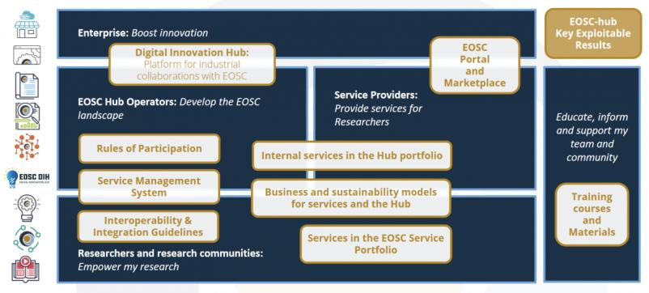
Fig.19: Map of KER of EOSC hub project
Specifically related to the EOSC DIH, the following key results can be considered:
- 18 business pilots. A wide and diverse list of business pilots and success stories from different sectors (environment, manufacturing, software simulation, blockchain, AI, logistics, housing…).
- Specific website and branding. The rebranding and independent website was the first step for sustainability after the EOSC hub project. A new image according to the EOSC portal style and more content on the website to start growing as a community.
- A platform for community interaction. A forum and several communication mechanisms allowed the EOSC DIH to create and develop its community getting a space for interacting with the companies and partnerships.
- Memorandum of Understand with a Terms of Reference for operating the DIH post-project. The EOSC DIH agreed to create an MoU and Terms of Reference to set up the basis of collaboration between the partners.
- Processes and Procedures. Design and implementation of processes and procedures to manage the onboarding of new DIH partners, community members, pilots or partnerships. The experience of the Open call is also considered a learning mechanism allowing to define future Open call procedures.
- The funding matchmaking: Information about funding opportunities were shared with the EOSC DIH community, previously matched to the activities and interests of the pilots. Multiple funding opportunities from ICT-51, EUhubs4data, REACH Incubator SMART4ALL and the NGI, such as DAPSI, ESSIF LAB, POINTER, and TRUST, were explored by the companies of the EOSC DIH community. In the words of the pilots, it was “extremely interesting the number of funding opportunities announced within the EOSC DIH” and "many of them were interesting".

Shaping the EOSC DIH future: The Sustainability Plan

Mission, Vision and value proposition
Mission
Our mission is to help companies and SMEs to integrate EOSC services and become more competitive by providing a single access point with technical support and consultancy provided by entities committed to remove the barriers between the Open Science and Industry.
Vision
EU companies are increasingly more competitive and digitised and EOSC is seen as a catalyst for more innovative and disruptive solutions with economic and societal impact.
Value Proposition
Industry requires innovation and becoming digitised to be competitive, but sometimes there is a lack of knowledge and the necessary environment to experiment. The EOSC DIH is a multi-dimensional entity that allows research e-Infrastructures to support business organisations to stimulate the innovation potential of research infrastructures, as well as helping SMEs, start-ups and other innovative actors to tap into the academic world both in accessing knowledge as well as technical services. The final goal is to create a one stop shop that brings IT services, research data, and expertise into a single place to support innovation in industry.
From the perspective of business, there is a clear need for digital services that e-infrastructures (and the service providers within them) can satisfy, in terms of not only computing and storage needs but also a set of integrated services to allow, for example, the data ingestion, management, sharing, a set of different models and algorithms that gives an added value.
The value proposition of the EOSC DIH can be summarized in 4 key areas:
- Piloting and co-design
- Technical Assets
- Consultancy and training
- Visibility-building ecosystem

The services
The EOSC DIH encompasses the following services to companies:
- Experimentation: Following the guidelines of the EC on its creation of the DIH, the EOSC DIH advocates for the “Test before investing” concept. The EOSC DIH is an environment to experiment where services or products can be designed and tested and where business pilots or proof of concepts are carried out. The EOSC DIH offers the co-design of proof of concepts and experiments, supporting companies in the process of gathering requirements, definition of the architecture, identification and selection of technical services and their technical integration. With the Platform as a Service (PaaS) and Software as a Service (SaaS) solutions, complemented with the computing and storage resources, pilots are able to be tested and performed.
- Technical Assets: The EOSC DIH helps companies and SMEs in working with data analytics, advanced modelling and simulations to address the optimal design of products, process optimization, quality improvement or decision-making support. It has a wide pull of HPC and Cloud experts to support companies accessing infrastructures and developing ML or Data analytics services to enhance their business processes. The EOSC DIH supports ML application porting to the EOSC infrastructure, implementation of best practices and prototyping of the AI enabled services, that is the most rapidly progressing technology for industry nowadays. In addition, the EOSC DIH experts on data management support companies on accessing different research data using advanced data management services and tools. For the piloting purposes, companies can also get storage capacity (online/archive). The EOSC DIH also offers the integration of solutions from our collaborators, such as the training facility for ML, AI and deep learning models by DEEP Hybrid Data Cloud Project and the MiCADO Orchestration tool by CloudSME.
- Consultancy and Training: Another main pillar of the DIH is the training on digital skills. The EOSC DIH provides SMEs with consultancy services to analyse and assess the technological-readiness and explore the IT solutions aligned with the business strategy of the companies. To support the transformation of digital skills, the DIH offers on demand technical training courses, digital business coaching and support for commercialization. Funding opportunities is also a key element to help companies in its growth. A clear landscape analysis of the funding opportunities helps SMEs to identify the best option to support the growth of their business and the EOSC DIH offers brokerage to different sources of funding.
- Community and Visibility: Cross border innovative environment to participate, widening the visibility of the business through media exposure, participation in not only EOSC related events, but also in industry and ICT fairs, providing digital and promotional material. The EOSC DIH offers the inclusion of the company solutions in the EOSC Marketplace, which can enhance the business networking and opportunities.

The EOSC DIH ecosystem

The EOSC DIH community and stakeholders
The EOSC DIH ecosystem is built by the EOSC DIH community and the stakeholders or entities with interest or relevant influence in the execution of the EOSC DIH activities. The following figure shows the map of these entities.
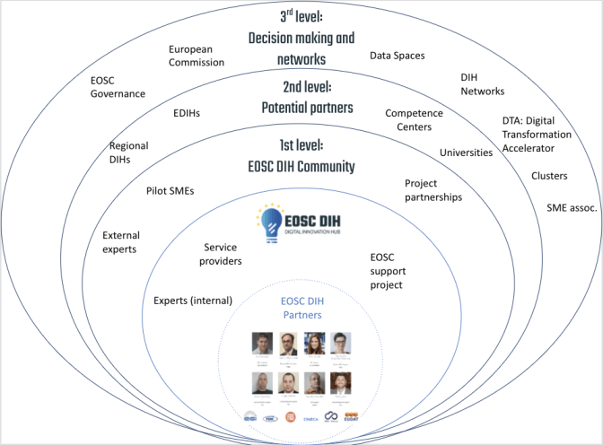
Fig.20: The EOSC Community and Stakeholders map
- Zero level: EOSC DIH. The people, entities and projects that allow the EOSC DIH to work. This core level includes the main EOSC DIH partners (mainly starting with those entities with effort in WP9 of the EOSC-hub project), other internal experts and service provider members. Will be expanded by those agreeing to the Terms of Reference.
- 1st level: Members of the community. Includes the running pilots, the experts offering services to the pilots and the partnerships that participate in the regular activities and meetings that the EOSC DIH organises.
- 2nd level: Potential partners. Includes the companies or entities that could participate by providing or consuming the services of the EOSC DIH.
- 3rd level: Decision making and networks. These include the policy making entities and DIH networks that support mechanisms for implementing the activities, existing and future.
Based on the influence and interest that these entities have in the EOSC DIH, an importance/influence matrix is created and proposed below. The proposed map follows a template retrieved from the JISC website and helps to identify specific engagement strategies for each area.
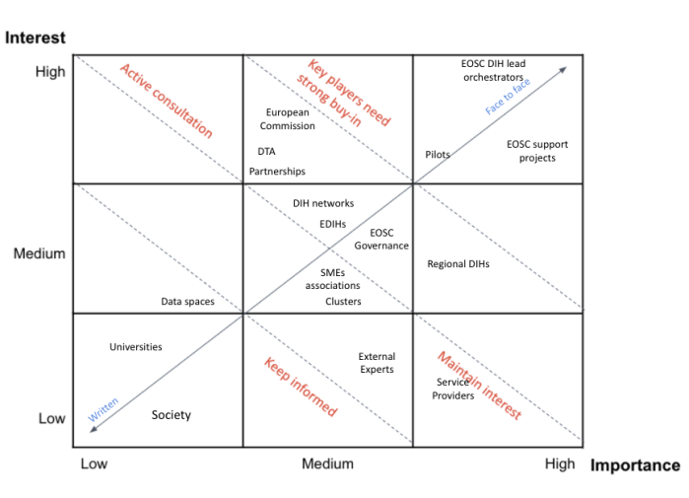
Fig.21: The importance/influence matrix for the EOSC DIH stakeholders

Community sustainability
Keeping an engaged community in an organization such as a DIH is one of the main pillars for long-term sustainability. An engaged and active community maintains the spirit of the DIHs as real hubs for innovation and co-creation while remembering the management and technical members the real needs of the industry.
The EOSC DIH intended to create a space where multiple types of companies and stakeholders could live together with different levels of participation and engagement. A series of workshops (Innovation community, Innovation ecosystem, Innovation Leadership, Collaboration Journey) were organised with the support of the KNOWCO Collabwith pilot, which helped the EOSC DIH members in the design of the community building strategy for a sustainable DIH in the future. Some of the key insights from the workshops rely on the need of a community activation, making the people participate and visible, generating a space of trust and defining the rules and a clear innovation value chain.
One of the first outcomes of the workshops was the identification of the EOSC DIH community. The community map described in section 3.3 represents the companies, entities, projects, networks and associations that interact or influence the daily work of the EOSC DIH distributed in 4 levels: the EOSC DIH itself, the EOSC DIH community, the potential partners and the governance (decision makers and networks). For those levels of stakeholders, there are different phases to consider when creating a community and can be summarised as follows:
- People: Keep the community full of people, if we do not have them, how are we going to look for them?
- Engagement: How are our people going to be engaged? How will we communicate with them?
- Interaction: How does the EOSC DIH facilitate interaction between the members and create collaborations?
- Value: How does the community share knowledge and support each other?
- Impact: How do we facilitate our community and can create innovation through collaborations and bring ideas into the market?

The following table summarizes the use of these schemes on How to facilitate the community dynamics applied to the EOSC DIH considering the different levels of engagement.
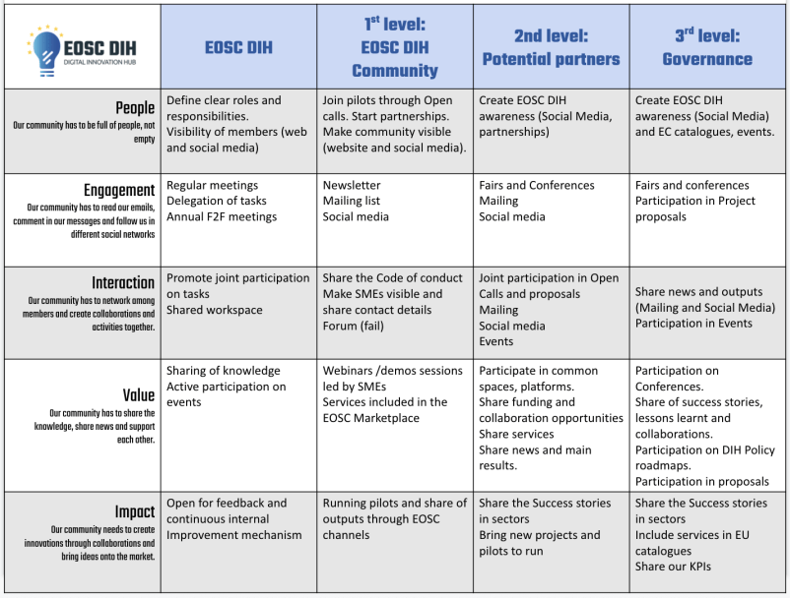
Fig.22: How to facilitate community dynamics table
To guarantee the active involvement of the members of the community in the EOSC DIH a Code of Conduct was created. It is expected that these rules would help companies to feel and perceive the EOSC DIH as a safe place for sharing the ideas, doubts and knowledge. The objective is to make people more empathetic, support members to actively listen to each other and to care about what others are saying; to help people to focus on positive interactions to generate positive energy, being nice, kind and caring to each other; to help to build relationships among ecosystem members. This code of conduct is public on the EOSC DIH website under the Community section and will be regularly shared among the EOSC DIH social media channels.

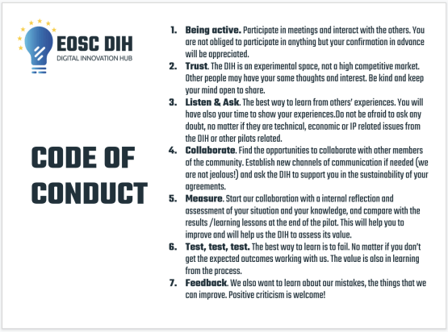
Fig.23: Code of conduct for the EOSC DIH
Finally, the Digital Value Chain scheme intends to represent the innovation process when launching a pilot or running an innovative experiment during the different phases - Design- > Test -> Train -> Grow - with the main actions to cover and the role of actors in them. The Digital Value Chain helps the community to understand the full and overall process of participating in the EOSC DIH and the support that the EOSC DIH members offer along the process.
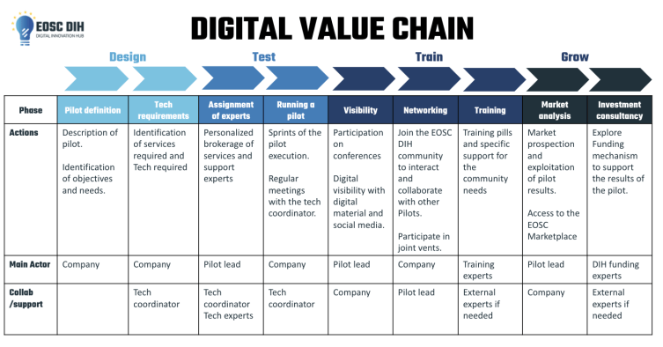
Fig.24: The Digital Value Chain

The SWOT and PEST analysis
The SWOT (strengths, weaknesses, opportunities, and threats) and PEST analysis (political, economic, societal and technological) are typically used for determining the context and the factors that influence a business or a project. While the SWOT analysis is focused on internal and external factors, the PEST analysis only considers the external factors.
The SWOT analysis for the EOSC DIH is presented as follows:
SWOT analysis
Strengths | Weaknesses
- Wide network of infrastructure resources  - Strong skills on advanced computing and data services  - Founding Partners well connected to EOSC  - In kind effort from partners and projects  - Connections with other Digital European Hubs across Europe  - Broad range of services available (Piloting, Technical support, Training and Visibility) | - Limited eligibility as a European Digital Innovation Hubs (EDIH).  - Distributed partners increase overhead.  - Lack of direct involvement of regional clusters  - Missing an automated link between EOSC DIH and EOSC Marketplace.  - Complexity of EOSC ecosystem and evolving state
Opportunities | Threats
- Financial support from EOSC related projects (EOSC Future)  - EDIH corridors to boost the collaboration with other DIH in Europe  - Strong support and promotion of the innovation activities in the different regions by governments, which can help in the engagement with regional Industry  - Increasing support from Universities and research entities to promote the Industry collaboration  - Visible interest in the DIH from external organisations, can be onboarded and increase the DIH value and offering  - Participation of other organisations, directly or indirectly (e.g. incubators, P2P investments, business angels), could increase relevance and position of the DIH | - Multiple initiatives and innovation support opportunities may cause competition to involve SMEs in this DIH  - SMEs fear to risk innovating in an unpredictable economic situation  - Distribution of efforts on Industry collaboration among the EOSC  - Lack of specific funding opportunities and/or capacity to attract funding to finance the DIH’s activities
The PEST analysis for the DIH covers the external political, economic, societal and technological factors at a European scale that could affect the work of the EOSC DIH and the achievement of its objectives.

PEST analysis
Political | Economic
- EC shifting DIH focus on a national/regional.  - EOSC governance is evolving with a number of different structures and the need to coordinate.  - Regional governments need incentives to participate in EU level activities.  - The Digital Single Market is the main EC initiative to share and boost the competitiveness of Europe by boosting the cross-border cooperation and transactions.  - Digital development is deployed at different speeds in Europe.  - EU high interest on AI, HPC and cybersecurity to compete with main actors (USA, China) | - The EC has a clear position on supporting the DIHs. The Digital Europe Programme is the main mechanism to fund EDIHs in addition to Coordination and Support Actions.  - The COVID breakout and lockdown had a high impact in the economy of SMEs.  - Funding and overall business model required to support the running and expanding of the EOSC DIH itself.
Social | Technological
- Digital natives already in the workforce.  - SMEs slow adoption of new technologies with a lack of digital skills.  - Society compromised with science and digitisation. | - Increase of commodity technologies forces shift value added services.  - Maturity and ease of use of EOSC services required to meet industry needs.  - Deluge of EOSC services requiring high levels of filtering.

Business Model Canvas
The Business Model Canvas is a strategic management template used for developing new business models and documenting existing ones. It offers a visual chart with elements describing an entity or product's value proposition, infrastructure, customers, and finances, assisting businesses to align their activities by illustrating potential trade-offs.
The Business Model Canvas for the EOSC DIH identifies 4 different types of value propositions represented by colours and aligned with the different customer segments. The customer relationships, key activities, key resources and cost structure also follows the colour assignment, while the notes in yellow are common for the overall proposal.
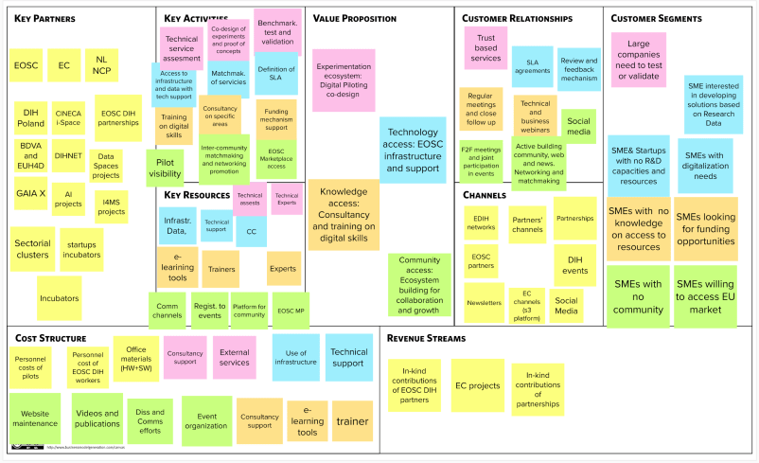
Fig.25: The EOSC DIH Business Model Canvas

Financial sustainability
Financial sustainability describes the ability of the EOSC DIH to survive financially in the long term, and therefore it is necessary to identify what kind of funding sources or revenue streams will be used to make sure the EOSC DIH can sustain its cost structure.
The current financial model of the EOSC DIH was based on the direct funding of the EOSC-hub project. The main activities of the EOSC DIH were covered by WP9 with a total of 248 PM, 116.5 PM of them dedicated to the coordination and execution of the 3 main tasks while, the rest of the 131.5PM went to the funding for personnel costs of the initial 6 pilots and the 9 companies involved in them.
In addition to this budget to cover the direct costs of the people involved in the setup, development and support of the EOSC DIH activities, €100.000 were allocated to fund the service providers for supporting the second wave of pilots (restricted to project consortium members), covering the use of services they needed to experiment in the DIH.
There are also some in-kind contributions of the EOSC DIH partners to cover indirect costs such as office materials, support on communication activities or event organization as well as external contributors from the partnerships that contribute to the support of the projects, such as the partnership with CloudSME or the Deep-Hybrid-DataCloud project.
For the next years, the financial sustainability of the EOSC DIH is going to be based in the funding of the EOSC Future project (under negotiation) that will allow to support the upcoming activities, including new open calls for pilots and ultimately allow the EOSC DIH to fully mature and time to develop where a separate financial business model can be established (i.e. membership fee). However, there are opportunities for in-kind support that will be provided by new partners joining the EOSC DIH from other projects and initiatives such as the EUHubs4Data project or those agreeing to the Terms of References bringing their own funding support that will help augment the overall effort required to continue to grow the DIH.

Organization and legal sustainability
The organization and legal sustainability of the EOSC DIH is collected in the EOSC DIH Memorandum of Understand (MoU) including a Terms of Reference (ToR) and intends to ensure that all current and future activities related to the EOSC DIH are understood by all, have policies, processes and procedures in place for managing the DIH including voting, usage rights, meetings and the addition and removal of members.
The EOSC DIH MoU/ToR is available in Annex V.

Lessons learnt and recommendations for other DIHs
After 3 years of working on the setup, development and evolution of the EOSC DIH, there are several lessons learnt that can be seen from both the EOSC perspective and the wider DIH environment.
From the EOSC perspective
- The EOSC is still a moving target, a quite complex initiative and both characteristics do not help in the EOSC DIH development and its alignment.
- The EOSC and the European Project related terminology oftentimes is not clear or easily understood for anyone external to the ecosystem.
- Industry has high requirements and expectations about the availability/reliability of the services and resources and sometimes the EOSC DIH is not able to fulfil them. The frequent comparison between EOSC with commercial offers and services shows the lack of visibility of the EOSC or knowledge about it.
- The EOSC needs to scale in operation, processes and procedures not only within the DIH, but also how it connects to the wider EOSC community for the services and expertise are required.
From the DIH perspective
- The EOSC DIH has a significant human component
  - When working with and orienting SMEs toward the research landscape, there is the need to learn/adjust the tasks to how things work in academia.
  - The distributed resources and the diverse innovators and their added value services means the DIH must deal with multiple challenges.
    - Going from 6 to 18 pilots is not about just better marketing/dissemination, it requires full commitment and strong coordination and communication.
    - How to quickly organize support and find expertise needed, especially when each pilot has different support requirements.
- The EOSC DIH has an EU network approach, rather than a regional focus.
  - The EOSC DIH is sector agnostic and region agnostic, which implies wide opportunities to collaborate in the EDIH corridors, but not able to be recognised by any member state as an EDIH.
  - The European DIHs community evaluates the impact of the different DIHs in a quantitative way (e.g., number of new employees, rise in the benefits, new patents generated working with the DIH) with very high expectations that SMEs and start-ups are far to reach.
- Open calls for pilot activities are a good opportunity to mobilise different types of organisations working on a variety of topics/ domains.
  - However, equity-free financial support is more appealing to the business community, and a voucher-based access to services/support (as done in the EOSC DIH open call) can attract interest, there is still a requirement for the services themselves to be clearly funded.
  - This type of initiative will normally generate significant interest in the business community and is a relevant activity to generate broader awareness about the DIH.
  - Onboarding stakeholders through open calls will engage these actors over a longer period of time, which can help foster a greater participation in the community.
- The evaluation of available platforms for collaboration in the DIH was done in the beginning of the project, to reuse available platforms. Several of the available solutions to be reused were too heavy or did not really address the user's potential expectations. DIHWARE, a tool developed by Engineering was investigated; however, due to high maintenance and license costs and a very low user experience and usability, its adoption was dropped. The use of a simpler own solution based on WordPress was agreed. It gives a channel for automatic notification about most important information to users and does not introduce additional overhead.
- The first-round projects were supported by the project, with direct funding to cover the experiment costs while the second round only were offered with in kind support. These differences, in addition to the different sectors and technologies covered, meant the inability to define clear standards / KPIs and the baseline for the assessment of the impact. Other DIHs or initiatives related to DIHs, most of them with sector and regional focus, suggested heterogeneous impacts assessment indicators, not clearly suitable for the type of experiments supported by the EOSC DIH.

With these lessons learnt and based on the experience of the last years working in the EOSC-hub project, the EOSC DIH is in the position of sharing the following recommendations:

Recommendations for EOSC ecosystem:
- The EOSC offerings for collaboration with the private sector should be clear with precise information about the access and usage or the process for the integration of services in order to be more directly linked to the EOSC DIH offering. A friendly user experience should be required into the rules to become providers.
- Agreements with pilots (i.e., SLAs) should take into account the availability of specialized support in order to be realistic, as sometimes this can take longer than expected causing mismatch with expectations of the pilots, as well as the timeline for the execution of a pilot.
- After 3 years of the project and with the forthcoming EOSC Future project, the EOSC DIH is being consolidated and should be considered the main interface between EOSC and industry.
- There should be some add on in the procedure for onboarding pilots coming from the EOSC portal, which should be initially validated by DIH partners, at least the initial evaluation for the pilot labelled as EOSC DIH should be more automatic.
- The EOSC DIH should be widely disseminated as an exploitation channel in new initiatives and projects. It is an initiative open for new partners and partnerships and more explicitly mentioned in high-level EOSC documentation.
- Accessing explicit data required by pilots should be an area of improvement moving forward e.g. data provider agreements.

Recommendations for the DIH ecosystem:
- Building a community is one of the hardest processes in the creation of a DIH. The use of a platform/forum for the interaction between partners requires a lot of effort for keeping the people engaged. Consider available tools to keep the community active and engaged (e.g., slack) and avoid starting from scratch.
- Start small and focused. Define clear procedures for the internal organization and the procedures for running pilots. The management of multiple parallel experiments requires much human effort.
- Open calls are a good instrument to engage with industry and other stakeholders, but also require joint cooperation for the legal, technical and financial departments.
- It is fundamental to have metrics and KPIs defined at the beginning of any pilot as introducing new metrics or KPIs once the pilot is running or at the end proves too difficult or impossible to measure. In addition, current impact assessments being carried out by external agencies or initiatives vary too greatly and do not seem applicable to small, short-term pilots. Input from DIHs will be important to evolve towards more standardize impact measurements.

Conclusions
The EOSC-hub WP9 ultimately created a Digital Innovation Hub that is positioned to be the mechanism for business organisations (e.g. start-ups, SMEs, large enterprises) to directly engage the European Open Science Cloud beyond the life of the project. The initial set of service offers were expanded via strategic partnerships, such as with DEEP-Hybrid Cloud and will only grow as formal connections are made with the EOSC Marketplace mature.
The DIH expanded upon the initial 6 business pilots that helped to kickstart activities reaching a total of 18 pilots ran during the project, a number greatly exceeding expectations. New business pilots also took advantage of a wider set of EOSC services beyond infrastructure-as-a-service.
Not only did WP9, via the creation, operation and evolution of the DIH, directly contribute to project objectives, it was also recognized as a project key exploitable result as well as included in the EC DIH catalogue.
Partners were active in both event organisation and participation as well as running dedicated webinars on community gathered topics of interest, totalling around 30 events. This included sessions within EOSC flagship events, where business pilots were also present having won best demos and posters. 2 success story publications were produced and technical meetings within pilots transitioned into community wide meetings.
Partnerships with other initiatives, projects and regional DIHs were also sought as an additional means of both dissemination and achieving a multiplier effect such as the flagship DIH coordination project DIHnet, Deep-Hybrid-DataCloud for augmenting the EOSC DIH service offering with machine learning services, OpenAIRE for data services, EOSC-Synergy for regional connections, amongst others.
Long-term measures were put in place for the DIH to live beyond the life of the project and to be the single, future mechanism for industry to engage with the European Open Science Cloud. In addition to the branding and dedicated online presence, a formal Terms of Reference was drafted outlining how the DIH would continue to operate outside of any single project as a number of initiatives will continue to the short-to-medium term (i.e., EOSC Future, EUHubs4Data, EGI-ACE).
As the DIH matures into the future with initial support from projects and organisation in-kind contributions, further monetary business models will be explored.
Overall, it was the commitment of the project partners that allowed to achieve what should be considered a successful outcome of the project.

ANNEX I. Onboarding new pilot procedure
Step | Resp. | Action
1 | WP9 Leaders | If via business@eosc-hub.eu or website, contact form:  In order to avoid having a single point of failure or multiple team members replying, it was agreed during a WP9 bi-weekly meeting to first agree via the dedicated WP9 group on Skype for who would be the best person or at least an available person to reply.  A starter email template is available to facilitate anyone who will need to reply, feeling free to adapt to personal preferences.  If from informal discussions, contact WP9 Manager to decide who will be the Pilot Contact Lead.  If from internal discussions with a clear Pilot Contact Lead, then skip to Step 2.
2 | Pilot Contact Lead | Sets up call to discuss further details:  Requested services, potential timelines  Technical requirement specification as much as possible
3 | Pilot Contact Lead | Inserts details in the "Use Case Requirements and Offer Collection" tab of the EOSC DIH Budget Google Spreadsheet
4 | Pilot Contact Lead | Prepares a "Call for Service Offers" to be sent to the relevant EOSC-hub service provider contacts.  As there is currently no single mailing list that can reach these contacts, the relevant contact list is between the WP9 partners and the pilot contact lead  Draft email template available.
5 | Pilot Contact Lead | Collects all service offers  Inserts details in the "Use Case Requirements and Offer Collection" tab of the EOSC DIH Budget Google Spreadsheet
6 | WP9 Leaders | Review’s service offers and selects the best candidate using the following criteria:  - Services and technical components matching the request requirements  - Availability and reliability  - How many other pilots have the providers already supported (spread opportunities)  - Costs
7 | WP9 Manager | Approves costs  Updates "Financial Summary " tab of the EOSC DIH Budget Google Spreadsheet
8 | Pilot Contact Lead | Informs all contacts individually:  - Provider(s) selected  - Provider(s) not selected along with a brief rationale
9 | WP9 Manager | Informs the EOSC-hub Project Office at eosc-hub-po@mailman.egi.eu that a new entry has been made to the EOSC DIH Budget Google Spreadsheet with the following information:  - Use Case Name  - EOSC-hub Service Provider(s)  - Total cost/PMs  - Start date of the activity  - Duration of the activity
10 | EOSC-hub Project Office | Confirms eligibility  Adds EOSC-hub Service Provider(s) to WP9.2.1 subtask for being able to claim effort within the project
11 | Pilot Contact Lead | Call with service providers to check the agreement clauses regarding joint IPR (not required for pilots only accessing to computing service).  Prepares and finalizes the agreement between EOSC DIH and the pilot partner. Depending on the agreement and the requirements of the pilot partner, this can be in the form of:  - MoU (template);  - Collaboration Agreement (template);  - SLA (Template);  - Other  *Important that the activities are defined and agreed for clarity of work to be carried out for the pilot itself, publication on the EOSC-hub website, promotion and reporting  If the service levels are not part of any of the above-mentioned agreements, then: OLA (template) between EOSC DIH and the Service Provider should be defined
12 | Pilot Contact Lead | Coordinates Pilot  Involves relevant personnel  Communicates to WP9 Manager related to any issues  Seeks approval from WP9 Manager prior to promising any additional budget to the given pilot
13 | Pilot Contact Lead | Informs the WP9 Manager that the pilot has concluded  Provides a report of overall pilot activities, major outcomes, etc.
14 | WP9 Manager | Updates the "Financial Summary " tab of the EOSC DIH Budget Google Spreadsheet with the final technical services provided and financial figures  Coordinates with WP3 for relevant communication and dissemination activities  Informs the EOSC-hub Project Office at eosc-hub-po@mailman.egi.eu that a pilot has been concluded, specifying the individual Pilot.
15 | EOSC-hub Project Office | Ensures all final administration updates are made

ANNEX II. Business Pilot Detailed Descriptions
BBC
Brief description
The video coding team within BBC R&D focuses on multiple aspects of video technology, with the general goal of supporting the delivery of high-quality content to all BBC audiences. In addition to performing core fundamental research on video compression standards, the video coding team is researching new, advanced ways of performing compression based on machine learning, artificial intelligence and content analytics, while also applying our findings to enable new content experiences.
Partners
BBC R&D https://www.bbc.co.uk/programmes/p015c5qy
Challenge
Audiences are consuming more and more video, demanding increasingly higher quality, using a variety of devices including TVs, smartphones, tablets and computers. This is why video compression standards are needed, which allow compressed content to be distributed and then decoded by anyone – ready to be displayed on the device of choice.
In this context, research is supported by H2020 Marie Sklodowska-Curie ETN grant JOLT and UK’s EPSRC iCASE grants where researchers are also enrolled to PhD programmes at Dublin City University and Queen Mary University of London. To enable their research, access to adequate computational facilities is needed.
The use of large-scale processing resources have the capabilities to transform how content providers obtain, produce, and deliver content in challenging scenarios. A move away from expensive bespoke broadcast specific facilities and hardware to more commoditised scalable-cloud based resources will enable providers to more efficiently manage its content compared to what has traditionally been achievable.
Achievements
Activities were still ongoing by project end due to delays resulting from the pandemic and the change of internal priorities by BBC R&D. Though the tasks had not yet been completed, project members gained experience in formalizing agreements with large enterprise and were able to provision the initial infrastructure based on technical requirements analysis and support.
NetService: Blockchain for university certificates
Brief description
The aim of the pilot is to address the possibility for public institutions to issue valid official documents in a digital form, on the blockchain. The proposed architecture is based on a permissioned blockchain (Ethereum Proof of Authority, or similar). This blockchain can be obtained, at project level and possibly within a commercial version of the product, via an authentication service from a Certification Authority of the EUTSL list, or the AAI service provided by EOSC-hub project such as Check-In or B2Access. The pilot will look to demonstrate that the solution can be deployed on a federated infrastructure such as the EOSC along with cloud service support.
Partners
NetService https://www.netservice.eu/en/home
Challenge
Original records can be manipulated and falsified by officials or black-market forgers. It is also not difficult in most cases to create realistic looking replicas of official documents which contain false information.
The major challenge is that a paper-based document is used to transmit some kind of information and identity to the bearer. Because these documents are easy to forge or can be based on real, but stolen documents, they convey significant privileges to the bearer with only a small risk of exposure.
In a blockchain-based system, paper-based documents are replaced with digital documents on an immutable ledger. The immutable nature of the blockchain means that these digital documents are impossible to duplicate or forge because there is only a unique, single record.
Achievements
Activities were still ongoing by project end due to delays resulting from the pandemic and the change of internal priorities. To date, 2 of the 4 planned phases were carried out in terms of investigating the EOSC-hub AAI integration with blockchain and accessing a cloud environment via multiple providers to evaluate federated capabilities.

DCP: Dynamic resource allocation and accounting in a digital marketplace
Brief description
Federated digital research infrastructure initiatives such as EOSC and Compute Canada are struggling to keep up with demand due to an explosion of AI/ML, big data, and heavy research computing. Issues in cross-border resource provisioning and remittance further frustrate these efforts. Meanwhile, commercial cloud is a large expense for enterprises, unaffordable for smaller researchers, and significant constraint on the pace of innovation.
Kings Distributed Systems’ mission is to unlock abundant, affordable, and easy to use computing power by recapturing spare capacity in servers and devices on university campuses, in data centres, government buildings, and enterprise facilities. Its solution, the Distributed Compute Protocol (DCP), is a web-based computing framework that streamlines edge network setup and workload deployment. DCP dynamically characterizes computing workloads, meters resource consumption, and uses fungible “computing credits” to report on individual user consumption.
EOSC data centres in Italy (Catania) and France (Strasbourg), and CENGN data centres in Canada (Toronto, Ottawa, Waterloo) simultaneously ran the DCP Worker. The DCP Workers executed research computing tasks from an epidemiology researcher, returned the results, and received “computing credits” proportional to the computing resources provided.
Partners
Distributed Compute Labs https://distributed.computer/
Kings Distributed Systems https://kingsds.network/
Challenge
To address the challenge of providing researchers with sufficient and cost-effective computing resources, Kings Distributed Systems is deploying the Distributed Compute Protocol (DCP), a cross-platform solution that aggregates computing resources from arbitrary devices and digital infrastructure － from smartphones to enterprise servers － and makes it available to researchers and innovators on-demand. DCP would allow both individual institutions as well as federated infrastructures, such as the EOSC, to recapture and allocate underutilized resources, while providing a credit-based accounting system to quantify usage of processing, bandwidth, and storage resources-
The company holds the vision that the Distributed Compute Protocol becomes the multi-platform standard for distributed and edge computing. Kings Distributed Systems is facilitating access to limitless computing resources to accelerate science, innovation and discovery. Overall, this pilot aims to not only test, but showcase the applicability and value of such a solution for the European Open Science Cloud.
Achievements
A researcher’s disease modelling job that would have taken 34 days on a single computer only took 3.9 hrs using DCP on EOSC and CENGN infrastructure. Furthermore, the researcher only needed 5 lines of code to go from running their job on one computer to deploying it across 1000. The simplicity of the tool is a major advantage for researchers.
We were able to collect performance metrics from the Workers and from the DCP Scheduler while under load. These metrics helped identify bottlenecks in the system design. Those bottlenecks have now been addressed and the DCP Scheduler can now handle 150,000 connected nodes, and these new Schedulers can be scaled horizontally to accommodate millions of connected Workers. We are hoping to benchmark the new Worker and Scheduler redesign on EOSC infrastructure to see how it compares to previous performance metrics.
How they used EOSC-hub services
We provided a DCP Worker Debian package that was deployed at two locations: 8 CPU cores at Catalonia, Italy, and 8 CPU cores in Strasburg, France. EOSC staff deployed the workers, configured the “compute credit” payment accounts, and monitored credit balances and resource utilization. Feedback on performance and ease-of-use was provided throughout. We look forward to testing the next iteration of the platform with EOSC staff and infrastructure.

The value proposal
The Distributed Compute Protocol streamlines massive and cheap computing. DCP eliminates the complexity of configuring environments, version control, dependency management, resource allocation, and accounting. Clients can leverage DCP to lower their cloud computing spend and to accelerate prototyping and discovery.
How EOSC-hub helped
EOSC-HUB helped in both direct and indirect ways. Directly, EOSC-HUB provided a testbed and IT support to deploy and benchmark our solution. Performance metrics and user feedback from these tests played a central role in helping us redesign certain components of our software solution, leading to 100x improvement in performance. Indirectly, our work with EOSC-HUB provided a positive credibility signal, allowing us to attract paid pilots and investment. We are very grateful to EOSC-HUB, and certainly hope to keep working with them.
Dissemination activities
Built out our higher education outreach strategies and documentation Including: Platform Whitepaper, Higher Education Information Security Assessment, Information Security and Technology Stack Overview, Informational Pitch Documentation (decks, info pamphlets), Onboarding Procedures, MOUs, Operational Overviews, Installation Documents
Preparation of an EOSC-DIH pilot poster and presentation for several events.
https://www.soscip.org/kds-dcl-the-future-of-distributed-computing-in-canada/
Exploitation and commercialization plans/strategy and future plans
Our near-term consists of the intermediate objectives described in Phases I and II. Phase I principally consists in releasing the Public DCP Network MVP, collecting user uptake, churn, and revenue metrics, and executing three high-touch enterprise projects on Private DCP Networks to open key verticals (medical, smart manufacturing, and smart logistics). Phase II will have been achieved when we can claim USD $8.0M in annual recurring revenue from a combination of Private DCP Network (license fees) and Public DCP Network (brokerage fees) activity. The main effort will shift from the core function to that of the toolchains function towards the end of Phase I. Our addressable market will increase as we expand—and mobilize our community to expand– our DCP toolchains, attracting even more clients to the DCP network (such as MATLAB-DCP and blender-DCP interfaces).
Kampal: Artificial Intelligence for rare disease diagnosis
Brief description
The Spanish Foundation for the Study and Treatment of Gaucher Disease and other Lysosomal Diseases (FEETEG) promotes the scientific research of Gaucher disease and its treatment methods. The Foundation is interested in predicting the probability of development of diseases such as neoplasms or Parkinson’s disease in patients of Gaucher disease (correlations between diseases). For this purpose, Kampal Data Solutions was contacted by FEETEG to develop an advanced analytical model based on Artificial Intelligence with the information available in the Gaucher Spanish Disease Registry.
Partners
Kampal Data Solutions https://www.kampal.com/
Challenge
Due to the fact that Gaucher disease is a rare disease with few national registries, the computational power of a local computer for the study of correlations with other diseases was enough to analyse the data collected.
The challenge was to generate a new model able to predict if a person has the probability of developing Gaucher disease. In this case, the AI model must include not only data from current Gaucher disease patients but also data from healthy patients. Opening our sample universe also to healthy patients exponentially increases the sample size (from hundreds to millions) and potentially the model’s complexity. This implies the need for advanced computational resources such as the cloud platform provided by EOSC.
Although this proof of concept is focused in Gaucher disease, the developed solution could be adapted in the future to other diseases databases. The obtained general-purpose solution will be exploited by Kampal Data Solutions in the mid-term.
Achievements
Kampal Data Solutions has developed a machine learning model able to cope with big data samples by using the cloud infrastructure provided by EOSC DIH. The case study was based on a medical data set provided by the FEETEG containing information of patients with Gaucher’s disease. In addition, extra data was generated following what the current literature considers normal values. This way allowed the company to obtain a big data sample that loosely resembles the natural proportion of patients with Gaucher Disease. To be able to handle the problem size increment the parallelization of the code was required, benefiting from cloud computing.
How they used EOSC-hub services
The pilot required extra computational resources to cope with the problem size (1 million samples). For that, Kampal Data Solutions got benefit from the EOSC DIH cloud infrastructure where 16 VCPUs with 32GB of RAM were used. To speed up the process and benefit from all the cores, the code was parallelized. This way, different operations can be done simultaneously on each core using only a fraction on the sequential computational time. The parallelization of the code was greatly simplified by using the R packages parallel and dplyr.
The value proposal
Although the obtained results do not have medical value, this proof of concept shows that the chosen model is scalable and could be efficiently applied to other conditions or illnesses where more data is available. The challenge now will be to identify the business opportunities to exploit the model.
How EOSC-hub helped
EOSC-hub has provided Kampal Data Solutions with powerful cloud infrastructure to support the scaled-up analytics required for validating the proof of concept. Using the computing power of the EOSC-hub services, Kampal Data Solutions could experiment and test its new models for the disease prediction.
The technical support provided from the EOSC DIH team helped Kampal Data Solutions to access and manage the Cloud and provide the company with a better understanding of the EOSC computing infrastructure, meanwhile the visibility service enhanced the exposure of the pilot through different European communities.

Dissemination activities
Kampal contributed to the dissemination of the pilot through social media (Twitter) with the acknowledgement to the EOSC DIH for its support in the service provisioning of cloud compute for the validation of the Machine Learning model for the Gaucher diagnosis.
Exploitation and commercialization plans/strategy and future plans
The validated model is expected to be reused to be adapted and applied to similar diseases. Kampal will open new contacts with other health associations.
BI Insight: Business Intelligence, Artificial Intelligence and Big Data technologies
Brief description
BI Insight S.A. is a Polish company operating in the market since 2006. It specializes in solutions combining Business Intelligence, Artificial Intelligence and Big Data technologies as well as best practices in data management. BI Insight has many years of experience in natural language processing (NLP), closely cooperates in the field with leading academic centres and industry experts and is one of the leaders of this type of solution on the Polish market.
BI Insight has created a system enabling users to access the knowledge contained in artifacts: presentations, text documents, sheets and others. The system utilizes Natural Language Processing and Machine Learning algorithms in creating recommendations, document classification, information retrieval (both from text and images embedded in documents), as well as building intelligent summaries.
The bi ECM system won the first prize in the GOVTECH 2019 competition and became a finalist of the IT Future Awards 2019 competition and has been successfully implemented at the Ministry of Development and is used there by about 150 users.
Partners
BI-Insight https://www.biinsight.pl/pl/
Challenge
The growing resources of all kinds of electronic documents, especially in large organizations, government institutions and administration, lead to the search for effective methods of working with such documents, their quick search, classification and full use of the information contained therein. To meet the challenge of improving work in the area of ​​sharing knowledge and information collected in the organization, we designed and implemented a solution that facilitates access to unlimited resources of knowledge accumulated in the form of unstructured documents, stored in local resources and private and public clouds.
A distinguishing feature of the solution is the mechanisms of automatic indexing and sending of documents as well as intelligent data searching. Thanks to this, our system can quickly, accurately and efficiently search for the most desired information, combining it with publicly available public registers and Wiki resources.
A user-friendly search engine using artificial intelligence mechanisms allows you to accelerate the process of obtaining information and optimize work in the organization, increasing personal productivity and efficiency of information circulation processes. The use of these features in scientific and academic environments can significantly contribute to accelerating the development of science, innovation, and discovery.
Achievements
To meet the challenge of improving work in the area of ​​sharing knowledge and information collected in the organization, we designed and implemented a solution that facilitates access to unlimited resources of knowledge accumulated in the form of unstructured documents, stored in local resources and private and public clouds. A user-friendly search engine using artificial intelligence mechanisms allows to accelerate the process of obtaining information and optimize work in the organization, increasing personal productivity and efficiency of information circulation processes. The use of these features in scientific and academic environments can significantly contribute to accelerating the development of science, innovation, and discovery. The EOSC DIH provided the opportunity to participate in events where the poster and demos were shown obtaining the prize for the best poster during the EOSC hub event in April 2020. https://www.eosc-hub.eu/eosc-hub-week-2020-poster-voting
How they used EOSC-hub services
DoRIS instance deployed to IFCA Scientific Cloud Infrastructure https://ifca.unican.es/en-us
Resources consumed: 1 VM instance: 16 vCPUs, 24GB RAM, 1TB storage
The value proposal
The DoRIS system facilitates access to unlimited resources of knowledge accumulated in the form of unstructured documents, stored in local resources and private and public clouds. A user-friendly search engine using artificial intelligence mechanisms allows to accelerate the process of obtaining information and optimize work in the organization, increasing personal productivity and efficiency of information circulation processes.
How EOSC-hub helped
Thanks to the cooperation with the EOSC-hub, BI Insight took advantage of the additional infrastructure for testing the DoRIS system. In addition, we see an opportunity to get closer to the international scientific community through participation in events organized by the EOSC. Another advantage is the possibility of using the EOSC Marketplace as a platform for presenting the DoRIS demo and the access to funding opportunities.
Dissemination activities
Participation in EOSC conferences and other events promoting DoRIS.
Posters promoting cooperation with EOSC and the development of DoRIS.
Posts in social media through the company channel.
News on the company’s website.
Exploitation and commercialization plans/strategy and future plans
We plan to further develop the system with new functionalities based on market needs verification. We have also started a project to develop a prototype of an innovative platform to support the processes of semantic search and inference based on a document model integrating the text and graphic layers. Due to its versatility and ease of use, the solution can be used by a wide range of business users. The main target groups are: public administration, legislative and regulatory institutions, courts and law firms, academic and research centres, historical and literary institutes, document archives and repositories, press and publishing agencies, as well as health care and clinical research centres.
KNOWCO4EOSC: Knowco Collabwith platform integrated with the EOSC
Brief description
Collabwith Marketplace is a pilot of EOSC DIH, where scientists can connect with industry, SMEs and start-ups to create impact with their scientific knowledge and research results. The Collabwith Marketplace includes a marketplace for collaboration opportunities and knowledge sharing and technology for an effective knowledge transfer and collaboration efficiency such as smart legal contracts to reduce bureaucracy and protect data and protect “knowledge sharing” activities with NDAs with specific clauses for IP, ethics and competition protection.
The objective of Collabwith Marketplace is to serve the scientific community and scientific providers with tools to share and transfer effectively their knowledge, research results and scientific services directly to industry and society.
Inside the Collabwith Marketplace scientists find challenges and technology (TRL3-9) from industry, SMEs and start-ups, services from industry, products from industry ready to test, open questions from scientists where they seek other technology and research results from scientists and funding calls.
The pilot consists of the integration of the following applications to enhance the Collabwith marketplace impact within the EOSC community:
- EOSC SSO (Single Sign On) API Integration to make it possible to sign up and log into the Collabwith Platform.
- Explore the Integration with the EOSC Marketplace
Partners
COLLABWITH https://knowco.net/
Challenge
The pilots sought to solve the challenge of easy access for academics and partners from the EOSC platform to Knowco Collabwith platform where the EOSC participants can use the Knowco Collabwith platform to make easy to discover, value and monetize their own knowledge and technology or to easily find solutions for increased cross border collaboration in Europe and beyond. Currently, the Knowco Collabwith platform has the functionalities of a community database with elastic search engine, to make a direct collaboration request to each member, and a marketplace of opportunities where each member can create collaboration opportunities for a service or for consulting needs. This pilot enhanced the capacity and capabilities of Knowco Collabwith with the EOSC APIs and other applications to increase the knowledge transfer to industry.
The goal was to increase the quality and success rate of the industry-academia collaboration and reduce the timeline for finding academics, start-ups, SMEs, corporate knowledge and innovation professionals by providing a matchmaking AI and machine learning algorithm as part of the Knowco Collabwith platform.
Objectives:
- Matched the past research on EOSC, based on services and products in the Marketplace, with industry business.
- Promoted EOSC research to a European community of business.
- Promoted EOSC research to a European community of innovation managers and start-ups.

Achievements
Expand the EOSC DIH network with Collabwith network and members. The Collabwith Marketplace is created for collaboration and increased connections between EOSC networks, IT providers, EOSC services providers and EOSC scientists. The Collabwith Marketplace has already integrated the Check-in SSO with eduGAIN to facilitate the connectivity between the scientists between EOSC Marketplace and Collabwith Marketplace.
For instance, the pilot has been achieved the following technical integrations:
- Visibility of EGI login button on Login and Sign-up page of Collabwith Platform
- Availability of Single Sign On for Collabwith Platform Users
- Availability of Single Sign On for EGI user community
- Hyperlinks to EOSC Marketplace from Collabwith Platform
The goal was to increase the quality and success rate of the industry-academia collaboration and reduce the timeline for finding academics, start-ups, SMEs, corporate knowledge and innovation professionals by providing a matchmaking AI and machine learning algorithm as part of the Collabwith marketplace.
How they used EOSC-hub services
The pilot results will be implemented directly on the Collabwith platform. The pilot results and the EOSC DIH services helped to increase the impact and the performance of the Collabwith platform and services. Collabwith was added as a Service Provider for AAI and the EGI SSO (Single Sign On) has been integrated using the OAuth 2.0 protocol. The AAI system was tested and evaluated on the existing testing and staging environments. Collabwith has used the consulting services from EOSC-DIH to be able to implement and integrate the SSO in the login of the Collabwith platform.
The value proposal
This pilot helps to understand and validate the business needs and challenges with the past and present research. The Marketplace inside the Collabwith includes the challenges from other open innovation platforms and the business needs from the start-ups, SMEs and companies who are members of the Collabwith platform, and those challenges and needs will be matched with the EOSC DIH participants to enhance the collaboration and the time to market of innovative solutions.
Collabwith is a full digital platform helping the academia to work on a digital environment and accept digitalization for collaboration, that has proven being vital, especially during time of crisis.
How EOSC-hub helped
EOSC DIH HUB helped to facilitate access to academics to the platform via the integration of the EGI SSO where every European academic can use their university emails and passwords to easily join the Collabwith marketplace. EOSC-HUB followed up the contact with EOSC Marketplace, and the EOSC DIH HUB helped actively navigate the documentation, ticketing system and processes at EGI to make it possible faster and efficiently. Additionally, EOSC DIH HUB shared regularly with us the funding opportunities that Collabwith Marketplace shared to the community providing even greater value.
Dissemination activities
Collabwith is hosting weekly demos of the Collabwith marketplace and functionalities where those functionalities are being introduced to users and members of the platform. The new functionality has additionally been showcased in a number of calls and will be features on future manuals/help sections of the website. EOSC DIH activities and opportunities are shared with the Collabwith community in regular newsletters and social media channels including YouTube. A podcast was recorded with the collaboration of the EOSC DIH coordinator and disseminated.
Exploitation and commercialization plans/strategy and future plans
Collabwith will increase its visibility in the scientific and academic thanks to the participation as a pilot of the EOSC DIH and with the integration of the Collabwith Marketplace inside the EOSC Marketplace. Collabwith will increase the number of scientists and academics into the Collabwith platform, and EOSC Marketplace will increase the number of services coming from the Collabwith members related to academic services.
The SSO is increasing the value, authority and trust of the Collabwith Platform because the SSO facilitates the access of the academic community by using their academic authentication details from EduGAIN into the sign in and log in of Collabwith Platform. The integration of the SSO will increase the number of academics and scientists into the Collabwith Platform.

DEIPDASFD: Decentralized Assessment of FAIR datasets
Brief description
Citizen Science has incredible potential. It might bring millions of new talents all over the world to work on the toughest and the most exciting challenges of humanity. However, it is still not widely popular and lacks quality of projects. We have identified the core problem and found an ultimate solution to it. Imagine how many new discoveries we can get in all possible disciplines and domains if we increase the quality of Citizen Science projects by 10X… Sounds impossible, right? But not anymore – with the Decentralized Assessment System built by DEIP Collective Intelligence Protocol, we can not only achieve a higher level of quality, but also make it scalable. This pilot project is aimed to showcase how DAS can tackle this problem and unlock full potential of Citizen Science.
Partners
DEIP https://deip.world/
Challenge
The pilot use case of the DAS will provide a potential step towards implementing a peer review infrastructure for FAIR data sets. The expected benefit of this pilot is aligned with the EOSC Interest Groups on Researcher Engagement and Use Cases. We will implement and launch a collaborative platform for reviewing FAIR data sets, which uses DAS for judging the reliability of data sets and enabling a novel incentive system for review. The DAS will test reputation-based incentives for reviewers, how it affects the quality and objectivity of reviews, and how efficiently it prevents various review gaming techniques. We will work closely with a thematic EOSC community with FAIRified data sets (e.g. ENVRI FAIR) and engage researchers from this community in the testing.
Achievements
As a business pilot of EOSC DIH, DEIP was able to find great partners for the pilot and implemented a web-based platform for the EU citizen science projects accelerator. The pilot is based on DEIP’s own developed deep-tech innovation - Decentralized Assessment System (DAS). DAS is a peer review system that uses an incentive model with reputation rewards and produces a quantifiable metric about the quality and reliability of any data set(s) being assessed. DAS is designed specifically for assessment of assets in expertise-intensive areas, such as scientific research. DAS introduces a comprehensive and robust assessment model:
- it sources the consensus about the quality of data sets among the domain experts through continuous two-level peer-review.
- it ensures fair rewards for contributions and curation efforts.
- it formalizes the result of assessment into explicit metrics/indicators useful for non-experts.

How they used EOSC-hub services
We use cloud services from EOSC-HUB partners to develop, test and deploy a pilot for our partners. We mostly utilize the hosting capabilities to host a web-based platform and all supporting services, as well as to host an initial set of blockchain nodes.
The value proposal
The pilot can not only showcase how we can unlock the potential of Citizen Science, but also show how we can add enormous value to media business and technology transfer.
Media businesses can benefit from the solution by utilizing objective quality indicators produced by DAS. News that references scientific research might become much more trustworthy and credible. Technology Transfer from another hand can benefit from DAS by sourcing innovation from the wide market of citizen science projects much more effectively.
How EOSC-hub helped
EOSC-HUB helped with brokerage for funding and opportunities, commercialization, and business help. We also got coaching on how to better commercialize solutions for scientific research, as well as got connected with more scientific communities and organizations. The scientific research domain is quite different from other business domains and our team strongly believes that EOSC-HUB provided a great competence and connections to help us to find better ways to approach this domain. We also find your technical infrastructure helpful to better design and test the platform with our business partners.
Dissemination activities
We participated in ESOC conference, where we presented our booth. Most of our activities included showcasing demos to potential partners which resulted in possible important collaborations. Also, we continue to engage partners via sending newsletter with updates.
Exploitation and commercialization plans/strategy and future plans
The platform will be used in the ongoing call from the ACTION Project accelerator call that starts on March 1st, 2021. Furthermore, together with one of our partners we applied for a grant to create a platform for Climate Change Action projects collaboration and assessment. The pilot use case of the DAS will provide a potential step towards implementing a peer review infrastructure. The expected benefit of this pilot is aligned with the EOSC Interest Groups on Researcher Engagement and Use Cases. The DAS will test reputation-based incentives for reviewers, how it affects the quality and objectivity of reviews, and how efficiently it prevents various review gaming techniques. We will continue to work closely with the thematic communities and engage researchers from this community in the testing.
Erasmus Play: Accommodation search engine
Brief description
Over 800.000 people participate in the Erasmus+ mobility program. According to the latest survey by the HousErasmus+, almost 50% of Erasmus+ mobility students had serious difficulties finding accommodation. Mainly due to lack of information and online scams, +30 million € were lot to the latter in the academic year of 2018/2019.
Erasmus Play is a metasearch engine for students and young professionals’ accommodations across Europe. The goal is to aggregate all available, and most importantly verified accommodations into the metasearch engine, making the search and booking as easy as possible. This is done by aggregating verified accommodations from regional and national accommodation platforms into the search engine.
As a start-up of Spanish universities, collaborating with Universities has been the key to serving students with this free tool in finding accommodation anywhere.
Although this pilot surges from the pain of finding accommodation as Erasmus+ students, it is a tool to help all the 1.3 million students that come to Europe to improve their education.
Partners
Erasmus Play https://erasmusplay.com/en/
Challenge
The concept of the pilot will be a meta-search engine similar to that of Skyscanner, in which all student accommodations available in the market both short and mid-term will be displaced for comparison.
This is going to be possible through API feed the platforms are granting us. The main objective is to make search and comparison easy, while redirecting them to these trustworthy platforms once they are ready to book.
The pilot will include a search bar for cities, move in and move out dates. List of accommodation searches will be on the left and a map with the location on the right. It is expected that the pilot will show real in time feed from platforms, attract, retain users, create useful content for users and make accommodation least of their problems.
Achievements
The search engine was launched in the first instance offering accommodation only in Spain. As requests for its use in other European countries grew, it was opened in all European cities 3 months after its first launch. Over 30 universities are engaged and collaborating to help their outgoing and incoming students to find accommodation.
How they used EOSC-hub services
EOSC-hub presented Guardomic services, with whom the metasearch engine is undergoing an extensive audit of its defences against cyberattacks. This continuous audit is strengthening the platform to withstand all potential attacks. EOSC-hub network has been leveraged to obtain high quality consultancy regarding map services and cloud services.
The value proposal
A safe place to lay your head is the first thought everybody has when preparing to stay in a different city. Erasmus Play aims to avoid home searching as a burden for student, young professional and digital nomads’ mobility. The centre of this goal is aggregating only verified accommodation as frauds are on the rise online.
A secure one stop site to find all available and verified accommodation anywhere. A search tool to make your stay as safe and burdenless as possible.

How EOSC-hub helped
EOSC-hub connected us with cloud-based organizations to help us find the best services to host the metasearch engine. As networking with higher education institutes is key to the success of helping students across Europe, EOSC-hub launched a newsletter to its network to enhance collaborations. Map services partners of EOSC-hub were engaged in assisting us with developing interactive map vision for the accommodation search engine. Guardomic services were introduced to secure a stronger defensive set up of the platform.
General methodology of cybersecurity approach was received from EOSC experts. In the final stage security assessment of the erasmusplay.com service was conducted, covering the analysis of the source code of the service (JavaScript), supported with basic security scans of the https://erasmusplay.com/ website. The obtained results were collected in the technical report.
Dissemination activities
Newsletters were launched by EOSC-hub in collaboration with us to potential stakeholders of Erasmus Play.
Exploitation and commercialization plans/strategy and future plans
The goal is continuous growth in offering verified accommodation in all European cities. Tons of verified accommodations in major European cities can be found in the metasearch engine, to be a reference for student accommodation future plans include working hard to offer more verified accommodation in smaller cities with low accommodation offers. Future plans also include aggregating verified accommodation worldwide for students and young professionals anywhere.
IBISA: Crop loss assessment stress test
Brief description
IBISA’s mission is to enable agriculture insurance for agricultural entrepreneurs. We leverage technology and data to build and manage efficient, scalable and transparent parametric insurance products worldwide and in an easy manner.
One of our key values is the innovative solution for loss assessment. For loss assessment IBISA combines the use of EO products with a “crow-watching” platform. The theory behind is that errors in individual assessment caused by partial information or bias tend to be cancelled.
The objective of this pilot project is to back test this solution to validate it faster and widely and identify points of improvement.
Partners
IBISA https://ibisa.network/
Challenge
The challenge of crop insurance is to maintain loss assessment scalable, fast and cost efficient. In order to do this, IBISA is developing a “hybrid-parametric” assessment. This technology mixes automatic identification of losses using Earth Observation data, and blockchain based crowd-assessments.
On one hand, automatic assessment uses automated loss identification based on satellite images to provide an estimation of loss. This method is very fast and scalable but suffers from limitations, typically in the presence of very cloudy conditions.
In order to overcome these limitations in a scalable manner, IBISA leverages crowd-watching and is building a community of people called “watchers” to provide a second opinion on the automated assessment. This “crowd-watching” is organised with a token-economy, that rewards good watchers and penalises cheaters, incentivising all the community to behave in the interest of the farmers and the IBISA system.
Achievements
During the duration of the pilot more than 10,000 crop assessments were done using our platform.
We built and tested a more robust NDVI (vegetation index).
How they used EOSC-hub services
Through the EOSC network we had access to test-field ground measurements of different parameters, and this helped us for our loss assessment platform calibration.
On the business side EOSC helped us identify follow-on support to develop a reputation token-based incentive model for the ‘crowd-assessment’ component of our loss assessment solution.
The value proposal
IBISA assesses losses on a periodic basis and without relying on data gathered on site. IBISA builds index based (parametric) insurance models, which lower the cost of individual assessment. We reduce damage assessment costs by using index-based triggers based on satellite Earth Observation technology instead of locally gathered rainfall data. IBISA also uses a collaborative “crowd- assessment” or “crowd-watching” to enhance accuracy in a scalable and cost-efficient manner. IBISA involves many “watchers” to derive a consensus from all of them, instead of centralizing decisions. This allows assessment based on transparent index and capability of doing periodic assessments.
All of the damage assessment is done through our state-of-the-art watcher platform, which allows for easy visualization of space imaging and various relevant datasets.
Strengthening this part of our solution is key for our business.
How EOSC-hub helped
Through the EOSC network we had access to test-field ground measurements of different parameters, and this helped us for our loss assessment platform calibration.
On the business side EOSC helped us identify follow-on support to develop a reputation token- based incentive model for the ‘crowd-assessment’ component of our loss assessment solution.
Dissemination activities
List the dissemination activities that you have carried out in this period (posters, participation in events /conferences, demos, social media, newsletters)
https://www.globalparametrics.com/wp-content/uploads/2020/11/WBI-press-release-final.pdf
https://www.luxembourgforfinance.com/wp-content/uploads/2020/09/Insurance_leo_september_2020.pdf?utm_source=magazine&utm_medium=email&utm_campaign=leo_insurance_210920
Exploitation and commercialization plans/strategy and future plans
IBISA enables local mutual insurers, takaful, insurers and cooperatives to provide transparent and objective protection (weather index insurance) to their customers. Fully digital end to end platform that includes the policy management system and automated remote loss assessment based on Earth Observation satellite data.
IBISA’s current target customers are well stablished local organizations with large customer base (>500.000 farmers). Typically, these organizations provide several services to farmers, but they lack the expertise and the digital capabilities to provide index-based insurance cost-efficiently and at scale. They have the direct link to the farmers but are missing the products and the tools to distribute and manage them.
IBISA has been operational on the field since September 2019, and it has evolved from prototype to MVP.
Our current traction is:
- 1 customer in India (DHAN). Currently 3000 farmers onboarded
- 1 customer in Niger (RBM). Currently 8700 breeders signed-up.
- 1 customer in Philippines (CLIMBS). Product launch in May 2021 with 3600 farmers.
- 1 customer in Switzerland (Food Corporation) that is leveraging our Earth Observation tools and Loss Assessment platform.
Over 5 years we will acquire 14 to 16 customers and reach 3 million farmers with our protection products.
BIGcoldTRUCKS: Big data analytics for cold chain logistics optimization in refrigerated trucks
Brief description
Odin Solutions (OdinS) is a SME founded in August 2014 and accredited as an innovative ICT company (EIBT) by MINECO and ANCES. OdinS has a strong background in the R&D fields of Internet of Things, Security and Data Analytic. The pilot contributes to the development of the supply chain 4.0, specifically the cold chain, and it is aligned with the interest of OdinS to contribute to the emergence of smart environments.
Partners
OdinS https://www.odins.es/en/
Challenge
A cold chain is a supply chain of perishable items which protects food from degradation, improper exposure to temperature, humidity, and other harms that can compromise their integrity. Deterioration of the food while transportation causes adverse effects on human health, product prices, and food availability.
Thanks to in-vehicle IoT deployments, vehicles can be more efficient, connected and automatised. However, the cold chain optimisation in refrigerated trucks has not been properly studied so far. Therefore, there is a need to understand how continuous monitoring of truck conditions such as temperature, humidity, openings, etc. can be used to support real-time assessment of quality and decision-making in cold chains.
At the same time, given that many companies have been capturing their trips’ data so far, we can also apply Big Data analytics on the long period data in order to discover their practices using pattern analysis of the data. This can lead to redesigning the transportation network to minimize quality loss and to avoid the adverse transportation conditions.
With BIGcoldTRUCKS we will optimise the cold chain through Big Data analytics and also study the characteristics of the trips and products in order to save petrol and reduce food waste. Our goal is twofold. First, we will develop a system that analyses historical data in order to extract existent patterns in the transportation of perishable goods and identify malpractice. Then, we will analyse real-time data in order to support decision-making in relation to the routes and the grouping of foodstuffs for their transportation.
Achievements
We managed to provide a solution that shows the following information:
- Ranking: Ranks the products according to their demand in 4 different ways: taking into account the product code, the product label, the groupings on the same trips and the number of pallets.
- Trip Duration: we find a list of licence plates and duration in hours of each trip; a table with statistics and a boxplot summarising the results.
- Seasonality: Shows the intensity of each product's exports to visualize its seasonality.
- Geographic Representation: The origin and destination of the orders are shown as well as the frequency with which the routes are carried out to provide a spatial view of how trips are distributed.
We have indexed the data using ElasticSearch and connected our dashboard to it using the elastic search package. This was a great achievement since this made the dashboard fully operative with respect to results’ retrieval time. Not only the calculations are automatic but also the indexing of the data.
We have also managed to provide daily and weekly predictions on the demand of each of the products. This is particularly useful for stock optimisation.
How they used EOSC-hub services
We used the Deep Hybrid DataCloud for deploying a Jupyter instance in the DEEP CLOUD testbed with a GPU. This served to ease the machine learning models training that were tested for the prediction of the demand of different products.
We are also at this point, trying to make our model available through the API in order to connect our dashboard to this computing environment. Our intention is to create an entry in the marketplace.
We also received support from the Services of Scientific Data Platforms Department of the Poznan Supercomputing and Networking Centre in order to fasten up the descriptive analysis that are shown in our Dashboard. Following their advice, we used the ElasticSearch solution, that was deployed in one of their machines, for data indexing. We were able to connect our dashboard to their machines by means of ssh tunnelling and the computing speed of the results was greatly improved.
The value proposal
Nowadays, many businesses are concerned about collecting data and make great efforts by deploying sensors. However, they lack solutions that extract information from such data. The transportation sector is not an exception.
Our solution provides meaningful knowledge for the logistics business, by giving a better understanding of the trips: product’s groupings, duration and product demand seasonality and prediction. Our solution helps in the identification of malpractice. If any kind of event is identified, for example product return, they can easily look for reasons and avoid a similar situation in the future.
The Return of the Investment is extremely fast. Our solution is implemented by connecting their database to our dashboard. They will immediately have access to our services. With such value, worker-hours can be reduced and therefore the small expense on our solution is quickly recovered given the gain in efficiency.
Our solution goes beyond the Business Intelligence paradigm since it is capable of analysing data in-depth given its connection to the state-of-the-art analytic tools, graphs are of the greatest quality and the functionalities can be customised with little addition of code. It is a flexible, agile solution for more than intelligent, wise logistic business.
How EOSC-hub helped
EOSC-hub helped by providing access to experts and tools, and also guidance and supervision through the process. All improvements with regards to operability of the dashboard are thanks to the guidance and provided support.
Dissemination activities
We participated with a poster in the ”REALISING THE EUROPEAN OPEN SCIENCE CLOUD - Towards a FAIR research data landscape for the social sciences, humanities and beyond” in the EOSC DIH booth.
Many of them were interesting, especially the EUHubs4Data. However, we are at this point too busy with many projects in OdinS and therefore we chose not to pursue any of those calls.

Exploitation and commercialization plans/strategy and future plans
We have submitted a project to the H2020 call Building a low-carbon, climate resilient future: Research and innovation in support of the European Green Deal (H2020-LC-GD-2020) within the Subtopic E. [2021] Reducing food losses and waste at every stage of the food chain including consumption, while also avoiding unsustainable packaging (IA).
In this project, we want to use the previous work focusing on the reduction of waste and dynamic pricing. Our purpose is to use the continuous monitoring of truck conditions from their load to their destiny in order to support real-time assessment of quality and for real-time decision-making in cold chains. This will be done by means of AI methodologies that include demand prediction according to product seasonality and baseline consumption and also product grouping in order to propose a more efficient way to transport goods. Such evaluation of the quality of the products according to trip conditions will be used as input of a dynamic pricing system, lowering the prices for the retailer.
In that sense, we will continue exploiting the solution and adding further functionalities so that it is more complete and covers more areas within the logistic business.
ESAX: Enhancing the Scalability of the Axyon platform
Brief description
Axyon AI is an Italian fintech start-up whose current applications are mainly focused on financial time series analysis with Machine Learning algorithms. More specifically, Axyon AI partners with financial institutions (asset managers, hedge funds, trading desks) to improve the performance and risk profiles of investment strategies. The main objective of the pilot is to work with EOSC DIH as a proof of concept of using the EOSC infrastructure and competences to enhance the TRL of the company services.
Partners
Axyon AI https://axyon.ai/
Challenge
Over the years, Axyon AI has developed an internal platform (the “Axyon Platform”) for data scientists and machine learning engineers, enabling them to work more efficiently and removing the need to worry about the management of available computational resources and the physical location of data. In this system, particular attention is placed on data security, which is crucial for a fintech company oftentimes working with proprietary data that cannot leave a certain facility, e.g. a bank’s secure data storage infrastructure.
One limitation of the current workload management system of the Axyon Platform is that the execution of computational jobs is limited to one GPU per job, which poses a limit to the complexity and size of machine learning models as well as the size of data batches used for training such models. The goal of this project is to overcome such limitations, by: (i) enabling the parallel training of machine learning algorithms on multiple GPUs within the same computational node, followed by (ii) assessing the possibility to distribute the training over multiple nodes.

Achievements
The key result of the ESAX project was bringing the computational scalability of the Axyon Platform to a new level, almost quadrupling the previous peak of parallelly executed jobs, with no issue in terms of system management load or network utilization. Moreover, the Platform now supports the optimization of large deep neural network models on multi-GPU multi-node HPC clusters, drastically reducing execution times and paving the way to more complex models and next-generation (e.g. exascale) computing capabilities.
How they used EOSC-hub services
ESAX used the CINECA HPC Tier-0 system Marconi100 (M100), an HPC cluster composed of 980 nodes equipped with 4 Nvidia v100 GPUs per node and an IBM Power9 AC922 at 3.1 GHz processor. Axyon's AI engine is based on the TensorFlow framework, which can natively exploit the Nvidia multi-GPU technology available on the cluster. M100 also enabled the testing of multi-node distributed training thanks to the Horovod framework that supports TensorFlow. For the project, the Axyon Platform consumed approximately 300k core-hours.
The value proposal
At the core of the Axyon Platform sits an automatic meta-optimization engine that executes several parallel jobs using a multitude of different Deep Neural Network morphologies, automatic feature engineering and selection, which requires a large amount of computational power (the typical run cycle of one meta-optimization run takes approximately 1 week on a small GPU cluster). With ESAX, the scalability of the Axyon Platform was dramatically improved, enabling the execution of a much greater number of parallel jobs in parallel, while the runtime of each single job was also reduced by parallelising it over multiple GPUs or even multiple nodes.
This allows Axyon to expand its offering by training AI models with exponentially larger datasets, which may for instance include a wider array of financial assets with much higher granularity level and different explanatory variables (e.g. sentiment data).
How EOSC-hub helped
The design and computing power of CINECA HPC Tier-0 system Marconi100 made it an ideal infrastructure for the ESAX project, as the Axyon Platform heavily relies on GPU computing through TensorFlow. The high parallelism capacity of M100 allowed running stress tests on the Platform workload management system to assess and improve its performance and scalability, with invaluable insights provided by CINECA consultants.
Dissemination activities
In June 2020, upon acceptance of our application, Riccardo Folloni, a Lead AI Engineer at Axyon, and Eric Pascolo, HPC Consultant for Industrial Application at CINECA, have talked about the ESAX project in a webinar on AI and HPC. The webinar was organized by Bi-Rex, a competence centre funded by the Italian Ministry of the Economic Development, within the “Industry 4.0” National Plan and focused on Big Data. Links: https://bi-rex.it/wp-content/uploads/2020/06/Axyon-Bi-rex-Presentation-11-06-2020.pdf (slides), https://www.cineca.it/news/intelligenza-artificiale-e-supercalcolo-un-binomio-vincente (video).
Shortly afterwards, we posted on LinkedIn about the project and the webinar, obtaining 1624 impressions.
In December 2020, Giacomo Barigazzi, co-founder of Axyon, together with IBM and CINECA’s representatives, participated in a webinar focusing on AI/Deep Learning applications in the financial sector. Link: https://webcast.digital4.biz/nd360-16dicembre2020/viewer#/in/
Cineca, IBM and Axyon also participated in three interviews to share their views on the development of AI/Deep Learning-based applications which leverage HPC infrastructure. Links to the 3 published articles:
- https://www.bigdata4innovation.it/intelligenza-artificiale/asset-management-e-trading-per-axyon-ai-le-sfide-si-vincono-grazie-alla-predittivita/
- https://www.bigdata4innovation.it/intelligenza-artificiale/infrastrutture-e-piattaforme-abilitanti-pa-predittivita-sempre-piu-al-servizio-delle-imprese/
- https://www.bigdata4innovation.it/esperti-e-analisti/cineca-verso-un-supercalcolo-sempre-piu-al-servizio-delle-pmi/

Exploitation and commercialization plans/strategy and future plans
Axyon's objective is to become a market leader by applying a factory approach to the development of AI-powered investment strategies. To achieve this, the company is building an integrated ecosystem of software solutions to support portfolio managers. ESAX is a key piece of this ecosystem and will help Axyon bring scientific rigorousness and industry-like automation in the development of AI solutions for investment.
Three main steps constitute the path ahead: (i) integrating more data-providers in the Axyon Platform and partnering with alternative and niche data providers, with the result of automatizing the whole data exploration, selection and download process, (ii) expand the product’s market coverage in terms of target asset classes coverage, especially in the fixed-income space, but mainly based on any feedback received from customers and trial users, and (iii) improving the risk management support features to allow the creation of customized end-to-end investment strategies for both asset management firms and large corporate trading desks.
MUON: Tomography for large industrial equipment
Brief description
Muon Systems is a small enterprise founded in 2015. The company develops all necessary hardware and software tools for the application of muon tomography or muography in different sectors like heavy industry, borders security or mining and civil engineering. This technique uses muons, a natural radiation generated at the atmosphere and reaching the earth surface. By studying the interaction of muons with matter, it is possible to reconstruct an image like X-ray radiography.
The objective of this pilot project is to validate by simulation the use of muography to reconstruct the complex inner structure of large industrial equipment.
Partners
Muon Systems https://muon.systems/en
Challenge
Muon tomography provides density maps of the inner of objects. To apply the technique, it is necessary to measure the muons, a type of natural radiation, before and after they pass through the target. An algorithm takes the measurements and reconstructs the interaction of the muons with the object in a density map. Density maps provide extremely useful information about the inner of the object, such as wear, accumulation of materials, etc.
Muon Systems is scaling its technology to be able to scan large industrial equipment. The larger and more complex the equipment is, the more difficult is to reconstruct the muon interaction. In addition, the industrial environment is hostile, so we need to simulate both the hardware design and the reconstruction algorithms before working at the facility.
The first step of the simulation is to build the scenario with the design of the equipment structure, its environment, and the detection hardware. The second step is to simulate the muon flow. In the case of a 10 m high and 7 m diameter smelting furnace, 15 minutes of exposure requires calculating the interaction of millions of muons within the scenario. This process is repeated for each value of the parameter analysed. The data generated in this process feed the reconstruction algorithm.
With this pilot project we will reduce the time needed to simulate this type of complex systems and we will test the execution of reconstruction algorithms that are more accurate than the current ones without exceeding the operational timing of the factory.
Achievements
We managed to produce a full set of simulations with geometry variations that are being used to design our muography algorithms to measure the thickness of the refractory in blast furnaces. These simulations are the first step of the expansion of the company to this kind of problem.
How they used EOSC-hub services
a) Extensive use of computational resources to run simulations needed to develop more sophisticated muography reconstruction algorithms.
b) Following the funding opportunities raised and shared by the EOSC-HUB organization.
The value proposal
The application of muography to blast furnaces is one of the long-term goals of the company. The development of dedicated algorithms to reconstruct the thickness of the refractory will open the possibility to extend this technique to the preventive maintenance of these objects, opening a large market for the company.
How EOSC-hub helped
EOSC-HUB has helped by providing computational resources, guidance about funding opportunities and also increasing the visibility of the company.
Dissemination activities
We did not have time yet to organize any dissemination activities, although it is in our plans to present some of the results in conferences taking place in summer 2021.
Exploitation and commercialization plans/strategy and future plans
The simulations produced in the context of this pilot are being used to develop algorithms to measure the thickness of the refractory of the blast furnace. The company is seeking to finish the algorithms and propose a feasibility study to the companies with which the company is already working in other muography applications.

ANNEX III. Survey
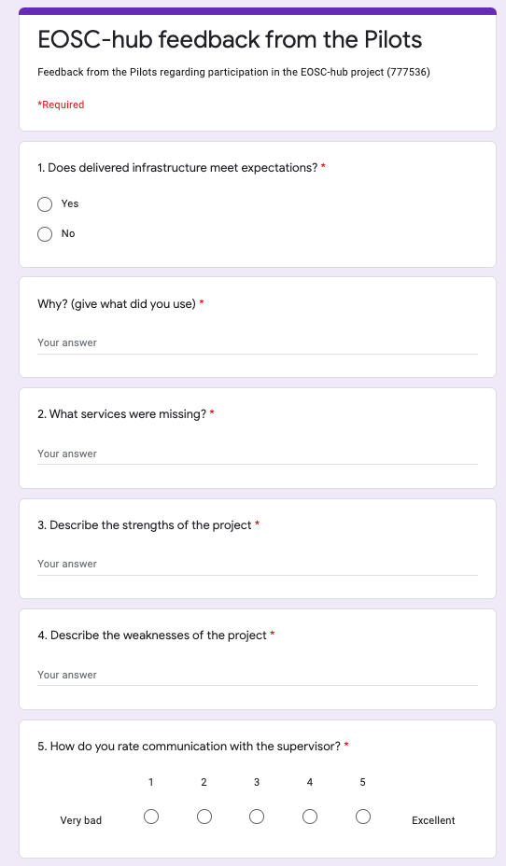

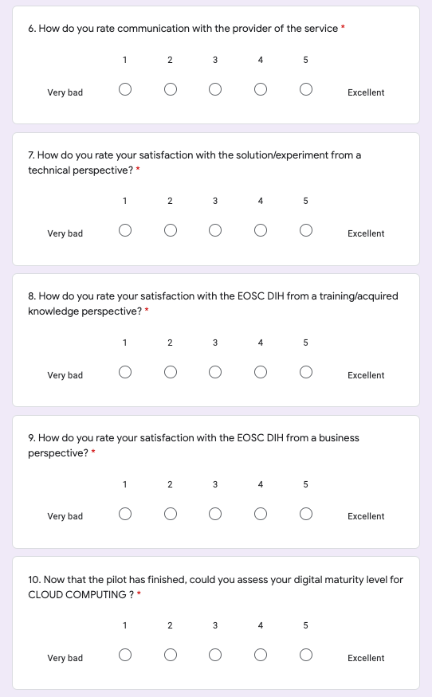
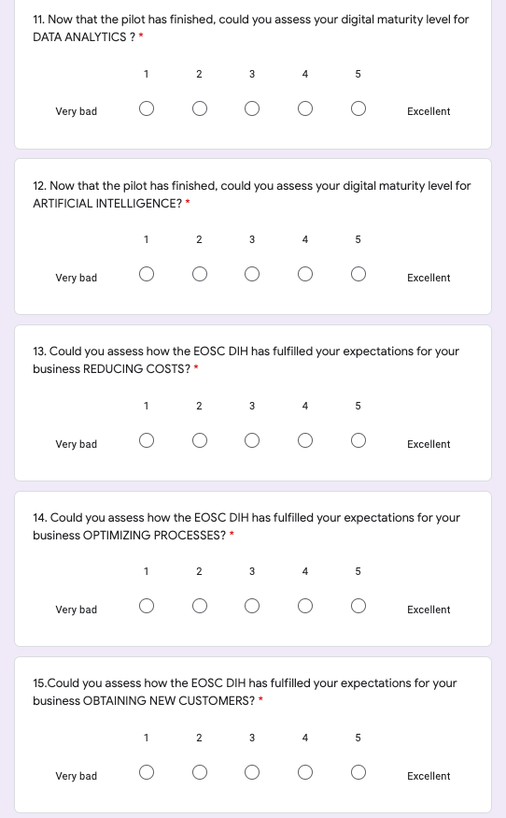
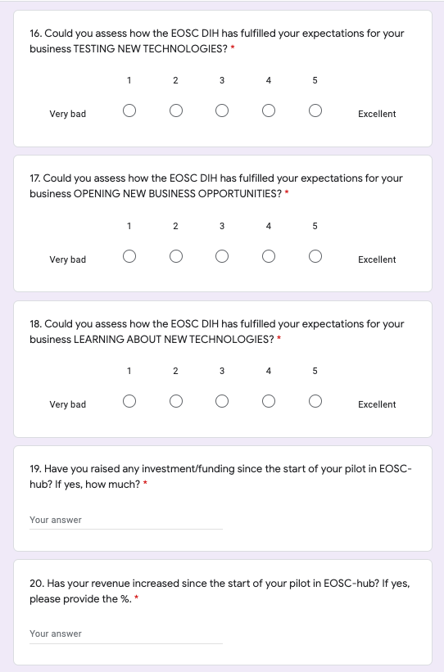

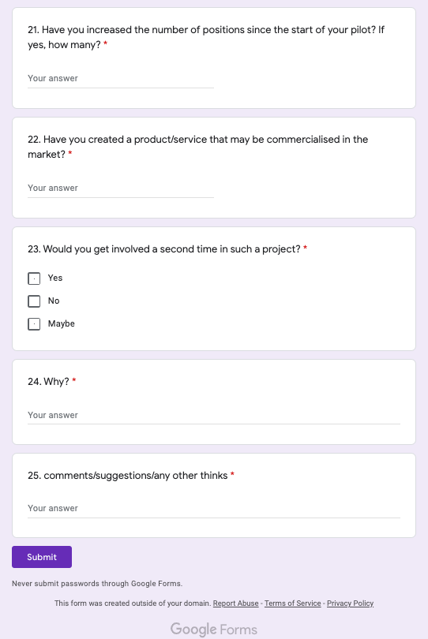

ANNEX IV. Industrial Events and dissemination activities
List of Industrial events attended from 2018-2021
2021
Event Name | Sector | Date | Location | Opportunity | Partners to Attend | URL
Shaping the future of the EOSC DIH: an industry showcase and path forward | Industry, EOSC | 26 Mar 2021 | Virtual | Final results and showcase | All | https://indico.egi.eu/event/5457/

2020
Event Name | Sector | Date | Location | Opportunity | Partner(s) to Attend | URL
EOSC-hub Week | EC Project | 18 May 2020 -  20 May 2020 | Karlsruhe, Germany (Virtual) | Provide updates on EOSC DIH activities and future plans | EGI Foundation  PSNC | https://eosc-hub.eu/events/eosc-hub-week-2020
State 2.0 Conference | ICT innovations | 05 Mar 2020 -06 Mar 2020 | Warsaw, Poland | EU perspective 2021-2027, Collaborations | PSNC | https://www.computerworld.pl/konferencja/panstwo-eng
EOSC hub joint event | EOSC related | 16 Nov 2020  - 18 Nov 2020 | Amsterdam, NL | Disseminate among research community | EGI Foundation  PSNC | https://www.eosc-hub.eu/events/joint-eosc-hub-freya-sshoc-event

2018-2019
Event Name | Sector | Date | Location | Opportunity | Partner to Attend | URL
EC DIHs 2nd WG Meeting | EC | 21 Feb 2018 | Brussels/Online | Understand the current level of discussions and how to connect the EOSC-hub JDIH | EGI Foundation | https://ec.europa.eu/futurium/en/implementing-digitising-european-industry-actions/digital-innovation-hubs-2nd-working-group-meeting
EC DIHs 3rd WG Meeting | EC | 25 May 2018 | Brussels | Networking among Digital Innovation Hubs, the role of Member States and regions, and the catalogue of Digital Innovation Hubs | EGI Foundation | https://ec.europa.eu/digital-single-market/en/news/third-meeting-working-group-digital-innovation-hubs
EC DIHs 4th WG Meeting | EC | 02 Jul 2018 | Brussels/Online | Understanding role that Digital Innovation Hubs can play to help SMEs acquire the digital skills they need for their digital transformation. | EGI Foundation | https://ec.europa.eu/digital-single-market/en/news/fourth-meeting-working-group-digital-innovation-hubs
BDVA Activity Group Meeting | BDVA | 14 Mar 2018 -  15 Mar 2018 | Brussels | Initiating collaboration between BDVA/iSpace and EOSC-hub DIH | EGI Foundation | http://www.bdva.eu/?q=node/974
BDVA Activity Group Meeting | BDVA | 12 Sep 2018 | Brussels | Initiating collaboration between BDVA/iSpace and EOSC-hub DIH | EGI Foundation | http://www.bdva.eu/node/1099
Big Data Value Meetup Sofia | BDVA | 14 May 2018 -  16 May 2018 | Sofia, Bulgaria | Promoting EOSC-hub DIH and networking | EGI Foundation | http://www.bdva.eu/node/1012
ICTFOOTPRINT.eu Workshop Event “Green ICT – in practice” | Green IT | 20 Mar 2018 | Amsterdam, NL | Networking with start-ups/SMEs present  Present during pitch sessions to promote EOSC-hub DIH  Learn about a self-assessment tool for SMEs to check how green they are | EGI Foundation | https://ictfootprint.eu/en/events/ictfootprinteu-hands-workshop-event-%E2%80%9Cgreen-ict-%E2%80%93-practice%E2%80%9D
ELIXIR Innovation and SME Forum | Industrial Biotechnology | 15 Oct 2018 -  16 Oct 2018 | Frankfurt, Germany | Present/promote DIH | EGI | https://www.elixir-europe.org/events/sme-event-frankfurt
ICT 2018 | ICT | 04 Dec 2018 -  06 Dec 2018 | Vienna, Austria | ~3k-4k participants; Networking session "Matchmaking Industry with the European Open Science Cloud" | EGI, PSNC, CINECA, F6S | https://ict2018.b2match.io/
Digital Innovation Hubs Annual Event 2018 | DIHs | 27 Nov 2018 -  28 Nov 2018 | Warsaw, Poland | Promotion of EOSC-hub and its Digital Innovation Hub for industry | EGI, PSNC | https://ec.europa.eu/digital-single-market/en/news/digital-innovation-hubs-annual-event-2018
ICT LIVE 2019 | ICT | 10 May 2019 -  12 May 2019 | Warsaw, Poland | Promotion/stand &collaboration | PSNC | https://warsawexpo.eu/wydarzenie/ict-live-2019-miedzynarodowe-targi-i-kongres-itmobile/
ITM POLSKA/SUBCONTRACTING | Industry 4.0 | 04 Jun 2019 -  07 Jun 2019 | Poznan, Poland | Promotion & collaboration between science and SME | PSNC | http://www.itm-polska.pl/pl/?_ga=2.123310989.723400862.1537358563-634059200.1537358563
Smart City Expo 2019 | Technologies | 11 Jun 2019 -  12 Jun 2019 | Łódź, Poland | EOSC-hub promotion | PSNC | https://www.linkedin.com/showcase/smart-city-expo-poland-2019
IT future expo | Technologies for business | 26 Sep 2019 | Warsaw, Poland | Promotion/stand & SME collaboration | PSNC | http://itfuture.pl/
6th EC DIH WG | EC | 03 Apr 2019 | Brussels, Belgium | Presentation given for EOSC DIH | EGI | https://ec.europa.eu/digital-single-market/en/news/sixth-meeting-working-group-digital-innovation-hubs
SmartAgriHubs Regional Cluster Workshop - North East Europe | DIHs | 30 May 2019 | Poznan, Poland | Promotion & collaboration | PSNC | https://docs.google.com/document/d/1XqwwXNh38Wrv4L5Ag1xkZ0MOSbRYHa2Jl9hYZGuf3_E/edit
HPC for Industry 4.0 | Industry 4.0 | 23 May 2019 | Milan, Italy | Presentation given for EOSC DIH | CINECA | https://events.prace-ri.eu/event/834/
BDV PPP Summit | Big Data | 26 Jun 2019 -  28 Jun 2019 | Riga, Latvia | Presentation given for EOSC DIH; Data Business Model Canvas Workshop | EGI | https://www.big-data-value.eu/ppp-summit-2019/
7th EC DIH WG | EC | 07 Jul 2019 | Brussels, Belgium | Networking | EGI, CINECA | https://ec.europa.eu/digital-single-market/events/cf/seventh-meeting-of-the-working-group-on-digital-innovation-hubs/menu.cfm?saved=Profile&new=Yes
European Research and Innovation Days | Research and innovation policy | 24 Sep 2019 -  26 Sep 2019 | Brussels, Belgium | Networking; Presentation requested | TBD | https://ec.europa.eu/info/research-and-innovation/events/upcoming-events/european-research-and-innovation-days_en
Digitising European Industry Stakeholder Forum 2019 | EC / DIHs | 13 Nov 2019 -  15 Nov 2019 | Madrid, Spain | Promotion & collaboration | EGI | https://ec.europa.eu/digital-single-market/en/news/digitising-european-industry-stakeholder-forum-2019
EBDVF 2019 | Big Data | 14 Oct 2019 -  16 Oct 2019 | Helsinki | Promotion & collaboration | EGI | http://www.bdva.eu/node/1273
SC19 | The International Conference for HPC, Networking, Storage and Analysis | 17 Nov 2019 -  22 Nov 2019 | Denver, USA | Promotion & collaboration, EOSC DIH presentation at the PSNC stand | PSNC | https://sc19.supercomputing.org/
EOSC Symposium | EOSC | 26 Nov 2019 -  28 Nov 2019 | Budapest | Evangelization | EGI, PSNC | https://www.eoscsecretariat.eu/eosc-symposium
DIH Info Day | National DIH & Industry | 10 Oct 2019 | Mallorca | Promotion & Collaboration | EGI | https://www.planetic.es/sites/default/files/planetic/public/content-files/page/Programa_Jornada%20DIH%2BAsamblea_PLANETIC_2019_publica%20final.pdf
Dissemination activities from 2018-2021.
Type of activities | Task # | Title | Date | Outlet /  Name of event | Location | Type of audience | Estimated Reach | Scale | Link
Presentation + Panel | WP9.1 | EGI and the EOSC-hub Digital Innovation Hub | 20 Mar 2018 | ICTFOOTPRINT.eu Workshop on “Green ICT – in practice" | Amsterdam | Industry | ~30 people at workshop | Europe | Event: https://ictfootprint.eu/en/events/ictfootprinteu-hands-workshop-event-%E2%80%9Cgreen-ict-%E2%80%93-practice%E2%80%9D  Slides: https://www.slideshare.net/ICTFOOTPRINTEU/egi-and-eoschub-digital-innovation-hub
Video Interview | WP9.1 | EOSC-hub Digital Innovation Hub Networking Session Invitation | 08 May 2018 | YouTube | Online | ICT 2018 Organisers | 10s | Worldwide | https://youtu.be/WrzU0OWHJAk
Video Interview | WP9.1 | EOSC-hub - Digital Innovation Hub | 14 Jun 2018 | YouTube | Online | Industry | 100s | Worldwide | https://youtu.be/qCaymgNaOcI
Website pages | WP9.1 | Digital Innovation Hub | 10 Jul 2018 | EOSC-hub website | Online | Industry | 1000s | Worldwide | https://www.eosc-hub.eu/eosc-hub-digital-innovation-hub
Social Media | WP9.1 | EOSC Digital Innovation Hub | 19 Oct 2018 | Twitter | Online | Industry | 1000s | Worldwide | https://twitter.com/EOSC_DIH
Flyer/Brochure | WP9.1 | EOSC Digital Innovation Hub | 08 Oct 2018 | Print Material | N/A | Industry | 1000s | Worldwide | EOSC-DIH Flyer
Poster | WP9.1 | EOSC Digital Innovation Hub | 08 Oct 2018 | Print Material | N/A | Industry | 1000s | Worldwide | EOSC DIH Poster
Logos | WP9.1 | EOSC Digital Innovation Hub | 03 Oct 2018 | Online/  Print Material | Online/Print | Industry | 1000s | Worldwide | EOSC-DIH_Square.png  EOSC-DIH_Full-Long.png  EOSC-DIH_Short-Horizontal.png
Presentation | WP9.2 | EOSC Digital Innovation Hub | 22 Oct 2018 | Online | Online | Industry | 1000s | Mainly Europe | For new industry contacts
Presentation | WP9.1 | EOSC Digital Innovation Hub | 22 Oct 2018 | Online | Online | Industry | 1000s | Mainly Europe | For project related usage
Demo | WP9.2 | EOSC-hub Business Pilots | 09 Oct 2018 | DI4R Demo: EOSC-hub Business Pilots | Lisbon | All DI4R participants | 300 | Mainly Europe | https://indico.egi.eu/indico/event/3973/contribution/42
Presentation | WP9.1 | EC DIH Initiatives: the wider context | 11 Oct 2018 | DI4R: DIH Session | Lisbon | Industry, e-Infrastructure, policymakers | ~40 | Mainly Europe | Slides: https://indico.egi.eu/indico/event/3973/session/28/contribution/262
Presentation | WP9.1 | EOSC Digital Innovation Hub (DIH): Digitizing Industry through EOSC-hub | 11 Oct 2018 | DI4R: DIH Session | Lisbon | Industry, e-Infrastructure, policymakers | ~40 | Mainly Europe | Slides: https://indico.egi.eu/indico/event/3973/session/28/contribution/259
Presentation | WP9.3 | EOSC-hub Commercialisation support services | 11 Oct 2018 | DI4R: DIH Session | Lisbon | Industry, e-Infrastructure, policymakers | ~40 | Mainly Europe | Slides: https://indico.egi.eu/indico/event/3973/session/28/contribution/261
Presentation | WP9.1 | EGI, EOSC, EOSC Digital Innovation Hub | 15 Oct 2018 - 16 Oct 2018 | Elixir SME Forum | Frankfurt | SMEs, life sciences, pharmaceuticals | ~100 | Mainly Europe | Slides: Holsinger Sy_EGI-EOSC-hub-DIH.pptx
Booth participation | WP9.1 | EOSC Digital Innovation Hub | 04 Dec 2018 | ICT 2018 | Vienna | Industry, DIHs | ~50 | Mainly Europe | Digital Innovation Hubs - Innovation & Startups Village:  https://ec.europa.eu/digital-single-market/events/cf/ict2018/item-display.cfm?id=23018  https://twitter.com/EOSC_DIH/status/1071044568114782208
Networking Session | WP9.1 | EOSC-hub, EOSC Digital Innovation Hub | 05 Dec 2018 | ICT 2018 | Vienna | Industry, policymakers | ~25 | Mainly Europe | Session: https://ec.europa.eu/digital-single-market/events/cf/ict2018/item-display.cfm?id=22095  Slides: Holsinger Sy_EGI-EOSC-hub-DIH.pptx
New pilot onboarding | WP9.2 | Free trials - €250 cloud vouchers | 05 Dec 2018 | Online | Online | Industry | 30 | Mainly Europe | https://eosc-hub.eu/eosc-dih-free-trial
New pilot onboarding | WP9.2 | Giveaway - €5,000 service voucher | 05 Dec 2018 | Online | Online | Industry | 1 | Mainly Europe | https://twitter.com/EOSC_DIH/status/1070286867462012929  https://twitter.com/EOSC_DIH/status/1070353963101368320
Presentation | WP9.1 | EOSC-hub, EOSC Digital Innovation Hub | 03 Apr 2019 | 6th EC DIH WG | Brussels, Belgium | Industry, policymaker | 200 | Mainly Europe | https://twitter.com/EOSC_DIH/status/1113391627014418435
Booth | WP9.1 | EOSC-hub, EOSC Digital Innovation Hub | 15 May 2019 | ICT LIVE 2019 | Warsaw, Poland | Industry |  | Poland
Presentation | WP9.1 | EOSC Digital Innovation Hub | 23 May 2019 | HPC for Industry 4.0 | Milan, Italy | Industry, e-Infrastructure | 50 | Mainly Europe | https://twitter.com/EOSC_DIH/status/1131582606846435329
Webinar | WP9.1 | EOSC Digital Innovation Hub | 28 May 2019 | The EOSC Digital Innovation Hub: open data services for biomedicine and business | Online | Comp biomedicine | 20 | Europe, USA | https://www.compbiomed.eu/compbiomed-webinar-8/
Video | WP9.1 | EOSC Digital Innovation Hub | 28 May 2019 | YouTube | Online | Comp biomedicine | 10s | Worldwide
Booth; Presentation | WP9.1 | EOSC-hub, EOSC Digital Innovation Hub | 30 May 2019 | SmartAgriHubs Regional Cluster Workshop - North East Europe | Poznan, Poland | Industry |  | North East Europe | https://twitter.com/EOSC_DIH/status/1134084678586122245
Panel session participation | WP9.1 | EOSC-hub, EOSC Digital Innovation Hub | 07 Jun 2019 | ITM POLSKA/SUBCONTRACTING | Poznan, Poland | Industry | 30 - panels, 2000 fairs | Poland
Participation in conference | WP9.1 | EOSC-hub, EOSC Digital Innovation Hub | 11 Jun 2019 | Smart City Expo 2019 | Łódź, Poland | Industry | 300 | Poland
Presentation | WP9.1 | EGI, EOSC, EOSC Digital Innovation Hub | 27 Jun 2019 | BDV PPP Summit | Riga, Latvia | Industry, e-Infrastructure, policymakers | 50 | Mainly Europe | https://twitter.com/syholsinger/status/1143774096313991168
Webinar | WP9.3 | Business Internationalisation | 09 Jul 2019 | Zoom | Online | Industry | 30+ | Mainly Europe | https://www.eosc-hub.eu/training-event/eosc-dih-webinar-business-internationalisation
Webinar | WP9.3 | Business Internationalisation | 09 Jul 2019 | YouTube | Online | Industry | 10s | Mainly Europe | https://youtu.be/CfJsoODkERE
Presentation | WP9.1 | EOSC-hub, EOSC Digital Innovation Hub | 10 Jul 2019 | EC JRC, NetService (SME/new DIH pilot), DIH network reps meeting | Bologna, Italy | EC JRC, Industry | 20+ | Italy | https://twitter.com/netservice/status/1148900392547344384?s=20
Booth | WP9.1 | EOSC Digital Innovation Hub | 26 Sep 2019 | IT future expo | Warsaw, Poland | Industry | 3000+ | Poland | https://twitter.com/EOSC_DIH/status/1177196953500823554?s=20
Publication | WP9.2 | EOSC Digital Innovation Hub | 04 Oct 2019 | EOSC DIH Business Pilot Success Stories | Print, Online | Industry | 100s | Mainly Europe | https://eosc-hub.eu/news/new-publication-eosc-dih-business-pilot-success-stories
Presentation | WP9.1 | EOSC-hub, EOSC Digital Innovation Hub | 10 Oct 2019 | Planetic DIH INFODAY | Mallorca, Spain | Industry, DIH | 50 | Spain | Event: https://www.planetic.es/sites/default/files/planetic/public/content-files/page/Programa_Jornada%20DIH%2BAsamblea_PLANETIC_2019_publica.pdf
Booth participation; Keynote presentation inclusion | WP9.1 | EOSC-hub, EOSC Digital Innovation Hub | 15 Oct 2019 | European Big Data Value Forum (EBDVF'19) | Helsinki, Finland | Industry, e-Infrastructure, policymakers | 500 | International | http://www.bdva.eu/node/1273  https://twitter.com/EOSC_DIH/status/1184064242816827394?s=20  https://twitter.com/EOSC_DIH/status/1184367342060539904?s=20
Webinar | WP9.3 | Intellectual Property Rights | 30 Oct 2019 | Zoom | Online | Industry | 30+ | Mainly Europe | https://www.eosc-hub.eu/events/webinar-eosc-hub-digital-innovation-hub-intellectual-property-rights-protecting-science-and
Webinar | WP9.3 | Intellectual Property Rights | 13 Nov 2019 | YouTube | Online | Industry | 10s | Mainly Europe | https://youtu.be/MQY37yUhevI
Presentation | WP9.1 | EOSC Digital Innovation Hub | 15 Nov 2019 | Digitising European Industry Stakeholder Forum | Madrid, Spain | Digital Innovation Hubs; policymakers | 300+ | Mainly Europe | https://ec.europa.eu/digital-single-market/en/news/digitising-european-industry-stakeholder-forum-2019  https://twitter.com/EOSC_DIH/status/1195291153790357504?s=20
Booth participation | WP9.1 | EOSC Digital Innovation Hub | 20 Nov 2019 | Supercomputing 2019 | Denver, CO, USA | Industry, service providers | 500+ | International | https://sc19.supercomputing.org/  https://twitter.com/EOSC_DIH/status/1197203717176643591?s=20
Material | WP9.1 | EOSC Digital Innovation Hub | 26 Nov 2019 | EOSC Symposium | Budapest, Hungary | EOSC community | 200+ | Mainly Europe | https://www.eoscsecretariat.eu/events/eosc-symposium-2019
Webinar | WP9.3 | Marketing & Communication | 27 Nov 2019 | Zoom | Online | Industry | 30+ | Mainly Europe | https://www.eosc-hub.eu/events/webinar-marketing-communication
Webinar | WP9.1 | EOSC-hub, EOSC Digital Innovation Hub | 29 Nov 2019 | Open Science and Research Results Exploitation: friends or foes? | Online | IPR, exploitation, data managers | 50 | Europe, USA | https://www.openaire.eu/item/open-science-and-research-results-exploitation-friends-or-foes
Webinar | WP9.3 | Marketing & Communication | 18 Dec 2019 | YouTube | Online | Industry | 10s | Mainly Europe | https://youtu.be/dRksdzJ6RAI
Social Media | WP9.1 | EOSC Digital Innovation Hub | 31 Dec 2019 | Twitter | Online | Industry | 1000s | Worldwide | Additional catch-all entry for tweets during the year:  https://twitter.com/EOSC_DIH
Article | WP9.1 | EOSC Digital Innovation Hub | 16 Feb 2020 | EGI Newsletter | Online | EGI community | 100s | International | https://www.egi.eu/about/newsletters/eosc-dih-a-one-stop-shop-for-digitising-companies/
Participation in conference, flyers | WP9.2 | EOSC Digital Innovation Hub | 05 Mar 2020 | Computerworld conference | Warsaw, Poland | Industry | 1000s | International | https://www.computerworld.pl/konferencja/panstwo-eng
Open Call Webinar | WP9.3 | Marketing & Communication | 23 Apr 2020 | Open Call Webinar | Online | Industry | 20+ | International | https://www.f6s.com/eoscdihopencall-webinar
Participation in conference | WP9.1 | EOSC Digital Innovation Hub | 19 May 2020 | EOSC hub week | Online | EOSC community | 500+ | International | https://www.eosc-hub.eu/eosc-hub-week-2020/agenda/eosc-industry
News item | WP9.2 | Business pilots | 20 Jul 2020 | Open call results news item | Online | EOSC DIH community | 500+ | International | https://eosc-dih.eu/results-open-call/
News item | WP9.2 | Business pilots | 24 Sep 2020 | Erasmus play pilot news item | Online | EOSC DIH community | 500+ | International | https://eosc-dih.eu/erasmus-play-successfully-launched-in-spain/
Webinar | WP9.3 | Marketing & Communication | 24 Sep 2020 | Technology Transfer models webinar | Online | EOSC DIH community | 20+ | International | https://eosc-dih.eu/technology-transfer-models-webinar/
Newsletter | WP9.1 | Marketing and communication | 25 Sep 2020 | EOSC DIH newsletter Issue 1 | Online | EOSC DIH community | 20+ | International
Webinar | WP9.3 | Marketing & Communication | 07 Oct 2020 | The fundamentals of growth Marketing webinar | Online | EOSC DIH community | 20+ | International | https://eosc-dih.eu/the-fundamentals-of-growth-marketing-webinar/
Training | WP9.3 | Training | 30 Oct 2020 | How to collaborate for innovation | Online | EOSC DIH community | 20+ | International
Video | WP9.1 | EOSC Digital Innovation Hub | 10 Nov 2020 | EOSC DIH Video on YouTube | Online | Industry, EOSC community | 100+ | International | https://www.youtube.com/channel/UCEvCFgFCDYb3zlI5V-tzL1Q?feature=emb_ch_name_ex
Webinar | WP9.3 | Marketing & Communication | 11 Nov 2020 | Funding for innovation Webinar, YouTube | Online | Pilots, EOSC community | 20 | International | https://eosc-dih.eu/funding-for-innovation-webinar/
Participation in conference | WP9.2 | EOSC Digital Innovation Hub | 18 Nov 2020 | EOSC hub final event | Online | EOSC community | 500+ | International | https://www.eosc-hub.eu/events/realising-european-open-science-cloud/engaging-private-sector-about-roadblocks-and-success-stories-uptake-eosc-services
Exhibition Booth with Posters, demos | WP9.1 | EOSC Digital Innovation Hub | 18 Nov 2020 | EOSC hub final event | Online | EOSC community | 500+ | International | https://www.eosc-hub.eu/events/realising-european-open-science-cloud/engaging-private-sector-about-roadblocks-and-success-stories-uptake-eosc-services
Video | WP9.1 | EOSC Digital Innovation Hub | 18 Dec 2020 | YouTube | Online | Industry | 100s | Worldwide | https://www.youtube.com/watch?v=FIthxxjjvWY
Social Media | WP9.1 | EOSC Digital Innovation Hub | 31 Dec 2020 | Twitter, LinkedIn | Online | Industry | 1000s | Worldwide | Additional catch-all entry for tweets during the year:  https://twitter.com/EOSC_DIH  https://www.linkedin.com/company/65002258/admin/
Business Publication | W9.2 | Business Pilot | 15 Mar 2021 | EOSC DIH website, Social Media | Online | EOSC DIH community, Industry | 100s | International | https://eosc-dih.eu/visibility/
Social Media | WP9.1 | EOSC Digital Innovation Hub | 31 Mar 2021 | Twitter, LinkedIn | Online | Industry | 1000s | Worldwide | Additional catch-all entry for tweets during the year:  https://twitter.com/EOSC_DIH  https://www.linkedin.com/company/65002258/admin/

Annex V. Memorandum of Understanding and Terms of Reference
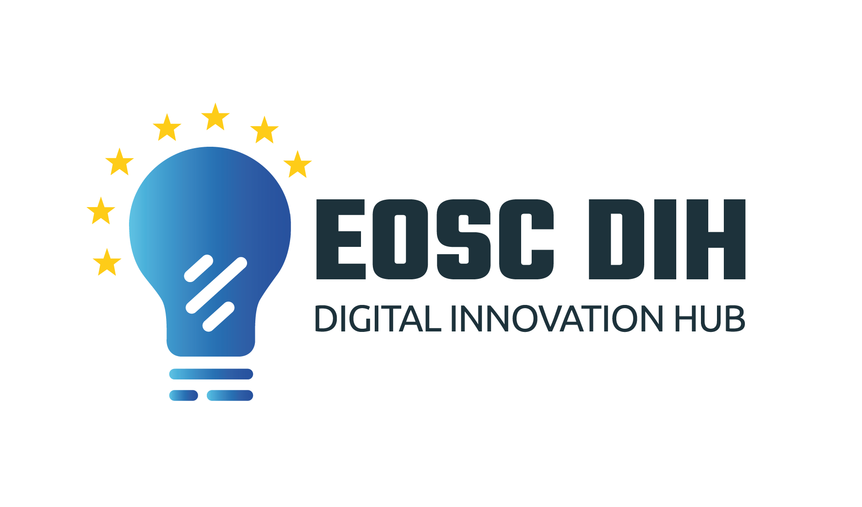
EOSC Digital Innovation Hub (EOSC DIH)
Memorandum of Understanding (MoU) and
Terms of Reference (ToR)

Document Link
Last Modified | 2021-03-31
Version | V7
Contact | business@eosc-dih.eu
Document Type | MoU/ToR
Document Status | Approved
Approved by | EOSC-hub WP9 Partners
Approved Date | 2021-03-31

Table of Contents
Background 111
Purpose and Nature of this MoU 111
Partners’ Rights and Expected Contributions 111
Projects and Reports 112
Partners’ Meetings 112
Conduct of the Partner’s Meetings 113
Voting 113
Chair 114
Acceptance, Withdrawal and Removal of Partners 114
Evaluation 115
Amendments 115
Entry in Force and Termination 115
Miscellaneous 115
Resolution of Conflicts 115
ANNEX 1: Terms of Reference (ToR) 117

- Background
The European Open Science Cloud Digital Innovation Hub (EOSC DIH) is an international and multi-partner cooperation that focuses on improving the competitiveness and innovation capacity of start-ups and SMEs by providing technical support and including indirect actions such as collaborations with incubators and research organizations, as well as improving the commercial innovation potential.
The EOSC DIH was set up by WP9 under the H2020 EOSC-hub project and was being designed to serve as the mechanism for business organisations (e.g. start-ups, SMEs, large enterprises) to directly engage with the European Open Science Cloud. EOSC-hub WP9 defined specific service offers to facilitate establishing business partnerships and business pilots to increase exploitation potential of commercially viable research data and other existing e-Infrastructure services while providing both human and technical services to commercial organisations to increase digitization capabilities and move new products or services into the market. The long-term strategy of the DIH was to live beyond the life of the project and to be the featured mechanism for industry to engage with the European Open Science Cloud.
The EOSC DIH in its current form shall therefore focus on supporting private industry in accessing the digital technologies and services offered by the European Open Science Cloud (EOSC) and facilitate industry focused partnerships across the ecosystem.
- Purpose and Nature of this MoU
The purpose of this MoU is to create a framework for cooperation between the Partners regarding the establishment, governance and operation of the EOSC DIH, as described in Annex 1: Terms of Reference (ToR). The Partners’ participation in the EOSC DIH is voluntary, based on service to the community with not-for-profit purpose. However, it is expected that Partners are strongly committed to the purpose of the EOSC DIH activities.
This MoU does not constitute a binding contract, nor does it create any financial obligation on either Partner towards the other Partner (provided, however, that this shall not limit a Partner’s financial responsibility for its own costs and expenses).
The Partners agree to provide each other with all necessary information, and not to withhold information that is relevant for the implementation of this MoU.
- Partners’ Rights and Expected Contributions
The rights of Partners shall include:
- Attendance and voting at the Partners’ meetings
- To be listed on the EOSC DIH website and relevant published material
- To invite up to two experts or third parties to attend specific sessions of a Partner’s meeting, provided this has been agreed by the Partners prior to confirming participation
- To be invited to participate in project funding proposals to support the EOSC DIH activities.

Each Partner is expected to:
- Maintain the EOSC DIH service catalogue
- Bear its own costs and expenses incurred in connection with performing the services offered and the activities connected with this MoU
- Seek to expand the scope and reach of services offered
- Disseminate and promote the EOSC DIH activities, onboard new business pilots and create new partnerships
- Serve as an interface with other DIHs, EC funded projects, and other relevant initiatives
- Actively participate in the annual and regular Partners’ meetings and EOSC community meetings
- Provide updates to other Partners on the status of the business pilots in which it is involved
- Organize, support, and participate in the DIH activities such as webinars, conferences and workshops
- Contribute to the circulation of relevant material such as funding opportunities, news or any other relevant information for the EOSC DIH community
- Contribute to the definition of the business models of the EOSC DIH
- Contribute to the governance and operation of the EOSC DIH, by striving to allocate 1 PM to support the services and activities above.

- Projects and Reports
Nothing in the MoU shall prevent Partners from participating in projects with private financing and/or in projects with competitive public financing (national or European).
In the case of joint EU funding projects concerning the EOSC DIH, one (or more) Partners shall strive to act as a beneficiary and the other Partners may participate as "third party" or equivalent, according to the figure of Joint Research Unit (JRU) referred to in article 14 of the H2020 Annotated Model Grant Agreement.
Any participation in projects or project proposals which mention the EOSC DIH as a key activity must be communicated to the EOSC DIH Partners in advance and as soon as practically possible. Such communication shall not imply that any or all Partners are potential beneficiaries.
Any deliverable produced via a relevant EU funded project shall be shared, where possible, with the Partners.
An annual report will be produced by the Partners to summarize the key activities carried out by the EOSC DIH.
- Partners’ Meetings
The Partners shall meet physically at least once a year for an annual meeting. In case objective reasons prevent such meeting from taking place physically, it may be conducted virtually.
Regular meetings will be held once a month and may be conducted virtually.
The Chair may call for additional meetings or extraordinary meetings, which may be conducted virtually.
A Partners’ meeting shall be quorate if at least 50% of the Partners are present at a meeting.
Partners shall subscribe to the EOSC DIH mailing list and use it as the primary written communication channel.
To allow for low latency communications, Partner shall use a secure instant messaging service via a dedicated Slack channel.
- Conduct of the Partner’s Meetings
The Chair shall circulate the agenda and relevant material at least three working days in advance of the Partners’ meeting, taking account of proposals submitted by the Partners.
The agenda items shall indicate if the item is brought for information or requires a decision.
Regular agenda items will be marked, at minimum, by the following categories:
- Administration aspects
- Status update regarding
- Ongoing business pilots
- Dissemination and promotional activities
- New or potential pilots and partnerships
- Review of all actions from previous meetings and assignment of new ones
- Agreement of date for the next meetings
- Any other business

At the beginning of each meeting the draft agenda shall be adopted by the Partners after any necessary modifications. New items may be added to the Agenda by the Chair, but they may only be subject to a decision if all Partners agree.
Delegates may only take the floor following permission to speak granted by the Chair. The Chair may call to order a delegate or an attendee whose remarks are irrelevant to the subject or inappropriate. The Chair may require a delegate or an attendee to leave the meeting room after calling him/her to order for three consecutive times during the meeting.
The Chair may be assisted, upon request, by a Partner in taking the minutes of the meeting. Partners shall strive to respond positively to such a request and consider this task to be a shared duty amongst all Partners.
All documents shall be stored electronically and made available to Partners in a secured manner.
- Voting
The Partners shall strive to reach decisions by consensus. If no consensus is reached after two consecutive group meetings, the Chair may decide to put the matter for voting, in which case, the majority rule shall be a simple majority.
Each Partner is entitled to one vote, with all votes being of equal value.
A Partner shall not have voting rights in decisions concerning that Partner’s removal from participation in the EOSC DIH and/or termination of its participation in this MoU.
Partners absent or abstaining from voting shall be counted as not voting.
In the event of a tie the Chair shall have a casting vote.
If a decision of the Partners is adopted following a vote, the minority positions shall be recorded and reported in the minutes.
- Chair
The Partners shall elect a Chair and a Vice-Chair among the delegates of the Partners by a simple majority.
The Vice-Chair shall replace the Chair in cases of absence, resignation, inability to act or in cases of conflict of interest which cannot be otherwise resolved.
The term of office for the Chair and the Vice-Chair shall be two years, renewable (without limitation) for the same period each time.
The Chair and Vice-Chair may assume other roles in the EOSC DIH.
The following persons shall be appointed as Chair and Vice-Chair, until a new Chair and Vice-Chair are elected:
- Chair: Sy Holsinger, EGI Foundation
- Vice-Chair: Marcin Plociennik, PSNC IBCh PAS.
the Chair shall:
- convene the meetings of the Partners
- ascertain the quorum required for the meeting and the majority in each voting
- determine the place and time of the Partners’ meeting (following consultation with the Partners)
- approve the proposed agenda to be circulated in advance of the Partners’ meeting, taking account of proposals submitted by the Partners.
- open and close the meeting and put forward proposals to vote and announce decisions
- manage the discussions and grant or withdraw permission to speak, as a general rule, in the order in which delegates express their desire to speak
- rule on points of order and conduct the meetings in accordance with this MoU
- Take the minutes of the meeting (or nominate another person to do so) and circulate them for approval within three working days after the last day of the meeting.

- Acceptance, Withdrawal and Removal of Partners
Interested entities that wish to participate in the EOSC DIH as Partners shall submit an application form for inclusion via the EOSC DIH website, along with the motivation for joining.
Applications for becoming a new partner are subject to approval by the Partners at the time of submission following voting.
Partners may withdraw from this MoU at any time upon at least six months prior written notice to the Chair. A Partner that withdrew shall continue to contribute to the EOSC DIH in accordance with this MoU until withdrawal is effective.
The Partners shall have the power to remove a Partner from participation in the EOSC DIH and/or terminate its participation in this MoU if the following conditions are met:
- The Partner has acted in a manner that is contradictory, undermines, or risks to undermine the provisions of this MoU or the purpose of the EOSC DIH
- The Partner has failed to rectify its action or inaction (as the case may be) within a period of six months after given notice by the Chair
- The Partner was given the opportunity to present its position at the Partners’ meeting before the decision is made
- The decision has been voted in favor by at least 80% majority of the Partners present at the meeting.
- Evaluation
The Partners shall strive to conduct a semi-annual survey in order to collect feedback from both the EOSC DIH Partners as well as the Community Members to gauge the effectiveness as well as suggestions for improvement for the functioning of the EOSC DIH.
- Amendments
Any modification of this MoU requires the written agreement by all signatories.
The Partners agree to review this MoU, ideally once a year.
- Entry into Force and Termination
This MoU will come into effect between the signatories that have signed it as of the date of its second signature. It will then come into effect regarding each additional signatory that signs it at the date of signature by said signatory.
All or individual signatories may decide to terminate this MoU in accordance with the clause on “acceptance, termination and removal of partner” above, or by agreement of all signatories.
- Miscellaneous
Annexes to this MoU form an integral part thereof.
This MoU is drawn up in English, the language which will govern all documents, notices, meetings and process relative thereto.
- Resolution of Conflicts
Conflicts arising in relation to this MoU shall be settled amicably. Any disagreement that cannot be settled amicably shall be escalated to the Chair who shall propose a solution.
If no amicable solution is found, the concerning Partner/s may withdraw from this MoU.

Change Log
This section provides background material and further non-binding details about changes made to the document. It is intended to provide the reader with additional information to better understand the history of the document.
Version | Date | Approved by | Changes
v1 | 2020-05-08 |  | First draft by Sy Holsinger, Elisa Cauhe, Marcin Plociennik, Matti Heikkurinen
v2 | 2020-09-22 |  | Additional comments provided by WP9 members during a dedicated meeting
v3 | 2020-10-27 |  | New updates and reorganization of articles
v4 | 2021-02-01 |  | WP9 members updated composition naming, voting per partner, operation procedures, partner acknowledge
v5 | 2021-03-20 |  | Ohad Graber-Soudry (X-officio)
v6 | 2021-03-30 |  | Sy Holsinger final review for internal DIH comments
v7 | 2021-03-31 | EOSC-hub WP9 Partners | Final approved version
ANNEX 1: Terms of Reference (ToR)
- Background
The European Open Science Cloud Digital Innovation Hub (EOSC DIH) is an international and multi-partner cooperation that focuses on improving the competitiveness and innovation capacity of start-ups and SMEs by providing technical support and including indirect actions such as collaborations with incubators and research organizations, as well as improving the commercial innovation potential.
The EOSC DIH was set up by WP9 under the H2020 EOSC-hub project and was being designed to serve as the mechanism for business organizations (e.g. start-ups, SMEs, large enterprises) to directly engage with the European Open Science Cloud (EOSC). EOSC-hub WP9 defined specific service offers to facilitate establishing business partnerships and business pilots to increase exploitation potential of commercially viable research data and other existing e-Infrastructure services while providing both human and technical services to commercial organisations to increase digitization capabilities and move new products or services into the market. The long-term strategy of the DIH was to live beyond the life of the project and to be the featured mechanism for industry to engage with the EOSC.
The EOSC DIH in its current form shall therefore focus on supporting private industry in accessing the digital technologies and services offered by the EOSC and facilitate industry focused partnerships across the ecosystem.
The content of these ToR was agreed by all of the EOSC-hub consortium members involved in its creation and are the founding Partners of the EOSC DIH.
- Stakeholders
The EOSC DIH ecosystem is built by the EOSC DIH community and the stakeholders or entities with interest or relevant influence in the execution of the EOSC DIH activities. The following figure illustrates the map of these entities:
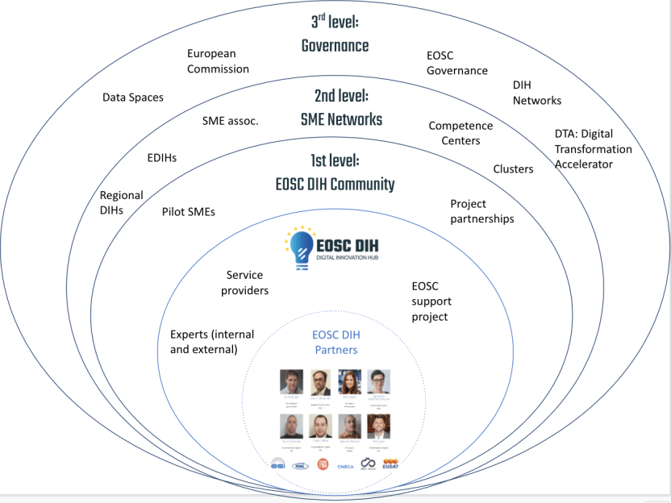

- Zero level - EOSC DIH: The persons and projects that enable the operation of EOSC DIH. This core level includes the Partners (initially those involved in WP9 of the EOSC-hub project), other internal experts and service providers. This level will expand as new persons or entities join and accept the Memorandum of Understanding.
- 1st level - Community Members: the running pilots, the experts offering services to the pilots and the partnerships that participate in the regular activities and meetings that the EOSC DIH organises.
- 2nd level – Potential Community Members: the companies or entities that could participate by providing or consuming the services of the EOSC DIH.
- 3rd level - Decision making and networks: the policy making entities and DIH networks that support mechanisms for implementing the activities of the EOSC DIH, existing and future.

The following table illustrates additional layers of engagement and interaction between the four levels described above:

- Community Members Rights and Obligations
The Community Members will have the following rights:
- To be invited to participate in regular community meetings and actively participate in webinars, conferences and other activities.
- To be included on the EOSC DIH website, in case of participation under pilots or partnerships, according to the relevant category.
- Subject to the needs, project objectives and applicable constraints, to receive invitations to participate in project proposals to obtain direct funding.
In order to maintain an active and engaged community, Community Members are required to:
- Participate, to the extent possible, in the activities of their interest organised by the EOSC DIH such as webinars, conferences or workshops.
- Contribute to the sharing of relevant external information for the community such as news and events.
- Actively participate, to the extent possible, in the community meetings that will take place regularly.
- Abide by and support the EOSC DIH Code of Conduct.

- Additional Roles
The following table provides a description of potential roles that individual Community Members could undertake:
Role | Description | Number of persons
Pilot Lead | Lead contact for managing in the pilot lifecycle from ensuring service provision to all documentation including website content, workplan and final reporting | 1 per pilot
Service expert | Specific service expert for supporting pilots or services part of the DIH catalogue | 1 per service
National DIH contacts | Serving as an interface with a specific national or regional DIH | 1 per country
Other DIH liaison | Serving as an interface with a specific national or regional DIH | 1 per DIH
Specific Support Project Rep | Serving as an interface with a specific support project | 1 per project

- Communication Channels
The following table provides a summary of the internal and external communication channels available within the EOSC DIH.
Communication Channel | Reference / Link
EOSC DIH Mailing Lists | partners@eosc-dih.eu
Website | https://eosc-dih.eu/
Confluence | https://confluence.egi.eu/display/EOSCDIH/EOSC+DIH+Home
Slack | eoscdih.slack.com (restricted channels)
External Communication Channels | Reference Link
Twitter | https://twitter.com/eosc_dih?lang=en
LinkedIn | https://www.linkedin.com/company/eosc-digital-innovation-hub/
Email | business@eosc-dih.eu
Slack | eoscdih.slack.com (dedicated community channels only)

- Reports
An annual report will be produced and circulated by the EOSC DIH Partners to summarize the key activities carried out by the EOSC DIH.
Any deliverable produced via a relevant EC funded project shall be shared, where possible, with the Community Members. Community Members will be offered an opportunity to contribute where relevant.

- IPR
Nothing in this ToR shall affect the rights and/or obligations of Community Members or Partners with respect to ownership of any patent, copyright, trade secret or any other intellectual property rights.

- Evaluation
A survey will be conducted at least on an annual basis, ideally every six months, in order to collect feedback from both the EOSC DIH partners as well as the Community Members to gauge the effectiveness as well as suggestions for improvement.

- Amendments
Any modification of the ToR will be made available to all Partners and Community Members.

https://s3platform.jrc.ec.europa.eu/digital-innovation-hubs-tool
www.fitsm.eu
https://twitter.com/EOSC_DIH
https://www.linkedin.com/company/65002258/
https://dihnet.eu/
https://s3platform.jrc.ec.europa.eu/digital-innovation-hubs-tool/-/dih/6109/view
https://www.jisc.ac.uk/guides/change-management/stakeholder-engagement
https://en.wikipedia.org/wiki/Business_Model_Canvas
https://app.mural.co/t/egi3550/m/egi3550/1612197174589/be82ffb9cf8cf7fc667f66a30d046e8919e3fe9d
https://eosc-dih.eu/about-us/
eoscdih.slack.com
https://eosc-dih.eu/community/code-of-conduct/

