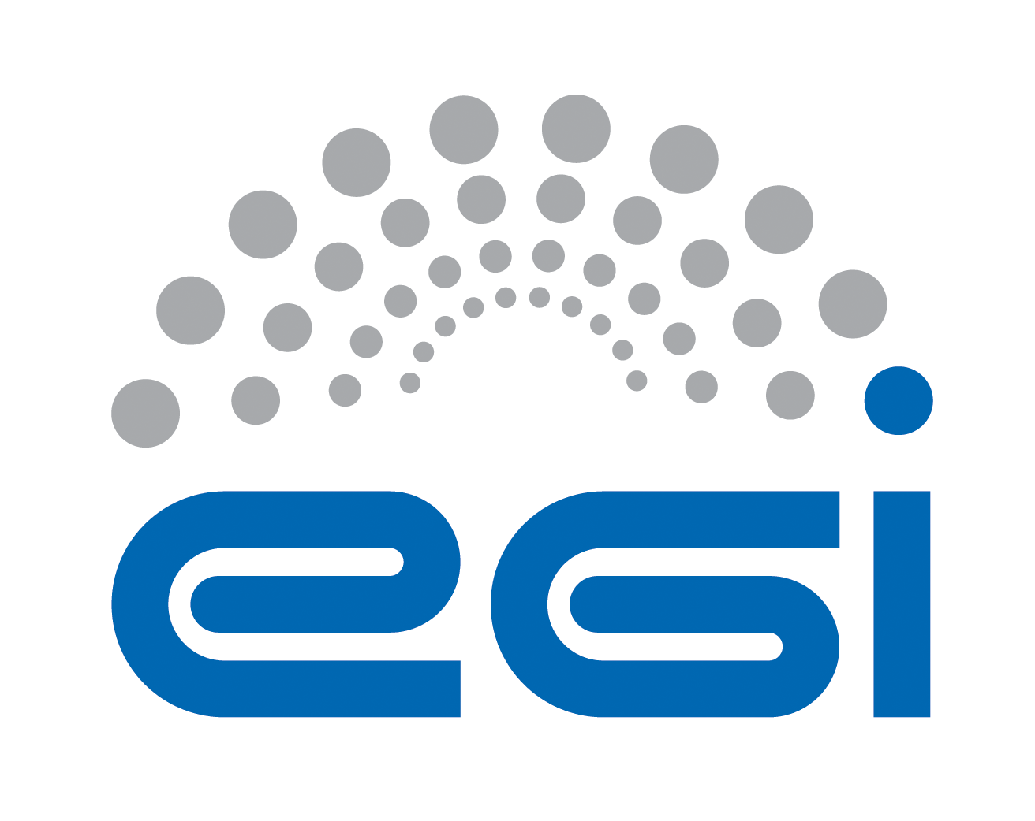
EGI.eu
OLA Performance Report

Title | EGI.eu OLA – performance report
Provider | IBERGRID
Service | Acceptance Criteria
Produced by | Pablo Orviz  Acceptance Criteria team manager  orviz@ifca.unican.es
Audience | EGI.eu Operations  operations@egi.eu
Purpose | Report on performance of the service
Period | 2015 May - 2015 October
Related agreements | https://documents.egi.eu/document/2456
Document Link: | https://documents.egi.eu/document/2596

Contents
1 Effort 3
2 General overview of Activity in the period 3
3 Performance against Service Targets 3
4 Issues arising in the period 4
5 Measures planned 4
6 Foreseen activities and changes 4

Effort
For a total of 5 PMs in the 6-month period being reported, the following table summarizes the partner's effort:

IFCA | CESGA
4 | 1

General overview of Activity in the period

Quality Criteria definition was not altered during this period, remaining at version EGI QC 7 (see ). Based on this criteria, no specific issue was found in the software products revisioned, neither any security vulnerability was detected while in the software verification process.

All the software verifications were made using the umd-verification tool (see ). During this period new UMD4 product verifications were accomplished, so that the team has been working to add Centos7 and Ubuntu support to the queue. YAIM support has been dropped in UMD4 so the configuration of the products need to be aligned with maintainer's recipes, that can appear in different formats (scripts, configuration management manifests like Puppet, ..).

Performance againSt Service Targets

The targets defined are:
- Incremental definition: no issue, need or requirement arised required any significant modification or enhancement in the Quality Criteria definition.
- Verification of acceptance criteria: a total of 40 products were verified:
  - 2 product verifications correspond to UMD4 products: site-bdii and top-bdii under centos7. Issues
  - CA 1.65-1 verification was not properly verified for Debian distros. The release package contained a syntax error in the specs that prevent from being installed. Version 1.65-2 was released for Debian distros.
- QoS level: base level support in GGUS through “EGI UMD Quality Assurance” support unit: no issues were raised.

The following table shows performance against targets:

Service level parameter | Target | M1 average | M2 average | M3 average | M4 average | M5 average | M6 average
Availability | N/A | N/A | N/A | N/A | N/A | N/A | N/A
Reliability | N/A | N/A | N/A | N/A | N/A | N/A | N/A
Support priority | Base

Issues arising in the period
CA release 1.65-1 for Debian distros contained a syntax error in the specs that prevent the 'deb' package from being installed. This was not properly detected by the verification team.

Measures planned
CA product verification does not follow the same verification process as the rest of UMD products. It is not attached to a specific distribution so that there is not a product ticket per operating system in the UMD testing process. This has to be noted in the verification procedure so that CA releases are deployed in all the operating systems supported under UMD.

This policy has been followed after the issue, so that next releases (1.65.2, 1.66.1, 1.67.1, 1.68.1 and 1.69.1) were installed for all the distributions supported both in UMD3 and UMD4.

Foreseen activities and changes
Now that we have a tool that allows fast deployments (installation, configuration and local testing), our effort should be dedicated to extend the testing process to involve additional services if the product requires so.

