Title: Interoperability is the key to freedom in the Cloud
Author(s): Michel Drescher, Technical Manager, EGI.eu
Focus Area
The European Grid Infrastructure (EGI) [1] is building a federated, standards-based IaaS Cloud platform, building on its decade-long experience in delivering a reliable, federated Grid infrastructure for scientific computing and e-Research across Europe and worldwide. Ultimately, the cloud solution offers advanced ICT capabilities for research, virtualised resources to run any environment chosen, cloud storage for easier sharing of data, and a number of support services to ensure applications run as efficiently as possible. Federation is enabled by a set of core services such as seamless authentication and authorization of users, gathering of accounting information, information discovery, monitoring and VM management across multiple cloud domains. Federated cloud providers engage by establishing an SLA with the federating organization – EGI.eu.
EGI chose a federation-based governance model, balancing out the individual freedom of participating suppliers, and the cost benefits of providing common services once instead of over and over again. Technical consistency in the service delivery between participating suppliers is ensured by extensive use and mandating of publicly defined interface specifications such as OCCI [2], CDMI [3] and OVF [4]. At the same time, customers enjoy a single point of contact for common services such as accounting, resource monitoring, etc. EGI’s service catalogue [5] and solution portfolio [6] allows researchers to make use of EGI’s services independently through one of the largest aggregation of federated IaaS Cloud resources in Europe.
EGI’s federated Cloud Infrastructure Platform will go into production in May 2014 with an initial capacity of 2,000 cores and 15 TB of storage. By the end of 2014, EGI will provide to its customers more than 10,000 cores and almost 1,5 PB of storage. Beyond that, EGI’s capacity building programme will include both increasing individual member capacity, and integrating more resource providers, in order to reach its goal of providing 10M cores and 1 Exabyte Cloud storage for its customers by 2025.
Who stands to benefit and how
Key to EGI’s IaaS Cloud federation is its design as an enabling solution for its stakeholders, much like virtualisation being an enabling technology for IaaS Clouds. With this in mind, EGI is targeting large research communities (or partnerships of communities) supporting multidisciplinary science in Europe and beyond. EGI Distributed Competence Centre provides support to research communities to develop their platforms on the federated cloud, offering through its federation both academic and commercial Cloud resources, seamlessly integrated, supporting a variety of Cloud infrastructure requirements at the same time.
Interoperable solutions based on open standards implementation
EGI strongly promotes open standards and, consequently, interoperability, as these enable a fair, open, transparent, and level playing field for all participants, both on the demand side and the supply side. EGI does not subscribe to the notion of standards stifling innovation and competition; instead, standards are seen as a mechanism to regulate governance and control over access to a market, where supply side players can compete and excel through their means of service delivery. Standards also allow the consumers of a service to compare competing offers, and ease risk management, such as reducing or eliminating the risk of a single point of failure when engaging with only one Cloud service provider – think of data centres buying connectivity from several competing network providers.
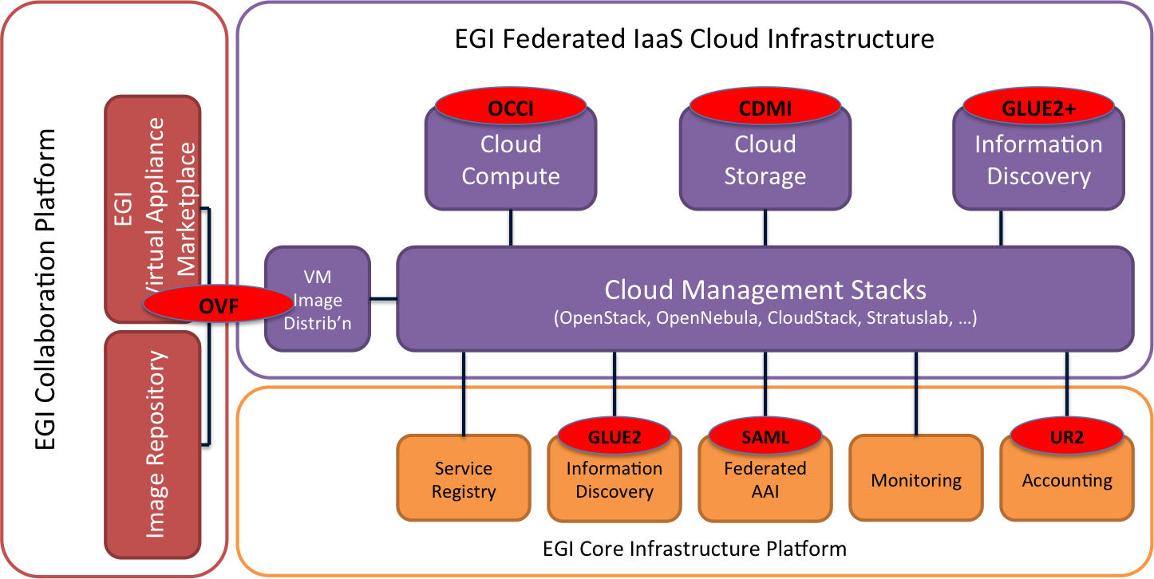
EGI federated Cloud Infrastructure Platform architecture and standards
EGI has chosen the following set of standards as being part of the mandate to participate in the Cloud infrastructure federation:
- OCCI [2]: A family of specifications defining access and management operations for IaaS Clouds. Highly extensible hence not limited to IaaS only. Extensions for business services such as accounting & monitoring are currently discussed.
- CDMI [3]: A specification defining a generic management interface, metadata management, and data access protocol negotiation for Cloud storage services. A near-perfect complement to OCCI (see above).
- GLUE2 [9], GLUE2+: Information model specification. Originally defined for academic Grid resources, an extension for Cloud resources is currently being discussed.
- SAML [10]: Specification regulating details of authentication and authorisation.
- UR2 [11]: Similarly to GLUE2 originally designed for Grid resources but includes in its latest published revision definition of accounting records for Cloud resources.
- OVF [12]: A specification for a container structure that includes binary VM images and basic deployment and contextualisation instructions. Starting point for managing virtual appliances.
This approach is very much in line with the latest Future of Cloud Computing survey [7] but even more so with the Digital Agenda for Europe:
“As science is increasingly driven by the processing of big data, researchers need access to science clouds and other e-infrastructure that satisfy their requirements. Interoperability of services and applications is a key concern because it broadens choice and ensures a level playing field for both service providers and users, driving competition and innovation. I am a fervent defender of interoperability and it is a priority of the Digital Agenda for Europe.”
Neelie Kroes, Siena Roadmap, June 2012
Business models and sustainable services
While based on standards, the EGI federated model allows the offering of services through any other IaaS access interfaces including proprietary ones. By aiming for a lightweight, yet comprehensive federation framework and composition, it allows its members to find their own sustainability means through compatible business models, which complement their own strategy by either strengthening existing service uptake, or broadening their service catalogue.
Different marketplace models are being evaluated. Services may be delivered through a marketplace tailored to the needs of the EGI users, or through the integration into a larger service, e.g. the Helix Nebula Marketplace [8].
Addressing new challenges on the horizon
Building capacity (see above) not only match growing demand in Cloud computing, but also ensures that new use cases and capability demand will be properly matched in due time. The EGI Federated Cloud will address long-standing issues in Cloud computing, and support future challenges such as the Big Data problem: While each individual Cloud provider has a wider variety of solutions at hand to provide networking services to their customers, inter-provider networking is an entirely different problem. The EGI federation will tackle this by pushing the limits to provide lightpaths as a service between members of the federation. At the same time, the amount of data generated, stored and curated is growing beyond imagination – data develops a sense of gravity, which gives rise to the need of flexibly placing compute services in close proximity to (practically inert) data resources, automated, on-demand and accounted for.
Part of EGI’s federation model is its extensive network of collaborations and pioneering researchers. EGI’s service catalogue and solution portfolio allows researchers to make use of EGI’s services independently through one of the largest aggregation of federated IaaS Cloud resources in Europe, or by focused strategic support and collaboration in projects through its community networks and support & community driven innovation solutions, charged through the federation’s governance bodies.
Links and References
[1] http://www.egi.eu
[2] http://occi-wg.org/about/specification/
[3] http://www.snia.org/cdmi
[4] http://www.dmtf.org/standards/ovf
[5] http://www.egi.eu/services/
[6] http://www.egi.eu/solutions/
[7] http://go.egi.eu/AnnualCloudSurvey2013
[8] http://www.helix-nebula.eu
[9] http://www.ogf.org/documents/GFD.147.pdf‎
[10] https://www.oasis-open.org/committees/tc_home.php?wg_abbrev=security
[11] https://www.ogf.org/documents/GFD.98.pdf
[12] http://www.dmtf.org/standards/ovf

