EGI Applications on Demand service – Documentation for operators

Author: | Giuseppe La Rocca (EGI.eu), Geneviève Romier (CNRS), Peter Solagna (EGI.eu), Stéphane Gerard (VUB)
Version: 1
Document Link:

DOCUMENT LOG
Issue | Date | Comment | Author
v.1 | 7/10/2016 | First version based on preliminary versions by Giuseppe La Rocca/EGI.eu; Peter Solagna/EGI.eu; Geneviève Romier/CNRS | Geneviève Romier /CNRS
v.2 | 07/04/2017 | Updated version of the documentation for operator | Giuseppe La Rocca/EGI.eu
v.3 | 27/04/2017 | Revised version | Stéphane Gerard/VUB

TERMINOLOGY
The EGI glossary of terms is available at: https://wiki.egi.eu/wiki/Glossary

Contents
1 Introduction 4
1.1 Scope 4
1.2 Vocabulary 5
2 Procedures 6
2.1 Pre-requisites 6
2.1.1 How to become an operator 6
2.1.2 Register to the operators’ dedicated list 7
2.1.3 Operators renewal 7
2.1.4 Operators’ withdrawal 7
2.2 Workflows 8
2.2.1 The workflow for the Applicant 8
2.2.2 The workflow for the Operator 8
2.3 Study of a new Applicant/User Affiliation Request 9
2.3.1 Note 9
2.3.2 Information about a new Applicant demand 9
2.3.3 Study of the Applicant and his/her Application 10
2.3.4 Validation of the Applicant/User Affiliation Request 13
2.3.5 Rejection of the Applicant/User Affiliation Request 15
2.4 Study of a new Applicant/Resource Allocation Request 16
2.4.1 Information about a new Resource Allocation Request 16
2.4.2 Example of new Resource Allocation Request email 16
2.4.3 Process the submitted Resource Allocation Request 16
3 Appendix I - Templates 18
4 References 20

Introduction
This document describes the procedures applicable to operators of the EGI Applications on demand service [R1], hereafter referred to as the Service, to validate the users’ requests to access the Service for performing compute and data-intensive simulations on large, distributed networks of computing and storage facilities.
In a nutshell, this Service is the EGI response to address the requirements of a large number of researchers, National Users Support Teams and small laboratories who are scattered across Europe which do not have access to dedicated computational resources, storage and community specific Virtual Research Environments to manage and analyse large amount of data. This Service, opened in April 2017, is directly targeting those researchers and research teams who do not fit into any established ‘Virtual Organization community’, and/or do not have suitable and usable services within their established VO community.
This Service provides also an example of distributed platform that integrates and make services easy to use by fragmented groups of users. By repurposing the components available in this Service, managers or system architects from Research Infrastructure communities can build targeted platform to reach their users.

Scope
This document is applicable to all and only the operators of this Service nominated responsible to process all the users’ requests to access and use the Service.
The process described in this document must be compliant with the following policies:
- Acceptable Use Policy and conditions of use of the EGI Applications on Demand service (Platform for the Long-tail of Science) [R2]
- EGI Applications on Demand service - Security Policy [R3]

Vocabulary
This document uses the vocabulary defined in the EGI Applications on Demand service - Security Policy [R2]. To ease the reading, it is repeated here:
Applicant | A natural person that seeks to gain access to the service by providing information to the Registry.
Application | The information provided by an Applicant and recorded by a Registry that describes the personal information, contact details, and research use case, and on which basis a resource allocation is made.
Registry | The Service that holds information about the Service Users and/or Applicants, also known as the User Management Portal (UMP), and any supporting systems that hold data about Users or Applicants.  The Registry allows users to authenticate using the EGI AAI CheckIn service and to provide information about their contacts, institutions, and research topic. The website is the initial user-facing interface for both the end users and the operators who will approve and manage the registrations and requests.
Management | Those individuals or organisational bodies that have control over Resource Centres, Resource Infrastructures, and any associated personnel, and who are capable and authorized to assume risks.
eduGAIN | The service interconnecting Research and/or Education identity federations around the world.

In addition, the following terms will be used:
- e-GRANT is the EGI resource allocation tool that allows researchers to request an amount of compute and storage resources for a given amount of time. The front-end is the user-facing interface for the operators who will approve and manage the resources requests.
- The EGI User Support is the body (or bodies) in charge to process Applications.
  - This includes: EGI UCST, Resource Allocation core activity, and any National International Liaison (NIL) who can participate to the activity.
- The Operators (of the Registries) are members of the EGI User Support that are nominated to be responsible for the validation of the Applicants and resources requests.
This document contains guidelines for the operators of the Registry and e-GRANT.

Procedures
The procedures described in this document are intended to provide specific recommendations and guidelines for the members of the EGI User Support team responsible for the validation of the Applicants and their resources allocation requests. In more detail, the document describe the workflow to process the users’ requests in a reasonable way and register them in the Service.

Pre-requisites
The EGI User Support members, that are willing to become operators of the Service, are in charge to review and process the users’ Affiliation Requests (ARs) and Resources Allocation Requests (RARs). This requires to have a specific account on the Registry and on e-GRANT.
To get these accounts, and the related permissions, they must follow this process:

How to become an operator
Send an official request in the Global Grid User Support (GGUS) system to get an account on the Registry and e-GRANT.

Request an account on the Registry
Ticket category must be “change request”
Type of issue must be “Other”
Support unit must be “LTOS”
The ticket must contain the following information:
- First and Last Name
- Professional email
- Phone number
- Institution/NGI
- Role in the NGI
- Motivation to become operators of the User Management Portal

The request to get an account on the Registry will be evaluated within 3 working days.

The account information (if any) will be sent to the requester.

Request an account on the e-GRANT
Ticket category must be “change request”
Type of issue must be “Other”
Support unit must be “e-GRANT RA Tool”
The ticket must contain the following information:
- First and Last Name
- Professional email
- Phone number
- Institution/NGI
- Role in the NGI
- Motivation to access e-GRANT

The request to get an account on e-GRANT will be evaluated within 3 working days.

The account information (if any) will be sent to the requester.

Register to the operators’ dedicated list
Once the two accounts have been created, the new operator must subscribe the following applications-platform-support@mailman.egi.eu mailing list in order to be automatically notified by the URP when a new ARs/RARs is submitted.
The operator is validated for a period of 1 year.

Operators renewal
Accounts on the Registry and e-GRANT are generally valid for a period of 1 year. If at the end of this period, the operator would like to continue to operate, he/she is invited to apply to renew them. The renew of these accounts is done creating a GGUS ticket as described before.

Operators’ withdrawal
If an operator is willing to withdraw this function, he/she must submit official requests in the Global Grid User Support (GGUS) system to close his/her accounts on the Registry/e-GRANT.

Request formulation
Ticket category must be “change request”
Type of issue must be “Other”
Support unit must be “LTOS” / “e-GRANT RA Tool”
Content must contain:
- First Name
- Last Name
- Username on the Registry
- Professional email
- Phone number
- Institution/NGI
- Role in the NGI
The accounts will be closed, the email will be dropped off the dedicated list and a confirmation will be sent to the requester.

Workflows

The workflow for the Applicant
For the user, the workflow consists in the following steps:
- Login to the User Registration Portal front page.
- Provide information about user’s affiliation and submit an Affiliation Request.
- Submit a Resource Allocation Request: in this request indicate approximately how much computing and storage capacity, and when these resources are needed.
In three working days, the two requests will be processed by the EGI User Support members and the user will be informed via e-mail about the outcome of this evaluation.
In case of acceptation:

- The User can login to any of the Science Gateway portals to use pre-defined scientific applications or to build and execute your custom compute and data intensive applications.
- The User MUST acknowledge EGI in his/her publications in case he/she publishes results found with the help of the provided resources.

The workflow for the Operator
For the operator, the workflow consists in the following steps:
- Receive Affiliation and Resource Allocation Requests e-mails through the no-reply@egi.eu mailing list;
- Study the Affiliation and the Resource Allocation Requests submitted by the Applicants;
- Validate or reject the Affiliation and the Resource Allocation Requests.

Study of a new Applicant/User Affiliation Request
To approve or reject a new user’s Affiliation Request, the EGI User Support operators have to access the User Registration admin Portal.

Note
As operator you are technically able to validate/reject all requests. But depending on your role you MUST act only on the requests of your own scope! For example, if you are a NIL you are only allowed to validate/reject requests of researchers of your NGI.
A ticket is open:
https://rt.egi.eu/rt/Ticket/Display.html?id=12233&results=6d5f8c397f8956cd5c8ec6adb10750ca
Concretely if a request is not in your scope, ignore it!

Information about a new Applicant demand
For each new User’s Affiliation Request submitted to access the EGI Applications on Demand service, all the EGI User Support operators receive an email through the no-reply@egi.eu mailing list. In parallel the Applicant is informed that his/her Affiliation Request will be approved or rejected within 3 days.
The email is such as the following example:

Example of new affiliation email
From: no-reply@egi.eu
Subject: [Applications-platform-support] [EGI LToS] Affiliation created.
To: applications-platform-support@mailman.egi.eu
Body:
Dear Platform Operator,

This e-mail is to inform you that the following new affiliation request has been sent:

- RequestID:
- First and Last Name:
- Affiliation:
- E-mail:
- Country:
- Linkedin:
- ResearchGate:

Please, access the Admin portal https://access.egi.eu:8888/login to process this request.

The request should be processed in 3 days.

Your Sincerely,
EGI User Community Support Team

P.S.: Please be aware that any changes in the portal can take up to 30 minutes to take effect.
_______________________________________________
Applications-platform-support mailing list
Applications-platform-support@mailman.egi.eu
http://mailman.egi.eu/mailman/listinfo/applications-platform-support

Study of the Applicant and his/her Application
The objective is to verify the following conditions:
- CONDITION 1: If the Applicant is affiliated to a research institution of your scope OR collaborating with a researcher affiliated to a research institution of your scope.
- CONDITION 2: If the request is only for research and non for profit goals and there is no VO relevant for the applicant (discipline VO or geographic VO).
- CONDITION 3: In case the Applicant has previously used the Service as a User, check whether the Applicant has produced some scientific results (e.g. publications, presentations) and if s(he) has acknowledged EGI as indicated in the AUP [R2].

Login on the Registry portal
Access the User Management Portal with the following link: https://access.egi.eu:8888/login
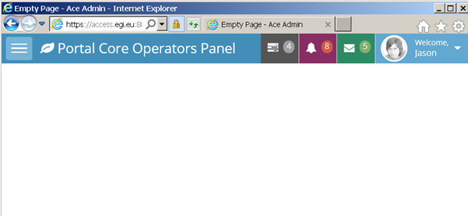
Click on the icon on the top - left corner of the web page to get the menu.
Note that the other icons and profile are currently not active. Tickets are open:
https://ggus.eu/index.php?mode=ticket_info&ticket_id=125638
https://ggus.eu/index.php?mode=ticket_info&ticket_id=125643
It is also currently impossible to logout. Ticket is https://ggus.eu/index.php?mode=ticket_info&ticket_id=125644

Get the list of Applicants
Click on the icon on the top - left corner of the web page to get the menu and chose “Affiliations”.
You can see the list of affiliations as in the figure:
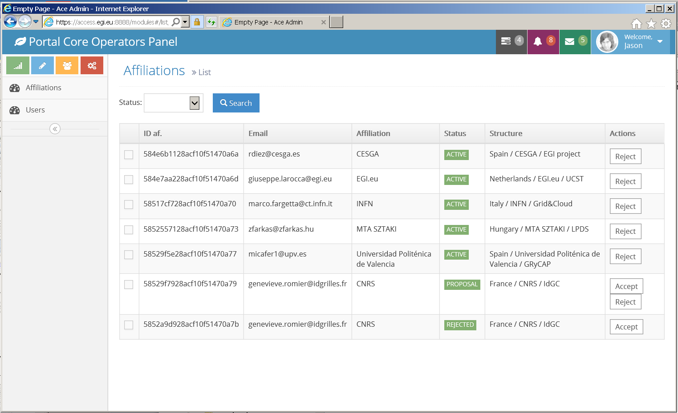
Three statuses are possible for the affiliations:
- PROPOSAL: this means that the Applicant request is pending.
- ACTIVE: this means that the Applicant request has been approved.
- REJECTED: this means that the Applicant request has been rejected.
You may list the affiliations by status. In this list you can see if there are applicants in your scope. If your scope is geographic you may rely on the Structure field and find if there is an Applicant in your NGI for example.
You have to keep in mind that the information reported by each Applicant MUST be verified.

Verify CONDITION 1
To verify [CONDITION 1] you may rely on the Affiliation given by the Applicant.

If the Applicant registered using an institutional e-mail and/or phone number, these contact details must be verified with the contacts information published by the institute home page.

Note: The institute MUST be in the European EGI scope as required in the security policy. Practically operators of NGIs are not concerned by Applicants out of their scope (the NGI). Only operators that are concerned by all the EGI scope MUST verify this point.

Note: For the moment it is not possible to know the first name and the last name of the Applicant. A ticket is open: https://rt.egi.eu/rt/Ticket/Display.html?id=12234
If you cannot find any information that proves that the Applicant is affiliated to a European research institute or if the Applicant registered with a personal email, the EGI User Support operators MUST contact the Applicant and ask:
- If he/she has a professional email he/she could use to register (if registered with personal email).
- What is his/her organism/enterprise.
- If he/she is collaborating with a research institution and can provide a referee.
If the Applicant provides a professional email related to a European research institute, ask him/her to register again and reject his/her current request [go to 2.5].
If the Applicant provides a referee for a European research institution, the EGI User Support operators MUST contact this reference to verify Applicant’s affiliation and the purpose of his/her collaboration.
In case the referee is out of the geographical scope of the EGI User Support operator, he/she MUST contact other operators (if any) in this scope and transfer to them the request. To contact other operators, use the applications-platform-support@mailman.egi.eu mailing list.
If the referee does not confirm the Applicant’s collaboration, reject the request [go to 2.5].
If CONDITION1 is met, continue with CONDITION2.

Verify CONDITION 2
To verify CONDITION 2:
This part of the process is currently manual because for the moment there is no information about the purpose of the research accessible on the portal.
A ticket is open https://rt.egi.eu/rt/Ticket/Display.html?id=12236
The operator MUST contact the Applicant and ask him/her to provide the purpose of the research he/she is willing to conduct and the applications/tools he/she would like to use. To ask for such information, the operator can use the e-mail template E1 in Appendix I).
The request MUST be only for research and non for profit goals.
- If the Applicant’s purpose of the request is not research or is for profit, the affiliation request MUST be rejected [go to 2.5].
  - If a referee was contacted, verify that the purpose described by the Applicant is the same as the purpose described by the Applicant. If not reject the affiliation request [go to 2.5].
- If the request is for research and non for profit goals, the EGI User Support operators have to verify if there is already, in the EGI Operations Portal, a VO whose scope matches the Applicant’s scientific discipline, or if there is a long-tail of science VO in the NGI of the Applicant that offers services that the Applicant need.
  - If a VO matching the request is found, the operator MUST contact the Applicant by email to inform him/her about the possibility to run the research programme in this different VO and introduce him/her to the VO manager.
    - To inform the Applicant, the EGI User Support operators can use e-mail template E2 in the Appendix I.
  - If the VO manager accepts the Applicant who agrees, the affiliation request can be rejected [go to 2.5].
- In the other cases continue with CONDITION 3.

Verify CONDITION 3
To verify CONDITION 3:
- Check in the e-GRANT portal whether a Resource Allocation Request (RAR) for the Applicant was already approved.
  - If a RAR was approved, check in the OpenAire portal if the Applicant has produced some scientific results (e.g. publications in scientific journals, conference proceedings, presentations, etc.)
- In case the Applicant has produced some scientific results, the EGI User Support operators have to check:
    - If EGI.eu has been acknowledged in these works.
      - If EGI.eu has been acknowledged, go to 2.4.
      - If EGI.eu has NOT been acknowledged, ask the User to clarify
        - If explanation is accepted go to 2.4.
        - If explanation is not available/accepted, the request will be rejected.
        - The User will be notified about the status of this request using the template E3.
  - If no RAR for the Applicant was approved, go to 2.4.

Validation of the Applicant/User Affiliation Request
In case all CONDITIONS (1 to 3) are met you have to validate the affiliation request.
Access the Registry portal and click on the icon on the top - left corner of the web page to get the menu and chose “Users”. You can see the list of Users as in the figure:
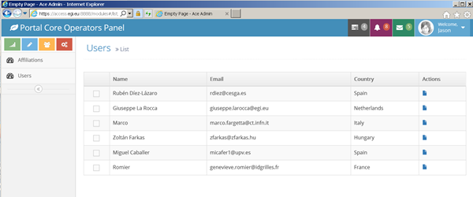
You will find the Applicants in the list of Users. Click on the Actions icon in the row of the Applicant that you will recognise with his/her email. This will provide you with the User details: the Affiliations of the User and their status.
Note: The Applicant’s e-mail address is used to uniquely identify the user in the Registry. By default, it is NOT possible to have Users registered with the same e-mail address and different affiliations. In case there is already an account for the User (with the same first and last name), the EGI User Support operators have to check the User’s e-mail address in the Applicant’s request.
In the Affiliation list, click on the ACCEPT button corresponding to the Applicant you want to accept.
The status of the Applicant, in the Affiliation list, is now ACTIVE and the User will be notified by the Registry portal.

Email content:
From: no-reply@egi.eu
Subject: [EGI Platform] Affiliation accepted.
Body:
Dear User,

This e-mail is to inform you that we successfully validated your user profile in the EGI Platform. You can now proceed to requesting a resource allocation (computing and storage capacity for your scientific activity).
You can reach the request page in the dashboard [1].

After the positive approval of your resource allocation request you will be able to use the platform through the connected science gateways.

Should you have any questions, please contact us at [2].

Your Sincerely,
EGI User Community Support Team
[1] https://access.egi.eu/#/dashboard
[2] support@egi.eu

Tracking (of the Affiliation Requests)
All the approved Affiliation Requests have to be reported in the following Google spreadsheet!

Rejection of the Applicant/User Affiliation Request
In case all CONDITIONS are not met you must reject the affiliation.
In the Affiliation list click on the REJECT button corresponding to the Applicant you want to reject.
The status of the applicant in the Affiliation list is now REJECTED.
The applicant receives an email informing him/her he cannot be accepted.

Email content:
From: no-reply@egi.eu
Subject: [EGI Platform] Affiliation rejected.
To: applicant email address
Dear User,

This e-mail is to inform you that we could not successfully validate your user profile in the EGI Platform, because we did not find your profile legitimate.

For further information you can contact us at [1].

Your Sincerely,
EGI User Community Support Team
[1] support@egi.eu

Study of a new Applicant/Resource Allocation Request
To approve or reject a user’s Resources Allocation Request, the EGI User Support operators have to access the e-GRANT portal and follow this process.

Information about a new Resource Allocation Request
For each new resource allocation request, all the EGI User Support operators receive an email through the no-reply@egi.eu mailing list. The email is such as the following example:

Example of new Resource Allocation Request email
Dear Broker,
User <First Name/Last Name> created new resource request: requestID.
Please log in to https://e-grant.egi.eu/ltos/auth/login and handle the request.
Should you have any questions, please contact us at [1].
Your Sincerely,
EGI User Community Support Team
[1] support@egi.eu

Process the submitted Resource Allocation Request
- Access the e-GRANT portal;
- If the computing and storage resources requested do NOT exceed the default quota assigned to the users of the Service, the request is approved;
- If the computing and storage resources requested do exceed the default quota assigned, ask for more clarification to the User;
  - If explanation is not available/accepted the request will be refused.
- The User will be notified about the status of the request.

Login on the e-GRANT portal
Access the User Management Portal with the following link: https://e-grant.egi.eu/ltos/auth/login
All the pending resource allocation requests are showed in the inbox panel. Click on the resource request that you want to process to get some details.
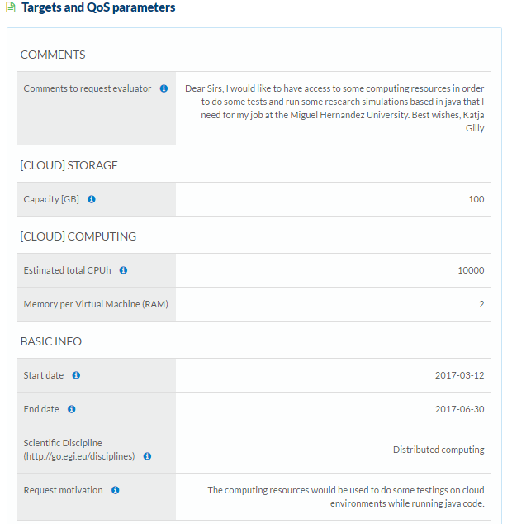

To approve/reject the request click on the “Accept Request” or ”Reject Request” buttons.

Tracking (of Resources Allocation Requests)
All the approved Resource Allocation Requests have to be reported in the following Google spreadsheet!

Appendix I - Templates
[E1] – Template to verify the Applicant’s research programme
Dear User,
Thank you for expressing your interest to access the 'EGI Applications on Demand service.
With the following, we would like to know which is the scientific domain you are involved with, and the reason why you want to use the services available in this Service.
This is not a review of the quality of your research but, before to approve your request, we need to be sure that:
- The allocated resources available in this Service will be used for research activities and non for profit scope.
- The EGI Foundation can have some benefits in supporting your research activities.
Many thanks in advance for your understanding.
Looking forward to hearing from you.
Your Sincerely,
EGI User Community Support Team

[E2] – Template to inform the User that her/his research activities can be performed in one of the already existing Infrastructure with another VOs.
Dear User,
Thank you expressing your interest to access the EGI Applications on Demand service for supporting your research programme.
This is to inform you that, during the evaluation of your Application and research programme, we have identified, in the EGI Operations Portal [1], some (or the following) already existing VOs whose scientific scope(s) fits with your research programme.
For your convenient and interest, hereafter follows some useful information about how to apply to this(these) scientific Virtual Organisation(s):
- VO_NAME
- VO_NAME Scope
- VO_NAME link (from the Operations Portal)
- VO_NAME contact point (e-mail address)
With the following, before to process your Applications, we would like to kindly invite you to verify first whether there is(are) any possibilities to apply to one of this(these) Virtual Organisation(s) and run your research programme.
Should you have any questions, please contact us at [2].
Your Sincerely,
EGI User Community Support Team
[1] https://operations-portal.egi.eu
[2] support@egi.eu

[E3] – Template to inform the User that the motivation to do not acknowledge EGI has not been accepted.
Dear User,
This is to inform you that your motivation to do not acknowledge EGI in your scientific results (e.g. publications and presentations) has not been accepted and, for this reason, we regret to info you that your account to access the EGI Applications on Demand service has been disabled.
Should you have any questions, please contact us at [1].
Your Sincerely,
EGI User Community Support Team
[1] support@egi.eu

References

No | Description/Link
R1 | https://access.egi.eu/
R2 | Acceptable Use Policy and conditions of use of the EGI Applications on Demand service (Platform for the Long-tail of Science)  https://documents.egi.eu/document/2635
R3 | EGI Applications on Demand service - Security Policy  https://documents.egi.eu/document/2734

wiki.egi.eu/wiki/AAI
http://access.egi.eu/
See http://www.edugain.org/
https://e-grant.egi.eu/ltos/auth/login
https://wiki.egi.eu/wiki/NGI_International_Liaison
http://helpdesk.egi.eu/
http://helpdesk.egi.eu/
http://access.egi.eu
https://operations-portal.egi.eu/
https://www.openaire.eu/search/find
https://e-grant.egi.eu/ltos/auth/login
10TB of on-line storage, 1000 hours of CPU

