EGI-Engage

Second release of the EGI Service Registry and Marketplace prototype
D3.13

Date | 20 April 2017
Activity | WP3
Lead Partner | SWING
Document Status | DRAFT
Document Link | https://documents.egi.eu/document/3028

Abstract

COPYRIGHT NOTICE
This work by Parties of the EGI-Engage Consortium is licensed under a Creative Commons Attribution 4.0 International License (http://creativecommons.org/licenses/by/4.0/). The EGI-Engage project is co-funded by the European Union Horizon 2020 programme under grant number 654142.
DELIVERY SLIP
 | Name | Partner/Activity | Date
From:
Moderated by:
Reviewed by
Approved by:

DOCUMENT LOG
Issue | Date | Comment | Author/Partner
v.1
...
...
v.n

TERMINOLOGY
A complete project glossary and acronyms are provided at the following pages:
- https://wiki.egi.eu/wiki/Glossary
- https://wiki.egi.eu/wiki/Acronyms

Contents
1 Introduction 5
2 Service architecture 5
2.1 High-Level Service architecture 6
2.1.1 Data Model 6
2.1.2 Workflows 8
2.1.3 Pay-for-Use support 13
2.1.4 Technology customisation 13
2.2 Integration and dependencies 14
3 Release notes 14
3.1 Requirements covered in the release 14
4 Prototypes evaluation 15
4.1 PrestaShop prototype 15
4.2 Open IRIS prototype 15
4.3 Final analysis 16
5 Feedback on satisfaction 16
6 Plan for Exploitation and Dissemination 17
7 Future plans 19
Appendix I. Related work 20

Executive summary

Introduction

Tool name | EGI Marketplace
Tool url | PrestaShop based demonstrator: http://marketplace.egi.eu/  Open IRIS based demonstrator: http://egi.science-it.ch
Tool wiki page | N.A.
Description | The EGI Marketplace demonstrators show and promote EGI services. End users can discover the services and request access to them by specifying a set of options.
Value proposition | The EGI Marketplace will facilitate the discovery and the access to the EGI services.
Customer of the tool | EGI Foundation, NGIs, RIs, service providers, academic organizations.
User of the service | Prospective EGI users: research groups, individual researcher, site admins, academic organizations, SMEs, etc.
User Documentation | N.A.
Technical Documentation | N.A.
Product team | N.A.
License | N.A.
Source code | N.A.

Service architecture
The EGI marketplace prototype has been implemented adopting and customising technologies developed by third parties.
In particular, two demonstrators have been set up, one based on PrestaShop and the other based on Open IRIS.

High-Level Service architecture
The high-level service architecture of the two demonstrators is based on the underlying technologies. Please refer to the PrestaShop and Open IRIS documentation for more details.
This section focuses on the description of the data model and workflows that has been implemented into the two prototypes. Different alternatives to introduce the pay-for-use support in the marketplace are also depicted.
Finally, PrestaShop and Open IRIS customisations needed to fully implement the specifications are described.

Data Model
The data model of the marketplace reflects the EGI service catalogue structure (https://www.egi.eu/services & https://www.egi.eu/internal-services). It is made of a three-level hierarchy where the first level contains the EGI service areas (categories in the marketplace) and the second level maps to the EGI services (sub-categories in the marketplace). Furthermore, an additional level defines the EGI service options (products in the marketplace). The service options represents the products that the end user could access or purchase in the marketplace.
The marketplace data model has been already detailed in the D3.7 First release of the EGI Service Registry and Marketplace prototype. It has been updated and extended in this second release, defining service options for all the services in the EGI service catalogue.
The complete data model is described in Appendix I. In the following, data associated to a customer (customer/user profile) and to a service order are described.

Customer/User profile
Each customer/user of the EGI marketplace needs to be registered to submit service orders. Customers are forced to register during their first login into the marketplace, the registration allows the marketplace to gather enough information to create and store a customer profile in its internal database. Part of the data are retrieved by the EGI CheckIn service, which take cares of the user authentication. The remaining data are provided by the same customers filling in a form.
The following table shows the attributes that make the customer profile up, specifying the source of the information (CheckIn or the Marketplace) and if an attribute is mandatory or optional.

Attributes | From | Mandatory/Optional
Name | CheckIn service | Mandatory
Surname | CheckIn service | Mandatory
e-mail | CheckIn service | Mandatory
Display name | CheckIn service | Mandatory
EGI unique identifier | CheckIn service | Mandatory
Country | Marketplace | Mandatory
Institution | Marketplace | Mandatory
Department | Marketplace | Mandatory
Departmental web page | Marketplace | Optional
Linkedin profile | Marketplace | Optional
ResearchGate profile | Marketplace | Optional
Supervisor name | Marketplace | Optional
Supervisor profile | Marketplace | Optional

Customer order profiling
…

Attributes | Value | Note
Customer typology | single user or representing a research community/project or a private company
Reason to request access to the EGI services | free text
User group name (Only if the customer represents a research community/project or a private company) | text (see note) | It maps to the VO name. In the case the customers is already using the EGI infrastructure (VO list not empty), the VO name could be chosen from a drop down menu listing all the customer VOs (retrieved during the authentication) plus the option to specify a new VO.
Information on the project  (Only if the customer represents a research community/project or a private company) | Project name: text  Project web site: URL | To be expanded in the feature. It could be automatically filled in querying the operations portal if the project is already using the EGI infrastructure

Workflows
This section…

Authentication
Overview:
The customer logs in the EGI marketplace through the CheckIn service.
Trigger:
- The customer decides to log in while he/she is visiting the marketplace.
- The customer starts the checkout process
Entities involved in the process
- Customer
- Marketplace
- CheckIn service
Input
- No input
Output
- Personal customer information including the unique EGI identifier.
- Customer’s VO membership list.
Steps
Step |  | Tool | Action | Note
1 |  | Marketplace | Redirect the customers to the CheckIn service
2 |  | CheckIn service | Authenticate the customers and provide the Marketplace with personal customer information ( including the unique EGI identifier) and VO membership list.
3 | Only at the first access (registration) | Marketplace | If not already provided by the CheckIn service, the following information should be also asked to the customer during the first access (registration):  - Country (mandatory), Institution (mandatory), Department (mandatory), Departmental web page (optional), Linkedin profile (optional), ResearchGate profile (optional), Supervisor name (optional), Supervisor mail (optional)
4 |  | Marketplace | Show the name of the customer in its web interface

Integration with other EGI tools
Tool | Integration
CheckIn service | Perform the customer authentication on behalf of the marketplace and provide it with personal customer information (including the unique EGI identifier) and VO membership list.

Discover and order services
Overview:
The customer navigates on the service catalogue exposed in the EGI marketplace and requests access to one or more services. The marketplace exposes services following the service catalogue structure:
- First level: service categories
- Second level: services
- Third level: service options
Trigger:
- The customer accesses directly the marketplace or through the EGI web site.
Entities involved in the process
- Customer
- Marketplace
Input
- No input
Output
- List of services including service options.
Steps
Step |  | Tool | Action | Note
1 |  | Marketplace | The customer navigates through the service catalogue published in the marketplace | Any look up feature to be implemented?
2 |  | Marketplace | The customer requests access to one or more services specifying a set of service options

Integration with other EGI tools
There are no dependencies from the EGI tools.

Check-Out
Overview:
Define the customer profile and gather information on the project willing to exploit the EGI services and common options for the selected services. Forward all the information to a backed system.
Trigger:
- Customer starts the check-out process after have requested access to one or more services
Entities involved in the process
- Customer
- Marketplace
- CheckIn service
- Operations Portal
Input
- Personal customer information including the unique EGI identifier.
- Customer’s VO membership list.
- Service list including options selected by the customers
Output
- Personal customer information including the unique EGI identifier
- Customer typology: representing a community or single user
- Reason to request access to the EGI services
- Only for customers representing a community:
  - Information on the project (to be expanded)
  - VO information
    - New or existing
    - VO name
Steps
Step |  | Tool | Action | Note
1 | Only if the customer is not already authenticated. | Marketplace | Automatically starts the authentication process
2 |  | Marketplace | Present to the customer the information gathered during the authentication process and request to fill in a form with the following fields:  - Customer typology: single user or representing a research community/project or a private company  - Reason to request access to the EGI services (free text)
3 v1 | Only if the customer represents a research community/project or a private company | Marketplace | Request to the customer to fill in an additional form with the following fields:  - User group name: it maps to the VO name. In the case the customers is already using the EGI infrastructure (VO list not empty), the VO name could be chosen from a drop down menu listing all the customer VOs (retrieved during the authentication) plus the option to specify a new VO.  - Information on the project (to be expanded): to be automatically filled in querying the operations portal if already using the EGI infrastructure
3 v2 | Only if the customer is a single user | Marketplace | Check if the amount of resources requested by the customer is less than the LTOS threshold (in the background):  - If yes, mark the customer as LTOS user  - If no, mark the customer as standard user.
4 |  | Marketplace | Submit/record the service request and the customer profile to a backend system
5 |  | Marketplace | Send a confirmation e-mail to the customers: “your order is being processed…”

Integration with other EGI tools

Tool | Integration
Operations Portal | Provide the marketplace with information related to already existing projects.
Marketplace backend | Receive the service request and the customer profile from the marketplace backend

Pay-for-Use support
…
- (EGI acts as a broker / or individual provider offers listed separate, but aggregated on the service level) Under cloud compute differentiate each option according to the access mode: for free or for pay. Then, we will have the option “General purpose instance” and “General purpose instance for pay”, etc.
  - Sy: I think this would “blow up” the list of services people would need to choose from
  - Seems no one likes this option, so we can just remove it or leave it as a record of discussion and focus on points 2 and 3
- (EGI acts as a broker) Add the pay-for-use attributes directly in the service options (product in the marketplace). Flag “for pay” to be added.
  - Sy: Think I prefer this, but need to see with the providers
  - Different access policies should be shown according to the flag selected: for pay or for free.
- (Direct contracts between customers and providers) Add an additional category related to the pay-for-use providers. Under this category all the providers will be listed. Under each provider, all its products will be listed.
  - Sy: I believe this is the concept of “individual stores”

Technology customisation

PrestaShop

Open IRIS

Integration and dependencies
Insert a description and/or visualisation (figure) of the dependencies to other tools.
If already described in technical documentation please provide link.
Highlight and shortly describe any change on the dependencies to other tools introduced by this release.
Integration with the EGI Check-In service (AAI).

Release notes

Requirements covered in the release
List requirements that have been implemented in the release

Prototypes evaluation

PrestaShop prototype

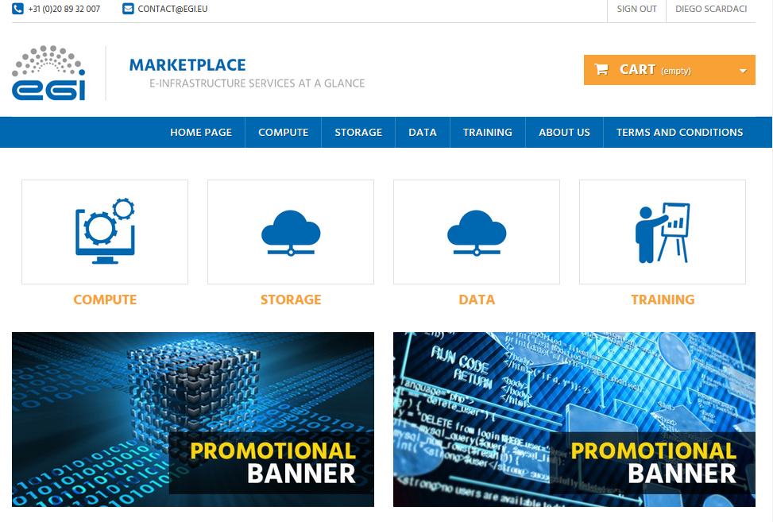
Figure 1. EGI Marketplace based on PrestaShop technology.

Open IRIS prototype

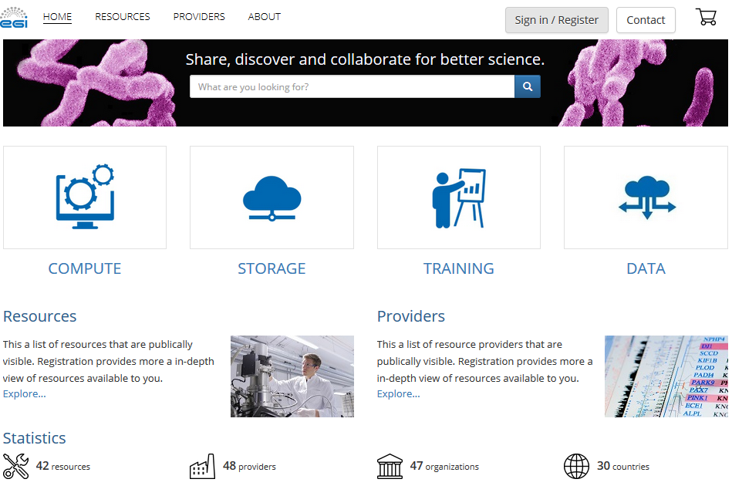
Figure 2. The EGI Marketplace based on Open IRIS technology.

Final analysis

Feedback on satisfaction
Who was involved in testing and what the outcome of the review was

Plan for Exploitation and Dissemination
This section should provide a plan for exploitation and dissemination (PEDR) of the project results documented in this deliverable. If a plan was already provided in an earlier deliverable, then this plan should provide an update. The content will be used to update the catalogue of project results (http://go.egi.eu/egi-engage-results) and to develop an overall PEDR for the whole project. You can create as many tables as the number of results being described.

Name of the result | Short name for the result (results generated under the project could be any tangible or intangible output, more particularly data, knowledge or information whatever its form or nature, whether it can be protected or not.)
DEFINITION
Category of result | - Technical input to standards: Technical specifications or extensions to standards adopted within the project  - Policy & Procedure developments: Technical procedures directed at users, service and infrastructure providers (for example to govern access and allocation to resources), policy reports and recommendations, and strategic analysis  - Software & service innovation: Software developments: (e.g.: workflows, Virtual Machines, applications), new software services deployed for the direct benefit of researchers (e.g.: web portals, gateways), e-Infrastructure Commons such as accounting, AAI, and the Federated Cloud platform and the Open Data platform, demonstrators and prototypes.  - Business model innovation: Business and sustainability-related outputs (the EGI Service Marketplace concept, the contribution to the Innovation space for the big data value chain, sustainability plans, pay-for-use models)  - Know-how: Includes all results from fact-finding activities (e.g. surveys, requirement gathering), but also the results from internal exercises (e.g. security challenges) and outputs that can be used for knowledge transfer as training materials.
Description of the result | Description of the result
EXPLOITATION
Target group(s) | Describe who will use those results. Es: RIs, international research collaborations and the long-tail of science, industry/SMEs, service providers, Funding agencies and decision/policy makers, Standardisation bodies"
Needs | What are the needs of the target groups that the results aims to fulfil?
How the target groups will use the result? | How the project result will be used? How are you going to achieve the best benefits from the project outcomes? How can you make sure the results they owned are used:  - in further research activities other than those covered by the project concerned  - in developing, creating and marketing a product or process  - in creating and providing a service  - in standardisation activities  Note: The exploitation does not need necessarily to be done by participants, who may prefer to ensure its use by another entity. Such indirect exploitation can be performed by licensing the results or assigning them to third parties, in accordance with the requirements established in the grant agreement "
Benefits | What are the expected benefits of the result when this will be used by the target groups?
How will you protect the results? | Protection of results is indeed essential in Horizon 2020, since an effective exploitation depends on it. Thus, participants must assess the possibility of protecting their results once these are generated. Please, describe what IP protection approach will you put in place for this result. This can range from simple attribution via open source license to full copyright for commercially exploitable results. (For more information you can read “How to manage IP in Horizon 2020: project implementation and conclusion” https://www.iprhelpdesk.eu/sites/default/files/newsdocuments/FS_IP_Management_h2020_implementation_0.pdf
Actions for exploitation | Please, describe the concrete actions that need to be executed to make the result reusable by the target group (e.g., for a software, this can include software packaging for distribution, documentation for the installation, etc). Once executed, the target groups should be able to use the results without barriers.
URL to project result | Link where the result will be made available
Success criteria | What are the success criteria in terms of adoption by the end of the project?
DISSEMINATION
Key messages | What messages will you tell to the target groups when informing about the results?
Channels | What channels will you use to deliver the messages to the target?  (e.g. Scientific publications, EGI web site, EGI newsletter, participation in conferences or trade fairs)
Actions for dissemination | Describe the concrete set of actions that will be put in place to disseminate this project output. When this result is ready, how will you reach to target group to ensure uptake of the result? (You can list the preliminary list of events where you plan to promote the results or material that will be produced or any other concrete actions that will be put in place during the project)
Cost | What is the expected cost of dissemination actions?
Evaluation | How will you evaluate the impact of the dissemination actions?

Future plans

- Related work

https://www.prestashop.com/en/documentation
http://iris.science-it.ch

