EGI-InSPIRE

Training Marketplace Work plan
(May-Sep 2011)

(TNA3.4)

Document identifier: | Workplan_TRAININGMARKETPLACE_2011May_v1
Date: | 10/06/2011
Activity: | NA3
Lead Partner: | STFC
Document Status: | DRAFT
Dissemination Level: | PUBLIC
Document Link: | https://documents.egi.eu/document/XX

Abstract
This document presents the goals and responsibilities of the Training Marketplace activity carried out within the TNA3.4 task of the EGI-InSPIRE project, provides an overview of its achievements from the 01/05/2010 – 30/04/2011 period and presents a detailed development and work plan for the 01/05/2011 – 19/09/2011 period (until the EGI Technical Forum 2011). The activity is responsible for the development and operation of the EGI Training Marketplace that is available at http://www.egi.eu/user-support/training_marketplace/.

- Copyright notice
Copyright © Members of the EGI-InSPIRE Collaboration, 2010. See www.egi.eu for details of the EGI-InSPIRE project and the collaboration. EGI-InSPIRE (“European Grid Initiative: Integrated Sustainable Pan-European Infrastructure for Researchers in Europe”) is a project co-funded by the European Commission as an Integrated Infrastructure Initiative within the 7th Framework Programme. EGI-InSPIRE began in May 2010 and will run for 4 years. This work is licensed under the Creative Commons Attribution-Noncommercial 3.0 License. To view a copy of this license, visit http://creativecommons.org/licenses/by-nc/3.0/ or send a letter to Creative Commons, 171 Second Street, Suite 300, San Francisco, California, 94105, and USA. The work must be attributed by attaching the following reference to the copied elements: “Copyright © Members of the EGI-InSPIRE Collaboration, 2010. See www.egi.eu for details of the EGI-InSPIRE project and the collaboration”. Using this document in a way and/or for purposes not foreseen in the license, requires the prior written permission of the copyright holders. The information contained in this document represents the views of the copyright holders as of the date such views are published.
- Document Log
Issue | Date | Comment | Author/Partner
V1 | 25/05/2011 | Initial STFC draft | Claire Devereux / STFC
V2 | 10/06/2011 | Second draft (update after F2F meeting with UCST) | Claire Devereux / STFC
V3 | 10/06/2011 | Final version | Gergely Sipos / EGI.eu
- Document amendment procedure
Amendments, comments and suggestions should be sent to the authors.
- Terminology
A complete project glossary is provided at the following page: http://www.egi.eu/about/glossary/.
- PROJECT SUMMARY

To support science and innovation, a lasting operational model for e-Science is needed − both for coordinating the infrastructure and for delivering integrated services that cross national borders.

The EGI-InSPIRE project will support the transition from a project-based system to a sustainable pan-European e-Infrastructure, by supporting ‘grids’ of high-performance computing (HPC) and high-throughput computing (HTC) resources. EGI-InSPIRE will also be ideally placed to integrate new Distributed Computing Infrastructures (DCIs) such as clouds, supercomputing networks and desktop grids, to benefit user communities within the European Research Area.

EGI-InSPIRE will collect user requirements and provide support for the current and potential new user communities, for example within the ESFRI projects. Additional support will also be given to the current heavy users of the infrastructure, such as high energy physics, computational chemistry and life sciences, as they move their critical services and tools from a centralised support model to one driven by their own individual communities.

The objectives of the project are:

- The continued operation and expansion of today’s production infrastructure by transitioning to a governance model and operational infrastructure that can be increasingly sustained outside of specific project funding.
- The continued support of researchers within Europe and their international collaborators that are using the current production infrastructure.
- The support for current heavy users of the infrastructure in earth science, astronomy and astrophysics, fusion, computational chemistry and materials science technology, life sciences and high energy physics as they move to sustainable support models for their own communities.
- Interfaces that expand access to new user communities including new potential heavy users of the infrastructure from the ESFRI projects.
- Mechanisms to integrate existing infrastructure providers in Europe and around the world into the production infrastructure, so as to provide transparent access to all authorised users.
- Establish processes and procedures to allow the integration of new DCI technologies (e.g. clouds, volunteer desktop grids) and heterogeneous resources (e.g. HTC and HPC) into a seamless production infrastructure as they mature and demonstrate value to the EGI community.

The EGI community is a federation of independent national and community resource providers, whose resources support specific research communities and international collaborators both within Europe and worldwide. EGI.eu, coordinator of EGI-InSPIRE, brings together partner institutions established within the community to provide a set of essential human and technical services that enable secure integrated access to distributed resources on behalf of the community.

The production infrastructure supports Virtual Research Communities (VRCs) − structured international user communities − that are grouped into specific research domains. VRCs are formally represented within EGI at both a technical and strategic level.

- EXECUTIVE SUMMARY
Developing a single, user focussed point of entry to the training area of the EGI website was identified as key to its future success. After a steady start in which services developed in EGEE by Edinburgh University were integrated into the EGI website there has been a rapid phase of development led by STFC which has seen new technologies and interfaces employed. Dependence on in house resources and customisations has been eliminated in all new developments.

The second and third versions of the Training Marketplace by STFC will offer a highly visible and accessible single entry point for users at http://www.egi.eu/user-support/training_marketplace/. Functionality of the v1 of this site will be expanded to including the ability to search for information, events and materials on any topic using a single search function. Events and materials can be rated and users can give feedback, embracing modern social endorsement methods. Tools such as the map and calendar have been integrated to offer users a choice of display formats. People can discuss their training requirements and NGIs and trainers can advertise resources and expertise and gather feedback on their ideas. V3 of this site by the time of the Technical Forum we hope to offer a gadget that will allow NGIs and VRCs to integrate the Training Marketplace into their own websites.

TABLE OF CONTENTS
1 Introduction 6
2 Activity SUMMARY 8
3 WORKPLAN 9
3.1 Technical details 10
4 Conclusion 11
5 References Error! Bookmark not defined.1

Introduction

The training coordination across the different projects and national teams will be facilitated by EGI.eu through a database of registered trainers (across all middleware types) and the advertising of planned training events.

Training will invariably be an underpinning element in the successful use and application of the ‘tools’ that become available through EGI. It is thus essential that suitable mechanisms are put in place to ensure the effective promotion (advertising), administration, documentation, tracking, and reporting of training programs and events, potentially even of online e-learning programs. A ‘Web site of training services’ was established under the EGEE project to meet these needs and this will continue to provide the principal vehicle for achieving the functions into the future.

A Training Working Group (TWG) has been convened to discuss the needs of the EGI community with respect to training and to capture and evaluate these requirements in order to support the effective development of the training ‘Market Place’ that will ultimately enable users and the user community to respond to the challenges and opportunities arising from the evolution of the EGI e-Infrastructure. The Group is accountable to the UCST under WP3 and its remit is as follows:

- To consider how User Support Teams from the NGIs and other partners can cooperate most effectively from the perspective of the delivery of quality training to as many members of the user community while avoiding duplication and wastage.
- To contribute and discuss training requirements and process these through the UCST Requirements Tracking System.
- To provide feedback to their organisations regarding the processing of training requirements.

The broad aims of this new training system will be to fulfil the evolving management and coordination role by creating an on-line Training ‘Market Place’, a sustainable framework within which the community of current, potential and future users can collectively build a comprehensive training resource on a collaborative basis. In as much as is possible, this collaborative training system will aim to:

- provide the ‘Road Signs’ to training related resources
- link training resources to relevant Applications and tools
- centralise and automate essential elements of the training advertising
- use self-service and self-guided services
- provide a centralized access to repositories of learning content
- consolidate training initiatives on a scalable web-based platform
- support, promote and establish standards relevant to training delivery
- enable knowledge reuse
- promote social bookmarking as a means of recording trainers and their credentials
- gather feedback and requirements
- provide statistical performance reports
Though EGI.eu has neither the mandate nor the capacity to undertake a training management function, to a large extent, the above stated tasks mirror many of the functions that traditionally form the basis of a Training Management System’, namely:

- Organisation wide training conformance
- Automated training set up (selection, bookings etc)
- Scheduling and assignment (of courses, trainers, venues, trainees and resources)
- Real time reporting (metrics for value/impact measurement)
- Streamline workflow
- Training histories
A third training-related service, the Trainers’ Registry, has been also inherited from EGEE. While this service was available for the EGI community for a few months in 2010, it has been recently put offline because neither the user communities, nor the NGIs considered this as a service that is valuable enough to be kept maintained and online. Should the community feel the need for a centrally stored registry of trainers, the training marketplace could integrate this in the future. A critical point is ensuring that the trainers’ profiles are maintained within such a registry.

Activity SUMMARY

The training services that EGI-InSPIRE took over from EGEE consisted of a training events calendar a Digital Library and a Trainers’ Registry. These systems were developed within the EGEE and its partner project and had been used successfully for many years. The systems have been developed and hosted at the UEDIN both during the EGEE projects and up until March 2011 within EGI-InSPIRE. Unfortunately, early in January 2011 UEDIN announced that they were closing down the department that had been doing this work which explained the unsatisfactory level of technical development from the institution previously.

On a positive note the training services continued to run during the course of the year and UEDIN staff addressed all technical problems as they emerged. What was lacking was a contribution of vision and engagement in the planning process. The UK JRU invited bids to host the services from its members and after peer review they reallocated the task to the Science and Technology Facilities Council (STFC) in March 2011 and took on the coordination and development of this service. A new developer and project manager were assigned and have been fully involved with the EGI Training TWG and the EGI.eu User Community Support Team (UCST), including attending face to face meetings to plan the development of the Training Marketplace. In addition to the developer an appropriate skilled support team exists at STFC, and STFC have been able to assign double the allocated effort to the activity to catch up with the slow rate of development in the initial phase of EGI-InSPIRE.

Before the end of March 2011 a new Training Marketplace gateway was released by STFC and integrated into the User Community Support pages of the EGI website. Previously the technology used for hosting the training services were MS SQL databases as back-ends for data storage for the trainers’ directory and the events calendar, with data extracted for the EGI website using coldfusion/php scripts. A Fedora (Open Source) repository was customised for the back end repository, holding the 9000+ training material items. The frontend to the Fedora repository was Drupal.

The initial plan for migration to STFC was to mirror these services and for the EGI site to point to them by the end of March 2011. The second phase of development (April onwards) was planned to utilize additional Drupal modules to perform the full functionality of the digital repository and migrating the training materials stored in Fedora into Drupal. Alongside the above outlined evolution of technologies there will be a project to redevelop the user interfaces to all training services. Developing a single, user focussed point of entry to the training area of the website was identified as key to its future success.

However, Edinburgh were unable to provide images of their machines used to host the training services within the timeframe outlined. This forced STFC to develop v1 of the Training Marketplace using new technology, the Drupal gateway, from scratch. The Training Marketplace gateway v1.0 is embedded into a frame in the EGI website and offers views of the training events registry. As an events registry it offers increased functionality to its predecessor by means of having calendar as well as list views. It also already offered users the ability to rate the training event and provide feedback that is visible to the community. The Trainers’ Registry has been removed from the Training Services portfolio, following a decision at the second User Community Board meeting: Virtual Research Communities did not find information about individual trainers useful (they are more interested in training capabilities and services offered by NGIs or projects), while NGIs had difficulties with keeping their trainers’ profiles up to date.

WORKPLAN
During the next period work will be focussed around the major release of v2.0 (estimated before 12 June 2011), a minor release of v2.5 by 31 July 2011, and a major release v3.0 before the Technical Forum.

Version 2 (April 2011 – June 2011).
Version 2.0 of the Training Marketplace will have a significantly new look and feel to the current v1.0. As such it is important to finalise all developments in this phase to prevent a series of subsequent minor releases that could confuse the user and reduce the effectiveness of site usage.

Version 2.0 of the Training Marketplace has been under development since April 2011. It contains significant increased functionality. This includes
- Map view of NGI training events, local gateways and NGI support teams
- Training wish list – web form for users to specify their needs and published list view of these requirements
- Advertise expertise and ideas – web form input for people to advertise their expertise, ideas and resources and published list view of these. For example, NGIs may wish to advertise a training resource, training VO, or a trainer may wish to advertise an idea for a course to gauge interest
- Advertise relevant MSc, PhD and other taught courses
- Integration of the existing 9000 Digital Library training repository materials
- Integration of advanced search functionality across all objects in the Training Marketplace. For example a search on the term gLite would find events and materials relating to the term.

Version 2 went live 07 June 2011.

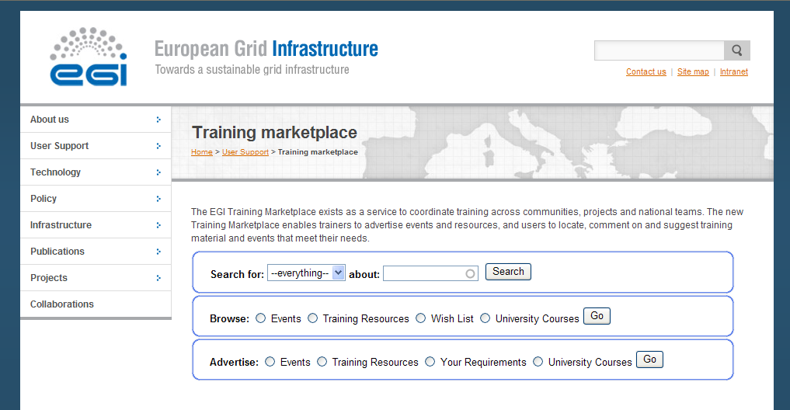

Figure 1. The Training Marketplace home page (version 2)

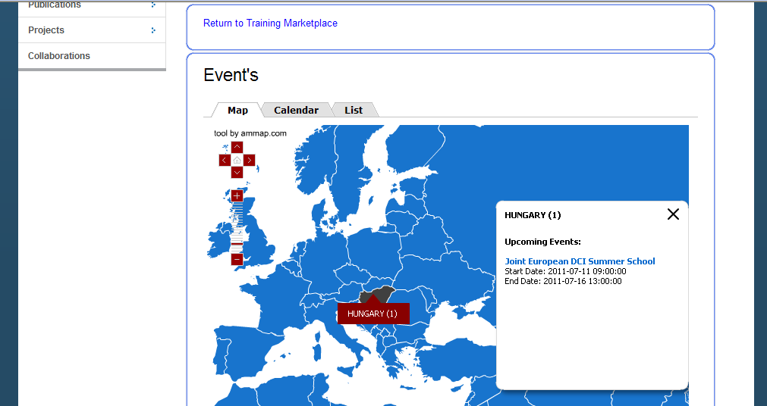

Figure 2. The events map view of the Training Marketplace in v2.0 showing the pop-up displayed by hovering the mouse over a country. The pop-up displays the newest 5 training events and further future events (if they exist) can be viewed by clicking on “more”

Task | Task name | Duration (weeks) | No. of persons involved | Expected date of completion by developer | Acceptance criteria | In production (10/06/2011)
T1 | Integration of ammap including dynamic listing of NGI events (v2.0) | 4 | 1 | 30-04-11 | Map displays in variety of browsers on EGI website
T2 | Integrate advanced search functionality across all elements of Training Marketplace (v2.0) | 1 | 1 | 30-04-11 | Search brings up results across events and materials
T3 | Wish list upload form and list display (v2.0) | 0.5 | 1 | 14-05-11 | Form available via website button
T4 | Expertise/ideas upload form and list display (v2.0) | 0.5 | 1 | 14-05-11 | Form available via website button
T5 | Taught courses upload form and list display (v2.0) | 0.5 | 1 | 14-05-11 | Form available via website button
T6 | Integration of existing digital library repository into training events website (v2.0) | 2 | 1 | 28-05-11 | Items integrated and obtainable via website

Version 2.5 and 3 (June 2011 – September 2011).
The user interface to the Training Marketplace will retain a similar look and feel between versions 3 and version 2, to ensure continuity and avoid confusion to the user. The most significant development task will be to create a gadget (or three separate gadgets) that will allow other projects to embed the Training Marketplace into their own websites and for the gadgets to be customisable. This customisation will mainly apply to the browse gadget and it will take the effect of showing a default view of the local region. An intermediate release (2.5) is planned for July with one new feature (T8).

Task | Task name | Duration (weeks) | No. of persons involved | Expected date of completion | Acceptance criteria | In production
T7 | Follow up requirements and bugs reported via EGI RT and Helpdesk | 1 | 1 | continuous | Historical requests uploaded and RT used to manage requests
T8 | “Report comment” field and functionality added to event feedback area (v2.5) | 1 | 1 | 15-07-11 | Clicking link fires email to UCST asking them to investigate
T9 | Hide feedback options until event has finished | 1 | 1 | 22-07-11 | Feedback option appears after end date of course
T10 | Develop tag cloud for wish list page | 1 | 1 | 29-07-2011 | Tag cloud displays on wish list web page
T11 | NGI / community gadget development  - Search functionality  - Forms  - Browse – configurable for location | 5 | 1 | 15-09-11 | Three gadgets are foreseen: one for searching, one for forms and one to browse. Browse options are configurable by region for NGIs
T12 | Integration with AppDB

Technical details
T1 – ammap technology chosen for mapping tool to retain same look and feel across EGI website. However, this required additional development to be able to capture dynamic information from the Drupal modules containing event information

T2 – Apache Solr integrated into Drupal website to enable advanced search functionality including search across blocks of text as well as titles, urls etc. Drupal’s existing search functionality has known limitations in these areas

T3-5 – enabled using a form in Drupal

T6 – Fedora currently retained as back end repository of training materials and Fedora, Apache Solr and Drupal have been integrated. Fedora configuration was copied from previous Digital Library configuration hosted at Edinburgh. This has allowed the 9000+ training materials to be imported into the Training Marketplace. However, the Fedora instance designed by Edinburgh is highly customised and lacks documentation. This will limit its future development and an alternative solution is being sought that will allow historical records in the repository to exist alongside newly uploaded materials
T7 – RT to be configured and requirements for future versions and bug fixes to be added from UCST, TWG and members of the community

T8 – customisation of Drupal module required. The service will allow the community to report inappropriate content to managers.

T9 - customisation of Drupal module required

T10 – Drupal module integration. The task will start only after there are enough items in the wishlist.

T11 – to be investigated along the lines of the AppDB gadget, which will allow the user to auto-generate code to embed in their website. This code will produce an iframe displaying the customised Training Marketplace

T12 - Beyond the period June – September 2011 we envisage developmental work to focus around cross-tool integration, for example between the AppDB and Training Marketplace. The focus of this task is yet to be defined. Integration of the tools via APIs or tags are foreseen as options.

Conclusion
Developing a single, user focussed point of entry to the training area of the EGI website was identified as key to its future success. After a steady start in which services developed in EGEE by Edinburgh University were integrated into the EGI website there has been a rapid phase of development led by STFC which has seen new technologies and interfaces employed. Dependence on in house resources and customisations has been eliminated in all new developments.

The Training Marketplace v2 and v3 developed by STFC offers a highly visible and accessible single entry point for users. Functionality has been expanded to including the ability to search for information, events and materials on any topic using a single search function. Events and materials can be rated and users can give feedback, embracing modern social endorsement methods. Tools such as the map and calendar have been integrated to offer users a choice of display formats. People can discuss their training requirements and NGIs and trainers can advertise resources and expertise and gather feedback on their ideas. By the time of the Technical Forum we hope to offer a gadget that will allow NGIs and VRCs to integrate the Training Marketplace into their own websites. Effort will be also spent on integrating the Training Marketplace with the EGI Application Database.

EGI Training Working Group: https://wiki.egi.eu/wiki/Training_Working_Group
Second EGI User Community Board meeting: https://www.egi.eu/indico/conferenceDisplay.py?confId=313

