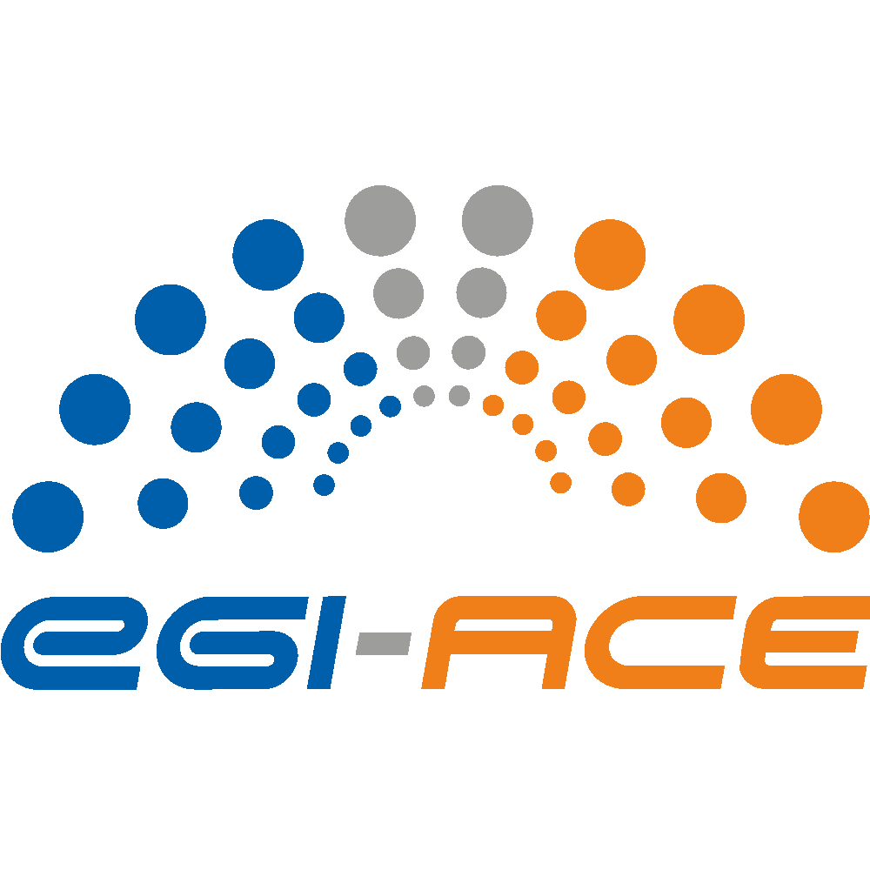
D2.9 EOSC Compute Platform Handbook

Lead partner: | EGI Foundation
Version: | 1
Status: | Under EC Review
Dissemination Level: | PUBLIC
Keywords: | EOSC, Compute, Handbook, EOSC Compute Platform
Document Link: | https://documents.egi.eu/document/3797

Deliverable Abstract
This is an final version of the EOSC Compute Platform Handbook. The EOSC Compute Platform Handbook is written for EOSC users to provide guidance on how to use the various services of the EOSC Compute Platform. The EOSC Compute Platform (ECP) is a system of federated compute and storage facilities together with higher level platforms to support various data and application hosting, data processing and analysis use cases.

COPYRIGHT NOTICE
This work by parties of the EGI-ACE consortium is licensed under a Creative Commons Attribution 4.0 International License. (http://creativecommons.org/licenses/by/4.0/).
EGI-ACE receives funding from the European Union's Horizon 2020 research and innovation programme under grant agreement no. 101017567.

DELIVERY SLIP
 | Name | Partner/Activity
From: | Giuseppe La Rocca | EGI Foundation/WP2
Moderated by: | Sjomara Specht | EGI Foundation/WP1
Reviewed by: | Gianni Dalla Torre,  Ignacio Lamata Martínez | EGI Foundation  EGI Foundation
Approved by: | SDS

DOCUMENT LOG
Issue | Date | Comment | Author
v.0.1 | 31.05.2023 | Full draft for external review | G. La Rocca  E. Fernandez  A. Manzi  L. Farkas
v.0.2 | 16.06.2023 | Incorporated comments/feedback from reviewers and produced the final version of the document. | G. La Rocca
v.1 | 26.06.2023 | Final

TERMINOLOGY
https://confluence.egi.eu/display/EGIG

Contents
Executive summary 5
1 Introduction 6
1.1. What is EOSC? 7
1.2. What is the EOSC Compute Platform? 8
1.3. How the Compute Platform supports FAIR Principles 10
1.3.1. Findable 10
1.3.2. Accessible 11
1.3.3. Interoperable 11
1.3.4. Re-Usable 12
1.4. Data Privacy 13
1.5. The Handbook and You 14
2. Accessing the EOSC Compute Platform 15
2.1. The EOSC Portal 15
2.2. The EOSC Cloud Compute Delivery model 16
2.2.1. Engagement with individual users (long tail of science) 17
2.2.2. Engagement with structured communities 17
2.2.3. Characteristics of the EOSC engagement process 18
2.3. Evaluating Requests and Granting Access 18
3. Accounts in the EOSC Compute Platform 21
3.1. Setting up Your Account 22
3.2. Cost of Use 23
4. Working with Data 24
4.1. Range of Data Services 24
4.2. Storing and Managing Research Data 26
4.2.1. Online Storage - Grid Storage 27
4.2.2. EGI Rucio 28
4.2.3. EGI Data Transfer 28
4.2.4. EGI DataHub 29
4.2.5. Online Storage - Block Storage 32
4.2.6. Online Storage - Object Storage 32
4.3. Additional Data Management Cases 33
4.4. The EOSC Data Transfer Service 34
5. Working with Compute 37
5.1. Software Distribution 38
5.2. Cloud Compute 41
5.3. Container Compute 42
5.4. High Throughput Compute 43
5.5. High Performance Compute 44
5.6. Workload Management 45
6. Other Advanced Services 48
6.1. Machine Learning 48
6.1.1. DEEP Open Marketplace 48
6.1.2. DEEP Training Facility 49
6.1.3. DEEP Development Environment 50
6.1.4. DEEPaaS API 50
6.1.5. DEEP Storage 50
6.1.6. DEEP Authentication and Authorisation 50
6.2. Development Environments 51
6.2.1. Notebooks 51
6.2.2. Replay 53
6.3. Cloud Orchestrators 55
6.3.1. Infrastructure Manager 56
6.3.2. Elastic Cloud Computing Cluster 58
6.3.3. PaaS Orchestrator 60
6.3.4. Dynamic On-Demand Analysis Software 61
7. Consultants 63
7.1. Generic Support 63
7.2. Services Supporters of the EOSC Compute Platform 63

Executive summary
Starting from 2021, EGI-ACE has played a key role to implement the Compute Platform of the European Open Science Cloud and contributed to the EOSC Data Commons through a federation of cloud compute and storage facilities, PaaS services and Data Spaces with analytics tools and federated access services.
The main objective of this report is to provide official documentation on how users from different scientific disciplines can use the services offered by the EOSC Compute Platform for supporting data- and compute-intensive research.
After a brief overview about the EOSC Compute Platform, the handbook provides an in-depth view on the Platform services which are grouped into three main categories: Compute, Data and Advanced services.
During the second part of the project, important milestones were reached in the three key areas. In Section 4, 5 and 6, users will explore recent updates and learn how to work with data, utilise computing solutions, and more, as offered by the EOSC Compute Platform.

Introduction
Over the last 30 months, the EGI-ACE project has implemented the Compute Platform of the European Open Science Cloud and contributed to the EOSC Data Commons by offering integrated computing, platforms, data spaces and tools as an integrated solution that aligns with major European cloud federation projects and HPC initiatives.
The main objective of this document is to provide EOSC users guidance on how to use the various services of the EOSC Compute Platform and serves as a comprehensive introduction to the services provided by the Platform. For EOSC users, this Platform appears as an open, data-centric, distributed, hybrid and secure infrastructure, consisting of a growing number of cloud, High-Throughput Compute (HTC) and High-Performance Compute (HPC) providers. This Platform will be accessible with a mix of funding mechanisms through interfaces that leverage standard-compliant solutions for federated authentication, authorization and compute management at nationally provided, distributed compute and storage facilities.
Compared to the first release of the handbook (D2.5), in this document special attention will be devoted to describing the most recent updates in the three main service categories of the EOSC Compute Platform.
In the category of services for “Data”, found in Section 2, the following updates are presented:
- The new EOSC Data Transfer Portal. The service, jointly developed by OpenAIRE and EGI-ACE in the context of the EOSC Future project, allows researchers to navigate the EOSC Marketplace, discover datasets of interest, and trigger the transfer of these datasets to the EOSC Compute Platform for data analytics. Specifically, the service leverages the EGI Data Transfer service to move datasets published in Zenodo and B2Share to the computing resources of the EOSC Compute Platform operated by EGI.
- The new features available in the EGI DataHub service.
In the category of services for “Compute”, found in Section 3, the following updates are presented:
- The Binder-based solution that, combined with the JupyterHub-based solution, offers researchers a scalable and user-friendly computing environment for big data and big compute analytics contributing to the reproducibility of Open Science.
- Rancher, the well-known Kubernetes Management platform, that the EOSC Compute Platform has started to offer as a solution for users working with containers. This solution provides end-users with a full software solution to operate and run complex containerised workloads.
- Recent updates with the Software Distribution service based on CernVM-FS.
Finally, in the Advanced service category in Section 4, the following update is presented:
- The evolved solution of DODAS, the Platform as a Service (PaaS) that now offers a more intuitive GUI to help scientific communities deploy complex virtual infrastructures for scientific data analysis from scratch.
The rest of this section is organised as follows:
- A brief introduction of the European Open Science Cloud (EOSC), the umbrella initiative of the Compute Platform, is provided in Section 1.1.
- A high-level overview of the services of the EOSC Compute Platform is described in Section 1.2.
- The implementation of the FAIR principles (Findable, Accessible, Interoperable, and Re-usable) in the EOSC Platform is discussed in Section 1.3.
- Data privacy considerations and its policies are outlined in Section 1.4.
- The next steps to be followed in this Handbook are presented in Section 1.5.

What is EOSC?
The European Open Science Cloud (EOSC) is an initiative of the European Commission (EC) and its Member States with the ambition to develop a ‘Web of FAIR Data and services’ for science in Europe. EOSC will be a multi-disciplinary environment where researchers can publish, find and re-use data, tools, and services, enabling them to work more efficiently.
EOSC builds upon the existing infrastructure and services supported by the EC, Member States, and research communities. It brings these together in a federated ‘system of systems’ approach, adding value by aggregating content and facilitating collaborative utilization of services.
EOSC aims to become Europe’s trusted virtual environment for 1.7 million European researchers and 70 million professionals in science, technology, humanities, and social sciences, in order to accelerate the creation of new knowledge, inspire education, stimulate innovation and promote accessibility and transparency.
The vision of EOSC was conceived in 2015 and officially launched in November 2018, with access to an initial set of services through the EOSC Portal. In recent years, the EC provided financial support to implement EOSC by means of projects under the EU Framework Program for Research and Innovation (Horizon 2020 and Horizon Europe), by means of Working Groups (in 2019-2020), and most recently in the form of Advisory Groups (from 2021).
The EOSC Association was established in Brussels in July 2020, to act as the focal point for the EOSC Partnership. It was founded as a Belgian non-profit Association (AISBL) and is open to interested stakeholder organisations that meet the published Rules of Participation.
In June 2021, the European Commission and the EOSC Association launched a Co-programmed European Partnership until 2030, aiming to strengthen EOSC with European funding of almost €500 million, and an in-kind contribution from partners of an additional €500 million. The main high-level General Objectives (GOs) of the Co-programmed European Partnership are defined as follows:
- GO1: Ensure that Open Science practices and skills are rewarded and taught, becoming the “new normal”.
- GO2: Enable the definition of standards, and the development of tools and services, to allow researchers to find, access, reuse and combine results.
- GO3: Establish a suitable and federated infrastructure enabling open sharing of scientific results.

What is the EOSC Compute Platform?
The EOSC Compute Platform is a system of federated hybrid compute and storage facilities, research data hosting, processing and analytics tools, and a set of complementary services for distributed data and computing, to support processing and analytics for distributed data and computing use cases for Open Science. The Platform is built on the EGI Federation, and it is offered by the EGI-ACE Project. The Platform federates the capacity of some of Europe’s largest research data centres and offers heterogeneous systems to meet different research needs, including state-of-the-art GPGPUs and accelerators supporting Artificial Intelligence (AI) and Machine Learning (ML), which makes the Platform an ideal innovation space for AI/ML applications. The Platform is offered with different costs and funding models to ensure that the diverse scientific communities can meet their needs and benefit from the investment from the European Commission and the Member States. The technical architecture of the EOSC Compute Platform is multi-layered (See Figure 1).
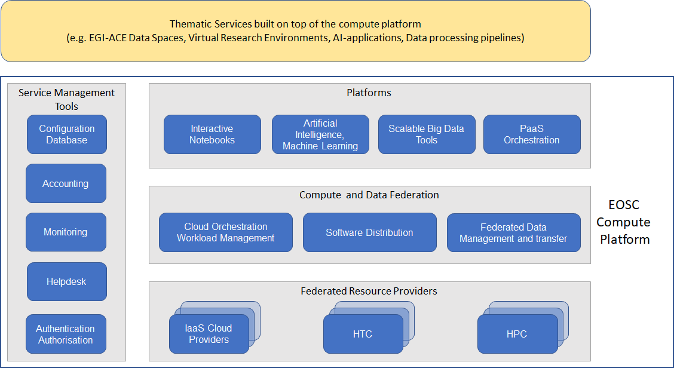
Figure 1 - The EOSC Compute Platform architecture
- The Federated Resource Providers layer provides an Infrastructure-as-a-Service (IaaS) hybrid infrastructure from academic and commercial providers to run and/or host research applications and data. The IaaS component of the EOSC Compute Platform are collaboratively provided by High Throughput Computing (HTC, described in Section 5.4), High Performance Computing (HPC, described in Section 5.5) and research cloud providers that are members of the EGI Federation from the following regions: Central Europe (Czech Republic, Germany, Poland, Slovakia), South Eastern Europe (Bulgaria, Romania, Turkey), Southern Europe (Italy, Portugal, and Spain), and Western Europe (France and The Netherlands). Through the Virtual Access (VA) funding mechanism, the capacity of the Federated Resource Tier is pre-paid by the EC and offered to researchers and projects of publicly funded environments.
- The Compute and Data Federation layer provides advanced solutions to facilitate common, recurring tasks in the hybrid IaaS federation, such as software distribution, virtual infrastructure orchestration and data management (e.g., transfer, replication, caching, etc).
- The Platforms layer extends the IaaS delivery model with high-level abstractions that simplify the execution of researchers’ workloads. It offers generic Platform-as-a-Service (PaaS) services that exploit the compute and storage resources of the lower level layers to create value-added services, such as development environments (see Section 6.2), Machine Learning and Deep Learning applications for data analysis (see Section 6.1), scalable Big Data tools, and Workload Management tools (see Section 5.6).
- The Service Management Tools enable user access to the EOSC Compute Platform (via authentication and authorisation mechanisms) and integrate the Compute Platform services with the rest of EOSC components. This layer includes Helpdesk, Monitoring, Accounting, Operations Management, Security and Incident response, and Software Quality Assurance.
On top of the Compute Platform are the Thematic Services, which are scientific domain-specific services and tools that provide simulation, machine learning and data analytics capabilities tailored to the needs of the specific research areas.

How the Compute Platform supports FAIR Principles
The European Commission aims to make science open and accessible to everyone, by enabling open access to research data, facilitating data sharing and reuse, and establishing mechanisms for interdisciplinary joint scientific collaborations. This section describes how the EOSC Compute Platform encourages the implementation of best practices according to the Findable, Accessible, Interoperable, and Re-usable (FAIR) principles, to achieve the implementation of distributed and federated virtual environments to store, manage, and share research data.

Findable
Metadata and persistent identifiers play a key role in findability, as they assist both human and computer users in the discovery of relevant assets. Both are intrinsic features of the EOSC Compute Platform. The Compute and Data Federation services layer depicted in Figure 1 exposes discoverable datasets and staging data inside and outside the EOSC Compute Platform Cloud. Services such as Rucio and DataHub provide abstraction layers to discover and access datasets stored in repositories with different technology in a scalable way. These solutions are used by large scientific communities, such as SeaDataNet, whose international oceanography community used DataHub to provide unified discovery and access to the large volumes of distributed marine and ocean data sets managed by marine data centres. Additional details about the Data Federation services can be found in Section 4.
The discovery of domain-specific software and pre-configured Virtual Machine images (e.g., Virtual Appliances) is made possible by the Application Database (AppDB) service of the Platform, which makes extensive use of metadata. Researchers in any community can easily discover and reuse software and Virtual Appliances that have been registered in AppDB and are offered natively.
Services such as DataHub use internal persistent identifiers for data assets, and implement mechanisms to connect to external handle systems to assign persistent identifiers, such as DOIs (Digital Object Identifiers), to datasets. In the long-term, the guidelines to address the Findability of Open Science will be further extended by the PID Policy and Implementation Task Force (TF) of the Implementation of EOSC Advisory Group. This TF is preparing recommendations to bridge the gaps raised in the SRIA document, promote the use of mature and recognised PID infrastructures, standardise the use of PIDs graphs, and integrate PIDs into FAIR Data Management.

Accessible
Access to the EOSC Compute Platform resources, such as datasets and services, are protected by strong security mechanisms. This aspect of the FAIR principle is an important requirement both for providers operating services in the Platform, who want to control who can access their resources, and for researchers in scientific communities, who want to access and use the resources offered by the Platform in a uniform and easy manner. The Platform provides a high-level authentication and authorisation mechanism via the EGI Check-in service. Check-in is part of EGI’s Authentication and Authorisation Infrastructure (AAI) and operates as a proxy service that connects federated Identity Providers (IdPs) with the Service Providers (SP) registered in the Platform. Access to datasets and applications hosted on the Compute Platform can be defined through Check-in, ensuring user identity (authentication) and enabling resource access based on a highly configurable group membership (authorisation). To guarantee the Accessibility aspect of the FAIR principle the Platform promotes the adoption of standard protocols to facilitate the data retrieval and the use of metadata to reference datasets, even when the data are no longer available. As an example, to demonstrate how the Platform contributed to support accessibility (A in FAIR) to data objects we highlight the collaboration started between ECRIN (the European Clinical Research Infrastructure Network), OneData and INFN. During this collaboration, the EGI DataHub service was adopted to harvest metadata about the data objects, including object provenance, location, and access details from a variety of source systems, and aggregate it in the ECRIN Clinical Research Metadata Repository (MDR). For further details, please refer to the official website.

Interoperable
Present and future services of the EOSC Compute Platform are developed in accordance with EOSC security policies and the interoperability guidelines for distributed computing and authentication-authorisation. The adoption of these interoperability guidelines, which encourage the development of modular services and the adoption of standard interfaces, allows domain-specific Thematic services to combine mature software tools, datasets, and services in order to address the needs of the different scientific communities.
Services of the Platform generally attempt to provide access through standard REST Application Programming Interfaces (API), which uses HTTP as the network protocol and provide OpenAPI compliant specifications to facilitate interoperability and composability of services.
The Workload Management Service, based on the DIRAC technology, represents one of the high-level solutions to ensure interoperability with the distributed heterogeneous resources. As an example, this service is currently used by the WeNMR structural biology community to run millions of jobs that predict, model, and dissect biomolecular interactions at the atomic level.

Re-Usable
Although reproducibility lies at the heart of science, it still remains one of the greatest challenges. From a technical perspective, the reproducibility of research outcome requires a detailed description of the computational environment used to conduct a study, including the data, software and dependencies used, together with documentation describing how all the different pieces fit together and contribute to producing the scientific result.
To enhance reproducibility and facilitate reproducible research, the Platform offers an interactive, Web-based piece of software called Jupyter Notebook (described in Section 6.2.1) complemented with Binder (described in Section 6.2.2). Jupyter Notebook allows users to create data and code-driven narratives made of interactively executable code, equations, descriptive text, interactive dashboards, and other rich media. In combination with the container-based execution environments of the EOSC Cloud Compute Platform, Jupyter Notebook improves the reproducibility of analysis. The growing popularity of computational notebooks presents a unique opportunity to support reproducible research. However, the reproducibility of the notebooks also depends on the availability of the required data it uses. Herein, it is normally recommended that users share the required input dataset alongside the Jupyter notebooks, which can readily be done through repository services such as GitHub and Zenodo. This guarantees that datasets are persistently and uniquely identified via Digital Object Identifiers (DOIs). Zenodo is an open access repository for research publications, scientific data and other 'research objects' and, together with Jupyter and Binder, is considered a key pillar of Open Science.
EGI-ACE provides access to Jupyter Notebook and Binder to offer an interactive and reproducible computing platform for building powerful development environments, as discussed in Section 6.2. These environments, combined with the DataHub service, have been tested in a pilot data transfer activity in the context of the PaNOSC project.

Data Privacy
The EOSC Compute Platform services comply with a set of policies that ensure that the services operate in good faith, without deliberately exposing the user to security risks, without claiming intellectual property of user-owned data, and protecting sensitive data generated during interactions between users and the services. The services do not access or use customer content for any purpose other than as required by law and to maintain the services and provide them to the service customers and their end users.
More specifically, to be part of the EOSC Compute Platform, the service provider must:
- Comply with the EGI’s Policy on the Processing of Personal Data.
- Provide its own Privacy Policy, which can be based on the Privacy Policy template provided by the AARC Policy Development Kit (PDK).
- Comply with all principles established in the GÉANT Data Protection Code of Conduct.
- Meet all requirements of any relevant EGI policies or procedures and must also be compliant with the relevant national legislation.
When accessing a service through EGI Check-in, the user is shown both the Terms of Use and a Data Privacy Policy, and consent to transfer data to the provider is required. These documents cover all aspects required by the GDPR (e.g., who is the Data Controller and the Data Processor, what personal data are processed when accessing and using the service, how long personal data will be retained for, etc.). Additionally, Check-in also maintains a browsable list of regulatory documents for further reference. If users need to process personal data on the services as part of their research activities, the EOSC Compute Platform can support the creation of specific Data Processing Agreements to comply with GDPR requirements.

The Handbook and You
If someone else has already organised access for you on the EOSC Compute Platform, then you can probably skip ahead to Section 4, Section 5, and Section 6. You will learn about working with data, using the computing solutions, and more, as offered by the EOSC Compute Platform.
If you need to request access and set up an account on the EOSC Compute Platform, please continue to Section 3, which explains the process step by step. Additional information about the main stakeholders of the EOSC Compute Platform and how the services of this Platform are offered to them is provided in Section 2.

Accessing the EOSC Compute Platform
EGI-ACE's primary objective is to deliver services for Open Science. The project makes the services via two channels, both fitting to different audiences:
- Individual users interested in one or few services for a relatively short period of time are served via the EOSC Portal and the Marketplace. More detailed information about the EOSC Portal and the Marketplace are provided in Section 2.1.
- Structured scientific communities, research projects and Research Infrastructures require combined, and customised integration of Compute Platform services. They are served via the EGI-ACE open call, which is explained in Section 2.2.2.

The EOSC Portal
The EOSC Portal (See Figure 2.1) is a catalogue that brings services and resources (e.g., databases, data catalogues) designed for Open Science visible in a single place. Through the EOSC Portal, researchers can discover open and seamless services, data, and other resources from a wide range of national, regional, and institutional public research infrastructures across Europe. Through the Marketplace section of the Portal (See Figure 2.2) users can access the services either in fully open access mode, or after service-specific authentication and authorisation steps.
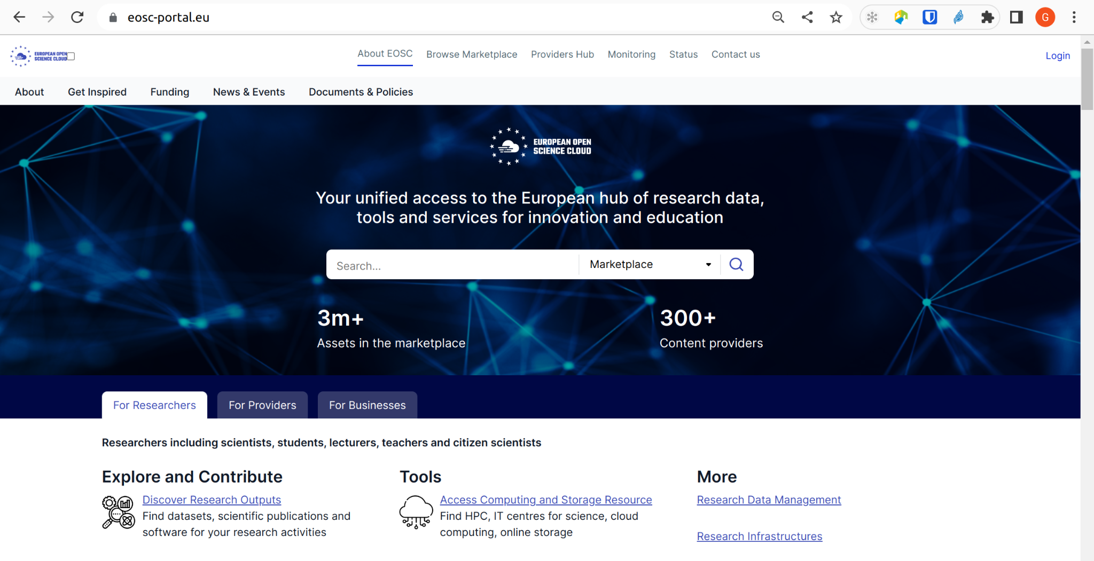
Figure 2.1 - The EOSC Portal website
In the context of the EOSC Future project, interoperability guidelines will be developed to further extend the Portal in order to help services to be compliant with specific standards or interfaces. These guidelines will contribute to facilitating the interoperability of datasets and tools from different providers and enable researchers to perform their work more quickly and disseminate their research results more widely. The EOSC Portal offers information for potential service providers on how to onboard their services to the EOSC Portal Catalogue and Marketplace.
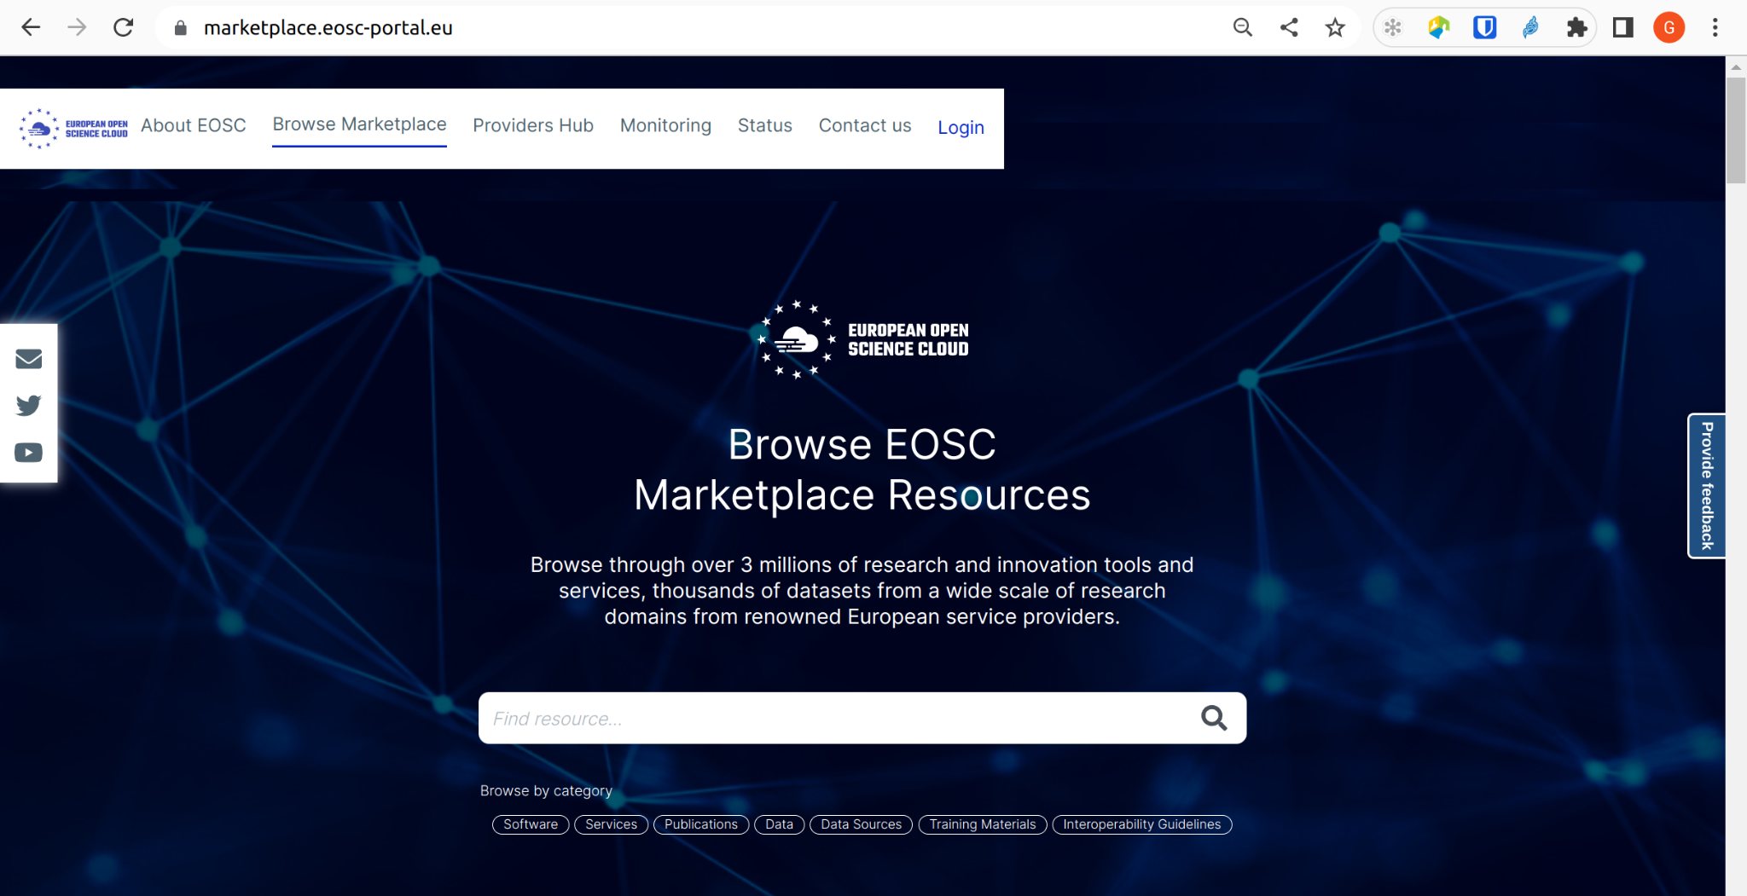
Figure 2.2 - The EOSC Marketplace website
The EOSC Portal Marketplace is the user interface for researchers looking for quality services for Open Science. From a technical perspective, from the EOSC Portal Marketplace, researchers can browse the catalogue and explore multi-disciplinary resources from leading organisations. The Marketplace offers capabilities to manage the entire research data lifecycle, from creation to processing, analysis, preservation, access, and reuse. Through the EOSC Marketplace, users can also get assistance from international technical teams who provide advice on the most suitable solutions to address their digital needs.

The EOSC Cloud Compute Delivery model
In this section, we will dive into the engagement process designed in the context of the EGI-ACE process to expand the demand side of EOSC across sectors and scientific disciplines. To engage with simple researchers and multi-national scientific communities, two channels have been defined, as shown in Figure 2.3.
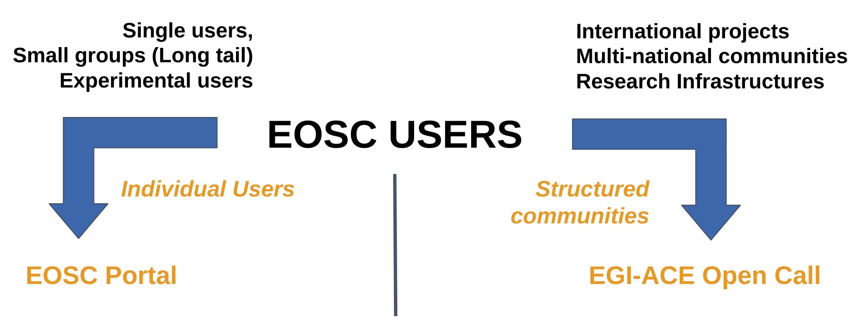Figure 2.3 - The EOSC Compute Platform delivery model

Engagement with individual users (long tail of science)
For single or small groups of users involved in piloting activities, the EOSC Compute Platform has already pre-allocated, ready-to-use resources. Requests to access the pre-allocated resources and high-level solutions offered by EOSC can be submitted directly via the Marketplace. From the Marketplace, this stakeholder group can easily discover the EOSC resources and services that suit the specific use cases. For example, this method was used by researchers from the Mario Negri Institute for Pharmacological Research in Milan, who focused on the identification of new markets aimed at predicting and preventing the development of epilepsy in individuals exposed to risk factors. Similarly, during the COVID-19 pandemic, researchers from the University of Bologna addressed the relationship between coronaviruses, human health, pig health and animal breeding in their most recent research. In practice, they investigated how pigs could represent a risk source of coronavirus infections for humans as this could cause damaging effects by disrupting livestock production chains. Also, researchers from the University of Helsinki in Finland used the Chipster platform to help virologists make sense of millions of virus genomes. In all these examples, the high-level solutions offered by EOSC contributed to support their research activities and stimulate innovation.

Engagement with structured communities
For projects with international footprint, Research Infrastructures (RIs) and multi-national communities, the EGI-ACE project has opened a call for use cases. Overall, this stakeholder group is mainly interested in the EOSC service offerings for long-term, customised use (more than three years) and, for this reason, this group provides an excellent opportunity to expand the demand side of EOSC across sectors and scientific disciplines.
Through the open call, EGI-ACE offered access to the EOSC infrastructure and platform services, dedicated user support and training. The access to services of the EOSC Compute Platform is sponsored by the European Commission via the Virtual Access (VA) mechanism and various national and institutional funding. More details about the cost of use are provided in Section 3.2.
For this stakeholder group, EOSC offers dedicated technical support, access to pledged resources and services with tailored configurations for helping the group to address a specific need.

Characteristics of the EOSC engagement process
Table 2.1 - Main characteristics of the two engagement processes
Process Type | Characteristics
Engagement with individual users | - Optimised towards ready-to-use resources  - Short-term engagement (weeks/months)  - Encourage self-service configurations  - Site-level support via the EGI Federated members  - Available users docs
Engagement with structured communities | - Optimised towards custom allocation of resources  - Long-term partnership (years) with agreed MoU or Collaboration Agreements  - Dedicated support via the EGI Federated members involved in the agreed MoU or Collaboration Agreements  - Custom set-up of services configuration

For individual users, the starting point is to submit a service order via the EOSC Marketplace at: https://marketplace.eosc-portal.eu.
For structured communities, the project offers the possibility to submit use case applications at: https://www.egi.eu/projects/egi-ace/call-for-use-cases/. The evaluation process used to decide which use cases will be officially supported is described in the following section.

Evaluating Requests and Granting Access
The review of the EGI-ACE use cases submitted by structured communities is carried out by multiple reviewers in a blind peer-review fashion. During the review process, the following four different aspects of the use case are assessed:
- Maturity: This assessment determines the current state of maturity of the application/platform proposed by the scientific community, understanding what it does and the results it produces.
- Feasibility: This assessment determines whether the objectives can be realistically achieved within the envisaged timeframe, and if there are special needs for technical support, training, and services.
- EOSC readiness: This assessment determines whether there are clear plans to share the ultimate results (datasets, services, etc.) in EOSC.
- Impact: This assessment determines the impact of the use case across Europe, or even beyond Europe.

If the use case is accepted during the peer-review process, the project grants access to infrastructure and to the platform’s services and resources and offers dedicated support and training when needed. More specifically, the support is offered taking into consideration different aspects, such as:
- The beneficiaries of the use case,
- Countries where the community has a footprint,
- How much the scientific topic matches the EGI members’ support priorities, and
- National and institutional investments.
At the end of the peer-review process, if the use case is accepted, the following level of support are offered by the project:
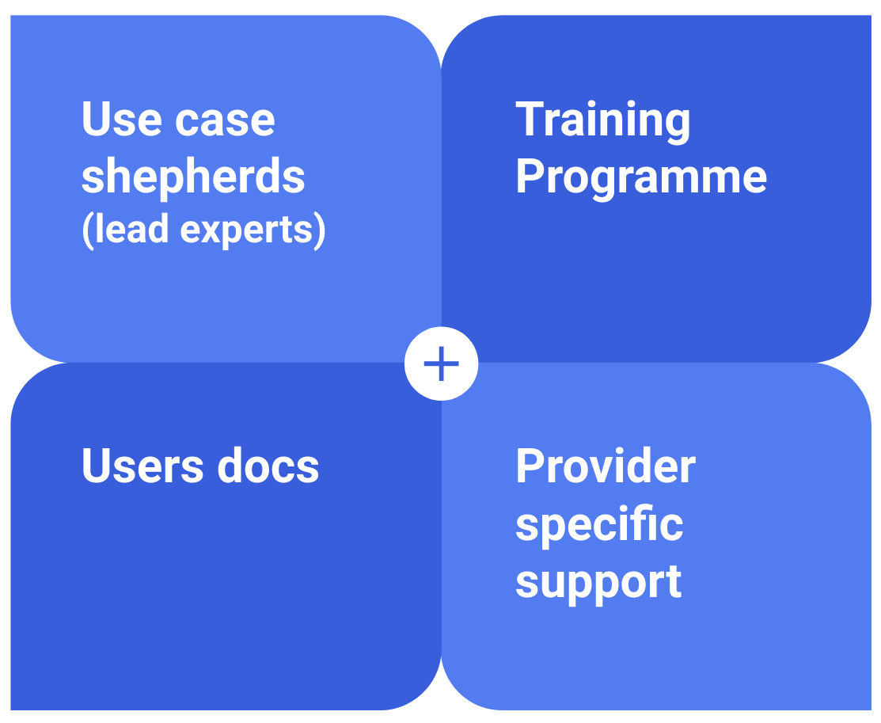
Figure 2.4 - The level of support offered by EGI-ACE to scientific communities
- Assign technical lead experts: Shepherds are technical experts who are assigned to the use cases that are served by the project and have the overall responsibility for mapping the use cases to providers, managing the implementation of the use cases, and reporting about achievements, lessons, and other outcomes. Shepherds create “Competence Centres”, which are use case specific support groups that consist of service providers, technical experts and other interested parties providing assistance for a use case.
- Training programme: To improve technical skills of researchers and scientific communities on the EOSC Compute Platform services, the project delivers a detailed training programme. This training programme is composed by online webinars available on the official website. If travelling or physical presence is needed, additional face-to-face events can be organised.
- Users docs: Documentation about the EOSC Compute Platform services to target the needs of Users and Providers is available on the website.
- Provider specific support: If necessary, dedicated support from the services/resources providers is offered to support the specific needs of the use case.

Accounts in the EOSC Compute Platform
Before getting access to the services and resources of the EOSC Compute Platform, it is necessary to register an account. Different options are offered to access the services and the resources of the Platform. More specifically, the access to the Platform is primarily based on the OpenID Connect (OIDC) standard, which replaces the legacy authentication and authorisation based on X.509 digital certificates. X.509 digital certificates are still used to grant access to HTC computing and storage resources even if its use is soon to become deprecated. Local accounts are still adopted to access HPC clusters of the IaaS hybrid layer.
Pros and cons in using local accounts, X.509 digital certificates, and token-based authentication mechanisms to access the services of the EOSC Compute Platform are reported in Table 3.1.
Table 3.1 - Use of different accounts in the EOSC Compute Platform: pros and cons
Type | Pros | Cons
Local account | - Access with public key Authentication.  - File transfer and Web applications are available. | - Scalability
X.509 Certificate | - Trust - Digital certificates allow individuals, organisations, and even devices to establish trust in the digital world.  - Scalability - it can secure billions of messages exchanged daily across the internet. | - Usability - X.509 certificates are difficult to handle for users.  - Interoperability - Hard to integrate identity federations.
OIDC token | - Accelerate the process by allowing users to sign into websites with a single click.  - Reduce frustration associated with maintaining multiple usernames and passwords.  - Gain greater control over online identity. Users can control how much personal information can be shared with websites.  - Reduced password security risks. | - The sign-in process sometimes can be confusing – It may require navigating to another site and giving consent to authorise the release of personal information.

Setting up Your Account
The following section details the steps through which researchers can quickly create a personal account to start profiting from the EOSC Compute Platform to support their daily work.
The EGI Check-in service provides a secure and user-friendly federated authentication and authorisation framework for helping researchers to access the different layers of the EOSC Compute Platform (see Figure 1.2). EGI Check-in enables Single Sign-On (SSO) to services through eduGAIN and other identity providers. Users without institutional accounts can access services through social media and other external accounts, including Google, Facebook, LinkedIn or ORCID (just to name a few). From a technical perspective, to grant access to the Platform, Check-in uses two different tools: COManage and PERUN.
- To register an account, please go to https://aai.egi.eu/signup and complete the login process. The full registration flow to register a personal account is described in the official documentation.
Once the account has been registered, users of the Computing Platform can leverage the EGI Check-in service to obtain OAuth2 access tokens (and, optionally, refresh tokens) to securely access the available services described in Section 4, Section 5, and Section 6.
The second step is to subscribe to one of the domain-specific groups (known as Virtual Organisations) that are configured to support the needs of a specific community.
- To enrol into one of the domain-specific groups created to address the needs of a scientific community, please check out the available groups (alias Virtual Organisations) in the EGI Operations Portal (under the VO Management menu). Each VO registered in the EGI Operations Portal has a different scope. Most of them serve specific communities (e.g.: alice, enmr.eu, etc.), while others can be used for piloting and training activities in EOSC (e.g.: vo.access.egi.eu, training.egi.eu). For more details, please check the dedicated VO id card published in the EGI Operations Portal. From a user perspective, users have to apply for VO membership, which, by default, is valid for one year. This process is described in the official documentation. The URL to subscribe to the VO is also published in the VO id card (Enrolment URL). The VO membership request is received and evaluated by the corresponding VO Managers, and users are notified by email about the result (approval or rejection) of the membership request.
- (optional) HTC resources and some of the Data services of the EOSC Compute Platform still use X.509 certificates. To get a digital certificate from one of the trusted Certification Authorities (CAs), please check the available documentation.

Cost of Use
Resources in the EOSC Compute Platform are offered by service providers that either run their own data centres or rely on community, private and/or public cloud services. More specifically, these service providers offer:
- Single Sign-On (SSO) via EGI Check-in, which allows users to login with their institutional (community) credentials.
- Global image catalogue at AppDB, with pre-configured virtual machine images.
- Resource discovery features, to easily understand which providers are supporting a scientific community, and what their capabilities are.
- Global accounting that aggregates and allows visualisation of usage information.
- Monitoring of availability and reliability, to ensure SLAs are met.

The full capacity of the EOSC Compute Platform is offered through the following access policies:
- Policy-based access is granted to users based on specific policies defined by the service providers. Access must be requested and will be checked for such services.
- National funding mobilised by the national e-Infrastructures participating in the EOSC Compute Platform.
- EGI participants’ funding supporting the cost of EGI federation services.
- Pay-per-use, providing access to services for a fee.

Working with Data
One of the main daily activities of researchers is to collect or create data that needs to be processed, analysed, or shared. The EGI-ACE offering in this area is quite vast and it includes low level storage services, data management frameworks and data transfer services.
The Federate Data Subsystem in EGI-ACE comprises a group of services (e.g., DataHub and Rucio) that provide data management capabilities to enhance the raw storage delivered by the Federated Resource Providers. Specialised services (e.g., openRDM) offer advanced organisation of data during ongoing research projects as an integrated environment with data management and digital lab notebook. The Federated Data Services offer APIs and CLIs that are integrated by both the Data Spaces and by the Platforms available in EGI-ACE and can be interfaced to the different computing services (Federated Cloud, HTC and HPC).

Range of Data Services
As introduced in the previous section, EGI-ACE offers mainly three categories of services to deal with data:
- Low level storage services coming from the Federate resource layer.
- Data Management services coming from the Federated Data Subsystem.
- Special data management services either used for scheduling transfer between storages or to organise lab experiments data.
Low level storage services are provided under a unique service in the EGI Catalogue: Online Storage, which includes the categories summarised in Table 4.1.
Table 4.1 - Online storage types in EGI-ACE
Type | Description | Available From
Online Storage - Block Storage | Block-level storage that can be attached to VMs as volumes, a simple solution for durable data that do not need to be shared outside a single VM. | Cloud Compute,  Container Compute
Online Storage - Grid Storage | File storage for high throughput and/or performance scenarios. | High Throughput Compute
Online Storage - Object Storage | Persistent, hierarchical blob storage for cloud native applications, archiving, and when data is shared between different VMs or multiple steps of processing workflows. | Cloud Compute,  Container Compute

The higher-level data management services available to researchers are listed in Table 4.2.
Table 4.2 - Data management services of the Computing Platform
Type | Description
EGI DataHub | High-performance data management solution that offers unified data access across multiple types of underlying storage, allowing users to share, collaborate and perform computations on the stored data easily. It serves as well as Open Data repository with OAI-PMH interface and PID/OID minting and metadata indexing service.
EGI Rucio | Service tailored to medium/big scientific collaborations with the functionality to organise, manage, and access their data at scale. The data can be distributed across heterogeneous data centres at widely distributed locations.

During the second part of the project, the Federated Data Services offering has been further enhanced, including the EOSC Data Transfer Portal, jointly developed with the EOSC Future project, and the new additional features offered by the EGI DataHub to provide more functionalities for researchers. More detailed information about these recent updates is provided below.
Other services are specialised data management services, either for scheduling transfer between storages or to organise lab experiments data. These are summarised in Table 4.3.

Table 4.3 - Specialized data management services
Type | Description
Very Large Data Transfers to the Compute Platform | Low level service to move data from one Grid or Object storage to another. It is used internally by Rucio itself to schedule transfers based on the data policies defined by the users.
Additional Data Management Cases | Combined FAIR data management platform, Electronic Laboratory Notebook (ELN) and Inventory Management System allowing a complete overview of workflows and information, from initial data generation to data analysis and publication.

Storing and Managing Research Data
As explained in the previous section, depending on the type of EGI Compute Platform and use case you are addressing, you might need to choose a different data service to store, access and manage data:
- EGI HTC user: Online Storage, in particular the Grid Storage, with optional data management functionalities implemented by the EGI Rucio.
- EGI Cloud user: Online storage and, in particular, Block and Object storages, with optional high-level management implemented by the EGI DataHub.
- EGI HPC user: High performance parallel file systems (site specific) and/or Object Storage eventually managed via the EGI Rucio or EGI DataHub.

The access to data storage services can be achieved through the use of credentials, as explained in Section 3. Depending on the different Data services available in EGI, there are different authentication mechanisms available, as not all data management services are yet enabled to use EGI Check-in and OIDC token credentials. Legacy X.509 certificates are needed instead to store or access data in the following services:
- Online Storage - Grid Storage
- EGI Rucio
- EGI Data Transfer
The following services are already integrated with EGI Check-in (or need other types of credentials but X.509 certificates):
- EGI DataHub
- Online Storage - Block Storage
- Online Storage - Object Storage
- openRDM
- EOSC Data Transfer
The following subsections of this chapter will provide more details on the different types of storage/data management service and how to interact with them.

Online Storage - Grid Storage
Grid Storage enables storage of files in a fault-tolerant and scalable environment with capabilities to share them with distributed teams. Your data can be accessed through multiple standard protocols and can be replicated across different providers to increase fault-tolerance. Grid Storage gives you complete control over what data you share, and with whom you share them.
The main features of Grid Storage are:
- Access highly scalable storage from anywhere.
- Control the data you share.
- Organise your data using a flexible and hierarchical structure.
Grid storage file access is based on the gridFTP and WebDav/HTTP protocols, together with XRootD and legacy SRM (under deprecation at some of the endpoints).
Several Grid Storage implementations are available in the EGI infrastructure, the most common being:
- EOS
- dCache
- DPM
- StoRM
Grid Storage endpoints in the infrastructure can be discovered through their publication on the EGI Information Systems (BDII), as described in the dedicated documentation page.
The interaction with the storage is facilitated by a CLI for the gfal2 library, which provides an abstraction layer on top of several storage protocols, offering a convenient API that can be used over different protocols. The online documentation describes the available commands and APIs. The Grid Storage is already integrated with the EGI Workload Management service described in Section 5.6 allowing automatic stage-in and stage-out of data when running your workloads.

EGI Rucio
EGI Rucio is a data management service that abstracts the data distribution in multi-location storage on the EGI Infrastructure. Hence, it is quite convenient if users are planning to store data in Grid storages and organise them in a common namespace as an abstraction layer over the physical location of the files.
Furthermore, Rucio allows users to manage data with expressive statements to define data policies that will be consequently used by Rucio to figure out the details of how to reach the desired result. An example of a data policy is: “Three copies of my files on different continents with a backup on tape”. Users can also automatically remove copies of data after a set period or once its access popularity drops.
The official documentation explains how to get started with Rucio, introduces the related terminology and explains how to set up the Rucio client.
In terms of authorisation, Rucio considers two user roles:
- Admins: they look after the day-to-day requirements of their research community, which means they will need to set up and maintain accounts, identities, quotas, and storage endpoints (RSEs).
- End users: they upload, register and access data, create rules in order to replicate data among the different storage endpoints, etc.
The Rucio client implements a set of commands for both admins and end users , which can be found in the documentation.

EGI Data Transfer
Support for large data transfers in and out of the EGI Compute Platform can be achieved through the use of EGI Data Transfer which allows the transfer between:
- Two grid storages (including staging from tape storages).
- One grid storage and one object storage.
- Two object storages.
The service is based on the FTS service and a Web interface, WebFTS, is also provided to enable a better user experience.
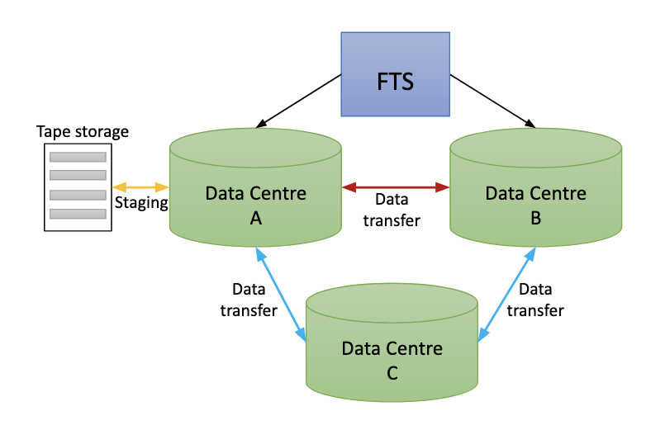
Figure 4.1 - Data flow example with EGI Data Transfer
Step by step tutorials for the users can be found on the EGI documentation in which is provided a tutorial for “Data transfer with grid storage” and “Data transfer with object storage”.
Furthermore, the transfer in and out of the EGI Compute Platform is provided free of charge, so that the desired data can be transferred from any provider to the EGI infrastructure.

EGI DataHub
The EGI DataHub is based on Onedata technology and it aims at abstracting the access to distributed storage available on the infrastructure (both POSIX and Object Storages), implementing a unique namespace which can be easily accessed via GUI or APIs.
As described before, the service is integrated with EGI Check-in, and it provides a GUI both for end-users and administrators to access and manage data and configure the storage endpoints. Our documentation includes concepts and terminology related to Onedata and the EGI DataHub.
An important aspect of the EGI DataHub is its flexible metadata mechanism which allows the storage of metadata in the form of simple key-value pairs, as well as entire metadata documents (currently in JSON and RDF formats), which can be attached to data resources and used during indexing and querying. Built on top of this metadata mechanism, EGI DataHub enables users to publish their data as open access content.
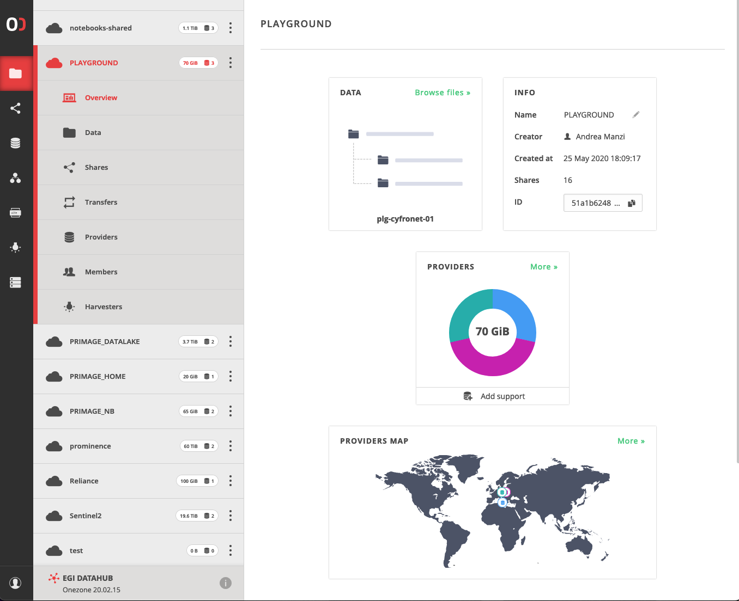
Figure 4.2 - The EGI DataHub graphical interface
The EGI DataHub supports several protocols and standards for open data such as OAI-PMH for publishing data, and handle system integration for registering DOI identifiers, enabling full open data management life cycle management from ingestion through curation to open access.

The EGI DataHub enables seamless sharing of data between users, with a strict access control. Users can share access to individual files as well as data spaces by sending automatically generated access tokens. Access control is fine grained and managed by a set of privileges assigned in the form of access control lists at the level of users, groups, and data spaces. Users can create groups for collaborating on a specific data space or set of spaces.
Users can access the EGI DataHub by directly interacting with the GUI or by installing the oneclient component and the related Python bindings, which enable POSIX access to storage federated via the EGI DataHub. For what concerns the integration with an API, data access can be achieved either via REST API or via CDMI. For oneclient and API access, a specific token must be generated either via GUI or via Onezone API, as described in the documentation. The documentation also includes a specific section on how to register, handle services and mint a Permanent Identifier (PID) for a data space or a subdirectory.
The recent major release of Onedata - 21.02.1, introduced the following new features on the EGI DataHub service:
- The Space Marketplace,
- Support for Datasets and Archives,
- Directory size statistics, and
- Workflow executions.

The Space Marketplace allows easy sharing, reuse, and collaboration on data collections. Every space can be advertised in the Marketplace, making it easy for other users to find them by keywords, tags, or organisation name search. The interested user can then apply for access to the space and the space maintainer decides upon approval/rejection of the request and the privileges that are assigned to the user. The whole process is straightforward and is integrated into the GUI, using an e-mail messaging system.

Datasets and Archives serve as great tools for managing distributed datasets throughout their lifecycle. Users can build hierarchical structures of datasets within Onedata spaces, control their replication using Quality-of-Service rules, and apply metadata and data protection barriers, useful for ensuring the integrity of the datasets at the final steps of their preparation. The datasets can be archived for long-term preservation, which can serve different purposes, such as citing in academic papers.

The Workflow Execution engine enables the creation of complex data processing pipelines that can leverage transparent access to distributed data provided by Onedata. The solution is powered by OpenFaaS and provides ready-to-use functions (lambdas) typically used in archiving pipelines. Additionally, new custom functions can be easily added and shared among groups of users. The workflow creation and management are integrated into the GUI.

Online Storage - Block Storage
Block storage provides block-level storage volumes to be used within virtual machines (VMs) available on the EGI Cloud. Block storage volumes are raw, unformatted block devices, which can be mounted as devices in VMs.
Block storage volumes that are attached to a VM are exposed as storage volumes that persist independently from the life of the VM and need to be explicitly destroyed when data is not needed anymore. Users can create a file system on top of these volumes or use them in any way they would use a block device (such as a hard drive).
The EGI Cloud is based on the Openstack technology, therefore the management of the block storage can be done either using the graphical dashboard or the Openstack client. EGI has also implemented a client (called the FedCloud client), which can be used as well to create and manage block storage. All these possible access methods are described in the documentation. The above methods are also necessary when it comes to provisioning volumes to your Virtual Machines, as explained in the documentation.

Online Storage - Object Storage
Object storage is a standalone service that stores data as individual objects, organised into containers. It is a highly scalable, reliable, fast and inexpensive data storage. It has a simple Web services interface that can be used to store and retrieve any amount of data, at any time, from anywhere on the Web.
The main features of object storage are:
- Storage containers and objects have unique URLs, which can be used to access, manage, and share them.
- Data can be accessed from anywhere, using standard HTTP requests to a REST API (e.g., VMs running in the EGI Cloud or in another cloud provider’s cloud, from any browser/laptop, etc.).
- Access can be public or restricted, using access control lists.
- The amount of data that can be stored is virtually unlimited. Only the space used is accounted for.
The documentation includes more details on the specific concepts of Object storage, like storage containers, objects, etc.
Object storage in the EGI infrastructure is available via two protocols: Swift and S3. There are different clients and access methods to use depending on the protocols, and there is specific documentation for Swift and S3 as well.

Additional Data Management Cases
While the services described in the previous sections are available in the EGI infrastructure, there are specialised services in the EGI-ACE portfolio that are offered for in-house installations by research communities, with support for customisation and configuration from EGI.
The openRDM service offers advanced organisation of data during ongoing research projects as an integrated environment offering data management and digital lab notebook. The openRDM service is based around the active research data management (ARDM) platform openBIS.
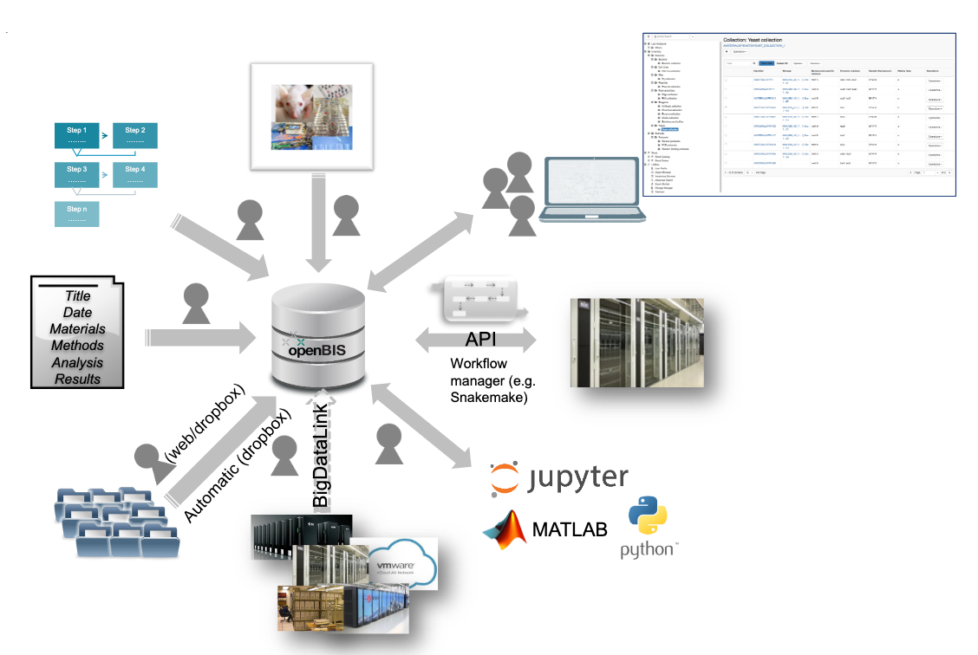
Figure 4.3 - openRDM functionalities
A demo instance of openRDM is available from some of the sites of the EGI Federation, so that users can test its functionality. Communities are then supported to install the service on their premises.
openBIS combines a data management platform with a digital lab notebook and a sample and protocol management system. It enables scientists to meet the ever-increasing requirements from funding agencies, journals, and academic institutions to publish data in conformity with the FAIR data principles – according to which data must be Findable, Accessible, Interoperable and Reusable. More details on openBIS can be found in the online documentation.

The EOSC Data Transfer Service
The EOSC Data Transfer allows users to easily transfer datasets discovered in the EOSC Portal to EOSC Compute facilities. The EOSC Data Transfer service consists of two main components:
- The GUI, which is integrated with the EOSC Portal, and
- A REST API, which implements an abstract layer for data transfers, wrapping the EGI Data Transfer service that is available in the EOSC Marketplace.
Specifically, thanks to this new service, users can browse the EOSC Portal to find datasets, then initiate data transfers to the storage of any computing infrastructure accessible to them. In particular, three sets of functionalities are covered:
- Parsing data records identified using Digital Object Identifiers (DOIs).
- Creating and managing data transfers.
- Managing storage elements.
Figure 4.4 shows the high-level technical architecture of the EOSC Data Transfer service as part of the EOSC platform.
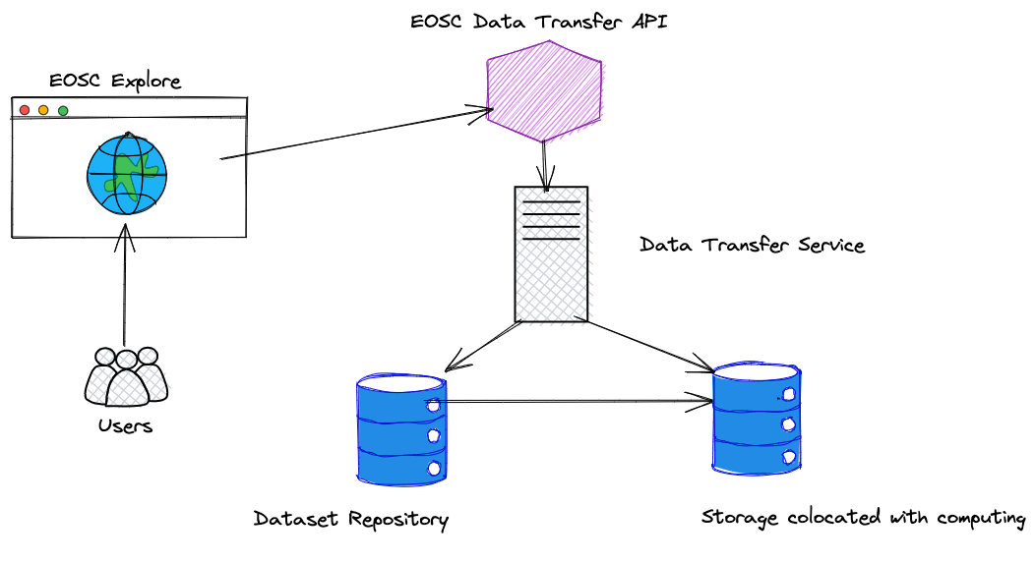
Figure 4.4 - High level architecture of the EOSC Data Transfer
The following components are part of the architecture:
- The main component is the EOSC Data Transfer API, which implements the API endpoints of the generic Data Transfer service and provides the reference integration of one of the Data Transfer services available in EOSC.
- A new GUI component in EOSC Explore has been implemented in order to invoke the EOSC Data Transfer API to perform transfers and management of storage elements. The API calls are redirected to a particular implementation of a Data Transfer Service, which is responsible to perform data transfer operations and storage management.
- The authentication and authorisation are based on EGI Check-in, the EOSC AAI Federation compatible service that operates towards a particular instance of a Data Transfer service. Some storage systems may use different authentication/authorisation mechanisms than the transfer service that will perform the data transfers to that storage system. Herein, in order to authorise access to some storage servers and perform transfers and/or manage storage elements, separate credentials (e.g., S3 access/secret keys) may be needed.
The initial release of the EOSC Data Transfer supports management of storage elements in storage systems with a WebDAV interface or an S3 API and can also use these storage systems as transfer destinations.
As far as source repositories are concerned, the first version supports parsing DOIs, both in canonical DOI notation and as HTTP URLs, which point to data records in one of the following data repositories:
- Zenodo
- B2SHARE
- European Synchrotron Radiation Facility

Working with Compute
Most of the scientific work of researchers involves computation. This could be the need to run a small analysis. Or a data reduction job that has to be repeated a million times on every measurement coming in from an ionosphere observation facility. Or a handful of cutting-edge simulations of climate models that each demand a huge number of compute cores. The EOSC Compute Platform provides a variety of compute services for each of these use cases, and you can choose the best compute tool for each application, be it CPU or GPU.
A paradigm that works as well for compute as it does for storage is elasticity. Cloud elasticity means that there is always room for one more processing core or storage volume: researchers’ simulations are not constrained to the fixed size of a cluster in their department’s basement but can scale to however many cores are needed for the question being analysed.
From a technical point of view, the Federated Compute Service of the EOSC Compute Platform offers a multi-cloud IaaS federation that brings together academic private clouds as a scalable computing platform for data and/or compute driven applications and services for research and science. The flexibility of the multi-cloud IaaS federation as a Service approach introduces several benefits and usage models. Besides serving compute/data intensive analysis workflows, Web services and interactive applications can be also integrated with and hosted on this infrastructure. Contextualisation and other deployment features can help application operators fine tune services in the cloud, meeting software (OS and software packages), hardware (number of cores, amount of RAM, etc.) and other types of needs (e.g., orchestration, scalability).
The offer of compute services of EGI-ACE covers different types of applications and use cases: from customisable and elastic Virtual Machine based cloud to a fully managed distributed platform to run jobs. These are tightly integrated with the storage solutions described in the previous chapter and can be complemented with the advanced services described in the next chapter. From a technical point of view, the Cloud and Container Compute offering of the EOSC Compute Platform relies on the EGI Federated Cloud Infrastructure, an IaaS-type cloud, made of academic private clouds and virtualised resources and built around open standards. Its development is driven by requirements of the scientific community.
The EGI-ACE compute offer is summarised in Table 5.1.
Table 5.1 - Compute services in EGI-ACE
Type | Description | Use Case
Cloud Compute | Provides access to VM-based computing with associated storage. It delivers a customisable platform where users have complete control over the software and the supporting compute capacity. | The flexibility of the computing platform enables a variety of workloads: user gateways or portals, interactive computing platforms and almost any kind of data- and/or compute-intensive workloads.
Container Compute | Supports the execution of container applications on top of Cloud Compute. | It provides deployment of Kubernetes, a widely used container orchestrator, that allows users to run and manage container-based applications.
High Throughput Compute | Provides access to large, shared Grid Computing systems for running computational jobs at scale. | Analysis of large datasets in an “embarrassingly parallel” fashion, i.e., by splitting the data into small pieces, and executing thousands, or even more independent computing tasks simultaneously, each processing one piece of data.
High Performance Compute | Supports highly optimised applications that need massively parallel computing with low latency and high bandwidth interconnection network. | Complex computational problems using tightly coupled parallel processing: simulations, analysis of large datasets or AI/ML workloads. Typically, these applications rely on MPI for supporting inter process communication.

For all these services, resources can be scaled (within a single provider or using multiple providers in a coordinated fashion) to meet your research needs. Some of the EGI-ACE providers include in these offerings GPUs for accelerating your computations.

Software Distribution
Before running your applications, you need to bring your software to the EOSC Computing Platform. EGI-ACE provides two software distribution services to make it possible: the CernVM File System and the EGI Applications Database.
The CernVM-File System (CernVM-FS or CVMFS) provides a scalable, reliable, performant, and low-maintenance software distribution service. It is available as a POSIX read-only file system in user space, it is mounted in /cvmfs in all the HTC providers of EGI and it can be configured as needed on Cloud Compute providers. User communities can upload their software in the repository management service, which provides a single place for users to publish their software, and a global network of replica servers makes this software instantly available on compute resources across the infrastructure.
The EGI Applications Database (AppDB) delivers a public software catalogue, aiming at providing end users with easy-to-find scientific software and ease-of-use for cloud VM deployment. Any EGI user can register their software in the form of Virtual Machine images in AppDB. Communities select which of those VM images to support, and providers will download and make them available for users automatically. AppDB provides a user-friendly interface for registering the VM images, managing the community endorsed VM images and to discover the availability of those images at the distributed computing providers. The workflow in EGI AppDB is depicted in Figure 5.1.

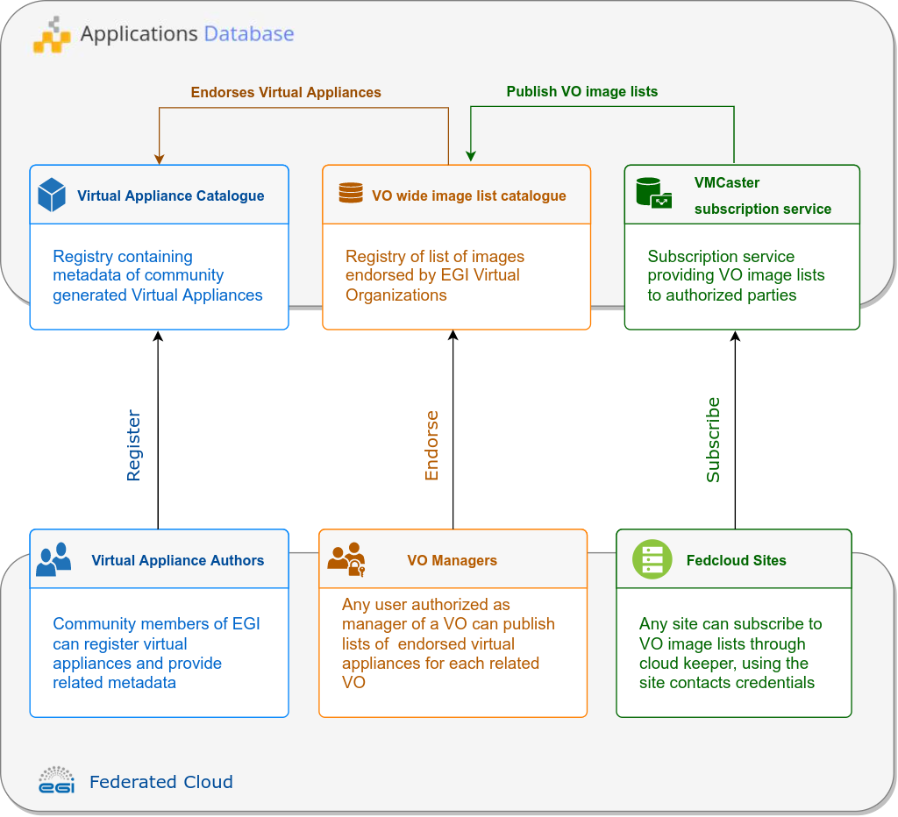
Figure 5.1 - AppDB Software distribution components
Besides those services, EGI-ACE also provides a curated list of software packages for infrastructure operators to deploy the software products that power the EOSC Compute Platform: The Unified Middleware Distribution (UMD) and Cloud Middleware Distribution (CMD). The software included in these repositories goes through a quality assurance process to ensure that new versions of the software meet the requirements for production in the global infrastructure.
During the second part of the project, the Software Distribution service based on CernVM File System was officially published in the EGI Service Catalogue. The service, which allows scientific communities and Research Infrastructures to deploy software on worldwide- distributed computing infrastructures to run data processing applications, is now fully integrated with the EGI Check-in service. This integration allows users of scientific communities and Research Infrastructures to access the repository management service to upload their software just using SSH/SCP commands. In that case, a prompt will appear on the client side, with an URL to EGI Check-in to authenticate themselves using their Home Institution Identity Provider Service. As soon as the software is available in the central repository, a global network of replica servers will make sure that the software is automatically available on the distributed compute resources of the infrastructure.

Cloud Compute
The foundational compute service in EGI-ACE is Cloud Compute, which allows researchers to deploy and scale Virtual Machines (VMs) on-demand. It offers computational resources in a secure and isolated environment, controlled via APIs, without the overhead of managing physical servers.
Although the compute resources in EGI-ACE are provided by independent resource centres that are members of the EGI Federated Cloud, once you gain access to the EOSC Cloud Compute platform (see Section 2), you can access all resources, regardless of the provider hosting them, using the same account.
The Cloud Compute service in EGI-ACE supports the execution of multiple kinds of compute- and data-intensive workloads (both batch and interactive), hosting long-running services (e.g., Web servers, databases, or applications servers), and the creation of disposable testing and development environments on VMs. You can select the hardware configurations (CPU, memory, GPU, disk) for your VMs. You can also run any Operating System or application, by leveraging the VM images and available applications from the software distribution services described in the Section 5.1.
When scientific projects need different computing power at different moments in time, the number of VMs can be automatically scaled, both up and down, to meet the demand, by employing an elastic computing cluster (see Section 6.3.2).
Working with VMs is easy, you can use a graphical user interface (GUI) of an orchestrator, e.g. Infrastructure Manager (see Section 6.3.1), to create new virtual servers, attach some block storage to them, and enclose them within custom-designed Virtual Networks (VNs) that include built-in firewalls to add layers of protection. A few clicks and minutes later you will be able to access the machine via Secure Shell (SSH) and start running software or importing data.
While all the above can be conveniently done from a GUI, nearly everything can also be done via a command line interface (CLI) or an Application Programming Interface (API). This means that repetitive tasks or complex architectures can be turned into shell scripts.
Creating VMs happens so often in EGI-ACE that tools were developed to capture the provisioning of these VMs and allow you to recreate them in a flash, in a deterministic and repeatable way, using an Infrastructure-as-Code (IaC) approach. Automating this activity mitigates the risks for human error and helps not to forget important configuration details (e.g., the size and hardware resources needed) or steps (e.g., making sure your datasets are attached to your VMs). Automation also makes it easier to share scientific pipelines with collaborators.
When you need to refer to your VMs using human-readable, memorable names instead of IP numbers, the Dynamic DNS service of EGI-ACE allows you to register your domain names, which can then be dynamically updated by your VMs to point to themselves, ensuring you have meaningful, always up-to-date domain names for all the services and endpoints of your application. This also allows you to simplify the configuration of clients/servers, to freely move VMs between sites without disrupting clients, and to request certificates that remain valid even when the VMs are moved to another site.
For more information about Cloud Compute, please check out its documentation or the tutorial on how to create your first VM.

Container Compute
The Container Compute service of EGI-ACE allows to deploy, run, and manage container-based applications in the EOSC Compute Platform. Containers are a standardised method to package application code and all its dependencies so the application can be easily and reliably run on any computer environment. Container images are a lightweight, standalone, and standardised executable package of software that includes everything needed to run an application: code, runtime, system tools, system libraries, and settings. Container engines execute container images on different host operating systems, making it possible to run them across different infrastructures with little or no modification. Container orchestration facilitates the operation, management, and automation of containers at scale, including the underlying compute resources. Kubernetes has become the de-facto standard container orchestration platform and is part of the proposed solution.
The service works with Open Container Initiative (OCI) container images, which is an open industry standard for container images and runtimes based on Docker's original image format, and it is currently interoperable with most container engines (including those available for Kubernetes). In practice, supporting OCI containers means supporting Docker containers, which is the de-facto industry standard.
The Container Compute service provides a unified way to manage and schedule containers, making it easier for users to deploy and manage the lifecycle of complex applications even at large scale. Users can define application requirements in the form of objects, such as pods, services, and deployments, and Kubernetes will manage the underlying infrastructure to ensure that the application is always running and available. Kubernetes also provides features such as self-healing, automatic scaling, and rolling updates, making it easier to manage and maintain applications over time.
There are two ways to run containerised workloads in EGI-ACE, both benefiting from the Kubernetes workload management features:
- With the fully managed Kubernetes installations based on Rancher, you only have to bring your container images and define your application’s requirements in the form of objects, such as pods, services, and deployments, while Kubernetes will manage the underlying infrastructure to ensure that the application is always running and available. You can even bring your own Kubernetes clusters into the service and manage all clusters from a central dashboard.
- With user-managed Kubernetes installations provisioned by the Infrastructure Manager (IM) on top of a federated group of OpenStack Infrastructure-as-a-Service (IaaS) providers. This service option allows for a greater user control and customisation of the Kubernetes environment.
For more information about Container Compute, please refer to the documentation.

High Throughput Compute
High Throughput Computing (HTC) is a computing paradigm that focuses on the efficient execution of a large number of loosely coupled tasks (e.g., data analysis jobs). HTC systems execute independent tasks that can be individually scheduled on the distributed computing resources of EGI’s federated infrastructure.
The EGI HTC service provides easy, uniform access to shared high-quality computing and storage resources with integrated monitoring and accounting tools that provide information about the availability and resource consumption. Every provider of the infrastructure offers a front-end gateway (ARC-CE or HTCondor-CE) that manages the authorisation and the submission of jobs to a local batch system (e.g., SLURM, PBS, or HTCondor). These systems rely on X.509 certificates and VOMS for user authentication and authorisation. See Section 3.1 for details.
Compared to Cloud Compute or Container Compute, where you have complete control over the resources and the ultimate responsibility for managing them, the HTC service offers a completely managed service where you only need to worry about the submission of jobs to the set of available distributed providers. HTC is tightly integrated with other components of the infrastructure: it provides access to files available through grid storage (see Section 4.2.1), it makes software available (as described in Section 5.1), and it can be used with the workload manager (see Section 5.6) to simplify the management of jobs in the infrastructure.
A new flavour of the HTC service is under integration into EGI-ACE, based on the SURF Spider platform. Spider is a versatile high-throughput data-processing platform, aimed at processing large, structured data sets, that runs on top of an internal elastic Cloud. Besides the job submission features, Spider supports Jupyter notebooks and many other user-centric features.

High Performance Compute
High Performance Computing (HPC) provides highly optimised computing systems that deliver large amounts of parallel computing power to run applications. Similarly, to HTC, it offers a managed service where you can find a fully operational environment in which to submit your jobs. Traditionally, HPC systems are managed in an isolated way and offer limited federation options. In EGI-ACE, a set of pilots are established to explore the integration of several HPC systems into the federation and facilitate access to them as part of the EOSC Compute Platform.
In most HPC systems, user access is performed via the Secure Shell Protocol (SSH) to a set of login nodes where users can interact with the system and submit jobs for their execution. The SSH credentials are locally managed usernames and password or SSH keys. For EGI-ACE, new ways of accessing the providers that leverage federated authentication are being tested, so users do not need to manage a new set of credentials for each of the individual systems. The following mechanisms are being tested for the EGI-ACE pilots:
- SSH access with OIDC tokens with ssh-oidc (see Section 3 for details), which enables access to SSH using federated identity technology as supported by EGI Check-in. This is the preferred authentication mechanism for EGI-ACE, as it minimises the requirements to the users: you just need to get an access token from Check-in.
- Access via a HTC-like middleware. In this case, users do not get direct access via SSH but, instead, a set of middleware components will handle the user access and the interaction with the HPC system. Users would be able to submit jobs using the same tools as for the HTC service (see also Section 5.4 for details). While this is the simplest option to implement for the infrastructure, it is not always possible to implement it due to strict policy restrictions in HPC systems.
- HPC as a Service. In those providers that deliver HPC hardware via IaaS interfaces, you can easily deploy small-scale HPC systems to run your workloads. While IaaS providers rely on hypervisors to create Virtual Machines, specialised hardware like GPU accelerators and low latency networks like InfiniBand can be configured as PCI Passthrough devices without major performance overheads. You can use orchestration tools like the Elastic Cloud Computing Cluster (see Section 6.3.2) to create elastic virtual clusters on these providers. This approach allows for a very flexible and customisable environment while providing access to HPC features.
To provide portability of applications between systems (Cloud, HTC, HPC), EGI-ACE recommends the use of containers with udocker, a user-level tool that executes containers in user space, without requiring root privileges like in managed services such as HTC, HPC, or other externally managed batch/interactive systems. udocker is a wrapper around several tools and technologies that pulls container images and executes them with minimal functionality that mimics the Docker command line tool, thus facilitating its use for users who are already familiar with Docker.
Access from HPC systems to the data available at the various data services of EGI-ACE described in Section 4 is currently under piloting.

Workload Management
EGI’s Workload Manager is a service that provides efficient management and distribution of workloads in the distributed computing infrastructure of the EOSC Compute Platform. The service, based on the DIRAC Interware project, delivers a complete solution for communities that need to access heterogeneous computing and storage resources distributed geographically, integrated in different HTC and cloud infrastructures or standalone computing clusters and supercomputers. EGI Workload Manager handles workload distribution in a transparent way by choosing appropriate computing and storage resources in real-time for the users. It manages data storage, data movement, data accessing and data processing, while supporting different storage technologies (HTC, HPC and Iaas Cloud).
Figure 5.6 highlights the main components of the Workload Manager. Its architecture allows new types of computing resources to be easily added and usage policies to be applied, as required by user communities. A REST API provides a language neutral interface to the service. A Web portal provides simple and intuitive access to most of the service functionalities, including management of computing tasks and distributed data. This Web GUI also has a modular architecture designed specifically to allow easy extension for the needs of particular applications.
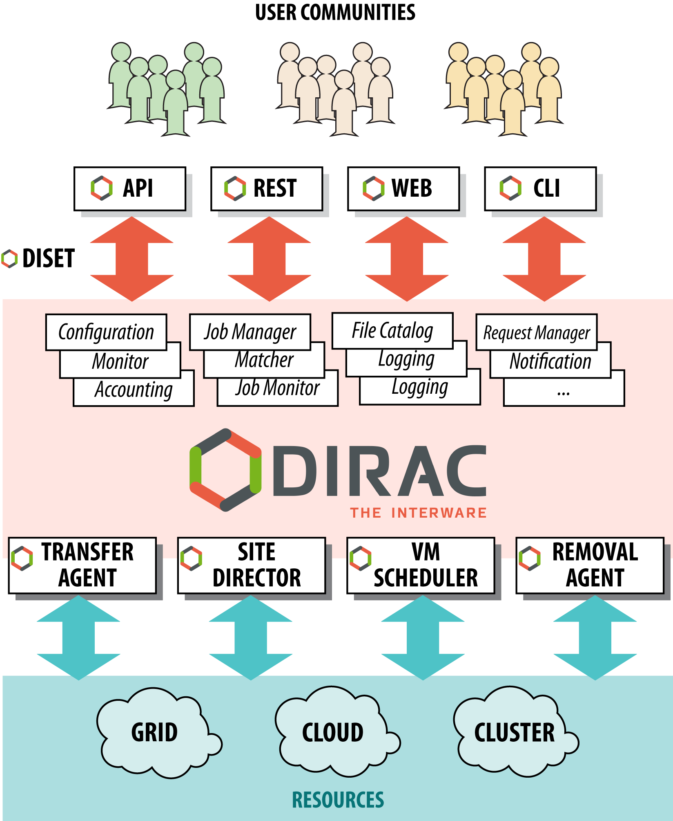
Figure 5.6 - DIRAC Components
User’s workload is expressed in the form of jobs, each job representing a unit of work that can be managed by DIRAC. Jobs are described through the Job Definition Language (JDL) and can be easily created with the Job Launchpad included in the Web portal (see Figure 5.7).
The basic information that every job defines is the path of the executable to be used and its arguments. Usually, its input and output are also specified. When user jobs are submitted to the Workload Manager Service, the service performs a booking of computing resources by means of so-called pilot jobs, which are submitted to various computing centres with appropriate access protocols.
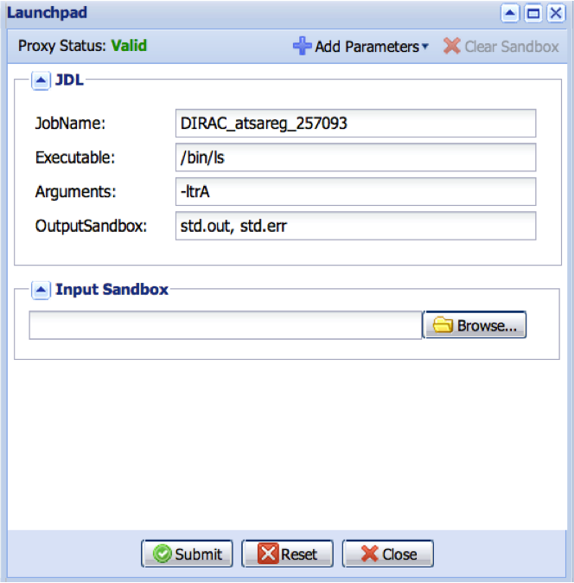
Figure 5.7 - DIRAC Job Launchpad
Once the job has been deployed on worker nodes, pilot jobs verify the execution environment and then request user payloads from the central DIRAC Task Queue. Altogether, the pilot jobs, and the central Task Queue, form a dynamic virtual batch system that overcomes the heterogeneity of the underlying computing infrastructures.

Other Advanced Services
Researchers and scientists are increasingly faced with the challenge of managing and analysing ever-growing volumes of data. This requires increasingly more compute and storage resources, as well as new approaches to orchestrate compute services to curate, triage, and work with data.
The EOSC Computing Platform, through EGI-ACE, provides advanced services that can meet these modern needs. In this chapter, we look at some of these higher-level services, with a particular focus on Machine Learning (ML) and Artificial Intelligence (AI) and provide recent updates about the advanced services offered by the EOSC Compute Platform.

Machine Learning
The Computing Platform provides a collection of specialised services, tools, and libraries for applying machine learning for feature detection and predictive analytics to datasets, the so called DEEP platform.
Machine learning with deep neural network approaches is called Deep Learning. The availability of powerful GPUs on the Computing Platform makes building, training, and evaluating large deep neural networks possible.
The DEEP platform offers a complete framework for users, practitioners, and developers of AI, allowing transparent training, sharing, and serving of Machine Learning and Deep Learning (ML/DL) applications, both locally and on hybrid cloud systems.
The provided set of tools and services cover the entire ML/DL development cycle, from model creation, data processing, training, validation, and testing, to the sharing and publication of the models. Users are able to focus on domain-specific challenges, while the DEEP platform manages other operational aspects: AAI, resource management, marketplace, CI/CD, software quality assurance, etc. with the assistance of experts from competence centres.
The DEEP platform consists of the following services: DEEP Open Marketplace, DEEP Training Facility, DEEP Development Environment, DEEPaaS API, DEEP Storage and DEEP Authentication and Authorisation, all of which will be discussed in the following sections.

DEEP Open Marketplace
The DEEP Open Marketplace is a curated repository of applications ready to be used or extended, fostering knowledge exchange and re-usability of applications. It aims to serve as the central knowledge hub for ML/DL applications, breaking knowledge barriers across distributed teams.
Pre-configured Docker containers, repository templates, and other related components are included in the DEEP Marketplace. You cannot only access, but also contribute to these via the DEEP Marketplace portal, which allows you to easily browse the available modules, download them and interact with them through the DEEP Platform’s API (see Section 6.1.4 for details). The user workflow to interact with the DEEP Open Marketplace is shown in Figure 6.1.
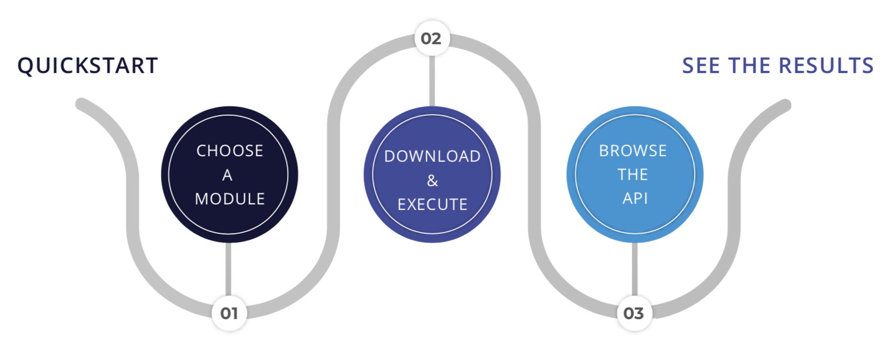
Figure 6.1 - User workflow for interacting with the DEEP Open Marketplace

DEEP Training Facility
The DEEP Training Facility allows you, as a data scientist, to develop and train your models, with access to the latest generation of EU computing e-Infrastructures.
Access to the training facility is facilitated by the DEEP Dashboard, which allows users to interact with the modules hosted in the DEEP Marketplace, discussed in the previous Section 6.1.1, or deploy external workloads, train users’ modules, and perform inference, while hiding the complexity of making deployments using the DEEP framework to the underlying Cloud, HTC and HPC resources (see Figure 6.2).
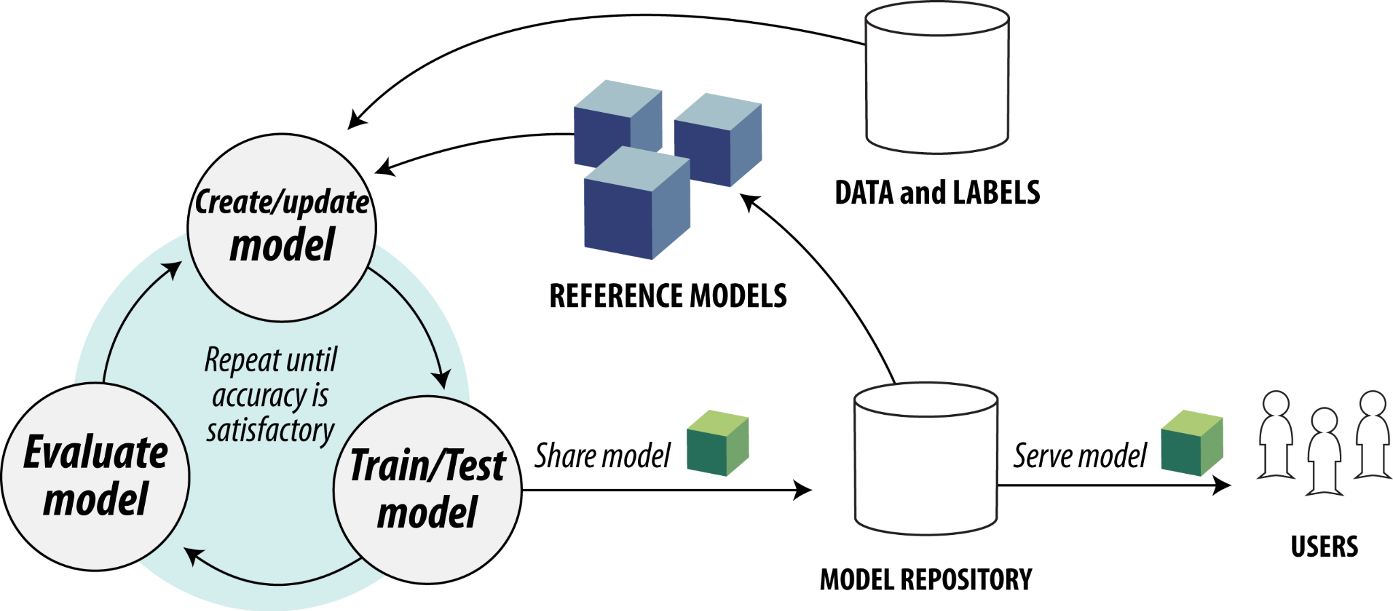
Figure 6.2 - DEEP platform workflow
The Training Facility requires modules and user applications to be containerised and integrated with the DEEP Platform API (see Section 6.1.4 for details) in order to expose their functionality. The training system will exploit the existing resources that are integrated with it (OpenStack, Kubernetes, Apache Mesos or HPC systems), through the INDIGO PaaS Orchestrator (discussed in Section 6.3.3).

DEEP Development Environment
To develop your ML/DL models and code, leveraging the DEEP learning frameworks, components, and tools, you can take advantage of the development environment based on Jupyter Notebook or JupyterLab (see also Section 6.2 for details).

DEEPaaS API
For the DEEP platform to be a true PaaS offering, its API is key. The DEEPaaS API makes the DEEP modules accessible even to non-experts, providing a consistent and easy way to access their functionality. It enables you, as a data scientist, to expose your applications through an HTTP endpoint and deliver a common interface for ML, DL and AI applications.
The DEEPaaS API is available for both inference and training. The DEEP platform provides asynchronous training and control to launch, monitor, stop and delete the model training.

DEEP Storage
The official storage service provided by the DEEP platform is Nextcloud, which supports data stored in external storages via standardised protocols like WebDAV, Amazon S3, or OpenStack Swift (e.g., using the rclone tool).
Besides the official storage service, other storage, and data services (see Section 4.1 for details) are supported to host data for processing and analytics, such as Ceph or MinIO. Both offer an AWS S3-compatible object store API.
Data repositories such as DSpace and Dataverse, are being validated and used in the framework of EOSC-Synergy project. The repositories can be deployed as a service for user communities via a Repository as a Service (RepaaS). These services are enablers of FAIRness of datasets and can be used by the user communities.

DEEP Authentication and Authorisation
Access to the DEEP Platform (see also Section 2 for details) is provided through the INDIGO Identity and Access Management (IAM), which covers all DEEP facilities and services (DEEP IAM). Further extending the AAI framework of the DEEP Platform to enable authentication using the EGI Check-in service is also planned.

Development Environments
The core objective of the EOSC Compute Platform is to provide solutions to advance research and innovation, embracing Open Science, and empowering scientists and researchers to perform domain-specific research tasks, without having to deal with the complexities of the underlying infrastructure.
An essential tool that contributes to this objective is a flexible development environment, where users can create and share documents containing live code, equations, narrative text, and rich media output. In the EOSC Compute Platform, the following development environments are available:
- EGI Notebooks a browser-based, scalable tool for interactive data analysis.
- EGI Replay, which allows re-creation of custom computing environments for reproducible execution of notebooks.

Notebooks
EGI Notebooks is a Web-based interactive development environment based on the JupyterHub technology, running on a cloud provider of EGI-ACE. As depicted in Figure 6.3, the overall architecture of the EGI Notebooks has been further enhanced in collaboration with other INFRAEOSC-07 projects, such asDICE, OpenAIRE Nexus, RELIANCE and C-SCALE:
- DICE:
  - Activated transparent data access to B2DROP from EGI Notebooks.
  - Added B2SHARE as input sources for the EOSC Data Transfer.
  - The integration with B2SAFE is in progress.
- OpenAIRE Nexus:
  - Added Zenodo as input sources for the EGI Replay and the EOSC Data Transfer services. The integration with GitHub and Zenodo enables researchers to easily engage with the concept of Open Science.
  - AppDB software harvested by OpenAIRE Explore.
- RELIANCE:
  - Enabled EGI Notebooks as the official interactive computing platform used by the project.
  - Enabled EGI Binder from any Research Objects in RoHub.
- C-SCALE:
  - Enabled EGI Notebooks as an interactive computing platform for C-SCALE.

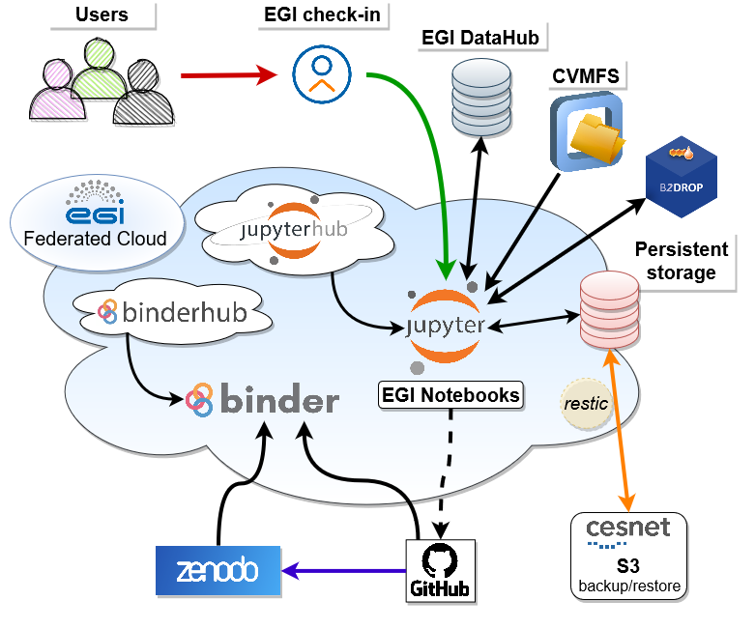
Figure 6.3 - Notebooks and Binder workflows
The EGI Notebooks service is offered with two service modes depending on your needs:
- Notebooks for researchers. In this configuration, notebooks are accessible to individually registered users as well as jointly enrolled in one of the available resource pools (known as Virtual Organisations). By default, the catch-all instance of the Notebooks offer 2 vCPU cores, 6 GB RAM and 20GB of personal storage space per user, and Python, Octave, R, Julia, Matlab as Kernels. From a technical perspective, computing and storage resources are provisioned from participating providers integrated with the EGI Cloud. Dedicated storage set-up can be made available case-by-case from a variety of storage capacity providers (e.g., EGI DataHub, AWS S3-compatible Online Storage, Object Storage, or specialised, area-specific data stores).
- Notebooks for communities. In this advanced set-up, user communities can have their customised EGI Notebooks service instance. EGI offers consultancy, support, and can operate the setup as well. A community specific setup allows the community to use the community's own Virtual Organisation (i.e., federated compute and storage sites) for Jupyter, add custom libraries into Jupyter (e.g., discipline-specific analysis libraries) or have fine grained control on who can access the instance (based on the information available to the EGI Check-in AAI service).
Notebooks are accessible to individually registered users as well as jointly enrolled Virtual Organisations, see Section 2 for details. Computing resources are provisioned from participating providers integrated with the EGI Cloud. Basic storage capacity is likewise provisioned from sites in the EGI Cloud, but additional storage can be made available case-by-case from a variety of storage capacity providers (e.g. EGI DataHub, AWS S3-compatible Online Storage - Object Storage, or specialised, area-specific data stores).
Essential notebook images are readily available to all researchers and scientists, but additional images can be made available upon request, with multiple choices for the supported programming language (e.g., Python, Julia, R, Octave or MATLAB).

Replay
EGI Replay offers an easy place to reproduce and share notebooks with other users with just a link. Specifically, the EGI Replay service makes it possible to recreate a custom computing environment for the reproducible execution of notebooks, allowing users to move across the reproducibility spectrum and support Open Science. Users who create their own notebooks in EGI Notebooks to analyse data can easily create a shareable link for those notebooks in the form of a GitHub repository. Based on this link, anyone can then reproduce the same data analysis using the link in the EGI Replay service.
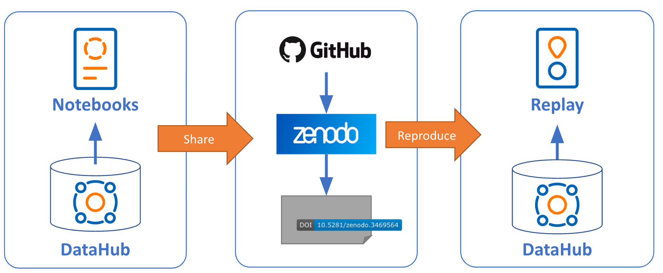
Figure 6.4 - Replay workflow
Similarly, to EGI Notebooks, the EGI Replay service is already connected to the EGI Infrastructure services such as: EGI Check-in, CVMFS, DataHub, Workload Manager and B2DROP. The service leverages the EGI computing capacity of the Federation to build containers on-the-fly, and to install libraries and dependencies to support the applications to be reproduced. From a technical point of view, the code repository can be hosted on popular git hosting platforms such as GitHub and GitLab and can be referenced with a DOI from Zenodo, FigShare or Dataverse.
By default, the EGI Replay service offers the following features:
- Users have a personal access token that can be used to access other EGI services
- Selected spaces of EGI DataHub are directly available under the /datahub folder, simplifying the access to shared data.
- Selected CVMFS repositories are available under the /cvmfs folder, simplifying the software distribution.
- Optionally, B2DROP storage accessed through API credentials is mounted in the /b2drop folder.
- Environments are guaranteed 2GB of RAM and can reach 6GB as maximum, and there are no hard limits on the session time per user, although sessions will be shut down automatically after two hours of inactivity. The public mybinder.org service has a 2GB memory limit and six hours of session time with automatic shut down after ten minutes of inactivity.
User communities can have their customised Replay service instance with extra features. EGI offers consultancy and support, as well as options to operate the setup.

Cloud Orchestrators
One of the challenges for researchers in recent years is to manage an ever-increasing amount of compute and storage services, which then form increasingly more complex end-user applications and platforms. An important advantage offered by the EOSC Compute Platform is the possibility to use different Cloud Orchestrators to enable the execution of complex tasks and workflows across multiple cloud platforms.
To address this need, several cloud-based orchestrators are available to support the creation of virtual infrastructures on top of IaaS Cloud resources. These tools have different levels of abstractions and features, as detailed below. Table 6.1 helps you understand which tool to choose (when it is not imposed by default) in the different specific scenarios.
Table 6.1 - Orchestrators in EGI-ACE
Name | Workload Type | Use Case
Infrastructure Manager | VMs and containers | Used to run workloads on a single IaaS Cloud provider.
Elastic Cloud Computing Cluster | VMs and containers | Used when you need to run workloads on clusters that can be elastically scaled and potentially span more than one IaaS Cloud provider.
PaaS Orchestrator | VMs, containers (both long running and batch), and HTC jobs | Used when you have both IaaS Cloud and HTC workloads. Machine Learning uses it for ML/DL workloads.
Dynamic On-Demand Analysis Software | Containers | Used when your workload is composed of Docker containers (Helm charts).

These orchestrator services are (planned to be) integrated with the Service Management Tools, allowing federated identity access, monitoring, and accounting.

Infrastructure Manager
Infrastructure Manager (IM) is a tool that enables the effective deployment of all the infrastructure necessary for end-user applications or services, either composed by VMs or by Docker containers.
IM orchestrates the deployment of custom virtual infrastructures on multiple back-ends. It automates the deployment, configuration, software installation, monitoring and update of virtual infrastructures. It supports a wide variety of back-end clouds, whether public (such as Amazon Web Services, Google Cloud or Microsoft Azure), on-premises (such as OpenStack) or container-based (such as Kubernetes), making user applications cloud-agnostic (see Figure 6.5).
In order to facilitate deterministic repeatability of virtual infrastructure deployments, IM adopts an Infrastructure-as-Code (IaC) approach. IaC allows users to define application architectures using high-level “recipes” and resorts to automated procedures for both the provisioning of virtual computing resources, and their automated configuration. In addition, it features DevOps capabilities based on Ansible, enabling the contextualization of the infrastructure at run-time by installing and configuring all the required software that may not be available in the VM images, ensuring that researchers will obtain a fully functional virtual infrastructure. The virtual infrastructures can be defined using its native language, called Resource and Application Description Language (RADL), or the TOSCA OASIS standard.
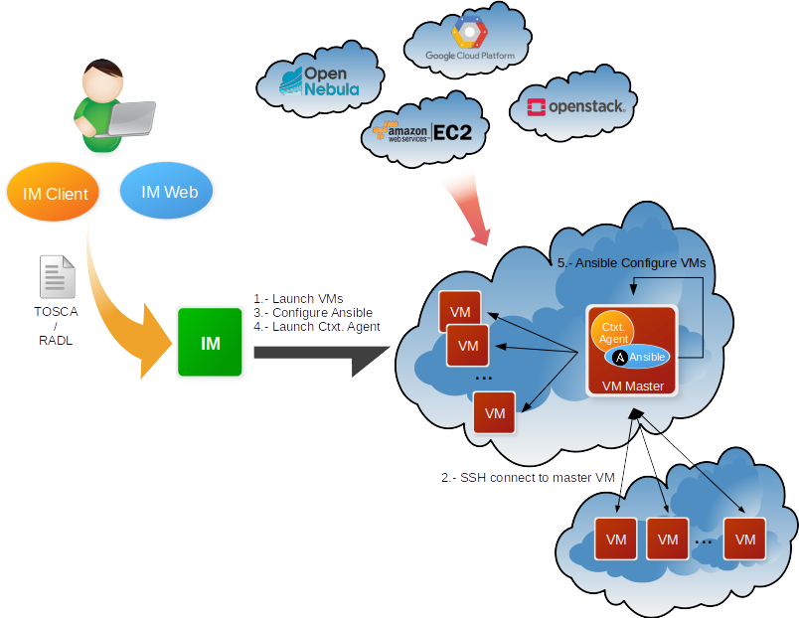
Figure 6.5 - Infrastructure Manager workflow
IM considers these aspects when it creates and manages virtual infrastructures:
- The software and hardware requirements specification for the user applications, using a simple language defined to be easy to understand by non-advanced users who just want to deploy a basic virtual infrastructure, but with enough expressivity for advanced users to set all the configuration parameters needed to get a fully configured infrastructure.
- The selection of the most suitable Virtual Machine Images (VMI) based on the user’s requirements.
- The provision of VMs on the configured cloud platform and/or Docker container workloads using the configured container orchestrator.
- Support for hybrid infrastructures, where nodes are spread across different cloud providers, enabling cloud bursting scenarios.
- The contextualization of the infrastructure at run-time by installing and configuring all the required software that may not be available in the images (either VMIs or Docker images).
- The elasticity management, both horizontal (adding/removing nodes) and vertical (growing/shrinking the capacity of nodes).
IM provides both XML-RPC and REST APIs to enable high-level components to access its functionality. These APIs allow clients to create, destroy, and inspect virtual infrastructures. IM also provides a command line tool (im-client) and two Web interfaces:
- im-dashboard, which can deploy predefined TOSCA templates with a few clicks, and
- im-web, which has advanced functionality for advanced users.
For more information about IM, the documentation and the source code can be consulted.

Elastic Cloud Computing Cluster
Elastic Cloud Computing Cluster (EC3) is a tool to create elastic virtual clusters on top of IaaS providers. Being based on Infrastructure Manager (or IM, detailed in the previous Section 6.3.1), EC3 supports the same extensive back-ends options.
EGI-ACE offers recipes to deploy TORQUE (optionally with MAUI), SLURM, SGE, Apache Mesos, OSCAR, ENES, Nomad and Kubernetes clusters that can be self-managed.
EC3 creates elastic cluster-like infrastructures that can automatically scale up or down, depending on demand and the configured policies (e.g., minimum, and maximum number of nodes). This creates the illusion of a real cluster without requiring an investment beyond the actual usage, delivering a cost-effective elastic Cluster-as-a-Service on top of an IaaS cloud.
The deployment of the virtual elastic cluster consists of two phases: (i) Start a VM to act as the cluster front-end, and (ii) The automatic management of the cluster size, depending on the workload and the specified policies.
For the first step, the EC3 launcher deploys the front-end using IM. Once the front-end and the elasticity manager (CLUES) have been deployed, the virtual cluster becomes totally autonomous and users can submit jobs, either from the cluster front-end or from an external node that provides job submission capabilities. Researchers will have the perception of a cluster with the number of nodes specified as minimum and/or maximum size.
CLUES will not only monitor the working nodes (to detect the ones that are idle) but will also intercept job submissions and will dynamically manage the cluster size transparently for the user, scaling up and down on demand. It uses IM to create/destroy the VMs that will act as worker nodes for the cluster.
EC3 supports three deployment models:
- Homogeneous clusters are composed of working nodes that have the same hardware and software characteristics. This is the default deployment model of EC3, where only one type of node is used, as shown in Figure 6.6.
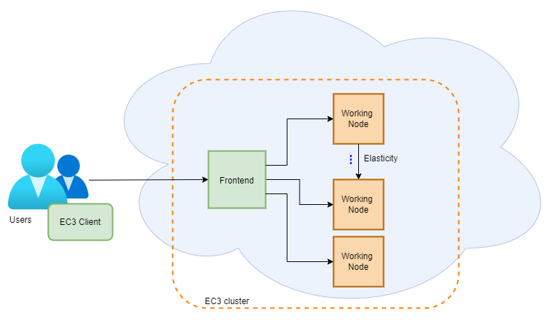
Figure 6.6 - Homogeneous cluster example

- Heterogeneous clusters allow the working nodes comprising the cluster to be of different hardware and/or software characteristics. This is of special interest when you need nodes with different configuration or hardware specifications, but all working together in the same cluster. It also allows you to configure several queues and specify to which queue the working node belongs to. This cluster type is depicted in Figure 6.7.
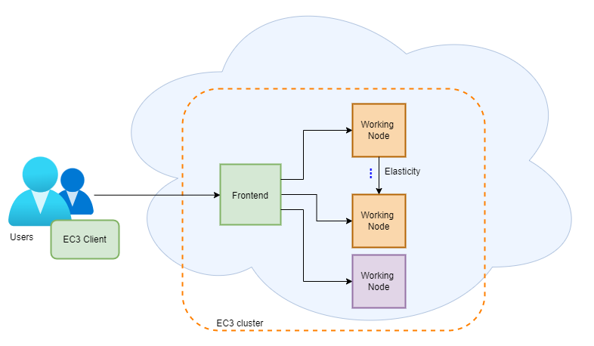
Figure 6.7 - Heterogeneous cluster example

- Hybrid clusters (sometimes also referred to as Cloud bursting) consist of launching nodes in two or more different cloud providers. This can overcome user quotas or saturated resources. When a limit is reached and no more nodes can be deployed inside the first cloud provider, EC3 will launch new nodes in the next defined cloud provider. The nodes deployed in different cloud providers can be different too, so that heterogeneous clusters with cloud bursting capabilities can be deployed and automatically managed with EC3. The nodes would be automatically interconnected using VPN or SSH tunnelling techniques. This cluster type is depicted in Figure 6.8.
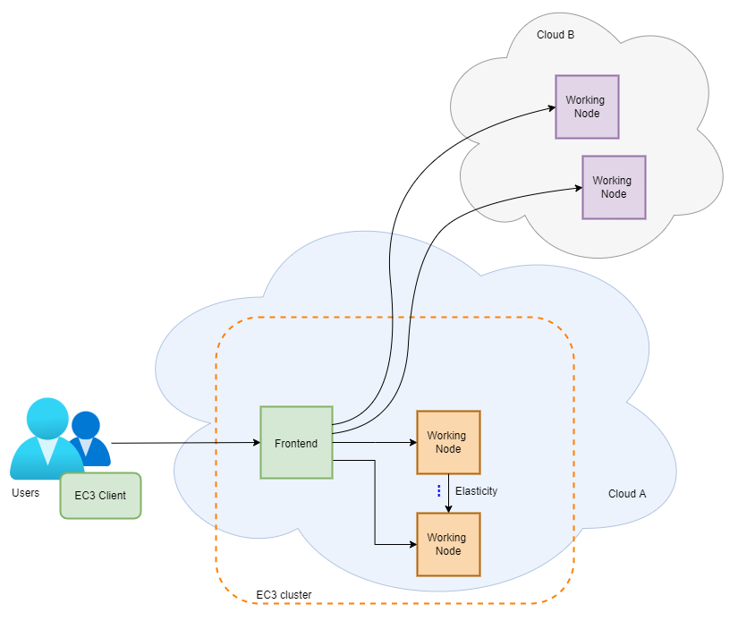
Figure 6.8 - Hybrid cluster example
For more information about EC3, please check out the documentation and the code.

PaaS Orchestrator
The PaaS Orchestrator is the core component of the INDIGO PaaS, an abstraction and federation layer on top of heterogeneous distributed computing environments, with the following key features:
- Supports provisioning compute and storage resources in IaaS Cloud providers, as well as deploying containerised workloads to container orchestrators and HTC sites.
- Supports deployments needing specialised hardware (e.g., GPUs and Infiniband).
- Automatic retries in case of deployment failure or timeout.
- Integration with Hashicorp Vault to manage public cloud credentials.
- Multi-tenancy support.
- Supports multiple identity providers.
- Has a REST API, command line, and Web interface for managing workloads.
The Orchestrator receives deployment requests declared in TOSCA templates and orchestrates the deployments on the best available cloud sites.
In order to select the best site, the orchestrator implements a complex workflow: it gathers information about the SLAs signed by the providers with the user, the availability of the compute and storage resources, and the location of the data requested by the user (if any).
Once the best site has been identified, the orchestrator starts the deployment workflow through one of its provider plugins:
- The Cloud/IaaS adapter uses Infrastructure Manager (see Section 6.3.1 for details) to provision virtual compute and storage resources on public (Amazon Web Services, Microsoft Azure, Google Cloud Platform) or private (OpenStack) infrastructures.
- The Apache Mesos connectors manage the interactions with the relevant cluster framework: Marathon for long-running services and Chronos for batch-like jobs.
- The Kubernetes adapter manages deployments on Kubernetes clusters.
- The HPC adapter submits jobs to HPC sites through a QosCosGrid (QCG) Gateway.
For more information about PaaS Orchestrator, please refer to the documentation and the source code.

Dynamic On-Demand Analysis Software
Dynamic On Demand Analysis Service (DODAS) is a Platform as a Service tool built by combining several solutions and products developed by the INDIGO-DataCloud H2020 project. The Platform as a Service allows instantiation of on-demand complex infrastructures over any cloud with almost zero effort and with very limited knowledge of the underlying technical details. It enables the execution of user analysis code, both in batch mode and interactively (via the Jupyter interface) and is highly customisable, offering several building blocks that can be combined together according to the specific use case. The currently available blocks allow combining Jupyter, HTCondor, Apache Spark, and more.

During the second part of the EGI-ACE project, the PaaS as a Service solution has been further evolved, integrating it both with (i) The PaaS Orchestrator, to simplify the deployment of on-demand virtual infrastructures on top of different IaaS resources, and with (ii) The EGI Check-in service, for the AAI management. The resulting solution is a powerful service that can be then exposed via the PaaS dashboard . The added value of this improved solution is twofold:
- It provides the DODAS service to the communities through a more user-friendly interface.
- It offers a built-in service ready for use (SaaS model) that could be a good way to promote the PaaS Orchestrator and the DODAS services.

For more information about DODAS, refer to the related publications and presentations.

Consultants
This section reports on the EGI-ACE service provider consulting partners, and generic supporters, selected to provide front-line support and technical expertise on how to integrate with the services of the EOSC Compute Platform.

Generic Support
The front-line support for the EOSC Compute Platform is support@egi.eu.

Services Supporters of the EOSC Compute Platform
Service | Institute | Contact
AppDB | IASA | William Karageorgos
DataHub | Cyfronet | Lukas Dutka, Bartosz Kryza, Łukasz Opioła
Workload Manager | CNRS | Ghita Rahal, Gino Marchetti, Andrei Tsaregorodtsev
DEEPaaS | CSIC | Álvaro López García
Accounting | CESGA | Carlos Fernandez
AAI, Monitoring | GRNET | Nicolas Liampotis
DODAS | INFN | Daniele Spiga, Diego Ciangottini
PaaS Orchestrator | INFN | Giacinto Donvito
Monitoring | SRCE | Emir Imamagic
RUCIO, Data Transfer, APEL, CVMFS | STFC | Ian Collier
EC3/IM | UPV | Miguel Caballer
Notebooks/Replay | CESNET | Zdeněk Šustr

https://www.eosc-portal.eu/
https://www.eoscsecretariat.eu/eosc-working-groups
https://www.eosc.eu/advisory-groups
https://eosc.eu/
See MoU: https://www.eosc.eu/sites/default/files/EOSC_Memorandum_30_July_2021.pdf
https://www.egi.eu/projects/egi-ace/
General-Purpose computing on Graphics Processing Units
https://en.wikipedia.org/wiki/Infrastructure_as_a_service
https://en.wikipedia.org/wiki/Platform_as_a_service
https://ec.europa.eu/research/openscience/index.cfm?pg=open-science-cloud
https://www.seadatanet.org/
https://appdb.egi.eu/
https://www.doi.org/
https://www.eosc.eu/advisory-groups/pid-policy-implementation
https://www.egi.eu/services/check-in/
https://ecrin.org/
https://www.ba.infn.it/index.php/en/
https://ecrin.org/clinical-research-metadata-repository
http://ecrin-mdr.online/index.php/Project_Overview
https://swagger.io/specification/
In computing, service composability is a design principle that encourages the design of services that can be reused in multiple solutions that are themselves made up of composed services.
http://diracgrid.org/
https://www.wenmr.eu/
https://jupyter.org/
https://jupyter.org/binder
Containers are a mechanism to pack and run applications together with their runtime dependencies.
https://github.org/
https://zenodo.org/
https://www.doi.org/
https://www.panosc.eu/
https://documents.egi.eu/document/2732
https://aarc-project.eu/policies/policy-development-kit/
https://wiki.refeds.org/display/CODE/Code+of+Conduct+for+Service+Providers
https://www.egi.eu/about/policy/policies_procedures.html
General Data Protection Regulation. See https://fra.europa.eu/sites/default/files/fra_uploads/fra-coe-edps-2018-handbook-data-protection_en.pdf
Available at https://aai.egi.eu/proxy/module.php/rciaminfo/services.php
See https://gdpr.eu/what-is-data-processing-agreement/ for more information
Available at https://eosc-portal.eu/
https://www.marionegri.it/eng/home
https://chipster.csc.fi/
https://www.egi.eu/projects/egi-ace/call-for-use-cases/
https://www.egi.eu/webinars/
https://docs.egi.eu/
https://openid.net/connect/
https://sectigo.com/resource-library/what-is-x509-certificate
https://www.egi.eu/services/check-in/
https://edugain.org/
https://incommon.org/software/comanage/
https://perun-aai.org/
https://docs.egi.eu/users/aai/check-in/signup/
https://oauth.net/2/
https://operations-portal.egi.eu/
https://operations-portal.egi.eu/
https://docs.egi.eu/users/aai/check-in/joining-virtual-organisation/
https://docs.egi.eu/users/aai/check-in/vos/voms/
https://appdb.egi.eu/
https://docs.egi.eu/users/data/storage/
https://eoscfuture.eu/
https://www.egi.eu/service/datahub/
https://docs.egi.eu/users/data/storage/grid-storage
https://en.wikipedia.org/wiki/GridFTP
https://en.wikipedia.org/wiki/WebDAV
https://xrootd.slac.stanford.edu/
https://www.gridpp.ac.uk/wiki/SRM
https://eos-web.web.cern.ch/eos-web/
https://www.dcache.org/
https://twiki.cern.ch/twiki/bin/view/DPM/
https://italiangrid.github.io/storm/
https://docs.egi.eu/users/data/storage/grid-storage#endpoint-discovery
https://dmc-docs.web.cern.ch/dmc-docs/gfal2/gfal2.html
https://docs.egi.eu/users/data/storage/grid-storage#access-from-the-command-line
https://docs.egi.eu/users/data/management/rucio/
https://docs.egi.eu/users/data/management/rucio/getting-started/
https://docs.egi.eu/users/data/management/rucio/admin/
https://docs.egi.eu/users/data/management/rucio/commands
https://docs.egi.eu/users/data/management/data-transfer/
https://fts.web.cern.ch/fts/
https://docs.egi.eu/users/tutorials/data-transfer-grid-storage/
https://docs.egi.eu/users/tutorials/data-transfer-object-storage/
https://docs.egi.eu/users/data/management/datahub/
https://onedata.org/
https://docs.egi.eu/users/data/management/datahub#components-and-concepts
https://www.openarchives.org/pmh/
https://www.doi.org/
https://docs.egi.eu/users/data/management/datahub/clients/
https://docs.egi.eu/users/data/management/datahub/api/
https://docs.egi.eu/users/data/management/datahub/api#getting-an-api-access-token
https://docs.egi.eu/users/data/management/datahub/api#working-with-pid--handle
https://github.com/onedata
https://www.egi.eu/service/datahub/
https://docs.egi.eu/users/data/storage/block-storage
https://docs.egi.eu/users/getting-started/openstack
https://docs.egi.eu/users/data/storage/block-storage#manage-from-the-command-line
https://docs.egi.eu/users/data/storage/block-storage#access-from-your-vms
https://docs.egi.eu/users/data/storage/object-storage
https://docs.egi.eu/users/data/storage/object-storage#concepts
https://www.architecting.it/blog/object-storage-standardising-on-the-s3-api/
https://docs.egi.eu/users/data/storage/object-storage#access-from-the-command-line
https://docs.egi.eu/users/data/storage/object-storage#access-via-the-s3-protocol
https://marketplace.eosc-portal.eu/services/openrdm-eu
https://openbis.ch/
https://openbis.ch/index.php/docs/user-documentation/
https://explore.eosc-portal.eu/
https://www.egi.eu/service/data-transfer/
https://www.egi.eu/service/check-in/
https://www.doi.org/the-identifier/resources/handbook/2_numbering#2.6
https://zenodo.org
https://www.eudat.eu/services/userdoc/b2share
https://esrf.fr
https://www.egi.eu/federation/egi-federated-cloud/
Message Passing Interface (MPI) https://www.mpi-forum.org/
https://cernvm.cern.ch/fs/
https://docs.egi.eu/users/compute/content-distribution/
https://appdb.egi.eu/
See https://wiki.egi.eu/wiki/Middleware for more information.
https://www.egi.eu/service/software-distribution/
https://cernvm.cern.ch/fs/
https://docs.egi.eu/users/compute/content-distribution/
https://marketplace.eosc-portal.eu/services/egi-cloud-compute
With private or public subnets, as required (including public IP numbers)
https://docs.egi.eu/users/getting-started/cli/
https://marketplace.eosc-portal.eu/services/dynamic-dns-service
See also the documentation at https://docs.egi.eu/users/compute/cloud-compute/dynamic-dns/
https://docs.egi.eu/users/compute/cloud-compute/
https://docs.egi.eu/users/tutorials/create-your-first-virtual-machine/
https://marketplace.eosc-portal.eu/services/egi-cloud-container-compute
https://kubernetes.io
https://opencontainers.org
https://www.rancher.com
https://www.grycap.upv.es/im/index.php
https://docs.egi.eu/users/compute/cloud-container-compute/
https://docs.egi.eu/providers/high-throughput-compute/
https://www.nordugrid.org/arc/ce/
https://opensciencegrid.org/docs/compute-element/htcondor-ce-overview/
https://italiangrid.github.io/voms/index.html
http://doc.spider.surfsara.nl/en/latest/Pages/about.html
Available later in 2022
https://github.com/EOSC-synergy/ssh-oidc
https://github.com/indigo-dc/udocker
https://docs.egi.eu/users/compute/orchestration/workload-manager/
http://diracgrid.org
https://dirac.readthedocs.io/en/latest/UserGuide/GettingStarted/UserJobs/JDLReference/index.html
https://deep-hybrid-datacloud.eu/
Developed in project DEEP-Hybrid-DataCloud and enhanced by services developed in the EOSC-Synergy project
https://marketplace.deep-hybrid-datacloud.eu/
https://marketplace.eosc-portal.eu/services/deepaas-training-facility
https://github.com/indigo-dc/DEEPaaS
https://nc.deep-hybrid-datacloud.eu/
The complete list of protocols supported by rclone is available at https://rclone.org/
https://ceph.io/en/
https://min.io/
https://iam.deep-hybrid-datacloud.eu/login
https://marketplace.eosc-portal.eu/services/egi-notebooks
https://docs.egi.eu/users/dev-env/replay/
https://jupyter.org
https://www.dice-eosc.eu/
https://www.openaire.eu/openaire-nexus-project
https://www.reliance-project.eu/
https://c-scale.eu/
https://appdb.egi.eu/
https://explore.openaire.eu/
https://reliance.rohub.org/
https://www.mathworks.com/products/matlab.html
https://docs.egi.eu/users/dev-env/replay/
https://github.com
https://gitlab.com
https://zenodo.org/
https://figshare.com/
https://dataverse.org/
https://www.ibm.com/topics/machine-learning
https://marketplace.eosc-portal.eu/services/infrastructure-manager-im, see also EGI webinar https://indico.egi.eu/event/5495/
https://www.ansible.com
https://imdocs.readthedocs.io/en/latest/radl.html
https://docs.oasis-open.org/tosca/TOSCA-Simple-Profile-YAML/v1.0/TOSCA-Simple-Profile-YAML-v1.0.html
https://www.grycap.upv.es/im/ and https://docs.egi.eu/users/compute/orchestration/im/
https://github.com/grycap/im
https://marketplace.eosc-portal.eu/services/elastic-cloud-compute-cluster-ec3
http://docs.adaptivecomputing.com/torque/4-2-10/torqueAdminGuide-4.2.10.pdf
https://slurm.schedmd.com/
http://star.mit.edu/cluster/docs/0.93.3/guides/sge.html
https://mesos.apache.org/
https://docs.oscar.grycap.net/deploy-ec3/
https://marketplace.eosc-portal.eu/services/enes-climate-analytics-service
https://www.nomadproject.io/
https://kubernetes.io/
https://servproject.i3m.upv.es/ec3/ and https://docs.egi.eu/users/compute/orchestration/ec3/
https://github.com/grycap/ec3
https://marketplace.eosc-portal.eu/services/paas-orchestrator
https://link.springer.com/article/10.1007/s10723-018-9453-3, see also EGI webinar https://indico.egi.eu/event/5720/
https://www.hashicorp.com/products/vault
http://www.qoscosgrid.org/trac/qcg
https://github.com/indigo-dc/orchestrator#guides
https://github.com/indigo-dc/orchestrator
https://marketplace.eosc-portal.eu/services/dynamic-on-demand-analysis-service-dodas-portal and https://web.infn.it/dodas/index.php/en/, see also EGI webinar https://indico.egi.eu/event/5695/
https://www.indigo-datacloud.eu/
https://indigo-paas.cloud.ba.infn.it
https://web.infn.it/dodas/index.php/en/publications-and-presentations

