EGI-Engage

The website is reviewed
M2.3

Date | 29 February 2016
Activity | NA2.1
Lead Partner | EGI.eu
Document Status | FINAL
Document Link | https://documents.egi.eu/document/2673

Abstract
This milestone describes the changes and revisions underwent by the EGI website throughout the first project year.

COPYRIGHT NOTICE
This work by Parties of the EGI-Engage Consortium is licensed under a Creative Commons Attribution 4.0 International License (http://creativecommons.org/licenses/by/4.0/). The EGI-Engage project is co-funded by the European Union Horizon 2020 programme under grant number 654142.
DELIVERY SLIP
 | Name | Partner/Activity | Date
From: | S.Coelho / I.Popescu | EGI.eu/WP2 | 29.02.2016
Moderated by: | Małgorzata Krakowian | EGI.eu/WP1
Reviewed by | K. Koumantaros  T. Ferrari  Y. Legré | GRNET/PMB  EGI.eu/NA1  EGI.eu/NA1 | 10.03.2016
Approved by: | AMB and PMB |  | 14.03.2016

DOCUMENT LOG
Issue | Date | Comment | Author/Partner
V1 | 29.02.2016 | First draft | S.Coelho / I.Popescu, EGI.eu
FINAL | 29.022016 | Final version | S.Coelho / I.Popescu, EGI.eu

TERMINOLOGY
A complete project glossary is provided at the following page: http://www.egi.eu/about/glossary/

Contents
1 Background information 4
2 The new EGI website 5
2.1 Aims 5
2.2 Technical development 5
2.3 Content development 7
2.4 Timeline 7

Background information
The EGI website is the main communication channel of EGI and its management is part of the NA2.1 task (Communications & Events) of the EGI-Engage project.
At the outset of the project there were no plans to revise the EGI website from a design & structure point of view. As such, the original goal of this milestone was to review the content of the website and to check which sections (if any) needed to be updated, according to the work developed during 2015.
However, during the first year of EGI-Engage it became clear that the website needed a complete restructuring because:
- The navigation structure of the website is out of line with current trends in online communication.
- The website is targeted at too many groups and tries to convey too many messages.
- The website is not structured/coded in a way that allows comfortable browsing in mobile devices.
- The website content is burdened by five years of legacy that, in many cases, no longer reflects the current EGI community nor the recently approved strategy.
As a consequence, the website is no longer an efficient communication channel.
To address this problem, the Communications team decided in conjunction with the Managing Director to completely renovate the EGI online presence. In order to do that we started, in late 2015, by defining the goals of the new website and by contacting professional communication agencies to work on the technical development.
At this stage, and although we do not have a hard deadline for this project, we aim to have the work completed by April 2016.
This short milestone will provide a current state of the art of the 'new website' project.

The new EGI website

Aims
Part of the problem of the old website is that it tries to convey too many messages, too much information to too many audiences. This is reflected, for example, in the effort of creating entry pages for five separate audience groups (e.g.: newcomers, researchers) and in turn reflects an underlying drive to be inclusive by exhausting all potential targets of inclusion. This communication strategy made sense at a time when EGI was starting and establishing itself in the e-Infrastructure landscape. Now it is not efficient as it clutters the communication with detail that does not add value.
The new website will try to address this problem of inclusiveness by being generic. Instead of listing all possible audiences, we will list what we have to offer and we will let the reader decide what to read on further (instead of trying to catalogue everyone a priori).
In conclusion, we’d like the new website to be about EGI, its services, solutions and supported users as a whole. The main aims of the website are:
- Showcase our services and solutions
- Establish EGI as a leading data and computing e-infrastructure for science
- Increase service awareness
- Give visibility to the stakeholders

Technical development
Due to the complex nature of the project, we invited a number of design agencies to submit a quote and a proposal for the development of the new website. All proposals were based on the design brief we prepared and sent beforehand.
The design agencies were asked to suggest a new ‘look and feel’, and to consider a mechanism to add content via ‘template’ pages on a CMS platform of their choice. We listed the following 'must haves':
(In brackets are included examples to illustrate the concept we are trying to explain – they should not be seen as guidelines, the design agency is free to experiment with format.)
A) Our website must have the following functionalities:
- Newsfeed
- Calendar
- Blog
- Social media buttons
- Possibility to add a media gallery
- Compatible with google analytics
B) Page templates – a mechanism to add different types of content
- Homepage
- Empty page to add content
- Profile page
- Index page
- ‘Gallery’ page
C) Homepage
- Slide banners with highlights
- Tickers (one by one) or sliders (a few at the time) with logos from stakeholders (scroll this page http://eudat.eu/ for an example of a slider)
D) Corporate area
This should be part of the website and be built from the same ‘blocks’, but made slightly different, for example with a different header.
After a round of four proposals and consultations with the Managing Director, the Communications team selected Digin – an agency based in France. Their website proposal was in line with our expectations and they understood best our website requirements. Moreover, they have a lot of experience with clients similar to EGI.

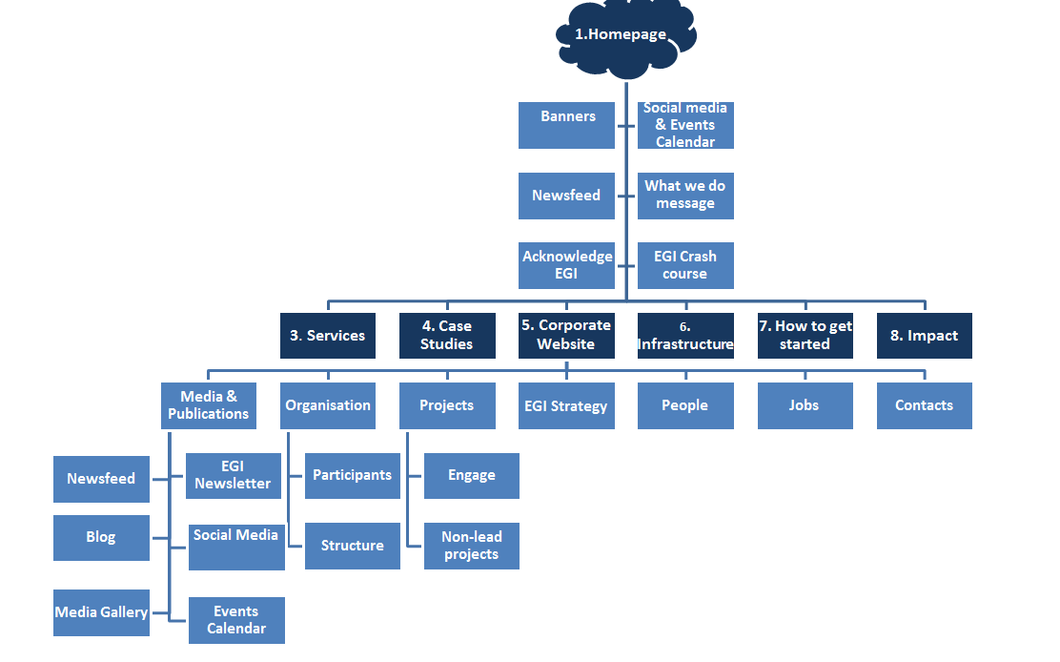

Content development
The new website will have comparatively less content and will focus on the EGI service offer. The previous image contains an outline of the future sitemap.

Timeline
Proposed timeline:
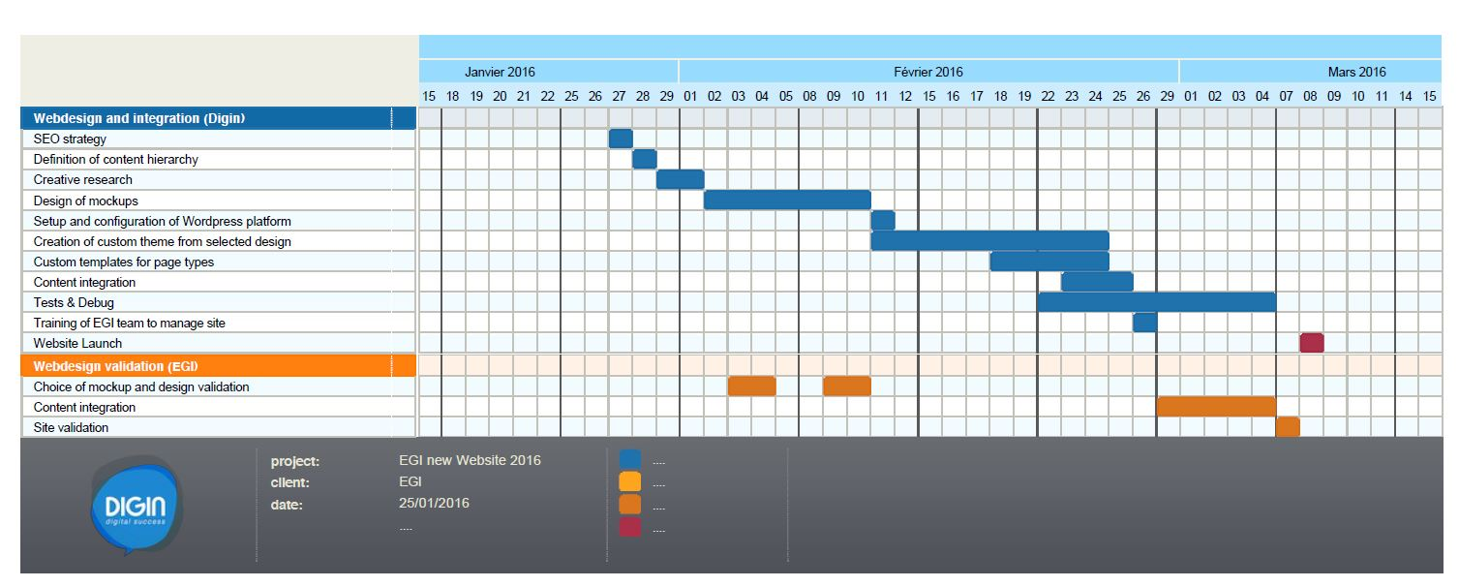

Start of project: end of February 2016
Taking into account our expectations, the technical solution is to use a Wordpress platform mainly for two reasons:
- Open-source, regularly maintained, consistent security updates.
- The administration interface is very intuitive and will allow us to keep the website up-to-date
- Complete control over our content
Main steps of the project:
- Advisory role on establishing the content tree, especially to produce a content hierarchy in line with the SEO strategy
- Custom webdesign: 5 different templates for the front end (home, blank page, profile, index and gallery) both in desktop and mobile resolution + 1 template for the Corporate area
- Setting up of the Wordpress platform and server
- Integration of the web design in a custom theme
- SEO optimization
- Integration of functionality for homepage slider
- Integration of blog functionality
- Integration of newsfeed functionality
- Integration of calendar functionality (interface with iCal or Google Calendar if you wish)
- Integration of Google Analytics
- Custom web development
- Slider (one by one or few at a time) for stakeholders’ logos
- Upload of the site on a temporary domain for validation (for instance : egi.digin.fr)
- Training on how to take control of the content: blog posts, pages, content (text and images), managing menu items, using the custom templates, etc.
- Specific tests and optimizations for tablets and smartphones
- General tests
- Launch of the website!

http://www.egi.eu
The milestone was submitted with the subtitle: The website is reviewed and a number of recommended changes have been applied
http://www.egi.eu/links-for/newcomers/
http://www.egi.eu/links-for/researchers/

