Marketplace User Manual

Author: | Diego Scardaci (EGI Foundation)
Version: | 1
Document Link: | https://documents.egi.eu/document/3235

DOCUMENT LOG
Issue | Date | Comment | Author
v.1 | 08/11/2017 | First version | Diego Scardaci (EGI Foundation)
...
...
v.n

TERMINOLOGY
The EGI glossary of terms is available at: https://wiki.egi.eu/wiki/Glossary
Contents
1 Introduction 4
2 Discover services and submit orders through the EGI Marketplace 5
3 Monitor Service Orders in the Marketplace 11

Introduction
The EGI Marketplace has the ambition of becoming the platform where an ecosystem of EGI-related services, delivered by EGI providers and partners, can be promoted, discovered, shared, ordered and accessed, including EGI offered services as well as discipline and community-specific tools and services enabled by EGI and/or provided by third parties under defined agreements.

Discover services and submit orders through the EGI Marketplace
This section depicts how a customer can access the EGI Marketplace, login, discover services, select service options and related attributes, and submit orders with illustrative screenshots.
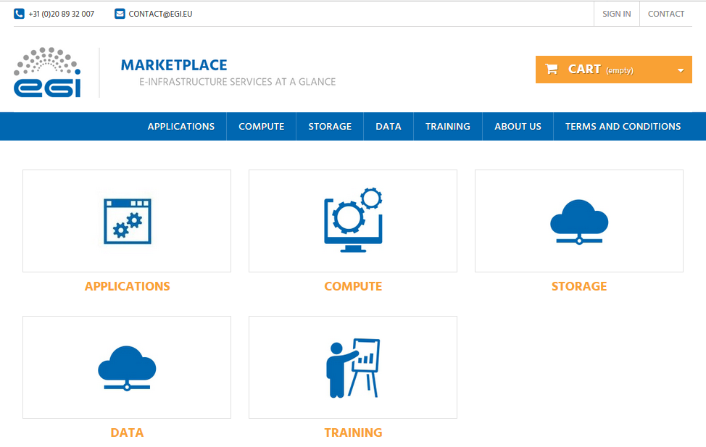
Figure 1. Home page of the EGI Marketplace
- After the customer lands on the EGI Marketplace, he/she can easily discover services navigating on the service tree from the homepage.
- The customer can log in from each page of the Marketplace. During the first login, he/she is requested to register. Part of the customer information is collected by the CheckIn service, see grey fields in Figure 4, the other attributes are manually provided by the same customer through the following form.
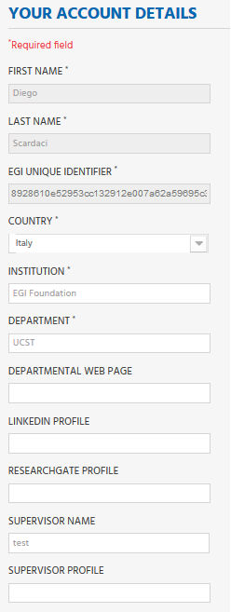
Figure 2. Form to gather the user profile. Fields in grey are filled in with values retrieved by the EGI CheckIn service and cannot be modified.
- When the customer selects a service category, a new view showing all the services under the category is shown. Figure 5 shows the view for the Compute service category.
Now, the customer can then select the service he/she wants to order.
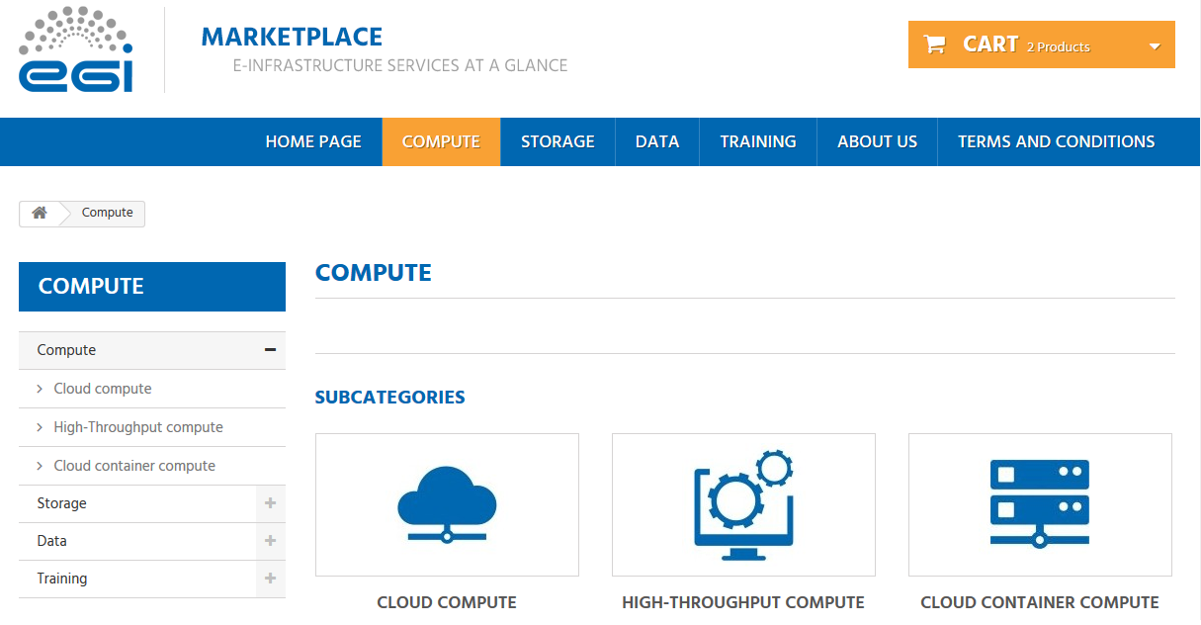
Figure 3. Service category view - Compute
- After the selection of a service, the customer is redirected to the service page that provides:
  - A short description of the service.
  - Links to the terms of use, the default SLA and to a more detailed description.
  - All the available service options.
Figure 6 and Figure 7 show relevant parts of the Cloud Compute service page. As an example, two options for the Cloud Compute service, Compute-intensive instance and High-memory instance, are shown.
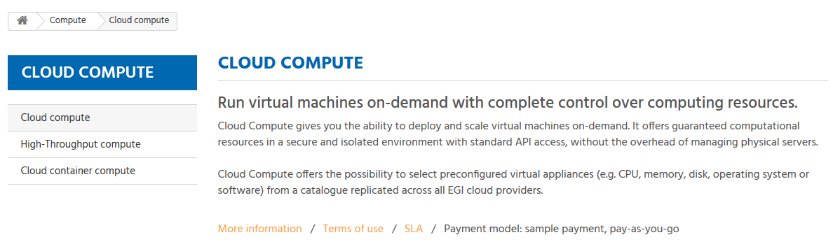
Figure 4. Service view - Cloud Compute
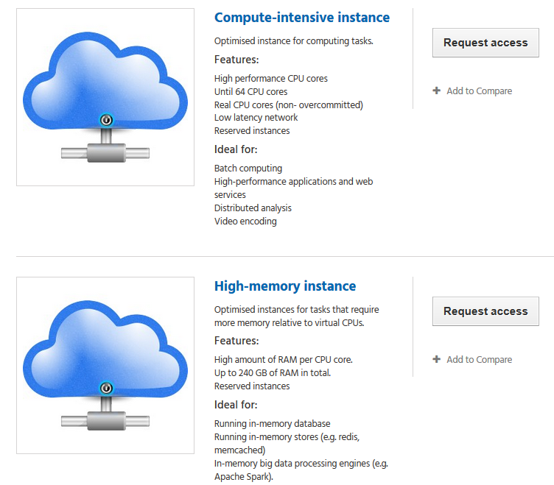
Figure 5. Example of service options - Cloud Compute
- Selecting a service option forwards the customer to a view that allows the customisation of the service option according to his/her requirements via the definition of additional attributes (see the data model in Appendix I). In addition, the customer can decide to add the option to the Cart to submit an order later. As example, see Figure 8 that shows the page for the Compute-Intensive Instance option of the Cloud Compute service.
- The customer can repeat this operation for all the services he/she wants to order.
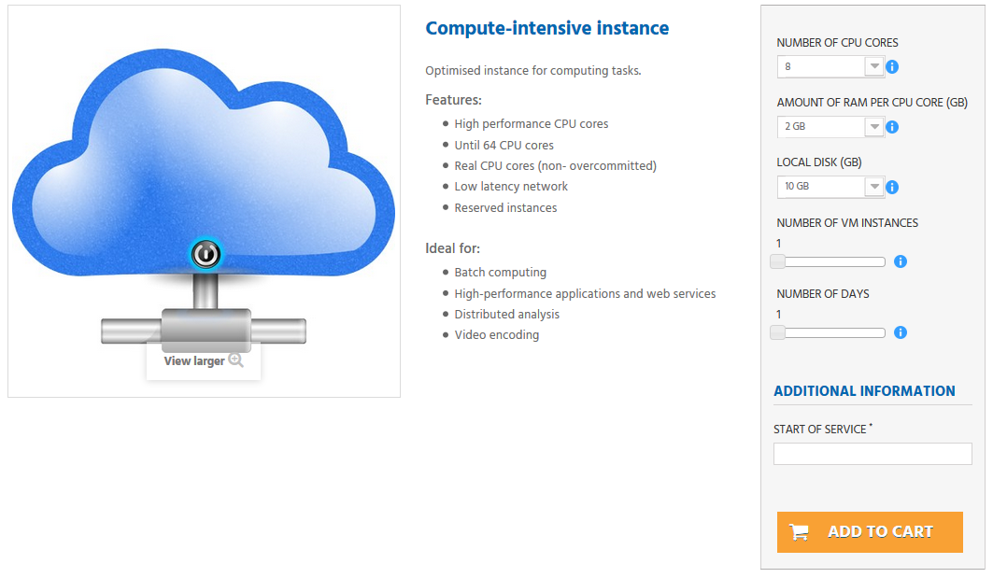
Figure 6. View to order a service. Compute-Intensive Instance in Cloud Compute service
- After the customer has added to the cart all the services he/she wants to order, the Check-Out process can be started by going to the cart. The cart lists all the services and the related options selected, see Figure 9.
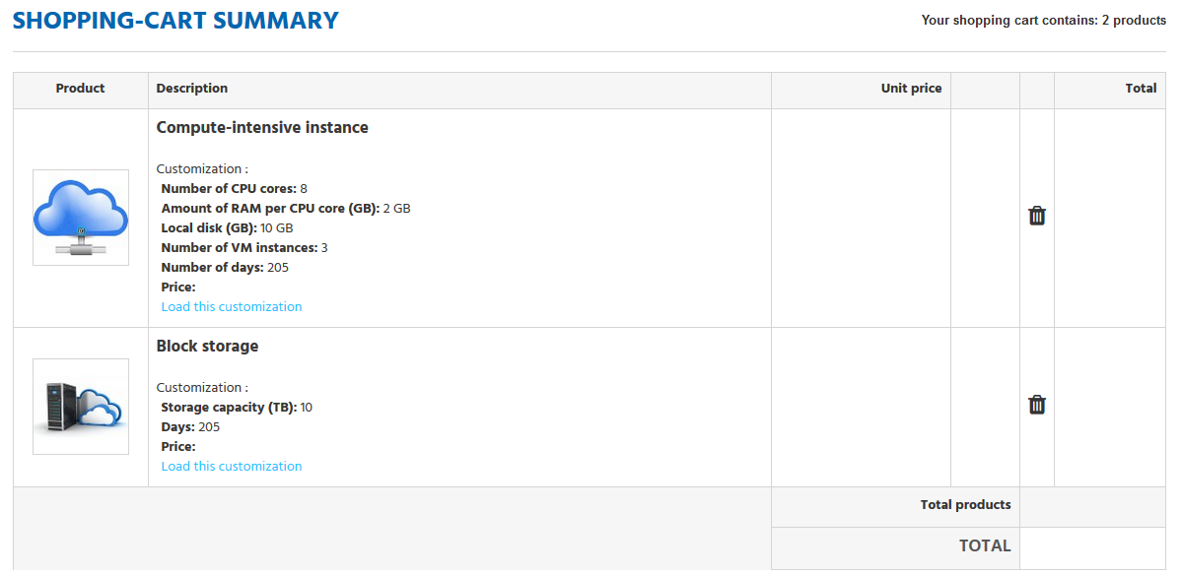
Figure 7. List of selected service options in the Cart
In the cart, the customer is asked to provide some additional information that allows the profiling of the service order, see Figure 10.
The order can only be submitted after the acceptance of the terms of service.
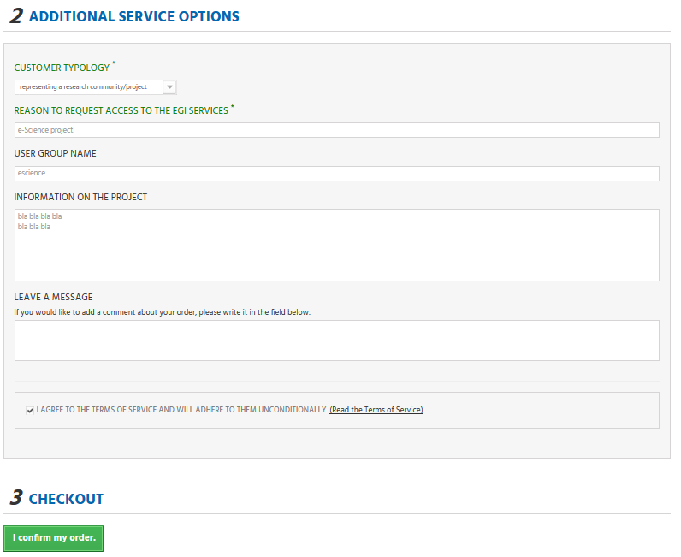
Figure 8. Service order profiling in the cart
- After the service order is submitted, the customer will be notified by e-mail and could check the status of his/her order through the customer dashboard.

Monitor Service Orders in the Marketplace
After a service order is submitted, a customer needs to be kept informed about its status. For this aim, a customer dashboard is available in the Marketplace. Customers can reach the dashboard clicking on the “USER DASHBOARD” link available in the top-right corner of the window. The link to the dashboard is available after the customer logged in.
In particular, the customer dashboard offers the following features:
- List of the submitted orders. For each order the following information is available:
  - Order reference;
  - Date;
  - Price (if applicable);
  - Payment type;
  - Status;
  - Link to the SLA document (available only when an order is accepted).
- A customer can retrieve details of a given order clicking on the corresponding “Details” button.
- Form to contact the EGI Support Team.
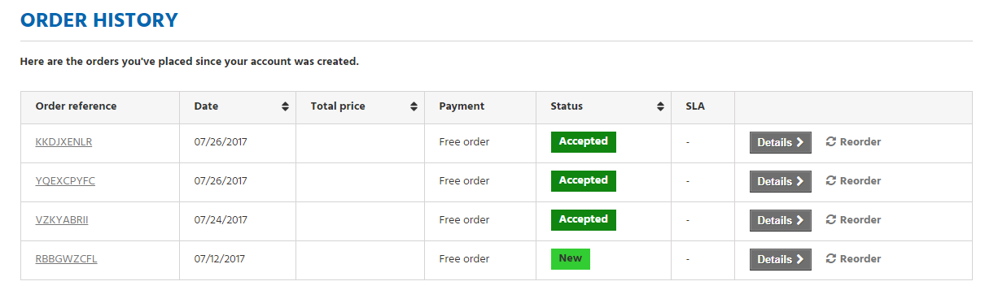
Figure 9. Customer Dashboard

