EGI-InSPIRE

VO Services Activities Work plan (May-October 2011)

(TNA3.4)

 | Document identifier: | VOServicesWorkPlan-12_v8
 | Date: | 08/06/2011
 | Activity: | NA3
 | Lead Partner: | EGI.eu
 | Document Status: | FINAL
 | Dissemination Level: | PUBLIC
 | Document Link: | https://documents.egi.eu/document/527

Abstract
This document presents the objectives, responsibilities and work plan of the Virtual Organisation Services (VO Services) subtask of the TNA3.4 “Technical Services” task of the EGI-InSPIRE project. It starts with a summary of the activities that have been carried out in the last six months of the project (Nov 2010–April 2011), followed by a work plan to be accomplished in the next six months (May-Oct 2011). The report also details the issues which slow down progress of some of the activities at the moment.

- Copyright notice
Copyright © Members of the EGI-InSPIRE Collaboration, 2010. See www.egi.eu for details of the EGI-InSPIRE project and the collaboration. EGI-InSPIRE (“European Grid Initiative: Integrated Sustainable Pan-European Infrastructure for Researchers in Europe”) is a project co-funded by the European Commission as an Integrated Infrastructure Initiative within the 7th Framework Programme. EGI-InSPIRE began in May 2010 and will run for 4 years. This work is licensed under the Creative Commons Attribution-Noncommercial 3.0 License. To view a copy of this license, visit http://creativecommons.org/licenses/by-nc/3.0/ or send a letter to Creative Commons, 171 Second Street, Suite 300, San Francisco, California, 94105, and USA. The work must be attributed by attaching the following reference to the copied elements: “Copyright © Members of the EGI-InSPIRE Collaboration, 2010. See www.egi.eu for details of the EGI-InSPIRE project and the collaboration”. Using this document in a way and/or for purposes not foreseen in the license, requires the prior written permission of the copyright holders. The information contained in this document represents the views of the copyright holders as of the date such views are published.

- Document Log
Issue | Date | Comment | Author/Partner
1 | 28/04/2011 | First draft | I. Blanquer / UPV
2 | 29/04/2011 | First Complete version | I. Blanquer / UPV
3 | 03/05/2011 | Review of first version | G. Borges / LIP
4 | 03/05/2011 | Final review | I. Blanquer /UPV
5 | 20/05/2011 | Corrections to the plan | I. Blanquer /UPV
6 | 25/05/2011 | Review from UCST | G. Sipos / EGI.eu
7 | 31/05/2011 | Final editing | G. Borges / LIP
8 | 08/06/2011 | Small changes in content and finalisation of cover and footer | G. Sipos / EGI.eu

- Document amendment procedure
Amendments, comments and suggestions should be sent to the authors. The procedures documented in the EGI-InSPIRE “Document Management Procedure” will be followed:
https://wiki.egi.eu/wiki/Procedures

- Terminology
A complete project glossary is provided at the following page: http://www.egi.eu/about/glossary/.

- PROJECT SUMMARY
To support science and innovation, a lasting operational model for e-Science is needed − both for coordinating the infrastructure and for delivering integrated services that cross national borders.
The EGI-InSPIRE project will support the transition from a project-based system to a sustainable pan-European e-Infrastructure, by supporting ‘grids’ of high-performance computing (HPC) and high-throughput computing (HTC) resources. EGI-InSPIRE will also be ideally placed to integrate new Distributed Computing Infrastructures (DCIs) such as clouds, supercomputing networks and desktop grids, to benefit user communities within the European Research Area.
EGI-InSPIRE will collect user requirements and provide support for the current and potential new user communities, for example within the ESFRI projects. Additional support will also be given to the current heavy users of the infrastructure, such as high energy physics, computational chemistry and life sciences, as they move their critical services and tools from a centralised support model to one driven by their own individual communities.
The objectives of the project are:
- The continued operation and expansion of today’s production infrastructure by transitioning to a governance model and operational infrastructure that can be increasingly sustained outside of specific project funding.
- The continued support of researchers within Europe and their international collaborators that are using the current production infrastructure.
- The support for current heavy users of the infrastructure in earth science, astronomy and astrophysics, fusion, computational chemistry and materials science technology, life sciences and high energy physics as they move to sustainable support models for their own communities.
- Interfaces that expand access to new user communities including new potential heavy users of the infrastructure from the ESFRI projects.
- Mechanisms to integrate existing infrastructure providers in Europe and around the world into the production infrastructure, so as to provide transparent access to all authorised users.
- Establish processes and procedures to allow the integration of new DCI technologies (e.g. clouds, volunteer desktop grids) and heterogeneous resources (e.g. HTC and HPC) into a seamless production infrastructure as they mature and demonstrate value to the EGI community.
The EGI community is a federation of independent national and community resource providers, whose resources support specific research communities and international collaborators both within Europe and worldwide. EGI.eu, coordinator of EGI-InSPIRE, brings together partner institutions established within the community to provide a set of essential human and technical services that enable secure integrated access to distributed resources on behalf of the community.
The production infrastructure supports Virtual Research Communities (VRCs) − structured international user communities − that are grouped into specific research domains. VRCs are formally represented within EGI at both a technical and strategic level.
- EXECUTIVE SUMMARY
This document describes the achievements and plans of the VO Services sub-task run by the TNA3.4 (Technical Services) task of the EGI-InSPIRE project. The main objective of this task is to support VO and VRC Managers in the monitoring of the infrastructure resources authorized for their VO, guiding them through the proper procedures and supporting them in the deployment and customization of tools for VO operation. This includes setting up communication channels, evaluating tools, providing new tools or clarifying documentations and procedures for operation.
The VO Services activity is focused primarily on Emerging User Communities (EUC) needs since “Heavy” User Communities (HUC) have dedicated support through the SA3 activity of EGI-InSPIRE. However, there are activities in TNA3.4 that could benefit other medium-sized and consolidated User Communities, such as Life Sciences.
During the first twelve months of the project, many different activities have been delivered under the ”VO Services" sub-task:
- An official communication channel (a support unit in the EGI Helpdesk) has been established through which VO Managers can address general and specific questions or requests to the VO Services staff.
- An inventory of services [R1] and monitoring tools [R2] has been evaluated explicitly referencing the added value from the VO perspective. Assessment on the usage of tools for increasing the productivity of VO users, such as DIANE-GANGA and its mini-Dashboard have been performed [R3].
- The procedures for setting up a VO SAM box have been defined [R11], providing help to several communities such as We-NMR and Life Sciences, including support on defining their own probes. VO specific SAM boxes have been setup and are offered as services for the phys.vo.ibergrid.eu, ict.vo.ibergrid.eu and life.vo.ibergrid.eu VOs.
- VO Management procedures and activities have been revised, requirements have been identified, gathered (through EGI Helpdesk and EGI Requirements Tracking system) and delivered to the developers of operational tools used by VOs in their daily work.
- The contents of the User support web site and of the VO Services wiki page [R4] have been improved and several communications have been performed in the frame of the User Forum and other events.
In order to achieve success within some of these activities, the VO Services team had to overcome technological and political difficulties. For example, one of the original aims of the task was to provide dashboards for VOs using the Dashboard system developed for HUCs by the TSA3.2.1 subtask of EGI-InSPIRE. However, due to technological constraints on the system provided by TSA3.2.1, this Dashboard cannot be operated without a commercial Oracle database installation.
The activity overcome this limitation by extending the EGI-wide used Nagios Service Availability Monitoring services with VO-specific frameworks. One of the main aims for the May-October six months period is to further develop this service towards an integrated portal that seamlessly integrates information from thes VO-specific Nagios service and from other sources in order to provide an overall picture for VO managers from a single portal. This portal intends to consolidate usage, alarms, tickets and basic VO information. The activity will also investigate possibilities to offer these services as embeddable Web modules for VO managers to use.
The work will continue in the other main activities of the task: Supporting VO manager and users requests through the specific EGI HELPDESK support unit; testing new components for improving VO productivity - such as the VL-Browser; integrating new communities into the VO Nagios service; promoting the activities of this task; updating documentation and material and finally capturing requirements from VOs and VRCs for additional new services and tools. Section 3 of the document provides details of the work plan.

TABLE OF CONTENTS
1 Introduction 7
2 Activity summary 8
2.1 Consultancy and Helpdesk service 8
2.2 Evaluation of support tools 9
2.3 Provision of services and tools for VOs 10
2.3.1 VO Monitoring 10
2.3.2 Accounting 11
2.4 Promotion activities 12
2.5 Issues and deviations 12
3 Work PLAN 13
3.1 Continuous Tasks 14
3.1.1 Operations of the VO Services in EGI Helpdesk 14
3.1.2 Support / Operate VO SAM instances as services 14
3.1.3 Support VO SAM configuration and VO probes integration 14
3.1.4 Capture and follow-up requirements from VO managers 14
3.1.5 Dissemination and awareness 14
3.1.6 Contribution projects QRs, deliverables and other reports 15
3.1.7 Meetings (USAG, NA3 internal, ...) 15
3.2 Sprints Tasks 15
3.2.1 S1: Review existing documentations for VO Managers 15
3.2.2 S2: Update VO documentation 15
3.2.3 S3: VO/VRC Admin Dashboard - Consolidation of the current functionalities 15
3.2.4 S4: VO/VRC Admin Dashboard - Integration of management panel 16
3.2.5 S5: VO/VRC Admin Dashboard - Integration of VO Accounting data 16
3.2.6 S6: Evaluation and documentation of new tools - VBrowser 16
3.2.7 S7: Evaluation and documentation of new tools - Tools for the management of full or in decommission SEs 16
3.2.8 S8: Evaluation and documentation of new tools – iFrame and Portlet technology for services 17
4 Conclusions 18
5 References 19

Introduction
The VO Services sub-task is carried out in the context of the TNA3.4 (Technical Services) subtask of the EGI-InSPIRE project. The activity is focused on Emerging User Communities (EUC) needs since Heavy User Communities (HUC) are supported through the SA3 activity. After one year of operation the main purposes of the VO Services activity can be defined as:
- provide services for high-level VO services, such as dashboards and monitoring tools to experiment, collect feedback and recommendations on such services;
- support VOs by guiding VO managers during the various steps of the VO management process;
- document VO management processes and best practices for VO managers;
- capture and feed in requirements to the developers of VO Management support tools from VO managers;
- assist VO managers in deploying, using and adapting technical services which may simplify their user community access to the infrastructure and promote collaboration within the VO;
- provide assessments on tools that could improve the usage of resources in a VO;
- and collect feedback from VO and VRC regarding the technical services provided by EGI and by the different NGIs, and map it into requirements for services improvement.
In the following sections, we will summarize the progress that has been achieved during the past twelve-month period, according to the EGI-InSPIRE work plan [R5], and propose a new work plan for the next six-month period (1-May-2011 to 31-Oct-2011).

Activity summary

EGI’s user community has two important structures: Virtual Organisations (VOs) and Virtual Research Communities (VRCs). A VO is a group of people (e.g. scientists, researchers) with common interests and requirements, which need to work collaboratively with other members of their collaboration and/or share resources (e.g. data, software, expertise, CPU, storage space) regardless of geographical location. They join a VO in order to gain access to resources by agreeing to a set of rules and policies that govern the access and security rights for the users, resources and data in question. EGI currently hosts more than 200 VOs for communities with interests as diverse as Earth Sciences, Computer Sciences and Mathematics, Fusion, Life Sciences or High-Energy Physics.
A VRC is a group of large-scale scientific research collaborations, either covering multiple VOs that are part of a larger domain area. The VRC model allows a community to have bi-directional interactions through defined points of contact with EGI across broader domain areas.
There are already more than 200 VOs hosted on EGI. Users are invited to join these VOs, or establish new ones. Setting up and operating a VO is a complex task that requires a wide set of central services (VOMS servers, WMS, File Catalogues, monitoring tools, accounting services, productivity services, etc.). Procedures are neither easily available nor complete, and community tools and services are available in EGI but their visibility is geographically constrained.
The VO Services activity focuses on breaking this geographical barriers and improving the accessibility to tools that could increase the productivity and satisfaction of VO managers and VRC representatives.  The VO Services activity is therefore organised around three focus areas:  - Consultancy and Helpdesk services.  - Evaluation of support tools for VO and VRC managers.  - Provision of services and tools for VO and VRC managers. | 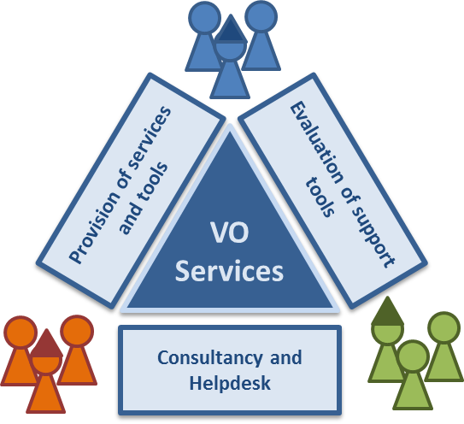  Figure 1: Focus areas of work for the VO Services activity.

Consultancy and Helpdesk service
This activity offers VO managers consultancy on operation, supporting discussions on operation scenarios, suggesting tools and services and pointing to operational documentation. In the activity we gather documentation and best practice procedures to optimize the VO manager daily activity and to discuss and analyse VO managers’ requests, involving different experts in the discussions, bridging VO managers’ requests with the appropriate support units and Identifying VO requirements, which are then resolved by us, by the User Community Support Team (UCST) or other teams and bodies reached through UCST.
The activity set up a communication channel by creating a User Support Unit in the EGI Helpdesk (VO Services Support Unit [R6]), which has a direct link to VO services staff and constitutes a database of discussions that could be used for further feedback. Additionally, the VO Services activity has a mailing list (mailto:vo-services@mailman.egi.euVO Services@mailman.egi.eu) that can be used to direct any particular question to the team. | 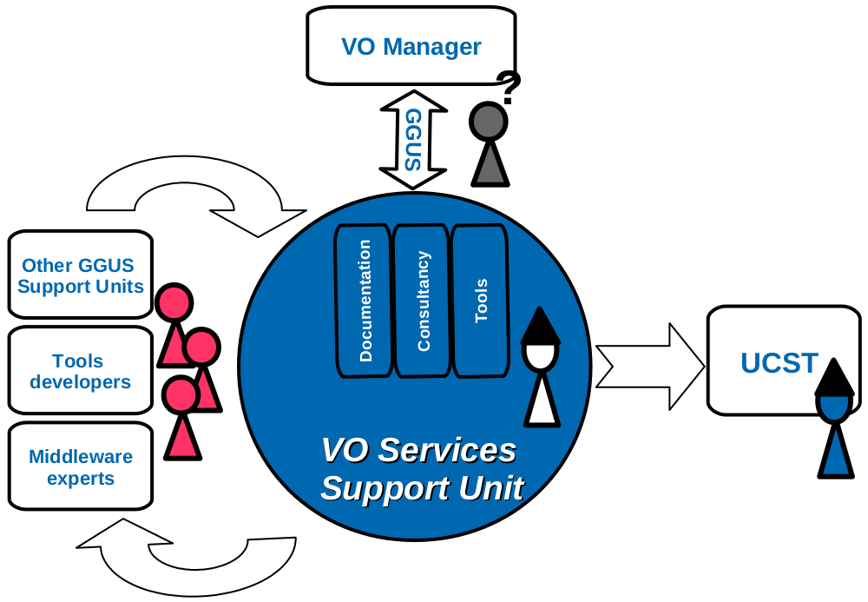  Figure 2: Focus areas of work for the VO Services activity.
Regarding documentation, the work performed in the first six-monthly period with the analysis of the monitoring and accounting tools and the core services required to set-up and operate a VO has been continued [R1,2] with the update on the procedure to register a new VO in EGI and the VOMS Management FAQ documentation [R7].

Evaluation of support tools
The objective of this activity is to investigate tools and services that could be adapted to VO environments, which could minimize time and optimize success, and foster production quality by the users of a VO. This activity is performed by promoting tools developed under the NGI scope to the whole EGI community and investigating how EGI global tools (EGI Accounting Portal, Operation Portal, etc...) should be improved to better meet the needs of VO / VRC managers. The outcome of this task is a set of evaluation documents about services. Such an evaluation document provides:
- A brief description of the software including its key features and link to the homepage of the software.
- The tool installation guide and user guide.
- FAQ documentation / links.
- Links for Demos.
- A report of the evaluation of the tool by members of the VO Services activity.
- Information on whether the tool is offered as a service, and if yes, by whom.
- Additional configuration and installation hints.

The current portfolio for services and tools is published in [R3], and currently includes evaluation documents about the following software:
- GANGA: A tool for job submission and management [R8].
- DIANE: A lightweight job execution control framework for parallel scientific applications aiming to improve the reliability and efficiency of job execution by providing automatic load balancing [R9].
- EGI introductory package: A mini-dashboard approach offered as a service by CERN, and providing a central view of DIANE and GANGA acknowledged user jobs [R10].
- VO SAM: A service for monitoring the infrastructure on the point of view of the VO, with the possibility to define own VO profiles and to include VO probes [R11].

Provision of services and tools for VOs
In this activity, most of the work has concentrated on improving the VO monitoring through the development of a VO-centric Service Availability Monitor based on the Nagios software widely known and used in EGI.

VO Monitoring
Resources of EGI are continuously monitored for correctness by various operational tools developed and provided by JRA1, SA1 and outside of EGI-InSPIRE. The tests performed by these tools on the sites are generic across the whole infrastructure and their results are visualised on a per NGI basis. However, this testing infrastructure neither provides services for VO managers to implement and run VO-specific tests on EGI sites, nor allow these persons to visualise the outcome of site tests on a per VO basis.
Having a framework to implement, run and visualise VO-specific tests is crucial to assure that custom software packages of the various VOs are properly configured and available for communities.
In the last six months the VO Services activity has implemented a VO-specific Service Availability Monitor (SAM) tool to meet this goal. The solution is a customised version of the Nagios software that is used as the standard service monitoring tool by EGI site administrators. The VO Services team produce the proper configuration guidelines for this service in order to run VO-specific tests on the infrastructure, spanning across sites from multiple NGIs. The architecture of the monitoring system is presented in Figure 1. This customised Nagios server can be extended with VO-specific test probes to:  - Ensure that VO-specific VOMS configuration of resources is correct. The tests are executed using the VO credentials.  - Check that VO-specific software packages are correctly installed.  - Recognise and warn if storage resources become full for a VO.  - Validate that special application requirements (e.g. bandwidth) or configuration features (e.g. ports) are fulfilled. | 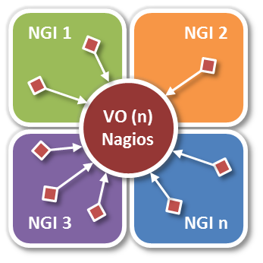  Figure 2. VO-specific Service Availability Monitor infrastructure based on Nagios server.
This service is available for VOs in two ways:
- The VO Services team (LIP in Portugal and UPV in Spain) hosts and provides this service for VOs.
- Any VO can install and operate the service for itself.
The NA3 VO Services team has interacted with the EGI SAM developers in order to produce a documentation [R11] so that VOs could easily deploy and configure the service for themselves. Such documentation was non-existent, and its creation had a significant impact since it smoothed the difficult and hard working process of installing and configuring SAM for VOs. Moreover, the NA3 VO Services has provided feedback so that the currently service could be improved from a VO/VRC perspective. The most important points agreed to be included in the SAM developers roadmap are to integrate:
- the possibility to support several VOs under the same service: This was required so the LIP-UPV team can serve multiple VOs with a single installation
- an option on the topology generation method to obtain the correct list of VO resources, and integrate them on the service monitoring box;
- and the possibility to define VO profiles, with default probes, which can be extended with the inclusion of VO own probes.
The VO SAM documentation was already used by some VOs while setting up their own services (We-NMR, Ibergrid user communities, Life Sciences), and the work has been acknowledge by the SAM developers. This activity also offers the possibility to temporarily host the service on behalf of the VO during the ramp-up of the VO. For that purpose, two Nagios instances are already set-up and available.

Accounting
Accounting of VOs in EGI is performed through the accounting portal [R12]. The accounting portal provides an aggregated view of the consumption of resources from the point of view of an NGI or a single VO. Customised view by sets of VOs requires interfacing through a long list of options in the “custom view”.
A requirement has been posted to the accounting portal developers to deal with a simpler and user-friendly interface which will allows an easier assessment of the VO/VRC activity in the infrastructure [R13]
Another requirement has been issued so that the accounting portal could offer the accounting data as a service in a machine format so that VO and VRC could grab that source of data, and reprocessed according to their own needs [R14].

Promotion activities
A key point in the VO services activity is to ensure that the tools are accessible and well-known by the user community. Therefore, VO Services activity has:  - Increased the visibility of services and achievements through a dedicated section within the EGI web site [R15] and a detailed wiki page linked to it [R4].  - Contributed to the EGI User Forum (Vilnius, April 2011), a demo of the above described VO-specific SAM tool, with two flyers (one of them also as poster) and two presentations [R16] and [R17]. | 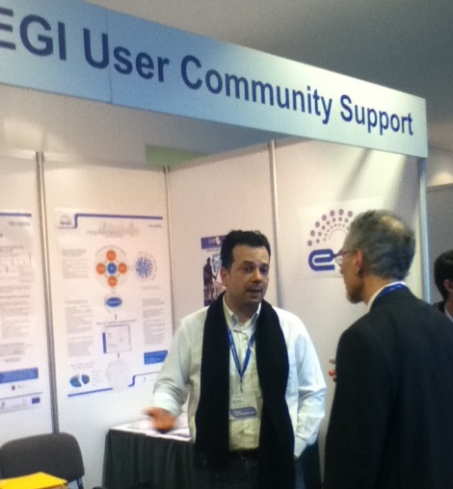

Issues and deviations
At the beginning of the project having a VO-specific monitoring tool (described in Section 2.3.1) was foreseen as an easily achievable goal. According to the DoW the CERN Dashboard system (provided for HUCs in TSA3.2.1) promised the required functionalities. However, detailed investigations revealed that this software requires a commercial Oracle database installation, thus cannot be hosted either by the LIP-UPV team of VOs.
While the team managed to come up with an alternative solution for the service based on a customisation of the EGI SAM infrastructure, the investigations around the CERN Dashboard used up effort from the activity. The impact of the missing functionality is minimized by the introduction of the VO SAM, available for any VO to use since April 2011.

Work PLAN
This chapter presents the proposed work plan for the VO Services activity for the next 6-month (May-October 2011). The total effort that is foreseen to be used within this period is 27 person week (there are 26 weeks in this six months).

Table 1 provides an overview of tasks that will be carried out as continuous tasks during the six month period, or carried out if needed on demand. The estimated effort required for each of these tasks is also provided.

Task | Required effort  (person week)
 | Estimated | Actual
Operation of the VO Services Support Unit in EGI Helpdesk | 1.5
Support and operate VO SAM instances as services | 1.5
Setup additional SAM instances and help users implement VO-specific probes for these instances | 2.5
Capture and follow-up requirements from VO managers | 1.0
Dissemination (presentations, production of materials, webpage updates) | 1.5
Contribute to project documents (e.g. periodic reports, deliverables, ...) | 0.5
Attending meetings (USAG, NA3 internal, ...) | 0.5
TOTAL EFFORT | 9.0

Table 2 provides an overview of activities that will be carried out as “sprints” in the six months. The estimated effort required for each of these tasks is also provided.
Sprint | Task | Duration  (person weeks)
 |  | Pragmatic | Extended
S1 | Review existing documentations for VO Managers | 0.5
S2 | Update VO documentation | 1.5
VO/VRC Admin Dashboard development
S3 | Consolidation of the current functionalities | 2.0
S4 | Integration of the management panel | 3.5
S5 | Integration of VO Accounting Data | 3.5
Evaluation and documentation of new tools
S6 | VBrowser | 1.0
S7 | Full or in decommission SE tools | 3.0
S8 | iFrame and portlet technologies for services | 3.0
TOTAL EFFORT |  | 18
Table 1 VO Services 6 month work plan

Continuous Tasks

Operations of the VO Services in EGI Helpdesk
We will continue to offer consultancy and helpdesk services to VOs/VRCs in whole EGI/NGIs community through the communication channels established during previous work plan. The operation of the VO Services support unit includes acknowledge tickets opened via EGI Helpdesk, and providing proper feedback. The VO Services mailing list can also be used as a public contact point for support but, if possible, all requests should be redirected to the EGI Helpdesk support unit since it provides a public web interface where users can search for tickets and consult tickets public history. Since this support unit has a very wide scope, the time estimated on answering tickets may vary: it could be really fast if the issue is well identified, or it could take very long time if some research about the subject is needed. The expected workload also depends on the number of submitted requests which is expected to increase during the next 6 month period. The estimated effort to be spent to this activity is 1.5 person weeks.

Support / Operate VO SAM instances as services
The VO SAM has constituted a service that attracted quite a lot of interest. The work performed in the second six-monthly period will continue in the following main lines. Two instances of the VO SAM are already in place and offered as services to VOs. We expect that additional VOs ask to be integrated as time goes by. Integration of a VO in one of the production services implies the configuration of the instance itself, and of the services that the VO SAM needs to use (PX Server, WMS, LFC, etc). The time estimated to this activity is 1.5 person weeks.

Support VO SAM configuration and VO probes integration
We will continue to provide support for all the communities that are willing to deploy their own VO SAM instance or develop their own VO probes. Contacts with fusion VO have been performed and We-NMR are already on board. We will continue to updating the installation and configuration information described in [R11] with the feedback from new users and the availability of new versions of the tools involved; and we will support the deployment of VO-specific Nagios probes providing documentation and guidelines to achieve it. The time estimated to this activity is 2.5 person week.

Capture and follow-up requirements from VO managers
Gathering requirements and following them up to identify solutions for them is an important task for the VO Services. VO Services has the responsibility to keep the submitters informed about the request status. We are presently handling a request from the several communities so that the project can provide a VO operational dashboard. Other requirements are being evaluated as support for the VOMS Registration Service, or the implementation of a tool to collect statistics from VOMS services. The time estimated to this activity is 1.0 person week.

Dissemination and awareness
The VO Services activity strongly depends on the awareness of the services by the user community. The following events are already identified and planned to attend:
- IBERGRID 2011 [R26]. A paper on VO services has been submitted to the conference.
- Yearly meeting of the Spanish National Network for e-Science [R27]. Information on the VO Services will be distributed at the event, with an estimated participation of 100 attendees.
- EGI Technical Forum 2011 [R28]. To be held in Lyon.
New dissemination materials will be created in order to raise the awareness on new services and tools which are integrated along the period. Also, web pages and wiki pages should be updated on demand.
The time estimated to this activity is 1.5 person weeks.

Contribution projects QRs, deliverables and other reports
We will continue to contribute to the Quarterly Reports, Metrics, deliverables and other reporting. The time estimated to this activity is 0.5 person weeks.

Meetings (USAG, NA3 internal, ...)
We will continue to participate in the regular NA3 meetings weekly calls, bimonthly USAG calls and others. The time estimated to this activity is 0.5 person weeks.

Sprints Tasks

S1: Review existing documentations for VO Managers
Review existing documentation for VO Managers, identifying gaps and detecting incoherencies and problems. The time estimated to this activity is 0.5 person weeks.

S2: Update VO documentation
Continue to aggregate documentation considered relevant for VOs in [R7]. This activity foresees providing new documentation (trigger by a request of complaint by the VOs) or reviewing / updating existent documentation as a results of Sprint S1. The time estimated to this activity is 1.5 person weeks.

S3: VO/VRC Admin Dashboard - Consolidation of the current functionalities
VO managers have to deal with a large set of tools and services to operate their daily work. The VO Admin dashboard intends to be a fully customized tool that will consolidate several VO tools and views into a single aggregated framework. The development of the VO admin started during previous period, and focused on identifying the sources of information to be integrated in this platform. The most important sources of information are:
- EGI Helpdesk [18] VO tickets, to monitor all the tickets concerning the resources and users of the VO.
- The CIC Operations Portal [R19] and the Central Operations Portal [R20] to update and check the information concerning the main services and web pages of the VO.
- The VOMS administrative interface, to operate subscriptions and VO configurations.
- The GStat - Information System Monitor [R21] to monitor the status of the sites or the equivalent VO-nagios box if deployed.
- The Grid Configuration Database - GOCDB [R22], to browse or update information about the resources in EGI.
- The Application Database [R23] to browse and update all the applications from your VO.
Work is still needed to consolidate the database system, and implement a caching mechanism (on some of the views) to allow a faster access to the information. The time estimated to this activity is 2 person weeks.

S4: VO/VRC Admin Dashboard - Integration of management panel
We plan to integrate a management panel so that each VO manager can customize the views of VO admin dashboard, emphasizing what, in his perspective, he thinks it is important. The permissions to change VO views are restricted to VO administrators identified via X509 certificates. The time estimated to this activity is 3.5 person weeks.

S5: VO/VRC Admin Dashboard - Integration of VO Accounting data
The VO admin dashboard is missing an important source of data to a technological problem: The VO accounting data (amount of computing and storage resources consumed by the VO from EGI). Therefore, we have included a requirement to the EGI accounting developers so that the VO accounting data could be retrieved from the portal on a machine format, and processed at the client side.
The accomplishment of this sprint is dependent on when our request could be integrated the accounting portal roadmap, and there is the possibility that it can be delayed to next period. The time estimated to this activity is 3.5 person weeks.

S6: Evaluation and documentation of new tools - VBrowser
Evaluate the VBrowser [R24] tool since the tool is considered an added value that abstracts the complexity of data management operations. VBrowser is an application to browse files and jobs in the Grid. This tool provides a simple GUI to create proxies, browse catalogues and manage jobs using user-friendly interfaces such as drag-and-drop facilities for copy and register, download or replication of complete directory trees. The installation is easy, but configuration of the proxy and associated certificates could be a barrier for many users. We will produce a report and provide general updated configuration files. The time estimated to this activity is 1.0 person week.

S7: Evaluation and documentation of new tools - Tools for the management of full or in decommission SEs
When an SE becomes full, or needs to be replaced, data may needs to be transferred to other sites. Currently such tasks must be carried out by the owners of the data using cumbersome command line scripts.
We will gather the requirements for better processes from different VOs, will map these requirements to existing features of various tools (e.g. VBrowser) and will make recommendation for the further development of these and/or other tools in order to satisfy the needs. The UCST, the UCB and through this technology providers will be involved if needed. The time estimated to this activity is 3.0 person week.

S8: Evaluation and documentation of new tools – iFrame and Portlet technology for services
Investigate and provide guidelines on how general services and services provided by the activity can benefit from iFrame and portlet technologies in order to become individual, customisable entities that can be integrated into any website. The activity is performed in collaboration with the providers of Application Database and Training services in TNA3.4. The time estimated to this activity is 3.0 person week.

Conclusions
The VO Services subtask has used the first 12 months of the project to:
- Clarify the scope and responsibilities of the activity within the project and within the EGI collaboration in the largest sense;
- Produce an inventory of basic and general grid core services including an evaluation of costs and requirements for their operation from different perspectives: Service provider, VO operations and User Support;
- Produce an inventory of tools with suited characteristics for VO monitoring;
- Improve procedures for VO management, namely revising the VO registration procedure, building a VO changes procedure, gathering requirements for the work-flow between all partners, tools and services involved in VO Management activities;
- Set-up an official communication channel, via a dedicated support unit in the EGI helpdesk, operate it, so that VO requests can be safely delivered to the VO Services staff;
- Create and set-up a VO SAM monitoring tool for enhancing VO resources availability;
- Raise awareness for the services by contributing to theEGI User Forum at Vilnius, by producing a Wiki page and contributing to the User Support section of the EGI.eu webpage.

The plan for the next 6 months includes:
- Continue with the provisioning of existing services – the support unit in the EGI Helpdesk, the VO SAM service, consultancy for VO Managers and users of VO-specific SAM instances.
- Review additional software tools that provide beneficial services for VO Managers and could be part of the service portfolio offered by the VO Services team.
- Introduce the “VO Dashboard” in the set of services provided by the team.
- Review iFrame and portlet technologies in order to extend the offered VO services towards customisable Web elements that can be integrated into any website.

After one year of operations, the feedback from the assessed user communities showed that the need for this activity is high since it covers a well identified gap from precedent projects.

References
R1 | https://wiki.egi.eu/w/images/f/f4/Setting_up_VO_Services_in_EGI_v2.pdf
R2 | https://wiki.egi.eu/w/images/1/1b/Monitoring_tools_V5.pdf
R3 | https://wiki.egi.eu/wiki/Services_and_Tools_Portfolio
R4 | https://wiki.egi.eu/VO_Services
R5 | https://documents.egi.eu/document/277
R6 | https://wiki.egi.eu/wiki/EGI_Helpdesk:VO_Services_FAQ
R7 | https://wiki.egi.eu/wiki/Relevant_documentation_for_VO_activities
R8 | http://ganga.web.cern.ch/ganga/
R9 | http://it-proj-diane.web.cern.ch/it-proj-diane
R10 | https://twiki.cern.ch/twiki/bin/view/ArdaGrid/EGIIntroductoryPackage
R11 | https://wiki.egi.eu/wiki/VO_Service_Availability_Monitoring
R12 | http://www3.egee.cesga.es/gridsite/accounting/CESGA/egee_view.php
R13 | https://rt.egi.eu/rt/Ticket/Display.html?id=1275
R14 | https://rt.egi.eu/rt/Ticket/Display.html?id=1802
R15 | http://www.egi.eu/user-support/services/
R16 | https://www.egi.eu/indico/contributionDisplay.py?sessionId=10&contribId=60&confId=207
R17 | https://www.egi.eu/indico/contributionDisplay.py?sessionId=10&contribId=49&confId=207
R18 | https://gus.fzk.de/pages/home.php
R19 | http://cic.in2p3.fr
R20 | http://operations-portal.egi.eu/
R21 | http://gstat-prod.cern.ch/
R22 | https://goc.gridops.org/
R23 | http://appdb.egi.eu/
R24 | http://www.nikhef.nl/~ptdeboer/vbrowser/
R25 | http://desktop.psnc.pl/pages.php?content=page_main
R26 | http://www.ibergrid.eu/2011
R27 | http://www.e-ciencia.es/FichaEvento.jsp?externos=null&IDEvento=25
R28 | http://tf2011.egi.eu/

