EGI-Engage

Scipion cloud deployment for MoBrain
D6.14

Date | 13 December 2016
Activity | WP6
Lead Partner | CNB – CSIC
Document Status | FINAL
Document Link | https://documents.egi.eu/document/2982

Abstract
Scipion is a powerful and versatile framework that allows researchers to obtain 3D maps of macromolecular complexes combining the best from the most popular 3D Electron Microscopy (EM) software packages. In the context of MoBrain project, CNB-CSIC has deployed the Scipion framework into the EGI Federated Cloud. CNB-CSIC team also tested the deployments with real Electron Microscopy user cases.
End users can try the features of Scipion without installing it, thanks to the Scipion Web Tools virtual machine available in the EGI Federated Cloud.
With the easy-to-deploy ScipionCloud appliance, researchers can access the full power of Scipion, leveraging the EGI Federated Cloud computing resources.

COPYRIGHT NOTICE
This work by Parties of the EGI-Engage Consortium is licensed under a Creative Commons Attribution 4.0 International License (http://creativecommons.org/licenses/by/4.0/). The EGI-Engage project is co-funded by the European Union Horizon 2020 programme under grant number 654142.
DELIVERY SLIP
 | Name | Partner/Activity | Date
From: | Laura del Cano | CNB – CSIC / WP6 | 06/12/2016
Moderated by: | Malgorzata Krakowian | EGI Foundation / WP1
Reviewed by | Gergely Sipos  Sy Holsinger  Enol Fernandez | EGI Foundation / WP6  EGI Foundation / WP2  EGI Foundation / WP6 | 18/11/2016  01/12/2016  02/12/2016
Approved by: | AMB and PMB |  | 13/12/2016

DOCUMENT LOG
Issue | Date | Comment | Author/Partner
v0.9 | 10/11/2016 | First draft | Laura del Cano / CNB-CSIC
V1 | 14/11/2016 | Full draft, ready for external review | Jesús Cuenca-Alba / CNB-CSIC
V2 | 17/11/2016 | Completed document metadata | Malgorzata Krakowian / EGI.eu
V3 | 21/11/2016 | Modified upon reviewers comments | Gergely Sipos, Sy Holsinger / EGI.eu
V4 | 01/12/2016 | External review | Enol Fernández / EGI.eu  Bram Koster / NECEN
Final | 06/12/2016 | Final version for approval | Jesús Cuenca-Alba / CNB-CSIC  Laura del Cano / CNB-CSIC
TERMINOLOGY
A complete project glossary and acronyms are provided at the following pages:
- https://wiki.egi.eu/wiki/Glossary_V3
- https://wiki.egi.eu/wiki/Acronyms
Additional acronyms, specific to this document:
Acronym | Description
3DEM | 3D Electron Microscopy
AWS | Amazon Web Services
EM | Electron Microscopy
FedCloud | EGI Federated Cloud
SPA | Single Particle Analysis
SWT | Scipion Web Tools

Contents
1 Introduction 5
2 Service architecture 8
2.1 High-Level Service architecture 8
2.1.1 Scipion 8
2.1.2 ScipionCloud 10
2.2 Integration and dependencies 11
2.2.1 MoBrain and the EGI Federated Cloud 11
2.3 Technical challenges 15
2.3.1 Interactive performance 15
2.3.2 Resources management 15
3 Feedback on satisfaction 18
4 Plan for Exploitation and Dissemination 19
5 Future plans 20
5.1 ScipionCloud improvement 20
5.1.1 GPU acceleration 20
5.1.2 Automatic cluster management 20
5.1.3 High availability 20
5.1.4 Security 21
5.1.5 Data transfer 21
5.2 Plans for exploitation 21
5.3 Plans for dissemination 22
6 Conclusions 23
7 References 24

Executive summary
Scipion (de la Rosa-Trevín, 2016) is a powerful and versatile framework that allows researchers to obtain 3D maps of macromolecular complexes combining the best from the most popular 3D Electron Microscopy (EM) software packages, satisfying the complex demands of contemporary EM studies.
CNB-CSIC MoBrain team has deployed Scipion in EGI Federated Cloud both in single node and cluster architectures. We tested it with real user cases. We also deployed one running Scipion Web Tools appliance that serves as test bed for novice users who want to try the features of Scipion without installing it, and with no direct access to cloud resources.
In this context of installing Scipion on cloud instances, we faced challenges regarding interactive performance, scalability and resource management. We created ScipionCloud, a gateway that solves those challenges, hence allowing easily deploying and accessing the full power of Scipion on commercial and academic clouds.

Introduction
In 2015, 3D Electron Microscopy on molecular structures under cryogenic conditions (“cryoEM”) was entitled “Method of the Year”. (3DEM Method of the year 2015, 2016). This was for good reason as the introduction of new types of direct electron detectors (that have several times higher detective quantum efficiency -DQE- than previously available ones), together with continuous improvements of advanced electron microscopes, in computing hardware as well as in software tools, transformed the technique in such a way that it became feasible to generate reconstructions with near-atomic resolution (Vinothkumar, 2016).
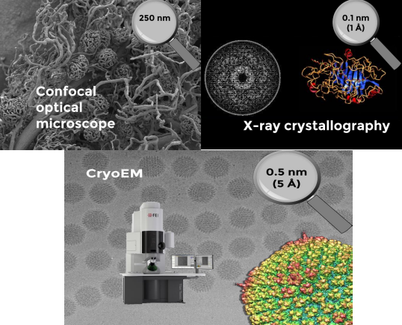
Figure 1 - CryoEM allows the high-resolution (5A) reconstruction of large and flexible macromolecular complexes, without 3D crystals, and from small amount of diluted samples.

without 3D crystals, and from small amount of diluted samples.
One key factor regarding hardware is the high performance of Graphical Processor Units, which is motivating more and more scientific programmers to optimize their software packages for these accelerators.
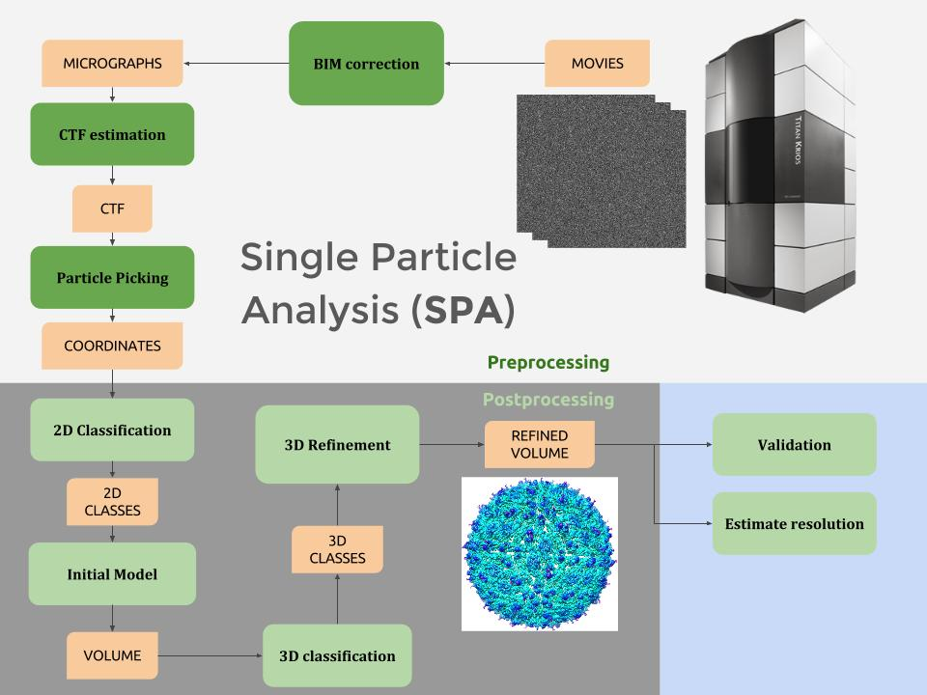
Another key hardware factor is the availability and reduction in net cost of Cloud Computing. Even though the required resources may be substantial, currently it is feasible to process entire 3DEM workflows in the cloud.
Figure 2 - CryoEM workflows start with a set of movies produced by the Electron Microscope. After 2D and 3D analysis steps, a 3D volume of the specimen is obtained.
Raw computing power and new algorithms, per se, are not sufficient to satisfy the growing and diverse needs of cryoEM scientists. Their studies demand also versatile project management tools that provide adequate support to the increasingly larger and more complex nature of the projects.
Scipion is an image processing framework that allows researchers to obtain 3D maps of macromolecular complexes combining the best from the most popular 3DEM software packages. All the low-level specifics (such as taking care of formats and conversions, or tracking the parameters of each step) are taken care of by Scipion. This inherent careful management of the specifics makes it straightforward to share and to repeat workflows, encouraging reproducibility in science.
Here we present the efforts that have been dedicated to deploy and assess Scipion on the EGI Federated Cloud, and the actual EM processing performance achieved on such deployments. The EGI Federated Cloud (Fernández-del Castillo, 2015) is a novel type of research e-infrastructure, based on the mature federated operations services that make EGI a reliable resource for science. As an IaaS-type cloud, it is built upon academic private clouds, virtualised resources and open standards.
Based on the experience deploying Scipion on the cloud, we created ScipionCloud, a gateway that allows the cryoEM users community to easily deploy Scipion on their cloud of choice. ScipionCloud is available as an EGI Virtual Appliance and as an Amazon Machine Image.

Tool name | ScipionCloud
Tool url | https://appdb.egi.eu/store/vappliance/scipion.v1.0
Tool wiki page | https://github.com/I2PC/scipion/wiki/ScipionCloud
Description | ScipionCloud is a virtual appliance that can be used to instantiate a Virtual Machine on the EGI Federated Cloud with a full installation of Scipion 1.0.1. The Virtual Machine includes a graphical environment that can be efficiently accessed with a web browser.
Value proposition | ScipionCloud will allow users to have a ready-to-use machine with a preconfigured Scipion installation and a powerful remote desktop solution to ensure the interaction happens as if deployed on the user’s computer.
Customer of the tool | INSTRUCT (ESFRI); West-Life (backend infrastructure); MoBrain CC; Individual researchers and research teams.
User of the service | Individual researchers and research teams.
User Documentation | https://github.com/I2PC/scipion/wiki/User-Documentation
Technical Documentation | https://github.com/I2PC/scipion/wiki/Developers-Page
Product team | Centro Nacional de Biotecnologia (CNB-CSIC)
License | GPL v2
Source code | https://github.com/I2PC/scipion
Table 1- ScipionCloud tool description summary.

Service architecture

High-Level Service architecture

Scipion
Scipion is an image processing framework aimed at obtaining 3D maps of macromolecular complexes using cryo Electron Microscopy. It emerged as a solution offered by the Instruct Image Processing Center (I2PC), allowing cryoEM end users to work with several software packages on the same reconstruction workflow without having to care about formats and conversions.
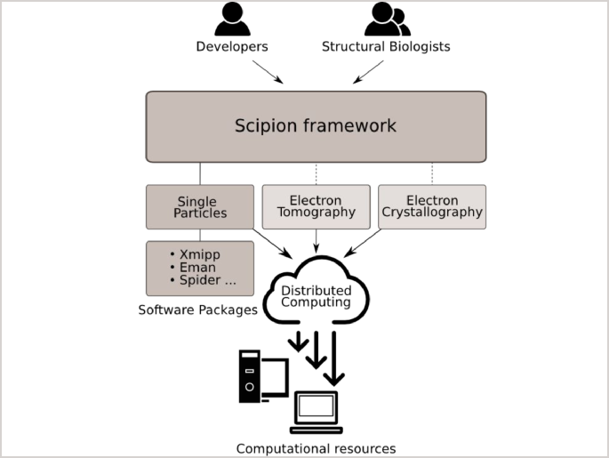
Figure 3 - Scipion serves as an interface between users, software packages and computing resources.

End-users operate through a workflow editor that exposes a list of protocols, conveniently grouped by categories. When these protocols are executed, all the steps of the workflow are tracked so they can be reproduced later on. Users have the possibility to add or modify steps or parameters. Workflows can be exported and imported across different projects. Furthermore, the Graphical User Interface (GUI) of Scipion provides a homogeneous access to all the underlying packages, enhanced with rich data viewers, wizards and other practical tools.

Scipion offers two User Interfaces: a desktop interface and a web interface.
The desktop interface supports a huge set of programs and protocols, while the web interface, Scipion Web Tools, offers a subset of them. Obviously, not every processing step makes sense in a web context: Scipion Web Tools focuses on simple and short workflows with manageable input and output that still provide useful results to the researcher, with the added advantage that she can try those workflows very easily. No local installation needed: just go to Web Tools page and proceed with the workflow.
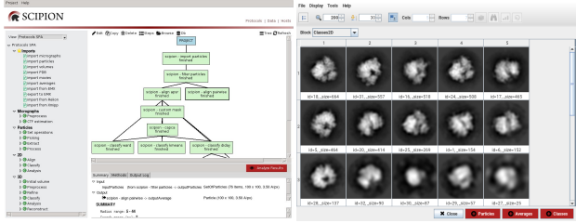
Figure 4 - Scipion desktop interface.
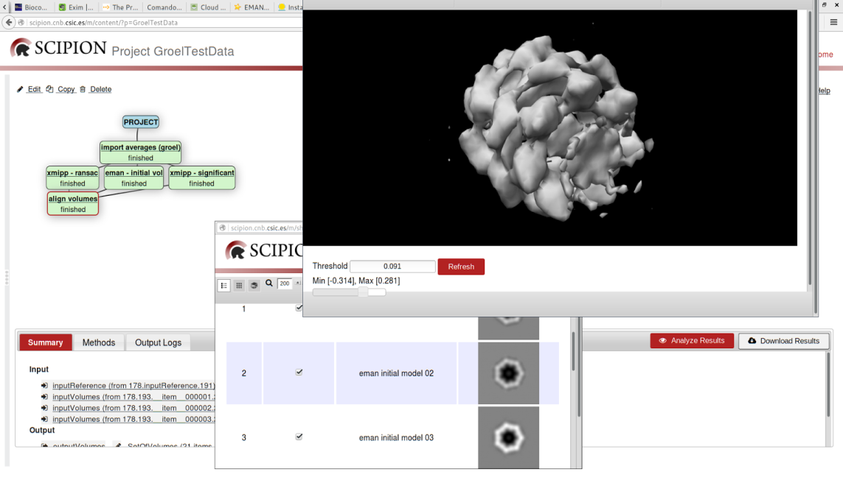
Figure 5 - Scipion Web Tools interface.

Current web tools version includes: initial volume estimation, movie alignment, local resolution (ResMap), reliability tools and interaction explorer.
Scipion can be installed from precompiled binaries or built from source code. It offers an automatic mechanism to install the EM packages that are integrated in the framework. This is the usual approach for installing Scipion in personal computers and large clusters

ScipionCloud
Scipion can solve all kind of complex EM projects, provided the researcher can access it. As stated in the previous section, this implied the installation and deployment on the researcher computing resources.
The arrival of cloud computing offered new possibilities for software distribution, and it is in this context that ScipionCloud was developed. With ScipionCloud, EM scientists have access to the full capabilities of Scipion, without the need to own computing resources nor to manage and deploy software.
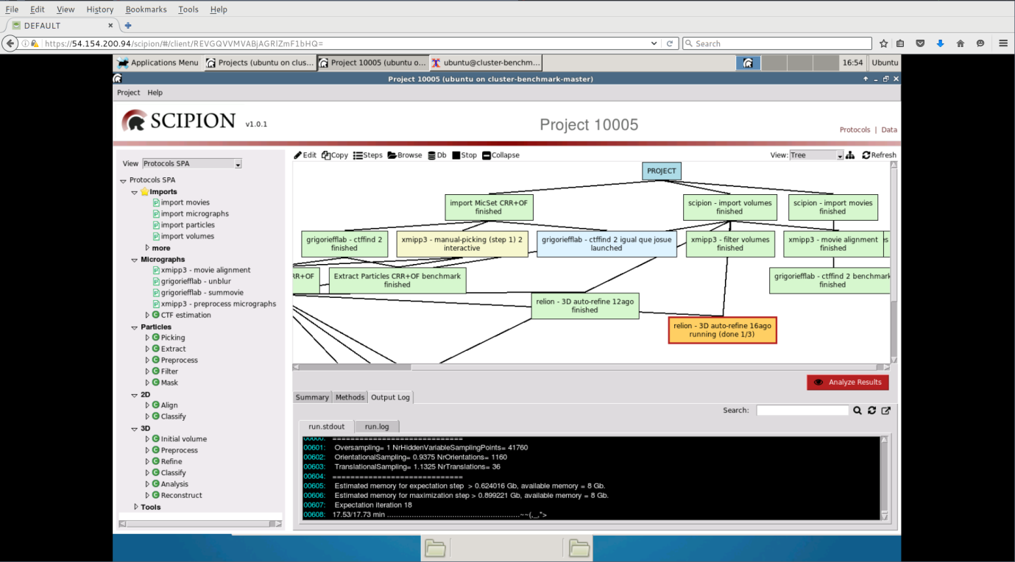
Figure 6 - Example of a ScipionCloud session.
ScipionCloud can be straightforwardly deployed following the documentation at the Scipion project wiki but essentially, once a user has available a set of cloud resources, the procedure to use ScipionCloud in FedCloud is:
- Launch a ScipionCloud instance, using the OCCI client, either as a standalone program, or from an OCCI virtual appliance. We advise to attach external storage, since cloud images normally have small root disks and Scipion projects usually require quite a lot of storage.
- Once the instance is running.
  - Connect to the instance with ssh to grab the randomly-generated remote display password and
  - Use this password to authenticate in the browser.
- Upload your data through ssh or rsync. Or download it from the remote desktop.
- Start Scipion.
Category | Package | Version
EM | Scipion | 1.0.1
 | Xmipp | 3.1
 | Relion | 1.4
 | Ctffind | 4.0.15
 | EMAN | 2.12
 | Motioncorr | 2.1
 | Spider | 21.13
 | Bsoft | 1.9.0
 | Chimera | 1.10
 | Frealign | 9.07
 | Resmap | 1.1.5-s2
 | Summovie | 1.0.2
System | Guacamole | 0.9.9
 | Apache HTTP server | 2.4.18
 | Apache Tomcat | 7.0.68
 | XRDP | 0.6.1
 | OpenMPI | 1.6.5.8
 | NFS | 4
 | Mesa | 11.0.7
 | Starcluster (available only for AWS) | 0.95.6
 | Nvidia CUDA (currently only on AWS) | 5.5
 | Glu (currently only on AWS) | 9.0.0
Table 2 - List of packages and libraries included in the first version of ScipionCloud.

Integration and dependencies

MoBrain and the EGI Federated Cloud
The EGI Federated Cloud is an IaaS-type cloud, made of academic private clouds and virtualised resources and built around open standards. It offers a wide set of services that can be accessed through different access policies. In the case of the MoBrain Competence Centre, an agreement (SLA) has been signed that allows MoBrain to access several computing and storage resources which can be used to further exploit EGI services and kick-start the development of a larger and integrated virtual research environment for life and brain scientists worldwide.
MoBrain users can access the EGI Federated Cloud resources through the Virtual Organization enmr.eu, which is currently the second largest VO in the area of life sciences.
One of the centres involved in the agreement is the CESNET-MetaCloud site in Czech Republic that has agreed to provide a small number (4-6) of cloud (2x 6-8 cores Intel E5) and GPU (NVIDIA Tesla M2090) nodes to the project for proof-of-concept use. This pool could be extended considerably (up to dozens of such nodes) temporarily for e.g. scalability experiments.
The CESNET-MetaCloud site has been chosen by our team to deploy Scipion due to the high availability of their resources and the quality of their support. Scipion deployments on CESNET-MetaCloud

Scipion single node deployment
We first started to deploy Scipion desktop on a single node to test basic user interaction and performance on the Cloud, based on Guacamole.
These initial tests were performed on a relatively small machine (mem_large: 4 cores, 16 GB RAM), and evolved to a final installation on a “fat node” (universe: 40 cores and 232 GB RAM) with a 1 TB Block Storage attached, where real cryoEM processing could be run.
This single node virtual machine was used to perform a benchmark of a typical SPA reconstruction workflow compared to local fat node and different setups on Amazon's Elastic Cloud Computing platform.
Currently it is in use by cryoEM scientists in our centre to reconstruct a protein fago.
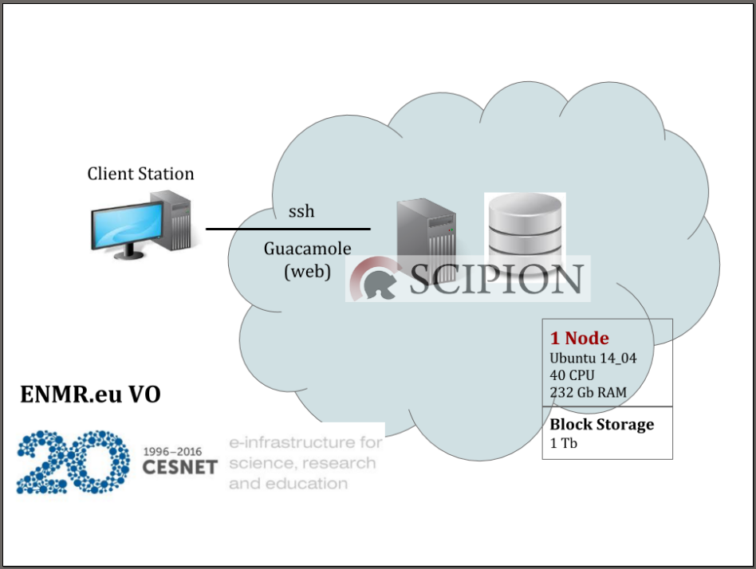
Figure 7 - Scipion single node deployment on FedCloud.

Scipion HPC cluster deployment
Next Scipion was deployed on a cluster of nodes to assess the feasibility and performance of this setup.
Figure 7 shows the final deployment on a cluster of 4 nodes of type mem_extra_large (8 cores and 32 GB RAM) and a 2 TB Block Storage attached.
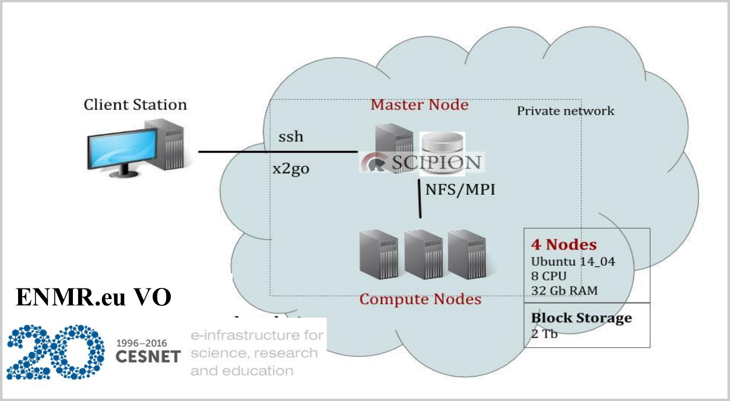
In this case we tested a different remote desktop solution called X2go. The performance of x2go was similar to guacamole, but x2go had the counterpart of needing software installation in the client computer (while guacamole can be accessed with a standard web browser).
Figure 8 - Scipion HPC cluster deployment on FedCloud.

Scipion Web Tools deployment

Finally we have deployed the latest version of Scipion Web Tools (1.0) on a single node of type mem_extra_large (8 cores and 32 GB RAM), since Web Tools predefined workflows do not require as much computational resources as a typical SPA workflow.
This virtual machine is currently being used as the development environment for the Scipion Web Tools integration on West-Life Virtual Research Environment.
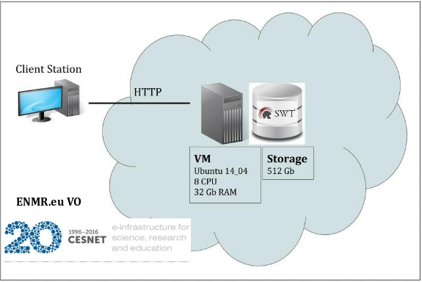
Figure 9 - Scipion Web Tools deployment on FedCloud

Technical challenges
Here we review the different technical challenges encountered when installing and testing Scipion, as well as the solutions adopted, which have been integrated on the ScipionCloud image.

Interactive performance
Commonly, applications developed for web (such as Scipion Web Tools) have an optimized front-end that works well with very low network resources. In the case of Scipion and the EM packages it incorporates, their interfaces are based on X11, which was developed for local area network operation. Therefore, under the cloud environment restrictions (lower bandwidth, higher latency) those interfaces feel too slow for interactive use. This is not a problem specific to EM software, so different generic solutions have been developed to address this issue. In our case we have tested VNC, NX, x2go and Guacamole.
Although NX, x2go and Guacamole provide similar levels of performance, we have chosen Guacamole since it does not require any software installation on the client side.
Thanks to the integration of Guacamole in ScipionCloud, the interactive performance is perfectly adequate (even though, as we stated, the user interfaces of the tools are based on X11). The end user connects to the cloud instance using a standard web browser and enjoys the same interactive performance as if the software were running on his own local computer. 2D interactive performance was a challenge but we solved it.
Additionally, some applications display 3D graphics based on OpenGL. When such graphics are rendered locally, GPUs can be used to provide real-time performance even with huge and complex volumes. Indeed, that was the initial purpose of the GPU in graphic cards. In cloud context, the rendering is done in the cloud instance, where usually there is neither a GPU nora middleware to handle the particularities of this scenario. We are working on integrating such a middle-ware in ScipionCloud but in the meantime, we provide non-accelerated OpenGL support (which allows displaying 3D graphics without a GPU).
3D interactive performance is an even bigger challenge in cloud contexts. In the current version we are supporting non-accelerated 3D graphics display. In future versions we will include the option to use a GPU in the cloud instance to accelerate 3D graphics display.

Resources management

Memory
We experienced memory to be the current limiting factor in some EM packages, like Relion (Scheres, 2012), that sporadically requires large amounts of memory per node (up to 20 GB/MPI process for Expectation steps, and 36 GB/MPI process in Maximization steps, for a typical reconstruction workflow). Therefore, we could not execute such programs on our cluster setup; we could only execute them on a fat node with sufficient memory for those most demanding steps.

Disk
A typical EM reconstruction workflow starts by processing the movies acquired on the microscope that can easily reach the Terabytes order. Transferring and storing movies on the virtual machine translates into long times and big storage. One practical solution is to process movies “locally” (that is, using a GPU powered server close to the microscope) and, after processing, to transfer the resulting micrographs, which have an order of magnitude lower size (Gigabytes), to the cloud machine. For this smaller transfer standard tools like rsync provide enough performance. In any case, to reduce transfer times we recommend using specialized transfer protocols, such as Aspera FASP or bcp.

Scalability
The demands of EM workflows are heterogeneous. We experience memory to be the current limiting factor when deciding the parallelization parameters. Still, some packages greatly benefit from a huge number of CPUs and less RAM, a setup that is achieved more efficiently with a set of instances working cooperatively (cluster architecture).
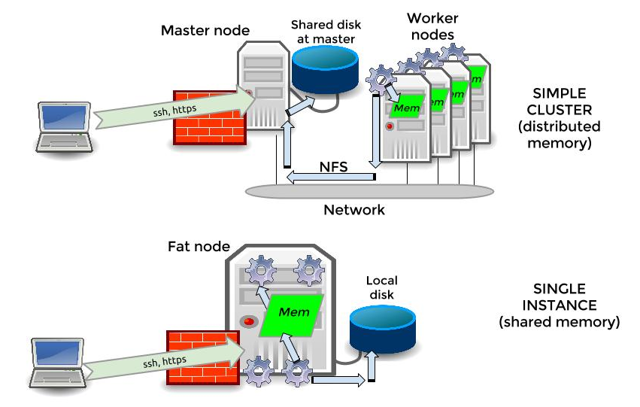
When using a single instance, the data is already available to the node on a local filesystem (typically, ext4 or xfs), accessed with POSIX standard operations. In a cluster, some mechanism is needed to simulate that the same files are locally available to all nodes. When a dedicated storage subsystem is available (typically, a Storage Area Network, or SAN), popular solutions like IBM Spectrum Scale (commercial license) and Lustre (open source) are implemented. This is not the case in cloud environments, so for this release of ScipionCloud the mechanism we integrated is NFS, an open-source file system that offers a good compromise of simplicity and performance.
Figure 10 - Single node versus cluster architecture in ScipionCloud.
To coordinate the parallel processing across multiple nodes, a middleware is required. In EM the de-facto standard is MPI. MPI has a long tradition, so plenty of choices are available. In ScipionCloud we opted for OpenMPI.

Feedback on satisfaction
CryoEM scientists from CNB-CSIC were involved in assessing the deployments with some of the cryoEM studies they were working on.
In face to face discussions they appreciated the ease of use and the real-time performance of the interactions with the graphical user interfaces. They were also satisfied with the technical support offered.
We plan to offer satisfaction surveys in order to gauge the feedback of remote users.
While the computing performance was good enough, some workflows took more time to complete than in alternative platforms (commercial cloud, local HPC facilities). We attribute this difference to the combination of NUMA (Non-Uniform Memory Access) and KVM (Kernel-based Virtual Machine) technologies used on that Federated Cloud particular instance, which reduce the performance when using big memory areas, like it is the case in Relion.

Plan for Exploitation and Dissemination

Name of the result | ScipionCloud Virtual Appliance.
DEFINITION
Category of result | Software & service innovation.
Description of the result | The image provides cloud-based Scipion v1.0, with high-performance remote graphic user interface support (through a standard Web Browser).
EXPLOITATION
Target group(s) | User communities linked to West-Life, related ESFRI projects (e.g. INSTRUCT) and the long-tail of science.
Needs | Solve complex cryoEM projects without local HPC resources, while keeping the high interactive performance of local facilities. Easy to use interface. Simple to deploy (no need to manage the software deployment details)
How the target groups will use the result? | ScipionCloud can be used as a VirtualBox appliance or instantiate as a Virtual Machine on a Federated Cloud site.
Benefits | Benefit from EGI cloud resources with no investment in installation and configuration of the Scipion software.
How will you protect the results? | Scipion and ScipionCloud are distributed with a General Public License (GPL) license.
Actions for exploitation | Register as a user to EGI Applications Database.  Become part of a Virtual Organization that endorses the appliance, like ENMR.  ScipionCloud can also be used as a VirtualBox appliance.
URL to project result | https://appdb.egi.eu/store/vappliance/scipion.v1.0
Success criteria | Number of users that instantiate the appliance.  Number of appliance downloads (for use with Virtualbox).  Number of Virtual Organizations to endorse it.
DISSEMINATION
Key messages | Scipion software now ready-to-use in your cloud of choice.
Channels | EGI Newsletter.  Relevant scientific journals.  Current channels of communication with Scipion users: wiki, newsletter, courses and presentations.
Actions for dissemination | See section 5.3
Evaluation | Paper accepted.  Number of visits of the online tutorial.  Users requests for support.  Monitor success criteria.
Explotation & dissemination costs | Support: 1 PM/year  Dissemination: 1PM/year
Table 3 ScipionCloud exploitation and disemination

Future plans

ScipionCloud improvement
The first version of ScipionCloud (1.0) is already available and functional, but we have identified some areas of improvement.

GPU acceleration
GPU vector architecture allows for high parallel performance, provided the programs are carefully optimized for such architecture. The optimization step may have significant costs in developer man-hours but, nevertheless, the processing time savings have led to an increase in the number of GPU-optimized versions of popular EM programs, like RELION-GPU(Kimanius, 2016), GCTF and Ge-FREALIGN. Therefore, it has become critical to support such GPU-optimized programs.
ScipionCloud includes GPU support for AWS. The EGI Federated Cloud is working on standardizing GPU-enabled instances, and in particular the CESNET-MetaCloud site has some GPU-powered instances that we could use to test GPU-optimized applications. We expect to have GPU-powered ScipionCloud on EGI appliances in future releases.

Automatic cluster management
ScipionCloud deployment has been automated in AWS with StarCluster, a utility for creating and managing distributed computing clusters hosted on Amazon's Elastic Cloud Computing.
Currently the version of ScipionCloud available on the EGI AppDB is not prepared to automatically deploy a cluster, but we plan to test solutions like EC3 and Occopus to improve the image with this functionality.
Another idea worth exploring would be alternative approaches to manage distributed computing. One example would be the ability to manage from Scipion local client workflow workloads running concurrently on different clusters / clouds.

High availability
While FedCloud infrastructure is quite robust, in cloud environments one cannot expect instances to live forever. Hence, we plan to include mechanisms to improve the fault tolerance of Scipioncloud, both at the data level (fault-tolerant distributed filesystem), job level (support for down nodes in cluster) and software level (improve checkpointing of EM programs).

Security
In the current release of ScipionCloud, we use password authentication for the web-based remote desktop Guacamole. The web connection is secured with HTTPS, but we find that getting the password via SSH is not convenient enough for the user. We plan to integrate other authentication approaches that are more convenient for the user of the Virtual Machine.
Besides, in the context of the future support of elastic clusters, a mechanism will have to dynamically create new virtual machines to accommodate the workload. This mechanism will require some credentials, proxy certificate or similar.
We will start by looking at the EGI Check-in service which would enable federated login for users, so they could come in with their existing accounts (e.g. institutional accounts).

Data transfer
Currently it is possible to ingest and download big datasets, using the recommended tools (bbcp, for example). In order to make this step easier for end users, we are considering the integration of more user-friendly transfer tools, or GUI wrappers for command line tools.

Plans for exploitation
We foresee different ways of helping users to benefit from ScipionCloud:
- Registered users of the EGI Applications Database can download the appliance. Besides, if they belong to a Virtual Organization that has endorsed the appliance they will be able to instantiate virtual machines using ScipionCloud appliance.
- We could also prepare a working environment for certain users from Instruct and Westlife communities, setting up the needed virtual machines upon request.
- We are also considering offering an online service where users can register and process their data online using ScipionCloud. A similar service is on the scope of the West-Life project but referring only to Scipion Web Tools and will be made available through the Virtual Research Environment. In order to have a full Scipion installation on EGI resources we will have to first integrate a login mechanism such as the EGI Check-in service and a mechanism to provide elastic allocation of resources to fulfil users’ needs.

Plans for dissemination
We have the following ideas to help disseminate our work on ScipionCloud:
- Write and submit a paper to a journal on structural biology.
- Use the existing channels of communication with Scipion users to advertise ScipionCloud and the new possibilities it offers. These include: Scipion wiki, mailing lists, newsletter and scheduled courses and talks.
- Write an article on EGI newsletter.
- Create an online tutorial that users can attend in our Youtube channel.
- Present ScipionCloud in Mobrain and Westlife user meetings.
- Publish a list of successful deployments and / or user cases.

Conclusions
We implemented ScipionCloud, a solution that allows to easily deploy the Scipion framework on the EGI Federated Cloud.
With ScipionCloud, researchers no longer need to invest up front in expensive facilities, nor face the complexities of productively deploying EM software: all Scipion advantages (ease of use, reproducibility, distributed computing) are now available through a standard web browser.
The degree of interactivity in ScipionCloud Graphical User Interfaces has been brought to a level in which it is basically the same as in a local computer.
We have three deployments in production that serve as real testbeds for cryoEM real use cases and dissemination and exploitation plan in place.

References
3DEM Method of the year 2015. (2016). Nature Methods , 13, 1.
de la Rosa-Trevín, J. e. (2016). Scipion: A software framework toward integration, reproducibility and validation in 3d electron microscopy. Journal of Structural Biology (195(1)), 93-99.
Fernández-del Castillo, E. S. (2015). The EGI federated cloud e-infrastructure. Procedia Computer Science (68), 196–205.
Kimanius, D. F. (2016). Accelerated cryo-em structure determination with parallelisation using gpus in relion-2. bioRxiv .
Scheres, S. (2012). Relion: implementation of a bayesian approach to cryo-em structure determination. Journal of Structural Biology (180(30)), 519–530.
Vinothkumar, K. a. (2016). Single particle electron microscopy: trends, issue and future perspective. Quaterly Review of Biophysics (49).

https://github.com/I2PC/scipion/wiki/ScipionCloud
http://scipion.cnb.csic.es/m/services
https://github.com/I2PC/scipion/wiki/ScipionCloud#how-to-use-scipioncloud
https://wiki.egi.eu/wiki/HOWTO11
http://west-life.eu
http://wiki.x2go.org/doku.php
http://guacamole.incubator.apache.org/
http://occopus.lpds.sztaki.hu/

