e-ScienceTalk

D4.5 Final Report on iSGTW and Social Media

EU DELIVERABLE: D4.5

Document identifier: | D3.7 - Final report on iSGTW and social media
Date: | 30/06/2013
Work package: | WP3
Lead Partner: | CERN
Document Status: | DRAFT
Dissemination Level: | PUBLIC
Document Link:

Abstract

This report focuses on the promotional strategies for iSGTW including social media, advertising and events.

- Copyright notice
Copyright © Members of the e-ScienceTalk collaboration, 2010. See www.e-sciencetalk.eu for details of the e-ScienceTalk project and the collaboration. e-ScienceTalk is a project co-funded by the European Commission as an Support Action within the 7th Framework Programme. e-ScienceTalk began in September 2010 and will run for 33 months. This work is licensed under the Creative Commons Attribution-Noncommercial 3.0 License. To view a copy of this license, visit http://creativecommons.org/licenses/by-nc/3.0/ or send a letter to Creative Commons, 171 Second Street, Suite 300, San Francisco, California, 94105, and USA. The work must be attributed by attaching the following reference to the copied elements: “Copyright © Members of the e-ScienceTalk Collaboration, 2010. See www.e-sciencetalk.eu for details of the EGI-InSPIRE project and the collaboration”. Using this document in a way and/or for purposes not foreseen in the licence, requires the prior written permission of the copyright holders. The information contained in this document represents the views of the copyright holders as of the date such views are published.
- Delivery Slip
 | Name | Partner/Activity | Date
From | A Purcell/ Z Qadir | CERN/QMUL | 24/07/12
Reviewed by | Moderator:  Reviewers:
Approved by | AMB & PMB
- Document Log
Issue | Date | Comment | Author/Partner
1 | 25/07/12 | First draft | A Purcell/ Z Qadir
2 | 31/07/12 | Final draft | C Gater, EGI
3
- Application area
This document is a formal deliverable for the European Commission, applicable to all members of the e-ScienceTalk project and its beneficiaries and collaborating projects.

- Document amendment procedure
Amendments, comments and suggestions should be sent to the authors.
- PROJECT SUMMARY

Over the last 10 years, the European Commission and governments have invested substantial funds in distributed computing infrastructures. Scientists have access to state-of-the-art computational and data resources located around the world, putting European research into a leading position to address the greatest challenges facing us today, such as climate change, pandemics and sustainable energy. The advent of the European Grid Infrastructure, combined with the blurring of boundaries between grids, clouds, supercomputing networks and volunteer grids, means that a clear consistent source of information aimed at non-experts is now more important than ever, through dissemination projects that cross national boundaries.

Objectives:

- e-ScienceTalk will build on the achievements of the GridTalk project in bringing the success stories of Europe’s e-Infrastructure to policy makers in government and business, to the scientific community and to the general public.

- e-ScienceTalk will work with EGI-InSPIRE and other collaborating projects to expand the scope of the existing GridTalk outputs, and to report on the interactions of grids with e-Infrastructures such as cloud computing and supercomputing.

- The project will explore options for the sustainability of e-ScienceTalk’s products.

- e-ScienceTalk will produce a series of reports aimed at policy makers to disseminate key policy issues underpinning grid and e-Infrastructure development in Europe. The project will also coordinate e-concertation activities.

- The GridCafé, GridCast and GridGuide suite of websites will cover new topics and explore novel web technologies; they will integrate closely with GridPP’s Real Time Monitor, combining live views of grid activity with the human aspects of computing.

- The growing weekly publication, International Science Grid This Week (iSGTW) will bring news and events to the existing and potential e-Science community.

- EXECUTIVE SUMMARY

This report highlights how effective the weekly e-newsletter International Science Grids This Week has been in achieving its aims of successfully driving up its subscriptions and social media activity during the e-ScienceTalk project.

During the e-ScienceTalk project, the iSGTW website was redesigned and a proactive Marketing Strategy [R1] was also implemented in May 2011. The strategy aimed to increase the website traffic, the number of newsletter subscribers, and range of readers. Five methods were used to achieve this: through conferences and events; media partnerships; collaborating projects; online promotion, including the newsletter, search engines and social media; and setting up iSGTW as a social media site itself.

Since the beginning of e-ScienceTalk, iSGTW’s subscriber numbers have increased by a third. The project has exceeded its target and now has 8,782 subscribers with an increasing number of social media followers (1,726 Twitter followers, 68 Google pluses and 1,167 Facebook). The website had nearly half million unique visitors and over one million page views. The three readership surveys also give a good indication of success in diversifying our audience [R2, 3 and 4]. This report also provides some recommendations to other niche publications on how to increase their social media presence.

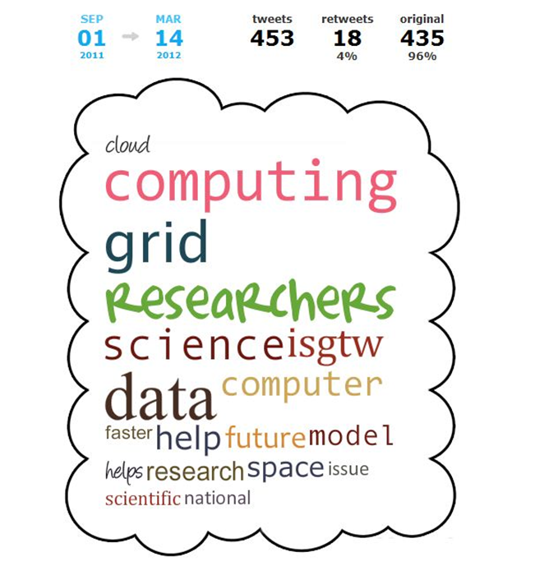

Table of Contents
1 Introduction 6
2 MARKETING STRATEGIES AND TOOLS 8
2.1 Conferences and Events 8
2.2 Media Partnerships 8
2.3 Collaborating projects 9
2.4 Online promotion 11
3 SOCIAL MEDIA STRATEGY 12
3.1.1 What are the benefits of social media? 12
Key questions to examine in developing a social media audit and strategy: 12
3.1.2 iSGTW Social Media Strategy 13
3.1.3 Twitter 14
3.1.4 Facebook 15
3.2 Google+ 17
3.3 LinkedIn 18
3.4 Klout 18
3.5 Google analytics and social bookmarking 18
3.6 Academic social networks 19
4 Conclusions 20
5 Appendix 22

Introduction

The publication, iSGTW is now eight years old and recently reached a 400th issue milestone on the 26th June. The publication currently has two editors: the European editor, Andrew Purcell, and a US Desk editor, Amber Harmon. A part-time Science Writer (e-ScienceTalk Dissemination Officer, Zara Qadir) also regularly writes features for the magazine. At the moment, there is also a budget to commission articles to freelance writers.

Previous Editors have included:
- Adrian Giordani, Interim European Editor and Editor-in-Chief, April 2012 - August 2012
- Miriam Boon, US editor, July 2009 - June 2012
- Vivian Tiän-Tiän Chang, AP Editor, 2012
- Jacqueline Hayes, EU editor, April 2011-April 2012
- Dan Drollette, EU editor, May 2008 - April 2011

During the e-ScienceTalk project, the site was relaunched with more interactive elements such as polls, a rating system, a calendar and ‘share’ features, and more user-generated content so people can submit announcements or job advertisements. The publication also briefly changed its name to reflect its widening scope (e.g. clouds, volunteer computing and supercomputing). However, the new name ‘The Digital Scientist’ had already been copyrighted to another commercial company in the US, so the name of iSGTW has remained since.

iSGTW’s subscriber numbers have increased by a third since the beginning of e-ScienceTalk. The readership has grown from 6,561 to 8,782 subscribers (see Figure 1). Our proactive social media strategy has also resulted in increasing number of social media followers (1,726 Twitter followers, 68 Google pluses and 1,167 Facebook).

During e-ScienceTalk, there were 440,164 unique visitors visiting the iSGTW website and 1,038,455 page views. This is considerably more traffic than during the previous project, GridTalk. The website now attracts between 10,000 and 18,000 unique visitors a month, but numbers has climbed in recent months (see Figure 2). On average, 13-16% of the subscribers open the newsletter every week.

The readership surveys provide a good indication that audience is diversifying [R2-9]. The publication has significantly increased the proportion of female readers to our site over the last few years to around one quarter but has not made as much progress attracting younger readers (i.e. <30 years).

The readership is also highly engaged, with the vast majority of respondents having forwarded an article or an issue and over half having saved or bookmarked an article or issue. The impact of the publication on its communities has been well-documented in two e-ScienceTalk Impact and Sustainability Reports [R10 and R11]. The final report will be published in July 2013, D1.5 Final Impact and Sustainability Report e-ScienceTalk and will include a number of in-depth interviews with readers.

MARKETING STRATEGIES AND TOOLS

This section outlines the strategies that have been used to market iSGTW throughout e-ScienceTalk. These strategies were first outlined in the D3.3 Marketing Strategy Report [R1].

Conferences and Events

During the e-ScienceTalk project, iSGTW attended 38 events and meetings (see Figure 1). ISGTW’s participation at these events included staffing booths in the exhibition areas for events, and also supporting GridCast to blog live from the events and to source stories for articles. Conferences are a good way to increase exposure and reach out to new communities. The hashtag (#) from events can be used to promote stories and to respond to news and developments at the conference.

Figure 1: Major events attended by iSGTW and e-ScienceTalk
PY1 | PY2 | PY3
- Joint PRACE/LinkSCEEM-2 CyI 2011 Winter SchoolCLCAR 2011  - CloudscapeIII  - e-IRG Workshop  - ISGC2011  - OGF31  - GISELA meeting 2011  - SC-Camp  EGI-User Forum 2011  - FET11  - Conference on role of e-infrastructure in Climate Change  - HealthGrid11  - TeraGrid2011 | - EGI Tech Forum 2011  - SC11  - 9th e-Infrastructure Concertation meeting  - eChallenges  - outGRID ITU High Level  - Citizen CyberScience  - CloudScapeIV  - ISGC2012  - ERF  - HealthGrid’12  - ICRI’12  - CRISP  - EGI Community Forum 2012 | - EGI Tech Forum 2012  - eChallenges  - EUDAT  - CRISP  - SC12  - CloudScapeV  - 10th eConcertation meeting  - ISGC 2013  - EGI Community Forum  - CAPRI  - E-IRG Workshop  - ISC'13

Media Partnerships

During e-ScienceTalk’s first year, iSGTW built several partnerships and was a media sponsor at a number of events including the Citizen CyberScience Summit, the EGI Technical Forum 2010 and the EGI User Forum 2011. ISGTW was also represented by Fermilab at the Supercomputing 2010 event in New Orleans in November 2010, attended by 10,000 delegates, where the new version of the website was previewed, and delegates were given the opportunity to subscribe. The relationship with the conference organisers has continued throughout the project. Many other media partnerships have also been developed including the International Supercomputing Conference in Leipzig, Germany (ISC’13). The iSGTW team have provided coverage (three articles) and promoted the conference in a side panel on the website.

For each European Grid Infrastructure (EGI) forum and many other conferences, APO the web and graphic design partner have created a poster to advertise the publication at the conference (see Figure 2). Each has had a unique design based around a theme from the host city. These professional-looking, eye-catching posers stand out, and are displayed in highly visible areas within the conference centre (e.g. coffee stands, lunch areas and podiums).

Prior to September 2011, delegates at conferences had been automatically signed up to receive iSGTW on registration. During e-ScienceTalk, subscribers were invited instead to submit their email address to the subscriber mailing list after an event in conference feedback surveys. Even though this approach reduces the number of subscribers for individual events, it ensures our readership is fully cognisant when signing up and has resulted in a lower unsubscribe rate. The publication has found that these active subscribers are more likely to explore and stay loyal and engaged for longer.
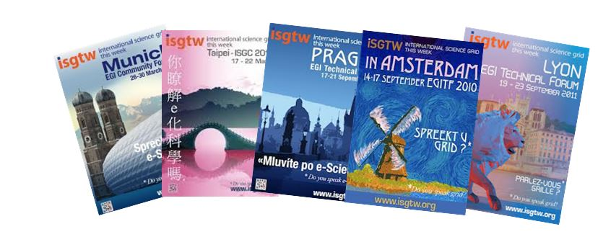
Figure 2: iSGTW posters designed during e-ScienceTalk

Collaborating projects
During e-ScienceTalk, seventeen collaborations with other EC- funded Projects have been formed (CHAIN, CRISP, EGI, EDGI, e-irgsp3, EMI, EU-IndiaGrid, EUDAT, ERINA+,GISELA, GlobalExcursion, iMENTORS, LINKSCEEM, neuGRID, Shiwa, Virtus and WeNMR). This opened up iSGTW to a number of different scientific communities. The projects are incredibly diverse (ESFRI projects, Virtual Research Organisations, Educational/outreach projects) and serve different scientific communities (Life sciences, Physics etc.). The e-ScienceTalk project has signed a Memoranda of Understanding (MoU) with each project which has proven to be mutually beneficial. iSGTW provides a platform to post announcements and publish applications and research findings. In return, the MoU partners promote e-ScienceTalk’s products to their communities and contacts. A number of projects have also had iSGTW as a joint or sole media sponsors for smaller events/workshops that it organises. This involves adding the e-ScienceTalk logos and links to e-ScienceTalk products to the event website, in return for promotional activities for the event. Below are two of the articles developed from these events (see Figure 3). In addition to attending events, projects have advertised iSGTW to their membership at various times during the project. In July 2012, a ‘Why subscribe?’ email was sent via MoU partners to invite members of collaborating projects to sign up to receive the newsletter (see Figure 4).

Figure 3: New events in 2012/2013
neuGRID invited iSGTW to outGRID - ITU High Level Workshop on Alzheimer’s and Neurodegenerative Diseases |  | WeNMR invited e-ScienceTalk to The 5th CAPRI Evaluation Meeting
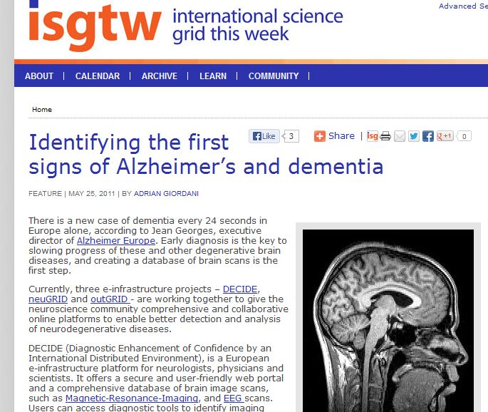 |  | 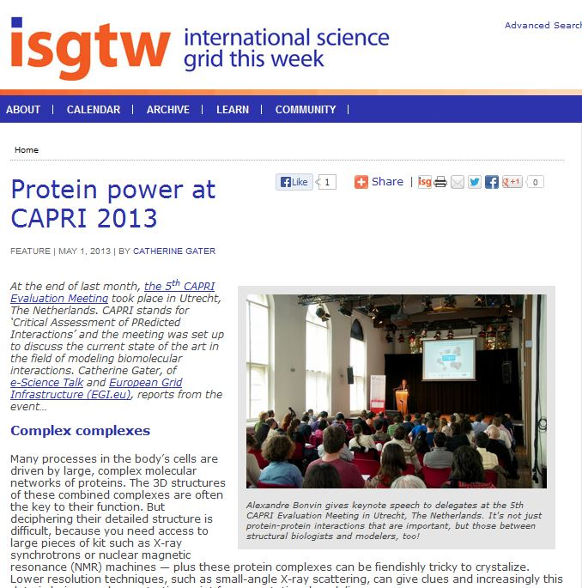

Hello from iSGTW (International Science Grid This Week),
We are an international online publication that cover stories about distributed computing and the science it enables (www.isgtw.org). This includes stories about work at CERN and other scientific institutions around the globe.
If you have any story ideas or suggestions for the site, please contact us at editors@isgtw.org.
Our newsletter is sent to 8,170 subscribers in 150 countries each week and our website receives around 20,000 visits per month. We invite you to sign-up to our weekly newsletter.

By subscribing to iSGTW you will get the following benefits:
- Receive a free weekly newsletter, with the latest news, features, and opinions from the e-science world.
- Have the ability to post on our announcement, event, and job sections, and create a blog, on the iSGTW website.
- If you upload an article in our announcements section on the iSGTW website, we will also tweet about it from our Twitter account.
- Subscribing is free and secure.
- It is easy to unsubscribe at any time. Just one click and you’ll be removed from the mailing list – no hassle and no worry on your part.
- You will become part of a diverse, thoughtful, and intelligent community of interesting people — scientists, computing researchers, public relation officers, students, and more — who read iSGTW, leave comments on stories, and participate in conversations. This community will be interested in what you have to add to the conversation.

You can also join us on our social media channels: Twitter (@iSGTW), or Facebook, or Google+.

Regards,
Adrian Giordani (iSGTW Editor)

Figure 4: Subscriber Email (July 2013)

Online promotion

Most traffic to iSGTW is from the publication’s website, search engines or social media sites. The remaining traffic comes from search engines, links from university pages and other news sources linking to iSGTW. Several methods have been used to increase the number of click-throughs including using short catchy titles to reflect the content of the newsletter. The e-ScienceTalk team has also included more cross-links between the other e-ScienceTalk websites. A number of Search Engine optimisation strategies have been implemented to aid discovery (e.g. improved meta-descriptions, image tags, dead links audits etc.) but the most effective strategy for securing high traffic is producing quality stories and regularly updating content.

social media STRATEGY

In January 2012, iSGTW implemented a proactive social media campaign. The aim was to monitor and increase our use of this social environment by regularly posting stories to Facebook, Twitter, Reddit, StumbleUpon and to investigate other sites and blogs, such as Slashdot, Nature Networks, Digg, Wikipedia, and Buzz. e-ScienceTalk now uses social media externally to share news, seek advice, problem solve, and post ideas. This next section explains why the editorial team developed a strategy highlighting some key questions that had to be explored and the crucial steps in devising an effective strategy (i.e. a carrying out a social media audit). There is also some analysis of what methods/ tools/techniques we have found to be most useful, and we present some of our observations and findings.

What are the benefits of social media?

Before developing a strategy, the editorial team explored the benefits of investing in social media. The iSGTW editorial team identified five main reasons for increasing its social media activity:
- Offering expertise in real-time. Provides a real-time voice for iSGTW on a daily basis and readers don’t have to wait for a weekly update
- Leveraging influence. Niche publications such as iSGTW can position itself as a primary source for the topics it covers
- Expanding editorial content. Gain insights about audiences and issues, and solicit feedback to enhance the editorial experience
- Curating content. Provides an opportunity to share content from other industry sources
- Widens our audience. More people can discover iSGTW content and it increases the exposure/reach of the project

Our social media strategy also had to be integrated into the goals outlined in our overall marketing strategy [R1].
- Increase subscriber numbers (e.g. subscribers and RSS feeds, Facebook ‘Likes’, Twitter followers)
- Increase traffic to the website (monitor social media referrals)
- Broaden the demographics of the readership e.g. new geographic regions, new subject areas.
- Increase interaction with the website e.g. through blogs, polls, social media sharing.

Key questions to examine in developing a social media audit and strategy:
- How much time do we currently spend on site?
- How much time should we devote to increasing our social media presence?
- How do we measure success and what analytics/tools do we plan to use?
- What online tools exist for scheduling, promoting and measuring the success or ROI of social media?

iSGTW Social Media Strategy

During GridTalk, iSGTW had a Facebook page, and a Twitter account (@isgtw). In May 2011, iSGTW started a more focussed campaign to promote iSGTW through branded social media and news aggregators. During the pilot stage (May 2011-September 2011), iSGTW sent out one tweet per day, one post a day on Facebook and posted every month some of its own content to Nature. Six months later in November 2011, the editorial team increased its investment in social media and spent approximately three hours a week developing social media through Twitter and other channels. The Science Writer, Adrian Giordani tweeted three to seven times a day and uploaded a story to Facebook daily. Stories were also promoted on Digg, Reddit, Stumbleupon and Slashdot. During this time, iSGTW also set up a Google+ account.

In Jan 2012, iSGTW automated and scheduled its tweeting process. iSGTW creates a selection of tweets on Wednesday and schedules tweets over the week via IFTTT (an easy-to-use automation tool). IFTTT allows automation of 36 services (e.g. send starred posts in Google Reader to Twitter and Facebook). iSGTW also recorded activities from links via bit.ly and archives tweets via Evernote. Since Sept 2011, there has been a significant rise in Twitter and Facebook followers (see Figure 5).

So what has happened in the last two years? Referral traffic from social media sites has increased. In April 2011, almost all of the traffic to the iSGTW website could be attributed to three sources: the newsletter (approximately 37% in April 2011), search engines (36%), and social media sites for 797 visits (about 7%). In June 2013, around 13% of traffic is from social media sites (3,285 visits). There has been a huge increase in the number of Twitter and Facebook followers. Our proactive social media strategy has also resulted in increasing the number of social media followers (1,726 Twitter followers, 68 Google pluses and 1,167 Facebook). Three years ago (September 2011) the publication had only 443 Twitter followers and 413 Facebook likes.

Figure 5: Growth in Twitter and Facebook followers

Twitter

Currently, the ISGTW Editor tweets live using Tweetdeck or Hootsuite, so as to be able to be responsive to what’s going on at any given time. Sometimes Hootsuite is used to schedule tweets. This dashboard allows you to manage multiple social networks and also provides some analytics.

Below are some recommendations on engaging followers on Twitter:
- Twitter is a good way of engaging with journalists, influencers, media, scientists etc.
- Try to link to other news stories because it makes it timely and puts the information in a wider context.
- Use thoughtful hashtags and mentions
- Reply to other people’s post especially if they have a lot of followers
- Keep content fresh
- It's really hard to know which post(s) made someone follow you but it’s good to record this type of information
- Increase the cross-talk by asking more questions to the iSGTW twitter audience when tweeting. Try and engage more in conversations on Twitter
- Examine follower count (fans, followers). Make sure you record these figures on a weekly basis as no free tools are available currently to record these trends. Use Nutshell to keep track.
- Monitor referral traffic through Google Analytics
- Examine interactions i.e. numbers of @retweets and @mentions

As e-ScienceTalk has its own twitter account (@e_scitalk), it was important to differentiate between the two accounts (see Figure 6). The project has explored a number of tools (see Figure 7).

Figure 6: @isgtw and @e_scitalk

 | 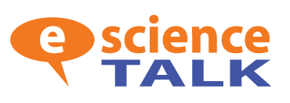
- iSGTW articles  - Stories around distributed computing and the science it enables  - MoU partner signings, events and announcements | - Developments in European policy  - MoU partner signings, events and announcements  - Repurpose iSGTW articles or promotion of articles prior to publication.  - Developments in European policy  - Events/projects that capture the public imagination (e.g. Turing)  - GridCast blogs at e-science events  - Other e-science articles

Figure 7: Online tools

Tools | Website
Google Analytics Social | www.google.com/analytics | Used to see how many people are being referred to the site via social media and also to see how much activity there is on you site (e.g. events such as shares on Digg, Stumbleupon etc.)
Tweetreach | http://tweetreach.com/ | Provides reports on reach and exposure for tweets
IFTT | https://ifttt.com/ | A service that enables customers to connect channels
Nutshell | http://www.nutshell.com/ | A free service and you can sign up to receive a daily update of number of followers, and daily quitters etc.
Twiangulate | http://twiangulate.com/search/ | To find who your most influential followers are and compare your followers to competitors. You can also map your social network.
Hootsuite | https://hootsuite.com/ | This is a dashboard to manage and measure social networks
Social Bro | http://www.socialbro.com/ | Dashboard to manage and measure social networks. Provides tools to target the right audience on twitter, and makes it easy for you to engage with your contacts.
Social mention | http://socialmention.com/ | Social Mention allows you to easily track and measure what people are saying about you. Strength: It is the likelihood that our brand is being talked about in social media Passion: Likelihood of repeat mentions from the same unique users) Reach: measure of the range of influence (number of authors divided by number of mentions)

Facebook

The number of people who like iSGTW on Facebook has grown rapidly. The target audience is university students and final year high school students, i.e. the future users of e- infrastructure. The project developed a branded iSGTW ‘branded’ welcome page (Figure 8). The page is detailed and includes multimedia elements such as photos and project videos.

Below are some recommendations on engaging on Facebook:
- Try not to leave your page incomplete
- Anything VISUAL should be prioritised for Facebook e.g. any podcasts, multimedia, photos, spotlights, GridCast blog videos
- Run regular polls, contests, events, website launches etc.
- Befriend other social networks, scientists
- Advertise to friends of your followers
- Be prepared to regularly interact with the people who ‘like’ you on Facebook.
- Promptly answer peoples’ questions written on your project’s Facebook wall.
- Monitor ‘Likes’ on a weekly basis.
- Monitor you referral traffic through Google Analytics
- Examine your Facebook Admin Insights page. Here, you can find out Total Reach (the number of unique people who have seen any content associated with your page). Sign up to receive a weekly update on your Facebook analytics. It’s useful to see what posts have been the most popular.

Figure 8: Screenshot of iSGTW ‘Welcome Page’

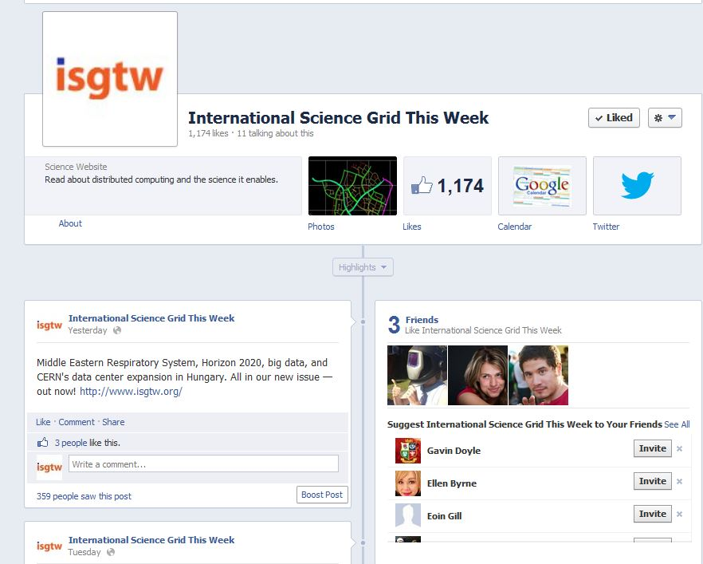

Google+

The iSGTW Google+ page has 68 followers (June 20th 2013). Google+ is clearly growing, and as the users tend to very tech-savvy and ready to engage on complex topics, it is perfect place for posting content to iSGTW (see Figure 9).

Below are some recommendations on engaging on Google+:
- We recommend CREATE HANGOUTS e.g. in conjunction with CMS on subjects such as ‘How CERN collects data?’ and provide an expert to contact
- Anything VISUAL should be posted on Google+ e.g. photos, spotlights, GridCast blog videos, photos from events etc.
- You can see who has Google plused articles in Google Analytics. Visit to Traffic Sources>Social> Data Hub Activity). Here, you will see conversations and events. Conversations include Google + data.

Figure 9: Screenshot iSGTW Google+ page
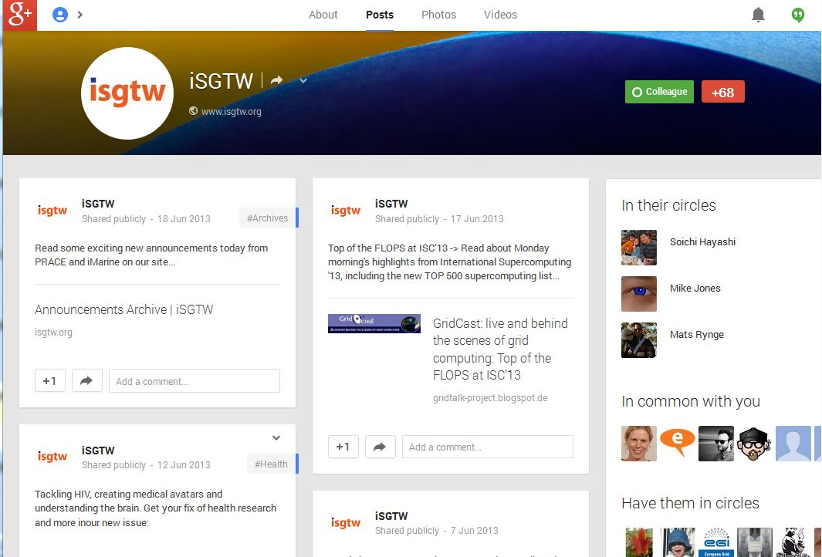

LinkedIn

The e-ScienceTalk project has an Internal LinkedIn group. In March 2012, LinkedIn had 150 active users but is growing rapidly and now has 225 million active users. Several projects have LinkedIn groups including e-IRG, EUDAT and PRACE. iSGTW does not have a group at the moment.

Below are some recommendations on engaging people on LinkedIn
- The platform can be used to find sources, share stories, build online communities and increase social referrals to iSGTW. Join groups such as HPC and Supercomputing, and post stories that generate a DISCUSSION once per month
- Analyse through Google Analytics for activity spikes and count interactions (e.g. comments etc.)

Klout

iSGTW has also used Klout for accessing influence and comparing to others. Klout gives you a numerical score out of 100 based on:
1.] True reach (How many people you influence)
2.) Amplification (How much you influence them)
3.] Network Impact (The influence of your network).

The publication has maintained a score of around 55 for a number of months. The publication also makes comparisons with other publications such as Datanami and HPC Wire.

Google analytics and social bookmarking

Google analytics also provides a useful social engagement report. The Social Actions report shows the number of social actions (+1 clicks, Tweets, etc.) taken on the site. In Google analytics, visit the traffic Sources section, and in the Social section, click the Data Hub Activity tab). Here, you will see conversations and events. Conversations include Google + data. The events tab shows the name of the social network and the type of action. However, the number of social hub partners is limited (Allvoices, Delicious, Diigo, Disqus, Echo, Google Groups, Google+, Hatena, Livefyre, Meetup, Pocket, Reddit, SodaHead, Stack Overflow, Typepad and VKontakte). Unfortunately, it does not include Facebook ‘likes’. However, this can be seen on the website for individual stories.

Academic social networks

There are a number of growing academic social networks including ResearchGate (www.researchgate.net) and Academia.edu (www.academia.edu). The editorial team has developed a reciprocal posting relationship with a Community Manager, Célya Gruson-Daniel from the network, MyScienceWork (http://www.mysciencework.com/ and Figure 10). iSGTW also regularly post to Nature Networks, which has generated interactions with readers (see http://network.nature.com/groups/isgtw/forum/topics/9975)

Figure 10: MyScienceWork
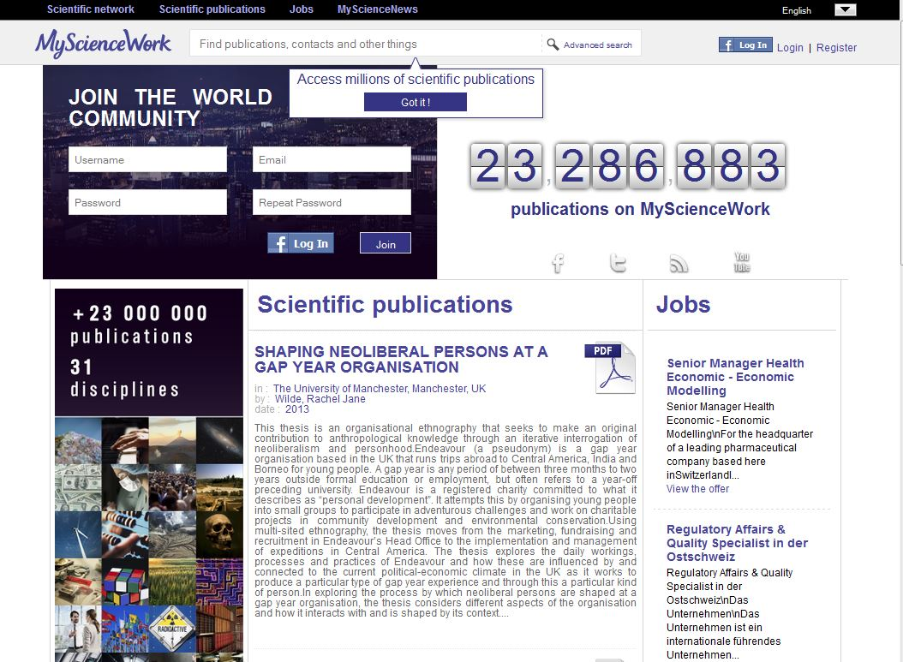

Conclusions
Now eight years old and having recently reached the milestone of its 400th issue, iSGTW is now a major dissemination channel for e-infrastructure projects in Europe, the US, and further afield. There have been 440,164 unique visitors visiting the iSGTW website and 1,038,455 page views since the start of the e-Science talk project. This is considerably more traffic than during the previous project, GridTalk. Generally, the website attracts between round 10,000 and 18,000 unique visitors a month, and numbers have climbed further recently. In the first six months of this year, traffic (in terms of page views) has been over double that achieved in the first six months of 2012.

The publication has also significantly increased its proportion of female readers over the last few years to around one quarter but has struggled to achieve similar increases in the number of young readers who come to the site. The results from our most recent readership survey suggest that we have a highly engaged audience, with 81 per cent of respondents saying that they have ‘discussed or forwarded an article or issue’. The results also reflect fairly positively on the impact of our publication, with respondents reporting that they have attended an event, applied for a job or contacted researchers based on information they have found on our site. Over one fifth of respondents also said that they have cited or linked to iSGTW in a blog, paper, poster or talk.

During the e-ScienceTalk project, iSGTW has also been highly effective in achieving its aims of successfully driving up its subscriptions and social media activity. Thanks to a proactive marketing strategy implemented in May 2011, iSGTW has been able to increase subscriber numbers by a third, as well as significantly increasing the number of number of social media followers (1,726 Twitter followers, 68 Google pluses and 1,167 Facebook). This marketing strategy comprised five methods for increasing iSGTW’s impact: (1) conferences and events; (2) media partnerships; (3) collaborating projects; (4) online promotion, including the newsletter, search engines and social media; and (5) setting up iSGTW as a social media site itself. While the rate of increase in subscriber numbers has slowed recently, this has been more than compensated for by a rapid increase in the number of people who follow the publication through its social media channels. We believe this reflects wider trends in terms of how people access content online and presents new challenges, as well as new opportunities, for building our audience.

We have found that as well as being a highly valuable source of article leads, conferences are a very good way to increase exposure and reach out to new communities. The Twitter hashtag from events can be used to promote stories and to respond to news and developments at the conference. Also, media partnerships give us a chance to offer delegates at the events the opportunity to sign up to our newsletter. And partnerships with other projects have helped us to further increase our subscriber numbers further.

Finally, with regards to our social media strategy, we have found this to be a vital tool in promoting the site and expanding our audience. The key to a successful social media strategy has been increased regularity and frequency of posting. For this, as well as tracking the reach of posts, there are various useful online tools available. As well as well-known social media outlets, such as Twitter, Facebook, and Google+, academic and professional social networks have been of use to us, such as LinkedIn, MyScienceWork, and ResearchGate. Other blogging and content aggregator sites, such as Reddit, StumbleUpon, Slashdot, Nature Networks, and Digg, have also been key tools in enabling us to successfully expand our audience.

REFERENCES

R1 | D33_Marketing_Strategy_final  https://documents.egi.eu/public/ShowDocument?docid=533
R2 | e‐ScienceTalk iSGTW Readership Survey July 2008 https://documents.egi.eu/document/754
R3 | e‐ScienceTalk iSGTW Readership Survey December 2008 https://documents.egi.eu/document/753
R4 | e‐ScienceTalk iSGTW Readership Survey July 2009 https://documents.egi.eu/document/755
R5 | e‐ScienceTalk iSGTW Readership Survey January 2010 https://documents.egi.eu/document/752
R6 | e‐ScienceTalk iSGTW Readership Survey July 2011 https://documents.egi.eu/document/767
R7 | e‐ScienceTalk iSGTW Readership Survey August 2012 https://documents.egi.eu/public/ShowDocument?docid=1327
R8 | e‐ScienceTalk iSGTW Readership Survey August 2013
R9 | e-ScienceTalk D1.3 Annual Impact and Sustainability Report  https://documents.egi.eu/public/ShowDocument?docid=712
R10 | e-ScienceTalk D1.4 Annual impact and sustainability report on e-ScienceTalk products  https://documents.egi.eu/public/ShowDocument?docid=1297

http://www.chain-project.eu/
http://www.crisp-fp7.eu
http://www.egi.eu/projects/egi-inspire/
http://edgi-project.eu/
http://www.e-irg.eu/about-e-irg/e-irgsp3.html
http://www.eu-emi.eu/
http://www.euindiagrid.eu/
http://www.eudat.eu/
http://www.erinaplus.eu/
http://www.gisela-grid.eu/
http://www.globalexcursion-project.eu/
http://www.imentors.eu/
http://www.linksceem.eu/ls2/
http://neugrid4you.eu/
http://www.shiwa-workflow.eu/
http://www.association-virtus.org/
http://www.wenmr.eu
http://www.itu.int/en/ITU-T/tsbdir/sap2012/Pages/outgrid-itu-201202.aspx
https://ifttt.com/
https://evernote.com/
https://hootsuite.com/
http://nutshellmail.com/
http://expandedramblings.com/index.php/resource-how-many-people-use-the-top-social-media/

