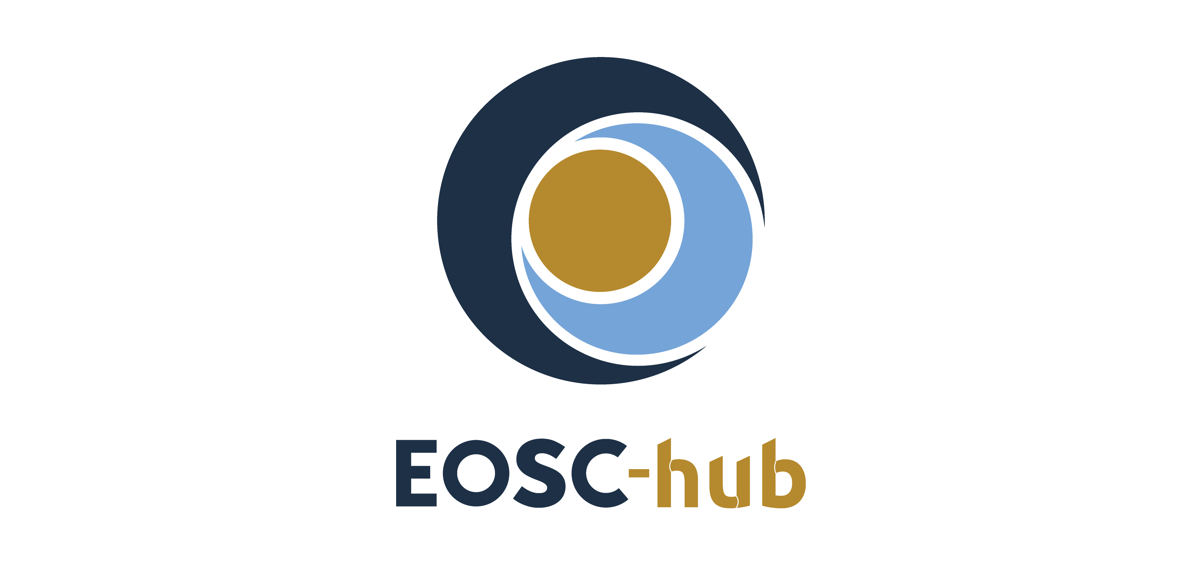

D11.2 - Training materials about competence centre services
Lead Partner: | EGI Foundation
Version: | 1.0
Status: | Under EC review
Dissemination Level: | Public
Document Link: | https://documents.egi.eu/document/3556

Deliverable Abstract
This report describes the training activities done during the first two years of the project. It includes the list of training events, materials, datasets and deployable training environments developed by the project and available in the online catalogue. The report also outlines the next year plan to improve the structure of the training catalogue and implement the recommendations and feedback collected during the first project review.

COPYRIGHT NOTICE
This work by Parties of the EOSC-hub Consortium is licensed under a Creative Commons Attribution 4.0 International License (http://creativecommons.org/licenses/by/4.0/). The EOSC-hub project is co-funded by the European Union Horizon 2020 programme under grant number 777536.
DELIVERY SLIP
Date | Name | Partner/Activity | Date
From: | Giuseppe La Rocca,  Yin Chen | EGI Foundation (WP11) | 31.12.2019
Moderated by: | Małgorzata Krakowian | EGI Foundation
Reviewed by: | Sandro Fiore,  Alexandre Bonvin | CMCC (T7.3),  UU (T7.6)
Approved by: | AMB

DOCUMENT LOG
Issue | Date | Comment | Author
v0.1 | 16.09.2019 | Initial ToC | Yin Chen/EGI Foundation
v0.2 | 22.11.2019 | Inputs from the EOSC-hub Competence Centres | Giuseppe La Rocca (EGI Foundation),  Yin Chen (EGI Foundation),  Carl-Fredrik Enell (EISCAT),  Rikard Slapak (EISCAT),  Javier Quiteros (GFZ),  Luca Trani (KNMI),  Eric Yen (AS),  Susheel Varma (EMBL-EBI),  Shaun de Witt (UKAEA),  Hanno Holties (LOFAR)
V1 | 09.01.2020 | Integrated feedback from reviewers | Giuseppe La Rocca (EGI Foundation)

TERMINOLOGY
https://wiki.eosc-hub.eu/display/EOSC/EOSC-hub+Glossary

Contents
1 Introduction 5
2 Training activities carried-out by the EOSC-hub Competence Centres 7
2.1 ELIXIR 8
2.2 Fusion 9
2.3 Marine 10
2.4 EISCAT_3D 10
2.5 EPOS-ORFEUS 11
2.6 Radio-Astronomy (LOFAR) 12
2.7 ICOS 13
2.8 Disaster Mitigation (DMCC+) 13
3 EOSC-hub training contents analytics 15
3.1 Monthly visits of the EOSC-hub training catalogue 15
3.2 Page views of the EOSC-hub training catalogue 16
4 Recommendations from reviewers 21
5 Plans for the next year 22
5.1 Training modules for researchers and scientific communities 23
5.2 Training modules for service providers 25
6 Conclusions and future outlooks 27

Executive summary
For more than 20 years the EC funded the set-up of e-Infrastructures for supporting researchers’ activities. Starting from 2016, the EC is now promoting the implementation of the European Open Science Cloud (EOSC) vision which, in a nutshell, aims to reduce the fragmentation of services offered by the different funded research infrastructures, increase their ability to exploit research data across scientific disciplines and between the public and private sector, and contribute to the uptake of the Open Science approach in research.
In this scenario, to improve skills and knowledge among the target stakeholders (e.g. researchers and service operators) and promote the adoption of Open Science principles, WP11 is contributing by delivering specialized training activities and technical support to new communities in different areas. In the present document we are going to describe the training activities carried out by the EOSC-hub Competence Centres during the first two years of the project. A list of training materials developed during this period will be also presented when available.
By the time of writing this report, a total of 22 training events were organized by the EOSC-hub Competence Centres. For some of them we reported delays in recruitment of new staff working in the project and, for this reason, additional training activities are expected during the third year of the project. To date, the EOSC-hub training registry contains more than 250 contents. These contents are published not only by the CCs but also by other project members. To present the available training contents in a much more coherent way, the architecture of the training registry will be further improved during the third year. In the new architecture all the contents will be organized for the following target groups: scientists/communities who are primarily interested in understanding how to use EOSC services for supporting their day-by-day research activities, and service providers who want to understand how to contribute to the EOSC ecosystem registering and offering new services for European researchers. The mock-up of the new training registry to take into account the recommendations from reviewers, as well as some figures to report the number of page views and the number of visits received so far by the EOSC-hub training registry, are also documented in this report.

Introduction
Task 11.5 in the EOSC-hub Work Package 11 coordinates the training activities of Competence Centers (CCs) and Thematic Centers (TCs). This document reports on training materials and activities carried out by the EOSC-hub Competence Centers during the reporting period. Competence Centers represents EOSC early adopters from different scientific domain areas, including: Life Sciences (ELIXIR RI), Physical Sciences (Eurofusion and ITER), Marine Sciences (EuroArgo/SeaDataNet RI), Radio Astronomy (LOFAR), Seismology (EPOS and ORFEUS EIDA data infrastructure), Environment and Climate (ICOS and eLTER), Disaster Mitigation (DMCC+). Overall, the main objectives of these CCs are to co-design and co-develop services for their respective scientific communities by mobilising generic services (aka “EOSC-hub common services”) from the so called EOSC-hub service portfolio. The Competence Centres are expected to bring new core data resources and services to the EOSC-hub catalogue. Training of the end users is normally included as one of the most important steps for a successful service implementation. Focused dissemination and training events to promote pilot services and PoC developed by the EOSC-hub Competence Centres were conducted in order to improve their uptake within the target groups.
A total of 22 training events were organised by WP11 during the reporting period in order to support the development of the service pilots in WP8, engage with scientific communities and other potential new users, facilitate the access and the exploitation of these services, and contribute to the implementation of the service business model design.
Even if the main focus of WP8 remains to facilitate the co-design and co-develop proof-of-concepts and new pilot services, 3 out of 8 Competence Centres (Marine - ARGO data discovery platform), EISCAT_3D - EISCAT Portal and ICOS-eLTER - ICOS Carbon Portal) reached mature integration between the EOSC-hub common and federated services and their community-specific services and, as a consequence, started the registration in the EOSC Marketplace. User documentation and training materials are also requested during the on-boarding of the final pilot services developed by the Competence Centres in the EOSC Marketplace.
According to the Description of Activities (DoA), during the first year of the project (PY1), the 8 Competence Centres focused mainly on testing and integrating the EOSC-hub common services in their community-specific services, and evaluate the feasibility of new community-specific service platforms for their scientific communities. During the second year of the project (PY2), some of the 8 Competence Centres started to produce training materials and to organize training activities for their communities. These activities were coordinated in collaboration with WP11. More details about the training activities organized so far by the more active Competence Centres will be reported in the present document.
The present document is organized as follows:

- Section 2 provides an update about the training activities carried-out by WP8, in collaboration with WP11, during the first two years of the project. It includes an initial list of training events, materials, datasets and deployable environments developed by the Competence Centres. All the training events and material developed so far are publicly available and can be downloaded from the EOSC-hub Training Registry.
- Section 3 provides information about the number of visits received by the EOSC-hub training catalogue and the number of page views. The collection of these metrics will help to clearly identify the intended target audience of the available material and better structure the EOSC-hub Training catalogue.
- Section 4 and 5 outlines how the recommendations collected by the reviewers during the first project review will be implemented and taken into account during the last part of the project.
- Finally, session 6 draws some conclusions and provides an outlook to future training plans conducted by WP8.

Training activities carried-out by the EOSC-hub Competence Centres
The EOSC-hub Competence Centres supports the design, integration of new, community-specific services and service platforms. This also includes the training and the dissemination of new solutions to the target users’ communities. According to the DoA, Competence Centres are expected to bring new core data resources and services to the EOSC-hub catalogue. Focused dissemination and communication activities (e.g. training events) are conducted in order to improve their uptake within the target groups.
The list of the 8 selected Competence Centres, and the partners contributing to the training activities in WP11, are reported in Table 1.
Table 1 Table. 1. Training contributions from the EOSC-hub Competence Centres
Competence Centers | Training Contents to produce | Partners responding for CCs training
ELIXIR CC | ELIXIR Core data resources | EMBL-EBI, CSC, MU
Fusion CC | Training the Fusion community to burst from local to generic systems based on user needs | UKAEA, CCFE (not in T11.5 but contributed to Fusion CC training activities)
Marine CC | Under preparation | IFREMER
EISCAT_3D CC | EISCAT Data Portal and its use | EISCAT, CSC
EPOS-ORFEUS CC | Training for EIDA nodes and seismology researchers about the ORFEUS-EIDA e-Infrastructure | GFZ, KNMI
Radio Astronomy CC | LOFAR Data Schools | ASTRON
ICOS CC | ICOS Carbon Portal and eLTER’s data management system | LUND, CESNET, EAA
Disaster Mitigation CC | A series of master class about DMCC+ case studies and simulation facilities | Academia Sinica (AS)

In the following subsections, the training activities carried out by the 8 Competence Centres during the first two years of the project are reported. These activities were conducted in order to improve the uptake of the piloting solutions within the target groups. Several training materials to train target scientific communities were also developed and published in the EOSC-hub training registry. All the available training modules developed by the EOSC-hub Competence Centres can be accessed through the EOSC-hub training registry:

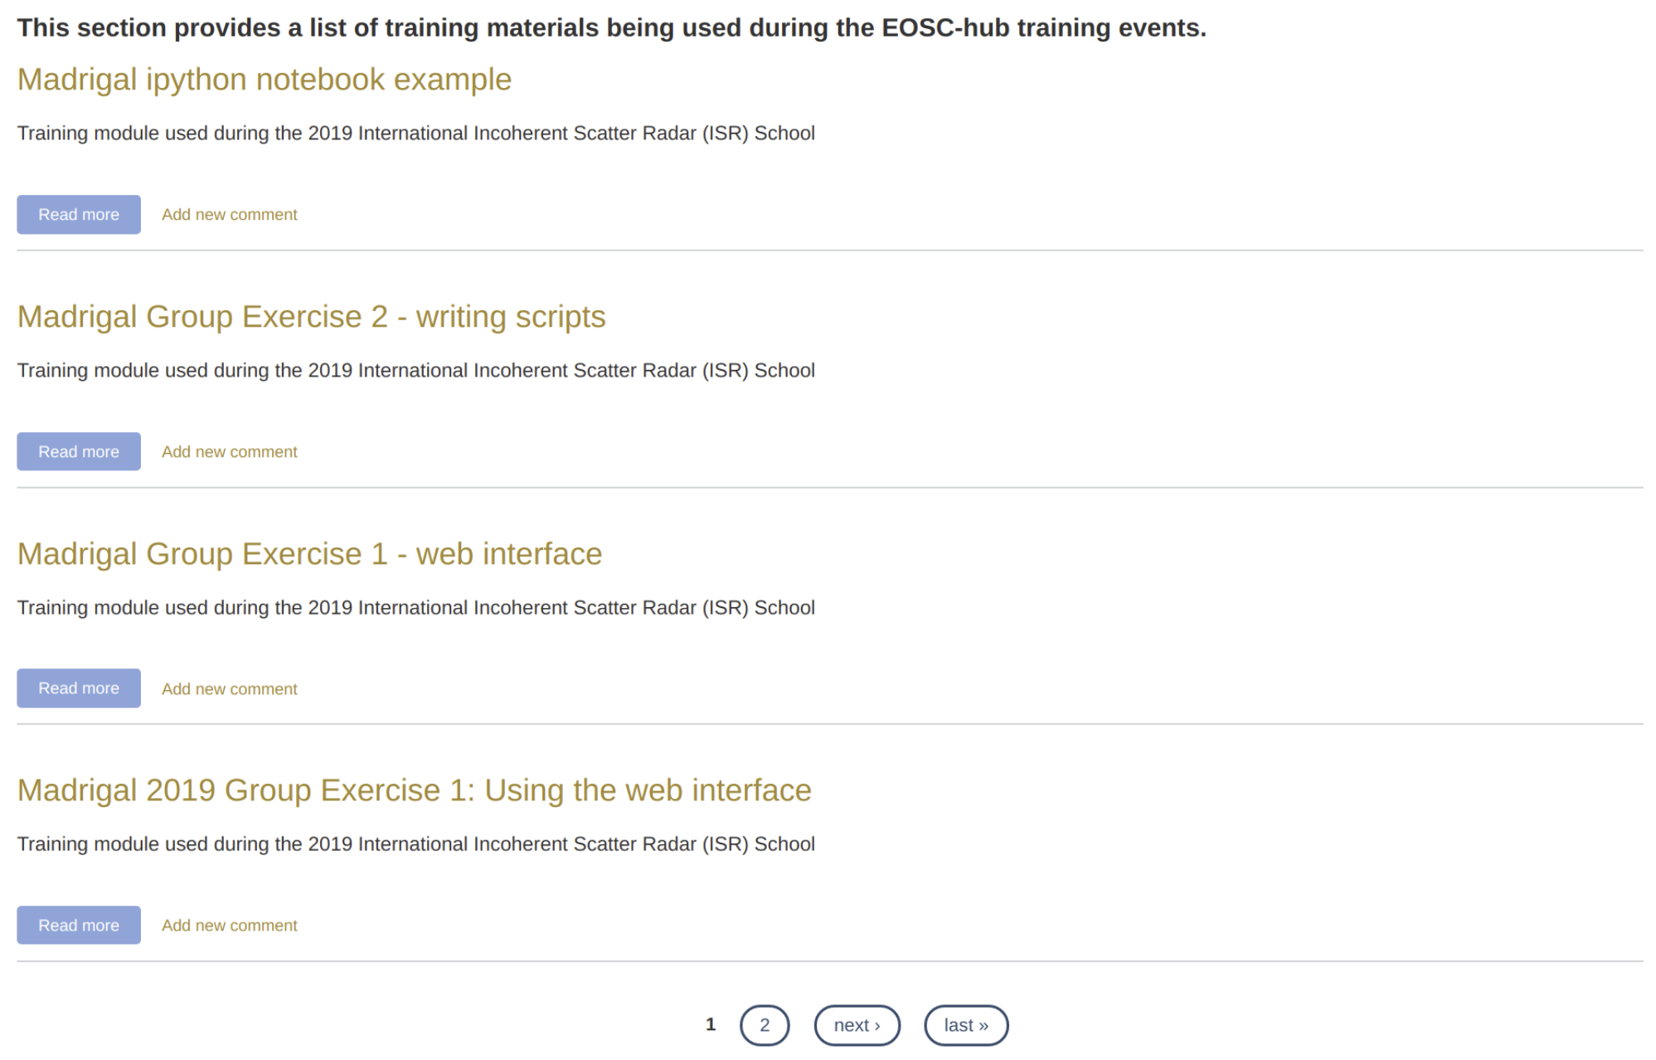
Fig. 1. Available training modules in the EOSC-hub training registry

ELIXIR
During the reporting period ELIXIR organized the following two training events on Authentication and Authorization Infrastructure (AAI):
- ELIXIR AAI Training, 10 September 2018
- ELIXIR – EXCELERATE: All hands meeting 2019, 17 June 2019
The target audience of both events were primarily developers and system administrators of service providers interested to extend their AAI frameworks and enable the ELIXIR AAI for users authentication and authorisation. Participants to the events were expected to have a relying service that they will connect to ELIXIR AAI using OpenID Connect. For those participants who haven’t brought their own services, a virtual machine with a test service, was also provided. During the hands-on sessions technical support was provided by experts for helping participants to integrate their own service to the test environment of ELIXIR AAI. Additional information on how to move the service in the ELIXIR production infrastructure was also provided at the end of the hands-on session.
Training materials on how to connect new services in the ELIXIR infrastructure was prepared and made available in the EOSC-hub training catalogue (Fig. 2).
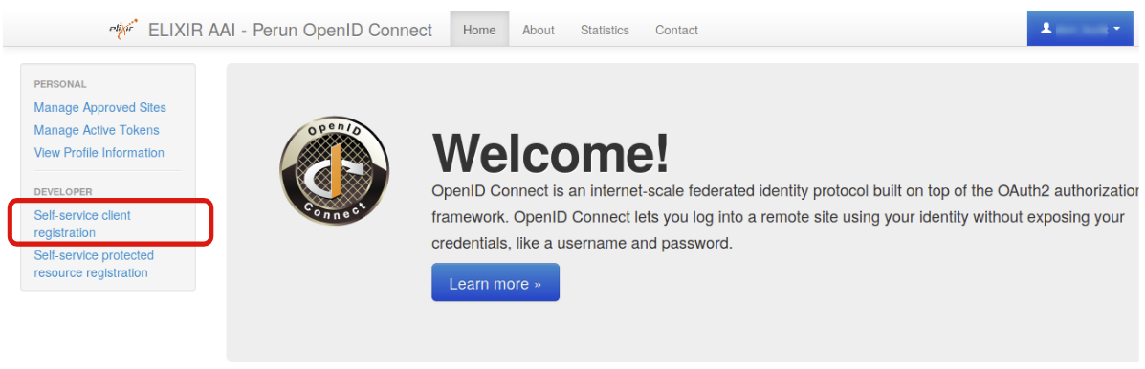
Fig. 2. Connecting a new service in ELIXIR
The two training sessions organized by the Competence Centre on ELIXIR AAI were attended by more than 50 participants.

Fusion
By the time of writing this report, no training activities were organized by this Competence Centre. A training documentation (see Fig. 3) for helping the fusion scientific community to exploit idle cloud resources for running containerized workloads was developed by the Fusion Competence Centre.

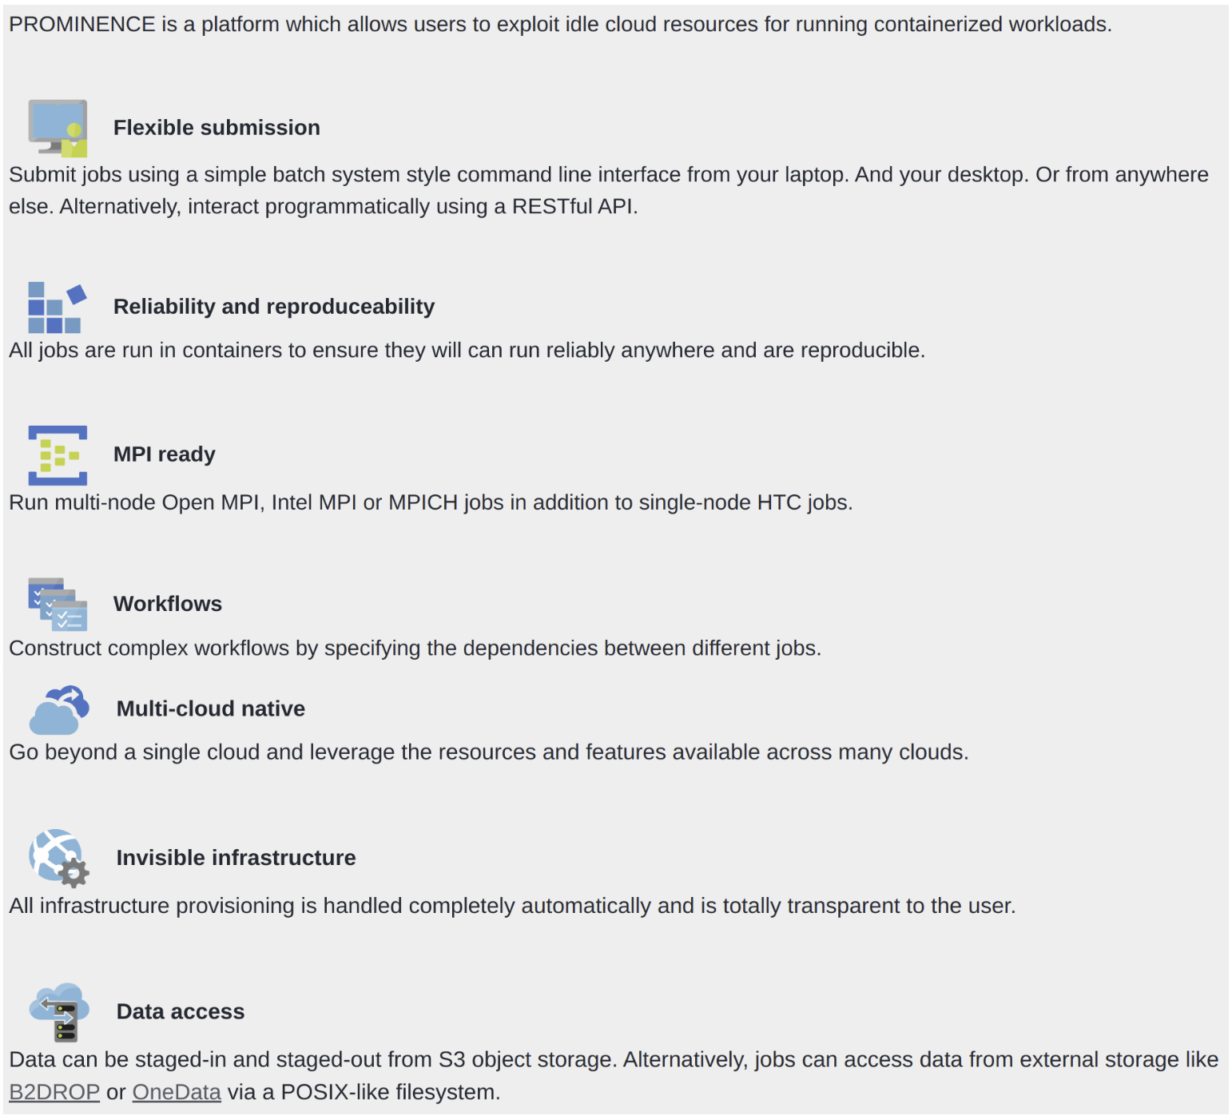
Fig. 3. Access cloud services for the fusion community with the PROMINENCE platform

Marine
By the time of writing this report, no training activities were organized by the Competence Centre.

EISCAT_3D
In PY2 this Competence Centre organized the International EISCAT Radar School. The school was organized with support from EISCAT and NSF in the United States. For this reason, an equal number of EU and US students were accepted. The school was intended for new users of incoherent scatter radars at any stage of their research career. Participants were expected to have a background in space physics, ionospheric physics, plasma physics, or radar (radio science). During the 5 full day school covered all essential aspects of incoherent scatter radar theory and practical use.
In total 15 teachers, representing both EU and US organizations including: The University of Oulu (Finland), EISCAT Scientific Association (Sweden), MIT (US), SRI International (US), and STFC (UK), were present at the school. The school was attended by 37 participants (25 males, 12 female) from 8 different countries. A user guide to access the DIRAC portal for EISCAT data (see Fig. 4) was prepared for this event and made available in the EOSC-hub training catalogue.

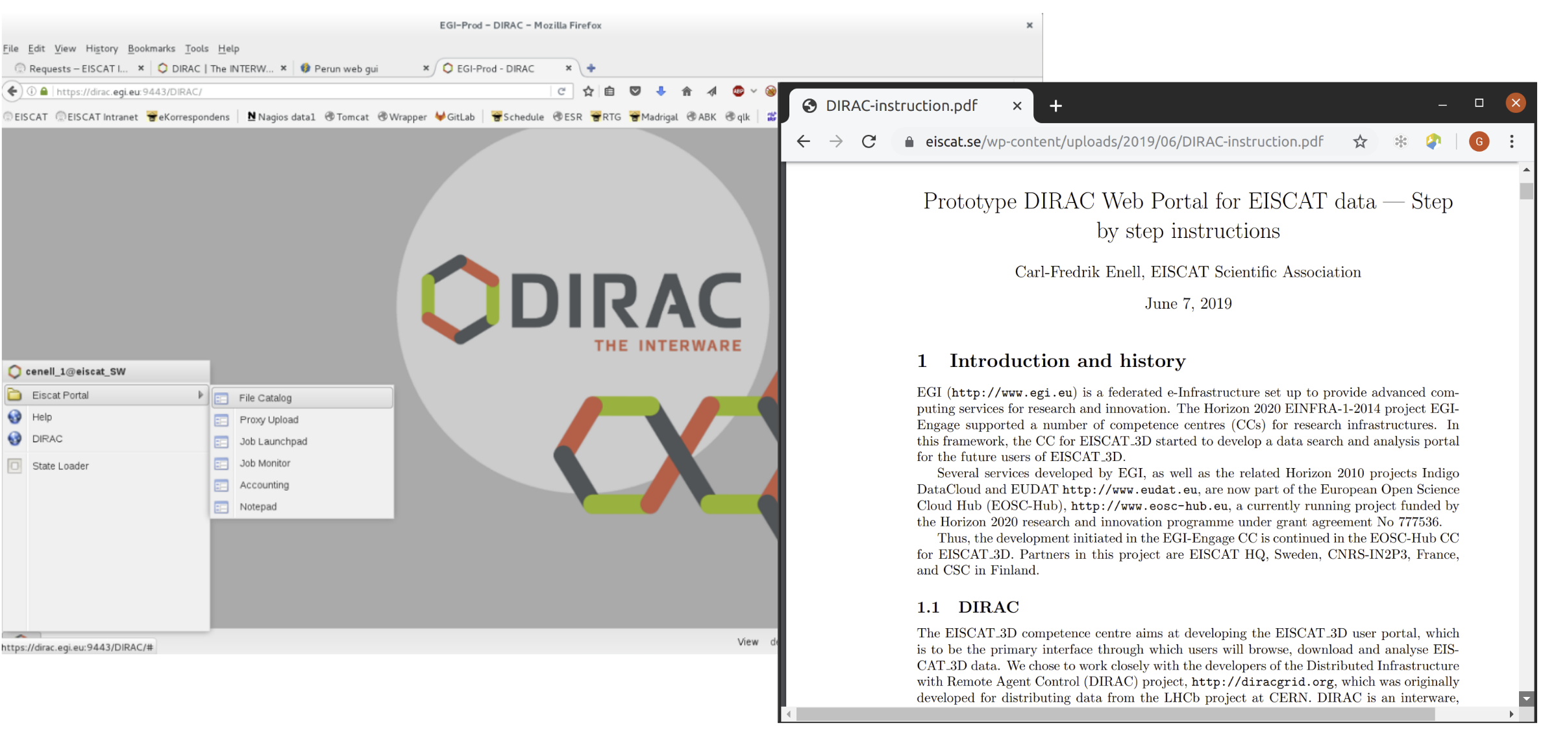
Fig. 4. The DIRAC web portal and user guide to analyse EISCAT data sets

EPOS-ORFEUS
In PY2 the EPOS-ORFEUS Competence Centre focused on the integration of the DMPilot-RuleManager framework in EOSC. This framework, which is intended mainly for seismology data centres’ operators, data managers and data stewards, enables seismology data centre operators to define and apply data management policies. Policies can be represented by a set of activities or rules. Typical rules performed in seismology data centre include acquisition and archival of waveform data from seismic sensors; generation of metadata and management of metadata catalogues; application of indicators for quality assurance and consistency check. Preliminary functionalities were presented and demonstrated to data centres operators at KNMI.

During the reporting period, the Competence Centre organized the following training activities:
- EPOS Seismology Meeting 2019: Presentation to provide a detailed view to seismologists on how to authenticate and access restricted by means of this service. Some examples were also provided including the support and integration from standard seismological libraries and applications.
- OBS Data Training Course 2019: Presentation on how to discover and access OBS data. Details about the AAI system were provided to the OBS community and many examples were given on how to use standard tools to make use of our system.

The user guide to access the European Integrated Data Archive infrastructure (EIDA) is shown in Fig. 5.

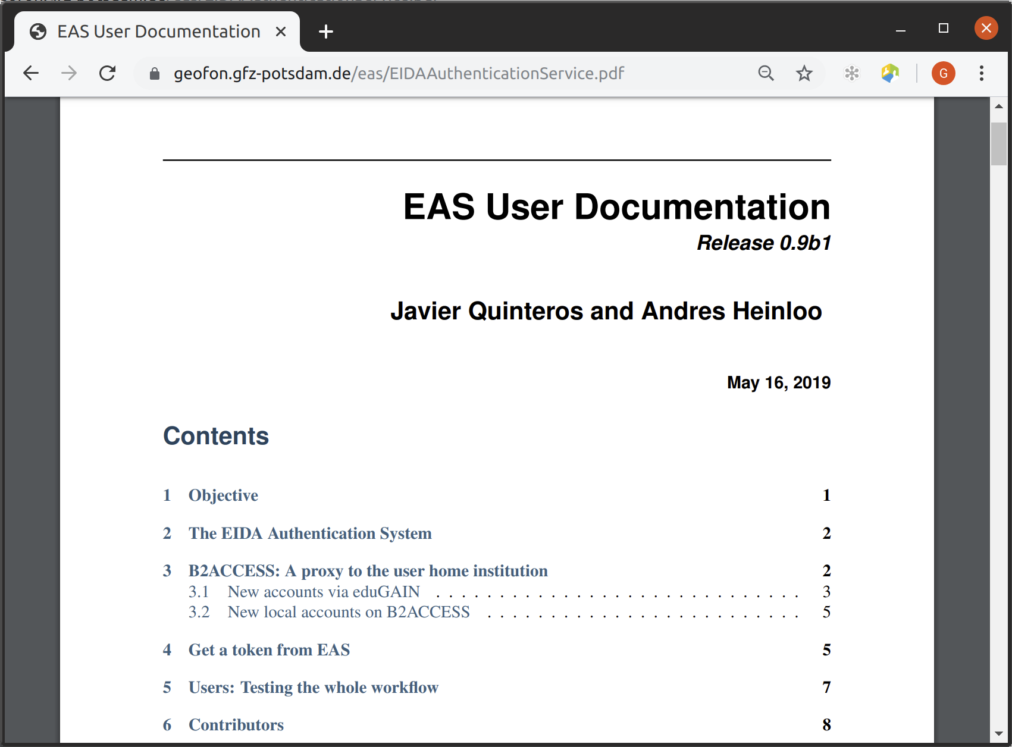
Fig. 5. The EIDA Authentication System

Radio-Astronomy (LOFAR)
EOSC training for Radio Astronomy Competence Centre (RACC) at this point in time has mainly resulted in the creation of awareness about EOSC, EOSC infrastructure, and RACC service development among the LOFAR user community, and the training of developers of LOFAR processing software in adopting the methods and framework that will allow incorporation of analysis pipelines in the RACC user processing service.

The main targeted event for providing training to the community in the context of the EOSC-Hub project is the LOFAR data school. The first occasion to provide training on developed RACC services will be September 2020. Apart from the LOFAR data school, training and knowledge sharing on usage of EOSC infrastructure has been part of various meetings and events, most notably:
- LOFAR User Meeting, Leiden 20 May 2019.
- Workshop on LOFAR Spider workflows, ASTRON 24 October 2019 (internal event).
- Prefactor CWL Busy week, ASTRON 26 – 28 November 2019 (internal event).
- Demo AAI integration of LOFAR services, ASTRON December 2019 (internal event).

ICOS
By the time of writing of this report, this Competence Centre organized internal training activities to the ICOS Ecosystem Thematic Centre (ETC). During these training activities members of the ICOS ETC were trained on the following topics:
- Use GitHub, Docker containers and orchestration of VMs through the ICOS server and the EGI FedCloud Infrastructure;
- Use SPARQL queries to locate and retrieve datasets;
- Ingest of results;
- Accessing securing storage through the EUDAT B2SAFE service core.

Disaster Mitigation (DMCC+)
DMCC has built up the collaboration framework between EGI and APAN (Asia Pacific Advanced Network) from 2015 to facilitate the cooperation in Asia and to demonstrate the EGI infrastructure and services through the Disaster Mitigation Working Group (DMWG, chaired by Eric Yen, the co-leader of DMCC). Accordingly, DMWG hosted disaster mitigation workshops and collaboration meetings twice a year at each APAN meetings since then. From summer of 2018, in collaboration with UND project (deeper Understanding to Natural Disaster, funded by TEIN project), 8 training events and workshops in different Asia countries were organized by the DMCC and the UND project.
Objectives of the training activities were mainly for:
- Training the trainers - based on the experiences from case studies, simulation portals and regional infrastructure;
- Case study progress discussion;
- Dissemination and outreach - local and regional user community engagement;
- Future collaboration discussion.
Target audience of training activities were primarily: Participants interested in numerical simulations on hazard risk assessment, cloud computing, regional infrastructure, disaster mitigation and agriculture applications. The training events organized by the EOSC-hub Disaster Mitigation Competence Centre were attended by more than 80 participants. The full list of events organized so far are listed below:
- Disaster Mitigation Workshop @APAN45, Singapore, 28 March 2018 (hosted by APAN DMWG, DMCC).
- Environmental Computing Workshop@ISGC2018, 19 March 2018 (hosted by DMCC, ASGC and LRZ).
- 3rd Masterclass on Disaster Mitigation @ APAN46, 08-09 August 2018 (hosted by APAN DMWG, UND and DMCC).
- Disaster Mitigation Collaboration Meeting @ APAN47, 20 Feb. 2019, Korea.
- Environmental Computing Workshop@ISGC2019, 1 April 2019 (hosted by DMCC, ASGC and LRZ).
- Disaster Mitigation Collaboration Meeting @ APAN48, 24 July 2019, Malaysia.
- UND Training @ Myanmar, 19-20 August 2019 (hosted by UND and DMCC).
- UND Training @Bangladesh, 25-27 November 2019 (hosted by UND and DMCC).

Several training modules, based on case studies, reviews and new case study discussions, were produced by the DMCC+ to share the experiences of disaster risk analysis.

EOSC-hub training contents analytics
In this section we report the number of visits and the number of page views received by the EOSC-hub training registry in the first two years of the project.
These metrics will help us to:
- Understand the internet traffic patterns to the EOSC-hub Training Catalogue.
- Identify the stakeholders of the training materials.
- Estimate how the internet traffic to the Catalogue changes after the promotions of events/materials through the official dissemination channels.

Monthly visits of the EOSC-hub training catalogue
The overall monthly visits of the EOSC-hub training catalogue of materials, from January 2018 (M01) to Dec. 2019 (M22), is shown in Fig. 6. As reported in the figure, starting from April 2018 (M04) when the initial release of the registry was published online, with progressively organisation and delivery of training activities on different topics such as: Common and Federated services, Data Management Planning, IT Security Forensics, ITSM training, and domain-specific events, the number of visits to the training materials has grown over the past months. From July 2019 (M19) a significant increment of the number of visits was recorded. This is justified by the 35 training activities organized and delivered by WP11 members during the period.
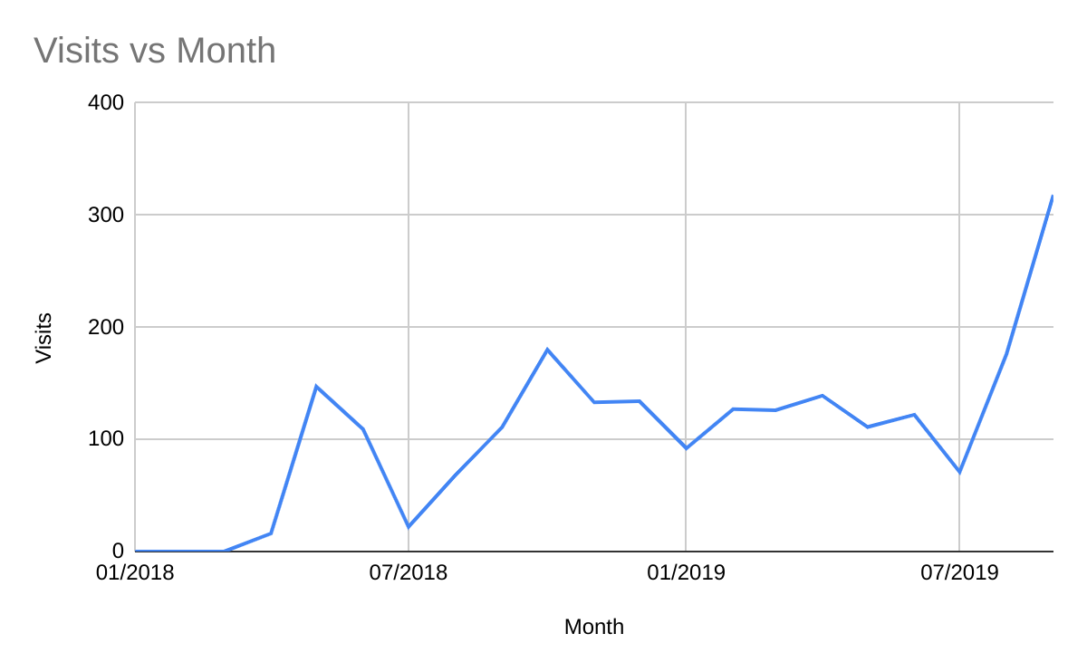Fig. 6. Monthly visit of the EOSC-hub training catalogue of materials

In Fig. 7 the distribution of page views per country is also shown:
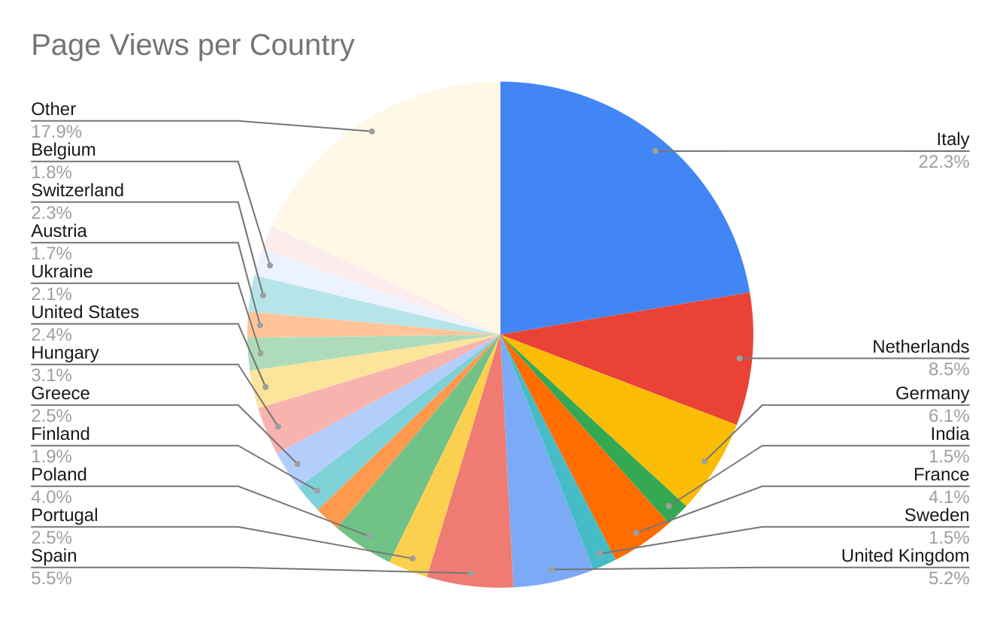Fig. 7. Number of page views per country

Page views of the EOSC-hub training catalogue
The statistics reported in the tables below were produced assuming that:
- A visit is defined as a sequence of consecutive page views without a 30-minute break.
- A visit always contains one or more-page views.
- A unique visitor always performs at least one, but possibly more, visits.
- The beginning of a visit is captured when the user lands on your website.

To evaluate the number of visits received, and the number of page views, the following metrics were considered:
- Page views is defined as the total number of times the generic web page and its content was viewed during a given period. In other words, this metric represents each time a user visits a page (e.g.: a single user loading the same page 5-times in a single session will generate 5-page views).
- Delta (δ) is the increase of page views (%) recorded from Jan 2018 to Dec. 2019.
- Unique page views represent an aggregate of page views generated by the same user during the same session (i.e. the number of sessions during which that page was viewed one or more times). Unique page views are calculated on a session basis, meaning if the same user loads a page 5 times in a given session, it's only calculated as 1 unique pageview.
- Average time on page is used to quantify the average amount of time visitors spend on a page. It reveals if they are reading the training content.
- Bounce rate represents the percentage of visitors who enter the site and then leave rather than continuing to view other pages within the same site.
- % Exit is the percentage of visits that were the last in the session.

In the tables below are reported the page views received for:
- EOSC services and how to use the EOSC-hub training registry.
- Domain-specific services already registered in the EOSC Portal Marketplace.
- Pilot services and proof-of-concepts developed by the Competence Centres.
- Data Management Planning.
- Common and Federated services.
- Collaborative services.

Training content | Page views | δ (%) | Unique page views | Avg. Time on page | Bounce rate | % Exit
Training material | 36 | +20 | 21 | 00:00:48 | 0.0% | 16.67%
EOSC-hub-services-overview | 145 | +590 | 92 | 00:02:03 | 54.55% | 27.59%
Train the trainers | 27 | +125 | 18 | 00:02:00 | 75.00% | 33.33%
Guidelines and best practices training delivery | 26 | +116 | 17 | 00:01:13 | 50.00% | 42.31%
Table 2. Number of page views for the EOSC services and how to use the EOSC-hub training registry
As expected, there is a clear raising interest in understanding the overall architecture of the EOSC-hub services, and how the EOSC solutions can help research communities on specific topics ranging from the analysis of complex datasets from different scientific domains, to the preservation, curation and sharing of datasets. We expect this trend will probably increase during the third year of the project.
During the third year of the project WP11 will be committed to coordinate a training and education programme to respond to this increasing demand and create “learning paths” for European researchers interested to understand which EOSC solutions can best fit in their scientific activities, and how service providers can contribute to the establishing EOSC ecosystem. More details about these learning paths will be provided in Section 4.
To support the organisation and the delivery of effective training events WP11 followed a “Train the Trainer” approach. Guidelines and best practices for training delivery were prepared and made available on the project wiki. These guidelines and documentation introduced the overall WP11 training management process, best practices on how to deliver training materials and events, and a detailed user manual on how to register new events and upload training contents in the EOSC-hub Training registry. A dedicated train-the-trainer webinar was also organized to share these knowledge and skills to all the project members involved in training activities.

Training content | Page views | δ (%) | Unique page views | Avg. Time on page | Bounce rate | % Exit
The ENES Climate Analytics Service (ECAS) | 94 | +74 | 68 | 00:01:34 | 52.17% | 41.49%
eo-pillar-services-geohazards-thematic-exploitation-platform | 85 | +165 | 50 | 00:01:13 | 45.00% | 27.06%
geo-discovery-and-access-broker-geo-dab | 59 | +436 | 48 | 00:02:32 | 70.27% | 61.02%
ecasnotebooks-timeseriesextraction | 52 | +15 | 30 | 00:01:34 | 50.00% | 21.15%
wenmr-suite-structural-biology | 43 | +86 | 28 | 00:01:47 | 50.00% | 30.23%
opencoasts-service | 30 | +66 | 22 | 00:00:58 | 28.57% | 26.67%
dodas-service | 22 | +1000 | 17 | 00:00:25 | 40:00% | 54.55%
ecasnotebooks-dailytemperaturerange | 21 | +10 | 11 | 00:01:17 | 66.67% | 23.81%
opencoasts-coastal-circulation-demand-forecast | 20 | N.A. | 10 | 00:01:19 | 0.00% | 20.00%
ecasnotebooks-timeseriesdifference | 13 | 8.3 | 10 | 00:01:38 | 0.00% | 23.08%
how-apply-bioinformatics-metallo-proteins | 13 | N.A. | 8 | 00:00:25 | 100.0% | 23.08%
ecasnotebooks-summerdaysipynb | 12 | +100 | 8 | 00:00:11 | 50.00% | 8.33%
Table 3. Number of page views received for the domain-specific services
The number of page views reported in Table 3 were expected. With the progressively integration of common and federated services with the EOSC Thematic Services, several training activities were organized to facilitate the promotion and the uptake of these new domain-specific services, and core data resources with the aim to reach a wider user base. This is confirmed by the % of increment reported on the 2nd. column. Training materials developed during these activities are now published in the EOSC-hub training registry. This trend is also confirmed by the number of service order requests we started to receive for the thematic services registered in the EOSC Portal Marketplace.
Training content | Page views | δ (%) | Unique page views | Avg. Time on page | Bounce rate | % Exit
elixir-aai-training | 23 | N.A. | 14 | 00:02:20 | 00.00% | 21.74%
dirac-portal-eiscat-data | 21 | N.A. | 13 | 00:01:00 | 33.33% | 54.17%
federated-aai-eida-services | 20 | N.A. | 12 | 00:01:10 | 66.67% | 50.00%
use-comcot-ss-model-storm-surge-forecasting-philippines-case-typhoon-manghut-2018 | 7 | N.A. | 3 | 00:00:07 | 00.00% | 14.29%
Warning! Big Waves Are Coming! Let's Talk About Tsunami and Storm Surges | 6 | N.A. | 4 | 00:01:16 | 100.00% | 33.33%
case-study-flood-conditions-middle-region-myanmar | 5 | N.A. | 3 | 00:00:18 | 00.00% | 20.00%
apan-disaster-mitigation-working-group-regional-collaboration | 2 | N.A. | 1 | 00:00:24 | 00.00% | 00.00%
Table 4. Number of page views received for the pilots and proof-of-concepts
As reported in D8.1 - Report on progress, achievements and plans of the Competence Centres, only the following 3 CCs: Marine (ARGO data discovery platform), EISCAT_3D (EISCAT Portal) and ICOS-eLTER (ICOS Carbon Portal) reached mature integration between common services and their community-specific services. The remaining are still in intensive integration and technology assessment. For this reason, the organization of training activities to promote the pilot services have been postponed during the third year of the project.

Training content | Page views | δ (X) | Unique page views | Avg. Time on page | Bounce rate | % Exit
/why-good-data-management-plan | 76 | +123 | 50 | 00:00:56 | 90.91% | 28.95%
Table 5. Number of page views received for the Data Management Planning
In Table 5, the number of page views measured for the implementation of a data management plan is shown. The importance of implementing a proper Data Management Plan (DMP) is increasingly acknowledged by the international research community. For this reason, the organization of this kind of activities will also continue in the third year of the project. In collaboration with the OpenAIRE-Advance project, more attention will be paid on research data management by means of “data domain protocols” that are core components of DMPs aimed at specific disciplines. The organisation of training activities on Data Management Planning will continue in the third year of the project in collaboration with the OpenAIRE-Advance project.

Training content | Page views | δ (%) | Unique page views | Avg. Time on page | Bounce rate | % Exit
tosca-heat | 108 | +1250 | 97 | 00:02:40 | 85.26% | 85.19%
egi-cloud-compute | 73 | +30 | 42 | 00:01:14 | 81.48% | 39.73%
egi-datahub | 58 | +152 | 44 | 00:00:44 | 52.17% | 37.93%
egi-jupyter-notebooks-examples | 55 | N.A. | 44 | 00:00:34 | 45:00% | 34.55%
knowledge-hub-pid-basics | 53 | N.A. | 38 | 00:01:16 | 77.78% | 52.83%
argo | 37 | +236 | 27 | 00:00:18 | 86.67% | 48.65%
egi-check-service | 33 | +230 | 25 | 00:03:16 | 56.25% | 42.42%
egi-workload-manager | 33 | +57 | 22 | 00:02:25 | 33.33% | 18.18%
spmt | 32 | +357 | 26 | 00:01:57 | 94.44% | 68.75%
training-eosc-hub-aai-service-provider-perspective | 30 | N.A. | 18 | 00:01:22 | 0.00% | 30.00%
component-metadata-infrastructure-services | 29 | +93 | 26 | 00:03:19 | 44.44% | 34.48%
b2find | 27 | +42 | 16 | 00:00:50 | 66.67% | 25.93%
b2handle | 27 | +42 | 13 | 00:00:17 | 40.00% | 22.22%
iam | 27 | +800 | 19 | 00:00:29 | 0.00% | 33.33%
operations-portal | 27 | +92 | 16 | 00:00:43 | 60.00% | 22.22%
egi-online-storage | 26 | +44 | 21 | 00:02:40 | 71:43% | 46.15%
b2access | 24 | +71 | 26 | 00:01:43 | 33.33% | 16.67%
egi-cloud-container-compute-training-material | 24 | +26 | 19 | 00:01:03 | 50.00% | 25.00%
eosc-hub-tech-talk-cloud-containers-orchestration-training-material | 24 | N.A. | 8 | 00:02:02 | 33.33% | 16.67%
b2drop | 23 | +53 | 17 | 00:01:15 | 75.00% | 39.13%
b2share | 20 | +81 | 12 | 00:00:52 | 25.00% | 15.00%
paas-orchestrator | 18 | +38 | 14 | 00:02:35 | 50.00% | 22.22%
rc-auth | 18 | +350 | 17 | 00:07:43 | 86.67% | 83.33%
transparent-data-movement-egi-eudat | 17 | N.A. | 16 | 00:06:32 | 100.00% | 76.45%
b2safe-and-b2stage | 14 | +16 | 10 | 00:00:52 | 100.00% | 35.71%
Table 6. Number of page views received for the Common and Federated services
Several training activities on Common and Federated services were organized for helping the integration of EOSC services in the domain-specific platforms (WP7) and service pilots (WP8). Beside the organization of training activities, WP5 and WP6 members contributed to update the materials published in the EOSC-hub training registry. As reported in Table 6, AAI and cloud compute services are the ones most visited since most of the Thematic Services and early adopters focused on the integration of federated authentication mechanisms and the access to the cloud resources to scale-up computing analyses. Other common and federated solutions such as: storage and PaaS solutions were also requested.
Training content | Page views | δ (%) | Unique page views | Avg. Time on page | Bounce rate | % Exit
egi-applications-database-appdb | 34 | +54 | 25 | 00:01:48 | 90.00% | 41.18%
egi-marketplace | 23 | N.A. | 10 | 00:00:54 | 50.00% | 34.78%
appdb | 16 | 0 | 6 | 00:02:39 | 0.00% | 18.75%
appdb-information-system | 15 | +400 | 14 | 00:08:24 | 83.33% | 73.33%
Table 7. Number of page views received for the Collaborative services

Recommendations from reviewers
After the first project review, the following feedback and recommendations, targeting WP11 activities, were collected:
“The current training catalogue of materials is not well structured and the intended targets of different materials are unclear. It requires further improvements to make it really usable and used by third parties and meet the requirements of EOSC”.
“The training catalogue and materials should be enhanced with clear routes that should be used by interested scientists/communities when trying to understand how to use EOSC, as well as for service providers to be able to provide services in EOSC”.
Reviewers’ recommendations will be addressed as part of the future plan during PY3 as reported in the next section.

Plans for the next year
To address recommendations from reviewers, the following activities will be pursued to restructure the architecture of the EOSC-hub training catalogue of materials and improve how training modules can be presented to the different target groups:
Action 1:
Keep up to date the WP11 training strategy in order to deliver a sound training programme to address the needs of the scientific communities involved in the project. This task will be done primarily working with WP7, WP8 and WP9 members, and establishing synergies and collaborations with other EOSC-related projects such as: OpenAIRE-Advance, FAIRsFAIR and FREYA. A new training programme to target the needs of the scientific communities for the last year of the project will be available early February 2020 (as part of M11.5 - Training programme of the third year).
Besides, to strengthen this strategy WP11 is also contributing in the EOSC-wide Training Coordinators’ Community of Practice with the aim to position EOSC-hub training with respect to other initiatives of the EOSC landscape. The main audiences of EOSC-hub training are Researchers and scientific communities and Service providers who need technical assistance on using/integrating/providing services. This complements the training effort of projects, like OpenAIRE-Advance and FAIRsFAIR that look into the ‘Open-ing’ and into the ‘FAIR-ification’ of science, and the efforts of EOSC-Enhance from early 2020 to pull together fundamental training on Open Science. Lastly, WP11 coordinator will participate in the Workshop on training in EOSC which will take place in The Hague, The Netherlands (26-28 Feb. 2020). During the event the EOSC projects will discuss training strategies for the post-EOSC-hub years in EOSC.
Action 2:
Revision of the EOSC-hub Training Registry layout on the project website, structuring content into:
- modules targeting main audiences (Researchers and scientific communities; and for Service providers), and
- topics covering key project results of EOSC-hub and its partners.
The new structure will provide clear routes with learning goals for the visitors.
Primarily, the needs of the following two stakeholders will be addressed:
- Researchers and scientific communities. For this target group the training contents will be re-organized in order to provide a high-level introduction about the Open Science and the vision that the EC is promoting to reduce the fragmentation of the available services operated by the different e-infrastructures, and improve the exploitation of data coming from different scientific domains. Training contents developed by OpenAIRE and the Foster projects will contribute to the implementation of these “learning paths”. Additional contents on how to implement an efficient Research Data Management plan will be made available. This content was provided in collaboration with the OpenAIRE-Advance project. To dig more into details, the catalogue will also provide technical material on how to use the Common and Federated services, or one of the domain-specific platforms developed by the selected Thematic Services.
- Service providers. For this specific target group, the training contents will focus primarily on describing all the needed terminology, concepts and activities to be carried out in order to improve the professional planning, development, operating and control of EOSC services. Policies and conditions for service providers interested to offer services through the hub, as well as best practices to train staff and prevent security attacks, will also be made available.

An initial, non-exhaustive, list of training modules to serve the needs of researchers/scientific communities and service providers will include the following topics:
- “Introduction to Open Science”. The overall principles and the benefits the Open Science approach can bring in the different phases of the research process will be provided in collaboration with the OpenAIRE-Advance and the Foster projects.
- “Introduction to EOSC”. An introduction about the EC vision and how the virtual environment provided by EOSC with open and seamless services for storage, management, analysis and re-use of research data can be used to facilitate the day-by-day work of European researchers from different scientific disciplines will be provided.
- “Research Data Management”. Managing research data is becoming increasingly important. Basic concepts of Research Data Management (RDM) are presented as well as tools for helping research communities to write an efficient Data Management Plan (DMP).
- “Common and Federated services in EOSC(-hub)”. For service providers to integrate with.
- “Domain-specific services and data tools in EOSC(-hub)”. For researchers interested in using the existing thematic services.
- “IT Service Management”. For service providers and organisations to better manage services with a customer focus and continuously improve high-quality service delivery.
- “IT Security Forensics”. For service providers interested in protecting services from the world’s most impactful threats.
- “How to contribute to EOSC”. For service providers interested in contributing to the establishing EOSC ecosystem.

Besides the website, the Service Providers’ Forum will also be used more effectively to publicise training events.

Training modules for researchers and scientific communities
To implement Action 3, WP11 proposes to re-organize the training contents in a hierarchical architecture. The mock-up of the new top level architecture for the EOSC-hub training registry is shown in Fig. 8:

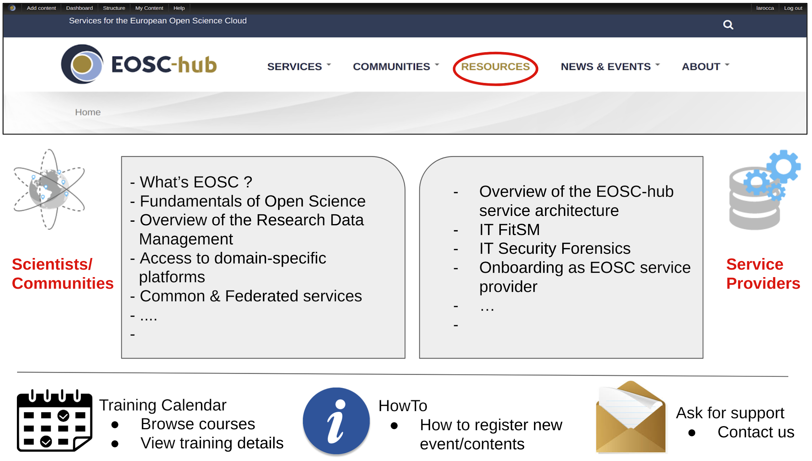
Fig. 8. Top level architecture of the new EOSC-hub Training registry

From the bottom of page visitors can access the calendar of training events (past and future events), ask for support contacting WP11 members, or get access to the available documentation for registering a new training event or uploading a new training content. From the top-level page researchers, scientific communities and service providers will be able to access the different training modules by clicking in the dedicated areas.
A preview of the training modules that will be available for researchers and scientific communities is shown in Fig. 9:
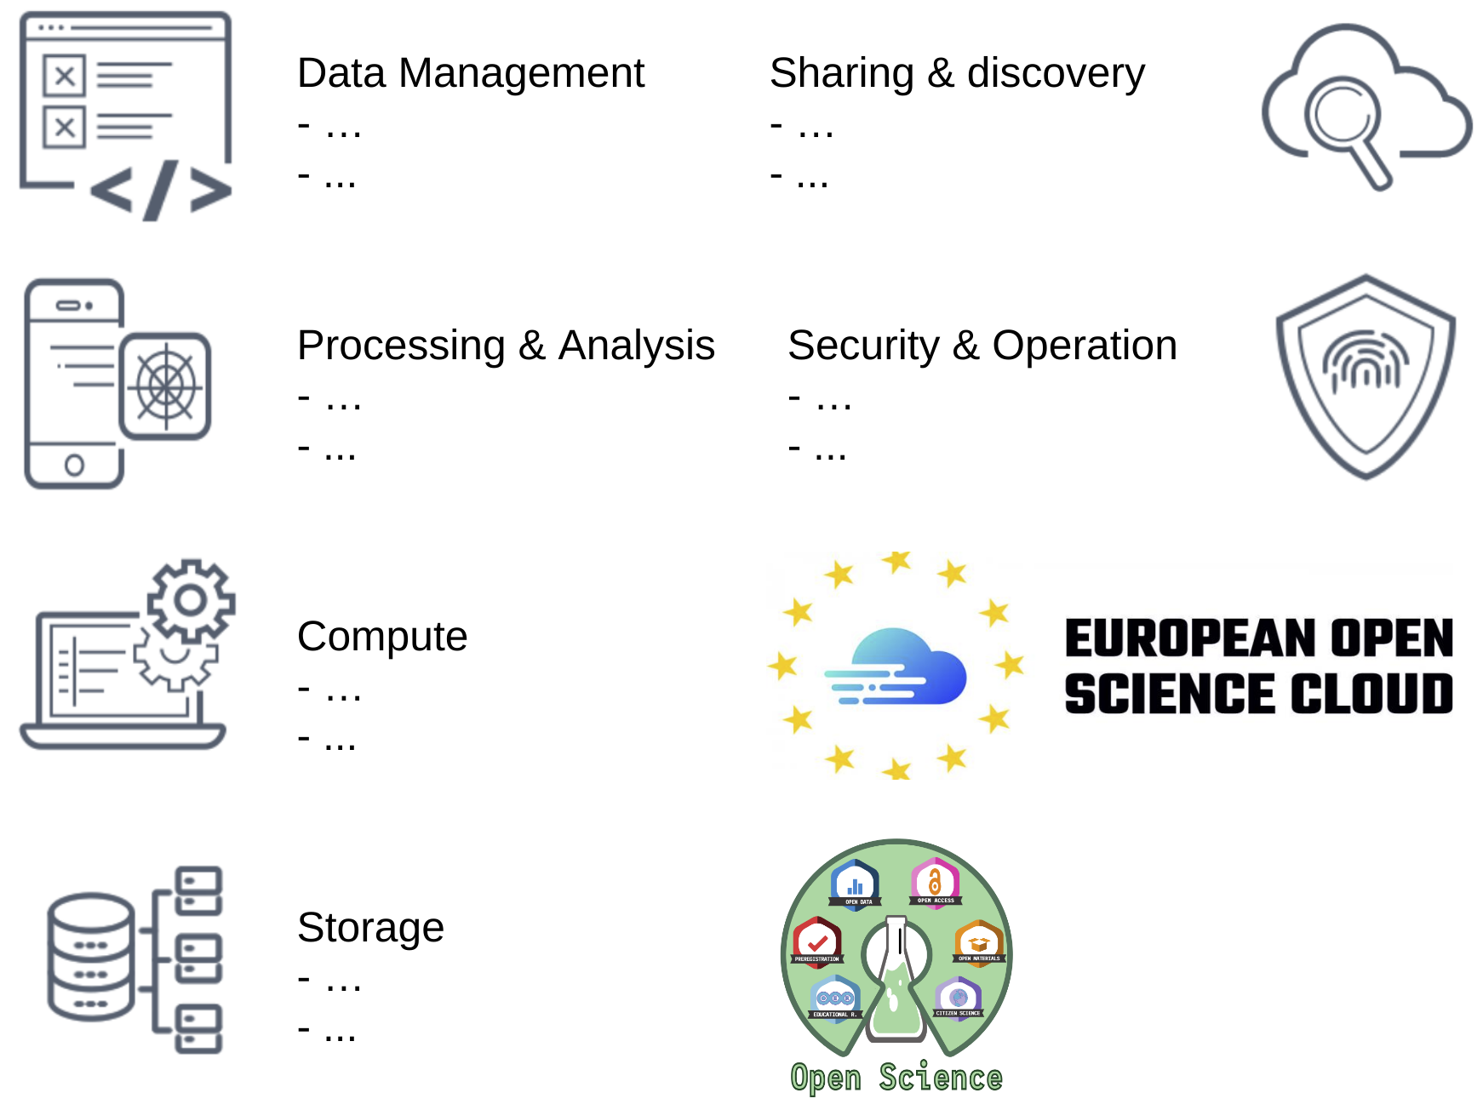
Fig. 9. Learning objectives available for researchers and scientific communities

From this second-level menu the available training materials, filtered per service categories (e.g.: Data Management, Processing & Discovery, etc.) are presented to the target users. Additional references to discover EOSC and which services are available for European researchers, and guidelines to make Open Science in practise, will be also provided.

Training modules for service providers
To serve the needs of service providers group, the following training modules will be provided:
- “Common and Federated services in EOSC(-hub)”. To target the interest of service providers, the latest updates about the Common and Federated services available in EOSC will be introduced for helping the integration of these “glue” services with the community-specific service pilots. Periodic webinars on how to integrate EOSC Common and Federated services will be also organized by WP11 in collaboration with WP5 and WP6 members.
- “IT Security Forensics”. Specialized modules to protect community-specific services from the world’s most impactful threats will be made available.
- “IT Service Management”. Fundamentals of the FitSM IT Service Management lightweight standard will be provided for helping service providers and organisations to improve the professional planning, operation, delivery and control of their services.
- “Service on-boarding”. It will include modules for federating service providers with EOSC. These modules will also include the Rule of Participations (RoPs), and the different integration options. Periodic webinars on this topic will be also organized by WP11 in collaboration with other WP members.

These training modules will contribute to facilitate the on-boarding of new service providers in EOSC as shown in Fig. 10.
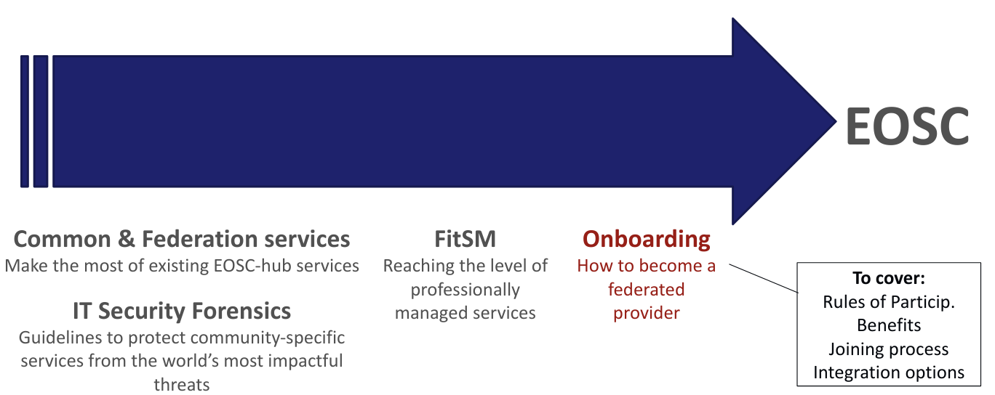
Fig. 10. Training modules to become an EOSC service provider

Conclusions and future outlooks
To maximise the impact of the training events, it was deemed necessary to wait for the finalisation of the recruitment processes of the 8 competence centres. Promotion of pilot services and training of users will start once the project is satisfied it can reach sufficient critical mass to both support the work within the individual competence centres and to increase the likelihood of cross-pollination between them.

During the first two years of the project, a total of 22 training events were organized by the 8 EOSC-hub Competence Centres. A total of 420 participants attended the training events organized by the Competence Centres. As part of the WP11 training strategy, to monitor the training activities and collect feedback from the participants to the events WP11 made available an online web form and a document template. Below are reported, as an example, the qualitative metrics measured during the Radar School 2019 organized by the EISCAT_3D Competence Centre:

Course Component | Average value  (1: poor – 6: excellent) | Standard Deviation (n=37)
Overall Evaluation | 5.38 | 0.56
Presentations | 5.31 | 0.65
Lab Exercises | 5.66 | 0.47
Advertising & Registration | N/A | N/A
Facilities | 4.36 | 0.91
Table 7. Feedback metrics (user’s satisfaction) from the Radar School 2019
With the progressively integration of the EOSC-hub common services in the Competence Centres community-specific services, and the consequence evaluation of the resulted new service platforms, additional training activities will be organized and delivered in PY3. More details about the upcoming events will be provided in the next WP11 report.

See: https://eosc-hub.eu/training-material (Select EOSC-hub Competence Centres as Keyword)
See: https://eosc-hub.eu/training-event/elixir-aai-training
See: https://eosc-hub.eu/training-event/elixir-excelerate-all-hands-meeting-2019
See: https://eosc-hub.eu/training-material/training-integration-openid-connect-services-elixir-aai
See: https://eosc-hub.eu/training-material/enabling-htc-hpc-applications-opportunistically-across-private-academic-and-public
See: https://eosc-hub.eu/training-event/2019-international-incoherent-scatter-radar-isr-school
See: https://eosc-hub.eu/training-material/dirac-portal-eiscat-data
See: https://eosc-hub.eu/training-event/epos-seismology-meeting-2019
See: https://eosc-hub.eu/training-event/obs-data-training-course-2019
See: https://eosc-hub.eu/training-material/federated-aai-eida-services
See: https://eosc-hub.eu/training-event/lofar-science-2019
See: https://eosc-hub.eu/training-event/3rd-masterclass-disaster-mitigation-apan46
See: https://eosc-hub.eu/training-event/environmental-computing-workshopisgc2018
See: https://eosc-hub.eu/training-event/3rd-masterclass-disaster-mitigation-apan46
See: https://eosc-hub.eu/training-event/disaster-mitigation-wg-meetingapan47
See: https://eosc-hub.eu/training-event/environmental-computing-workshopisgc2019
See: https://eosc-hub.eu/training-event/disaster-mitigation-collaboration-meeting-apan48
See: https://eosc-hub.eu/training-event/und-training-mm
See: https://eosc-hub.eu/training-event/und-project-training-bangladesh
See https://docs.google.com/spreadsheets/d/1Cje-YrvBOJ4KqQUw_fwB7TjaKSBHXzW7pae50QWUyM8/edit#
See: WP11 Guidelines and Best Practices for Training Delivery: https://confluence.egi.eu/display/EOSC/Guidelines+and+Best+Practises+on+Training+Delivery
See: WP11 Train the trainer webinar: https://indico.egi.eu/indico/event/4281/
A total of 59 service order requests from 19 different countries were collected until December 2019.
See: https://documents.egi.eu/document/3485
See: https://dans.knaw.nl/en/current/workshop-on-training-in-eosc
See: https://www.fosteropenscience.eu/
See: https://docs.google.com/forms/d/14CgvI7O5JJArcMggY7xG4bj6oePdnHdqXiMH4U-O9k4/edit
See: https://documents.egi.eu/public/ShowDocument?docid=3296

