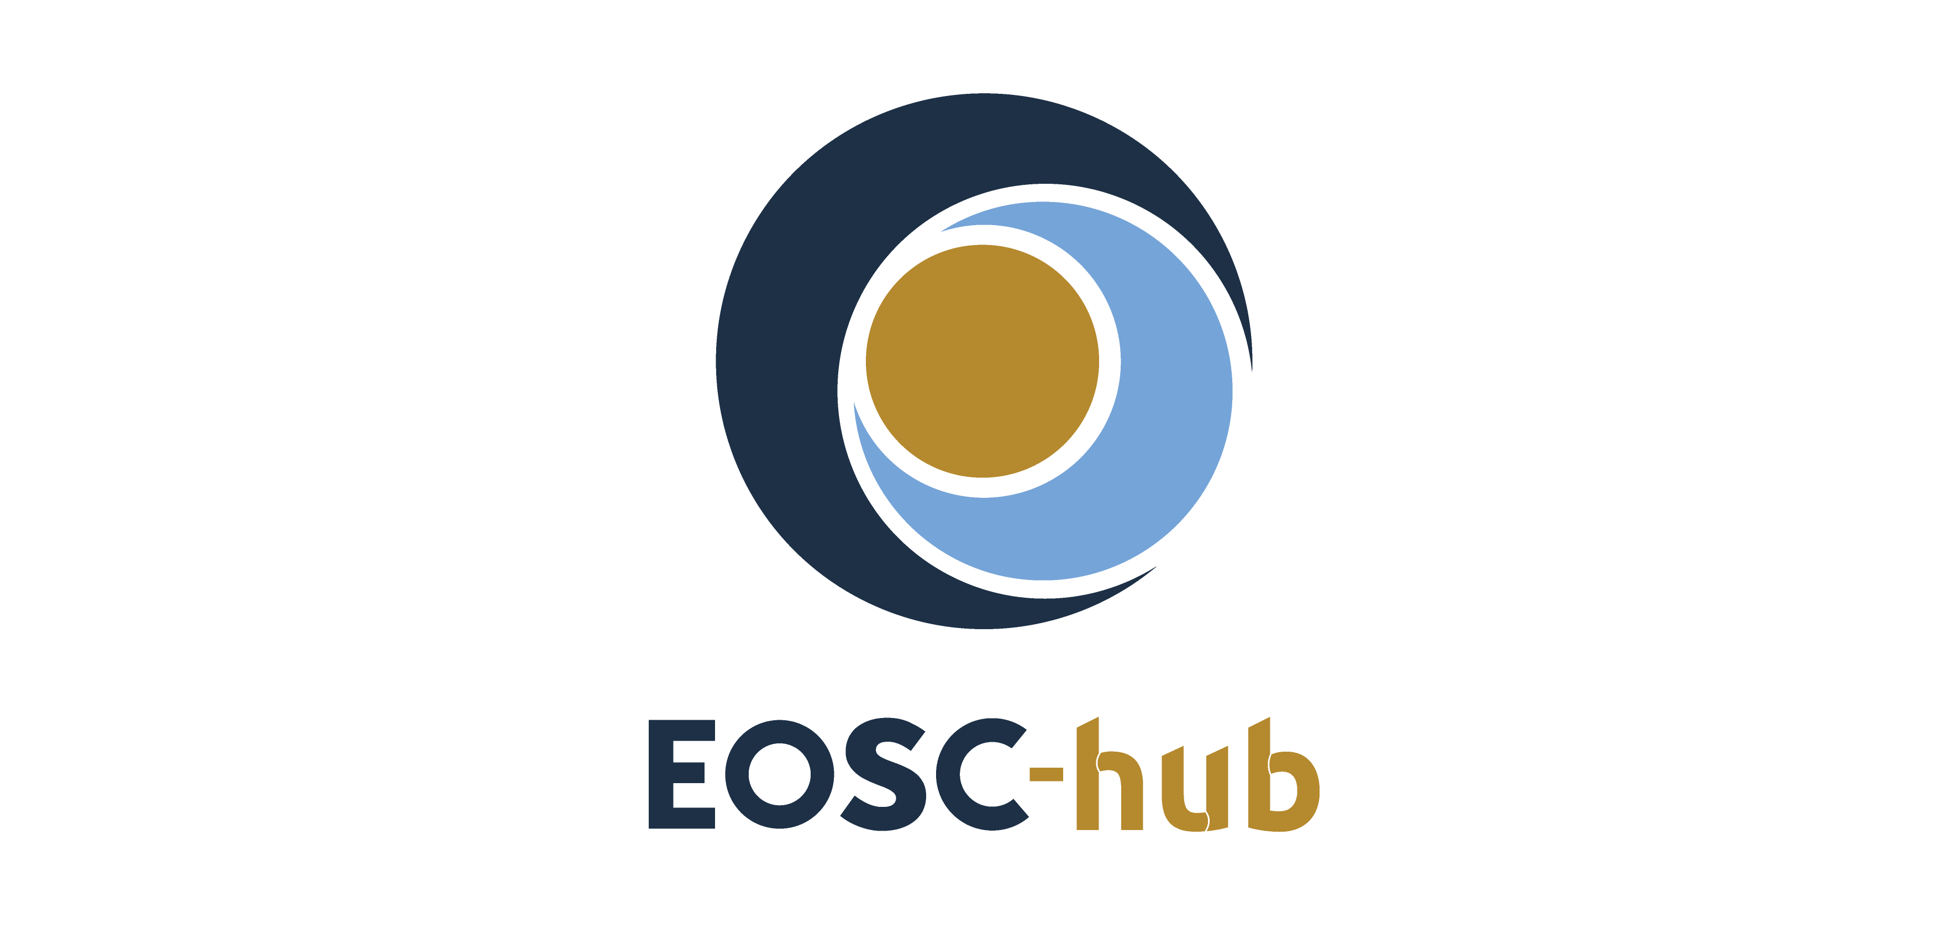

Integration Report

Abstract
This document describes the major integration activities successfully completed by EOSC-hub with a focus on the EOSC Portal and on the thematic services from European research communities joining EOSC.

COPYRIGHT NOTICE
This work by Parties of the EOSC-hub Consortium is licensed under a Creative Commons Attribution 4.0 International License (http://creativecommons.org/licenses/by/4.0/). The EOSC-hub project is co-funded by the European Union Horizon 2020 programme under grant number 777536.
TERMINOLOGY
https://wiki.eosc-hub.eu/display/EOSC/EOSC-hub+Glossary

Contents
2 Introduction 6
2.1 Components 6
2.2 Processes 9
2.3 Operations 10
3 EOSC Service Integration and Composability 11
3.1 EOSC Technical Architecture and interoperability guidelines 11
3.2 Driving use cases 13
3.2.1 Thematic services 13
3.2.2 Competence Centers 15
3.2.3 EOSC Early Adopter Programme 17
3.2.4 Business pilots 20

Executive summary
This document describes the major integration activities successfully completed by EOSC-hub with a focus on the EOSC Portal and on the thematic services from European research communities joining EOSC.

EOSC Portal development, integration and delivery
EOSC-hub contributed to the design, the development and the operation of the EOSC Portal since its conception and the launch in November 2018 working in collaboration with other EOSC projects. The project is operating the EOSC Portal and is developing and maintaining a series of enabling components like the web-site with its informative sections, the Authentication and Authorisation infrastructure (AAI), an AARC Blueprint Architecture compliant proxy based on EGI Check-in technology, a unified service catalogue & marketplace, a rich catalogue of services where users can discover and access EOSC services. The catalogue currently offers around 250 services to the European Research Area and integrated additional features such as the ordering, enabling users to request access to EOSC services, and the user space, providing scientists with a personal space where they can combine EOSC services.

Recently, EOSC-hub integrated into the portal additional tools to improve the user experience and enrich its functionalities: a helpdesk, offering a simple and unified interface to request support, an order management tool, to facilitate and speed-up the processing of the orders and a monitoring system. During the third year of the project, an EOSC Portal metrics dashboard, an initial accounting system and a more sophisticated monitoring system will be delivered.

EOSC Hub: Core services and service management processes
In addition to this, as part of the EOSC Service Management System (SMS), EOSC-hub designed, developed and is operating processes that enable the onboarding of new services in EOSC, incident and service requests management, service order and customer relationship management, service level management and technical support. To properly operate the EOSC according to the FitSM standard, they are complemented with a number of operational processes like the Capacity Management (CAPM), the Information Security Management (ISM), the Change Management (CHM), etc.

Integration of thematic services
EOSC-hub is actively working on service integration and composability with a twofold approach. On one side, the project is defining an overall framework to facilitate service integration and composability leveraging the definition of interoperability guidelines. 13 interoperability guidelines have been currently defined by the EOSC-hub Technology Committee and others are being prepared. EOSC services conforming with these guidelines will offer well-established and documented interfaces for usage and integration, based on well-known standards or APIs, facilitating the exploitation of EOSC services from user communities willing to create new scientific services and the combined usage of EOSC services.

In parallel, the project is integrating flagship use cases from ESFRI, relevant scientific communities, SMEs and industries. In this context, 30 thematic services have already been integrated from several large research communities (CLARIN, CMS/DODAS, ECAS/ENES, GEOSS, OPENCoastS, WeNMR, EO Pillar, DARIAH, LifeWatch) and are now available to the European researchers through the EOSC Portal. Nine additional cases will be fully integrated by the end of the project.
In total these thematic services successfully completed 40 technical integration use cases with 19 different services from the e-infrastructure service portfolio (EGI, EUDAT and INDIGO). The publication of the services in the EOSC Portal fostered their uptake as demonstrated by key virtual access metrics. For example:
- The number of monthly visits to metadata search portal for CLARIN service: 647 with a baseline value of 425, accounting for a +52% increase.
- The number of newly registered users per period in the WeNMR portal: 3844 with a baseline of 1750, an increase of 120% with a corresponding increase of the CPU hours consumed in the EGI infrastructure (from an average of 15M CPU/hours in a 8 month period to 18.5 CPU/hours, an increase of the +23%).
- One of the thematic services, OPENCoastS, was opened for cross-border access at European level and can now count 114 cross-border deployments.

The WeNMR portal has also seen an increase of registrations over the last weeks (around 1500 new users) with many users indicating they intend to use the HADDOCK WeNMR service for COVID-19 projects. For this purpose, together with EGI/EOSC experts, the team is looking both into expanding the processing capacity of the HADDOCK portals on top of the EGI infrastructure and providing customized solutions to support researchers.

The project is running 8 Competence Centers (CCs) to co-design and co-develop services for the following communities by mobilising generic services from EOSC-hub: ELIXIR, Fusion (ITER), Argo, SeaDataNet, EISCAT_3D, EPOS-ORFEUS, LOFAR and SKA, ICOS, eLTER and Disaster Mitigation communities. All the 8 CCs successfully piloted EOSC-hub services and 19 services from the EOSC-hub catalogue successfully passed user community assessments for integration with community services.

EOSC-hub has also launched an EOSC Early Adopter Programme (EAP) for research communities interested in exploring the latest state-of-art technologies and services offered by the European Open Science Cloud (EOSC). As a result, 13 research projects were selected with 75 planned integrations. The EAP research projects are expected to publish their services in the EOSC Portal.
Finally, EOSC-hub also worked with SMEs and industries with the EOSC Digital Innovation Hub (EOSC DIH) that supported 11 pilots that achieved 21 integrations with EOSC-hub services (5 new pilots still to be started).

Introduction
EOSC-hub has deeply contributed to the design, the development and the operation of the EOSC Portal since its conception and the launch in November 2018. Working in collaboration with other EOSC projects (OpenAIRE-Advance, eInfraCentral, etc.), EOSC-hub made a relevant effort on coordinating and integrating all the contributions in a consistent and well-structured portal. In this context the most notable achievements are the EOSC Portal concept paper and the definition of the EOSC Portal Collaboration Agreement that enabled an active and focused collaboration between all the actors involved in the EOSC Portal development. This collaboration delivered a homogeneous and improved portal at the end of 2019. Nowadays, collaborations with other EOSC projects on enhancing the EOSC Portal is continuing with a strict partnership with EOSC-Enhance and with a continuous requirement gathering from all the other EOSC projects (cluster projects, regional projects, thematic, etc).
Currently, EOSC-hub is delivering to the EOSC Portal key components and processes and is guaranteeing the daily operation of the portal as described in the following.

Components
EOSC-hub is developing and maintaining a series of enabling components of the EOSC Portal, currently fully integrated in the production instance:
- The website with its informative sections: a Drupal web portal providing general information about EOSC with a structure agreed with the main EOSC stakeholders.
- Authentication and Authorisation infrastructure (AAI): an AARC Blueprint Architecture compliant proxy, based on EGI Check-in technology, has been integrated with the portal enabling the federate authentication. Following AARC interoperability guidelines, the proxy has been integrated with other major AAI infrastructures (GEANT eduTeams, EGI Check-in, EUDAT B2ACCESS, ORCID, DARIAH, etc.).
- Unified service catalogue & marketplace: a rich catalogue of services fully developed by EOSC-hub where users can discover and access EOSC services exposed in a homogeneous way. The catalogue currently offers around 250 services to the European Research Area, around half of these services were imported from the eInfraCentral catalogue as result of the EOSC Portal CA work. This component also offers:
  - Ordering feature: enabling users to request access to EOSC services. More than 250 orders have been processed since the portal launch.
  - User space feature: providing scientists with a personal space where they can combine all the services needed to deal with a certain scientific problem.
- Helpdesk: it provides a unified interface for the users of all the different infrastructures integrated on EOSC, facilitating their access to a support unit and providing a unified system to store, classify and escalate the incidents and problems. It enables 1st level support and facilitates incident and problem management across EOSC infrastructure.

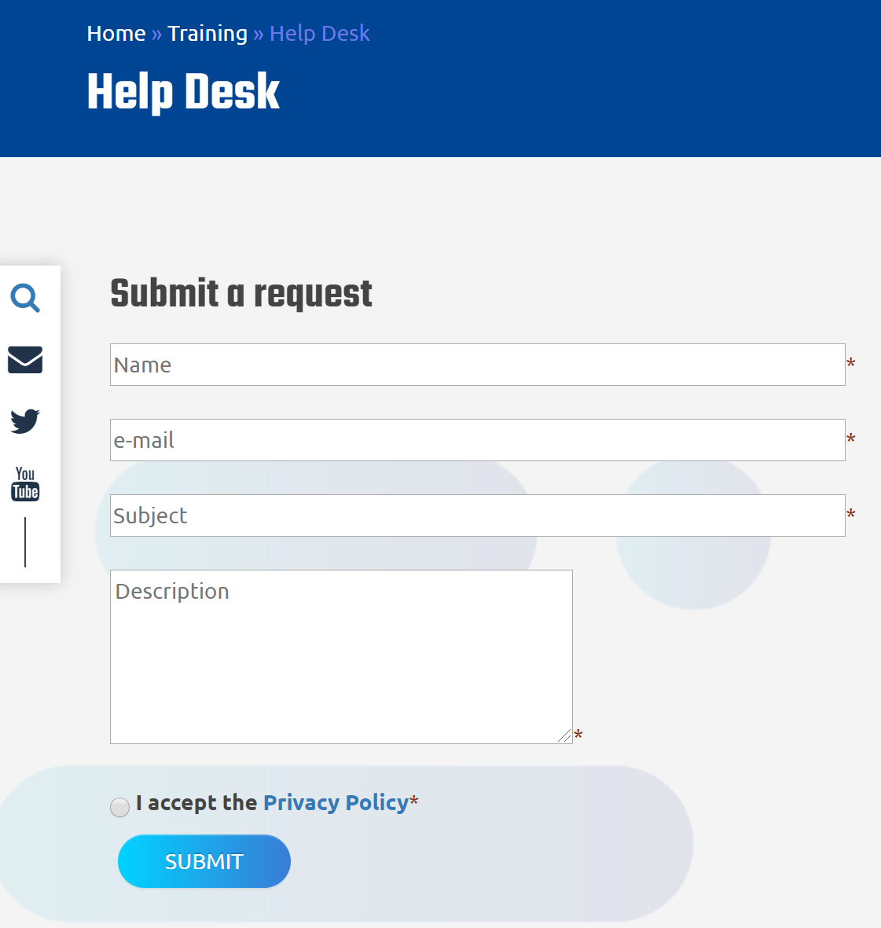
Figure 1. Simple web form to submit a request on the EOSC Portal Helpdesk from the EOSC Portal.
- The Order Management system for the EOSC Portal (SOMBO): this component enables flexible order management and supports automatic order propagation towards service providers. Status of the orders is reported back to the customer and can be seen in the user space area of the EOSC Portal.
- Monitoring: a pilot integration with the ARGO Monitoring Service has been completed. Thanks to this integration, it is possible to check the validity of the services onboarded in the portal and identify "dead" services. Through a public dashboard, portal operators, customers and providers can now check the health status of a service and get information about its stability (availability and reliability) in a given period of time.

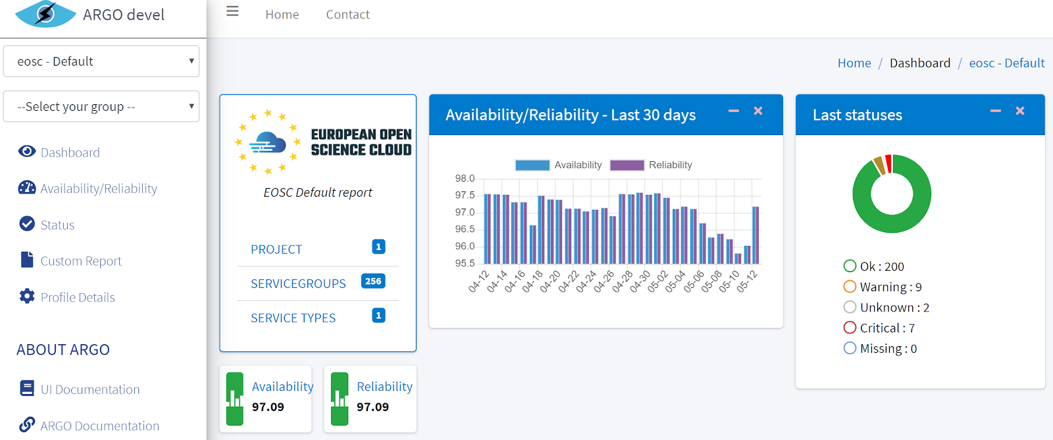
Figure 2. Dashboard to monitor the endpoints of the services published in the EOSC Portal.
EOSC-hub is continuing to devote effort to enrich the EOSC Portal enhancing the current components and designing new ones to enable new features and enrich the user experiences.
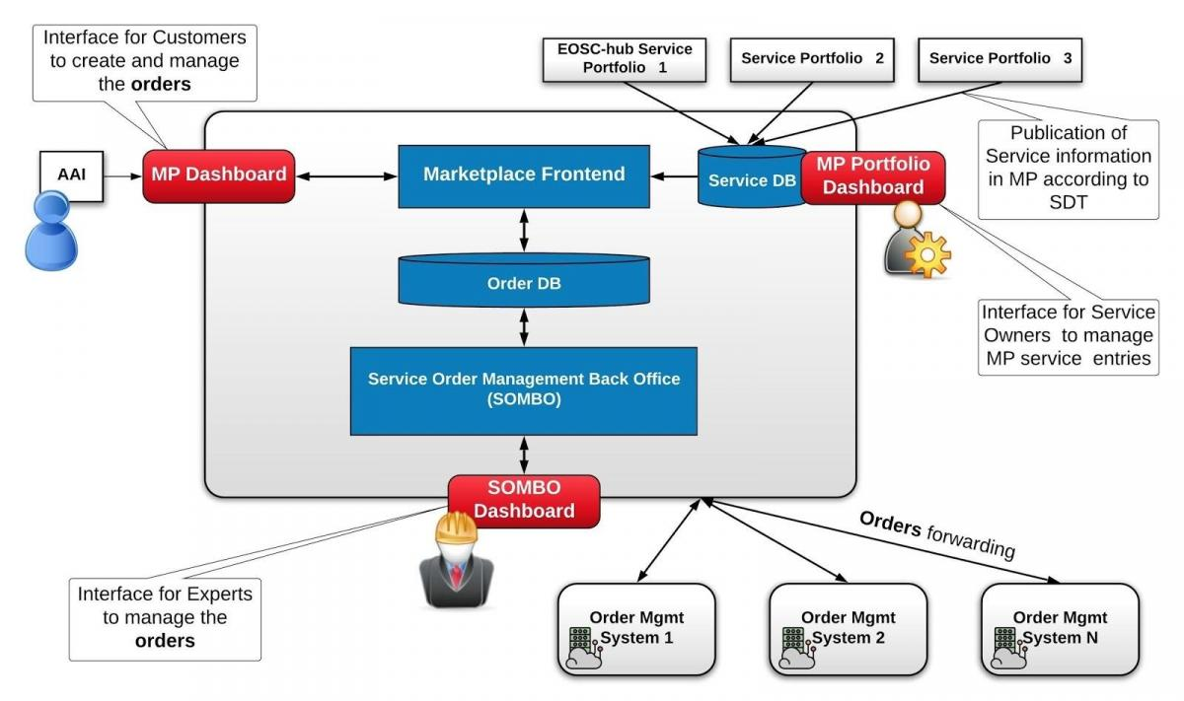
Figure 3. Architecture of the order management system of the EOSC Porta (SOMBO).
The roadmap of the third year of the project foresees the integration in the portal of the following tools:
- EOSC Portal metrics dashboard: a dashboard to monitor the usage of the portal that provides information on services and providers (number of offered services and providers, requests for new services, service orders, new communities involved, etc.) and views/visitors (number of visitors of Portal and Marketplace, visitors country distribution, page views, number of unique users making an order, etc.).
- Accounting: it will gather information about the usage of the computing and storage resources (e.g. number of CPU hours) involved in experiments supported by EOSC services.
- Enhanced Monitoring: will provide more accurate information about the status of the EOSC services.

Processes
Furthermore, as part of the EOSC Service Management System (SMS), EOSC-hub designed, developed and is operating processes that enable:
- Service onboarding in EOSC: the number of services in the EOSC service catalogue is progressively increasing thanks to the onboarding process setup and operated by EOSC-hub. Each European service provider can decide to onboard its services in the catalogue following the instructions available in the EOSC Portal. Around other 50 services are being reviewed and will be published in the next weeks. Furthermore, EOSC-hub developed an Integration handbook for service providers to assist service providers in choosing the preferred approach when onboarding into EOSC through EOSC-hub.
- Incident and service requests management: to restore normal / agreed service operation within the agreed time after the occurrence of an incident, and to respond to user service requests. Support units have been established to manage incidents and requests for EOSC core services (Portal, Catalogue & Marketplace, AAI, etc) while those related to services onboarded in the EOSC Portal are automatically notified to the respective service provider.
- Order management and Customer Relationship: this process establishes and maintains good relationships with customers. It acts as first contact point for services requests coming from the EOSC Portal & Marketplace, efficiently processes the requests for services and oversees their fulfillment after the orders have been forwarded to the corresponding services providers or to the EOSC technical support (in case of request for development/integration).
- Technical support: it is triggered by the order management process when a customer requires support on identifying the EOSC services needed to satisfy his/her needs or the combined usage of two or more EOSC services. Technical experts work with the customer to define the best integration solution for his/her case and provide support until the customer service is properly integrated in EOSC.
A number of other processes have been defined in the SMS to properly operate the EOSC according to the FitSM standard, for example the Service Level Management (SLM), the Capacity Management (CAPM), the Information Security Management (ISM) and the Change Management (CHM).

Operations
The EOSC Portal is deployed in the computing center of one of the EOSC-hub partners (CYFRONET) and all its components are operated by EOSC-hub partners.

EOSC Service Integration and Composability
EOSC-hub is actively working on fostering service integration and composability in EOSC.
The project is implementing a twofold approach to achieve this aim:
- Define an overall framework (a reference technical architecture for EOSC) to facilitate service integration and composability leveraging the definition of interoperability guidelines.
- Integrate driving use cases from ESFRI, relevant scientific communities, SMEs and industries into EOSC.

EOSC Technical Architecture and interoperability guidelines
EOSC-hub designed a reference Technical Architecture for EOSC that facilitates access to services, lower barriers to integrate and composes services and promotes the usage of services between adjacent communities. This is achieved by identifying key technical functions, named building blocks, and defining related technical specifications that include a high-level architecture, suggested EOSC standards and APIs and interoperability guidelines.
In this way, EOSC ‘compliant’ services will offer well-established and documented interfaces for usage and integration, based on well-known standard or APIs, facilitating:
- the exploitation of EOSC services from user communities willing to create new scientific services that could rely on well-established and documented interfaces for the integration. An example of exploitation of EOSC services is when a community creates a new scientific workflow re-using EOSC federation and common services, like AAI, accounting, Cloud orchestrator and/or data management solutions.
- the combined usage of EOSC services, indeed the adoption of well-known standards and interfaces will very likely reduce the cost to integrate services. For example, two accounting infrastructures can be made easily interoperable if they use the same standard usage record format, in such case accounting data extracted from them can be merged and presented in a unique view. Another example is about data processing and data management services implementing compliant interfaces that enable a joint usage by thematic services.
As a consequence, less mature or small scientific communities can leverage on EOSC services for a series of IT functions and focus on their scientific work, access to scientific services will be open to new communities thanks to the documented interfaces and new scientific workflows can be created combining existing applications.
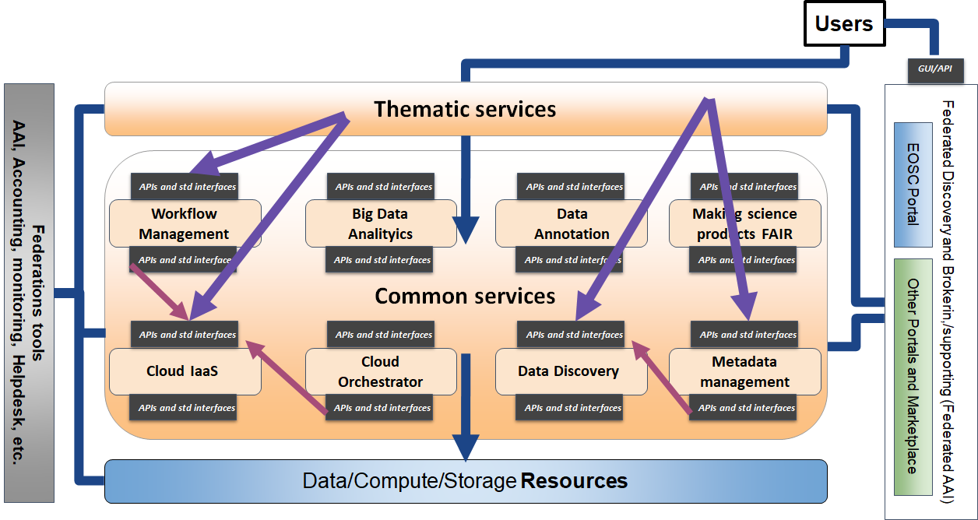
Figure 4. EOSC Technical Architecture. Functional view.
The proposed technical architecture for EOSC was firstly presented through a webinar in the summer 2019 attended by around 50 researchers, then a survey was launched to collect feedback from key stakeholders. 7 full answers were received from ERICs, clusters and regional projects, national organisations and e-infrastructures with positive feedback on the approach and a general interest in contributing on the definition of the interoperability guidelines. The work was also presented at the EOSC Symposium where the audience expressed big interest in the approach.
13 interoperability guidelines have been currently defined by the EOSC-hub Technology Committee and others are being prepared. All the guidelines will go through a feedback collection process in the wider EOSC collaboration. Currently, a survey is open to collect feedback on 3 key specifications on three services candidates for inclusion in the future EOSC core: Helpdesk, Accounting and Monitoring.

Driving use cases

Thematic services
The EOSC-hub service portfolio includes 39 research-oriented services grouped in 9 thematic areas: CLARIN, DODAS, ECAS/ENES, GEOSS, OPENCoastS, WeNMR, EO Pillar, DARIAH, LifeWatch. 30 of these services have been integrated in EOSC and are now available to the European researchers through the EOSC Portal, integration of the remaining 9 services will be completed by the end of the project.
Before being published in the portal, these research oriented services have been integrated with several EOSC-hub services (delivered by EGI, EUDAT and INDIGO) to implement essential features like the AAI and the monitoring and to re-use services supporting the whole data lifecycle from creation to processing, analysis, preservation, access and reuse. Examples of these services are cloud orchestrators, workflow engines, workload managers, data catalogues and repositories, etc.
Overall, the research-oriented services delivered by EOSC-hub successfully achieved 40 integrations with 19 different services. Some integrations covered multiple services, for example the integration of the EGI Workload Manager with WeNMR enabled the usage of this service in the 7 biological tools offered by the WeNMR suite. The integration process is continuing facilitated by the interoperability guidelines being delivered by the Technology Committee of the project.
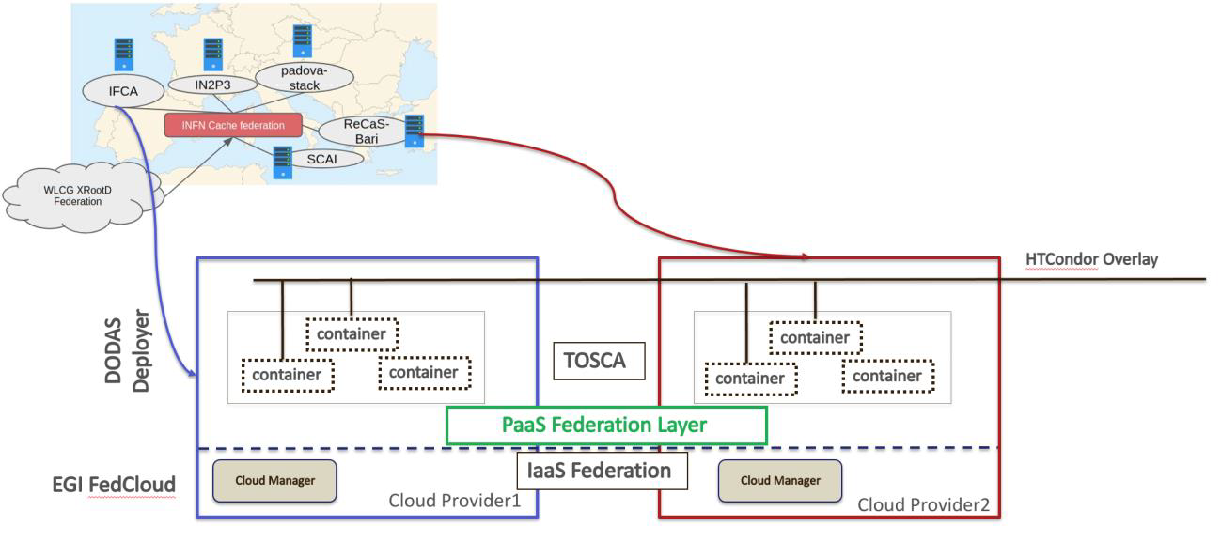
Figure 5. DODAS integration with the EGI Federated Cloud.
The publication of the services in the EOSC Portal promoted their uptake as demonstrated by key metrics. Some examples are the number of monthly visits to metadata search portal for CLARIN service (647 with a baseline value of 425, an increase of the 52%), the number of large communities adopting DODAS (4 - CMS, AMS, Virgo, Fermi - only CMS was using DODAS at the start of the project) and the number of newly registered users per period in the WeNMR portal (3844 with a baseline of 1750, an increase of the 120%). One of the thematic services, OPENCoastS (see figure 6 and 7), moved from a national to a European scope thanks to EOSC-hub and now can count 114 international deployments (baseline value was 0).

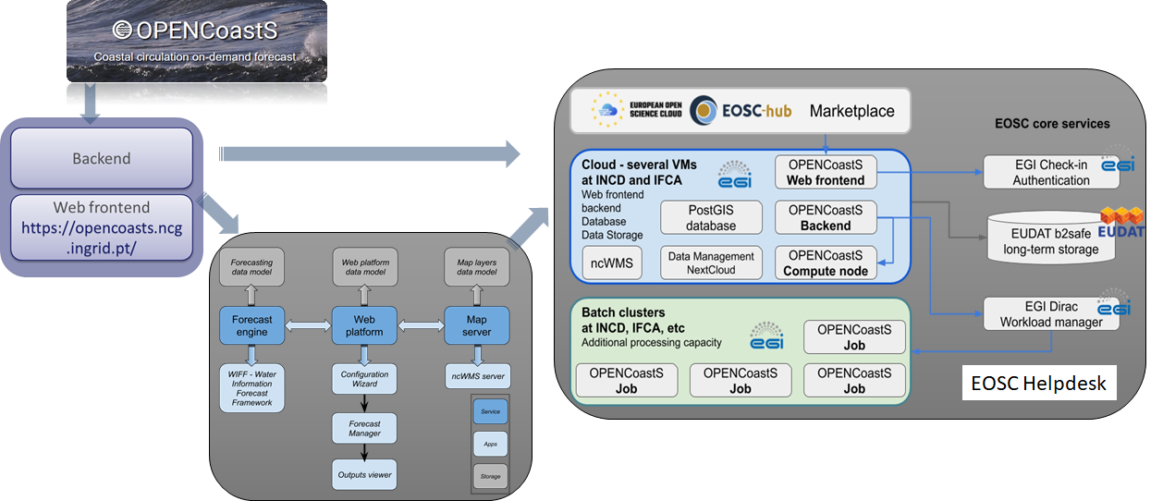
Figure 6. OPENCoastS architecture with highlighted the integrations with e-infrastructure services.
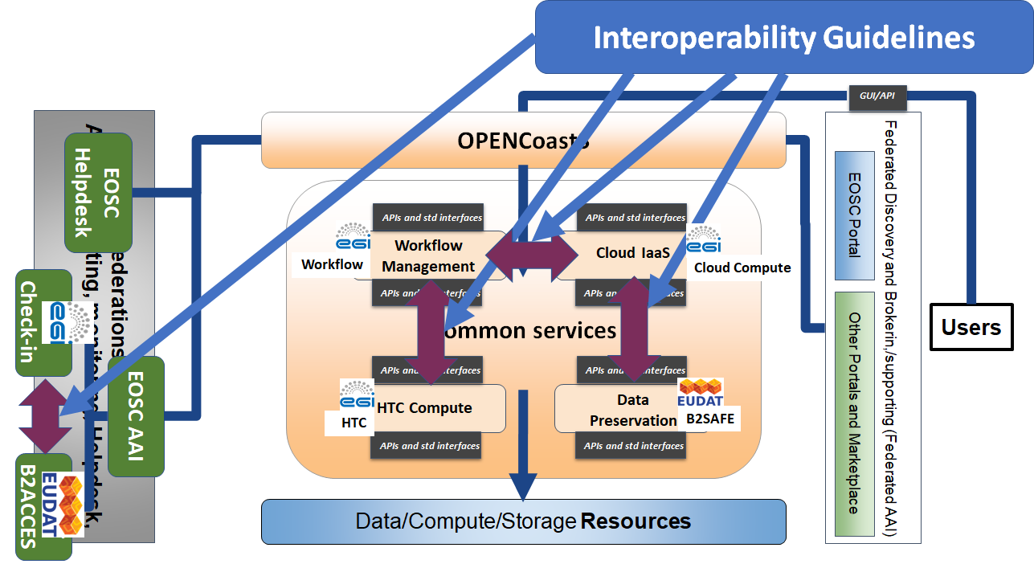
Figure 7. Mapping the OPENCoastS architecture to the EOSC Technical Architecture. Arrows in purple show the interactions between e-infrastructure services facilitated by the interoperability guidelines.
Finally, it is important to mention that the WeNMR portal has seen an increase of registrations (around 1500 new users) over the last weeks with many users indicating they intend to use it for COVID-19 projects. The HADDOCK WeNMR team is already involved in several collaborations ranging from drug screening against the protease to modelling COVID-19 related protein-protein interactions. For this purpose, together with EGI/EOSC experts, the team is looking both into expanding the processing capacity of the HADDOCK portals and providing customized solutions to support researchers.
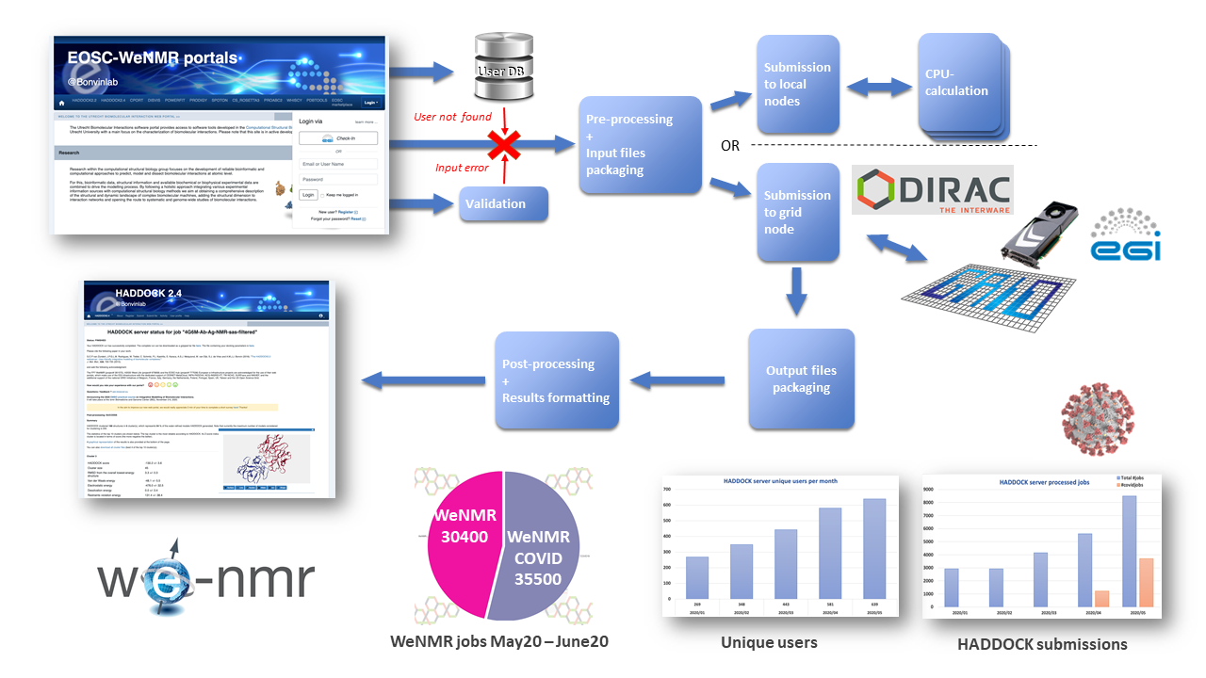
Figure 8. The WeNMR portal and HADDOCK , with its background machinery integrating various EOSC services. The bar and pie plots at the bottom report usage statistic, also highlighting the fraction of COVID-related submissions.

Competence Centers
The project includes eight Competence Centers (CCs) that work on establishing infrastructures to support users cope with the data deluge, with the challenges of various compute intensive data analysis scenarios. Each CC operates as a project on its own, with a small consortium composed of representative institutes from the Research Infrastructures, experts of relevant e-infrastructure services, and software/technology developers. CCs expect to bring scalable setups for ELIXIR, Fusion (ITER), Argo, SeaDataNet, EISCAT_3D, EPOS-ORFEUS, LOFAR and SKA, ICOS, eLTER and Disaster Mitigation communities. The overall objective of the CCs is to co-design and co-develop services for these communities by mobilising generic services from the EOSC Hub service portfolio.
All the 8 CCs successfully piloted EOSC-hub services and 19 services from the EOSC-hub catalogue successfully passed the CC assessment and were integrated with the community services. Integration was completed for other 6 services that are being assessed by the communities while other 15 services are planned to be integrated by the end of the project.
The following picture shows the status of the service assessment for all the CCs according to this colour classification:
- Green: technology is integrated and positively evaluated by users.
- Blu: technology is integrated but user assessment is yet to finish.
- Yellow: integration is ongoing.
- Grey: technology/service is considered for adoption, but the integration and assessment work is yet to start.
- Red: technology was assessed and was found unsuitable.
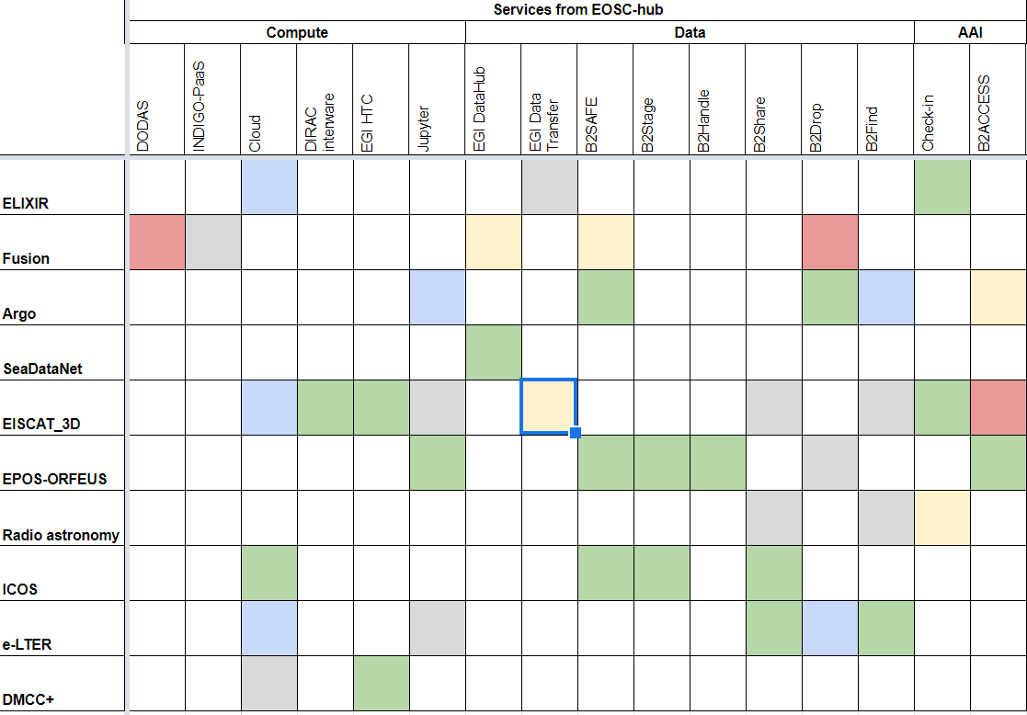
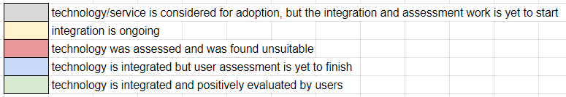
Figure 9. Status of the service assessment for all the CCs.
Piloting of the technologies will continue until the end of the project and the number of EOSC-hub services that will be adopted by the CCs is expected to increase.
While most of the CCs aim to reach prototype and pilot setup with their community-specific services, some aim for production service level and making those services available for access via the EOSC Portal. In particular:
- The Fusion CC reached an initial version of their PROMINENCE service for the EOSC Portal launch event (Nov 2018), registered PROMINENCE in the EOSC Portal and now updating it with additional delivery options.
- The Marine CC aimed to reach a mature-enough ARGO data platform for EOSC by month 18. The service is in the EOSC Portal Marketplace since November 2019.
- The EISCAT_3D CC aimed to reach a mature-enough EISCAT_3D Portal for EOSC and is in the EOSC Portal onboarding pipeline at the moment.
- The Disaster Mitigation CC reached a production version of their tsunami simulation portal and applied for registration in the EOSC Portal. It is in the onboarding pipeline at the moment.
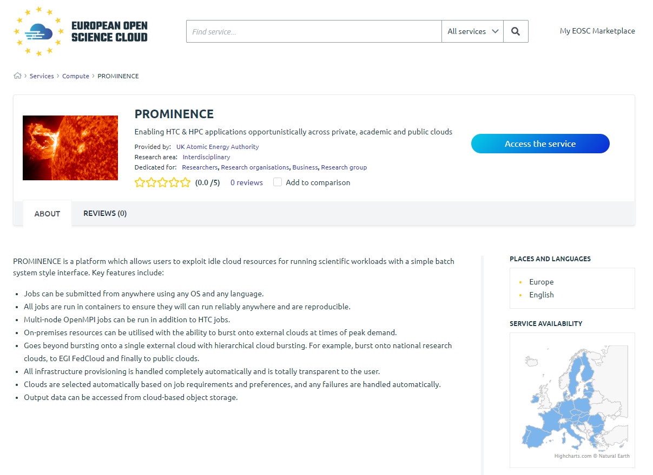
Figure 10. The PROMINENCE service from the Fusion competence center in the EOSC Portal.

EOSC Early Adopter Programme
The EOSC-hub project has launched an EOSC Early Adopter Programme (EAP) for research communities interested in exploring the latest state-of-art technologies and services offered by the European Open Science Cloud (EOSC).
The Early Adopter Programme is allowing research communities to scale up the in-house infrastructure and to access a richer set of resources. EOSC-hub is providing expertise and resources to enable active usage of the EOSC and foster a culture of co-operation between researchers and EOSC providers.
The programme offers a wide range of services from EOSC-hub, its partners, namely OCRE, OpenAIRE and GÉANT, and other providers that published their services in the EOSC Portal and Marketplace for:
- Data discovery and reuse
- Data processing and analysis
- Data management, curation and preservation
- Access, deposition and sharing, federated authentication and authorization.
As result of 2 calls, 13 pilots were selected with 75 planned integrations with services from EOSC-hub and its partners. All the pilots will run until the end of the project and, as part of their work plan, they will publish their services in the EOSC Portal and will work on the sustainability aspects looking for long-term agreements with the providers to continue the collaboration within EOSC after the end of the projects.
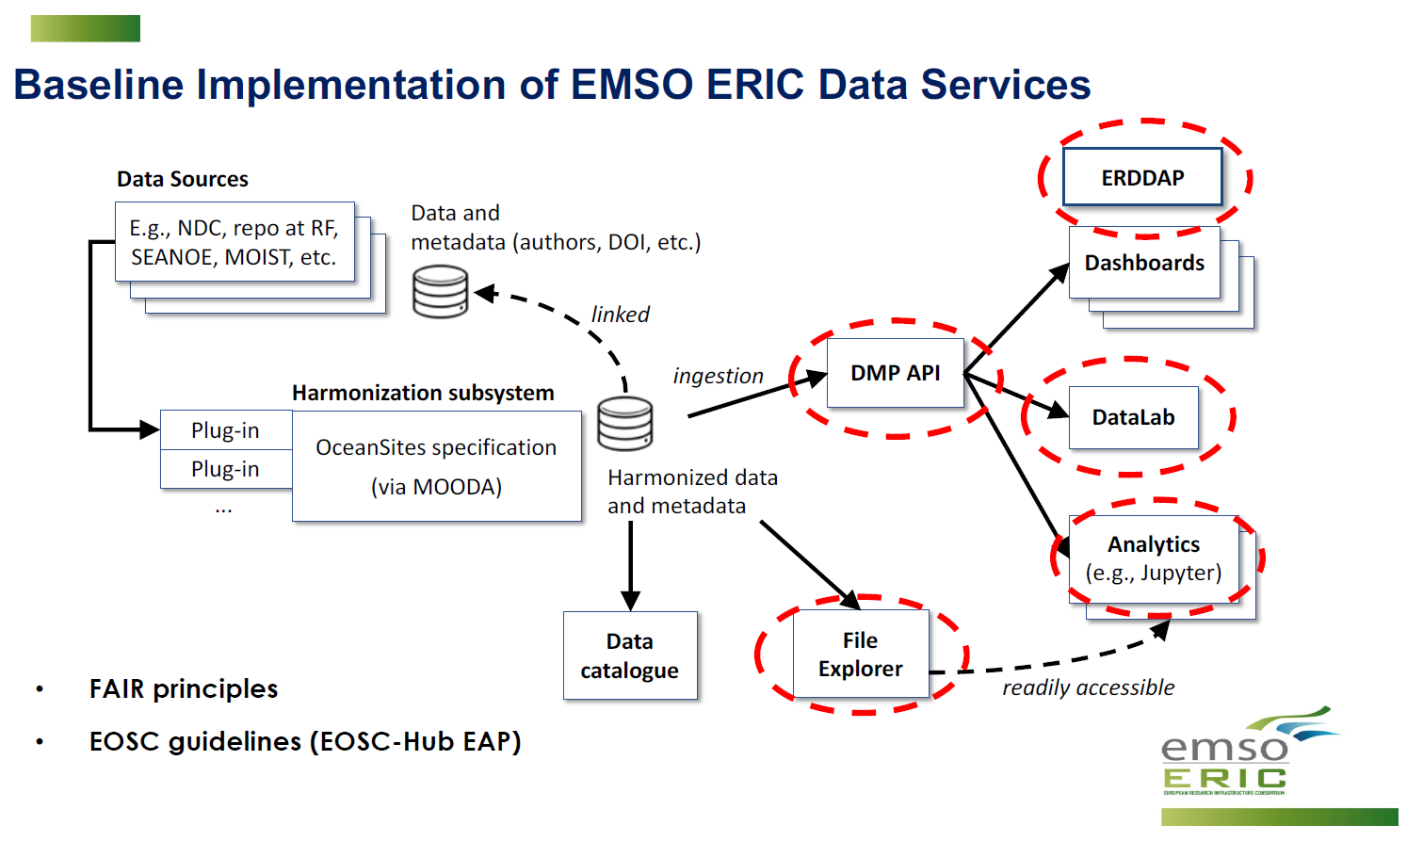
Figure 11. Architecture of the EMSO ERIC data management services deployed in the EGI Federated Cloud.
The following table lists and shortly describes the 13 EAP pilots.
More information on the current status of the pilots is available in the EOSC Early Adopter Programme booklet.

Pilot | Institution | Scientific area
Towards an e-infrastructure for plant phenotyping | INRA (France) | Plants and agriculture
Mapping the sensitivity of mitigation scenarios to societal choices | IIASA (Austria) | Earth and related Environmental sciences, Economics and Business
STARS4ALL | STARS4ALL Foundation | Light Pollution
Transitioning EMSO ERIC Data Management Platform to production | EMSO ERIC | Earth Sciences
Big Data Analytics for agricultural monitoring using Copernicus Sentinels and EU open data sets | European Commission, Joint Research Centre | Earth and Environmental Sciences, Agriculture
Supporting FAIR data discoverability in clinical research: providing a global metadata repository (MDR) of clinical study object | ECRIN (France) | Health Sciences
Open AiiDA lab platform for cloud computing in Materials Science | EPFL (Switzerland) | Physical sciences, Chemical sciences, Materials engineering
VESPA-Cloud | OBSPM (France) | Astronomy
OpenBioMaps data management service for biological sciences and biodiversity conservation | UNIDEB (Hungary) | Biology, conservation biology, ecology, biodiversity
AGINFRA+: Virtual Research Environments to Support Agriculture and Food Research Communities | CNR (Italy) | Agricultural sciences
EOSC DevOps framework and virtual infrastructure for ENVRI-FAIR common FAIR data services | ENVRI-FAIR Cluster project | Earth and related Environmental sciences
Integration of toxicology and risk assessment services into the EOSC marketplace | Edelweiss Connect GmbH (Switzerland) | Bioinformatics
Towards a Global Federated Framework For Open Science Cloud: Three Use Cases | AASCTC (Saudi Arabia) & CNIC-CNAS (China) | Several areas

Business pilots
The EOSC Digital Innovation Hub (DIH) is a mechanism for private companies to collaborate with public sector institutions in order to access technical services, research data, and human capital. There is a network of Digital Innovation Hubs in place across Europe, already supporting sectors such as manufacturing, internet of things, cybersecurity or cognitive computing. The EOSC DIH will add to the network by bringing private companies into the European Open Science Cloud through concrete business cases.
The EOSC DIH builds on individual public e-Infrastructures business engagement programmes and outreach activities in place for several years. The added value brought through a joint effort is in packaging a wider variety of services and expertise into a more coherent offer that would otherwise have to be accessed individually or compiled on their own. Services available to industry include, but are not limited to, access to e-Infrastructure resources; wealth of data produced by the research community; expertise and support; coaching and training; and visibility on a European and international scale, amongst others.
The EOSC DIH initially ran 6 business pilots (for a period of 12-18 Months) that were preselected during the project preparation phase (as a result of the open call procedure for the best pilots, out of 30 high-quality applications). All of the pilots have performed successfully the phases of requirements identification, design of the architecture, including the definition of the integration with EOSC-hub services, and implementation tasks. At the beginning of 2019 (January-April), after 12 months, pilots opened the releases for validation by early adopters, collecting documented feedback that helped further improve the services.
The initial 6 performed pilots achieved 14 integrations with EOSC-hub services and the new 5 pilots have been defined on the later stage with 7 integrations. A description is available below.

Initial pilots
Business Pilot 1: CyberHAB (Water body management sector) focusing on the management of harmful algae blooms, exploiting Data Cloud Services (DCS) to support the key processes required (data processing, modelling, integration of images).
Service integrated: EGI Cloud Compute, INDIGO IAM, EGI DataHub, PaaS Orchestrator.

Business Pilot 2: Sports Smart Video Analysis (Sports sector) that have developed a mobile-friendly cloud platform, provided as a SaaS, for data-driven video analysis and automatic processing of videos of athletes’ training sessions.
Service integrated: EGI Cloud Compute.

Business Pilot 3: ACTION Seaport (Local coastal authorities) ACTION Seaport is an advanced mobile-friendly platform providing accurate, capable of serving simultaneously multiple Port Authorities - as well as coastguards and other maritime authorities worldwide– in decision support to improve safety, environmental and operational performance.
Service integrated: EGI Cloud Compute.

Business Pilot 4: Bot Mitigation Engine (Cybersecurity sector) that created a solution, called Guardonic, for online service providers in the business sector to prevent online services from botnet attacks such as web scraping, online fraud, digital ad fraud and spam. It behaves as a filter between global networks and a client’s online services independent of where they are running.
Service integrated: PSNC Openstack cloud-based infrastructure.

Business Pilot 5: Space Weather Data Services for the future DRACO Observatory (Climate sector) developed a cloud-based framework for handling of the DRACO observatory data
Service integrated: EGI Cloud Container Compute, HPC computing, intensive workloads, high throughput, large databases and application server.

Business Pilot 6: Furniture Enterprise Analytics - DataFurn (Furniture industry sector) developed a furniture analytics Platform-as-a-Service that collects, analyses and visualises online content (from social media and blogs to online portals), detects useful product-related content, extracts relevant furniture product-service topics/features, monitors brand influence and customer interactions and early predicts furniture trends for the upcoming seasons (e.g. regarding colours or textiles).
Service integrated: EGI Cloud Compute.

Pilots onboarded during the project
In addition, 5 new pilots have been defined, where 4 of them are still ongoing, next 7 integrations have been achieved with EOSC-hub services.
Business Pilot 7: Kampal - Artificial Intelligence for rare disease diagnosis: Assessing the probability of development of further diseases in Gaucher disease patients (finished)
Service integrated: EGI Cloud Compute

Business Pilot 8: BI Insight - Business Intelligence, Artificial Intelligence and Big Data technologies - Access the knowledge contained in artefacts: presentations, text documents, sheets and others.
Service integrated: EGI Cloud Compute, to be integrated: DEEP ML/DL services

Business Pilot 9: BBC R&D - video coding and compression - Transforming video content through compression and large-scale processing
Service integrated: PSNC HPC infrastructure

Business Pilot 10: DCP - dynamic resource allocation and accounting in a digital marketplace - Automating resource allocation and multi-metric accounting in a federated digital marketplace
Service integrated: EGI Cloud Compute

Business Pilot 11: NetService - Blockchain for university certificates Enabling public institutions to issue valid official documents in a digital form on the blockchain.
Service integrated: EGI Check-in, EGI Cloud Compute

FitSM web-site: https://www.fitsm.eu/
EOSC-hub D13.2 Periodical assessment of the services: https://documents.egi.eu/public/ShowDocument?docid=3501
WeNMR HADDOCK service in the EOSC Portal: https://marketplace.eosc-portal.eu/services/haddock
EOSC Portal Concept paper and EOSC Portal Collaboration Agreement: https://wiki.eosc-hub.eu/display/EOSC/EOSC+Portal
A Collaboration Agreement between EOSC-hub and EOSC-Enhance will be finalised in the coming weeks.
EOSC Portal web-site: https://www.eosc-portal.eu/
AARC Blueprint Architecture 2019: https://zenodo.org/record/3672785/files/AARC-G045-AARC_BPA_2019-Final.pdf
EOSC Service Catalogue & Marketplace: https://marketplace.eosc-portal.eu/
EOSC Portal Helpdesk: https://www.eosc-portal.eu/helpdesk
EOSC Order Management system: https://www.eosc-portal.eu/news/sombo-order-management-system-eosc-portal-now-production
EOSC Portal monitoring dashboard: https://eosc.ui.devel.argo.grnet.gr/
ARGO Monitoring service: http://argoeu.github.io/index.html
EOSC SMS: https://www.eosc-hub.eu/eosc-hub-key-exploitable-results/#KER2
EOSC service portfolio: https://www.eosc-hub.eu/eosc-hub-key-exploitable-results/#KER5
Instruction to onboard services in the EOSC Portal service catalogue and marketplace: https://www.eosc-portal.eu/for-providers
EOSC-hub Integration handbook for service providers: https://documents.egi.eu/document/3603
EOSC Interoperability and Integration guidelines: https://www.eosc-hub.eu/eosc-hub-key-exploitable-results/#KER8
EOSC-hub webinar - An EOSC-hub proposal for the EOSC technical architecture: https://www.eosc-hub.eu/events/eosc-hub-proposal-eosc-technical-architecture
ESS (ERIC), PANOSC (Cluster), CESSDA (ERIC) & SSHOC (Cluster), NI4OS (EOSC Reg. project), EOSC-Synergy (EOSC Reg. project), SurfSARA (National organization), OpenAIRE (e-infrastructure).
EOSC Technical Architecture presentation in “Impact of Requirements of FAIR on Technical Architecture” session at the EOSC Symposium 2019: https://www.eoscsecretariat.eu/eosc-symposium2019/impact-fair-technical-architecture
EOSC-hub D10.4 - EOSC Hub technical architecture and standards roadmap: https://www.eosc-hub.eu/deliverable/d104-eosc-hub-technical-architecture-and-standards-roadmap
Feedback collection on the EOSC-hub proposals for technical specifications of Helpdesk, Accounting and Monitoring: https://www.eosc-hub.eu/news/have-your-say-eosc-hub-proposals-technical-specifications-helpdesk-accounting-and-monitoring
Proposal for EOSC Helpdesk technical specification: https://wiki.eosc-hub.eu/display/EOSCDOC/Helpdesk
Proposal for EOSC Accounting technical specification: https://wiki.eosc-hub.eu/display/EOSCDOC/Accounting
Proposal for EOSC Monitoring technical specification: https://wiki.eosc-hub.eu/display/EOSCDOC/Monitoring
EOSC Early Adopter Programme booklet: https://www.eosc-hub.eu/sites/default/files/Booklet_Early_Adopter_Programme.pdf
EOSC Digital Innovation Hub (DIH) website: https://eosc-dih.eu/

