D2.9 - A Service Provider's Reference Cards to Data Sharing Policies
Lead Partner: | DANS
Version: | 1
Status: | FINAL
Dissemination Level: | Public
Document Link: | https://documents.egi.eu/document/3644

Deliverable Abstract
Building on current best practice, notably the EOSCpilot policy recommendations and the EC Expert Group report on FAIR data, the EOSC-hub deliverable report D2.8 recommends 22 practical steps bridging general policy recommendations and future technical implementation of data sharing within the EOSC-hub service ecosystem. With this deliverable, we have translated those recommendations into practical Why-, What-, and How-reference cards that aid data and service providers in that EOSC-hub service ecosystem with the implementation of data sharing policies.

COPYRIGHT NOTICE
This work by Parties of the EOSC-hub Consortium is licensed under a Creative Commons Attribution 4.0 International License (http://creativecommons.org/licenses/by/4.0/). The EOSC-hub project is co-funded by the European Union Horizon 2020 programme under grant number 777536.
DELIVERY SLIP
Date | Name | Partner/Activity | Date
From: | Frans Huigen, Ilona von Stein | DANS/WP2 | 29/05/2020
Moderated by: | Malgorzata Krakowian | EGI Foundation
Reviewed by: | Alex Vermeulen  Mark van de Sanden  Gergely Sipos | ICOS/Thematic Service Provider  point of view  EUDAT/Data Infrastructure  Services point of view  EGI/WP8
Approved by: | AMB

DOCUMENT LOG
Issue | Date | Comment | Author
V0.1 | 29/04/2020 | First reference card structuring proposal, on which working group members provided feedback. | F Huigen, I von Stein, M Wittenberg (DANS); R Baxter (EPCC); J Nordling (CSC); C Ohmann & M Matei (ECRIN); A Manzi  (EGI.eu)
V0.2 | 14/05/2020 | Feedback incorporated:  - added document log, copyright notice, tables of concepts and acronyms, and contents overview  - altered reference cards order and structuring  - additional content and references | F Huigen, I von Stein
V0.3 | 15/05/2020 | Delivered first draft for layout and design to TRUST-IT (R  Carrillo) | F Huigen
V0.4 | 26/05/2020 | First version of the visuals and layout, minor initial comments incorporated. | F Huigen; R Carrillo & G  Savini (TRUST-IT)
V0.5 | 26/05/2020 | Second version of layout and design of the reference cards (section two of this deliverable) received comments by work group members. | I von Stein; A Manzi; T Wildish (EMBL-EBI); J  Nordling; C Ohmann
V0.6 | 28/05/2020 | Added a third section on next steps to deliverable. | F Huigen, I von Stein
V0.7 | 28/05/2020 | Design and content iterations done to the reference cards by  TRUST-IT. | R Carillo & G Savini
V0.8 | 29/05/2020 | Wrote abstract. Further detailing - preparing final draft. | F Huigen
V0.9 | 29/05/2020 | Full draft ready, but without the reference cards. They are in a  separate pdf (delivered by TRUST-IT). | F Huigen, I von Stein
V0.10 | 29/05/2020 | Merged final design version of the reference cards with this deliverable full draft into one PDF.  Final v1.0 D2.9 ready for internal review. | F Huigen, I von Stein
V1 | 29/07/2020 | Final version after external review | F Huigen, I von Stein

TERMINOLOGY
https://wiki.eosc-hub.eu/display/EOSC/EOSC-hub+Glossary
Terminology/Acronym | Definition
DataTags | A system of human-readable and machine-actionable labels that  express conditions under which datasets can be stored, transmitted, or used; https://techscience.org/a/2015101601/
DOI | Digital Object Identifier, a well-recognised form of PID (qv);  h ttp://www.doi.org/
FAIR principles | Principles of best practice in open research data management, an  acronym of Findability, Accessibility, Interoperability and Reusability; h ttps://www.force11.org/group/fairgroup/fairprinciples
FREYA | European project on PIDs (qv). https://www.project-freya.eu
GDPR | The General Data Protection Regulation came into force as of 28 May, 2018. It is a regulation valid for the whole of the European Union, concerning privacy and the protection of privacy and  personal data.
RDA (WG) | Research Data Alliance (Working Group)
PID | Persistent identifier, for example a DOI or accession number.
Sensitive data | Data which, for whatever reason, cannot be openly shared without  the risk of disclosure of legally or ethically sensitive information.

Contents
1 Introduction and Context 5
2 Service Provider’s Reference card to data sharing policies; Why 7
3 Service Provider’s Reference card to data sharing policies; What 8
4 Service Provider’s Reference card to data sharing policies; How 9
5 Next steps 10

Introduction and Context
Conveying policy recommendations in an attractive pragmatic way to the EOSC-hub data and service providers, that is the main objective of this deliverable. It leans on the First Policy Recommendations D2.8 report as published in December 2018 (Baxter et al., 20181). The First Policy Recommendations have been translated into hands-on guidance that we recommend being adopted by data and service providers within the EOSC-hub Consortium.
To start with, there are three major high-level recommendations that pertain to the whole of the EOSC-hub service ecosystem:
- Implement FAIR
- Build technical expertise in 'safe data' and 'safe settings'
- Support the wider development of ethical and information governance
By implementing these three major recommendations, data and service providers bridge gaps between general policy recommendations and future technical implementation of data sharing policies. To assists the providers engaged in the EOSC-hub Service Ecosystem as practically as possible, we mapped these major recommendations to three questions: 'Why?, What?, and How?'':
- "Why should [providers] care about implementing data sharing policies?" maps to the third recommendation: Support the wider development of ethical and information governance.
- "What are essential concepts that [service providers] should be aware of in the context of data sharing policies in the EOSC-hub ecosystem?" This question maps to the second recommendation: "Build technical expertise in 'safe data' and 'safe settings'".
- "How should providers of data and services go about a pragmatic approach to bridging the gap between future technical implementation and policy recommendations for data sharing?" This question maps to the first recommendation: implement FAIR data. As extension: sensitive and non-sensitive personal data are also taken into account.
Each of the three recommendations mentioned above have been split up into a total of twenty-two sub-recommendations. This enlarges the granularity of the recommendations. We maintain that granularity by providing reference to sources - international initiatives, concepts, outputs - that might be able to help the data and service providers answer the main three questions: why, what, and how. Each reference card, following this introductory section, handles its own question and underlying sub-recommendations.
We made a design choice to map and translate recommendations into practical reference handles that data and service providers, engaged in the EOSC-hub consortium, can immediately use to overcome challenges in policy implementation. We think the reference card form is suitable for this purpose because they can easily be distributed online and offline. For example, as stand-alone presentation slides, or as visually appealing
A5-formatted flyers during conferences or professional gatherings. On the next three pages you will subsequently find The Why, The What, and The How reference cards. They are designed in such a way, that they can be spread separately. Closing off this deliverable is a section on next steps.

Service Provider’s Reference card to data sharing policies; Why
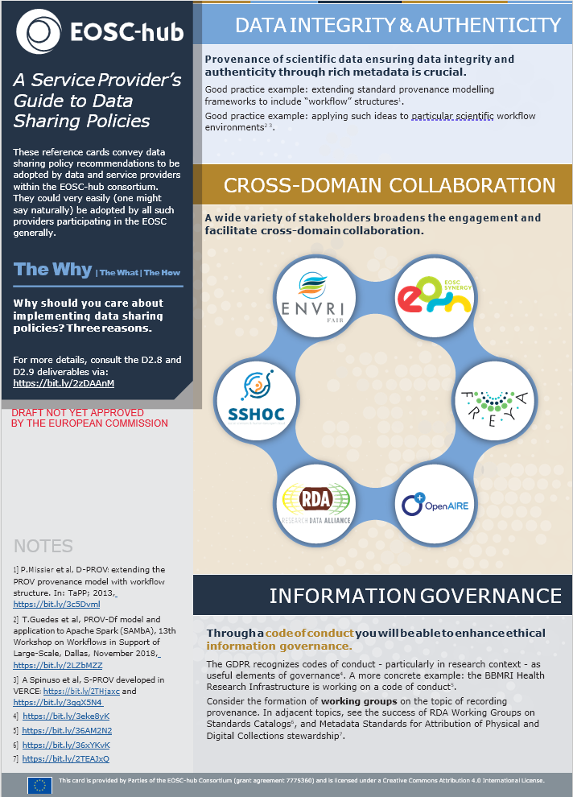

Service Provider’s Reference card to data sharing policies; What
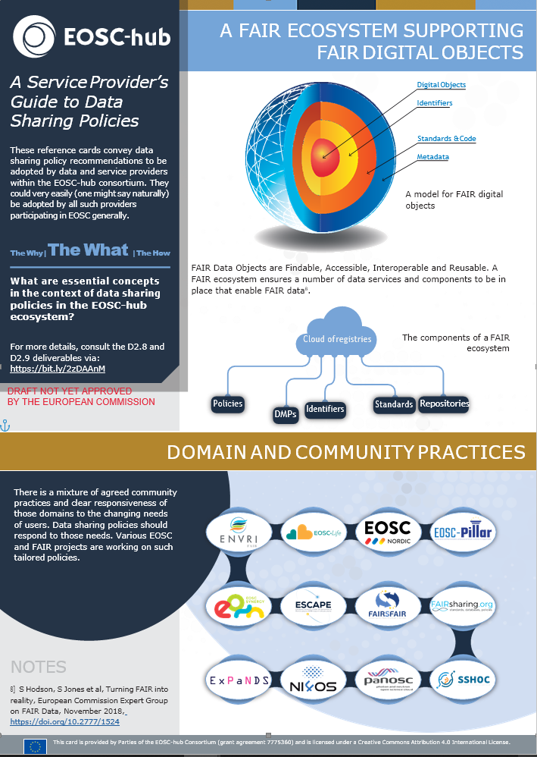

Service Provider’s Reference card to data sharing policies; How
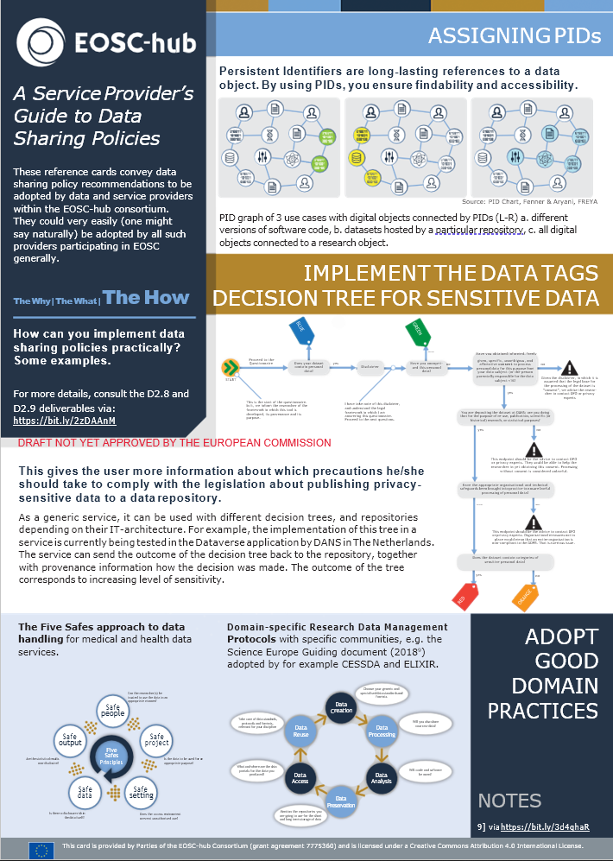

Next steps
The First Policy Recommendations (EOSC-hub D2.8) have been translated into three service provider’s reference cards. These cards (The Why, The What and The How) convey data sharing recommendations to be adopted by data and service providers within the EOSC-hub consortium. We suggest an online dissemination strategy for these cards, although they are also designed in such a way that they can be printed on paper. We will showcase the cards at a variety of EOSC and FAIR related (online) activities and events, providing appropriate visibility to all stakeholders. Also, further online dissemination (e.g. social media presence, webinars, video style interview) will be carried out to facilitate adoption and to obtain user feedback. Another possibility is to organize and roll-out an online focussed workshop. Details of the communication plan of these cards are to be worked out in accordance with EOSC-hub project governance and management.

https://documents.egi.eu/document/3419

