EGI-InSPIRE

Operational Level Agreements within
the EGI production infrastructure

EU MILESTONE: MS429

Document identifier: | EGI-MS429.docx
Date: | 10/06/2014
Activity: | SA1
Lead Partner: | EGI.eu
Document Status: | DRAFT
Dissemination Level: | PUBLIC
Document Link: | https://documents.egi.eu/document/XX

Abstract
MS429 describes the advancements made in PY4 with respect to EGI Operational Level Agreements for services provided by EGI.eu, RPs and RCs, the current status of performance reporting and the PY5 work plan.

Copyright notice
Copyright © Members of the EGI-InSPIRE Collaboration, 2010-2014. See www.egi.eu for details of the EGI-InSPIRE project and the collaboration. EGI-InSPIRE (“European Grid Initiative: Integrated Sustainable Pan-European Infrastructure for Researchers in Europe”) is a project co-funded by the European Commission as an Integrated Infrastructure Initiative within the 7th Framework Programme. EGI-InSPIRE began in May 2010 and will run for 4 years. This work is licensed under the Creative Commons Attribution-Noncommercial 3.0 License. To view a copy of this license, visit http://creativecommons.org/licenses/by-nc/3.0/ or send a letter to Creative Commons, 171 Second Street, Suite 300, San Francisco, California, 94105, and USA. The work must be attributed by attaching the following reference to the copied elements: “Copyright © Members of the EGI-InSPIRE Collaboration, 2010-2014. See www.egi.eu for details of the EGI-InSPIRE project and the collaboration”. Using this document in a way and/or for purposes not foreseen in the license, requires the prior written permission of the copyright holders. The information contained in this document represents the views of the copyright holders as of the date such views are published.
- Delivery Slip
 | Name | Partner/Activity | Date
From |  | EGI.eu
Reviewed by
Approved by | AMB & PMB
- Document Log
Issue | Date | Comment | Author/Partner
1 |  | V1.0 for external review | M.Krakowian
- Application area
This document is a formal deliverable for the European Commission, applicable to all members of the EGI-InSPIRE project, beneficiaries and Joint Research Unit members, as well as its collaborating projects.
- Document amendment procedure
Amendments, comments and suggestions should be sent to the authors. The procedures documented in the EGI-InSPIRE “Document Management Procedure” will be followed:
https://wiki.egi.eu/wiki/Procedures
- Terminology
A complete project glossary is provided at the following page: http://www.egi.eu/about/glossary/. Additional Operations specific terms are provided at the Operations glossary page: https://wiki.egi.eu/wiki/Glossary.

- PROJECT SUMMARY
To support science and innovation, a lasting operational model for e-Science is needed − both for coordinating the infrastructure and for delivering integrated services that cross national borders. The EGI-InSPIRE project will support the transition from a project-based system to a sustainable pan-European e-Infrastructure, by supporting ‘grids’ of high-performance computing (HPC) and high-throughput computing (HTC) resources. EGI-InSPIRE will also be ideally placed to integrate new Distributed Computing Infrastructures (DCIs) such as clouds, supercomputing networks and desktop grids, to benefit user communities within the European Research Area.
EGI-InSPIRE will collect user requirements and provide support for the current and potential new user communities, for example within the ESFRI projects. Additional support will also be given to the current heavy users of the infrastructure, such as high energy physics, computational chemistry and life sciences, as they move their critical services and tools from a centralised support model to one driven by their own individual communities.
The objectives of the project are:
- The continued operation and expansion of today’s production infrastructure by transitioning to a governance model and operational infrastructure that can be increasingly sustained outside of specific project funding.
- The continued support of researchers within Europe and their international collaborators that are using the current production infrastructure.
- The support for current heavy users of the infrastructure in earth science, astronomy and astrophysics, fusion, computational chemistry and materials science technology, life sciences and high energy physics as they move to sustainable support models for their own communities.
- Interfaces that expand access to new user communities including new potential heavy users of the infrastructure from the ESFRI projects.
- Mechanisms to integrate existing infrastructure providers in Europe and around the world into the production infrastructure, so as to provide transparent access to all authorised users.
- Establish processes and procedures to allow the integration of new DCI technologies (e.g. clouds, volunteer desktop grids) and heterogeneous resources (e.g. HTC and HPC) into a seamless production infrastructure as they mature and demonstrate value to the EGI community.
The EGI community is a federation of independent national and community resource providers, whose resources support specific research communities and international collaborators both within Europe and worldwide. EGI.eu, coordinator of EGI-InSPIRE, brings together partner institutions established within the community to provide a set of essential human and technical services that enable secure integrated access to distributed resources on behalf of the community. The production infrastructure supports Virtual Research Communities (VRCs) − structured international user communities − that are grouped into specific research domains. VRCs are formally represented within EGI at both a technical and strategic level.

- EXECUTIVE SUMMARY
Operational Level Agreements (OLAs) are defined in the Information Technology Infrastructure Library [ITIL] and describe how IT groups work together to meet IT service level requirements.
The purpose of an OLA is to optimize the delivery of IT services to customers and users. It is an internal agreement that defines how two different units within an organization will work together to support the delivery of a set of IT services to customers and users. The framework includes three OLAs: the Resource Centre OLA, the Resource infrastructure Provider OLA and the EGI.eu OLA.
During PY4 a set of improvements have been introduced in terms of monitoring and reporting. The main achievement is introduction of EGI.eu OLA [EGIOLA], an agreement between each of EGI core services and activities’ providers and EGI.eu to cover the provision and support of the services being part of Federated Operations EGI.eu service.
The service management processes and the OLA framework will further evolve in PY5 by:
- extending the reporting capabilities of the Operations Portal with RP service reports, EGI.eu service reports,
- implementing an improvement plan of the OLA framework and service management processes of EGI.eu to satisfy a set of requirements for federated infrastructures in compliance to ISO/IEC 20000,
- creation of SLA/OLA framework to supporting provisioning of agreed resources to the EGI users as a result of EGI Resource Allocation activity.

TABLE OF CONTENTS
1 Introduction 6
2 OLA framework 7
3 EGI.eu OLA 8
4 Service Level Targets 9
4.1 Targets 9
4.1.1 Resource Centres 9
4.1.2 Resource infrastructure Providers 9
4.1.3 EGI.eu 9
5 Reporting 13
5.1 RC OLA reporting 13
5.1.1 Extensions for GLOBUS, UNICORE, Desktop Grid and QCG 13
5.1.2 Extensions for Cloud Resources 13
5.2 RP OLA reporting 13
5.2.1 Extensions for all NGI core services 13
5.3 EGI.eu OLA reporting 13
6 Future Work 14
7 Conclusions 15
8 References 16

Introduction
EGI operation services are distributed and comprehend Global Services and Local Services [ARCH], where different stakeholders play the role of service provider to different groups of customers.
Crucial to EGI is the maximization of the Quality of Service provided by these services and experienced by an end-user. Services have to comply with a minimum set of requirements to jointly offer a reliable, secure and highly available service infrastructure. These requirements are defined by the OLA framework, which supports service management at various levels: Resource Centre (RC), Resource infrastructure Provider (RP) and EGI.eu. The framework is comprised of three agreements defining the minimum set of services and the corresponding minimum performance provided by Resource Centres, Resource infrastructure Providers (EIROs and NGIs) and EGI.eu.
- The Resource Centre OLA (RC OLA) [RCOLA]. This agreement is defined between a Resource Centre (RC) and the respective Resource infrastructure Provider (RP).
- The Resource infrastructure Provider OLA (RP OLA) [RPOLA]. This agreement is defined between a Resource infrastructure Provider (RP), its respective Resource Centres (RCs), and EGI.eu.
- The EGI.eu OLA (which is to be distinguished from the top level EGI OLA framework) [EGIOLA]. This agreement is defined between EGI Core services and activates providers and EGI.eu that are offered to the EGI partners and the RPs.
The milestone summarizes the advancements made in PY4 with respect to EGI Operational Level Agreements for services provided by EGI.eu, RPs and RCs, the current status of performance reporting and the PY5 work plan.
A more detailed overview of the EGI OLA framework is given in section 2. The description of the EGI.eu OLA is provided in Section 3. Section 4 provides an update on the current targets for Resource Centres and Resource infrastructure Provider services. The related reporting mechanisms are described in section 5. Section 6 presents the PY5 work plan, and Section 7 concludes the deliverable.

OLA framework
The OLA framework is the mechanism adopted within EGI in order to integrate resource providers into the pan-European production infrastructure while ensuring interoperation of operational services, Quality of Service, and to enforce a common set of policies and procedures.
The Quality of Service (i.e. as perceived by an end-user) and its maximization are of crucial importance from the EGI perspective. It is therefore important that the providers of services and resources within EGI commit to a minimum set of requirements to jointly offer a reliable, secure and highly available service infrastructure.
EGI OLA framework incorporates three types of OLAs (Figure 1):
- The Resource Centre OLA (RC OLA) [RCOLA]. This agreement is defined between a Resource Centre (RC) and the respective Resource infrastructure Provider (RP).
- The Resource infrastructure Provider OLA (RP OLA) [RPOLA]. This agreement is defined between a Resource infrastructure Provider (RP), its respective Resource Centres (RCs), and EGI.eu.
- The EGI.eu OLA (which is to be distinguished from the top level EGI OLA framework) [EGIOLA]. This agreement is defined between EGI Core services and activates providers and EGI.eu that are offered to the EGI partners and the RPs.
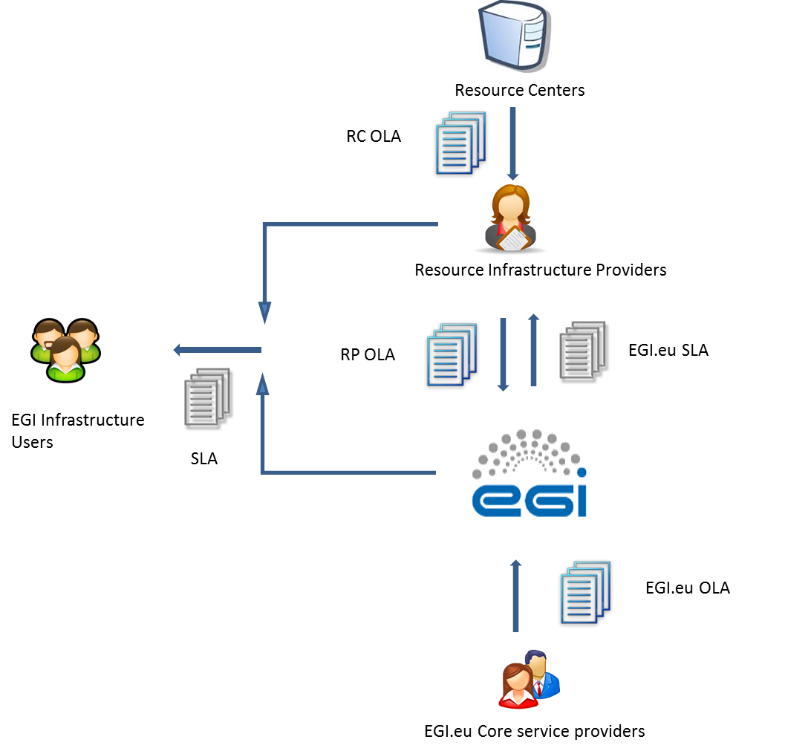
Figure 1. EGI OLA framework.

EGI.eu OLA

As a result of OLA framework review in collaboration with FedSM project [FSM] during PY4, EGI.eu OLA document [EGISLA] created during PY3 has been recognized as EGI.eu SLA between EGI.eu and Resource Infrastructure Providers. Therefore new EGI.eu OLA had to be created.
Newly created EGI.eu OLA [EGIOLA] is the agreement between each of EGI core services and activities’ providers and EGI.eu to cover the provision and support of the services being part of Federated Operations EGI.eu service. Federated Operations consist of operational tools, processes and people necessary to guarantee standard operation of heterogeneous infrastructures from multiple independent providers, with a lightweight central coordination. This includes, for example, the monitoring, accounting, configuration and other services required to federate service provision for access by multiple research communities. A federated environment is the key to uniform service and enables cost-efficient operations, while allowing resource centres to retain responsibility of local operations.
EGI core services and activities have being evaluated within the EGI Council for long-term strategic impact and decisions and potential sustainability models for what services and activities should be offered and funding models to support them. The EGI core services and activities provided by EGI.eu partners were re-bid in 2013. With all partners EGI.eu OLA has been agreed and signed covering each of the EGI core service and activities separately.
The documents defines such aspects as: scope, service hours, service components, support, service level targets, limitations and constrains, communication, reporting and escalation, additional responsibilities, customer responsibilities and review process.
The EGI core services and activities are:
- 1st & 2nd level support
- Acceptance criteria
- Accounting and Metrics Portal
- Accounting Repository
- Catch-all services
- Collaboration tools/IT support
- Incident management helpdesk (GGUS)
- Message Broker Network
- Monitoring Central Services
- Operations Portal
- Operations Support
- SAM central services
- Service registry (GOCDB)
- Security coordination
- Software Provisioning Infrastructure
- Security monitoring and related support tools
- Staged Rollout

Service Level Targets
EGI Service Level Management Support Unit (SLM) is responsible within the EGI Incident Management tool (GGUS) for ensuring that all IT Service Management Processes, Operational Level Agreements etc. are appropriate for the agreed Service Level Targets.
The following service targets are constantly monitored:
- Availability which is defined as the percentage of time that the service was up and running appropriately.
- Reliability which is defined as the percentage of time a service is up and running appropriately, excluding periods of scheduled intervention
- Unknown which is defined to be the percentage of time where there is no monitoring information regarding the status of the service.
While Availability measures the level of correct functionality delivered by a set of capabilities, Reliability estimates the quality of problem/incident management of a service.

Resource Centres
It is mandatory that EGI certified Resource Centre (RCs) provide the following monthly targets, based on ROC_CRITICAL profile:
Table 1. RC service level targets as defined in the RC OLA.
Availability | must be above 70%
Reliability | must be above 75%
Unknown | must be below 10%
During PY4 it was agreed to increase the threshold to Availability: 80% and Reliability: 85%. Technical implementation of this change will take place during PY5.

Resource infrastructure Providers
It is mandatory that EGI RPs comply with the following monthly targets:
Table 2. RP service level targets as defined in the RP OLA.
Top-BDII Availability | must be above 99%
Top-BDII Reliability | must be above 99%
ROD performance index | must not exceed 10
During PY4 all Resource Infrastructure Providers registered their NGI core services under NGI core services groups or sites in GOC DB [GSG]. As a result of this action a complete list of services which should be monitored in terms of SLM has been defined. In PY5 monitoring and reporting for all services are planned to be developed.

EGI.eu
The Service Targets for each EGI Core service and activities may differ due to the criticality and available support level of the services. Technical services targets have been defined in percentage of availability and reliability, and support priority. Human services targets are defined according to support priority.
Table 3. EGI.eu OLA service level targets.
Component | Service level parameter | Target
Overall service  (unless identified separately below) | Availability | 97%
 | Reliability | 98%
1st and 2nd Level Support | 1st Level Support: Maximum time to assign a ticket to a support unit within support hours | 1 working hour
 | 1st Level Support: Maximum response time to tickets that are internally handled by 1st level support | 1 working hour
 | 2nd Level Support: Support priority | Advanced
Acceptance criteria | Incremental definition | New document version is produced every year, following two public drafts.
 | Verification of acceptance criteria | The verification activities must support the UMD releases. The estimated number of products to verify in one year is 200 PPA.
 | Support priority | Base
Accounting and Metric Portal | Accounting Portal availability | 99%
 | Accounting Portal reliability | 99%
 | Accounting Portal: Support priority | Medium
 | Metric Portal: Support priority | Best effort
Accounting Repository | Availability | 99%
 | Reliability | 99%
 | Support priority | Medium
Catch-all services | Support priority | Medium
Collaboration tools/IT support | DNS: Availability | 99%
 | Other: Availability | 90%
 | Reliability | 99%
 | Support priority | Medium
Incident management helpdesk (GGUS) | Availability | 99%
 | Reliability | 99%
 | Support priority | Medium
Message Broker Network | Availability | 95%
 | Reliability | 95%
 | Support priority | Medium
Monitoring Central services | Availability | 99%
 | Reliability | 99%
 | Support priority | Medium
Operations Portal | Availability | 99%
 | Reliability | 99%
 | Support priority | Medium
Operations Support | Support priority | Medium
SAM central services | Availability | 99%
 | Reliability | 99%
 | Support priority | Medium
Service registry (GOCDB) | Availability | 99%
 | Reliability | 99%
 | Support priority | Medium
Security coordination | Support priority | Medium
Software Provisioning Infrastructure | UMD repositories, web front-end, the community repository: Availability | 90%
 | Other: Availability | 75%
 | Reliability | 90%
 | Support priority | Medium
Security monitoring and related support tools | Availability | 99%
 | Reliability | 99%
 | Support priority | Medium
Staged Rollout | Support priority | Base

The support priorities are explained as follow:
- Base service defines a response time of 5 working days regardless of the ticket priority level.
- Medium support priority is as follow:
Ticket Priority | Response time
Less urgent | 5 working days
Urgent | 5 working days
Very Urgent, | 1 working day
Top Priority | 1 working day

- Advanced support priority is as follow:
Ticket Priority | Response time
Less urgent | 5 working days
Urgent | 1 working day
Very Urgent, | 1 working day
Top Priority | 4 working hours

Reporting
The Service Availability Monitoring [SAM] is the grid monitoring and availability/reliability calculation system of EGI. The SAM monitoring infrastructure is used to monitor the resources and services within the production infrastructure; ad-hoc monitoring probes are developed for new integrated services with the purpose of checking the functionality exposed by their public interfaces.

RC OLA reporting

Extensions for GLOBUS, UNICORE, Desktop Grid and QCG
During PY4 Nagios probes for Globus, UNICORE, Desktop Grid and QCG distributed within the SAM release, have been added in the profile for the availability and reliability calculation.
For sites deploying mixed middleware versions a unified availability calculation algorithm has been implemented. A combination of service metric results for different middleware services exposing the same capability should be applied.

Extensions for Cloud Resources
Nagios probes for Cloud resources have been added to Operations profile in PY4. In PY5 it is foreseen to introduce them into the availability and reliability calculation.

RP OLA reporting

Extensions for all NGI core services
So far RP OLA reporting is based on one service (Top-BDII) and it is essential to extend this list to cover all NGI core services. To provide such information development work has started in PY4 by extending EGI Operations Portal tool.

EGI.eu OLA reporting
In order to track the availability performance of the operational tools maintained by EGI-InSPIRE partners on behalf of EGI.eu, the services endpoints were added to GOCDB, and described with a specific set of service types. The services were grouped under EGI.eu Operations Centre entity in order to produce availability calculation using the existing SAM infrastructure.
Most of the operational tools development teams already delivered probes to test the functionalities of their tools. The probes have been integrated in the SAM infrastructure [SAM] together with a new profile OPS_MONITOR_CRITICAL to contain the relevant probes to be used for the availability/reliability calculation of the central tools. The results of EGI Global services monitoring are provided by MyEGI.
The Operations Portal will be responsible for the calculation of EGI.eu performance statistics and the generation of monthly reports.

Future Work
RP and EGI.eu reports. A new availability and reliability reporting module is being developed by the Operations Portal to make EGI.eu and RP monthly reports available by the Operations Portal. Currently RP reports are manually generated by extracting statistics for the top-BDII service from the SAM Programmatic Interface. These reports will be improved in two ways. As service topology information of NGIs and EIROs is now complete and provided by GOCDB, a larger number of services will be included in the RP monthly reports. Reports will be computed and provided by the Operations Portal. Different reports will be generated: for the technical services (i.e. top-BDII, VOMS, WMS and other grid service endpoints) and for the operational tools (i.e. SAM instances, regional accounting databases etc.).
Evolving the OLA framework into a set of OLAs and SLAs. During PY4 in collaboration with the FedSM project [FSM], with creation of EGI.eu OLAs, the OLA framework has been completed. Future work will focus on SLA framework: EGI.eu SLA (between EGI.eu and RP) and User SLA (between EGI.eu, RP and Users).
Creating SLA framework for technology product teams and users. After end of EMI and IDGF projects, technology providers represented by those projects has been contacted to agree on service level support provided to EGI users. First agreement has been completed and each of Technology Product team has declared level of support in EGI helpdesk system (GGUS) and automatic mechanism has been developed in EGI helpdesk system to track and report if the agreement is fulfilled. It is planned to sign with each of Technology Product team an SLA to document officially declaration of both parties.
In PY4 EGI has started resource allocation activity which is supposed to simplify reaching an agreement between users and Resource Centers concerning the parameters and conditions of use of resources. This activity is supposed to be supported by SLA and OLA framework to assure provisioning agreed resources to the EGI users.

Conclusions
The milestone summarizes the advancements made in PY4 with respect to EGI Operational Level Agreements for services provided by EGI.eu, RPs and RCs, the current status of performance reporting and the PY5 work plan.
The OLA framework defines the service quality levels and the responsibilities of delivering quality services to the end users. The OLAs have been defined as middleware independent as possible to be applied to the middleware stacks currently in use by the infrastructure. With the integration of other middleware types in the EGI infrastructure, the OLAs may be updated to be compatible with the new services, as part of an evolution process developed within the OMB.
In PY4 a new OLA was defined and approved: the EGI.eu OLA, concerning the EGI.eu core services.
As the GOCDB service groups are widely deployed by the NGIs to group their core services it is now possible to extend the RP OLA to include more core services in the RP OLA, on top of the Top-BDII, to have a more precise picture of the quality level of the service provisioning.
The main task for PY5 will be the extension of the current reporting framework to include RP, Cloud resources and EGI.eu Core service; these will be provided by the Operations Portal availability and reliability module under implementation.

References
[ARCH] | EGI Operations Architecture: grid service management best practices  https://documents.egi.eu/document/763
[CUST] | ITILv3 Customer http://www.knowledgetransfer.net/dictionary/ITIL/en/Customer.htm
[EGIOLA] | EGI.eu Operational Level Agreement  https://documents.egi.eu/document/2170
[EGISLA] | EGI.eu Operational Level Agreement  https://documents.egi.eu/document/1093
[FSM] | A Strategic Roadmap on ITSM in federated e-Infrastructures (http://fedsm.eu/)
[GSG] | GOCDB Service Groups  https://wiki.egi.eu/wiki/NGI_services_in_GOCDB#NGI_service_groups
[ITIL] | ITIL Glossary  http://www.itil-officialsite.com/InternationalActivities/ITILGlossaries_2.aspx
[PROC09] | Resource Centre Registration and Certification  https://wiki.egi.eu/wiki/PROC09
[RCOLA] | EGI Resource Centre Operational Level Agreement  https://documents.egi.eu/document/31
[RPOLA] | Resource infrastructure Provider Operational Level Agreement  https://documents.egi.eu/document/463
[SAM] | Service Availability Monitoring  https://wiki.egi.eu/wiki/SAM

https://wiki.egi.eu/wiki/Core_EGI_Activities
https://goc.egi.eu/portal/index.php?Page_Type=View_Object&object_id=12607&grid_id=0
http://grid-monitoring.cern.ch/myegi/sam-pi/metrics_in_profiles/?vo_name=ops&profile_name=OPS_MONITOR_CRITICAL
https://grid-monitoring.cern.ch/myegi/
https://wiki.egi.eu/wiki/FAQ_GGUS-QoS-Levels

