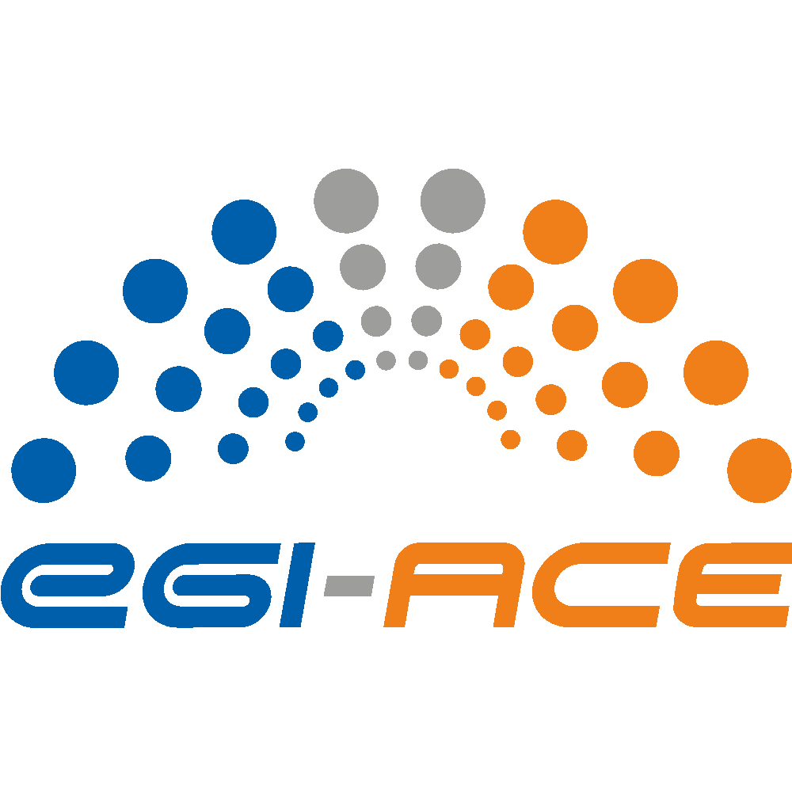
D2.8 Technical, Policy and Service Management Integration Report

Lead partner: | EGI Foundation
Version: | 1
Status: | Under EC review
Dissemination Level: | PUBLIC
Keywords: | Onboarding, Portfolio, Catalogues, SMS, ITSM, FAIR
Document Link: | https://documents.egi.eu/document/3801

Deliverable Abstract
EGI-ACE delivers ‘EOSC Compute Platform’ services and ‘Thematic Services’ in EOSC. This deliverable reports on the integration and alignment activities between EGI-ACE and EOSC. The document describes the approaches that were taken by the project for the service portfolio integration; technical interoperability; service management system; FAIRness assessment of the data spaces offered by EGI-ACE. Based on the findings, the project will continue strengthening its links with EOSC in 2023.

COPYRIGHT NOTICE
This work by parties of the EGI-ACE consortium is licensed under a Creative Commons Attribution 4.0 International License. (http://creativecommons.org/licenses/by/4.0/).
EGI-ACE receives funding from the European Union's Horizon 2020 research and innovation programme under grant agreement no. 101017567.

DELIVERY SLIP
 | Name | Partner/Activity
From: | Gergely Sipos | EGI Foundation / WP2
Moderated by: | Sjomara Specht | EGI Foundation
Reviewed by: | Xavier Salazar  Magdalena Brus | EGI Foundation / C-SCALE project  EGI Foundation / EGI-ACE & C-SCALE
Approved by: | SDS

DOCUMENT LOG
Issue | Date | Comment | Author
v.0.1 | 16/12/2022 | Full draft for external review | G. Sipos,  G. La Rocca  E. Bellussi,  S. Andreozzi  E. Fernandez,  A. Paolini,  D. Scardaci
v.0.2 | 19/12/2022 | Draft improved based on review | G. Sipos
v.1 | 20/12/2022 | Final

TERMINOLOGY
https://confluence.egi.eu/display/EGIG

Contents
Executive summary 4
1 Introduction 6
2 The EGI-ACE Service Architecture 8
2.1 EOSC Compute Platform services 8
2.1.1 Infrastructure layer (bottom part of the KER1 EOSC Compute Platform) 8
2.1.2 Federation layer (middle part of the KER1 EOSC Compute Platform) 9
2.1.3 Platforms layer (upper part of the KER1 EOSC Compute Platform) 9
2.1.4 Service Management Tools (KER2) 9
2.2 Support to Thematic Services 10
2.3 Support for users and providers 11
3 Service portfolio integration and evolution 12
3.1 EGI-ACE services in the EOSC Portal 12
3.2 EGI-ACE data spaces as data sources in the EOSC Portal 20
3.3 EGI-ACE services in EGI 20
3.4 Towards an EGI Community Service Portfolio 21
4 Technical interoperability 25
5 Service Management System alignment 28
5.1 The EOSC Service Management System 28
5.2 EGI-ACE services in the EOSC and EGI SMSs 30
5.3 Service Delivery Maturity Improvement 32
6 FAIR maturity of the EGI-ACE data spaces 34
6.1 The approach 34
6.2 Thematic services / data spaces covered 36
6.3 Findable 36
6.4 Accessible 37
6.5 Interoperable 39
6.6 Reusable 40
6.7 Overall findings 41
7 Conclusions 43
Appendix I - FAIR maturity assessment sheet 44
Appendix II - FAIR maturity assessment responses 62

Executive summary
EGI-ACE is a 30-month project (Jan 2021 - June 2023) with a mission to empower researchers from all disciplines to collaborate in data- and compute-intensive research through free-at-point-of-use services.
EGI-ACE delivers the ‘EOSC Compute Platform’, an integrated compute environment that federates compute and storage facilities with various platforms and access layers. The project also contributes to the EOSC Data Commons through the setup and provisioning of ‘Data Spaces’ that integrate scientific datasets and data analytics tools with the Compute Platform and deliver them as ‘Thematic services’ in EOSC.
EGI-ACE services are made available for users via the EOSC Portal and Marketplace. A high level of usability and quality required the project to integrate services, to align service capabilities and management processes with those required by EOSC. This deliverable reports on these integration and alignment activities after 2 years of the 2.5-year project. The overall collaboration with EOSC is covered in the multilateral Collaboration Agreement that EGI-ACE signed with the other projects of the INFRAEOSC-07 call, and with the EOSC Future project (INFRAEOSC-03). This deliverable focuses on the service integration, covering the following details:
- Onboarding - Making EGI-ACE services available for access in EOSC: The project has already made available and delivers 30 services and 5 Data Spaces via the EOSC Portal. Additional 2 generic services (AppDB, Binder), and 1 Data Space (OpenRiskNet/NanoCommons) are planned for onboarding in the next few months.
- Technical integration - Making EGI-ACE services compatible with the EOSC Core and Exchange: EOSC does not have a formal Interoperability Framework yet. EGI-ACE is actively contributing to establishment of such framework, providing requirements and feedback to the interoperability guidelines for EOSC Core, focusing on the interfaces for interconnecting the EOSC Compute platform to the Core platform. In the meantime, EGI-ACE established compatibility with services of some of the other INFRAEOSC-07 projects (DICE, C-SCALE, OpenAIRE-Nexus and RELIANCE).
- Service Management System (SMS) - Ensuring that the services are managed according to the EOSC expectations: All the onboarded EGI-ACE services meet the EOSC requirements for delivery, and most of them are operated according to ISO20000 IT Service Management standard of the EGI Foundation SMS. In 2023 the project plans to bring all its services under a service management system that is coherent with the existing EGI Foundation SMS. Produced in May 2023, D7.5 will provide a separate document about the SMS of the project.
FAIRness - Ensuring that the EGI-ACE data space services provide Findable, Accessible, Interoperable, and Reusable research results. We carried out a self-assessment using the ‘FAIR Data Maturity Model’ from the RDA FAIR Data Maturity Model Working Group. The findings revealed that compliance is relatively high in the Findable, Accessible and Reusable areas. The project should harvest this value through demonstrators and articles.

Introduction
EGI-ACE is a 30-month project (Jan 2021 - June 2023) with a mission to empower researchers from all disciplines to collaborate in data- and compute-intensive research through free-at-point-of-use services.
EGI-ACE delivers three Key Exploitable Results (KER):
- (KER1) The ‘EOSC Compute Platform’, an integrated compute environment that federates compute and storage facilities with various platforms and access layers.
- (KER2) Services that ensure the operation of the EOSC Compute Platform as a coherent environment. These ‘enabling services’ include technical tools (Check-in, Configuration Database, Monitoring service, Usage Accounting system, and Helpdesk), as well as human activities, such as an IT Management System, service security oversight, incident response team, and resource allocation team.
- (KER3) contributions to the EOSC Exchange through the setup and provisioning of Thematic Services (data analytics platforms and data spaces). Analytics platforms are online environments that can process (transform, visualise, etc.) scientific data in scalable way. Data spaces integrate and host scientific datasets and data analytics tools on top of the Compute Platform and deliver them for big data access and computing.
EGI-ACE is run by the EGI community, an international collaboration that federates the digital capabilities, resources, and expertise of hundreds of national and international research communities in Europe and worldwide. Within EGI-ACE, the EGI Federation and research communities of pan-European relevance are joining efforts to deliver a distributed federated infrastructure that responds to the present and future needs of data-centric scientific computing in Europe through the EOSC.
The project was designed with the following main objectives:
- Deliver the European Open Science Cloud Compute Platform and expand the supply-side.
- Contribute to the implementation of the EU Data Strategy and particularly its EOSC Data Commons to support the objectives of Green Deal, Health, Fundamental Research and Social Sciences and Humanities.
- Integrate the EOSC Compute Platform with the EOSC Portal and the EOSC Core.
- Contribute to the realization of a global Open Science Cloud.
- Increase the demand-side of EOSC across sectors and disciplines.
After 24 months of operation, this deliverable reports on the integration and alignment work that the project carried out to federate and deliver services in EOSC through the EOSC Portal. The document is an updated version of D2.4 deliverable that covered the same topics 1 year ago.
The overall collaboration with EOSC is covered in the multilateral Collaboration Agreement that EGI-ACE signed with the other projects of the INFRAEOSC-07 call (C-Scale, Reliance, OpenAire-Nexus, DICE), and with the EOSC Future project (INFRAEOSC-03). The collaboration agreement covers the following joint activity areas:
Activity 1 Technical Activities:
- Resource Onboarding
- Architecture & Technical Interoperability
- Resource Provisioning and Technical Support
Activity 2 Uptake:
- Promotional activities
- Joint engagement activities through events
- Joint EOSC Training activities
This document is focused on the Technical Activities, and starts with an introduction of the EGI-ACE service portfolio and support for thematic services (Section 2), then covers the different technical integration activities that exist between EGI-ACE and the EOSC Core:
- Service portfolio integration (Section 3)
- Technical integration (Section 4)
- Service Management System alignment (Section 5)
- FAIR maturity alignment (Section 6)

The EGI-ACE Service Architecture

EOSC Compute Platform services
The EOSC Compute Platform (KER1) federates distributed compute and storage facilities to support processing and analytics via a set of services for distributed data and compute use cases. The EOSC Compute Platform architecture is organized in functional blocks as shown in Figure 1.
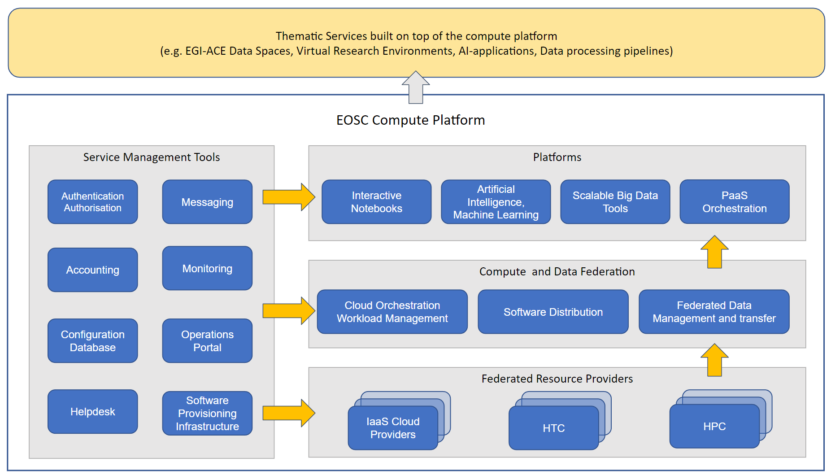
Figure 1. EOSC Compute Platform functional block diagram

Infrastructure layer (bottom part of the KER1 EOSC Compute Platform)
At the bottom of the architecture, the Federated Resource Providers deliver a hybrid infrastructure from academic and commercial providers for running/hosting research applications and data. Different types of providers are included in this layer:
- IaaS Cloud Providers provide access to Virtual Machine-based computing with associated Object and Block storage. These deliver a very flexible and customisable platform where users have complete control over the software and the supporting compute capacity. This flexibility of the computing platform enables the support of various workloads: user gateways or portals, interactive computing platforms and almost any kind of data- and/or compute-intensive workloads.
- HTC (High Throughput Compute) provides access to large, shared computing systems for running computational jobs at scale. These allow researchers to analyse large datasets in an ‘embarrassingly parallel’ fashion, i.e., by splitting the data into small pieces, and executing thousands, or even more independent computing tasks simultaneously, each processing one piece of data. HTC thus means an execution and management of many independent tasks over longer time periods.
- HPC (High Performance Compute) (since July 2022) supports very optimised application of machines that have a lot of interconnected processing units, with many dependent tasks that need large amounts of parallel computing along with low latency and high bandwidth interconnection network.

Federation layer (middle part of the KER1 EOSC Compute Platform)
The Compute Federation services orchestrate the execution of user workloads in the Federated Resource Providers. They exploit data locality by moving computing near data and facilitate application portability with the support of a diverse range of computing platforms (Cloud IaaS, HTC, HPC) and the interaction with software distribution tools (as VM images, container images or binaries directly). There are three services in this layer of the architecture:
- Hybrid cloud orchestration for the deployment of custom virtual infrastructure over multiple IaaS cloud backends within academic and commercial clouds;
- Workload Manager for the scheduling and execution of jobs in the federated resource providers (both cloud and HTC/HPC);
- Software distribution, for making software available at the Federated Resource Providers (e.g., as VM images).
The Federated Data services support exposing discoverable datasets and staging data into/out of the EOSC Compute Platform Cloud. The Federated Data Management services control the raw storage capacity offered by the Federated Resource Providers to deliver data products that can be transferred among the EGI-ACE providers, and between EGI-ACE providers and external data repositories. The Federated Data Management function uses the Data Transfer service to perform the transfers.

Platforms layer (upper part of the KER1 EOSC Compute Platform)
A Platforms service area provides generic added-value services for scientific communities to build thematic services for end-users (typically for researchers). The platforms rely on the existing Compute Federation and Data Federation services to access the Federated Resource Providers and deliver Interactive Notebooks, PaaS Orchestration to facilitate the deployment of complex applications, and Artificial Intelligence and Machine Learning and Scalable Big Data Tools that can be reused in several research disciplines.

Service Management Tools (KER2)
The Service Management Tools pillar delivers the functionality for services of all other areas to be integrated into the Federation. They support the operation of the EOSC Compute platform and integrate and interoperate with the EOSC Core that is run and is further developed in the EOSC Future project. EGI’s Authentication and Authorisation service, called Check-in, is a key component of the architecture that enables using a common identity across all the layers and services of the EOSC Compute platform. Configuration Database, Monitoring, Accounting, and Helpdesk services are also included in this area alongside other non-technical services and coordination activities like Operations Management, and Security and Incident Response.

Support to Thematic Services
The project contributes to the EOSC Exchange through the setup and provisioning of Thematic Services that integrate and host data analytics applications/tools, and/or scientific datasets on top of the Compute Platform. Thematic services provide discipline specific capabilities for the end users.
Processing platforms are one type of Thematic Services that host data analytics environment (with GUI and processing logic) ‘in the cloud’ and allow users to send data to it for analysis. Data Spaces host and integrate both data and online applications/tools into a single unit, enabling the scalable analysis of big datasets ‘in the cloud’.
In contrast to simple “Publication of Open Data”, a Public Data Space manages issues of access and use, as well as provides related tools and infrastructure. The EC’s usage of the term “data space” assumes a public data space, so we interpret a public Data space as a “public collection of FAIR, quality data and related resources consumed, produced and provided by identified participants, each respecting societal values and operating within an explicit framework of trust and governance”.
EGI-ACE Data Spaces are built by scientific communities, research infrastructures and projects. The EGI-ACE consortium includes 5 Data Spaces and 10 Processing Platforms (See Figure 2) and supports additional ones that contact EGI-ACE via its open calls with the intention of setting up new Thematic Services on top of the EOSC Compute Platform. Data Spaces and other Thematic Services share the EOSC Compute Platform as a common architecture. The rest of their setup is specific to their scientific domains and target user groups.
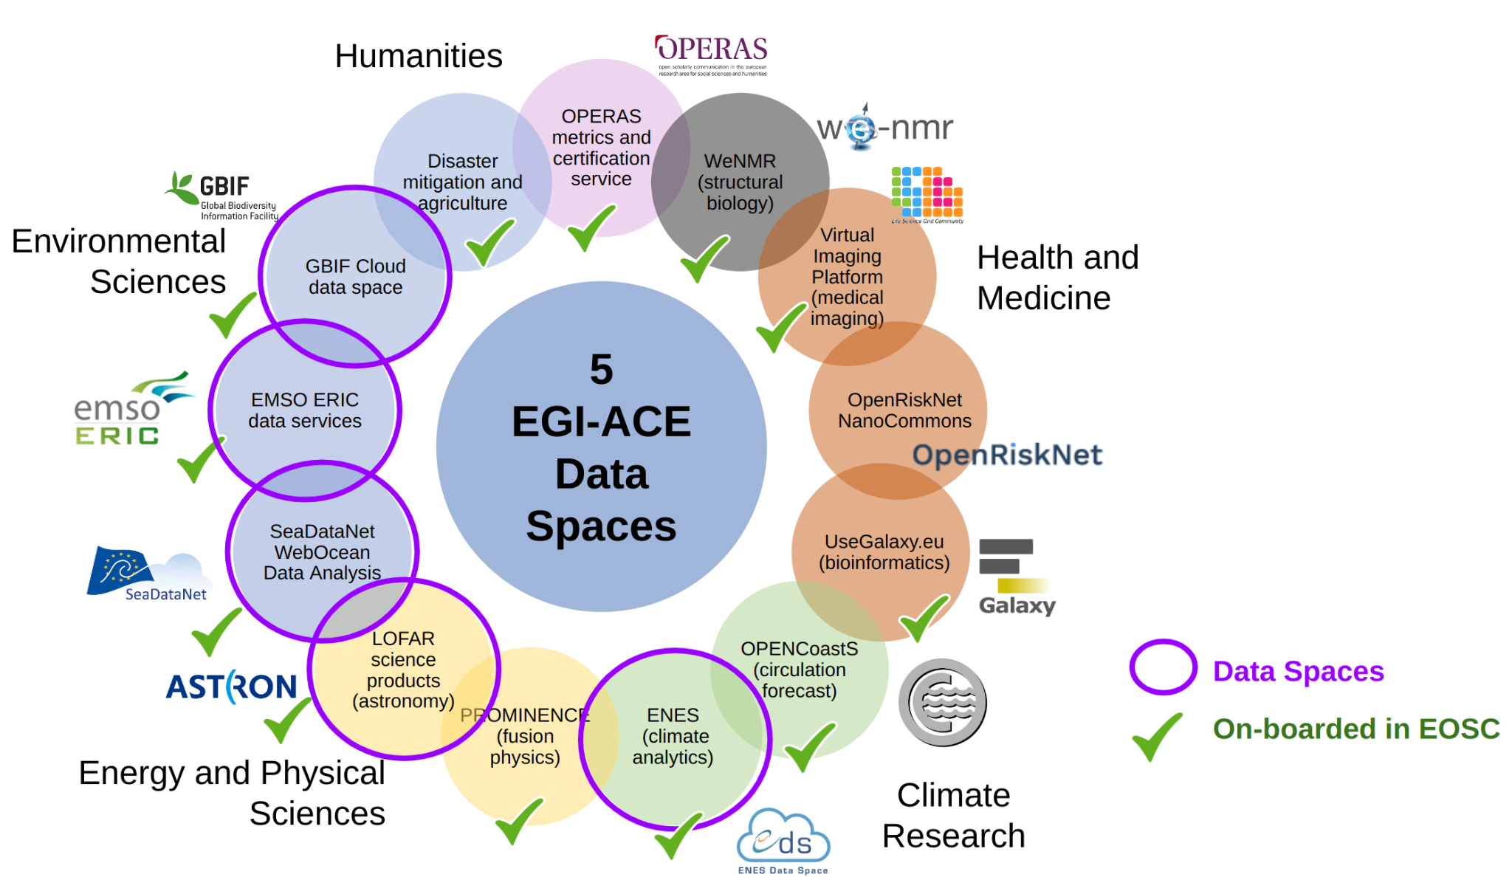
Figure 2. EGI-ACE Data Spaces included in the project consortium

Support for users and providers
Support for users and providers is an integral part of the project work plan. User support helps individual users and user communities in the uptake and use of the services; provider support helps new providers join the infrastructure and existing providers in operating according to the EOSC and EGI standards. Without support, there would be no (or much less) uptake, as experience shows that e-infrastructures use, and deployment are quite effort intensive activities where proper support can save a lot of time and effort for the customers.
- User support is based on the following 4 pillars: Shepherds, Training programme, User documentation, Site/service-specific support teams.
- Provider support is based on the following 4 pillars: Provider documentations, EGI.eu and NGI operations teams (OMB), Onboarding support (WP2), and Integration support (in WP7 and EOSC Future).
The structured and integrated support that EGI-ACE provides for users and service providers is an important distinctive feature that sets the EOSC Compute Platform apart from commercial compute services.

Service portfolio integration and evolution

EGI-ACE services in the EOSC Portal
Making a service available in EOSC requires the service to be visible and accessible to users via the EOSC Portal and its Marketplace. Column 3 of Table 1 below provides a service-by-service overview of the status of EGI-ACE services in the EOSC Portal.
Most of the EGI Foundation services, and some of the NGI services of the EOSC Compute Platform, have been onboarded to the EOSC Portal during the EOSC-hub project. Task 2.2 of EGI-ACE provided assistance to the remaining providers to complete the onboarding task that, in most cases meant filling out the service registration form on the EOSC Portal, in some cases meant registering the provider behind an already registered EOSC Service (for example registered GSI as a provider for the EGI Cloud Compute service). Only two services are not registered in the EOSC Portal:
- AppDB - which is used as a component within the EGI Cloud Compute Service,
- Binder - which recently completed user validation and is expected to reach production level and registration in EOSC in Q1 2023.
A few of the EGI-ACE Thematic services have been onboarded to EOSC Portal before EGI-ACE (mainly by the EOSC-hub project); however, most of these have to be updated in EGI-ACE due to the new functionalities they offer, or on-boarded as new services with the support of Task 2.2. Five new EGI-ACE Data Space services were on-boarded in EOSC Portal: the ENES Data Space, the LOFAR Science Processing, SeaDataNet WebOcean Data Analysis, EMSO ERIC Data Portal, and GBIF Cloud Data Space. The OpenRiskNet/NanoCommons (unfunded) Data Space is still under development, and it is not in the EOSC Portal yet. The OPERAS Metrics and Certification Services Data space (unfunded) is still not deployed in the EOSC Compute Platform.
All the onboarded services of EGI-ACE are listed on a single page within the EOSC Marketplace, using the ‘Related platforms’ field that is present in the profile of every onboarded service, and is filled as ‘EGI-ACE’ for the project services.
During the second year of the project, the EGI-ACE services were used by more than 78,000 users. In particular, the EGI-ACE Data Spaces reported significant progress after their integration with the EOSC Compute Platform in 2022. All but one of them are now operating production services in EOSC to serve the needs of their scientific community. With the onboarding of the Data Spaces in the EOSC Portal, the providers have also started planning several dissemination and outreach activities aimed at promoting and facilitating the uptake of these Thematic Services and increasing the user base. Thanks to these extensive dissemination and outreach activities, enforced by the communications activities facilitated by the project, the EGI-ACE Data Spaces are now used by 4,346 users consuming 21.9 million Cloud CPU/h.
Overall, the EOSC Compute Platform layer served 60 user communities in this period. These communities are either part of the consortium (Data Space providers, Thematic Services and Early Adopters), or they applied for access via the EOSC Portal, the EGI-ACE Open Calls, or directly with the EGI Foundation. The total capacity requested by the EGI-ACE scientific use cases amounts to more than 20 Millions of Cloud CPU/h.
A more detailed analysis of the usage of the EOSC Compute Platform is provided in EGI-ACE D2.2.
The EGI-ACE project is leveraging the decade-long service delivery experiences of the EGI Foundation. The services of the EGI Foundation are governed by the EGI Council. They are grouped into two service portfolios:
- External services (or EGI services in short) target scientists, multinational projects and research infrastructures and are provided by EGI’s federated cloud providers and data centres. The services can be requested by everyone involved in academic research and businesses via the EGI Marketplace and, recently, via the EOSC Marketplace. The External services are part of the ‘Federated resource providers’, the ‘Compute and data federation’ and the ‘Platforms’ layers of the EOSC Compute Platform (See Figure 1). EGI external services are sustained by a mix of national funds and EGI Council membership fees.
- Internal services are provided for the benefit of the EGI Council members and affiliated organisations. The internal services complement the EGI Services for academia and business with tools designed to facilitate coordination and improve how the EGI Federation works together. The EGI internal services form the ‘Service Management tools’ pillar of the EOSC Compute Platform (See Figure 1). The EGI Internal services receive funding from the EGI Council membership fees, and thus, they are sustainable outside EOSC.

Table 1: Status of EGI-ACE services in EOSC Portal and in the EGI Catalogues
EGI-ACE service | Organisation | Status in EOSC Portal Catalogue | URL | Status in EGI Service Catalogue | URL | Comments
EOSC Compute Platform: Federated resource provider services (KER1)
EGI Cloud Compute | EGI Foundation | Onboarded as EGI Cloud Compute | URL | In the catalogue “EGI Services for Research” | URL | Platform TAG on EOSC Marketplace: EGI-ACE
SURF HTC | SURF | Registered as provider of the previously onboarded EGI High-Throughput Compute Compute | URL | In the catalogue “EGI Services for Research” | URL | SURF is the only provider of EGI High-Throughput Compute that receives funding for virtual access.  Platform TAG on EOSC Marketplace: EGI-ACE
EGI Cloud Container Compute | EGI Foundation | Onboarded as EGI Cloud Container Compute | URL | In the catalogue “EGI Services for Research” | URL | Platform TAG on EOSC Marketplace: missing
Dynamic DNS Service | IISAS | Onboarded as Dynamic DNS Service | URL | Service component of the EGI Cloud Compute Service in the catalogue “EGI Services for Research” | URL | Platform TAG on EOSC Marketplace: EGI-ACE
EGI Online Storage | EGI Foundation | Onboarded as EGI Online Storage | URL | In the catalogue “EGI Services for Research” | URL | Platform TAG on EOSC Marketplace: missing
EOSC Compute Platform: Compute and data federation services (KER1)
EGI AppDB | EGI Foundation | Not in EOSC Catalogue | N/A | Service component of the EGI Cloud Compute Service in the catalogue “EGI Services for Research” | URL
EGI DataHub | EGI Foundation | Onboarded as EGI DataHub | URL | In the catalogue “EGI Services for Research” | URL | Platform TAG on EOSC Marketplace: EGI-ACE
EGI Data Transfer | EGI Foundation | Onboarded as EGI Data Transfer | URL | In the catalogue “EGI Services for Research” | URL | FTS-based solution  Platform TAG on EOSC Marketplace: EGI-ACE
Rucio | UKRI-STFC | Onboarded as SCD STFC Rucio Data Management Service | URL | In the portfolio “EGI Services for Research” as ‘EGI Data Orchestrator’ in Alpha status (it will be published in the catalogue when it transitions to Beta) | N/A | Platform TAG on EOSC Marketplace: EGI-ACE
OpenRDM | EnhanceR | Onboarded as openRDM EU | URL | Not in EGI catalogues | N/A | Platform TAG on EOSC Marketplace: EGI-ACE
CVMFS | UKRI-STFC | Onboarded as STFC CVMFS Content Distribution Service | URL | In the catalogue “EGI Services for Research” | URL | Platform TAG on EOSC Marketplace: EGI-ACE
EOSC Compute Platform: Platform services (KER1)
EC3 | UPV | Onboarded as Elastic Cloud Compute Cluster (EC3) | URL | Not in EGI catalogues | N/A | Platform TAG on EOSC Marketplace: EGI-ACE
Infrastructure Manager | UPV | Onboarded as Infrastructure Manager (IM) | URL | In the catalogue “EGI Services for Research” | URL | Platform TAG on EOSC Marketplace: EGI-ACE
DODAS | INFN | Onboarded as Dynamic On Demand Analysis Service (DODAS Portal) | URL | Not in EGI catalogues | N/A | Platform TAG on EOSC Marketplace: EGI-ACE
EGI Workload Manager (DIRAC) | EGI Foundation | Onboarded as EGI Workload Manager | URL | In the catalogue “EGI Services for Research” | URL | Platform TAG on EOSC Marketplace: EGI-ACE
EGI Notebooks | EGI Foundation | Onboarded as EGI Notebooks | URL | In the catalogue “EGI Services for Research” | URL | Platform TAG on EOSC Marketplace: EGI-ACE
EGI Reply (Binder) | EGI Foundation | To be onboarded in EOSC Catalogue | N/A | In the portfolio “EGI Services for Research” as ‘EGI Reply’ in Alpha status (it will be published in the catalogue when it transitions to Beta) | N/A | N/A
Indigo PaaS Orchestrator (TOSCA) | INFN | Onboarded as PaaS Orchestrator | URL | Not in EGI catalogues | N/A | Platform TAG on EOSC Marketplace: EGI-ACE
DEEP training solution | IFCA | Onboarded as DEEP training facility | URL | Not in EGI catalogues | N/A | Platform TAG on EOSC Marketplace: EGI-ACE
Service Management Tools (KER2)
Check-in | EGI Foundation | Onboarded as EGI Check-in | URL | In the catalogue “EGI Services for Research” | URL | Platform TAG on EOSC Marketplace: EGI-ACE
ARGO Messaging Service (AMS) | GRNET | Supporting service to the EOSC Compute Platform; no need to onboard in EOSC | N/A | In the catalogue “EGI Services for Federation” as service component of EGI Operational Tools | URL
ARGO Monitoring Service | GRNET | Supporting service to the EOSC Compute Platform; no need to onboard in EOSC | N/A | In the catalogue “EGI Services for Federation” as EGI Service Monitoring | URL
GGUS Helpdesk Service | KIT | Supporting service to the EOSC Compute Platform; no need to onboard in EOSC | N/A | In the catalogue “EGI Services for Federation” as EGI Helpdesk | URL
GOCDB Configuration database | UKRI-STFC | Supporting service to the EOSC Compute Platform; no need to onboard in EOSC | N/A | In the catalogue “EGI Services for Federation” as EGI Configuration Database | URL
Operations Portal | CCIN2P3 | Supporting service to the EOSC Compute Platform; no need to onboard in EOSC | N/A | In the catalogue “EGI Services for Federation” as service component of EGI Operational Tools | URL
Software Provisioning Infrastructure | LIP & CSIC | Supporting service to the EOSC Compute Platform; no need to onboard in EOSC | N/A | In the catalogue “EGI Services for Federation” as service component of EGI Validated Software and Repository | URL
Thematic services (KER3)
Health and medicine
HADDOCK2.4 from WeNMR | BC-UU | Onboarded as HADDOCK2.4 web portal | URL | Not in EGI catalogues and no plan to include them in the existing catalogues | N/A | Platform TAG on EOSC Marketplace: EGI-ACE
DisVis from WeNMR | BC-UU | Onboarded as DisVis web portal | URL | Not in EGI catalogues and no plan to include them in the existing catalogues | N/A | Platform TAG on EOSC Marketplace: EGI-ACE
PowerFit from WeNMR | BC-UU | Onboarded as PowerFit web portal | URL | Not in EGI catalogues and no plan to include them in the existing catalogues | N/A | Platform TAG on EOSC Marketplace: EGI-ACE
SpotOn from WeNMR | BC-UU | Onboarded as SpotOn web portal | URL | Not in EGI catalogues and no plan to include them in the existing catalogues | N/A | Platform TAG on EOSC Marketplace: EGI-ACE
AMBER from WeNMR | MRCUF | Onboarded as -based Portal Server for NMR structures (AMPS-NMR) | URL | Not in EGI catalogues and no plan to include them in the existing catalogues | N/A | Platform TAG on EOSC Marketplace: missing
Virtual Imaging Platform | CRATIS | Onboarded as Virtual Imaging Platform | URL | Not in EGI catalogues and no plan to include them in the existing catalogues | N/A | Platform TAG on EOSC Marketplace: EGI-ACE
OpenRiskNet/  NanoCommons | N/A | Not yet | N/A | Not in EGI catalogues and no plan to include them in the existing catalogues | N/A
UseGalaxy.eu | ELIXIR-BE & EMC | Onboarded as European Galaxy Server | URL | Not in EGI catalogues and no plan to include them in the existing catalogues | N/A | Platform TAG on EOSC Marketplace: EGI-ACE
Climate research
OPENCoastS | LNEC | Onboarded as OPENCoastS Portal | URL | Not in EGI catalogues and no plan to include them in the existing catalogues | N/A | Platform TAG on EOSC Marketplace: EGI-ACE
ENES Data Space | EMCCC | Onboarded as ENES Data Space | URL | Not in EGI catalogues and no plan to include them in the existing catalogues | N/A | Platform TAG on EOSC Marketplace: EGI-ACE
Energy and physical sciences
PROMINENCE | UK-AEA | Onboarded as PROMINENCE | URL | Not in EGI catalogues and no plan to include them in the existing catalogues | N/A | Platform TAG on EOSC Marketplace: EGI-ACE
LOFAR Science Processing | NWO-ASTRON | Onboarded as LOFAR Science Processing | URL | Not in EGI catalogues and no plan to include them in the existing catalogues | N/A | Platform TAG on EOSC Marketplace: missing
Environmental sciences
SeaDataNet WebOcean Data Analysis | SDN | Onboarded as WebODV - Online extraction, analysis, and visualization of SeaDataNet and Argo data | URL | Not in EGI catalogues and no plan to include them in the existing catalogues | N/A | Platform TAG on EOSC Marketplace: EGI-ACE
EMSO ERIC data services | EMSO ERIC | Onboarded as EMSO ERIC Data Portal | URL | Not in EGI catalogues and no plan to include them in the existing catalogues | N/A | Platform TAG on EOSC Marketplace: EGI-ACE
GBIF Cloud Data Space | GBIF-PT | GBIF Portugal Occurrence Records | URL | Not in EGI catalogues and no plan to include them in the existing catalogues | N/A
Disaster mitigation and agriculture | ASGC | Onboarding as iCOMCOT Tsunami Wave Propagation Simulation Portal | URL | Not in EGI catalogues and no plan to include them in the existing catalogues | N/A | Platform TAG on EOSC Marketplace: EGI-ACE
Social sciences and humanities
OPERAS Metrics service | OPERAS | Onboarded as OPERAS Metrics service | URL | Not in EGI catalogues and no plan to include them in the existing catalogues | N/A | Platform TAG on EOSC Marketplace: EGI-ACE

EGI-ACE data spaces as data sources in the EOSC Portal
The EOSC Portal released a significant update in November 2022, which allows the registration of Data Sources (data repositories) in EOSC, and activating a metadata harvesting for them, so their content becomes directly searchable via the EOSC Portal interface. The project intends to assess this new functionality in 2023 to understand whether the registration of the EGI-ACE Data Space services according to this would bring extra value for researchers (so they could more easily discover data from the data spaces using the EOSC Portal search functionality).

EGI-ACE services in EGI
The EOSC Compute Platform service portfolio was assembled during the EGI-ACE proposal preparation time based on the EGI Foundation services (internal and external) and based on additional services that EGI Council members wished to offer for pan-European access via the EOSC Portal.
Column 3 of Table 1 provides a service-by-service overview of the status of the EGI-ACE services in the EGI Service External/Internal portfolios. As can be seen, most of the EOSC Compute Platform services are already included in the EGI Catalogues (they are green in column 3):
- 5/5 federated resource providers are in the EGI Catalogue (external)
- 4/6 compute & data federation services are in the EGI Catalogue (external)
- 2/8 platform services are in the EGI Catalogue (external)
- 6/6 federation management tools are in the EGI Catalogue (internal)
EGI Catalogue membership offers better sustainability for a service outside the project. One of the focus points for the service portfolio management task of EGI-ACE in 2023 must be the clarification of the relationship between the EOSC Compute Platform and the EGI Federation governance and portfolios. This is expected to result in the onboarding of additional services from the EOSC Compute Platform to the EGI Service Portfolios, and in open and transparent processes for new providers and new services to join the EOSC Compute Platform. This work has been stated as strategic recommendation #2 in the recently published ‘EGI-ACE Strategic Plan’ D2.2 deliverable. EGI-ACE Task 2.2 and WP7 will work on this with the EGI-ACE Project Management Board (PMB), the EGI Executive Board (EB), and the EGI Services and Solutions Board (SSB).
Services of the EGI-ACE Data Spaces are not part of the EGI Service Portfolios. A subset of these Data Space services is delivered by institutes represented in the EGI Council directly (e.g., EMSO ERIC), or indirectly (e.g., University of Utrecht represented by SURF). Some of the Data Space providers are outside the network of EGI Council members. The Data Space services are all thematic services, i.e., are relevant to specific scientific disciplines (which is narrower or broader depending on the thematic service). Given that the EGI Portfolios currently include only services that are cross-cutting across all disciplines and represent the ‘common denominator’ for big data science on e-infrastructures, EGI-ACE thematic services would fall out of scope for the EGI Portfolios. Thematic Services are better supported and promoted by the EGI community in alternative ways, such as ‘Service Level Agreements’ and written use cases. However, some thematic services that are appealing for several or broad enough disciplines (e.g., Galaxy for life sciences and environmental sciences) could be considered for stronger support by EGI beyond EGI-ACE’s lifetime. This needs to be discussed and decided in 2023 alongside the EOSC Compute Platform service action mentioned above.

Towards an EGI Community Service Portfolio
Services from the EGI Federation are organised in two main portfolios:
- EGI Services for Federation (also known as internal service portfolio) capturing all the services that are offered within the EGI federation to enable the affiliated resource providers to operate together and jointly provide value to its customers.
- EGI Services for Research (also known as external service portfolio) capturing all EGI-branded services that are offered by the EGI Federation to researchers.
The EGI-ACE service catalogue includes additional services that are not part of these two EGI portfolios. It is essential to develop a long-term engagement structure that allows the excluded providers to remain engaged with the EGI Federation after EGI-ACE to continue the success of delivering services to researchers in the context of the EOSC.
For this reason, we are proposing the creation of a third EGI service portfolio called “EGI services from the Community”. This portfolio aims to capture services that are not branded as “EGI”, but are delivered directly by EGI partners, and create value together with the EGI-branded services. Figure 3 provides an overview of the relationship between the existing two, and this proposed new 3rd service portfolio.

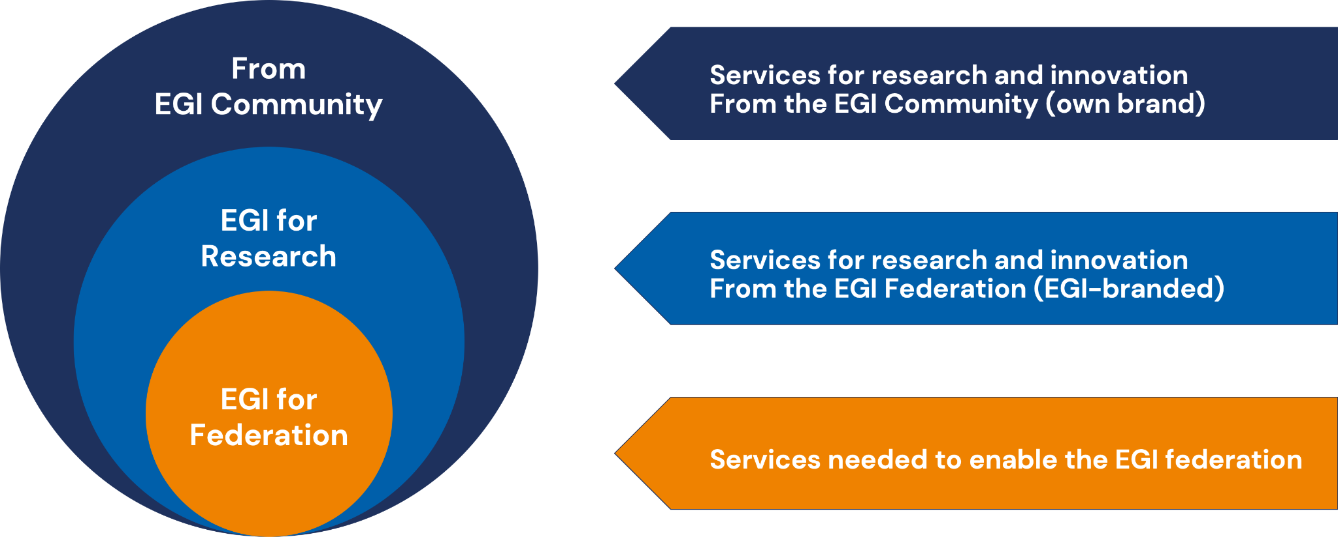
Figure 3. EGI Service Differentiation
Table 2: Comparing the different EGI Service Portfolios
Portfolio | EGI Services for Federation | EGI Services for Research | EGI Services from the Community (proposal)
Service owner | EGI Foundation | EGI Foundation | Different provider institutes
Suppliers | EGI Foundation and members selected via bidding | Mostly by EGI Federation members | Providers of services for research
Service categories | - Coordination  - Operations  - Security & Identity | - Compute  - Compute Orchestration  - Storage & Data  - Security & Identity  - Applications  - Training | (Work in progress)  - Scientific applications  - Science gateways  - Data spaces  - Research platforms
How to join the portfolio | The composition is strictly controlled by the EGI Foundation depending on the requirements of the EGI Federation; suppliers that meet the identified needs are selected periodically based on a bidding process open to the EGI Council Participants | The composition is controlled by the EGI Foundation depending on the requirements of the research communities; major changes to the services can be proposed following the service portfolio management process and are approved by the EGI Council as the ultimate decision-making body of the EGI Federation | Open application with eligibility requirements (work in progress), e.g.:  - Some level of integration with EGI services  - Compliance to EGI policies  - Signed form of collaboration agreement  Different levels of partnership may be defined, e.g.  - EGI as promotion channel  - EGI as support for technical integration  - EGI as front-end negotiator
How to access | Available to the EGI Federation members  - Publicly funded organisations represented in the EGI Council  - Commercial providers as “Federation” partner in the EGI DIH  - Organisations collaborating via MoUs or other agreements | Orderable  - Via EGI channels  - Simple request  - Application in an Open Call  - Order via EGI marketplace  - Via EOSC Portal | Depending on the specific provider policies
Funding | Combination of  - EGI Federation membership fees  - In-kind contributions  - EC-funded projects | Combination of  - In-kind contributions  - Grants from projects  - Pay for use | Depending on the specific provider

One key success factor for the EGI Services from the Community is the business model, more specifically, the value proposition, the requirements, and the benefits. The current approach is to define a tiered partnership model with an increasing set of requirements and benefits through the various tiers. Table 3 provides an overview of a possible multi-tier model. For the success of this engagement structure, it will be important to validate the proposed structure with candidate providers of the EGI-ACE project. This will be the focus of work in 2023.

Table 3: Partnership tiers for the portfolio of EGI Services from the Community
 | Promotion | Support | Full
Requirements | - Complete and sign agreement  - Fill the onboarding service entry  - Review the service entry yearly  - Accept selected EGI policies  - Dependency on some EGI service | - Requirements from the previous level  - Pay annual fee  - Interface some ITSM process (full list to be defined) | - Requirements from the previous level  - Integrate more ITSM processes, e.g., CRM (full list to be defined)
Benefits | - Promote your service via the EGI channels to reach out a wider community | - Benefits from the previous level  - Receive committed support from the EGI Federation to operate and deliver your service  - Support for onboarding into EOSC | - Benefits from the previous level  - EGI as front-end negotiation and order management

Next steps to continue the development of this service portfolio are:
- Jan 2023: complete the concept and requirements.
- Mar 2023: update EGI Service Portfolio Management process, the definition of the agreement and start validating the concept with a selected subset of providers.
- June 2023: first services are added to the EGI Community catalogue, Engagement to start publicly with additional providers.

Technical interoperability
The EOSC Compute platform delivered by EGI-ACE will guarantee technical interoperability supporting the standards and interfaces of the EOSC Interoperability Framework (EIF), that is currently being built in the EOSC Future project in collaboration with other relevant initiatives, including the ‘Technical Interoperability of Data and Services’ Task Force.
At the time of writing EOSC does not have an Interoperability Framework. The ‘onboarding’ process implements the compliance between EOSC Core and Exchange services.
Once developed, the EIF will facilitate interdisciplinary research and foster service/resource integration and composability. It will be made of a wide library of policies and interoperability guidelines describing standards and API’s. The EIF will provide guidelines for providers to connect resources to EOSC-Exchange but will also provide guidelines to be adopted within services made available through EOSC-Core, supporting the composability and integration of resources across boundaries. EGI-ACE is an active actor in shaping the EIF and is collaborating with EOSC Future to define the interoperability guidelines for EOSC Core, providing requirements and feedback with a focus on the interfaces for interconnecting the EOSC Compute platform to the Core platform.
When the interoperability guidelines for the EOSC Core reaches an adequate level of maturity, EGI-ACE will update its services to be compliant as it is needed. However, the required effort is not expected to be major since many of the technologies adopted by EOSC Future to implement the EOSC Core (e.g., monitoring, AAI, accounting, etc) are also used by EGI to implement its service management tools. A clear example is AAI, the interoperability guidelines for AAI will be derived from the work delivered by the AARC Architecture Working Group and further enhanced by AEGIS. The AAI solution adopted by EGI-ACE, Check-in, is already compliant with many of these interoperability guidelines on AAI and joining the future EOSC AAI Federation will be a simple task for EGI-ACE.
Furthermore, EGI-ACE will contribute to the interoperability guidelines for EOSC Exchange developing guidelines in the technical areas of its interest (e.g., Computing, Data Platform for processing, etc.). Since January 2022 a ‘Compute continuum Working Group’ is run by EOSC Future, aiming at defining a metadata schema as extension of the EOSC profile to describe the compute resources in the EOSC resource catalogue. This metadata schema will be a flexible and extensible specification for describing services providing access to generic computing resources covering as much as possible the complete compute continuum: cloud, HTC and HPC and potentially the edge, including access to hardware accelerators (e.g., GPUs) in all these systems whenever available. Having such specifications will mitigate the lack of standards in the compute service area and provide the basis for interoperation by enabling the discovery and potentially automated usage of compute services by the user communities. Thanks to this metadata schema, user communities and single users with computing needs for a specific scientific aim can be triaged and dispatched to the most appropriate kind of compute platform according to their requirements. Unfortunately, the WG did not make much progress during 2022, there are no visible outcomes on their website.
Finally, EGI-ACE contributes to the validation of the EIF developing resource composability demonstrators and early adopter pilots in collaboration with EOSC Future and the other INFRAEOSC-07 projects. These pilots foresee the combined usage of services from multiple providers with a level of automation that has increased during the project lifetime. EGI-ACE is also leading the design and the development of the Data Transfer capabilities of the EOSC Platform. This new feature enables the easy movement of data registered in EOSC and will be accessible via EOSC Interoperability Framework API or directly from the EOSC Catalogue and Marketplace. This capability is already available as a demonstrator in the EOSC Platform (See Figure 4) and is expected to be fully operational in Q2 2023.
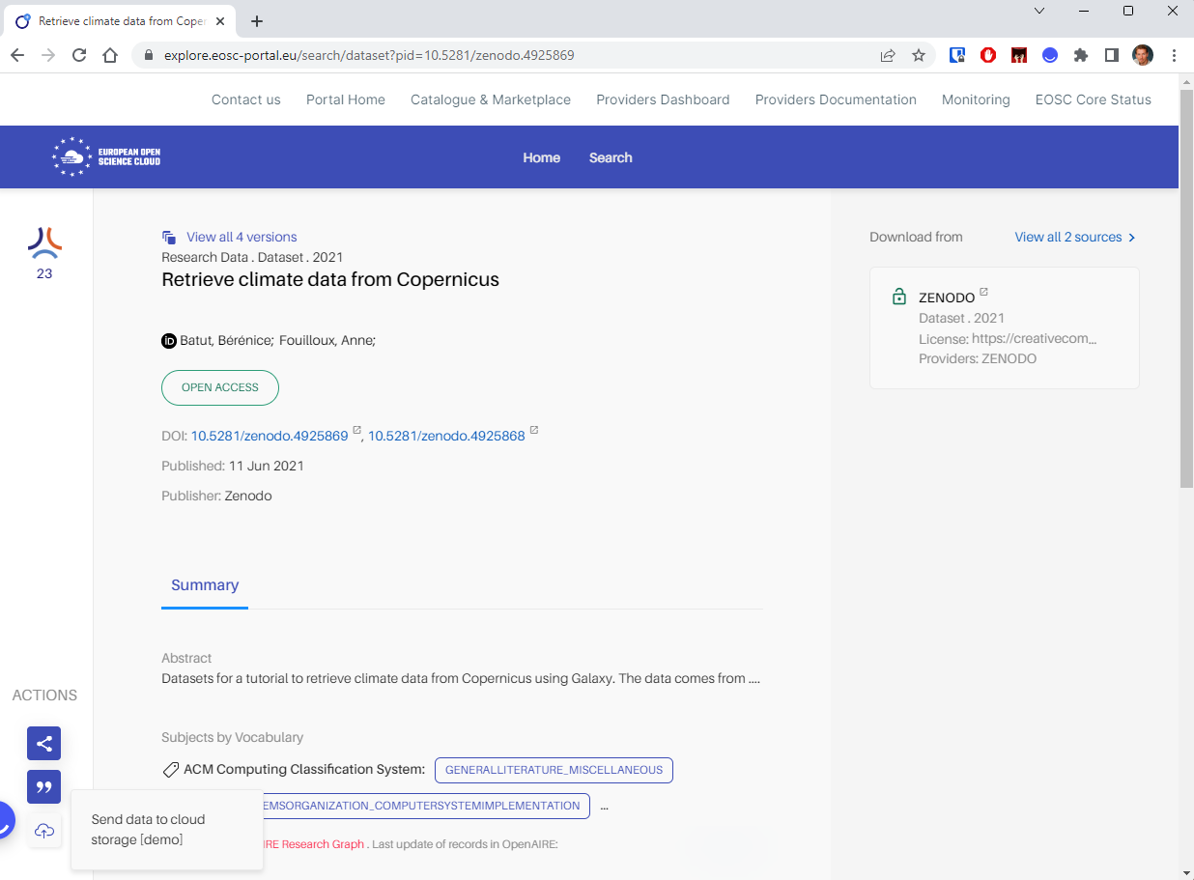
Figure 4. Data transfer capability within the EOSC Portal based on EGI-ACE technology (bottom left corner)

Another important EGI-ACE contribution to the EOSC Platform is related to the development of mechanisms to facilitate the access to Compute and Storage resources leveraging the EIF. EGI-ACE designed and planned to deliver in the first semester of 2023 a capability that will enable the semi-automated allocation of Compute and Storage resources from the EOSC Platform for ‘simple’ use cases where the access can be easily automated. This capability together with the Data Transfer will allow users navigating over the EOSC Catalogue to easily move datasets on EOSC Compute and Storage resources that are automatically assigned to them, and to perform analysis on those data.
Furthermore, the EGI Notebook service has been made interoperable with the B2DROP service of DICE, and the Zenodo service of OpenAIRE-Nexus and will be adopted to deliver a generic EOSC Notebook service.
In addition to the collaboration with EOSC Future, EGI-ACE also contributes to the EOSC Association (EOSC-A) task forces with its own representatives (See Table 4). Such EOSC-A TFs are expected to steer the EOSC evolution and, in particular, the technical ones will also perform a key role in defining the future directions of the EIF. In this context, the experience gained dealing with real use cases will make the contributions of the EGI-ACE representatives valuable for the activities of these TFs.

Table 4: EGI-ACE participation in the technical Task Forces of the EOSC Association.
EOSC Task Force | Relevance for EGI-ACE | Current relevant results | WPs/  Tasks
Technical interoperability of data and services | The experience in implementing interoperability guidelines will be shared | - EGI-ACE is contributing to the TF sharing interoperability guidelines on how to describe and access compute resources in EOSC  - EGI-ACE is contributing on shaping the overall architecture of the EOSC Interoperability Framework | T2.2
AAI Architecture | Ensuring the continued compatibility of the EGI Check-in service with the EOSC AAI requirements | - Contribution to EOSC AAI architecture v2022 | WP6
Researcher engagement and adoption | The uptake of EGI-ACE services, the understanding of community needs, and areas of unmet demands can be fed into it | - Set-up a distributed user support networks with technical experts from different areas to support  - integration plans of scientific use cases in the EOSC Compute Platform.  - Served requested for support received either via the EOSC Portal Marketplace (113) and the EGI Open Call (42)  - On-boarded three new platforms in the EOSC Portal Marketplace and contributed to the EOSC Exchange. | T2.3

Service Management System alignment

The EOSC Service Management System
EOSC Future operates the EOSC IT Management System (ITSM), covering the EOSC Core, and demanding some level of ITSM readiness from providers of the EOSC-Exchange. The EOSC Future ITSM builds on the ITSM that was laid down by EOSC-hub to ensure a robust yet pragmatic service delivery in the EOSC federated infrastructure with different types of many-to-many relationships between users, providers, and clients.
What is an IT Service Management System?
The key idea behind IT service management could be summarized like this: by following a service-oriented approach, an IT organisation (which may be everything from an internal IT department over a shared IT unit up to an external IT provider) is able to better understand what they do and offer, and how this is aligned to the needs of their customers and users. A Service Management System is the overall management system that controls and supports management of services within an organisation or federation. The SMS can be regarded as the entirety of interconnected policies, processes, procedures, roles, agreements, plans, related resources, and other elements needed and used by a service provider to effectively manage the delivery of services to customers. By following the processes of the SMS, the activities carried out to plan, deliver, operate, and control the services become more structured and repeatable, with clearly defined responsibilities. All this helps an IT organisation to increase its level of professionalism and organisational maturity.

The EOSC Future Service Management System (SMS) is structured and organised into processes and procedures according to the FitSM IT Management standard, i.e., the same standard that is used by the EGI Foundation for the EGI External service and Internal services. FitSM is a free, pragmatic, lightweight and achievable standard aimed at facilitating service management in IT service provision, including federated scenarios. By defining requirements, the 14 processes of FitSM help EOSC service providers as is shown in Table 5.

Table 5: The 14 processes of FitSM, and their benefits for EOSC providers.
Process | Objective
Service portfolio management (SPM) | To define and maintain a service portfolio
Service level management (SLM) | To maintain a service catalogue, and to define, agree and monitor service levels with customers by establishing meaningful service level agreements (SLAs) and supportive operational level agreements (OLAs) and underpinning agreements (UAs) with suppliers
Service reporting management (SRM) | To specify all service reports and ensure they are produced according to specifications in a timely manner to support decision-making
Service availability and continuity  management (SACM) | To ensure sufficient service availability to meet agreed requirements and adequate service continuity
Capacity management (CAPM) | To ensure sufficient capacities are provided to meet agreed service capacity and performance requirements
Information security management  (ISM) | To manage information security effectively through all activities performed to deliver and manage services, so that the confidentiality, integrity, and accessibility of relevant information are preserved
Customer relationship management  (CRM) | To establish and maintain a good relationship with customers receiving services
Supplier relationship management  (SUPPM) | To establish and maintain a healthy relationship with suppliers supporting the service provider in delivering services to customers, and monitor their performance
Incident and service request  management (ISRM) | To restore normal / agreed service operation within the agreed time after the occurrence of an incident, and to respond to user service requests
Problem management (PM) | To investigate the root causes of (recurring) incidents to avoid future recurrence of incidents by resolving the underlying cause, or to ensure workarounds/temporary fixes are available
Configuration management (CONFM) | To provide and maintain a logical model of all configuration items (CIs) and their relationships and dependencies
Change management (CHM) | To ensure changes to CIs are planned, approved, implemented, and reviewed in a controlled manner to avoid adverse impact of changes to services or the customers receiving services
Release and deployment management  (RDM) | To bundle changes of one or more CIs to releases, so that these changes can be tested and deployed to the live environment together
Continual service improvement  management (CSI) | To identify, prioritize, plan, implement and review improvements to services and service management

For each of these processes, as well as for a number of general aspects in the context of ITSM, FitSM (within the FitSM-1 document) defines a small number of implementation requirements, while the FitSM-2 document provides guidelines on the activities to set up and implement ITSM using these processes. The FitSM-3 document describes the proposed roles to be assigned to execute the ITSM processes as part of a service management system.
At a base level, all onboarded services become in the scope of EOSC SPM when they are included into the EOSC Exchange Service Portfolio, and then publicly exposed in a Service Catalogue (the EOSC Portal and its Marketplace). How the scope of other EOSC SMS processes impacts on new onboarded services depends on the choices the service providers make for integrating with other EOSC Core services. For example, enabling ‘ordering’ (i.e., users have to request access to the service via the EOSC Marketplace) will bring the Exchange service partially into the scope of CRM, using the Helpdesk involves the Exchange service in the ISRM process, and so on. Additional integration activities may bring the services within the scope of other SMS processes.

EGI-ACE services in the EOSC and EGI SMSs
The minimum requirements of the EOSC SMS are met by any provider who successfully onboards services to the EOSC Portal. The EGI-ACE services that are onboarded to EOSC, therefore, already meet the EOSC Criteria. This section provides an overview of the SMS maturity of the EGI-ACE services independently of the EOSC requirements. As the section shows, most of the EGI-ACE services operate with a very mature SMS, and the project puts emphasis on lifting the SMS maturity of its whole portfolio.
The EGI Foundation has established a Management System for its IT-Services. This Service Management System (SMS) holds an ISO/IEC 20000 certification 1:2018. This is an international standard that outlines the requirements for design, transition, delivery, and improvement of IT services that fulfil service requirements and provide value for both the customer and the service provider. The ISO/IEC 20000-1:2018 standard allows to demonstrate excellence and prove best practices in IT service management.
The EGI-ACE services relate to the EGI SMS in one of these three ways:
- Some of the EGI-ACE EOSC Compute Platform services are already governed by the EGI Council (i.e., they are in the EGI External or Internal portfolios) therefore, are covered by the EGI SMS. (See these services listed with green background in column 3 under the ‘EOSC Compute Platform...’ sections of Table 1.)
- Some of the EGI-ACE EOSC Compute Platform services are not (yet) included in the EGI Service portfolios; therefore, their SMS is not covered by the EGI Foundation SMS. (See these services listed with red background in column 3 under the ‘EOSC Compute Platform...’ sections of Table 1.)
- EGI-ACE thematic services are not covered by the EGI SMS at all. (See these services listed under the ‘Thematic services (KER3)’ section of Table 1., with red background in column 3.)
The project intends to raise the maturity of the services in group 2 by bringing them under the EGI SMS. The existing level of service management of these services is an important consideration for this work. The project, therefore, performed a preparatory activity, the maturity assessment of these services. From the operational perspective, the important aspects of an SMS are to ensure that the services are monitored (to ensure high availability), they have a helpdesk (to ensure users and the monitoring can open trouble tickets), they a reregistered in the Configuration DB (so changes can be tracked, and status information can be obtained for monitoring), and that Capacity plans and Availability and Continuity plans are available for them. The findings of this assessment are summarised in Table 6 below.
Table 6: Maturity assessment of the EGI-ACE Compute Platform services that are outside of the EGI Foundation SMS.
EGI-ACE service | Monitored? | Has a Helpdesk support unit? | Has an entry in the GOCDB configuration DB? | Has a capacity plan? | Has an availability and continuity plan?
EOSC Compute Platform: Compute and data federation services
DynamicDNS | YES | YES | YES | YES | YES
EOSC Compute Platform: Compute and data federation services
AppDB | YES | YES | YES | IN PROGRESS | YES
Rucio | YES | YES | YES | YES | YES
OpenRDM | YES | YES | YES | NO | NO
CVMFS | YES | YES | YES | YES | YES
EOSC Compute Platform: Platform services
EC3 | YES | YES | YES | IN PROGRESS | YES
Infrastructure Manager | YES | YES | YES | YES | YES
DODAS | NO | YES | YES | YES | IN PROGRESS
Reply (Binder) | YES | YES | YES | IN PROGRESS | YES
Indigo PaaS Orchestrator (TOSCA) | YES | YES | YES | IN PROGRESS | IN PROGRESS
DEEP training solution | NO | NO | YES | NO | NO

Based on the findings we can estimate the amount of work required to bring these services under the EGI Foundation SMS. If these services would like to receive EGI Core funding (i.e., the funds collected by EGI Foundation from its members and redistributed to service providers), then we need to bring the services into the existing EGI governance and SMS.
If Core funding is not needed for these new services, then we can go for a ‘lightweight’ SMS, with e.g., requiring maturity in the areas covered in Table 6 above, as well as maturity in some user-facing activities especially Customer Relationship Management and Service Level Management. These requirements could be formulated in a new, ‘lightweight SMS’ that would apply to the services that EGI includes in its portfolio but does not consider as Core service. Deciding on the direction to make with these services is work in 2023 for Task 2.2, the affected service providers, and the EGI Services and Solutions Board (SSB).

Service Delivery Maturity Improvement
The EGI-ACE project is planning to implement a new initiative to drive up the level of service delivery maturity across all the EGI-ACE services. This will start with the EGI Internal services that are co-funded by the EGI Foundation and will then extend to other services of the EGI-ACE Compute Platform, then to the data space/thematic services.
SMS maturity is a cornerstone of service delivery maturity. EGI has been delivering FitSM/ISO27k courses for 6 years, delivered over 90 courses and trained over 1,200 people. The project also funds FitSM training and these have been delivered to the EGI-ACE providers, increasing the skills of key staff involved in service delivery.
The requirements of SMS integration can mean different things for different processes and services. For example, for Information Security Management this implies providing details of the security contact responsible for service delivery at an organisation providing services within the EGI Federation and an ability to follow the correct EGI procedures when dealing with a security incident. For Incident and Service Request Management this implies being able to react to tickets raised against a service or resource. For internal services funded by EGI Foundation, the SMS integration requirements are more stringent; for example, extending to using the Change Management service run by EGI Foundation for changes which have the potential to directly affect other services; producing and periodically updating Capacity Management plans and Availability and Continuity plans.
Within the project we plan to drive improvements of service delivery by a process including three main parts:
- Review, improvement and updating of documentation and training materials for all areas deemed to be within the scope of this work for the target services, depending on the considerations outlined above.
- Conduct self-evaluation by service suppliers on themselves to verify whether the requirements are being met.
- Conduct external evaluation to validate the self-evaluation. This may be done with an external party, e.g., EGI Foundation.
Improvements to service availability may be made sustainable by incorporating the expectations outlined within this work in future Operational Level Agreements as part of subsequent phases of service delivery.

FAIR maturity of the EGI-ACE data spaces

The approach
Supporting ‘Findable, Accessible, Interoperable, Reusable’ (FAIR) research is one of the main goals of EOSC. Reaching the FAIRness of research objects in EOSC is a shared responsibility of the EOSC-Core, and the services in the EOSC-Exchange. The EGI-ACE project carried out a FAIRness assessment of the Data Spaces supported in WP5 with the goals to understand their current level of FAIR maturity, and to identify areas for improvement to reach ‘more FAIRness’ even if this was not an official objective of the project.
The initial results of this first self-assessment were already included in D2.4 - Technical, Policy and Service Management Integration Report. In this section, we provide the final self-assessment of the FAIR Data Maturity of the EGI-ACE Data Spaces. Section 6.7 provides the new findings. Also, for this second self-assessment, the “FAIR Data Maturity Model: specification and guidelines” from the RDA FAIR Data Maturity Model Working Group was used.
In a nutshell, the main objectives of the RDA FAIR Data Maturity Model are to:
- Define a sort of lingua franca for the evaluation of FAIRness on a general level, and
- make results of FAIR assessment approaches comparable.
From the technical perspective, the RDA model proposes a set of:
- Indicators: the individual aspects of FAIRness that are evaluated on a service/objects/platform,
- Priorities: the relative importance of the Indicators to achieve FAIRness, and
- Maturity levels: the way that the results of the evaluation of the Indicators can be given a value.
The RDA FAIR Data Maturity Model includes 47 Indicators:
- 7 for the Findable,
- 12 for the Accessible,
- 12 for the Interoperable, and
- 16 for the Reusable aspect.
The Model assigns one of the following 3 Priorities for each Indicator:
- Essential: such an Indicator addresses an aspect that is of the utmost importance to achieve the given aspect (F or A or I or R) under most circumstances, or, conversely, the given part of FAIRness would be practically impossible to achieve if the Indicator were not satisfied.
- Important: such an Indicator addresses an aspect that might not be of the utmost importance under specific circumstances, but its satisfaction, if at all possible, would substantially increase the F/A/I/R characteristic.
- Useful: such an Indicator addresses an aspect that is nice-to-have but is not necessarily indispensable.
To measure progresses since the first self-assessment, the following FAIR Indicators Maturity Levels are considered:
- 0 - Not applicable
- 1 - Not being considered yet
- 2 - Under consideration or in planning phase
- 3 - In implementation phase
- 4 - Fully implemented
To be consistent with the first self-assessment report, we decided to cluster the results of the FAIR Indicators Maturity levels as follows:
- ‘TRUE’ means that the object satisfies the aspect of the Indicator (Maturity Level = 4).
- ‘FALSE’ means that the objective does not satisfy the aspect of the Indicator and additional work is needed (Maturity Level = 0, 1, 2, or 3).
We turned the RDA FAIR Data Maturity Model into a self-assessment survey which was filled in by the EGI-ACE Data Spaces providers. The survey itself can be found in Appendix I, with the same colours as above indicating the Priorities of the Indicators (Red/Orange/Blue):
- Red Indicators are Essential
- Orange Indicators are Important
- Blue Indicators are Useful
Appendix II includes all the updated responses from all the Data Spaces to all the Indicators. The Priority of the Indicators are expressed with the same colour coding there too. The next subsections break down the responses by area:
- Section 6.3 details the responses for the “Findable” Indicators.
- Section 6.4 details the responses for the “Accessible” Indicators.
- Section 6.5 details the responses for the “Interoperable” Indicators.
- Section 6.6 details the responses for the “Reusable” Indicators.
To make the responses easier to understand, we came up with a summarising methodology that is used in Sections 6.3-6.6. For each EGI-ACE Data Space we measure how many percent of the Essential and Important Indicators are met within a given area. These summaries give a good feeling about ‘how close’ (or how far) is a specific Data Space to meet an F/A/I/R area. The left sides of the tables in Sections 6.2-6.5 list the Indicators of the given areas using the same Red/Orange/Blue colour coding for Priority as earlier. The right side of the tables provide the percentage values for satisfying the Essential and Important Indicators. These numbers have coloured background:
- If at least 90% of the Essential and Important Indicators are met, then the background colour is GREEN. These Data Spaces require no/minimal further improvement in the respective F/A/I/R area.
- If 60-90% of the Essential and Important Indicators are met, then the background colour is ORANGE. These Data Spaces require further work to achieve compliance in the respective F/A/I/R area.
- If less than 60% of the Essential and Important Indicators are met the background colour is RED. These data spaces require significant work to achieve compliance in the respective F/A/I/R area.
Section 6.6 provides a summary of the assessment findings across all the 4 areas, using the same GREEN / ORANGE / RED background colouring scheme.

Thematic services / data spaces covered
We aimed to cover all the Data Spaces of WP5 with the assessment. However, the OpenRiskNet/NanoCommons Data Space is still not ready yet for the assessment because their services are not mature enough. The Operas Metrics service and Certification service have not yet been moved into the EGI-ACE cloud environment. (The OpenRiskNet/NanoCommons and the OPERAS communities are self-funded in the project.)
The assessment was not carried out to the WeNMR, OPENCoastS, PROMINENCE, Disaster and Mitigation and Agriculture and VIP thematic services, because they act as computational platforms but do not store and manage data for users. Within these platforms, the users can upload (or define) input data, define/select data analysis/transformation steps, and then download the results after the computation is finished. Making the computational results FAIR is entirely the users’ responsibility, outside these platforms.
The 5 remaining thematic services of WP5 have been fully assessed with the methodology introduced by the RDA Working Group “FAIR data maturity model” and their results are included in the sections and tables below. The assessment covered:
- GBIF Cloud Data Space
- ENES Data Space
- LOFAR Science Processing
- EMSO ERIC Data Portal
- SeaDataNet WebOcean Data Analysis
These Data Spaces are already in production, or close to this stage so their FAIRness features are established.

Findable
Table 5 shows the summary of the compliance with the Essential and Important Indicators of the Finable area. Observations and explanations:
- No significant changes were reported by the EGI-ACE Data Spaces at M24.
- GBIF Cloud Data Space, LOFAR Science Processing, SeaDataNet WebOcean Data Analysis, useGalaxy.eu and EMSO ERIC Data Portal were already fully compliant at M12.
- No major progresses were reported for the ENES Data Space in this area as no additional efforts are expected in the lifecycle of CMIP6 data.
- The Disaster Mitigation and Agriculture Data Space is still not compliant with this Indicator. Activities to improve the compliance with this Indicator are in the planning phase.
Table 7: The outcome of the “Findable” Indicators assessment.
Findable Indicators | Data Space | % of Essential and Important Indicators satisfied
RDA-F1-01M Metadata identified by a persistent identifier  RDA-F1-01D Data identified by a persistent identifier  RDA-F1-02M Metadata is identified by a globally unique identifier  RDA-F1-02D Data is identified by a globally unique identifier  RDA-F2-01M Rich metadata is provided to allow discovery  RDA-F3-01M Metadata includes the identifier for the data  RDA-F4-01M Metadata is offered in such a way that it can be harvested and indexed | GBIF Cloud Data Space | 100%
 | ENES Data Space | 71%
 | LOFAR Science Processing | 100%
 | EMSO ERIC Data Portal | 100%
 | SeaDataNet WebOcean Data Analysis | 100%

Accessible
Table 8 shows the summary of the compliance with the Essential and Important Indicators of the Accessible area. Observations and explanations:
- No significant changes were reported by the EGI-ACE Data Spaces at M24.
- GBIF Cloud Data Space, ENES Data Space, LOFAR Science Processing, EMSO-ERIC Data Portal, and SeaDataNet WebOcean Data Analysis were already 90-100% compliant with the Indicators at M12.
- No major progresses were reported for the ENES Data Space in this area as no additional efforts are expected in the lifecycle of CMIP6 data.
- The EMSO-ERIC Data Portal is still failing to meet the Essential (RDA-A2-01M) Indicator in this area. According to the feedback collected during the self-assessment, additional work is planned to allow metadata to be accessible even when the data is no longer available.

Table 8: The outcome of the “Accessible” Indicators assessment.
Accessible Indicators | Data Space | % of Essential and Important Indicators satisfied
RDA-A1-01M Metadata contains information to enable the user to get access to the data  RDA-A1-02M Metadata can be accessed manually (i.e., with human intervention)  RDA-A1-02D Data can be accessed manually (i.e., with human intervention)  RDA-A1-03M Metadata identifier resolves to a metadata record  RDA-A1-03D Data identifier resolves to a digital object  RDA-A1-04M Metadata is accessed through standardised protocol  RDA-A1-04D Data is accessible through standardised protocol  RDA-A1-05D Data can be accessed automatically (i.e., by a computer program)  RDA-A1.1-01M Metadata is accessible through a free access protocol  RDA-A1.1-01D Data is accessible through a free access protocol  RDA-A1.2-01D Data is accessible through an access protocol that supports authentication and authorisation  RDA-A2-01M Metadata is guaranteed to remain available after data is no longer available | GBIF Cloud Data Space | 100%
 | ENES Data Space | 91%
 | LOFAR Science Processing | 100%
 | EMSO ERIC Data Portal | 91%
 | SeaDataNet WebOcean Data Analysis | 100%

Interoperable
Table 9 shows the summary of the compliance with the Essential and Important Indicators of the Interoperable area. Observations and explanations:
- This is still the area with the lowest level of compliance overall. Only two data spaces, ENES Data Space, GBIF Cloud Data Space and SeaDataNet WebOcean Data Analysis meet all the Essential and Important criteria in this area. However, note that this area does not have any Essential Indicators, only Important and Useful ones. No-compliance in this area is therefore not as critical as in any of the other three areas.
- No major progresses were reported from the other Data Spaces.

Table 9: The outcome of the “Interoperability” Indicators assessment.
Interoperability Indicators | Data Space | % Of Essential and Important Indicators satisfied
RDA-I1-01M Metadata uses knowledge representation expressed in standardised format  RDA-I1-01D Data uses knowledge representation expressed in standardised format  RDA-I1-02M Metadata uses machine-understandable knowledge representation  RDA-I1-02D Data uses machine-understandable knowledge representation  RDA-I2-01M Metadata uses FAIR-compliant vocabularies  RDA-I2-01D Data uses FAIR-compliant vocabularies  RDA-I3-01M Metadata includes references to other metadata  RDA-I3-01D Data includes references to other data  RDA-I3-02M Metadata includes references to other data  RDA-I3-02D Data includes qualified references to other data  RDA-I3-03M Metadata includes qualified references to other metadata  RDA-I3-04M Metadata includes qualified references to other data | GBIF Cloud Data Space | 86% → 100%
 | ENES Data Space | 100%
 | LOFAR Science Processing | 57%
 | EMSO ERIC Data Portal | 14%
 | SeaDataNet WebOcean Data Analysis | 100%

Reusable
Table 10 shows the summary of the compliance with the Essential and Important Indicators of the Interoperable area. Observations and explanations:
- 3 of the EGI-ACE Data Spaces, GBIF Cloud Data Space, ENES Data Space, and SeaDataNet WebOcean Data Analysis were fully compliant with this area.
- LOFAR Science Processing misses two Important Indicators (RDA-R1.1-03M, RDA-R1.3-02D) but meets all essential ones, reaching 78%.
- EMSO-ERIC Data Portal is missing 3 Important Indicators (RDA-R1.1-02M, RDA-R1.1-03M, RDA-R1.2-01M) and 2 Essential Indicators (RDA-R1-01M, and RDA-R1.1-01M), reaching 44% compliance.

Table 10: The outcome of the “Reusable” Indicators assessment.
Reusable Indicators | Data Space | % of Essential and Important Indicators satisfied
RDA-R1-01M Plurality of accurate and relevant attributes are provided to allow reuse  RDA-R1.1-01M Metadata includes information about the licence under which the data can be reused  RDA-R1.1-02M Metadata refers to a standard reuse licence  RDA-R1.1-03M Metadata refers to a machine-understandable reuse licence  RDA-R1.2-01M Metadata includes provenance information according to community-specific standards  RDA-R1.2-02M Metadata includes provenance information according to a cross-community language  RDA-R1.3-01M Metadata complies with a community standard  RDA-R1.3-01D Data complies with a community standard  RDA-R1.3-02M Metadata is expressed in compliance with a machine-understandable community standard  RDA-R1.3-02D Data is expressed in compliance with a machine-understandable community standard | GBIF Cloud Data Space | 100%
 | ENES Data Space | 100%
 | LOFAR Science Processing | 78%
 | EMSO ERIC Data Portal | 66% → 44%
 | SeaDataNet WebOcean Data Analysis | 100%

Overall findings
Table 11 brings together the final FAIR assessments of the EGI-ACE Data Spaces and Thematic Services into a single view.
- WeNMR: No major changes since the first self-assessment.
- VIP: No major changes since the first self-assessment. VIP is not meant for long term data storage and for this reason VIP does not implement FAIR principles for data.
- GBIF Cloud Data Space: The data space is rather mature by now and no changes regarding their FAIRness is envisaged.
- OPENCoastS: Improved metadata description at the interface mainly and provided the users the opportunity to download input and output data as a bundle, thus linking metadata (present in the input files) and data (output files).
- ENES Data Space: No major changes since the last assessment. No additional efforts are expected in the lifecycle of CMIP6 data.
- SeaDataNet WebOcean Data Analysis: No major updates since the first self-assessment. The Data Space was already compliant with FAIR principles.
- EMSO-ERIC Data Portal: During the second self-assessment the Data Space focused on improving many interoperability issues. More specifically, the EMSO ERIC Data Portal finalized an agreed metadata specification using vocabularies and standards and put it in place in some services such as ERDDAP. Last but not least, the Data Space is also working on making all data and metadata available through all interfaces according to our specification. The specification is a living document that the Data Space is planning to publish in Zenodo.
- useGalaxy.eu: The European Galaxy project has focused on the last year to improve various data management aspects of the platform. Data libraries have been substantially improved, new ways for data import have been added and work to enhance Accessibility have been started.
- LOFAR Science Processing: No major changes since the first self-assessment.
Table 11: Overall summary of the FAIRness assessment of the EGI-ACE Data Spaces.
Data Space | Findability (F) | Accessible (A) | Interoperable (I) | Reusability (R)
GBIF Cloud Data Space | 100%  Compliant | 100%  Complaint | 86% → 100%  Compliant | 100%  Compliant
ENES Data Space | 71%  Compliant | 91%  Compliant | 100%  Compliant | 100%  Compliant
LOFAR Science Processing | 100%  Compliant | 100%  Compliant | 57% Compliant, but working on it | 78%  Compliant
EMSO ERIC  Data Portal | 100%  Compliant | 91% Compliant | 14% Compliant, but working on it | 66% → 44%  Compliant
SeaDataNet WebOcean Data Analysis | 100%  Compliant | 100%  Compliant | 100%  Compliant | 100%  Compliant
WeNMR | Computational platforms that do not manage data.  FAIRness cannot be interpreted for these.
Virtual Imaging Platform
PROMINENCE
OpenCoastS
OpenRiskNet/  NanoCommons | Unfunded data spaces that are not ready yet for FAIRness assessment.

Conclusions
The document provided final details on the 4 main EOSC integration areas: Service portfolio integration, Technical integration, Service Management System alignment, and FAIR Maturity Alignment.
The level of integration in all these areas is already very high, but there is a number of actions remaining open in each area:
- Service portfolio integration: Reach full integration into the EOSC Portal, and increase integration into the EGI Service portfolios:
  - Two more generic services (AppDB, Binder-Replay), and one Data Space (OpenRiskNet/NanoCommons) to finish the onboarding in the EOSC Portal.
  - Finish the integration of the ‘Data Orchestrator’ and ‘Content distribution’ services to the EGI External Catalogue.
  - Decide on and implement the integration of the OpenRDM, EC3, Infrastructure Manager (IM), DODAS, Indigo PaaS Orchestrator, DEEP training solution services to the EGI Community Portfolio.
- Technical integration through standards: Increase technical interoperability with the EOSC Core and with relevant services of EOSC-Exchange:
  - Contribute to the establishment of the EOSC Interoperability Framework with a focus on the interfaces for interconnecting the EOSC Compute platform to the Core.
  - Further extend compatibility demonstrators across EGI-ACE services and non-EGI-ACE services of the EOSC-Exchange, particularly adding an automated resource allocation mechanism into the EOSC Portal to expand the data transfer and Notebook capabilities for the long tail of science.

Appendix I - FAIR maturity assessment sheet
The template used in EGI-ACE to assess the FAIRness maturity of the Data Spaces is the following:
Table 12: The “Findable” Indicators assessment
Indicators for Findable | Priority | Results
RDA-F1-01M Metadata identified by a persistent identifier.  ● Principle: F1 (meta)data are assigned a globally unique and eternally persistent identifier.  ● Description: This indicator evaluates whether or not the metadata is identified by a persistent identifier. A persistent identifier ensures that the metadata will remain findable over time and reduces the risk of broken links.  ● Assessment details: The persistence of an identifier is determined by the commitment of the organisation that assigns and manages the identifier, so the evaluation of this  indicator needs to take into account the persistence policy of that organisation. Such a commitment could be expressed by a university or research institute,  by a research infrastructure or by an organisation that issues formal identifiers, such as the International DOI Foundation. A possible way to evaluate this  indicator is to verify that the identifier used for the metadata is listed in a registry service like the RDA-endorsed FAIRsharing. | Essential | 0 - Not applicable  1 - Not being considered yet  2 - Under consideration or in planning phase  3 - In implementation phase  4 - Fully implemented
RDA-F1-01D Data identified by a persistent identifier.  ● Principle: F1 (meta)data are assigned a globally unique and eternally persistent identifier.  ● Description: This indicator evaluates whether or not the metadata is identified by a persistent identifier. A persistent identifier ensures that the metadata will remain findable over time and reduces the risk of broken links.  ● Assessment details: The persistence of an identifier is determined by the commitment of the organisation that assigns and manages the identifier, so the evaluation of this indicator needs to consider the persistence policy of that organisation. Such a commitment could be expressed by a university or research institute, by research  infrastructure or by an organisation that issues formal identifiers,  such as the International DOI Foundation. A possible way to evaluate this  indicator is to verify that the identifier used for the data is listed in a registry service like the RDA-endorsed FAIRsharing. | Essential | 0 - Not applicable  1 - Not being considered yet  2 - Under consideration or in planning phase  3 - In implementation phase  4 - Fully implemented
RDA-F1-02M Metadata is identified by a globally unique identifier.  ● Principle: F1 (meta)data are assigned a globally unique and eternally persistent identifier.  ● Description: The indicator serves to evaluate whether the identifier of the metadata is globally unique, i.e., that there are no two identical identifiers that identify different metadata records.  ● Assessment details: Global uniqueness of identifiers should be evaluated based on a description of how identifiers are assigned. Such a description should make it clear that the mechanism for assigning identifiers cannot possibly assign the same identifier to different resources, or assign an identifier that has already been assigned via some other  mechanism/organisation. A possible way to evaluate this indicator is to verify that the identifier used for the data is listed in a registry service like the RDA-endorsed FAIRsharing. | Essential | 0 - Not applicable  1 - Not being considered yet  2 - Under consideration or in planning phase  3 - In implementation phase  4 - Fully implemented
RDA-F1-02D Data is identified by a globally unique identifier.  ● Principle: F1 (meta)data are assigned a globally unique and eternally persistent identifier.  ● Description: The indicator serves to evaluate whether the identifier of the data is globally unique, i.e., that there are no two people that would use that same identifier for two different digital objects.  ● Assessment details: Global uniqueness of identifiers should be evaluated based on a description of how identifiers are assigned. Such a description should make it clear that the mechanism for assigning identifiers cannot possibly assign the same identifier to different resources or assign an identifier that has already been assigned via some other mechanism/organisation. A possible way to evaluate this indicator is to verify that the identifier used for the data is listed in a registry service like the RDA-endorsed FAIRsharing. | Essential | 0 - Not applicable  1 - Not being considered yet  2 - Under consideration or in planning phase  3 - In implementation phase  4 - Fully implemented
RDA-F2-01M Rich metadata is provided to allow discovery.  ● Principle: F2: Data are described with rich metadata.  ● Description: The indicator is about the presence of metadata, but also about how much metadata is provided and how well the provided metadata supports discovery.  ● Assessment details: This indicator can be evaluated by verifying that metadata is provided. The amount of metadata to be provided may also be part of the metadata policy of the repository where the data is published. | Essential | 0 - Not applicable  1 - Not being considered yet  2 - Under consideration or in planning phase  3 - In implementation phase  4 - Fully implemented
RDA-F3-01M Metadata includes the identifier for the data.  ● Principle: F3: Metadata clearly and explicitly include the identifier of the data they describe.  ● Description: The indicator deals with the inclusion of the reference (i.e. the identifier) of the digital object in the metadata so that the digital object can be accessed.  ● Assessment details: This indicator can be evaluated by verifying that the identifier of the data is included in the metadata element that is specified for that purpose in the metadata standard used, for example in an "about" or "describes" predicate, or a Link Relation 16 such as "describes"/"described By". | Essential | 0 - Not applicable  1 - Not being considered yet  2 - Under consideration or in planning phase  3 - In implementation phase  4 - Fully implemented
RDA-F4-01M Metadata is offered in such a way that it can be harvested and indexed.  ● Principle: F4: (Meta)data are registered or indexed in a searchable resource.  ● Description: The indicator tests whether the metadata is offered in such a way that it can be indexed. In some cases, metadata could be provided together with the data to a  local institutional repository or to a domain-specific or regional portal, or metadata could be included in a landing page where it can be harvested by a search engine. The  indicator remains broad enough on purpose not to limit the way how and by whom the harvesting and indexing of the data might be done.  ● Assessment details: This indicator can be evaluated by verifying that the metadata is made available of or indexing. This is the case when the metadata is in fact harvested and indexed, for example in a general search engine or in a more restricted index, such as an institutional repository or a discipline-specific portal. | Essential | 0 - Not applicable  1 - Not being considered yet  2 - Under consideration or in planning phase  3 - In implementation phase  4 - Fully implemented

Table 13: The “Accessible” Indicators assessment
Indicators for Accessible | Priority | Results
RDA-A1-01M Metadata contains information to enable the user to get access to the data.  ● Principle: A1: (Meta)data are retrievable by their identifier using a standardised communication protocol.  ● Description: The indicator refers to the information that is necessary to allow the requester to gain access to the digital object. It is about (i) restrictions to access the data (i.e. access to the data may be open, restricted or closed), (ii) the actions to be taken by a person who is interested to access the data, in particular when the data has not been published on the Web or (iii) specifications that the resources are available through specified authentication/authorisation system including single sign-on providers such as eduGAIN or through specialised solutions. | Important | 0 - Not applicable  1 - Not being considered yet  2 - Under consideration or in planning phase  3 - In implementation phase  4 - Fully implemented
RDA-A1-02M Metadata can be accessed manually (i.e., with human intervention).  ● Principle: A1: (Meta)data are retrievable by their identifier using a standardised communication protocol.  ● Description: The indicator refers to any human interactions that are needed if the requester wants to access metadata. The FAIR principle refers mostly to automated interactions where a machine is able to access the metadata, but there may also be metadata that require human interactions. This may be important in cases where the metadata itself contains sensitive information. Human interaction might involve sending an e-mail to the metadata owner or calling by telephone to receive instructions.  ● Assessment details: The indicator can be evaluated by looking for information about the way that metadata can be accessed with human intervention, either in documentation, for example in a landing page, or in metadata about the metadata in cases where there is multi-layered metadata, for example using CatalogRecord in DCAT. | Essential | 0 - Not applicable  1 - Not being considered yet  2 - Under consideration or in planning phase  3 - In implementation phase  4 - Fully implemented
RDA-A1-02D Data can be accessed manually (i.e., with human intervention).  ● Principle: A1: (Meta)data are retrievable by their identifier using a standardised communication protocol.  ● Description: The indicator refers to any human interactions that are needed if the requester wants to access the digital object. The FAIR principle refers mostly to automated interactions where a machine is able to access the digital object, but there may also be digital objects that require human interactions, such as clicking on a link on a landing page, sending an e-mail to the data owner, or even calling by telephone.  ● Assessment details: The indicator can be evaluated by looking for information in the metadata that describes how access to the digital object can be obtained through human intervention. | Essential | 0 - Not applicable  1 - Not being considered yet  2 - Under consideration or in planning phase  3 - In implementation phase  4 - Fully implemented
RDA-A1-03M Metadata identifier resolves to a metadata record.  ● Principle: A1: (Meta)data are retrievable by their identifier using a standardised communication protocol.  ● Description: This indicator is about the resolution of the metadata identifier. The identifier assigned to the metadata should be associated with a resolution service that enables access to the metadata record.  ● Assessment details: The indicator can be evaluated by checking that the metadata can be accessed using its identifier. The evaluator or evaluation tool may also want to verify that the resolution delivers the correct metadata record. | Essential | 0 - Not applicable  1 - Not being considered yet  2 - Under consideration or in planning phase  3 - In implementation phase  4 - Fully implemented
RDA-A1-03D Data identifier resolves to a digital object.  ● Principle: A1: (Meta)data are retrievable by their identifier using a standardised communication protocol.  ● Description: This indicator is about the resolution of the identifier that identifies the digital object. The identifier assigned to the data should be associated with a formally defined retrieval/resolution mechanism that enables access to the digital object or provides access instructions for access in the case of human-mediated access. The FAIR principle and this indicator do not say anything about the mutability or immutability of the digital object that is identified by the data identifier -- this is an aspect that should be governed by a persistence policy of the data provider.  ● Assessment details: The indicator can be evaluated by invoking the mechanism specific to the protocol (e.g. GET for HTTP) and verifying that this delivers the digital object. | Essential | 0 - Not applicable  1 - Not being considered yet  2 - Under consideration or in planning phase  3 - In implementation phase  4 - Fully implemented
RDA-A1-04M Metadata is accessed through standardised protocol.  ● Principle: A1: (Meta)data are retrievable by their identifier using a standardised communication protocol.  ● Description: The indicator concerns the protocol through which the metadata is accessed and requires the protocol to be defined in a standard.  ● Assessment details: This indicator can be evaluated by looking at the way the metadata can be accessed. Common metadata access protocols are HTTP and FTP, Atom,  OAI-PMH and Web Services Metadata Exchange. | Essential | 0 - Not applicable  1 - Not being considered yet  2 - Under consideration or in planning phase  3 - In implementation phase  4 - Fully implemented
RDA-A1-04D Data is accessible through standardised protocol.  ● Principle: A1: (Meta)data are retrievable by their identifier using a standardised communication protocol.  ● Description: The indicator concerns the protocol through which the digital object is accessed and requires the protocol to be defined in a standard.  ● Assessment details: This indicator can be evaluated by looking at the way the data can be accessed. Common data access protocols are HTTP and FTP, DAP and JSON-RPC. | Essential | 0 - Not applicable  1 - Not being considered yet  2 - Under consideration or in planning phase  3 - In implementation phase  4 - Fully implemented
RDA-A1-05D Data can be accessed automatically (i.e., by a computer program).  ● Principle: A1: (Meta)data are retrievable by their identifier using a standardised communication protocol.  ● Description: The indicator refers to automated interactions between machines to access digital objects. The way machines interact and grant access to the digital object.  ● Assessment details: This indicator can be evaluated by resolving the link to the data, e.g. by resolving the persistent identifier and verifying that the data is reached. In the common case that the identifier is an HTTP URI, this can be done using the HTTP GET method. The evaluator or evaluation tool may also want to verify that the resolution delivers the correct data. | Important | 0 - Not applicable  1 - Not being considered yet  2 - Under consideration or in planning phase  3 - In implementation phase  4 - Fully implemented
RDA-A1.1-01M Metadata is accessible through a free access protocol.  ● Principle: A1.1: The protocol is open, free, and universally implementable.  ● Description: The indicator tests that the protocol that enables the requester to access metadata can be freely used. Such free use of the protocol enhances data reusability.  ● Assessment details: The indicator can be evaluated on the basis of information provided about whether the use of the protocol is free of charge. Common examples are HTTP and FTP. | Essential | 0 - Not applicable  1 - Not being considered yet  2 - Under consideration or in planning phase  3 - In implementation phase  4 - Fully implemented
RDA-A1.1-01D Data is accessible through a free access protocol.  ● Principle: A2: Metadata should be accessible even when the data is no longer available.  ● Description: The indicator intends to verify that information about a digital object is still available after the object has been deleted or otherwise has become unavailable. If possible, the metadata that remains available should also indicate why the object is no longer available.  ● Assessment details: The indicator can be evaluated by assessing whether an authentication and authorisation process is present in the protocol (e.g., HMAC). | Important | 0 - Not applicable  1 - Not being considered yet  2 - Under consideration or in planning phase  3 - In implementation phase  4 - Fully implemented
RDA-A1.2-01D Data is accessible through an access protocol that supports authentication and authorisation.  ● Principle: A2: Metadata should be accessible even when the data is no longer available.  ● Description: The indicator intends to verify that information about a digital object is still available after the object has been deleted or otherwise has become unavailable. If possible, the metadata that remains available should also indicate why the object is no longer available.  ● Assessment details: The indicator can be evaluated by assessing whether an authentication and authorisation process is present in the protocol (e.g., HMAC). | Useful | 0 - Not applicable  1 - Not being considered yet  2 - Under consideration or in planning phase  3 - In implementation phase  4 - Fully implemented
RDA-A2-01M Metadata is guaranteed to remain available after data is no longer available.  ● Principle: A2: Metadata should be accessible even when the data is no longer available  ● Description: The indicator intends to verify that information about a digital object is still available after the object has been deleted or otherwise has become unavailable. If possible, the metadata that remains available should also indicate why the object is no longer available.  ● Assessment details: The indicator can be evaluated on the basis of information provided about the life cycle of metadata and data, which should indicate that the metadata will remain available if the data is no longer available. This information is likely to be available from the repository where the metadata and data are stored. | Essential | 0 - Not applicable  1 - Not being considered yet  2 - Under consideration or in planning phase  3 - In implementation phase  4 - Fully implemented

Table 14: The “Interoperable” Indicators assessment
Indicators for Interoperable | Priority | Results
RDA-I1-01M Metadata uses knowledge representation expressed in standardised format.  ● Principle: I1: (Meta)data use a formal, accessible, shared, and broadly applicable language for knowledge representation.  ● Description: The indicator serves to determine that an appropriate standard is used to express knowledge, for example, controlled vocabularies for subject classifications.  ● Assessment details: The indicator can be evaluated by looking at information describing the way metadata values are expressed using controlled vocabularies, verifying that the standard used is appropriate for the domain and the type of digital object. Deciding on the appropriateness of the knowledge representation may be based on its inclusion in a registry like the one developed by FAIRsharing. | Important | 0 - Not applicable  1 - Not being considered yet  2 - Under consideration or in planning phase  3 - In implementation phase  4 - Fully implemented
RDA-I1-01D Data uses knowledge representation expressed in standardised format.  ● Principle: I1: (Meta)data use a formal, accessible, shared, and broadly applicable language for knowledge representation.  ● Description: The indicator serves to determine that an appropriate standard is used to express knowledge, in particular the data model and format.  ● Assessment details: The e indicator can be evaluated by looking at information about the data model and format, verifying that the standard used is appropriate for the domain and the type of digital object. Deciding on the appropriateness of the knowledge representation may be based on its inclusion in a registry like the one developed by FAIRsharing. | Important | 0 - Not applicable  1 - Not being considered yet  2 - Under consideration or in planning phase  3 - In implementation phase  4 - Fully implemented
RDA-I1-02M Metadata uses machine-understandable knowledge representation.  ● Principle: I1: (Meta)data use a formal, accessible, shared, and broadly applicable language for knowledge representation.  ● Description: This indicator focuses on the machine-understandability aspect of the metadata. This means that metadata should be readable and thus interoperable for machines without any requirements such as specific translators or mappings.  ● Assessment details: This indicator can be evaluated by looking at the knowledge representation model used for the expression of the metadata. Examples are RDF, OWL, JSON-LD and SKOS. Information about models and formats can be looked up in a registry like the RDA-endorsed FAIRsharing (see for example: https://fairsharing.org/standards/?q=&selected_facets=type_exact:model/format) | Important | 0 - Not applicable  1 - Not being considered yet  2 - Under consideration or in planning phase  3 - In implementation phase  4 - Fully implemented
RDA-I1-02D Data uses machine-understandable knowledge representation.  ● Principle: I1: (Meta)data use a formal, accessible, shared, and broadly applicable language for knowledge representation.  ● Description: This indicator focuses on the machine-understandability aspect of the metadata. This means that metadata should be readable and thus interoperable for machines without any requirements such as specific translators or mappings.  ● Assessment details: This indicator can be evaluated by looking at the knowledge representation model used for the expression of the metadata. Examples are RDF, OWL, JSON-LD and SKOS. Information about models and formats can be looked up in a registry like the RDA-endorsed FAIRsharing (see for example: https://fairsharing.org/standards/?q=&selected_facets=type_exact:model/format). | Important | 0 - Not applicable  1 - Not being considered yet  2 - Under consideration or in planning phase  3 - In implementation phase  4 - Fully implemented
RDA-I2-01M Metadata uses FAIR-compliant vocabularies.  ● Principle: I2: (Meta)data use vocabularies that follow the FAIR principles  ● Description: The indicator requires the vocabulary used for the metadata to conform to the FAIR principles, and at least be documented and resolvable using globally unique and persistent identifiers. The documentation needs to be easily findable and accessible.  ● Assessment details: The indicator can be evaluated by verifying that each of the vocabularies used in the metadata is documented and resolvable using globally unique and persistent identifiers, with the documentation being easily findable and accessible. Typically, the reference to the specification of the vocabularies used will be included in the documentation of the digital object or the repository where it is kept. | Important | 0 - Not applicable  1 - Not being considered yet  2 - Under consideration or in planning phase  3 - In implementation phase  4 - Fully implemented
RDA-I2-01D Data uses FAIR-compliant vocabularies.  ● Principle: I2: (Meta)data use vocabularies that follow the FAIR principles.  ● Description: The indicator requires the controlled vocabulary used for the data to conform to the FAIR principles, and at least be documented and resolvable using globally unique and persistent identifiers. The documentation needs to be easily findable and accessible.  ● Assessment details: The indicator can be evaluated by verifying that each of the vocabularies used in the data is documented and resolvable using globally unique and persistent identifiers, with the documentation being easily findable and accessible. Typically, the reference to the specification of the vocabularies used will be included in the documentation of the digital object or the repository where it is kept. | Useful | 0 - Not applicable  1 - Not being considered yet  2 - Under consideration or in planning phase  3 - In implementation phase  4 - Fully implemented
RDA-I3-01M Metadata includes references to other metadata.  ● Principle: I3: (Meta)data include qualified references to other (meta)data.  ● Description: The indicator is about the way that metadata is connected to other metadata, for example through links to information about organisations, people, places, projects, or time periods that are related to the digital object that the metadata describes.  ● Assessment details: The indicator can be evaluated by looking at the occurrence of references to other metadata, for example ORCID for people or Geonames for places. | Important | 0 - Not applicable  1 - Not being considered yet  2 - Under consideration or in planning phase  3 - In implementation phase  4 - Fully implemented
RDA-I3-01D Data includes references to other data.  ● Principle: I3: (Meta)data include qualified references to other (meta)data  ● Description: This indicator is about the way data is connected to other data, for example linking to previous or related research data that provides additional context to the data.  ● Assessment details: The indicator can be evaluated by looking at the presence of references to other data in the data. For example, there may be links to other resources in cells in a spreadsheet, or in  RDF-based data. | Useful | 0 - Not applicable  1 - Not being considered yet  2 - Under consideration or in planning phase  3 - In implementation phase  4 - Fully implemented
RDA-I3-02M Metadata includes references to other data.  ● Principle: I3: (Meta)data include qualified references to other (meta)data.  ● Description: This indicator is about the way metadata is connected to other data, for example linking to previous or related research data that provides additional context to the data. Please note that this is not about the link from the metadata to the data it describes; that link is considered in principle F3 and in indicator RDA-F3-01M.  ● Assessment details: The indicator can be evaluated by looking at the presence of references to other data in the metadata. | Useful | 0 - Not applicable  1 - Not being considered yet  2 - Under consideration or in planning phase  3 - In implementation phase  4 - Fully implemented
RDA-I3-02D Data includes qualified references to other data.  ● Principle: I3: (Meta)data include qualified references to other (meta)data.  ● Description: This indicator is about the way data is connected to other data. The references need to be qualified which means that the relationship role of the related resource is specified, for example that a particular link is a specification of a unit of measurement, or the identification of the sensor with which the measurement was done.  ● Assessment details: The indicator can be evaluated by validating the presence of references with specification of the relationship role that the related resource has with the data object. | Useful | 0 - Not applicable  1 - Not being considered yet  2 - Under consideration or in planning phase  3 - In implementation phase  4 - Fully implemented
RDA-I3-03M Metadata includes qualified references to other metadata.  ● Principle: I3: (Meta)data include qualified references to other (meta)data  ● Description: This indicator is about the way metadata is connected to other metadata, for example to descriptions of related resources that provide additional context to the data. The references need to be qualified which means that the relationship of the related resource is specified, for example person Y is the author of dataset X.  ● Assessment details: This indicator can be evaluated by looking at the presence of references with specification of the relationship that the related resource has to the described resource. | Important | 0 - Not applicable  1 - Not being considered yet  2 - Under consideration or in planning phase  3 - In implementation phase  4 - Fully implemented
RDA-I3-04M Metadata includes qualified references to other data.  ● Principle: I3: (Meta)data include qualified references to other (meta)data.  ● Description: This indicator is about the way metadata is connected to other data. The references need to be qualified which means that the relationship role of the related resource is specified, for example dataset X is derived from dataset Y.  ● Assessment details: This indicator can be evaluated by looking at the presence of references with specification of the relationship role that the related resource has with the described resource. | Useful | 0 - Not applicable  1 - Not being considered yet  2 - Under consideration or in planning phase  3 - In implementation phase  4 - Fully implemented

Table 15: The “Reusable” Indicators assessment
Indicators for Reusable | Priority | Results
RDA-R1-01M Plurality of accurate and relevant attributes are provided to allow reuse.  ● Principle: R1: (Meta)data are richly described with a plurality of accurate and relevant attributes.  ● Description: The indicator concerns the quantity but also the quality of metadata provided in order to enhance data reusability.  ● Assessment details: This indicator can be evaluated with the help of standards registries such as the RDA-endorsed FAIRsharing (see for example: https://fairsharing.org/standards/?q=/format&selected_facets=type_exact:reporting%20guideline). | Essential | 0 - Not applicable  1 - Not being considered yet  2 - Under consideration or in planning phase  3 - In implementation phase  4 - Fully implemented
RDA-R1.1-01M Metadata includes information about the licence under which the data can be reused.  ● Principle: R1.1: (Meta)data are released with a clear and accessible data usage license. More information about that principle can be found here.  ● Description: This indicator is about the information that is provided in the metadata related to the conditions (e.g., obligations, restrictions) under which data can be reused. In the absence of licence information, data cannot be reused.  ● Assessment details: This indicator can be evaluated by looking in the metadata for licence information. This information may be in human-readable text; machine-understandability of the information is covered in indicator RDA-R1.1-03M. | Essential | 0 - Not applicable  1 - Not being considered yet  2 - Under consideration or in planning phase  3 - In implementation phase  4 - Fully implemented
RDA-R1.1-02M Metadata refers to a standard reuse licence.  ● Principle: R1.1: (Meta)data are released with a clear and accessible data usage license.  ● Description: This indicator requires the reference to the conditions of reuse to be a standard licence, rather than a locally defined licence.  ● Assessment details: The indicator can be evaluated by verifying that the licence is indeed a standard licence. Examples of standard licences are: Creative Commons licences, Open Data Commons. | Important | 0 - Not applicable  1 - Not being considered yet  2 - Under consideration or in planning phase  3 - In implementation phase  4 - Fully implemented
RDA-R1.1-03M Metadata refers to a machine-understandable reuse licence.  ● Principle: R1.1: (Meta)data are released with a clear and accessible data usage license.  ● Description: This indicator is about the way that the reuse licence is expressed. Rather than being a human-readable text, the licence should be expressed in such a way that it can be processed by machines, without human intervention, for example in automated searches.  ● Assessment details: The indicator can be evaluated by verifying that the link to the licence resolves to a machine-understandable expression of the conditions. An example of such a machine-understandable expression is the RDF expression of Creative Commons licences, or the various serialisations of the Open Data Rights Language (ODRL). | Important | 0 - Not applicable  1 - Not being considered yet  2 - Under consideration or in planning phase  3 - In implementation phase  4 - Fully implemented
RDA-R1.2-01M Metadata includes provenance information according to community-specific standards.  ● Principle: R1.2: (Meta)data are associated with detailed provenance.  ● Description: This indicator requires the metadata to include information about the provenance of the data, i.e., information about the origin, history or workflow that generated the data, in a way that is compliant with the standards that are used in the community for which the data is curated.  ● Assessment details: The indicator can be evaluated by verifying that the licence is indeed a standard licence. Examples of standard licences are: Creative Commons licences, Open Data Commons. | Important | 0 - Not applicable  1 - Not being considered yet  2 - Under consideration or in planning phase  3 - In implementation phase  4 - Fully implemented
RDA-R1.2-02M Metadata includes provenance information according to a cross-community language.  ● Principle: R1.2: (Meta)data are associated with detailed provenance.  ● Description: This indicator requires that the metadata provides provenance information according to a cross-domain language.  ● Assessment details: The indicator can be evaluated by assessing whether a cross-domain language is used for provenance information (such as PROV-O). | Useful | 0 - Not applicable  1 - Not being considered yet  2 - Under consideration or in planning phase  3 - In implementation phase  4 - Fully implemented
RDA-R1.3-01M Metadata complies with a community standard.  ● Principle: R1.3: (Meta)data meet domain-relevant community standards.  ● Description: This indicator requires that metadata complies with community standards.  ● Assessment details: The indicator can be evaluated by verifying that the metadata follows a community standard. A service like the RDA-endorsed FAIRsharing or the Metadata Standards Catalog could be helpful to identify the relevant standards. | Essential | 0 - Not applicable  1 - Not being considered yet  2 - Under consideration or in planning phase  3 - In implementation phase  4 - Fully implemented
RDA-R1.3-01D Data complies with a community standard.  ● Principle: R1.3: (Meta)data meet domain-relevant community standards.  ● Description: This indicator requires that data complies with community standards.  ● Assessment details: The indicator can be evaluated by verifying that the data follows a community standard. A service like the RDA-endorsed FAIRsharing could be helpful to  identify the relevant standards. | Essential | 0 - Not applicable  1 - Not being considered yet  2 - Under consideration or in planning phase  3 - In implementation phase  4 - Fully implemented
RDA-R1.3-02M Metadata is expressed in compliance with a machine-understandable community standard.  ● Principle: R1.3: (Meta)data meet domain-relevant community standards.  ● Description: This indicator requires that the metadata follows a community standard that has a machine-understandable expression.  ● Assessment details: This indicator can be evaluated by verifying that the community standard used for the metadata has a machine-understandable expression. | Essential | 0 - Not applicable  1 - Not being considered yet  2 - Under consideration or in planning phase  3 - In implementation phase  4 - Fully implemented
RDA-R1.3-02D Data is expressed in compliance with a machine-understandable community standard.  ● Principle: R1.3: (Meta)data meet domain-relevant community standards.  ● Description: This indicator requires that the data follows a community standard that has a machine-understandable expression.  ● Assessment details: This indicator can be evaluated by verifying that the community standard used for the data has a machine-understandable expression. | Important | 0 - Not applicable  1 - Not being considered yet  2 - Under consideration or in planning phase  3 - In implementation phase  4 - Fully implemented

Appendix II - FAIR maturity assessment responses
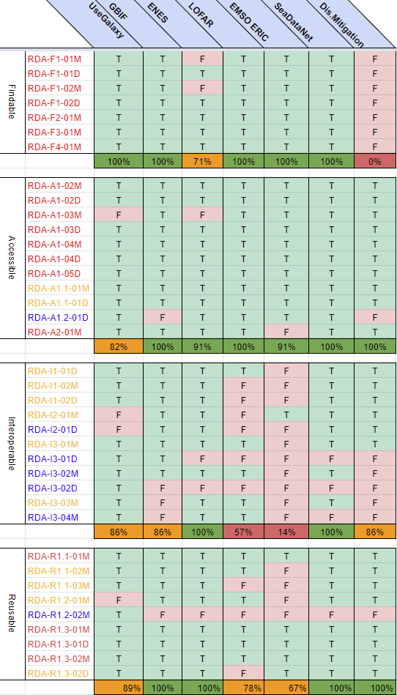
Figure 5 - Initial FAIR maturity assessment responses collected at M12

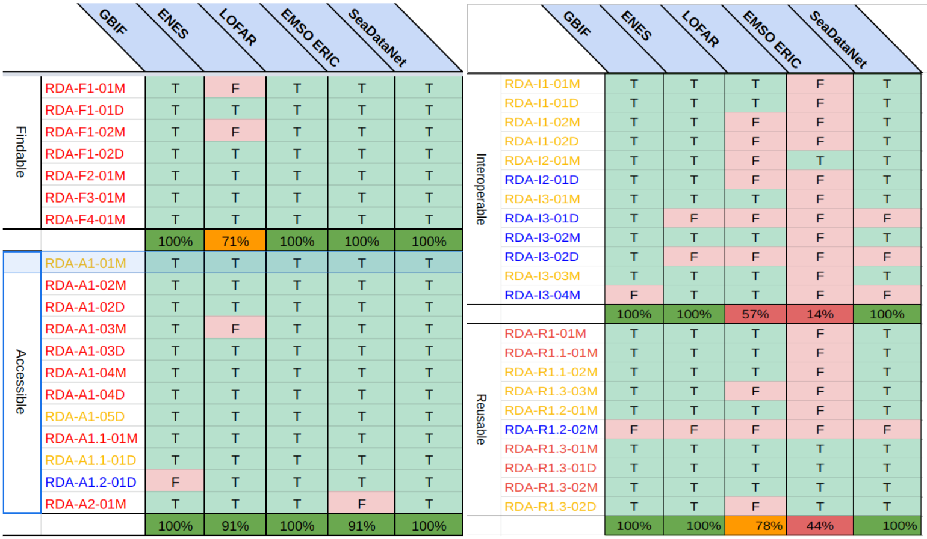
Figure 6 - Final FAIR maturity assessment responses collected at M24

https://www.rd-alliance.org/groups/fair-data-maturity-model-wg
KER = Key Exploitable Result: https://www.egi.eu/project/egi-ace/#services
EOSC Exchange: https://eoscfuture.eu/ker/eosc-exchange/
European Data Strategy and EOSC Data Commons: https://ec.europa.eu/info/strategy/priorities-2019-2024/europe-fit-digital-age/european-data-strategy
EGI-ACE D2.4 Technical, Policy and Service Management Integration Report: https://zenodo.org/record/6602260
https://eosc-portal.eu/5-infraeosc-07-2020-projects
EOSC Future project: https://eoscfuture.eu/
EGI Operations Management Board: https://confluence.egi.eu/display/EGIBG/Operations+Management+Board
https://eosc-portal.eu/
https://marketplace.eosc-portal.eu/
EGI-ACE task 2.2: EOSC Portal alignment and coordination
EGI-ACE services in the EOSC Marketplace (both delivered and supported services are included): https://marketplace.eosc-portal.eu/services?related_platforms=52
Early Adopters (7): IDIA, EISCAT_3D, VIRGO, e-RIHS, PHIRI, GEO-DAB, Terradue Data Spaces (5): GBIF, LOFAR, SeaDataNet, EMSO-ERIC, ENES Thematic Services (10): WeNMR (4), VIP (1), OpenCoast (1), UseGalaxy (1), PROMINENCE (1), DM (1), OPERAS (1) Via the EGI-ACE Open Call: 38
EGI-ACE D2.2 EGI-ACE Strategic Plan: https://zenodo.org/record/5745168
EGI External services: https://www.egi.eu/services/
EGI Internal services: https://www.egi.eu/services/federation/
If the EGI-ACE tag is present to the service in the EOSC Marketplace, then the service appears in the EGI-ACE specific listing here: https://marketplace.eosc-portal.eu/services?related_platforms=74. The lack of tags are due to the fact that have to be added by the provider organisation, and sometimes tags disappear due to suspected bug in the EOSC Marketplace.
Data sources in the EOSC Portal: https://search.eosc-portal.eu/search/data-source?q=*
EGI-ACE D2.2 EGI-ACE Strategic Plan - https://zenodo.org/record/6944570#.Y6BHQnaM5D8
EGI Use cases: https://www.egi.eu/solutions/use-cases/
EGI-ACE services: https://www.egi.eu/project/egi-ace/#services
https://www.eosc.eu/advisory-groups/technical-interoperability-data-and-services
https://aarc-project.eu/
https://aarc-project.eu/about/aegis/
B2DROP service: https://marketplace.eosc-portal.eu/services/b2drop
Zenodo service: https://marketplace.eosc-portal.eu/services/zenodo
https://www.eosc-hub.eu/eosc-hub-key-exploitable-results/#KER2
FitSM IT Service Management standard: https://www.fitsm.eu/
https://www.egi.eu/services/
https://www.egi.eu/services/federation/
FitSM-1 document - Requirements: https://www.fitsm.eu/downloads
FitSM-2 document - Objectives and Activities: https://www.fitsm.eu/downloads
FitSM-3 document - Role model: https://www.fitsm.eu/downloads
FitSM courses by EGI: https://indico.egi.eu/category/327/
https://zenodo.org/record/6602260
FAIR Data Maturity Model Working Group: FAIR Data Maturity Model Specification and Guidelines: https://zenodo.org/record/3909563
There are only Essential indicators in the Findable area.

