EGI-InSPIRE

Roadmap for the maintenance and development of the deployed operational tools

EU MILESTONE: MS704

Document identifier: | EGI-MS704-50-V5
Date: | 26/10/2010
Activity: | JRA1
Lead Partner: | EGI.eu
Document Status: | DRAFT
Dissemination Level: | PUBLIC
Document Link: | https://documents.egi.eu/document/50

Abstract
A public report describing the roadmap for all the deployed operational tools over the next 18 months defining release and deployment dates

Copyright notice:
Copyright © Members of the EGI-InSPIRE Collaboration, 2010. See www.egi.eu for details of the EGI-InSPIRE project and the collaboration.
EGI-InSPIRE (“European Grid Initiative: Integrated Sustainable Pan-European Infrastructure for Researchers in Europe”) is a project co-funded by the European Commission as an Integrated Infrastructure Initiative within the 7th Framework Programme. EGI-InSPIRE began in May 2010 and will run for 4 years.
This work is licensed under the Creative Commons Attribution-Noncommercial 3.0 License. To view a copy of this license, visit http://creativecommons.org/licenses/by-nc/3.0/ or send a letter to Creative Commons, 171 Second Street, Suite 300, San Francisco, California, 94105, USA. The work must be attributed by attaching the following reference to the copied elements: “Copyright © Members of the EGI-InSPIRE Collaboration, 2010. See www.egi.eu for details of the EGI-InSPIRE project and the collaboration”.
Using this document in a way and/or for purposes not foreseen in the license, requires the prior written permission of the copyright holders.
The information contained in this document represents the views of the copyright holders as of the date such views are published.

Delivery Slip
 | Name | Partner/Activity | Date
From | T. Antoni | KIT / JRA1 | 28/07/2010
Reviewed by | Moderator:  Reviewers:
Approved by | AMB & PMB

Document Log
Issue | Date | Comment | Author/Partner
1.0 | 28/07/2010 | First draft | T. Antoni / KIT
2.0 | 06/08/2010 | Second Draft including input from the tool developers | T. Antoni / KIT
3.0 | 02/09/2010 | Comments from Daniele Cesini | T. Antoni / KIT
4.0 | 05/10/2010 | Comments from the reviewers  New input from Operations Portal and GGUS  Further input requested but still missing for most of the tools | T. Antoni / KIT
5.0 | 22/10/2010 | Including new input from all tools | T. Antoni / KIT

PROJECT SUMMARY

To support science and innovation, a lasting operational model for e-Science is needed − both for coordinating the infrastructure and for delivering integrated services that cross national borders.

The EGI-InSPIRE project will support the transition from a project-based system to a sustainable pan-European e-Infrastructure, by supporting ‘grids’ of high-performance computing (HPC) and high-throughput computing (HTC) resources. EGI-InSPIRE will also be ideally placed to integrate new Distributed Computing Infrastructures (DCIs) such as clouds, supercomputing networks and desktop grids, to benefit the user communities within the European Research Area.

EGI-InSPIRE will collect user requirements and provide support for the current and potential new user communities, for example the ESFRI projects. Support will also be given to the current heavy users of the infrastructure, such as high energy physics, computational chemistry and life sciences, as they move their critical services and tools from a centralised support model to one driven by their own individual communities.

The objectives of the project are:

- The continued operation and expansion of today’s production infrastructure by transitioning to a governance model and operational infrastructure that can be increasingly sustained outside of specific project funding.
- The continued support of researchers within Europe and their international collaborators that are using the current production infrastructure.
- The support for current heavy users of the infrastructure in earth science, astronomy and astrophysics, fusion, computational chemistry and materials science technology, life sciences and high energy physics as they move to sustainable support models for their own communities.
- Interfaces that expand access to new user communities including new potential heavy users of the infrastructure from the ESFRI projects.
- Mechanisms to integrate existing infrastructure providers in Europe and around the world into the production infrastructure, so as to provide transparent access to all authorised users.
- Establish processes and procedures to allow the integration of new DCI technologies (e.g. clouds, volunteer desktop grids) and heterogeneous resources (e.g. HTC and HPC) into a seamless production infrastructure as they mature and demonstrate value to the EGI community.

The EGI community is a federation of independent national and community resource providers, whose resources support specific research communities and international collaborators both within Europe and worldwide. EGI.eu, coordinator of EGI-InSPIRE, brings together partner institutions established within the community to provide a set of essential human and technical services that enable secure integrated access to distributed resources on behalf of the community.

The production infrastructure supports Virtual Research Communities − structured international user communities − that are grouped into specific research domains. VRCs are formally represented within EGI at both a technical and strategic level.
Table of contents
1. Introduction 5
1.1. Purpose 5
1.2. Application area 5
1.3. References 5
1.4. Document amendment procedure 5
1.5. Terminology 5
2. EXECUTIVE SUMMARY 6
3. List and status of tools 7
3.1. Operations Portal 7
3.1.1. Current status 7
3.1.2. Dependencies 7
3.2. GGUS 7
3.2.1. Current status 7
3.2.2. Dependencies 7
3.3. GOCDB 8
3.3.1. Current Status 8
3.3.2. Regionalisation 8
3.3.3. Dependencies 8
3.4. Accounting Repository 8
3.4.1. Current Status 9
3.4.2. Dependencies 9
3.5. Accounting Portal 9
3.5.1. Current Status 9
3.5.2. Dependencies 9
3.6. Service Availability Monitoring Framework 9
3.6.1. Message Broker 9
3.6.2. MyEGI 9
3.6.3. Nagios Config Generator 10
3.7. Metrics Portal 10
3.7.1. Current Status 10
3.7.2. Dependencies 10
4. Roadmaps for the first 18 Months 11
4.1. Operations Portal 11
4.2. GGUS 11
4.3. GOCDB 12
4.4. Accounting Repository 12
4.5. Accounting Portal 13
4.5.1. Regional instance roadmap 13
4.5.2. Central instance roadmap 13
4.6. Service Availability Monitoring Framework 14
4.6.1. Message Broker 14
4.6.2. MyEGI 14
4.6.3. Central databases 14
4.7. Metrics Portal 15
5. Conclusions 16

Introduction

Purpose
The purpose of this milestone is compiling the first year roadmaps for all the deployed operational tools defining release and deployment dates. The two main parts of the document are a status description of all the tools, including their dependencies, and a section containing the roadmaps.

Application area
This document is a formal deliverable for the European Commission, applicable to all members of the EGI-InSPIRE project, beneficiaries and Joint Research Unit members, as well as its collaborating projects.

References
Table 1: Table of references

R 1 | MS701 – Operations Portal Workplan: https://documents.egi.eu/document/39
R 2 | GGUS Portal: www.ggus.org
R 3 | GOCDB technical documentation:  http://goc.grid.sinica.edu.tw/gocwiki/GOCDB_Technical_Documentation
R 4 | GOCDB latest released version:  http://www.sysadmin.hep.ac.uk/rpms/egee-SA1/centos5-devel/x86_64/repoview/gocdb.html
R 5 | GOCDB latest development version:  http://www.sysadmin.hep.ac.uk/svn/grid-monitoring/trunk/gocdb/
R 6 | Accounting Repository documentation main page:  http://goc.grid.sinica.edu.tw/gocwiki/ApelHome
R 7 | NAGIOS alarm system homepage:  http://www.nagios.org/
R 8 | Message broker – Active MQ  http://activemq.apache.org/
R 9 | MS702 – Establishing the operational tool product teams:  https://documents.egi.eu/document/60

Document amendment procedure
Amendments, comments and suggestions should be sent to the authors. The procedures documented in the EGI-InSPIRE “Document Management Procedure” will be followed:
https://wiki.egi.eu/wiki/Procedures

Terminology
A complete project glossary is provided in the EGI-InSPIRE glossary:
http://www.egi.eu/results/glossary/.

EXECUTIVE SUMMARY
This milestone “Roadmap for the maintenance and development of the deployed operation tools” is a recurring milestone. One is planned for the beginning of each project year. The aim of the milestone is to give an overview of the plans for the developments for the operational tools, describing their release schedules and the content of each release. Of course the plans have to be adapted to changes to the operations model and procedures. This is especially valid for this first edition of the milestone, as the details of the operational procedures are still being defined. It is also clear that the level of detail that can be provided concerning the content of specific releases will be larger of releases closer to the time of writing of the milestone than for releases close to the end of the year considered.
The tools in the scope for the milestone are:
- Operations Portal
- GGUS
- GOCDB
- Accounting Repository
- Accounting Portal
- Service Availability Monitoring
- Metrics Portal
For each of these tools there are two sections. In chapter 3 the current status of the tools and their dependencies to other tools are described. This is meant to provide the background on which the new developments and plans will be realised. It can be seen in this chapter, that there are lots of interdependencies between the tools. Some of the tools are of utmost importance for the functioning of the overall operations infrastructure. For those tools sophisticated fail over mechanisms should be in place to make sure that the availability and reliability of the tools can be maximised.
Chapter 4 of this document contains the roadmaps for all the tools in scope. All development teams have detailed plans for the first year. Nevertheless it is important that the advisory bodies put in place to steer and monitor this activity start their work soon. The requirements coming from the users of the various tools need to be channelled and prioritised by these groups and discussed with the developers, to make sure that changes don’t jeopardise the integrity of the interplay between the tools.

List and status of tools

Operations Portal

Current status
The Operations portal is described in detail in the EGI-InSPIRE milestone document MS701 [R 1]. In this milestone the focus is therefore in this paragraph only on dependencies with other tools.

Dependencies
The Operations portal depends on a number of tools and middleware services to gather status information about the grid. Information gathered from the external sources is cached in Lavoisier in order to preserve the tool functionality and to increase its robustness in case of problems to retrieve fresh information from the sources. The Operations portal depends on:
- GOCDB
- SAM PI
- ActiveMQ broker network and Nagios services
- GSTAT
- BDII
Other services on which the Operations Portal depends are GGUS and VOMS.
GGUS tickets are created and updated via SOAP calls. If GGUS is unavailable we can't ensure a correct behaviour of the application.
We retrieve information from the different VOMS servers to feed our database of users. If a VOMS server is unavailable for some time the resulting list of users is not updated but the functionality of the tool is not compromised.

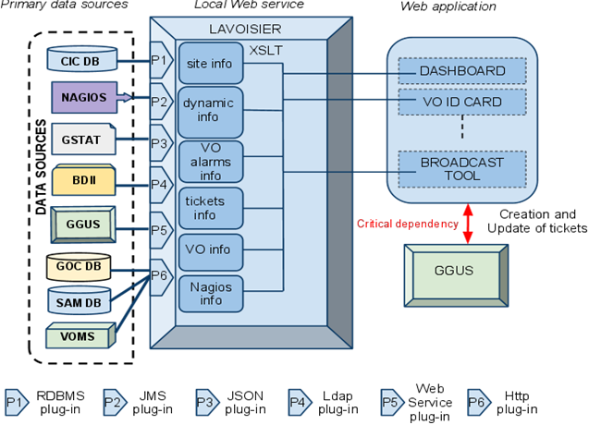
Figure 1: Schematic view of the Operations Portal and its dependencies

GGUS

Current status
The role of GGUS [R 2] in the EGI infrastructure is more or less the same as in EGEE. Nevertheless there are various workflows to adapt and details to be changed. The major on-going task is to include the new NGIs in GGUS. This can happen in different ways. The simplest solution is to just have support unit for the new NGI. The most sophisticated solution is to have an interface to the NGI helpdesk system that enables a seamless transfer of tickets between the two systems. In the July 2010 release of GGUS a first version of the regionalised GGUS (xGUS) has been made available for NGI-DE. Another instance of this is currently under development for NGI_AEGIS.
A workflow for middleware related issues has been agreed between EGI and EMI and IGE.
New support units for working groups and other bodies within EGI are being set up.
GGUS depends on the gathering of requirement from its users. These requirements will be collected mainly by the OTAG and the USAG, once these bodies start their work.

Dependencies
GGUS depends on:
- GOCDB (site names, email contacts)
- OIM (OSG Information Management System)
- VOMS (rights for Team/Alarmers)
Information is regularly extracted from these systems and stored in GGUS. In case of the GOCDB and OIM this is the information needed for the direct assignment of tickets to sites, e.g. site contact and NGI/ROC affiliation. In VOMS the special attributes for the team and alarm tickets are defined. Since the retrieved information is stored locally a failure of these tools for GGUS only means that there are nor updates of the information.

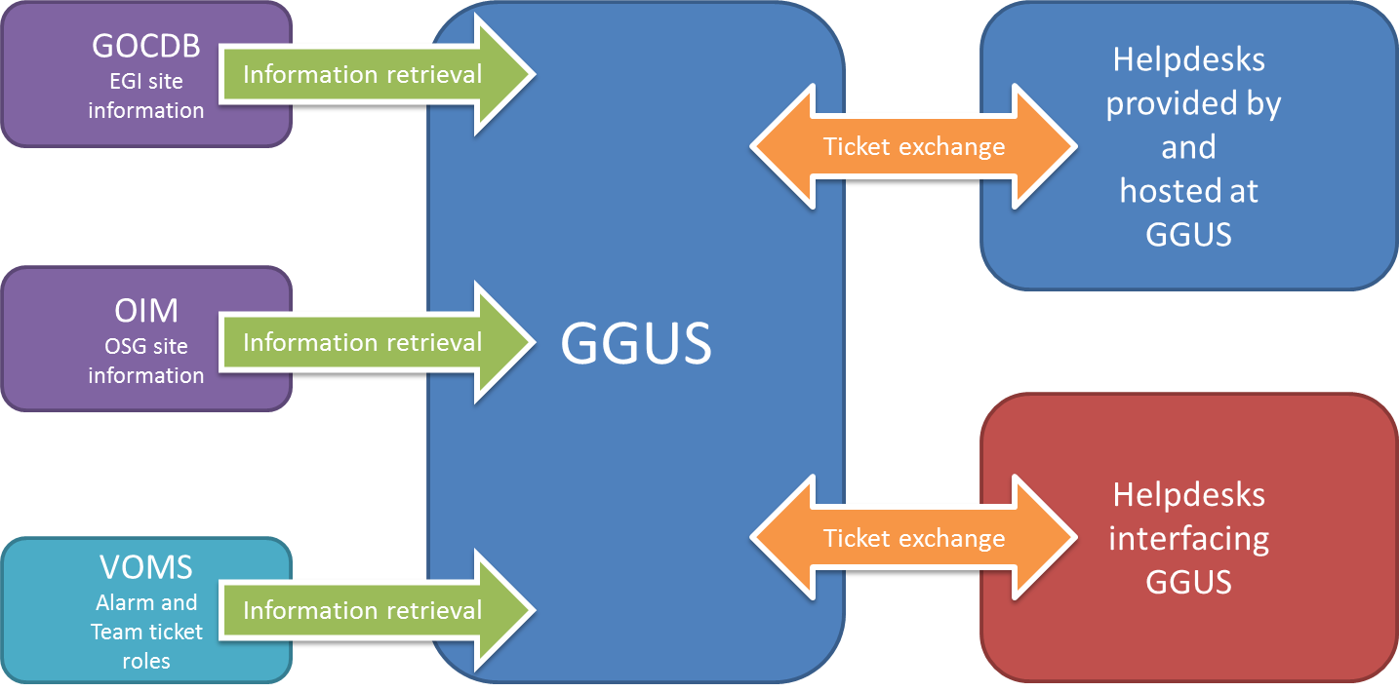
Figure 2: Schematic view of GGUS dependencies to and from other tools
The GGUS platform is helpdesk provider for:
- CIC
- LHCOPN
- ROC DECH
- NGI_AEGIS (under development)
If GGUS is in downtime these helpdesks are as well. They are all included in the GGUS fail over concept, which will be finalised at the end of the year.
GGUS interfaces to ROC helpdesks:
- AP
- RU
- NE
- SE
- SW
- CE
- CERN
- OSG
During GGUS downtimes they work as stand-alone systems. Tickets are resynchronised afterwards. The interfaces are either done via web services or via messaging. Some older ROC helpdesk interfaces are still realised partially by e-mail.
GGUS interfaces to NGI helpdesks:
- CZ
- France
- GRnet
- PL
- DE
During GGUS downtimes they work as stand-alone systems. Tickets are resynchronised afterwards. The interfaces are either done via web services or via messaging. Some older ROC helpdesk interfaces are still realised partially by e-mail.

GOCDB

Current Status
As of the end of July GOCDB is in a transition phase between GOCDB3 and GOCDB4 [R 3]. The GOCDB4 central portal is online since November 2009. Data appearing there are synchronised from GOCDB3 data. The GOCDB3 Programmatic Interface has been decommissioned on the 15th of July. As a result, all client tools connecting to GOCDB are all contacting GOCDB4 and there is no more dependency on GOCDB3. The GOCDB4 input system which is due to replace GOCDB3 web portal is under finalisation and testing.

Regionalisation
The last released version of GOCDB regional module dates from March 2010 (gocdb4.0d3). It is not a fully functional tool but all the basic components are included so that initial deployment can be tested using that version. It is available at [R 4]
The latest development version of the module has not been packaged yet, but the code is available from the SVN repository at [R 5].
This development version is a fully functional system, although additional development and enhancements are needed before this can be labelled "production". The estimated timeline for this is September 2010.
The documentation is available on the wiki page GOCDB Regional Module Technical Documentation.
Important note: GOCDB regional modules can't be operated in production until GOCDB3 has been fully decommissioned.

Dependencies
As a primary source of information GOCDB doesn't depend on any other tool. For completeness, below is a list of tools that have dependencies on GOCDB:
- Operations portal and operations dashboard (IN2P3)
- ATP (CERN)
- Top-BDII config generator (CERN)
- GridView (CERN)
- NCG (SRCE)
- Regional Nagios (CERN)
- GGUS (KIT)
- Gstat (ASGC)
- SAMAP (Poznan)
- APEL (STFC)
- Accounting Portal (CESGA)
The list is not exhaustive. Some VO specific tools are using the GOCDB programmatic interface (e.g. to feed downtime calendars), and the information may also be used by regional tools (local monitoring, local helpdesks etc.).

Accounting Repository
The EGI accounting repository stores information about the usage of sites resources, primarily computing resources, within the EGI production infrastructure. It receives records from accounting probes running in the sites and exports accounting information to consumers (i.e. the accounting portal for visualization).
Currently the accounting repository runs as a central instance only, but developments are foreseen to have a distributable version that can be installed at a regional or NGI level. See the roadmap section for an estimate timeline of this development. More information on the accounting repository can be found here [R 6]

Current Status
As of the end of July 2010 the usage record transport mechanisms adopted by the APEL server is in a transition from R-GMA to ActiveMQ. Decommission of the R-GMA server is planned for the end of 2010.
- The ActiveMQ based APEL client has been released to production within gLite3.2 early June 2010.
- Around 41 sites are using this version at the time of writing.
- The server accepts publication from both systems in parallel. They are then processed and archived in exactly the same way.

Dependencies
APEL’s only dependency is on GOCDB , which is used to retrieve information necessary to build the EGI topology information used for summaries and the ACLs for the APEL AMQ broker.

Accounting Portal

Current Status
The accounting portal allows dynamic queries against aggregated accounting data produced by the NGI/EIROs’- accounting infrastructures and gathered by different accounting sensors (e.g. APEL, DGAS, SGAS, Gratia. The accounting portal is a central access point providing an aggregated view. Topology information is extracted from GOCDB. The set of usage information to display is selected according to the client’s role to comply with the privacy policy endorsed by EGI. Currently the accounting portal exists as a central instance only.

Dependencies
- GOCDB
- Accounting Repository
- Operations Portal

Service Availability Monitoring Framework
The Service Availability Monitor (SAM) is the system that is used to monitor EGI resources within the production infrastructure. It includes the following components:
- The test framework: based on the NAGIOS system [R 7] set up and customized by the NAGIOS Configurator (NCG)
- Database components: The Aggregated Topology Provider (ATP), the Metric Description Database (MDDB) and the Metrics Result Database (MRDB)
- Message bus (ActiveMQ[R 8]) to publish the monitoring results
- A visualization tool: MyEGI

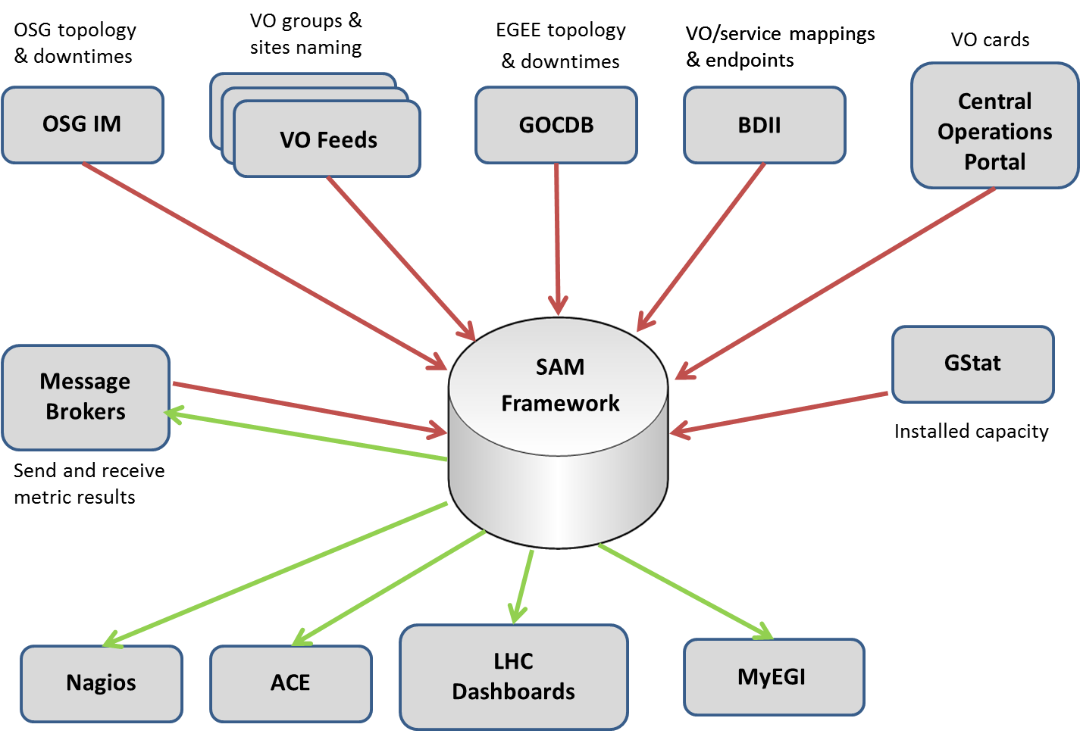
Figure 3: Schematic view of the depencencies of the SAM framework

Message Broker
The network of message brokers is deployed centrally. The fully connected mesh network is located at three geographically separated locations (brokers are distributed among CERN, Croatia and Greece). Although the operation of the broker network does not depend on any other tool (the software is self-contained), for the configuration part information is taken from the GOCDB through the GOCDB programmatic interface.

MyEGI
The MyEGI portal is available either for regional deployment on a regional/national nagios instance or for central deployment on top of the central EGI databases. The portal depends on the correct functioning of the underlying Nagios instances, and on the availability of the messaging network in order to collect and inport messages into the portal.
Currently MyEGI is deployed with all regional, national and project level instances of Nagios.

Nagios Config Generator
The Nagios Config Generator (NCG) is a core component of Service Availability Monitoring Framework. The main function of NCG is the bootstrapping of the Nagios monitoring system by generating its configuration, which is based on various existing information sources (e.g. GOCDB, Metric Description Database) and the Nagios administrator’s input.

Metrics Portal

Current Status
The Metrics Portal displays a set of metrics that will be used to monitor the performance of the infrastructure and the project, and to track their changes over time. The portal automatically collects all the required data and calculates these metrics before displaying them in the portal. The portal aggregates information from different sources such as GOCDB, GGUS, GridView, etc. using various connectors provided by the data provider.

Dependencies
Metrics portal depends on:
- GOCDB (number of countries, number of resource centers)
- GGUS (operational tickets, user tickets, unsolved tickets, assignment time, response time)
- GSTAT (number of job slots, total available computing power)
- ACE (availability/reliability)
- Accounting Portal (number of jobs submitted, CPU usage, job efficiency)
In the future, the Operations Portal and ATP can be additional sources of information from which to retrieve metrics information.

Roadmaps for the first 18 Months

Operations Portal
The roadmap for the Operations Portal is described in detail in EGI-InSPIRE milestone MS701.
We will therefore limit the description here to a short summary.
The main objectives for the coming year are the following:

Features | Timeline
Migration to Symfony for the VO ID Card | Release 2-3 . October 11th
Migration to Symfony for the Broadcast | Release 2-4 . November 2010
Migration to Symfony for the Downtime notifications | December 2010
Enhancements of Lavoisier Programmatic Interface | December 2010
Integration of VO specific tests within the Dashboard | February 2011
Release of Lavoisier 2.0 | March 2011
Study of the Harmonisation of GOC DB and Operations Portal | September 2010
Harmonisation of central instances of GOC DB and Operations Portal | August 2011

This summary is an estimation of the coming features in the next year. The priority of new features or improvements needed on existing features could be re-assessed during the year during OTAG meetings.

GGUS
The following topics are on the roadmap for development in the next 18 months. Of course other topics will come up once the advisory bodies like the OTAG and the USAG will have started their work and have gathered requirements from the users of the helpdesk infrastructure.
- Finalize GGUS - VOMS synchronisation automation:
GGUS is notified on every update of the VOMS roles for teamer and alarmers. Up to now manual intervention is necessary to update the GGUS user database with the current users properties. A script will be implemented as a step towards full automation regarding the VOMS - GGUS synchronisation.
(July – September 2010)
- GGUS redesign:
With the end of EGEE and the start of EGI the GGUS website will get a new GGUS logo and a new layout. Along with the trend of decreasing height/width ratio of modern monitors (less height, more width) the navigation bar will be moved from the top to the left of each web page. That way more space for the content will be available.
(July – September 2010)
- Implementation of the cross-project workflow for middleware issues:
For the proper handling of middleware issues a workflow has been agreed between EGI and EMI, the major part of this workflow (also the EMI part) will be implemented within GGUS.
- Report generator enhancements:
New types of reports will be implemented, currently requested is the report "Response time per SU"
(July – December 2010)
- Improve GGUS availability by an improved failover system for the web interface (active/active instead of active/passive).
(August-December 2010)
- Review of support units:
Remove obsolete support units that have no tickets or don't exist any longer
(September-December 2010)
- Review of documentation:
Documentation needs to be reviewed and updated if necessary.
(September-December 2010)
- Review of GGUS support units.
(September 2010 – March 2011)
- On-going improvements to the GGUS interfaces e.g. implementing a web service interface for creating child tickets.
- Migration of support unit mailing lists to “egi.eu” and clean-up of CERN e-groups for GGUS after the complete migration.
- Enhancement of LHCOPN dashboard
Implement new features if required (e.g. integrate with GGUS ticket work flow)

GOCDB
Main directions for GOCDB development in the months to come will follow:
- development, improvement and support of the central GOCDB4 after the decommission of GOCDB3
- development, improvement and distribution of the regional GOCDB
- Work on integration and harmonisation between GOCDB and other operational tools

Below is a more detailed list of tasks:
- Provide a production quality package for GOCDB regional module (Sep 2010)
- improvement of GOCDB failover system and backend replication (Sep 2010)
- Data access optimization (Oct 2010)
- finalisation of the publication interface from regional to central GOCDB (Oct 2010)
- Consolidation and enhancement of the web admin interface for GOCDB regional module (Oct 2010)
- Provide a SOAP interface to GOCDB in parallel to GOCDBPI (Oct 2010)
- Provide a MySQL version of the GOCDB regional module (Apr 2011)
- Work on GOCDB and Operations Portal common front end, as well as on integration with other tools, portals and frameworks (date TBD)

In addition to these high level tasks, development work on GOCDB will include the items put in GOCDB savannah tracker at: https://savannah.cern.ch/task/?group=gocdb
The list of GOCDB development is discussed and validated within the OTAG, and high level objectives are discussed within InspireJRA1.
The plans are published on GOCDB development wiki page at:
http://goc.grid.sinica.edu.tw/gocwiki/GOCDB4_development
More general documentation is available from the main wiki index page at
http://goc.grid.sinica.edu.tw/gocwiki/GOCDB_Documentation_Index

Accounting Repository
Main directions for accounting repository development in the months to come will be the development, improvement and consolidation of the server architecture. Below is a detailed list of tasks:
- Integration with the EGI messaging system and network of brokers. The work is done on APEL side and only needs confirmation from the message broker team
- Delivery of example summary client for integration by Region Cs, e.g. OSG, DGAS, SGAS. (Target: November 2010)
- Redesign study of the server architecture.
(Target: December 2010)
- Ingestion of summary records by central repository. This will allow existing RegionCs to publish by ActiveMQ and stop direct database insertion. Also any new Region Cs to start publishing.
(Target: December 2010)
- Improvement on the archiving of old records.
(Target: April 2011)
- Incremental implementation of the new architecture, depending on the study mentioned above. (Target: October 2011)
- Delivery of prototype regionalised repository for testing by a few Region Bs.
(Target: February 2011)
Analysis early in EGI showed that the central repository was too heavyweight and complicated for distribution to NGIs. The design of a simpler version has started but full deployment is unlikely to take more effort than the 3 months allocated in JRA1 and not be complete by the end of Year 1. The prototype will be delivered and testing with a few NGIs will start in year 1. STFC will continue the work at its own expense until completion.

Accounting Portal
During this period we will focus in improving the regional version of the portal and the new NGI view.
All releases will be discussed inside JRA1 and especially in the OTAG and USAG groups. New functionality requests will be evaluated by these groups.
There is a GGUS SU (Accounting Portal) created to provide specific support about the accounting portal.

Regional instance roadmap
Several NGIs have expressed their interest in deploying the regional instance of the regional portal. The initial version of the regional portal is already available. Some improvements will be done in the following months with respect to the installation scripts. Additional improvements will be incorporated based on the feedback from the candidate NGIs.
In the future the regional accounting portal will use the new accounting infrastructure based on ActiveMQ. This new accounting infrastructure allows greater flexibility to configure regional accounting repositories. Several modifications are foreseen in the regional accounting portal to support ActiveMQ.
Below the expected release dates and functionalities associated with each release are included.

Release date | New functionalities
Dec 2010 | Improved installation support  GOCDBPI-V4 support
March 2011 | New improvements based on NGI feedback
June 2011 | ActiveMQ support

Central instance roadmap
Special focus will be on trying to improve the NGI view and the addition of new functionalities that could be useful to NGIs.
Below the expected release dates and functionalities associated with each release are included.
Release date | New functionalities
July 2010 | GOCDBPI-V4 support  Tier2 report improvements  Tier2 view improvements
Dec 2010 | NGI View V1  Support for the new Italian NGI structure in Tier2 report and Tier 2 view
March 2011 | NGI View V2  Application Domain Accounting first release
June 2011 | Installed Capacity  Report with the Contributed CPUs  Parallel job support
Sep 2011 | Local job accounting  Application Domain Accounting improvements  Storage accounting first release  Improved parallel job support

Service Availability Monitoring Framework

Message Broker
The development of the Message Broker software is maintained by the EMI project. The EGI JRA1 involvement to the Message Broker developments is limited to the harmonization of the Production Message Broker configuration within the EGI operational tools needs.
During the first 18 months of the project we will focus on 3 basic areas:
- Stability and maintenance: this includes the deployment of new EMI releases for messaging tools and the respond to configuration bug fixes on current releases.
- Integration of other operational tools’ needs: this includes the configuration of the broker network based on the requirements that the rest of the tools have. We are already working on the APEL integration, which is about to be deployed.
- Review the way that tools are using the broker network and provide best practices: this is about checking which (EGI) tools are using the broker network and ensure that they are using the information system for their producer/consumer configuration in order to be able to be informed dynamically about changes to the broker network. Scripts and configuration files will be created upon request on behalf of the other operational tools for their messaging configuration.
The Messaging Software maintainers (Apache and EMI project) are providing the documentation for it. All scripts that are developed for the configuration include either manual pages or help options for their operations.

MyEGI
The development of MyEGI is focused on three areas:
- The improvement of the user interface based on user feedback
- Introduction of a more pluggable framework based on well-known design patters such as model-view-controller, facade, etc. and the use of an Object Relational Mapper for database abstraction to allow new features to be added more easily, such as gridmap-style views, NGI views and to be able to answer faster to new user requirements.
- Addition of new views for NGI operations, including gridmap-style views.
New releases are delivered in an incremental fashion, with a release every 3-4 weeks. These will be a mix of bug fixes and new feature development.
We plan for a major release of MyEGI at PM7 with the new pluggable framework (item 2) and for a final release of MyEGI at PM11 with the new views included (item 3).

Central databases
The central database components are required for MyEGI both as a central and regional component. Therefore we see most of the maintenance effort for these to be driven by the development of MyEGI, and any releases would be in sync with MyEGI releases.
The discussion on new developments is highly related to the other tools’ needs thus there is no standard board or meeting for them. We use JIRA task management system for every task that is decided during the discussion as central tracking system. Any input on directions from boards such as the OTAG will be added to JIRA and scheduled along with bugs and improvements coming from other user communities.

Nagios Config Generator
The development of NCG follows Service Availability Monitoring procedures and requirements. During the first 18 months of the project development will be focused on 3 areas:
- Integration with the central database components (Aggregated Topology Provider, Metric Description Database).
- Integration of new resources and probes (e.g. operational tools and grid middleware probes).
- Fault tolerance – NCG depends on centralized information sources which can be unavailable. Basic caching is already implemented, but finer grained fault tolerance mechanisms should be put in place.

Metrics Portal
During this period new metrics will be implemented and existing ones will be improved. Additionally the portal will be updated to support new interfaces to access future releases of operational tools.
Below the expected release dates and functionalities associated with each release are included.
Release date | New functionalities
Dec 2010 | Update current metrics to support new releases of the tools  Availability/Reliability calculations
June 2011 | New features requested by JRA1/SA1 management teams  Update current metrics to support new releases of the tools
Dec 2011 | New features requested by JRA1/SA1 management teams  Update current metrics to support new releases of the tools

Conclusions
This document shows that the deployed operational tools are all interdependent. It is therefore very important, that JRA1 makes sure that the release process for all these tools is well defined and takes these dependencies into account when testing new releases of the tools. The release procedure for all these tools should at least be centrally monitored, to make sure that this complex system of interlinked tools doesn’t break. The EGI-InSPIRE milestone document MS702 [R 9] is addressing this issue. A review of the fail over mechanisms for the tools should be is currently being performed to make sure that the mechanisms match the importance of the tools
All the operational tools have detailed plans for the first year of the project. The plans are still subject to change as the operational procedures are still developing and the tools have to be adapted to these changes. To channel the requirements coming in from the users of the tools it is important that the advisory bodies foreseen for this task (USAG, OTAG) start their work soon.

