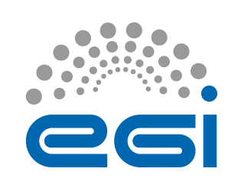
EGI service portfolio
Authors: EGI Services and Solutions Board
& EGI.eu Communications Team
Version: 7
Date: 18 April 2016
Contact: policy@egi.eu

The first edition of the EGI service portfolio was developed during 2013 to improve service orientation and clarify the unique offering that current and potential beneficiaries can request. This first version focused mainly on services internal to EGI as essential to enable the federation to work together and serve international research communities.
This work was initiated in the context of improving the maturity in managing services by developing and implementing best practices for ensuring clarity of service offering and warranties and meeting the expectations of beneficiaries (see [1]).
Later, in July 2015, EGI.eu proposed the establishment of the Services and Solutions Board (SSB) as a new body responsible for managing the portfolio of services and solutions regarding EGI.eu and the EGI federated services, ensuring transparency across functions, and advising the EGI Council (see [2]).
Following the creation of the SSB, the group worked extensively to implement the service portfolio management process (SPM) from FitSM (see [3]), to define the templates and to update the EGI service portfolio.
Following the improved maturity in designing and delivering services, we have proposed an update to the EGI service portfolio that was approved at the EGI Council last November [5]. This version covered both services that are internal to the EGI and services that EGI collectively delivers to the beneficiaries (researchers and SMEs/Industries).
According to the established practice, each service is described in a Service Design and Transition Package (SDTP) document [4] composed of the following sections: 1) Value Proposition, 2) Business case, 3) Service design, 4) Service transition plan.

In order to improve the clarity on the difference between the services that EGI as a federation offers to potential customers vs. the services that are developed internally for EGI to efficiently operate as a federation, we separate them into:
- “EGI service portfolio” containing the services that EGI offers as a federation to potential requesting customers
- “EGI internal service portfolio” containing the services that are organised within the federation to enable EGI resource providers to operate together.
In the next months, we will develop SDTPs documents for all services in the two portfolios.

Expected impact

Improve service orientation

Improve capabilities to promote EGI services and their value
- Improve management of services
- Clarify alignment with the EGI strategy
- Facilitate management interoperability in federated environments
- Provide a better understanding of all the components, dependencies and processes behind service delivery

References
[1] http://fitsm.itemo.org/
[2] https://documents.egi.eu/document/2374
[3] https://wiki.egi.eu/wiki/EGI_Service_Portfolio_Management
[4] https://documents.egi.eu/document/2550
[ [5] https://indico.egi.eu/indico/event/2720/

EGI Service Portfolio
This table presents a summary view of the services that EGI as a federation offers for research and innovation.
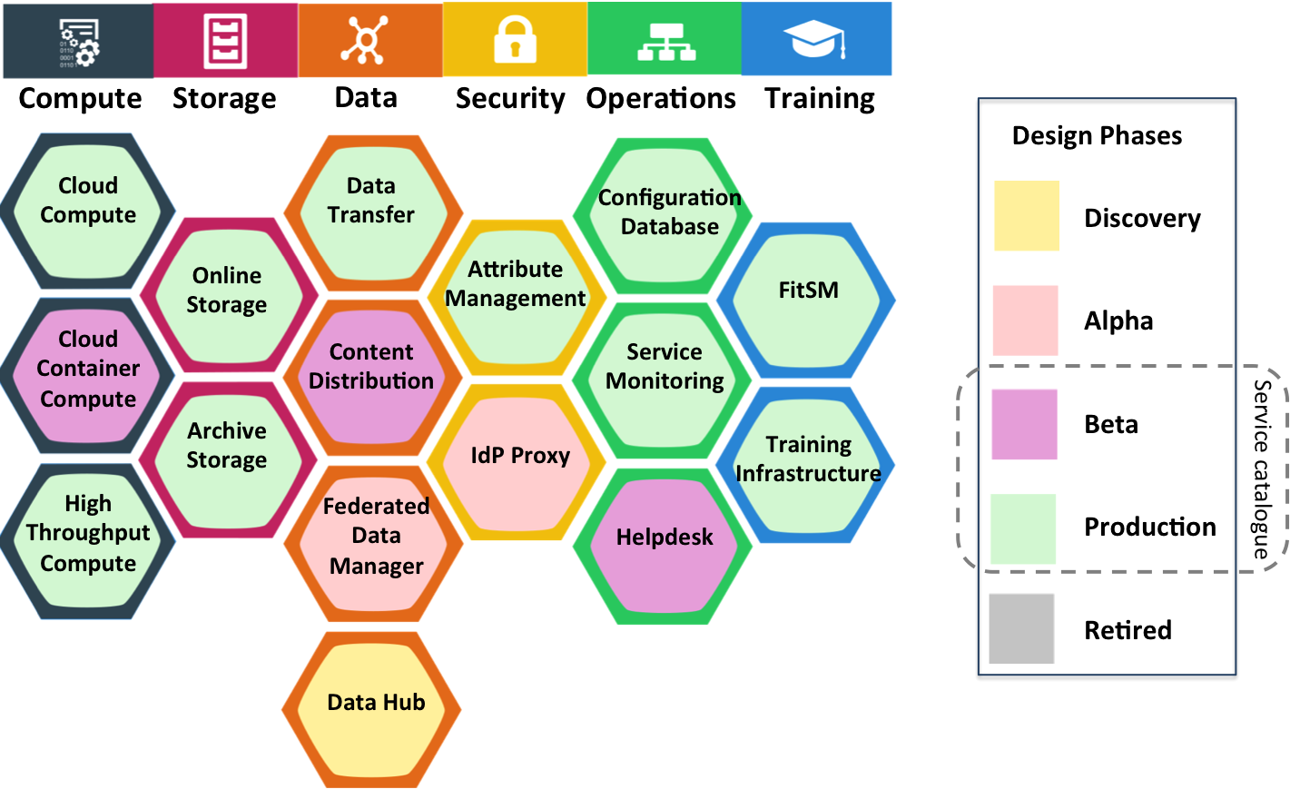

Each service can be in a different design phase defines as follows:
- discovery: researching users needs, exploring technological or policy constraints;
- alpha: prototype available for closed set of users;
- beta: service being developed while available for testing publicly;
- production: service available in the live environment meeting security/performance requirements;
- retired: the service is not anymore offered
The EGI service catalogue(s) will be composed of live services, that is services that are either in beta or production phase.

Service Category | Service name | Description | Benefits | Phase | Performance Indicators
Compute | Cloud Compute | Run virtual machines on-demand with complete control over the computing resources | - On-demand provisioning  - Full control over computing resources  - Standard interface to deploy on multiple service providers | Production
 | Cloud Container Compute | Run Docker containers within isolated user-space with no overhead | - Accessible through different interfaces  - Interoperable and transparent | Beta
 | High-Throughput Compute | Analyse large datasets by executing large numbers (thousands) of computational tasks | - Access large amounts of processing capacity over long periods of time  - Achieve faster results  - Shared resources among users, enabling collaborative research | Production
Storage | Online Storage | Store and retrieve files, their metadata and assign global identifiers on a large scale | - Highly scalable storage system accessible from anywhere  - Easily share data  - Access through different interfaces | Production
 | Archive Storage | Archive files and preserve them for future use in a secure environment | - Stores large amounts of data  - Long-term retention  - Reliable and interoperable | Production
Data | Data Transfer | Transfer asynchronously large sets of files from one storage endpoint to another | - Ideal for very large files  - Able to handle large amounts of files  - Transfer process with automatic retrying | Production
 | Content Distribution | Deliver content with scalable, reliable and low maintenance software and data delivery system available as user-space read-only file system | - Manage centrally the software to distribute across federated environments  - Make content available as a read-only file system that efficiently downloads and caches files on demand | Production
 | Federated Data Manager | Share, discover, and process data federated from different sources | - Single virtual storage that maps virtual paths to physical file paths  - Users can store their data across multiple sites, and can run their applications directly as if the files are local | Alpha
 | Data Hub | Access selected public datasets and efficiently consume them from EGI compute services | - Easy access to selected large-scale datasets  - Easy and efficient access | Discovery
Security | Attribute Management | Manage community membership and expose trusted information | - Easy and trusted way to manage Virtual Organization membership | Production
 | Identity Provider Proxy | Handle transparent Single Sign-On from multiple heterogeneous identity providers | - Easy Single Sign-On from multiple heterogeneous identify providers | Alpha
Operations | Configuration Database | Manage the configuration information of a federated e-infrastructure including the provided service instances and staff contacts | - Ready-to-use solution  - Improves the operation of a distributed infrastructure  - Hierarchical management with roles and capabilities | Production
 | Service Monitoring | Monitor a wide range of platforms and provide operational and business insight for a wide range of built-in and user defined key performance indicators | - Repository of information and solutions  - Progress tracking | Production
 | Helpdesk | Handle service requests and incidents for distributed support teams | - Reduced cost for setting up the monitoring services, minimal development effort  - Ready-to-use user interfaces and flexible availability calculating flexible tools  - Automated reporting tools | Production
Training | FitSM | Learn how to manage IT services with a pragmatic, lightweight and achievable standard | - Increase your expertise in managing IT services  - Increase professional profile by a recognized certification | Production
 | Training Infrastructure | Handle online training courses and learning activities in a dedicated resource pool | - Allows easy deployment, predictability and repeatability of courses  - Customizable Virtual Machine images on the training infrastructure can be deployed before the course | Production

EGI Internal Services Portfolio
This table presents a summary view of the services that are delivered internally to the EGI federation to enable the EGI resource providers to work together.

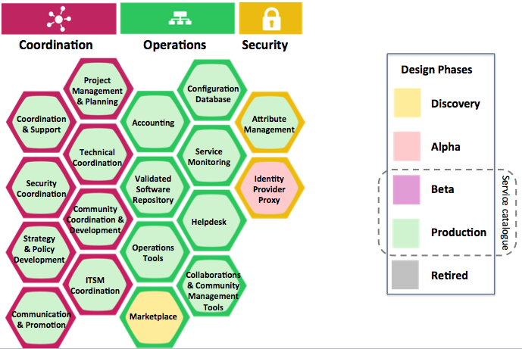

Service Category | Activity name | Description | Benefits | Phase | Performance Indicators
Operations | Configuration Database | Manage EGI resource providers, resource centres and services, including service instances and staff contacts | - Ready-to-use solution  - Highly available and reliable  - Improves the operation of a distributed infrastructure | Production
 | Accounting | Track and report usage of the resources in the EGI infrastructure | - Increased control over resource consumption  - Secure data handling  - Reliable, high available, high performance service | Production
 | Service Monitoring | Monitor EGI services and provide operational and business insight for a wide range of built-in and user defined key performance indicators | - Ready-to-use user interfaces and flexible availability calculating flexible tools  - Automated reporting tools  - Improve the quality of the services, and prove to customers/funders the quality of service achieved | Production
 | Helpdesk | Handle EGI service requests and incidents for distributed support teams | - Central point of contact for support  - Repository of information and solutions  - Keeps track of progress | Production
 | Validated Software and Repository | Manage high-quality software releases for the EGI infrastructure | - Great visibility of the software published and integrated with EGI  - Automatic updates of software packages  - Reduced overall time needed in package management | Production
 | Operations Tools | Integrate resources and operations in EGI federated ecosystem | - Operational integration  - Increased efficiency of running operations in a federated ecosystem  - Easy coordination of large collaborations | Production
 | Marketplace | Discover and access the best IT services, data, instrumentation and research resources to perform multi-disciplinary research in EGI federated environment | - Easily discover expertise that can be tapped into based on usage of resources available  - Increase competitiveness by providing a low cost of entry to expensive technologies for small academic institutions and businesses  - Facilitate inter-disciplinary research by providing access to technologies typically considered outside of a particular field | Discovery
 | Collaboration and Community Management Tools | Manage and coordinate activities ensuring that operational activities across the federated infrastructure work seamlessly, without fragmentation | - Established processes to coordinate operations, user communities, security, integration, and service management  - Facilitated access to existing knowledge  - Documentation policies, information procedures, best practices, data gathering and reporting for specific functions | Production
Security | Identity Provider Proxy | Handle transparent Single Sign-On from multiple heterogeneous identity providers | - Integrate different through sources of identities  - Increased productivity and security | Discovery
 | Attribute Management | Manage community membership and expose trusted information | - Integration with EGI services  - The service operations policies are compliant with EGI policies  - Easy and trusted way to manage Virtual Organization membership | Production
Coordination | Project Management and Planning | Manage projects according to common strategies and policies with other resource providers in Europe and worldwide to support users to collaborate internationally | - Reduced management overhead  - More efficient and effective execution of joint strategies for e-Infrastructures with many partners from different countries  - Stronger connection with the EC policies | Production
 | Operations Coordination and Support | Manage and coordinate activities ensuring that operational activities across the federated infrastructure work seamlessly, without fragmentation | - Benefit from experience from other infrastructures  - Resource providers can use the consulting and other expertise  - Access to one or more research communities | Production
 | Technical Coordination | Gather information about technology development roadmaps and influences these by prioritizing service providers and expert users’ requirements | - Existence a forum for collaborative work and exchange of information  - Communication channels to trusted technology providers  - Reuse of existing solutions and effort focused on integration  - Access to expertise and a test environment | Production
 | Security Coordination | Enhance the capabilities of local security activities in distributed infrastructures | - Increased security in the services  - Increased reputation by implementing mature processes around security | Production
 | Community Coordination and Development | Provide coordination to the NGIs, to structured communities and to industry/SME engagement activities to help these build sustainable user communities for e-infrastructure services | - Speed up the time for resolving problems, or getting new services onto the infrastructure  - Influence the evolution of EGI  - Obtain first-hand information about new services  - Benefit from the experience of other users/members | Production
 | Strategy and Policy Development | Define common strategies and policies with other resource providers in Europe and worldwide to support users to collaborate internationally | - More efficient and effective definition and execution of joint strategies for e-Infrastructures with many partners from different countries  - Stronger influence on the evolution of EC policies | Production
 | ITSM Coordination | Coordinate the implementation and evolution of the IT service management system across EGI | - Defined process to ensure quality of IT services sufficient to satisfy customer requirements | Production
 | Communications and Promotion | Deliver messages beyond the reach of usual communication channels | - Amplify the dissemination of national or field-specific results to a European and research-wide level | Production

