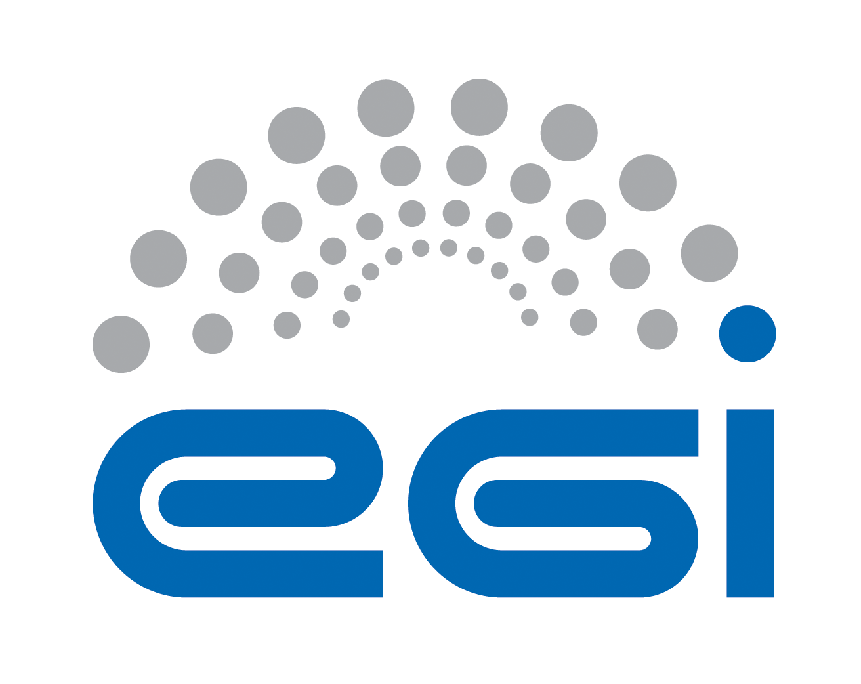
Guide: Service Design and Transition Package

Guide: | Service Design and Transition Package
Author: | Sy Holsinger
Version: | V4
Date: | 29 March 2016
Document Link: | https://documents.egi.eu/document/2550

Purpose and Use

Guide
- This document is a guide to help support the completion of the Service Design and Transition Package (SDTP).
- The guide provides instructions for each section and table that is required for defining and documenting an SDTP.

Template
- The SDTP template is to be used for creating a service design and transition package (SDTP).
- The template provides a structure to be applied for defining and documenting a SDTP, which will be:
  - Section 1 is to be initially completed by the service proposer as input to the SSB for analysis and decision taking to plan/extend the EGI service portfolio service.
  - Once approved by the SSB to move forward, Section 2 is to be completed for presentation to the EGI Executive Board.
  - Once the service is endorsed, Sections 3 and 4 are to be completed by the service owner and relevant team members for service design and transition in consultation with the SSB.
- Once the all activities within the service transition plan have been concluded, this document is closed. If any service undergoes major changes, then a new SDTP is created. For any minor updates and developments will follow the relevant service management processes (e.g. Change Mgmt., Release and Development Mgmt.)

TABLE OF CONTENTS
Purpose and Use 2
Guide 2
Template 2
1 Value Proposition Design 4
1.1 Customer/User Profile 4
1.2 Service Overview 4
2 Business Case Design 5
3 Service Design 7
3.1 Service requirements 7
3.2 Service architecture 8
3.2.1 High-Level Service architecture 8
3.2.1.1 Enabling service components 8
3.2.1.2 Integration and dependencies 9
3.2.2 Technical service architecture 9
3.3 Service acceptance criteria 9
4 Service Transition PLan 11

Value Proposition Design
This first section must be complete as the minimum set of information required for the Service and Solutions Board (SSB) to review, provide feedback as necessary and/or instruct to move forward with Section 2.

Customer/User Profile
(Potential) Customer of the service | A customer commissions the service provider to receive the service, doing so on behalf of a number of users (see below) – specify the organisation type/category of the service e.g. NGI; RI; Resource Provider
(Potential) User of the service | Specify the user type/category of the service e.g. large research groups; individual researcher; site admins
User profile  (pains/gains) | Describe the situation without the new or changed service, including potential pain points the service is intended to resolve or unexploited opportunities for the customer(s).

Service Overview
Service Name | Clear, short name of service
General description | Provide a high-level description of what the service does and functionality included.  i.e. Grid Compute: A service that allows to run computational tasks on high quality IT resources, accessible via a uniform/standard interface and supporting authentication/authorisation based on a membership within a virtual organisation. Grid Compute services are federated together from hundreds of providers across Europe and beyond offering seamless access to computing capabilities with integrated monitoring and accounting.
Value Proposition  (pain relievers / gain creators) | Describe how the new or changed service alleviates specific user pains and/or supports its intended customer(s) to exploit new opportunities.
EGI2020 Strategy | Describe how this aligns to the EGI2020 Strategy  Provide specific reference(s) to the document e.g. page, section numbers

Success criteria
Objective | Indicator | Description | Target
Define one or more strategic objectives for this service | Name of the performance indicator(s) used to measure the progress towards the objective | Short description of the indicator and of how it will be measured | Target value for the chosen indicator(s)

Success criteria are defined with the objectives and may be quantified by performance indicators.

Business Case Design
The following business case has been developed to support informed decision-making with respect to the extension or change of the service portfolio from a strategic perspective. Upon approval by the SSB, this section, together with Section 1, will be presented to the EGI Executive Board by the EGI.eu Director or Technical Director.
 | Best case | Average case | Worst case
Demand assessment | Describe what is the full market potential (all user types / categories and size) and most likely uptake possible | Describe somewhere between the best and worst case scenario | Describe the minimal uptake of the service e.g. only by EGI federation; 1 user group
Assumptions  (about market uptake) | What assumptions need to be made to expect the best case scenario e.g. EC policy supports it; no commercial alternative; high user friendliness will equal mass uptake | What assumptions need to be made to expect the average case scenario e.g. requested by multiple user groups ensuring some uptake | What assumptions need to be made to expect the worst case scenario e.g. service design is high quality and will be supported at least internally
Expected organisational impact on the service provider | In the best case scenario, what organisation changes would need to be made to support the demand e.g. additional staff, expanded data centre, no impact | In the average case scenario, what organisation changes would need to be made to support the demand e.g. additional staff, expanded data centre, no impact | In the worst case scenario, what organisation changes would need to be made to support the demand e.g. additional training of staff, no impact
Expected Cost | Provide an estimate of the resources required to develop (CAPEX) and maintain / operate (OPEX) the service in the best case e.g. human effort; financial investment | Provide an estimate of the resources required to develop (CAPEX) and maintain / operate (OPEX) the average case e.g. human effort; financial investment | Provide an estimate of the resources required to develop (CAPEX) and maintain / operate (OPEX) the worst case e.g. human effort; financial investment
Expected Revenue | What revenue types will the provider obtain in return for the investment described above and possible estimates e.g. direct payment(s); funding; in-kind contribution | What revenue types will the provider obtain in return for the investment described above and possible estimates e.g. direct payment(s); funding; in-kind contribution | What revenue types will the provider obtain in return for the investment described above and possible estimates e.g. direct payment(s); funding; in-kind contribution
Risks | What are the organisational, technical, financial, market and/or legal risks associated to the service provider e.g. inability to scale to demand | What are the organisational, technical, financial, market and/or legal risks associated to the service provider e.g. competitor offers better / cheaper service | What are the organisational, technical, financial, market and/or legal risks associated to the service provider e.g. technology is not mature and stable enough to deliver required customer levels
Constraints / limiting factors | Describe the factors that may limit or hold back the success of the service e.g. size of the market; demand in the market; availability of supply; competition; availability of finances; quality and skills of employees
Access Policy | Select at least 1 of the following 3 access policies the service can be accessed through; if more than one apply, specify the scenario:  - Policy-based: users are granted access to the service based on policies defined by the EGI service provider(s) or by EGI.eu  - Wide access: users can freely access the service provided  - Market-driven: users can negotiate a fee to access the service either directly with the EGI service provider or indirectly with EGI.eu  - Services allowing access to rival services (e.g. computing capacity or storage) are usually provided under as policy- or market-driven.  - Services allowing access to non-rival services (e.g. software packages or scientific data) are usually provided under a wide access policy.

Service Design
With endorsement by the EGI Executive Board and EGI Council, the service design moves forward. The following aspects must be defined comprising the service requirements, the service architecture (both high-level and technical) and the service acceptance criteria.

Service requirements
Following, the results of the service requirements analysis:
Category | Requirements | Weight  (1-10)
Functional and technical service requirements
Availability, continuity and performance-related service requirements
Security and data protection-related service requirements
Usability-related service requirements
Organisational service requirements

Service architecture
The service architecture provides an overview of the key (logical) service components and their dependencies to help better understand the structure and logical as well as technical setup of the service.

High-Level Service architecture
These sections describe how the service is built. A service component is a logical part of a service that provides a function enabling or enhancing a service. A service is usually composed of several service components. A service component is usually built from one or more configuration items (CIs).Although a service component underlies one or more services, it usually does not create value for a customer alone and is therefore not a service by itself.

Enabling service components
Enabling service components are the minimum set of service components that make the service available.
Component name | Description | TRL
Enhancing service components
Enhancing service components are any additional service components that improves the service, however, the service would still run without them, even if at lesser quality. For the TRL, refers to the instructions provided in the previous section.

Component name | Description | TRL

Integration and dependencies
Insert a description and/or visualisation (figure) of the dependencies between the identified service components.

Technical service architecture
Describe the technical service architecture, taking into consideration the following perspectives:
- Environmental architecture
- Network infrastructure
- Hardware
- Software / applications
- Information

Service acceptance criteria
The service acceptance criteria are based on the results from the requirements analysis and listed in the following table:
Category | Acceptance criteria | Critical  (Yes/No)
Functional and technical acceptance criteria
- Functionality to be effectively provided by the service
- Other
Availability, continuity and performance-related acceptance criteria
Security and data protection-related acceptance criteria
Usability-related acceptance criteria
Organisational acceptance criteria
- Criteria for effective communication
- Criteria for effective user or support staff training

Critical acceptance criteria according to the above table are regarded as show-stoppers. That means that, if any of the critical acceptance criteria is not achieved, the deployment of the service to the live environment will be delayed.
Number of unachieved critical acceptance criteria preventing deployment | 1 or more
Number of unachieved non-critical acceptance criteria preventing deployment | [Insert number]

Service Transition PLan
The following table provides the service transition plan for the new or changed service that services as the action plan regarding all activities to be carried out.
Phase | Activities and timing | Responsibilities (RACI) | Links/References to other documents
Specification, negotiation and agreement | e.g. complete service portfolio entry template
Development and procurement
Testing | e.g. carry out assessment of service acceptance criteria
Operation with early life support
Regular operation

http://go.egi.eu/strategy2020
http://www.egi.eu/services/access_policy/
Technology Readiness Levels (TRL) are a method of estimating technology maturity of components during the acquisition process. For non-technical components, you can specify “n/a”. For technical components, you can select them based on the following definition from the EC: - TRL 1 – basic principles observed - TRL 2 – technology concept formulated - TRL 3 – experimental proof of concept - TRL 4 – technology validated in lab - TRL 5 – technology validated in relevant environment (industrially relevant environment in the case of key enabling technologies) - TRL 6 – technology demonstrated in relevant environment (industrially relevant environment in the case of key enabling technologies) - TRL 7 – system prototype demonstration in operational environment - TRL 8 – system complete and qualified - TRL 9 – actual system proven in operational environment (competitive manufacturing in the case of key enabling technologies)

