e-ScienceTalk

Weekly Issues of iSGTW

EU DELIVERABLE: D3.7

Document identifier: | D3 1 iSGTW Weekly Publication
Date: | 11/09/2013
Work package: | WP3
Lead Partner: | CERN
Document Status: | FINAL
Dissemination Level: | PUBLIC
Document Link:

Abstract

This report focuses on the publication of weekly issues of iSGTW which was also supported by social media, advertising and events. It highlights how effective the weekly e-newsletter International Science Grid This Week has been in achieving its aims of successfully driving up its subscriptions and social media activity during the e-ScienceTalk project.

- Copyright notice
Copyright © Members of the e-ScienceTalk collaboration, 2010. See www.e-sciencetalk.eu for details of the e-ScienceTalk project and the collaboration. e-ScienceTalk is a project co-funded by the European Commission as an Support Action within the 7th Framework Programme. e-ScienceTalk began in September 2010 and will run for 33 months. This work is licensed under the Creative Commons Attribution-Noncommercial 3.0 License. To view a copy of this license, visit http://creativecommons.org/licenses/by-nc/3.0/ or send a letter to Creative Commons, 171 Second Street, Suite 300, San Francisco, California, 94105, and USA. The work must be attributed by attaching the following reference to the copied elements: “Copyright © Members of the e-ScienceTalk Collaboration, 2010. See www.e-sciencetalk.eu for details of the EGI-InSPIRE project and the collaboration”. Using this document in a way and/or for purposes not foreseen in the licence, requires the prior written permission of the copyright holders. The information contained in this document represents the views of the copyright holders as of the date such views are published.
- Delivery Slip
 | Name | Partner/Activity | Date
From | C Gater | EGI.eu | 11/09/13
Reviewed by | Moderator: C Gater  Reviewers: Project team |  | 11/09/2013
Approved by | AMB & PMB
- Document Log
Issue | Date | Comment | Author/Partner
1 | 11/09/13 | Final draft | C Gater /EGI.eu
2
3
- Application area
This document is a formal deliverable for the European Commission, applicable to all members of the e-ScienceTalk project and its beneficiaries and collaborating projects.

- Document amendment procedure
Amendments, comments and suggestions should be sent to the authors.
- PROJECT SUMMARY

Over the last 10 years, the European Commission and governments have invested substantial funds in distributed computing infrastructures. Scientists have access to state-of-the-art computational and data resources located around the world, putting European research into a leading position to address the greatest challenges facing us today, such as climate change, pandemics and sustainable energy. The advent of the European Grid Infrastructure, combined with the blurring of boundaries between grids, clouds, supercomputing networks and volunteer grids, means that a clear consistent source of information aimed at non-experts is now more important than ever, through dissemination projects that cross national boundaries.

Objectives:

- e-ScienceTalk will build on the achievements of the GridTalk project in bringing the success stories of Europe’s e-Infrastructure to policy makers in government and business, to the scientific community and to the general public.

- e-ScienceTalk will work with EGI-InSPIRE and other collaborating projects to expand the scope of the existing GridTalk outputs, and to report on the interactions of grids with e-Infrastructures such as cloud computing and supercomputing.

- The project will explore options for the sustainability of e-ScienceTalk’s products.

- e-ScienceTalk will produce a series of reports aimed at policy makers to disseminate key policy issues underpinning grid and e-Infrastructure development in Europe. The project will also coordinate e-concertation activities.

- The GridCafé, GridCast and GridGuide suite of websites will cover new topics and explore novel web technologies; they will integrate closely with GridPP’s Real Time Monitor, combining live views of grid activity with the human aspects of computing.

- The growing weekly publication, International Science Grid This Week (iSGTW) will bring news and events to the existing and potential e-Science community.

- EXECUTIVE SUMMARY

This report focusses on the weekly publication of the e-newsletter International Science Grid This Week. iSGTW has been effective in achieving its aims of successfully driving up its subscriptions and social media activity during the e-ScienceTalk project. In total, 146 issues of iSGTW were published between 1 September 2010 and 31 July 2013.

During the e-ScienceTalk project, the iSGTW website was redesigned and a proactive Marketing Strategy [R1] was also implemented in May 2011. The strategy aimed to increase the website traffic, the number of newsletter subscribers, and range of readers. Five methods were used to achieve this: through conferences and events; media partnerships; collaborating projects; online promotion, including the newsletter, search engines and social media; and setting up iSGTW as a social media site itself.

Since the beginning of e-ScienceTalk, iSGTW’s subscriber numbers have increased by a third. The project has exceeded its target and now has 8,782 subscribers with an increasing number of social media followers (1,726 Twitter followers, 68 Google pluses and 1,167 Facebook). The website had nearly half a million unique visitors and over one million page views. The three readership surveys also give a good indication of success in diversifying our audience [R2, 3 and 4]. social media presence.

Table of Contents
1 Introduction 6
2 Relaunch of iSGTW 7
3 a typical issue 8
4 marketing isgtw to a wider audience 12
5 web statistics, events and social media 13
6 Annual readership survey 14
7 Conclusions 16
8 REFERENCES 17

Introduction

During e-ScienceTalk, the weekly online newsletter, International Science Grid This Week (www.isgtw.org) has broadened its scope significantly to cover e-Infrastructures such as supercomputing, distributed computing, networks, data, cloud and volunteer computing, as well as other forms of distributed computing and their impact on grid development. The newsletter now covers a broad range of international, national and regional grid projects, as well as related developments in the wider world of modern science and research. Throughout the project, the publication has continued to send out a high quality issues with a spread of articles from across the globe, including the US, Europe, Asia Pacific region, Latin America and Africa. In total, ISGTW has published 146 issues during the project.

The content and strategic direction of iSGTW is overseen by the iSGTW Advisory Board, which includes representatives from CERN, Fermilab, EGI.eu, Open Science Grid, Academia Sinica Grid Computing and QMUL. The EU Editor in Chief is based at CERN, and there have been three editors for the publication during the project, Dan Drollette, Jacqui Hayes and Andrew Purcell, supported by Science Writer Adrian Giordani. The publication is produced jointly by the EU Editor and a US Desk Editor, giving a broader geographical scope for the publication, and producing live social media coverage across many time zones. At the start of the project, the US based role was funded by Open Science Grid and was based at Fermilab. Editors included Anne Heavey and Miriam Boon. In PM27, a new US Desk Editor was hired and funded through the National Science Foundation, based at the University of Indiana. iSGTW has managed these changes during the project to deliver a consistently high-quality publication.

From 29th May 2013, iSGTW produced issues with 2 rather than 3 feature articles, together with a spotlight article and a ‘visual’, an article focusing on an iconic image or video. The total number of articles published has therefore decreased in PY3 compared to PY2. This however places the magazine at a sustainable level of content for the reduced post-project effort levels, meaning that the magazine will continue to be issued weekly by the EU and US editors after the end of July 2013. A number of content sharing agreements are in place, or are being negotiated, including with NUANCE published by Ubuntunet and MyScienceWorks, aimed to increase the range and geographical coverage of the publication.

Relaunch of iSGTW

The principle aim in PY1 for iSGTW was to relaunch the publication on a new CMS. During Q1, US web design company Xenomedia worked on building the website using OpenPublish Drupal, in consultation with working groups and strategy groups that included Board and e-ScienceTalk members. This included producing a new navigational structure for the site, a refreshed look and feel to reflect the new branding and additional interactive elements such as polls, surveys and the facility to comment on and share articles through social media channels.

A number of promotional posters were produced in collaboration with WP2 for display at events, including a teaser poster displayed at the 8th e-Infrastructure Concertation Meeting at CERN in November 2011. A screenshot of the website was unveiled at the Fermilab booth at Supercomputing SC10, with an invitation to subscribe to the new publication. A working beta version of the site was submitted as D3.2 in PM3, and this was fully launched with the first issue on 12 January 2011 after extensive beta testing by the Advisory Board. The final issue of iSGTW was published on 22 December as a short issue, signing off the publication and introducing the new one.

The version of the website launched in January 2011 includes a number of additional functionalities:

- Web site with new design and navigational layout
- All legacy content ported across to the new site from the previous iSGTW site
- Site taxonomies (types of content) defined
- Search and advanced search capabilities
- Content tagging (legacy and new)
- Contextual search, simple and advanced
- Registration to the site, enabling readers to comment on and rate articles
- Reader blog section, allowing readers to publish blogs within the site
- Slide show and video galleries
- Reader polls
- Calendar including events
- ShareThis function, enabling easy sharing of the content on social media sites
- Smart phone friendly template compatible with iPhone and Android and other major platforms

In order to formally protect the iSGTW name itself, the name was trademarked in Switzerland under the Madrid protocol after legal searches in France, Benelux, US and the UK.

a typical issue

The main features in a typical issue of iSGTW after the relaunch are shown below:

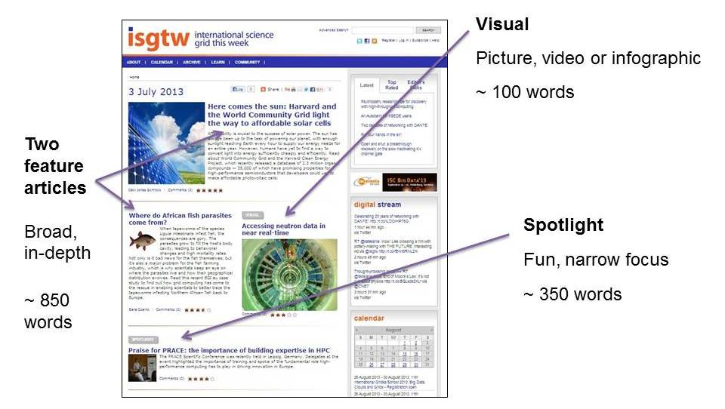
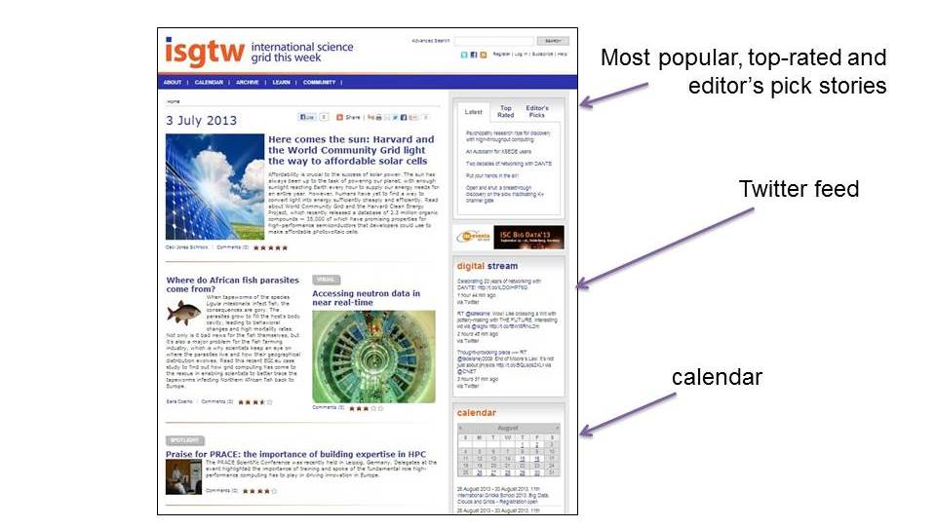
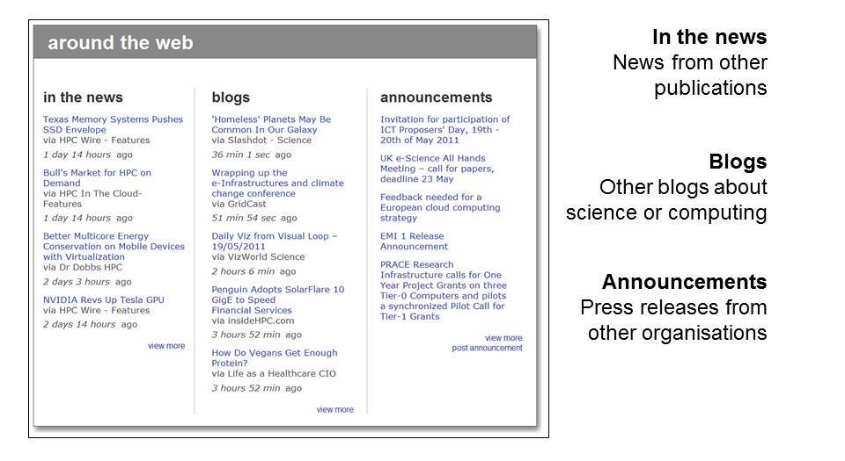
Some examples of iSGTW’s most popular stories are shown below:

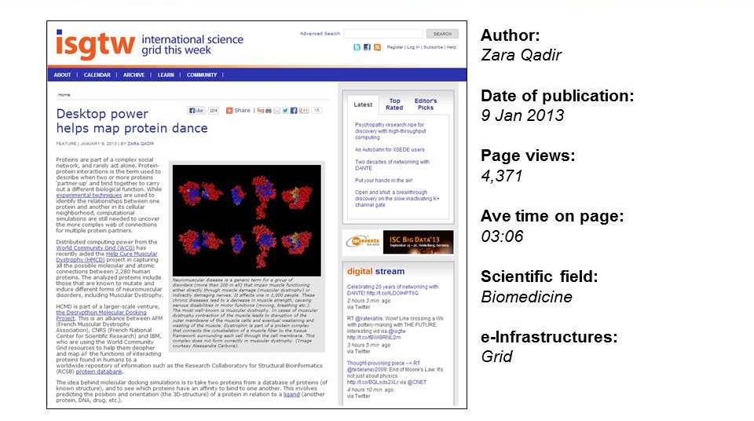
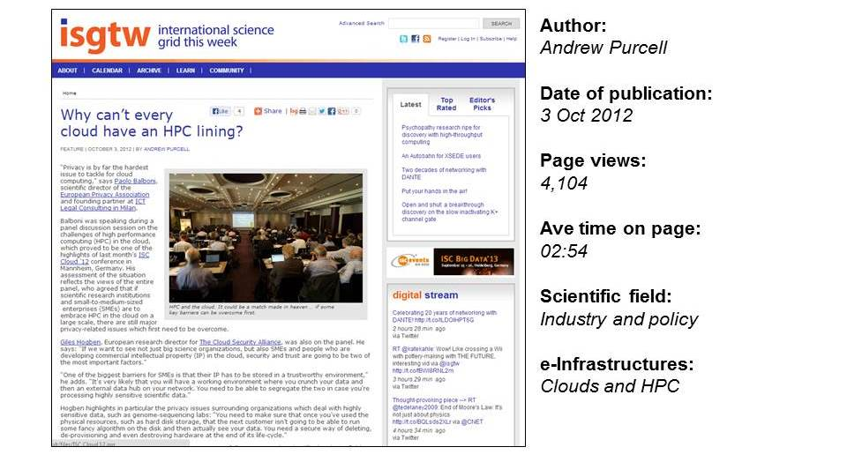
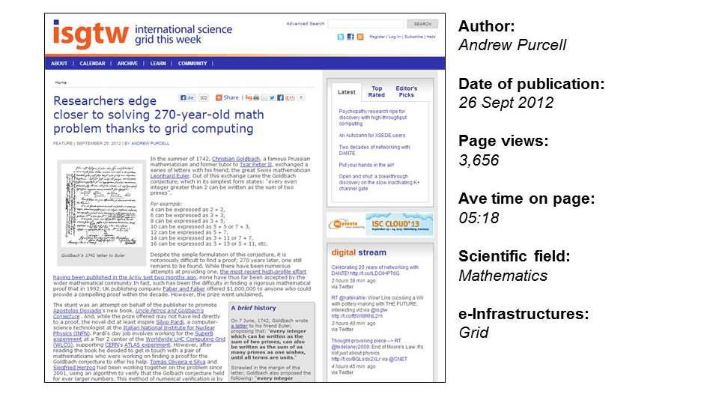
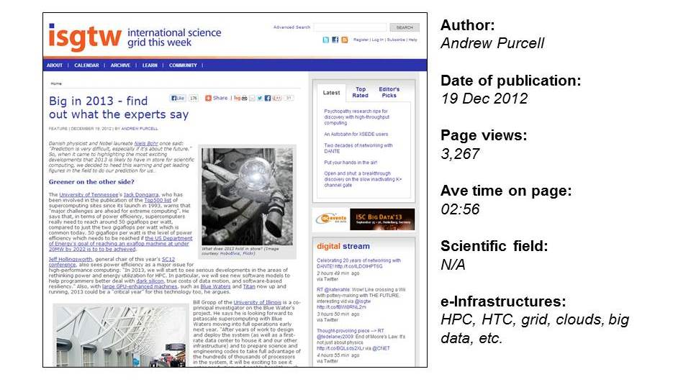

marketing isgtw to a wider audience

In May 2011, iSGTW started a more aggressive campaign to promote iSGTW through branded social media and news aggregators. The suggested plan of action was summarised in a Marketing strategy for iSGTW. This marketing strategy comprised five methods for increasing iSGTW’s impact: (1) conferences and events; (2) media partnerships; (3) collaborating projects; (4) online promotion, including the newsletter, search engines and social media; and (5) setting up iSGTW as a social media site itself. Social media has provided the advantage of giving iSGTW a voice in real-time and an opportunity to share content from other industry sources. In addition, more people can discover iSGTW content (@isgtw and iSGTW Facebook), and this therefore increases the exposure and reach of the project. iSGTW regularly tweets its articles daily, as well as stories around distributed computing and the science it enables, as well as e-ScienceTalk project and MoU partner events and announcements.

During the e-ScienceTalk project, iSGTW has been effective in achieving its aims of driving up its subscriptions and social media activity. Thanks to the proactive marketing strategy, iSGTW has been able to increase subscriber numbers by 30% during the project, as well as significantly increasing the number of number of social media followers (1,726 Twitter followers, 68 Google pluses and 1,167 Facebook).

During the second project year, iSGTW started to see a trend for more rapid social media growth and more modest growth in weekly subscriptions. This continued in the final project year, reflecting a change in the habits of the readership that were largely in line with trends reported by other online news sources. A greater proportion of the audience arrived at iSGTW articles through links from Twitter and blog posts. While readers are now reaching iSGTW in a more piecemeal fashion, the audience is very likely to be broader and more diverse than at the start of the project. So while the rate of increase in subscriber numbers has slowed during PY3, with a slight upturn towards the end of the project, this has been compensated for by a rapid increase in the number of people who follow the publication through its social media channels. In fact, Q11 saw peak unique visitor numbers, page views and visit duration for the entire project. iSGTW’s audience is not only much larger than at the start of the project, but readers are also more engaged (spending longer on visits, and reading more pages per visit).

The media form an increasing proportion of iSGTW’s readers, as shown by the annual readership survey. As a result, iSGTW’s stories are increasing being ‘picked up’ by other media including Symmetry, HPCwire, Discovery News and Wired US and UK, increasing traffic to the publication and widening the audience.

web statistics, events and social media

There have been 440,164 unique visitors visiting the iSGTW website and 1,038,455 page views since the start of the e-Science talk project. This is considerably more traffic than during the previous project, GridTalk. Generally, the website attracts between round 10,000 and 18,000 unique visitors a month, and numbers have climbed further towards the end of the project.

As well as being a highly valuable source of article leads, conferences have proved an effective way to increase exposure and reach out to new communities. The Twitter hashtag from events can be used to promote stories and to respond to news and developments at the conference. Media partnerships give iSGTW a chance to offer delegates at the events the opportunity to sign up to the newsletter. Partnerships with other projects have helped iSGTW to increase subscriber numbers further.

The key to a successful social media strategy has been an increased regularity and frequency of posting. For this, as well as tracking the reach of posts, there are various useful online tools available. In addition to well-known social media outlets, such as Twitter, Facebook, and Google+, academic and professional social networks have been of use, such as LinkedIn, MyScienceWork, and ResearchGate. Other blogging and content aggregator sites, such as Reddit, StumbleUpon, Slashdot, Nature Networks, and Digg, have also been key tools in enabling iSGTW to successfully expand its audience.

Annual readership survey

iSGTW has surveyed its readership annually using an online tool called Zoomerang . The final survey in 2013 had 17 questions in total and was completed by 113 respondents. The surveys in previous years had 137 (PY1) and 236 (PY2) respondents. Many of the questions remain the same each year in order to help compare the results. In the final year, however, a number of the questions were directly related to short and long-term impacts of iSGTW.

The final survey results suggest that iSGTW has quite a dedicated audience, with a comfortable majority of respondents reporting that they read at least three out of every four issues. Meanwhile, a further third report that they read at least half of the issues.

The surveys give the impression of a highly engaged readership, with typically 80 per cent of respondents saying that they have ‘discussed or forwarded an article or issue’. Well over half of respondents also reported that they had saved or bookmarked an article or issue. Significant numbers of respondents report that they have attended an event based on information they have found on our site, or have themselves submitted an event or job announcement to our site. Around 15% of respondents also said that they had contributed in some way to the newsletter at some point and a similar percentage said they had used iSGTW to source an image. In addition, around 13% of respondents reported that they had either cited or linked to iSGTW in a blog, paper, poster or talk.
Respondents in each survey reported that iSGTW is pitched at roughly the right technical level, is relatively easy to navigate, covers a good spread of topics and regions, and is a useful and informative resource for readers. Readers were also asked to tell us which topics they most like to read about. The most popular topics were broadly the same each year. As far as academic subjects are concerned, ‘physics and astronomy’ proved to be the most popular choice and ‘future computing technology’ came out on top in terms of the infrastructure related topics. The consistency of the responses to this survey question over the last three years suggests that these results accurately reflect the readers’ tastes.

Over two thirds of people felt that iSGTW has raised awareness of particular e-science tools, services, resources, projects, initiatives, and/or potential collaborators. Over a third of respondents reported that iSGTW has helped them with their research work and others reported that iSGTW had helped improve the exposure of their work and that iSGTW is a useful resource in terms of establishing new research collaborations. Only around half of respondents reported that they ‘agree’ or ‘strongly agree’ with the statement and “I use iSGTW to keep informed about events and announcements”.

In PY2 and PY3, around 10% of respondents reported that they work in the media. This suggests that iSGTW has significant ‘second order impact’ through the articles that are inspired as a result of journalists and other communications workers reading iSGTW. Despite a reasonably high number of people reporting that they are involved in grid computing, only around half reported that they like to read about this topic. This suggests that the decision to broaden the range of computing topics covered by iSGTW was a good one. Volunteer and cloud computing came out on top as the subjects respondents most like to read about. Despite the large number of respondents reporting that they like to read about volunteer computing, only one fifth reported that they are currently involved with such projects. As such, our coverage of volunteer computing has the potential to act as a way of mobilising people to become involved with these projects themselves.

In terms of the age demographic of the readership, the results have been almost identical in each survey. Consistently, 31-40 is the largest category and there has been a growth in readers aged 51-60. However, iSGTW does not yet target younger, typical university-aged students successfully, with just 10% of respondents saying that they are under 30.

Also, while the vast majority of the audience is male, the proportion of the audience which is female has held steady (at just under a quarter) from PY2. This is up from just 15% in 2008 and 18% in 2011. iSGTW has been publishing articles which are specifically targeted at women in science and there is also a special section on women in the grid on the site, which iSGTW has promoted on suitable occasions using the social media accounts.

Finally, almost 90% of respondents say that they would recommend iSGTW. This suggests that the vast majority of readers believe iSGTW to be a good quality publication.

Conclusions
Now eight years old and having recently reached the milestone of its 400th issue, iSGTW is now a major dissemination channel for e-infrastructure projects in Europe, the US, and further afield. There have been 440,164 unique visitors visiting the iSGTW website and 1,038,455 page views since the start of the e-Science talk project. This is considerably more traffic than during the previous project, GridTalk. Generally, the website attracts between round 10,000 and 18,000 unique visitors a month, and numbers have climbed further recently. In the first six months of this year, traffic (in terms of page views) has been over double that achieved in the first six months of 2012.

REFERENCES

R1 | D33_Marketing_Strategy_final  https://documents.egi.eu/document/533
R2 | e‐ScienceTalk iSGTW Readership Survey July 2008 https://documents.egi.eu/document/754
R3 | e‐ScienceTalk iSGTW Readership Survey December 2008 https://documents.egi.eu/document/753
R4 | e‐ScienceTalk iSGTW Readership Survey July 2009 https://documents.egi.eu/document/755

https://documents.egi.eu/document/533
www.zoomerang.com

