Strategy and Innovation Board (SIB)
TERMS OF REFERENCE
Document identifier | EGI-doc-2131-v6
Document Link | https://documents.egi.eu/document/2131
Last Modified | 04/04/2016
Version | vfinal
Policy Group Acronym | SIB
Policy Group Name | Strategy and Innovation Board
Contact Person | Yannick Legré, EGI.eu
Document Status | FINAL
Approved by | EGI Council
Approved Date | 12/11/2015

DOCUMENT LOG
Issue | Approval Date | Approved by | Amendment
v.1 | 22 May 2015 |  | Initial outline for discussion
v.2 | 28 Oct 2015 |  | Revised version from Council Feedback for approval
v.3 | 10 Nov 2015 | EGI.eu Council | Revised version for Council Approval
v.4 | 10 Jan 2016 |  | Revised version from Council Feedback
v.5 | 25 Feb 2016 |  | Typos and material corrections
v.6 | 04 Apr 2016 |  | Cleaned version
TERMINOLOGY
A complete project glossary is provided at the following page: http://www.egi.eu/about/glossary/

Contents
1 Title 3
2 Definitions 3
3 Purpose and Responsibilities 3
4 Authority 3
5 Composition 3
5.1 Membership 3
5.2 Chair 4
5.2.1 Duties 4
5.2.2 Term of Office 4
5.3 Secretary 4
5.3.1 Duties 4
5.3.2 Term of Office 5
5.3.3 Method of Appointment 5
6 Operating Procedures 5
6.1 Communications and Meetings 5
6.2 Decision Making 5
6.3 Reports 6
7 Amendment 6
7.1 Entry in Force, Review, Approval 6
7.2 Amendment log 6
Annex A: Organogram of EGI policy groups 7

Title
The name of the group is Strategy and Innovation Board (“SIB”, hereafter also referred to as “the Group”).

Definitions
There are no additional key terms that need to be described in order to understand the SIB ToR. For a complete list of all terms, the EGI Glossary V2 is to be referenced.

Purpose and Responsibilities
The Strategy and Innovation Board (“the Group”) will provide advice and guidance to the EGI council and to EGI.eu leadership about the strategy in terms of:
- Relationship and service provision to user communities
- Relationship to other e-infrastructures
- Relationship to industry
- Technology and innovation
- e-infrastructure organisation and management

Authority
The Group is authorised by the EGI Council to investigate any activity within its Terms of Reference. The EGI Council is the governing body of the Group.

Composition

Membership
The Group is composed by 9 members. Membership should involve high-level representatives of the following sectors:
- Public research: 3 members
- Computing/Data: 2 members
- Big industry: 1 member
- SMEs: 1 member
- Policy makers/advisors: 2 members
Members are appointed for a 2-year term renewable once. Every 2 years, a call for nomination is issued and publicised through EGI council representatives and EGI communication channels and will stay open for a period of one month. Applications are open to anyone and should include a short statement of interest (1 paragraph) and brief CV (1 page). Applications will be reviewed by the EGI.eu Executive Board (EB) before selection through a vote of the EGI Council.
Attendance to SIB meetings is open to EGI council and Executive Board members, EGI.eu Director, EC representatives and invited guests under EB supervision to provide the SIB with information of current direction, achievements and foreseen strategy.
Members of the group are treated as individual experts who do not formally represent any constituency and their recommendations does not imply any approval or endorsement by their respective organisations.

Chair
The Chair is appointed and renewed by the EGI Council Chair in consultation with the EGI.eu Director. The Chair is selected among the members of the SIB.

Duties
- The Chair will be responsible for calling and running regular meetings and polling the membership for agenda items
- The Chair will represent the SIB and report on its work to the Council. If the chair of the group is not available to discuss at the council he/she will appoint a deputy from the SIB. The EGI Council Chair can take the mantle on if absolutely necessary.
- Regular agenda items include, but are not limited to:
  - Ensuring updates to the list of recommendations to the EGI Council
  - Reviewing and prioritising topics brought to the attention of the Group
  - Nominating a note taker at the beginning of each meeting that records minutes and circulate for approval within 5 working days
  - Providing materials for the agenda points will indicate if the item is informational or is designed to lead to a decision

Term of Office
The term of office is 2 years.

Secretary
EGI.eu will offer secretarial support in the organisation of the Group meetings and editing of the recommendations document.

Duties
Duties of the Secretary include:
- Assisting with the logistical details of meetings (be they face to face or phone/video)
- Support agenda preparation
- Taking and distributing minutes at the Group meetings
- Preparation and development of the recommendations document
- Assisting with the provision of, management and maintenance of document repositories and Group web(s) and wiki(s)

Term of Office
There is no limit.

Method of Appointment
The Secretary is nominated by the EGI.eu Director upon request by the Group chair.

Operating Procedures

Communications and Meetings
- All the members of the Group must subscribe to the SIB@mailman.egi.eu mailing list and should use it as primary written communication channel.
- The Group deliberations happen by face-to-face meetings, phone/video conferences or via the Group mailing list.
- A quorum of members must be present before a meeting can proceed. At least 50% members must be present for the meeting to proceed.
- The Group will meet at least 3 times a year (2 virtual meetings and 1 face-to-face meeting).
- Where practicable, the agenda together with reports and documents that relate to the Group will be forwarded to members in sufficient time to enable consideration prior to meetings.
- Accurate minutes will be kept of each meeting of the Group. The minutes of a meeting shall be submitted to group members for ratification at the next subsequent meeting of the Group.
- The group’s wiki page is https://wiki.egi.eu/wiki/SIB. The Chair/Secretary should make sure that all the updates concerning the group’s dates, agenda and minutes are posted on group’s Wiki page. Access to this information will be restricted to the SIB members, the EGI Council members, EGI.eu Executive Board members and EGI.eu office members.

Decision Making
- Wherever possible, the Group will arrive at proposed draft recommendations documents and/or advice by clear consensus, as determined by the Chair.
- A voting process will only start if consensus cannot be reached in a reasonable time or if at least 3 voting members of the Group call for a vote.
- A decision is adopted if more than 50% of the voting members cast their vote for the proposed decision. Each member present or represented holds a vote.
- If the Group’s recommendations are adopted by majority vote, minority positions will be recorded and reported.
- The Group may by majority decision refer matters for decision to the EGI Council Chair on issues where a consensus cannot be achieved.

Reports
The Strategy and Innovation Board (SIB) have ownership of Strategy and Innovation Recommendations – this is intended to be a living document that will be maintained and updated by regular virtual meetings (via telephone and web conferencing). In the initial construction of the document, it is anticipated that these will take place monthly, however virtual meetings may be less frequent after the initial version.
The recommendations document will be reviewed as a standing item at Council Meetings, and on a regular basis by the EB, to provide timely feedback to the SIB, and to incorporate SIB considerations in the future direction and strategy of EGI.

Amendment

Entry in Force, Review, Approval
These Terms of Reference can be amended by mutual agreement of the Group Members through consultation and consensus. The amendments must be approved by the Governing Body.
The Group will review its Terms of Reference on an annual basis as a minimum.
The present Terms of Reference enters into force with immediate effect.

_______________________________________
EGI.eu Director

Amendment log
This section provides background material and further non-binding details about changes made to the document. It is intended to provide the reader with additional information to better understand the history of the document.

--There have been no official revisions to this document to date--

Annex A: Organogram of EGI policy groups
This diagram presents the EGI policy groups, their functional area and the position in the overall EGI Governance. The description of each group is available at the following page: http://www.egi.eu/about/policy/groups/

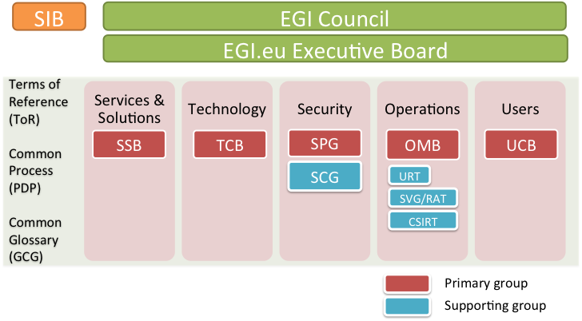

https://wiki.egi.eu/wiki/Glossary_V2

