EGI-Engage

First release of the EGI Service Registry and Marketplace prototype
D3.7

Date | 09 October 2016
Activity | JRA1
Lead Partner | SWING
Document Status | DRAFT
Document Link | https://documents.egi.eu/document/2914

Abstract
This document details the work done to release the first demonstrator of the EGI Service Registry and Marketplace, a tool that has the ambition of becoming the platform where an ecosystem of EGI related services can be promoted, discovered and shared. The implementation of such a demonstrator also allowed a further refinement of the assessment of available solutions and open-source tools, done during the first year of the project
Before starting with the design and the implementation of the demonstrator, an analysis has been done to identify the relationship between the EGI service catalogue, the related Integrated Management System (IMS) process and procedures and the marketplace. Such analysis also covered a first study of the marketplace interfaces towards the other EGI tools.
Two marketplace demonstrators based on two different technologies, PrestaShop and Open IRIS, have been implemented to assess the capabilities of these two tools. Open IRIS is the most promising tool identified during the first phase of the assessment, instead, PrestaShop is a free, open source e-commerce solution largely adopted in the commercial world.
A data model, reflecting the EGI service catalogue structure, has been defined and implemented in the two marketplace prototypes. The outcome of the evaluation of these demonstrators showed that both technologies present different kind of limitations that prevent to fully satisfy all the EGI requirements. EGI needs to further evaluate the costs to customise such tools according to the EGI needs, and other solutions will also be examined.
Finally, a first preliminary study to define proper procedures and requirements to on-board in the marketplace community specific tools and services enabled by EGI has been accomplished.

COPYRIGHT NOTICE
This work by Parties of the EGI-Engage Consortium is licensed under a Creative Commons Attribution 4.0 International License (http://creativecommons.org/licenses/by/4.0/). The EGI-Engage project is co-funded by the European Union Horizon 2020 programme under grant number 654142.
DELIVERY SLIP
 | Name | Partner/Activity | Date
From: | Diego Scardaci  Dean Flanders | EGI Foundation - INFN /JRA1  SwiNG / JRA1 | 6 Oct. 2016
Moderated by:
Reviewed by
Approved by:

DOCUMENT LOG
Issue | Date | Comment | Author/Partner
v.0.8 | 13 Aug. 2016 | First draft version | Dean Flanders (SwiNG)
v.0.9 | 23 Aug. 2016 | Second draft version | Dean Flanders (SwiNG)
v.1 | 6 Oct. 2016 | Ready for internal review | Diego Scardaci (EGI Foundation - INFN)  Dean Flanders (SwiNG)
v.2 | 10 Oct. 2016 | Ready for external review | Diego Scardaci (EGI Foundation - INFN)  Dean Flanders (SwiNG)

TERMINOLOGY
A complete project glossary and acronyms are provided at the following pages:
- https://wiki.egi.eu/wiki/Glossary
- https://wiki.egi.eu/wiki/Acronyms

Contents
1 Introduction 7
2 EGI Service Catalogue 8
2.1 Overview 8
2.2 EGI Service Portfolio 10
2.3 EGI Internal Service Portfolio 14
2.4 EGI Service Portfolio Management process and related procedures 19
2.5 Access request management 20
2.6 Relationship between the EGI Service Catalogue and the marketplace 21
2.6.1 EGI tools and relationship with catalogue processes 21
2.7 Services and Solutions Board 23
3 Service architecture 24
3.1 High-Level Service architecture 24
3.2 Integration and dependencies 24
4 Marketplace prototype 24
4.1 Data model of the prototype 24
4.1.1 Service areas (category in the marketplace) 25
4.1.2 Services (sub-categories in the marketplace) 26
4.1.3 Service options (products in the marketplace) 28
4.1.4 Service providers 35
4.2 Reporting of PrestaShop prototype 36
4.3 Reporting of Open Iris prototype 37
5 Publishing of thematic platforms 38
6 Release notes 38
6.1 Requirements covered in the release 38
7 Feedback on satisfaction 39
8 Dissemination and exploitation plan 39
9 Future plans 39

Executive summary
This document details the work done to release the first demonstrator of the EGI Service Registry and Marketplace. The EGI marketplace has the ambition of becoming the platform where an ecosystem of EGI related services can be promoted, discovered and shared, including EGI offered services as well as discipline and community specific tools and services enabled by EGI and/or provided by third parties under defined agreements.
As follow-up of the analysis of existing solutions, open-source tools and extensions to implement the EGI marketplace done during the first year of the project, the assessment of technologies has been further refined in the last months taking into account the defined criteria. As outcome of this activity, the previously depicted plan has been partially amended and we have decided to assess two technologies with live instances: PrestaShop and Open IRIS. The latter was the most promising solution identified during the first evaluation to fully fulfil the marketplace requirements. Instead, PrestaShop is a free, open source e-commerce solution largely adopted in the commercial world with a wide community behind that guarantees for its sustainability. The adoption of PrestaShop could potentially reduce the cost EGI will incur to maintain a solution such us Open IRIS and, in addition, could help on designing a marketplace ready to attract commercial actors, such as SMEs.
The deployment of the two EGI marketplace demonstrators based on PrestaShop and Open IRIS required a prior analysis to understand the relation between the marketplace with the EGI service catalogue and its Integrated Management System (IMS) process and procedures. Such analysis also covered a first study of the marketplace interfaces towards the other EGI tools that included the definition of the implementation guidelines of the service access workflow in the marketplace and the study of the impact on the other EGI tools involved in this process, e-Grant and the Long Tail of Science (LToS) platform, which should be re-designed to remove redundant features. The analysis of the interfaces with the other tools will start in the next months after the first evaluation of the two prototypes will be completed.
A data model has been defined and implemented in the two marketplace prototypes. It reflects the EGI service catalogue structure and is made of a three-level hierarchy where the first level contains the EGI service areas (categories in the marketplace) and the second level maps to the EGI services (sub-categories in the marketplace). Furthermore, there is an additional level that defines the EGI service options (products in the marketplace). The service options represents the products that the end user could access or purchase in the marketplace.
A subset of such data model has been implemented in the two marketplace demonstrators, based on PrestaShop and Open IRIS, to assess the capabilities offered by these two tools. The outcome of such evaluation demonstrated that both technologies present different kinds of limitations that prevent to fully satisfy all the EGI requirements. PrestaShop is a very powerful tool to implement a marketplace but it needs to be deeply customised with additional plugins and ad hoc developments to properly act as EGI marketplace. An assessment of the costs EGI would incur is needed. Open IRIS could be adopted as tool to implement the EGI marketplace only if both identified licensing and technical issues will be fixed in the next months.
In these two demonstrators, only services from the EGI service catalogue have been published. However, the marketplace will be opened in the next months to the wider EGI community and its services. Proper procedures and requirements to be respected by the services providers will have to be defined. In addition, the data model could be extended to include additional attributes. This activity already started with the drafting of possible collaboration models to include thematic community platforms within the marketplace, which is briefly introduced in this document.

Introduction
This deliverable describes the work done to implement the two marketplace demonstrators based on PrestaShop and Open IRIS platforms.
PrestaShop is a free, open source e-commerce solution. The software is published under the Open Software License (OSL). It is written in the PHP programming language with support for MySQL database. PrestaShop is currently used by 250,000 shops worldwide and is available in 60 different languages. PrestaShop has its strength in being like a traditional online store that most people are already familiar with. It gives an attractive and simple to use interface, as well as a set of functionality that is immediately useful. The adoption of PrestaShop could reduce the cost EGI will incur to maintain a solution such us Open IRIS and, in addition, could help on designing a marketplace ready to attract commercial actors, such as SMEs.
Open IRIS (Integrated Resource and Information System) is a platform that was originally developed as a Swiss wide project to facilitate sharing of research resources within Switzerland. In the course of the evaluating the requirements for the EGI marketplace the opportunity was taken to work with a variety of organizations outside of Switzerland to validate the different marketplace concepts as well as drive the direction of the development of the system to broaden its features and to increase adoption. This has resulted in Open IRIS now being used in several other countries by hundreds of researchers daily. Historically Open IRIS has been focused on instrumentation and lab services, but the objective is to be a single point where researchers can find and use all forms of resources needed to conduct their research. This includes resources within their organization, including those of the researchers, as well as resources from other organizations or commercial providers. Open IRIS is tailored for the research world, so it looks promising to be easily adapted to the EGI world.
The document is structured as follows:
- Section 2: Introduces the EGI service catalogue and its relationship with the marketplace. It also covers the first analysis of the interfaces between the marketplace and the other EGI tools.
- Section 3: Gives information on the architecture of the demonstrators.
- Section 4: Details the defined data model and reports a first evaluation of the demonstrators.
- Section 5: Describes the outcome of the first study to publish in the marketplace services not in the EGI service catalogue focusing on the thematic platforms.
The document is completed by the release notes, the feedback on satisfaction, a draft dissemination and exploitation plan and future plans.

Tool name | EGI Marketplace
Tool url | PrestaShop based demonstrator: http://vps302866.ovh.net  Open IRIS based demonstrator: http://egi.science-it.ch
Tool wiki page | N.A.
Description | The EGI Marketplace demonstrators shows and promotes EGI services. End users can discover the services and request access to it by specifying a set of options.
Value proposition | The EGI Marketplace will facilitate the discovery and the access to the EGI services.
Customer of the tool | EGI Foundation, NGIs, RIs, service providers, academic organizations
User of the service | Potential EGI users: research groups, individual researcher, site admins, academic organizations, SMEs, etc.
User Documentation | N.A.
Technical Documentation | N.A.
Product team | N.A.
License | N.A.
Source code | N.A.

EGI Service Catalogue

Overview
The first edition of the EGI service portfolio was developed during 2013 to improve service orientation and clarify the unique offering that current and potential beneficiaries can request. This first version focused mainly on services internal to EGI as essential to enable the federation to work together and serve international research communities.
This work was initiated in the context of improving the maturity in managing services by developing and implementing best practices for ensuring clarity of service offering and warranties and meeting the expectations of beneficiaries.
Later, in July 2015, EGI.eu proposed the establishment of the Services and Solutions Board (SSB) as a new body responsible for managing the portfolio of services and solutions regarding EGI.eu and the EGI federated services, ensuring transparency across functions, and advising the EGI Council.
Following the creation of the SSB, the group worked extensively to implement the service portfolio management process (SPM) from FitSM, to define the templates and to update the EGI service portfolio.
Following the improved maturity in designing and delivering services, an update to the EGI service portfolio was approved at the EGI Council in November 2015. This version covered both services that are internal to the EGI and services that EGI collectively delivers to the beneficiaries (researchers and SMEs/Industries).

According to the established practice, each service is described in a Service Design and Transition Package (SDTP) document composed of the following sections:
- Value proposition
- Business case
- Service design
- Service transition plan
The definition of a service portfolio brought several benefits such as:
- Improved service orientation
- Improved capabilities to promote EGI services and their value
- Improved management of services
- Helped to clarify the alignment with the EGI strategy
- Facilitate management interoperability in federated environments
- Better understanding of all the components, dependencies and processes behind service delivery
In order to improve the clarity on the difference between the services that EGI as a federation offers to potential customers versus the services that are developed internally for EGI to efficiently operate as a federation, the portfolio has been separated into:
- EGI service portfolio: containing the services that EGI offers as a federation to potential requesting customers.
- EGI internal service portfolio: containing the services that are organised within the federation to enable EGI resource providers to operate together.

EGI Service Portfolio
The following figure and table represent a summary view of the services that EGI as a federation offers for research and innovation.
Services are classified in six categories/areas:
- Compute
- Storage
- Data
- Security
- Operations
- Training
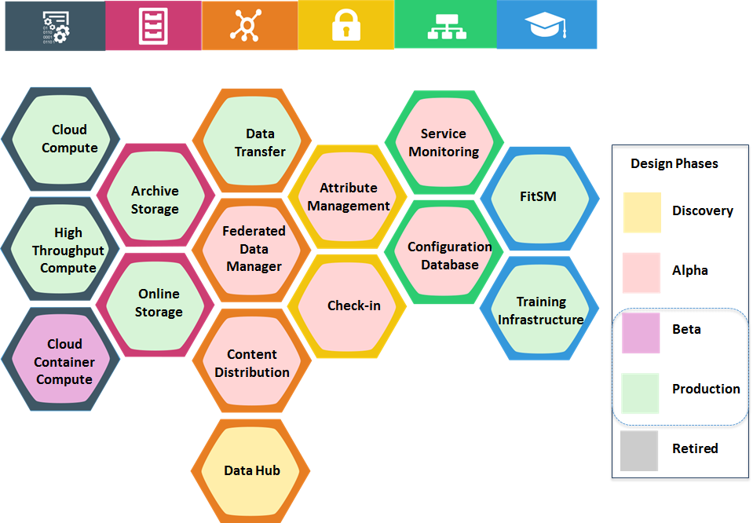
Figure 1 - The EGI Service Portfolio
Each service can be in a different design phase defines as follows:
- Discovery: researching user’s needs, exploring technological or policy constraints
- Alpha: prototype available for closed set of users
- Beta: service being developed while available for testing publicly
- Production: service available in the live environment meeting security/performance requirements
- Retired: the service is not anymore offered
The EGI service catalogue(s) is composed of live services, that is services that are either in beta or production phase.
Table 1 - The EGI service portfolio
Category | Service name | Description | Benefits | Phase
Compute | Cloud Compute | Run virtual machines on-demand with complete control over the computing resources | - On-demand provisioning  - Full control over computing resources  - Standard interface to deploy on multiple service providers | Production
 | Cloud Container Compute | Run Docker containers within isolated user-space with no overhead | - Accessible through different interfaces  - Interoperable and transparent | Beta
 | High-Throughput Compute | Analyse large datasets by executing large numbers (thousands) of computational tasks | - Access large amounts of processing capacity over long periods of time  - Achieve faster results  - Shared resources among users, enabling collaborative research | Production
Storage | Online Storage | Store and retrieve files, their metadata and assign global identifiers on a large scale | - Highly scalable storage system accessible from anywhere  - Easily share data  - Access through different interfaces | Production
 | Archive Storage | Archive files and preserve them for future use in a secure environment | - Stores large amounts of data  - Long-term retention  - Reliable and interoperable | Production
Data | Data Transfer | Transfer asynchronously large sets of files from one storage endpoint to another | - Ideal for very large files  - Able to handle large amounts of files  - Transfer process with automatic retrying | Production
 | Content Distribution | Deliver content with scalable, reliable and low maintenance software and data delivery system available as user-space read-only file system | - Manage centrally the software to distribute across federated environments  - Make content available as a read-only file system that efficiently downloads and caches files on demand | Production
 | Federated Data Manager | Share, discover, and process data federated from different sources | - Single virtual storage that maps virtual paths to physical file paths  - Users can store their data across multiple sites, and can run their applications directly as if the files are local | Alpha
 | Data Hub | Access selected public datasets and efficiently consume them from EGI compute services | - Easy access to selected large-scale datasets  - Easy and efficient access | Discovery
Security | Attribute Management | Manage community membership and expose trusted information | - Easy and trusted way to manage Virtual Organization membership | Production
 | Identity Provider Proxy | Handle transparent Single Sign-On from multiple heterogeneous identity providers | - Easy single sign-on from multiple heterogeneous identify providers | Alpha
Operations | Configuration Database | Manage the configuration information of a federated e-infrastructure including the provided service instances and staff contacts | - Ready-to-use solution  - Improves the operation of a distributed infrastructure  - Hierarchical management with roles and capabilities | Production
 | Service Monitoring | Monitor a wide range of platforms and provide operational and business insight for a wide range of built-in and user defined key performance indicators | - Repository of information and solutions  - Progress tracking | Production
 | Helpdesk | Handle service requests and incidents for distributed support teams | - Reduced cost for setting up the monitoring services, minimal development effort  - Ready-to-use user interfaces and flexible availability calculating flexible tools  - Automated reporting tools | Production
Training | FitSM | Learn how to manage IT services with a pragmatic, lightweight and achievable standard | - Increase your expertise in managing IT services  - Increase professional profile by a recognized certification | Production
 | Training Infrastructure | Handle online training courses and learning activities in a dedicated resource pool | - Allows easy deployment, predictability and repeatability of courses  - Customizable virtual machine images on the training infrastructure can be deployed before the course | Production

EGI Internal Service Portfolio
The following figure and table represent a summary view of the services that are delivered internally to the EGI federation to enable the EGI resource providers to work together.
Services are classified in three categories/areas:
- Coordination
- Operations
- Security
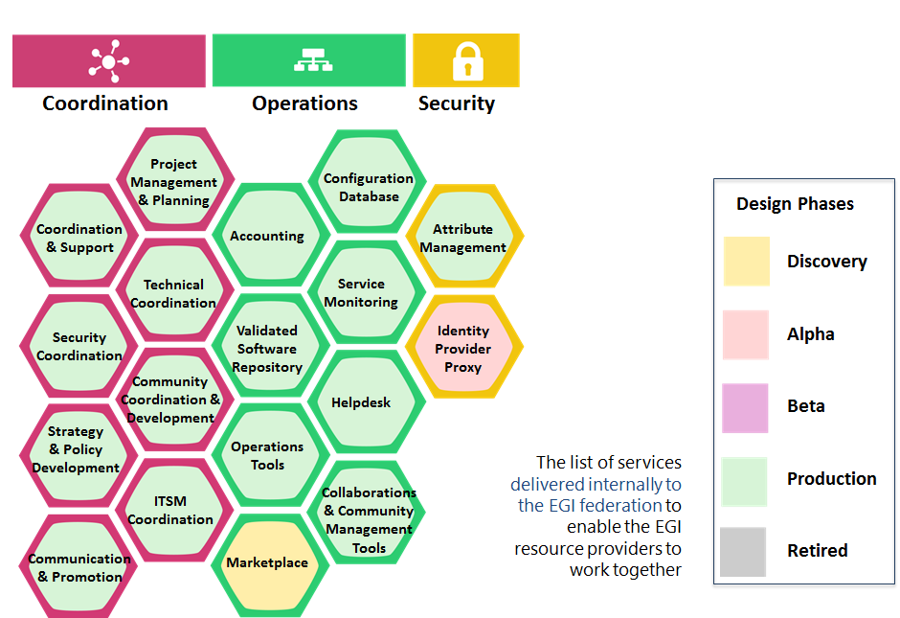
Figure 2 - The EGI Internal Service Portfolio

Table 2 - The EGI Internal Service Portfolio
Category | Service name | Description | Benefits | Phase
Operations | Configuration Database | Manage EGI resource providers, resource centres and services, including service instances and staff contacts | - Ready-to-use solution  - Highly available and reliable  - Improves the operation of a distributed infrastructure | Production
 | Accounting | Track and report usage of the resources in the EGI infrastructure | - Increased control over resource consumption  - Secure data handling  - Reliable, high available, high performance service | Production
 | Service Monitoring | Monitor EGI services and provide operational and business insight for a wide range of built-in and user defined key performance indicators | - Ready to use user interfaces and flexible availability calculating flexible tools  - Automated reporting tools  - Improve the quality of the services, and prove to customers/funders the quality of service achieved | Production
 | Helpdesk | Handle EGI service requests and incidents for distributed support teams | - Central point of contact for support  - Repository of information and solutions  - Keeps track of progress | Production
 | Validated Software and Repository | Manage high-quality software releases for the EGI infrastructure | - Great visibility of the software published and integrated with EGI  - Automatic updates of software packages  - Reduced overall time needed in package management | Production
 | Operations Tools | Integrate resources and operations in EGI federated ecosystem | - Operational integration  - Increased efficiency of running operations in a federated ecosystem  - Easy coordination of large collaborations | Production
 | Marketplace | Discover and access the best IT services, data, instrumentation and research resources to perform multi-disciplinary research in EGI federated environment | - Easily discover expertise that can be tapped into based on usage of resources available  - Increase competitiveness by providing a low cost of entry to expensive technologies for small academic institutions and businesses  - Facilitate inter-disciplinary research by providing access to technologies typically considered outside of a particular field | Discovery
 | Collaboration and Community Management Tools | Manage and coordinate activities ensuring that operational activities across the federated infrastructure work seamlessly, without fragmentation | - Established processes to coordinate operations, user communities, security, integration, and service management  - Facilitated access to existing knowledge  - Documentation policies, information procedures, best practices, data gathering and reporting for specific functions | Production
Security | Identity Provider Proxy | Handle transparent Single Sign-On from multiple heterogeneous identity providers | - Integrate different through sources of identities  - Increased productivity and security | Discovery
 | Attribute Management | Manage community membership and expose trusted information | - Integration with EGI services  - The service operations policies are compliant with EGI policies  - Easy and trusted way to manage Virtual Organization membership | Production
Coordination | Project Management and Planning | Manage projects according to common strategies and policies with other resource providers in Europe and worldwide to support users to collaborate internationally | - Reduced management overhead  - More efficient and effective execution of joint strategies for e-Infrastructures with many partners from different countries  - Stronger connection with the EC policies | Production
 | Operations Coordination and Support | Manage and coordinate activities ensuring that operational activities across the federated infrastructure work seamlessly, without fragmentation | - Benefit from experience from other infrastructures  - Resource providers can use the consulting and other expertise  - Access to one or more research communities | Production
 | Technical Coordination | Gather information about technology development roadmaps and influences these by prioritizing service providers and expert users’ requirements | - Existence a forum for collaborative work and exchange of information  - Communication channels to trusted technology providers  - Reuse of existing solutions and effort focused on integration  - Access to expertise and a test environment | Production
 | Security Coordination | Enhance the capabilities of local security activities in distributed infrastructures | - Increased security in the services  - Increased reputation by implementing mature processes around security | Production
 | Community Coordination and Development | Provide coordination to the NGIs, to structured communities and to industry/SME engagement activities to help these build sustainable user communities for e-infrastructure services | - Speed up the time for resolving problems, or getting new services onto the infrastructure  - Influence the evolution of EGI  - Obtain first-hand information about new services  - Benefit from the experience of other users/members | Production
 | Strategy and Policy Development | Define common strategies and policies with other resource providers in Europe and worldwide to support users to collaborate internationally | - More efficient and effective definition and execution of joint strategies for e-Infrastructures with many partners from different countries  - Stronger influence on the evolution of EC policies | Production
 | ITSM Coordination | Coordinate the implementation and evolution of the IT service management system across EGI | - Defined process to ensure quality of IT services sufficient to satisfy customer requirements | Production
 | Communications and Promotion | Deliver messages beyond the reach of usual communication channels | - Amplify the dissemination of national or field-specific results to a European and research-wide level | Production

EGI Service Portfolio Management process and related procedures
The goal of the EGI Service Portfolio Management (SPM) process is to manage the service portfolio to ensure not only the review of the current portfolio, but how new or changed services are aligned with business decisions as part of the overall organization strategy.
This process has to satisfy the following requirements:
- A service portfolio shall be maintained. All services shall be specified as part of the service portfolio.
- Design and transition of new or changed services shall be planned.
- Plans for the design and transition of new or changed services shall consider timescales, responsibilities, new or changed technology, communication and service acceptance criteria.
- The organizational structure supporting the delivery of services shall be identified, including a potential federation structure as well as contact points for all parties involved.
- Three procedures have been defined to implement this process as described in the below table.
Table 3 - Procedures of the EGI Service Portfolio Management process
Title | Statement
SPM1: Add, Change, Retire a service in the service portfolio | This procedure describes the steps to add/remove/change a service in either EGI Service Portfolios
SPM2: Review the service portfolio | This procedure describes the steps to review the EGI Service Portfolios
SPM3: Create, update the organisational structure involved in delivering services | This procedure describes the steps to create or update the organisational structure involved in delivering services

Access request management
The following picture describes how a request to access services is managed in EGI. It involves three process:
- Business Development & Stakeholder (BDS) - this process supports the identification of new (potential) business opportunities and partnerships and to effectively manage stakeholder expectations and requirements. In the context of the access request management, it defines a prioritized list of stakeholders that provide input for the outreach activities.
- Customer Relationship Management (CRM) - this process has four goals that need to be achieved to properly manage an access:
  - Mobilising services, resources and support from the EGI community for customers who are interested in becoming active EGI users; (these customers are handed over to CRM from the BDS process);
  - Defining and carrying out software/service integration and deployment activities (to turn interested customers into active users);
  - Supporting the customers in reaching long-term operational setups at EGI resource providers;
  - Maintaining a relationship with active customers.
- Service Level Management (SLM) - the primary purpose of this process is to maintain a service catalogue, and to define, agree and monitor service levels with customers by establishing meaningful service level agreements (SLAs), supportive operation level agreements (OLAs) and underpinning agreements (UA). It is involved in the access request management when the CRM process complete the software/service integration in the infrastructure and the assessment of the customer requirements.
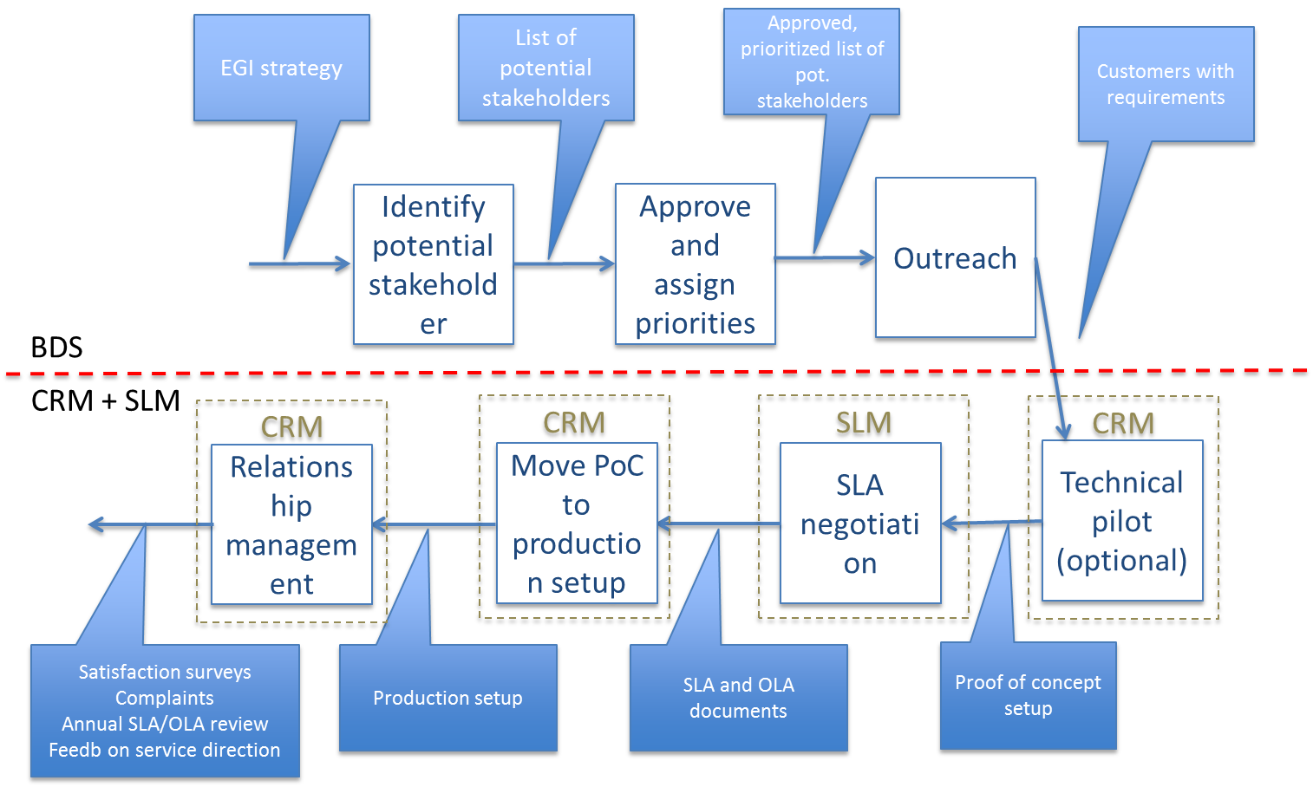
Figure 3 - Workflow to manage a request to access services in EGI.

Relationship between the EGI Service Catalogue and the marketplace
When operational, the marketplace will become the main tool to advertise the services in the EGI Service Catalogue. It will expose all the live EGI services following the same structure of the service catalogue (services classified in six categories and areas). Service options will be defined to facilitate the access to the services.
Furthermore, the marketplace will partially automate the access request management described in the previous section implementing procedures to handle the customers’ requests and acting as a orchestrator of the several EGI tools involved in such processes.

EGI tools and relationship with catalogue processes
The analysis of how the future EGI marketplace will be integrated with the tools of the EGI infrastructure is still a work in progress. Now, a first study has been done to define the implementation guidelines of the service access workflow in the marketplace, analysing the impact on the other EGI tools involved in this process: e-Grant and the Long Tail of Science (LToS) platform.
The driving concept of this analysis is that the EGI marketplace will become the unique place where a new user could discover a service, browsing the service catalogue, and request an access, specifying quantity, quality and duration. This has an impact on e-Grant and the LToS platform, indeed these features are already partially exposed in these tools. Now, through e-Grant, users can specify the service profile they need and submit a request (for a subset of the service in the EGI catalogue), while the LToS platform partially implements a service discovery and a user profiling features.
To remove these redundancies and implement the proposed workflow, e-Grant will be converted to a backend service that will take care of the service request management. Furthermore, it will be extended to cover the entire EGI service catalogue. Instead, the LToS platform will entirely rely on the marketplace for the user profiling.
In this context, the marketplace will be also integrated with the EGI AAI check-in service delegating to it the whole process to authenticate, authorise and register and profile the end-users. The service access workflow will implement different branches according to the various identified user profiles: single user, research infrastructure, projects, etc.
The analysis of the relationship between the EGI marketplace and the other EGI tools will start in the next months after the first evaluation of the two prototypes is completed. Particular attention will be devoted to the definition of the interfaces with the AppDB and GOCDB and if and how services published on these two tools should be presented in the marketplace.
A full list of tools that should be integrated with the marketplace is reported in the following table.
Table 4 - EGI Tools to be integrated with the Marketplace.
Tool | Relation | Description
Operation Portal | Provides information on the status of EGI federated resources. | The Operations Portal provides a view, based on the role of the viewer, to information about the status of EGI resources and services. The portal provides following tools: VO registration, VO management, VO dashboard, COD dashboard, Operation dashboard, Security dashboard, broadcast and downtime notification mechanism.
GOCDB | Provides a list of resource providers that can be listed in the marketplace. | The GOCDB is the central input system for recording e-infrastructure topology information. This includes the resource providers that contribute to the production infrastructure, their associated Service Endpoints, service downtime information and contact details for participants who maintain the infrastructure. It is accessed by all project actors (end-users, site managers, NGI managers, support teams, VO managers), by other tools and by third party middleware in order to fetch the infrastructure topology and its status.
GGUS | Incident management system for EGI related services in the marketplace. | The GGUS system is the primary means by which users request support when they are using the EGI infrastructure. The GGUS system creates a trouble ticket to record the request and tracks the ticket from creation through to solve.
AppDB | Provides a list of software packages and VMs, along with information to resource providers hosting them. Moreover, it provides a collection of dashboards for VM operations and VM image management. | The EGI Applications Database (AppDB) is a central service that stores and provides to the public, information about software solutions in the form of native software products and/or virtual appliances, the programmers and the scientists who are involved, and publications derived from the registered solutions.  From an operational point of view, the AppDB offers a dashboard to the VO managers in order to manage the images that will be available to resource providers which are supporting their VOs, whereas another dashboard available to the end-users for performing VM operations to the EGI Cloud infrastructure.
e-Grant | Users can requests allocations of resources from participating resources providers. | e-GRANT is a tool supporting Resource Allocation process. It allows researchers to request an amount of compute and storage resources for a given amount of time. e-GRANT handles all activities involved in RA Process which leads to SLA signing.

Services and Solutions Board
The Services and Solutions Board (SSB) is responsible for managing the portfolio of services and solutions regarding the EGI foundation and the EGI federated services. This includes all services and solutions that are planned, active or to be retired. To support this goal, the SSB will carry out the following activities:
- Advise the EGI management on the priorities for evolving the services and solutions portfolio.
- Conduct regularly scheduled management reviews of both services and solutions portfolios and related ITSM processes (see below).
- Implement the recommendations from the EGI Strategy and Innovation Board (SIB) that have been endorsed by the EGI Council.
- Interface with the UCB (User Community Board) concerning the services and solutions for the research communities.
- Interface with the TCB (Technology Coordination Board) concerning the evolution of technology and how this can affect services and solutions.
- Interface with the OMB (Operations Management Board) concerning the services and solutions for resource providers.
- Steer the creation, review and approval of service/solution design packages including descriptions and specifications alongside any information to be added to the service portfolio.
- Plan the design and transition of new or changed services considering timescales, responsibilities, new or changed technology and communication.
The SSB Terms of Reference (TOR) is available at https://documents.egi.eu/document/2374.

Service architecture
The EGI marketplace prototype has been implemented adopting technologies developed by third parties. In particular, two demonstrators have been set up, one based on PrestaShop and the other based on Open IRIS.

High-Level Service architecture
For the high-level service architecture of the two demonstrators, refer to the PrestaShop and Open IRIS documentation.

Integration and dependencies
Currently, the marketplace demonstrators are not integrated with the EGI tool ecosystem, they are simple instances of the two chosen technologies (PrestaShop and Open IRIS). This provided more flexibility and simplicity during the testing phase.

Marketplace prototype

Data model of the prototype
The data model implemented in the marketplace prototype reflects the EGI service catalogue structure. It is made of a three-level hierarchy where the first level contains the EGI service areas (categories in the marketplace) and the second level maps to the EGI services (sub-categories in the marketplace). Furthermore, an additional level defines the EGI service options (products in the marketplace). The service options represents the products that the end user could access or purchase in the marketplace.
The first two levels of the hierarchy are described in the table below.
Table 5 - EGI Service Catalogue - first and second levels.
Service area | Services
Compute | Cloud Compute, Cloud Container Compute and High-Throughput Compute
Storage | Online Storage, Archive Storage
Data | Data transfer, Content Distribution
Operations | Configuration Database, Service Monitoring
Security | Check-in, Attribute Management
Training | Training Infrastructure, FitSM

For five of the services, Cloud Compute, High-Throughput Compute, Online Storage, Training Infrastructure and FitSM, have been also defined the service options that are described in the following.
The following subsections describe the attributes that will be showed in the marketplace for each level of the hierarchy:
- Service areas (category in the marketplace)
- Services (sub-category in the marketplace)
- Service options (products in the marketplace)
Finally, data to describe service providers in the marketplace are also defined. Each service in the marketplace will be linked to one or more providers.

Service areas (category in the marketplace)
Each category in the marketplace will be described with the attributes showed in the table below.
Table 6 - Service areas
Attribute | Definition | Notes
Name | Name of the category | The first level category maps to the EGI service area:  - Compute  - Storage  - Data  - Operations  - Security  - Training
Description | Description of the category | Inspired by the description of the EGI service areas in the service catalogue: short, punchy and expressing the value

Services (sub-categories in the marketplace)
The EGI marketplace will present services to the end-users with a set of attributes described in the table below. These attributes are inherited and sometime specialised by the service options.
Attribute | Definition | Notes
Name | Name of a specific service as assigned by the service provider | Format: Free text  Example: Cloud Compute
Unique ID | Global unique and persistent identifier of a specific service  Note: this allows to map a service to a specific organization/e-Infrastructure | Format: DOI or any other relevant standard; it should contain information about the identifier type and value.  Additional info:  A PID can be used ideally resolvable to a landing page or a machine readable data typed metadata page. It should be assigned by the CoS owner.
Short description | High-level description of what the service does in terms of functionalities it provides and the resources it enables access to. It may include the value ( benefit) to a customer and their users delivered by a service | Format: Free text  Additional info:  It may provide also information related to the offered capacity, number of installations, underlying data that is offered  Benefits are usually related to alleviating pains (e.g., eliminate undesirable outcomes, obstacles or risks) or producing gains (e.g. increased performance, social gains, positive emotions or cost saving).
Description | Longer description of what the service does in terms of functionalities it provides and the resources it enables access to the service | Format: Free text
Web page | URL to a webpage providing more information about the service | Format: URL  Additional info:  This webpage is usually hosted and maintained by the service provider. It contains current and additional information, such as what APIs are supported or links to the documentation.
Service phase | Phase of the service design selected among:  beta: service being developed while available for testing publicly  production: service available in the live environment meeting security/performance requirements | Source: UK Government Service Design Manual  Format: Closed enumeration
Category | Link to categories this service belongs to | Format: Closed enumeration
Service condition | Restrictions that apply to this service | Format: List of sentences, each of them defining a condition
Payment Model | Supported payment models and restrictions that apply to each of them | Format: List of sentences, each of them stating the type of payment model and the restriction that applies to it  Additional info:  Example of types of payment models are: free, pay-as-you-go, subscription, membership  Variable pricing for corporate customers, higher education, etc.
Term of use | URL to a document containing the rules which one must agree to abide by in order to use the service | Format: URL
SLA | URL to a document containing information about the levels of performance that a service provider is expected to achieve (service level agreement) | Format: List of URLs

Service options (products in the marketplace)
The service options includes some common options described in the table below.
Common service options | Description
Description of the research activity | Information on the research activity that needs to access the EGI services. In particular, relevant when access for free is requested.
Access type | Reserved or opportunistic (does not apply to the training and to some Cloud Computing options).
Start and end dates | Specify the period in which users will access the services. The period can also be undefined.

Compute/Cloud Compute
Service description: Cloud Compute gives you the ability to deploy and scale virtual machines on­-demand. It offers guaranteed computational resources in a secure and isolated environment with standard API access, without the overhead of managing physical servers.
Cloud Compute offers the possibility to select pre­configured virtual appliances (e.g. CPU, memory, disk, operating system or software) from a catalogue replicated across all EGI cloud providers.
Service option (Instance types) | Description | Attributes
General purpose instance | Base performance instance type.  Features:  - Accessible in opportunistic or reserved ways  - CPU cores could be overcommitted  Ideals for:  - Web services  - Micro-services  - Development environments  - Building server  - Small database  - Test environments | Number of CPU cores: [1,2,4,8]  Amount of RAM per CPU core (GB): [1,2,4]  Local disk (GB): [10,20,40]
Compute-intensive instance | Optimised instance for computing tasks.  Features:  - High performance CPU cores  - Until 64 CPU cores  - Real CPU cores (non- overcommitted)  - Low latency network  - Reserved instances  Ideals for:  - Batch computing  - High-performance applications and web services  - Distributed analysis  - Video encoding | Number of CPU cores: [8,12,16,20,24,28,32,64]  Amount of RAM per CPU core (GB): [2,4,8]  Local disk (GB): [10,20,40]  Note 1: Some CPU cores/RAM per core combinations are not permitted. Maximum total RAM available for 1 instance is 240 GB.  Note 2: Only reserved instances admissible.
High-memory instance | Optimised instances for tasks that require more memory relative to virtual CPUs.  Features:  - High amount of RAM per CPU core.  - Up to 240 GB of RAM in total.  - Reserved instances  Ideal for:  - Running in-memory database  - Running in-memory stores (e.g. redis, memcached)  - In-memory big data processing engines (e.g. Apache Spark). | Number of CPU Cores: [2,4,8,12,16]  Amount of RAM per CPU core (GB): [16,32,48,64,80,96,112,120]  Local disk (GB): [10,20,40]  Note 1: Some CPU Cores/RAM per core combinations are not permitted. Maximum total RAM available for 1 instance is 240 GB.  Note 2: Only reserved instances admissible.
GPU instance | GPU-enabled instances.  Features:  - 1 or 2 GPU cores  - 8 CPU cores for each GPU core  - Large memory  Ideals for:  - Graphics and general purpose GPU compute applications | Number of GPU cores: [1,2]  Number of CPU cores per GPU core: [8]  Amount of RAM (GB): [24,50]  Local disk (GB): [280]  Note 1: The amount of RAM will be 24GB with 1 GPU core or 50GB with 2 GPU cores.  Note 2: Only reserved instances admissible.

Compute/High-throughput Compute
Service description: with High­Throughput Compute you can run computational jobs at scale on the EGI infrastructure. It allows you to analyse large datasets and execute thousands of parallel computing tasks.
High­Throughput Compute is provided by a distributed network of computing centres, accessible via a standard interface and membership of a virtual organisation. EGI offers more than 650,000 cores of installed capacity, supporting about 1.6 million computing jobs per day.
This service supports research and innovation at all scales: from individuals to large collaborations.
Service option | Description | Attributes
Base | It allows the execution of large numbers of independent or loosely coupled computing tasks. Limited parallel and multi-thread computing can be supported as well. | Number of CPU cores: [1-32]  Amount of RAM per CPU core (GB): [4-8]  Other technical requirements: [text]
MPI | It allows parallel computing, with support of MPI protocol and libraries. | Number of CPU cores: [1-256]  Amount of RAM per CPU core (GB): [4-8]  Parallelism (Threads): [8-24]  Other technical requirements: [text]

Storage/Online Storage
Service description: Online Storage allows you to store data in a reliable and high-­quality environment and share it across distributed teams. Your data can be accessed through different standard protocols and can be replicated across different providers to increase fault­-tolerance.
Online Storage gives you complete control over the data you share and with whom.
Service option | Description | Attributes
Block storage | Block Storage is a block-level storage solution that allows you to expand the storage capacity of your instances in the EGI Federated Cloud. This means you can increase your storage without increasing the size or capacity of your instance or by provisioning new ones. Once you mount and format your drive, you can use it just like a regular hard drive attached to your server. Or you can detach your block storage volume from one server and attach it to another. Or you can delete your server, keeping your data intact and ready for the next time you need it. | Storage capacity [TB]: [1, 5, 10, other]  Special requirements (e.g. performance, close to the computational resources, etc.): [text]
Object storage | Object storage manages data as objects. Each object includes the data itself, a variable amount of metadata, and a globally unique identifier. Cloud object storage allows relatively inexpensive, scalable and self-healing retention of massive amounts of unstructured data. | Storage capacity [TB]: [1, 5, 10, other]  Interfaces: [CDMI, POSIX, SWIFT, to be specified by the users]  Special requirements (e.g. performance, close to the computational resources, etc.): [text]
File storage | Highly scalable storage system accessible from anywhere allowing to easily share data through different standard interfaces. It assigns global identifiers to files and allows to organise your data using a flexible hierarchical structure. | Technology: [DPM, DCache, STORM, …, any]  Special requirements (e.g. performance, close to a specific site, etc.): [text]

Training/Training Infrastructure
Service description: The Training Infrastructure offers cloud compute and online storage for training activities. It is useful to organise onsite tutorials or workshops and online training courses or as a platform for self-paced learning.
For example, with the Training Infrastructure trainers can create and deploy any custom virtual machine images for the students. A library of existing virtual machines images is offered so that tutors can customise and use these according to their specific needs. This allows easy deployment, sharing and reuse of course materials.
The Training Infrastructure uses the same high-quality computing and storage environment that EGI provides to researchers.
Service option | Description | Attributes
Cloud Training Infrastructure | The Training Infrastructure offers cloud compute and online storage for training activities. It is useful to organise onsite tutorials or workshops and online training courses or as a platform for self-paced learning.  For example, with the Training Infrastructure trainers can create and deploy any custom virtual machine images for the students. A library of existing virtual machines images is offered so that tutors can customise and use these according to their specific needs. This allows easy deployment, sharing and reuse of course materials.  The Training Infrastructure uses the same high quality computing and storage environment that EGI provides to researchers. | Location: [text]  Aim of the training event: [text]  Number of concurrent trainees: [number]  Number of CPU cores: [number]  Amount of RAM (GB): [number]  Online storage size (GB): [number]  Special requirements (e.g. VM images/apps available in the training infra, big instances, etc.): [text]

Training/FitSM
Service description: FitSM is a lightweight standards family aimed at facilitating service management in IT service provision, including federated scenarios. FitSM training aims at providing those involved in operating federated infrastructures with the professional skills they need in order to effectively manage their services.
FitSM professional training is certified by TÜV SÜD, a global leader in standardisation and certification. The qualification programme offers three training levels: Foundation, Advanced and Expert.
Service option | Description | Attributes
Foundation level | Target audience:  - All individuals involved in the provisioning of (federated) IT services  - Candidates who wish to progress to advanced level of the qualification and certification scheme  Contents:  - Basic IT service management concepts and terms (based on FitSM-0)  - Purpose and structure of FitSM standards and their relationship to other standards  - Process framework underlying FitSM  - Requirements defined in FitSM-1 | Number of students: [number]  Location: [text]
Advanced Level in Service Planning and Delivery | Target audience:  - Individuals aiming to fulfil a coordinating role in the ITSM processes related to the planning and delivery of IT services  - Candidates who wish to progress to expert level of the qualification and certification scheme  Contents:  - Repeat the most important foundation knowledge on (lightweight) ITSM  - Become familiar with the general aspects of implementing ITSM, the processes required to plan and deliver services effectively (according to the FitSM-1 standard), and important interfaces in a service management system  - ITSM processes in focus of this training: Service portfolio management, service level management, service reporting management, service availability and continuity management, capacity management, information security management, customer relationship management, supplier relationship management  Entry requirements:  - Must hold FitSM Foundation Certificate | Number of students: [number]  Location: [text]
Advanced Level in Service Operation and Control | Target audience:  - Individuals aiming to fulfil a coordinating role in the ITSM processes related to the operation and control of IT services  - Candidates who wish to progress to expert level of the qualification and certification scheme  Contents:  - Repeat the most important foundation knowledge on (lightweight) ITSM  - Become familiar with the general aspects of implementing ITSM, the processes required to operate and control services effectively (according to the FitSM-1 standard), and important interfaces in a service management system.  - ITSM processes in focus of this training: Incident and service request management, problem management, configuration management, change management, release and deployment management, continual service improvement management  Entry requirements:  - Must hold FitSM Foundation Certificate | Number of students: [number]  Location: [text]
Expert level | Target audience:  - Individuals aiming to fulfil the role of internal or external consultant or auditor in the topic area of IT service management (ITSM).  Contents:  - Repeat the most important advanced level knowledge on (lightweight) ITSM  - ITSM-related frameworks and standards  - Understanding the organisational context of implementing ITSM (including federation structures and scope setting)  - Leadership and governance (including top management responsibilities, governance practices, effective communication and organisational change management)  - Planning and implementing ITSM (including service management planning, service design and transition and effective documentation)  - Monitoring, reviewing and improving ITSM (including capability & maturity assessment, key performance indicators, managing an audit program and conducting audits)  Entry requirements:  - Must hold both FitSM Advanced Certificates in Service Planning and Delivery (SPD) and Service Operations and Control (SOC) | Number of students: [number]  Location: [text]
Consultancy | Advise on how to manage IT services with a pragmatic and lightweight standard. | Description of the consultancy: [text]

Service providers
The following table defines the attributes that will identify the service providers within the EGI marketplace.
Attribute | Definition | Notes
Name | Organisation or federation or part of an organisation or federation that manages and delivers a service or services to customers | Format: Free text  Additional info:  The entity with whom the customer signs the SLA; this entity will be able to give information about other contributors to the service
Description | Short description of the organisation or federation or part of an organisation or federation | Format: Free text
Contacts | Delegate of the organisation | Format: Name and e-mail
Logo | Organisation logo | Format: Image
Webpage | URL to the provider website | Format: URL

Reporting of PrestaShop prototype
The PrestaShop basic release offers a set of functionalities that could be enriched with several add-ons available within its community. Usually, the add-ons are not for free. Many of these plugins are published in the PrestaShop marketplace. Furthermore, PrestaShop can be customised to satisfy the needs of a customer with ad hoc developments.
The evaluation of the EGI marketplace demonstrator based on PrestaShop confirmed the appealing of the professional interface provided by the tool. The creation of the three-level hierarchy EGI catalogue was done in a few steps through the PrestaShop back office. However, some limitations of the basic release did not allow to fully satisfy the EGI requirements. The main hindrances identified are related to:
- Service request workflow: It cannot be customised. EGI needs a custom workflow for each service category since different products may require different delivery processes.
- Attribute management: Only attributes with a limited range of options can be defined. There is no way to define dates or free text/numerical attributes.
- Shipping: It should be disabled since EGI sells services. This is possible only for virtual products but these cannot have associated attributes.
- Supplier management: Suppliers cannot be listed into the product descriptions.
An analysis was performed to identify possible plugins that could overcome these issues. Add-ons have been identified to partially fix the attribute and supplier management and the shipping issues but not to create custom service request workflow. Then, ad hoc developments are also needed to fulfil all the EGI needs
The conclusion of this study is that PrestaShop is a very powerful tool to implement a marketplace, but it needs to be deeply customised with additional plugins and ad-hoc developments to properly act as EGI marketplace. An assessment of the costs EGI would incur to customise PrestaShop will be done in the next weeks.

Reporting of Open Iris prototype
After the first assessment done early this year, Open IRIS seemed promising as tool to implement the EGI marketplace. Indeed, among the examined tools, it had the better match with the EGI requirements and already offers many of the marketplace features envisaged (see D3.2). In addition, it is more tailored for the research world. The further analysis on the Open IRIS terms of use and the trial of a live instance of Open IRIS highlighted some issues that will need to be resolved. The most important are described below:
- Licensing: Open IRIS is offered primarily as a free SaaS platform by partner institutions. The partners have the objective of creating a sustainable consortium model, where members pay to support the long term operation and development of the platform in a similar model to the SBGrid consortium at Harvard. Currently, the SaaS platform is developed and operated by an SME based in Ireland, CodeFirst. Access to the SaaS platform and source code is guaranteed after the payment of annual fee and only for the duration of the agreement. The annual fee includes 1PM of development support for customization of the product to the benefit of the partner and the community of users. It is planned to make the Open IRIS code open source with Apache License 2.0. As there is currently not an open source license model defined it conflicts with the licensing model in the EGI-Engage requirements on licensing defined in the consortium agreement (see Page 21, https://documents.egi.eu/document/2533).
- Category management: Open IRIS offers a minimal support for category management that does not allow to implement the three-level hierarchy EGI catalogue defined above.
- Rough user interface: The looks and feel of the user interface needs improvements to make it attractive for EGI potential users.
- Terminology and entity model: They are more oriented to devices management and need customisations (e.g. adding/removing attributes, rephrasing labels, etc.) to be compliant with the EGI ecosystem.
As conclusion of this evaluation, Open IRIS could be adopted as tool to implement the EGI marketplace only if both the licensing and technical issues can be overcome in the next months.

Publishing of thematic platforms
After this first phase, where only EGI services will be published in the marketplace, this new tool will be opened to the whole EGI collaboration and partners.
For example, the marketplace could become an important instrument to better promote and provide visibility to the thematic community services that are fundamental enablers of research and mediators of access to the EGI services. As thematic community service, we intend all the services and platforms that make use in some form of the EGI services.
An analysis to understand how to include the thematic platforms in the set of services published in the marketplace already started and two possible collaboration models have been envisaged:
- Thematic Service Partner: leaving the ownership and funding of the service to the organization developing and operating it, but promoting the service in the EGI service marketplace as an "EGI powered" community service, operated by a partner, in the context of a partnership agreement.
- Thematic Service Supplier: introducing community platforms in the form of scientific applications/VREs in the EGI service catalogue. EGI financially supports the operations of the service. If the supplier is also a technology provider, the supplier retains IPs of the software produced. EGI and the supplier agrees on how to maintain and further develop the service (new features).
These models are currently under discussion and will be refined in the next months.
In addition, thematic platforms that will be published in the marketplace should satisfy some criteria such as guarantee a certain level of quality of the service, being compliance to generic security policies and EC regulations like GDPR, etc. The complete definition of such requirements is still a work in progress.

Release notes

Requirements covered in the release
The main aim of the first release of the EGI Service Registry and Marketplace was the further evaluation of two technologies that could be adopted to implement it: PrestaShop and Open IRIS.
In the first release of the two demonstrators, a subset of the data model defined in section 4 has been implemented according to the capabilities of the two tools.

Feedback on satisfaction
The two demonstrators have not been reviewed by a wide audience but only by the persons directly involved in the task JRA1.2.
Everybody agreed that both the assessed solutions required further customisation to be adopted as tool to implement the EGI Service Registry and Marketplace.

Dissemination and exploitation plan
The marketplace will become the main instrument to advertise the EGI services and to manage the customer service request. Considered its fundamental role, it will be operated directly by EGI and will be fully integrated with the EGI tool ecosystem.
When operational, the marketplace will be linked to the EGI web site and customers will be redirected there to navigate into the EGI service catalogue and request access to one or more services. Existing of this new “door” to easily access the EGI services will be advertised using all the available EGI communication channels.
Effectiveness of this new tool will be simply monitored counting the number of accesses and the service requests performed through it. The latter value will be compared with the number of service requests done through the traditional channels.

Future plans
Several activities related to the marketplace have been planned for the next months. First of all, the IMS procedures described in section 2 will be extended/updated to take into account the existence of this new tool. In addition, the current access request management will be carefully analysed to identify steps that could be automated within the marketplace. In this context, clear interfaces towards all the other EGI tools involved in the access request management will be defined and, in particular, user-facing tools, such as e-Grant and the LToS platform, will be integrated with the marketplace to offer a unique user experience to the customers. Main outcome of this activity will be a marked simplification of the customer’s procedures to access the EGI services.
In parallel with this design activity, the assessment of the technologies to implement the marketplace will continue. Both the analysed technologies, PrestaShop and Open IRIS, present different kinds of limitations that prevent them to fully satisfy all the EGI requirements. EGI will then evaluate the costs to customise them according to the EGI needs and, in parallel, will examine other possible solutions. Another option already identified is the WordPress ecommerce plugin from WPMUDEV.org adopted by UberCloud to implement its marketplace. Other technologies will be also evaluated including specific cloud marketplace enablement tools such as AppCara, App Marketplace, Juju, Alien4Cloud and Cloudify.
Finally, the data model described in this document will be completed with the definition of the service options for all the EGI services and extended to properly represent other service categories such as the thematic community platforms. Furthermore, criteria to on board and monitor services in the marketplace will be defined to guarantee an adequate quality to the EGI customers.

D3.2 Design of the EGI Service Registry and Marketplace: https://documents.egi.eu/document/2658
D2.4 Concept of EGI Marketplace: https://documents.egi.eu/document/2535
Production instance at Institut Curie, http://iris.curie.fr.
https://documents.egi.eu/document/2374
http://fitsm.itemo.org/
https://indico.egi.eu/indico/event/2720/
https://documents.egi.eu/document/2550
https://www.prestashop.com/en/documentation
http://iris.science-it.ch
https://www.egi.eu/services & https://www.egi.eu/internal-services
http://addons.prestashop.com/
https://documents.egi.eu/document/2658
http://iris.science-it.ch
https://sbgrid.org
http://www.codefirst.IE
https://premium.wpmudev.org/project/e-commerce
https://www.theubercloud.com/store/

