1.) Exercise: Calculate the Average Monthly Temperature of the region of interest. Datasets will be downloaded from the Climate Change Knowledge portal [1].
[1] http://sdwebx.worldbank.org/climateportal/index.cfm
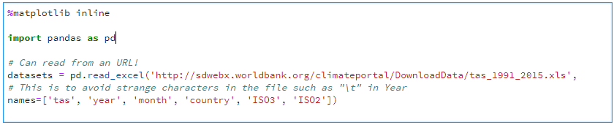
Take a look at the datasets
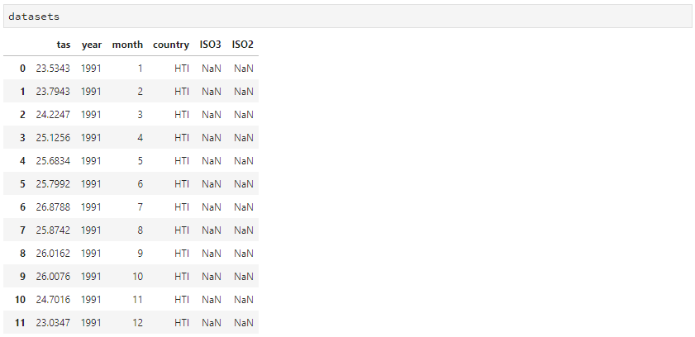
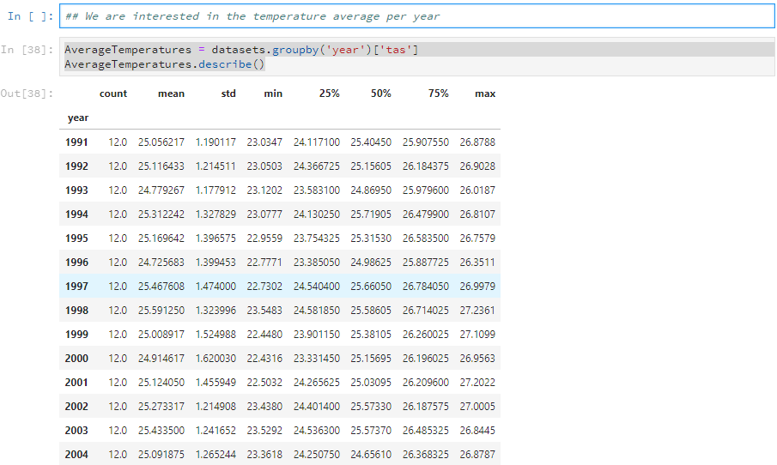

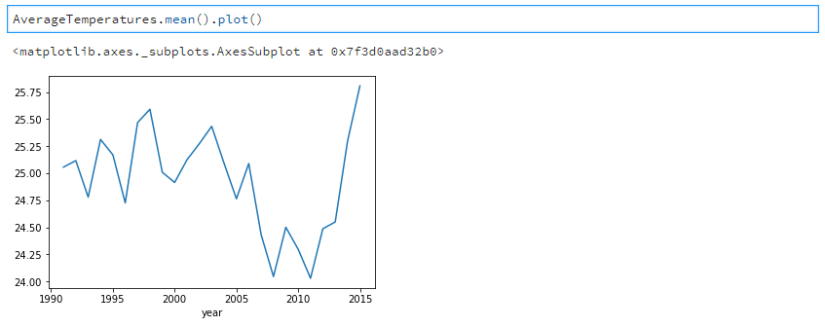
2.) Exercise: Calculate the Average Monthly Rainfall of the region of interest. Plot the average monthly temperature and rainfall in the same plot.
Datasets will be downloaded from the Climate Change Knowledge portal [1].
