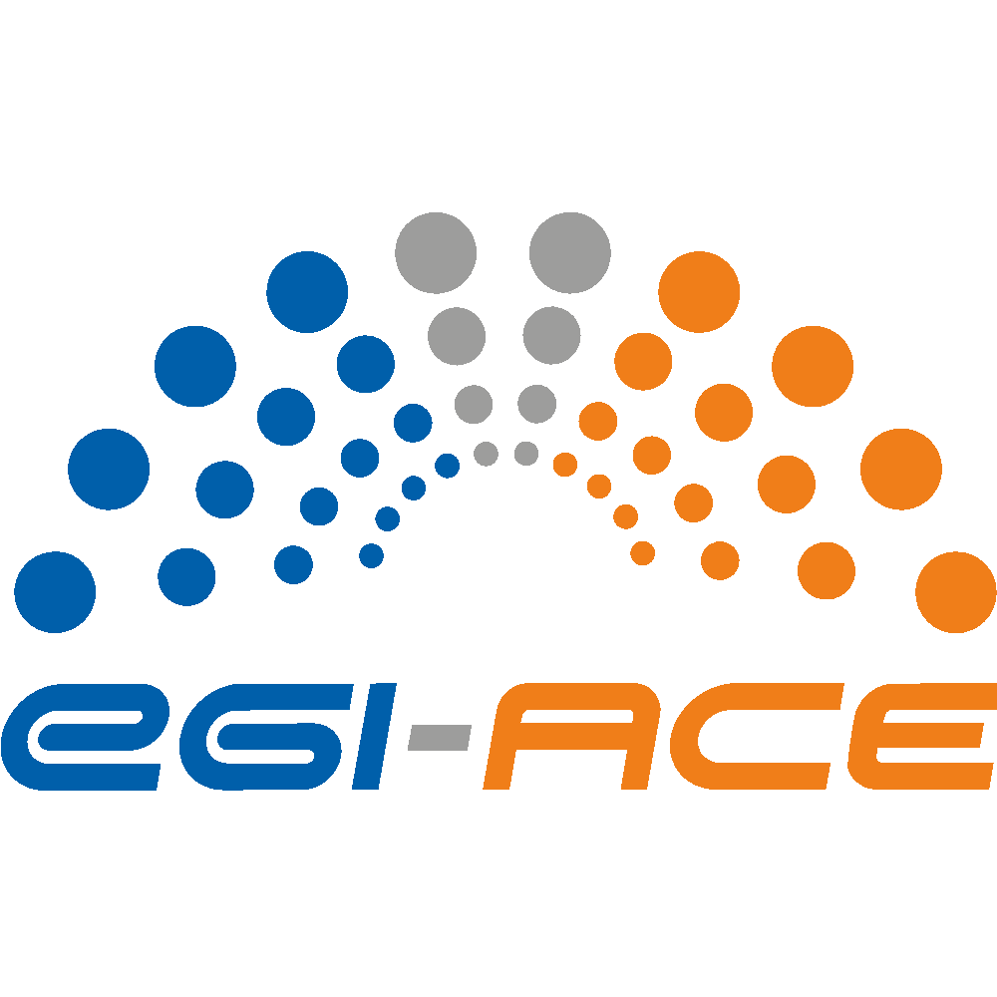
D1.7 Dissemination and Exploitation Plan

Lead partner: | EGI Foundation
Version: | 1.1
Status: | Under EC Review
Dissemination Level: | Public
Keywords: | Dissemination, Exploitation
Document Link: | https://documents.egi.eu/document/3806

Deliverable Abstract
This document provides an update to the key exploitable results, including aspects such as the definition, value proposition, IP management, exploitation path and dissemination activities and adoption.

COPYRIGHT NOTICE
This work by parties of the EGI-ACE consortium is licensed under a Creative Commons Attribution 4.0 International License. (http://creativecommons.org/licenses/by/4.0/).
EGI-ACE receives funding from the European Union's Horizon 2020 research and innovation programme under grant agreement no. 101017567.
DELIVERY SLIP
Date | Name | Partner/Activity
From: | Smitesh Jain  Magdalena Brus | EGI Foundation  EGI Foundation
Moderated by: | Smitesh Jain | EGI Foundation
Reviewed by: | Hien Bui  Gwen Frank | EGI Foundation

DOCUMENT LOG
Issue | Date | Comment | Author
v.0.1 | 08.06.2022 | Initial version | Smitesh Jain
v.0.2 | 13.06.2022 | Dissemination details | Magdalena Brus
v0.3 | 24.06.2022 | Updates with data space related exploitation activities | Smitesh Jain
v1.0 | 25.06.2022 | Final Version | Smitesh Jain
v2.0 | 24.11.2023 | Updates to the deliverable based on the comments by reviewers from final recommendations | Smitesh Jain  Enol Fernández

TERMINOLOGY
https://confluence.egi.eu/display/EGIG
Terminology/Acronym | Definition
EOSC | European Open Science Cloud
KER | Key Exploitable Result
OLA | Operational Level Agreement
UA | Underpinning Agreement
SDS | Service Delivery and Support board
IP | Intellectual Property
IPR | Intellectual Property Rights
HTC | High Throughput Computing
HPC | High Performance Computing
RI | Research Infrastructure
SME | Small- or Medium-sized Enterprise
GOSC | Global Open Science Cloud
EOSC AG | EOSC Advisory Groups
EOSC TF | EOSC Task Forces
DoA | Description of Action
HRP | Horizon Results Platform

Contents
1 Introduction 6
1.1 Updates from D1.4 6
1.2 Relationship with other project deliverables and outputs 6
1.3 Exploitation and Dissemination Process 6
1.3.1 Identifying KERs 7
1.3.2 KER Champions 8
1.3.3 Exploitation 8
Mapping EGI-ACE stakeholder groups to the Horizon Results Platform User Groups 10
1.3.4 Dissemination 12
Dissemination Activities 13
2 The EOSC Compute Platform 19
3 Services enabling federated computing in EOSC 24
4 Research data spaces and processing tools for EOSC 28
5 Intellectual Property Generated in the Project 31
6 Exploitation and Sustainability Beyond the Project 35
EOSC Compute Platform (KER1) 35
New services in EGI service portfolio 35
Delivery for existing use cases 35
Infrastructure services for future use cases 36
Platform services for future use cases 37
Services enabling federated computing in EOSC (KER2) 38
Research Data Spaces and Processing Tools for EOSC (KER3) 38
Exploitation of generated knowledge 39
7 Conclusions 41
Appendix 1: EGI-ACE Stakeholder group definition 42
Appendix 2: Horizon Results Platform Template 43
Appendix 3: Radical Innovation Breakthroughs 48

Executive summary
The Dissemination and Exploitation plan deliverable establishes the link between EGI-ACE results and its dissemination and innovation management practices. The deliverable presents the Key Exploitable Results and presents a plan for promoting them and exploiting them by mapping them to the overall project dissemination presented in D2.6 Communications and Engagement Plan.
The first issue of this deliverable (D1.4 - Dissemination and Exploitation Plan) was published in July 2021.
During the first project period EGI-ACE executed successfully the plan defined in D1.4. This second issue includes the following updates:
- An expanded exploitation and dissemination plan than the one presented in D1.4
- A plan to capture the direct and indirect innovation enabled by the project.
- A plan to capture the impact brought forth by the exploitation of the project results by researchers and by service providers.
- Identification of three new KERs and archival of the previously defined five KERs in the DoA and D1.4.
- Submission of the three KERs to the Horizon Results Platform.

This deliverable will serve as an input to the final periodic report and the D1.6 Quality, Risk and Innovation Management, due in M30. The Key Exploitable Results (KERs) will also feature in the project outreach materials (presentations, flyers, EGI website and other similar materials).

Introduction
This deliverable presents the project’s Key Exploitable Results (KERs) and the process used in defining them, their value propositions and aspects related to dissemination and exploitation (including IPR-related issues) among other things. The deliverable will also include some updates to the analysis presented in the deliverable D1.4.

Updates from D1.4
As will be described in more detail in the document later, the five KERs as identified in the project proposal and included in D1.4 have been deprecated and replaced with three new KERs. Consequently the chapters 2-6 from D1.4 have been removed from the document and replaced with new chapters covering these new KERs.
Another major change from D1.4 is the removal of the section “1.2 KER-centric view of project’s dissemination and exploitation plans”. The content of this section is still present in essence but distributed across the subsections of the new section “1.3 Exploitation and Dissemination Process”. This section also expands greatly on the Dissemination activities and Exploitation plan.

Relationship with other project deliverables and outputs
This deliverable complements the Innovation Management section of the deliverables D1.1 and D1.3 (Quality, Risk, and Innovation Management Plan) by describing the process for capturing the project results and supporting the exploitation of them. This deliverable is also closely related to D2.6 “Communication and Engagement Plan” which defines the project’s engagement channels and dissemination activities. This deliverable will serve as an input to the final periodic report, due in M30. The Key Exploitable Results (KERs) will also feature in the project outreach materials (presentations, flyers, EGI website and other similar materials).

Exploitation and Dissemination Process
A project result is any output generated during the project implementation. Some examples of project results include know-how, experience, algorithms, prototypes, new products or services, policy recommendations, roadmaps, learnings, reports, publications, data, events, etc. However, not all of these results can be exploited i.e. use and benefit from something often for commercial purposes or in public policymaking. A Key Exploitable Result (KER) is a project result or a group of similar project results with particularly high exploitation potential. The process of managing, exploiting and disseminating these KERs and the project results contained within them, in EGI-ACE is represented in the figure below. The activities are grouped into four categories which are explained in detail in the following sections.

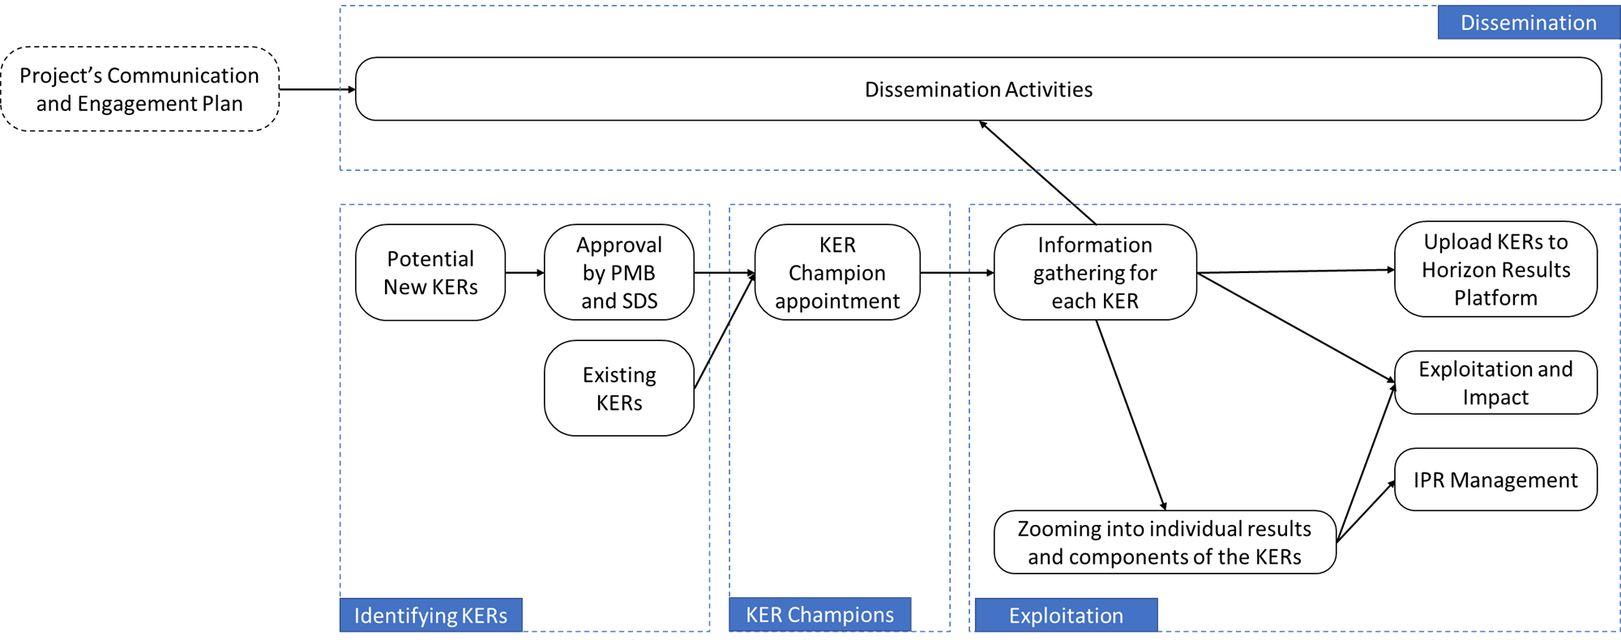
Figure 1: KER management, exploitation and dissemination process

Identifying KERs
The EGI-ACE project proposal identified the following five KERs in its Impact section:
- Free at point of use services, IT resources, data, and analytics via EOSC portal;.
- Training, handbooks and consultancy;
- Improved Service Management and Tools;
- Interoperability Toolkit;
- Strategy and Recommendations.
However, during the course of the first year, it was identified that these five initial KERs do not fully reflect the results and impact of the project. The main objective of the EGI-ACE project is to deliver integrated computing, platforms, data spaces and tools as an integrated solution that is aligned with major European cloud federation projects and HPC initiatives. For this, the project delivers the EOSC Compute Platform and contributes to the EOSC Data Commons through a federation of Cloud compute and storage facilities, PaaS services and data spaces with analytics tools and federated access services. Keeping this in mind and to better reflect the objective and impacts of the project, a set of new KERs was defined with the support of the Project Coordinator, Technical Coordinator, Communications Manager, Project Manager and the Project Office. These KERs were also presented to the Project Management Board (PMB) and Service Delivery and Support Board (SDS) for feedback and approval. Taking into consideration the feedback provided, the following three KERs were identified,
- The EOSC Compute Platform;.
- Services enabling federated computing in EOSC;.
- Research data spaces and processing tools for EOSC.
It is possible that the project activities will identify additional KERs in the future. These KERs will be managed through the same process, such as being presented to the PMB and the SDS for feedback and approval. They will also get a KER champion assigned.

KER Champions
To support in collecting and managing the information related to the KERs, individuals from the project consortium have been assigned in the role of a ‘KER Champion’ by the SDS. These KER Champions are considered as the foremost experts of the respective KERs within the project. Their role is to act as an Ambassador for the KER - a primary spokesperson within the project, helping to encourage uptake, exploitation and dissemination of the KER. They provide the relevant data for the Horizon Result Platform template for their respective KERs. They support the development and exploitation plan, pointing to the relevant contact persons for technical, IP and other exploitation plan aspects of the KER. KER champions take the lead in providing inputs on dissemination messaging. And finally, they also help bridge the gap between technical outputs and their practical implications by promoting the uptake.

Exploitation
As evident from the above discussions, the project takes a very KER centric view towards exploitation. When considering any KER, the following mechanism will be used to ensure consistent exploitation approach:
- Define the scope of the KER with the support of the PMB and the SDS;
- Capture the KER related details (both pre-identified and potential new KERs identified during the project lifetime) with the support of the KER Champions, based on the Horizon Results Platform (HRP) template;
- Map KERsdevelopment into project activities (often in a way that is not limited to a single work package);
- Monitor and update the KER details at periodic intervals.
Each of these KER is an umbrella under which similar or strongly related project results have been grouped together. To ensure a strong exploitation approach, project results under these KERs will be zoomed into. Templates have been created to capture information related to these individual project results.
For the three identified KERs, the expected users,benefits, and value propositions for using these results have been identified and are presented in the following chapters. Through discussions with the KER Champions, the Horizon Results Platform template for each of the KERs was filled and uploaded to the platform . The details for each of these KERs with selected fields from the HRP template can be found in the later chapters of this document.
These identified KERs for the EGI-ACE project could be either:
- Results that could and should be taken forward in the same application context the project works on, i.e., the EGI/EOSC ecosystem
- Results that could be taken up by anyone outside the specific context of the project.
When focusing on the first category of results, it is possible to make the following assumptions stemming from the EGI/EOSC environment:
- The services will be provided based on the ‘Free at the point of use’ model, based on commonly agreed rules of participation that provide basic sustainability or business model parameters;.
- The primary use of the services will be processing varied research data sets that adhere to FAIR principles defined by the user community;
- The users are - at least in the immediate future - technically skilled, science-literate people capable of performing the tasks in a highly autonomous fashion.
The exploitation potential of the result is thus based on quite clear criteria: fitness for purposes of a particular research task, level of integration with the marketplaces (EGI, EOSC), and awareness of and attitudes towards the solution of the EGI and EOSC user communities. The openness of the platform and the technical skills of the user communities make the retention of users more challenging than in other IT service markets. The perceived ‘switching costs’ to another solution; providing better performance; are low.
The results belonging to the second category - results that could be taken up by anyone outside the specific context of the project - present a slightly more multifaceted challenge. A larger set of exploitation opportunities and stakeholder groups is balanced by the need to describe resources in a way that makes them relevant to a much broader range of stakeholders (also outside the project’s primary context). These results are typical candidates for inclusion in the EC Horizon Result Platform that is geared more towards investor groups ranging from private profit-oriented entities to public service and development-oriented organisations (including third-sector entities). This difference in orientation requires taking a broader set of aspects into account in capturing the results and a slightly different approach to disseminating them.
The role of joint ownership agreements is especially important for the KERs falling under this second category, as major project results are typically generated through the involvement of several organisations. The Horizon Results Platform requires assigning a partner or partners in the role of ‘Owner for exploitation’ and the joint ownership agreement needs to consider the fair distribution of a much broader range of benefits (investments, partnerships, consulting, paid service provision, among others) than is the case with pure academic use. A lot of this information is already captured in the OLAs, and UAs used by the Service Management System of the project. However, when the potential exploitation approaches go beyond the service provisioning in the EOSC Exchange context, it is important to review the exploitation roles of the partners involved in the development of the result.
All this is further complicated by the fact that the KERs are a group of individual results with each of them potentially having different access rights and IP protection mechanisms. So, zooming into the individual results contained within each of the KERs and collecting information around them and their protection is a key part of the exploitation plan.
Another aspect that the exploitation management should consider is developing a clear understanding of how the project enables innovative scientific research. One component of this is to explore writing publications related to the innovation built by the project especially focusing on innovative infrastructure for federated computing and the data spaces.
The other part is to understand the wider impact brought about by the project through the exploitation of its results by the users and service providers. A template will be developed to capture this information from all sources in a systematic manner. To capture this information, following channels will be used,
- As part of the regular customer reviews carried out by task T2.3.
- User workshop which bring together users and shepherds to share updates on progress, achievements, impact
- Interviews with service providers
- Any other form of ad-hoc discussions as required

Mapping EGI-ACE stakeholder groups to the Horizon Results Platform User Groups
To better coordinate the exploitation and dissemination activities, this section aligns the EGI-ACE stakeholders as identified in D2.6 “Communication and Engagement Plan” with the Horizon Results Platform User Groups. The focus of deliverable D2.6 is on maximising the awareness of the key stakeholder groups during the project lifetime. It defines the following stakeholder groups based on the type of interaction between the project and them:
- Users that demonstrate the project's positive impact by providing success stories. These include Researchers, International projects and Research Infrastructures (RIs), Industry/SMEs, Public sector;
- Service and content providers for research providing services that can be encouraged to integrate into the project. These include Academic HTC/Cloud providers, HPC providers, Data Space providers;
- EOSC Governance and Core who need to be aware of the project and its potential to ensure inclusion of EGI-ACE in the future EOSC technical and organisational structure. These include EOSC Association, EOSC AGs/TFs, Providers of EOSC Core;
- Peer initiatives which can be encouraged to align their approaches to increase the overall awareness of the solutions offered. These include INFRAEOSC-7 projects, GAIA-X, EOSC-like initiatives outside Europe (GOSC), EOSC-Future Project.
In contrast, the Horizon Results Platform entry offers the following categorisation:
- Others/ No specific audience;
- Public or private funding institutions;
- EU and Member State Policy-makers;
- International Organisations (e.g., OECD, FAO, UN, etc.);
- Other Actors who can help us fulfil our market potential;
- Research and Technology Organisations;
- Academia/Universities;
- Private Investors.
Mapping between these two taxonomies is not straightforward. The following table maps the Horizon Results Platform categories to EGI-ACE stakeholder groups. In practice, each KER will have a subset of EGI-ACE categorisation entities and Horizon Results Platform audiences that is specific to that KER. This further underlines the importance of the KER Champion role. Without a deeper understanding of the situation and goals related to the result, it is impossible to determine which of the target groups are relevant for that KER.
EGI-ACE stakeholder group | Entities in EGI-ACE categorisation | Potentially matching Horizon Results Platform entries
Users | - Researchers  - International projects and Research Infrastructures (RIs)  - Industry/SMEs  - Public sector | - EU and Member State Policy-makers  - International Organisations (ex. OECD, FAO, UN, etc.)  - Other Actors who can help us fulfil our market potential  - Research and Technology Organisations  - Academia/ Universities
Service and content providers for research | - Academic HTC/Cloud providers, HPC providers, Data Space providers | - International Organisations (ex. OECD, FAO, UN, etc.)  - Research and Technology Organisations  - Academia/ Universities
EOSC Governance and Core | - EOSC Association  - EOSC AGs/TFs  - Providers of EOSC Core | - Public or private funding institutions  - EU and Member State Policy-makers  - International Organizations  - Other Actors who can help us fulfil our market potential  - Research and Technology Organisations  - Academia/ Universities
Peer initiatives | - INFRAEOSC-7 projects  - GAIA-X  - EOSC-like initiatives outside Europe (GOSC)  - EOSC-Future Project | - Public or private funding institutions  - EU and Member State Policy-makers  - International Organisations (ex. OECD, FAO, UN, etc.)  - Other Actors who can help us fulfil our market potential  - Research and Technology Organisations  - Academia/ Universities
Stakeholder categories mostly outside the ones defined in D2.6 |  | - International Organisations (ex. OECD, FAO, UN, etc.)  - Private Investor

As noted in the above table, the D2.6 stakeholder groups do not explicitly consider International Organisations or private investors. The former can be either a potential user of the services provided or a supplier of data and other resources that could be integrated into EGI-ACE supported workflows. Separating these two roles is crucial in the day-to-day operations of the project. However, the difference is less crucial when assessing the role of International Organisations as investors (funding or effort) in the exploitation phase.
When considering private investors, the expectations need to be tempered. As most of the project’s outputs are licensed under an Open-Source license or under Creative Commons, identifying IP and developing protection mechanisms (e.g. Trademark) and negotiating the details of the governance of the use of this IPR would require considerable up-front investments with very uncertain return. However, using the Horizon Results Platform template as the basis of the KER review with the Champions will ensure that feasibility of this option is assessed systematically.

Dissemination
The majority of the content in this section is derived from the D2.6 “Communications and Engagement Plan”. Dissemination activities for the stakeholders as identified in D2.6 and their relation with the KERs are included in the section below. D2.6 also discusses how to utilise the existing channels not only to disseminate but also to engage with different target groups and create an environment and opportunities for two-way communications. That way, the KERs and the development process around them can be continuously consulted and aligned with the stakeholders' expectations.
The earlier phase of the project mainly focused on digital dissemination and engagement activities. As the global pandemic did not allow face-to-face events, online webinars and meetings were the main tools to ensure all target audiences and stakeholders stay up to date on the latest developments of the project. Pandemic or not, online communication channels play a crucial role in the dissemination of the project. Platforms and tools such as social media, newsletters, and websites are populated with the success stories, call for use cases, news items, explanatory videos and infographics. The project outcomes and results additionally benefit from publication in scientific journals, online events/webinars and training sessions, depending on the audience. In addition to our digital efforts, the project also focuses on offline engagement through participation in and organisation of events, and conference booths. These initiatives provide a unique opportunity for face-to-face interaction, allowing us to showcase KERs and engage stakeholders directly. This underlines our commitment to creating a two-way communication environment, ensuring continuous consultation with stakeholders.

Dissemination Activities
The dissemination activities for each stakeholder category is displayed below. The table includes examples, objectives and appropriate indicators to measure the impact.
Target audience 1 - stakeholder category: users
Communication activity | Related KER | Objective(s) | Dissemination output(s) and example(s) | Impact indicators | Notes
Promote call for use cases | KER1, KER3 | Inform users about the offering and how it supports their activities. This includes informing about the application process. | - Dedicated webpage on the call  - Newsletter items  - Programme  - Include/mention in relevant events, webinars, training sessions | # of applicants gained through the dissemination outputs | In the second period of the project, onboarding of new communities is not anymore a top priority.
Write use cases/ success stories to illustrate the service uptake | KER1, KER2, KER3 | Create awareness of the impact of the EGI-ACE services. | - Populate use cases section on website  - Newsletter items  - Social media posts  - Add to relevant scientific journals  - Presentations during relevant events | - Engagement statistics on online platforms  - # times use case(s) used in presentations during relevant events  - # of scientific journals use case(s) are included | In the second reporting period, the success stories will focus on promoting Integrated clouds to reach out to more cloud providers and users in the countries where the clouds are present.
Promote the added value of EGI-ACE and demonstrate how it supports research for EOSC | KER1, KER3 | Summarise the key use cases and demonstrate the added value for long tail of science, industry and data space providers | - Develop an extensive brochure / publication | - Number of views | Towards the end of the project
Promote webinars, training sessions and other events | KER1, KER2, KER3 | Inform and invite users to informative and interactive knowledge sharing events. | - Highlighted webpage on EGI-ACE events  - Newsletter items  - Social media posts  - Targeted emails to relevant mailing lists | - Engagement statistics on online platforms  - Click-through statistics to registration forms on online platforms  - # of participants finding out about the event via the used channels (newsletter, social media, email, webpage) | In the second period, we will focus on more targeted promotion of the Webinar programme to specific audiences (e.g. through targeted email campaigns)
Publish specific impact reports of Data Spaces | KER3 | Inform, create awareness, share impact of EGI-ACE for the Data Spaces | - Brochure/leaflet on the project’s impact for each Data Space available online and for print  - Social media posts  - Targeted emails to relevant mailing lists | - # of clicks and downloads  - # printed versions collected during events
Promote services | KER1, KER2 | Inform, create awareness, highlight benefits of our service offering | - Website  - Social media  - video | - increased usage of the services | In the second part of the project, we will focus on Promotion of HPC services as soon as they are available (most likely in July 2022)
Promote the underused services | KER1, KER2 | Inform, create awareness, highlight benefits of services that are not being used enough | - Promotional campaign highlighting the benefits of specific services  - the campaign will include short videos shared through Social Media platforms highlighting the functionalities of different services  - Persons responsible for different services will be contacted by Task 2.4 to find the optimal way to communicate each specific service | - increased usage of the services | In the second period, we will focus on the promotion of those services that are not used as widely as other services. Examples include: RUCIO, FTS, DODAS,DEEP, PaaS Orchestrator and MasterPortal
Promote EOSC Compute Platform | KER1 | Inform, create awareness of the value for users | - Digital version , to be shared through communications channels  - Printed version; to be distributed at physical events | - # of clicks and downloads  - # printed versions collected during events

Target audience 2 - stakeholder category: service and content providers for research
Communication activity | Related KERs | Objective(s) | Dissemination output(s) and example(s) | Impact indicators
Create guidelines on how to join the EOSC Compute Platform | KER1, KER2 | Get information across on how to join the EOSC Compute Platform | - Infographic style quick guide available online and for print  - Targeted emails to relevant mailing lists | - # of clicks and downloads  - # of printed versions collected during events  - interactions after targeted emails sent
Demonstrate (HPC) integration in EOSC | KER1 | Show the impact of EGI-ACE as means of integration in EOSC | - Use cases available online  - Newsletter item  - Targeted emails to relevant mailing lists | - # of page visits and other relevant page statistics  - requests to partner with the project or use guidelines
Setting up and operating Data Spaces | KER3 | Focus on explaining:  - what are the data spaces and what they bring to different target groups  - How are they useful  - Step-by-step introduction of how to set up a data space | - Brochure | - # of views

Target audience 3 - stakeholder category: EOSC Governance and Core
Communication activity | Related KERs | Objective(s) | Dissemination output(s) and example(s) | Impact indicators
Vocalise and visualise the project’s contributions to EOSC in various communication materials | KER1, KER3 | Show the impact and importance of EGI-ACE to EOSC and the association | - Use cases available online  - Data Spaces impact reports available online and offline  - Social media posts directly targeting the EOSC Association  - Presentations during relevant events  - Posts on EOSC Liaison platform  - Posts on the Horizon Results platform  - Promotion of the EGI-ACE quarterly impact report  - Infographics  - Video  - Participation and organisation of events | - Page statistics  - # of printed versions collected  - Social media engagement statistics  - Engagement after presentations
Inform relevant EOSC task forces about activities, results, engagement possibilities | KER1, KER3 | Proposing synergies and collaborations between the relevant EOSC task forces | - Targeted emails to specific mailing lists  - Posts on EOSC Liaison platform | - # of joint presentations or booth attendances  - # engagement activities leading to collaborative activities
Interact with providers of EOSC Core | KER1, KER2 | Contribute to development and improvement process of EOSC Core services | - Direct communication | Implementation of feedback

Target audience 4 - stakeholder category: peer initiatives
Communication activity | Related KERs | Objective(s) | Dissemination output(s) and example(s) | Impact indicators
Reach out to INFRA-EOSC07 projects and EOSC Future | KER1, KER3 | Keep projects informed and engaged to cross-promote relevant content | - All relevant communication/dissemination material that showcase results, calls, highlighted activities  - Cooperation through cross-project and collaboration board meetings | - # materials/posts shared via communication channels of projects  - # responses to relevant communication material
Continuously communicate and engage with initiatives such as GAIA-X and GOSC to share and align approaches and lessons learned | KER1, KER2, KER3 | Contribute to and from similar approaches to Open Science | - Direct communication  - Presentations at relevant events | - # meetings and/or joint activities organised to exchange and align approaches
Document the best practices and lessons learned | KER1, KER2, KER3 | To communicate e.g. the set up of Data Spaces and Innovation management | - Scientific papers | - # downloads  - # views

The Dissemination activities carried out related to each of the KERs are included in the chapters related to the KERs below.

The EOSC Compute Platform
Figure 2 provides a representation of the EOSC Compute Platform as overlaid on the EOSC Architecture diagram. The right side of the figure also presents the various components of the EOSC Compute Platform.
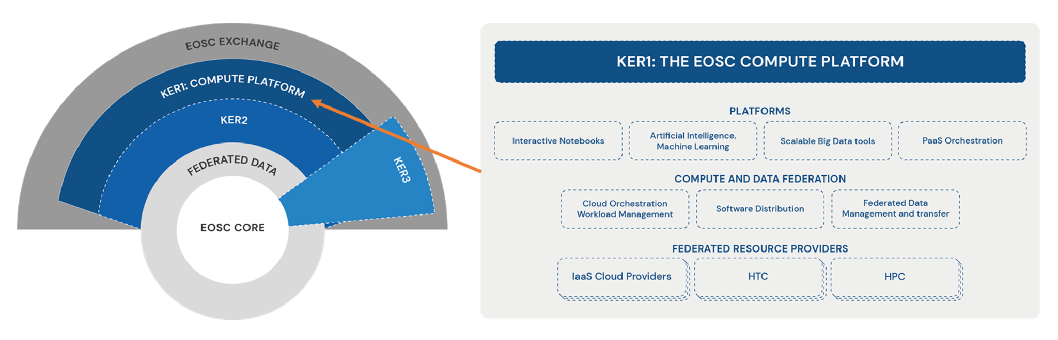
Figure 2: KER 1 - The EOSC Compute Platform

Result Description | The EOSC Compute Platform is a free-at-the-point-of-use, distributed computing environment. It is built on a hybrid infrastructure composed of cloud computing resources, High-throughput computing (HTC) sites and High Performance Computing (HPC) centres. It empowers users with higher-level services to ease the setup and operation of complex workflows, applications, containers, virtual research environments and data spaces on top of the hybrid infrastructure. The Platform supports diverse data processing and analysis use cases. Thanks to EC and national funds, it provides free at-the-point-of-use services with user support and training for research infrastructures, communities, projects and the long tail of science. E-Infrastructure providers joining the EOSC Compute Platform can benefit from the simplified integration with EOSC, streamlined user access handling and scalable resource allocation mechanisms, and various financial incentives.
Result Type | Services
Project Results | The project results grouped under the KER are as below,  - KER1a IM For EGI-ACE  - KER1b Dynamic DNS For EGI-ACE  - KER1c EGI Workload Manager  - KER1d Datahub  - KER1e FTS  - KER1f RUCIO  - KER1g OpenRDM  - KER1h EGI Notebook  - KER1i Deep Training Facility  - KER1j DODAS  - KER1k EC3  - KER1l PaaS Orchestration  - KER1m AppDB  - KER1n CVMFS  - KER1o Federated Resource Providers  - KER1p Replay
Key Innovation | Brief summary for key innovation for each service is presented here,  Infrastructure Manager  This is a new service in the EGI service portfolio and has been integrated with ARGO monitoring, EGI Dynamic DNS, and the AppDB Information System, while also enhancing GPU support. The IM service offers Cloud brokering functionality and allows users to share virtual infrastructure. It also has improved security by storing user cloud credentials in a Vault service integrated with the IM-Dashboard.  Dynamic DNS for EGI-ACE  A secondary DNS server is deployed at LIP and the service has been integrated with GOCDB, GGUS, and ARGO monitoring. The service demonstrates improved compliance with EGI Federation Service Management and IMS through various measures such as an Availability & Continuity Plan, OLA, Capacity Plan, and updated terms of service and documentation.  EGI Workload Manager  The service has been integrated with EGI Check-In, Notebooks, Cloud Compute, RUCIO.  EGI DataHub  The service integrates with Accounting, Notebooks, and Binder (Replay), providing seamless functionality across these platforms. A new marketplace is created within Datahub, enabling users to search, find, and request access to datasets. The integration with OpenFaaS facilitates workflow automation. Additionally, directory statistics are implemented, and bug fixes, along with other minor improvements, are made to enhance the overall service experience.  FTS  The service has been integrated with Check-in. A dedicated instance is created specifically for EGI Virtual Organisations (VOs), ensuring optimal performance and resource allocation. A set of APIs has been implemented to abstract file transfer service implementations, allowing smooth integration with the EOSC Portal following the EOSC Data Transfer Interoperability Guideline.  RUCIO  The service was integrated with the EGI environment, including monitoring, GOCDB, and Check-In, to ensure seamless interoperability. A migration from virtual machines (VMs) to Kubernetes took place, improving scalability and enabling more efficient resource management.  OpenRDM  The service was integrated with the EGI environment, specifically with Check-In, to ensure smooth collaboration and functionality. Additionally, a demo instance was deployed and onboarded on the EOSC Marketplace, showcasing the service's capabilities. The service also provides support for in-house deployments by institutions, accommodating their specific requirements and needs.  EGI Notebook  Access control is enhanced through closer integration with EGI Check-In, enabling customised access profiles for each user. Operational improvements are made, including enhanced monitoring, accounting, and backup functionalities. The service expands its support for programming frameworks such as MATLAB, RStudio, and Julia, along with libraries for machine learning. Users are provided with increased RAM and CPU availability, allowing them to run larger analytics workloads. Integration with DataHub and B2Drop is established to streamline data management. Bug fixes are also implemented to improve the overall stability and reliability of the service.  Deep Training Facility  The service evolved into the AI4EOSC platform and integrated with the EGI environment, specifically EGI Check-in.  DODAS  The service successfully integrates with Check-In, Indigo PaaS, Monitoring, and Accounting. To enhance performance in data analytics, a local cache mechanism is implemented, improving data retrieval and processing speed.  EC3  The service is integrated with Monitoring and Accounting systems, enabling comprehensive tracking and management of resources. It also introduces support for GPUs, enhancing the capabilities of the service for computationally intensive tasks. Furthermore, improvements are made to better support Kubernetes, ensuring efficient orchestration and scalability of deployments.  PaaS Orchestration  The service has successfully integrated with Check-In, Monitoring, and Accounting systems.  AppDB  The cloud marketplace was expanded with a container catalogue, providing users with a wider range of options. OpenStack horizon endpoints were added to the portal, allowing users to filter sites based on horizon support for improved visibility. The VMOps dashboard introduced a new administrative view with cloud site issue reports, enhancing administrative capabilities. The information system data was enriched with new properties and correlations to improve the user experience, and the portal experience for site administrators was improved by providing more details about associated sites and roles. The catalogue also underwent FAIR improvements, expanding PID support and relevant metadata. Additionally, support for RO-Crate as a packaging format for software products was implemented.  CVMFS  The service was successfully integrated with Check-In and Monitoring systems. Additionally, support for containers was added.CVMFS has been integrated in the EGI service portfolio as the Software Distribution service.  Federated Resource Providers  The service now includes accounting capabilities for GPU and storage resources, providing better resource management and allocation. Central resource discovery is improved with information on GPU resources and enhanced monitoring functionalities. The infrastructure is expanded to include new GPU and cloud providers, extending the service's reach. A common Command Line Interface (CLI) called "fedcloudclient" is introduced for interacting with the cloud providers. New VM images for Ubuntu 22.04, CentOS 8, and Jupyter are made available, and the documentation is revised with updated information. A central dashboard is implemented to facilitate the discovery of OpenStack providers. Additionally, there is a pilot integration of HPC providers, with federated access, monitoring, accounting, and policy review, along with documentation on guidelines for integrating new providers. The usage of SURF Spider in the High-Throughput Compute is incorporated as well.  Replay  Replay has been integrated in the EGI service portfolio as a new service. It has been well integrated in the EGI environment with integration with Check-in, DataHub, Monitoring and Accounting.
Types of Customers | - Individuals  - SMEs  - Academia  - Research and Technology Organisations  - Public Institutions and Authorities
Number of customers | 77000+
Value Proposition | Researchers/Users  - Having a broad and growing spectrum of types of compute resources behind a single interface (EGI-ACE Open Call) and single allocation process.  - Streamlined support and communication through the use case shepherds and with access to experts for consultancy to select the most suitable types and combination of compute and related platform/data services to realise a use case.  - Build partnerships with national providers for long-term usage of their compute resources.  - Free-at-point-of-use access to national and relevant international capacity.  - The distributed setup allows for computation to happen where the data is removing the need to move large amounts of data and any privacy concerns.  - Reusing software across providers with the use of AppDB removes the hurdle of installing software at every provider.  Providers  - Providers who join the EOSC Compute Platform benefit from the simplified integration with EOSC  - Co-funding by the EC to deliver relevant services across national borders.  EOSC  - The Platform allows the efficient use of European Commission and national funds, by integrating cross-border with national access mechanisms, maximising the return of investment for all stakeholders.  - Computing infrastructure is completely integrated with the EOSC ecosystem making EOSC an end-to-end destination.
Exploitation | - 77000+ users  - 144 research communities  - 8 SMEs supported  - 189 access requests through EOSC Marketplace  - 44 use case applications  - 7 processing platforms to EOSC  - 30 thematic services in EOSC  - 29 cloud providers  - +180 HTC providers  - 5 pilot HPC centres
Dissemination & Communication | - 13 Webinars, 10 training sessions and 4 demos / estimated reach  +300 attendees  - Covering all of the services included in the catalogue  - 32 presentations at conferences and workshops / estimated reach  +900 attendees  - EGI Conference 2021, 2022, 2023  - EGI-ACE Communities Workshops (2021 and 2022)  - EOSC Future Ask me anything sessions (3 events)  - International Conferences (ARCOS Symposium 2021, MiniGateways 2022, APAN55, ISGC 2023, ISC 2022, SC 2022, IEEE SYMPOSIUM ON CONVERGENCE OF CLOUD & HPC 2022)  - Community/Technology specific workshops (OSG AHM, EISCAT_3D, Rucio, DIRAC, FTS, HealthyCloud, HTCondor Workshop)

Services enabling federated computing in EOSC
Figure 3 provides a representation of this KER as overlaid on the EOSC Architecture diagram. The right side of the figure also presents the various technical and support services that are provided as part of this KER.
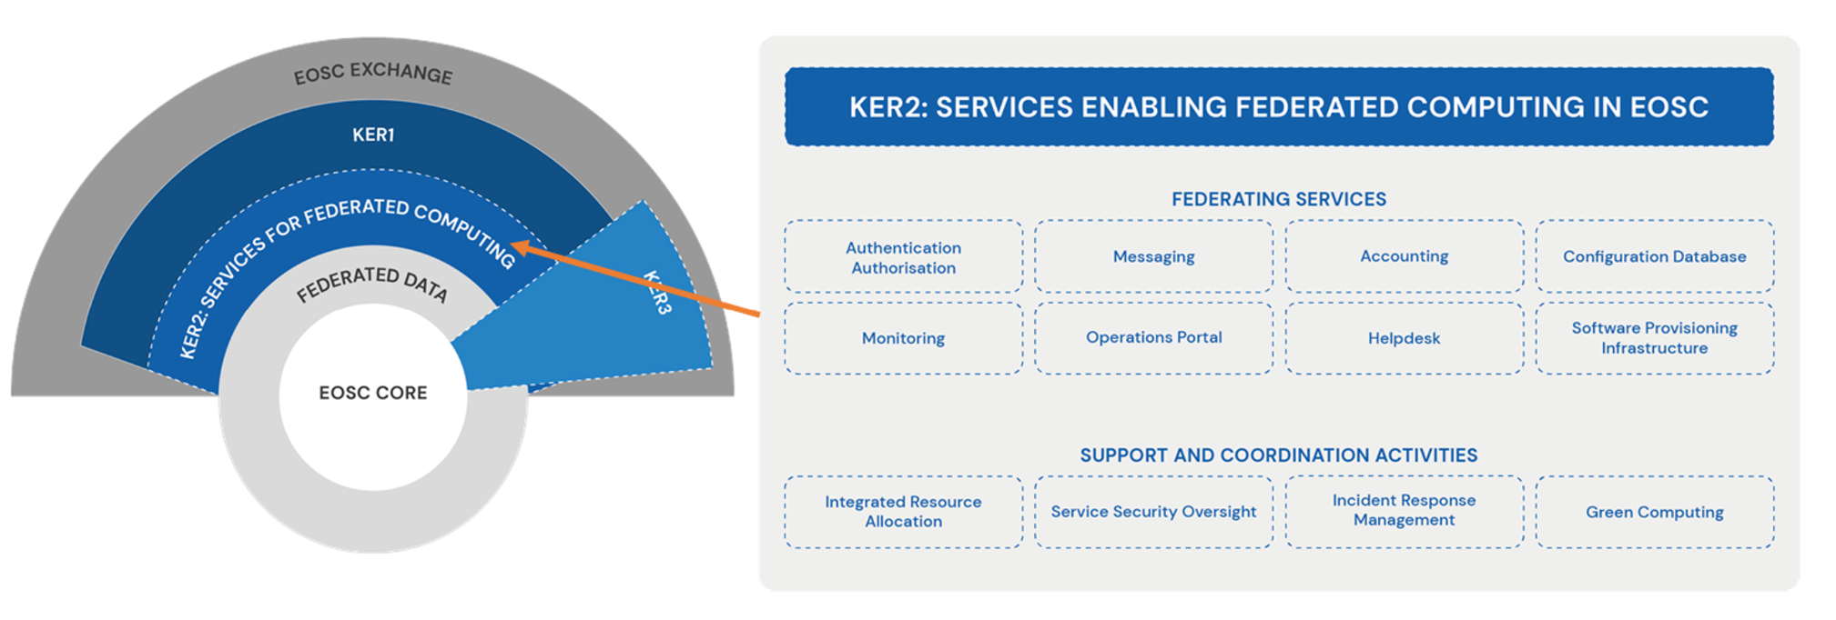
Figure 3: KER 2 - Services enabling federated computing in EOSC
Result Description | EGI-ACE project delivered various services that ensure the efficient management of the EOSC Compute Platform as a federated environment. These enabling services include technical elements (Check-in, Configuration Database, Monitoring service, Usage Accounting system, and Helpdesk), as well as non-technical elements and coordination activities, such as an IT Management System, service security oversight, incident response team, and resource allocation team. For providers, these services ensure a simplified and seamless integration into the Compute Platform and, therefore, with EOSC. For users, this provides a scalable resource allocation approach that considers local and European policies and the needs of national and international research communities. The project also developed a knowledge catalogue with best practices and training materials to help providers of the EOSC Compute Platform improve energy efficiency at data centres.
Result Type | Services
Project Results | The project results grouped under the KER are as below,  - KER2a Accounting  - KER2b Authentication and Authorisation  - KER2c Configuration Database  - KER2d Helpdesk  - KER2e Messaging  - KER2f Monitoring  - KER2g Operations Portal  - KER2h Software Provisioning Infrastructure  - KER2i Green Computing  - KER 2j Support and Coordination Activities
Key Innovation | Brief summary for key innovation for each service is presented here,  Accounting  New protocol for transferring accounting records from resource sites to the repository. Automatic controls from validating data and new benchmarks for performance to reduce the impact of erroneous published data and to improve reporting. New code and libraries for performance improvements along with replacement of outdated coding paradigms (Python2 to Python 3 and PHP5 to PHP8).  Authentication and Authorisation  Support the communities with accessing the EGI services with AAI. Implementation of compliance with AARC guidelines which are policies that need to be followed to enable the federation's operation. Migration from user x509 certificate to token technology. Migration to KeyCloak.  Configuration Database  Improved compatibility with MariaDB Galera (database) and with IdP technologies (Indigo IAM, EOSC AAI and others). Improvements to user data privacy. Improved WriteAPI for updating services and service endpoints. Code redesign to make it easier to extend in future.  Helpdesk  Improved the user interface for submitting tickets (characters limit removed, added more formatting options to text boxes, and modified the layout). Improved the selection of the recipients when opening tickets to multiple resource centres. Updated system components to latest versions (Oracle DB, BMC ARSystem Server Suite, Apache Webserver, PHP, OS). Improved anonymization processes of GGUS according to EGI Privacy Policy  Messaging  Development of new documentation for users of the messaging service. New and updated metrics to measure the usage and capacity of the services. The newly created AMS Library is a simple library that allows other services to interact with the ARGO Messaging Service. To improve the continuity and availability of the services, a second parallel instance as a proof of concept has been deployed.  Monitoring  Implemented new monitoring probes and automated deployment of probes to verify that the EGI services work. New web UI to display results of the monitoring tests, status pages summarising failures and downtime, to display tags-based views and analyse trends. Updated documentation. Improve the detection, report creation and notifications related to status change of services.  Operations Portal  The service achieved improved integration with EGI Check-in, enhancing authentication and authorization processes. A migration to a new web platform was completed, providing better access to different sections of the portal. A new section was added to assign and display badges based on the performance of EGI FedCloud resource centers. A dashboard was implemented to provide SLA performance reports. The service also migrated to a feature-rich back-end PHP framework, Symfony 5, for improved functionality. The VO Identity Card section was enhanced to store comprehensive information about each VO in the EGI Infrastructure. Lastly, support for multiple accounts of the same user was improved, ensuring a smoother user experience. New API CALL to identify sites vulnerable to critical vulnerabilities has been developed. Automated computing of KPI showing infrastructure patch status for vulnerabilities  Software Provisioning Infrastructure  Migration of the service from the previous supplier (IASA) to the new one (IBERGRID - CSIC, LIP). Implemented a new front-end to make it more robust against vulnerabilities. Implemented a new architecture of the service based on Nexus Repository OSS to support new artifacts like containers. Creation of a mirror middleware repository.  Green Computing  Survey on the current status of Green Computing across EGI Foundation and on Green Software. Creation of the Green Computing Task Force.  Support and Coordination Activities  Security policies are continuously evolved to address new technological developments, ensuring the protection of the infrastructure. The assessment of software vulnerabilities and security monitoring are conducted to maintain a secure environment. The service is also responsible for handling security incidents promptly. Additionally, the Integrated Resource Allocation process ensures the allocation of appropriate resources and services based on use case requirements, as well as national, local, and institutional priorities.
Types of Customers | - SMEs  - Research and Technology Organisations
Number of Customer | 220+
Value Proposition | For Providers (of the EOSC Compute Platform)  - The result enables standardised ‘access to market’ mechanism to service providers with built-in mechanisms to ensure fairness across the group of providers.  - Simplified order handling and customer relationship management (because of the first-line CRM team that pre-analyses and brokers orders to best-fitting providers, because of the shepherd who liaises with the use cases).  - Being part of a computing community that advises each other on topics of shared interest (e.g. containers, green computing).  - Working with like-minded compute centres on harmonised policies, protocols, and approaches for service operation, architecture and funding.  For users (of the EOSC Compute Platform)  - A simplified landscape of protocols and tools to get information about, and interact with compute services in EOSC  - A scalable resource allocation approach that considers local and European policies and the needs of national and international research communities
Exploitation | - A network of 22 shepherds from 9 institutes  - 200 participants who gained FitSM certificates (167 FitSM Foundation Certificates & 46 FitSM Advanced Certificates)  - Integration of the various services included in KER1 with services in KER2 is described in the Key Innovation section of KER1.  - Seven new fully integrated providers in EGI Cloud (CNAF, GSI-LCG2, GRNET-OpenStack, ILIFU, CNIC, WALTON, ELKH-Cloud)  - Expansion beyond EU (South Africa, China, Eastern countries)
Dissemination & Communication | - Green Computing sessions at EGI 2022 and EGI 2023 Conferences  - HPC integration with EOSC Compute Platform  - Ask me anything (EOSC Future) – June 2022  - IEEE INTERNATIONAL SYMPOSIUM ON CONVERGENCE OF CLOUD & HPC (July 2022)  - EGI 2022 Conference (September)  - SuperComputing 2022 (November)  - Cloud integration models in a dedicated workshop at EGI 2022 Conference  - Security workshop and training at:  - International Symposium on Grids & Clouds (ISGC) 2023 (March)  - EGI 2022 and EGI 2023 Conferences

Research data spaces and processing tools for EOSC
Figure 4 provides a representation of this KER as overlaid on the EOSC Architecture diagram. The right side of the figure also presents the scientific domains in which the data spaces of the project are part of.
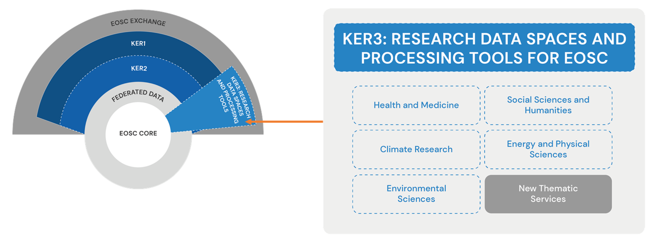
Figure 4: KER 3 - Research data spaces and processing tools for EOSC

Result Description | Leveraging the EOSC Compute Platform, the EGI-ACE project has set up and provisioned a thriving collection of Research Data Spaces and data processing tools.  Data Spaces are Thematic Services that host and integrate both datasets and scientific tools in a single unit, enabling scalable, online analysis of big datasets. The Data Spaces federate data from multiple providers and host this data on the EOSC Compute Platform together with applications that read and can process the data. Both Data Spaces and the processing tools are integrated into the EOSC Portal and Marketplace as Thematic services to facilitate user access.
Result Type | Services
Project Results | The project officially supported 5 Data Spaces:  - Climate Research: ENES Data Space  - Energy and Physical Sciences: LOFAR Science Processing  - Environmental Sciences: WebODV - Online extraction, analysis and visualization of SeaDataNet and Argo data,  EMSO Data Portal, and GBIF Portugal Occurrence Records  and additional 17 Thematic Services:  - Health and Medicine:  - WeNMR (4): HADDOCK2.4 web portal, DisVis Web Portal, PowerFit Web Portal, and SpotOn Web Portal  - Virtual Imaging Platform (1),  - UseGalaxy.eu (1), and  - OpenRiskNet (1)  - Climate Research: OPENCoastS Portal (1)  - Energy and Physical Sciences: PROMINENCE/Fusion (1)  - Environmental Sciences: Disaster Mitigation and Agriculture (1)  - Social Sciences and Humanities: OPERAS (2)  - Astronomy and Astrophysics: EISCAT Data Access Portal (1)  - Physical Sciences: VIRGO (1)  - Humanities: e-RIHS (1)  - Earth Sciences: Geohazards Exploitation Platform (GEP) and GEO-DAB  The project also supported the setup and operation of additional 36 Thematic Services of external scientific communities,  with the intention of contributing to the EOSC Exchange and Data Commons.
Key Innovation | The main focus of these services in the EGI-ACE project was to provide user support, training, and continuous operation. However, in combination with KER#1 and KER#2, these services enabled use cases during the project execution phase which is documented in the section 4.1.2.  In case of certain thematic services, combining with the EOSC Compute Platform allows for innovating the delivery mechanism (from local applications to web applications running in cloud).
Types of Customers | - Individuals  - SMEs  - Academia  - Research and Technology Organisations
Number of Customers | - 77K+  - Number of users of the EGI-ACE WP5 Thematic Services (17) + T2.3 Early Adopters (7) + T2.3 use cases (42)  - 37K+  - Users from external thematic services (e.g. NBIS, OBSEA, CLARIN, etc.) and the business use cases selected via the EOSC DIH.
Value Proposition | For Scientific Communities  - Streamlined support and communication through the use case shepherds and with access to experts for consultancy to select the most suitable types and combination of compute and related platform/data services to realise a use case.  - Build partnerships with national providers for long-term usage of their compute resources.  - Free-at-point-of-use access to national and relevant international capacity.  - Increase user base and reusability of their services  - Development of sustainability plans for operation beyond the lifetime of the project.  EOSC  - Contribution to the EOSC Data Commons through the setup and provisioning of ‘Data Spaces’  - Contributions to multiple EOSC strategic objectives as defined by the PPP/SRIA.  - Development of guidelines and best practice approaches on how to set up and operate Data Spaces.
Exploitation | - Details on the number of users and other metrics related will be provided in the D5.5 Periodical assessment of Data space services  - The project has also initiated the process of registering its 5 Data Spaces in the DATA SPACE RADAR  - ENES Data Space has since been registered on the radar.
Dissemination & Communication | - 25 training events were organized by the WP5 partners,  - 8 by WeNMR,  - 5 by OpenCoastS,  - 2 EISCAT_3D,  - 6 by Virtual Imaging Platform, and  - 4 by ENES.  - Additional events organized:  - Session at EOSC Symposium 2022  - Booth at the International Data Space Symposium (2023)  - Session at European GeoSciences Union (EGU) (2023)

Intellectual Property Generated in the Project
There is a lot of Intellectual Property generated by the project including the website, deliverables, reports, software extensions, presentations and other publications. All the deliverables, reports, presentations, video and the content of the website is copyrighted. For the sake of limiting the IP asset list, the following table groups certain assets while providing some of the assets individually. only lists IP assets not mentioned earlier.

Name | Beneficiary(s) involved during the project | Confidential | Type of protection or licensing action used | Protection or licensing actions used
Deliverables, Website Content, Report, Presentations, Videos, | All Partners | Majority Public (except some deliverables) | Copyright | CC By 4.0
EGI-ACE Logo | EGI | No | Trademark | LImited use.
Additional code related to new functionalities, improvements and integration with other components for Infrastructure Manager. | UPV | No | Copyright | GPL V3
Additional code related to new functionalities, improvements and integration with other components for Dynamic DNS. | IISAS | No | Copyright | 3-clause BSD
Additional code related to integrations with other components for Workload Manager. | CNRS | No | Copyright | GPL V3
Additional code related to new functionalities, improvements and integration with other components for DataHub. | CYFRONET | No | Copyright | Apache 2.0
Additional code related to integration of FTS with EGI Checkin. | CERN | No | Copyright | Apache 2.0
The new set of APIs for FTS integration with the EOSC Portal | EGI | No | Copyright | Apache 2.0
Additional code related to integration with EGI Check-in and other components for RUCIO. | STFC | No | Copyright | Apache 2.0
Additional code related to new OpenRDM functionalities and integration with EGI Check-in | ETH | No | Copyright | Apache 2.0
Additional code related to new functionalities, improvements and integration with other components for EGI Notebooks. | EGI Foundation  CESNET | No | Copyright | Based on originally created by Jupyter.  MIT License
Additional code related to integration with other components for DEEP Training Facility. | CSIC | No | Copyright | Multiple licenses for different parts of the code: Apache 2.0, MIT, GPL-3.0  https://github.com/orgs/deephdc/repositories
Additional code related to new functionalities, improvements and integration with other components for DODAS. | INFN | No | Copyright | Apache 2.0
Additional code related to integration with other components for EC3. | UPV | No | Copyright | Apache 2.0
Additional code related to integration with other components for PaaS Orchestration. | INFN | No | Copyright | Apache 2.0
Additional code related to new functionalities, improvements and integration with other components for AppDB. | IASA | No | Copyright | Apache 2.0
Additional code related to integration with other components for CVMFS. | STFC | No | Copyright | Apache 2.0
New code for Accounting probes in GPU and storage sites | CSIC  EGI | No | Copyright | Apache 2.0
Fedcloudclient - A command-line client designed for interaction with the OpenStack services in the EGI infrastructure. | IISAS | No | Copyright | MIT
New code related to information discovery for Federated Resource Providers | EGI |  |  | Apache 2.0
Additional code related to new functionalities, improvements and integration with other components for Replay . | EGI Foundation  CESNET | No | Copyright | MIT License
Additional code related to new functionalities, improvements and integration with other components for Accounting Repository. | UKRI | No | Copyright | Open Source.  Apache Software License 2.0
Additional code related to new functionalities, improvements and integration with other components for Accounting Portal. | CSIC | No | Copyright | Open Source.  v.2 Apache License
Additional code related to new functionalities, improvements and integration with other components for Check-in service components. | GRNET  CESNET  EGI | No | Copyright | Apache 2  GPL 2.1
Additional code related to improvements and code redesign for GOCDB. | UKRI | No | Copyright | gLite/Apache 2
Additional code related to new functionalities and improvements for Helpdesk. | KIT | No | Copyright | BMC Software
Additional code related to new libraries, improvements and management of new metrics for Messaging. | GRNET  SRCE | No | Copyright | Apache Software License 2.0
User Documentation: New documentation for users using the ARGO Messaging Service. | GRNET  SRCE | No | Copyright | Copyright ©
Additional code related to improvements for Monitoring. | GRNET*  (*ARGO is a service co-developed and operated by GRNET, SRCE & CNRS) | No | Copyright | Apache 2.0
Additional code related to improvements for the Operations Portal | CNRS  INT | No | Copyright | Apache 2.0/ MIT License
Additional code related to improvements for the Software Repositories | LIP  CSIC | No | Copyright | V.2 Apache License
Surveys related to Green Computing | EGI  CSIC  CNRS  JISC  UKAEA  Tubitak  SURF | Yes  No | Copyright | N/A
Integrated Resource Allocation Know-how | EGI | Yes | Trade Secret | Confidentiality
Updated Security Policies | EGI | No | Copyright | CC-BY 4.0
Innovation Management in EC Projects | EGI | Yes | Trade Secret | Confidentiality
Catalogue of Services (EGI Community Service Portfolio) | EGI | No | Copyright | Copyright (c)

Exploitation and Sustainability Beyond the Project

EOSC Compute Platform (KER1)

New services in EGI service portfolio
Three services from the EGI-ACE service portfolio have now been included in the EGI service portfolio of research. These services and other services in the portfolio along with the related user support and training will be continued to offered to individual researchers, national and international research projects, research communities, research infrastructures and commercial research entities.
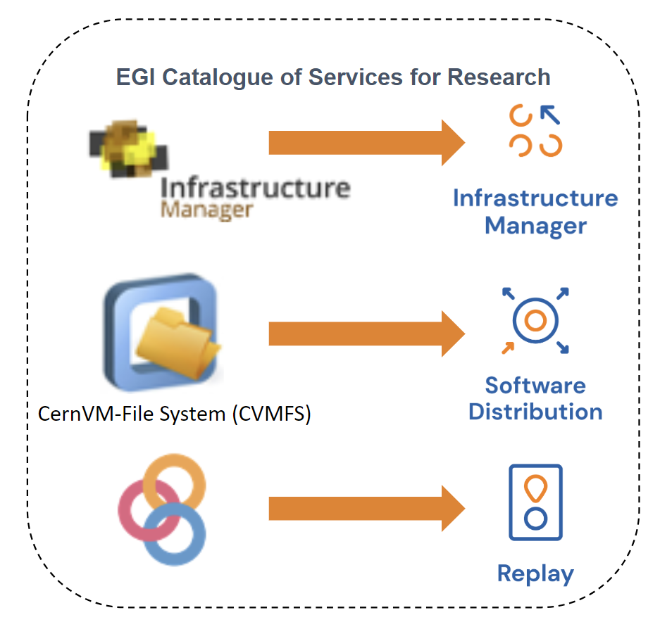

Delivery for existing use cases
During the course of the project, through its open calls, 42 external use cases were selected to receive EGI-ACE services. As mentioned earlier, EGI-ACE followed an integrated resource allocation mechanism where in the use case was matched with providers whose institutional, local or national priorities matched with that of the use case. That combined with the mixed funding model of EGI-ACE has ensured that some of the use cases will continue to receive support even after the project has been completed. Among the 42 selected use cases, 22 are still being supported while 14 use cases completed piloting activities.

Infrastructure services for future use cases
EGI-ACE delivered the EOSC Compute Platform (ECP), a federated system of 36 compute and storage infrastructure and platform services that support diverse types of data processing and data analytics cases.
The rolling open call and the intensive support mechanism through shepherds developed during the EGI-ACE project has been extremely successful. With the integrated resource allocation which takes into consideration the institutional, local and national priorities into consideration while matchmaking users with providers was vital to ensuring continued support for these users and their use cases even after the project had completed. Therefore, this mechanism is now being continued in the form of EGI open calls.
EGI-ACE combined multiple funding streams to deliver services to the call applicants:
- Virtual Access (VA) funding, going directly from the EC to EGI-ACE providers (~8 million EUR distributed to 17 ECP and 15 thematic service providers during the project duration)
- National and institutional funding, available to providers to support local/national or thematic user groups (over 200 HTC, 29 cloud, 5 GPU providers)
- Research community funding that is available to pay for ECP services. Such funding often comes in the form of EC-funded projects, involving the EGI Foundation in the project consortia ( we served 13 communities this way).
With the end of the project the 1st funding source will cease, so the delivery will continue through the other two funding sources.
To be able to keep the same scale of delivery, moreover to even increase the scale the EGI Foundation was looking into obtaining additional funding that can compensate for the 1st funding source and expand the scale of the 3rd funding source. The EOSC Procurement, particularly its Lot 2 and 3 calls were a good match to compensate for the loss of the 1st funding stream. The EOSC Procurement provides funding to deliver services for the ‘European EOSC Node’. EC calls in various pillars of the HE and DE work programme are monitored to identify projects that can contribute to the 3rd income source and scale out delivery. The current projects where the compute services are used are in the table below.
Depending on the outcome of the EOSC procurement evaluation outcome the KER 1 will have the following growth path in EOSC:
- EOSC Procurement Lot 2 is won by an EGI consortium:
The exploitation and sustainability pathways are quite straightforward in this scenario. Through the winning bid the international delivery of the EOSC Compute Platform and its services can continue and the same and even beyond the scale of EGI-ACE.
- EOSC Procurement Lot 2 is won by a competing consortium
In this scenario it is unclear at this moment whether and under what condition can the EOSC Compute Platform services be provided in the European EOSC Node. (Can stakeholders from outside the Procurement winning consortia provide services in the European EOSC Node at all?) Even if delivery will be allowed, the scale of delivery will be severely impacted, especially for use cases that require international compute delivery. Moreover, the EOSC Compute platform will have to compete with the winning consortium to attract potential users.

Platform services for future use cases
The considerations that were described in the ‘Infrastructure services for future use cases’ section largely apply to the Platform services layer of KER1 as well, most importantly that the end of Virtual Access funding will impact the scale of international delivery. However the EOSC Procurement overlaps with the scope of the platform services only slightly (i.e. with only a few of the services that are in EGI-ACE KER1). The project consortium therefore put effort into positioning these services for uptake in additional community projects and diversifying the sources of incomes and exploitations. The biggest exploitation path for these platform services is therefore Horizon Europe projects. Those projects where services from the platform layer of the EOSC Compute platform are currently delivered are listed below:
Service | Project
Check-in | Development and delivery under Blue-Cloud-2026, CRAFT_OA, AI4Europe, interTwin, ENVRI-Next (starting Feb 2024), TANGO projects.
Cloud Compute (including AppDB and DynamicDNS) | EOSC-Beyond (from March 2024) cover development of the service, service delivery covered under AI4Europe, AI4PublicPolicy, BD4NRG, Blue-Cloud-2026, DATAMITE, DECIDO, DigtBrain, EUCAIM, EuroScienceGateways, LABPLAS, LETHE and PITHIA-NRF projects
Cloud Container Compute | EOSC-Beyond (from March 2024) covers development of the service. Existing service delivery activity under ANERIS project
DataHub | Delivery and development of the service under interTwin, Eureka3D & EuroScienceGateway projects.
Infrastructure Manager and EC3 | Delivery and development of the service under interTwin and iMagine projects. Included in EOSC-Beyond (from March 2024). EC3 is being incorporated as part of Infrastructure Manager functionality
Notebooks and Replay | Delivery on ENVRI-Next project (starting Feb 2024), Blue-Cloud-2026, SoBigData++. Further development on EOSC-Beyond (from March 2024)
Workload Manager | Delivery under EuroScienceGateway project, further development and delivery on GreenDIGIT (start early 2024)
DEEP training facility | Delivery and development under AI4EOSC and iMagine projects.
RUCIO | Delivered under EUCAIM and interTwin projects.
FTS | Delivered under th EUCAIM project. Further development under EOSC-Beyond (from March 2024)

It should be noted that several of the projects mentioned in the table are also exploitation channels for the Infrastructure services of KER1, because the platform services are sitting on top of these infrastructure services and they are joint offerings from EGI in these community projects.

Services enabling federated computing in EOSC (KER2)
The services that formed KER2 are part of the Core service portfolio of EGI. Their continuation after the project is secured through the foundational EGI sustainability mechanisms which is based on EGI membership fees, project and other incomes obtained by the EGI Foundation. Their exploitation will continue after EGI-ACE through the EGI infrastructure, and through other Horizon Europe Projects. The following HE projects are exploiting the services at the moment: InterTwin, GRASP_OS, EOSC-Beyond (from April 2024).
The only R&D activity that was carried out in EGI-ACE around KER2 was relating to green computing. The project ran two surveys around different aspects of Green Computing:
- First survey covered focused on Green Computing practices (Sept 2022) to measure the progress made by partners in operating their data centres, specifically changes made to reduce their carbon impact and awareness of green issues and mitigations
- Second survey focused on the software optimisation for energy efficiency (Q3 2022) to take a snapshot of existing levels of awareness on Green Software and to further make an informed decision on possible recommendations.
The outcomes of both the surveys were valuable for the definition of an action plan on how EGI could lower its environmental impact (primarily power consumption). Based on this action plan a new project, called GreenDIGIT will start in March 2024 in the Horizon Europe programme.

Research Data Spaces and Processing Tools for EOSC (KER3)
The data spaces and thematic services from within the consortium that form the KER 3 will be further exploited and sustained through the following mechanisms:

Data space/ Thematic Service | Mechanism
EMSO-ERIC  useGalaxy.eu  SeaDataNet  ENES Data Space | Through projects,  - Blue-Cloud-2026  - EuroScienceGateway  - EOSC Beyond
WeNMR  VIP  GBIF  ASTRON  OpenRiskNet  OpenCoastS  Operas  Prominence | Through,  - Fundings from national agencies,  - National infrastructure calls,  - EGI SLA/MoU

Exploitation of generated knowledge
EGI-ACE promoted capacity-building initiatives, such as assigning ‘Shepherds’ for each use case to ensure user success. These shepherds were assigned to each use case and offeried tailored support. These shepherds formed ‘Competence Centres’, cross-functional groups skilled in implementing use cases successfully. The project created a network of 22 shepherds from 9 institutes. This network will be leveraged in future EGI endeavors. A shepherds’ handbook was prepared. The document provides detailed information about the overall engagement process, the roles and the responsibilities and additional documentation. The document is now available publicly and can be reused by any entity interested in replicating the structure.
As was reported in the IP section, EGI-ACE has contributed significantly to the augmentation of the EGI knowledge base in the form of workshops, webinars, user documentation and trainings. The updated documentation can be found on the EGI documentation website and has also been onboarded on the EOSC Marketplace. The project also organised tutorials and webinars for services which served and will continue to serve as guidance tools. They are open available and can be accessed quickly from the EGI website.
During the project a significant amount of know-how has been generated. Most notably among that is the knowledge around Data Spaces. The first compilation of the knowledge was published on Zenodo in the form of, “Data Spaces 101: "Everything you wanted to know about data space but were afraid to ask". This document provides an introduction to Data Spaces, with some focus on initial design questions and governance, as well as relationships between data spaces. Paper on data spaces? How we will address the recommendation from the reviewers? Anything else to promote for reuse?
Among the significant know-how generated by the project is also the process for managing Innovation and Exploitation in collaborative projects. This process developed during EGI-ACE formed the basis for the process used in EOSC Future. This know-how is now being further used and refined under iMagine and interTwin projects.

Conclusions
EGI-ACE has not only succeeded in delivering its proposed activities and achieved its objectives but also has become one of the shining stars of the European Open Science Cloud project landscape. The project reached unprecedented scales of compute delivery across diverse sectors and scientific disciplines through which it empowered a large ecosystem of thematic services and data spaces made for open science. All this was key in serving the 104K+ users. The project not only brought EOSC to the next level but also expanded the EGI Federation and EGI Community with new members, new services, new partners and new users.
Sustainability pathways have been developed not only for most of the services within the EGI-ACE portfolio but also for external use cases that joined the journey.

Appendix 1: EGI-ACE Stakeholder group definition
Stakeholder category: Users
Stakeholder group | Main motivation for engagement with the project
Researchers | This group wants to access services provided by the project for short term use (< 1 year).
International projects | This group wants to access services provided by the project for mid-term use (<3 years).
Research Infrastructures (RIs) | This group is interested in the service offerings of the project for long term, customised use (>3 years).
Industry/SMEs | The group wants to use the EOSC Compute platform for prototyping applications, and to receive technical support for the integration of applications/platforms with EOSC Compute continuum.
Public sector | This group is an early adopter of academic compute services and could use the project to access services in the EOSC Compute platform and to receive technical assistance for architecting and implementing compute-setups.
Stakeholder category: Service and content providers for research
Academic HTC/Cloud providers | This group will make use of the project’s wider reach to ensure their services are used across borders.
HPC providers | This group will be interested to learn about the project’s HPC integration and guidelines and follow them to become providers in EOSC.
Data Space providers | This group will be interested in how to interact with the services offered by the project to offer data spaces (i.e. scientific datasets and applications all integrated on scalable compute platforms.)
Stakeholder category: EOSC Governance and Core
EOSC Association | This group will benefit from the contributions of the project to the EOSC and will be interested in learning about the results, impact and development of the EOSC Compute Platform also with respect to competing/complementing solutions ‘out there’.
EOSC AGs/TFs | This group will be interested in receiving expertise from the project for specific topics to collaborate seamlessly on EOSC matters.
Providers of EOSC Core | This group will be eager to receive feedback and requirements on the services to continuously develop them.
Stakeholder category: Peer initiatives
INFRAEOSC-07 projects | This group will benefit from the joined activities, promotion and collaboration to further serve the EOSC mission and raise awareness.
GAIA-X | This group will be interested in learning about approaches to similar activities.
EOSC-like initiatives outside Europe (GOSC) | This group will be interested in learning about practices and technical solutions used/delivered by EGI-ACE to adopt those for the support of computing for Open Science.
EOSC-Future Project | This group will share a similar motivation as the ‘INFRAEOSC-7 projects’ and is interested in integrating their activities with that of the project where relevant

Appendix 2: Horizon Results Platform Template
The platform is available at the following link,
https://ec.europa.eu/info/funding-tenders/opportunities/portal/screen/opportunities/horizon-results-platform
Any H2020 or FP7 beneficiary can (and is encouraged) to submit project results by clicking the link Publish my Result (requires access to an account that is defined as a participant contact).
Result Title, Target Audiences and Needs | Instructions, suggestions | Answers
Title of result (120 characters) | Ideally a punchy name that makes sense to someone who hasn’t heard about EOSC, e-Infrastructures or Cloud technologies. Writing acronyms (like EOSC) out might be a good idea.
Message/ Teaser to potential user (1000 characters) | From the help text:  ”Please state what your result is, what it is for, what makes it special in terms of adding value or knowledge, what is your purpose of making it public, and what is your target audience.”  Essentially a 5W summary of the result: https://en.wikipedia.org/wiki/Five_Ws
Video/ image section | Upload an image (primary goal: visually attractive item to draw attention and trigger curiosity) or add a link to a YouTube/Vimeo video.
Result Type | Dropdown list with a few options.
Target Audience | Select max three from the list; somewhat start-up-oriented list, but includes e.g. policy makers and  other.
Our needs are | Another dropdown list, max three choices. Heavily geared towards investors/funding sources and entrepreneurship-related training.
We specifically need/ are looking for (600 words) | Freeform description of what the result owners are looking for (more specifically than the selection from the list) from the members of the target audiences selected.  Ideally it would be possible to present engagement as something that is in the self-interest of the target audience members.
ABOUT US
Main project | EC-funded project that was the main contributor
Other related projects | Optional – won’t be visible in the entry
Result Contributors | The partners that contributed to the result. Dropdown list with full partner names (may need GA to map short names to long ones)
Owners for exploitation | Partners that will serve as contact points for further exploitation. Less important for open EOSC services (in which case entries would probably imply a commitment to user onboarding and support). In case the business model is based on licensing of IPR, this needs more care (either single owner or parties to a joint ownership agreement)
Start-up created for further exploitation? | Yes/no
Logo | Not applicable unless there’s a startup in the works
TESTIMONIALS/ REFERENCES
Title | Title of the success story collection (should at least contain material that is not created by the contributors or owners).  You can add several entries on this section (click Add information)
Link | URL
FIND US ON
Description | No help text, but this could be e.g., homepage or EOSC marketplace entry.  As with testimonials, it is possible to add more than one line: homepage + marketplace entry ideal solution.
Link | URL
RESULTS DESCRIPTION AND INFLUENCE
Result description (1200 characters) | More detailed description of the result, freeform.  N.B. The form seems to calculate characters in bulleted lists wrong (effective character limit seems to be lower with formatting than without it).
Business Sector(s)/ Policy Area(s) | Dropdown list, several options, select max 3.
Tags/ Keywords | From the help text:  We would recommend that you use keywords to describe the technology, science, sector, content or nature of the result and very importantly, keywords to denote potential uses or applications of your result. Please note that, by default, you will see in your submission form all keywords linked to the main project you had chosen for declaring this result. This is to help you get started. Feel free to remove those keywords irrelevant to this result.
YOUR RESULT'S CONTRIBUTION TO SUSTAINABLE DEVELOPMENT
Contribution to UN Sustainable Development Goals | Dropdown list with the goals listed (compulsory, includes not applicable as one of the answers. Max three  For background, see: https://www.un.org/sustainabledevelopment/sustainable-development-goals/
Radical Innovation Breakthrough? (optional) | Refers to a specific list of Radical Innovation Breakthroughs (RIBs) defined by the Commission based on a study. Details can be found at https://www.researchgate.net/publication/335661904_100_Radical_Innovation_Breakthroughs_for_the_future - list of RIBs copied to Appendix 4
Are you a member of the 'World Alliance for 1000 Solutions'? | Yes/no – the alliance homepage is at https://solarimpulse.com/world-alliance
YOUR RESULT'S INFLUENCE ON POLICY
Has your result had or you expect it to have significant influence on policy-making? | Yes/no – e.g. I would imagine results related to natural hazards would automatically have at least a moderate impact on policy. Error in the helpdesk, so exact definition is a bit unclear
OTHER INFORMATION/ DATA TO SHARE
Title (optional, one or more links to further information) | Open access publications, presentations
Link | URL
RESULT AND BUSINESS MATURITY AND EXPLOITATION OUTLOOK
Result Maturity | TRL (https://en.wikipedia.org/wiki/Technology_readiness_level) rating market deployment or not applicable. Anything onboarded on EOSC marketplace should be at least TRL 8-9.
Current Stage and Next Steps | More details/justification of the maturity. Investor perspective noted in the help text.
Do you already have customers for this result? | Yes/no. If yes, see next:
Number of existing customers | Categories (1-5, 6-30, 31-50, 51-100, 101-500, 501-1000, >1000)
What type of customers/ users do you have? | Different types of for-profit/public sector entities + individuals (number of choices doesn’t seem to be limited)
Which Business Sectors do your customers mainly come from? | Many categories; allows more than three options.
Unique value proposition | Help text suggests mapping this to the teaser (consistency). The Wikipedia page on the topic might offer some food for thought and help to get from scientific communications mode to shameless self-promotion: https://en.wikipedia.org/wiki/Unique_selling_proposition
Do you have a scalable business model? | The help text offers some help, but as a rule of thumb: for a business model to be scalable, staffing requirements should grow in a strongly sublinear fashion and/or the revenue per customer (or end-user) should remain relatively stable.  Grant-based sustainability is usually not scalable, nor is consulting. Franchising, licensing and platform business models can be.
Is your result replicable? | Judgement call, some help from the instructions available.  Possible rule of thumb: if you can move all the staff members involved in the result to a new project with only a minor dip in customer/client satisfaction, the result is replicable. Web-based self-service solutions can be replicable, training probably not.
Please elaborate on the Replicability | Justification for a claim for replicability
Is your result and your business model sustainable in the long-term? | The help text doesn’t make much sense – the site linked to it talks about sustainability in the ecological sense, but I would interpret this in the economic sense.  Rule of thumb might be a weaker version of scalability: if you assume you can generate revenue to cover the costs, you are probably sustainable. Even grants- or donations-based revenue models can be sustainable, but would probably need elaboration (e.g. plan on creating a brand, goodwill to overcome donor apathy – Oxfam/Wikipedia sustainability model)
Please elaborate on Sustainability | Justification to claim the solution is sustainable.
Are you targeting geographical markets? | Market areas, can also be global
INVESTORS CORNER
What level of investment (EUR) are you currently looking for? | Levels of funding sought: if a € sum is chosen, additional tick boxes explaining what potential investors would receive

Appendix 3: Radical Innovation Breakthroughs
From the report, 100 Radical Innovation Breakthroughs for the Future, published at Horizon scanning study: Future Radical Innovation Breakthroughs.
(Areas of high potential relevance to EOSC-related activities in bold)
2D Materials | Bioluminescence | Energy Harvesting | Lab-On-A-Chip
3D Printing of Food | Bionics (medicine) | Epigenetic Change Technologies | Marine and Tidal Power Technologies
3D Printing of Glass | Bioplastic | Exoskeleton | Metamaterials
3D Printing of Large Objects | Bioprinting (of human parts) | Flexible Electronics | Microbial Fuel Cells
4D Printing | Blockchain | Flying Car | Microbiome
Airborne Wind Turbine | Brain Functional Mapping | Gene editing | Molecular Recognition
Aluminium-based Energy | Brain Machine Interface (BMI) | Gene Therapy | Molten Salt Reactor
Antibiotic Susceptibility Testing | Carbon Capture and Sequestration | Genomic Vaccines | Nano-LEDs
Artificial Intelligence | Carbon Nanotubes | Geoengineering and Climate Engineering | Nanowires
Artificial Photosynthesis | Chatbots | Graphene Transistors | Neuromorphic Chip
Artificial Synapse/ Brain | Computational Creativity | High-precision Clock | Neuroscience of Creativity and Imagination
Asteroid Mining | Computing Memory | Harvesting Methane Hydrate | Optoelectronics
Augmented Reality | Control of Gene Expression | Holograms | Plant Communication
Automated Indoor Farming | Desalination | Humanoids | Plastic-Eating Bugs
Biodegradable Sensors | Driverless | Hydrogels | Precision Farming
Bioelectronics | Drug Delivery | Hydrogen Fuel | Quantum Computers
Bioinformatics | Emotion Recognition | Hyperloop | Quantum Cryptography
Bioluminescence | Energy Harvesting | Hyperspectral Imaging | Regenerative Medicine
Bionics (medicine) | Epigenetic Change Technologies | Lab-On-A-Chip | Reprogrammed Human Cells
Bioplastic | Exoskeleton | Marine and Tidal Power Technologies | Self-healing Materials
Bioprinting (of human parts) | Flexible Electronics | Metamaterials | Smart Tattoos
Blockchain | Flying Car | Microbial Fuel Cells | Smart Windows
Brain Functional Mapping | Gene editing | Microbiome | Soft Robot
Brain Machine Interface (BMI) | Gene Therapy | Molecular Recognition | Speech Recognition
Carbon Capture and Sequestration | Genomic Vaccines | Molten Salt Reactor | Spintronics
Carbon Nanotubes | Geoengineering and Climate Engineering | Nano-LEDs | Splitting Carbon Dioxide
Chatbots | Graphene Transistors | Nanowires | Swarm Intelligence for undertaking practical tasks
Regenerative Medicine | Spintronics | Touchless Gesture Recognition | Neuroscience of Creativity and Imagination
Reprogrammed Human Cells | Splitting Carbon Dioxide | Underwater Living | Technologies for Disaster Preparedness
Self-healing Materials | Swarm Intelligence for undertaking practical tasks | Warfare Drones | Targeting Cell Death Pathways
Smart Tattoos | Targeting Cell Death Pathways | Wastewater Nutrient Recovery | Neuromorphic Chip
Smart Windows | Technologies for Disaster Preparedness | Water Splitting | High-precision Clock
Soft Robot | Thermoelectric Paint | Computing Memory | Computational Creativity
Speech Recognition | Harvesting Methane Hydrate

The following categories are not available on the Participant Portal; however they are listed here for completeness sake – they could be good keywords and topics for the policy-impact.
List of Radical Social Innovation Breakthroughs (RSBs)
Access/Commons-Based Economy | Life Caching | Car-free City | Owning and Sharing Health Data
Alternative Currencies | Local Food Circles | Collaborative Innovation Spaces | Read/Write Culture: diversifying information gatekeepers
Basic Income | New Journalist Networks | Gamification | Reinventing Education
Body 2.0 and the Quantified Self

List of Global Value Networks (GVNs)
Carbon retention for climate change mitigation | Individualised manufacturing close to the customer | Smart transport | Sustainable use of materials
Decent and meaningful life for elderly people | Peer to peer based consumption decisions | Space as a global commons | Sustainable use of water systems and resources
Enabling mechanisms for self-organising communities | Planning and infrastructure for liveable human settlements | Sustainable energy solutions | User data markets
Global Capacity for Social Innovation | Pro-active health and self-care approaches | Sustainable food for all | Valid information and knowledge co-creation
Human and social security | Remote interaction with people and machines | Sustainable housing | Virtual citizen interaction for entertainment
Individualised manufacturing close to the customer | Security network against military and criminal attacks | Sustainable tourism | Art and culture
Peer to peer based consumption decisions | Smart transport | Sustainable use of materials

KER1 https://ec.europa.eu/info/funding-tenders/opportunities/portal/screen/opportunities/horizon-results-platform/41512
KER2 https://ec.europa.eu/info/funding-tenders/opportunities/portal/screen/opportunities/horizon-results-platform/41519
KER3 https://ec.europa.eu/info/funding-tenders/opportunities/portal/screen/opportunities/horizon-results-platform/39783
https://ec.europa.eu/info/funding-tenders/opportunities/portal/screen/opportunities/horizon-results-platform
Solutions for a sustainable EOSC (report from the EOSC Sustainability WG)
Solutions for a sustainable EOSC (report from the EOSC Sustainability WG)
Solutions for a sustainable EOSC (report from the EOSC Sustainability WG)
https://internationaldataspaces.org/adopt/data-space-radar/
https://www.egi.eu/services/research/
https://digital-strategy.ec.europa.eu/en/library/european-open-science-cloud-eosc-factsheet-procurement
https://documents.egi.eu/public/ShowDocument?docid=3866
https://docs.egi.eu/
https://search.marketplace.eosc-portal.eu/trainings/eosc.egi-fed.3e8a50537ba359ddcb27714b62ca4cf1
https://www.egi.eu/egi-ace-dissemination-activities/
https://zenodo.org/records/8325726
https://www.imagine-ai.eu/
https://www.intertwin.eu/
Options: Policy Related Results, Scientific or Technological R&D results (including HW), ICT Software Digital Solution, Other Intangible Results, Services, Other
Options: Others/ No specific audience, Public or private funding institutions, EU and Member State Policy-makers, International Organisations (ex. OECD, FAO, UN, etc.), Other Actors who can help us fulfil our market potential, Research and Technology Organisations, Academia/ Universities, Private Investors
Options: Business partners - SMEs, Entrepreneurs, Large Corporations; Incubators / Accelerators; Marketing Mentoring or Coaching; Financing Expertise; Technology Transfer Expertise; Legal / IPR advise; I/we wish to transfer my/our IPR to an interested party; Investor readiness training; Investor introductions; Business plan development; Expanding to more markets /finding new customers; Executive Training; Business Angels; Venture Capital; Crowd-funding Equity; Other type of Investment
Options: Agriculture and rural development; Banking and financial services; Borders and security; Budget; Business and industry; Climate action; Competition; Consumers; Culture and media; Customs; Digital economy and society; Economy, finance and the euro; Education and training; Employment and social affairs; Energy; Environment; EU enlargement; European neighbourhood policy; Food safety; Foreign affairs and security policy; Fraud prevention; Home affairs; Humanitarian aid and civil protection; Institutional affairs; International cooperation and development; Justice and fundamental rights; Maritime affairs and fisheries; Migration and asylum; Public health; Regional policy; Research and innovation; Single market; Sport; Statistics; Taxation; Trade; Transport; Youth
Options: Individuals; SMEs; Big corporations; Academia; R&T organisations; Public Institutions and Authorities; Governments; Commerce; Manufacturers
Agriculture and rural development; Banking and financial services; Borders and security; Budget; Business and industry; Climate action; Competition; Consumers; Culture and media; Customs; Digital economy and society; Economy, finance and the euro; Education and training; Employment and social affairs; Energy; Environment; EU enlargement; European neighbourhood policy; Food safety; Foreign affairs and security policy; Fraud prevention; Home affairs; Humanitarian aid and civil protection; Institutional affairs; International cooperation and development; Justice and fundamental rights; Maritime affairs and fisheries; Migration and asylum; Public health; Regional policy; Research and innovation; Single market; Sport; Statistics; Taxation; Trade; Transport; Youth
https://ec.europa.eu/info/sites/info/files/research_and_innovation/knowledge_publications_tools_and_data/documents/ec_rtd_radical-innovation-breakthrough_052019.pdf
https://www.researchgate.net/publication/335661904_100_Radical_Innovation_Breakthroughs_for_the_future

