EGI-Engage

Resource template changes:

OCCI extension, final specification
D4.3

Date | 06 November 2015
Activity | WP4
Lead Partner | CSIC
Document Status | DRAFT
Document Link | https://documents.egi.eu/document/2644

Abstract
This Report deals with the effort to standardize changing resource templates in existing virtual machine instances. The main motivation is achieving the ability to resize an existing virtual machine instance. The standardization of resource template replacement with OCCI, originally envisioned as a separate extension to the standard, was finally achieved by augmenting the standard during preparation of the OCCI 1.2 release.

COPYRIGHT NOTICE
This work by Parties of the EGI-Engage Consortium is licensed under a Creative Commons Attribution 4.0 International License (http://creativecommons.org/licenses/by/4.0/). The EGI-Engage project is co-funded by the European Union Horizon 2020 programme under grant number 654142.
DELIVERY SLIP
 | Name | Partner/Activity | Date
From: | Zdeněk Šustr, Boris Parák | CESNET
Moderated by:
Reviewed by
Approved by:

DOCUMENT LOG
Issue | Date | Comment | Author/Partner
v.1 | 22/10/2015 | Document created | B. Parak / CESNET
V1.2 | 04/11/2014 | Internal review changes | A. Lopez / CSIC
...
v.n

TERMINOLOGY
A complete project glossary is provided at the following page: http://www.egi.eu/about/glossary/

Contents
1 Introduction 4
2 Virtual Machine (Compute) Instance Resizing 5
2.1 Changes introduced into the standard 6
Appendix I. Specifications 7

Introduction
The OCCI (Open Cloud Computing Interface) standard is a set of community drive specifications delivered by trough Open Grid Forum (OGF), allowing for the development and deployment of interoperable clouds. The OCCI specification consists on several complimentary documents defining the core abstract model, its renderings and the extensions to the core model. Currently, the Infrastructure extension contains the required resource types, attributes and actions needed to manage Infrastructure as a Service (IaaS) resources.
The current version of the standard to the date is OCCI v. 1.1. The new version 1.2 has been developed in the last months, passing through the public comment phase that ended in July 2015. Currently the v. 1.2 version of the standard is going through the OGF processes to be officially released to the public.
IaaS cloud consumers normally specify their needs by selecting a set of hardware resources (in form of CPU, memory, disk, etc.) that are provisioned to the requested virtual machine or instance. The OCCI specification defines a consistent way of requesting these resources by means of the resource templates.
Resource templates consist of a set of predefined resources set by the resource provider that will determine the final size of the virtual machine instances (i.e. number of CPUs, memory, etc.). They are applied to compute resource (i.e. virtual machine) instances as Mixins.
During the lifetime of a virtual machine, IaaS customers may find that their initial estimation of the resources was not accurate enough; hence a way of readjusting the resources attached to a running instance is needed. However, the current OCCI 1.1 standard did not envision changing a resource template associated with a virtual machine instance during its lifetime.
Therefore it became necessary to augment the OCCI standard so as to achieve the desired and needed functionality.

Virtual Machine (Compute) Instance Resizing
As explained in the Introduction, the size of an instance is determined by an associated Resource Template, applied as a Mixin to a Compute instance. Therefore, an virtual machine resize should be done by applying a new Resource Template Mixin to the existing Compute instance, as shown in Figure 1. However, up until, and including, OCCI v. 1.1, Mixins may only have been associated or disassociated, not exchanged in place, as the standard did not specify unambiguously what the behaviour when applying a new Mixin would be.

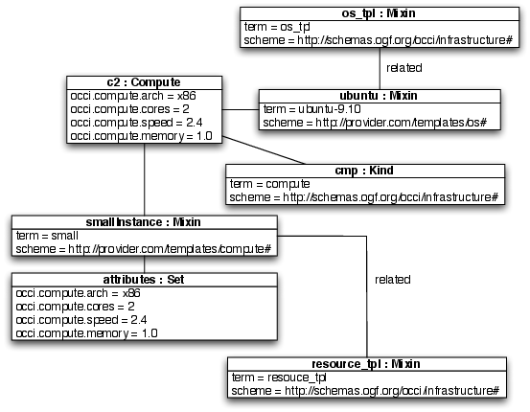

Fig.1 - Object Diagram of a Compute Instance and its Associated OS Template Mixin and Resource Template Mixin.
Therefore the OCCI Core definition for OCCI v. 1.2 has been updated based on comments provided during the public comment phase to also allow replacing Mixins, wherefore Mixins related to the same parent, applied sequentially, can replace each other. Nevertheless, the desired behaviour --whether Mixins should replace each other or stay in place side-by-side-- is further specified by the standard depending on the given Mixin.
The OCCI Infrastructure extension specification has similarly been updated to specify that by replacing a Resource Template Mixin, the size of the compute instance is changed, and related Mixins replace each other.
As a reference, we attach the OCCI 1.2 Core and OCCI 1.2 Infrastructure Extension drafts as for the date of this deliverable. However, it is worth notice that these are not the final documents, as they are subject to the OGF processes that are still ongoing.

Changes introduced into the standard
The Section 3.5.2 “Resource Template” from the OCCI Infrastructure Extension has been augmented as follows:
3.5.2 Resource Template
(...)
If a Resource Template is already associated with the given Resource instance, associating a new Resource Template (using mechanisms defined by the chosen rendering and transport protocol) MUST result in an immediate removal of the old Resource Template and association of the new Resource Template. The change must affect the the given Resource instance, in a provider-specific way (e.g., resizing the instance).
- Specifications
Draft OCCI Core 1.2 https://documents.egi.eu/document/2644
Draft OCCI Infrastructure 1.2 https://documents.egi.eu/document/2644

http://occi-wg.org/
https://www.ogf.org/
http://occi-wg.org/about/specification/

