EGI-Engage

Risk analysis and risk response for Period 2
D1.4

Date | 24 October 2016
Activity | NA1
Lead Partner | EGI.eu
Document Status | FINAL
Document Link | https://documents.egi.eu/document/2925

Abstract
The document describes result of risk registry review after one year of the project. The Risk registry is provided as separate internal private document. The Work Package leaders and the Project Management Board reviewed the risk registry. The document describes the improvements applies to the risk management process, the outcome of the periodic registry reviews and the trends in risk management. Finally the document reports on how recommendations on risk management from the PY1 review report were addressed during PY2.

COPYRIGHT NOTICE
This work by Parties of the EGI-Engage Consortium is licensed under a Creative Commons Attribution 4.0 International License (http://creativecommons.org/licenses/by/4.0/). The EGI-Engage project is co-funded by the European Union Horizon 2020 programme under grant number 654142.
DELIVERY SLIP
 | Name | Partner/Activity | Date
From: | Małgorzata Krakowian | EGI Foundation/NA1
Moderated by: | Sy Holsinger | EGI Foundation/NA2 | 24 Oct 2016
Reviewed by | Tiziana Ferrari | EGI Foundation/NA1 | 28 Oct 2016
Approved by: | AMB and PMB

DOCUMENT LOG
Issue | Date | Comment | Author/Partner
v.1 | 12/10/2016 | First version | Małgorzata Krakowian/EGI Foundation
v.2 | 02/11/2016 | Second version taking into account review feedback | Tiziana Ferrari/EGI Foundation  Małgorzata Krakowian/EGI Foundation
FINAL |  | Final version with KPI and metrics review

TERMINOLOGY
A complete project glossary is provided at the following page: http://www.egi.eu/about/glossary/

The following definitions are used in the EGI-Engage Risk management process and apply to this document:
Risk: a risk is defined as an uncertain event or condition that if it occurs, has a negative (threats) or positive (opportunities) effect on a Project's Objectives. (Source: PMBOK) In EGI-Engage the risk management process has been limited to threats.

Risk Registry: a database of identified risks with the associated analysis and response planning as well the estimation of risk occurrence and the history of their treatment.

EXCUTIVE SUMMARY
The Project Risk management process includes conducting risk management planning, identification, analysis, response planning and control. The objective is to detect threats and decrease their likelihood and impact by proper treatment as well as to collect lessons learned from risks occurrence to facilitate continuous learning of project management team. Benefits of risk management include:
- Raise the level of focus and attention on risks.
- Take a proactive approach for preventing risks from becoming issues.
- Ensure a consistent approach for analysing, prioritizing, communicating and managing risks.
- Provide a means to efficiently and effectively mitigate risks.
- Save cost and time by identifying, prioritizing, and managing risks.
- Increase the impact and success of the project.
The Risk registry has been reviewed by the Work Package leaders and the Project Management Board three times during the project lifetime: 10.2015, 3.2016 and 9.2016. The risks are under the control of the Activity Management Board (AMB) and currently there is no threat requiring attention from the Project Management Board (PMB). The trend has been that identified risks through each risk registry review are decreasing its risk level in most of the cases and new risks are being identified continuously. This analysis result has reassured project management that the risk management process is working properly.
In order to address PY1 review recommendations concerning the enlargement of risk assessments to include risks associated with strategy, the project risk management activities were complemented by a risk management process that is part of the Core Management System of the EGI Foundation as of October 2016. The Integrated Management System, of which the “Core” is part, will be subject to external audit ISO 9001 & ISO/IEC 20000-1 certification at the end of 2016.

Contents
1 Introduction 5
2 Risk management process 6
2.1 Changes 7
2.2 IMS Risk Management 7
3 Results of the risk registry review for Period 2 8
3.1 Risk level distribution 8
3.2 Work package risk distribution 9
4 Conclusions 10

Introduction
This document that provides guidelines on how risk management is applied in the project, is D1.2 “Risk Analysis and Risk Response for Period 1”. The document defines risk identification, analysis, response and control, and serves as baseline for risk management in Period 2. Section 2 provides an overview of risk management in EGI-Engage. Various changes and improvements were introduced during the course of the second period; these are detailed in Section 3. These are based on the outcomes and experience resulting from three formal reviews of the Risk Registry conducted in October 2015, March 2016 and September 2016. The outcomes of the last risk review are instrumental to help the project management team to plan necessary actions to avoid or mitigate identified threats in project year 2.
This report also provides the results of the first re-assessment of the probability and impact of risks identified during the project proposal phase and the proposed response, as well as the result of new risk identification activities.
The structure and contents of this deliverable is as follows. Section 2 describes changes to the Risk management process applied in PY1. Section 3 provides the results of the first review of the probability and impact of risks identified during the project proposal phase and proposed response, as well as the results of new risk identification performed within each Work Package.
The Risk Registry itself – internally managed through a shared spreadsheet, is confidential with access limited to Activity Management Board (AMB) and Project Management Board members (PMB). The Risk Register will be made available to reviewers at project review time as separate document.
Risk management activities in the context of EGI-Engage are complemented by a risk management process conducted by the EGI Foundation, which is part of the Integrated Management System that will be subject to ISO 9001 & ISO/IEC 20000-1 certification.

Risk management process
The Risk management process, as defined in D1.2, contains four sub-processes:
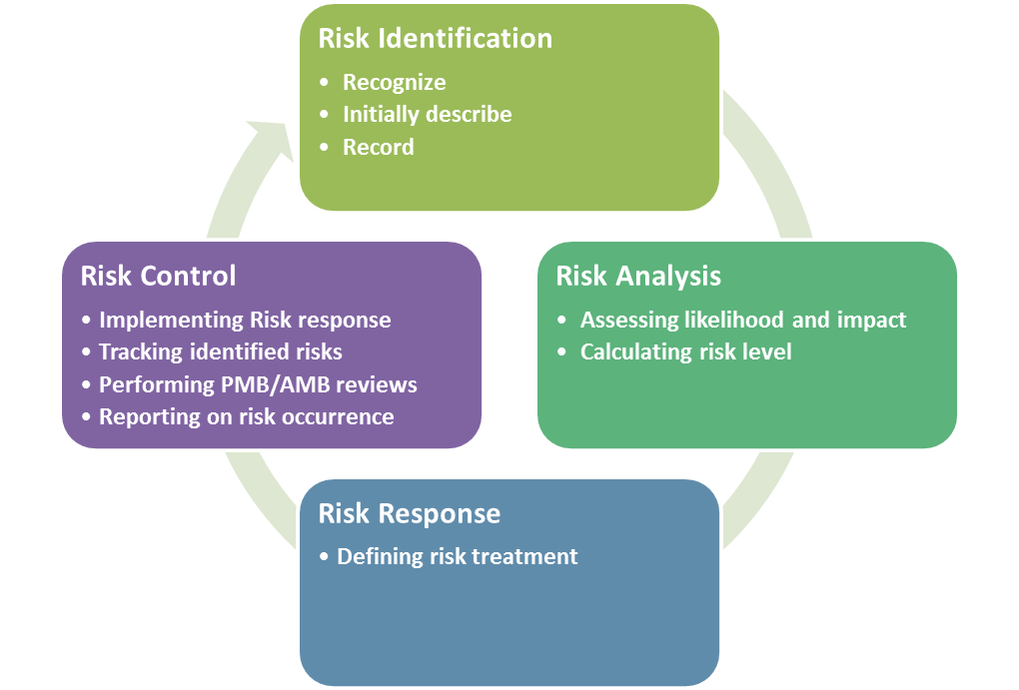
Figure 1 - Four sub-processes of Risk Management in EGI-Engage
Process 1. Risk identification
- Goal: determining which risks can affect the project and documenting it in the Risk registry
- Description: a process that is used to find, recognize, and describe the risks that could affect (prevent or undermine) the achievements of project objectives.
Process 2. Risk analysis
- Goal: assessing the likelihood and impact and evaluating the risk level
- Description: a process that is used to understand the nature, sources, and causes of the identified risks, to estimate their level of impact and related consequences, and to examine the necessary controls (an activity that prevents or detects issues to mitigate risks) that currently exist.
Process 3. Risk response
- Goal: defining the actions to be taken in order to avoid the risks or to minimize their impact (risk response plan) for each risk.
- Description: a process of developing options and actions to reduce threats to project objectives.

Process 4. Risk control
- Goal: improving the success of risk management activities through continuous monitoring and adjustment
- Description: a process for implementing the risk response plan, tracking identified risks, and performing risk status review.
The whole process was defined in D1.2 as well as via a dedicated page on the EGI wiki, and is reported in this deliverable to provide background information.

Changes
Based on experience from project year 1, the following changes were introduced after agreement by the Activity Management Board and the Project Management Board.
- The risk registry review is executed every 6 months instead of every 3 months, in order to be able to be able to better assess the outcomes of the applied contingency plans.
- The risk management process defined in the context of the activities of the project, is extended to the EGI Foundation services in compliance to ISO 9000/20000, and will be subject to audit and certification. The same procedure will be reused to maintain the EGI Infrastructure.
- A clear procedure regarding the risk registry review to be defined to clearly assign responsibilities of treatments, and organize communication on risk management within and across WPs.
- Following recommendations from Project Year 1 review:
  - Risks associated with strategy will be covered. It has been decided to include them by EGI Integrated Management System risk management process.
  - More attention is dedicated to align levels of detail among work packages.

IMS Risk Management
Risk management activities in the context of EGI-Engage are complemented by a risk management process conducted by the EGI Foundation, which is part of the Integrated Management System. The Integrated Management System is a management system implemented to plan, implement, monitor and continually improve all business processes under responsibility of EGI Foundation. Therefore EGI Foundation-specific risks, like strategy risks, will be covered by IMS risk management process. IMS risk management process is in phase of implementation and will be audited as part of Information management system against ISO 9001 standard.
IMS risk management process has been defined based on experience from EGI-Engage project and are kept consistent with each other.

Results of the risk registry review for Period 2
The Risk analysis was performed by Work Package leaders with the support of the Quality and Risk Manager between June and September 2016.
All risks were reviewed according to the following questions:
- Are the risks still relevant to the project?
- Have the risk levels changed?
- Are the proposed countermeasures still valid and being applied?
- Are the consequences of the risk occurrence still valid?
In addition, in the risk registry for each risk an owner has been assigned. The Work Package leader is responsible for coordinating the treatment application, as well as for monitoring the trend in comparison to the risk level defined during the project proposal phase.
Each Work package leader is responsible to identify new risks during the period after consultation with the task leaders and the WP partners.
In the Risk registry the following types of risks are recorded:
- Foreseen: identified during project proposal phase.
- Unforeseen: identified during project execution phase.
After one year of the project, the Risk registry comprises:
- 9 foreseen risks out of 20 identified during the project proposal phase.
- 29 unforeseen out of 38 identified in total during the project execution phase.

Risk level distribution

Figure 2 - Risk level distribution
Figure 2 shows that most of the risks identified for the EGI-Engage project are medium or low.
During the risk review from September 2016 (comparing to the risk review from March 2016):
- 8 risks have had their risk level decreased, mainly reaching low risk level
- 12 risks remain low risk level
- 3 new have been identified (2 – Medium, 1 - High)
- No risks have been identified as requiring a contingency plan.

Work package risk distribution

Figure 3 - Work package risk distribution
Each risk is assigned to a specific work package, which is primarily responsible for applying the agreed treatment for a given risk. Figure 3 shows the distribution of current risks for each work package. As shown, the risk management process covers all work packages. The number of risks for each work package changes during the project lifetime, including the type of activities and advancement of work.

Conclusions
The risk management process is part of the Activity Management Board (AMB) and Project Management Board (PMB) activities. The Quality and Risk Manager is in charge of coordinating and controlling the process.
The Risk registry has been reviewed by the Work Package leaders and the Project Management Board three times during the project lifetime: October 2015, March 2016 and September 2016. The risks are under the control of the Activity Management Board (AMB) and currently there is no threat requiring attention from the Project Management Board (PMB). The trend has been that identified risks through each risk registry review are decreasing its risk level in most of the cases and new risks are being identified continuously. This analysis result has reassured project management that the risk management process is working properly.
Any issues related to the process are and will continue to be reported to the Work Package 1 leader.
The Risk registry review will be conducted two more times prior to the end of the project: during the project report for period 2 as well as in the context the final project report. Complementary Information Management System Risk process will be implemented which will cover EGI Foundation related risks which may impact EGI-Engage project.

The Risk Registry is available for AMB and PMB members at https://documents.egi.eu/document/2795.
https://documents.egi.eu/document/2540
https://wiki.egi.eu/wiki/EGI-Engage:Risk_Plan
https://wiki.egi.eu/wiki/PROC04_Risks_review

